FAMU-FSU College of Engineering
Department of Electrical and Computer Engineering

Final Report

EEL4914C/4915C – ECE Senior Design Project II
Project title: IEEE SOUTHEASTCON 2015 HARDWARE COMPETITION FINAL REPORT
Team 1B

Student team members:
− Louis Cooper, Electrical engineering (Email: lecooper228@gmail.com)
− Evan Marshall, Computer engineering (Email: evan1.marshall@hotmail.com)
− Chelsea Ogle, Electrical engineering (Email: ceo11@my.fsu.edu)
− Lorenzo Smith, Electrical engineering (Email: lorenzos2291@gmail.com)
− Ivan Vargas, Electrical engineering (Email: iv11b@my.fsu.edu)

Senior Design Project Instructor: Dr. Michael Frank
Senior Design Project Adviser: Dr. Bruce Harvey
Senior Design Project Reviewer: Dr. Victor DeBrunner
Submitted in partial fulfillment of the requirements for
EEL4914C/4915C – ECE Senior Design Project II
February 6, 2015

Project Executive Summary

The FAMU-FSU College of Engineering is sponsoring two teams to design and build a robot capable of competing in, and ideally winning, the SoutheastCon Hardware Competition. The competition takes place annually and is sponsored by IEEE. Based on an internal competition between the two teams, one team will compete in this year’s competition. The competition this year features a white line on a black background that acts as the course for an autonomous robot. The robot must detect a start LED and begin following the line to four game zones, at each of which it has a task to complete. The robot must turn one face on a Rubik’s cube 180 degrees, successfully play a handheld Simon Says game for 15 seconds, write the word “IEEE” on an Etch-A-Sketch, and pick up a playing card to carry it over the finish line. All of these tasks must be completed by the robot autonomously. Points are awarded for the completion of each task, and there are three five-minute rounds in which the course may be attempted. In the event of a tie in points, the winner will be determined by the fastest time.

The current design for completing these tasks consists of a lightweight, two-level, HDPE chassis to maximize the speed of the robot, as well as to fit within the size requirements of the competition. A differential drive system integrated with a line following sensor array will be used in order to follow the line of the course. There are three main types of arm/gripper mechanisms in the current design, used in order to manipulate the toys in the game zone. The chassis gripper, located in the front of the robot, is a stationary gripper used to hold onto and position the games properly to complete the tasks. There are two Etch-A-Sketch grippers used in order to drop down onto the Etch-A-Sketch knobs and turn them. Finally, the main arm will be used to push the buttons on the Simon game, turn the Rubik’s cube and pick up the playing card. Additionally, there are other sensors in order to facilitate the completion of tasks. Distance sensors are used to find and position properly for the games and a microphone will be used to pick up the unique tones played for each button by Simon. The microcontroller unit used in order to integrate all of the sensors, arms and motors into a working system, is an Arduino Due. The construction of the final prototype for the design is nearly complete. The integration of the software with the hardware is currently underway, with tests being carried out. This should be completed before the internal competition, with extra time allowed for testing and fixes.

Table of Contents

Table of Contents
1 Introduction
1.1 Acknowledgements
1.2 Problem Statement
1.3 Operating Environment
1.4 Intended Use(s) and Intended User(s)
1.5 Assumptions and Limitations
1.6 Expected End Product and Other Deliverables
2 System Design
2.1 Central Processing Unit
2.2 Sensors
2.2.1 Line Following and Start LED
2.2.2 Sound Sensing /Microphone for Simon
2.2.3 Distance Sensing / Object Detection
2.3 Arms / Grippers
2.3.1 Chassis Gripper
2.3.2 Main Arm
2.3.3 EaS Grippers
2.4 Drive System
2.5 Power Supply
2.6 Chassis
3 Detailed Design of Major Components/Subsystems
3.1 Overview and Chassis
3.2 CPU
3.3 Drive System
3.4 Sensors
3.4.1 Starting
3.4.2 Line Following
3.4.3 Microphone for Simon
3.4.4 Object Detection
3.5 Arms/Grippers
3.5.1 Arm Layouts
3.5.2 Pin Connections
3.5.3 General Coding Information
3.6 Power Supply
4 Testing Plan
4.1 Programming
4.1.1 Arduino Due
4.1.2 Driver Shield
4.1.3 Servo Controller
4.2 Drive System
4.2.1 Line Following
4.2.2 Chassis
4.3 Sensors
4.3.1 Line Following
4.3.2 Object Detection (Find Game)
4.3.3 Microphone
4.3.4 Start LED
4.4 Arms/Grippers
4.4.1 Chassis Gripper
4.4.2 Main Arm
4.4.3 EaS Grippers
4.4.4 Chassis
4.5 Power System
4.5.1 Arduino Due
4.5.2 Driver Shield
4.5.3 Servo Controller
5 Risk Assessment
5.1 Technical Risks
5.1.1 Insufficient number of I/O ports on Microcontroller
5.1.2 Insufficient MCU Memory
5.1.3 Line Following System Failure
5.1.4 Sound Sensor/Simon Says System Failure
5.1.5 Arm Mechanism Failure
5.1.6 Gripper Mechanism Failure
5.1.7 Etch-A-Sketch Arms Failure
5.1.8 Structural Failure
5.1.9 Power System Failure
5.2 Schedule Risks
5.2.1 Resource Availability
5.2.2 Team Member Scheduling Conflicts
5.3 Budget Risk
5.3.1 Underestimation of Design Expense
5.3.2 Damage to Components or Systems
5.4 Summary of Risk Status
7 Qualifications and Responsibilities of Project Team
8 Schedule
9 Budget Estimate
10 Deliverables
11 References

Introduction

Acknowledgements

SoutheastCon Team 1B would like to acknowledge Dr. Bruce Harvey, Dr. Victor DeBrunner and Dr. Michael Frank for their astute advice and input guiding the development of the team and robot. Their involvement has helped to motivate SoutheastCon Team 1B to put forth maximum effort and to excel. The team would also like to thank the FAMU-FSU College of Engineering for their facility resources and $750.00 contribution to the project.

Problem Statement

SoutheastCon is an annual technical, professional and student conference held by IEEE. The convention features several competitions including a hardware competition in which teams build robots that perform tasks autonomously. This year’s competition will require that an autonomous robot complete 4 different game related objectives and follow a white line course in under 5 minutes. There will be 3 of these 5 minute rounds in which the team can score points. Points are awarded for completing the games and following the course. If there is a tie the victor will be determine by whichever robot completed the course faster.

Team 1B’s robot will be able to recognize the beginning of the game and engage in each of the four tasks to gain points per round. The four tasks must be completed to gain points and may be played in any sequence. The tasks are rotate one face of a Rubik’s Cube 180 degrees, draw IEEE on an Etch-A-Sketch, successfully play Simon Says for 15 seconds, lastly pick up one playing card and carry it across the finish line. A robot that will be able to perform these tasks within the time limit will be completed by March so that it may compete with Team 1A’s robot.
The team will use the resources provided by the college of engineering for advice, financing, meetings, and presentations. The team is confident in completing a competing robot within the budget and time constraints.

Operating Environment

SoutheastCon will be providing a piece of flat, black, standard plywood with taped navigation lines as a course for the robot. The location of the event will be at the Hilton Fort Lauderdale Marina Hotel in Florida. It is assumed that the competition will be held inside the Hotel which will exclude the any extreme weather conditions. The design of the robot has been influenced by the operating environment, as far as the materials used that will touch the surface. There are some unknown factors such as the temperature of the competition room, and other small factors that are irrelevant to the existing design.

Intended Use(s) and Intended User(s)

The intended use of this prototype will be to compete in the IEEE SoutheastCon 2015 Hardware Competition. The prototype will also represent FAMU-FSU College of Engineering. In greater detail, the prototype will be used to play the Simon Says Carabiner, draw IEEE on an Etch-A-Sketch, rotate a face on a Rubik’s cube 180 degrees, and carry one playing card across the finish line.
The intended users for this prototype will be SoutheastCon Team 1B. Team 1B will use this prototype as the capstone for the engineering program under the ECE Department. The complete design process will incorporate all engineering principles and knowledge gained over the past years.

Assumptions and Limitations

Assumptions: Environment lighting will be feasible for the competing prototype. The sound from the audience during each round will be quiet. The temperature inside the room will be close to 25 degrees Celsius. There will be time to do final checks and test prior to competing. The final rules will be sent out two months prior to completion. Each item for the game will be in new condition. There will be time in between each round to charge or swap the power source on the prototype. Points will not be taken away for not placing a game back in its original position after playing it.

Limitations: Robot must be completed before the competition. There will also be a time limit of 5 minutes to gain the maximum amount of points per round. The budget from the College of Engineering will be $750. The size of the robot may not exceed 1’x1’x1’. The prototype may not communicate with anyone or anything outside of the course. The prototype may not split up into separate pieces. The prototype may not be remotely controlled. The prototype cannot contain any flammable liquids, gases, or explosives. The prototype cannot project anything inside or outside of the playing field. The prototype may not present any danger to the judges, spectators, and/or the playing board.

Expected End Product and Other Deliverables

The final project will be an autonomous robot that will operate for three 5 minute rounds during the SoutheastCon 2015 Hardware Competition. Successful project management will ensure the robot parts and equipment will meet the budget requirement, the work force will be distributed to a qualified member of the group, and a detailed schedule will guide the design process. The group is required to complete the project before the competition in April 2015. The proper documentation and project reports will make up the essentials of what will be delivered by the design team. The goal of our design project is to deliver a robot that will receive maximum points in the competition.

System Design

Central Processing Unit
The microcontroller that will be used for the final project is the Arduino Due. There were many reasons for selecting this microcontroller including cost, performance and ease of use. At $40 the Due was reasonably priced enough that a second one could purchased in case one is damaged. Having a second Arduino also means that multiple people can be working different parts of the project at the same time. The Due was not the most powerful microcontroller out of the selection but it is more than powerful enough for this project. There are over 60 pins that can be used on the Due which means that can handle all of the interfacing needs of the project. This will include all of our different systems including the drive system and different servo configurations for different arms being used in this project. The Arduino is also an extremely popular microcontroller. It has a large array of tutorials, custom libraries and support available for use. By having these kind of resources available it means that there will be less time being spent learning how to use the microcontroller so more time can be spent in the design and testing phase of the project. Table 2.1b shows a more detailed overview of the microcontroller.
Table 2.1a - Overview of the Arduino Due
Operating Voltage | 3.3 V
Microcontroller | AT91SAM3X8E
Input Voltage | 7-12V recommended
Digital I/O Pins | 54 with 12 being PWM
Analog Input Pins | 12
Analog Output Pins | 2
Flash Memory | 512 KB
Clock Speed | 84 MHz

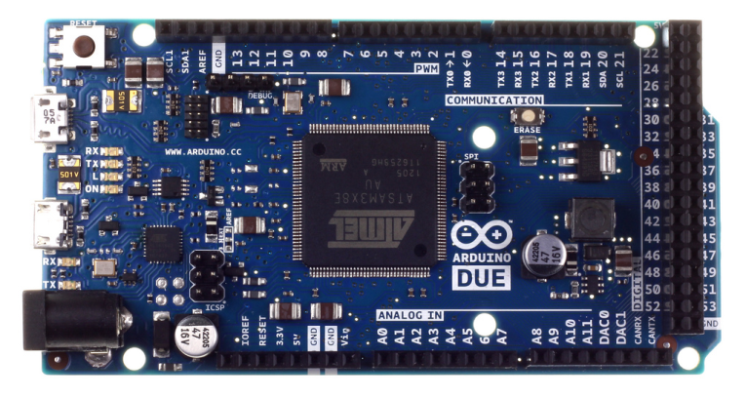
Figure 2.1a - A top view of the Arduino Due

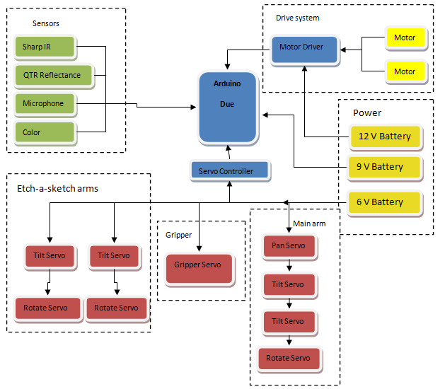
Figure 2.1b- Top level diagram showing all of the different systems interfacing with the Arduino

Sensors
The sensors for the robot are what allows it to take in visual and audio information from its surroundings, allowing it to follow the course and play each of the games. Choosing simple and versatile options are a top priority.

Line Following and Start LED

The robot must be able to properly navigate along a white line, 0.94 inches wide, and cover it at all times. The sensor must be able to achieve this at various speeds and also recognize intersections. The digital sensor chosen has the ability to measure the position of the line and create smooth movements utilizing PID control. The alternative methodology was to use analog readings and store them in a array using binary sequences to determine turns and intersections. The combination of both was decided for it enables the robot to sucsessfully navigate the course.

Pololu QTR-8RC Reflectance Sensor Array - 10$

According to the product webpage- This sensor module has 8 IR LED/phototransistor pairs mounted on a 0.375" pitch, making it a great detector for a line-following robot. Pairs of LEDs are arranged in series to halve current consumption, and a MOSFET allows the LEDs to be turned off for additional sensing or power-savings options. Each sensor provides a separate digital I/O-measurable output.

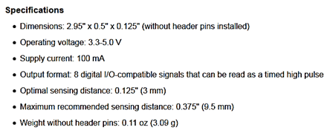
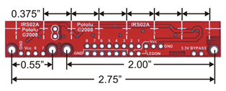
Figure 2.2.1a: QTR-8RC Reflectance Sensor Array Dimensions

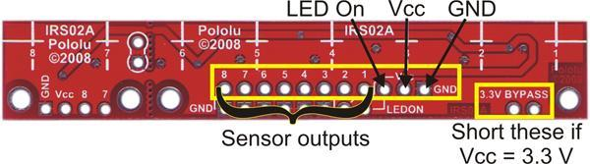

Figure 2.2.1b: Pin Connections on module

This sensor was chosen for multiple reasons. Its 8 independent outputs make it easy to cover more than the 0.94” line. The module can also be accompanied by an additional line sensor (the Pololu QTR-1RC) for additional coverage and accuracy. This smaller (1 IR LED/phototransistor pair) module will be used to recognize the “off” signal from the start LED. It will also read the position of a line and can be programed to correct itself. Its drawbacks are its small maximum sensing distance of 0.375” and its use of 10 I/O pins (1 extra for the LED).
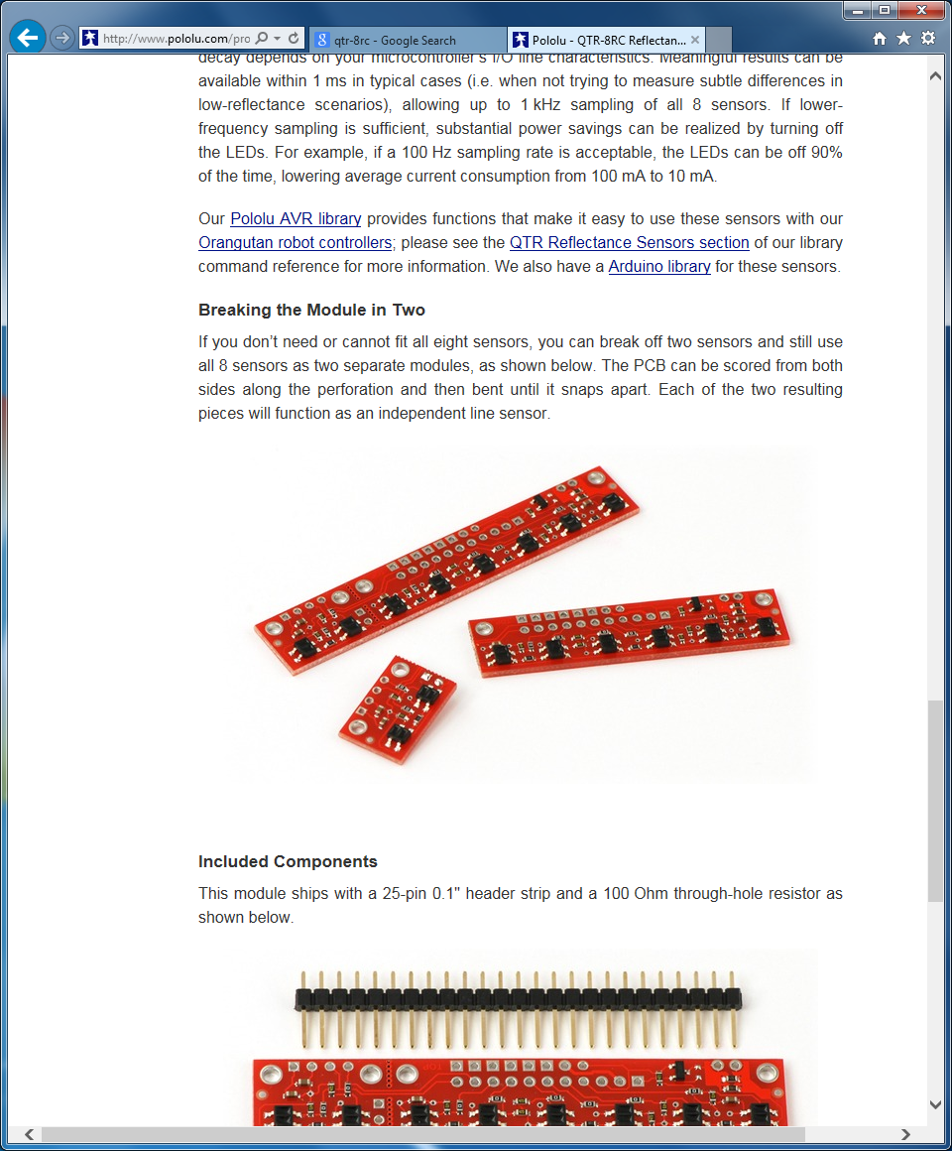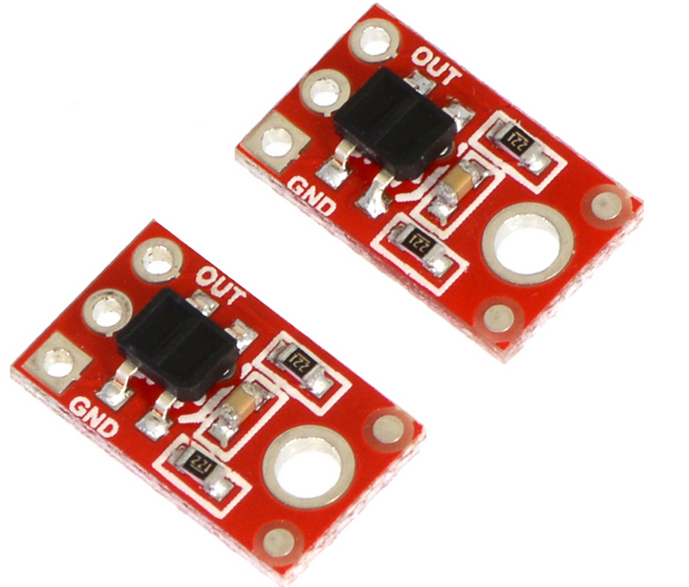
Figure 2.2.1c:QTR-8RC along side 2 QTR-1RC modules

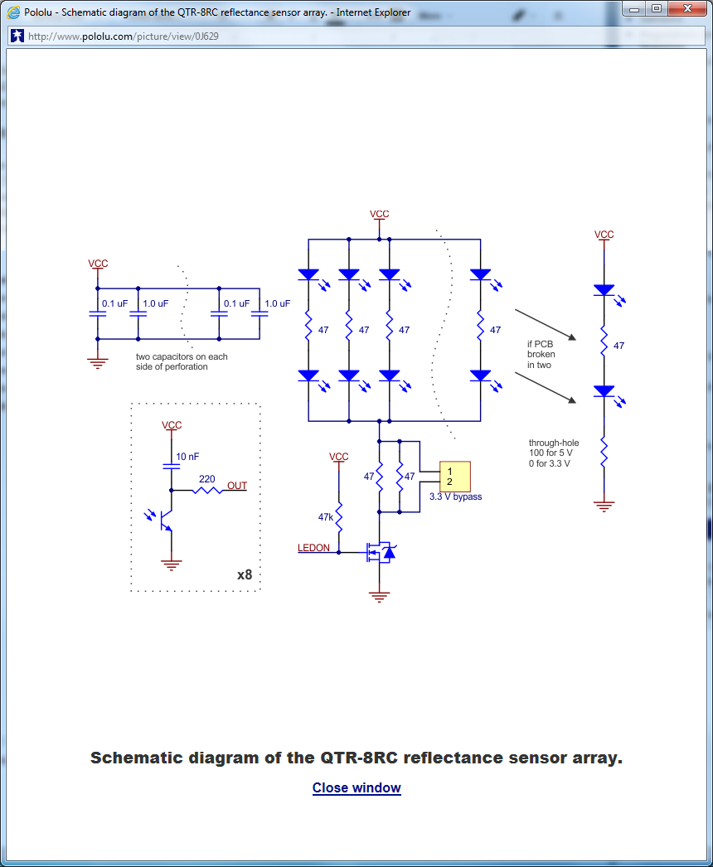
Figure 2.2.1d: Schematic diagram of the QTR-8RC reflectance sensor array

Sound Sensing/Microphone for Simon

In order to play Simon, the idea is to use the sounds played for each of the four colored buttons in order to recognize the pattern. In order to achieve this, a microphone capable of recognizing the frequencies played by Simon will be necessary. Alternatives considered were the use of a camera or simple RGB color sensor. The camera was determined to be over-design for complexity, while the color sensor would more power and precise mounting placment.

Electret Microphone Amplifier from Adafruit

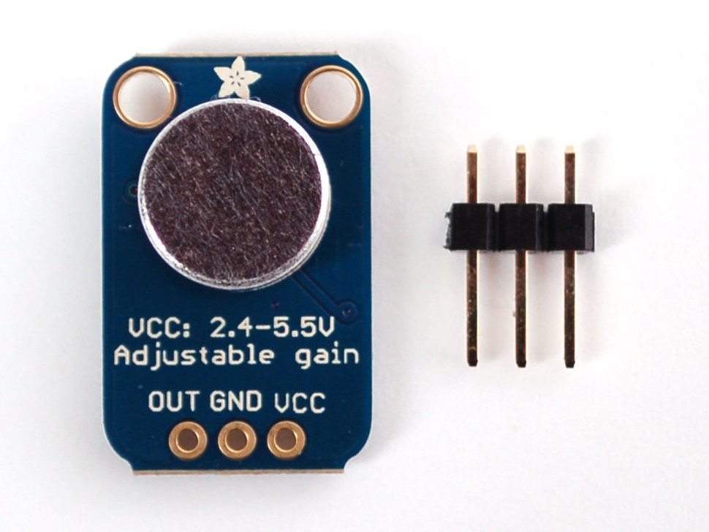
Figure 2.2.2a: Electret Microphone Board w/ Pin connections

According to the product webpage - This small board couples a small electret microphone with a Maxim MAX4466 op-amp to amplify the sounds of voice, door knocks, etc loud enough to be picked up by a microcontroller’s Analog to Digital converter. The unit comes fully assembled as shown. Works from 2.4V up to 5V.
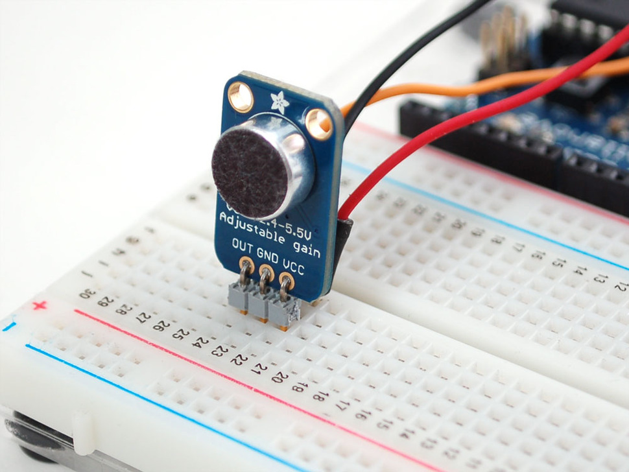
Figure 2.2.2b: Electret Microphone Breakout on breadboard with pins
The Electret Microphone Breakout board was chosen to pick up the sounds emitted from the Simon game. The general idea is to use a FIR filter designed via MATLAB to determine the various frequencies associated with the 4 colors of the simon game (red, blue, yellow, and green). The implementation will be discussed in further detail in section 3.4.3.
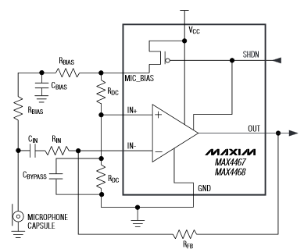
Figure 2.2.2c: Electret Microphone Breakout Op-Amp Typical operating circuit Schematic
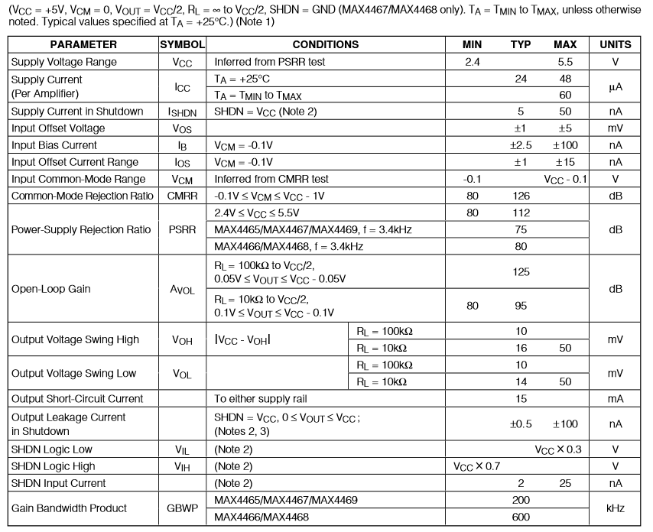

Figure 2.2.2d: Electrical Characteristics Courtesy of Maxim
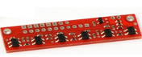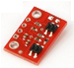

Distance Sensing/Object Detection
In order to locate the games properly, some form of detection must be added. The sensor chosen will inform the robot of the game’s location relative to it. With proper response, the robot can continue to execute the proper game playing sequence with accuracy.

Since the order of the games will not change, a camera would have been over-designing. The use of an ultasonic range finder was also considered, but its minmum distance and reliability would cause to many problems. The chosen idea was to used one (optionally 2) IR, optical range finder, to serve as the robot’s “eyes” , to detect its position relative to each game. A optional longer range sensor will be used to spot objects further away and slow down the motors. This will only be included if future testing requires the robot need a further sensing distance. The smaller range sensor will be used to accurately get into position to precisely play each games.

(Optional) Sharp GP2Y0A60SZLF Analog Distance Sensor 3V - 12$

From the product webpage - The GP2Y0A60SZ distance sensor from Sharp offers a wide detection range of 4″ to 60″ (10 cm to 150 cm) and a high update rate of 60 Hz. The distance is indicated by an analog voltage, so only a single analog input is required to interface with the module. The sensor ships installed on our compact carrier board, which makes it easy to integrate this great sensor into your project, and is configured for 3V mode.

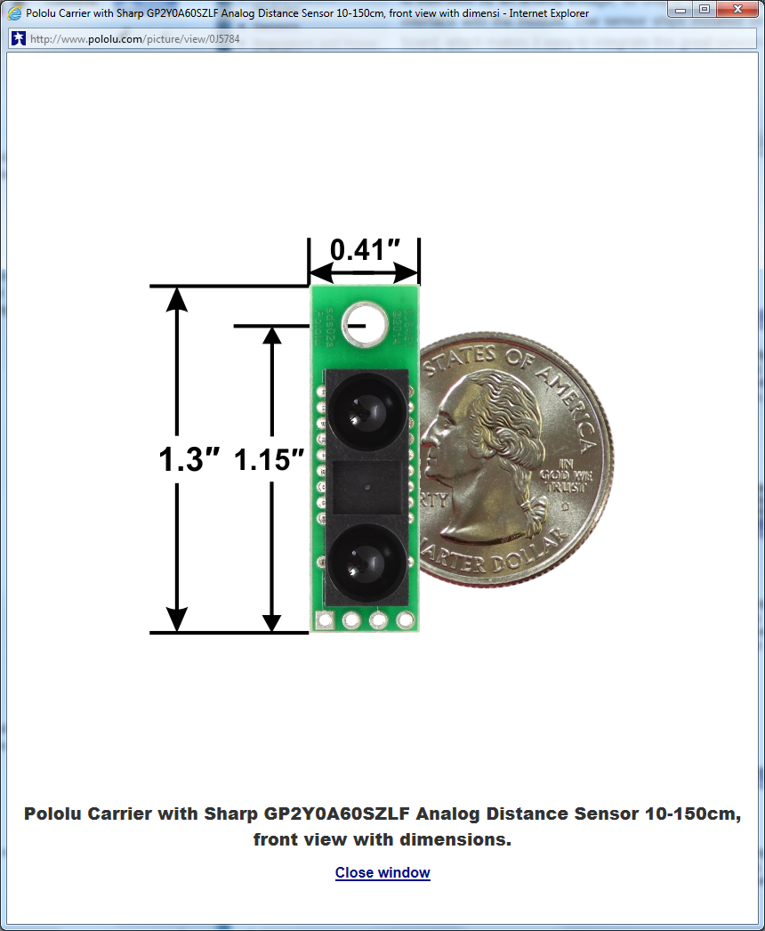
Figure 2.2.3a: GP2Y0A60SZLF Analog Distance Sensor w/ Dimensions

Feature summary
- Operating voltage: 3V version: 2.7 V to 3.6 V
- Average current consumption: 33 mA (typical)
- Distance measuring range: 10 cm to 150 cm (4″ to 60″)
- Output type: analog voltage
- Output voltage differential over distance range: 3V version: 1.6 V (typical)
- Update period: 16.5 ± 4 ms
- Enable pin can optionally be used to disable the emitter and save power
- Size without header pins: 33 mm × 10.4 mm × 10.2 mm (1.3″ × 0.41″ × 0.4″)
- Weight without header pins: 2.5 g (0.09 oz)

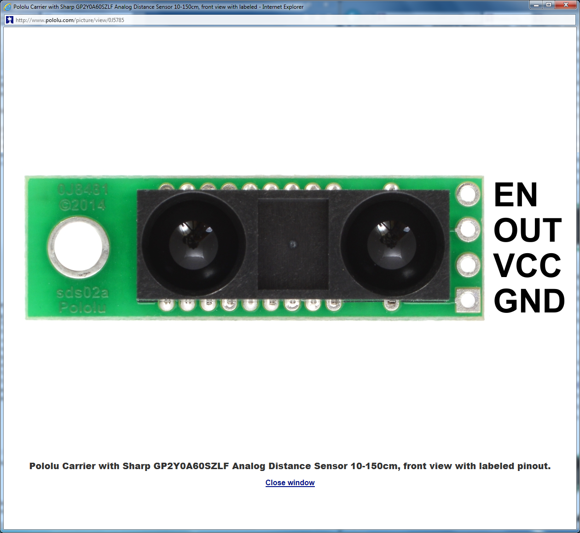
Figure 2.2.3b: GP2Y0A60SZLF Analog Distance Sensor pinout

This sharp analog distance sensor has a range of 4”-60”, and will be used to first detect objects. It will allow the robot to slow its speed when within a certain range. Once it becomes closer than 4”, the smaller digital IR sensor will take over.

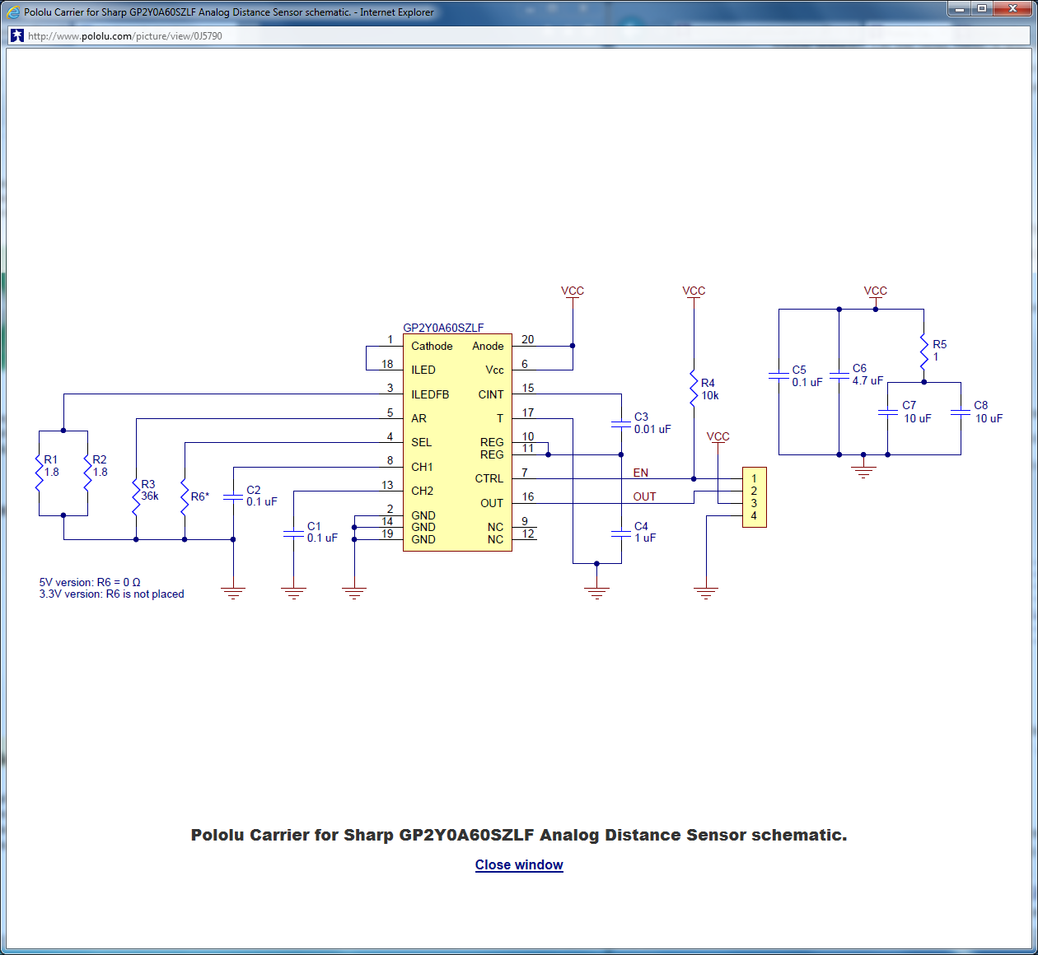
Figure 2.2.3c: GP2Y0A60SZLF Analog Distance Sensor Schematic Diagram

Sharp GP2Y0D815Z0F Digital Distance Sensor - 9$

From the product webpage - This small digital distance sensor detects objects between 0.5 cm and 15 cm (0.2″ and 6″) away. With its quick response time, small size, low current draw, and short minimum sensing distance, this sensor is a good choice for non-contact, close-proximity object detection, and our compact carrier PCB makes it easy to integrate into your project.

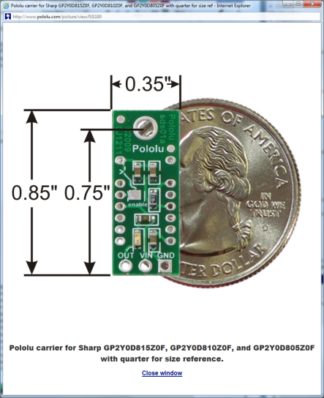
Figure 2.2.3d: GP2Y0D815Z0F Digital Distance Sensor w/ Dimensions

Feature summary
- Operating voltage: 2.7 V to 6.2 V
- Average current consumption: 5 mA (typical)
- Distance measuring range: GP2Y0D815Z0F: 0.5 cm to 5 cm (0.2″ to 6″)
- Output type: digital signal (low when detecting an object, high otherwise)
- Steady state update period: 2.56 ms typical (3.77 ms max)
- Enable pad can optionally be used to disable the emitter and save power (this feature requires you to cut a trace first)
- Size without header pins: 21.6 mm × 8.9 mm × 10.4 mm (0.85″ × 0.35″ × 0.41″)
- Weight without header pins: 1.5 g (0.05 oz)

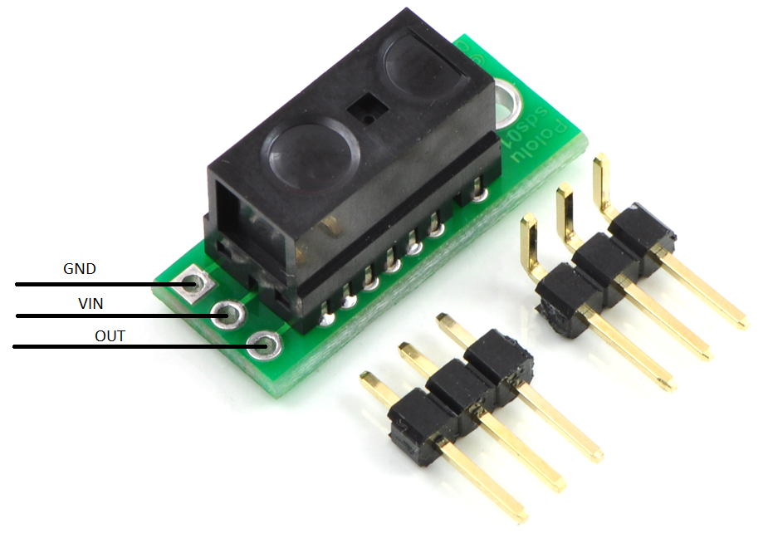
Figure 2.2.3e: GP2Y0D815Z0F Digital Distance Sensor pinout

This sharp digital distance sensor has a range of 0.2”-6”, and will be used for accurate detection of objects. It will allow the robot to precisely slow its speed, then eventually stop, when within a certain range. Once it becomes close enough, the robot will execute the proper game playing sequence.

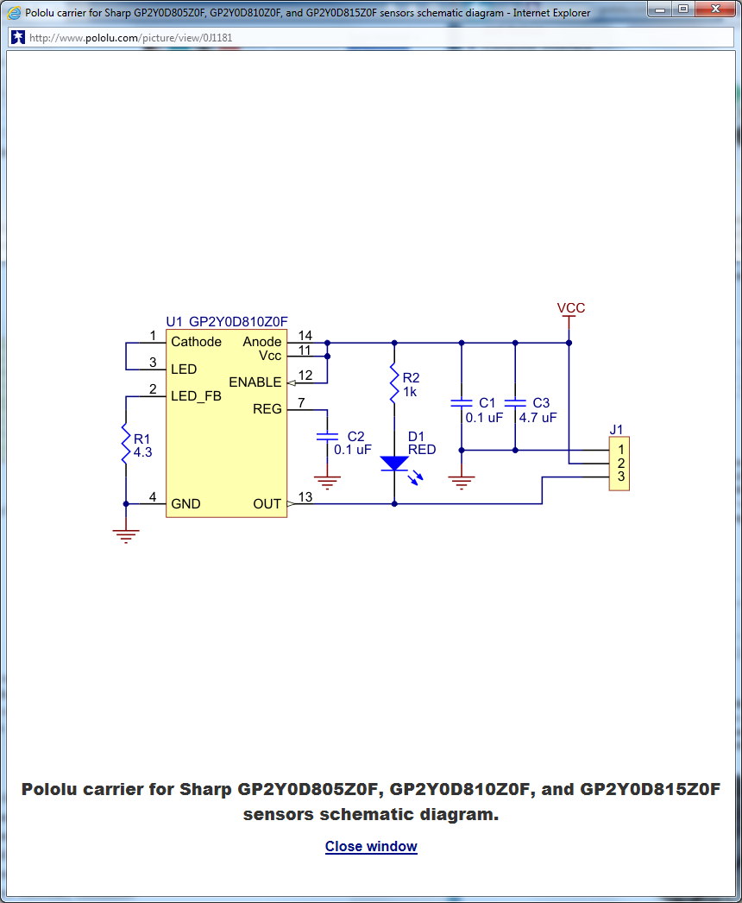
Figure 2.2.3f: GP2Y0D815Z0F Digital Distance Sensor Schematic Diagram

Arms/Servos
In order to complete the individual tasks, several mechanical appendages will be constructed to manipulate the toys. Several options for these robotic arms/grippers have been considered to find the best solution. The factors that went into consideration include Arduino compatibility, cost, and robustness.

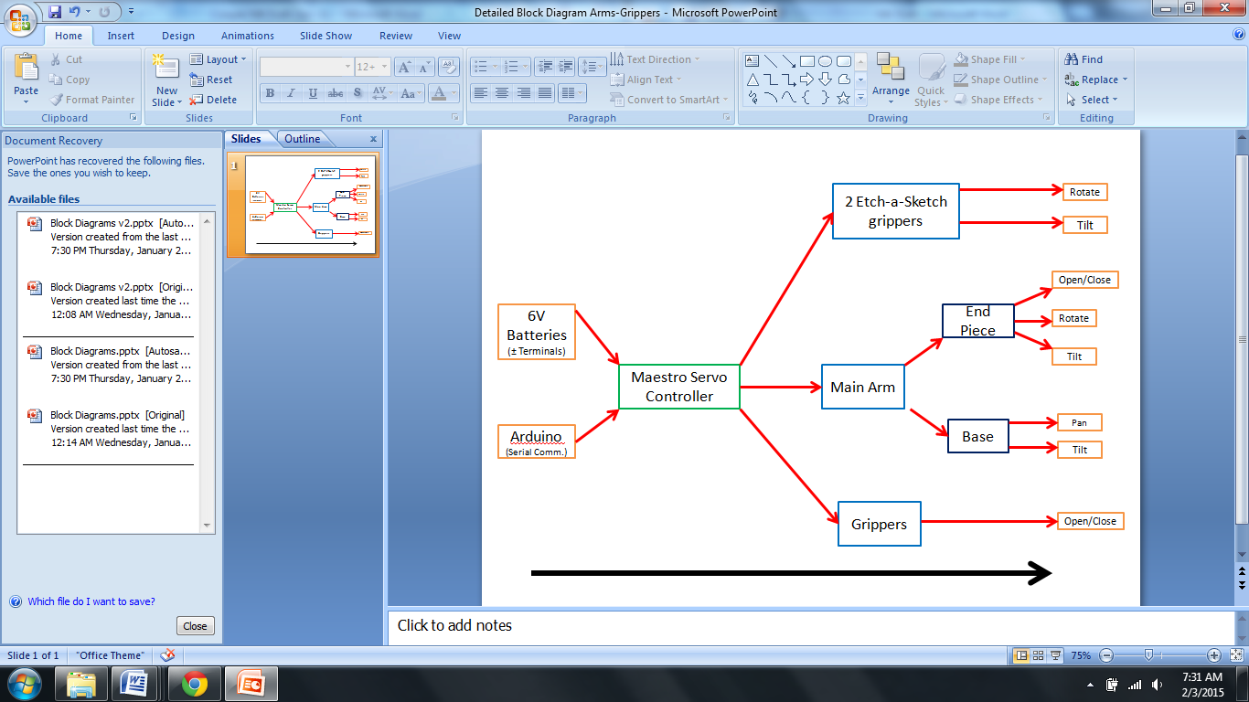
Figure 2.3a: Top Level Diagram for Arms/Servos

Chassis Gripper:
The design will include a gripping mechanism to hold some of the toys in place. The grippers will consist of the Little Gripper Kit from Lynxmotion (LGK), metal brackets, and High Density Polyethylene (HDPE) cutouts to increase the range. The grippers open and close based on the servo's position. A high torque servo will be used to achieve a strong grip. The HDPE cutouts can be replaced at any time for a more flexible design that will have better positioning for the challenges.
The original design has been modified due to failed system integration. The Chassis Gripper will be placed in front of the caster wheel instead of behind it. The range will also need to be shortened to meet the one (1) foot requirement of the SoutheastCon competition. The final position and shape of the Chassis Gripper will develop after extensive testing with other subsystems.

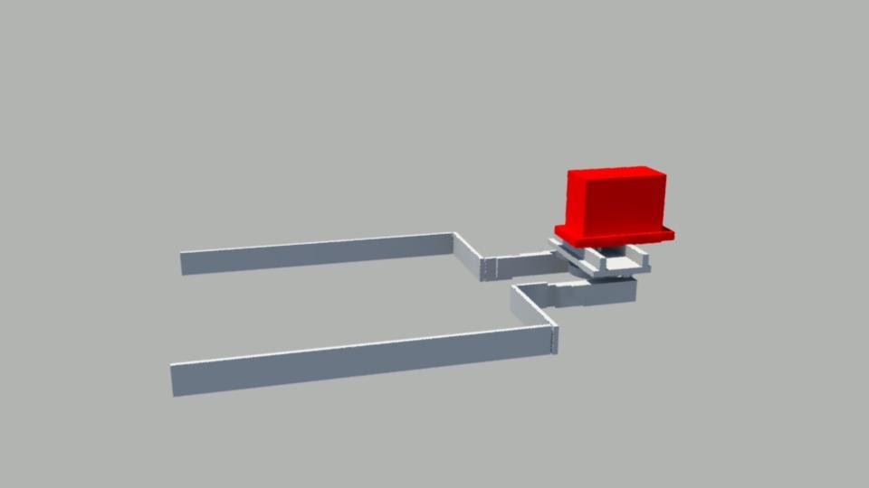
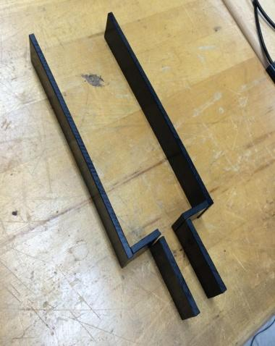

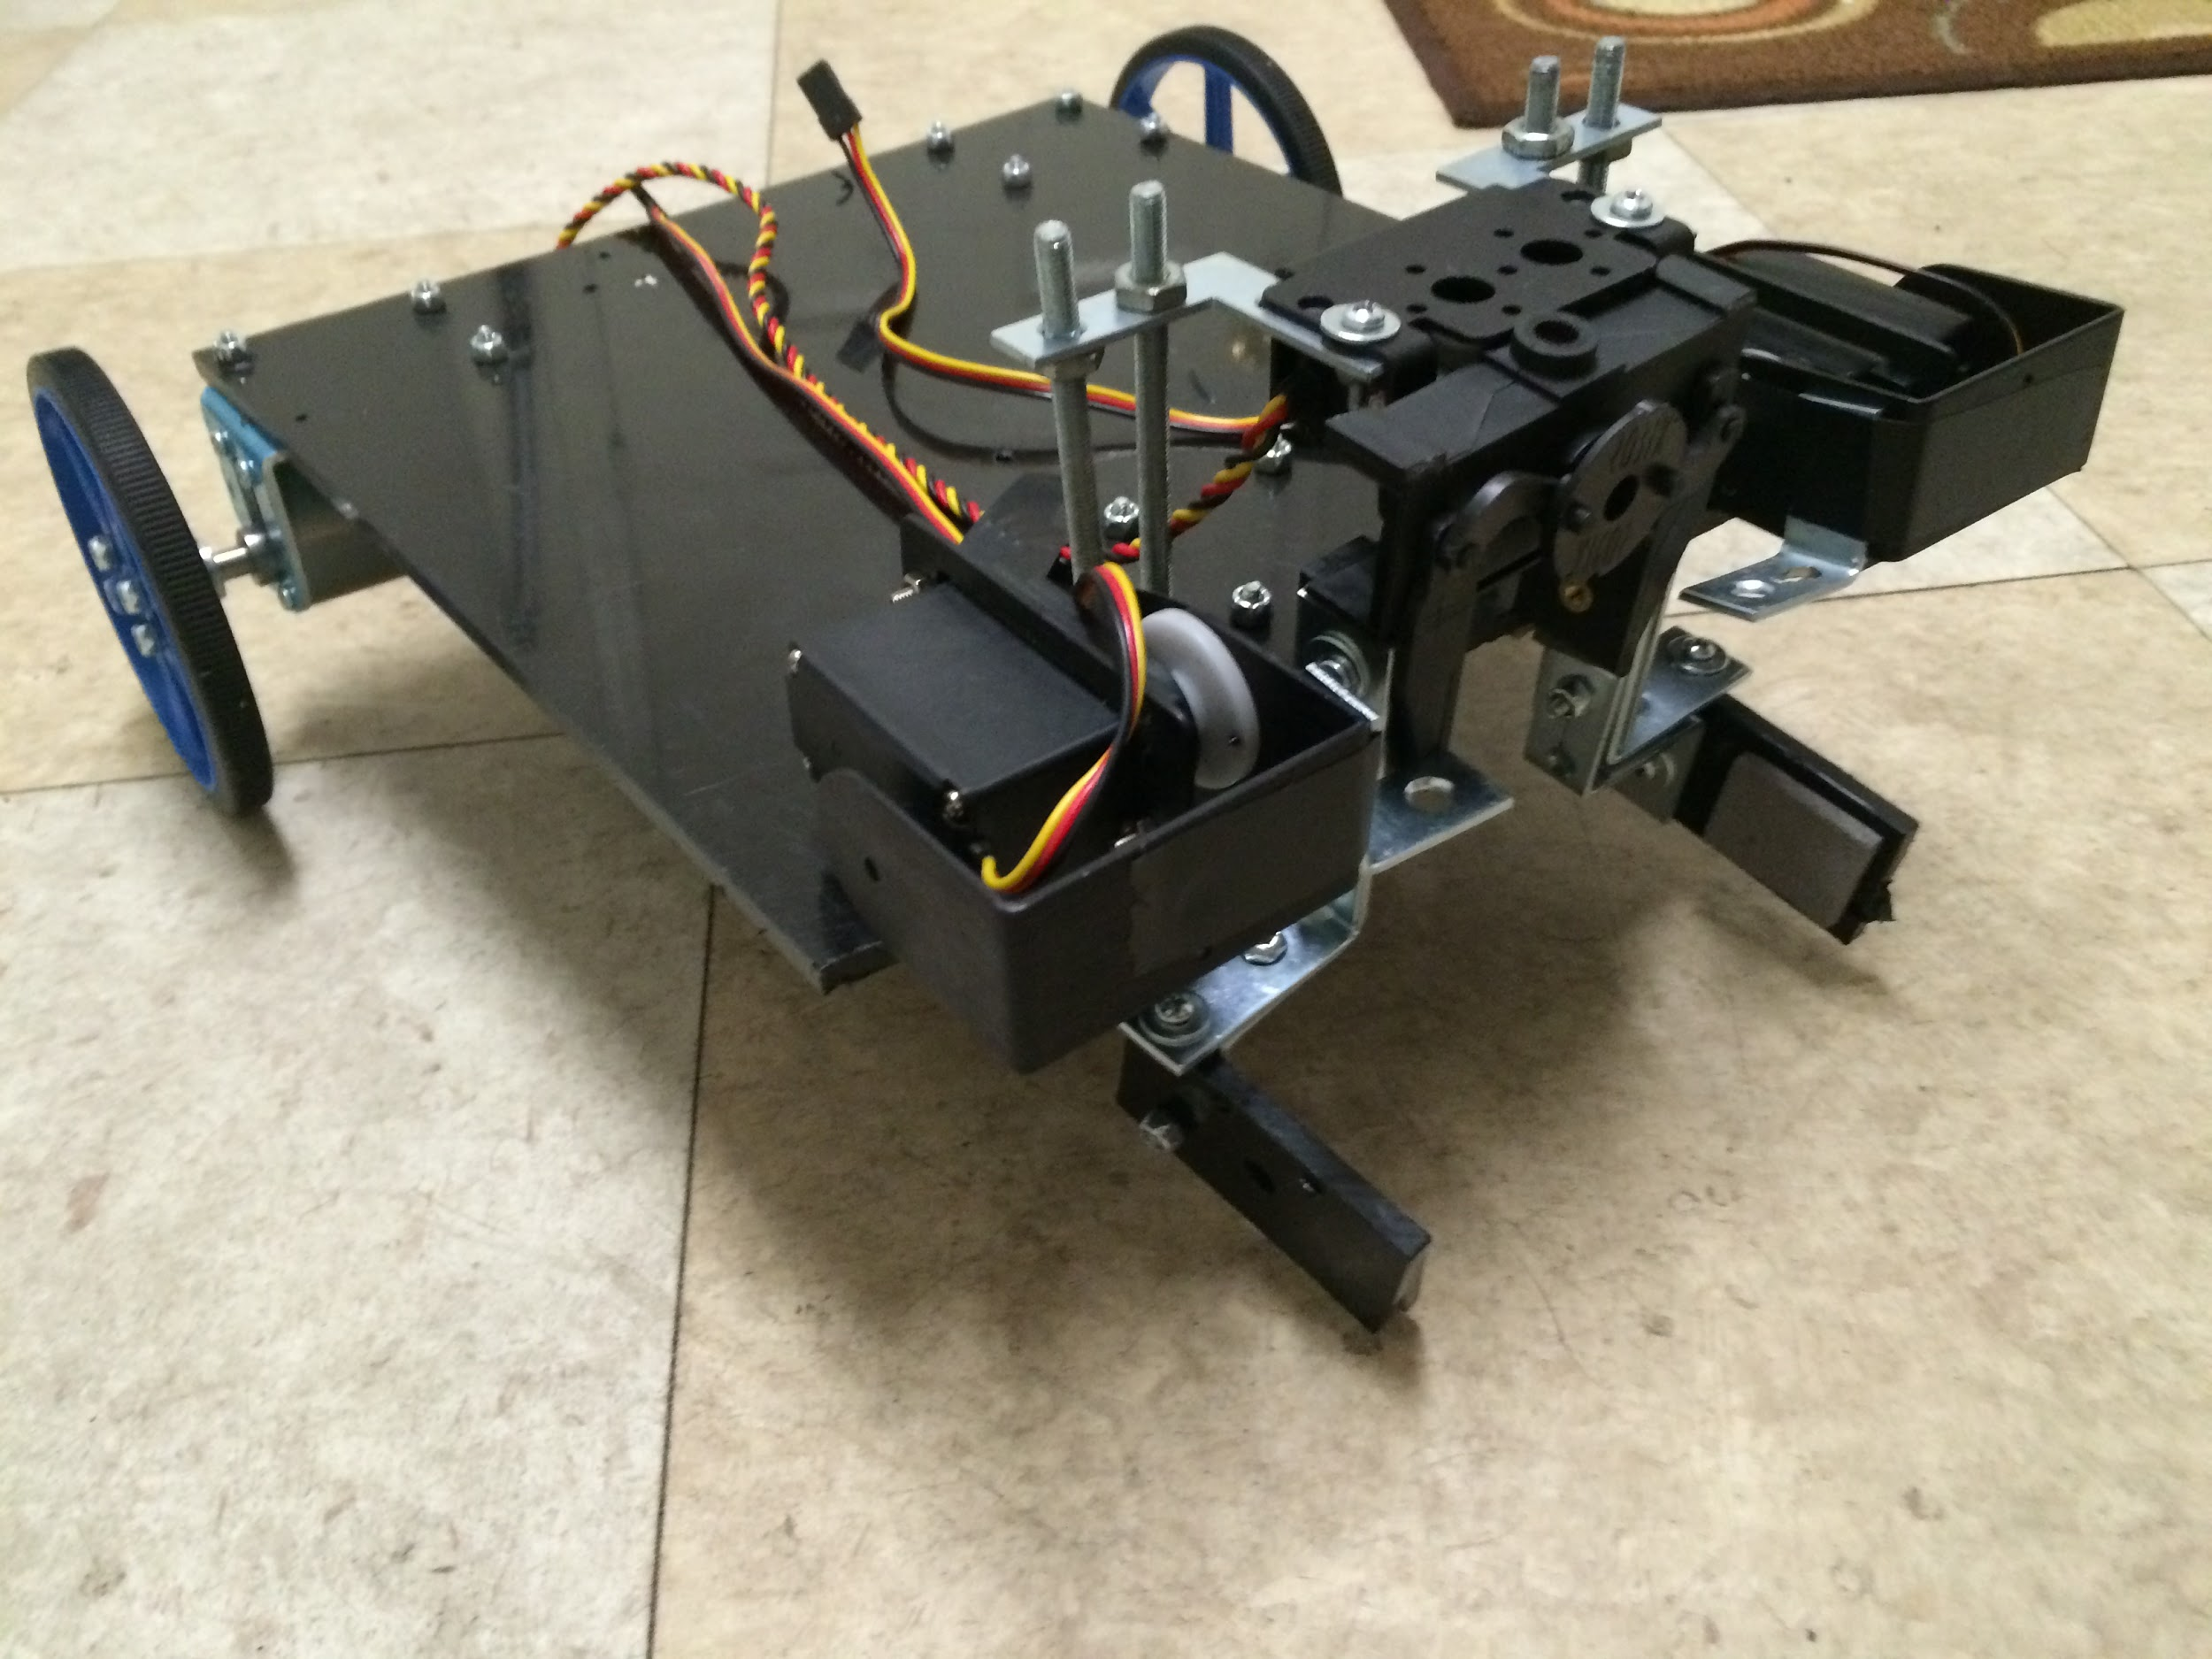

Figure2.3b:Original 3D model (left), HDPE cutouts (right), and Chassis Gripper Prototype(bottom)

Main Arm
A large servo-controlled arm will cooperate with sensors and the Chassis Gripper to complete the Rubik’s Cube challenge, Simon challenge, and the Playing Card challenge. The Main Arm will contain five (5) servos to produce the necessary motions. The base will be able to pan and tilt while the end piece will be able to tilt, open/close, and rotate 360˚. The end piece will also be made of HDPE cutouts mounted to a LGK.

Figure 2.3c: Main Arm Prototypel

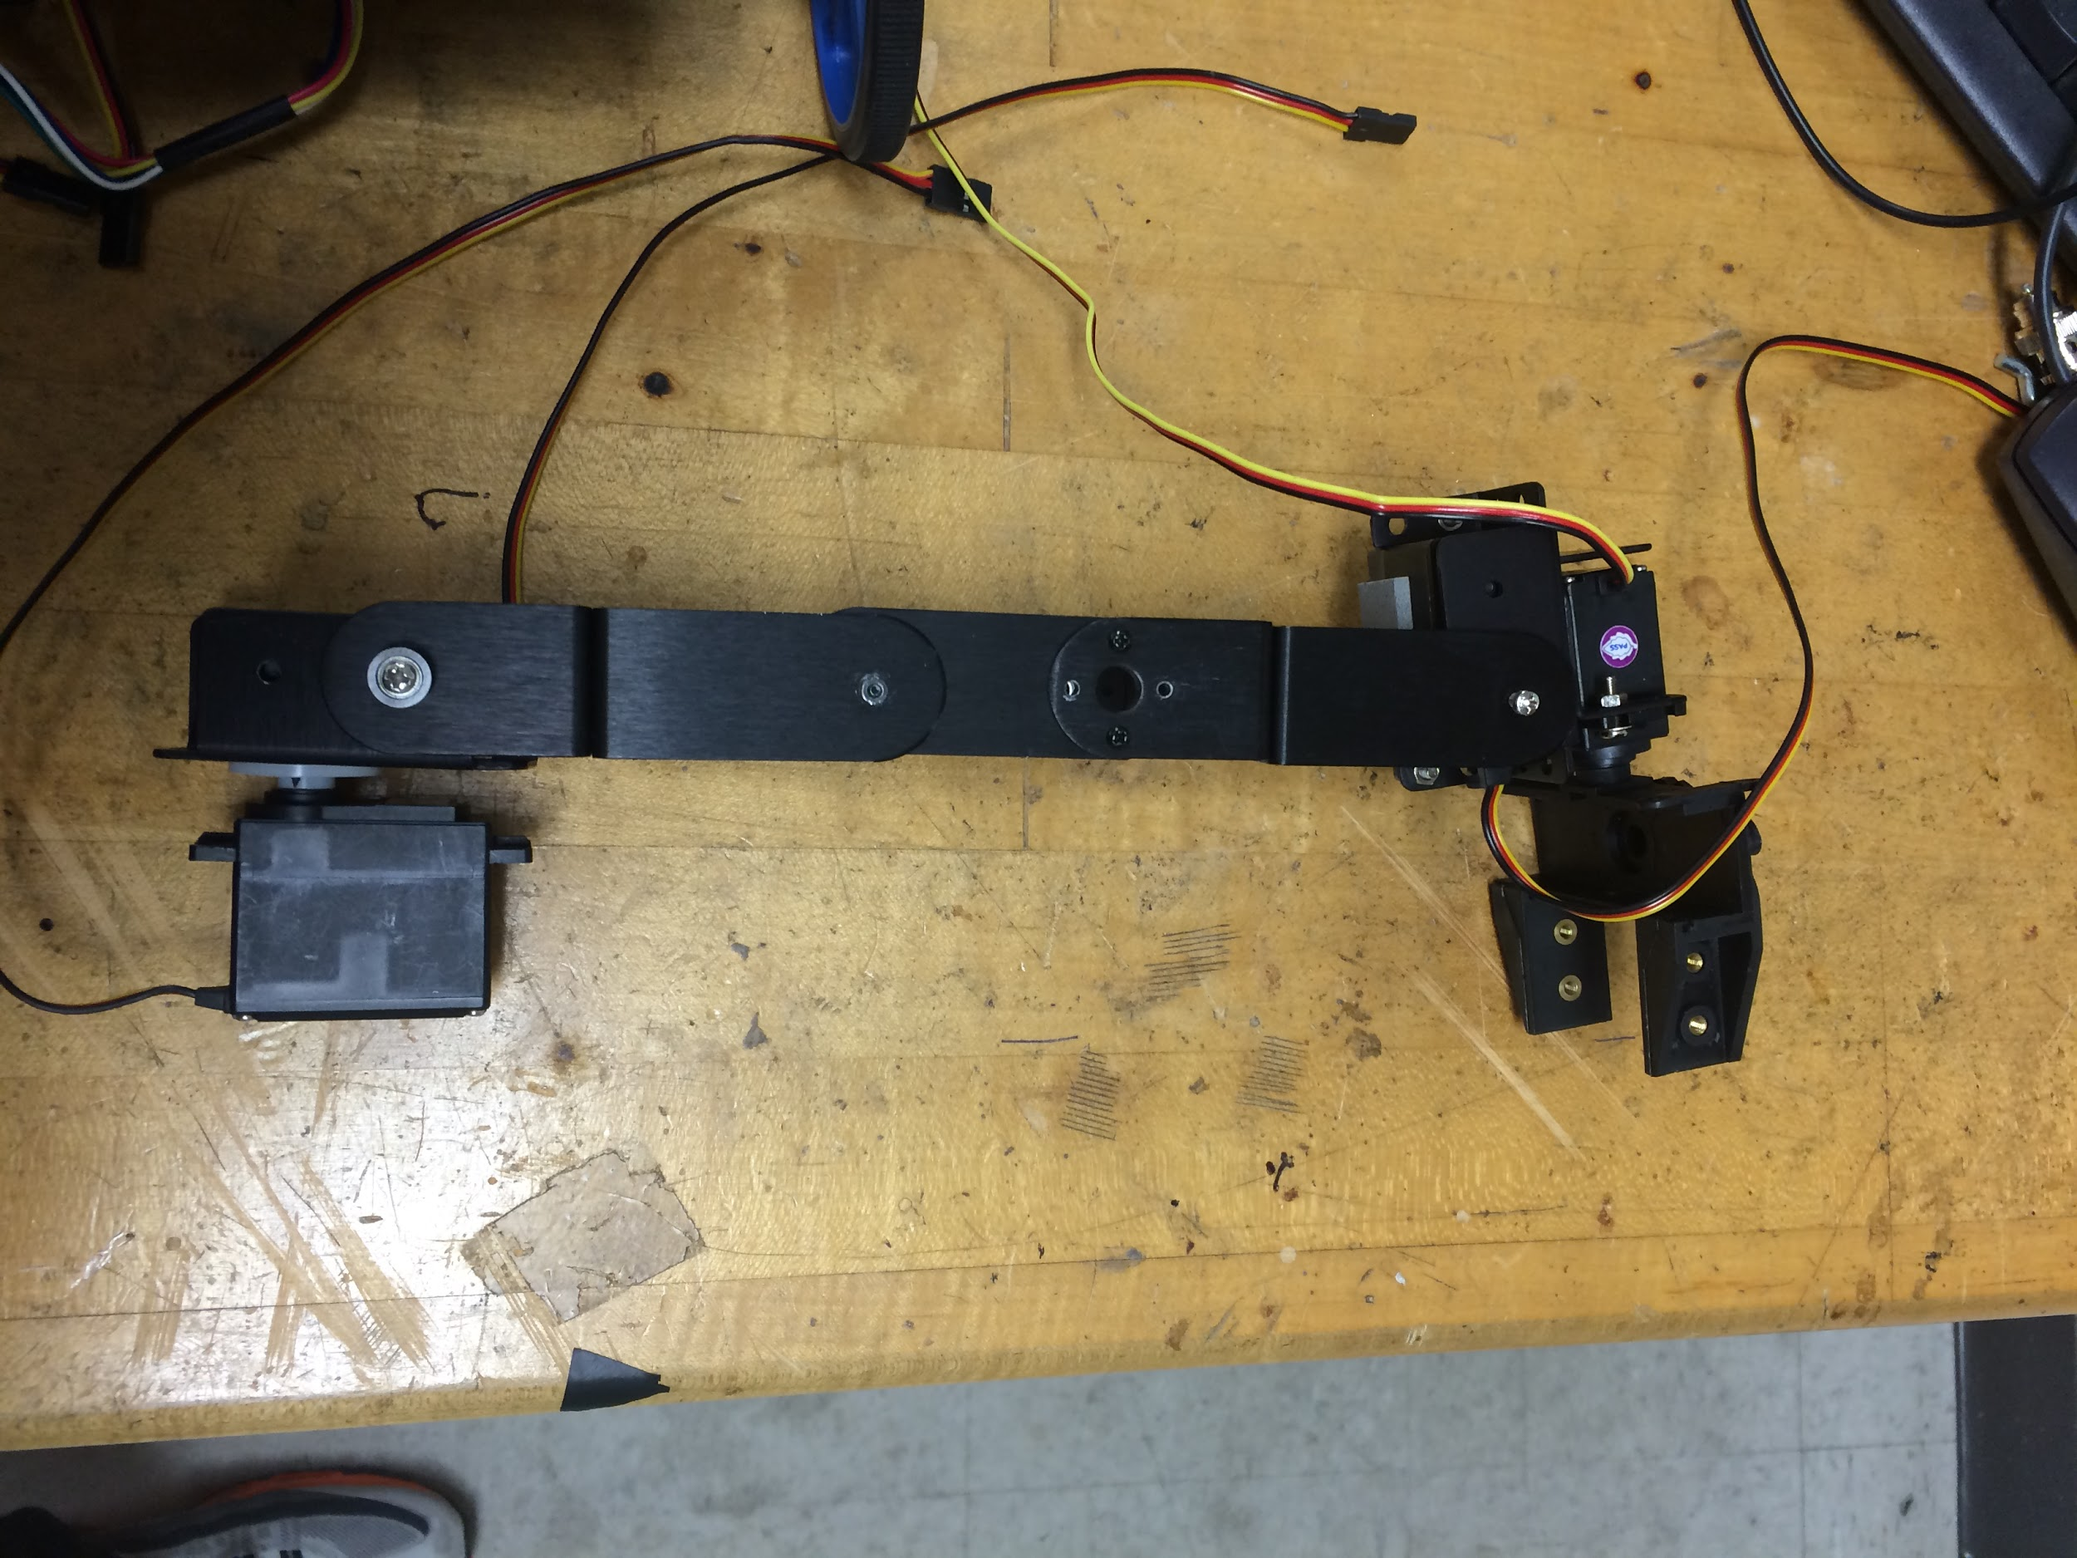
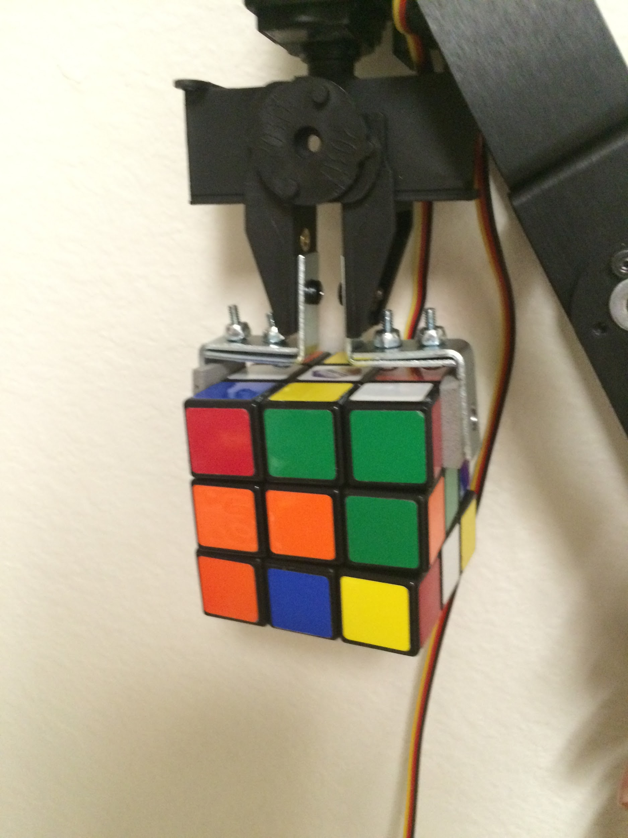

Etch-a-Sketch Arms:

Two EaS Grippers will be used to complete the Etch-a-Sketch challenge. The Grippers will be able to tilt the end piece to apply a downward force on the knobs. The end pieces will be able to rotate to turn the knobs and draw the letters. Once constructed and mounted, a subroutine will be created for the EaS Grippers to draw the letters and complete the challenge. Two independent arms will shorten the time taken by manipulating both knobs instead of transitioning from one to the other. The Chassis Gripper and Main Arm will also hold the game in place if needed.
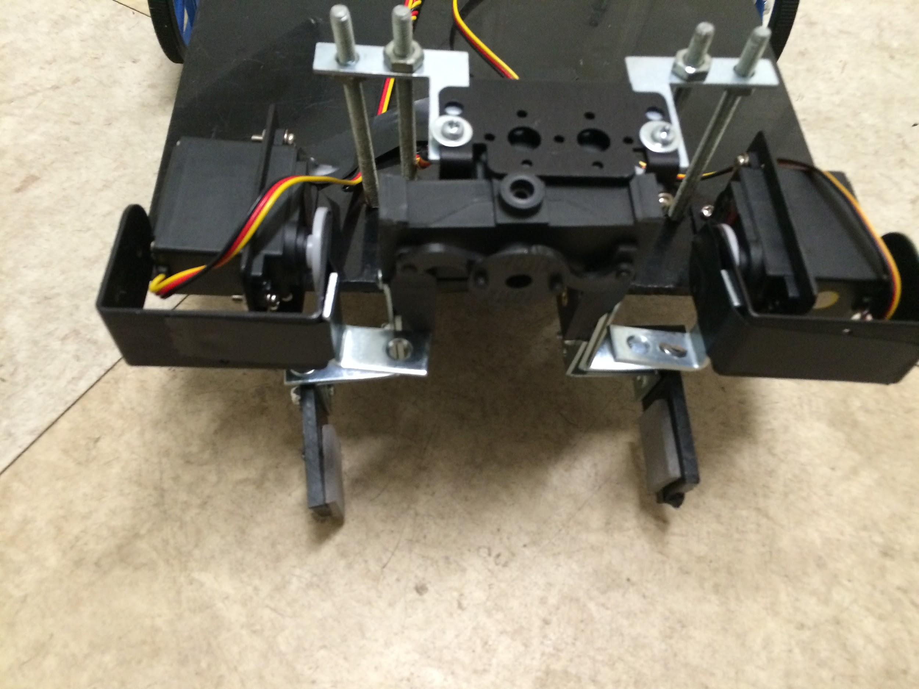
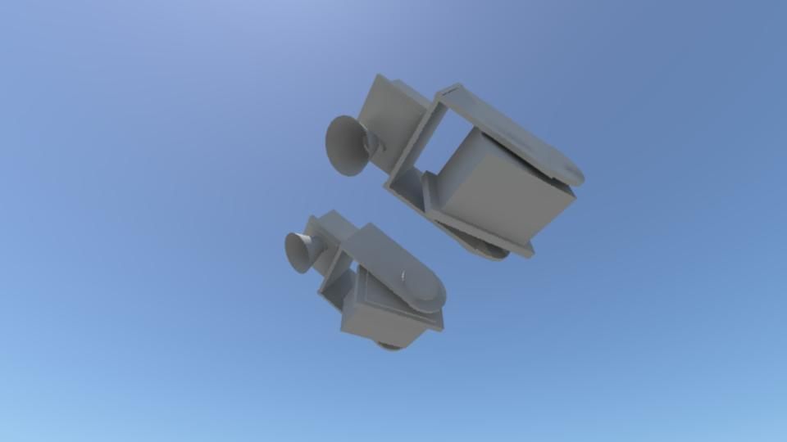

Figure 2.3d: Etch-A-Sketch Grippers 3D Model (left), EaS Grippers Prototypes (right)

Figure 2.3e: Top-Level Diagram for Powering Servos/Arms

Drive System
The drive system will be comprised of three major components working together in order to create all of the movements necessary for the robot’s navigation. The components are the Arduino Due, the Pololu A4990 Dual Motor Driver Shield for Arduino, and two DC brushed motors. The Arduino Due features 12 pins for PWM (pulse width modulation), which can be connected to the four pins (need one PWM for each motor) for motor control on the motor driver shield. The motor driver shield chosen is able to operate between 6V and 32V, and is capable of delivering 0.65 A to each motor channel. It is capable of regulating the current to the motors automatically (0.9 A peal), and protects the microcontroller from reverse-voltage, over-voltage, short-circuit and over-temperature conditions. The DC motors chosen operate at 12V, and the measured value for the current drawn while they are operational was found to be 0.3A, so the motor driver chosen is capable of providing enough power. The PWM frequency used by the driver has a minimum 17.3 kHz, with a max of 26 kHz, and a typical value of 21.7 kHz. The motor driver also has two diagnostic pins that are not necessary for its operation, but can be used to monitor the motor driver. The Arduino Due can be programmed using libraries available with the motor driver in order to change the speed and direction of each of the two motors (independently) to power this differential drive system. The line following system will determine the direction the robot needs to turn in order to follow the course, and will call the functions to set the motor speed/direction with the speed (positive value for forwards, negative value for backwards) as an argument.
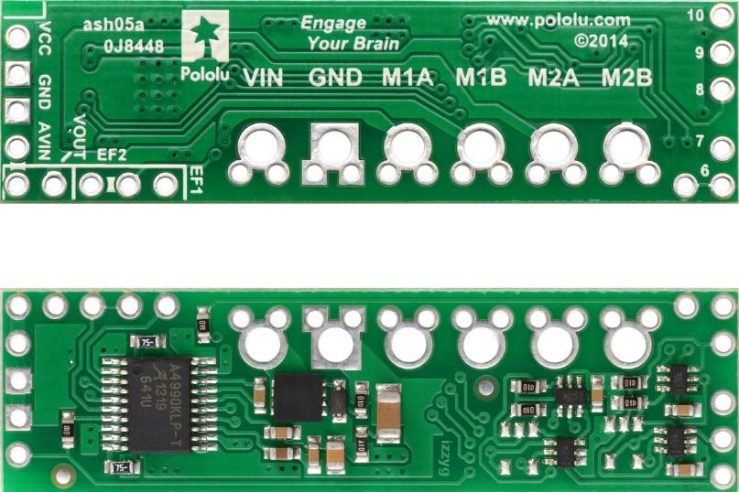
Figure 2.4a: A4990 Dual Motor Driver Shield for Arduino, Top and Bottom View

The motors chosen are 50:1 Metal Gearmotors with 64 CPR encoders, which can optionally be used in order to provide feedback to the microcontroller about the velocity of and the distance travelled by the motors to aid in navigation. At 12V, the motors chosen have a no-load speed of 200 RPM, and stall torque of 170 oz-in, which should be more than enough to move the robot at the desired rate. The RPM and the wheel radius will allow for a max speed of around 1 m/s. The motors have already been purchased and are more powerful than necessary, partially to account for potential situations in which the robot will be making a slight turn and only be powered by only one motor. Additionally, in order to ensure the balance of the robot with the current design, counterweight may be added. The motors have been purchased, and at the time of the purchase the weight estimate for the robot was unclear, so more powerful motors were chosen in order to ensure that they would be adequate. With an estimate of 22 lbs (10 kg) for the mass of the robot, and 0.5 ft/s² acceleration (half of the desired velocity of 1 ft/s), along with the wheel diameter, an estimated torque of 163 oz-in (11.8 kg-cm) was required for one motor to power the robot. This calculation was done with the following equation, where the efficiency is 58% (68% generally for DC motors, deducted an additional 10% to account for frictional forces/other unknowns).
torque = (mass)(acceleration)(wheel radius)(1/efficiency) (1)
If it is found that the motors are still too powerful, less powerful options could still be considered, however the priority for this is very low. The motors will be connected to two Pololu 90x10 mm plastic wheels with silicone tires for grip. The wheels are attached to the motors using a universal mount also by Pololu. A 1” plastic ball caster wheel was chosen initially for the design, however this will be used only for testing of the drive system.

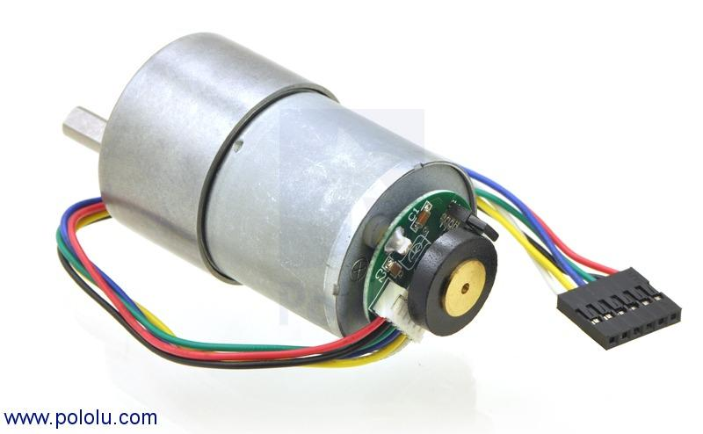
Figure 2.4b: 50:1 37D Metal Gearmotor with Encoder
The motors will be placed at the back of the robot, on the first layer of the chassis. The reason for this is that a lot of the robot’s weight will be in the back, and the two powered wheels will provide stability. Additionally, the mounts and servos for the arms to play the Simon Says game, and the grippers to hold the toys in place will take a lot of room in the front of the robot. Placing the motors in the back allows more room for these other components. The caster wheel will be placed in the front, and a sturdier caster wheel has been chosen. Currently in use is a 2” ball caster wheel with swivel plate shown below. One concern in choosing a caster with a swivel and a bracket is the wheel may need to turn around before actually turning, this would have to be considered in the programming for the system.

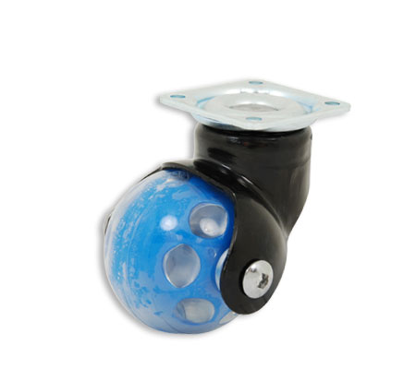
Figure 2.4c: 2" Ball Caster Wheel with Swivel Plate
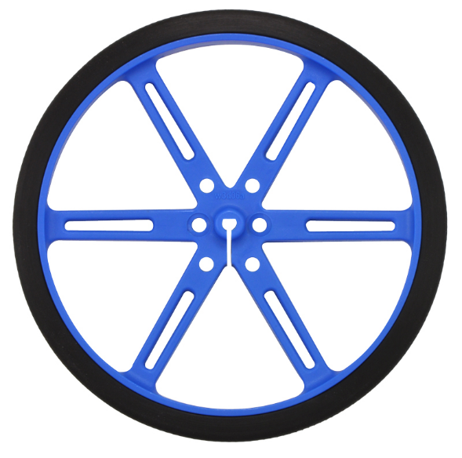
Figure 2.4d1: Pololu 90x10mm Plastic Wheels

With all of these components, and the 12V battery source for the motors, the drive system will operate as a differential drive system. The top level diagram for the system can be seen below.

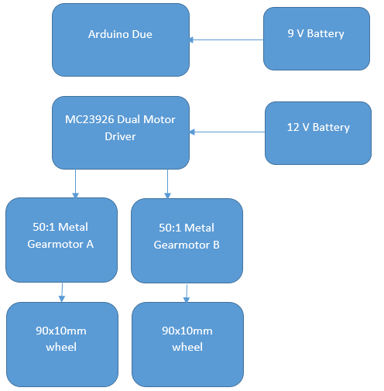
Figure 2.4e: Top Level Diagram for Drive System

Power Supply
With great consideration the team is convinced to have a power system of two NiMH Battery Packs and a third Energizer recharageable battery. There will be multiple power sources because of the different ranges of voltages need by the parts. While each part will require a different voltage source and the Arduino due will be used to supply voltage as well. Arduino built in voltage regulator it will be able to supply voltages to the parts with that were out too low compared to the two battery sources.

Nickel-metal hydride batteries NiMH have been chosen because their energy density approaches that of a lithium-ion cell. The only bad side to NiMH requires long periods of time to charge with a high self-discharge rate. Lithium-ion cell are leading currently in Power Capacities with because it has a zero memory less effect. NiCad stores less energy every time you recharge it and will take an extra steps to fully discharge to recharge. The Energizer recharageable 9V battery was choosing to supply the arudino due constant voltage. The arudino due required constant power to allow consistent course completion. A serparate single Energizer recharageable 9V battery was selected to give the arduino enough effienct power at a reasonable price.

The team has decided to purchase two power supplies to power the rest of the robot components; one NiMH battery will supply 12 V and the second will supply 6 V. The wheel motor and Arduino due board require 12 V input to operate. Also the motors used in the ARMS/Grippers will be using the 6 V power supply. The sensors operate at a smaller voltage threshold hold and requires a voltage regulator to step the down voltage from either voltage source. The Arduino Due board has a voltage regulator and will be use to supply power to the sensors.

Table 2.5a: Different Battery Options
12 Volts | Price | Current Output (mAh) | Weight
NiMH Battery | $29.95 |  | 997 grams
6 Volts
NiMH Battery | $15.15 | 2200 | 142 grams

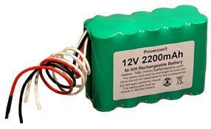
- Figure 2.5a: Selected 12V Power Supply

Specs for 12V Supply
- Power Capacity 2200 mAh
- 10 (2x5) AA size 2200 mAh NiMH cells
- Power 26 Watts
- Weight 1 kg
- Discharging rate 2 A
- Charging rate 0.5-2.2 A

Discharging the battery pack below 10 V may damage NiMH. Leaving the ends of the wires uncovered; will allow the battery to improperly discharge. Power Capacity may be too close to the current being drawn upon startup of the drive motors.

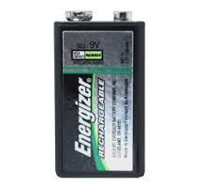
Specs for 9V Supply
- Power Capacity 1400 mAh
- Charge Cycles up to 1500 times
- Charge rentention up to 12 months
- Toys usage time 240-360 minutes per charge

The Arduino Due has an operation voltage range of 7-16V ensuring the Due may handle the 9V battery’s peak voltage. The Arduino Due was selected to have a separate battery source to provide a constant power supply. When the power supply is interrupted for the arudino due the robot will reset and may cost the game. The group decided to isolated the arudino due power supply from everything else.

Energizer was selected becuase the charge capacity of the 1400 mAh can easily last three rounds within the competition with time to spare. Also the charage cycles of 1500 times was key to the selection of the 9V battery because the battery will be used prior to the competition. Sele

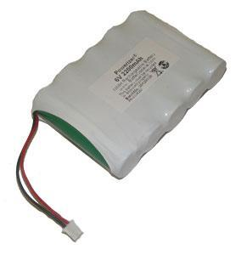
Figure 2.5b: Selected 6V Power Supply
Specs for 6V Supply
- Power Capacity 2200 mAh
- 6 Volts
- 5 (1x5) AA size 2200 mAh NiMH flat top cells
- Power 9.6 Watts
- Weight 0.14kg
- Discharging rate 2 A
- Charging rate 0.5-2.2 A

Discharging the battery pack below 6 V may damage NiMH. Leaving the ends of the wires uncovered will cause the battery to improperly discharge. The wires are too short as well and will need to be extended to provide better positioning on the chassis.

The servos have an optimal voltage range of 4.8-6 volts. The battery’s optimal voltage is rated at 7.1V falling in between both the Arduino Due and drive motors operating range. The total required current from all the servos is 1400mA giving the battery a longer life span off one cycle of charging. This was deeply desired by the group for multiple usage throughout three rounds with accurate performance.

The Arduino will act as the third power source providing the lower voltage to the sensors that operate in within the 3.3-5 volts. The voltage will actually be specified through coding to power each pin assigned to the sensors.

The 9V battery will be charged by Energizer Recharge Universal Charger. The Charger features a LCD showing a charging status. Also the charger is capable of charging the 9V battery under 3 hours.

Voltage Regulator

The voltage regulator has a lower efficiency rate, supplying voltage at efficiencies ranging between 80-90%. This will supply the sensors with a small amount of current, potentially not allowing the sensors to operate properly

The team has decided to go with one charger that will supply charge to both batteries to the cut the cost, eliminating the need to buy a charger for each power source. This gives more room in the budget to buy more power supplies (back-up batteries) to cut down on the need for charging in-between rounds. It is proposed to purchase one spare battery for each source. The charger is priced at $16.95 and is capable of charging batteries between the ranges of 6-12 V. This charger will be able to fully charge each battery within four hours.

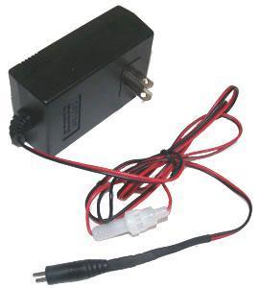
Figure 2.5c: Image of Selected Charger

In the event that the method for connecting the driver motors is changed, the male jumper can be cut off and the wires can be plugged into a breadboard or soldered to manually configure it.

The chassis will be a two layer chassis, made of cut HDPE. The top layer of the chassis will be used to hold the main arm, as well as the batteries for the robot. The bottom layer will hold breadboard, the DC brushed motors, the Etch-A-Sketch arms and motors, the grippers and the line following system. A 3D model of the empty chassis can be seen below in Figure 2.6a, and another view with component placements can be seen in Figure 2.6b.

The robot will include two rear wheels with motors, and a caster wheel in the front for support. A line reflectance sensor array will be placed close to the rear wheels to ensure more accurate turns around the course. Another, smaller IR sensor will be placed towards the middle to detect the start LED and also double as a line follower. In front of the caster should be the object detector, used to see objects directly in ahead of the robot. The main arm, side arms, and grippers will be mounted at the front to simplify locating and playing games. The power supply and processor will be placed on the back and double as a counterweight to the components in the front. The components in the 3D diagrams used in this report will be color coded according to Table 2.6.

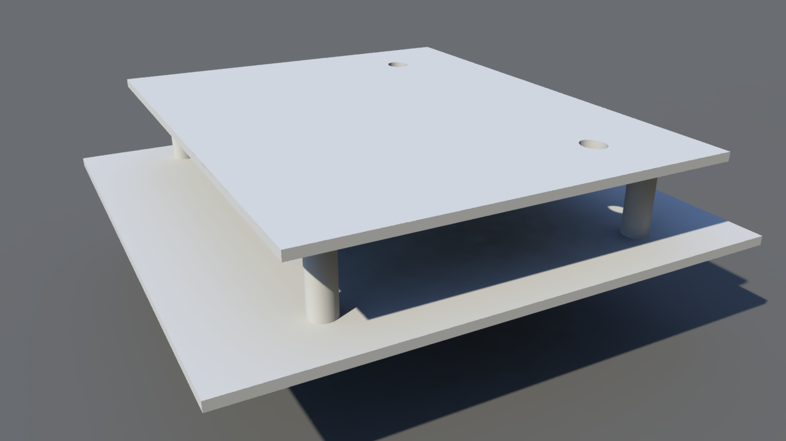
Figure 2.6a: Empty Chassis 3D Model
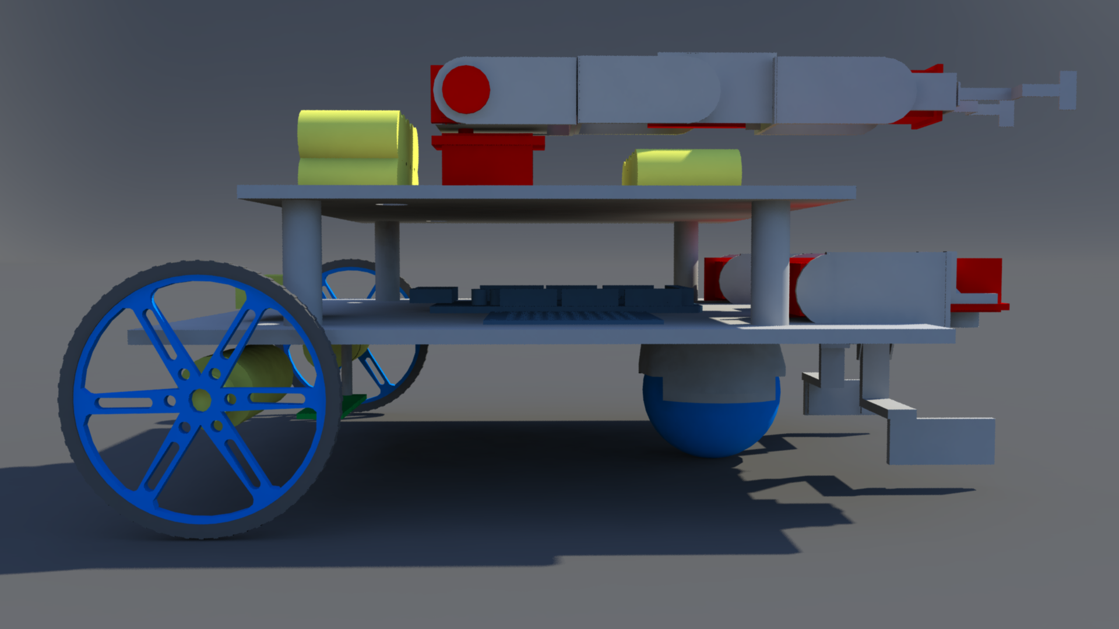
Figure 2.6b: Chassis Model with Components

Table 2.6: Color Coding for 3D Diagrams
Color | Significance
Red | Servo
Green | Sensors
Yellow | Motors
Blue | Circuits/Microcontroller

Design of Major Components/Subsystems

Overview
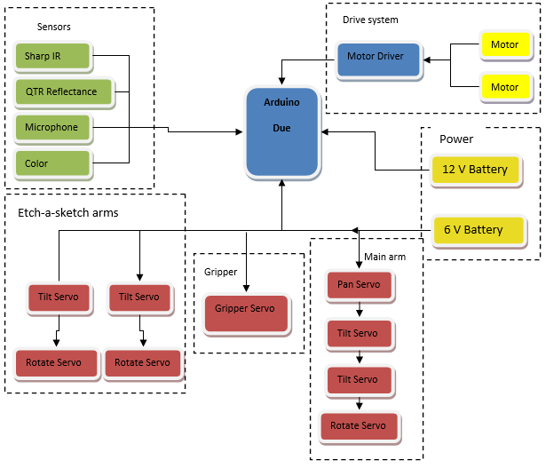
Figure 4.1a: Top Level System Design Block Diagram
The team has agreed on a well-balanced robot. It is proposed that the robot will drive across the course using an ideal speed covering all untraveled taped course. Sensors will be used to follow the course line, start the robot based off of IR sensors, and detect sound to play a Simon, and measure distance from games. The autonomous robot will be discerning enough to recognize each game secure it with the grippers and manipulate each using the arms designated for them. The robot intelligence will also ensure its accuracy in manipulating the games to gain maximum points. The robot will be programmed to finish the four tasks as fast as possible within a five minute time limit. The robot will play three rounds and must have enough power to last all three. NiMH batteries were chosen because of their large battery capacity in theory if fully charged the NiMH batteries can withstand three rounds. The team has decided to bring fully charged spare batteries for the competition as well as the charger. The robot will have two NiMH batteries with different voltages and the Arduino board will be used to power the sensors using low voltages.

The Chassis is the backbone for the robot, it will provide protection, stability and support for the system. The team agreed to use a two level chassis in order to distribute the weight evenly throughout the robot as well as space out the different components to maximize wiring space.

Top Level of Chassis
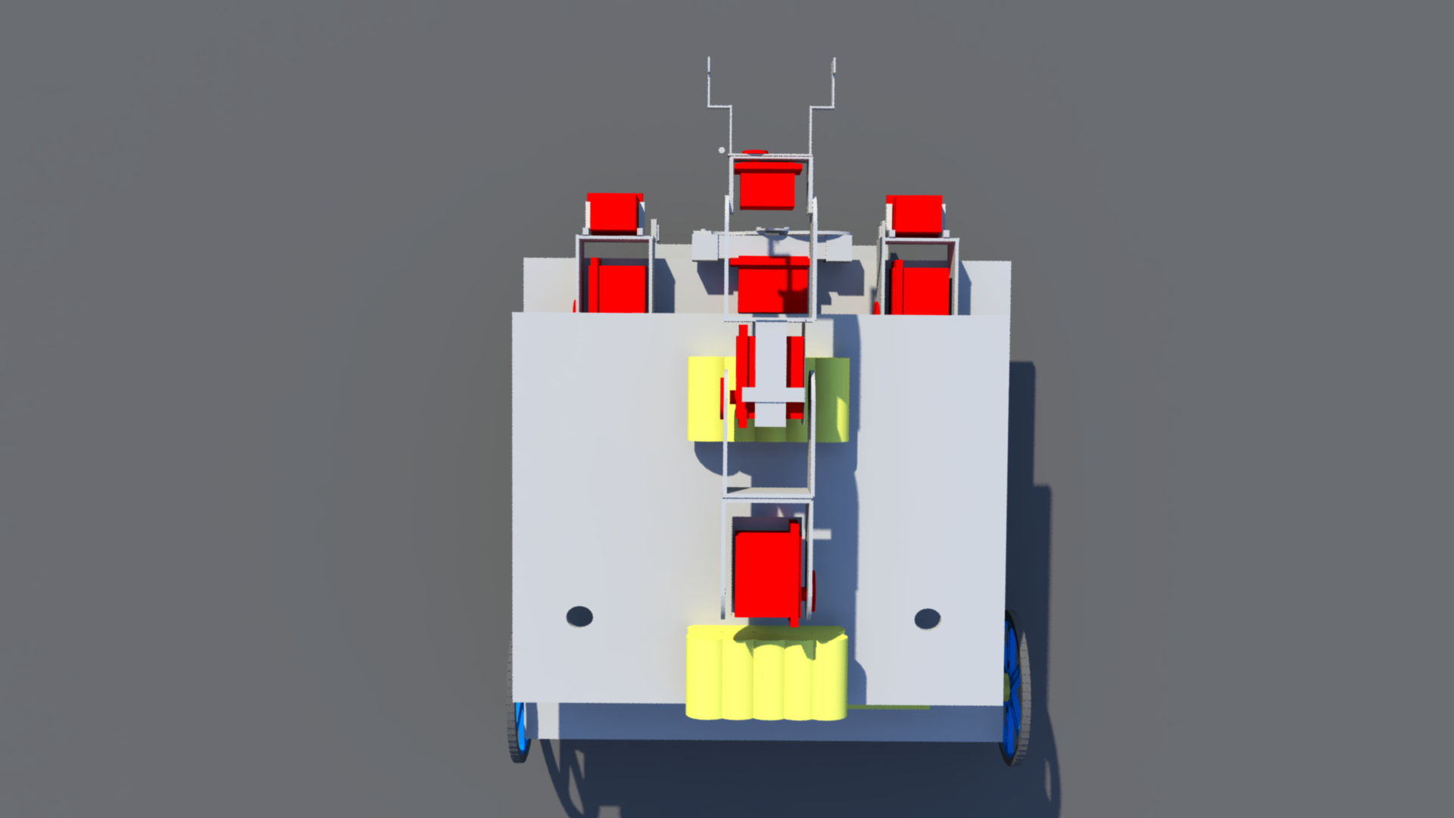

Figure 3.7a: Chassis Top Layer

The top level of the chassis will support the both the 12 V and 6 V batteries. The diagram above depicts a clear visual of the design, the two holes will be use to send down the wires from the batteries to their respective breadboards. The top level of the chassis has the main purpose of freeing up space on the bottom level for wiring, the DC drive motors, and weight distribution. The weight of the overall robot will be a major factor when stopping and taking off. The goal is to distribute the weight throughout the robot evenly such that there does not need to be additional sections in the code to ensure that the robot does not tip over when turning, starting or stopping. As seen in Figure 3.7a above, the main arm and the batteries are placed on the top layer.

Bottom Level Chassis

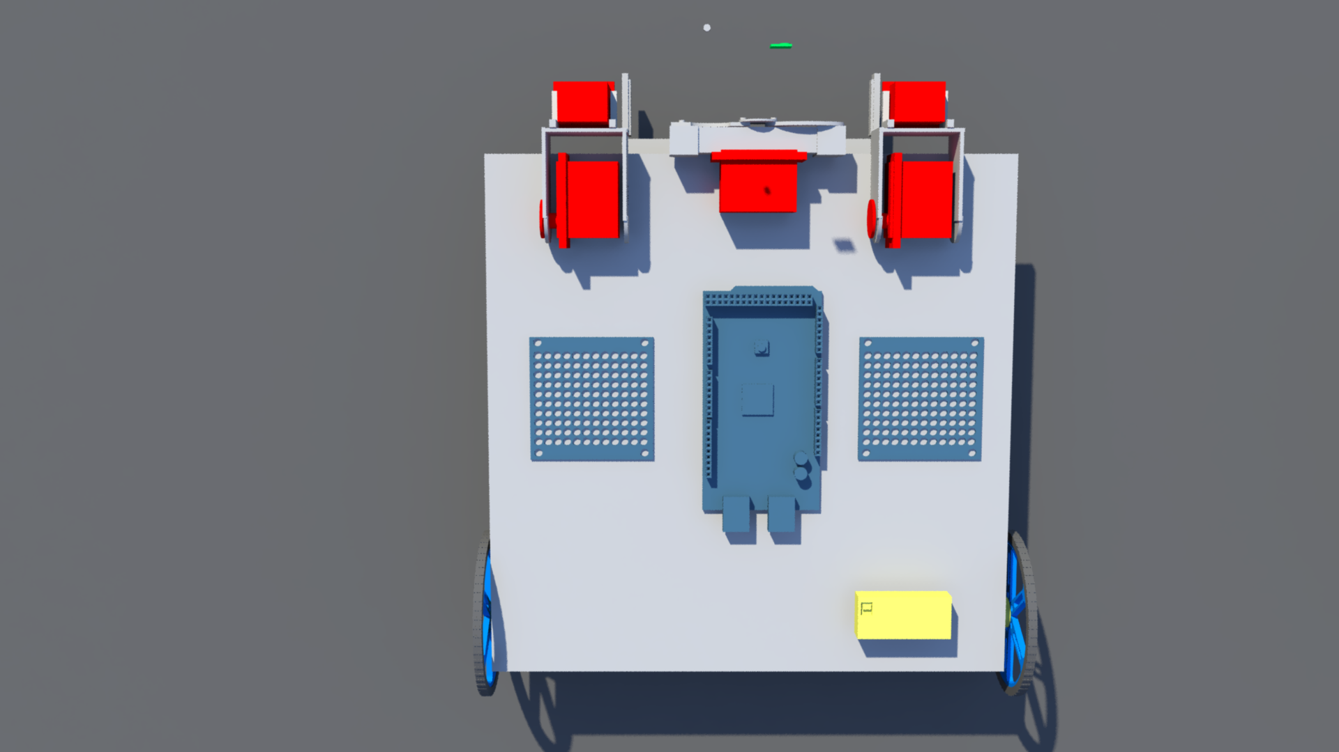
Figure 3.7b Bottom Layer of Chassis
As seen in the figure above, the DC drive motors and wheels are attached to the bottom layer of the chassis, along with the breadboards, microcontroller, arms for Etch-A-Sketch and the grippers. A more clear view of the grippers can be seen in the complete side view of the chassis below.

Figure 3.7c: Side view of Complete Chassis

Central Processing Unit

The microcontroller being used for this project is an Arduino Due. There are 12 pins for pulse width modulation (PWM). These pins will be reserved for the servos and the DC motor control. These pins, which are numbered 2-13, can be seen on the right side of Figure 3.1a. Depending on which type of servos are eventually purchased an analog to digital converter may be needed to be put in between the servo and the PWM pins. This microcontroller operates at 3.3v so there will need to be a voltage regulator in between the motors and the microcontroller to ensure that board does not get damaged.

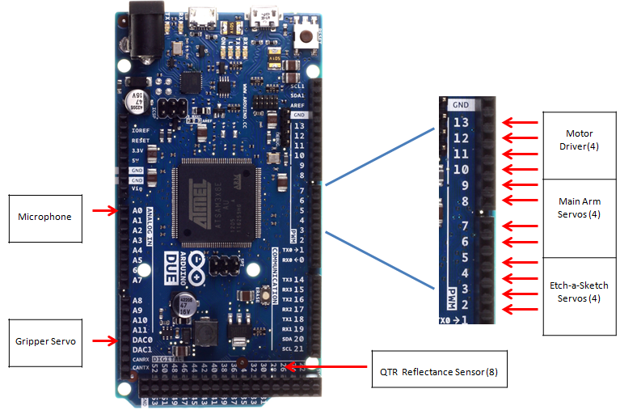

Figure 3.1a - Arduino Microcontroller and PWM pins

The QTR-8RC reflectance sensor will be used for line following. This sensor requires 8 digital I/O pins. It will be connected to pins 22, 24, 26, 28, 30, 32, 34, 36, and 38. These pins all sit next to each other as seen in Figure 3.1a. Having all of the reflectance sensor pins in a row allows for easier management. The color sensor for determining whether the start LED is on or off also require a digital I/O pin. This can be placed on pin 52 to differentiate from the reflectance sensor pins.
Most of the pins being used on the board will be digital pins of some kind but there are a couple of analog pins being used. There will be 1 analog input pin, A0 that will be used for the microphone. The microphone will be used for determining what note is being played in Simon Says. By figuring out what pitch is being played the Arduino can tell the appropriate servos to turn and click the corresponding button on the game. The gripper servo will be connected to an analog output pin, DAC0.
Figure 3.1b - Flow chart showing how the code will branch

Initial code
Rubik's Cube
Simon Says
Etch-a-sketch
Playing Card
Line follow and distance
Game+
Game+
Game+
Final code
Game+

Programming will be an integral part of this project. The flowchart in Figure 3.1b shows a brief overview of the code will be broken up and worked on. First there will be an initial branch of code calling all of the proper libraries and setting up some known variable such as the different servos. This will be done in 2 different files which will be a games.h file and a main.cpp file. The main.h file will have the code for line following, object detection, detecting the start and what the robot should do once it passes the finish line. All of the game functions will also be called in the main.cpp file. The games.h will have the definitions for the game functions. So the actual servo movements and controlling will be done inside of the games.h file while the main.cpp simply calls whichever game function is needed at the time. These two files will be consist of the initial branch. There will be different branch for each game coming off of the games.h file. So each game function will be constructed independently of each other. Here the main priority will be getting the servo movements working under perfect conditions. For example the Etch-a-Sketch function will have the servos spins so that IEEE is written on the Etch-a-Sketch. A separate branch will be made for the main.cpp file where the line following and game detection will be initially worked on. Once this first section of the main.cpp and a single game function is finish the two files will be combined and tested. So the robot will show that it can clearly follow a line, find a game and play it correctly. As more game functions are completed they will be added to the main branch one by one. By the time all of the branches are added the robot should be able to adequately start by itself, follow a line, detect and correctly play all 4 games and cross the finish line. The only thing left to do with the code once the main branch the only thing left to do with the code is try to make the code smaller and have the robot complete the games faster.

Drive System

Microcontroller, motor driver shield and DC motor integration
The Arduino Due microcontroller will be used for sending digital signals to the motor driver shield. There are twelve pins on the MCU with pulse width modulation, four of these will be used to connect to the motor driver shield, two for each motor. The A4990 Dual Motor Driver Shield for Arduino was created specifically with the use of Arduino microcontrollers in mind, designed to connect directly to the board and use the libraries already written for the Driver Shield, which have explicitly been tested with the Arduino Due. It was designed specifically for the application of controlling two higher voltage DC motors. The driver itself is powered by the Arduino, using the 5V output and the ground. The power source for the motors is connected directly to the driver shield. There are two connections for each motor, M1A, M1B, M2A and M2B, which are connected to the red and black wires (power and ground) of the motors. The connections for the system can be seen in the figure below. There is an additional pin for monitoring the driver, but it is not mandatory to be placed on one of the PWMs and can be placed in any other MCU pin formatted for input.
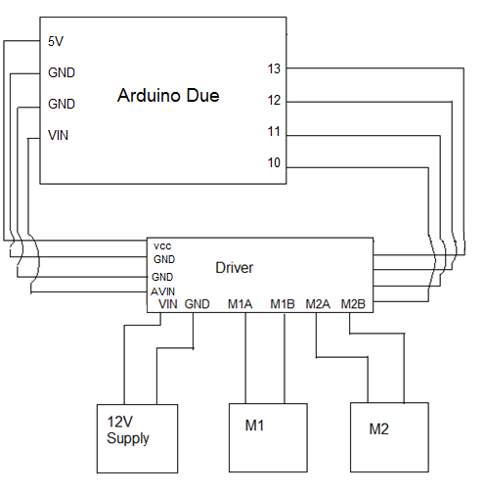
Figure 3.3a: Pin Connections for Drive System

There are libraries available to work with the motor driver shield, along with the pins on the Arduino Due capable of using PWM, on the website it was purchased from. These libraries allow for the motors’ speed and direction to be controlled with code such as the example code that is included below. The line following system would call the function for each motor with a single parameter- the desired speed.

Psuedo Code for Drive System
Void SetMotor1Speed (int speed)
{
Init()
boolean reverse ß 0

if (speed < 0)
speed ← -speed
reverse ← 1
if (speed > maximum speed)
speed ← maximum speed
#ifdef A4990MOTORSHIELD_USE_20KHZ_PWM // defined in libraries, send //speed to motor
OCR1A ←speed
#else
analogWrite (_M1PWM, speed * 51/80)
// case for if either speed was negative (exclusive) or _flipM1 was active
If (reverse xor _flipM1)
digitalWrite (_M1DIR, HIGH)
else
digitalWrite (_M1DIR, LOW)
}
The same code applies for motor two, swapping out M1 for M2. Feedback from the line following system would determine the speed, and from its sign, the direction (the variables speed and reverse in the code), a table below depicts this. The variable “reverse” is 1 for the backwards direction of the motor. Additionally, a timing diagram for the input/output of the motor driver shield can be seen below for the various functions.

Table 3.3: Variables for Drive System Operation
Operation | M1 speed | M1 reverse | M2 speed | M2 reverse
Left Turn | 0 | 0 | speed > 0 | 0
Hard Left Turn | speed > 0 | 1 | speed > 0 | 0
Right Turn | speed > 0 | 0 | 0 | 1
Hard Right Turn | speed > 0 | 0 | speed > 0 | 1
Forward Drive | speed > 0 | 0 | speed > 0 | 0
Backward Drive | speed > 0 | 1 | speed > 0 | 1

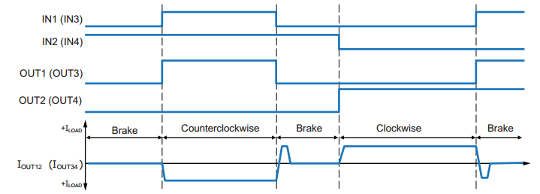
Figure 3.3b: Timing Diagram for Brushed DC Motor Input and Output Sequence

Using functions from the line following sensor array, an “error” value will be determined based on the line’s distance from the centere of the array of sensors. From this error, a PID control system is implemented, based on the following psuedocode:
MotorSpeed = kp*error + kd*(error- lastError) + ki*(errorSum);
RightMotorSpeed = RightBaseSpeed + MotorSpeed;
LeftMotorSpeed = LeftBaseSpeed - MotorSpeed;
Additionally, in the even that a line is detected under half of sensors in the array - as it would be in a 90 degree turn - for loops changing the speed of each motor to implement a right angle turn will be hard coded. This will be discussed in further detail in the line following sensor section.

Sensors

The sensors for the robot are split into 4 different categories: starting, line following, microphone for Simon, and object detection. All sensors chossen were fairly cheap and simple to implement, making replacement a good possibility for a contingency plan. The overall code and sensors are equally important because they dictate where and what the robot does next. The concept for the code will be to start, then exicute a line following loop until the digital distance sensor comes withen range of the first game, exicute the function for the game, increment a counter to decide which game is next, and once finished the last game cross the line and stop.

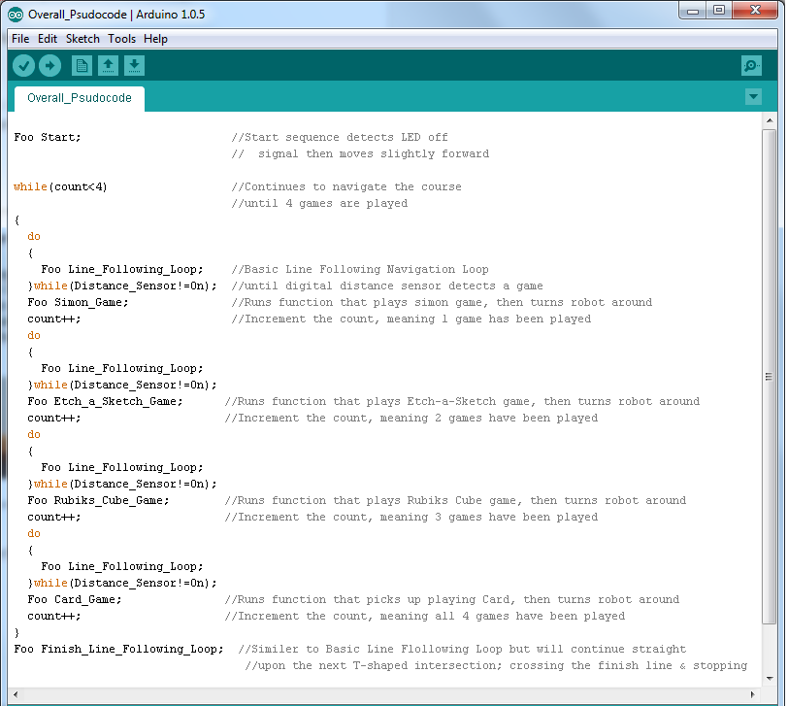
Figure 3.4: Overall Code Layout

Starting LED Sensor

The robot must begin in a white 1’x1’ square and detect the shut off signal of a visible flush red LED. In order to achieve this, the QTR-1RC reflectance sensor module, with 1 phototransistor pair, will be placed around the midpoint of the robot. With the optional help of a light filter, the array will recognize the off signal and alert the processor by detecting a change in the light. The robot will then move forward, about a foot, and then begin to navigate the course.

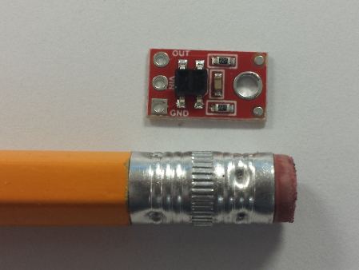

Figure 3.4.1a: Module size compariason

The sensor will be place underneath the first level and in the middle to be positioned correctly to detect the shut off signal.
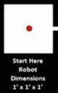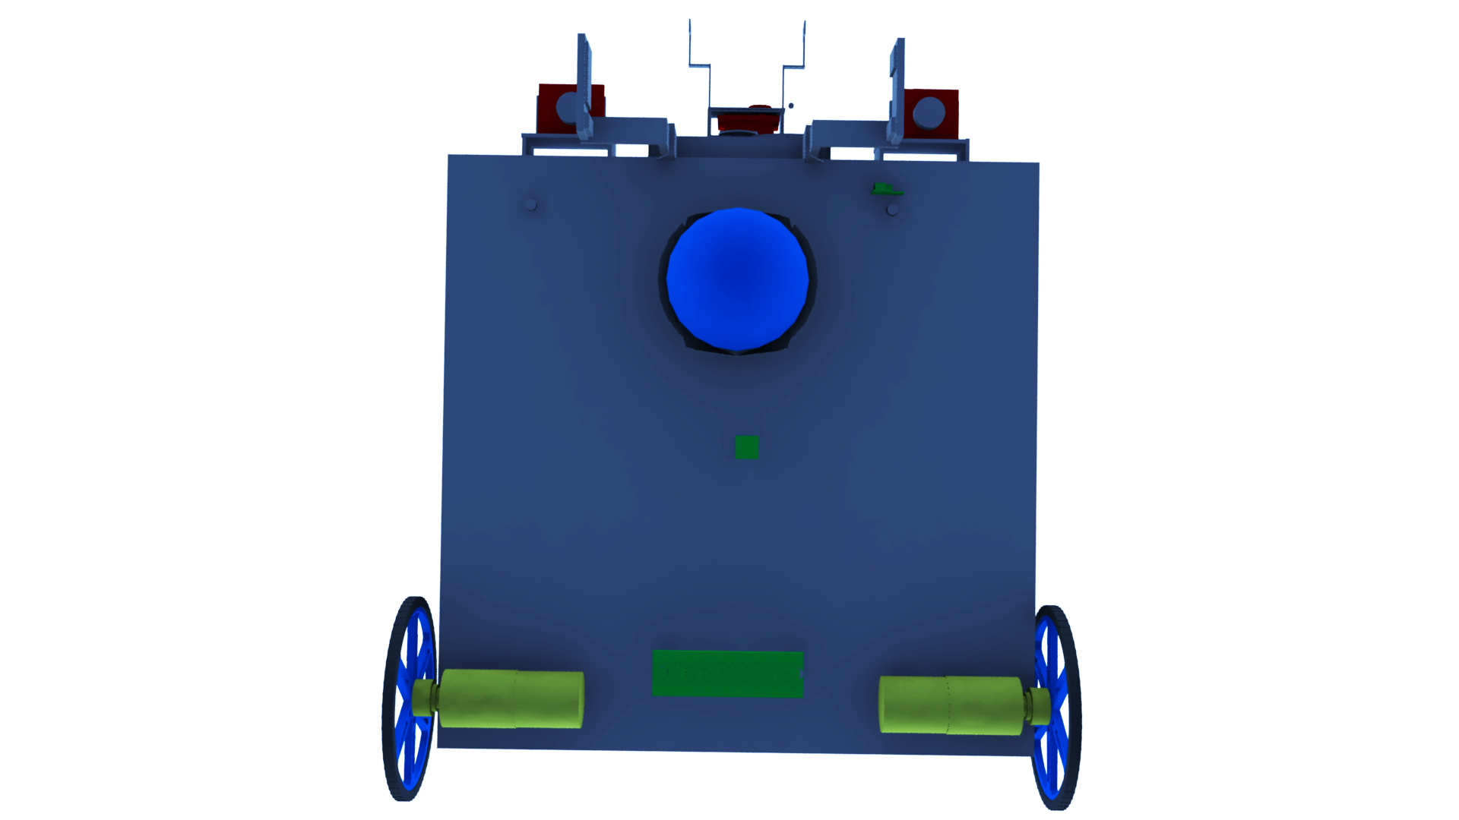
Figure 3.4.1b: Location of sensor

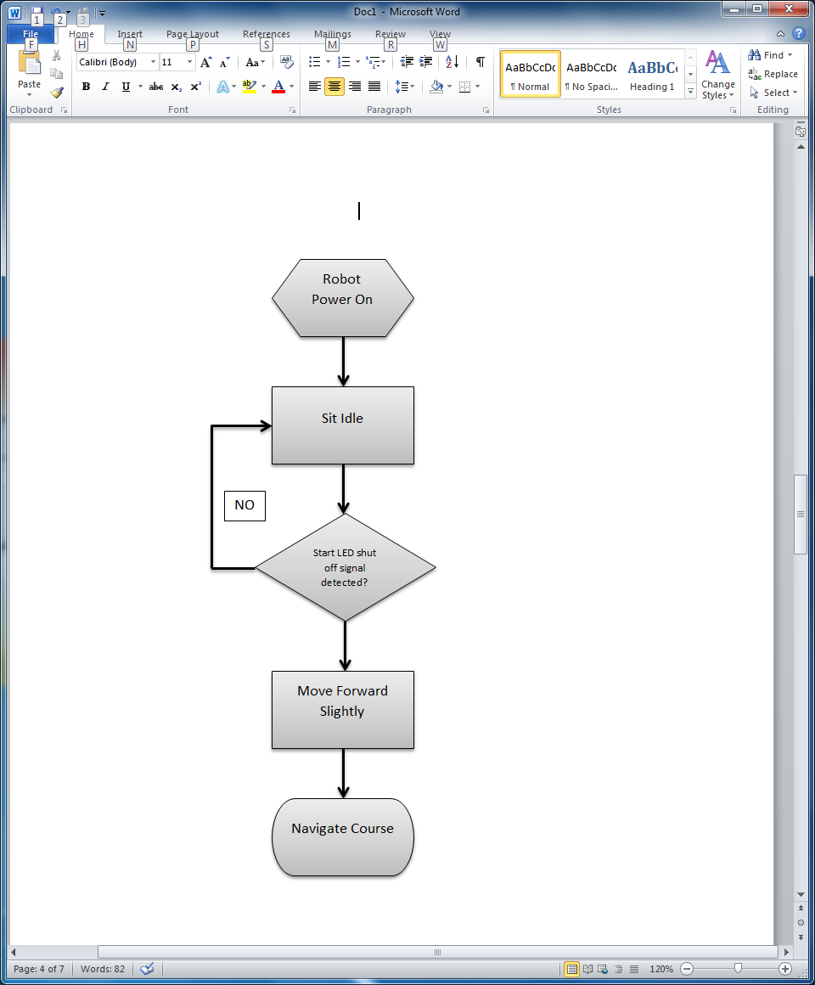
Figure 3.4.1c: Sequential Block Diagram for Start
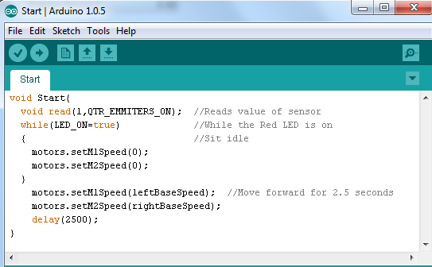
Figure 3.4.1d: Code Block for Start Sequence

Line Following

The robot must navigate a 0.94” white line varying each round. The 8 sensor array (QTR-8RC) and the same QTR-1RC used for detecting the start LED, will be used to accomplish this task. The larger module will be placed near the rear, by the motor controlled wheels, for accurate turns. The risk of detecting the white block late, due to the position of the sensor, should not pose a problem because the games will/ are allowed to be move to the very front of each playing zone. It will also be able to detect intersections and other complex course structure until it reaches the finish point by utilizing different cases (turn senarios).

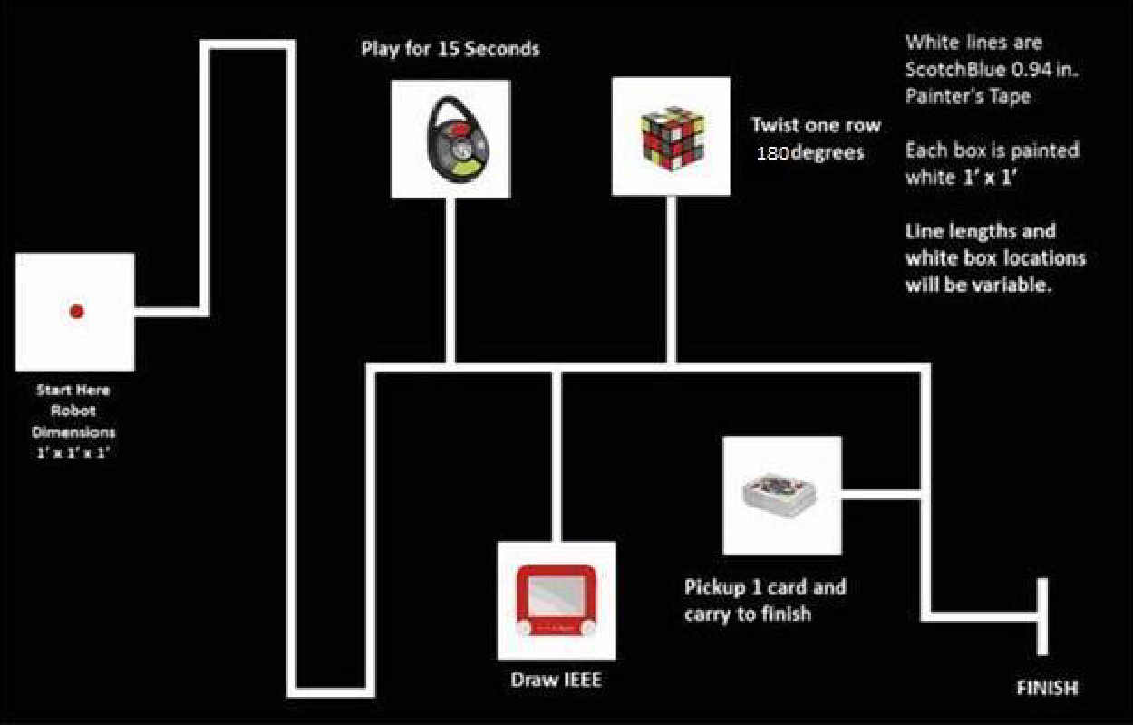

Figure 3.4.2a: Competition Course
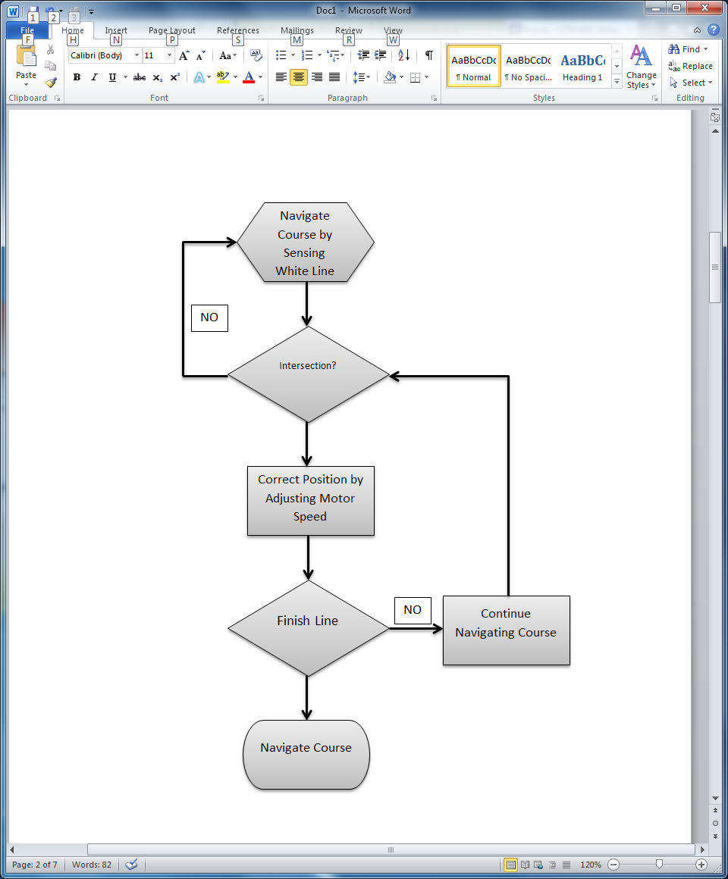

Figure 3.4.2b: Sequential Block Diagram for Line Following

The sensor’s 8 outputs will be connected to 8 digital pins of the processor. The sensor’s LED output will also be connected to a digital pin and serve as an indication during calibration.
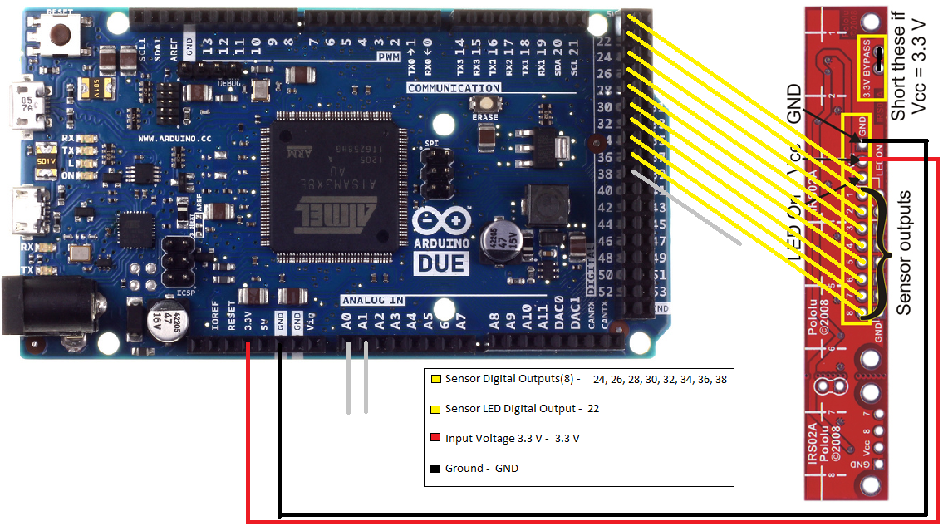

Figure 3.4.2c: Pinout for Line Following

The concept of navigating the course requires reading in values of the sensor and storing them in a byte with each bit representing the status of one of the nine sensors used. A 1 will represent if the particular sensor is over the line, and a 0; off the line. Therfore, the robot will be able to determine what type of turns and then decided on the correct action to take. For example: a strait line will be (000110001) and a lest turn (111110000).
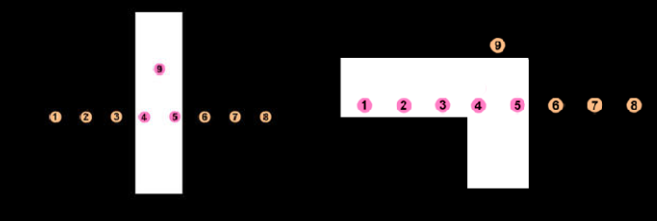

Figure 3.4.2d: Straight and left turn values being read

This will allow the robot to make the right decision when coming back to the main course. For example the value (111110001) represents a left turn off of the main course. When the robot reads this it will simply make a flag or store a value remembering this turn was made. Then when the robot comes back and reads a T-shaped (111111110) intersection, it will simply make a left based on the previouly read value and continue in the correct direction.

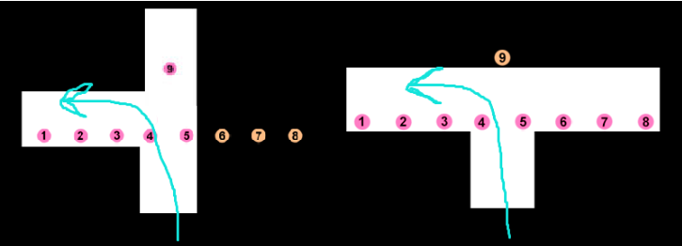
Figure 3.4.2e: T-shaped concept

While on a strait line, the robot will use the values read to determine its position and correct “error” whenever its not directly over the line. These two techniques used together will enable the robot to succesfully navigate the course.

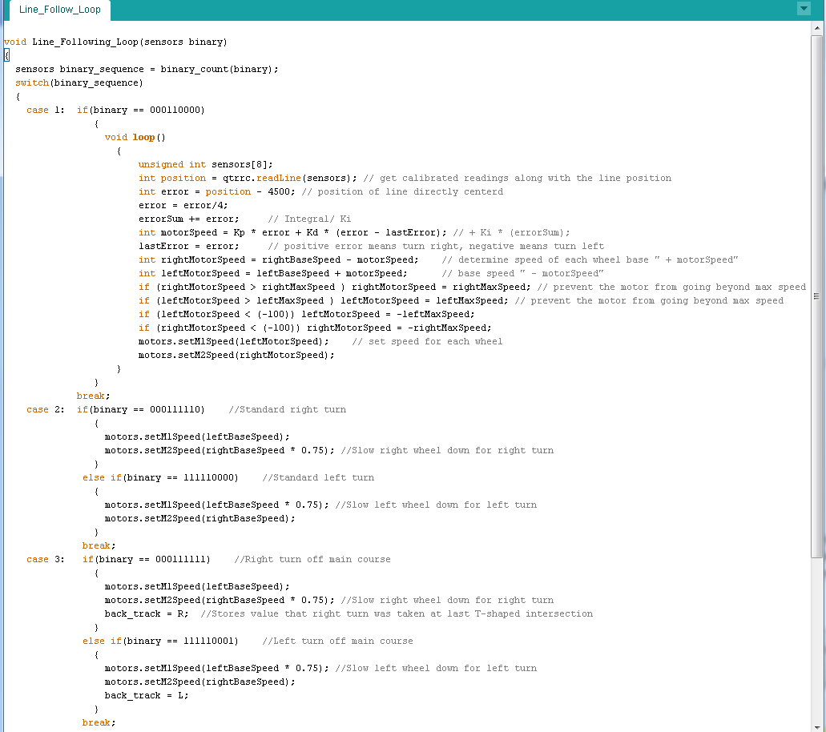
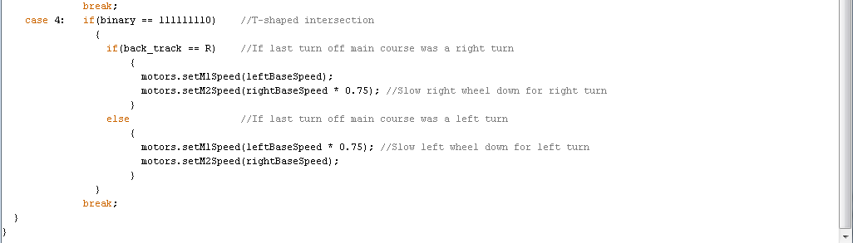
Figure 3.4.2f: Code for Line following loop

Microphone for Simon

The robot must first correctly play Simon for 15 seconds. Using a microphone was decided to be ideal for this task. It will be placed on the main (pan & tilt) arm to accurately measure the frequency of the various Simon sounds. The signal will then be used to determine which button the robot must correctly press.

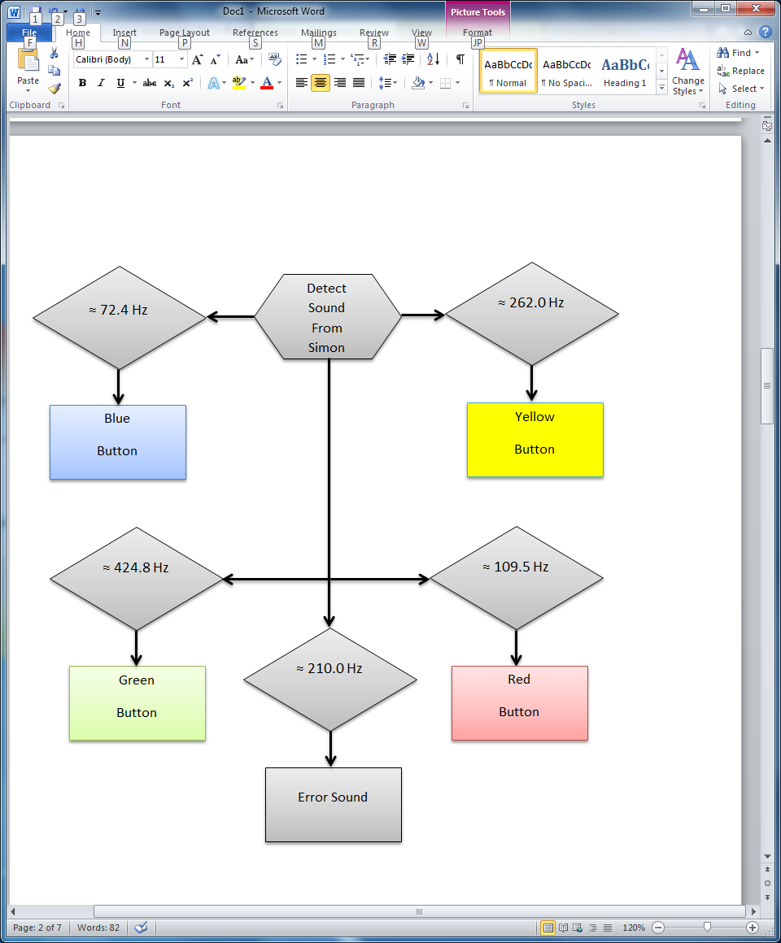

Figure 3.4.3a: Sequential Block Diagram for Microphone

Using the fdatools in MATLAB, filters will be designed with C headers containing the coefficients necessary to implement the filters. These will be used to distinguish between the different frequencies, and allow the robot to properly recognize with button on Simon was activated. The robot will then act accordingly based on the button’s sound.

Object Detection

The robot must locate each game within a 1’x1’ white square. The team decided to use two optical range sensors to complete this task. The sensors will be located on the front of the robot; as low as possible to detect all games. It will send a signal to the processor to slow down, stop, and then start a game specific sequence whenever the robot comes within a certain range.

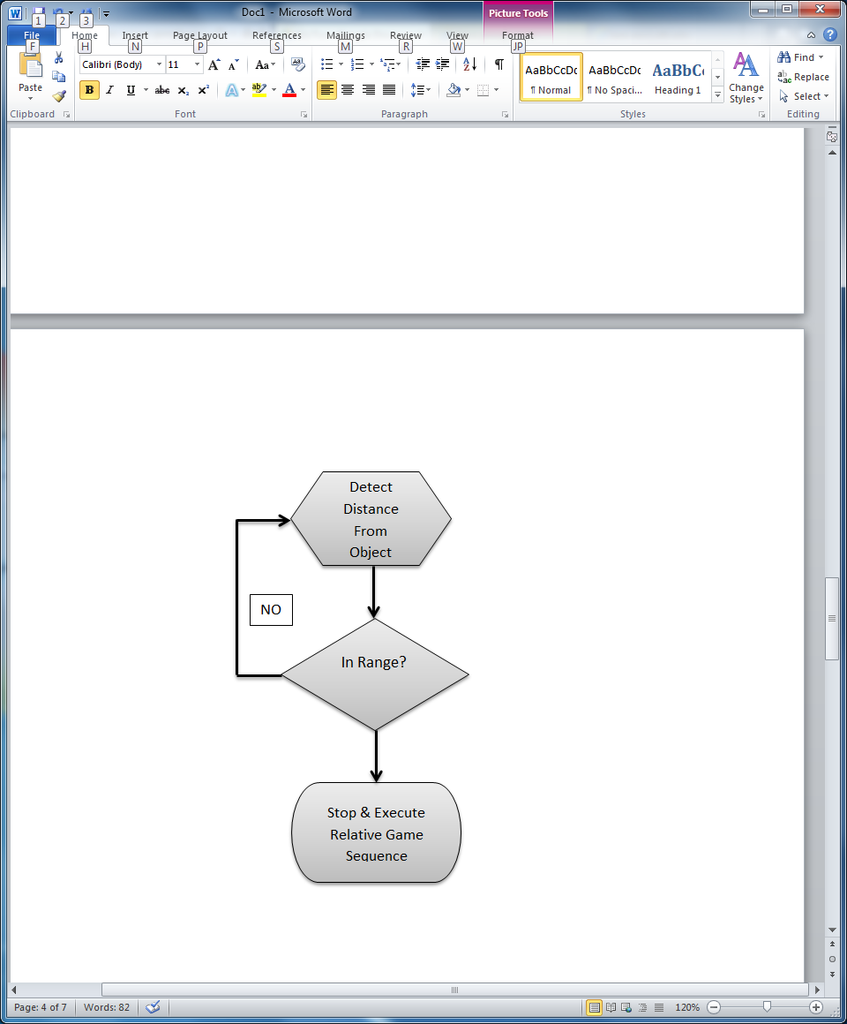

Figure 3.4.4a: Sequential Block Diagram for Object Detection
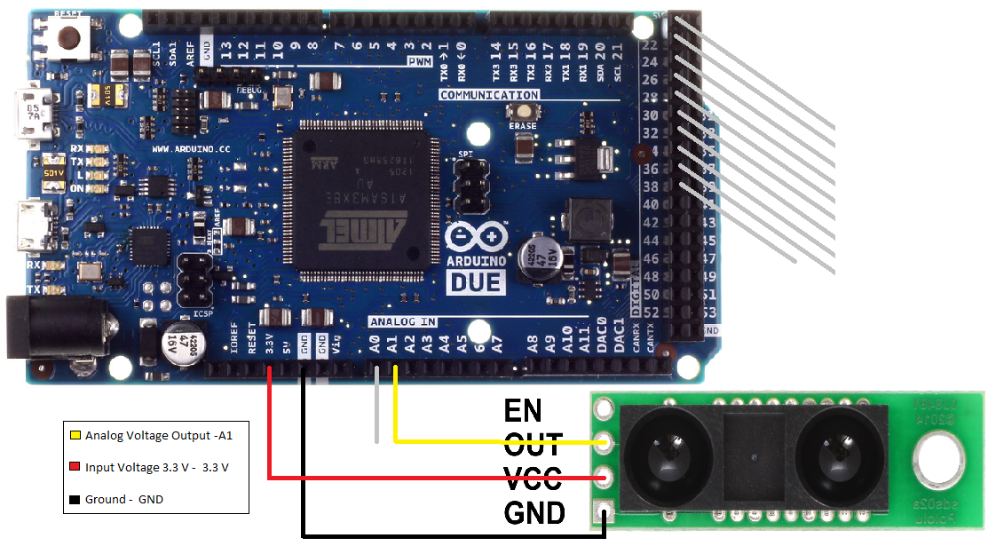

Figure 3.4.4b: Pinout Diagram for 4”-60” Analog IR sensor

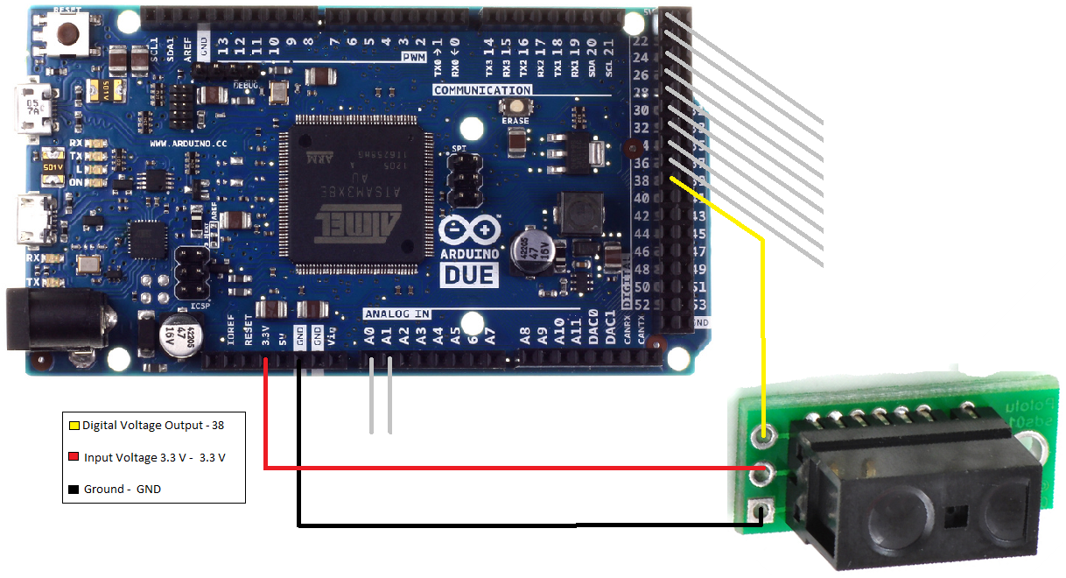
Figure 3.4.4c: Pinout Diagram for 0.2”-6” Digital IR sensor

Servos/Arms/Grippers

The proposed design for the mechanical arms is largely centered on programming servos. The servos create all of the movements for the arms and grippers. Sequential programming will instruct the servos to position joints and end pieces to perform the toy challenges. The servos selected for the arms are controlled by Pulse Width Modulation and powered by 6V NiMH battery pack.

Mini Maestro Servo Controller

The mini maestro servo controller power supply will be used to control all the servos implemented in this project. Voltage will come from the 6 Volt battery and supply the controller. The mini maestro servo controller will act as a buck booster and supply the appropriate amount of current to the servos controlling the main arm and the grippers. The mini servo controller can be powered using the Vin terminal on the controller; the voltage range is between 5 and 16 volts.

The Maestro controller comes with a configuration and control program available for windows. The program will be used to familiarize the controls of the mini maestro servo controller. The mini maestro is capable of using general-purpose digital outputs and analog or digital inputs, allowing events beyond just moving servos.

Features
- Pulse rate 1 to 333 Hz
- Wide pulse range of 64 to 4080E-6 (sec)
- Speed Control per channel
- Acceleration Control per channel
- Maestro Arduino Library
- 12 Channels
- Script Size 8 Kb

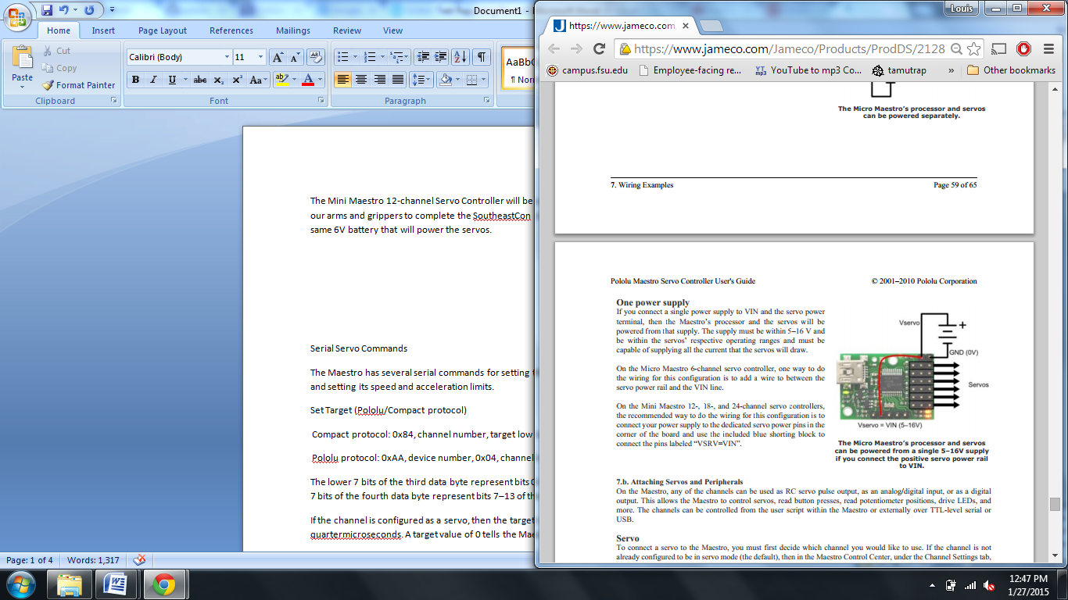

Plan of Attack
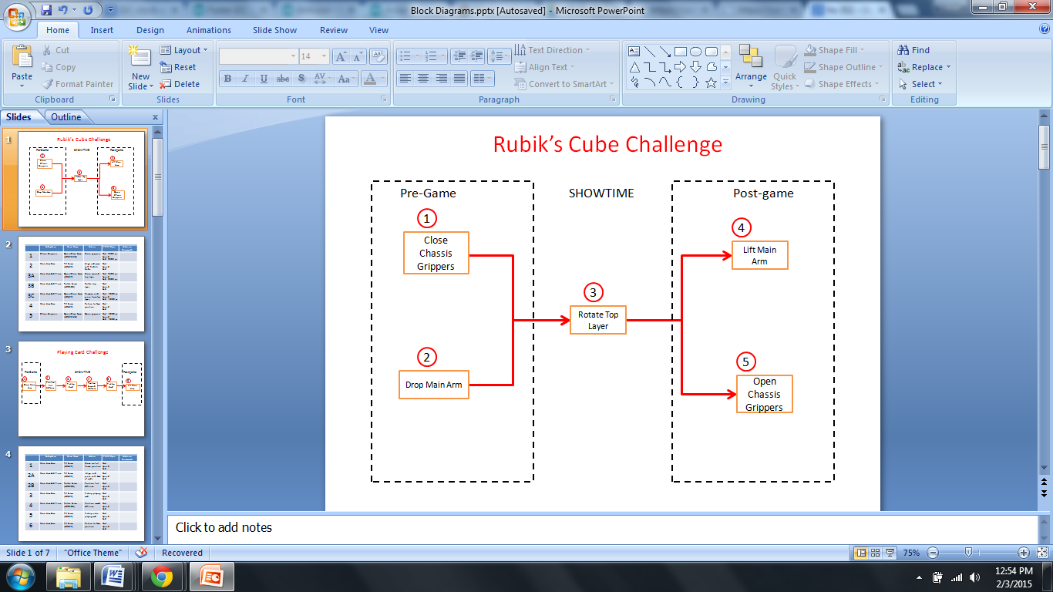

 | Subsystem | Servo Name | Action
1 | Chassis Gripper | Open/Close Servo  (HS-625MG) | Close grippers
2 | Main Arm Base | Tilt Servo  (HS-422) | Align end piece with Rubik’s Cube
3A | Main Arm End Piece | Open/Close Servo  (HS-422) | Close around top layer
3B | Main Arm End Piece | Rotate Servo  (HS-85BB) | Rotate top layer
3C | Main Arm End Piece | Open/Close Servo  (HS-422) | Remove end piece from top layer
4 | Main Arm Base | Tilt Servo  (HS-422) | Return to home position
5 | Chassis Grippers | Open/Close Servo  (HS-625MG) | Open grippers

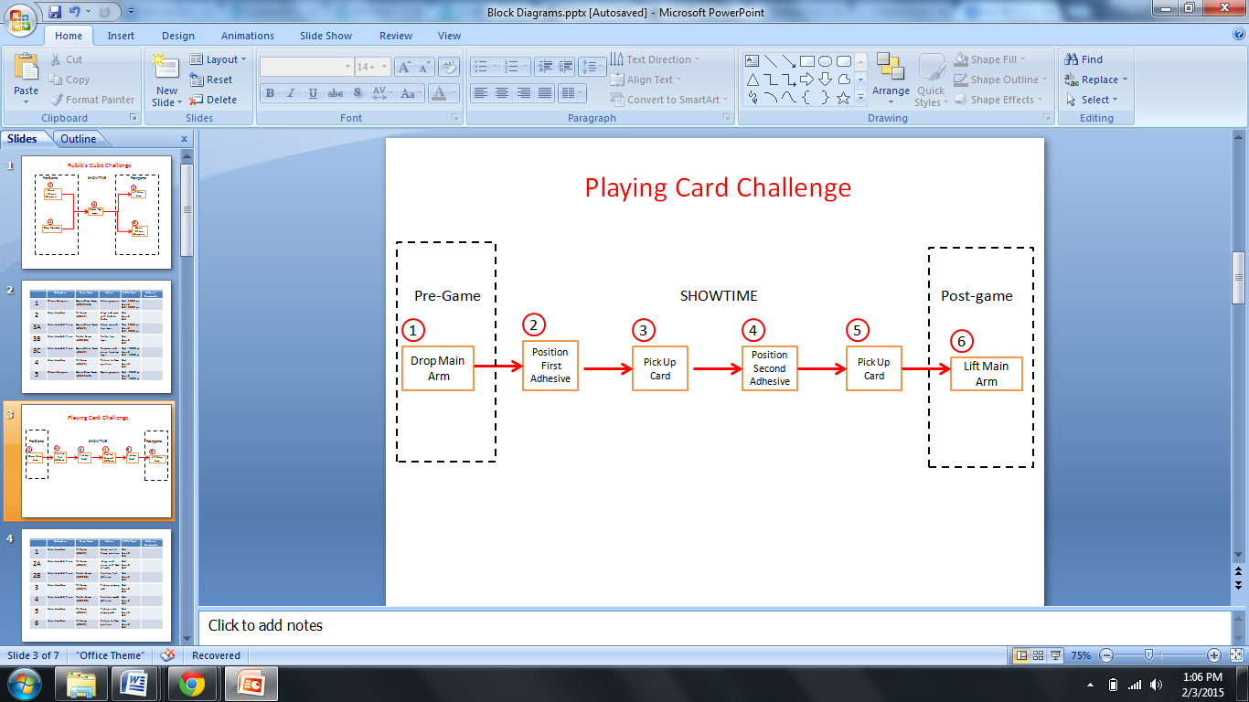

 | Subsystem | Servo Name | Action
1 | Main Arm Base | Tilt Servo  (HS-422) | Move out of home position
2A | Main Arm End Piece | Tilt Servo  (HS-422) | Align end piece with deck of cards
2B | Main Arm End Piece | Rotate Servo  (HS-85BB) | Position first adhesive
3 | Main Arm Base | Tilt Servo  (HS-422) | Pick up playing card
4 | Main Arm End Piece | Rotate Servo  (HS-85BB) | Position second adhesive
5 | Main Arm Base | Tilt Servo  (HS-422) | Pick up extra playing card
6 | Main Arm Base | Tilt Servo  (HS-422) | Return to home position

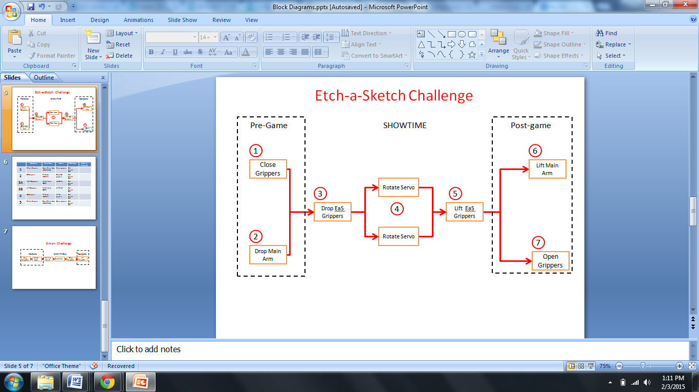

 | Subsystem | Servo Name | Action
1 | Chassis Grippers | Open/Close Servo  (HS-625MG) | Close grippers
2 | EaS Grippers | Tilt Servo  (HS-311) | Drop EaS grippers
3A | Right EaS gripper | Rotate Servo  FS90R | Up/Down
3B | Left EaS gripper | Rotate Servo  FS90R | Left/Right
4 | EaS Grippers | Tilt Servo  (HS-311) | Lift Eas grippers
5 | Chassis Grippers | Open/Close Servo  (HS-625MG) | Open grippers

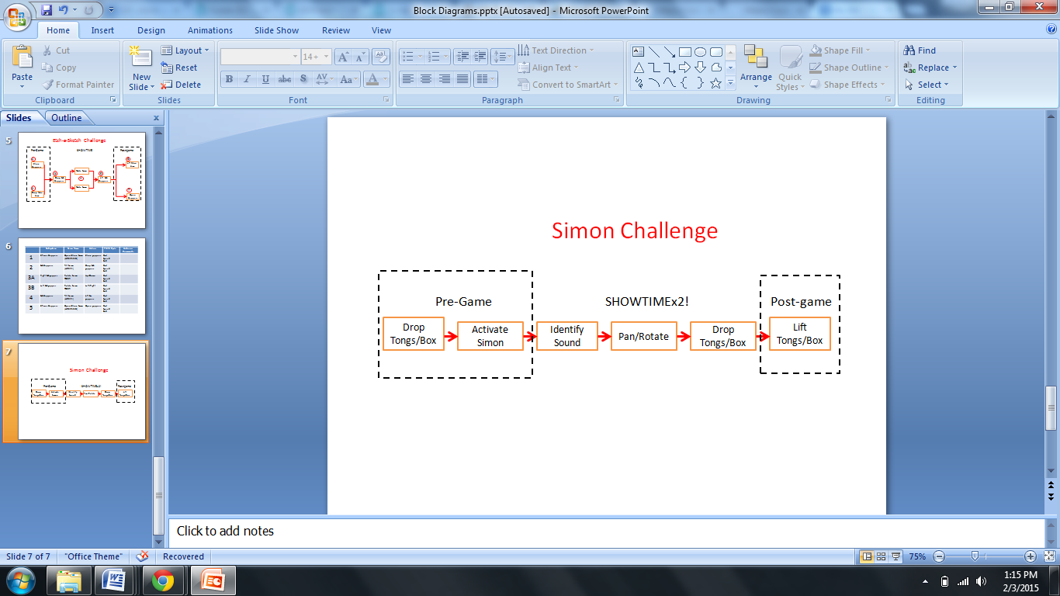

Connections and Layouts

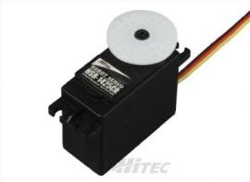

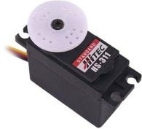

x 2

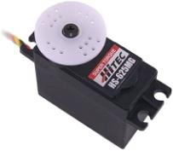
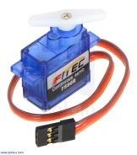
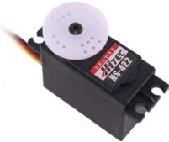

x 2 x 4

EaS Grippers Main Arm Chassis Gripper

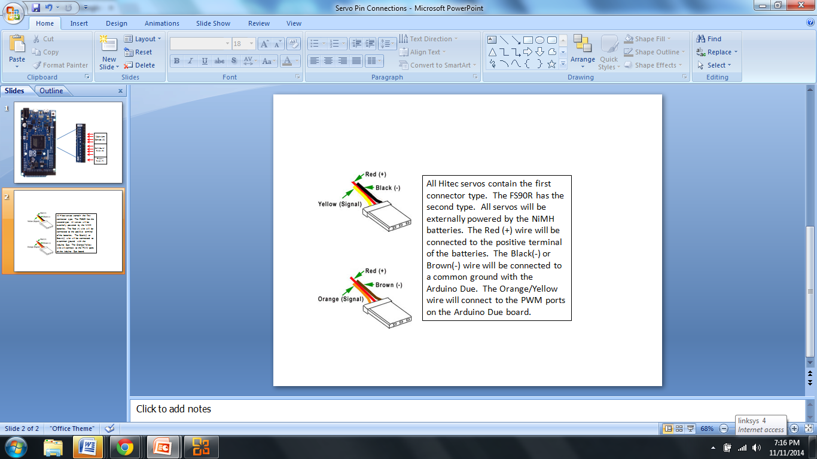

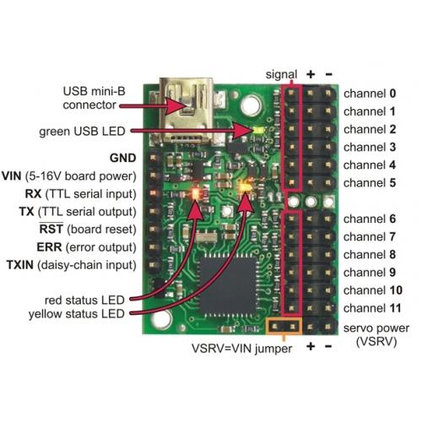

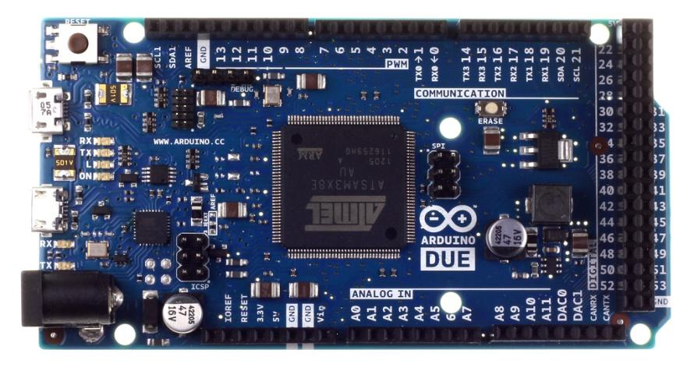

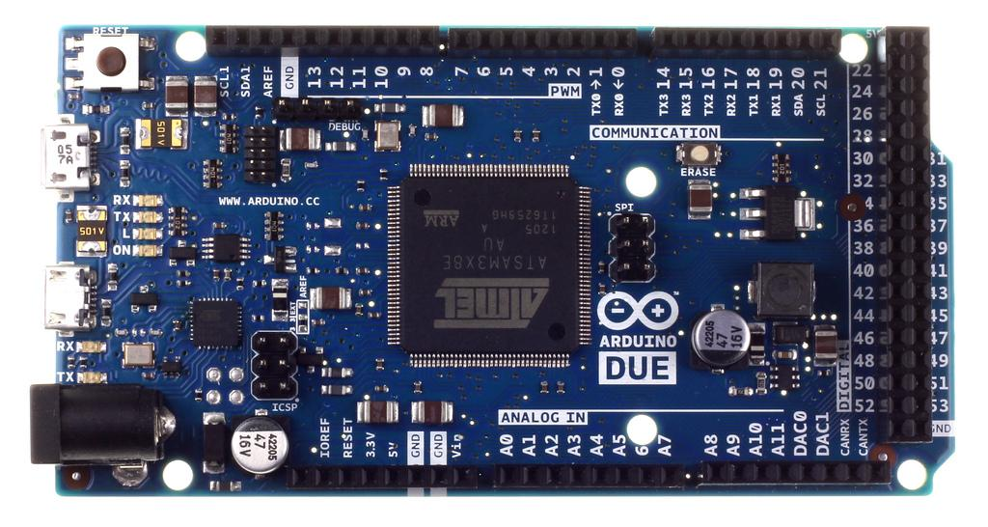

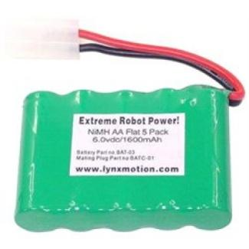

General Coding Information
Using the Arduino software, a program will be written to the Arduino Due to send serial commands to a servo controller. The Mini Maestro 12-channel Servo Controller will be used to control all of the different servos used in our arms and grippers to complete the SoutheastCon challenges. The controller will be powered by the same 6V battery that will power the servos. The Due’s serial port is 3.3V, so it should not be directly connected to the Maestro’s 5V TX line. This means the Due can only be used for sending commands to the Maestro, not receiving. However, the Due’s TX line can be directly connected to the Maestro’s 5V RX line. The Maestro and Due must share a common ground as well. A Maestro-Arduino library will also be used to simplify the coding process. The library has user-friendly functions to generate the required bytes to control the Maestro. An example code has been given.

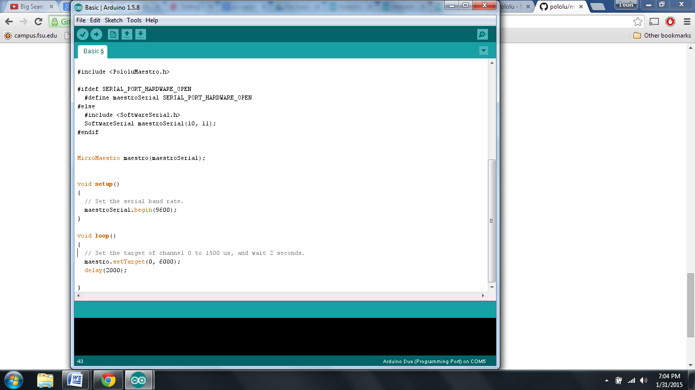

Power Supply

The team will manufacture a housing case to secure to the chassis near the rear end of the robot. The placement of the batteries also will aid in balancing robot’s weight. One battery will power the robot’s central processing unit and drive motors. While the other battery will power the motors used to control the arms. Lastly the voltage regulator will step-down the incoming voltage to two different voltages for sensors requiring lower voltages.

Two chargers will be purchased with capability to charge both NiMH batteries. Batteries will be tested and calculated to an accurate full charge time. Data will be use to devise a charging schedule to prepare the batteries before every use. Also data and observations will be used to determine how many spare batteries are necessary. The spare batteries are being considered for back to back use, playing three consecutive rounds.

Pin Connections:

The team has decided to use to breadboards, one for each battery and the components connected to them. The 12 volt battery will supply voltage to the positive voltage bus on the breadboard(1) allowing the Arduino and drive motors to connect to the 12 V simultaneously. The current calculated from the torque for each drive motor is 299.53mA. The stall current is rated at an alarming 5A this will only be a problem when starting up at full power. To overcome this set back a H-bridge will be use to control the voltage sent to the drive motors. Through coding the motors will receive a low voltage to allow a slow take off increasing friction and traction of the wheels. The equations used to calculate the current drawn from the current is displayed below using the given values.

The torque calculated previously was 11.8 kg-cm, with the absolute maximum estimated weight of, 10kg speed of 0.3048 m/s (1 ft/s), and acceleration of 0.1524 m/s².

$$P= τv$$ (2)
$$P=IV$$ (3)

Contingency Plan:

The price of the batteries and chargers are low enough to purchase more when needed. Having a spare of batteries cuts idle time. If system was to fail during the competition alkaline batteries will be purchased and used to build a replacement power source.

Table 3.6a: Power Consumption for Motors and Arduino
Battery | 12 Volts | 26.4 Wh |  | 2200mAh ( Capacity)
Item | Description | Quantity | Volts (V) | Current (mA)
50:1 Metal Gearmotor 37Dx54L | Wheel Motor | 2 | 12 | 600
Arduino Due | Microcontroller | 1 | 12 | 800
Total |  | 3 | 12 | 1400

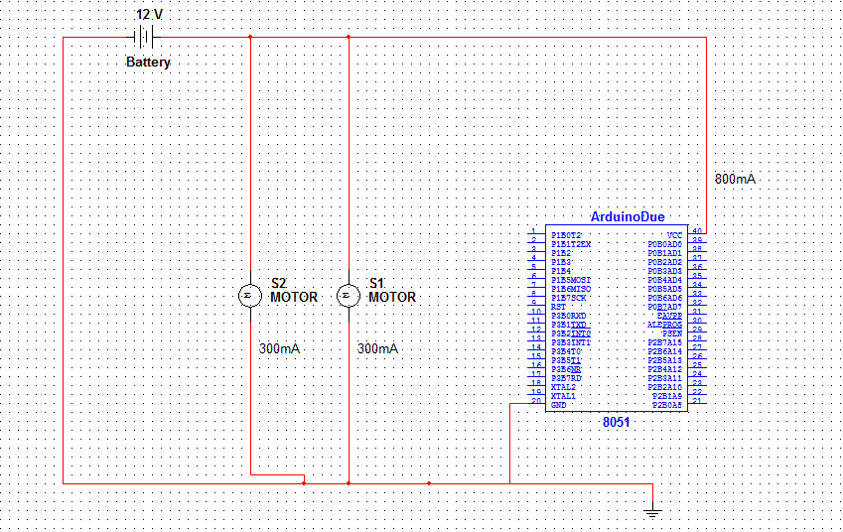
Figure 3.a: DC Motors and Arduino Battery Connections

Table 3.6b Power Consumption for Servos
Battery | 6 Volts | 9.6Wh |  | 2200mAh
Item | Description | Quantity | Volts (V) | Required Current (mA)
HS-422 | Standard Servo | 5 | 4.8-6 | 750
FS90R | CR Micro Servo | 2 | 4.8-6 | 400
HSR-1425CR | CR Standard Servo | 1 | 4.8-6 | 100
HS-85BB | Micro Servo | 1 | 4.8-6 | 240
Total |  | 9 | 4.8-6 | 1490

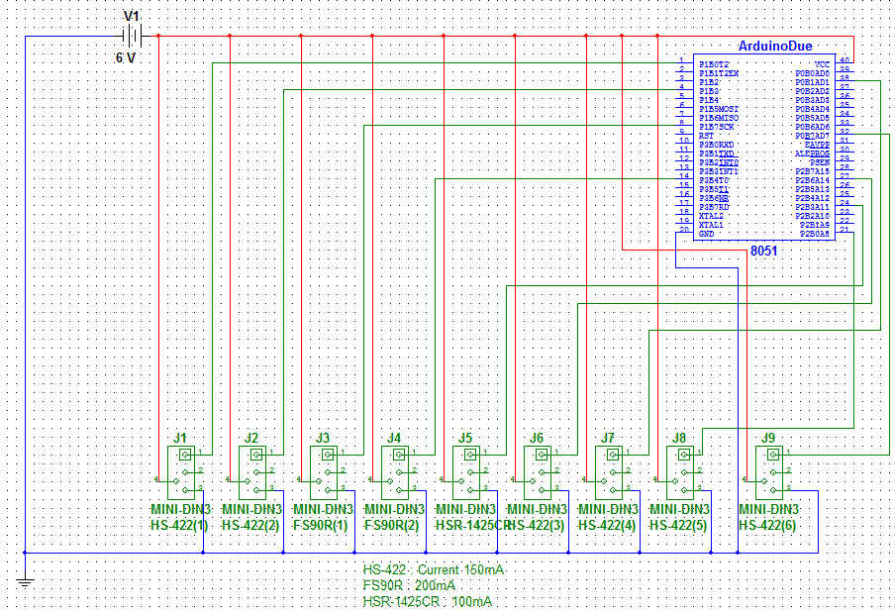
Figure 3.6b Servo Motors Battery Connections

Table 3.6c: Sensor Power Consumption
Item |  | Description |  |  | Quantity | Volts (V) |  | Current (mA)
Micro Phone |  | Sensor |  |  | 1 | 2.7-5.5 |  | 0.5
Analog Distance Sensor |  | Sensor |  |  | 1 | 2.7-3.6 |  | 33
Digital Distance Sensor |  | Sensor |  |  | 1 | 2.7-6.2 |  | 5
QTR-8RC Reflectance Sensor |  | Sensor |  |  | 1 (8 in pack) | 3.3-5 |  | 200
Total |  |  |  |  | 4 |  |  | 238.5

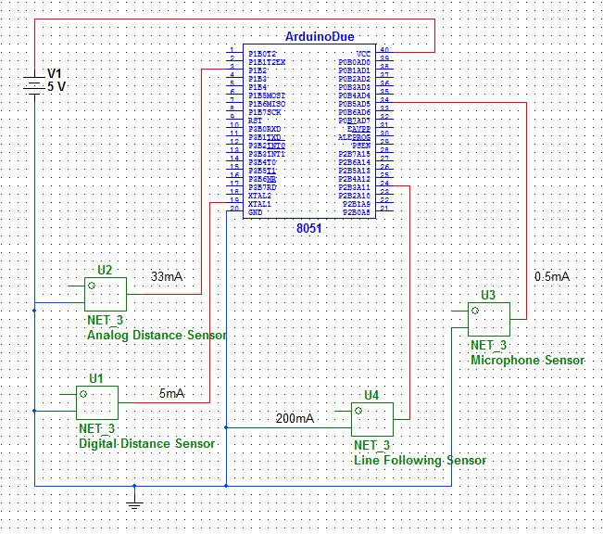
Figure 3.6c: Sensor Battery Connections

Testing Plan

4 Testing Plan
4.1 Programming
4.1.1 Arduino Due
4.1.2 Driver Shield
4.1.3 Servo Controller

Scheduled Test Reporting Form

Test Item: Servo Controller
Tester Name: Louis Cooper
Test Date: TBD
Test Location: COE
Test ID: Integration
Test No: 1
Test Attempt #: 1
Test Result:

Objective:
We will test the compatibility of the Arduino Due microcontroller and the 12-channel Mini Maestro Servo Controller. The Servo Controller will be used to regulate the voltage and control all the servos used in the arm and gripping mechanisms.

Description:
The Arduino Due will control the Maestro Servo Controller and rotate 2-3 test servos simultaneously. This will test the basic operation UART mode for controlling the Maestro Servo Controller with serial commands from a MCU. The test servos will go through a sequence of servo positions to verify functionality.

Requirements:
· Laptop with Arduino Software
· Maestro 12-channel Servo Controller
· Arduino Due
· 6V Battery
· Testing Servo

Anticipated Results:
The servos should be able to reach MOST of the servo positions. There may be dead zones or coding errors that could cause the servos to miss one (1) or two (2) servo positions.

Requirement for Success:
The testing servos must demonstrate that they are being controlled by the Arduino Due through serial commands to the Maestro Servo Controller.

Actual Results:

Reason for Failure:

Recommended Fix:

Other Comments:
(Optional)

4.2 Drive System
4.2.1 Line Following

Scheduled Test Reporting Form

Tester Name: Chelsea Ogle
Test Date: 10/10/14 (check)
Test Time: 12:30 pm
Test Location: FAMU-FSU CoE

Test No:
Test Attempt #: 1
Test Result: PASS

Test ID: Line Following Test

Objective:
The main purpose of this is to test the line following sensors interacting with the motors via the motor driver shield and the Arduino. The line following prototype chassis will stay stationary, but the motors reactions to a line will be observed.

Description:
Each motor will be connected to the A4490 Motor Driver Shield for Arduino, a 12 V power supply will also be connected to the driver shield. The Arduino will remain connected to the computer for power. The line following sensors will also be connected to the Arduino. Using libraries from both the sensors and the driver shield, sample line following code altered to work with the driver shield will be uploaded to the board. The prototype chassis will be lifted with a box such that the wheels spinning do not cause it to move, and a black line on a white box will be moved around beneath the line following sensors.

Requirements:
· DC Power Supply, +/- 25V
· 12 V DC Brushed Metal Gearbox Motors (2)
· Wires for connections
· A4490 Motor Driver Shield for Arduino
· White box with black tape line
· Arduino Mega
· Line Following Sensors

Procedure:
Connect the motor shield to the 12V DC power supply, with ground. Connect each motor to the driver shield, with the red wire in the A terminal, and the black in the B. Connect the driver shield and the line following sensors to the Arduino, using two PWM pins for the motor connections. Connect the Arduino to a computer using the USB, and upload the line following code, leaving the USB for supplying power. Prop up the prototype chassis such that it will not move when the wheels spin. Calibrate the line following sensors by moving the black line back and forth beneath them. Once the line following loop is running, keep the line beneath the sensors and move it, observing the effects.

Anticipated Results:
With the line in the center of the line following sensor array, each motor should move forward at the same speed. With the line to the left, the left motor should spin backwards while the right moves forwards. With the line to the right, the left motor should spin forwards while the right spins backwards.

Requirement for Success:
With the line in the center of the line following sensor array, each motor should move forward at the same speed. With the line to the left, the left motor should spin backwards while the right moves forwards. With the line to the right, the left motor should spin forwards while the right spins backwards. The further left/right the line moves, the faster the motors should spin in opposite directions of each other.

Actual Results: PASS
The motors behaved as required in response to the line moving beneath the sensors.

Reason for Failure:

Recommended Fix:

Other Comments:

Scheduled Test Reporting Form

Tester Name: Ogle, Vargas, Marshall
Test Date: 11/11/14
Test Time: 11:00 am
Test Location: FAMU-FSU CoE

Test No: 2
Test Attempt #: 2
Test Result: FAIL

Test ID: Line Following Test

Objective:
The main purpose of this is to test the line following sensors interacting with the motors via the motor driver shield and the Arduino. This test will actually put the prototype chassis on a white surface with a black line to test line following.

Description:
Each motor will be connected to the A4490 Motor Driver Shield for Arduino, a 12 V battery will also be connected to the driver shield. The Arduino will be connected to a 9V battery for power. Using libraries from both the sensors and the driver shield, sample line following code altered to work with the driver shield will be uploaded to the board. The prototype chassis will be placed on a white surface with a black line and should be able to follow it.

Requirements:
· 12 V and 9 V batteries
· 12 V DC Brushed Metal Gearbox Motors (2)
· Wires for connections
· A4490 Motor Driver Shield for Arduino
· White surface with black tape line
· Arduino Mega
· Line Following Sensors
· Prototype chassis with motors, wheels, Arduino, and line following sensors connected.

Procedure:
Connect the motor shield to the 12V DC power supply, with ground. Connect each motor to the driver shield, with the red wire in the A terminal, and the black in the B. Connect the driver shield and the line following sensors to the Arduino, using two PWM pins for the motor connections. Connect the Arduino to a computer using the USB, and upload the line following code, and then use a 9V batter for power. Place the chassis on the ground, turn on the Arduino, and move the line following sensors left and right over the line to calibrate. Then let the code run and observe the results.

Anticipated Results:
The robot will follow the line, around curves and over right angle turns. It may or may not take a turn in a T-shape, but it will always be covering the line.

Requirement for Success:
The robot must remain covering/following the line at all times.

Actual Results: FAIL
The robot drove over the line and past it.

Reason for Failure:
The PID controller constants were not correct for accurately following the line. Additionally the wires making connections to the driver shield need to be secured, they were not remaining connected.

Recommended Fix:
Increase the constant corresponding to the differential part of the PID and decrease the constant corresponding to the proportional part of the PID.

Other Comments:

Scheduled Test Reporting Form

Tester Name: Ogle, Vargas, Marshall
Test Date: 11/20/15
Test Time: 11:00 am
Test Location: FAMU-FSU CoE

Test No:
Test Attempt #: 3
Test Result: PASS

Test ID: Line Following Test

Objective:
The main purpose of this is to test the line following sensors interacting with the motors via the motor driver shield and the Arduino. This test will actually put the prototype chassis on a white surface with a black line to test line following.

Description:
Each motor will be connected to the A4490 Motor Driver Shield for Arduino, a 12 V battery will also be connected to the driver shield. The Arduino will be connected to a 9V battery for power. Using libraries from both the sensors and the driver shield, sample line following code altered to work with the driver shield will be uploaded to the board. The prototype chassis will be placed on a white surface with a black line and should be able to follow it.

Requirements:
· 12 V and 9 V batteries
· 12 V DC Brushed Metal Gearbox Motors (2)
· Wires for connections
· A4490 Motor Driver Shield for Arduino
· White surface with black tape line
· Arduino Mega
· Line Following Sensors
· Prototype chassis with motors, wheels, Arduino, and line following sensors connected.

Procedure:
Connect the motor shield to the 12V DC power supply, with ground. Connect each motor to the driver shield, with the red wire in the A terminal, and the black in the B. Connect the driver shield and the line following sensors to the Arduino, using two PWM pins for the motor connections. Connect the Arduino to a computer using the USB, and upload the line following code, and then use a 9V batter for power. Place the chassis on the ground, turn on the Arduino, and move the line following sensors left and right over the line to calibrate. Then let the code run and observe the results.

Anticipated Results:
The robot will follow the line, around curves and over right angle turns. It may or may not take a turn in a T-shape, but it will always be covering the line.

Requirement for Success:
The robot must remain covering/following the line at all times until the end of the test course.

Actual Results: PASS
The robot remained on the course at all times until the end of the course. It was always following the line, and took all turns in the course. A video of the test is available online.

Reason for Failure:

Recommended Fix:

Other Comments:
Additional changes to the code will need to be made to change it to a white line on a black surface. Also the code must be customized more to take follow the test course for the internal competition as desired.

Scheduled Test Reporting Form

Tester Name: Ogle, Vargas, Marshall
Test Date: 1/24
Test Time: 11:00 am
Test Location: FAMU-FSU CoE

Test No:
Test Attempt #: 4
Test Result: FAIL

Test ID: Line Following Test

Objective:
The main purpose of this is to test the line following sensors interacting with the motors via the motor driver shield and the Arduino. This test will use the new chassis and place it on a black surface with a white line.

Description:
Each motor will be connected to the A4490 Motor Driver Shield for Arduino, a 12 V battery will also be connected to the driver shield. The Arduino will be connected to a 9V battery for power. Using libraries from both the sensors and the driver shield, sample line following code altered to work with the driver shield will be uploaded to the board. The new chassis will be placed on a black surface with a white line, specifically the provided test course.

Requirements:
· 12 V and 9 V batteries
· 12 V DC Brushed Metal Gearbox Motors (2)
· Wires for connections
· A4490 Motor Driver Shield for Arduino
· Test Course
· Arduino Mega
· Line Following Sensors
· New chassis with motors, wheels, Arduino, and line following sensors connected.

Procedure:
Connect the motor shield to the 12V DC power supply, with ground. Connect each motor to the driver shield, with the red wire in the A terminal, and the black in the B. Connect the driver shield and the line following sensors to the Arduino, using two PWM pins for the motor connections. Connect the Arduino to a computer using the USB, and upload the line following code, and then use a 9V batter for power. Place the chassis on the ground, turn on the Arduino, and move the line following sensors left and right over the line to calibrate. Then let the code run and observe the results.

Anticipated Results:
The robot will follow the line, around curves and over right angle turns. It should always be covering the line.

Requirement for Success:
The robot must remain covering/following the line at all times, until it runs out of course.

Actual Results: FAIL
The robot attempted to follow the line, but either veered off of the course, or became stuck at some points.

Reason for Failure:
The orientation of the motors needs to be flipped in the code, and not all line following sensors were connected properly.

Recommended Fix:
Manage line following sensor connections, and change code such that the motors are correct.

Other Comments:
The code may also need to be changed in the way with which it handles the sensor data. Currently, it gives a value of the weighted average of the sensor values, as opposed to observing each individually. Dealing with the values of each individual sensor could provide more customizable code and accuracy.

Scheduled Test Reporting Form

Tester Name:
Test Date:
Test Time:
Test Location:

Test No:
Test Attempt #: 5
Test Result:

Test ID: Line Following Test
Objective:
The main purpose of this is to test the line following system with the additional 9th sensor. The goal of this test is to have the robot behave as needed on the test course provided when it encounters T-shapes and the game zones. The distance sensor may also be integrated in the design for game zone detection.
Description:
Each motor will be connected to the A4490 Motor Driver Shield for Arduino, a 12 V battery will also be connected to the driver shield. The Arduino will be connected to a 9V battery for power. Using libraries from both the sensors and the driver shield, sample line following code altered to work with the driver shield will be uploaded to the board. The new chassis will be placed on a black surface with a white line, specifically the provided test course.
Requirements:
· 12 V and 9 V batteries
· 12 V DC Brushed Metal Gearbox Motors (2)
· Wires for connections
· A4490 Motor Driver Shield for Arduino
· Test Course
· Arduino Mega
· Line Following Sensors
· New chassis with motors, wheels, Arduino, and line following sensors connected.
Procedure:
Connect the motor shield to the 12V DC power supply, with ground. Connect each motor to the driver shield, with the red wire in the A terminal, and the black in the B. Connect the driver shield and the line following sensors to the Arduino, using two PWM pins for the motor connections. Connect the Arduino to a computer using the USB, and upload the line following code, and then use a 9V batter for power. Place the chassis on the ground, turn on the Arduino, and move the line following sensors left and right over the line to calibrate. Then let the code run and observe the results.
Anticipated Results:
The robot will follow the line, around curves and over right angle turns. It should always be covering the line. When the course branches off to a game zone, the robot should go to the game zone, and it should be able to return to the main course after pausing there.
Requirement for Success:
The robot must remain covering/following the line at all times, until it runs out of course. It must turn off of the main course to approach game zones, pause at the game zone, and return to the main course.
Actual Results:

Reason for Failure:

Recommended Fix:

Other Comments:

4.2.2 Driver Shield

Scheduled Test Reporting Form

Tester Name: Chelsea Ogle
Test Date: 10/10/14
Test Time: 12:30 pm
Test Location: FAMU-FSU CoE

Test No: 1
Test Attempt #: 1
Test Result: PASS

Test ID: Motor Driver Shield Test

Objective:
The main purpose of this test is to ensure that the A4490 Motor Driver Shield is fully operational and programmable with Arduino. In this test a simple program using the header/c files included with the driver shield will be uploaded to an Arduino Mega. The driver shield will be connected to the motors. Whether or not the program runs properly and controls the motors as desired will be tested.

Description:
A 12 V power supply will be connected to the Vin of the driver shield, and each motor will be connected. A simple program to spin motor one in the positive direction, and then in the negative direction, and then do the same on motor two, will be uploaded to the Arduino Mega. The code features a for loop that increases the speed with a slight delay from zero to the max, and then decreases it, and then does the same for the negative max speed. If this test is successful, the motor driver shield is operational and capable of being programmed for the purposes of the project.

Requirements:
· DC Power Supply, +/- 25V
· 12 V DC Brushed Metal Gearbox Motors (2)
· Wires for connections
· Arduino Mega (or Due)
· A4490 Motor Driver Shield for Arduino
· Power supply for the Arduino (USB connected to a PC)

Procedure:
Connect the motor shield to the 12V DC power supply, with ground. Connect each motor to the driver shield, with the red wire in the A terminal, and the black in the B. Connect the driver shield to the Arduino, using two PWM pins for the motor connections. Connect the Arduino to a computer using the USB, and upload the code, leaving the USB for supplying power.

Anticipated Results:
Motor one will increase from no speed to max speed quickly, and decrease back to zero. Then motor one will increase from no speed to max negative speed quickly, and decrease back to zero. The same thing should happen to motor two right after motor one runs. This should loop continuously.

Requirement for Success:
Motor one must increase from no speed to max speed quickly, and then decrease back to zero. It must then increase from no speed to max negative speed quickly, and then decrease back to zero. After a brief delay, motor two should behave in the exact same manner. This should loop continuously.

Actual Results: PASS
The motors behaved as required for success using the driver shield.

Reason for Failure:

Recommended Fix:

Other Comments:

4.2.3 Chassis

Scheduled Test Reporting Form

Tester Name: Chelsea Ogle
Test Date: 10/10/14
Test Time: 12:30 pm
Test Location: FAMU-FSU CoE

Test No: 1
Test Attempt #: 1
Test Result: PASS

Test ID: Drive System

Objective:
The main purpose of this test is to test the drive system on the new chassis. It is to make sure that all of the connections and positioning are sufficient for operation.

Description:
A 12 V power supply will be connected to the Vin of the driver shield, and each motor will be connected. A simple program to spin motor one in the positive direction, and then in the negative direction, and then do the same on motor two, will be uploaded to the Arduino Uno. The code features a for loop that increases the speed with a slight delay from zero to the max, and then decreases it, and then does the same for the negative max speed. If this test is successful, the motor driver shield is operational and capable of being programmed for the purposes of the project.

Requirements:
· DC Power Supply, +/- 25V
· 12 V DC Brushed Metal Gearbox Motors (2)
· Wires for connections
· Arduino Mega (or Due)
· A4490 Motor Driver Shield for Arduino
· Power supply for the Arduino (USB connected to a PC)

Procedure:
Connect the motor shield to the 12V DC power supply, with ground. Connect each motor to the driver shield, with the red wire in the A terminal, and the black in the B. Connect the driver shield to the Arduino, using two PWM pins for the motor connections. Connect the Arduino to a computer using the USB, and upload the code, leaving the USB for supplying power.

Anticipated Results:
Both motors will increase from no speed to max speed quickly, and decrease back to zero (forward). Then both motors will increase from no speed to max negative speed quickly, and decrease back to zero(reverse). Then the motors should do this again, with one moving forward and one backwards (left turn) and vice versa (left turn). This should loop continuously.

Requirement for Success:
The chassis should move briefly forwards, backwards, left and right in a continuous loop.

Actual Results: PASS
The robot behaved as required for success using the components of the drive system on the new chassis.

Reason for Failure:

Recommended Fix:

Other Comments:

4.3 Sensors
4.3.1 Line Following

Scheduled Test Reporting Form

Tester Name: Evan Marshall
Test Date: 10/15/14
Test Time: 3:00 pm
Test Location: FAMU-FSU CoE

Test No: 1
Test Attempt #: 1
Test Result: PASS

Test ID: Line Following Sensor Functional Demo

Objective:
The main purpose of this is to test the line following sensor’s functionality by properly connecting it to the Arduino and running a test code to ensure the Pololu QTR-8RC is not defective.

Description:
The sensor module will be connected to the Arduino using all 8 sensors pins, the emitter pin, vin (3.3V and 5V), and ground. A sample code that calibrates the sensors for 10 seconds, exposing them to the lightest and darkest surfaces, and runs a loop reading in digital values of each sensor in the array. These readings are sent to the serial monitor to check if each sensor if functioning correctly while moving black and white surfaces over the module.

Requirements:
- Wires and Breadboard

- White box with black tape line

- Arduino Due

- Pololu QTR-8RC

Procedure:
Connect each sensor pin and the LED emitter pin to digital pins on the Arduino. Then connect ground and vin pins. (If using 3.3V remember to short the 3.3 bypass on the module) Upload the demo code to the Arduino with correct values. Open the serial window and wait for the LED on the Arduino to light up (this indicates that calibration is in progress). Slide the box over the module during the calibration. Once complete, verify printed values while continuing to move the box over the module.

Anticipated Results:
Both motors will increase from no speed to max speed quickly, and decrease back to zero (forward). Then both motors will increase from no speed to max negative speed quickly, and decrease back to zero(reverse). Then the motors should do this again, with one moving forward and one backwards (left turn) and vice versa (left turn). This should loop continuously.

Requirement for Success:
All 8 sensors in the module must read accurate values between 0-1000 (0 being lighter, 1000 being darker).

Actual Results: PASS
The sensor read correctly and accuratly

Reason for Failure:

Recommended Fix:

Other Comments:

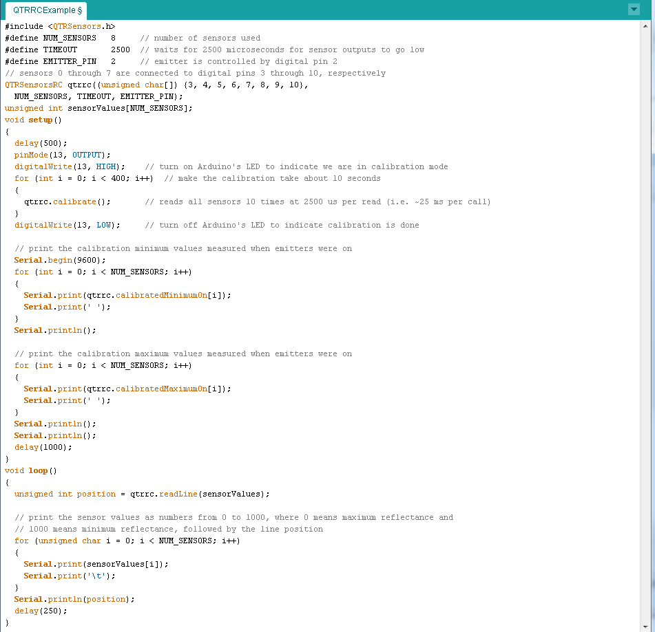
Demo Code Used
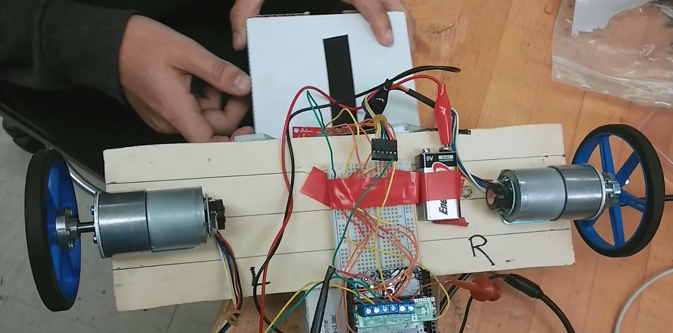
Test Setup

4.3.2 Object Detection (Find Game)

Scheduled Test Reporting Form

Tester Name: Evan Marshall
Test Date: 12/16/14
Test Time: 1:00 pm
Test Location: FAMU-FSU CoE

Test No: 1
Test Attempt #: 1
Test Result: PASS

Test ID: Digital Distance Sensor Functional Demo

Objective:
The main purpose of this is to test the digital distance sensor’s functionality, range, and responsiveness by properly connecting it to the Arduino and running a test code to ensure it is not defective.

Description:
The sensor module will be connected to the Arduino using its output pin, vin (3.3V), and ground. A sample code that lights the module’s red LED whenever an object is within range and prints the response on the screen will be implemented.. These readings are sent to the serial monitor to check if the sensor is functioning correctly while moving objects towards and away from the module.

Requirements:
- Wires and Breadboard

- Small box and ruler

- Arduino

- Pololu Carrier with Sharp GP2Y0D815Z0F Digital Distance Sensor 15cm (0.2”-6”)
Procedure:
Connect output pin to a digital pin on the Arduino. Then connect ground and vin pins. Upload the sample code to the Arduino with correct the pin value. Open the serial window slide the box slowly towards the module while measuring the distance with the ruler. When the object becomes in range, the LED will light and display the response time as well as the time in range on the serial monitor. Once complete, verify printed values while continuing to move the box at various distances.

Requirement for Success:
Objects within 6” are detected quickly and accurately. They are properly displayed on the screen and the red LED on the module lights when in range.

Actual Results: PASS
The module read correctly and accurately.

Reason for Failure:
None.

Recommended Fix:
None.

Other Comments:
If the digital distance sensor max range of 6” inches proves to be too small once future testing on the track begins, the analog distance sensor (4”-60”) will be used also.

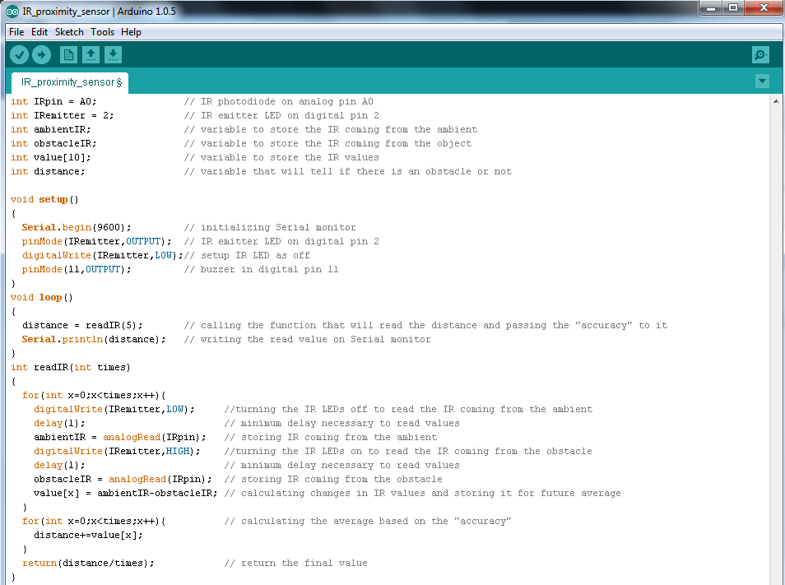
Demo Code Used

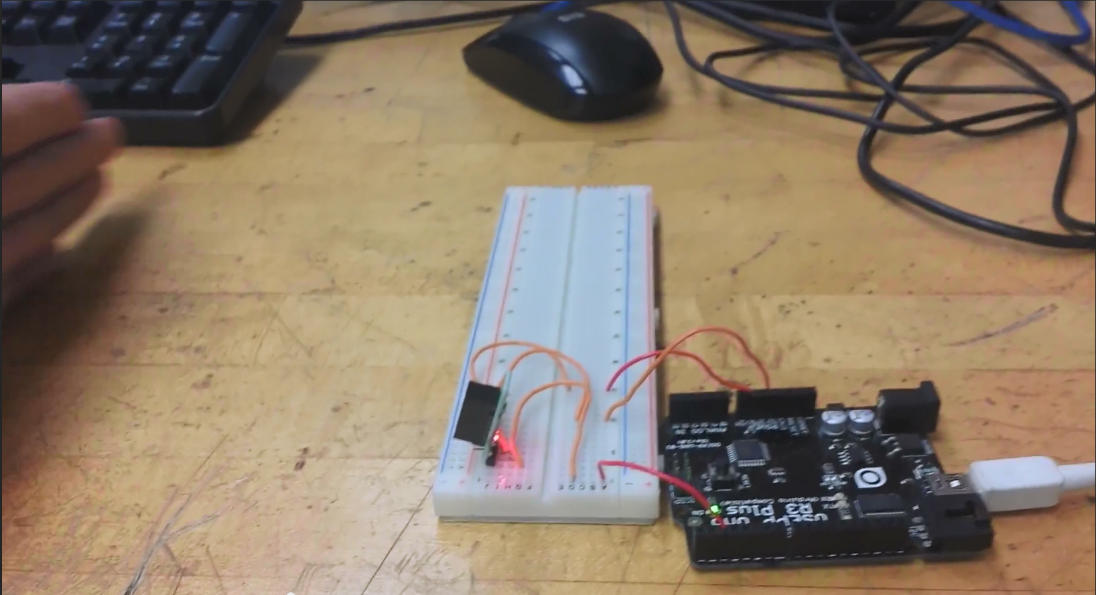
Test Setup

4.3.3 Microphone

Scheduled Test Reporting Form

Tester Name: Evan Marshall
Test Date:
Test Time:
Test Location: FAMU-FSU CoE

Test No: 4
Test Attempt #: 1
Test Result:

Test ID: Microphone Functional Demo

Objective:
This test will see if the microphone can correctly pick up the correct frequency coming out of
speakers.

Description:
This test will have 2 different frequencies being outputted by a computer. The goal is to have the
Arduino correctly pick up these frequencies. An oscilloscope will be used to ensure that the
output frequency from the computer is the intended frequency.

Requirements:

Procedure:
The 9v battery should be hooked up to the Arduino Due. The microphone output will be attached
to an analog pin on the Due. The audio out of the computer will be connected to an oscilloscope
and speakers. The first frequency that will be outputted is 440 Hz. Results of what the Arduino
Due and the oscilloscope play will be recorded. This step will then be repeated but with a
frequency of 20 Hz being outputted from the computer.

Anticipated Results:
The readings from the microphone match those of the oscilloscope which should match the
frequency being outputted from the computer.

Requirement for Success:
When the computer outputs a 440 Hz frequency the oscilloscope and Arduino correctly display a
440 Hz result. The same applies when the computer outputs a 50 Hz frequency.

Actual Results:
(Brief )

Reason for Failure:
(Brief )

Recommended Fix:
(Brief)

Other Comments:
(Optional)

4.3.4 Start LED

Scheduled Test Reporting Form

Tester Name: Evan Marshall
Test Date: 1/11/15
Test Time: 10:00 am
Test Location: FAMU-FSU CoE

Test No: ?
Test Attempt #: 1
Test Result: PASS

Test ID: Start LED functional demo

Objective:
The main purpose of this is to test the start LED sensor’s functionality, and responsiveness by properly connecting it to the Arduino and running a test code to ensure it is not defective.

Description:
The sensor module will be connected to the Arduino using its output pin, vin (5V), and ground. A sample code that reads a reflective change and prints the response on the screen will be implemented.. These readings are sent to the serial monitor to check if the sensor is functioning correctly whenever a red LED over the module shuts off.

Requirements:
- Wires and Breadboard

- Red LED

- Arduino Due

- QTR-1RC reflectance sensor

Procedure:
Connect output pin to a digital pin on the Arduino. Then connect ground and vin pins. Upload the sample code to the Arduino with the correct pin value. Place the light red LED over the module and open the serial window. When the red LED shuts off, the module should read the signal and display the response time on the serial monitor. Once complete, verify printed values while continuing to test detection of the shut off signal.

Requirement for Success:
Timely responses when the red LED changes its status from on to off. They are properly displayed on the screen.

Actual Results: PASS
The module read correctly and accurately.

Reason for Failure:
None.

Recommended Fix:
None.

Other Comments:

4.4 Arms/Grippers
4.4.1 Chassis Gripper

Description: A problem with the Chassis Gripper could potentially lead to a failed challenge. The components may not be strong enough to grip the toys as necessary, or may break or be positioned incorrectly. The Chassis Gripper is largly reliant on the line following/navigation accuracy, and the distance sensor.Because the gripper will not be subject to that great of forces, it will mostly be tested to ensure that the toys do not move around a lot in the game zone. Additional tests will optimize the location of the gripper and components on the chassis. The HDPE cutouts can be easily adjusted to meet the design requirements. The current scheduled test report forms are listed:

Scheduled Test Reporting Form

Tester Name: Louis Cooper
Test Date: 1-25-15
Test Location: Cooper’s Apartment
Test ID: Chassis Grippers
Test No:
Test Attempt #: 1
Test Result: Fail

Objective:
Verify the chassis grippers are functioning properly. The chassis grippers must be able to hold Simon, Rubik’s Cube, and Etch-a-Sketch. The inner portion of the chassis grippers will be used to hold Simon and Rubik’s Cube. The outer portion will be used to hold Etch-a-Sketch.

Description:
The chassis grippers’ servo will be controlled by a USB-driven servo controller. It will open and close around the Etch-a-Sketch game and secure it in place. Small tugs and pulls will be applied to the game knobs to simulate the rotating motion of the EaS grippers.

Requirements:
· Laptop with Maestro Control Center Software
· Maestro 12-channel Servo Controller
· 6V Battery
· Chassis Grippers Prototype

Procedure
1. Connect the chassis gripper servo and the Main Arm prototype servos to the Maestro 12-channel Servo Controller
2. Connect the 6V Battery to the input voltage pins of the Servo Controller
3. Power on the laptop and open the Maestro Control Center Software
4. Connect the Servo Controller to the laptop via USB
5. Send a one millisecond (1 ms) wave to the gripper servo to open with maximum torque
6. Place Etch-a-Sketch inside the gripper’s inner brackets.
7. Send a two millisecond (2 ms) wave to the gripper servo to close with maximum torque
8. Twist the knobs of the Etch-a-Sketch game

Anticipated Results:
The chassis grippers should be able to fully open and close to ensure basic functionality. In addition to their basic operation, the chassis grippers must hold the Etch-a-Sketch securely to allow the EaS grippers to efficiently interact with the game knobs.

Requirement for Success:
While fully open, distance between the outer portions should be more than 4”. While closed, distance should be less than 3.65”. The closed separation should not exceed 3.65” when Etch-a-Sketch experiences an external force.

Actual Results:
The outer portions of the chassis grippers were displaced beyond the threshold. This allowed the Etch-a-Sketch game to move out of alignment. The EaS grippers cannot complete the competition task if the game is not aligned properly.

Reason for Failure:
The outer portions of the chassis grippers are loosely secured and can easily be displaced.

Recommended Fix:
The mounting brackets must be adjusted and tightened to make the outer portions more resilient.

Other Comments:
The chassis grippers should also be used in conjunction with the main arm to decrease the effects of an external force on the Etch-a-Sketch game.

Scheduled Test Reporting Form

Tester Name: Louis Cooper
Test Date: 1-31-15
Test Location: COE
Test Category: Chassis Grippers
Test No:
Test Attempt #: 1
Test Result:

Objective:
Verify the chassis grippers are functioning properly. The chassis grippers must be able to hold Simon, Rubik’s Cube, and Etch-a-Sketch. The inner portion of the chassis grippers will be used to hold Simon and Rubik’s Cube. The outer portion will be used to hold Etch-a-Sketch.

Description:
The chassis grippers’ servo will be controlled by a USB-driven servo controller. It will open and close around the Rubik’s Cube and secure it in place. The main arm will perform the necessary movements to twist the top layer while the cube is enclosed in the chassis grippers.

Requirements:
· Laptop with Maestro Control Center Software (w/ USB cord)
· Maestro 12-channel Servo Controller
· 6V Battery
· Chassis Grippers Prototype
· Main Arm Prototype

Procedure:
1. Connect the chassis gripper servo and the Main Arm prototype servos to the Maestro 12-channel Servo Controller
2. Connect the 6V Battery to the input voltage pins of the Servo Controller
3. Power on the laptop and open the Maestro Control Center Software
4. Connect the Servo Controller to the laptop via USB
5. Send a one millisecond (1 ms) wave to the gripper servo to open with maximum torque
6. Place the cube inside the gripper’s inner brackets.
7. Send a two millisecond (2 ms) wave to the gripper servo to close with maximum torque
8. Align the main arm end piece with the top layer of the cube using the tilt and open/close servos
9. Slowly increase the wave length from one millisecond (1 ms) to two milliseconds (2 ms) on the proper channel to rotate the main arm end piece

Anticipated Results:
The chassis grippers should be able to fully open and close to ensure basic functionality. In addition to their basic operation, the chassis grippers must hold the Rubik’s Cube securely to allow the main arm to efficiently interact with the top layer of the cube.

Requirement for Success:
When fully closed, the gripper’s inner portion separation should not exceed 2.5” to secure the cube. If the grippers’ position remains unperturbed, the main arm should successfully twist the cube 180˚.

Actual Results:

Reason for Failure:

Recommended Fix:
Other Comments:

Scheduled Test Reporting Form

Tester Name: Louis Cooper
Test Date: 1-30-15
Test Location: COE
Test ID: Chassis Grippers
Test No:
Test Attempt #: 1
Test Result:

Objective:
Verify the chassis grippers are functioning properly. The chassis grippers must be able to hold Simon, Rubik’s Cube, and Etch-a-Sketch. The inner portion of the chassis grippers will be used to hold Simon and Rubik’s Cube. The outer portion will be used to hold Etch-a-Sketch.

Description:
The chassis grippers’ servo will be controlled by a USB-driven servo controller. It will open and close around the Simon Carabiner and secure it in place. The main arm will perform the necessary movements to push the buttons on Simon while it is enclosed in the chassis grippers.

Requirements:
· Laptop with Maestro Control Center Software
· Maestro 12-channel Servo Controller
· 6V Battery
· Chassis Grippers Prototype
· Main Arm Prototype
· Simon Carabiner

Procedure:
1. Connect the chassis gripper servo and the Main Arm prototype servos to the Maestro 12-channel Servo Controller
2. Connect the 6V Battery to the input voltage pins of the Servo Controller
3. Power on the laptop and open the Maestro Control Center Software
4. Connect the Servo Controller to the laptop via USB
5. Send a one millisecond (1 ms) wave to the gripper servo to open with maximum torque
6. Place Simon Carabiner inside the gripper’s inner brackets.
7. Send a two millisecond (2 ms) wave to the gripper servo to close with maximum torque
8. Align the main arm end piece with Simon Carbiner
9. Press all five (5) buttons using the main arm

Anticipated Results:
The chassis grippers should be able to fully open and close to ensure basic functionality. In addition to their basic operation, the chassis grippers must hold the Simon Carabiner securely while the main arm interacts with the Simon Carabiner.

Requirement for Success:
When fully closed, the grippers’ inner portion separation should not exceed 2.5” to secure the Simon Carabiner. If the grippers’ position remains unperturbed, the main arm should be free to effectively complete the Simon challenge.

Actual Results:

Reason for Failure:
.

Recommended Fix:
.

Other Comments:

4.4.2 Main Arm

Overview

A competition ready robot must have The final end piece for the main arm has not been finalized. Testing will find the best
Scheduled Test Reporting Form

Test Item: Arm Mobility
Tester Name: Louis Cooper
Test Date: 1-30-15
Test Location: COE
Test ID: Main Arm
Test Attempt #: 1
Test Result:

Objective:
Verify the main arm is functioning properly. The main arm base must be able to lift, pan, and tilt. The end piece should open, close, and rotate. The main arm will be used to complete the following challenges: Rubik’s Cube, Simon Carabiner, Etch-a-Sketch, and the Playing Card.

Description:
The main arm servos will be controlled by a USB-driven servo controller. They will rotate in their respected brackets and generate the necessary movements for a competition ready main arm.

Requirements:
· Laptop with Maestro Control Center Software
· Maestro 12-channel Servo Controller
· 6V Battery
· Main Arm Prototype

Procedure:
1. Connect the main arm prototype servos to the Maestro 12-channel Servo Controller
2. Connect the 6V Battery to the input voltage pins of the Servo Controller
3. Power on the laptop and open the Maestro Control Center Software
4. Connect the Servo Controller to the laptop via USB
5. Send several different pulse wave lengths to the respected channels

Anticipated Results:
While controlling the base servos, the main arm will be able to lift, pan, and tilt. The end piece will remain stationary during main arm base movements. The same independence will be valid when the end piece is controlled and the main arm base is stationary.

Requirement for Success:
The main arm servos should be free to reach their expected servo positions. The entire setup should be able to move and hold its position with limited interference

Actual Results:

Reason for Failure:

Recommended Fix:

Other Comments:
(Optional)

Scheduled Test Reporting Form

Test Item: Arm Rubik’s Cube
Tester Name: Lorenzo Smith
Test Date: 1-30-15
Test Location: COE
Test Category: Main Arm
Test No: 6
Test Attempt #: 1
Test Result:

Objective:
Verify the main arm can complete the Rubik’s Cube challenge. The main arm must rotate one face of Rubik’s Cube 180 degrees.

Description:
The main arm servos will be controlled by a USB-driven servo controller. The main arm will be placed into position above the Rubik’s Cube. Next, the arm end piece will grip the top layer and rotate 180 degrees. The bottom two layers of the Rubik’s Cube will be secured isolating its movement.

Requirements:
· Laptop with Maestro Control Center Software
· Maestro 12-channel Servo Controller
· 6V Battery
· Main Arm Prototype
· Rubik’s Cube

Procedure:
1. Connect the main arm prototype servos to the Maestro 12-channel Servo Controller
2. Connect the 6V Battery to the input voltage pins of the Servo Controller
3. Power on the laptop and open the Maestro Control Center Software
4. Connect the Servo Controller to the laptop via USB
5. Control the main arm prototype using the Maestro Control Center Software

Anticipated Results:
If the bottom two layers are secure, the arm will rotate the top layer of Rubik’s Cube 180 degrees.

Requirement for Success:
The main arm must rotate the top layer a full 180 degrees. The end piece cannot slip off the side of the cube. The end piece must also endure the sturdiness of the cube when gripping the top layer.

Actual Results:

Reason for Failure:

Recommended Fix:

Other Comments:

Scheduled Test Reporting Form

Test Item: Hold Etch a Sketch
Tester Name: Lorenzo Smith
Test Date: 1/26/15
Test Time: 10:15pm
Test Location: COE
Test ID: Main Arm
Test No: 5
Test Attempt #: 1
Test Result: N/A

Objective:
The Main arm will be used to secure the position of Etch-a-Sketch. The main arm will increase the accuracy of drawing IEEE with the EaS Grippers by pressing the Etch-a-Sketch. Applying a downward force on the board will help prevent the game from being pushed from under the EaS Grippers.

Description:
The main arm will be controlled so that the end piece will press the Etch-a-Sketch game down. Small tugs and pulls will be applied to the game board to test the strength of the downward force. Notes will also be taken to calibrate the main arm position.

Requirements:
· Laptop with Maestro Control Center Software
· Maestro 12-channel Servo Controller
· 6V Battery
· Main Arm Prototype
· Etch-a-Sketch

Procedure:
1. Connect the main arm prototype servos to the Maestro 12-channel Servo Controller
2. Connect the 6V Battery to the input voltage pins of the Servo Controller
3. Power on the laptop and open the Maestro Control Center Software
4. Connect the Servo Controller to the laptop via USB
5. Control the main arm using the Maestro Control Center Software

Anticipated Results:
The main arm should successfully press down the game board. However, the force applied may not be strong enough to prevent the game from sliding.

Requirement for Success:
The main arm must apply a downward force onto Etch-a-Sketch holding it in position for the EaS Grippers. It must also maintain the force until a legible letter is drawn on the game board.

Actual Results:

Reason for Failure:

Recommended Fix:

Other Comments:

Scheduled Test Reporting Form

Tester Name: Louis Cooper
Test Date: 1-30-15
Test Location: COE

Test ID: Main Arm
Test No:
Test Attempt #: 1
Test Result:

Objective:
The main arm bust be able to pick up a playing card and carry it across the finish line to complete one of the SoutheastCon competition challenges. Our design requires the main arm to place an adhesive on top of the deck.

Description:
The main arm servos will be controlled by a USB-driven servo controller. The arm will first rotate the end piece to align the adhesive with the deck of cards. Then, it will tilt down to rest on the deck and secure one (1) playing card. Next, the end piece will secure another card with a secondary adhesive strip on the opposite side of the end piece. After both cards have been secured, the end piece will be rapidly swept side to side to ensure the cards stay attached until the SoutheastCon competition finish line is crossed.

Requirements:
· Laptop with Maestro Control Center Software
· Maestro 12-channel Servo Controller
· 6V Battery
· Main Arm Prototype
· Deck of Cards
· Duct Tape

Procedure:
1. Connect the chassis gripper servo and the Main Arm prototype servos to the Maestro 12-channel Servo Controller
2. Connect the 6V Battery to the input voltage pins of the Servo Controller
3. Power on the laptop and open the Maestro Control Center Software
4. Connect the Servo Controller to the laptop via USB
5. Align the main arm end piece and the first adhesive (duct tape) with the deck of cards
6. Send a two millisecond (2 ms) wave to the base tilt servo to lower the end piece as far as possible
7. Raise the end piece to about 3” above the deck of cards
8. Rotate to the end piece and align the second adhesive with the deck of cards
9. Send another two millisecond (2 ms) wave to the base tilt servo to pick up the second card
10. Raise the end piece again and violently sweep the tilt and rotate servos of the main arm end piece

Anticipated Results:
The main arm should be free to make all the necessary movements to secure two playing cards.

Requirement for Success:
At least one playing card must be secure to complete one of the challenges in the SoutheastCon competition. The card must also be in playable condition to receive any points.

Actual Results:

Reason for Failure:

Recommended Fix:

Other Comments:
(Optional)

4.4.3 EaS Grippers

Scheduled Test Reporting Form

Tester Name: Louis Cooper
Test Date: TBD
Test Location: COE
Test ID: Etch-a-Sketch Grippers
Test No: 1
Test Attempt #: 1
Test Result:

Objective:
Verify the Etch-a-Sketch grippers are functioning properly. The Etch-a-Sketch grippers must be able to twist the knob of the Etch-a-Sketch game. To complete the SoutheastCon challenge. The letters “IEEE” must be sketched legibly on the screen. This test will determine if the current design should be pursued further or abandoned.

Description:
The Etch-a-Sketch grippers will tilt down from a temporary chassis and twist the knobs of the Etch-a-Sketch game. The game will be tightly secured to examine the grippers’ effect on the knobs only and not the game as a whole.

Requirements:
· Laptop with Maestro Control Center Software
· Maestro 12-channel Servo Controller
· 6V Battery
· Etch-a-Sketch Grippers Prototype
· Etch-a-Sketch
· Duct Tape & Wooden Block

Procedure:
1. Connect the EaS grippers’ servos to the Maestro 12-channel Servo Controller
2. Connect the 6V Battery to the input voltage pins of the Servo Controller
3. Power on the laptop and open the Maestro Control Center Software
4. Connect the Servo Controller to the laptop via USB
5. Secure the Etch-a-Sketch game with duct tape
6. Secure the EaS grippers onto the wooden block with duct tape
7. Align the EaS grippers with the game
8. Send a two millisecond (2 ms) wave to both of the tilt servos in the EaS grippers to drop them on to the game with maximum torque
9. Rotate the grippers in either direction

Anticipated Results:
The EaS grippers should be able to turn the game knobs in either direction. Slow rotation of the grippers will be more effective than the maximum rotation speed.

Requirement for Success:
A straight line in both directions will confirm the ability to produce the letters ‘I’ and ‘E’ to complete the SoutheastCon challenge. A prime result will be the production of both letters using a subroutine in the Maestro Control Center Software.

Actual Results:

Reason for Failure:

Recommended Fix:

Other Comments:
Subroutine should be documented to easily code the Arduino Due for serial communication with the Servo controller. The EaS grippers will be used in conjunction with the Main Arm and Chassis Grippers. The Main Arm and Chassis Grippers must be strong enough to hold the Etch-a-Sketch in place during the IEEE subroutine.

4.4.4 Chassis
4.5 Power System
4.5.1 Arduino Due
4.5.2 Driver Shield
4.5.3 Servo Controller

Risk Assessment

Technical Risks

Insufficient number of I/O ports on Microcontroller
Description:
The microcontroller has a limited number of I/O ports available for all of the necessary inputs and outputs of the system. Additionally, it only has a limited amount of I/O ports with PWM capabilities, which is an important requirement for several aspects of the systems design, as the current strategy for implementing all moving parts of the robot require these.
Probability: <Moderate>
The possibility of not having enough general I/O pins, that is I/O pins without PWM capabilities, is low, the MCU was chosen because of its generous amount of pins, and currently the sensors chosen do not require more than what is available. There is a higher risk of not having enough pins with PWM capabilities, as the current design requires a lot of motors that must be controlled by these. As of now, there are enough pins with PWM capabilities for the design, but there is not much room for error.
Consequences: <Moderate>
There are ways to solve this issue, including purchasing I/O expansion packs to increase the number of available pins, and changing the design/implementation of different aspects of the system in order to use less pins.
Strategy:
In order to counter this risk, the current strategy is to select a design that does not require more pins than what is available. If this becomes impossible, the strategy to counter this risk will be to acquire an expansion pack.

Insufficient MCU Memory

Description:
The necessary programming for the implementation of the robot’s design could potentially require more flash memory than what is available in the MCU.
Probability: <Very Low>
The MCU chosen has 512KB of flash memory available, which should be more than enough to handle of the necessary programming for the robot.

Consequences: <Severe>
If the programming necessary to control the robot does not fit in the available flash memory, it would not be able to operate properly. The design would have to be changed in order to fit the programming into the available memory, potentially not allowing for all parts of the program to be kept.
Strategy:
Steps have already been taken to avoid this risk, in choosing an MCU with a large amount of flash memory. In addition to this, programming will be done as efficiently as possible in an attempt to not waste memory.

Line Following System Failure
Description:
There is the possibility that the line following sensors could fail, or that the programming used in order to implement the line following system could fail. The course is not set, so there is the possibility that a line configuration not programmed for could be encountered, and the robot could navigate it improperly. Additionally, any small errors made by the system could easily snowball into larger errors.

Probability: <Low/Moderate >
The team plans to test many different course configurations in an attempt to debug and prepare for as many different potential situations as possible. Plans will be made in order to handle configurations/situations that are difficult, and potentially improbable to actually be encountered, just to ensure that the system works as effectively as possible. The sensors chosen have been tested and work effectively, and they will be tested frequently in order to ensure they are working properly.

Consequences: <Catastrophic>
If the line following system fails, the robot will be unable to navigate the course properly and earn points. Additionally, the current program is reliant on the order the robot encounters the toys in (which is constant). If the line following system has an error and the robot misses a turn or goes the wrong direction, it could approach a toy zone and perform the incorrect actions for the toy contained in it.

Strategy:
The current strategy, as stated before, is to prepare for the worst case scenarios when testing this system, in order to ensure there are protocols for handling difficult line configurations and errors.

Sound Sensor/Simon System Failure
Description:
There is a possibility that the sound sensor for playing the Simon game could fail. The competition area may be noisier than expected, causing the sensor to pick up on background noise instead of the tone played by Simon. Additionally, there is simply the potential that the sensor could provide malfunction and provide incorrect information.

Probability: <Moderate>
It is entirely possible that the interference sounds from the competition area will be too much, and cause this part of the system to malfunction, and give incorrect information about the tone played by Simon.
Consequences: <Severe>
If this system fails, there will not be as many points earned for the Simon portion of the competition, as it the error buzzer will sound after a few seconds have passed and the robot does not play Simon properly. This is obviously undesirable, as the goal is to play the game for the full 15 seconds to earn maximum points. This error is not catastrophic, however, as it does not affect any of the other subsystems.

Strategy:
This subsystem will be tested extensively, with team members emulating the potential background noise of the competition area. If it is found that the system is incapable of operating under the necessary conditions, additional options will be explored for playing this game.

Arm Mechanism Failure

Description:
The main arm mechanism for manipulating the Rubik’s cube, picking up the playing card, and pressing the buttons on the Simon game is an important aspect of the design with many potential errors. The programming for the arm mechanism could potentially cause it to operate incorrectly, positioning itself wrong or turning the wrong way. The servos used for the various motions of the arm could encounter resistances for which they are not strong enough. Additionally, on the other hand the servos could be fully operational and the end piece of the gripper could snap or break due to improper positioning or too much resistance.

Probability: <Low/Moderate>
The possibility of the servos not operating as manufactured is very low. The potential for the end piece of the gripper breaking is slightly higher, however the material chosen for this is rather sturdy (HDPE) and the weights/resistances the arm mechanism is dealing with should not be that high. The more probably potential risk is improper positioning (due to programming or other factors) of the arm causing it to not operate correctly.

Consequences: <Catastrophic>
If this subsystem fails, there is the potential to lose all of the points available in three out of the four games in the competition. If the components break or work improperly, the arm will not manipulate the toys correctly and will not earn points.

Strategy:
The current plan to avoid this is to extensively test the system and debug the related software in order to ensure that everything is working as well as possible. Testing will be done with the components in order to ensure they are physically strong enough to handle any sort of situation they may be placed in during competition.

Gripper Mechanism Failure
Description: The gripper mechanism could potentially fail for any of the reasons listed in the previous section for the arm mechanism. The components may not be strong enough to grip the toys as necessary, or may break or be positioned incorrectly.

Probability: <Low>
The gripper mechanism will not be subject to that great of forces, it will mostly be used just to ensure that the toys do not move around a lot in the game zone. The motion for this is just the inward motion for each of the side panels, and nothing more. However, if a toy is approached from the incorrect angle, the gripper mechanism may try to tighten further than physically possible and break the end pieces or damage the servo. This is mostly reliant on the line following/navigation accuracy, and the distance sensor.

Consequences: <Severe>
If the Rubik’s cube or Simon game cannot be held in place properly, then they cannot be manipulated by the arm mechanism properly, and points will be lost for these portions of the competition.

Strategy:
The team will attempt to make the accuracy of the navigation and distance sensing as good as possible in order to ensure that the toys are lined up with the gripper mechanism as accurately as possible in order to prevent this risk from happening.

Etch-A-Sketch Arms Failure
Description:
There is the potential that the Etch-A-Sketch arms could be lined up improperly with the knobs of the Etch-A-Sketch, and therefore not be able to turn them properly. It is also possible that the custom end pieces for the arms could not grip onto the knobs properly. The program for this toy will turn the servos a set amount in order to create the letters, if the servo turns but the end piece does not grip the knob properly, then the letter will not be drawn properly.

Probability: <Low>
There will be steps taken in order to make sure that the end pieces for the arms grip the knobs as tightly as possible, and their shape will help with self-aligning onto the knobs. The arms lining up with the knobs properly are again reliant on the navigation and distance sensor, which will be made as accurate as possible.

Consequences: <Moderate/Severe>
If this system fails, no points will be earned for this game, and it is valued rather high in points. However, no other systems are reliant on this system, so if it fails the effect will not be catastrophic.

Strategy:
The inside of the end pieces will be made to fit the grooves on the knobs of the Etch-A-Sketch. Their grip will be tested extensively in an attempt to make the turning of the knobs as accurate as possible. If the team finds that the grooves on the inside of the end pieces are wearing down or not gripping properly, additional simple fixes will be explored, including lining them with rubber or something similar to add traction.

Structural Failure

Description:
There is a risk that the weight of the components of the robot will be too heavy for the chassis, and cause it to cave in or break. It could also affect the caster wheel, causing too much friction for the wheel to move forward efficiently (this is why the new caster wheel is being considered). Additionally, if the structural integrity of the chassis is compromised, the wheels might have too much weight on them or the caving in of the structure may cause them to be inaccurate. Additionally it must be ensured that all components are secured onto the chassis well.

Probability: <Very Low>
The material chosen should be strong enough to hold the weight of the robot, and throughout the design and build process the weight distribution will be checked in order to ensure the balance of the robot is good.

Consequence: <Moderate>
The consequences of the chassis failing in competition would be more severe, but if it is found that the material chosen was not strong enough, changing it out for a new material shouldn’t be very difficult.

Strategy:
As stated, the balance of the robot will be checked frequently in order to ensure that the weight is distributed evenly. Additionally, the structural integrity will be frequently checked to ensure that the material is strong enough. If the material needs to be swapped out for something stronger, the change will be made.

Power System Failure
Description:
If there are any issues in the wiring or the batteries used in power the various system, things such as shorts, could potentially cause damage to circuit components or even other parts of the robot. Additionally, if power is not supplied properly to the various systems, they may not work properly.

Probability: <Low/Moderate>
The probability of this risk affecting the project is low because all circuitry will be checked thoroughly and power calculation carried out in order to ensure that the necessary voltage and current are delivered to the desired locations. Additionally things such as fuses will be used in order to prevent damage to components.

Consequence: <Catastrophic>
If the robot does not receive adequate power during competition it cannot earn any points, and if components are damaged they may be expensive to replace.

Strategy:
In order to prevent this risk, a lot of testing will be done to ensure that the batteries are capable of delivering enough power to the components. Calculations will be made in order to ensure that the power system is adequate, and all connections will be thoroughly checked.

Schedule Risks

Resource Availability

Description:
Throughout the engineering process of building and design the robot, different components – potentially custom – and other resources will need to be acquired for various subsystems. There is a risk of these resources not being available when the team needs access to them. For example, the machine shop at the College of Engineering tends to have very long waiting lists in spring, meaning that an item may not be received from them for 2-3 weeks.

Probability: <Low>
The probability of this risk occurring is fairly low for this project, as a large amount of the components necessary for the robot have already been acquired, or are to be acquired in the near future. However, the risk of parts being damaged and in need of replacement later in the year is more probable.

Consequence: <Moderate>
The consequences of this risk occurring would be moderate as they would put the schedule for building and testing the robot behind.

Strategy:
The strategy for avoiding this risk is to simply order parts as soon as possible in order to ensure that they acquired by the time they are absolutely necessary to the project. By ordering parts even earlier than this, as the team has been, this risk is greatly avoided.

Team Member Scheduling Conflicts

Description: During the course of the project, it is possible that individual team members may have some sort of personal emergency or other unforeseen scheduling conflict that could set the project back. This could be a problem when trying to achieve the goals of the project on time.

Probability: <Low>:
Any sort of unplanned or unscheduled event that would pull a team member away from the project in such a way that they can’t help or contact the team for a significant amount is rather unlikely.

Consequences: <Moderate>
In the event such a scheduling issue occurs, the project might get slightly set back, but the other team members could most likely pick up the necessary slack in order to meet the project goals in a timely manner.

Strategy:
There isn’t a strategy for preventing unforeseen events from happening, however, allowing some leeway in the schedule allows for this sort of event to not catastrophically affect the project.t

  - Budget Risks

Underestimation of Design Expense
Description:
There is a risk that the initial ideas for design required components that were not expected, potentially adding to costs. Additionally, if the design changes in some way that causes it to be more expensive, that may not have been included in the budget.

Probability: <Low>
The current forecast for the design expense is under budget, and the majority of the necessary parts for the project have already been ordered. Much thought has been put into the design to ensure that these unexpected costs will not occur.

Consequences: <Severe>
The consequences of this risk are severe if it occurs enough such that the budget is exhausted. As of right now, this is very unlikely, however if this occurs the team will have to pay for the remaining costs out of pocket, which is undesirable.

Strategy:
In order to avoid this risk, careful planning was put into the budget in order to ensure that there was some money left after all necessary components were bought, and all components were researched in order to ensure they were the best option.

Damage to Components or Systems

Description:
If any component becomes damaged or fails in any way, it will have to be replaced. This could occur due to incorrect wiring, faulty equipment, etc.

Probability: <Moderate/High>
In a project such as this with many components potentially able to fail or take damage, it is likely that one component may fail or become damaged. Additionally, there is the chance that with all of the testing done to the prototype, components may become damaged from use.

Consequences: <Severe>
As stated in the previous risk, the consequences of this risk are severe if it occurs enough such that the budget is exhausted. As of right now, this is very unlikely, however if this occurs the team will have to pay for the remaining costs out of pocket, which is undesirable.

Strategy:
In order to avoid this risk, much care will be taken when handling all components. All circuits will be thoroughly checked prior to connecting them to a power source, along with thorough calculations. Additionally, room was left in the budget to allow for leeway.

Summary of Risk Status

For each subsystem in the design, there are potentials for failure, and each of these present a risk. In addition to these risks, there are risks in scheduling involving resources (monetary and components) and personnel. For each of the risks discussed, the potential causes and consequences are well understood. There are strategies and backup plans for handling each of the risks discussed.

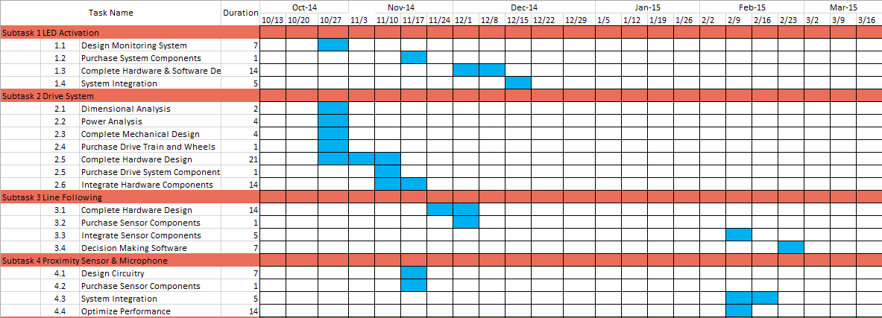
Schedule

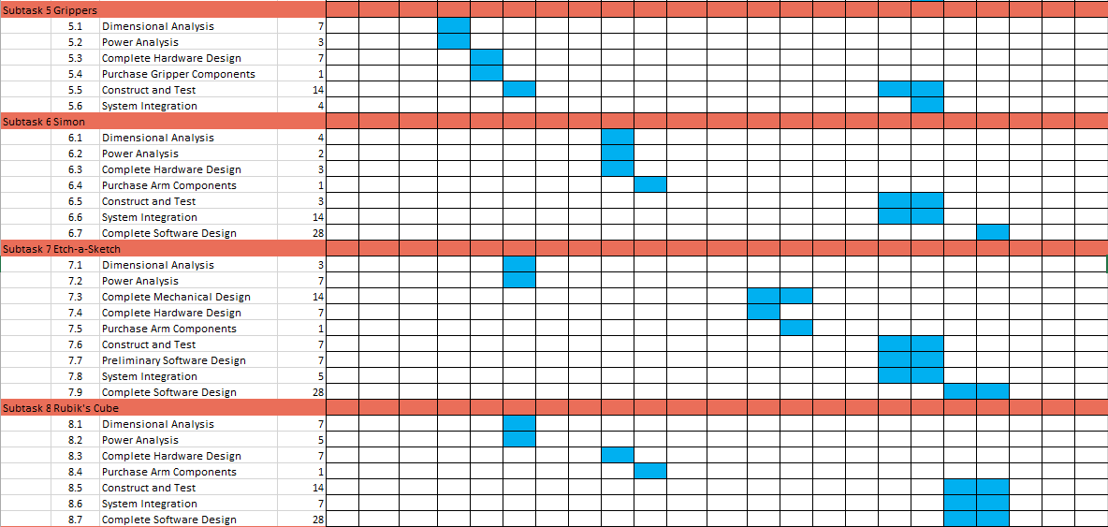
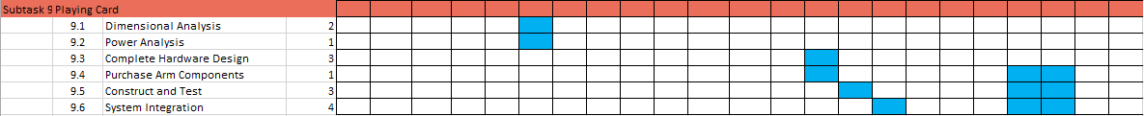

Budget Estimate



Deliverables
At the end of this project, the overall completed product will be a fully autonomous robot that meets all of the needs and requirements set forth by the 2015 SoutheastCon Hardware
Competition rules. All parts and equipment purchased for the robot will meet the budget requirements. The delivered hardware and software will be integrated in order to fulfill the objective of the design, receiving as many points possible in competition. The goal of the team is to deliver a robot capable of competing with the other SoutheastCon team by April of 2015.
In addition to the hardware and software delivered by the team, Milestone reports and presentations will be delivered throughout the design process to the project team’s advisors and sponsors. Documentation of meetings, the budget, and details of the subsystems will also be delivered via the group blog.

References
[1] J.A. Marin, J.E. Armstrong, and J.L. Kays, “Elements of an Optimal Capstone Design Experience,” Journal of Engineering Education, January 1999, pp. 19-22.

