FAMU-FSU College of Engineering
Department of Electrical and Computer Engineering

Final Report

EEL4911C – ECE Senior Design Project I
Project title: IEEE SOUTHEASTCON 2015 HARDWARE COMPETITION
Team 1B

Student team members:
− Louis Cooper, Electrical engineering (Email: lcooper_228@yahoo.com)
− Evan Marshall, Computer engineering (Email: evan1.marshall@hotmail.com)
− Chelsea Ogle, Electrical engineering (Email: ceo11@my.fsu.edu)
− Lorenzo Smith, Electrical engineering (Email: lorenzos2291@gmail.com)
− Ivan Vargas, Electrical engineering (Email: iv11b@my.fsu.edu)

Senior Design Project Instructor: Dr. Michael Frank
Senior Design Project Adviser: Dr. Bruce Harvey
Senior Design Project Reviewer: Dr. Victor DeBrunner
Submitted in partial fulfillment of the requirements for
EEL4911C – ECE Senior Design Project
April 16, 2015

Table of Contents

Table of Contents
1 Introduction
1.1 Acknowledgements
1.2 Problem Statement
1.3 Operating Environment
1.4 Intended Use(s) and Intended User(s)
1.5 Assumptions and Limitations
1.6 End Product and Other Deliverables
2 System Design
2.1 Central Processing Unit
2.2 Sensors
2.2.1 Line Following
2.2.2 Sound Sensing
2.2.3 Distance Sensing / Object Detecting
2.3 Arms / Grippers
2.4 Drive System
2.5 Power Supply
2.6 Chassis
3 Design of Major Components/Subsystems
3.1 Overview
3.2 CPU
3.3 Drive System
3.4 Sensors
3.4.1 Starting
3.4.2 Line Following
3.4.3 Microphone for Simon
3.4.4 Object Detection
3.5 Servos/Arms/Grippers
3.6 Power Supply
4 Testing Plan
4.1 System and Integration Test Plan
4.1.1 Insufficient number of I/O ports on Microcontroller
4.1.2 Insufficient MCU Memory
4.1.3 Line Following System Failure
4.1.4 Sound Sensor/Simon Says System Failure
4.1.5 Arm Mechanism Failure
4.1.6 Gripper Mechanism Failure
4.1.7 Etch-A-Sketch Arms Failure
4.1.8 Structural Failure
4.1.9 Power System Failure
4.2 Test Plan for Major Components
4.2.1 Resource Availability
4.2.2 Team Member Scheduling Conflicts
4.3 Summary of Test Plan Status
4.3.1 Underestimation of Design Expense
4.3.2 Damage to Components or Systems
4.4 Summary of Risk Status
Qualifications and Responsibilities of Project Team
5 Schedule
6 Budget
7 Risk Assessment
8 Conclusion
9 Appendices
10 References

Introduction

Acknowledgements

SoutheastCon Team 1B would like to acknowledge Dr. Bruce Harvey, Dr. Victor DeBrunner and Dr. Michael Frank for their astute advice and input guiding the development of the team and robot. Their involvement has helped to motivate SoutheastCon Team 1B to put forth maximum effort and to excel. The team would also like to thank the FAMU-FSU College of Engineering for their facility resources and $750.00 contribution to the project.

Problem Statement

SoutheastCon is an annual technical, professional and student conference held by IEEE. The convention features several competitions including a hardware competition in which teams build robots that perform tasks autonomously. This competition requires that the robot complete 4 different game related objectives and follow a white line course in under 5 minutes. There are 3 of these 5 minute rounds in which the team can score points. Points are awarded for completing the games and following the course. If there is a tie the victor will be determine by whichever robot completed the course faster.

Team 1B’s robot is able to recognize the beginning of the game and engage in each of the four task to gain points per round. The four tasks must be completed to gain points and may be played in any sequence. The task are rotating one face of a Rubik’s Cube 180 degrees, draw IEEE on Etch-A-Sketch, successfully play Simon’s says for 15 seconds, lastly pick up one playing card and carry it across the finish line. The team will use the resources provided by the college of engineering for advice, finance, meetings, and presentations.

Operating Environment

SoutheastCon will be providing a flat black standard plywood with taped navigation lines as a course for the robot. The location of the event will be at the Hilton Fort Lauderdale Marina Hotel in Florida. It is assumed that the competition will be held inside the Hotel which will exclude the any extreme weather conditions. The design of the robot has been influenced by the operating environment, as far as the materials used that will touch the surface. As well as following a thin line taped onto a black flat plywood. There are some unknown factors such as the temperature of the competition room and other small factors that are irrelevant to the existing design.

Intended Use(s) and Intended User(s)

The intended use of this prototype will be to compete in the IEEE SoutheastCon 2015 Hardware Competition. The prototype will also represent FAMU-FSU College of engineering. In greater detail, the prototype will be used to play the Simon Says Carabiner, draw IEEE on an Etch-A-Sketch, rotate a face on a Rubik’s cube 180 degrees, and carry one playing card across the finish line.
The intended users for this prototype will be SoutheastCon Team 1B. Team 1B will use this prototype as the capstone for the engineering program under the ECE Department. The complete design process will incorporate all engineering principles and knowledge gained over the past years.

Assumptions and Limitations

Assumptions: Environment lighting will be feasible for the competing prototype. The sound from the audience during each round will be quiet. The temperature inside the room will be close to 25 degrees Celsius. There will be time to do final checks and test prior to competing. The final rules will be sent out two months prior to completion. Each item for the game will be in new condition. There will be time in between each round to charge or swap the power source on the prototype. Points will not be taken away for not placing a game back in its original position after playing it.

Limitations: Robot must be completed before the competition. There will also be a time limit of 5 min to gain the maximum amount of points per round. The budget from the College of Engineering will be $750. The size of the robot may not exceed 1x1x1 ft. The prototype may not communicate with anyone or anything outside of the course. The prototype may not split up into separate pieces. The prototype may not be remotely controlled. The prototype cannot contain any flammable liquids, gases, or explosives. The prototype cannot project anything inside or outside of the playing field. The prototype may not present any danger to the judges, spectators, and/or the playing board.

End Product and Other Deliverables

The final project is an autonomous robot that operates for at least three 5 minute rounds with the rules and regulations of the SoutheastCon 2015 Hardware Competition. Successful project management ensured the robot parts and equipment met the budget requirement, the work force was distributed to a qualified member of the group, and a detailed schedule guided the design process. The group was required to complete the project before the internal competition in March 2015. All hardware and software necessary for the operation of the robot, as well as the user manual make up the essential deliverables of the project. The final robot is capable of doing all of the following autonomously during each round: following a white line course on a black background, pressing the center button on a Simon Says game and guessing a color, writing “IEEE” on an Etch-A-Sketch, twisting one layer of a Rubik’s cube 180 degrees, and picking a playing card up off a deck and carrying it across the finish line. In addition to the main hardware/software, the deliverables include all of the project’s reports and presentation, the website for the project and all other project documentation. The goal of our design project was to deliver a robot that will receive maximum points in the competition.

System Design

Central Processing Unit

The microcontroller that will be used for the final project is the Arduino Due. The reasons for selecting this microcontroller includes cost, performance and ease of use. The Due price fit the budget requirements. The pin count of arduino due was a factor valued heavily in the selection of the due. The Due is capable of handling all of the interfacing needs of the project. The interfacing will in short connect all circuits to the Due. This will include all of our different systems, the drive system, different servo configurations for different arms and sensors.
Table 2.1a - Overview of the Arduino Due
Operating Voltage | 3.3 V
Microcontroller | AT91SAM3X8E
Input Voltage | 7-12V recommended
Digital I/O Pins | 54 with 12 being PWM
Analog Input Pins | 12
Analog Output Pins | 2
Flash Memory | 512 KB
Clock Speed | 84 MHz

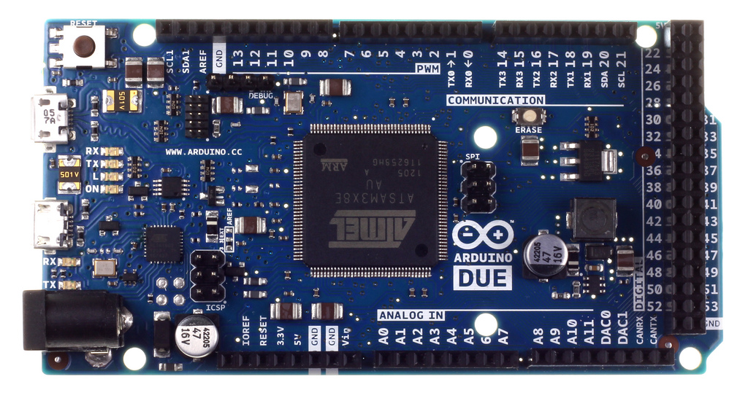
Figure 2.1a - A top view of the Arduino Due

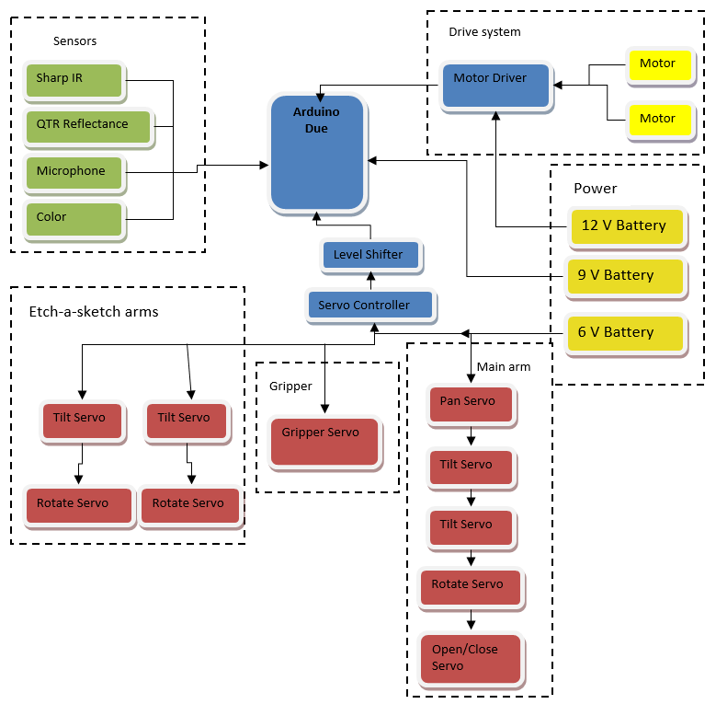

Figure 2.1b- Top level diagram showing all of the different systems interfacing with the Arduino
2.2 Sensors

The sensors for the robot are what allows it to take in visual and audio information from its surroundings, allowing it to follow the course and play each of the games. Choosing simple and versatile options were a top priority.

2.2.1 Line Following

The robot had to be able to properly navigate along a white line, 0.94 inches wide, and cover it at all times. The sensor also had to be able to achieve this at various speeds and also recognize intersections. The digital sensor chosen had the ability to measure the position of the line and create smooth movements utilizing PID control. The methodology for turn recognition was to use analog readings and store them in a array using binary sequences to determine patterns and intersections. The combination of both was decided for it enables the robot to successfully navigate the course.

Pololu QTR-8RC Reflectance Sensor Array - 10$

According to the product webpage- This sensor module has 8 IR LED/phototransistor pairs mounted on a 0.375" pitch, making it a great detector for a line-following robot. Pairs of LEDs are arranged in series to halve current consumption, and a MOSFET allows the LEDs to be turned off for additional sensing or power-savings options. Each sensor provides a separate digital I/O-measurable output.

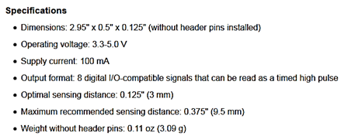
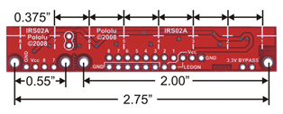
Figure 2.2.1a: QTR-8RC Reflectance Sensor Array Dimensions

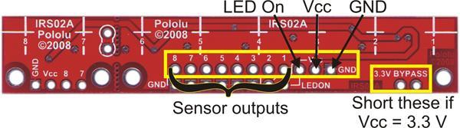

Figure 2.2.1b: Pin Connections on module

This sensor was chosen for multiple reasons. Its 8 independent outputs made it easy to cover more than the 0.94” line. The module was also be accompanied by two additional line sensors (the Pololu QTR-1RC) for additional coverage and accuracy. The smaller (IR LED/phototransistor pair) modules were used to cover the outsides for right and left turn detection. The main array placed in the middle was used to read the position of a line and can be programed to correct itself (via PID control). Its drawbacks were its small maximum sensing distance of 0.375” and its use of 10 I/O pins.

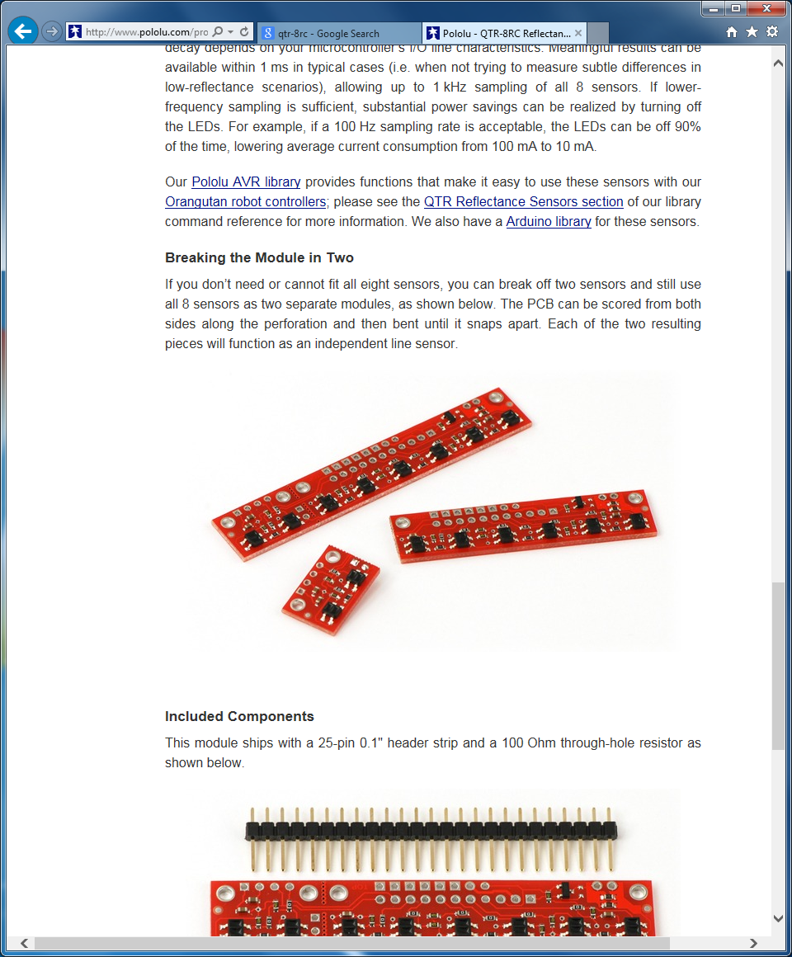
Figure 2.2.1c: Module separated into two separate components

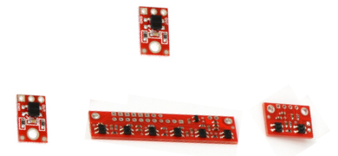

Figure 2.2.1d: Positioning of all line following sensors
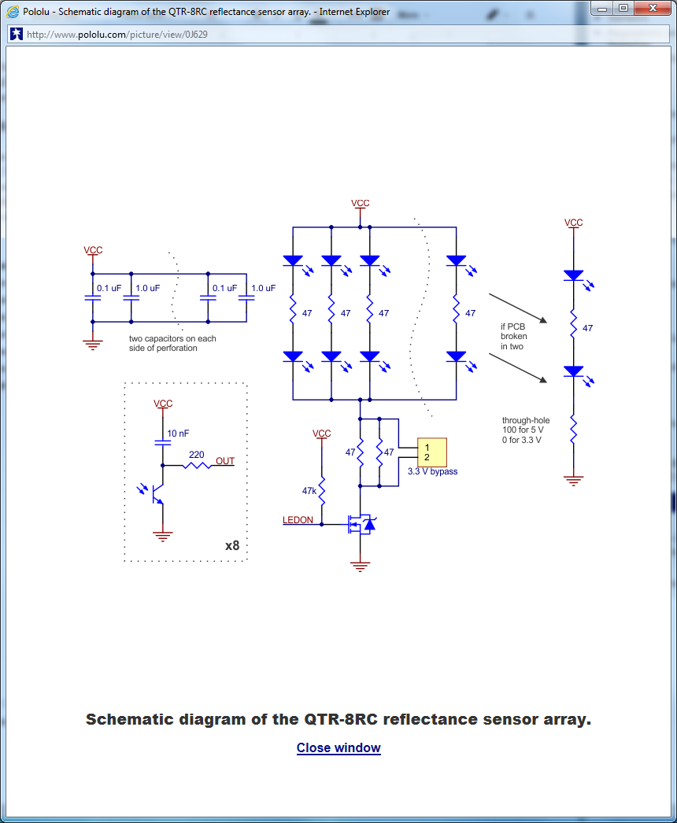
Figure 2.2.1e: Schematic diagram of the QTR-8RC reflectance sensor array

2.2.2. Start LED
The robot had to start the course after detecting a when a red LED had shut off. To accomplish this, a mini photocell light sensor was used. Only needing 5V, it was very small, simple to integrate, and gave analog readings easily distinguishable.
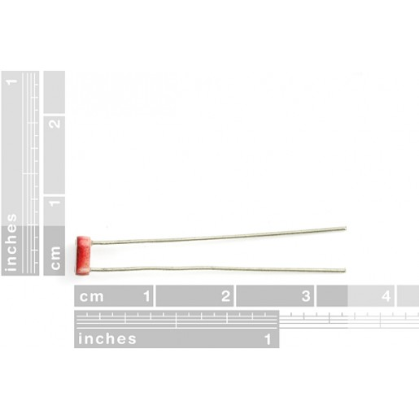
Figure 2.2.2a: Mini Photocell Light Sensor Dimensions

2.2.3 Distance Sensing/Object Detection
In order to locate the games properly, some form of detection had to be added. The sensor chosen informed the robot of the game’s location relative to it. With the proper response, the robot went on to continue and execute the proper game playing sequence with accuracy.

Since the order of the games will not change, a camera would have been over-designing. The use of an ultrasonic range finder was also considered, but its minimum distance and reliability would cause too many problems. The chosen idea was to used a IR, optical range finder, to serve as the robot’s “eyes” , to detect its position relative to each game. The range sensor was used to accurately get into position to precisely play each games.

Sharp GP2Y0A41SK0F Analog Distance Sensor 5V - 10$

From the product webpage - The GP2Y0A41SK0F Sharp analog distance sensor features a detection range of 1.5″ to 12″ (4 cm to 30 cm). The shorter range gives you higher resolution measurements, and the lower minimum detection distance makes this sensor great for detecting very close objects. The distance is indicated by an analog voltage, making this sensor very easy to use.

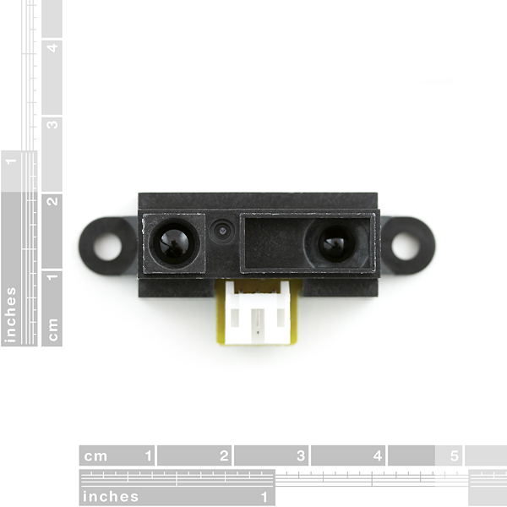

Figure 2.2.3a: GP2Y0A41SK0F Analog Distance Sensor w/ Dimensions

Feature summary
- Operating voltage: 4.5 V to 5.5 V
- Average current consumption: 12 mA
- Distance measuring range: 4 cm to 30 cm (1.5″ to 12″)
- Output type: analog voltage
- Output voltage differential over distance range: 2.3 V (typical)
- Update period: 16.5 ± 4 ms
- Size: 44.5 mm × 18.9 mm × 13.5 mm (1.75″ × 0.75″ × 0.53″)
- Weight: 3.5 g (0.12 oz)

This sharp analog distance sensor was used for accurate detection of objects. It allowed the robot to precisely slow its speed, then eventually stop, when within a certain range; around 4”. Once it became close enough, the robot began to execute the proper game playing sequence.

2.3 Arms/Servos
In order to complete the individual tasks, several mechanical appendages were constructed to manipulate the toys. Several options for these robotic arms/grippers were considered to find the best solution. The factors that went into consideration include compatibility, cost, and robustness.
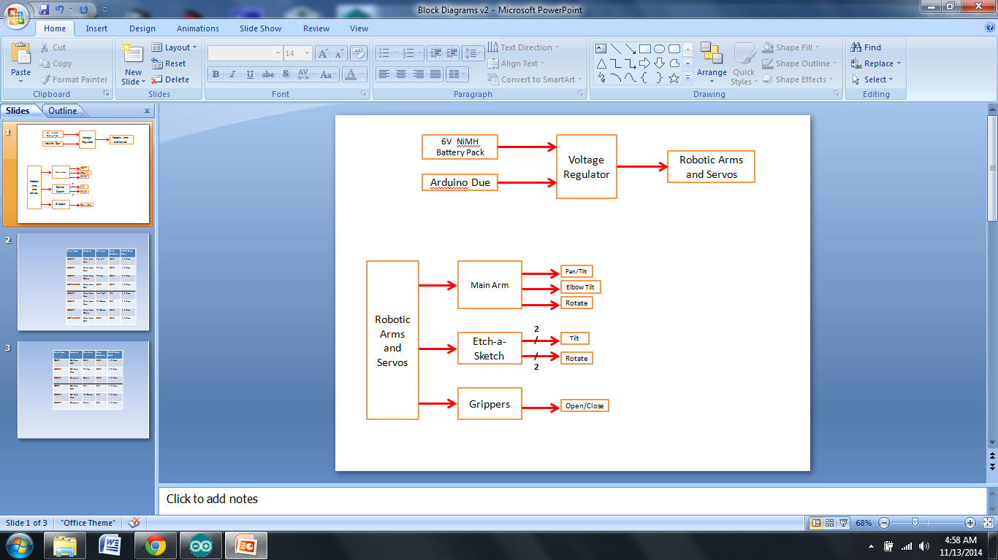
Figure 2.3a: Top Level Diagram for Arms/Servos

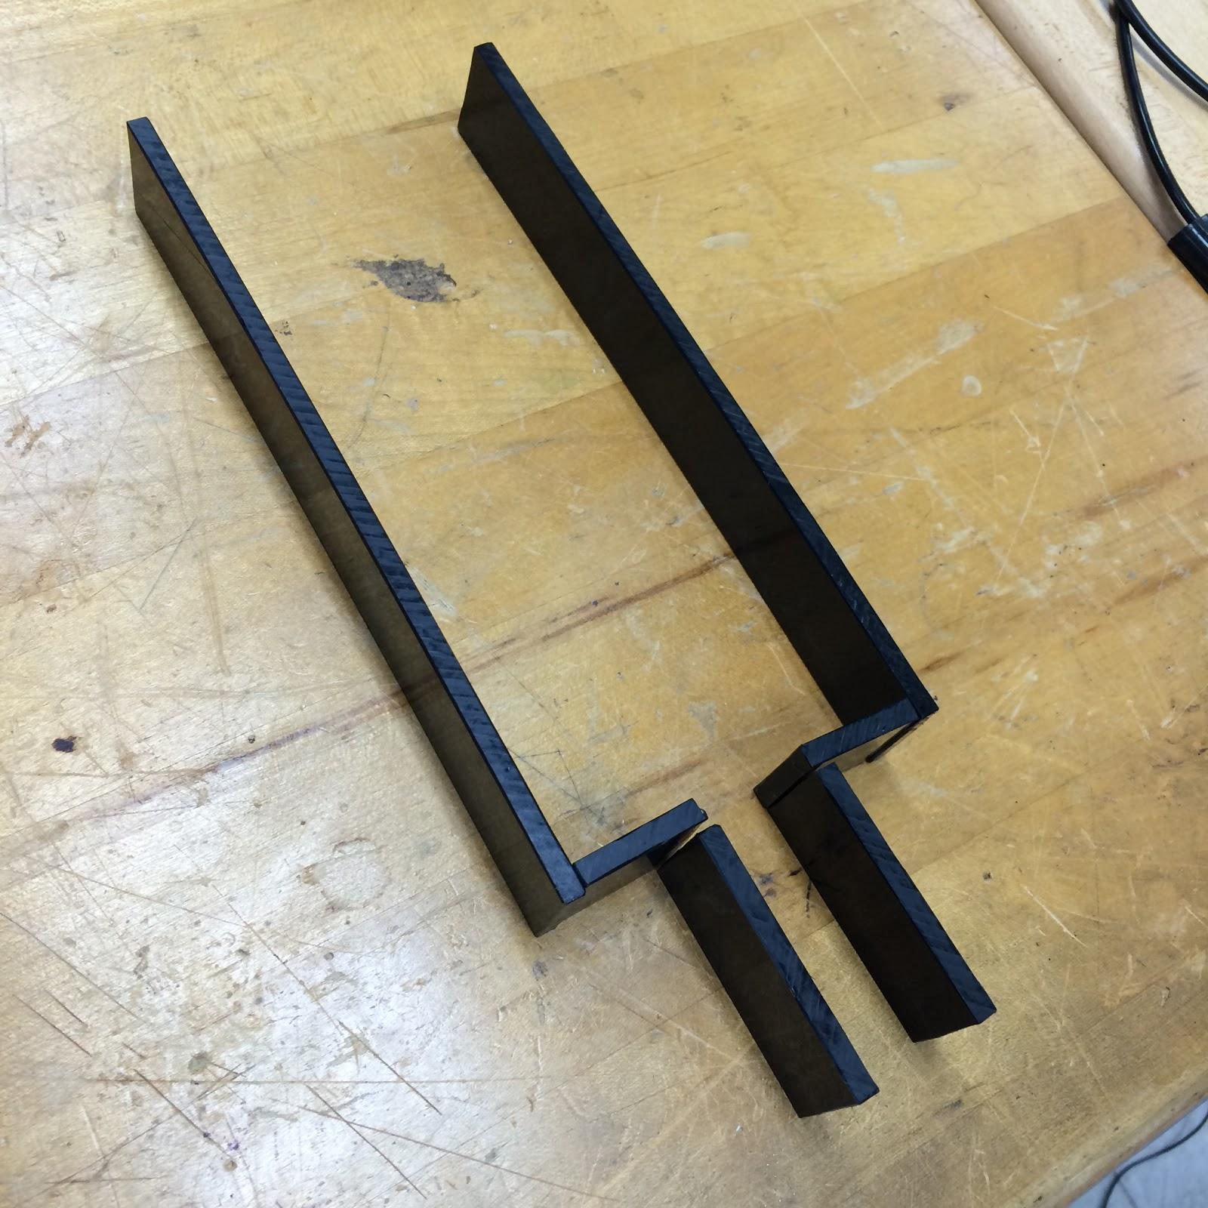
Grippers:
The design includes a gripping mechanism to hold all of the toys in place. The grippers consist of the Little Gripper Kit from Lynxmotion (LGK) and High Density Polyethylene (HDPE) cutouts to increase the range. The grippers open and close based on the servos position. An appropriate servo was purchased and tested for system integration, with a standard cheap servo like the HS-422. The LGK gripper were made of HDPE with a gripping foam material on the inside. The actual length of the grippers ended up being shorter than the figures shown to the right and below.
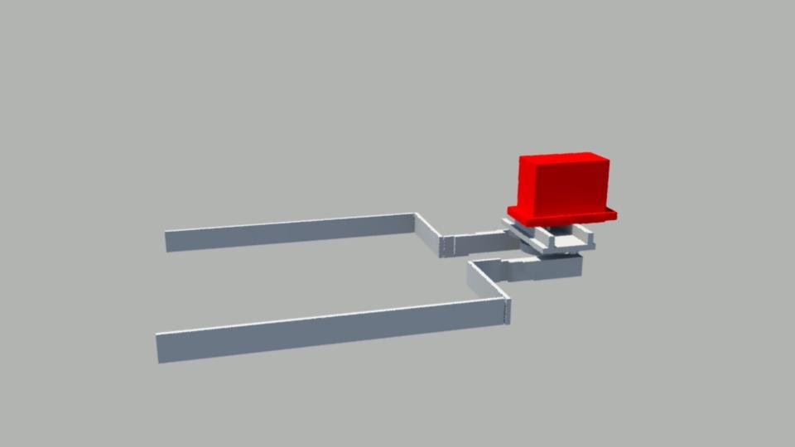

Figure2.3b: Gripper End Piece 3D model - left, Actual Piece -right
Main Arm
To complete the Rubik’s Cube challenge, Simon challenge, and the Playing Card challenge, a large servo-controlled arm cooperates with the sensors and grippers. Grippers hold the cube in place while a main arm tilts down and twists the top two layers of the Rubik’s cube. The arm is able to pan and tilt by standard servos at the base. Attached to the end of the mechanical arm is a rotating pair of tongs. The tong shape will be positioned over the cube and a continuous rotation servo will twist the top layer. Flat surfaces will catch the corners early and produce a strong enough grip to twist the cube. An adhesive was placed on the inner brackets for the card challenge instead of purchasing another arm. The card must be secured and in usable condition in order to complete the challenge.

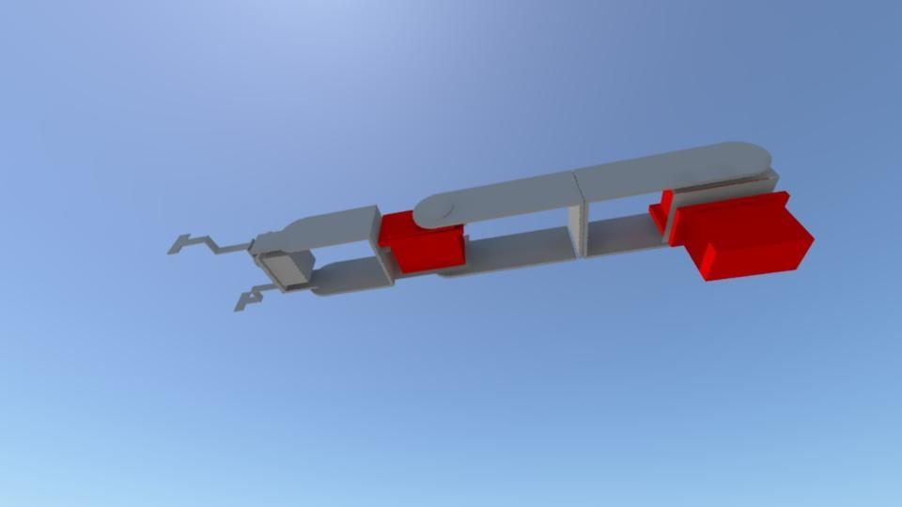
Figure 2.3c: Main Arm 3D Model

Etch-a-Sketch Arms:

The last challenge, Etch-a-Sketch, has two additional mechanical arms with custom end-pieces to twist the knobs. Standard servos were used for the tilt motion and the continuous rotation of the knobs. A subroutine was used to draw the letters and complete the challenge. Two independent arms shorten the time taken by manipulating both knobs instead of transitioning from one to the other. The Grippers also hold the game in place.
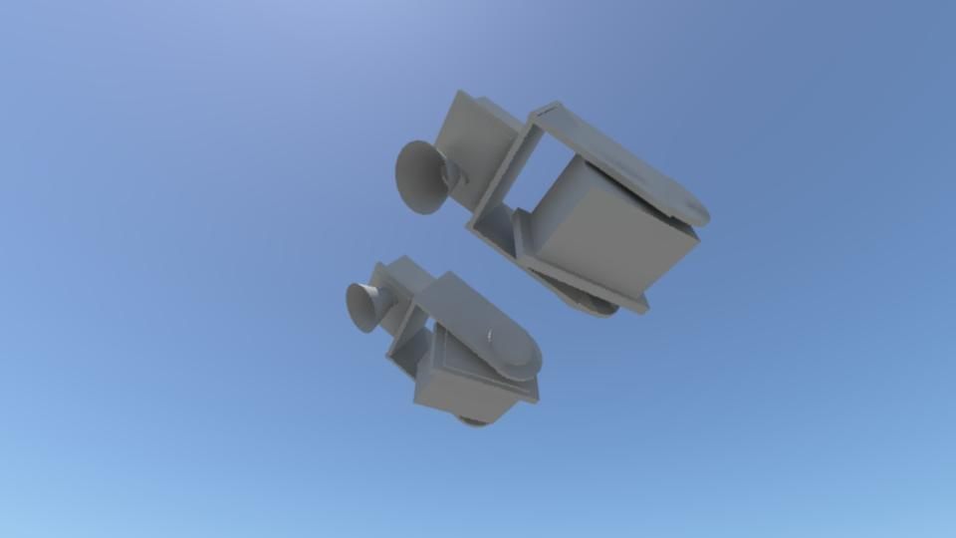
Figure 2.3d: Etch-A-Sketch Arms 3D Model

All of the servos are controlled using a Mini Maestro servo controller.

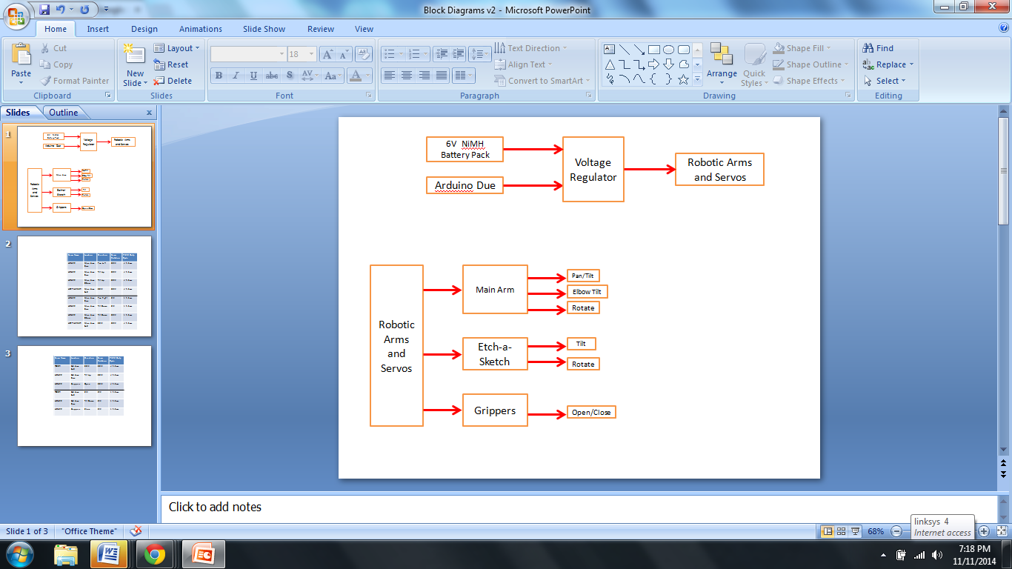
Figure 2.3e: Top-Level Diagram for Powering Servos/Arms

Drive System
The drive system used in the robot’s design is a differential drive system. There are two motored wheels positioned at the center of the bottom layer of the chassis (and a little towards the front). This differs from the placement in the 3D models, as it was a decision made later, and will be discussed in a later section. The motors chosen to power these wheels were two 12V 50:1 Metal Gearbox motors, with 64 CPR encoders. The motors are mounted to the chassis using universal mounts from Pololu. The wheels connected to the motors are also from Pololu, they are 90x10mm plastic wheels with silicone tires for grip. The motors chosen have more than enough power to ensure the robot’s mobility(calculations shown in a later section), and the wheels prevent slipping on the course. Additionally, there is a two inch ball caster wheel on a swivel plate mounted on the back end of the robot, this swivels freely while the two powered motors control the robot’s direction. In order to properly control the motors and protect the MCU, a motor driver shield was chosen. The shield used in the final design is a MC33926 Motor Driver Shield for Arduino. This conveniently is placed directly on top of the Arduino Due, provides all current necessary to power each of the motors, and came with included libraries to make setting the speeds of the motors simple. The 9V power supply is connected to the Arduino Due to provide power for the logic that determines the motors’ speed and direction, while the 12V supply is hooked up to the driver shield to power each of the motors. The top level diagram showing these connections for the drive system can be seen below.
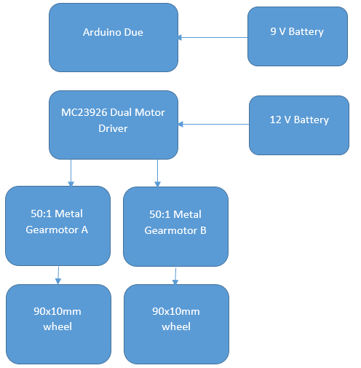
Figure 2.3: Top Level Diagram for Drive System

Power Supply

The power system is comprised of a 6V NiMH battery pack, a 12V NiMH battery pack, and a 9V Alkaline battery. There are multiple power sources because of the different voltage requirements of the subsystems. The 6V battery will power the servo array. The 12V battery will power the 2 DC brushed motors. The 9V will power the Arduino Due, sensors, and servo controller. The sensors operate at a smaller voltages and require a voltage regulator to step the down voltage from the 9V battery. The Arduino Due board has a voltage regulator and will be use to supply power to the 5V sensors and 5V servo controller.

Nickel-metal hydride batteries NiMH have been chosen because their energy density approaches that of a lithium-ion cell. The only bad side to NiMH requires long periods of time to charge with a high self-discharge rate. Lithium-ion cell are leading currently in power capacities because they have zero memory loss effect. The Alkaline 9V battery was chosen to supply the Arduino Due constant voltage throughout the entire round.
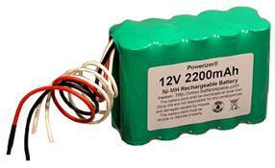
Figure 2.5a: Selected 12V Power Supply

Specs for 12V Supply
- Power Capacity 2200 mAh
- 10 (2x5) AA size 2200 mAh NiMH cells
- Power 26 Watts
- Weight 1 kg
- Discharging rate 2 A
- Charging rate 0.5-2.2 A

Discharging the battery pack below 10 V may damage NiMH. Leaving the ends of the wires uncovered; will allow the battery to improperly discharge. Power Capacity may be too close to the current being drawn upon startup of the drive motors.

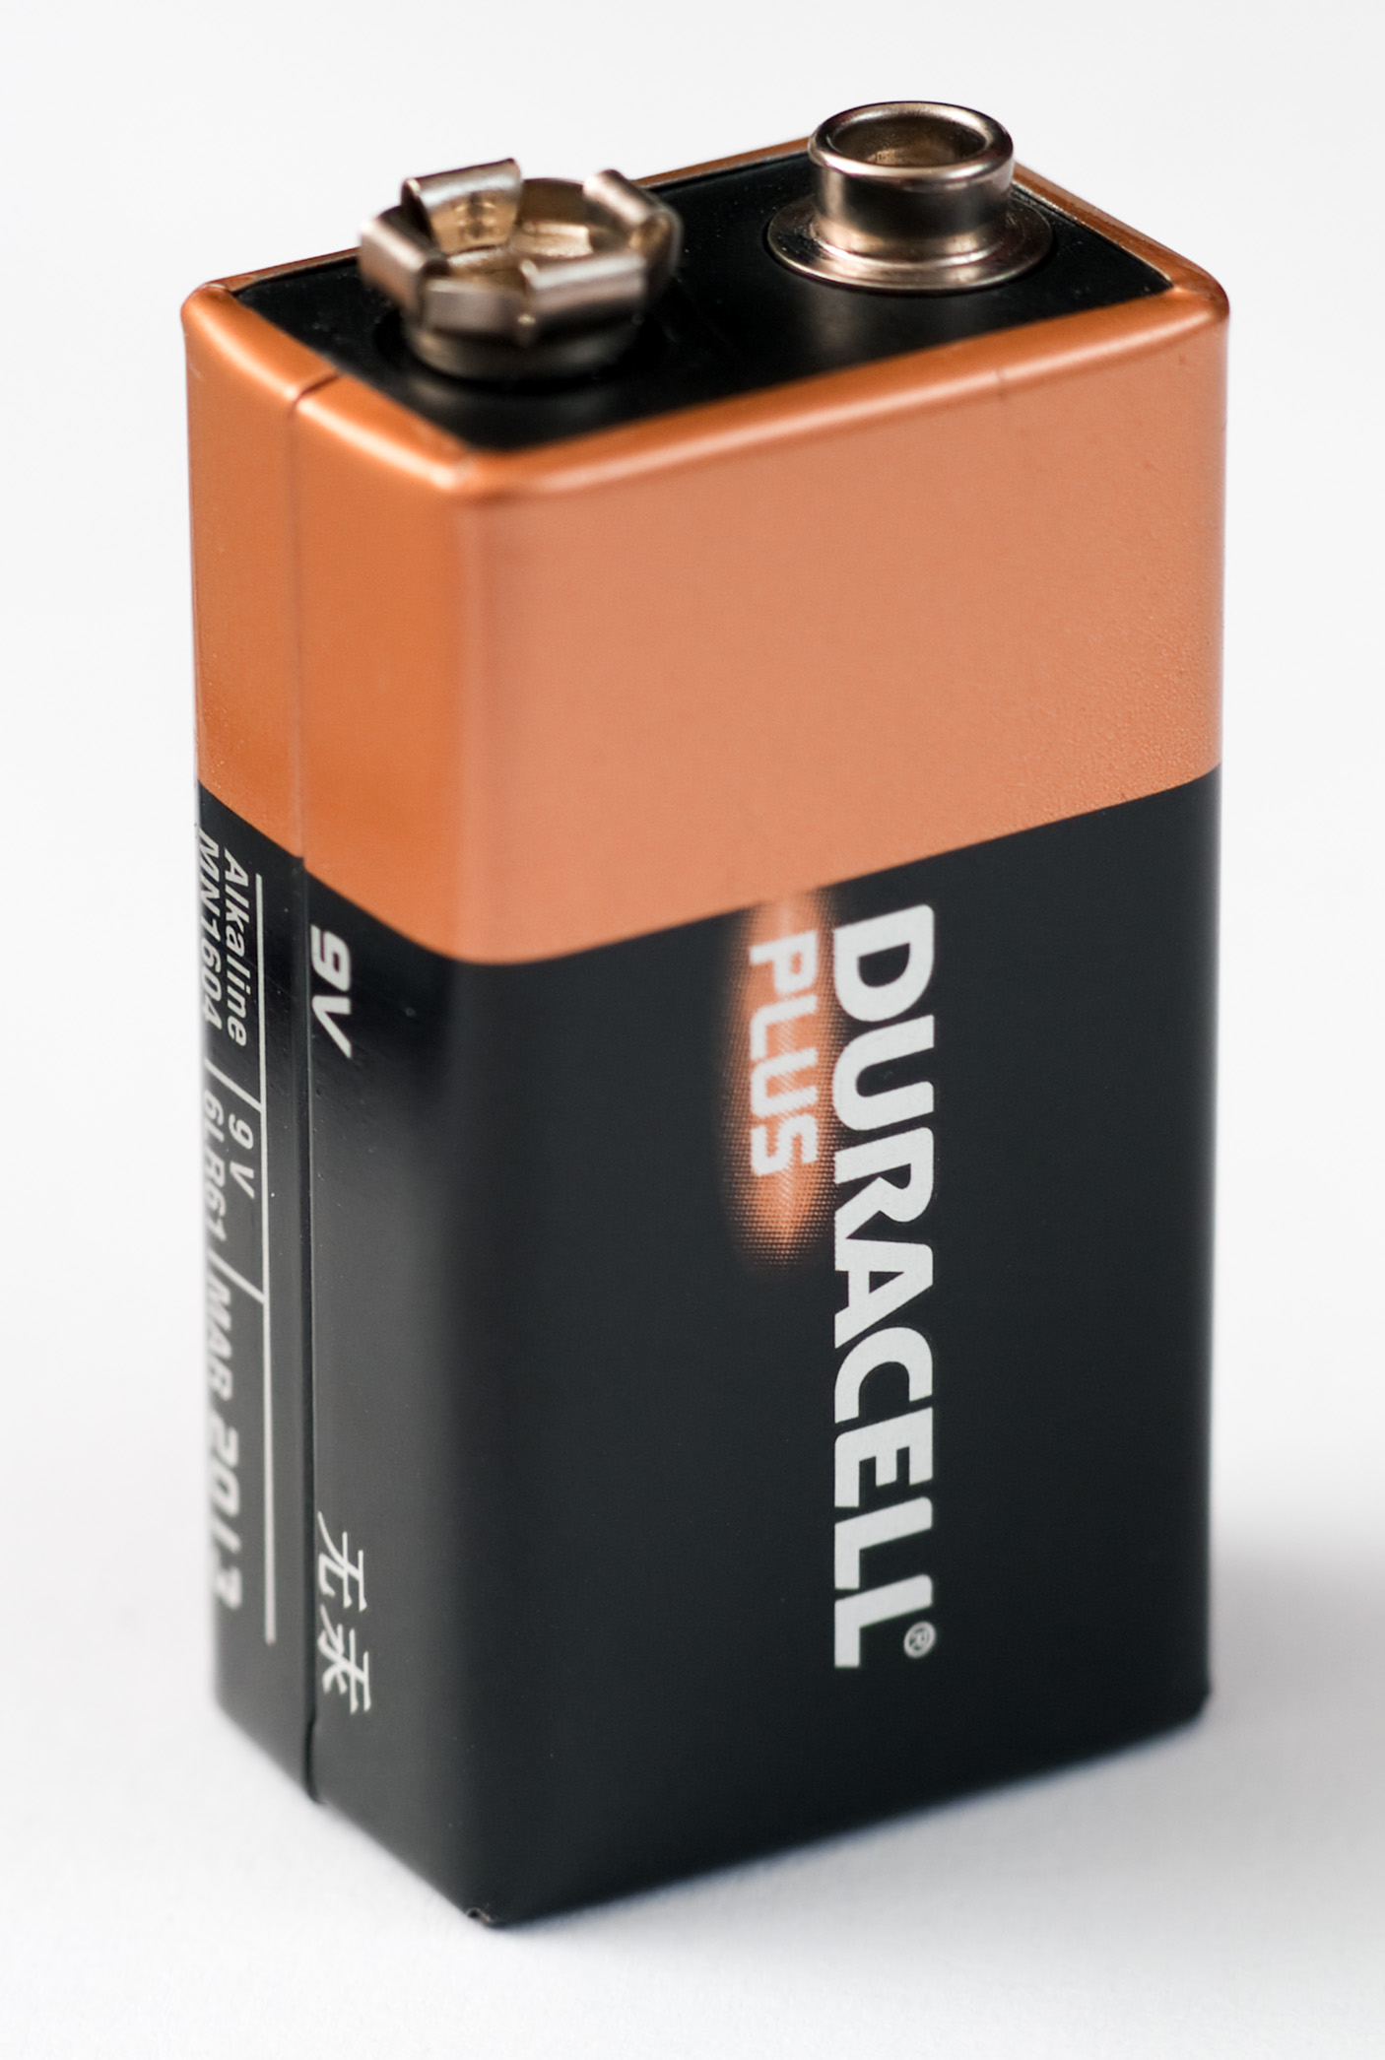
Specs for 9V Supply
- Power Capacity 1400 mAh
- Charge Cycles up to 1500 times
- Charge retention up to 12 months
- Toys usage time 240-360 minutes per charge

The Arduino Due has an operation voltage range of 7-16V ensuring the Due may handle the 9V battery’s peak voltage. The Arduino Due was selected to have a separate battery source to provide a constant power supply. When the power supply is interrupted for the Arduino Due, the MCU resets. Isolation of the Arduino Due’s power source greatly reduces that risk.

The 9V Alkaline battery was selected because the charge capacity of the 1400 mAh can easily last three rounds within the competition with time to spare. The 9V battery has a battery holder with a switch. The switch allows easy access to power the robot on and off. The 9V battery weight is also was considered with respect to the robot’s turns and acceleration.

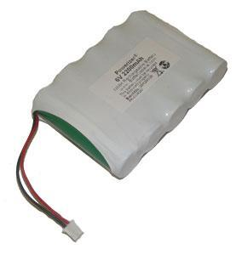
Figure 2.5b: Selected 6V Power Supply
Specs for 6V Supply
- Power Capacity 2200 mAh
- 6 Volts
- 5 (1x5) AA size 2200 mAh NiMH flat top cells
- Power 9.6 Watts
- Weight 0.14kg
- Discharging rate 2 A
- Charging rate 0.5-2.2 A

Discharging the battery pack below 6 V may damage NiMH. Leaving the ends of the wires uncovered will cause the battery to improperly discharge. The wires are too short as well and will need to be extended to provide better positioning on the chassis.

The servos have an optimal voltage range of 4.8-6 volts. The battery’s optimal voltage is rated at 7.1V falling in between both the Arduino Due and drive motors operating range. The total required current from all the servos is 1400mA giving the battery a longer life span off one cycle of charging. This was deeply desired by the group for multiple usage throughout three rounds with accurate performance.

The Arduino will act as the third power source providing the lower voltage to the sensors that operate in within the 3.3-5 volts. The voltage will actually be specified through coding to power each pin assigned to the sensors.
The 9V battery will be charged by Energizer Recharge Universal Charger. The Charger features a LCD showing a charging status. Also the charger is capable of charging the 9V battery under 3 hours.

Voltage Regulator

The voltage regulator has a lower efficiency rate, supplying voltage at efficiencies ranging between 80-90%. This will supply the sensors with a small amount of current, potentially not allowing the sensors to operate properly

The team has decided to go with one charger that will supply charge to both batteries to the cut the cost, eliminating the need to buy a charger for each power source. This gives more room in the budget to buy more power supplies (back-up batteries) to cut down on the need for charging in-between rounds. It is proposed to purchase one spare battery for each source. The charger is priced at $16.95 and is capable of charging batteries between the ranges of 6-12 V. This charger will be able to fully charge each battery within four hours.

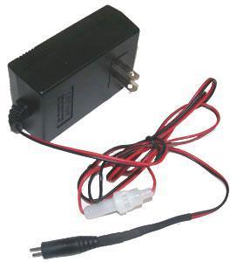
Figure 2.5c: Image of Selected Charger

In the event that the method for connecting the driver motors is changed, the male jumper can be cut off and the wires can be plugged into a breadboard or soldered to manually configure it.

Chassis

The chassis will be a two layer chassis, made of cut HDPE. The top layer of the chassis will be used to hold the main arm, as well as the batteries for the robot. The bottom layer will hold breadboard, the DC brushed motors, the Etch-A-Sketch arms and motors, the grippers and the line following system. A 3D model of the empty chassis can be seen below in Figure 2.6a, and another view with component placements can be seen in Figure 2.6b.

The robot will include two rear wheels with motors, and a caster wheel in the front for support. A line reflectance sensor array will be placed close to the rear wheels to ensure more accurate turns around the course. Another, smaller IR sensor will be placed towards the middle to detect the start LED and also double as a line follower. In front of the caster should be the object detector, used to see objects directly in ahead of the robot. The main arm, side arms, and grippers will be mounted at the front to simplify locating and playing games. The power supply and processor will be placed on the back and double as a counterweight to the components in the front. The components in the 3D diagrams used in this report will be color coded according to Table 2.6.

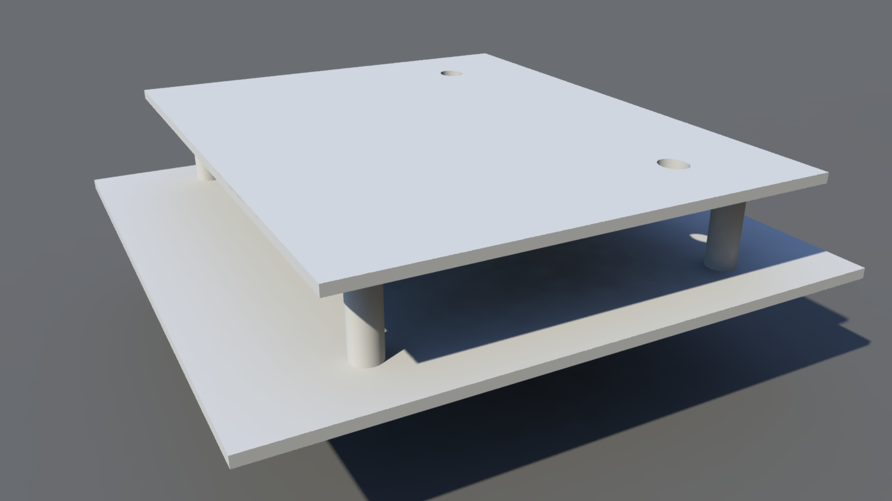
Figure 2.6a: Empty Chassis 3D Model
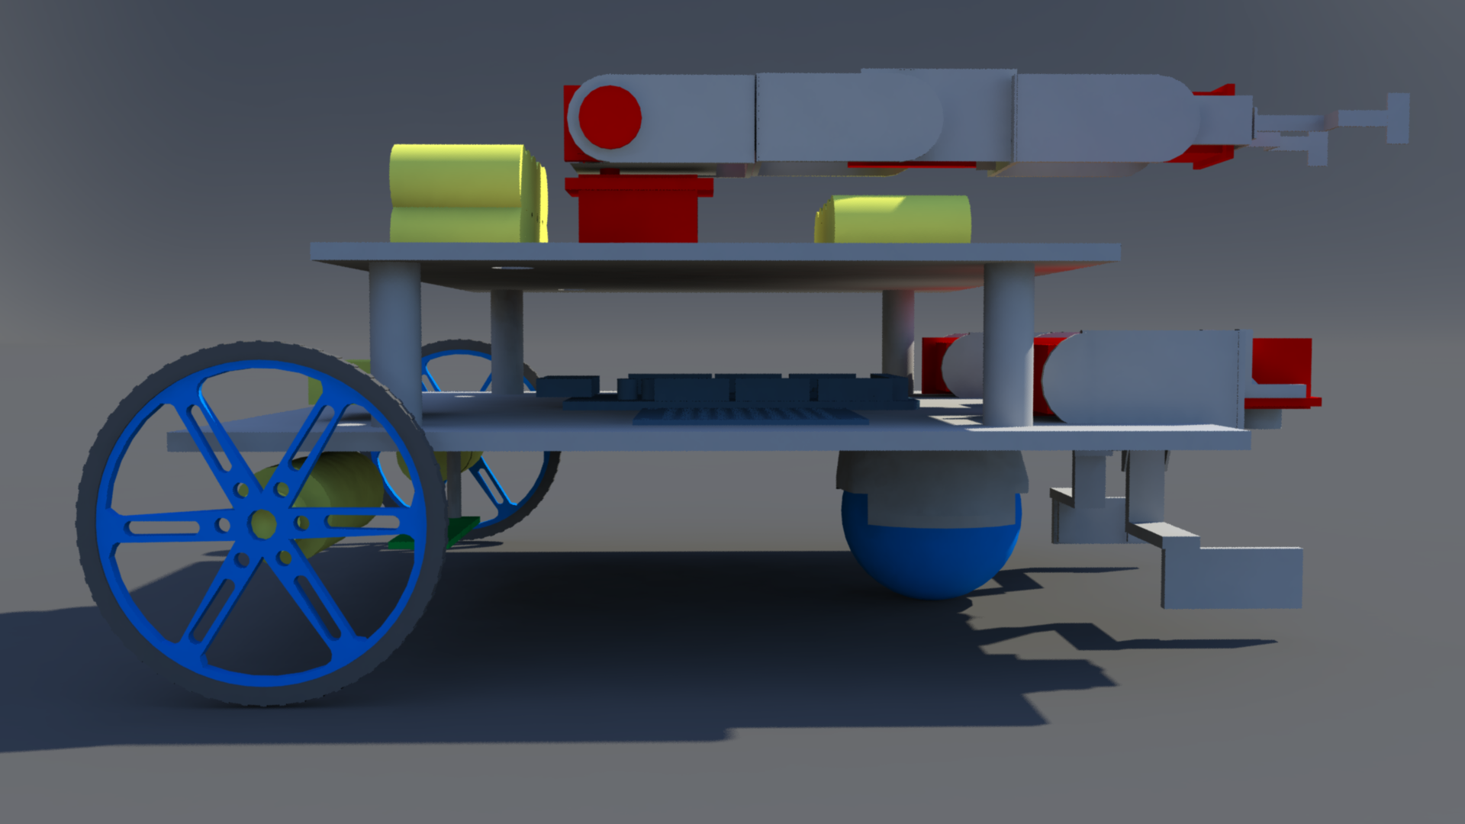

Figure 2.6b: Chassis Model with Components

Table 2.6: Color Coding for 3D Diagrams
Color | Significance
Red | Servo
Green | Sensors
Yellow | Motors/Batteries
Blue | Circuits/Microcontroller and wheel colors

Design of Major Components/Subsystems

Overview

Figure 4.1a: Top Level System Design Block Diagram
The team has agreed on a well-balanced robot. It is proposed that the robot will drive across the course using an ideal speed covering all untraveled taped course. Sensors will be used to follow the course line, start the robot based off of IR sensors, and detect sound to play a Simon, and measure distance from games. The autonomous robot will be discerning enough to recognize each game secure it with the grippers and manipulate each using the arms designated for them. The robot intelligence will also ensure its accuracy in manipulating the games to gain maximum points. The robot will be programmed to finish the four tasks as fast as possible within a five minute time limit. The robot will play three rounds and must have enough power to last all three. NiMH batteries were chosen because of their large battery capacity in theory if fully charged the NiMH batteries can withstand three rounds. The team has decided to bring fully charged spare batteries for the competition as well as the charger. The robot will have two NiMH batteries with different voltages and the Arduino board will be used to power the sensors using low voltages.

Central Processing Unit
The microcontroller that will be used for the final project is the Arduino Due. There were many reasons for selecting this microcontroller including cost, performance and ease of use. At $40 the Due was reasonably priced enough that a second one could purchased in case one is damaged. Having a second Arduino also means that multiple people can be working different parts of the project at the same time. The Due was not the most powerful microcontroller out of the selection but it is more than powerful enough for this project. There are over 60 pins that can be used on the Due which means that can handle all of the interfacing needs of the project. This will include all of our different systems including the drive system and different servo configurations for different arms being used in this project. The Arduino is also an extremely popular microcontroller. It has a large array of tutorials, custom libraries and support available for use. By having these kind of resources available it means that there will be less time being spent learning how to use the microcontroller so more time can be spent in the design and testing phase of the project. Table 2.1b shows a more detailed overview of the microcontroller.
The microcontroller being used for this project is an Arduino Due. There are 12 pins for pulse width modulation (PWM). These pins will be reserved for the servos and the DC motor control. These pins, which are numbered 2-13, can be seen on the right side of Figure 3.1a. Depending on which type of servos are eventually purchased an analog to digital converter may be needed to be put in between the servo and the PWM pins. This microcontroller operates at 3.3v so there will need to be a voltage regulator in between the motors and the microcontroller to ensure that board does not get damaged.

Figure 3.1a - Arduino microcontroller top view

Table 3.1 - Arduino microcontroller pin setup

Pin location | Sensor
Digital 22,24,26,28,30,32,34,36 | QTR reflectance sensor array
PWM 13-10 and A0-A4 | Motor Driver
A9 | Microphone
TX 18 and RX 19 | Servo controller
A6 | Color sensor
Digital 53 | Individual reflectance sensor
A8 | IR Distance sensor

The QTR-8RC reflectance sensor is being used for line following. This sensor requires 7 digital I/O pins. It is be connected to pins 22, 24, 26, 28, 30, 32, 34, 36. These pins all sit next to each other as seen in Figure 3.1a. Having all of the reflectance sensor pins in a row allows for easier management. The individual reflectance sensor for determining whether to turn left or right on the course also requires a digital I/O pin. This is located at pin 53.
Most of the pins being used on the board are digital pins of some kind but there are a couple of analog pins being used. There will be 1 analog input pin, A9 that will be used for the microphone. The microphone will be used for determining what note is being played by the Simon game. By figuring out what pitch is being played the Arduino can tell the appropriate servos to turn and click the corresponding button on the game. The color sensor for the red LED and the IR distance sensor also require the use of analog pins. The motor driver is unique in the fact that it uses both digital pins and analog pins. The mini maestro uses the serial communication ports 18 and 19 to communicate with the Arduino. Figure 3.1b - Flow chart showing how the code will branch

Initial code
Rubik's Cube
Simon Says
Etch-a-sketch
Playing Card
Line follow and distance
Game+
Game+
Game+
Final code
Game+

Programming will be an integral part of this project. The flowchart in Figure 3.1b shows a brief overview of the code will be broken up and worked on. First there will be an initial branch of code calling all of the proper libraries and setting up some known variable such as the different servos. This will be done in 2 different files which will be a games.h file and a main.cpp file. The main.h file will have the code for line following, object detection, detecting the start and what the robot should do once it passes the finish line. All of the game functions will also be called in the main.cpp file. The games.h will have the definitions for the game functions. So the actual servo movements and controlling will be done inside of the games.h file while the main.cpp simply calls whichever game function is needed at the time. These two files will be consist of the initial branch. There will be different branch for each game coming off of the games.h file. So each game function will be constructed independently of each other. Here the main priority will be getting the servo movements working under perfect conditions. For example the Etch-a-Sketch function will have the servos spins so that IEEE is written on the Etch-a-Sketch. A separate branch will be made for the main.cpp file where the line following and game detection will be initially worked on. Once this first section of the main.cpp and a single game function is finish the two files will be combined and tested. So the robot will show that it can clearly follow a line, find a game and play it correctly. As more game functions are completed they will be added to the main branch one by one. By the time all of the branches are added the robot should be able to adequately start by itself, follow a line, detect and correctly play all 4 games and cross the finish line. The only thing left to do with the code once the main branch the only thing left to do with the code is try to make the code smaller and have the robot complete the games faster.

Drive System

The drive system is comprised of three major components working together in order to create all of the movements necessary for the robot’s navigation. The components are the Arduino Due, the Pololu Dual MC33926 Motor Driver Shield for Arduino and two DC brushed motors. The shield makes it easy to control two brushed DC motors with the Arduino Due. It operates between 5V and 28V, and is capable of delivering a continuous 3 A to each motor channel. It is capable of regulating the current to the motors automatically, and protects the microcontroller from reverse-voltage, over-voltage, short-circuit and over-temperature conditions. The DC motors chosen operate at 12V, and the measured value for the current drawn while they are operational was found to be 0.3A, so the motor driver chosen is capable of providing enough power. Additionally, the stall current of each motor is 5 A, and the motor shield is capable of delivering a 5 A peak. The PWM frequency used by the driver is 20kHz. The Arduino Due is easily programmed using libraries available with the motor driver in order to change the speed and direction of each of the two motors (independently) to power this differential drive system. The line following system determines the direction the robot needs to turn in order to follow the course, and calls the functions to set the motor speed/direction with the speed (positive value for forwards, negative value for backwards) as an argument.

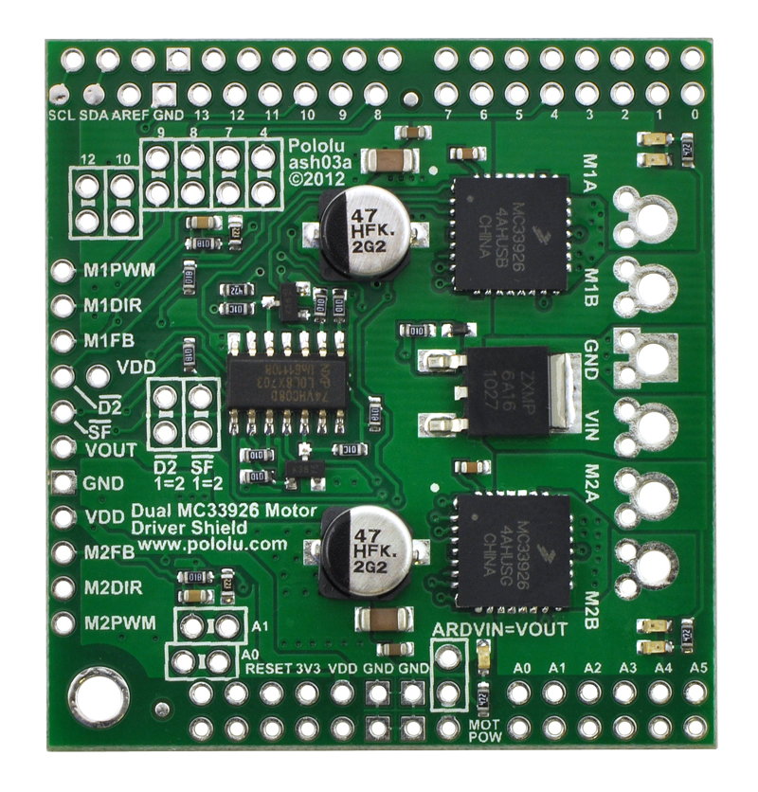
Figure 3.3a: MC33926 Dual Motor Driver Shield for Arduino, Top and Bottom View
The motors chosen are 50:1 Metal Gearmotors with 64 CPR encoders, which can optionally be used in order to provide feedback to the microcontroller about the velocity of and the distance travelled by the motors to aid in navigation. At 12V, the motors chosen have a no-load speed of 200 RPM, and stall torque of 170 oz-in, which should be more than enough to move the robot at the desired rate. The RPM and the wheel radius will allow for a max speed of around 1 m/s. The motors chosen were more powerful than necessary, as the weight of the robot was uncertain at the time of their purchase. Additionally, in order to ensure the balance of the robot with the design, the team considered adding counterweight, and wanted to ensure the motors would be powerful enough to accommodate that. With an estimate of 10 kg for the mass of the robot, and 0.5 ft/s² acceleration (half of the desired velocity of 1 ft/s), along with the wheel diameter, an estimated torque of 11.8 kg-cm was required for one motor to power the robot. This calculation was done with the following equation, where the efficiency is 58% (68% generally for DC motors, deducted an additional 10% to account for frictional forces/other unknowns).
torque = (mass)(acceleration)(wheel radius)(1/efficiency) (1)
The motors are connected to two Pololu 90x10 mm plastic wheels with silicone tires for grip. The wheels are attached to the motors using a universal mount also by Pololu. The motors are placed in the middle of the robot, on the first layer of the chassis. Initially, the motored wheels were to be placed at the back of the robot, with the caster wheel in the front in order to ensure enough room for the arms and to maintain the balance of the robot. However, with this configuration, the line following sensors were placed at the back of the robot. This was problematic for navigation, as the robot could not properly straighten out with the line following decisions being made from the back end of the robot. The team decided to switch the positions of the caster wheel and the motored wheels in order to improve navigation. Initially, there was concern that this would get in the way of the arm/gripper mechanisms and put the robot off-balance, but when the change was made neither of these concerns were a problem. A ball caster wheel was chosen in order to minimize potential navigation errors due to the caster changing positions after turns.
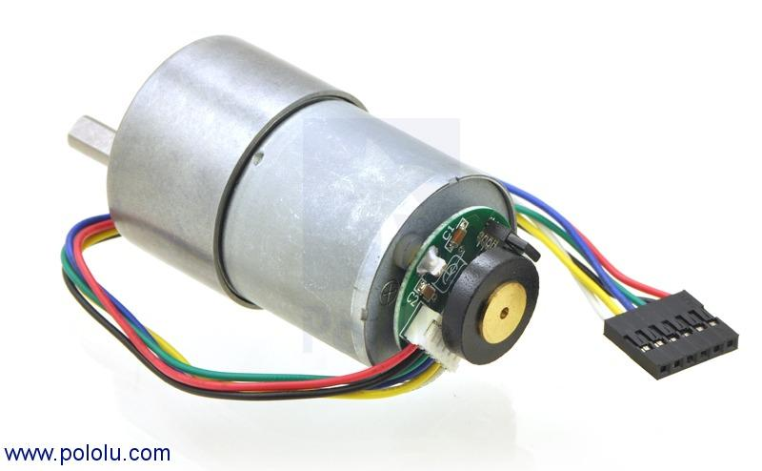
Figure 3.3b: 50:1 37D Metal Gearmotor with Encoder

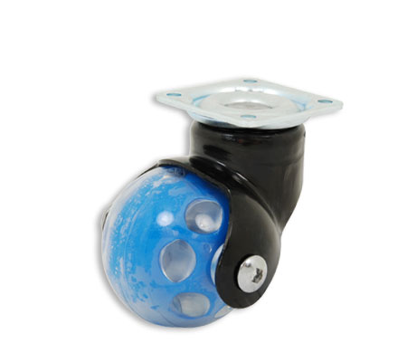
Figure 3.3c: 2" Ball Caster Wheel with Swivel Plate
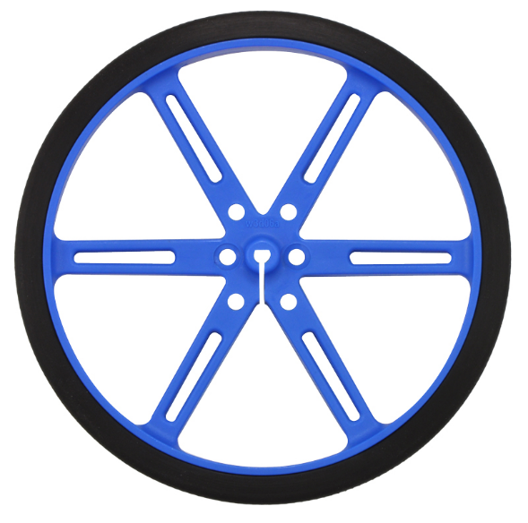
Figure 3.3d: Pololu 90x10mm Plastic Wheels

With all of these components, and the 12V battery source for the motors, the drive system operates as a differential drive system.
Microcontroller, motor driver shield and DC motor integration
The Arduino Due microcontroller is used for sending digital signals to the motor driver shield. There are twelve pins on the MCU with pulse width modulation, two of these are be used to power the motors, hooked up to the shield. The MC33926 Dual Motor Driver Shield for Arduino was created specifically with the use of Arduino microcontrollers in mind, designed to connect directly to the board and use the libraries already written for the Driver Shield, which have explicitly been tested with the Arduino Due. Stackable extended female headers were included to extend the pins the shield covers, so they can still be used easily. It was designed specifically for the application of controlling two higher voltage DC motors. The driver itself is powered by the Arduino, using the 5V output and the ground. The 12V power source for the motors is connected directly to the driver shield. The connections for the system can be seen in the figure below, where M1DIR and M2DIR are the logic pins that determine motor direction, M1PWM and M2PWM are the necessary PWM pins to power the motor, SF is that status flag indicator which detects faults, D2 disables the motors if there is a fault, and M1FB and M2FB are the current sense output.
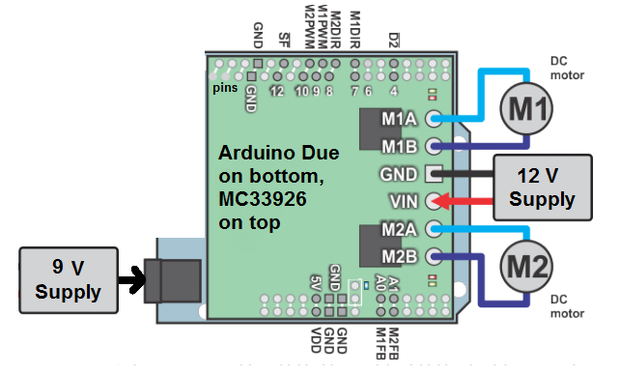
Figure 3.3a: Pin Connections for Drive System (modified Diagram from MC33926 User Manual)
There are libraries available to work with the motor driver shield that allow for the motors’ speed and direction to be controlled with code such as the example code that is included below. The line following system calls the function for each motor with a single parameter- the desired speed as a signed integer, with the negative values representing a reverse direction.
Psuedo Code for Drive System
Void SetMotor1Speed (int speed)
{
Init()
boolean reverse ß 0

if (speed < 0)
speed ← -speed
reverse ← 1
if (speed > maximum speed)
speed ← maximum speed
#ifdef MC33926MOTORSHIELD_USE_20KHZ_PWM // defined in libraries, send //speed to motor
OCR1A ←speed
#else
analogWrite (_M1PWM, speed * 51/80)
// case for if either speed was negative (exclusive) or _flipM1 was active
If (reverse xor _flipM1)
digitalWrite (_M1DIR, HIGH)
else
digitalWrite (_M1DIR, LOW)
}
The same code applies for motor two, swapping out M1 for M2. Feedback from the line following system would determine the speed, and from its sign, the direction (the variables speed and reverse in the code), a table below depicts this. The variable “reverse” is 1 for the backwards direction of the motor. Additionally, a timing diagram for the input/output of the motor driver shield can be seen below for the various functions.

Table 3.3: Variables for Drive System Operation
Operation | M1 speed | M1 reverse | M2 speed | M2 reverse
Left Turn | 0 | 0 | speed > 0 | 0
Hard Left Turn | speed > 0 | 1 | speed < 0 | 0
Right Turn | speed > 0 | 0 | 0 | 1
Hard Right Turn | speed < 0 | 0 | speed > 0 | 1
Forward Drive | speed > 0 | 0 | speed > 0 | 0
Backward Drive | speed > 0 | 1 | speed > 0 | 1

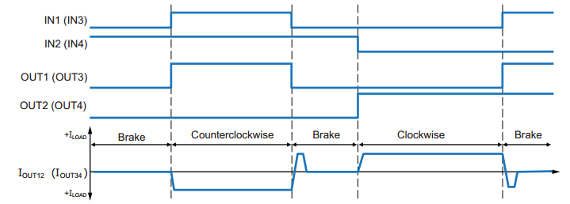
Figure 3.3b: Timing Diagram for Brushed DC Motor Input and Output Sequence

Sensors

The sensors for the robot were split into 3 different categories: starting, line following, and object detection. All sensors chosen were fairly cheap and simple to implement, making replacement a good possibility for a contingency plan. The overall code and sensors were equally important because they dictate where and what the robot did next. The concept for the code was to start, then execute a line following loop until the digital distance sensor came within range of the first game, execute the function for the game, increment a counter to decide which game was next, and once finished the last game; cross the finish line and stop.

Overall Loop

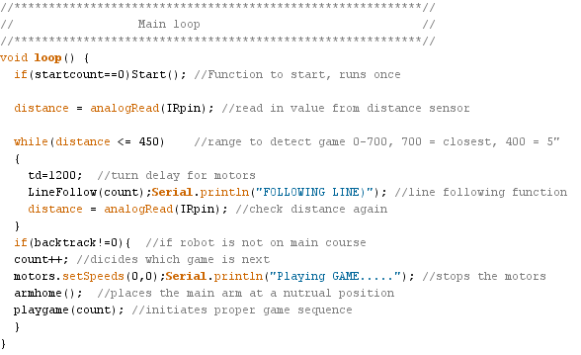
Figure 3.4.1a: Overall Code Layout

3.4.2 Starting LED Sensor

The robot had to begin in a white 1’x1’ square and detect the shut off signal of a visible flush red LED. In order to achieve this, the mini photocell light sensor was be placed around the midpoint of the robot. The sensor then recognized the off signal and alerted the processor by detecting a change in the light. The robot then moved forward, about a foot, and then began to navigate the course.
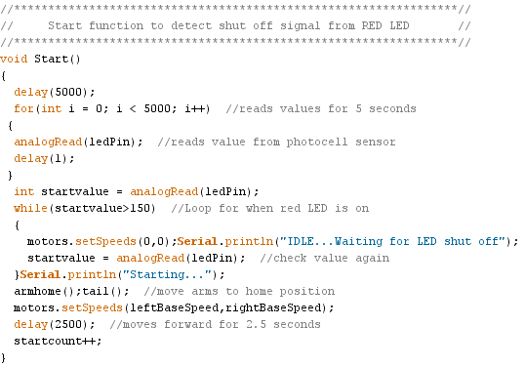

Figure 3.4.2a: Code Block for Start Sequence

3.4.3 Line Following

The robot had to navigate a 0.94” white line varying each round. The 6+2 sensor array (QTR-8RC) and two QTR-1RC were used to accomplish this task. The larger module was placed near the rear, by the motor controlled wheels, for accurate turns. The risk of detecting the white block late, due to the position of the sensor, did not pose a problem because the games were allowed to be moved to the very front of each playing zone. It was also able to detect intersections and other complex course structure until it reached the finish point by utilizing different cases (turn scenarios).

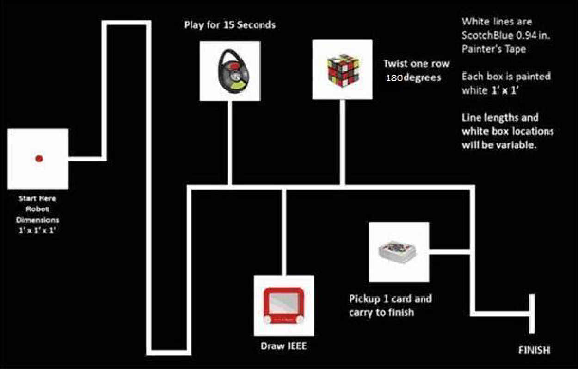

Figure 3.4.3a: Competition Course
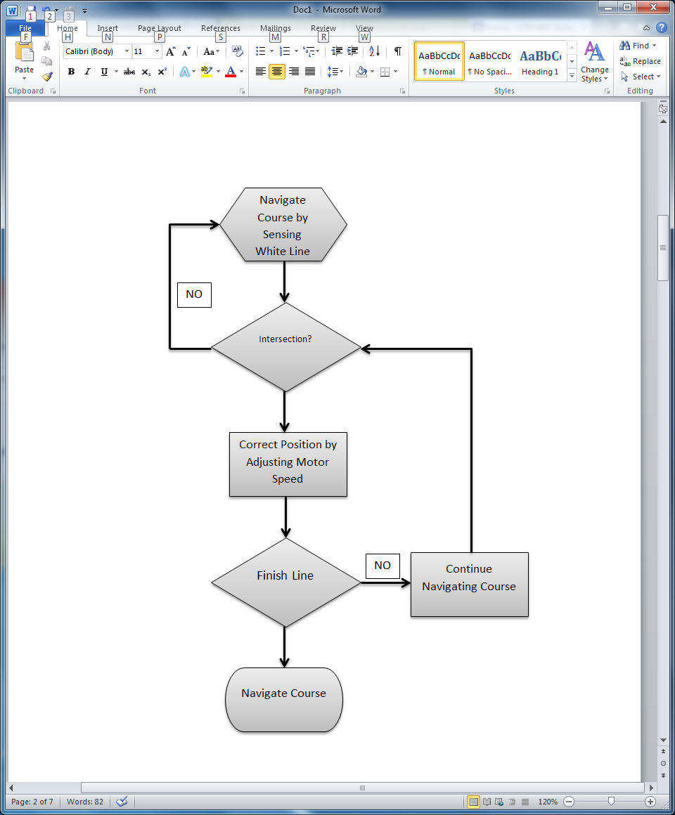

Figure 3.4.3b: Sequential Block Diagram for Line Following

The sensor’s 8 outputs were connected to 8 digital pins of the processor. The sensor’s LED output will also be connected to a digital pin and serve as an indication during calibration.
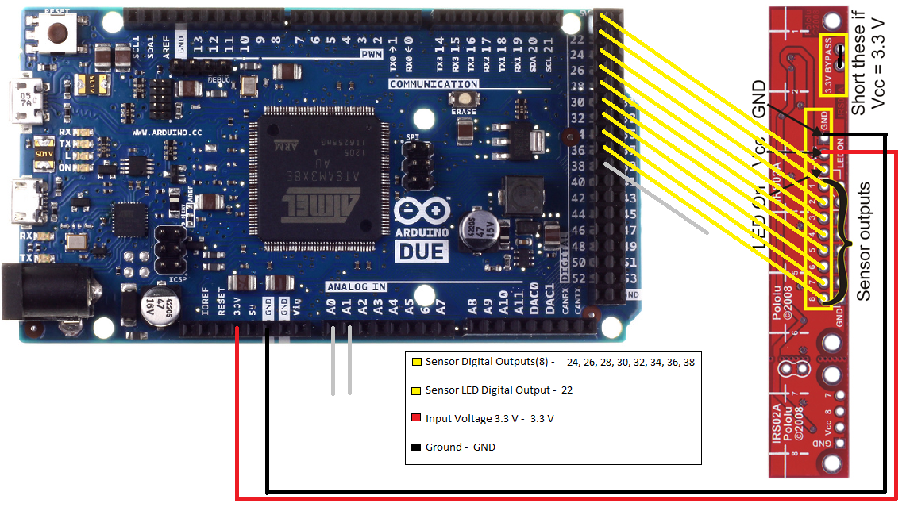

Figure 3.4.3c: Pinout for Line Following

The concept of navigating the course required reading in values of the sensor and storing them in a byte with each bit representing the status of one of the nine sensors used. A 1 represented the particular sensor whenever it was over the line, and a 0; off the line. Therefore, the robot was able to determine what type of turns and then decided on the correct action to take. For example: a straight line was (000110001) and a left turn (111110000).
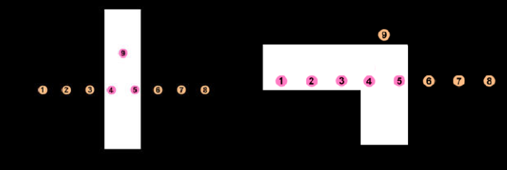

Figure 3.4.3d: Straight and left turn values being read

This had allowed the robot to make the right decision when coming back to the main course. For example the value (111110001) represented a left turn off of the main course. When the robot read this it simply made a flag or stored a value remembering the turn was made. Then when the robot came back and read a T-shaped (111111110) intersection, it had simply made a left based on the previously read value and continued in the correct direction.

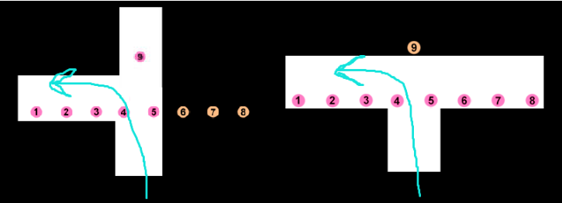
Figure 3.4.3e: T-shaped concept

While on a straight line, the robot had used the values read to determine its position and correct the “error” whenever its not directly over the line (PID control). These two techniques used together enabled the robot to successfully navigate the course.

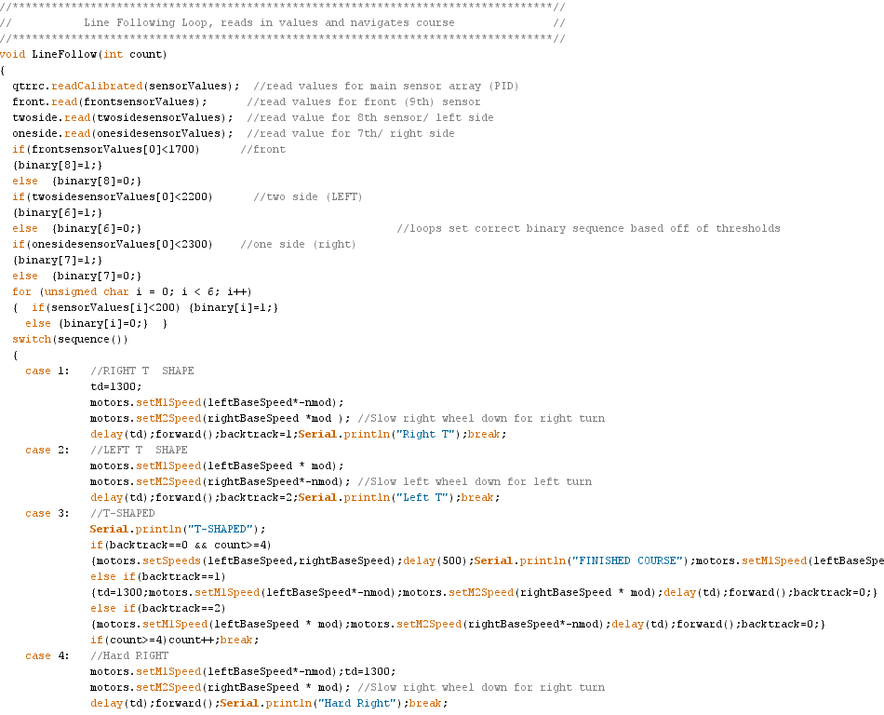
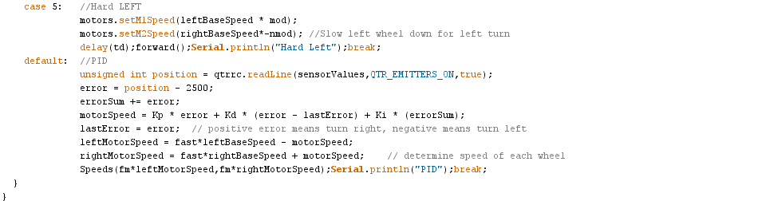
Figure 3.4.3f: Code for Line following loop

3.4.4 Object Detection

The robot had to locate each game within a 1’x1’ white square. The team decided to use a analog optical range sensor to complete the task. The sensor was located on the front of the robot; as low as possible to detect all games. It had to send a signal to the processor, allowing the robot to slow down, stop, and then start a game specific sequence whenever the robot came within a certain range; roughly 4”.

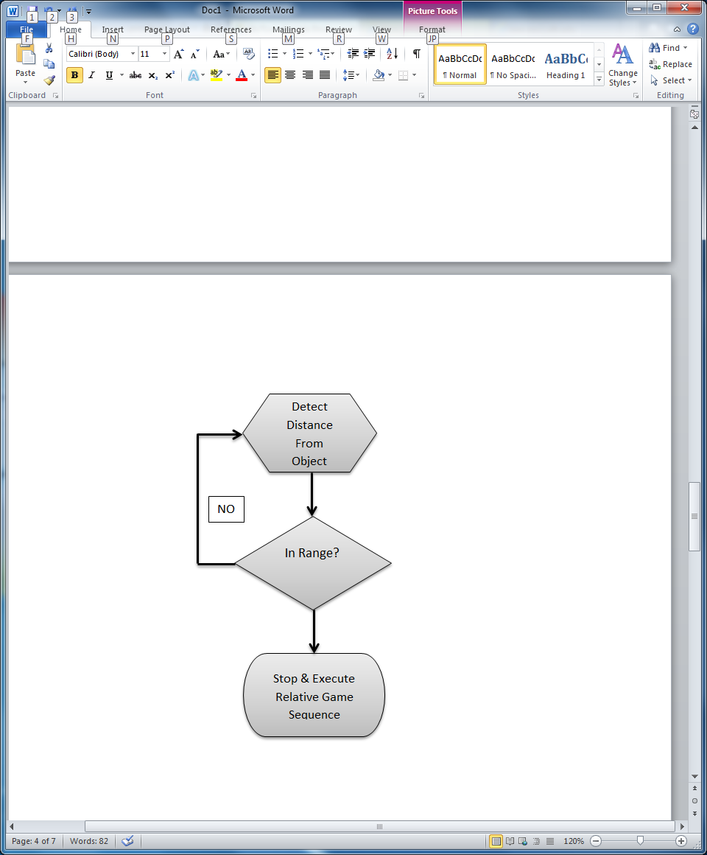

Figure 3.4.4a: Sequential Block Diagram for Object Detection

3.4.5 Microphone for Simon
This was not included in the overview as it was not featured in the final design, however the design process will be discussed here. To play the Simon Says game, the initial plan was to use an Adafruit Electret Microphone amplifier to pick up the tones played by the Simon Says game in order to successfully complete the game. Five 8th order elliptic bandpass IIR filters were designed using MATLAB’s fdatool. Four of these filters were centered around the four frequencies played by the game, while the fifth was at a frequency away from the other four and acted as a control. The filter calculations were done sample by sample at a rate of 1000 Hz (twice that of the max frequency used). This was possible due to the Arduino Due having an ARM chip. Over a period of half a second, the energy of each of the filters was calculated and then compared. If the energy of one filter was higher than all the others and a certain threshold above the control it was considered a positive for the frequency the filter was centered around and the corresponding button was pushed. Despite the poor quality of the tones generated by the game, team was successful in creating code that distinguished which button was to be pressed the majority of the time. However, in the competition environment with the game’s speaker on the ground, the tones could not be picked up successfully.

Servos/Arms/Grippers

The proposed design for the mechanical arms is largely centered on programming servos. In order to program the servos to move to desired target locations, a 12-Channel Mini-Maestro Servo Controller was added to the design. The servos create all of the movements for the arms and grippers. Using libraries and the Maestro control center program, sequential programming was written in order to instruct the servos to position joints and end pieces to perform the toy challenges. The Maestro controller is powered by the 5V pin on the Arduino Due, a 6V battery pack was used in order to properly distribute power to the servos, and a level shifter on the control signal to step up the voltage from the 3.3V Arduino pins to 5V.

General Coding Information
The Pololu Maestro Control Center software included with the Mini Maestro servo controller was used in order to generate the code to set the target locations for the servos and control them such that they were able to manipulate the games successfully. An example of code generated using these tools to move the main arm into the starting position can be seen below.

void armstart()
{
maestro.setSpeed(0, 5);
maestro.setSpeed(1, 20);
maestro.setSpeed(2, 20);
maestro.setSpeed(3, 20);
maestro.setSpeed(4, 20);
maestro.setSpeed(5, 20);
maestro.setSpeed(6, 20);
maestro.setSpeed(7, 20);
maestro.setSpeed(8, 20);
maestro.setSpeed(9, 20);
maestro.setSpeed(10, 20);
maestro.setSpeed(11, 20);
//////////////////////////////////////
//////////////////////////////////////
maestro.setTarget(0,4992);
maestro.setTarget(1,2400);
maestro.setTarget(2,4080);
maestro.setTarget(3,3808);
maestro.setTarget(4,6992);
maestro.setTarget(6,7524);
maestro.setTarget(8,5984);
maestro.setTarget(9,6020);
maestro.setTarget(10,4480);
maestro.setTarget(11,7028);
delay(500);
maestro.setTarget(0,7532);
}

Power Supply
With great consideration the team is convinced to have a power system of three NiMH Battery Packs. There will be three different power sources because of the different ranges of voltages need by the parts. The Arduino due was used to supply voltage to sensors as well.The Arduino has a built in voltage regulator and it it will be able to supply voltages to the parts with that were out too low compared to the two battery sources.

Nickel-metal hydride batteries NiMH have been chosen because their energy density approaches that of a lithium-ion cell. The only bad side to NiMH requires long periods of time to charge with a high self-discharge rate. Lithium-ion cell are leading currently in Power Capacities with because it has a zero memory less effect. NiCad stores less energy every time you recharge it and will take an extra steps to fully discharge to recharge.

The team has decided to purchase three power supplies in which one will supply 12 V, one 9V and the third will supply 6 V. The wheel motors require 12 V input to operate. The motors used in the ARMS/Grippers will be using the 6 V power supply. The 9V supply will be used solely to power the Arduino Due. The sensors operate at a smaller voltage threshold hold and requires a voltage regulator to step the down voltage from either voltage source. The Arduino Due board has a voltage regulator and will be use to supply power to the sensors.

Table 2.5a: Different Battery Options
12 Volts | Price | Current Output (mAh) | Weight
NiMH Battery | $29.95 |  | 997 grams
6 Volts
NiMH Battery | $15.15 | 2200 | 142 grams

The placement of the batteries also aids in balancing robot’s weight. One battery powers the robot’s drive motors, while the other battery powers the motors used to control the arms. A third battery powers the central processing system. A Voltage level shifter is added to step-up the voltage control signal to communicate with the maestro controller with CPU.

Two chargers were purchased with capability to charge both NiMH batteries. Batteries were tested and calculated to an accurate full charge time. Data was used to devise a charging schedule to prepare the batteries before every use. Also data and observations were used to determine how many spare batteries are necessary. Spare 6V and 9V batteries were purchased for back to back use, for testing situations and playing more than three consecutive rounds. A smart charger was selected that is capable of charging both batteries. This feature allows eliminates charging the batteries improperly.

Pin Connections:

The team has decided to use to breadboards, one for each battery and the components connected to them. The 6 volt battery is used to power the servos for the arms/grippers, the 9V is used to power the Arduino and the 12 volt battery supplies voltage to the motors. The current calculated from the torque for each drive motor is 299.53mA. The stall current is rated at an alarming 5A this will only be a problem when starting up at full power. In order to ensure the protection of the Arduino, and to distribute power to the motors as desired, the MC33296 Motor Driver Shield was used. The equations used to calculate the current drawn from the current is displayed below using the given values.

The torque calculated previously was 11.8 kg-cm, with the absolute maximum estimated weight of, 10kg speed of 0.3048 m/s (1 ft/s), and acceleration of 0.1524 m/s².

$$P= τv$$ (2)
$$P=IV$$ (3)

Contingency Plan:

The price of the batteries and chargers are low enough to purchase more when needed. Having a spare of batteries cuts idle time. If system was to fail during the competition alkaline batteries will be purchased and used to build a replacement power source.

Table 3.6a: Power Consumption for Motors and Arduino
Battery | 12 Volts | 26.4 Wh |  | 2200mAh ( Capacity)
Item | Description | Quantity | Volts (V) | Current (mA)
50:1 Metal Gearmotor 37Dx54L | Wheel Motor | 2 | 12 | 600
Arduino Due | Microcontroller | 1 | 12 | 800
Total |  | 3 | 12 | 1400

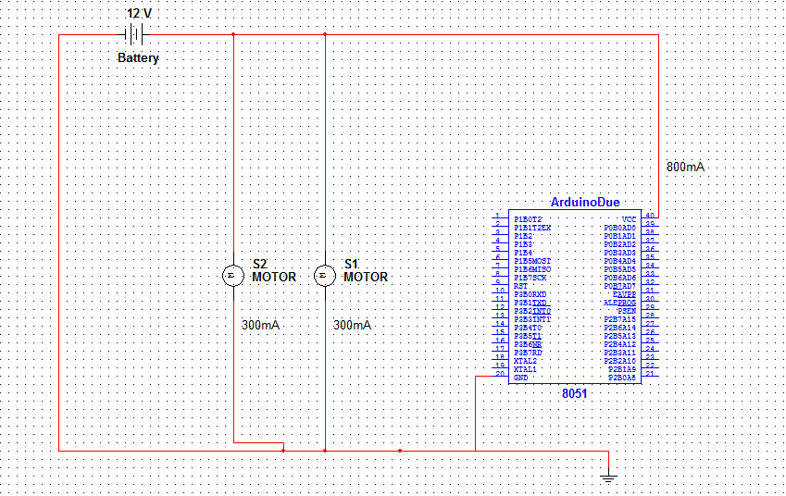
Figure 3.a: DC Motors and Arduino Battery Connections

Table 3.6b Power Consumption for Servos
Battery | 6 Volts | 9.6Wh |  | 2200mAh
Item | Description | Quantity | Volts (V) | Required Current (mA)
HS-422 | Standard Servo | 5 | 4.8-6 | 750
FS90R | CR Micro Servo | 2 | 4.8-6 | 400
HSR-1425CR | CR Standard Servo | 1 | 4.8-6 | 100
HS-85BB | Micro Servo | 1 | 4.8-6 | 240
Total |  | 9 | 4.8-6 | 1490

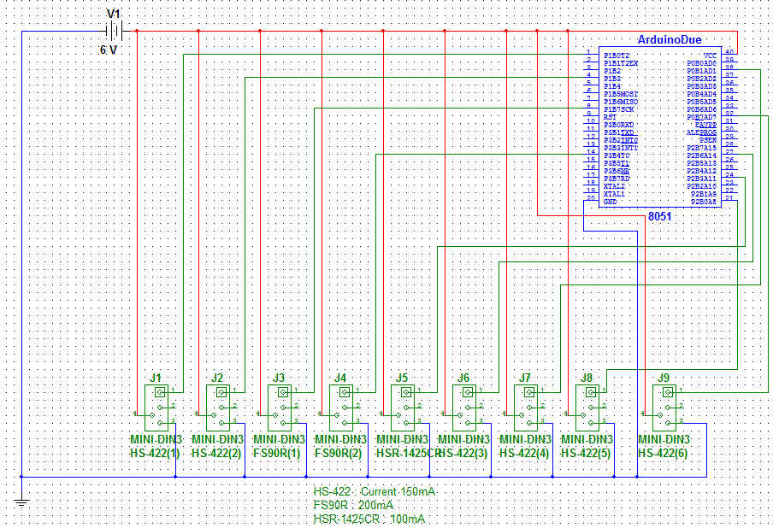
Figure 3.6b Servo Motors Battery Connections

Table 3.6c: Sensor Power Consumption
Item |  | Description |  |  | Quantity | Volts (V) |  | Current (mA)
Analog Distance Sensor |  | Sensor |  |  | 1 | 2.7-3.6 |  | 33
QTR-8RC Reflectance Sensor |  | Sensor |  |  | 10 (8 in pack) | 3.3-5 |  | 200
Total |  |  |  |  | 4 |  |  | 238.5

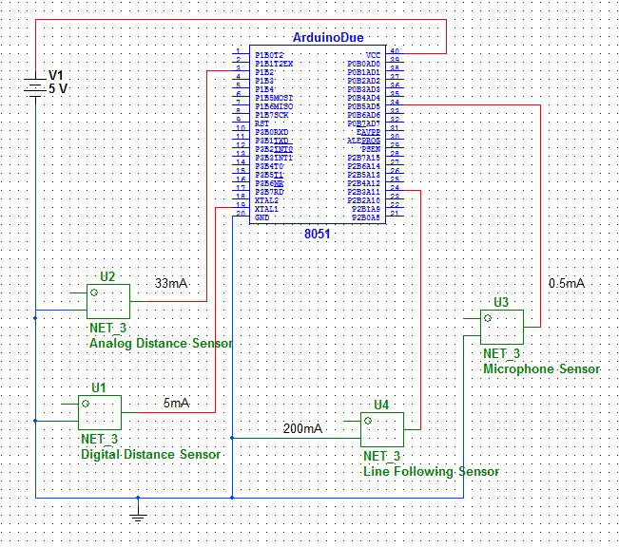
Figure 3.6c: Sensor Battery Connections

Chassis

The Chassis is the backbone for the robot, it will provide protection, stability and support for the system. The team agreed to use a two level chassis in order to distribute the weight evenly throughout the robot as well as space out the different components to maximize wiring space.

Top Level of Chassis

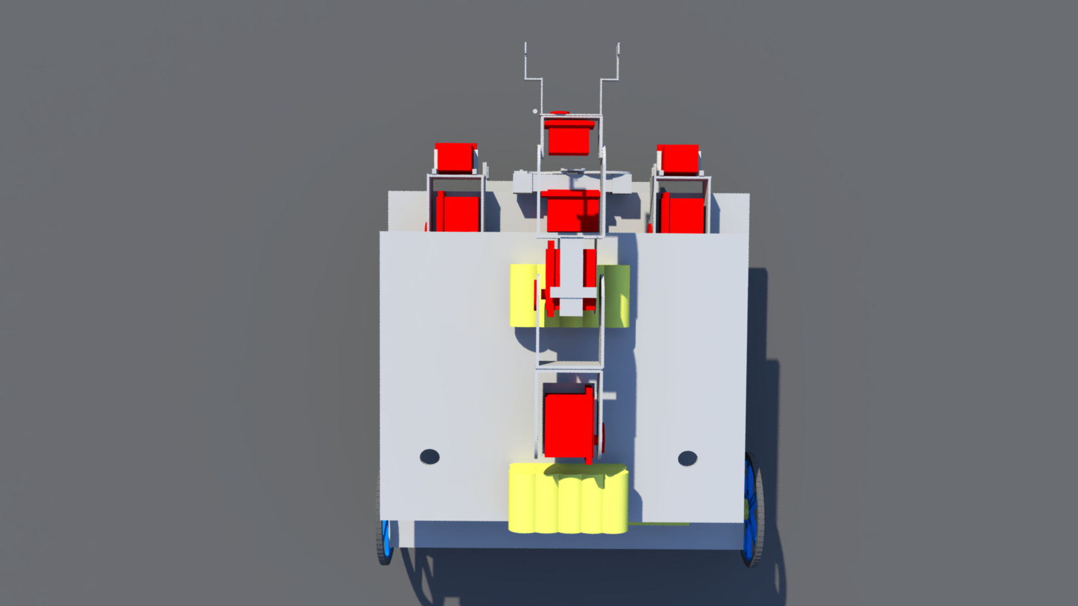
Figure 3.7a: Chassis Top Layer

The top level of the chassis supports the 12 V battery, while the bottom layer supports the 9V and 6 V batteries. The diagram above depicts a clear visual of the design, prior to moving the 6V to the bottom layer. The two holes were used to send down the wires from the batteries to their respective breadboards, as well as wires from the main arm. The top level of the chassis has the main purpose of freeing up space on the bottom level for wiring, the DC drive motors, and weight distribution. The weight of the overall robot was a major factor when stopping and taking off. The goal was to distribute the weight throughout the robot evenly such that there did not need to be additional sections in the code to ensure that the robot does not tip over when turning, starting or stopping. As seen in Figure 3.7a above, the main arm and the batteries are placed on the top layer, in the original design, however the 6V was moved to the bottom layer after testing showed it made the robot more balanced.

Bottom Level Chassis
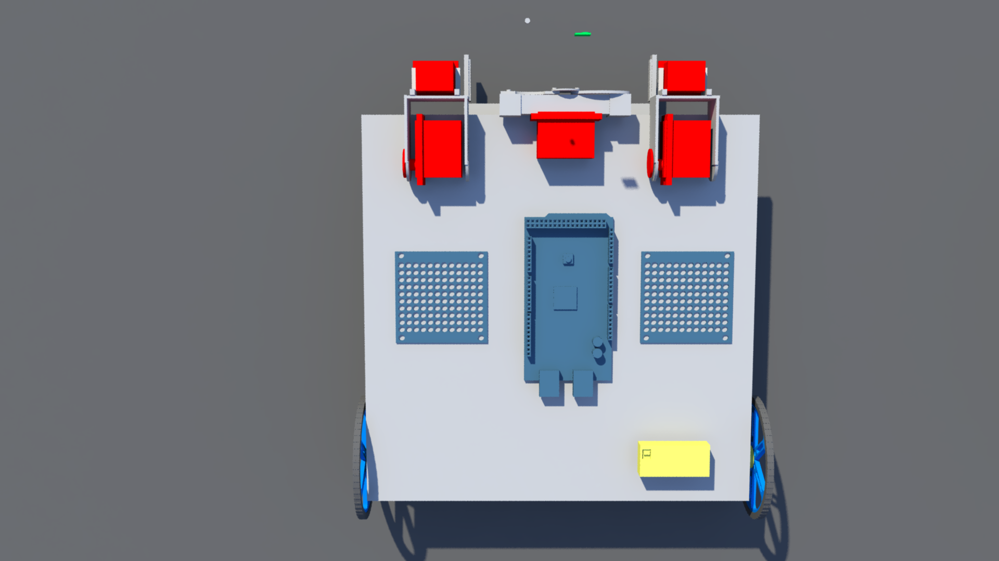

Figure 3.7b Bottom Layer of Chassis
As seen in the figure above, the DC drive motors and wheels are attached to the bottom layer of the chassis, along with the breadboards, microcontroller, arms for Etch-A-Sketch and the grippers. A more clear view of the grippers can be seen in the complete side view of the chassis below.

Figure 3.7c: Side view of Complete Chassis

The diagram above shows a side view of the concept chassis prior to the completion of the final design, in the final design the position of the caster wheel and the motor wheels are reversed.

Risk Assessment

Technical Risks

Insufficient number of I/O ports on Microcontroller
Description:
The microcontroller had a limited number of I/O ports available for all of the necessary inputs and outputs of the system. Additionally, it only had a limited amount of I/O ports with PWM capabilities, which is an important requirement for several aspects of the systems design, as the strategy for implementing all moving parts of the robot required these.

Probability: <Moderate>
The possibility of not having enough general I/O pins, that is I/O pins without PWM capabilities, was low, the MCU was chosen because of its generous amount of pins, and the sensors chosen do not require more than what is available. There was a higher risk of not having enough pins with PWM capabilities, as the design required a lot of motors that must be controlled by these. In the final design, there were enough pins with PWM capabilities for the design, but there was not much room for error.

Consequences: <Moderate>
There were ways to solve this issue, including purchasing I/O expansion packs to increase the number of available pins, and changing the design/implementation of different aspects of the system in order to use less pins.

Strategy:
In order to counter this risk, the strategy was to select a design that did not require more pins than what was available. If this became impossible, the strategy to counter this risk would have been to acquire an expansion pack.
Outcome:
This risk did not become a factor in the final design, there were enough I/O pins and PWMs.

Insufficient MCU Memory

Description:
The necessary programming for the implementation of the robot’s design could have potentially require more flash memory than what is available in the MCU.

Probability: <Very Low>
The MCU chosen has 512KB of flash memory available, which should be more than enough to handle of the necessary programming for the robot.

Consequences: <Severe>
If the programming necessary to control the robot did not fit in the available flash memory, it would not be able to operate properly. The design would have had to be changed in order to fit the programming into the available memory, potentially not allowing for all parts of the program to be kept.

Strategy:
Steps were taken to avoid this risk, in choosing an MCU with a large amount of flash memory. In addition to this, programming was done as efficiently as possible in an attempt to not waste memory.

Outcome:
This risk did not become a factor in the final design, the final program for the robot fit easily into the available memory.

Line Following System Failure
Description:
Even in the final design, there is the possibility for this error. The line following sensors could fail, or that the programming used in order to implement the line following system could fail. The course was not set, so there is the possibility that a line configuration not programmed for could be encountered, and the robot could navigate it improperly. Additionally, any small errors made by the system could easily snowball into larger errors.

Probability: <Moderate >
The team planned to extensively on the practice course configurations in an attempt to debug and prepare for possible situations in competition. Plans were be made in order to handle configurations/situations that are difficult, and potentially improbable to actually be encountered, just to ensure that the system works as effectively as possible. The sensors chosen have been tested and work effectively, and they will be tested frequently in order to ensure they are working properly.

Consequences: <Catastrophic>
If the line following system failed, the robot would be unable to navigate the course properly and earn points. Additionally, the current program is reliant on the order the robot encounters the toys in (which is constant). If the line following system had an error and the robot missed a turn or goes the wrong direction, it could approach a toy zone and perform the incorrect actions for the toy contained in it.

Strategy:
The strategy, as stated before, was to prepare for the worst case scenarios when testing this system, in order to ensure there are protocols for handling difficult line configurations and errors.

Outcome:
During the internal competition, line following errors were encountered that made the robot unable to complete the course. Perhaps due to the change in lighting, the robot would not line up properly after a turn, causing it to turn off of the course. The line following sensor array was not wide enough in order to realize that a being a little off/diagonal on a straight line was not a turn, and as right angle turns were hard-coded, it took one. The team fixed this error before the final demonstration by breaking up the line following sensor array into 3 pieces and spreading them out, so that the center section handled straight lines/curves, while the outer sections were there to detect right-angled turns. This worked nearly flawlessly during the senior design fair.

Sound Sensor/Simon Says System Failure
Description:
There is a possibility that the sound sensor for playing the Simon Says game could fail. In a noisy environment, the sensor may pick up on background noise instead of the tone played by Simon. With the Simon Says game flat on the ground, the tone is very quiet. Additionally, there is the potential that the programming (sound processing) for sensor could malfunction and provide incorrect information.

Probability: <Moderate>
It was entirely possible that the interference sounds from the competition area would be too much, and cause this part of the system to malfunction, and give incorrect information about the tone played by Simon.
Consequences: <Severe>
If this system failed, there would not be as many points earned for the Simon Says portion of the competition, as it the error buzzer will sound after a few seconds have passed and the robot does not copy Simon properly. This was obviously undesirable, as the goal was to play the game for the full 15 seconds to earn maximum points. This error is not catastrophic, however, as it does not affect any of the other subsystems.

Strategy:
This strategy to avoid this was to test extensively, with team members emulating the potential background noise of the competition area. If it was found that the system is incapable of operating under the necessary conditions, additional options were to be explored for playing this game.

Outcome:
While the team was able to write a program capable of detecting the tones played by the Simon Says game, it could not be implemented during the internal competition or the final demonstration. The background noise was much louder than the sound of the game flat on a surface. Additionally, the microphone did not pick up the correct tone from every angle, so if the arm the microphone was attached to was in the incorrect position, the incorrect color would be chosen. The interrupts in the code for Simon Says also interfered with line following. The team decided to press the center button of the game and guess a color before driving away, in order to potentially gain points.

Arm Mechanism Failure

Description:
The main arm mechanism for manipulating the Rubik’s cube, picking up the playing card, and pressing the buttons on the Simon Says game is an important aspect of the design with many potential errors. The programming for the arm mechanism could have potentially caused it to operate incorrectly, positioning itself wrong or turning the wrong way. The servos used for the various motions of the arm could have encountered resistances for which they are not strong enough. Additionally, on the other hand the servos could be fully operational and the end piece of the gripper could have snapped or broken due to improper positioning or too much resistance.

Probability: <Low/Moderate>
The possibility of the servos not operating as manufactured is very low. The potential for the end piece of the gripper breaking is slightly higher, however the material chosen for this is rather sturdy (HDPE) and the weights/resistances the arm mechanism is dealing with were not be that high. The more probable potential risks are improper positioning (due to programming or other factors) of the arm causing it to not operate correctly.

Consequences: <Catastrophic>
If this subsystem fails, there is the potential to lose all of the points available in three out of the four games in the competition. If the components break or work improperly, the arm would not manipulate the toys correctly and will not earn points.

Strategy:
The plan to avoid this was to extensively test the system and debug the related software in order to ensure that everything is working as well as possible. Testing was done with the components in order to ensure they were physically strong enough to handle any sort of situation they may be placed in during competition.

Outcome:
This system operated well in the internal competition, properly manipulating the games. During the final demonstration some minor errors in alignment were occasionally made, but the system is still fully operational. Proper alignment was tested and the game placement was moved accordingly in order to ensure that the system operates well.

Gripper Mechanism Failure
Description: The gripper mechanism could potentially fail for any of the reasons listed in the previous section for the arm mechanism. The components may not be strong enough to grip the toys as necessary, or may break or be positioned incorrectly.

Probability: <Low>
The gripper mechanism is not subjected to that great of forces, it is mostly used just to ensure that the toys do not move around a lot in the game zone. The motion for this is just the inward motion for each of the side panels, and nothing more. However, if a toy is approached from the incorrect angle, the gripper mechanism may try to tighten further than physically possible and break the end pieces or damage the servo. This is mostly reliant on the line following/navigation accuracy, and the distance sensor.

Consequences: <Severe>
If the Rubik’s cube or Simon Says game cannot be held in place properly, then they cannot be manipulated by the arm mechanism properly, and points will be lost for these portions of the competition.

Strategy:
The team attempted to make the accuracy of the navigation and distance sensing reliable in order to ensure that the toys are lined up with the gripper mechanism as accurately as possible in order to prevent this risk from happening.

Outcome:
This risk is not a major factor in the overall design, as long as the games are placed properly in the game zones the robot is able to align the gripper properly. If the gripper is slightly off due to navigation, the components aren’t damaged but the game is unable to be played. The team does/did a lot of testing on how the robot approaches the game zones and the proper toy placement.

Etch-A-Sketch Arms Failure
Description:
There was the potential that the Etch-A-Sketch arms could be lined up improperly with the knobs of the Etch-A-Sketch, and therefore not be able to turn them properly, however the gripper should prevent this. It is also possible that the custom end pieces for the arms could not grip onto the knobs properly. The program for this toy will turn the servos a set amount in order to create the letters, if the servo turns but the end piece does not grip the knob properly, then the letter will not be drawn properly.

Probability: <Low>
There will be steps taken in order to make sure that the end pieces for the arms grip the knobs as tightly as possible, and their shape will help with self-aligning onto the knobs. The arms lining up with the knobs properly are again reliant on the navigation and distance sensor, which will be made as accurate as possible.

Consequences: <Moderate/Severe>
If this system fails, no points will be earned for this game, and it is valued rather high in points. However, no other systems are reliant on this system, so if it fails the effect will not be catastrophic.

Strategy:
The inside of the end pieces were to be made to fit the grooves on the knobs of the Etch-A-Sketch. Their grip was tested extensively in an attempt to make the turning of the knobs as accurate as possible. If the team found that the grooves on the inside of the end pieces are wearing down or not gripping properly, additional simple fixes will be explored, including lining them with rubber or something similar to add traction.

Outcome:
The original custom end piece design did not properly grip and turn the knobs of the Etch-A-Sketch, an alternative was found. Cylindrical caps slightly bigger than the knobs were filled with cotton and then covered in a very sticky tape. With this design, the soft cotton allowed the knobs to align easily, while the tape and the size of the caps and volume of the cotton provided enough grip to turn the knobs properly. The final design requires the tape/cotton to be replaced, but with each at the proper level it works properly.

Structural Failure

Description:
There was a potential risk that the weight of the components of the robot will be too heavy for the chassis, and cause it to cave in or break. It could also have affected the caster wheel, causing too much friction for the wheel to move forward efficiently. Additionally, if the structural integrity of the chassis was compromised, the wheels might have had too much weight on them or the caving in of the structure may cause them to be inaccurate. Additionally it must be ensured that all components were secured onto the chassis well.

Probability: <Very Low>
The material chosen should be strong enough to hold the weight of the robot, and throughout the design and build process the weight distribution will be checked in order to ensure the balance of the robot is good.

Consequence: <Moderate>
The consequences of the chassis failing in competition would be more severe, but if it is found that the material chosen was not strong enough, changing it out for a new material shouldn’t be very difficult.

Strategy:
As stated, the balance of the robot was checked frequently in order to ensure that the weight is distributed evenly. Additionally, the structural integrity was frequently checked to ensure that the material is strong enough. If the material needs to be swapped out for something stronger, the change will be made.

Outcome:
The structural integrity of the chassis never became a problem in the final design. However, it was found that the motored wheels in the back with the caster in the front was problematic for line following and other system operation. The placement of these was swapped. Additionally, the initial caster wheel was replaced with the current caster wheel.

Power System Failure
Description:
If there were any issues in the wiring or the batteries used in power the various system, things such as shorts, they could potentially cause damage to circuit components or even other parts of the robot. Additionally, if power is not supplied properly to the various systems, they may not work properly.

Probability: <Low/Moderate>
The probability of this risk affecting the project was low because all circuitry was checked thoroughly and power calculation carried out in order to ensure that the necessary voltage and current are delivered to the desired locations.

Consequence: <Catastrophic>
If the robot did not receive adequate power during competition it couldn’t earn any points, and if components are damaged they may be expensive to replace.

Strategy:
In order to prevent this risk, a lot of testing was done to ensure that the batteries are capable of delivering enough power to the components. Calculations were made in order to ensure that the power system is adequate, and all connections will be thoroughly checked.

Outcome:
There were no issues with power in the final design, it was capable of running for three five-minute rounds as necessary. The 9V battery had to be recharged or replaced for longer operation, but this was not a problem.

Schedule Risks

Resource Availability

Description:
Throughout the engineering process of building and design the robot, different components – potentially custom – and other resources needed to be available for various subsystems. There was a risk of these resources not being available when the team needed access to them. For example, the machine shop at the College of Engineering tends to have very long waiting lists in spring, meaning that an item may not be received from them for 2-3 weeks.

Probability: <Low>
The probability of this risk occurring was fairly low for this project, as a large amount of the components necessary for the robot were acquired with a lot of time to spare. However, the risk of parts being damaged and in need of replacement later in the year was more probable.

Consequence: <Moderate>
The consequences of this risk occurring would have been moderate as they would put the schedule for building and testing the robot behind.

Strategy:
The strategy for avoiding this risk was to simply order parts as soon as possible in order to ensure that they acquired by the time they are absolutely necessary to the project. By ordering parts even earlier than this, as the team has been, this risk is greatly avoided.

Outcome:
All of the necessary parts for the robot were acquired prior to the competition and demonstrations. There were not any situations in which a part was needed and unavailable, or in which something broke and there wasn’t a spare. One unforeseen issue was the Simon Says game breaking, and not being available in any toy store/shopping center nearby, but one was found before the final demonstration.

Team Member Scheduling Conflicts

Description: During the course of the project, it was possible that individual team members may have had some sort of personal emergency or other unforeseen scheduling conflict that could set the project back. This could have been a problem when trying to achieve the goals of the project on time.

Probability: <Low>:
Any sort of unplanned or unscheduled event that would pull a team member away from the project in such a way that they can’t help or contact the team for a significant amount is rather unlikely.

Consequences: <Moderate>
In the event such a scheduling issue occurred, the project might have gotten slightly set back, but the other team members could most likely pick up the necessary slack in order to meet the project goals in a timely manner.

Strategy:
There wasn’t a strategy for preventing unforeseen events from happening, however, allowing some leeway in the schedule allowed for this sort of event to not catastrophically affect the project.

Outcome:
This risk was not a factor in the project.

  - Budget Risks

Underestimation of Design Expense
Description:
There was a risk that the initial ideas for design could require components that were not expected, potentially adding to costs. Additionally, if the design changed in some way that caused it to be more expensive, that may not have been included in the budget.

Probability: <Low>
The forecast for the design expense was under budget, and the majority of the necessary parts for the project were already ordered well ahead of time. Much thought was put into the design to ensure that these unexpected costs would not occur.

Consequences: <Severe>
The consequences of this risk were severe if it occurred enough such that the budget was exhausted. This was very unlikely, however if this occurs the team would have to pay for the remaining costs out of pocket, which is undesirable.

Strategy:
In order to avoid this risk, careful planning was put into the budget in order to ensure that there was some money left after all necessary components were bought, and all components were researched in order to ensure they were the best option.

Outcome:
There were no unexpected expenses that caused the budget to be exhausted.

Damage to Components or Systems

Description:
If any component became damaged or failed in any way, it would have to be replaced. This could have occurred due to incorrect wiring, faulty equipment, etc.

Probability: <Moderate/High>
In a project such as this with many components potentially able to fail or take damage, it is likely that one component may fail or become damaged. Additionally, there is the chance that with all of the testing done to the prototype, components may become damaged from use.

Consequences: <Severe>
As stated in the previous risk, the consequences of this risk were severe if it they occurred enough such that the budget is exhausted. This was very unlikely, however if this occurred the team would have to pay for the remaining costs out of pocket, which is undesirable.

Strategy:
In order to avoid this risk, much care was taken when handling all components. All circuits were to be thoroughly checked prior to connecting them to a power source, along with thorough calculations. Additionally, room was left in the budget to allow for leeway.

Outcome:
There was damage to some components throughout the course of the project, including right before the final demonstration, however there was a spare already purchased and readily available. This risk never affected the project in such a way that the budget was exhausted or such that the robot could not operate.

Summary of Risk Status

For each subsystem in the design, there were potentials for failure, and each of these present a risk. Scheduling and budget risks are no longer relevant, as the project has completed. The final product still has the capability of making mistakes, but overall the risks did not interfere with the successful operation of the robot. One of the games (Simon Says) had to be partially left out of the design, but this risk was known, and the team was willing to give up points on one part to focus on gaining points in others.

Schedule

Schedule summary

Tasks | Completed by
Drive System | 1/17
Chassis | 2/10
Rubik’s Cube | 2/10
Playing Card | 2/25
Distance Sensing | 2/25
LED Activation | 2/25
Etch-a-Sketch | 3/20
Line Following | 3/20

Schedule Summary
The proposed schedule in November outlined dates of purchasing, decision finalization, building, and assembly. This schedule was written for the first semester with the expectancy to change per week based on the status of tasks. Due to unforeseen events, tasks and due dates were pushed back. Also there were occasions where the estimated time was more than enough; creating extra time get a head start on the next task or helping hands on a difficult task. Tasks that were not finished on time pushed back due dates on the schedule.

Budget Estimate

Final Budget Summary
The estimated budget cost was determined to be $655.60. This expense was calculated based off of equipment & gaming toys. This estimate does not include replacing broken parts or spare equipment. The final budget totalled $621.26. Ideas for building the robot changed over time affecting the budget. The innovative ideas from making use of resources at home & at the College of Engineering reduced the budget, but it led to out-of-pocket spending. The final budget only reflects purchases that have been properly documented.

Deliverables
The final project is an autonomous robot that operates for at least three 5 minute rounds with the rules and regulations of the SoutheastCon 2015 Hardware Competition. Successful project management ensured the robot parts and equipment met the budget requirement, the work force was distributed to a qualified member of the group, and a detailed schedule guided the design process. The group was required to complete the project before the internal competition in March 2015. All hardware and software necessary for the operation of the robot, as well as the user manual make up the essential deliverables of the project. The final robot is capable of doing all of the following autonomously during each round: following a white line course on a black background, pressing the center button on a Simon Says game and guessing a color, writing “IEEE” on an Etch-A-Sketch, twisting one layer of a Rubik’s cube 180 degrees, and picking a playing card up off a deck and carrying it across the finish line. In addition to the main hardware/software, the deliverables include all of the project’s reports and presentation, the website for the project and all other project documentation. The goal of our design project was to deliver a robot that will receive maximum points in the competition.

Conclusion

The team was successful in designing and building a robot capable of competing in the internal competition. The robot did not win the internal competition. Due to a line following error, the robot was unable to make it to the games successfully, and could not gain points. However, at the time of the internal competition, the robot was capable of playing all of the games that the winning team could play, and was able to press the center button on the Simon Says game, while the other team could not. The team fixed the issues with line following before the project’s final presentation, and the robot was able to successfully navigate the course, draw IEEE on the Etch-A-Sketch, turn one layer of the Rubik’s cube 180 degrees and pick up a playing card from a deck. The robot was only unsuccessful in playing the Simon Says game in a competition environment, however the colors could be recognized and the correct button pushed in a quieter environment.

References
[1] J.A. Marin, J.E. Armstrong, and J.L. Kays, “Elements of an Optimal Capstone Design Experience,” Journal of Engineering Education, January 1999, pp. 19-22.

Appendix A - User Manual

The User Manual for the final product of this project is included in a separate document attached.

Appendix B - Complete Test report forms
B Testing Plan
B.1 Programming
B.1.1 Arduino Due
B.1.2 Driver Shield
B.1.3 Servo Controller

Scheduled Test Reporting Form

Test Item: Servo Controller
Tester Name: Louis Cooper
Test Date:
Test Location: COE
Test ID: Integration
Test No: 1
Test Attempt #: 1
Test Result:PASS

Objective:
We will test the compatibility of the Arduino Due microcontroller and the 12-channel Mini Maestro Servo Controller. The Servo Controller will be used to regulate the voltage and control all the servos used in the arm and gripping mechanisms.

Description:
The Arduino Due will control the Maestro Servo Controller and rotate 2-3 test servos simultaneously. This will test the basic operation UART mode for controlling the Maestro Servo Controller with serial commands from a MCU. The test servos will go through a sequence of servo positions to verify functionality.

Requirements:
· Laptop with Arduino Software
· Maestro 12-channel Servo Controller
3.3 V - 5 V level shifter
· Arduino Due
· 6V Battery
· Testing Servo

Anticipated Results:
The servos should be able to reach MOST of the servo positions. There may be dead zones or coding errors that could cause the servos to miss one (1) or two (2) servo positions.

Requirement for Success:
The testing servos must demonstrate that they are being controlled by the Arduino Due through serial commands to the Maestro Servo Controller.

Actual Results: PASS
The servo controller can correctly talk to the microcontroller of the serial communication pins. Speeds, accelerations and target values can be set for individual channels by the Arduino microcontroller.

B.2 Drive System
B.2.1 Line Following

Scheduled Test Reporting Form

Tester Name: Chelsea Ogle
Test Date: 10/10/14 (check)
Test Time: 12:30 pm
Test Location: FAMU-FSU CoE

Test No:
Test Attempt #: 1
Test Result: PASS

Test ID: Line Following Test

Objective:
The main purpose of this is to test the line following sensors interacting with the motors via the motor driver shield and the Arduino. The line following prototype chassis will stay stationary, but the motors reactions to a line will be observed.

Description:
Each motor will be connected to the A4490 Motor Driver Shield for Arduino, a 12 V power supply will also be connected to the driver shield. The Arduino will remain connected to the computer for power. The line following sensors will also be connected to the Arduino. Using libraries from both the sensors and the driver shield, sample line following code altered to work with the driver shield will be uploaded to the board. The prototype chassis will be lifted with a box such that the wheels spinning do not cause it to move, and a black line on a white box will be moved around beneath the line following sensors.

Requirements:
· DC Power Supply, +/- 25V
· 12 V DC Brushed Metal Gearbox Motors (2)
· Wires for connections
· A4490 Motor Driver Shield for Arduino
· White box with black tape line
· Arduino Mega
· Line Following Sensors

Procedure:
Connect the motor shield to the 12V DC power supply, with ground. Connect each motor to the driver shield, with the red wire in the A terminal, and the black in the B. Connect the driver shield and the line following sensors to the Arduino, using two PWM pins for the motor connections. Connect the Arduino to a computer using the USB, and upload the line following code, leaving the USB for supplying power. Prop up the prototype chassis such that it will not move when the wheels spin. Calibrate the line following sensors by moving the black line back and forth beneath them. Once the line following loop is running, keep the line beneath the sensors and move it, observing the effects.

Anticipated Results:
With the line in the center of the line following sensor array, each motor should move forward at the same speed. With the line to the left, the left motor should spin backwards while the right moves forwards. With the line to the right, the left motor should spin forwards while the right spins backwards.

Requirement for Success:
With the line in the center of the line following sensor array, each motor should move forward at the same speed. With the line to the left, the left motor should spin backwards while the right moves forwards. With the line to the right, the left motor should spin forwards while the right spins backwards. The further left/right the line moves, the faster the motors should spin in opposite directions of each other.

Actual Results: PASS
The motors behaved as required in response to the line moving beneath the sensors.

Reason for Failure:
N/A

Recommended Fix:
N/A

Other Comments:

Scheduled Test Reporting Form
Tester Name: Ogle, Vargas, Marshall
Test Date: 11/11/14
Test Time: 11:00 am
Test Location: FAMU-FSU CoE

Test No: 2
Test Attempt #: 2
Test Result: FAIL
Test ID: Line Following Test

Objective:
The main purpose of this is to test the line following sensors interacting with the motors via the motor driver shield and the Arduino. This test will actually put the prototype chassis on a white surface with a black line to test line following.
Description:
Each motor will be connected to the A4490 Motor Driver Shield for Arduino, a 12 V battery will also be connected to the driver shield. The Arduino will be connected to a 9V battery for power. Using libraries from both the sensors and the driver shield, sample line following code altered to work with the driver shield will be uploaded to the board. The prototype chassis will be placed on a white surface with a black line and should be able to follow it.
Requirements:
· 12 V and 9 V batteries
· 12 V DC Brushed Metal Gearbox Motors (2)
· Wires for connections
· A4490 Motor Driver Shield for Arduino
· White surface with black tape line
· Arduino Mega
· Line Following Sensors
· Prototype chassis with motors, wheels, Arduino, and line following sensors connected.
Procedure:
Connect the motor shield to the 12V DC power supply, with ground. Connect each motor to the driver shield, with the red wire in the A terminal, and the black in the B. Connect the driver shield and the line following sensors to the Arduino, using two PWM pins for the motor connections. Connect the Arduino to a computer using the USB, and upload the line following code, and then use a 9V battery for power. Place the chassis on the ground, turn on the Arduino, and move the line following sensors left and right over the line to calibrate. Then let the code run and observe the results.

Anticipated Results:
The robot will follow the line, around curves and over right angle turns. It may or may not take a turn in a T-shape, but it will always be covering the line.

Requirement for Success:
The robot must remain covering/following the line at all times.

Actual Results: FAIL
The robot drove over the line and past it.

Reason for Failure:
The PID controller constants were not correct for accurately following the line. Additionally the wires making connections to the driver shield need to be secured, they were not remaining connected.

Recommended Fix:
Increase the constant corresponding to the differential part of the PID and decrease the constant corresponding to the proportional part of the PID.

Other Comments:

Scheduled Test Reporting Form
Tester Name: Ogle, Vargas, Marshall
Test Date: 11/20/15
Test Time: 11:00 am
Test Location: FAMU-FSU CoE

Test No:
Test Attempt #: 3
Test Result: PASS

Test ID: Line Following Test

Objective:
The main purpose of this is to test the line following sensors interacting with the motors via the motor driver shield and the Arduino. This test will actually put the prototype chassis on a white surface with a black line to test line following.

Description:
Each motor will be connected to the A4490 Motor Driver Shield for Arduino, a 12 V battery will also be connected to the driver shield. The Arduino will be connected to a 9V battery for power. Using libraries from both the sensors and the driver shield, sample line following code altered to work with the driver shield will be uploaded to the board. The prototype chassis will be placed on a white surface with a black line and should be able to follow it.

Requirements:
· 12 V and 9 V batteries
· 12 V DC Brushed Metal Gearbox Motors (2)
· Wires for connections
· A4490 Motor Driver Shield for Arduino
· White surface with black tape line
· Arduino Mega
· Line Following Sensors
· Prototype chassis with motors, wheels, Arduino, and line following sensors connected.

Procedure:
Connect the motor shield to the 12V DC power supply, with ground. Connect each motor to the driver shield, with the red wire in the A terminal, and the black in the B. Connect the driver shield and the line following sensors to the Arduino, using two PWM pins for the motor connections. Connect the Arduino to a computer using the USB, and upload the line following code, and then use a 9V batter for power. Place the chassis on the ground, turn on the Arduino, and move the line following sensors left and right over the line to calibrate. Then let the code run and observe the results.

Anticipated Results:
The robot will follow the line, around curves and over right angle turns. It may or may not take a turn in a T-shape, but it will always be covering the line.

Requirement for Success:
The robot must remain covering/following the line at all times until the end of the test course.

Actual Results: PASS
The robot remained on the course at all times until the end of the course. It was always following the line, and took all turns in the course. A video of the test is available online.

Reason for Failure:
N/A
Recommended Fix:
N/A
Other Comments:
Additional changes to the code will need to be made to change it to a white line on a black surface. Also the code must be customized more to take follow the test course for the internal competition as desired.

Scheduled Test Reporting Form
Tester Name: Ogle, Vargas, Marshall
Test Date: 1/24/15
Test Time: 11:00 am
Test Location: FAMU-FSU CoE

Test No:
Test Attempt #: 4
Test Result: FAIL

Test ID: Line Following Test

Objective:
The main purpose of this is to test the line following sensors interacting with the motors via the motor driver shield and the Arduino. This test will use the new chassis and place it on a black surface with a white line.

Description:
Each motor will be connected to the A4490 Motor Driver Shield for Arduino, a 12 V battery will also be connected to the driver shield. The Arduino will be connected to a 9V battery for power. Using libraries from both the sensors and the driver shield, sample line following code altered to work with the driver shield will be uploaded to the board. The new chassis will be placed on a black surface with a white line, specifically the provided test course.

Requirements:
· 12 V and 9 V batteries
· 12 V DC Brushed Metal Gearbox Motors (2)
· Wires for connections
· A4490 Motor Driver Shield for Arduino
· Test Course
· Arduino Mega
· Line Following Sensors
· New chassis with motors, wheels, Arduino, and line following sensors connected.

Procedure:
Connect the motor shield to the 12V DC power supply, with ground. Connect each motor to the driver shield, with the red wire in the A terminal, and the black in the B. Connect the driver shield and the line following sensors to the Arduino, using two PWM pins for the motor connections. Connect the Arduino to a computer using the USB, and upload the line following code, and then use a 9V batter for power. Place the chassis on the ground, turn on the Arduino, and move the line following sensors left and right over the line to calibrate. Then let the code run and observe the results.

Anticipated Results:
The robot will follow the line, around curves and over right angle turns. It should always be covering the line.

Requirement for Success:
The robot must remain covering/following the line at all times, until it runs out of course.

Actual Results: FAIL
The robot attempted to follow the line, but either veered off of the course, or became stuck at some points.

Reason for Failure:
The orientation of the motors needs to be flipped in the code, and not all line following sensors were connected properly.

Recommended Fix:
Manage line following sensor connections, and change code such that the motors are correct.

Other Comments:
The code may also need to be changed in the way with which it handles the sensor data. Currently, it gives a value of the weighted average of the sensor values, as opposed to observing each individually. Dealing with the values of each individual sensor could provide more customizable code and accuracy.

Scheduled Test Reporting Form
Tester Name: Ogle, Vargas, Marshall
Test Date: 1/24/15
Test Time: 11;30 am
Test Location: FAMU-FSU CoE

Test No:
Test Attempt #: 5
Test Result: FAIL

Test ID: Line Following Test
Objective:
The main purpose of this is to test the line following system with the additional 9th sensor. The goal of this test is to have the robot behave as needed on the test course provided when it encounters T-shapes and the game zones. The distance sensor may also be integrated in the design for game zone detection.
Description:
Each motor will be connected to the A4490 Motor Driver Shield for Arduino, a 12 V battery will also be connected to the driver shield. The Arduino will be connected to a 9V battery for power. Using libraries from both the sensors and the driver shield, sample line following code altered to work with the driver shield will be uploaded to the board. The new chassis will be placed on a black surface with a white line, specifically the provided test course.
Requirements:
· 12 V and 9 V batteries
· 12 V DC Brushed Metal Gearbox Motors (2)
· Wires for connections
· A4490 Motor Driver Shield for Arduino
· Test Course
· Arduino Mega
· Line Following Sensors
· New chassis with motors, wheels, Arduino, and line following sensors connected.
Procedure:
Connect the motor shield to the 12V DC power supply, with ground. Connect each motor to the driver shield, with the red wire in the A terminal, and the black in the B. Connect the driver shield and the line following sensors to the Arduino, using two PWM pins for the motor connections. Connect the Arduino to a computer using the USB, and upload the line following code, and then use a 9V battery for power. Place the chassis on the ground, turn on the Arduino, and move the line following sensors left and right over the line to calibrate. Then let the code run and observe the results.
Anticipated Results:
The robot will follow the line, around curves and over right angle turns. It should always be covering the line. When the course branches off to a game zone, the robot should go to the game zone, and it should be able to return to the main course after pausing there.
Requirement for Success:
The robot must remain covering/following the line at all times, until it runs out of course. It must turn off of the main course to approach game zones, pause at the game zone, and return to the main course.
Actual Results:FAIL
Robot mistook the finish line as a right turn. Robot also had incorrectly made the turn after leaving the playing card game location.
Reason for Failure:
Robot default to right turns on T shapes therefore went right at the finish instead of finishing properly.The playing card game location is very close to the main course and the sensor did not properly see tht turn.
Recommended Fix:
Adjust the location of the QTR reflectance sensor to be closer to the motors. Also have code specifically for the finish line so that when the last T shape is detected the robot will continue forward instead of proceeding with the default right action.
Other Comments:

Scheduled Test Reporting Form
Tester Name: Marshall
Test Date: 2/28/15
Test Time: 11;30 am
Test Location: FAMU-FSU CoE

Test No:
Test Attempt #: 6
Test Result: FAIL

Test ID: Line Following Test
Objective:
The main purpose of this is to test the line following system with the new system for detecting and responding to T-shaped junctions. Additionally, this test integrates the new driver shield with the Arduino Due for line following.
Description:
Each motor will be connected to the MC33926 Motor Driver Shield for Arduino, a 12 V battery will also be connected to the driver shield. The Arduino will be connected to a 9V battery for power. Using libraries from both the sensors and the driver shield, line following using the new algorithm to recognize T-shapes will be uploaded to the board. The new chassis will be placed on a black surface with a white line, specifically the provided test course.
Requirements:
· 12 V and 9 V batteries
· 12 V DC Brushed Metal Gearbox Motors (2)
· Wires for connections
· MC33926 Motor Driver Shield for Arduino
· Test Course
· Arduino Due
· Line Following Sensors
· New chassis with motors, wheels, Arduino, and line following sensors connected.
Procedure:
Connect the motor shield to the 12V DC power supply, with ground. Connect each motor to the driver shield, with the red wire in the A terminal, and the black in the B. Connect the driver shield and the line following sensors to the Arduino, using two PWM pins for the motor connections. Connect the Arduino to a computer using the USB, and upload the line following code, and then use a 9V battery for power. Place the chassis on the ground, turn on the Arduino, and move the line following sensors left and right over the line to calibrate. Then let the code run and observe the results.
Anticipated Results:
The robot will follow the line, around curves and over right angle turns. It should always be covering the line. When the course branches off to a game zone (T-shapes), the robot should go to the game zone, and it should be able to return to the main course after pausing there.
Requirement for Success:
The robot must remain covering/following the line at all times, until it runs out of course. It must turn off of the main course to approach game zones, pause at the game zone, and return to the main course.
Actual Results:FAIL
New chassis is not level and this causes issues when attempting to drive. The sensors are picking up the line as desired, however.
Reason for Failure:
Robot failed to complete course, not due to new programming but due to the chassis structure.
Recommended Fix:
Work was started immediately to fix the balance of the chassis.
Other Comments:

Scheduled Test Reporting Form
Tester Name: Marshall
Test Date: 4/6/15
Test Time: 1:30 pm
Test Location: FAMU-FSU CoE

Test No:
Test Attempt #: 7
Test Result: Pass

Test ID: Line Following Test
Objective:
The main purpose of this is to test the line following system with the new system for detecting and responding to T-shaped junctions. Additionally, this test integrates the new driver shield with the Arduino Due for line following.
Description:
Each motor will be connected to the MC33926 Motor Driver Shield for Arduino, a 12 V battery will also be connected to the driver shield. The Arduino will be connected to a 9V battery for power. Using libraries from both the sensors and the driver shield, line following using the new algorithm to recognize T-shapes will be uploaded to the board. The new chassis will be placed on a black surface with a white line, specifically the provided test course.
Requirements:
· 12 V and 9 V batteries
· 12 V DC Brushed Metal Gearbox Motors (2)
· Wires for connections
· MC33926 Motor Driver Shield for Arduino
· Test Course
· Arduino Due
· Line Following Sensors
· New chassis with motors, wheels, Arduino, and line following sensors connected.
Procedure:
Connect the motor shield to the 12V DC power supply, with ground. Connect each motor to the driver shield, with the red wire in the A terminal, and the black in the B. Connect the driver shield and the line following sensors to the Arduino, using two PWM pins for the motor connections. Connect the Arduino to a computer using the USB, and upload the line following code, and then use a 9V battery for power. Place the chassis on the ground, turn on the Arduino, and move the line following sensors left and right over the line to calibrate. Then let the code run and observe the results.
Anticipated Results:
The robot will follow the line, around curves and over right angle turns. It should always be covering the line. When the course branches off to a game zone (T-shapes), the robot should go to the game zone, and it should be able to return to the main course after pausing there.
Requirement for Success:
The robot must remain covering/following the line at all times, until it runs out of course. It must turn off of the main course to approach game zones, pause at the game zone, and return to the main course.
Actual Results:Pass
The robot follows the line 7/9 times accurately with out going off of course.
Reason for Failure:
Twice the robot went off course out of nine attempts. The robot seems to overlook the line after completing a gaming task, reason being unknown.
Recommended Fix:
Calibrating the sensors before starting and making sure they are clean.
Other Comments:

B.2.2 Driver Shield

Scheduled Test Reporting Form

Tester Name: Chelsea Ogle
Test Date: 10/10/14
Test Time: 12:30 pm
Test Location: FAMU-FSU CoE

Test No: 1
Test Attempt #: 1
Test Result: PASS

Test ID: Motor Driver Shield Test (Integration of New Shield)

Objective:
The main purpose of this test is to ensure that the new MC33926 Motor Driver Shield is fully operational and programmable with the Arduino Due. In this test a simple program using the header/c files included with the driver shield will be uploaded to an Arduino Due. The driver shield will be connected to the motors. Whether or not the program runs properly and controls the motors as desired will be tested. Addition, this will be a test of how well the robot drives assembled on the chassis.

Description:
A 12 V power supply will be connected to the Vin of the driver shield, and each motor will be connected. A simple program to spin motor one in the positive direction, and then in the negative direction, and then do the same on motor two, will be uploaded to the Arduino Due. The code features simple functions to set each motor to a low forward speed.

Requirements:
· DC Power Supply, +/- 25V
· 12 V DC Brushed Metal Gearbox Motors (2)
· Wires for connections
· Arduino Due
· MC33926 Motor Driver Shield for Arduino
· Power supply for the Arduino (9 V)

Procedure:
Connect the motor shield to the 12V DC power supply, with ground. Connect each motor to the driver shield, with the red wire in the A terminal, and the black in the B. Connect the driver shield to the Arduino, using two PWM pins for the motor connections. Connect the Arduino to a computer using the USB, and upload the code, power the Arduino with a 9V battery.

Anticipated Results:
Both motors will be set to a forward speed and the robot will move forward slowly.

Requirement for Success:
Motors must be set to desired speed and move well with the new chassis.

Actual Results: PASS
The motors behaved as required for success using the driver shield.

Reason for Failure:
N/A

Recommended Fix:
N/A

Other Comments:

Scheduled Test Reporting Form

Tester Name: Vargas, Marshall
Test Date: 10/10/14
Test Time: 12:30 pm
Test Location: FAMU-FSU CoE

Test No: 1
Test Attempt #: 2
Test Result: PASS

Test ID: Motor Driver Shield Test

Objective:
The main purpose of this test is to ensure that the A4490 Motor Driver Shield is fully operational and programmable with Arduino. In this test a simple program using the header/c files included with the driver shield will be uploaded to an Arduino Mega. The driver shield will be connected to the motors. Whether or not the program runs properly and controls the motors as desired will be tested.

Description:
A 12 V power supply will be connected to the Vin of the driver shield, and each motor will be connected. A simple program to spin motor one in the positive direction, and then in the negative direction, and then do the same on motor two, will be uploaded to the Arduino Mega. The code features a for loop that increases the speed with a slight delay from zero to the max, and then decreases it, and then does the same for the negative max speed. If this test is successful, the motor driver shield is operational and capable of being programmed for the purposes of the project.

Requirements:
· DC Power Supply, +/- 25V
· 12 V DC Brushed Metal Gearbox Motors (2)
· Wires for connections
· Arduino Mega (or Due)
· A4490 Motor Driver Shield for Arduino
· Power supply for the Arduino (USB connected to a PC)

Procedure:
Connect the motor shield to the 12V DC power supply, with ground. Connect each motor to the driver shield, with the red wire in the A terminal, and the black in the B. Connect the driver shield to the Arduino, using two PWM pins for the motor connections. Connect the Arduino to a computer using the USB, and upload the code, leaving the USB for supplying power.

Anticipated Results:
Motor one will increase from no speed to max speed quickly, and decrease back to zero. Then motor one will increase from no speed to max negative speed quickly, and decrease back to zero. The same thing should happen to motor two right after motor one runs. This should loop continuously.

Requirement for Success:
Motor one must increase from no speed to max speed quickly, and then decrease back to zero. It must then increase from no speed to max negative speed quickly, and then decrease back to zero. After a brief delay, motor two should behave in the exact same manner. This should loop continuously.

Actual Results: PASS
The motors behaved as required for success using the driver shield.

Reason for Failure:
N/A

Recommended Fix:
N/A

Other Comments:

B.2.3 Chassis

Scheduled Test Reporting Form

Tester Name: Chelsea Ogle
Test Date: 10/10/14
Test Time: 12:30 pm
Test Location: FAMU-FSU CoE

Test No: 1
Test Attempt #: 1
Test Result: PASS

Test ID: Drive System

Objective:
The main purpose of this test is to test the drive system on the new chassis. It is to make sure that all of the connections and positioning are sufficient for operation.

Description:
A 12 V power supply will be connected to the Vin of the driver shield, and each motor will be connected. A simple program to spin motor one in the positive direction, and then in the negative direction, and then do the same on motor two, will be uploaded to the Arduino Uno. The code features a for loop that increases the speed with a slight delay from zero to the max, and then decreases it, and then does the same for the negative max speed. If this test is successful, the motor driver shield is operational and capable of being programmed for the purposes of the project.

Requirements:
· DC Power Supply, +/- 25V
· 12 V DC Brushed Metal Gearbox Motors (2)
· Wires for connections
· Arduino Mega (or Due)
· A4490 Motor Driver Shield for Arduino
· Power supply for the Arduino (USB connected to a PC)

Procedure:
Connect the motor shield to the 12V DC power supply, with ground. Connect each motor to the driver shield, with the red wire in the A terminal, and the black in the B. Connect the driver shield to the Arduino, using two PWM pins for the motor connections. Connect the Arduino to a computer using the USB, and upload the code, leaving the USB for supplying power.

Anticipated Results:
Both motors will increase from no speed to max speed quickly, and decrease back to zero (forward). Then both motors will increase from no speed to max negative speed quickly, and decrease back to zero(reverse). Then the motors should do this again, with one moving forward and one backwards (left turn) and vice versa (left turn). This should loop continuously.

Requirement for Success:
The chassis should move briefly forwards, backwards, left and right in a continuous loop.

Actual Results: PASS
The robot behaved as required for success using the components of the drive system on the new chassis.

Reason for Failure:
N/A

Recommended Fix:
N/A

Other Comments:

B.3 Sensors
B.3.1 Line Following

Scheduled Test Reporting Form

Tester Name: Evan Marshall
Test Date: 10/15/14
Test Time: 3:00 pm
Test Location: FAMU-FSU CoE

Test No: 1
Test Attempt #: 1
Test Result: PASS

Test ID: Line Following Sensor Functional Demo

Objective:
The main purpose of this is to test the line following sensor’s functionality by properly connecting it to the Arduino and running a test code to ensure the Pololu QTR-8RC is not defective.

Description:
The sensor module will be connected to the Arduino using all 8 sensors pins, the emitter pin, vin (3.3V and 5V), and ground. A sample code that calibrates the sensors for 10 seconds, exposing them to the lightest and darkest surfaces, and runs a loop reading in digital values of each sensor in the array. These readings are sent to the serial monitor to check if each sensor if functioning correctly while moving black and white surfaces over the module.

Requirements:
- Wires and Breadboard

- White box with black tape line

- Arduino Due

- Pololu QTR-8RC

Procedure:
Connect each sensor pin and the LED emitter pin to digital pins on the Arduino. Then connect ground and vin pins. (If using 3.3V remember to short the 3.3 bypass on the module) Upload the demo code to the Arduino with correct values. Open the serial window and wait for the LED on the Arduino to light up (this indicates that calibration is in progress). Slide the box over the module during the calibration. Once complete, verify printed values while continuing to move the box over the module.

Anticipated Results:
Both motors will increase from no speed to max speed quickly, and decrease back to zero (forward). Then both motors will increase from no speed to max negative speed quickly, and decrease back to zero(reverse). Then the motors should do this again, with one moving forward and one backwards (left turn) and vice versa (left turn). This should loop continuously.

Requirement for Success:
All 8 sensors in the module must read accurate values between 0-1000 (0 being lighter, 1000 being darker).

Actual Results: PASS
The sensor read correctly and accurately

Reason for Failure:
N/A

Recommended Fix:
N/A

Other Comments:

B.4 Arms/Grippers
B.4.1 Chassis Grippers
Chassis Grippers Test Reporting Form
Tester Name: Louis Cooper
Test Date: 1-25-15
Test Location: Cooper’s Apartment
Test ID: Chassis Grippers
Test No:
Test Attempt #: 1
Test Result: Fail

Objective:
Verify the chassis grippers are functioning properly. The chassis grippers must be able to hold Simon, Rubik’s Cube, and Etch-a-Sketch. The inner portion of the chassis grippers will be used to hold Simon and Rubik’s Cube. The outer portion will be used to hold Etch-a-Sketch.

Description:
The chassis grippers’ servo will be controlled by a USB-driven servo controller. It will open and close around the Etch-a-Sketch game and secure it in place. Small tugs and pulls will be applied to the game knobs to simulate the rotating motion of the EaS grippers.

Requirements:
- Laptop with Maestro Control Center Software
- Maestro 12-channel Servo Controller
- 6V Battery
- Chassis Grippers Prototype

Procedure
- Connect the chassis gripper servo and the Main Arm prototype servos to the Maestro 12-channel Servo Controller
- Connect the 6V Battery to the input voltage pins of the Servo Controller
- Power on the laptop and open the Maestro Control Center Software
- Connect the Servo Controller to the laptop via USB
- Send a one millisecond (1 ms) wave to the gripper servo to open with maximum torque
- Place Etch-a-Sketch inside the gripper’s inner brackets.
- Send a two millisecond (2 ms) wave to the gripper servo to close with maximum torque
- Twist the knobs of the Etch-a-Sketch game

Other Comments:
The chassis grippers should also be used in conjunction with the main arm to decrease the effects of an external force on the Etch-a-Sketch game.

Anticipated Results:
The chassis grippers should be able to fully open and close to ensure basic functionality. In addition to their basic operation, the chassis grippers must hold the Etch-a-Sketch securely to allow the EaS grippers to efficiently interact with the game knobs.

Requirement for Success:
While fully open, distance between the outer portions should be more than 4”. While closed, distance should be less than 3.65”. The closed separation should not exceed 3.65” when Etch-a-Sketch experiences an external force.

Actual Results:
The outer portions of the chassis grippers were displaced beyond the threshold. This allowed the Etch-a-Sketch game to move out of alignment. The EaS grippers cannot complete the competition task if the game is not aligned properly.

Reason for Failure:
The outer portions of the chassis grippers are loosely secured and can easily be displaced.

Recommended Fix:
The mounting brackets must be adjusted and tightened to make the outer portions more resilient.

Appendix C - Software

The code below is the code that was written for this project. The code was written with the Arduino IDE for the Arduino Due.

//****************************************************************************************************************************//***********************************************************************************//
//****************************************************************************************************************************//**************************************************************//
// P.E.T.E. The Scorpion King // Southestcon Team 1B 2015
//****************************************************************************************************************************//***********************************************************************************//
//****************************************************************************************************************************//***********************************************************************************//
#include <QTRSensors.h> //Included Libraries
#include "DualMC33926MotorShield.h"
#include <PololuMaestro.h>
#include <ADC_DAC_Timer.h>
#ifdef SERIAL_PORT_HARDWARE_OPEN
#define maestroSerial SERIAL_PORT_HARDWARE_OPEN
#else
#include <SoftwareSerial.h>
SoftwareSerial maestroSerial(0, 1);
#endif
//**********************************************************************************************************************//
#define rightMaxSpeed 200 // max speed of the robot //Defined Variables
#define leftMaxSpeed 200 // max speed of the robot
#define rightBaseSpeed 50 // this is the speed at which the motors should spin when the robot is perfectly on the line
#define leftBaseSpeed 50 // this is the speed at which the motors should spin when the robot is perfectly on the line
#define NUM_SENSORS 9 // number of sensors used
#define TIMEOUT 2500 // waits for 2500 us for sensor outputs to go low
#define EMITTER_PIN 49 //QTR_NO_EMITTER_PIN // no emitter pin
//**********************************************************************************************************************//
void Start(); //Main Functions
void LineFollow(int);
void playgame(int);
//***************************************//
int sequence(); //Sub-Functions
int color();
void Simon();
void EAS();
void Rubik();
void Card();
void armhome();
void tail();
void armstart();
void armfinish();
void turn_around();
void reverse();
void forward();
void stopIfFault();
void Speeds(int,int);
void energy();
void simonhome();
void simonred();
void simonyellow();
void simongreen();
void simonblue();
void push();
void sreverse();
//*******************************************************************************************************************//
DualMC33926MotorShield motors; //Hardware Objects
MiniMaestro maestro(maestroSerial);
//ADC_DAC_Timer ADC_DAC_Timer;
QTRSensorsRC qtrrc((unsigned char[]) {22,24,26,28,30,32} ,6, TIMEOUT, EMITTER_PIN); //main array
QTRSensorsRC twoside((unsigned char[]) {43} ,1, TIMEOUT, EMITTER_PIN);
QTRSensorsRC oneside((unsigned char[]) {41} ,1, TIMEOUT, EMITTER_PIN);
QTRSensorsRC front((unsigned char[]){51},1,TIMEOUT,EMITTER_PIN); //front sensor
//********************************************//
// Variables //
//********************************************//
unsigned int sensorValues[6]; //
unsigned int twosidesensorValues[1];
unsigned int onesidesensorValues[1];
unsigned int frontsensorValues[1]; //
unsigned int binary[NUM_SENSORS];// + 1]; //
//********************************************//
int IRpin = A9; //
int ledPin = A6; //
int distance; //
int count=0; //
int startcount=0; //
int bcount = 0;
//********************************************//
int error; //
int errorSum = 0; //
int motorSpeed; //
int lastError = 0; //
int leftMotorSpeed; //
int rightMotorSpeed; //
unsigned int backtrack = 0; //
unsigned int E = 0;
unsigned int Ep = 0;
unsigned int ett = -99;
unsigned int ct = 0;
bool Rb = false;
bool sound = false;
float sd = 1500;
float nmod = 1.5; //
float mod = 1.5; //

float td = 1200; //at x1 speed 1200; //turn delay //
float fast = 1; //speeds up base speed //
float fm = 1; //
//********************************************//
float Kd = 0.4;//0.3; //
float Kp = 0.02;//0.015; //
float Ki = 0;//0.0000009; //
//*******************************************************************************//
unsigned char first_button = 'n';
unsigned char next_button = 'n';
float SigIn = 0;
int i = 0;
int z = 0;
boolean flag = false;
float red[1000], blue[1000], green[1000], yellow[1000], control[1000];
float e_red = 0, e_blue = 0, e_green = 0, e_yellow = 0, e_control = 0; // initialize energy values
float value = 250; // value above control energy needed to indicate button, TBD with testing

static float x[5][4][3] = {{{0,0,0},{0,0,0},{0,0,0},{0,0,0}},
{{0,0,0},{0,0,0},{0,0,0},{0,0,0}},
{{0,0,0},{0,0,0},{0,0,0},{0,0,0}},
{{0,0,0},{0,0,0},{0,0,0},{0,0,0}},
{{0,0,0},{0,0,0},{0,0,0},{0,0,0}}}; // x(n), x(n-1), x(n-2) for each section
static float y[5][4][3] = {{{0,0,0},{0,0,0},{0,0,0},{0,0,0}},
{{0,0,0},{0,0,0},{0,0,0},{0,0,0}},
{{0,0,0},{0,0,0},{0,0,0},{0,0,0}},
{{0,0,0},{0,0,0},{0,0,0},{0,0,0}},
{{0,0,0},{0,0,0},{0,0,0},{0,0,0}}}; // y(n), y(n-1), y(n-2) for each section
//****************************************************************************************************************//
//**************************************************//
// Initalize and runs once //
//**************************************************//
void setup() {
maestroSerial.begin(9600);
//ADC_DAC_Timer.set_sample_rate(1200); // set sample rate to 1200 kHz, twice the maximum frequency of ~500 Hz;
//ADC_DAC_Timer.adc0_setup (); // initialize A0 pin to sample at 1200 kHZ
//ADC_DAC_Timer.dac0_setup (); // initialize DAC0 pin to write data at 1200 kHZ
Serial.begin(9600); //DON'T Comment out to use arms *******
motors.init();motors.setSpeeds(0,0);armhome();armstart();
for(int i =0;i<400;i++){qtrrc.calibrate();qtrrc.emittersOn();}
count=0;fast=1;
}
//***********************************************************//
// Main loop //
//***********************************************************//
void loop() {
if(startcount==0)Start(); //Function to start, runs once

distance = analogRead(IRpin); //read in value from distance sensor

while(distance <= 450) //range to detect game 0-700, 700 = closest, 400 = 5"
{
if(binary[0]==0 && binary[1]==1 && binary[2]==1 && binary[3]==1 && binary[4]==1 && binary[5]==0 && binary[6]==0 && binary[7]==0 && binary[8]==0 && binary[9]==1){fast = 1;}//&& Rb == false){fast = 1.5;}
//else if(Rb == true){fast=1;}
td=1200; //turn delay for motors
LineFollow(count);Serial.println("FOLLOWING LINE)"); //line following function
distance = analogRead(IRpin); //check distance again
}
if(backtrack!=0){ //if robot is not on main course
count++; //dicides which game is next
motors.setSpeeds(0,0);Serial.println("Playing GAME....."); //stops the motors
armhome(); //places the main arm at a nutrual position
playgame(count); //initiates proper game sequence
}
}
//*****************************************************************//
// Start function to detect shut off signal from RED LED //
//*****************************************************************//
void Start()
{
delay(5000);
for(int i = 0; i < 5000; i++) //reads values for 5 seconds
{
analogRead(ledPin); //reads value from photocell sensor
delay(1);
}
int startvalue = analogRead(ledPin);
while(startvalue>150) //Loop for when red LED is on
{
motors.setSpeeds(0,0);Serial.println("IDLE...Waiting for LED shut off");
startvalue = analogRead(ledPin); //check value again
}Serial.println("Starting...");
armhome();tail(); //move arms to home position
motors.setSpeeds(leftBaseSpeed,rightBaseSpeed);
delay(2500); //moves forward for 2.5 seconds
startcount++;
}
//***********************************************************************************//
// Line Following Loop, reads in values and navigates course //
//***********************************************************************************//
void LineFollow(int count)
{
qtrrc.readCalibrated(sensorValues); //read values for main sensor array (PID)
front.read(frontsensorValues); //read values for front (9th) sensor
twoside.read(twosidesensorValues); //read value for 8th sensor/ left side
oneside.read(onesidesensorValues); //read value for 7th/ right side
if(frontsensorValues[0]<1700) //front
{binary[8]=1;}
else {binary[8]=0;}
if(twosidesensorValues[0]<2200) //two side (LEFT)
{binary[6]=1;}
else {binary[6]=0;} //loops set correct binary sequence based off of thresholds
if(onesidesensorValues[0]<2300) //one side (right)
{binary[7]=1;}
else {binary[7]=0;}
for (unsigned char i = 0; i < 6; i++)
{ if(sensorValues[i]<200) {binary[i]=1;}
else {binary[i]=0;} }
switch(sequence())
{
case 1: //RIGHT T SHAPE
td=1300;
motors.setM1Speed(leftBaseSpeed*-nmod);
motors.setM2Speed(rightBaseSpeed *mod ); //Slow right wheel down for right turn
delay(td);forward();backtrack=1;Serial.println("Right T");break;
case 2: //LEFT T SHAPE
motors.setM1Speed(leftBaseSpeed * mod);
motors.setM2Speed(rightBaseSpeed*-nmod); //Slow left wheel down for left turn
delay(td);forward();backtrack=2;Serial.println("Left T");break;
case 3: //T-SHAPED
Serial.println("T-SHAPED");
if(backtrack==0 && count>=4)
{motors.setSpeeds(leftBaseSpeed,rightBaseSpeed);delay(500);Serial.println("FINISHED COURSE");motors.setM1Speed(leftBaseSpeed * mod);motors.setM2Speed(rightBaseSpeed*-nmod);delay(td);forward();motors.setSpeeds(0,0);armfinish();while(1){}}
else if(backtrack==1)
{td=1300;motors.setM1Speed(leftBaseSpeed*-nmod);motors.setM2Speed(rightBaseSpeed * mod);delay(td);forward();backtrack=0;}
else if(backtrack==2)
{motors.setM1Speed(leftBaseSpeed * mod);motors.setM2Speed(rightBaseSpeed*-nmod);delay(td);forward();backtrack=0;}
if(count>=4)count++;break;
case 4: //Hard RIGHT
motors.setM1Speed(leftBaseSpeed*-nmod);td=1300;
motors.setM2Speed(rightBaseSpeed * mod); //Slow right wheel down for right turn
delay(td);forward();Serial.println("Hard Right");break;
case 5: //Hard LEFT
motors.setM1Speed(leftBaseSpeed * mod);
motors.setM2Speed(rightBaseSpeed*-nmod); //Slow left wheel down for left turn
delay(td);forward();Serial.println("Hard Left");break;
default: //PID
unsigned int position = qtrrc.readLine(sensorValues,QTR_EMITTERS_ON,true);
error = position - 2500;
errorSum += error;
motorSpeed = Kp * error + Kd * (error - lastError) + Ki * (errorSum);
lastError = error; // positive error means turn right, negative means turn left
leftMotorSpeed = fast*leftBaseSpeed - motorSpeed;
rightMotorSpeed = fast*rightBaseSpeed + motorSpeed; // determine speed of each wheel
Speeds(fm*leftMotorSpeed,fm*rightMotorSpeed);Serial.println("PID");break;
}
}
//***************************************//
// Checks to decide next game //
//***************************************//
void playgame(int count)
{
switch(count)
{
case 1: maestro.setSpeed(10, 0);maestro.setTarget(10, 9984);forward();forward();maestro.setTarget(10, 4480);reverse();sreverse();Simon();tail();reverse();reverse();turn_around();break;
case 2: maestro.setSpeed(10, 0);maestro.setTarget(10, 6480);forward();forward();EAS();tail();delay(2000);reverse();reverse();reverse();reverse();turn_around();break;
case 3: Rubik();armhome();tail();delay(2000);reverse();turn_around();reverse();break;
case 4: Card();armhome();tail();delay(2000);reverse();turn_around();forward();reverse();break;
default: break;
}
}
//*********************************************************************//
// Determines type of intersection, if not, default is PID control //
//*********************************************************************//
int sequence()
{
if(binary[6]==0 && binary[7]==1 && binary[8]==1)
{
//RIGHT T 00 001100 1 1
return 1;
}
else if(binary[6]==1 && binary[7]==0 && binary[8]==1 && count!=1)
{
//LEFT T 01 001100 0 1
return 2;
}
else if(binary[2]==1 && binary[3]==1 && binary[6]==1 && binary[7]==1 && binary[8]==0 && count<5)
{
//T-SHAPED 01 001100 1 0
return 3;
}
else if(binary[6]==1 && binary[7]==1 && binary[8]==0 && count>=5)
{
//T-SHAPED 01 000000 1 0
return 3;
}
else if(binary[7]==1 && binary[8]==0)
{
//Hard Right 00 001100 1 0
return 4;
}
else if(binary[6]==1 && binary[8]==0)
{
//Hard LEFT 01 0011
return 5;
}
else if(binary[0]==0 && binary[1]==0 && binary[2]==0 && binary[3]==0 && binary[4]==0 && binary[5]==0 && binary[6]==0 && binary[7]==0 && binary[8]==0 && binary[9]==0)
{
count=6;backtrack=0;
return 3;
}
return 0;

}
//*****************************************//
// Arm sequence for Simon Game //
//*****************************************//
void Simon()
{
maestro.setSpeed(0, 10);
maestro.setSpeed(1, 10);
maestro.setSpeed(2, 10);
maestro.setSpeed(3, 10);
maestro.setSpeed(4, 0);
maestro.setSpeed(5, 10);
maestro.setSpeed(6, 0);
maestro.setSpeed(7, 10);
maestro.setSpeed(8, 10);
maestro.setSpeed(9, 10);
maestro.setSpeed(10, 20);
maestro.setSpeed(11, 0);
maestro.setTarget(10, 4480);
Serial.println("Playing SIMON");

simonhome();simonred();delay(1000); push();
/*
for(int f = 0; f<=10000; f++)
{
if(flag)energy();
switch(color())
{
case 1: //Red
simonred();delay(2000);push();
break;
case 2: //Yellow
simonyellow();delay(2000);push();
break;
case 3: //Green
simongreen();delay(2000);push();
break;
case 4: //Blue
simonblue();delay(2000);push();
break;
case 5: simonhome();//Error
break;
}
if(bcount>4)break;
delay(1);
}*/
first_button='n';next_button='n';
}
//*****************************************//
// Arm sequence for Etch-a-Sketch //
//*****************************************//
void EAS()
{
maestro.setSpeed(0, 20); // 0 Base Tilt
maestro.setSpeed(1, 35); // 1 Left EaS
maestro.setSpeed(2, 20); // 2 Base Pan
maestro.setSpeed(3, 35); // 3 Right EaS
maestro.setSpeed(4, 1000);// 4 Arm Rotate
maestro.setSpeed(5, 1000);// 5 --
maestro.setSpeed(6, 1000);// 6 Arm Tilt
maestro.setSpeed(7, 1000);// 7 --
maestro.setSpeed(8, 1000);// 8 EaS UP/DOWN
maestro.setSpeed(9, 1000);// 9 EaS LEFT/RIGHT
maestro.setSpeed(10, 50); // 10 GRIPPER
maestro.setSpeed(11, 100);// 11 Arm OPEN/CLOSE
///////////////////////////////////////////////////////////////
maestro.setTarget(2, 5068);
maestro.setTarget(1, 2400);
maestro.setTarget(3, 9800);
maestro.setTarget(6, 7576);
maestro.setTarget(11, 1984);
delay(500);
maestro.setTarget(10, 9984);
maestro.setTarget(1, 9200);
maestro.setTarget(3, 3020);
delay(3000);
maestro.setTarget(0, 7065);
maestro.setTarget(4, 9632);
delay(500);
maestro.setTarget(0, 8000);
maestro.setTarget(6, 7168);
delay(2000);
//maestro.setTarget(11, 5000);
//delay(1000);
///////////////////////////////////////////////////////////////////////
maestro.setTarget(9, 6800); //Right (I1)
maestro.setTarget(8, 6000);
delay(800);
maestro.setTarget(9, 5200); //Left (I2)
delay(450);
maestro.setTarget(9, 6000); //Down (I3)
maestro.setTarget(8, 5200);
delay(1350);
maestro.setTarget(9, 5200);
maestro.setTarget(8, 6000); //Left (I4)
delay(650);
maestro.setTarget(9, 6000); //Stop
maestro.setTarget(8, 6000);
////////////////////////////////////////////////
maestro.setTarget(9, 6800); //Right (1E1)
delay(2000);
maestro.setTarget(9, 5200); //Left (1E2)
delay(850);
maestro.setTarget(9, 6000); //Up (1E3)
maestro.setTarget(8, 6800);
delay(550);
maestro.setTarget(9, 6800); //Right (1E4)
maestro.setTarget(8, 6000);
delay(600);
maestro.setTarget(9, 5200); //Left (1E5)
delay(650);
maestro.setTarget(9, 6000); //Up (1E6)
maestro.setTarget(8, 6800);
delay(550);
maestro.setTarget(9, 6000); //Stop
maestro.setTarget(8, 6000);
/////////////////////////////////////////////
maestro.setTarget(9, 6800); //Right (2E1)
delay(1300);
maestro.setTarget(9, 5200); //Left (2E2)
delay(700);
maestro.setTarget(9, 6000); //Down (2E3)
maestro.setTarget(8, 5200);
delay(600);
maestro.setTarget(9, 6800); //Right (2E4)
maestro.setTarget(8, 6000);
delay(600);
maestro.setTarget(9, 5200); //Left (2E5)
delay(650);
maestro.setTarget(9, 6000); //Down (2E6)
maestro.setTarget(8, 5200);
delay(600);
maestro.setTarget(9, 6000); //Stop
maestro.setTarget(8, 6000);
//////////////////////////////////////////////////////
maestro.setTarget(9, 6800); //Right (3E1)
delay(1750);
maestro.setTarget(9, 5200); //Left (3E2)
delay(700);
maestro.setTarget(9, 6000); //Up (3E3)
maestro.setTarget(8, 6800);
delay(550);
maestro.setTarget(9, 6800); //Right (3E4)
maestro.setTarget(8, 6000);
delay(600);
maestro.setTarget(9, 5200); //Left (3E5)
delay(650);
maestro.setTarget(9, 6000); //Up (3E6)
maestro.setTarget(8, 6800);
delay(550);
maestro.setTarget(9, 6800); //Right (3E7)
maestro.setTarget(8, 6000);
delay(650);
//////////////////////////////////////////////////
maestro.setTarget(9, 6000); //Stop
maestro.setTarget(8, 6000);
delay(2000);
maestro.setTarget(10, 3000);

maestro.setTarget(0, 5065);
maestro.setTarget(1, 2400);
maestro.setTarget(3, 9800);
maestro.setTarget(11, 1600);
delay(3000);
maestro.setTarget(0, 5065);
maestro.setTarget(2, 5168);
maestro.setTarget(4, 9632);
maestro.setTarget(6, 7576);
}
//***************************************************//
// Arm sequence to turn Rubik's cube row 180* //
//***************************************************//
void Rubik()
{
maestro.setSpeed(0, 30);
maestro.setSpeed(1, 10);
maestro.setSpeed(2, 30);
maestro.setSpeed(3, 10);
maestro.setSpeed(4, 0);
maestro.setSpeed(5, 10);
maestro.setSpeed(6, 10);
maestro.setSpeed(7, 10);
maestro.setSpeed(8, 10);
maestro.setSpeed(9, 10);
maestro.setSpeed(10, 0);
maestro.setSpeed(11, 50);
Serial.println("Playing Rubik's Cube GAME..");
maestro.setTarget(0, 6189);
maestro.setTarget(1, 2400);
maestro.setTarget(2, 5168);
maestro.setTarget(3, 9800);
maestro.setTarget(4, 9673);
maestro.setTarget(6, 7171);
maestro.setTarget(10, 4533);
maestro.setTarget(11, 1984);
delay(1000); //Frame 0
maestro.setTarget(0, 7094);
delay(1000); //Frame 1
maestro.setTarget(0, 8000);
delay(1500); //Frame 2
maestro.setTarget(11, 7232);
delay(1300); //Frame 3
maestro.setTarget(0, 7182);
delay(1000); //Frame 4
maestro.setTarget(6, 8117);
delay(1000); //Frame 5
maestro.setTarget(0, 7240);
delay(1000); //Frame 6
maestro.setTarget(10, 9930);
delay(1300); //Frame 7
maestro.setTarget(4, 1984);
delay(1000); //Frame 8
maestro.setTarget(10, 4480);
delay(1300); //Frame 9
maestro.setTarget(0, 6189);
maestro.setTarget(6, 7171);
maestro.setTarget(11, 1984);
Serial.println("Finished Rubik's Cube GAME..");
//delay(5000); //Frame 10
}
//***************************************************//
// Arm sequence to pick up playing card //
//***************************************************//
void Card()
{
maestro.setSpeed(0, 30);
maestro.setSpeed(1, 0);
maestro.setSpeed(2, 0);
maestro.setSpeed(3, 0);
maestro.setSpeed(4, 0);
maestro.setSpeed(5, 0);
maestro.setSpeed(6, 30);
maestro.setSpeed(7, 0);
maestro.setSpeed(8, 0);
maestro.setSpeed(9, 0);
maestro.setSpeed(10, 0);
maestro.setSpeed(11, 0);
delay(1000);
Serial.println("Playing Card GAME..");
maestro.setTarget(0, 6189);
maestro.setTarget(1, 2400);
maestro.setTarget(2, 5090);
maestro.setTarget(3, 9800);
maestro.setTarget(4, 9401);
maestro.setTarget(6, 4603);
maestro.setTarget(10, 4533);
maestro.setTarget(11, 1984);
delay(1000);
maestro.setTarget(0, 7250);
maestro.setTarget(2, 5090);
maestro.setTarget(4, 9401);
maestro.setTarget(6, 4603);
maestro.setTarget(10, 4480);
delay(1000);
maestro.setTarget(0, 8000);
delay(2000);
maestro.setTarget(6, 5847);
delay(2000);
maestro.setTarget(0, 6250);
delay(1000);
maestro.setTarget(0, 5600);
delay(1000);
Serial.println("Finished Card GAME..");
//delay(10000); //Frame 10
}
//**************************************************//
// Stops motors if fault reading //
//**************************************************//
void stopIfFault()
{
if (motors.getFault())
{
motors.setSpeeds(0,0);
Serial.println("Fault");
while(1);
}
}
//**********************************************************************************************************//
// Sets speeds for motors after PID control //
//**********************************************************************************************************//
void Speeds(int m1speed, int m2speed)
{
if (m1speed > leftMaxSpeed ) m1speed = leftMaxSpeed; // prevent the motor from going beyond max speed
if (m2speed > rightMaxSpeed ) m2speed = rightMaxSpeed; // prevent the motor from going beyond max speed
if(m1speed<0)m1speed=0;
if(m2speed<0)m2speed=0;
motors.setM1Speed(m1speed); // set speed for each wheel
motors.setM2Speed(m2speed);
stopIfFault();
}
//********************************************************************//
// Reverse sequence after playing a game, turn around to continue //
//********************************************************************//
void turn_around()
{
motors.setSpeeds(-leftBaseSpeed*mod,rightBaseSpeed*mod);
delay(2650);// at x1 speed delay(2600);
motors.setSpeeds(0,0);delay(500);
}
void forward()
{
motors.setSpeeds(0.75*leftBaseSpeed,0.75*rightBaseSpeed);delay(800);motors.setSpeeds(0,0);
}
void reverse()
{
motors.setSpeeds(-leftBaseSpeed,-rightBaseSpeed);delay(500);motors.setSpeeds(0,0);
}
//***********************************************************//
// Arm home position between movements and while driving //
//***********************************************************//
void armhome()
{
maestro.setSpeed(0, 20);
maestro.setSpeed(1, 20);
maestro.setSpeed(2, 20);
maestro.setSpeed(3, 20);
maestro.setSpeed(4, 20);
maestro.setSpeed(5, 20);
maestro.setSpeed(6, 20);
maestro.setSpeed(7, 20);
maestro.setSpeed(8, 20);
maestro.setSpeed(9, 20);
maestro.setSpeed(10, 20);
maestro.setSpeed(11, 20);
//delay(1000);
maestro.setTarget(0, 6189);delay(250);
maestro.setTarget(1, 2400);delay(250);
maestro.setTarget(2, 5168);delay(250);
maestro.setTarget(3, 9800);delay(250);
maestro.setTarget(4, 9673);delay(250);
maestro.setTarget(6, 7171);delay(250);
maestro.setTarget(10, 4533);delay(250);
maestro.setTarget(11, 1984);//;delay(250);
delay(1);
}
void tail()
{
maestro.setSpeed(0, 20);
maestro.setSpeed(1, 20);
maestro.setSpeed(2, 20);
maestro.setSpeed(3, 20);
maestro.setSpeed(4, 20);
maestro.setSpeed(5, 20);
maestro.setSpeed(6, 20);
maestro.setSpeed(7, 20);
maestro.setSpeed(8, 20);
maestro.setSpeed(9, 20);
maestro.setSpeed(10, 20);
maestro.setSpeed(11, 20);
delay(1000);
maestro.setTarget(0, 2246);
maestro.setTarget(1, 2400);
maestro.setTarget(2, 5323);
maestro.setTarget(3, 9800);
maestro.setTarget(4, 5906);
maestro.setTarget(6, 9090);
maestro.setTarget(10, 4480);
maestro.setTarget(11, 7028);
delay(1);
}
void armstart()
{
maestro.setSpeed(0, 5);
maestro.setSpeed(1, 20);
maestro.setSpeed(2, 20);
maestro.setSpeed(3, 20);
maestro.setSpeed(4, 20);
maestro.setSpeed(5, 20);
maestro.setSpeed(6, 20);
maestro.setSpeed(7, 20);
maestro.setSpeed(8, 20);
maestro.setSpeed(9, 20);
maestro.setSpeed(10, 20);
maestro.setSpeed(11, 20);
//////////////////////////////////////
//////////////////////////////////////
maestro.setTarget(0,4992);
maestro.setTarget(1,2400);
maestro.setTarget(2,4080);
maestro.setTarget(3,3808);
maestro.setTarget(4,6992);
maestro.setTarget(6,7524);
maestro.setTarget(8,5984);
maestro.setTarget(9,6020);
maestro.setTarget(10,4480);
maestro.setTarget(11,7028);
delay(500);
maestro.setTarget(0,7532);
}
void armfinish()
{
maestro.setSpeed(0, 10);
maestro.setSpeed(1, 20);
maestro.setSpeed(2, 20);
maestro.setSpeed(3, 20);
maestro.setSpeed(4, 20);
maestro.setSpeed(5, 20);
maestro.setSpeed(6, 20);
maestro.setSpeed(7, 20);
maestro.setSpeed(8, 20);
maestro.setSpeed(9, 20);
maestro.setSpeed(10, 20);
maestro.setSpeed(11, 20);
//////////////////////////////////////
//////////////////////////////////////
maestro.setTarget(0,4992);
maestro.setTarget(1,2400);
maestro.setTarget(2,4080);
maestro.setTarget(3,3808);
maestro.setTarget(4,6992);
maestro.setTarget(6,7524);
maestro.setTarget(8,5984);
maestro.setTarget(9,6020);
maestro.setTarget(10,4480);
maestro.setTarget(11,7028);
delay(500);
maestro.setTarget(0,7532);
}
//***********************************************************//
// Arm positons for Simon buttons //
//***********************************************************//
void simonhome() //
{ //
maestro.setTarget(0, 6919); //
maestro.setTarget(2, 4974); //
maestro.setTarget(4, 4391); //
maestro.setTarget(6, 6306); //
maestro.setTarget(11, 1984); //
delay(1); //
} //
void push() //
{ //
Serial.println("Pushing Button"); //
maestro.setSpeed(0, 20);
maestro.setTarget(0, 7445);delay(500);//if(flag)energy();delay (500);if(flag)energy(); //
maestro.setTarget(0, 6619);delay(1000);
maestro.setSpeed(0, 10); //
//delay(1500); //
} //
void simonred() //
{ //
maestro.setTarget(2, 5023);
maestro.setTarget(4, 3498);
maestro.setTarget(6, 6496); //
bcount++;
delay(1); //
} //
void simonyellow() //
{ //
maestro.setTarget(2, 4935);
maestro.setTarget(4, 6333);
maestro.setTarget(6, 6523); //
bcount++;
delay(1); //
} //
void simongreen() //
{ //
maestro.setTarget(2, 5102);
maestro.setTarget(4, 4702);
maestro.setTarget(6, 6523); //
bcount++;
delay(1); //
} //
void simonblue() //
{ //
maestro.setTarget(2, 4741);
maestro.setTarget(4, 5556);
maestro.setTarget(6, 6523); //
bcount++;
delay(1); //
} //
int color() //
{
if(sound==false)return 5;
else if(first_button=='r' && next_button=='n')return 1;
else if(first_button=='y' && next_button=='n')return 2;
else if(first_button=='g' && next_button=='n')return 3;
else if(first_button=='b' && next_button=='n')return 4;
else if(first_button=='n' && next_button=='n')return 5;

else if(first_button=='r' && next_button=='r'){simonred();delay(sd);push(); return 1;}
else if(first_button=='r' && next_button=='y'){simonred();delay(sd);push(); return 2;}
else if(first_button=='r' && next_button=='g'){simonred();delay(sd);push(); return 3;}
else if(first_button=='r' && next_button=='b'){simonred();delay(sd);push(); return 4;}

else if(first_button=='y' && next_button=='r'){simonyellow();delay(sd);push(); return 1;}
else if(first_button=='y' && next_button=='y'){simonyellow();delay(sd);push(); return 2;}
else if(first_button=='y' && next_button=='g'){simonyellow();delay(sd);push(); return 3;}
else if(first_button=='y' && next_button=='b'){simonyellow();delay(sd);push(); return 4;}

else if(first_button=='g' && next_button=='r'){simongreen();delay(sd);push(); return 1;}
else if(first_button=='g' && next_button=='y'){simongreen();delay(sd);push(); return 2;}
else if(first_button=='g' && next_button=='g'){simongreen();delay(sd);push(); return 3;}
else if(first_button=='g' && next_button=='b'){simongreen();delay(sd);push(); return 4;}

else if(first_button=='b' && next_button=='r'){simonblue();delay(sd);push(); return 1;}
else if(first_button=='b' && next_button=='y'){simonblue();delay(sd);push(); return 2;}
else if(first_button=='b' && next_button=='g'){simonblue();delay(sd);push(); return 3;}
else if(first_button=='b' && next_button=='b'){simonblue();delay(sd);push(); return 4;}

else if(first_button=='r')return 1;
else if(first_button=='y')return 2;
else if(first_button=='g')return 3;
else if(first_button=='b')return 4;
else if(first_button=='n')return 5;

//else return 5;
//
}
void sreverse()
{
motors.setSpeeds(leftBaseSpeed*.6,rightBaseSpeed*.6);delay(100);motors.setSpeeds(0,0);
} //
//****************************************************************************************//
/*float IIRfilter(float input)
{
// using direct form 1, 8th order with three SOS

// red filter
const float coefficients[4][6] = {
{1, 0.8107162714, 1 ,1, 0.3670210838, 0.9446472526 },
{1, -0.2471809834, 1 , 1, 0.2221876681, 0.9440216422 },
{1, 0.5471410751, 1 , 1, 0.4520819783, 0.9838575721 },
{1, 0.05018815026, 1,1, 0.1462451071, 0.9834697247 }};

const float gain[4] =
{0.5909016728,0.5909016728,0.170055747,170055747 };
int stages;

float temp = input;
for (stages = 0; stages < 4; stages++) // 3 sections
{
x[0][stages][0] = temp; // copy current input into temp value

// multiply by gain of stage
temp = temp*gain[stages];
// numerator coefficients processing
temp = (coefficients[stages][0] * x[0][stages][0]); //b0*x(n);
temp += (coefficients[stages][1] * x[0][stages][1]); // B1 * x(n-1)
temp += (coefficients[stages][2] * x[0][stages][2]); // B2 * x(n-2)

// denominator coefficients processing
temp -= (coefficients[stages][4] * y[0][stages][1]); //A1*y(n-1)
temp -= (coefficients[stages][5] * y[0][stages][2]); //A2*y(n-2)

// leave out A0, always 1. (I'm lazy)

y[0][stages][0] = temp;

//shuffle delay buffer
y[0][stages][2] = y[0][stages][1];
y[0][stages][1] = y[0][stages][0];

x[0][stages][2] = x[0][stages][1];
x[0][stages][1] = x[0][stages][0];
}
return temp;
}
float IIRfilter1( float input)
{
// using direct form 1, 6th order with three SOS

//blue filter
const float coefficients[4][6] = {
{1, -1.295823812, 1, 1, -0.9139990211, 0.9453237057 },
{1, -0.3256674111, 1 , 1, -0.7813637853, 0.9433461428 },
{1, -1.085906744, 1 , 1, -1.000316739, 0.9842764735 },
{1, -0.6328216195, 1,1, -0.7212827802, 0.9830512404 }};

const float gain[4] =
{0.5909016728,0.5909016728,0.170055747, 0.170055747};
int stages;
if (input > 32767) input = 32767;
else if (input < - 32767) input = -32767;

float temp = input;
for (stages = 0; stages < 4; stages++) // 3 sections
{
x[1][stages][0] = temp; // copy current input into temp value
// multiply by gain of stage
temp = temp*gain[stages];
// numerator coefficients processing
temp = (coefficients[stages][0] * x[1][stages][0]); //b0*x(n);
temp += (coefficients[stages][1] * x[1][stages][1]); // B1 * x(n-1)
temp += (coefficients[stages][2] * x[1][stages][2]); // B2 * x(n-2)

// denominator coefficients processing
temp -= (coefficients[stages][4] * y[1][stages][1]); //A1*y(n-1)
temp -= (coefficients[stages][5] * y[1][stages][2]); //A2*y(n-2)

// leave out A0, always 1. (I'm lazy)

y[1][stages][0] = temp;

//shuffle delay buffer
y[1][stages][2] = y[1][stages][1];
y[1][stages][1] = y[1][stages][0];

x[1][stages][2] = x[1][stages][1];
x[1][stages][1] = x[1][stages][0];
}
return temp;
}
float IIRfilter2( float input)
{
// using direct form 1, 6th order with three SOS

// green filter
const float coefficients[4][6] = {
{1, 1.57859695, 1 , 1, 1.260312915, 0.945941329 },
{1, 0.7202236652, 1 ,1, 1.143236995, 0.942730248 },
{1, 1.019960761, 1 , 1, 1.098047733, 0.9826704264 },
{1, 1.416714907, 1, 1, 1.342698455, 0.9846578836}};

const float gain[4] =
{0.5909016728, 0.5909016728, 0.170055747, 0.170055747};

int stages;
if (input > 32767) input = 32767;
else if (input < - 32767) input = -32767;

float temp = input;
for (stages = 0; stages < 4; stages++) // 3 sections
{
x[2][stages][0] = temp; // copy current input into temp value
// multiply by gain of stage
temp = temp*gain[stages];
// numerator coefficients processing
temp = (coefficients[stages][0] * x[2][stages][0]); //b0*x(n);
temp += (coefficients[stages][1] * x[2][stages][1]); // B1 * x(n-1)
temp += (coefficients[stages][2] * x[2][stages][2]); // B2 * x(n-2)

// denominator coefficients processing
temp -= (coefficients[stages][4] * y[2][stages][1]); //A1*y(n-1)
temp -= (coefficients[stages][5] * y[2][stages][2]); //A2*y(n-2)

// leave out A0, always 1. (I'm lazy)

y[2][stages][0] = temp;

//shuffle delay buffer
y[2][stages][2] = y[2][stages][1];
y[2][stages][1] = y[2][stages][0];

x[2][stages][2] = x[2][stages][1];
x[2][stages][1] = x[2][stages][0];
}
return temp;
}
float IIRfilter3( float input)
{

// yellow filter
const float coefficients[4][6] = {
{ 1, -0.8566756845, 1 , 1, -0.4170191288, 0.9447023273 },
{1, 0.1969311088, 1,1, -0.2727819383, 0.9439666867 },
{1, -0.5970606804, 1 , 1, -0.5025027394, 0.9838917255},
{1, -0.1022472084, 1, 1, -0.1979734451, 0.9834356904}};

const float gain[4] =
{0.5909016728, 0.5909016728, 0.170055747, 0.170055747};

int stages;
if (input > 32767) input = 32767;
else if (input < - 32767) input = -32767;

float temp = input;

for (stages = 0; stages < 4; stages++) // 3 sections
{
x[3][stages][0] = temp; // copy current input into temp value
// multiply by gain of stage
temp = temp*gain[stages];
// numerator coefficients processing
temp = (coefficients[stages][0] * x[3][stages][0]); //b0*x(n);
temp += (coefficients[stages][1] * x[3][stages][1]); // B1 * x(n-1)
temp += (coefficients[stages][2] * x[3][stages][2]); // B2 * x(n-2)

// denominator coefficients processing
temp -= (coefficients[stages][4] * y[3][stages][1]); //A1*y(n-1)
temp -= (coefficients[stages][5] * y[3][stages][2]); //A2*y(n-2)

// leave out A0, always 1. (I'm lazy)

y[3][stages][0] = temp;

//shuffle delay buffer
y[3][stages][2] = y[3][stages][1];
y[3][stages][1] = y[3][stages][0];

x[3][stages][2] = x[3][stages][1];
x[3][stages][1] = x[3][stages][0];
}
return temp;
}
float IIRfilter4( float input)
{
// using direct form 1, 6th order with three SOS

// control filter
const float coefficients[4][6] = {
{1, 1.432457209, 1 , 1, 1.732014298, 0.9398831129 },
{1, 1.946813822, 1 ,1, 1.801209092, 0.9488067627 },
{1, 1.682780862, 1 , 1, 1.726361156, 0.9809364676 },
{1, 1.899137378, 1 ,1, 1.861540914, 0.9863984585 }};

const float gain[4] =
{0.5909016728, 0.5909016728, 0.170055747, 0.170055747};

int stages;
if (input > 32767) input = 32767;
else if (input < - 32767) input = -32767;

float temp = input;

for (stages = 0; stages < 4; stages++) // 3 sections
{
x[4][stages][0] = temp; // copy current input into temp value

// multiply by gain of stage
temp = temp*gain[stages];
// numerator coefficients processing
temp = (coefficients[stages][0] * x[4][stages][0]); //b0*x(n);
temp += (coefficients[stages][1] * x[4][stages][1]); // B1 * x(n-1)
temp += (coefficients[stages][2] * x[4][stages][2]); // B2 * x(n-2)

// denominator coefficients processing
temp -= (coefficients[stages][4] * y[4][stages][1]); //A1*y(n-1)
temp -= (coefficients[stages][5] * y[4][stages][2]); //A2*y(n-2)

// leave out A0, always 1. (I'm lazy)

y[4][stages][0] = temp;

//shuffle delay buffer
y[4][stages][2] = y[4][stages][1];
y[4][stages][1] = y[4][stages][0];

x[4][stages][2] = x[4][stages][1];
x[4][stages][1] = x[4][stages][0];
}
return temp;
}
void ADC_Handler (void){

if (ADC->ADC_ISR & ADC_ISR_EOC7){ // initialize when ADC end-of-conversion is flagged (NOTE: pin A0 is AD7, so the EOC flag is on EOC7)
SigIn = *(ADC->ADC_CDR+7); // gets sample at set rate (interrupt)

red[i] = IIRfilter(SigIn); // run red filter
e_red += (red[i]*red[i]); // calc. red energy

blue[i] = IIRfilter1(SigIn);
e_blue += (blue[i]*blue[i]);

green[i] = IIRfilter2(SigIn);
e_green += (green[i]*green[i]);

yellow[i] = IIRfilter3(SigIn);
e_yellow += (yellow[i]*yellow[i]);

control[i] = IIRfilter4(SigIn);
e_control += (control[i]*control[i]);

i++;
if(i == 500)
{
flag = true;
i = 0;
}
}
}
void energy()
{
e_red = e_red/500;
e_blue = e_blue/500;
e_yellow = e_yellow/500;
e_control = e_control/500;
e_green = e_green/500;
if ((e_red > e_green) && (e_red > e_blue) && (e_red > e_yellow) && (e_red > (e_control + 10000000)))
{Serial.println("blue"); if(first_button=='n'){first_button='b';}next_button='b';sound=true;}
else if ((e_green > e_red) && (e_green > e_blue) && (e_green > e_yellow) && (e_green > (e_control + 30000000)))
{Serial.println("yellow");if(first_button=='n'){first_button='y';}next_button='y';sound=true;}
else if ((e_blue > e_red) && (e_blue > e_green) && (e_blue > e_yellow) && (e_blue > (e_control + 30000000)))
{Serial.println("red");if(first_button=='n'){first_button='r';}next_button='r';sound=true;}
else if ((e_yellow > e_red) && (e_yellow > e_green) && (e_yellow > e_blue) && (e_yellow > (e_control + 15000000)))
{Serial.println("green");if(first_button=='n'){first_button='g';}next_button='g';sound=true;}
else
Serial.println("none");
e_red = 0; e_blue = 0; e_green = 0; e_yellow = 0; e_control = 0;
flag = false;
}*/
//***********************************************************//
//*****************************************************************************************************************************************************************************************//
//*****************************************************************************************************************************************************************************************//
//*****************************************************************************************************************************************************************************************//
//*****************************************************************************************************************************************************************************************//

