**FAMU-FSU College of Engineering   
Department of Electrical and Computer Engineering**

**PROJECT PROPOSAL AND STATEMENT OF WORK**

**EEL4911C – ECE Senior Design Project I**

Project title: **IEEE Southeast Con 2015 Hardware Competition PROJECT PROPOSAL**

Team #:  _1B__

Student team members:

− **Louis Cooper**, Electrical engineering Email: [lecooper228@gmail.com](mailto:lecooper228@gmail.com)

− **Evan Marshall**, Computer engineering Email: [evan1.marshall@hotmail.com](mailto:evan1.marshall@hotmail.com)

− **Chelsea Olge**, Electrical engineering Email: [ceo11@my.fsu.edu](mailto:ceo11@my.fsu.edu)

− **Lorenzo Smith**, Electrical engineering Email: [lorenzos2291@gmail.com](mailto:lorenzos2291@gmail.com)

− **Ivan Vargas**, Electrical engineering Email: [93.vargas.ivan@gmail.com](mailto:93.vargas.ivan@gmail.com)

Senior Design Project Instructor: **Dr. Michael Frank**

Senior Design Project Adviser:  **Dr. Bruce Harvey**

Senior Design Project Reviewer: **Dr. Victor Debrunner**

Submitted in partial fulfillment of the requirements for

EEL4911C – ECE Senior Design Project I

October 17, 2014

**Project Executive Summary**

Southeast Con is an annual Technical, Professional and Student Conference held by IEEE.  The convention features several competitions, including a hardware competition in which teams build robots that autonomously perform the tasks. The goal of this project is to design and build a robot capable of completing the four task within 5 minutes scoring the max points in 3 rounds.

Team 1B robot will be able to recognize the beginning of the game and engage in each of the four task to gain points per round. The four task must be completed to gain points and may be played in any sequence. The task are rotating one face of a Rubik’s Cube 180 degrees, draw IEEE on Etch-A-Sketch, successfully play Simon’s says for 15 seconds, lastly pick up one playing card and carry it across the finish line. A robot that will be able to perform these tasks within the time limit will be completed by March for the in-house competition.

The team will use the resources provided by the college of engineering for advice, finance, meetings, and presentations. The team are confident in completing a competing robot within the budget requirements.

**Table of Contents**

Project Executive Summary

Table of Contents

1    Introduction

1.1    Acknowledgements

1.2    Problem Statement

1.3    Operating Environment

1.4    Intended Use(s) and Intended User(s)

1.5    Assumptions and Limitations

1.6    Expected End Product and Other Deliverables

2    Concept Generation & Selection

   2.1       Central Processing Unit

   2.2       Sensors

       2.2.1      Line Following

       2.2.2      Sound Sensing

       2.2.3      Distance Sensing / Object Detecting

   2.3       Arms / Grippers

   2.4       Drive System

   2.5       Power Supply

   2.6       Chassis

3    Proposed Design

3.1    Overview

3.2    CPU

3.3    Drive System

3.4    Sensors

       3.4.1      Starting

       3.4.2      Line Following

       3.4.3      Microphone for Simon

       3.4.4      Object Detection

   3.5       Arms / Grippers

   3.6       Power Supply

4    Statement of Work (SOW)

4.1    Task 1: Project Management

4.2    Task 2: Design And Implement Competition Ready Robot

4.2.1    Objectives

4.2.2    Approach

4.2.3      Test and Verification Plan

       4.2.4        Subtask 1: Detect Start Light

          4.2.4.1      Objectives

          4.2.4.2      Approach

          4.2.4.3      Test/Verification Plan

        4.2.5        Subtask 2.1: Drive System

          4.2.5.1      Objectives

          4.2.5.2      Approach

          4.2.5.3      Test/Verification Plan

        4.2.6        Subtask 2.2: Line Following / Navigation

          4.2.6.1      Objectives

          4.2.6.2      Approach

          4.2.6.3      Test/Verification Plan

        4.2.7        Subtask 3.1: Game Detection

          4.2.7.1      Objectives

          4.2.7.2      Approach

          4.2.7.3      Test/Verification Plan

        4.2.8        Subtask 3.2: Hold Games in Place

          4.2.8.1      Objectives

          4.2.8.2      Approach

          4.2.8.3      Test/Verification Plan

        4.2.9        Subtask 3.3: Play Simon

          4.2.9.1      Objectives

          4.2.9.2      Approach

          4.2.9.3      Test/Verification Plan

        4.2.10        Subtask 3.4: Draw IEEE on an Etch-a-Sketch

          4.2.10.1      Objectives

          4.2.10.2      Approach

          4.2.10.3      Test/Verification Plan

        4.2.11        Subtask 3.5: Rotate a Rubik’s Cube face 180 Degrees

          4.2.11.1      Objectives

          4.2.11.2      Approach

          4.2.11.3      Test/Verification Plan

        4.2.12        Subtask 3.6: Pick up a Playing Card

          4.2.12.1      Objectives

          4.2.12.2      Approach

          4.2.12.3      Test/Verification Plan

5      Documentation

    5.1 Subtask - Power System Documentation

          5.1.1      Objective

          5.1.2      Approach

          5.1.3      Outcomes of Task

    5.2 Subtask - Software Documentation

          5.2.1      Objective

          5.2.2      Approach

          5.2.3      Outcomes of Task

    5.3 Subtask - Budget Documentation

          5.3.1      Objective

          5.3.2      Approach

          5.3.3      Outcomes of Task

    5.4 Subtask - Testing Reports

          5.4.1      Objective

          5.4.2      Approach

          5.4.3      Outcomes of Task

    5.5 Subtask - Project Milestone Reports and Presentations

          5.5.1      Objective

          5.5.2      Approach

          5.5.3      Outcomes of Task

    5.6 Subtask - Weekly Meeting Discussion Notes

          5.6.1      Objective

          5.6.2      Approach

          5.6.3      Outcomes of Task

6    Risk Assessment

    6.1 Administrative Risks

6.1.1 Financial Risk

6.1.2 Personal Injury

6.1.3 Scheduling

    6.2 Design Risks

6.2.1 Software Failure

6.2.2 Structural Failure

6.2.3 Line Following System Failure

6.2.4 Grabber and Arm Mechanism Failure

6.2.5 Audio Sensor Failure

6.2.6 Power System Failure

7    Qualifications and Responsibilities of Project Team

8    Schedule

9    Budget Estimate

10    Deliverables

11    References

1. **Introduction**

***1.1 Acknowledgements***

Southeast Con Team 1B would like to acknowledge Dr. Bruce Harvey, Dr. Victor DeBrunner and Dr. Michael Frank for their astute advice and input guiding the development of the team and robot. Their involvement has helped to motivate Southeast Con Team 1B to put forth maximum effort and to excel. The team would also like to thank the FAMU-FSU College of Engineering for their facility resources and $750.00 contribution to the project.

***1.2 Problem Statement***

The main priority of this project is to build a robot capable of completing four task within three 5 minute rounds. The robot is giving a course to travel on which will have white navigation lines taped to a 5/8in x 4 ft. x 8 ft. standard sheet of plywood painted flat black. Teams may place the assigned task in any orientation/locations within a white square. The robot it’s self must fit in a 1’x1’ square, completely self-propelled. Teams will be given $750.00 as a budget for parts and must be ready to compete by Mid-March of the upcoming year.

The problem solution is to divide the tasks and combine the functions. The driving system will be used to cover small distances and navigate quick turns provided by the course within a timely manner. The robotic Arms/Grippers will be use to engage in all the task/games as well as hold a game in place for accuracy and precision. A microcontroller will be used to allow the robot to run autonomously and perform each task needed to win.

***1.3 Operating Environment***

Southeast Con will be providing a flat black standard plywood with taped navigation lines as a course for the robot. The location of the event will be at the Hilton Fort Lauderdale Marina Hotel in Florida. It is assumed that the competition will be withheld inside the Hotel which will exclude the any extreme weather conditions. The design of the robot has been influenced by the operating environment, as far as the materials used that will touch the surface. As well as following a thin line taped onto a black flat plywood. There are some unknown factors such as the temperature of the competition room and other small factors that are irrelevant to the existing design.

***1.4 Intended Use(s) and Intended User(s)***

The intended use of this prototype will be used to compete in IEEE Southeast Con 2015 Hardware competition. The prototype will also represent FAMU-FSU College of engineering. In greater detail, the prototype will be used to play Simon, draw IEEE on an Etch-A-Sketch, rotate a face on Rubik’s cube 180 degrees, and carry one card across the finish line.

The intended users for this prototype will be Southeast Con Team 1B . Team 1B will use this prototype as the capstone for the engineering program under the ECE Department.  The complete design process will incorporate all engineering principles and knowledge gained over the past years.

***1.5 Assumptions and Limitations***

Assumptions: Environment lighting will be feasible for the competing prototype. The sound from the audience during each round will be quiet. The temperature inside the room will be close to 25 degrees Celsius. There will be time to final checks and test prior to competing. The final rules will be sent out two months prior to completion. That each item for the game will be in new condition. It will be time in between each round to charge or swap the power source on the prototype. Points will not be taking away for not placing a game back in the original position after playing the game.

Limitations: Robot must be completed before the competition. There will also be a time limit of 5 min to gain maximum amount of points per round. The budget from the College of Engineer of $750. The size of the robot may not exceed 1x1x1 ft. The prototype may not communicate with anyone or anything outside of the course. The prototype may not split up into pieces. The prototype may not be remotely controlled. The prototype can not contain any flammable liquids, gases, or explosives. The prototype cannot project anything inside or outside of the playing field. The prototype may not present any danger to the judges, spectators, and or the playing board.

***1.6 Expected End Product and Other Deliverables***

The final project will be an autonomous robot that will operate for three 5 minute rounds during the Southeast Con 2015 Hardware Competition. Successful project management will ensure the robot parts and equipment will meet the budget requirement, the work force will be distributed to a qualified member of the group, and a detailed schedule will guide the design process. The group is required to complete the project before the competition in April 2015. The proper documentation and project reports will make up the essentials of what will be delivered by the design team. The goal of our design project is to deliver a robot that will receive maximum points in the competition.

1. **Concept Generation & Selection**

***2.1 Central Processing Unit***

The CPU has quite a few parameters that were considered heavily before deciding which CPU will be used for our prototype. The factors are explained below.

Memory: Memory is important because memory is needed for image processing, storing codes and commands that will allow the robot to function autonomously.

Input/Output: To give the robot flexibility with development the CPU must be capable of expanding or have adequate amount I/O pins. I/O pins must be both digital or Analog Hardware ports and

Library: Library support can cut the coding time and make the program task easier on the schedule and programmers. A central processing unit with open libraries adequate for this project will be a great investment.

Cost: Low cost boards that includes adequate memory, I/O and library will best suit our design.

Table 2.1a - Different microcontroller options

|  |  |  |  |  |  |
| --- | --- | --- | --- | --- | --- |
| **Board** | **Microcontroller** | **Clock Speed** | **Operating Volt** | **Flash** | **Price** |
| Arduino Due | AT91SAM3X8E | 84 MHz | 3.3 | 512 KB | $46 |
| Arduino Mega | ATmega2560 | 16 MHz | 5 | 256 KB | $50 |
| BeagleBone | ARM Cortex-A8 | 720 MHz | 5 | SD slot | $89 |
| TI MSP430 Launchpad | MSP430G2xx | 16 MHz | 5 | 16 KB | $10 |
| STM32 Value Line Discovery | ARM Cortex-M3 | 24 MHz | 5 | 128 KB | $10 |

***2.2 Sensors***

The sensors for the robot have to serve as its eyes and ears. Many possibilities were available but choosing simple and versatile options were essential.

**2.2.1 Line Following:**

The robot must be able to properly navigate along a white line, approximately 0.94 inches wide, and cover it at all times. The sensor must be able to achieve this at various speeds and also recognize intersections.

**Option A:** [QTR-8RC Reflectance Sensor Array](http://www.pololu.com/product/961) – 10$         [video link](http://www.youtube.com/watch?v=i_K1ylsg3ZM)

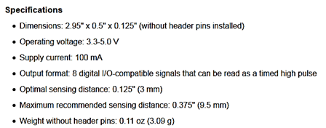

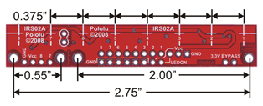

**Option B:** [TCRT5000 Reflective Optical Sensor](http://www.vishay.com/optical-sensors/list/product-83760/) – 1$                 [video link](http://www.youtube.com/watch?v=t0rKEx9IOt4)

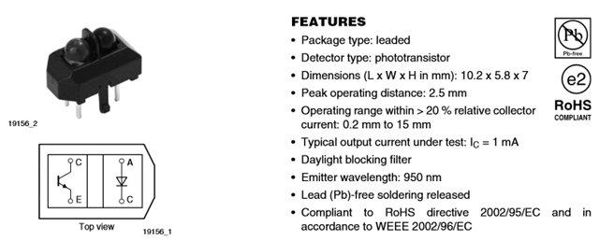

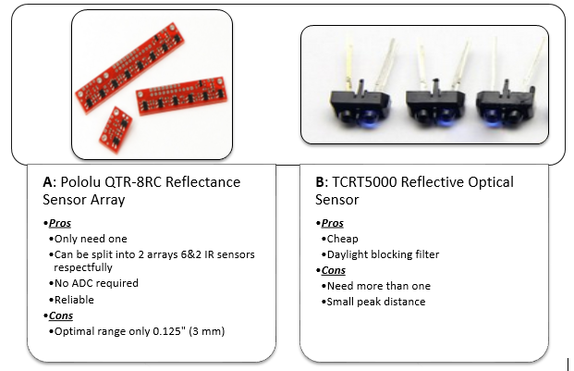

**2.2.2 Sound Sensing:**

For the concept of Simon, we decided to play based on sound. In order to achieve this, we need a microphone capable of recognizing Simon’s sound frequencies.

**Option A:** [Sparkfun Sound Detector– 11$](https://www.sparkfun.com/products/12642) [video link](https://www.sparkfun.com/videos#all/E4L8bYt6lCs/190)**[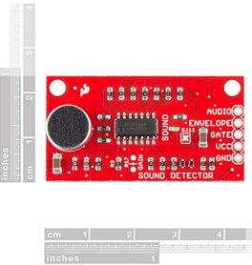](https://www.sparkfun.com/products/12642)**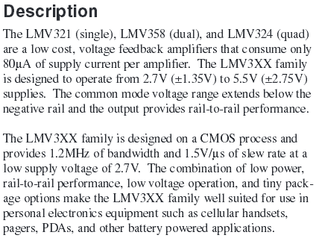

**Option B:**[**Freetronics Microphone Sound Input Module – 10$**](http://www.freetronics.com/products/microphone-sound-input-module#.VDupU2OwXTo) [video link](https://www.youtube.com/watch?v=uVy8w4AJ1hc)

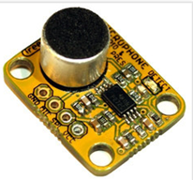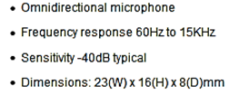

**[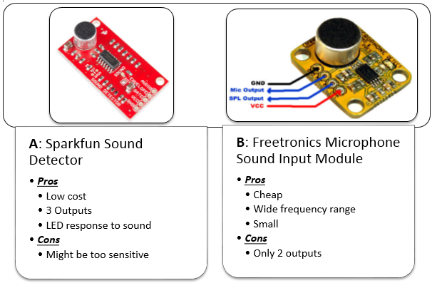](http://www.freetronics.com/products/microphone-sound-input-module#.VDupU2OwXTo)**

**2.2.3 Distance Sensing/ Object Detection:**

In order to locate the games properly, we need to add some form of detection. This sensor will inform the robot of the game’s location relative to it. With proper response, the bot can continue to execute the proper game playing sequence with accuracy.

**Option A:** [**LV-MaxSonar®-EZ™  Sensor Line -**30$](http://maxbotix.com/Ultrasonic_Sensors/Rangefinders.htm)[video link](http://www.youtube.com/watch?v=IN6h5yEGUac)

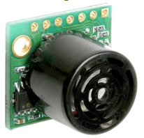

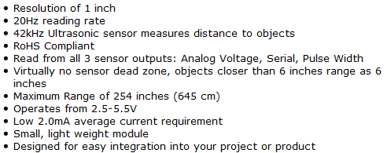

**Option B:** [REDBOT Mechanical Bumper Sensor -5$](http://www.karlssonrobotics.com/cart/RedBot-Sensor-Mechanical-Bumper/?gclid=CIfZ3_bqssECFSxk7AodXmIA8w) [video link](https://www.sparkfun.com/videos#all/70yBAWThTc4/160)

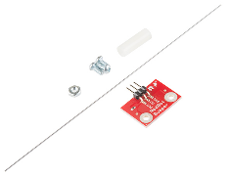

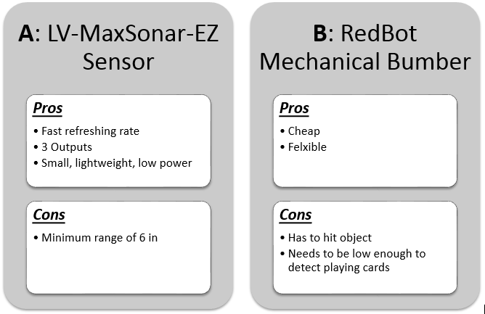

***2.3 Arms/Grippers***

In order to complete the individual tasks, several mechanical arms will be constructed to manipulate the toys. Several options for these robotic arms/grippers have been considered to find the best solution. The factors that went into consideration include compatibility, cost, versatility, functionality, and power consumption. The following table lists the different games and the selected arms that will be used to complete each task.

Grippers

The design will include a gripping mechanism to hold all of the toys in place. The grippers will consist of metal tongs connected to a rotating servo extension. The servo open and closes the grippers based on its position. An appropriate servo will be purchased and tested for system integration, preferably an analog servo like the HS-422. The grippers open and close when the servo rotates the plates creating a clamping motion. The idea comes from the Little Gripper Kit from Lynxmotion (LGK). The entire servo will need to be designed and manufactured. An alternative option is to have two stationary extensions.

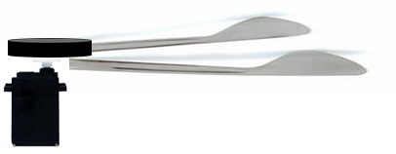

Rubik’s Cube Option A

The approach for the Rubik’s Cube challenge is to have separate mechanical systems cooperate to complete the challenge. Grippers will hold the cube in place while the Rubik’s Cube arm descends and twists the top layer of the Rubik’s cube. The arm will be able to pan and tilt by standard servos at the base. Attached to the end of the mechanical arm is a rotating pair of tongs. The tong shape will be position over the cube and a micro servo will twist the top layer. The protruding corners leave space for the tong positioning. Flat surfaces will catch the corners early and produce a strong enough grip to twist the cube. The alternative approach would be to purchase the (LGK) and program it to grip the top layer. The interactive tongs would be more precise but also more expensive and harder to implement.

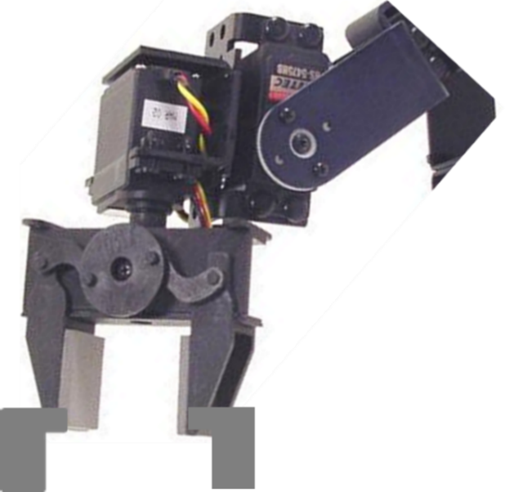

Rubik’s Cube Option B

The second design for the Rubik’s Cube challenge incorporates a box to twist the top layer of the Rubik’s cube. One edge will be slightly larger than the rest to play the Simon challenge as well. The box would need to be manufactured and extremely precise to fit the Rubik’s cube perfectly. The arm mechanics would not change just the end piece.

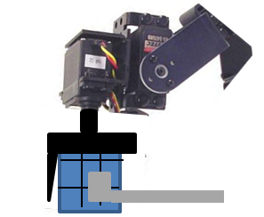

Etch-a-Sketch Option A

The first option for Etch-a-Sketch is to have another mechanical arm with a custom end piece to twist the knobs. The arm will be split into two parts to properly manage the 2 EaS wheels. Standard servos will be used for the pan and tilt motion but a special micro servo will be used to create the continuous rotation of the knobs. A subroutine will be used to draw the letters and complete the challenge. Two independent arms will shorten the time taken by manipulating both knobs instead of transitioning from on to the other. The Grippers will also hold the game in place if needed.

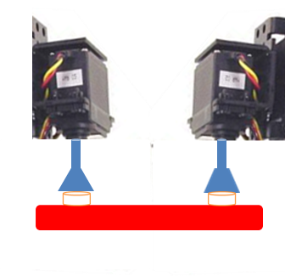

Etch-a-Sketch Option B

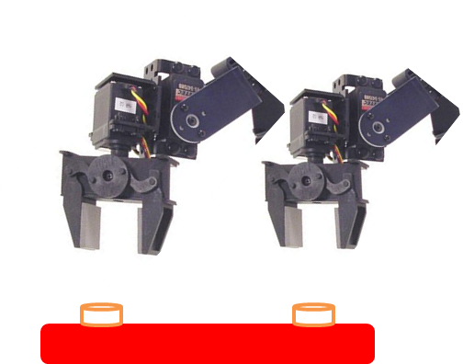The back-up plan is to purchase two (LGNK) kits and order two continuous rotation motors. The extra parts make this plan less cost friendly. The range of motion for the arms and wrist will remain the same making the back-up easier to implement. More time and work will need to be allocated to program the servos that control the gripping mechanism.

Simon Option A

The first option for Simon will be to use the same arm that completes the Rubik’s Cube challenge. Simon’s buttons will be pushed by the ends of the pair of tongs. Each button will have a subroutine to place the arm in position and the tilt servo will simply drop the arm on the button to press it. The buttons are fairly sensitive so precision must be considered when positioning. The microphone and mechanical arm will cooperate to complete the Simon challenge.

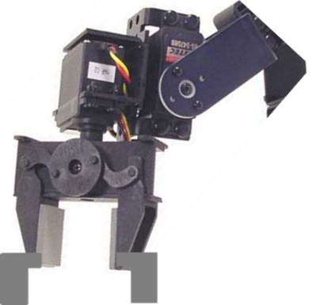

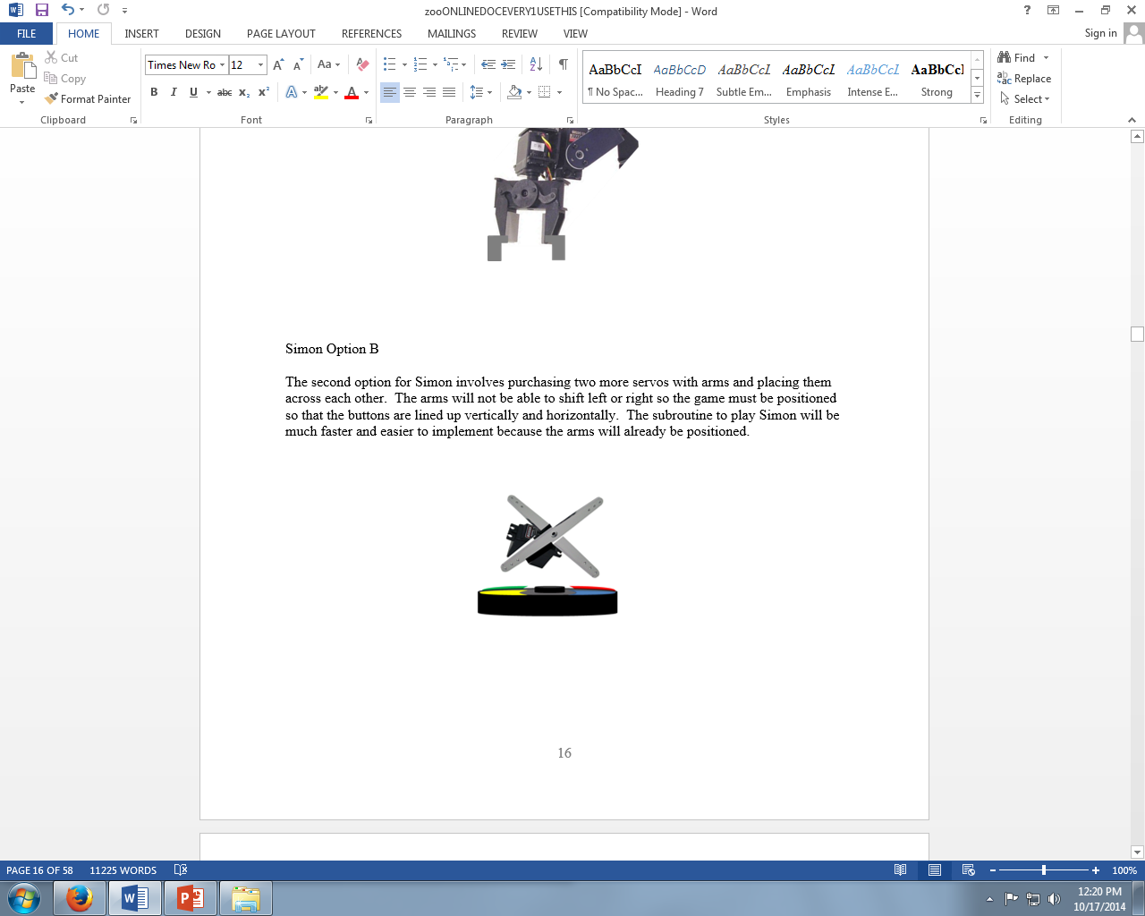

Simon Option B

The second option for Simon involves purchasing two more servos with arms and placing them across each other. The arms will not be able to shift left or right so the game must be positioned so that the buttons are lined up vertically and horizontally. The subroutine to play Simon will be much faster and easier to implement because the arms will already be positioned.

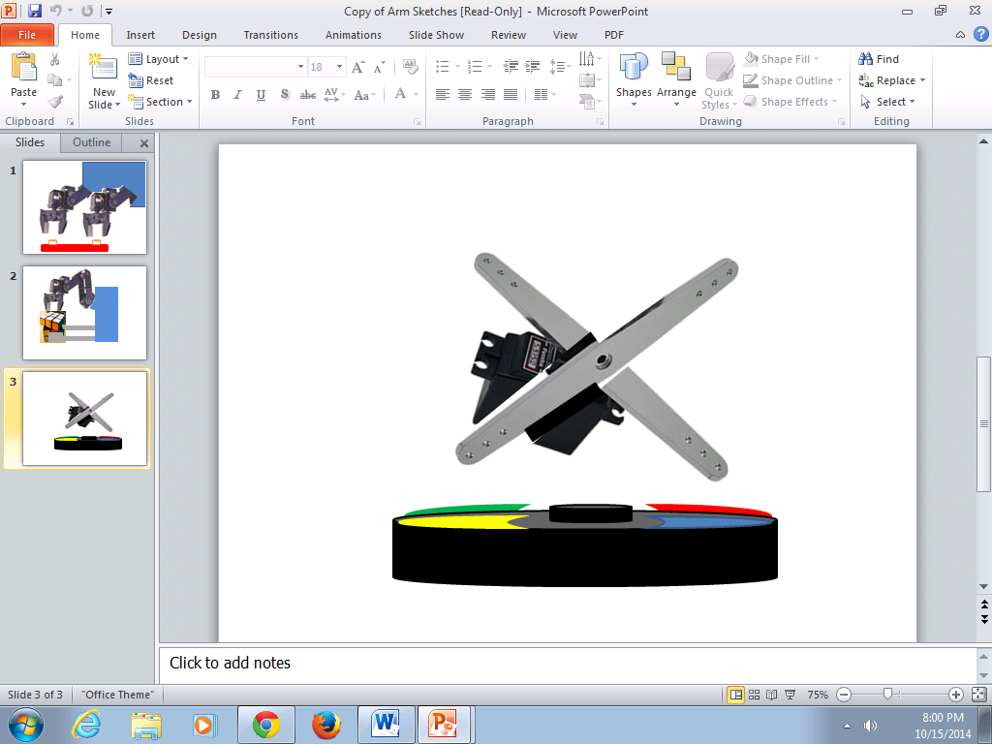

Playing Card Option A1

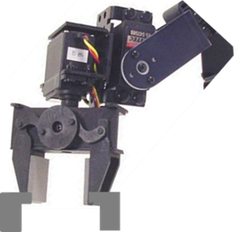A suction cup will be placed on the inner brackets of the Rubik’s Cube arm making it more versatile and preventing unnecessary purchases for another mechanical arm. The card must be secured and in usable condition in order to complete the challenge. Because this option cannot be fully tested until the Rubik’s Cube arm is constructed, option B will also be pursued to ensure a working solution.

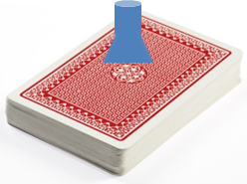

Playing Card Option B

A flat metal surface will tilt down and rest on top of the deck of playing cards with a suction c. The cup will be securing the card as in option A1, but a larger suction cup will be attached to the metal surface. The flat metal surface will basically act as a drawbridge.

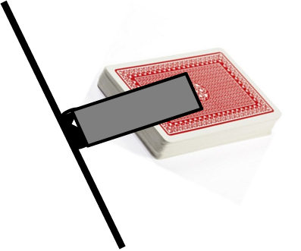

***2.4 Drive System***

Three layouts were considered for the wheels and motors of the drive system. The first two layouts, A and B, each consist of two motor-powered wheels and a single caster wheel. They differ in that option A places the caster wheel at the front of the system, while option B places it at the back. The third option, C, consists of four motor-powered wheels. The layouts for these systems can be seen in the figure below. In each of these systems, turning would be achieved by powering a wheel on one side (or two wheels on one side in the case of option C) in one direction, while powering the wheel(s) on the other side in the other direction. With this design, the robot would pivot approximately around the point in the middle of the powered wheels. This is an advantageous system of navigation as it does not require wheels that can actually pivot/turn themselves.

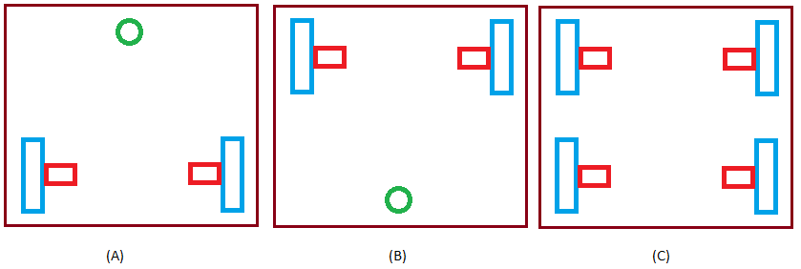

*Figure 1: Drive System Options  
Blue Rectangles- Wheels, Red Rectangles- Motors, Green Circle- Caster Wheel (note: not drawn to scale)*

One of the main advantages option C has over options A and B is increased stability. The additional wheel and its placement allows for some leeway in the balance and distribution of the robots weight, as it is less likely to tip over. Additionally, without the caster wheel and with four powered wheels, there is the potential of having more precision when lining the robot up with the toys, and the lines. The main disadvantage of this layout is that it requires more components. There would need to be two additional motors in order for option C to work properly, this raises the cost of the robot both in monetary value, and in power consumption. Another disadvantage of the two additional motors needed for option C is that they take up more space on the chassis, potentially getting in the way of other components.

The caster wheel in options A and B allow the system to use the two powered motors for turning while the caster swings freely. An advantage of this is that it allows for sharper turns than the configuration of option C. The caster wheel provides stability while not increasing costs with additional motors, however it will be necessary to distribute more of the robot’s weight closer to the two motor-powered wheels in order to ensure that the robot does not tip over in this configuration. In addition to not adding to the cost with additional motors, the configuration of options A and B allow for more space on the chassis for other robot components.

Option C is more costly than A and B, in monetary value, space, and power. While it may offer additional stability and potentially precision, the wheel configuration in options A and B provides the necessary stability for the system, while allowing for tighter turns. The team has come to the conclusion that the advantages of a system with A and B’s configuration outweigh the advantages of option C’s.

The only difference between option A and B is the location of the caster wheel, option A places it at the front of the system, and option B places it at the back. Whichever side the  caster wheel is located on must carry less weight in order for the system to remain stable. The advantages of option A include the fact that having the caster wheel in the front of the system frees up space in the front of the robot for the necessary components in the systems for the arms/grabbers, as well as for sensors, since the motors will be in the back. Additionally, it would be ideal for the line following system’s sensors to be located where the powered wheels are located. Placing these sensors in the back again frees up space for the components that must remain located at the front of the robot. One of the advantage of placing the caster wheel in the back in option B is that the weight of the sensors, arms, and other necessary components at the front of the robot would be distributed closer to the two powered wheels, and therefore potentially more stable. However, there is still the disadvantage of the motors (and line following sensors) being in the way of other components. Based on this, the team has decided to go with option A for the drive system, deciding that counter weights could be placed in the back of the robot if absolutely necessary to provide stability.

Motor:

The motor chosen for each of the two powered wheels is a 12 V, 200 rpm, 170 oz-in DC brushed motor with an encoder shown below. Brushless motors were briefly considered as they have increased torque per weight, efficiency, lifetime, and reliability than their brushed counterparts. However they are much more expensive and more difficult to program with (brushed motors are more simplistic). Though brushed motors have many advantages, the expense was too much, and brushed motors are capable of performing well in the applications of this system.

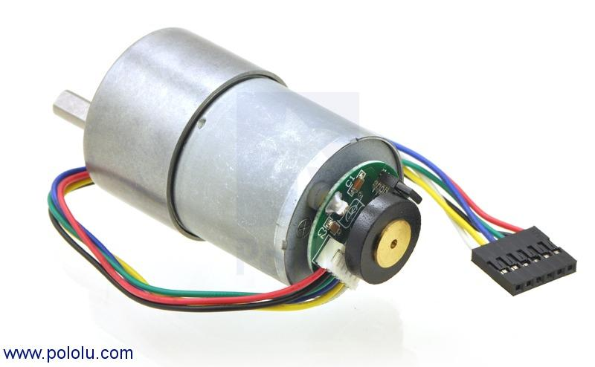

The wheels used for the two motor-powered wheels will be plastic 90 mm diameter wheels with removable silicon tires. The silicon tires are sticky to provide additional traction,  which will be important for the drive system’s accuracy. If the wheels were to slip, the distance actually traveled by the system would potentially different than that seen by the program. The wheels and tires that will be used can be seen below.

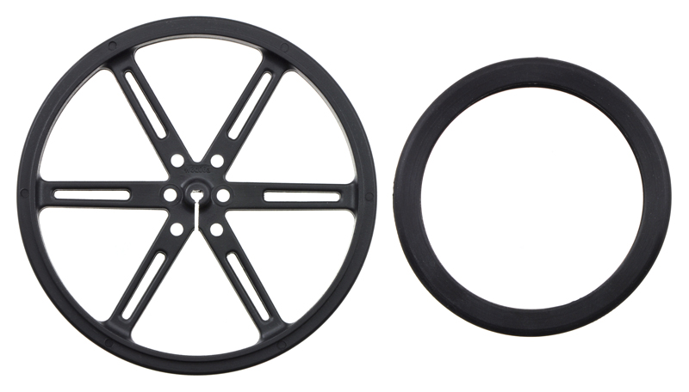

***2.5 Power Supply***

With great consideration the team is convinced to have a power system of three NiMH Battery Packs. There will be two different power sources because of the different ranges of voltages need by the parts. While each part will require a different voltage source and the Arduino due will be used to supply voltage as well. Arduino built in voltage regulator it will be able to supply voltages to the parts with that were out too low compared to the two battery sources.

Nickel-metal hydride batteries NiMH have been chosen because their energy density approaches that of a lithium-ion cell. The only bad side to NiMH requires long periods of time to charge with a high self-discharge rate. Lithium-ion cell are leading currently in Power Capacities with because it has a zero memory less effect. NiCad stores less energy every time you recharge it and will take an extra steps to fully discharge to recharge.

**Plan A**

The team has decided to purchase two power supplies in which one will supply 12 V and the second will supply 6 V. The wheel motor and Arduino due board require 12 V input to operate. Also the motors used in the ARMS/Grippers will be using the 6 V power supply. The sensors operate at a smaller voltage threshold hold and requires a voltage regulator to step the down voltage from either voltage source. The Arduino due board has a voltage regulator and will be use to supply power to the sensors.

**Plan B**

The second proposal plan would be to use one battery and purchase a voltage regulator and use it to supply the voltage used a secondary supply as Plan A. The trade off would be cheaper in favor Plan B however Plan A has a higher efficiency rate.

Table 2.5a - Pros and cons of different battery types

|  |  |  |  |  |  |  |
| --- | --- | --- | --- | --- | --- | --- |
|  | Alkaline | Fuel Cell | Lead Acid | Lithium | NiCad | **NiMH** |
| Price | Cheap | Expensive | Cheap | Most Expensive | Cheap | Cheap |
| Power Capacities | Low Power | High Power | Low power | High Power | High Power | High Power |
| Weight | Heavy | Heavy | Light | Very Light | Light | Light |
| Replace Expense | Expensive | Expensive | Cheap | Expensive | Cheap | Cheap |
| Ability to supply large amount of current in small time periods | Bad | Good | Average | Average | Great | Great |
| Rechargeable | Yes | Yes | Yes | Yes | Yes | Yes |

Table 2.5b - Different battery options

|  |  |  |  |
| --- | --- | --- | --- |
| 12 Volts | Price | Current Output (mAh) | Weight |
| Battery 1 | $54.95 | 5000 | 283 grams |
| **Battery 2** | $29.95 | 2200 | 997 grams |
|  |  |  |  |
| 6 Volts |  |  |  |
| **Battery 1** | $15.15 | 2200 | 142 grams |
| Battery 2 | $9.95 | 900 | 63 grams |

*Bolded represents the team’s selection.

Image of the selected 12 V Power supply

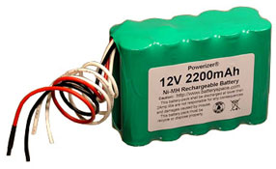

Image of the selected 6 V power supply

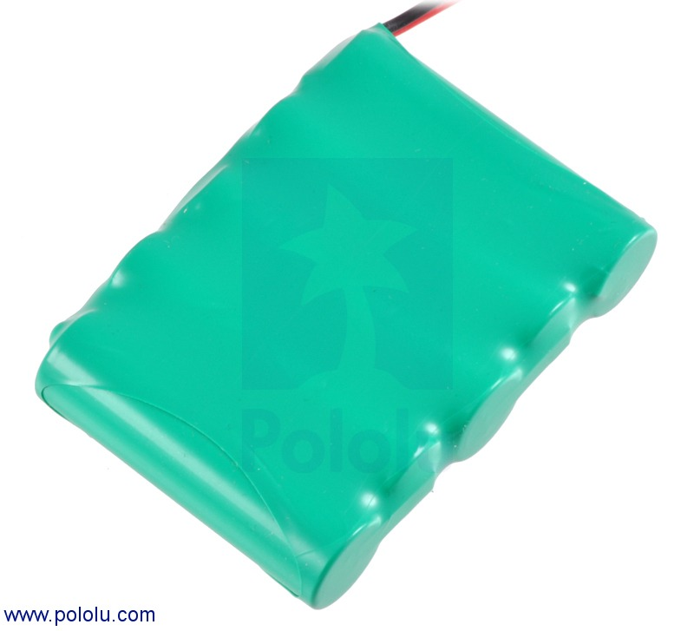

The team has decided to go with one charge that will supply both batteries to the cut the cost instead of buying two charger for each power source. This gives more room in the budget to buy more power supplies to cut down on the charging in-between rounds. It is propose to purchase one spare battery for each source. The charge is priced at $16.95 and is capable of charging batteries between the ranges of 6-12 V.

Image of selected charger

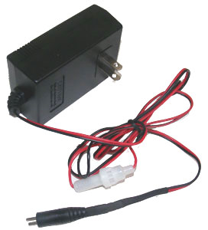

Connecting the drive motor

In case we change the way we wish to connect the drive motor, we can cut off the male jumper and plug the wires into a bread board and manually configure it.

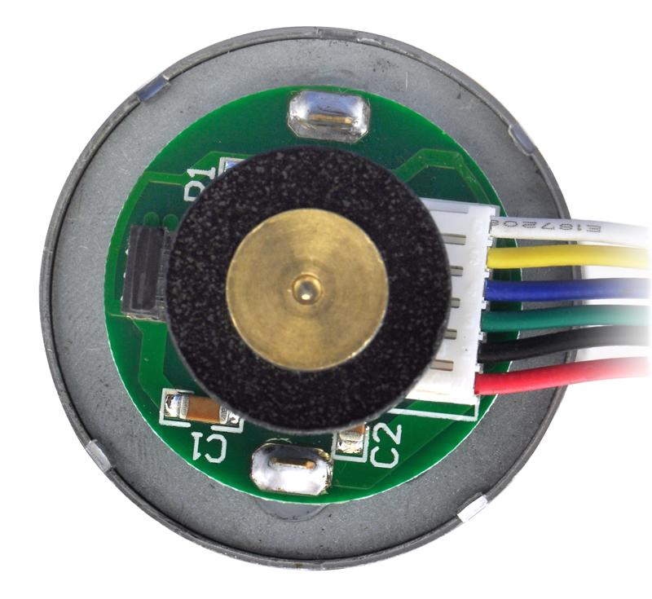

Remember, batteries connected in parallel add in mAh (for higher life and current output) while batteries connected in series add in voltage (for high voltage applications). To increase battery life, get batteries of higher mAh, and/or connect more of the same battery type in parallel.

In this section:  For each major decision point that you encountered in developing your proposed design (these could relate to solution strategies, principles of operation, choices of components, design tools, test methods, etc.), show the different possible solutions that you considered (there should be more than one!), discuss advantages/disadvantages of each, indicate which of the options was selected to be part of the final proposal, and say why – justify the decision made in terms of a discussion of the pros/cons, tradeoffs between different design criteria, quantitative comparison of the alternatives via decision matrices, or other reasoned modes of argument.  Also include, in this section, a report on any detailed analyses or simulations that you may have carried out in order to evaluate the different alternatives that were considered.

***2.6 Chassis***

For the chassis the team decided that there were three types of material options available. The chassis could be made out of either a wood, metal or plastic.

Once all game playing sequences are properly integrated, the focus will be speed. The choice for the chassis should reflect this. The team is considering plastic or laser-cut acrylic for a lightweight option. This will allow the robot to navigate the course faster, therefore earning more points. However; if weight is to become an issue, a wood, metal or aluminum frame could work.  This shouldn't be the case, so the primary choice is a plastic/ acrylic design.

The robot will include two rear wheels with motors, and a caster wheel in the front for support. A line reflectance sensor array will be placed close to the rear wheels to ensure more accurate turns around the course. Another, smaller IR sensor will be placed towards the middle to detect the start LED and also double as a line follower. In front of the caster should be the object detector, used to see objects directly in ahead of the robot. The main arm, side arms, and grippers will be mounted at the front to simplify locating and playing games. The power supply and processor will be placed on the back and double as a counterweight to the components in the front

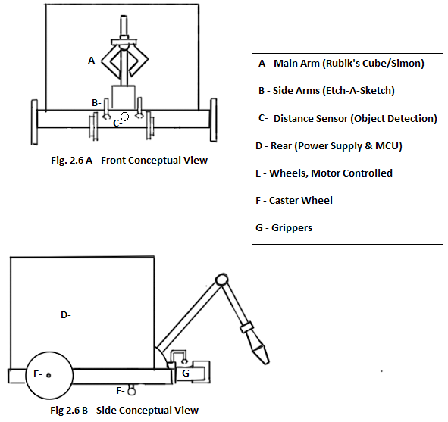

1. **Proposed Design**

***3.1 Overview***

The team has agreed on a well balanced robot. It is proposed that the robot will drive across the course using an ideal speed covering all untraveled taped course. Sensors will be used to follow the course line, start the robot based off of IR sensors, detect sound to play a Simon, and measure distance from games. The autonomous robot will be discerning enough to recognize each game secure it with the grippers and manipulate each using the arms designated for them. The robot intelligence will also ensure it’s accuracy in manipulating the games to gain maximum points.  The robot will be programmed to finish the four tasks as fast as possible within a five minute time limit. The robot will play three rounds and must have enough power to last all three. NiMH batteries were chosen because of their large battery capacity in theory if fully charged the NiMH batteries can withstand three rounds. The team has decided to bring fully charged spare batteries for the competition as well as the charger. The robot will have two NiMH batteries with different voltages and the Arduino board will be used to power the sensors using low voltages.

***3.2 CPU***

  The microcontroller being used for this project is an Arduino Due.  There are 12 pins for pulse width modulation (PWM). These pins will be reserved for the servos.  These pins, which are numbered 2-13, can be seen on the right side of Figure 3.1a. Depending on which type of servos are eventually purchased an analog to digital converter may be needed to be put in between the servo and the PWM pins.  This microcontroller operates at 3.3v so there will need to be a voltage regulator in between the motors and the microcontroller to ensure that board does not get damaged.

  After the robot has been turned on the microcontroller will wait for a signal from the start light sensor to indicate that the light has been switched off. If the signal is not received, the robot will not perform any actions. Then the robot will go into a line following and game searching mode. Here the robot will attempt to stay on a white line as best as it can. While doing this it will also be on the lookout for games. Since the games will always be in the same order, the robot will be programmed to search for games in a certain order. After it has played a game the robot will add one to a counter being reserved for deciding which game to play. This can be seen in Table 3.1a. After the counter reaches 4, which means all of the games have been played, the robot will no longer be looking for games. Instead the robot will look for the finish line. After the robot has crossed the finish the robot will stop and wait. Figure 3.1b shows the overview of this entire process.

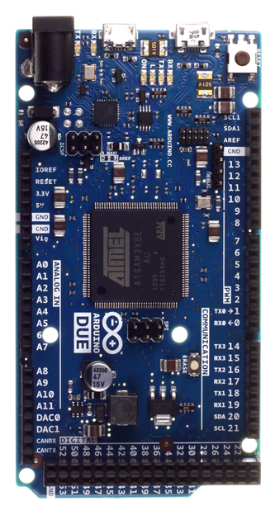

Figure 3.1a - The Arduino due microcontroller

Turn robot on

Wait for start light

Follow course

Does the counter equal 4?

Find and play next game

Add 1 to the counter

No

Look for the finish line

Stop moving once over the finish line

Yes

Figure 3.1b - The top level code diagram

Table 3.1a - Showing what game the robot will play at different counter values

|  |  |
| --- | --- |
| Counter value | Game being played |
| 0 | Simon says |
| 1 | Etch-a-Sketch |
| 2 | Rubik’s cube |
| 3 | Playing car |
| 4 | No game – go to finish line |

***3.3 Drive System***

In searching for a motor capable of powering the robot as desired, the team decided a brushed DC motor with an encoder would be the best choice. Brushless motors were briefly considered for their increased performance and lifetime. In a brushless DC motor, there is a higher speed for the available torques, but it is much more expensive than the brushed motors. Additionally, brushed motors are more simple to program. It was decided that the simplicity and lower cost of brushed motors were more advantageous, so for the drive system this type of motor will be used. After consulting with a mechanical engineering student, and reviewing previous year’s projects, the first motor considered by the team was a 12 V metal gearmotor with a 50:1 gear ratio.  It has a torque of 170 oz-in or 0.12 kg-m, and 200 RPM.

The desired velocity for the robot is 1 ft/s, or 0.3048 m/s, with an acceleration of 0.5 ft/s2 or 0.1524 m/s2. Not accounting for friction, and estimating the robots mass at 3 kg the force required to move the robot is as follows:

*F = m*a*

This gives a force of 0.4572 N. Using a wheel radius of 0.045 m and factoring in that Brushed DC motors usually have an efficiency of 68%, and deducting an additional 10% from this to account for friction, the torque required to move the robot is as follows:

*T = F*r*(1/efficiency)*

This yields a torque of 0.0355 kg-m, which is far less than the torque of the selected motor. Additionally, these calculations are assuming one powered wheel, in case only one wheel is moving in order to turn the robot a certain direction. The majority of the research for the robot motor was done using a helpful “robot motor factor” on the Society of Robot’s website, the calculations are essentially the same as those used here.

The CPU selected for the project already has motor controllers included, so in selecting a motor all that was required was a DC motor with an encoder. Two 12 V with motors with 64 CPR encoders were considered, with the specs in the following table.

Table 3.3a - Different motor options

|  |  |  |
| --- | --- | --- |
|  | Motor A | Motor B |
| Gear Ratio | 50:1 | 30:1 |
| Torque (kg-cm) | 12 | 8 |
| Stall Current @ 12 V (A) | 5 | 5 |
| RPM | 200 | 350 |

While motor B also most likely has enough torque to properly move the robot around the course, motor A has a higher torque, in addition to a higher gear ratio, which is desirable. Considering the weight of the robot used for motor calculations was a rather rough estimate, and the two motors are the same price, the team has decided to go with Motor A in order to ensure it will be powerful and precise enough for our applications.

***3.4 Sensors***

The sensor for the robot are split into 4 different categories: starting, line following, microphone for simon, and object detection. All sensors proposed are fairly cheap and simple to implement, making replacement a good possibility for a contingency plan.

**3.4.1 Starting**

The robot must begin in a white 1’x1’ square and detect the shut off signal of a flush red LED. In order to achieve this, a reflectance sensor array with 2 IR sensor will be placed around the midpoint of the robot. With the optional help of a light filter, the array will detect the off signal and alert the processor. The robot will then move forward, about a foot, and begin navigating the course.

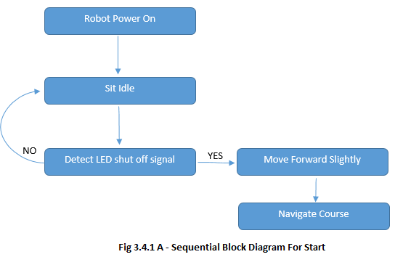

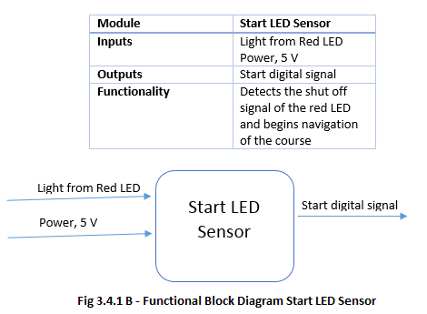

**3.4.2 Line Following**

The robot must navigate a 0.94” white line varying each round. A 6-8 IR sensor array will be used to accomplish this task. It will be placed near the rear, by the motor controlled wheels, for accurate turns. I will also be able to detect intersections and other complex course structure until it reaches the finish point.

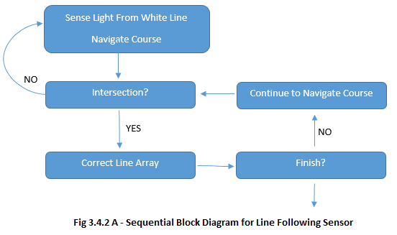

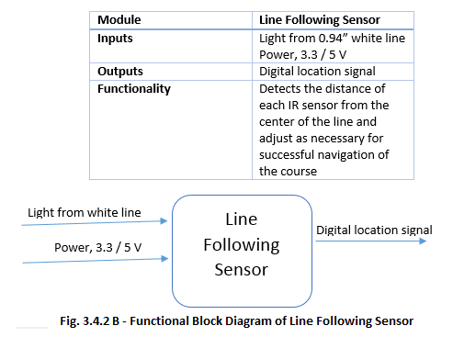

**3.4.3 Microphone for Simon**

The robot must first correctly play Simon for 15 seconds. Using a microphone was decided to be ideal for this task. It will be placed on the main (pan & tilt) arm to accurately measure the frequency of the various Simon sounds. The signal will then be used to determine which button the robot must correctly press.

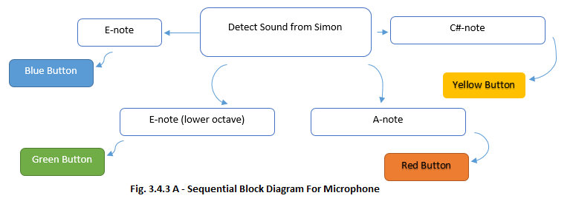

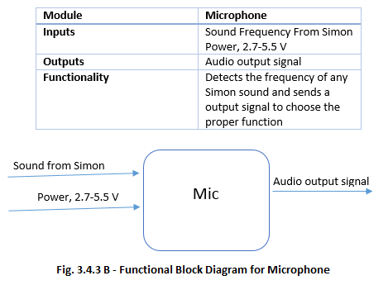

**3.4.4 Object Detection**

The robot must locate each game within a 1’x1’ white square. The team decided to use a ultrasonic range sensor to complete this task. The sensor will be located on the front of the robot; as low as possible to detect all games. It will send a signal to the processor to slow down, stop, and then start a game specific sequence whenever the robot comes within a certain range.

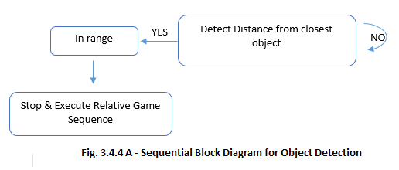

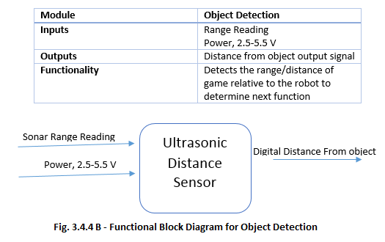

**3.5 Arms/Grippers**

The proposed design for the mechanical arms is largely centered on programming servos. The servos create all of the movements for the arms and grippers. Sequential programming will instruct the servos to position joints and end pieces to perform the toy challenges. The servos we have selected for the arms are controlled by Pulse Width Modulation and powered by 4.8-6V DC power supply. The Arduino Due has 12 Digital PWM outputs so an Analog-to-Digital Converter will be incorporated to interface with the Arduino Due board. Also, a voltage regulator will mediate the power supply for the individual servos.

Top Level Diagram for Arms/Grippers

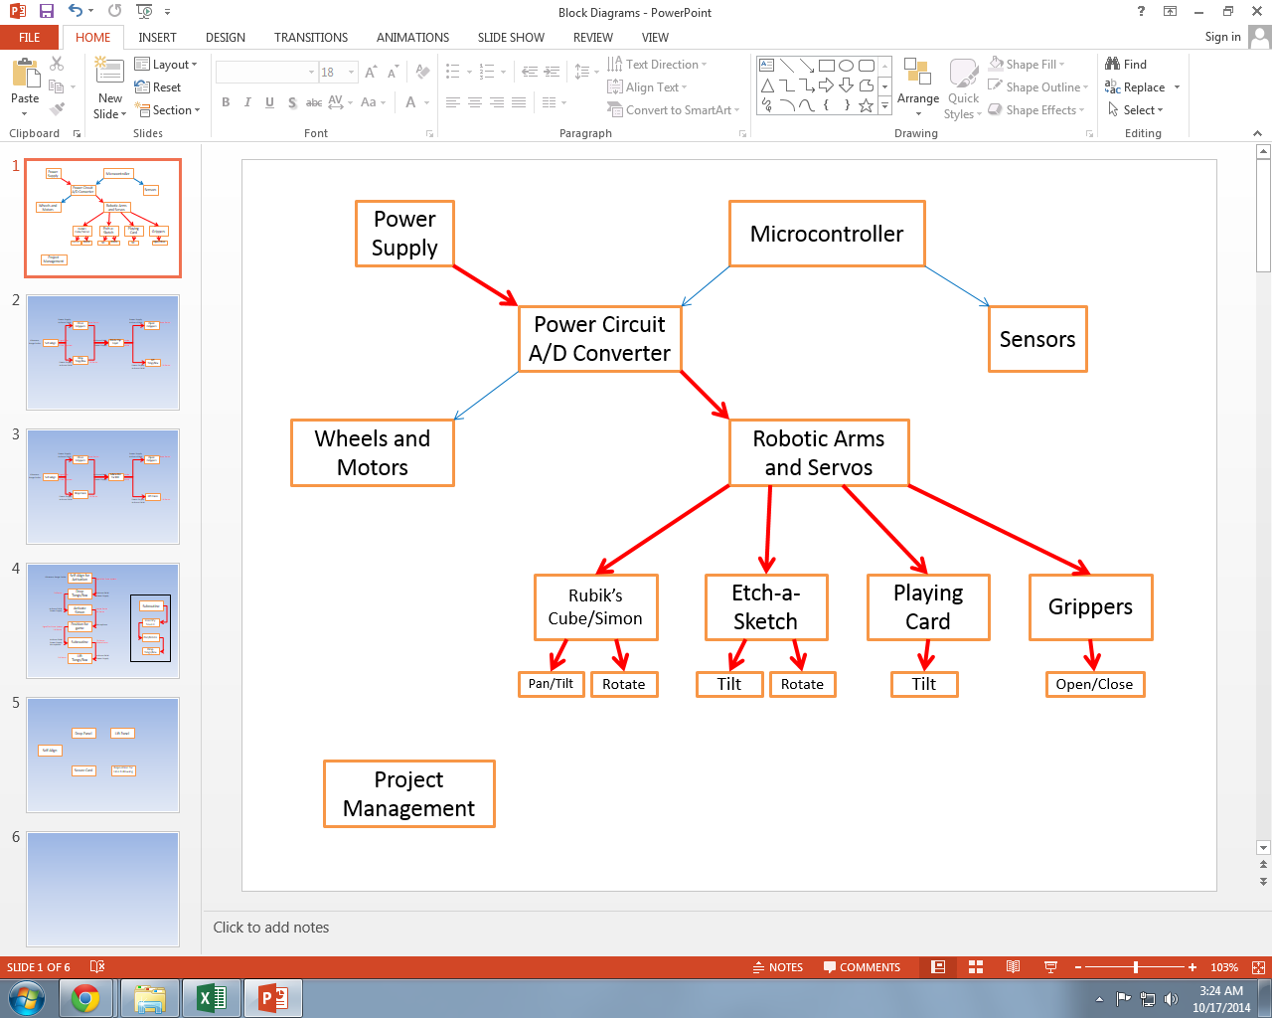

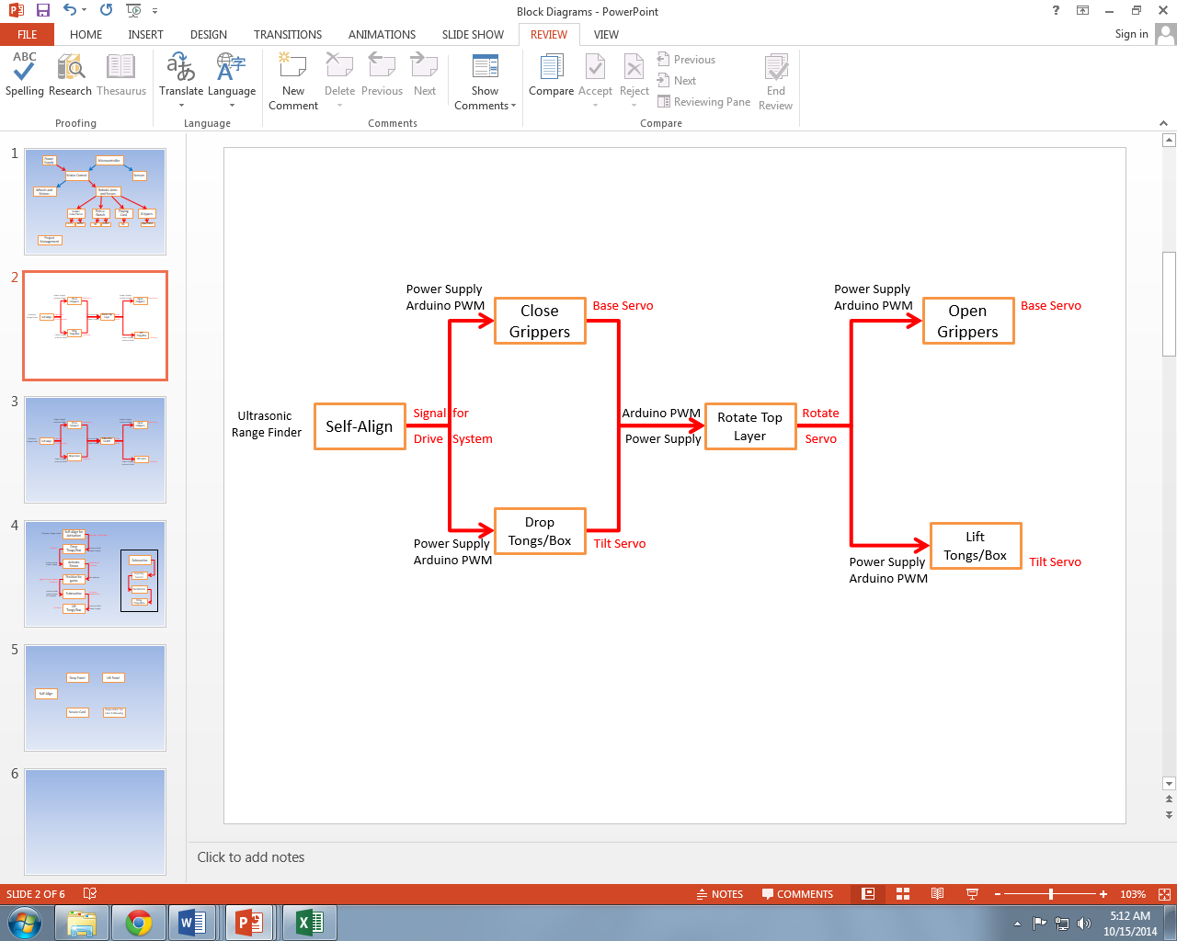

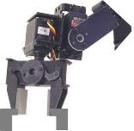

System Level Diagram for Rubik’s Cube

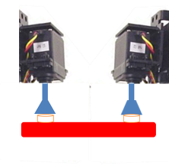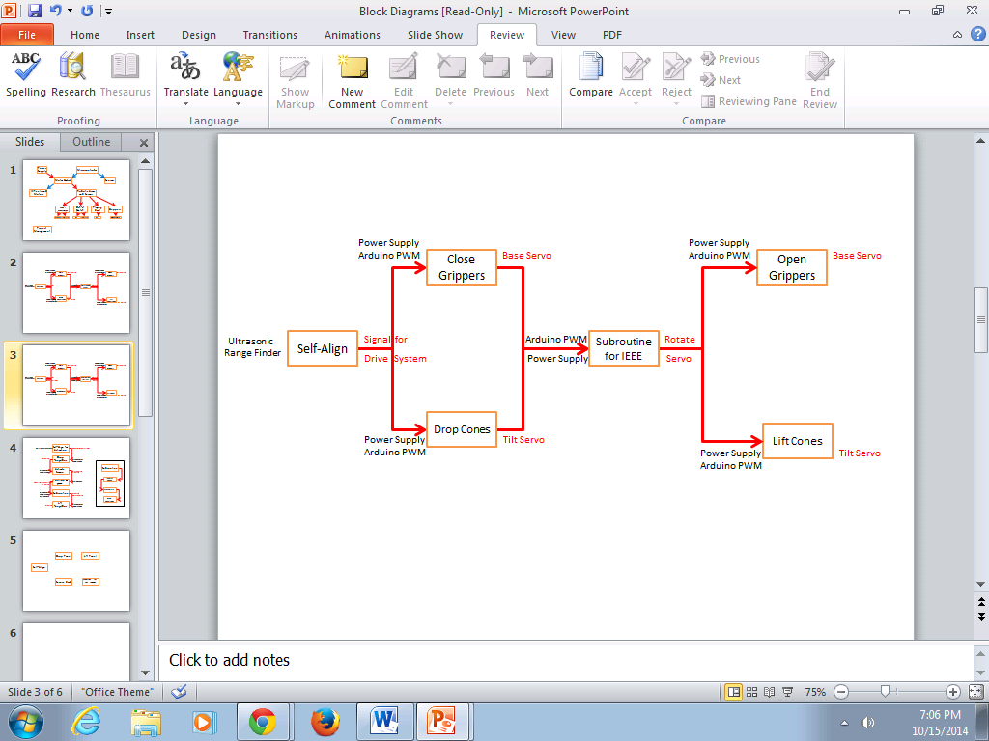

System Level Diagram for Etch-a-Sketch

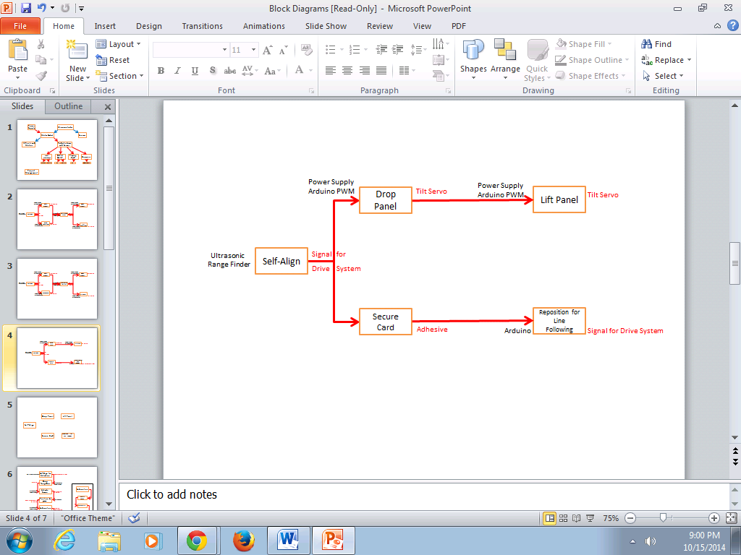

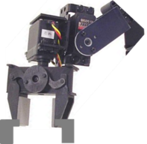

System Level Diagram for Playing Card



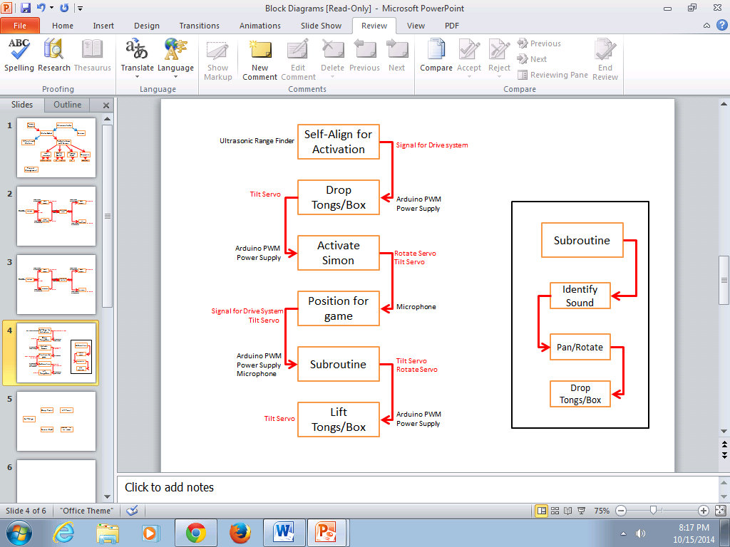

System Level Diagram for Simon

The current selected servos are listed below with their operating conditions and outputs.

HS-422 (Analog PWM)

The first selection for servo motors is the HS-422. It is standard sized and will be used for the pan and tilt motion in the mechanical arms.

|  |  |  |  |
| --- | --- | --- | --- |
|  |  |  |  |

|  |  |
| --- | --- |
| Required Pulse | 3-5 Volt Peak to Peak Square Wave |
| Maximum Torque | 57 oz-in |
| Operating Voltage | 4.8-6.0 Volts |
| Operating Temperature Range | -20°C to 60°C |
| Operating Speed | 0.21sec/60° at no load |
| Operating Speed | 0.16sec/60° at no load |
| Stall Torque | 45.82 oz-in. (3.3kg-cm) |
| Stall Torque | 56.93 oz-in. (4.1kg-cm) |
| Weight | 1.6oz (45.5g) |

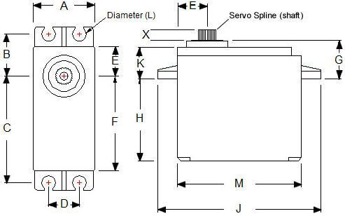

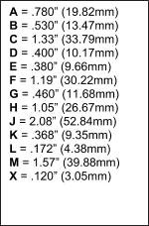

HS-85BB (Analog PWM)

The HS-85BB is a micro servo with the same power as a standard size servo. It is great for small gas and electric aircraft as well as many robotic projects. It has a standard size spline which means it will fit most servo accessories and extensions.

|  |  |
| --- | --- |
| Required Pulse | 3-5 Volt Peak to Peak Square Wave |
| Maximum Torque | 49 oz-in |
| Operating Voltage | 4.8-6.0 Volts |
| Operating Temperature Range | -20°C to 60°C |
| Operating Speed(4.8V) | 0.16sec/60° at no load |
| Operating Speed(6V) | 0.14sec/60° at no load |
| Stall Torque(4.8V) | 41.66 oz-in. (3kg-cm) |
| Stall Torque(6V) | 48.6 oz-in. (5kg-cm) |
| Weight | 0.67oz (19.2g) |

|  |
| --- |
|  |

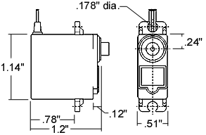

HSR-1425CR (Analog PWM)

The HSR-1425CR servo is a standard servo modified for continuous rotation.  The servo is fairly robust and will be used to open and close the grippers.

|  |  |
| --- | --- |
| Required Pulse | 3-5 Volt Peak to Peak Square Wave |
| Maximum Torque | 42 oz-in |
| Operating Voltage | 4.8-6.0 Volts |
| Operating Temperature Range | -20°C to 60°C |
| Operating Speed(4.8V) | 44 RPM at no load |
| Operating Speed(6V) | 52 RPM at no load |
| Stall Torque(4.8V) | 38.8 oz-in. (2.8kg-cm) |
| Stall Torque(6V) | 42 oz-in. (3.1kg-cm) |
| Weight | 1.47oz (41.7g) |

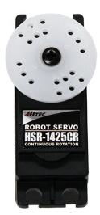

1.59" x 0.77"x 1.44"

(40.6 x 19.8 x 36.6mm)

FS90R (Analog PWM)

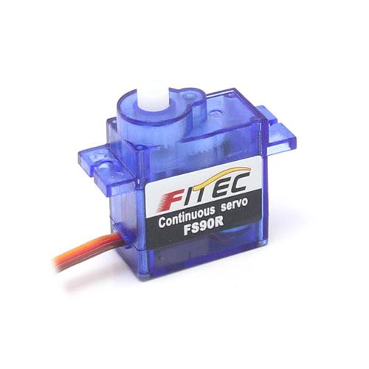The FS90R is the smallest servo that is manufactured specifically for continuous rotation. It has great speed and torque for its size.  It will be used to rotate the Etch-a-Sketch cones.

0.91 x 0.49 x 0.87”

(23.2 × 12.5 × 22 mm)

|  |  |
| --- | --- |
| Required Pulse | 3-5 Volt Peak to Peak Square Wave |
| Maximum Torque | 20.8 oz-in. (1.5kg-cm) |
| Operating Voltage | 4.8-6.0 Volts |
| Operating Temperature Range | -20°C to 60°C |
| Operating Speed(4.8V) | 110 RPM at no load |
| Operating Speed(6V) | 130 RPM at no load |
| Stall Torque(4.8V) | 18.1 oz-in. (1.3kg-cm) |
| Stall Torque(6V) | 20.8 oz-in. (1.5kg-cm) |
| Weight | 0.317 oz (9g) |

**3.6 Power Supply**

The team will manufacture a housing case to secure to the chassis near the rear end of the robot. The placement of the batteries also will aid in balancing robot’s weight. One battery will power the robot’s central processing unit and drive motors. While the other battery will power the motors used to control the arms. Lasty the voltage regulator will step-down the incoming voltage to two different voltages for sensors requiring lower voltages.

Two chargers will be purchased with capability to charge both NiMH batteries. Batteries will be tested and calculated to an accurate full charge time. Data will be use to devise a charging schedule to prepare the batteries before every use. Also data and observations will be used to determine how many spare batteries are necessary. The spare batteries are being considered for back to back use, playing three consecutive rounds.

Contingency Plan

The price of the batteries and chargers are low enough to purchase more when needed. Having a spare of batteries cuts idle time. If system was to fail during the competition alkaline batteries will be purchased and used to build a replacement power source.

These subsections will describe in greater details each of the blocks in the overview block diagram.  These should include block diagrams and subsections of their own if needed to complete the description of the proposed design.

1. **Statement of Work (SOW)**

**4.1** **Task 1: Project Management**

The team has agreed to divide the project up into two projects and complete task assigned for each.

The technical project is assigned to each member based of his/or qualifications and experience. The robot will be divide up into five subsystems that one member will be assigned too for the remainder of the project. It is the team member responsibility to use resource, problem solving skills, and critical thinking techniques to complete the assigned task(s). The technical project will be completed using everything learned from previous technical classes taking at the College of Engineering.  No task is restricted to solely one member of the team. All task can be completely with other members.

The administrative project will consist of a task manager that will represent the group's leader. The task manager will have total control of administrative duties and responsibilities. The task manager may appoint task and positions when deemed necessary. The administrative project duties will be given to administrative positions to accomplish goals proficiently. Positions have been created and will be filled by each member. Task Manager Lorenzo Smith, Treasure - Louis Cooper, Secretary Chelsea Ogle, Equipment Manager Ivan Vargas, Leading Programmer Evan Marshall. All other responsibilities will be the task manager responsibility unless assigned to someone else.

Contingency plan: Task are govern with a time period for ideal completion including time for troubleshooting. Professors on campus having expertise and knowledge in the technical field related will be contacted for advice.

The administrative project may develop integral conflict amongst members which the code of conduct will be referred to for a solution. Also in the event that a member is not performing in their best ability the member may be impeached. Weekly evaluations will be given by task manager to update the team on its individual and team's performance and status. New task will be given out weekly and written down in each personal project journal.

**4.2** **Task 2: Design And Implement Competition Ready Robot**

**4.2.1** **Objectives**

The robot must be able to complete the challenges set for the IEEE 2014 Southeast Con Hardware Competition.  These challenges must be completed by the robot without any outside assistance. The more challenges that the robot completes, the more points that the team will receive. The goal is to receive as many points as possible by completing the challenges in quick and timely manner. The first challenge is that the robot must sense that a red LED has turned off and follow the course. This course will consist of a white line against a black surface with games inside white squares. There will be four games the robot has to play. Simon says needs to be played for 15 seconds. IEEE must be drawn on an Etch-a-Sketch. One face of a Rubik's cube must be turned 180 degrees. A standard size playing card must be picked up and carried across the finish line. The robot must complete these tasks under five minutes.

**4.2.2** **Approach**

There are many challenges that this robot will be designed to complete. Each team member will be assigned to work on a different subtask individually. This way everyone will be working on something relevant to the project.

**4.2.3** **Test/Verification Plan**

When the subtasks have all been completed a full competition scenario must be simulated. The robot must be placed in the start square and autonomously start, follow the course and play all of the games. This will be done with a course that will be as reasonable difficult as the rules allow. There will be different levels of ambient noised being played in the simulation environment. After each simulation notes will be taken about what was and was not done correctly. Any corrections will be made to incorrect actions taken by the robot. By this point the robot should be mostly complete. There will just be fine tuning to have the robot to play the games as fast as possible.

**4.2.4** **Subtask 1: Detect start light**

**4.2.4.1**   **Objectives**

The robot must be placed on the course near a red LED. When the LED turns off the robot must start following the course and play the games. If this task is not completed, no points will be awarded.

**4.2.4.2**   **Approach**

A light sensor will be used to detect the red LED. This is the same type of light sensor that will be used to follow the course.

**4.2.4.3**   **Test/Verification Plan**

A red LED will be placed in the same kind of conditions expected to be on the final course. The sensor will be placed at an appropriate height. The LED will switch between on and off. The sensor should send a different signal whether or not it detects that the LED is on or off. If no changes are seen by the sensors then changes need to be made to either the sensor height and sensor cover to ensure that it can correctly see the LED.

**4.2.5 Subtask 2.1 Drive System**

**4.2.5.1**   **Objectives**

The robot must have some form of mobility in order to navigate the course. If the robot cannot move properly, no other parts of the competition can be completed.

**4.2.5.2**   **Approach**

The source of the robot’s mobility will be two DC motors with encoders, connected to two plastic wheels covered in silicone tires for traction. The DC motors will be integrated with the Line Following System for proper navigation. Additionally, in order to maintain stability, a caster wheel will be added to the system.

**4.2.5.3**   **Test/Verification Plan**

The DC motors, plastic wheels with tires, and caster wheel will all be mounted to a chassis of some sort with a power source. The motors will also be connected to the MCU’s motor controllers. A simple program will be written to test that the motors can move the robot forwards and backwards, and turn left and right.

**4.2.6**  **Subtask 2.2: Line following/Navigation**

**4.2.6.1**   **Objectives**

The robot must be able to navigate a white lined course against a black surface. If the robot cannot follow the course few points will be rewarded and it is likely that robot will not place in the competition.

**4.2.6.2**   **Approach**

Six light sensors will be placed at the front of the robot to detect whether or not the robot is on the line. A drive system will need to be created for the line following system to be useful. The light sensors will have to send a signal to the microcontroller which can tell the drive system which way the motors are supposed to spin. The robot must be able to make 90 degree turns.

**4.2.6.3**   **Test/Verification Plan**

An initial test will be done with a white spot against a black background. This will be to check if the sensor can accurately see the color difference. This test will be done in a well lit room. Once the drive system has been finished the line sensors will need to communicate with the drive system on which way to go. Different course configurations will be made with 90 degree turns leading to paths off of the main course. There will also be shallow turns and the paths will be placed at random intervals to see how the robot reacts. Configurations will be done with the main code until the robot can properly traverse the course.

**4.2.7**  **Subtask 3.1: Game detection**

**4.2.7.1**   **Objectives**

The robot must be able to detect when there is a game nearby. If the robot cannot do this then no games can be played and few points will be awarded.

**4.2.7.2**   **Approach**

The main sensor being used for this subtask is an ultrasonic rangefinder. The rangefinder will be placed low and face forward on the robot.

**4.2.7.3**   **Test/Verification Plan**

The primary test will to be to see how accurate the rangefinder is. The rangefinder will be hooked up to the microcontroller and a small program will be written to display the current distance being output by the rangefinder. The rangefinder will placed directly in front of a wall. Then the rangefinder will be slowly pulled back parallel to a tape measure. If the distance being displayed on the computer matches the one shown by the tape measure the next line of testing can commence. If there is a large discrepancy then the code and the connections will be checked to see if there any errors there. The next test will have the rangefinder communicating with the drive system. The robot will drive down a straight line course and should stop once the rangefinder provides a small enough value to tell the robot that a game is close enough to be played.

**4.2.8**  **Subtask 3.2: Hold Games in place**

**4.2.8.1**   **Objectives**

The games need to be held in place to make the mechanical arms more accurate.   A gripping mechanism will be used to accomplish this task.

**4.2.8.2**   **Approach**

The servo extension will include a rotating plate, 2 flat metal thigh-shaped plates and a pair of tongs.  Our design requires a custom made gripper rather than purchased one.  We will start with the manufacturing process and follow with programming for basic operation.  All of the metal components need to be trimmed and welded together.  The rotating plate must also have a well defined hole that attaches to the servo spline.  An external vendor or the industrial engineering 3D printer will be contacted to provide this service.

**4.2.8.3**   **Test/Verification Plan**

After the apparatus is made, the next step will be to control the base servo with the Arduino Due.  Multiple items will be gripped and held to observe the strength and mechanics of the grippers.  A successful gripping mechanism will be able to hold all the toys and prevent them from sliding in any direction.

**4.2.9**  **Subtask 3.3: Play Simon**

**4.2.9.1**   **Objectives**

Simon says is a game that relies on lights and sounds. The game will play a random series of pitches that correspond to certain colored buttons. The robot has to push colored buttons in the same order the Simon played them.

**4.2.9.2**   **Approach**

A microphone will be used to detect the pitches that Simon outputs.  A mechanical arm will then be positioned to come down and press the buttons that correspond to the correct pitches.

**4.2.9.3**   **Test/Verification Plan**

The primary test will be hooking up the microphone to the microcontroller. Different pitches within the range will be outputted by a computer speaker. A program will be made that should display what frequency the microphone currently hears. Once the microphone is reporting the correct pitch from the computer Simon says will start being played in a quiet environment in front of the microphone. The goal here is to store the different frequencies that Simon outputs in the correct order. Then this system will be attached to the system that pushes the Simon buttons. After the game is correctly played in a quiet environment, ambient noise will be added to the test room. This will be done playing crowd noise over speakers. It is highly unlikely that the games will be played in complete silence at the competition so the extra noise will simulate a more realistic environment.

**4.2.10**  **Subtask 3.4: Draw IEEE on an Etch-a-Sketch**

**4.2.10.1**   **Objectives**

An Etch-a-Sketch has two knobs that draw a line. The left knob moves the line horizontally. The right knob moves the line vertically. Moving the knobs simultaneously can create curves and diagonal lines. The letters IEEE must be drawn on the Etch-a-Sketch to complete this challenge.

**4.2.10.2**   **Approach**

Two arms will lower on top of the knobs on the Etch-a-Sketch. These arms will have cones shapes which will spin the knobs. The knobs will programmed to spin one at a time to move the line until the letters IEEE have been spelled out. .  The cones must be durable and ribbed in extreme detail to turn the etch-a-sketch knobs.  An external vendor will be contacted to provide the manufacturing process (preferably IE 3D printing).

**4.2.10.3**   **Test/Verification Plan**

Initial test with the arms for Etch-a-Sketch playing will just be having each arm spin. Tests will be done spinning each arm independently for different time durations. After proper control of the arms has been established the arms will be placed on the Etch-a-Sketch knobs. A large “L” will be the first item drawn to ensure that both horizontal and vertical drawing is working. After the “L” can be drawn an attempt will be made to write IEEE on the Etch-a-Sketch. This will be done by trying to draw the “I” first. Once and I has been correctly drawn the “E”s will then be drawn adjacent to the “I”. The final drawing of IEEE should be fairly legible.

**4.2.11**  **Subtask 3.5: Rotate a Rubik's cube face 180 degrees**

**4.2.11.1**   **Objectives**

The robot must turn one face of the Rubik's cube 180 degrees. The rest of the Rubik’s must not move.

**4.2.11.2**   **Approach**

A mechanical arm will come on top of the cube and rotate the top face 180 degrees. Two arms will come from the sides to ensure that the rest of the cube does not turn.

**4.2.11.3**   **Test/Verification Plan**

The primary test will be having the arm rotate freely. When proper control of the arm has been established then the arm will be manually placed on top of the Rubik's cube. Then the arm will attempt to rotate the top Rubik's cube face. After it is seen that the Rubik's cube face can be turned the robot will attempt to find the Rubik's and rotate the face all under its own power.

**4.2.12**  **Subtask 3.6: Pick up playing card and cross finish line**

**4.2.12.1**   **Objectives**

There will be standard deck of playing cards placed in the course. The robot must be able to pick a card and have the card showing as the robot carries the card across the finish line. The card cannot be bent and must remain in playable condition.

**4.2.12.2**   **Approach**

A suction cup will be placed back on the Rubik's cube playing arm. The arm will drive over the deck of cards and lower onto the top of the deck. The robot will then reverse and drive past the finish.

**4.2.12.3**   **Test/Verification Plan**

This testing will be done after the Rubik's cube portion has been completed. The primary test will just have the arm already placed over the cards and lowering attempting to pick up the card. Then when the card can be picked up on a fairly consistent basis the robot will have to drive over the deck and pick up a card.

**5 Documentation**

Documentation is a task that should be completed throughout the entirety of the project and for all systems involved in the project. Smaller updates to individual team member logs, and the team blog will allow members of the team to remain updated on the project’s progress in the event that they miss a meeting or need important information about a particular subsystem. Advisors and sponsors can also remain updated through these means, as well as through the project’s larger reports and presentations. Additionally, documentation will allow the overall project to remain well organized, with all crucial information about various systems easily accessible.

**5.1 Subtask – Power System Documentation**

**5.1.1 Objective**

Accurate and thorough documentation of the robot’s power system, along with circuit and block diagrams will be necessary for designing and integrating all of the various subsystems in the robot. It will also allow team members to quickly understand the power system when necessary.

**5.1.2 Approach**

A top-level block diagram and all necessary circuit diagrams will be documented. A list or table of all circuit components will be created and updated regularly.

**5.1.3 Outcomes of Task**

The completion of this task will provide all team members with an easily accessible source of information on the power distribution for the robot.

**5.2 Subtask – Software Documentation**

**5.2.1 Objective**

Considering the large amount of code that will be involved with this project, it will be extremely beneficial to have an organized documentation of the software. This will allow team members to easily find and review the code for various subsystems and allow for easier integration.

**5.2.2 Approach**

Simple block diagrams will be created for the various algorithms used in the code, to keep an easily read record of how each of them operates. A record of all of the functions written for the project will be kept, in an organized tabular format, with the following information available for each: title, parameters, return data (if any), and a brief explanation of what it does.

**5.2.3 Outcomes of Task**

The outcome of completing this task should be a well-organized documentation of how the project’s software works. Ideally, this should allow for team members to easily recognize how different parts of the software works, and easily be able to find information about it.

**5.3 Subtask – Budget Documentation**

**5.3.1 Objectives**

The budget for the project has already been outlined, however as work on the project continues and more components are purchased, it should be reviewed on at least a weekly basis in order to ensure that the funds will not be exhausted.

**5.3.2 Approach**

Any expenses related to the project should be recorded on a weekly basis, or preferably as purchases are made so that nothing is overlooked. Also on a weekly basis, the budget should be discussed in order to ensure that funds are not being exhausted too quickly.

**5.3.3 Outcomes of Task**

The outcome of completing this task should be a well-organized documentation of how the team’s funds were spent. Additionally, this task should ensure that the money in the money spent does not go over the allotted budget.

**5.4 Subtask – Testing Reports**

**5.4.1 Objectives**

The completion of this task should ensure that there is an ongoing record kept of the status of the robot’s systems and their operation. The plans for testing have been outlined previously, the purpose of this task is to record the outcomes of those tests.

**5.4.2 Approach**

As tests are completed for the robot, team members involved in testing will document the outcome of the tests in written notes that will be posted online where team members and advisors can view them. The notes will include the test performed, systems involved, its outcome, and potential solutions in the case of failure.

**5.4.3 Outcomes of Task**

The outcome of completing this task should be a complete record of the tests performed throughout the design process, and their results. This will allow for team members and advisors to track the progress of the project.

**5.5 Subtask- Project Milestone Reports and Presentations**

**5.5.1 Objective**

The purpose of this task is to provide project advisors and sponsors with a detailed account of the progress and direction of the project through milestone reports.

**5.5.2 Approach**

The milestone reports will contain a thorough record of the design process for the project. It will include decisions made for the design, as well as the reasoning that led to the decisions. The current design of the robot and all work completed will be included as well. Each milestone report will be completed with the information required in the provided rubric. Reports will be emailed to all project advisors for review.

**5.5.3 Outcome of Task**

The main outcome of this task is presenting the project’s sponsors and advisors with the current status of the project and the project’s direction in order to get feedback on the proposed design and progress.

**5.6 Subtask – Weekly Meeting Discussion Notes**

**5.6.1 Objective**

The goal of this task is to keep a record of the team’s discussions, as well as meeting times throughout the project

**5.6.2 Approach**

During team meetings, notes of decisions made by the team will be kept. Additionally, notes of decisions and important points made in advisors meetings will be taken as well. These notes will be posted online for all team members and project advisors to access.

**5.6.3 Outcomes of Task**

The completion of this task will result in a complete record of all meetings had with the team and its advisors, including what was discussed, and how long the meeting lasted.

**6 Risk Assessment**

**6.1 Personal/Administrative Risks**

**6.1.1 Financial risk**

Risk: The possibility of going over the given budget for the project is an important risk to

consider. Throughout the process of designing and building the robot, unexpected costs

may occur that were not written into the original budget. For example, components

may break and require replacement, or it may be discovered that certain components

do not work together well, or estimated prices for components may not be high enough.

Solution: In order to avoid going over the allotted budget, analysis of the budget will be

performed and checked frequently. The available balance will be compared with

components left to buy, in order to ensure that there is enough to pay for all necessary

parts. Additionally, extra money in the budget will be set aside to act as a buffer in the

event of unexpected costs due to damaged parts in need of replacement. If the budget

is exhausted, the team will have to pay out of pocket or seek out potential sponsors.

**6.1.2 Personal Injury**

Risk: In assembling the robot, the use of power tools, soldering kits, circuitry, etc. will be

necessary. There are physical risks in the use of these tools that could potentially cause

personal harm.

Solution: All necessary safety precautions will be taken in the process of building the robot in

order to prevent harm to team members and to the robot’s components.

**6.1.3 Scheduling**

Risk: Improper scheduling and delegation of tasks may cause the risk of the project’s progress

falling behind. For example if one team member is assigned too much work, or not given

enough time to complete a task, that task may not be completed within the desired

timeline. As many parts of the system are dependent on the completion of other parts,

this sort of error could delay the entire project substantially.

Solution: In order to avoid this issue, the schedule will be made with careful

consideration, making sure that each task is allotted enough time for completion.

Additionally, each individual team member’s project work load will be considered, in order

to ensure that there is not too much assigned to one person at once. If it is found that

the initial schedule is not promoting steady progress, alterations will be made in order

to distribute tasks evenly. Communication between team members will play an important role

in ensuring these alterations are made where necessary. If there is not enough time in the

schedule to complete all of the requirements of the system, certain requirements will be

dropped in favor of requirements the team feels the robot can earn the most points in the

competition with.

**6.2 Design Risks**

**6.2.1 Software Failure**

Risk: The software written and/or obtained to operate the robot will be extensive and

complex. The potential for bugs in the code is rather high, and could cause one or more of the

many subsystems in the robot to fail. For example, an error in the code for the line-following

system of the robot could potentially cause errors in the navigation of the course.

Solution: Throughout the process of designing and building the robot, the code will be tested

extensively, and debugged as much as possible to prevent these sort of errors and

attempt to avoid this risk.

**6.2.2 Structural Failure**

Risk: The design of the chassis and placement of the parts onto it (especially moving parts)

are very important considerations that host potential risks capable of causing the robot

to fail. The chassis must be strong enough to support all of the components, or there is

a risk of it bending or breaking. Additionally, the placement of the components must be

carefully considered, if the system is off balance there is a risk of the robot falling over if

it turns or stops too quickly. Moving parts also have the risk of getting in the way of

each other.

Solution: In the design process careful consideration will be made in the placement of

components. Measurements will be taken of the components and of their full range

of motion in order to ensure that there is no interference between parts that move

simultaneously. Additionally, the balance and structural integrity of the chassis will be

carefully considered. It will be made of materials and with a design strong enough to

support the weight of all of the components. Also throughout the process of building

and testing the robot, the balance will be checked and alterations made if necessary.

**6.2.3 Line Following System Failure**

Risk: The line following system is perhaps one of the most critical system of the robot’s

design, as without a method for properly navigating the course, the robot cannot

complete other necessary tasks. The course provided can vary in the pathways between each

toy, however the order of the toys always remains the same. If the line following

program encounters a line configuration it is unfamiliar with, or makes an error in some way,

this creates the possibility of the robot skipping one of the toys. In the current design, the way

the robot interacts with each of the toy zones is entirely dependent upon the order it

encounters them in, so skipping a toy zone would cause the robot to interact improperly

with the following toy zones.

Solution: The team will try to obtain a test course with difficult line configurations that would be

comparable to the type of line configurations that might be present in the competition.

This way, the team will be able to prepare and test for these types of situations, and

hopefully not be surprised by the course on the actual day of competition. Additionally,

the team will try to think of and prepare for as many potential situations as possible.

**6.2.4 Grabber and Arm Mechanisms Failure**

Risk: Any failure in the mechanisms for grabbing the toys and holding them in place or for

manipulating the toys could cause the robot to not be able to properly complete the

necessary tasks in the competition. The sensor for detecting the distance from the toys

could potentially fail or be inaccurate, and this could potentially in turn cause the

grabbing mechanism to be incorrectly positioned for grabbing the toys, and in turn the other

arms would be incorrectly positioned for manipulating them. The motors/gears that control the

grabbing mechanism could also fail. The arms for the Etch-A-Sketch and Rubik’s cube could

potentially not grab onto the toys properly or slip, or have their motors fail as well.

Solution: For the grabber mechanism, the team will try to have the design such that the robot’s

positioning near the toy doesn’t have to be extremely precise, and so that the way the grabber

closes in on the toy adjusts it into place. Similar steps will be taken for the arms, in order to

ensure that they are able to interact with the toys effectively. All of these systems will be

tested extensively in order to ensure that they are not faced with a situation that could

cause damage to them, and to find and fix potential errors.

**6.2.5 Audio Sensor Failure**

Risk: The current approach for the Simon Says game is to use a microphone in order to

detect the frequency Simon plays, and respond accordingly. If the center the competition

takes place in has a lot of background noise, it is possible that the microphone may not be

able to properly detect the correct frequency if it picks up the background noise. This would

cause the system to fail, as the robot would not know which button to push on the game.

Solution: The team will try to choose a microphone and program the system such that the

frequency detected is accurate with respect to the one played by the game. In order to test the

system, it will be placed in a noisy environment, or the background noises potentially at

the competition will be simulated. If the results of these tests indicate that the system

cannot handle a reasonable level of background noise, the team will try another method with a

camera or sensor that can detect which colored button is lit up.

**6.2.6 Power System Failure**

Risk: If there are any issues in the wiring or the batteries used in power the various system,

things such as shorts, it could potentially cause damage to circuit components or even other

parts of the robot. Additionally, if power is not supplied properly to the various systems, they

may not work properly.

Solution: All of the circuit components chosen will be as reliable as possible. In connecting the

circuitry for the various systems, extreme care will be taken that the connections and correct

and sound.

**7 Qualifications and Responsibilities of Project Team**

|  |  |  |
| --- | --- | --- |
| Task | Assignment | Skills and Knowledge |
| Power | Lorenzo Smith | Electronics Lab, Circuits II Lab, Fundamentals of Power |
| Drive System | Chelsea | Fundamentals of Power, Electronics, Circuits I and II, Digital Communicatons |
| Arms/Grippers | Louis | Electronics, Robotics, C Programming, RF Signals |
| CPU/Sensors | Ivan & Evan | C, C++, and Assembly language programming |



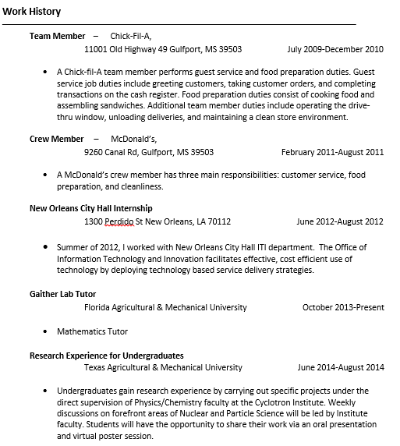



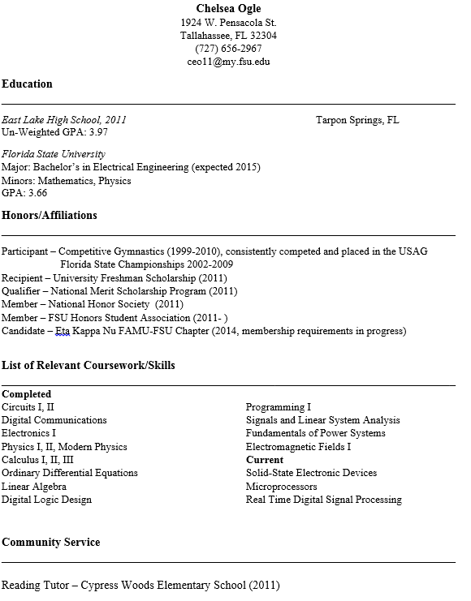



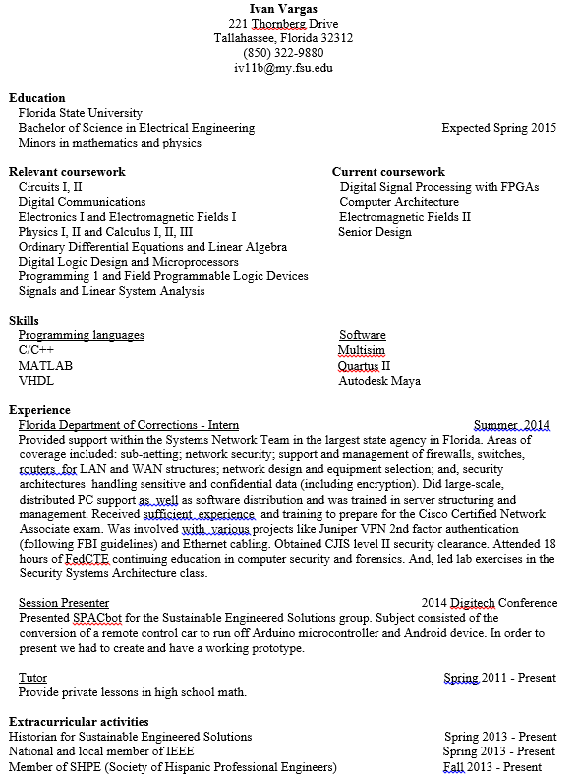

**8 Schedule**

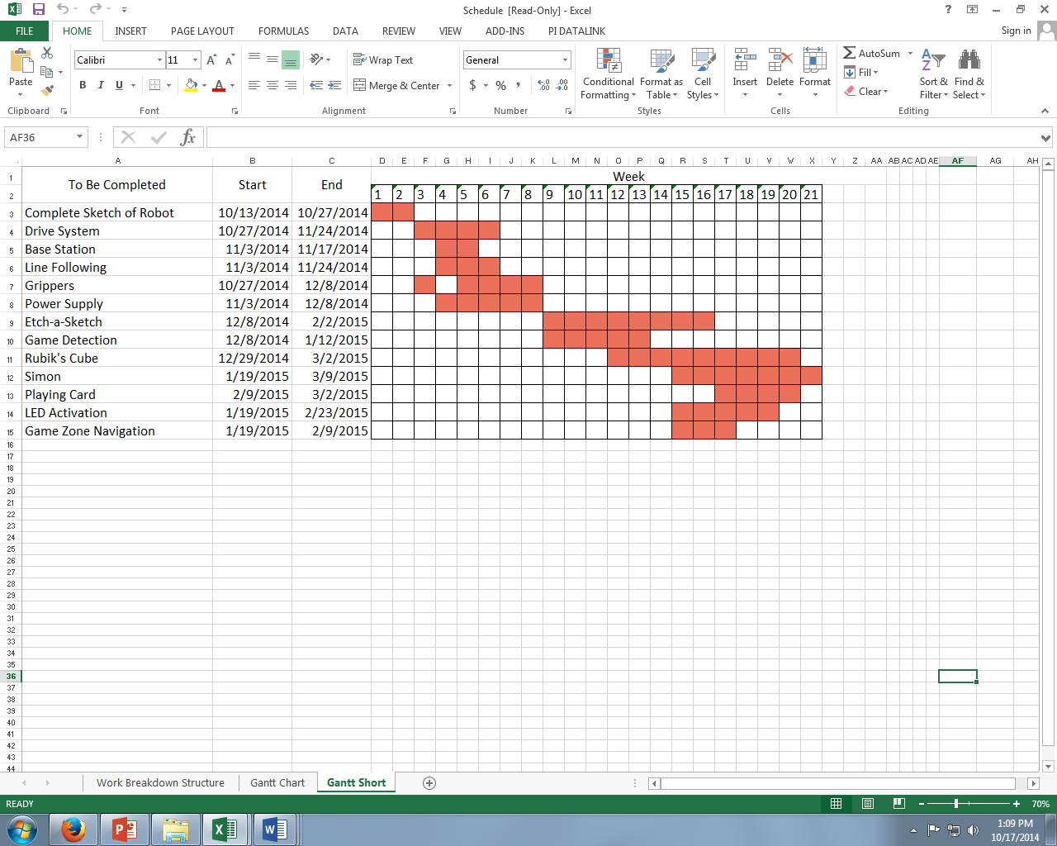

<https://www.dropbox.com/s/s263kk42e5j17aj/Schedule.xlsx?dl=0>

For viewing purposes, a detailed Gantt chart along with a Work Breakdown Structure is in the link above.

**9 Budget Estimate**

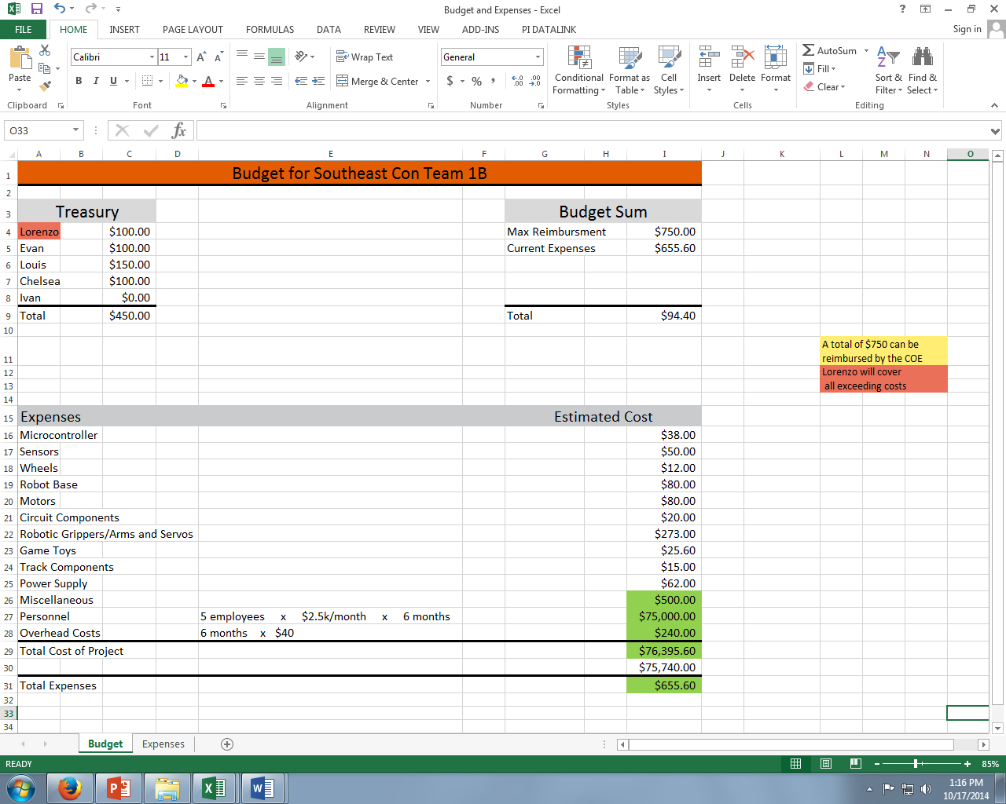

For viewing purposes, a list of expenses is in the link below.

<https://www.dropbox.com/s/htadcxb86mh1vkz/Budget%20and%20Expenses.xlsx?dl=0>

**10 Deliverables**

At the end of this project, the overall completed product will be a fully autonomous robot

that meets all of the needs and requirements set forth by the 2015 SoutheastCon Hardware

Competition rules. All parts and equipment purchased for the robot will meet the budget

requirements. The delivered hardware and software will be integrated in order to fulfill the

objective of the design, receiving as many points possible in competition. The goal of the team is

to deliver a robot capable of competing with the other SoutheastCon team by April of 2015.

In addition to the hardware and software delivered by the team, Milestone reports and

presentations will be delivered throughout the design process to the project team’s advisors and

sponsors. Documentation of meetings, the budget, and details of the subsystems will also be

delivered via the group blog.

**11 References**

1. J.A. Marin, J.E. Armstrong, and J.L. Kays, “Elements of an Optimal Capstone Design Experience,” Journal of Engineering Education, January 1999, pp. 19-22.
2. Coleman Benson, “Basics: How Do I Choose a Battery?”, (Robot Shop), [online] 201[3,](http://www.robotshop.com/blog/en/how-do-i-choose-a-battery-8-3585) http://www.robotshop.com/blog/en/how-do-i-choose-a-battery-8-3585  
   (Accessed: 10 October 2014).
3. “Battery Calculator” (Society of Robots), [online] <http://www.societyofrobots.com/battery_calculator.shtml>(Accessed: 10 October 2014).
4. “Robot Dynamics” (Society of Robots), [online] http://www.societyofrobots.com/mechanics_dynamics.shtml  
   (Accessed: 1 October 2014).

<http://www.robotshop.com/blog/en/how-do-i-choose-a-battery-8-3585>

[http://www.societyofrobots.com/battery_calculator.shtml  
  
http://www.societyofrobots.com/RMF_calculator.shtml](http://www.societyofrobots.com/battery_calculator.shtml)