Table of Content
Chassis 2
Strut 6
Shock 9
Lower A-arm 10
Upper Link 11
Rotational Link 12
Hymne Joint 14
Shim 15

Chassis

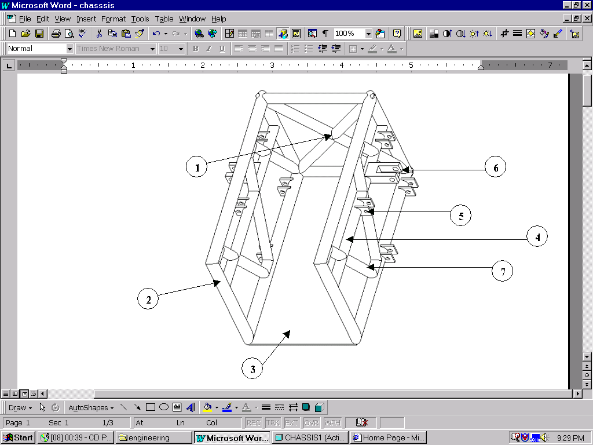

Figure 1: The above figure shows the possible chassis design of the new car.

This design is purely used to mount the designed suspension components, and solve any problems with spacing of the parts. The diameter of the chromoly tube fame is 1.25”; this dimension is the same as that on the existing car “Sunsation I”. Due to the lack of progress, in all aspects for the new design of “Sunsation II” the team decided to go back to the chromoly frame, like that of the old car.
The chassis consists of three distinctive parts, part (1) X-member, two symmetric sides part (2), and base plate part (3).

- This part is called the X-member and closes the chassis. The X design helps to stiffen the front end as while as serve a protective barrier in a front-end. As stated in the above paragraph, the chromoly tube throughout this chassis design is 1.25” diameter. Although this piece is only a concept, it is designed using the specifications standards set by the concept of the initial new design. The X-member can be fabricated by first welding a square. Then linking the square using two v-shaped chromoly pieces.
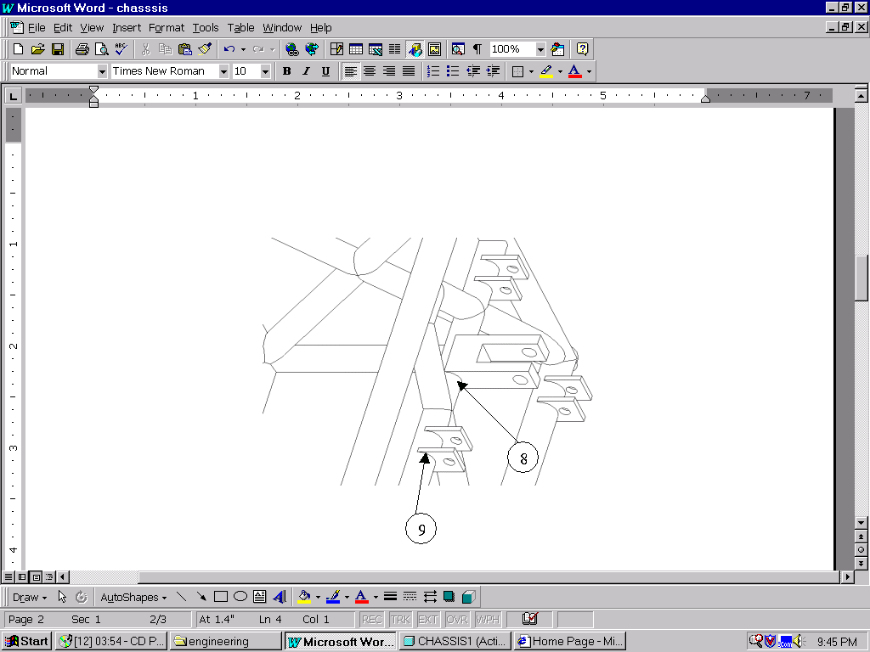
- Part (6) is the shock mount. The new coil over shock desired to be used on Sunsation II, is much shorter, lighter and somewhat stronger than the original shock unit. Therefore a new shock mount needed to be designed. The new shock mount is positioned lower to accommodate the shorter shock. The shock mount is a separate machined part designed to be welded to the chassis.

Figure 2: Figure 2 illustrates the welding and machining to be done the securely attach the shock mount to the round surface of the chromoly tube chassis.

- Part 3 of the chassis represents the underside of the uni-body, because the body design isn’t completed at this time the specific base of the chassis is unknown.

- Part 4 of the chassis represents a support cross member that is used to stiffen the sides of the chassis and mount the upper arm mounts and shock mount. Similar to the X-member this part is only used to give an example of what can be done.

- Part 5 is the one of the eight A-arm mounts. There are four lower A-arm mounts and 4 upper A-arm mounts. Each mount consists of two .25” plates 1.00” apart. This is further illustrated in figure 2.

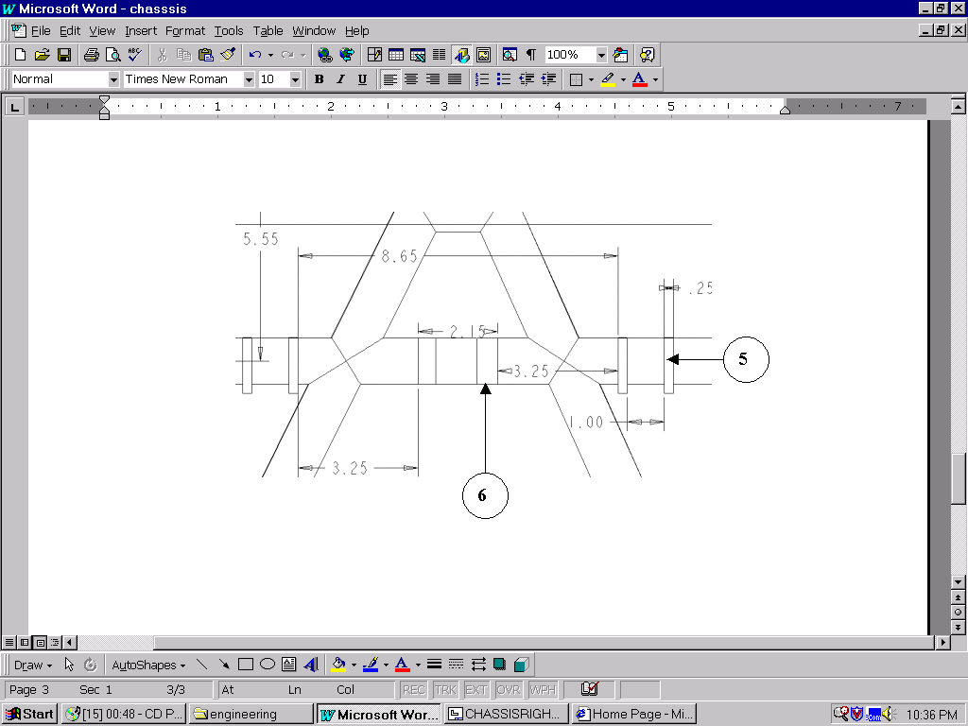

Figure 3: Close view of one side of the design, showing the shock mount and A-arm mounting points.
- Part 6 represents shock mount. Similar to the A-arm mounts it consists of two metal plates welded to the support cross member. Figure also shows the dimensions of the support cross member.

- Part 7 represents a support system for the sides of the chassis. Similar to the part 1 and 4 this is only a concept or team developed. The pattern is similar to the A-arm design used on the suspension arms, and gave a good reference for placing the A-arm mounts and the shock-mounts. Figure 4 below shoes the dimensions our team used to construct the side trusses.

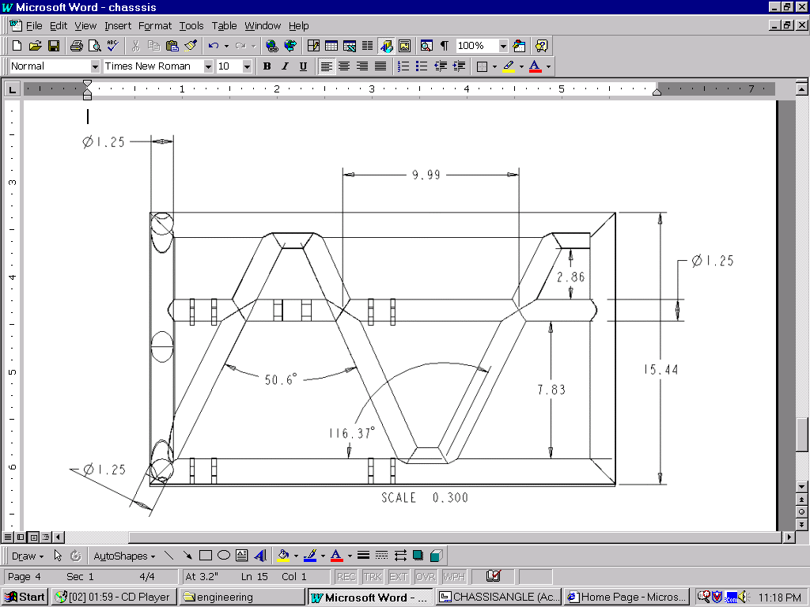
Figure 4

8/9. Parts 8 and 9 represents the welds needed to attach the suspension components to the chromoly chassis. This method once again is concept that was developed by our team.

Strut

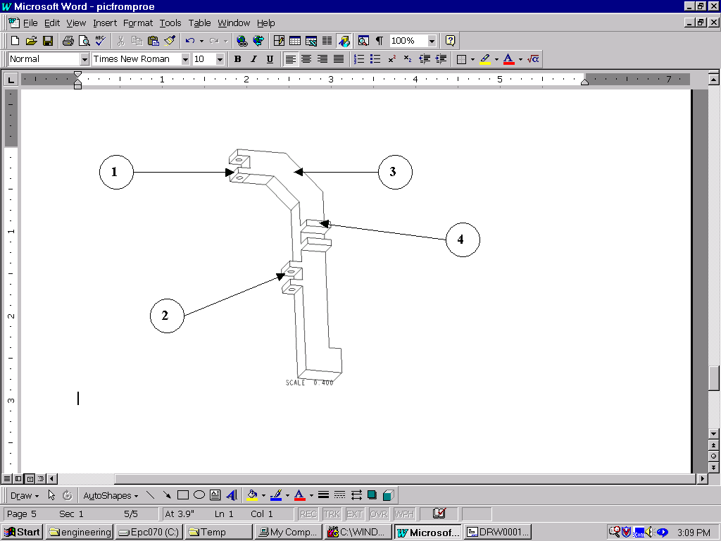
Figure 5: The figure above is an illustration of our teams strut design.

The figure above is an illustration of our teams strut design.

The basic design of the strut was taken from susation I. The only changes made to the original design were the addition of feature 3 and shorting of the length and width. The above figure represents one of the two struts.(right strut)

- Part 1 represents one of the two A-arm mounts. Similar to the A-arm mounts on the chassis these mounts are fabricated of two metal plates welded to the strut. The strut must be able to rotate to accommodate the steering angle, therefore the A-arm mounts are placed vertical. Joints with three degrees of freedom will be used to accommodate the vertical movement from the suspension and the rotational movement from the steering. These will be discussed later in this user manual.
- Feature 2 represents the lower A-arm mount.
- Feature 3 represents the slop of the strut. Our team designed this slop to serve two purposes, to avoid colliding into the fragile solar cell array during full compression of the suspension, and to minimize the outward movement of the tires during suspension travel.
4. Feature 4 represents the pitman arm. The pitman arm shown in the above figure is designed with zero ackerman steering. Our team wasn’t able to effectively calculate the ackerman for sunsation II. Although our team couldn’t calculate the angle of the pitman arm the literature acquired on the subject is included in order help the next team.

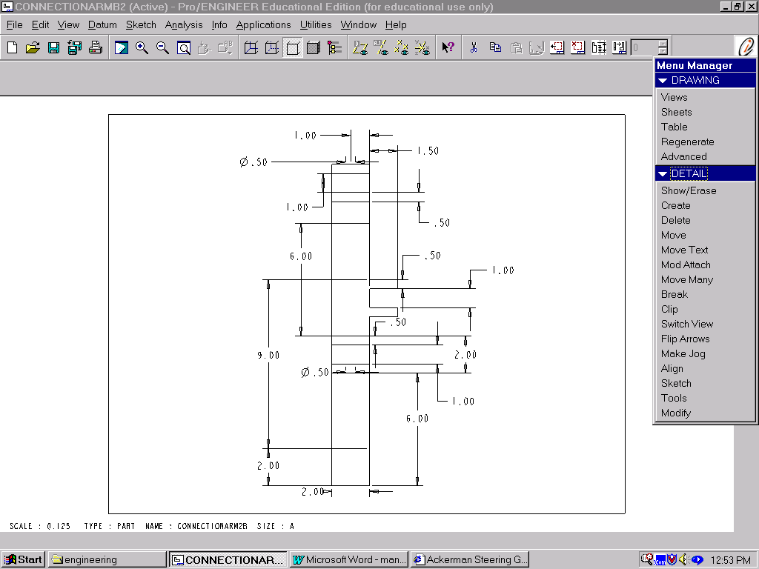
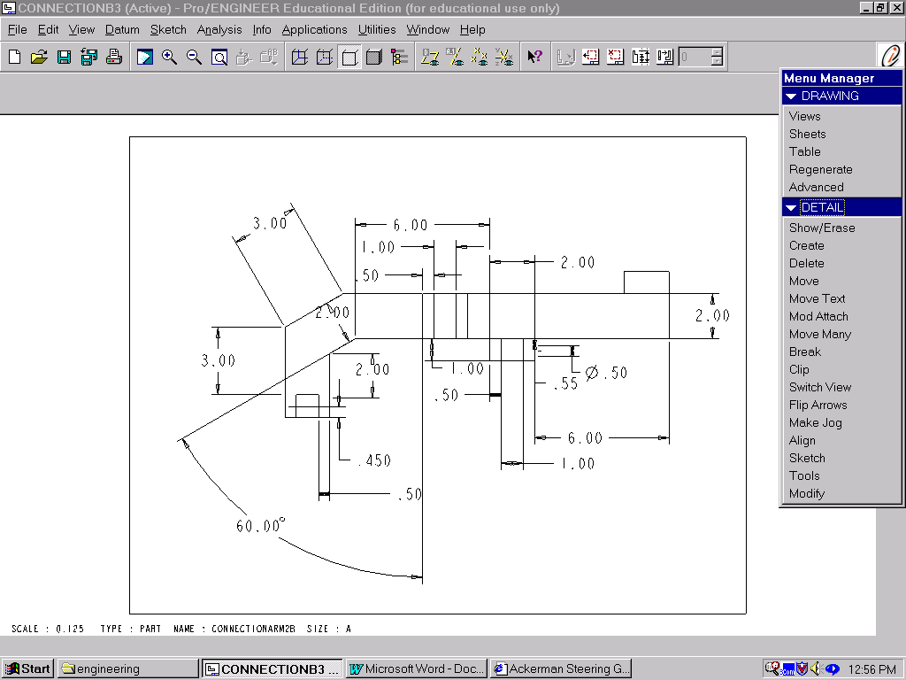

Figure 6

Figure 7

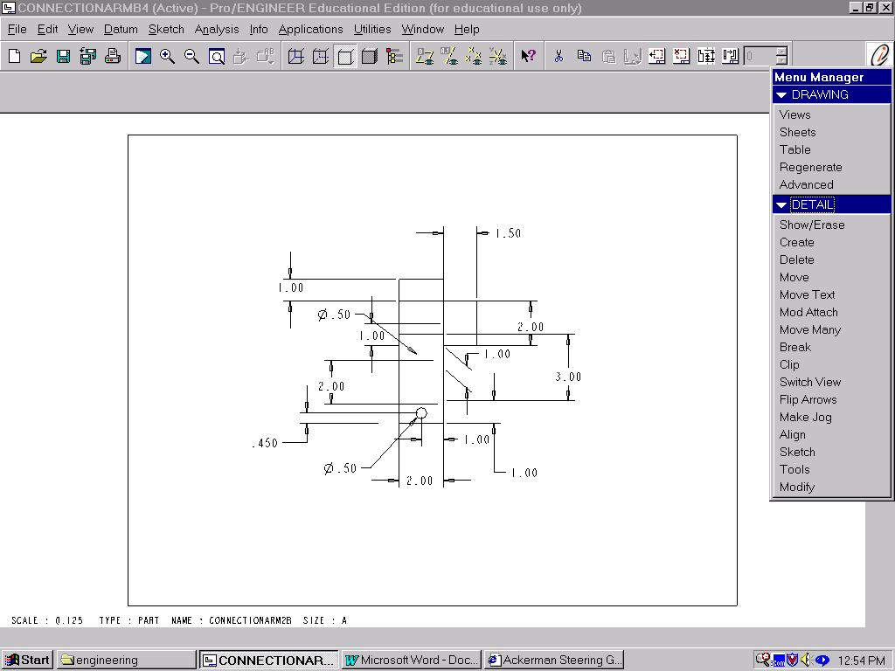

Figure 8

Shock
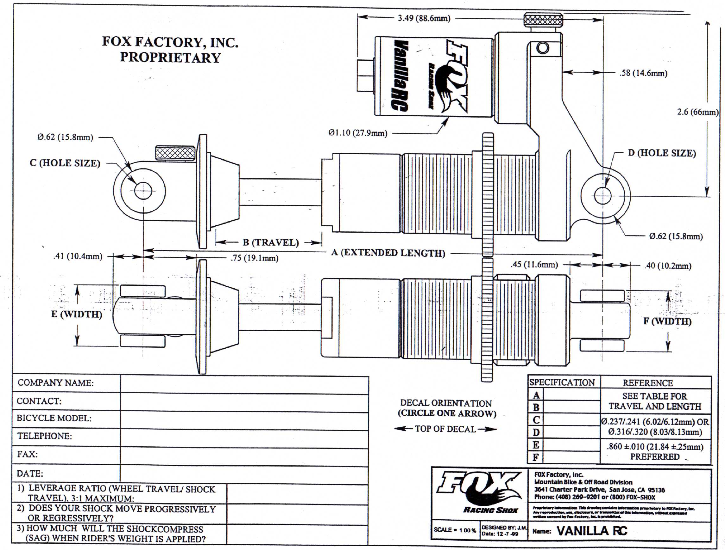
Figure 9

The shocks on the previous design were functional, but were extremely heavy and proved too not be fully adjustable. In order to save weight, improve performance, and be fully adjustable, our team decided to implement motorcycle shocks fitting all the desirable specifications. These shocks are made by “Fox Racing Shocks”, and have and 1.5” of travel, interchangeable springs to adjust for pre-load, and high performance. This idea of going with a motorcycle shock was given by our sponsor Dr. Harrison as well as some of our fellow colleagues on the SAE team. This type of shock has also been used in some of our competitors (other schools) cars. Essentially, our design was designed around the new body design and the desire for this lightweight, smaller and more efficient shock. Figure 1.6 shows a schematic drawing of the desired “Fox Shox” that will be used in our design. In the above figure, D represents were the retaining pin will be placed to attach the shock assembly to shock mount on the chassis. C represents the hole that will attach the shock assembly to the lower A-arm. Things our team likes about this particular shock is that it is fully adjustable, lightweight, fulfills the travel specification, and is easy to adjust. The fault of this shock is that is expensive. Each shock cost $500 a piece.

Lower A-arm
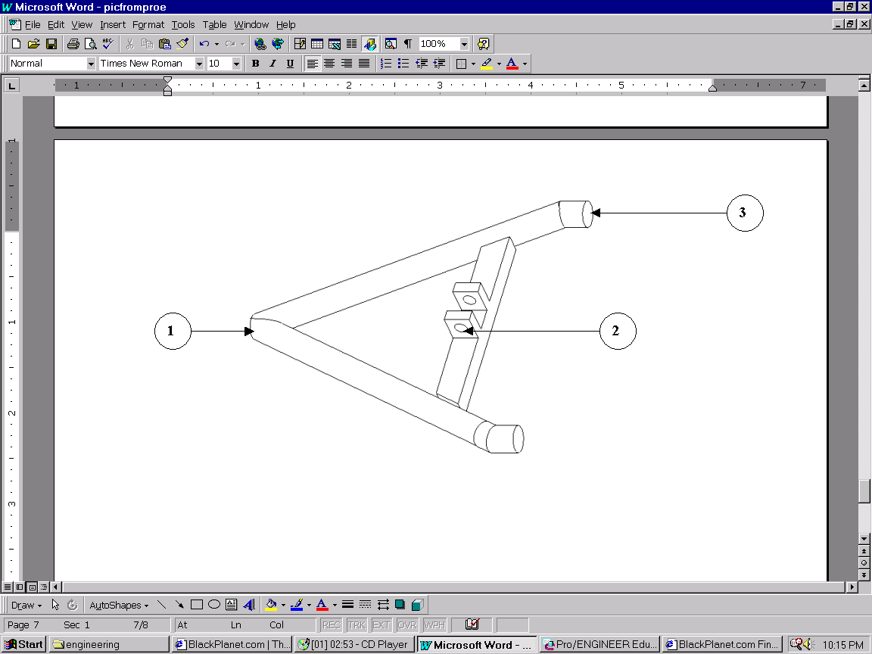

Figure10

Figure 10 represents the lower A-arm. Our team decided to design the lower A-arm from the prior design. The only changes made where the dimensions and the location of the shock mount. The lower A-arm will be fabricated from chormoly tubing similar to the chassis. The tubing used to construct the lower A-arm will 1”.

1. Feature 1 represents were the strut connects to the lower A-arm. The connection between the two will be accomplished using a hyme joint. This particular joint has three two degrees of freedom.
2. Feature 2 is the position where the shock will be attached to the lower A-arm. Similar to the shock mount on the chassis it is simply two metal plates welded to the stiffing member.
3. Feature 3 represents were the lower A-arm connects to the chassis. Similar to feature 1, feature 3 uses and hyme joint . In order to produce the angle shown above feature 3 must be welded in place. The end of feature must then be capped to accept the screw of the hyme joint.

Upper Link

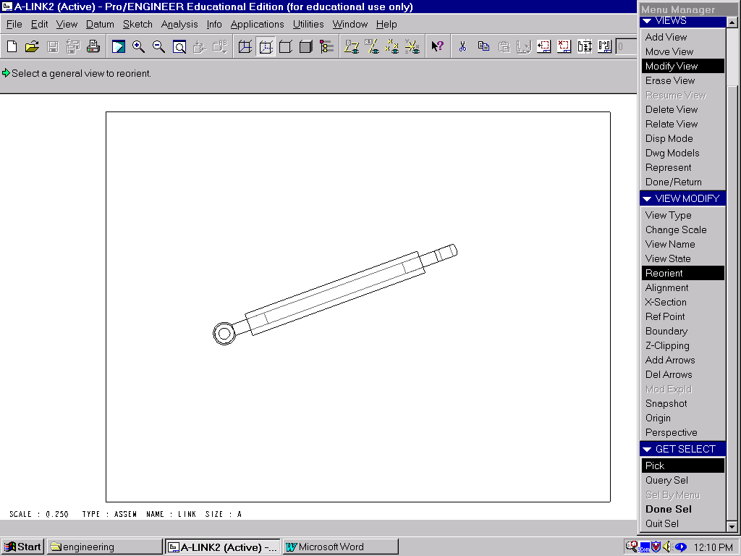

Figure 11

In order to decrease overall weight of the suspension our team decided to use links instead of a solid A-arm design, as used on the prior design. Each link has crossed threads connected to hyme joints. Therefore, simply applying a torque will either shorten or lengthen the link. The above figure shows the upper link with the hymne joint inserted. Our team is not sure if the links will be able to be machined using the schools facilities or manufactured by an outside company. The dimensions needed for each link is shown in the below figure.

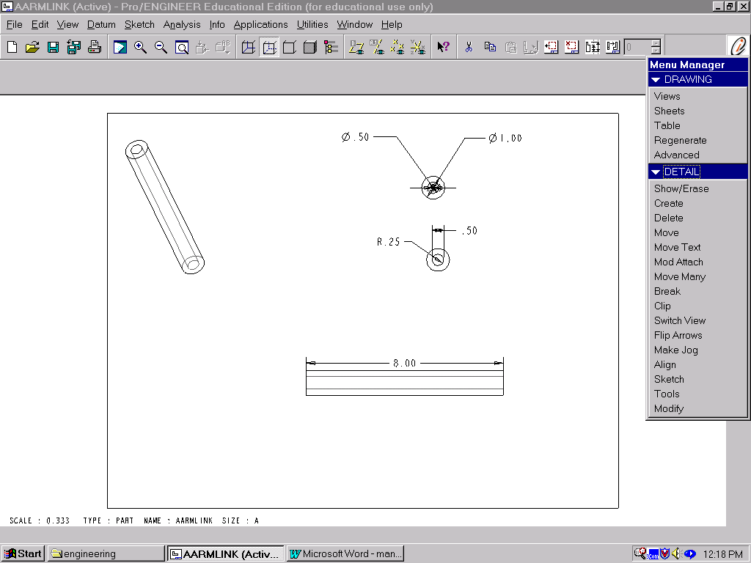
Figure 12

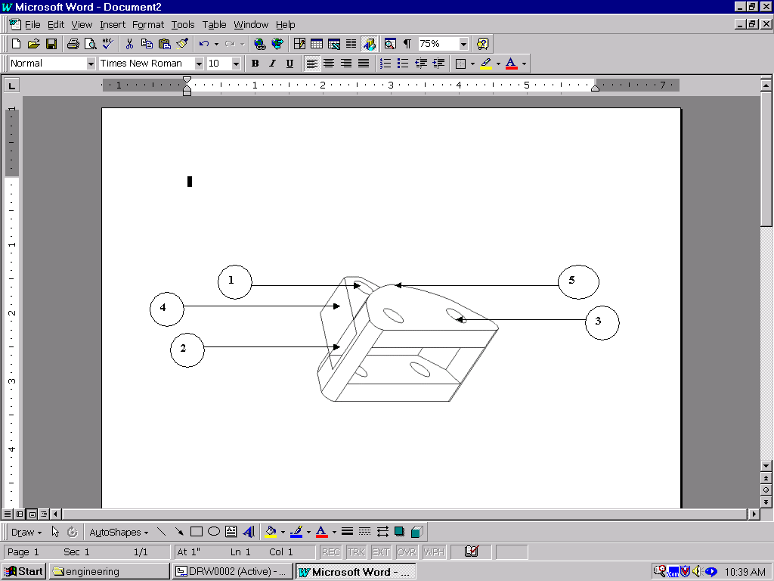
Rotational Link

Figure 13

The purpose of this part is to link the upper A-arms to the strut. This part can easily machined from scrape metal. This part allows for easier disassembly for maintenance purposes and it also saves weight by enabling the use of links instead of a sold suspension arm.

- Feature 1 represents the hole connects the rotational link to the strut. Because this part will under go a large amount of stress from suspension movement and steering input. Out team decided to use a joint with only rotational freedom in stead o of a hymne joint.
- Feature two is the slot that allows the upper links to move freely without binding
- Feature three represents one of the mounting points for the upper links. Similar like the other suspension mounting used a shim and hymne joint will be used to connect the rotation arm to the upper link.
- Feature four shows were the rotational joint is placed inside the connection arm. This protrusion will be mated with the upper slots on the connection arm.
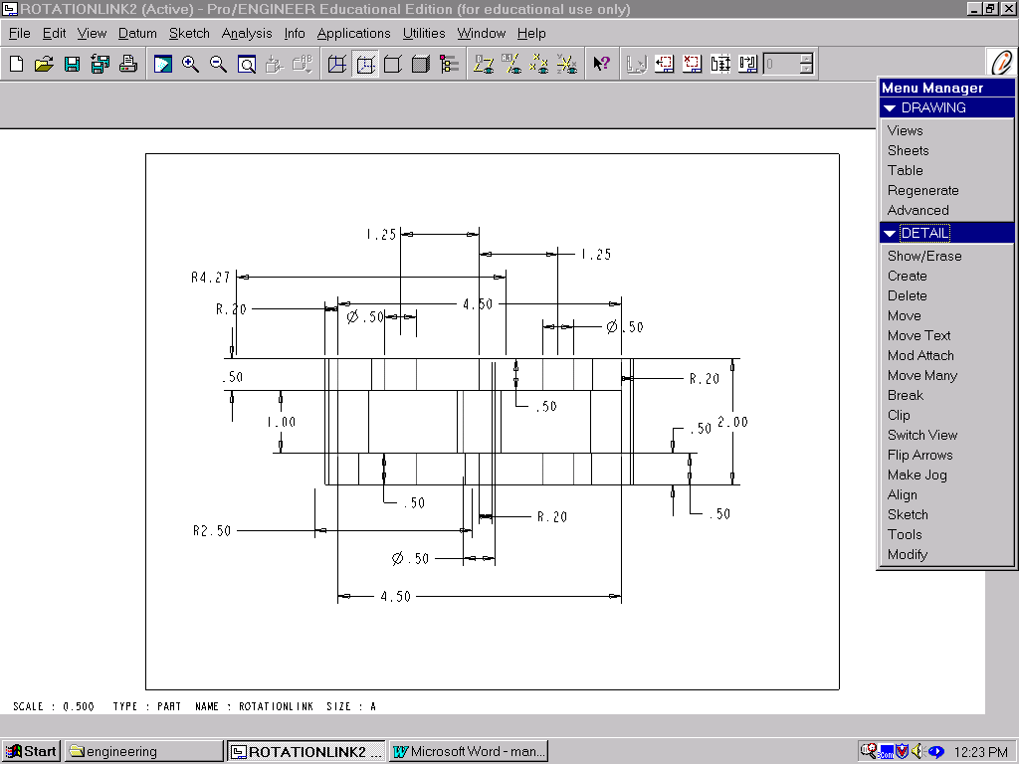
- Feature five is the curve needed to be machined to allow the connection arm to rotate around the rotational link.

Figure 14

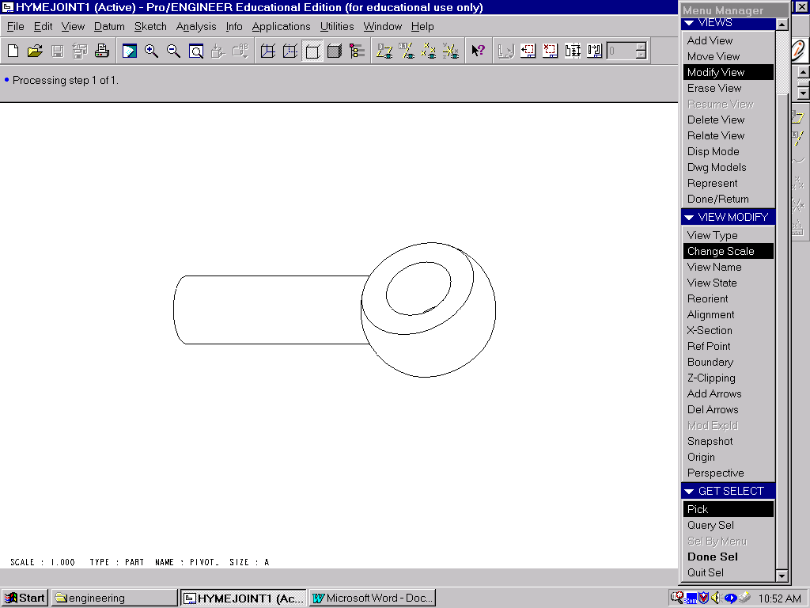
Hymne Joint

Figure 15

The figure above represents the joint used by our team to allow the suspension to move in the y direction (up and down), and rotational motion. At this time out team hasn’t chosen a manufacture therefore the exact the specifications of the joint haven’t been determined. The modeling of the hymne joint used in our assembly is just a representation of what we can be designed by an outside company. These dimensions are illustrated in figures 13 and 14

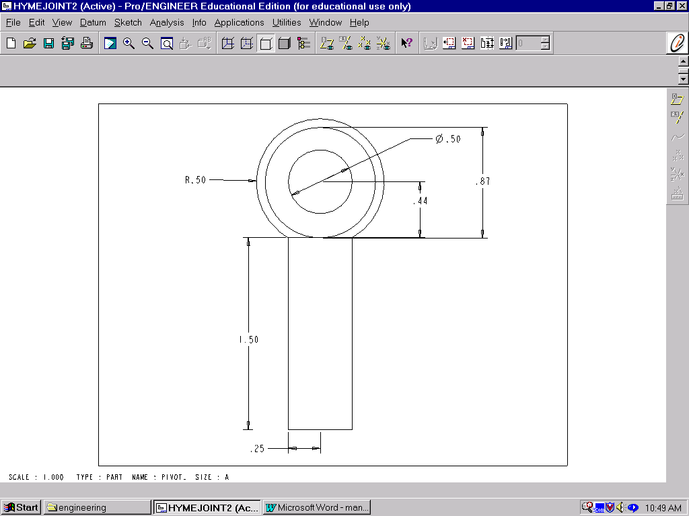
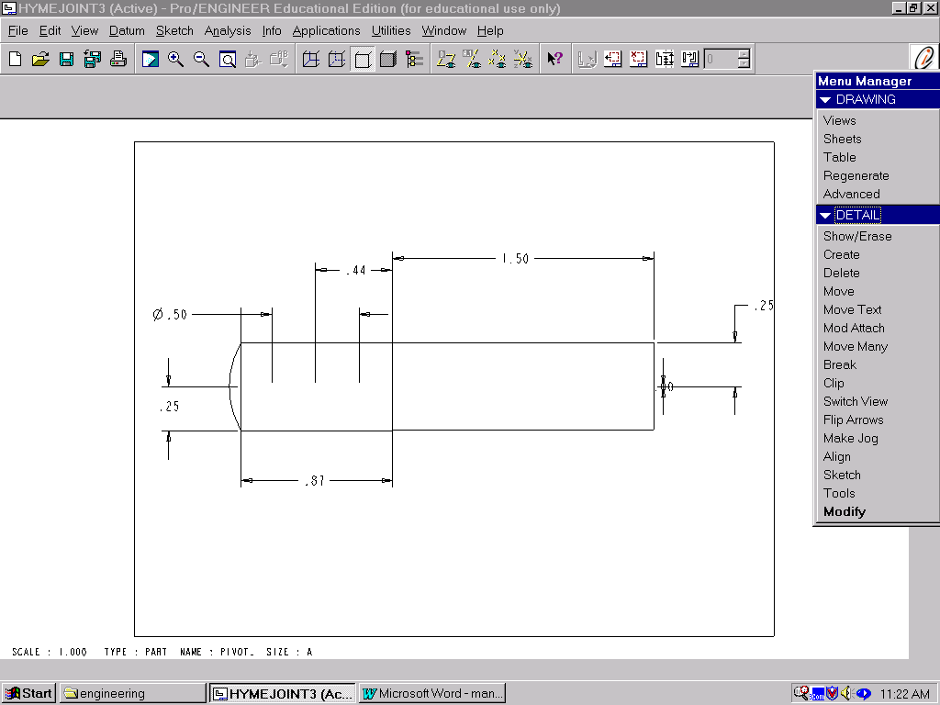
Figure 17

Figure 16

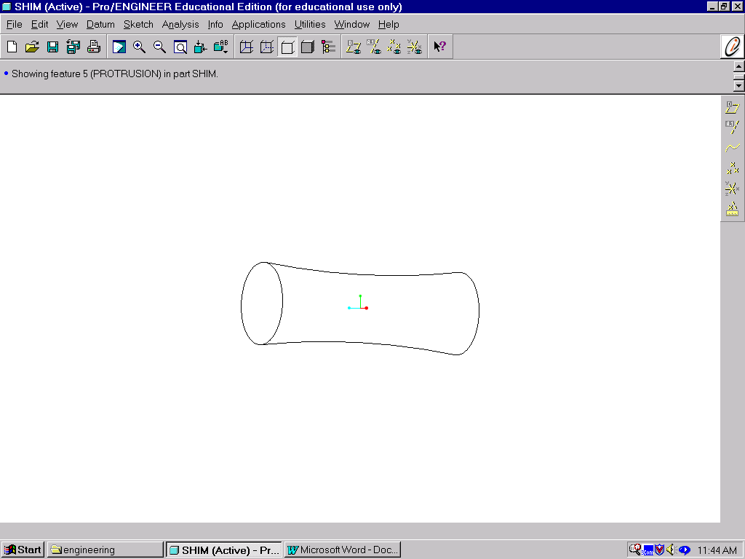
Shim

Figure 18

The figure above is an illustration of the type of shim that will be needed for our front suspension design. Similar to the hyme joint the shim will have to be fabricated by an outside company.

