Introduction
Solar car racing is a form of racing that has been around for several years. It not only provides a means of competition for student solar car clubs; it also provides valuable information on the use of alternative energy sources. Increasing prices of oil should be a indicator to us all that one-day, our natural gas and oil reserves will be depleted. Yearly, schools from around the country converge and compete head to head for prizes and bragging rights. Similar to many universities the FAMU-FSU College of Engineering (COE) has established a solar car club. For the 2001 solar car challenge the club has decided to build a new car named Sunsation II.
The cars in the race come in all shapes and sizes. The race specification of the solar challenge is made available to each school, and the remaining design decisions are up to the students. In spite of this, every car has solar panels, a chassis, suspension, batteries (to store the energy harnessed from the sun), wheels, and braking/steering systems.
As stated above, for the 2001 solar challenge the FAMU-FSU COE is building a new car, Sunsation II. Our team of mechanical engineers was asked to design the front suspension of this new car. Because of the complexities of this project it has been divided into two phases. The first stage of our design includes the following: Determine shock/spring configuration, determine steering mechanism and characteristics, analyze design for loading and conformance to specs, write preliminary design report, drawings completed, and have parts on hand or on order by 12/1/00. The second phase of this project includes assembling, analyzing performance, and analyzing composite material.
The purpose of this report is to explain the process used to complete the first stage of our design. It includes, design statement, background information, design specification, scheduling, budget, conceptual designs, semester overview, conclusion, and appendices.

Design Statement/Specifications
The purpose of this project is to design and build a new front-suspension for Sunsation II. The first step our team did was to investigate the prior design and analyze the pros/cons of this design.
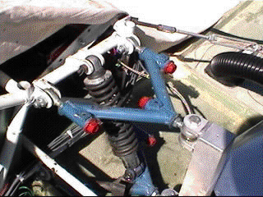

Figure 1: double A-arm independent suspension, with a coil-over shock

Figure1 shows a double A-arm independent suspension, with a coil-over shock. Once the main operations of this design was understood our team discussed the likes and dislikes with our team sponsor. A composite list of the likes and dislikes can be found below.

Prior design likes
- camber adjustment
- caster adjustment
- toe/in toe out
- simplistic yet effective design

Prior design dislikes
- weight
- bulky coil over shock
- difficult to adjust
- wheel scrub

Figure 1 also shows that the front and rear suspensions are attached to a chormoly tube chassis. Similar to any racecar design weight is always an issue. Due to the fact Sunsation II is a solar car the less amount of weight equals improved acceleration, top speed, and energy efficiency. To make the new car lighter it will utilize a composite uni-body design. Although this is excellent for subtracting a great deal of weight from the car, it is difficult to attach the suspension to the chassis. Hence, a new suspension mounting scheme must be designed to absorb the disturbance of the road. In spite of the weight reduction the composite body will give. There is still a substantial amount of weight the suspension must be able to support. Therefore, not only must the new suspension be light, it must be also be sturdy enough to support the 900 to 1000 lbs. of load.
For aerodynamics purposes, the car will be totally enclosed by the uni-body, with only the wheels visible. The suspension must operate inside this shell with out colliding with the uni-body, or effecting the driver. The prior design had a total suspension design of 6” (3” up 3” down). It was stated by the design team of Sunsation I that this amount worked well. Therefore our team decided to design the new suspension to this specification.
The design specifications for Sunsation II includes easy adjustment for camber, caster, toe-in/out, unibody mountable, 6” of total suspension travel, light weight, and support body weight (900 to 1000lbs).

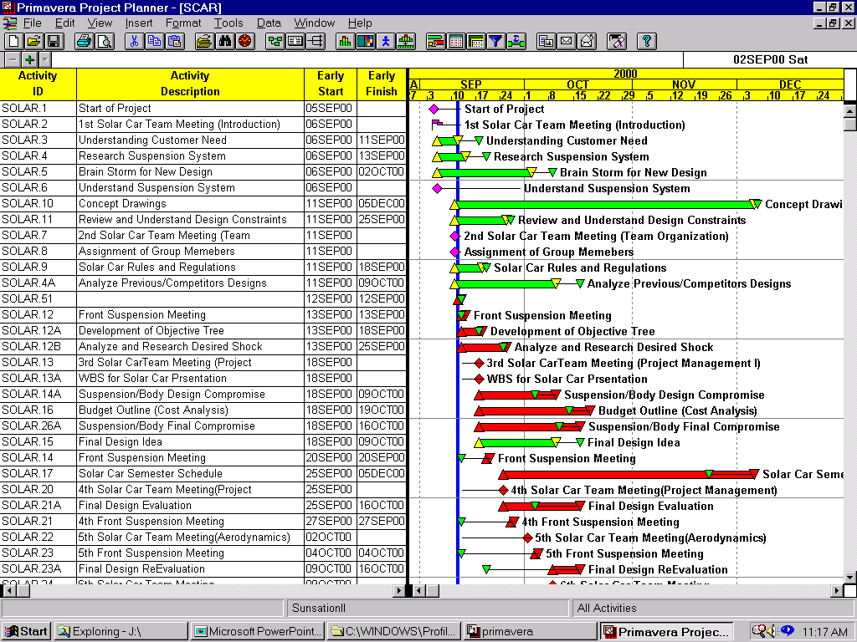Schedule

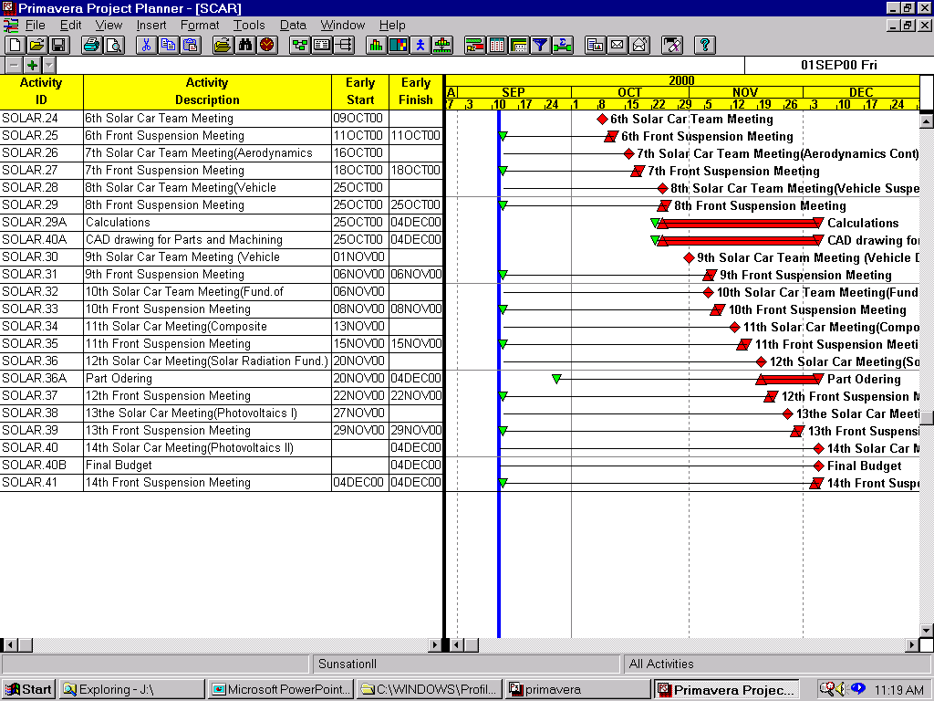

Figure 2: schedule of the project, created using primavera

Figure 2 includes the schedule of the project, created using primavera. Some of the main points included are the weekly solar team and front suspension team meetings. The solar team meetings provided a chance for all the groups to report progress. There were also weekly lectures by professors. The topics covered were suspension design, material selection, scheduling, and aerodynamics. The weekly meetings for the front suspension team were used to brainstorm concepts, and solve problems. Several of these meetings were with the SAE team, which provided valuable information concerning shock selection and suspension geometry. The tasks completed from the schedule include:
- WBS
- Budget
- Final Design
- Shock selection
- Suspension mounting system
- Simulated Drawings
- Minimizing Scrub
Unfinished tasks include:
- Composite material stress analysis
- Finalized engineering drawings
- Ordering Parts
- Machining parts
- Suspension performance analysis
The second phase of the design will start next semester, the Unfinished tasks and next semester task will be added to Figure 2.

Budget
- Bulk metal (aluminum/iron) 600.00
- Shocks 1200.00
- Wheels 1200.00
- Tires 1000.00
- Hardware (Bolts/Nuts) 300.00
- Steering linkage 500.00
- Steering Box 500.00
- Brake calipers 400.00
- Brake rotors 700.00
- Rotor hubs 800.00
- Brake lines 200.00
- Master cylinder 200.00
- Pedal Assembly 250.00

- Total 7850.00

The money used to construct Sunsation II is coming from donations made by small companies and several large corporations. The purpose of this budget is to provide an estimate of the total cost of the front suspension. The prices are inflated slightly in order to make sure that the amount given will cover the design and construction of the suspension. The parts included on the budget are the essential components of the front suspensions. The front suspension group realizes that there maybe components not included on this budget/parts list hence the inflated prices, which allows the adding of parts without going over budget.

