VirtuLab: Web-Based Flow Visualization Facility (WBFVF)

Final Design Report

Written By:

Justin W. Scott
Sydni S. Credle
Karen A. Davis

EML 4552-Senior Design
April 5, 2001

Table of Contents

Introduction……………………………………………………………………………..3

Specifications……………………………………………………………………………6

Work Breakdown Structure (WBS)………………………………………..12

Scheduling……………………………………………………………………………...14

LabVIEW ..……………………………………………………………………………..17
6. Web Page and Live Video ConfigurationDevelopment….…………………………………………………..….34

Conclusion .…………………………………………………………..………………..40

Appendices
A: NI Days………………………………….…………………………………………..42

B: Meeting Notes……………………………………………………………………..46

C: Camera Mount Specifications ……………..…………………………….54

D: Systems Function Breakdown..............................................56
E: E-mails…………………………………………….………………………………….59
F: LabVIEW Virtual Instruments………………..………………………….101
G: Web Page Pictures................................................................109

Introduction

Client Statement

Design and build a towing tank facility and the associated imaging processing system capable of providing visualization-enhanced information to supplement the teaching of fluid mechanics. The facility should have computer-interfaced instrument control function and can be operated remotely via the Internet. This unique feature can increase students’ accessibility and provide distance learning capability.

Motivation

The teaching of fluid mechanics is often difficult because students are unable to visualize the complexities of the theory being taught. There is a necessity to find a link between theory and reality. It has been found that experimentation facilitates complete comprehension on the part of the students.

Objective

The overall goal is to successfully design a water-towing tank that will enable students to analyze flow of water over various objects. The water-towing tank consists of an object suspended and able to be pulled at a constant rate while being imaged. In the future, the flow visualization facility will be made available for distance learning purposes. Students will be able to remotely access and control laboratory instruments through a computer network and ultimately enhance their grasp of the subject at hand.

This project involves pragmatic application of previously learned topics within the mechanical design process as well as the learning and full understanding of the components required in making the system remotely available.

A methodology as to how to configure instruments and data acquisition remotely via software will be explored and implemented. The system is based on LabVIEW coupled with other Internet programming techniques. Ideally, the remote laboratory system will take user commands through a web browser, relay them to LabVIEW, then, control the real instruments in the laboratory, as shown in Figure 1 below.

Client

Client

Client

LabVIEW Internet Connectivity Tool set

Internet

Figure 1: Schematic diagram illustrating basic setup of web-based flow visualization system.

Personal
Computer
Motor Controller

Flow Visualization Facility
Visualization
Camera
WebCam
For Lab Video Image streaming

Below are listed the mechanical and computer aspects that need to be analyzed, modeled, and fabricated:

Mechanical Design Aspects
- Design mobile camera mounts
- Investigate and modify all necessary existing specifications:
- Motors
- Material Selection and Design
- Successfully design and set up video recording system for the remote monitoring purpose

Computer-Related Aspects
- Remote instrument control via the Internet using LabVIEW 6.i.
- Video studio design for the direct lab imaging recording
- Direct video and data streaming via the Internet using multimedia software
- Interface the physical laboratory with the Internet to create a virtual laboratory

Specifications

The initial phases of the design process are the Concept Development and Specifications, which involves identifying the customer’s needs, gathering information on competition and exploring possible alternatives, concept generation and selection, and defining the form and function of the project. Completion of these tasks are managed through research as well as the conducting of detailed information gathering sessions with the customer/client. It is important in these foundational steps to translate customer wants, which have little to no technical basis, into tangible engineering processes and sub-systems. The specifications are broken down into five different subsystems; performance specifications/customer requirements, design specifications, engineering requirements, and design and performance parameters. The following is a design specification report of the Web-Based Flow Visualization Facility.

Performance Specifications/Customer Requirements
This area is dedicated to list the expectations for the performance of the design. The main objectives that were named by the client were remote control accessibility, live video streaming from the web page, and the use of LabVIEW programming.

Design Specifications

The design specifications provide a detailed description of the completed design. Figure 2 shows the actual picture of the flow visualization facility.

Motor
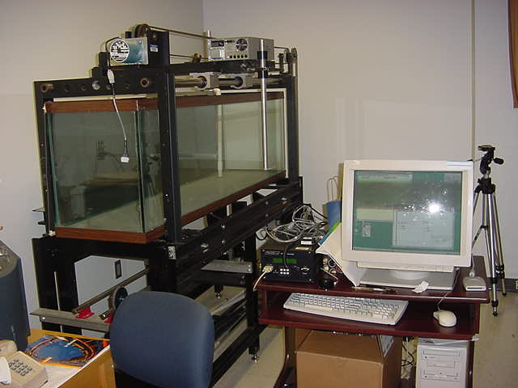
Camera mount location

Towing Tank

Web Cam Location

Motor Controller

Figure 2: Picture of the existing system.

Camera Mount Design

The first sub-design in the WBFVF project was to create a camera mount that could be attached to the existing platform on the towing tank. The needs for the camera mount are listed as follows:

- Capable of forward/ backward movement
- Capable of left/ right movement
- Easy fabrication
- Cost efficient
- Locking mechanism
- Very strong (to support camera and lens attachment)
- Easy to use
- Lightweight

From these needs, ideas were showcased for consideration using a morphological chart that illustrated the various ideas for the required functions. Each component was then evaluated in order to choose a final design (morphological chart and evaluation data appear in Appendix C). This final design is shown in Figure 3 and 4.
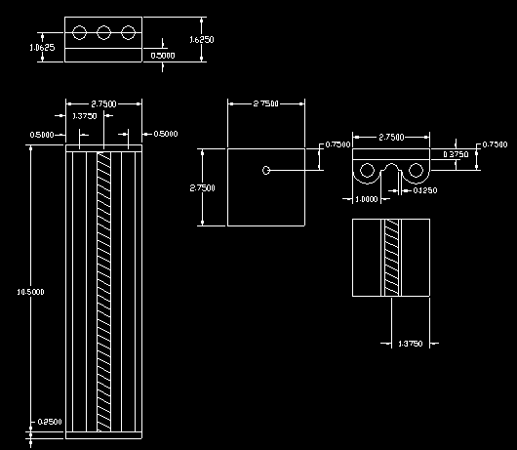
Figure 3: Detailed drawing of the top slider of the camera mount.

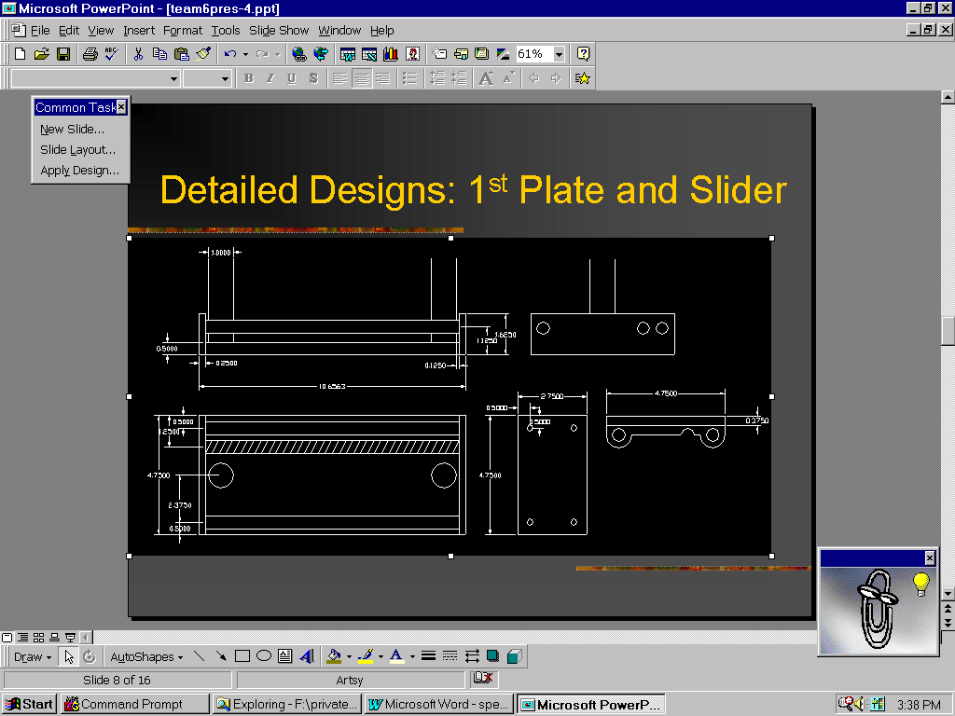
Figure 4: Detailed drawing of the bottom slider of the camera mount.
Engineering Requirements

This section reveals the design and performance parameters that contribute to achieving the customer requirements. After clarifying the client’s problem statement, evaluation of the existing system was carried out. The client then defined the desired functions for the camera mount. Research was performed to understand the capabilities of the LabVIEW 6.i program and the web camera. Once the software and hardware were ordered, independent research was conducted among group members, as well as networking with knowledgeable experts to become proficient operators of all the equipment.¹

Design Parameters
The client’s main concern for the function of the camera mount was to ensure that the camera and the object were in sync with each other for accurate data acquisition. The camera should be adjustable to capture various points of the flow. For these reasons, a threaded track was chosen to allow fine adjustment. If in the future the client would like the camera mount to be remote controlled, the threaded tracks would also be fairly simple to add a motor onto.¹

Performance Parameters
Specifications are not only for the direct effects that an engineer may need to take into account, but also the indirect functions that may help prevent user confusion or accidents. The user will only be given a preset range of velocity control in order to reduce confusion and prevent hazards.¹

Design Objectives
Based on an assessment of the client’s needs, a composite list of design objectives was compiled. Table 1 illustrates these needs along with evaluation numbers that designate the weight of importance placed on each item. The highest ranking an item could receive was a value of 10, while the lowest was a value of 1. The criteria for ranking came directly from client interaction.

Table 1. Composite List of Design Specifications.
Wishes of Demands (W/D) | Specifications | Importance (scale from 1-10)
D | Computer Interfaced Instrument Control | 10
D | Remote Operation via the Internet | 10
D | Direct Video and Data Streaming via Internet | 10
D | Low Vibrations | 10
D | Transparent Imaging Window | 10
D | Constant Object Velocity | 9
D | Synchronized Elements | 10
D | Easy Control of Motor | 9
D | Design of System Web Page | 7
W | Inexpensive | 8
W | Durable | 8
W | Safe for Human | 8
W | Doesn't Rust | 7
W | Easy to Use | 9
W | Pleasing to the Eye | 5
W | Long Life Expectancy | 6
W | Low Noise Output | 5
W | Speed Flexibility | 8
W | High Quality | 8
W | Splash Proof | 8
W | Stand Alone Physical Unit | 7
W | Easy Cleaning | 5
W | Starts Immediately | 8
W | No sharp Corners | 5
W | Stops Easily and Immediately | 8
W | High Material Strength | 6
W | Easy experiment Reset Control | 8
W | Shock Absorption | 5
W | Easy to Repair | 5
W | Low to no Contamination | 9
W | Safe for Environment | 6

Work Breakdown Structure (WBS)

Within the project management cycle, extensive planning, scheduling and controlling takes place providing a “road map” to the completion of tasks from the onset of the project to the day of delivery. Planning is an integral part of the engineering design process in that it provides the answer to the ‘how’ question of undertaking a design activity.¹ Two key elements of the project management plan are the Work Breakdown Structure (WBS) and the Project Schedule.
The purpose of the WBS is to clearly state how each task is related to the whole project in terms of variables such as budget, schedule, performance, and responsibility. Through this, the project is partitioned into distinct work packages that can be tracked continuously for status at any time. The WBS should include the following:

- Each project task as an element big enough to be identified and assigned to individual members of the team.
- Each task defined clearly and concisely.
- Each task described in such a way that comparison and analysis can be made in terms of such things as money, labor, and/or resources.

Figure 5 shows an illustration of the work breakdown structure for the Web-Based Flow Visualization Facility (WBFVF) Project. Using the tree diagram method, the tasks needed for completion have been listed according to the functional areas of organization within the experiment.¹ The functional areas are listed again for completeness below:

- Understand Customer Requirements
- Web Camera
- Camera Mount
- LabVIEW
- Motor Controller
- Teleconference
- Simulation/Testing
- Project Management Activities

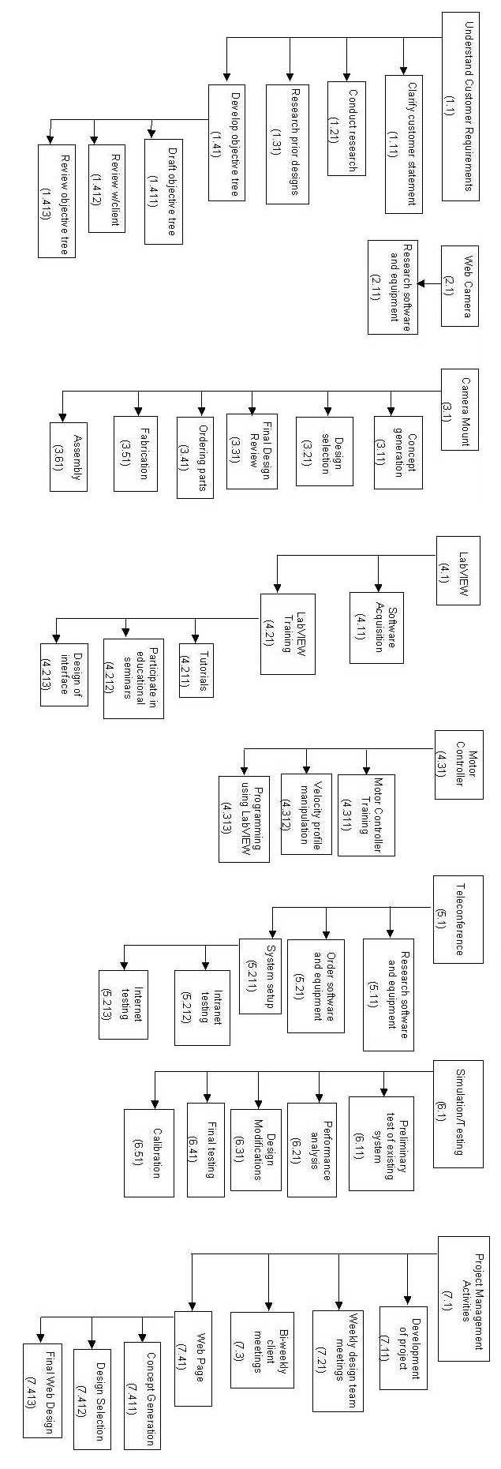
Figure 5: Illustration of work break down structure (WBS) for the Web-Based Flow Visualization Facility (WBFVF).

Scheduling: The Gantt Chart

Developing a schedule for a project involves deciding when each task and subtask listed within the WBS should begin and how long it should last. Ultimately, the process translates the list of project tasks into a timetable illustrating events along with respective completion dates.¹
For the current WBFVF project, a Gantt chart was used to provide this visual representation of the relationships between the different pieces within the project. The Gantt chart is a bar chart that plots work activities against a time line.¹ As seen in Figure 6, the project activities are listed on the vertical axis while the chronological time scale (in weeks) along the horizontal axis displays the schedule and duration for each task.¹ The solid lines show an activity’s duration in time. It should be noted that the project activities in the Gantt Chart can be found on the top tier of the WBS.

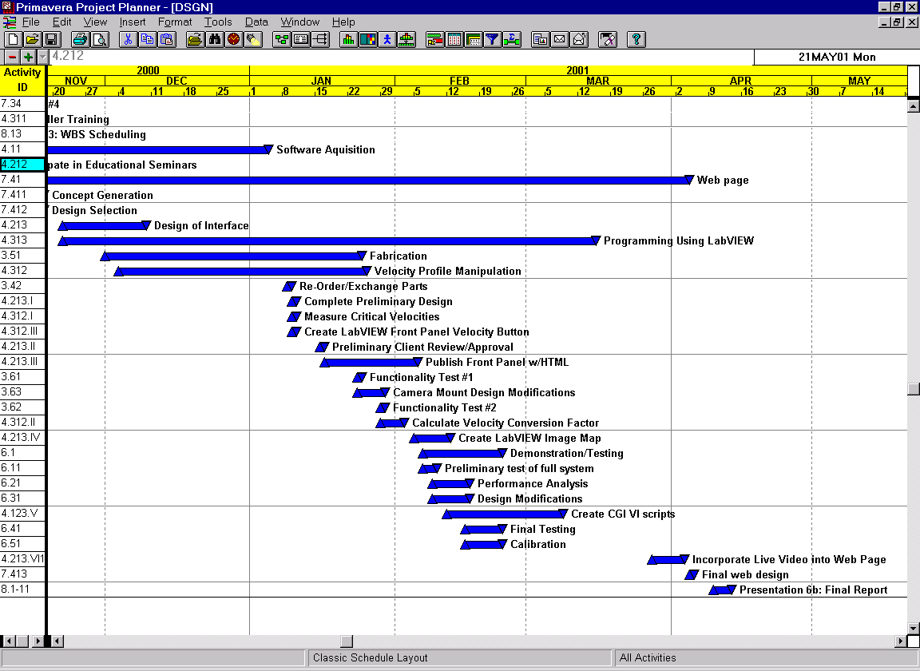
Figure 6: Gantt chart used for scheduling

Table 2: Division of Responsibilities
Tasks | Justin | Karen | Sydni
Understanding Customer Statement | X | X | X
Conduct Research | X | X | X
Research Prior Designs | X | X | X
Develop Objective Tree | X | X | X
Web Camera Research | X |  | X
Camera Mount Concept Generation | X | X | X
Camera Mount Design Selection | X | X | X
Camera Mount Design Drawings | X
Camera Mount Final Design Review | X
LabVIEW Research | X | X | X
LabVIEW Software Ordering | X | X | X
LabVIEW Programming |  |  | X
LabVIEW Motor Control |  | X | X
LabVIEW Educational Seminar |  | X | X
LabVIEW Tutorials | X | X | X
Teleconference Research | X | X | X
Teleconference System Setup | X | X | X
Teleconference Intranet Testing | X | X | X
Teleconference Internet Testing | X | X | X
Existing System Modifications | X | X | X
Weekly Design Team Meetings | X | X | X
Bi-weekly Client Meetings | X | X | X
Web Page Concepts | X
Web Page Design Selection | X
Web Page Live Video Research | X
Web Page Live Video Setup | X
Reports | X | X | X

The benefits of planning become clear when working with complex design projects that involve many people and extend over a long period of time. By making a management plan, large, complicated projects get divided into a series of smaller, manageable tasks that help to give the project a definite structure as well as keep the amount of time and effort wasted to a minimal. Additionally, systematic planning provides a framework for communicating with clients, helps to allocate resources, and serves as a benchmark to measure progress during the project.¹

LabVIEW

Introduction

Within the WBFVF, there consist five main separate functions: initialize the system (Initialize.vi), activation (Activation.vi), setting the speed of the motor via the VP9000 motor controller (SetVelocity.vi), running the motor at the specified speed (Run_Demo.vi), and deactivation (Deactivation.vi). The preceding programs began with an initial concept, and upon performance testing; further refinement was achieved through troubleshooting. The time that was allocated to each program was dependent upon the complexity of the desired function. The upcoming sections will provide a methodology along with a detailed description of the LabVIEW programming including local and global variables, Common Gateway Interface (CGI) scripting, and the iterative debugging process.

Glossary

- (CGI)-Common Gateway Interface
- Global Variables-See local variables definition. Use global variables to access and pass data among several VIs.
- Local Variables-Block diagram entity that passes information between locations in an application that cannot be wired. Use local variables to access front panel objects from more than one location in a single VI.
- SubVI-VI used in the block diagram of another VI. Comparable to a subroutine.
- Virtual Instrument (VI)-Program in LabVIEW that models the appearance and function of a physical instrument.

Global and Local Variables

For completeness, it should be noted that all global variables referenced throughout the following control programs were compiled into a single VI named myglobal2.vi. Figure 7 below shows the panel for the myglobal2.vi program. It shows the Booleans and radio buttons used within all other WBFVF functions.
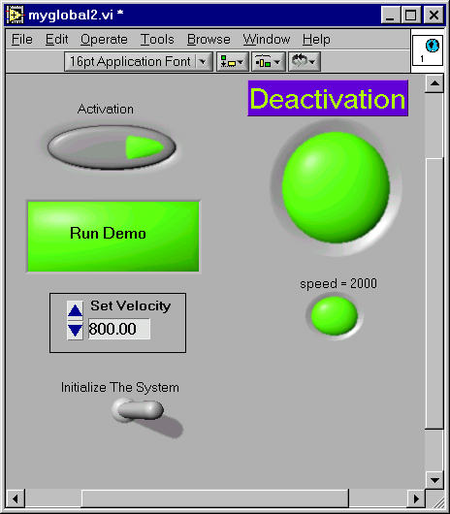

Figure 7: Front panel for the myglobal2.vi program used as a reference.

The icons used to call specific local or global variables within the myglobal2.vi program are shown in Figure 8A and 8B, respectively.

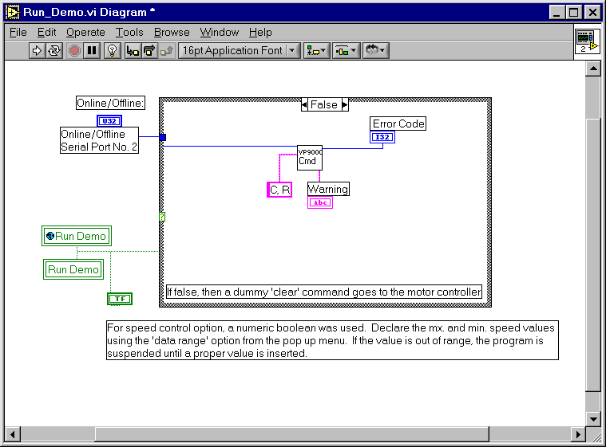
(A)
(B)

Figure 8A-B: Icon representation of a local and global variable.

The procedure for insertion of such icons is as follows:

-From the <Select a VI> menu within the Functions palette of the diagram, choose the subVI that contains the global variable. (i.e.- myglobal2.vi) Drag and drop the icon onto the diagram. Right click the icon and select the sought after global variable name from the <Select an Item> submenu.

-To create a local variable, right click on the Boolean in the diagram corresponding to the front panel button and select <create local variable> from the pop-up menu. Wire the global to the case loop, the global to the local variable, and the Boolean to the wire connecting the global variable to the case loop. Figures 9A-D show a variety of acceptable configurations for the wiring of global and local variables.

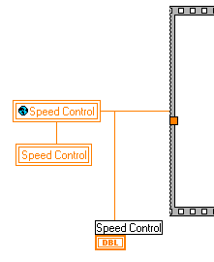
Case structure
(A)

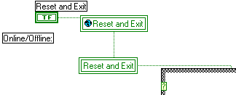

Case structure

(B)

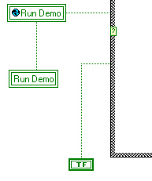
Case structure

(C)

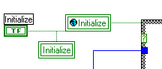
Case structure

(D)

Figure 9A-D: Illustrations of the wiring for both global and local variables.

Common Gateway Interface (CGI)

A CGI routine is any program capable of accepting information from a client (web browser), processing that information in some way, and sending a response back to the client. For example, any web page that contains HTML form elements- such as ring menus, text fields, radio buttons- and has a submit button for the user to press once the elements have been filled out, uses a CGI routine to process the submission.²

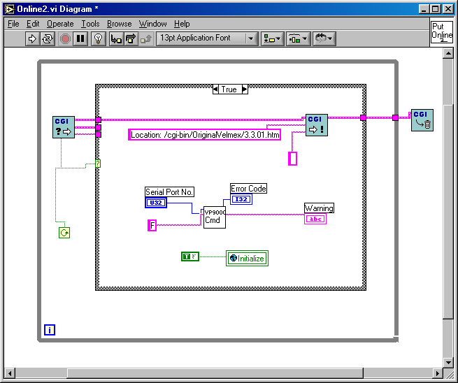

Figure 10: Shows the diagram including the CGI scripting components marked in red circles.

The Internet Toolkit creates such CGI scripts in the form of CGI VIs using standard G programming techniques. Figure 11 shows the CGI VI that reads the value of a radio button and relays the information to the respective LabVIEW program. Components that are circled in red are contained in every CGI VI. The leftmost subVI is responsible for containing the environment and any content string submitted by the client and providing that information back to the diagram. The next outlined subVI to the right is responsible for sending a response back to the client to be displayed in the browser. The last subVI frees the resources associated with this particular CGI call.²

Publishing the Front Panel Using HTML

In LabVIEW, select Tools>Options, select Web Server: Configuration and check the box to ‘Enable the Web Server.’ For Web Server: Browser Access and Web Server: Visible VIs type in an asterisk and click add. This will allow all users from all top addresses to see any VI that is running in memory. One can restrict either of these fields in the appropriate field. Click ok to save the settings and then totally close and relaunch LabVIEW so that the G Server is activated. To test for the correct configuration, type in the following URL: http://localhost/.snap?filename.vi. The running VI should be viewable from the same computer as the opened VI using this Web address. In order to view the front panel from another computer, simply replace localhost with host machine’s IP address.

Once LabVIEW programs are able to be viewed, the front panel is then able to be embedded into the source code of the HTML document. There are two options for embedding the front panel image; statically or dynamically. Static front panel images are obtained by using the .snap? argument. An example coding is as follows:³

<HTML>
…
<IMG SRC=”.snap?FilePath.vi”>
…
</HTML>

Dynamic images are accomplished using the .monitor? code instead of .snap? An example of a dynamic HTML WebPages is as follows:

<HTML>
…
<IMG SRC=”.monitor?FilePath.vi”>
…
</HTML>

Create HTML image map corresponding to root elements within program.

To successfully implement an image map into the HTML coding, the two major components that are needed are the IMG tags within the HTML document and the map information containing the coordinates.

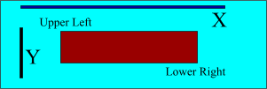

Figure 12: Illustration of how to get the proper layout coordinates.

Figure 12 shows the methodology for choosing the correct coordinates used for the ImageMap. As seen in Figure 12, X is considered the horizontal axis and Y is the vertical. The point (0,0) is the uppermost left corner and in the case of a 300X100 image, (300, -100) is the lowest right corner.³ An example of the source code needed for the image map is found below:

<MAP Name="buttons">
<AREA Shape="Rect" coords = "270,175,403,230"
HREF="/cgi-bin/OriginalVelmex/Online2.vi">
<AREA Shape="Rect" coords = "403,300,500,370"
HREF="/cgi-bin/OriginalVelmex/VP9000Cmd2.vi">
</MAP>

Initialize.vi

The WBFVF uses a Superior Electric motor, model M092-FD09 which is in turn connected to the Velmex VP9000 motor controller. For interactive control from a local PC a RS-232 cable was connected from the front panel connector to the computer’s COM1 serial port.
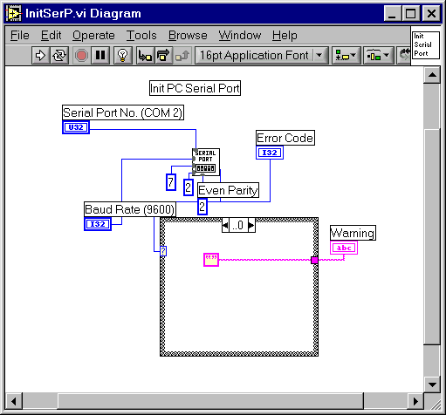
When controlling instruments from a PC, it is important that the parameters for both the instrument and the computer be identical. For the WBFVF, the following initial conditions need to be set: 9600 baud rate, 7 data, 2 stop bits, and even parity.⁴

Figure 13: Below shows an illustration of the LabVIEW front panel and the corresponding diagram, which sets the parameters (i.e. “initializes” the system).

Activation.vi

After the motor controller has been initialized, it must be given the command to put into ‘online-mode,’ meaning it will then be ready to receive executable commands. With the VP9000, the online-mode can be accomplished by sending an E, F, or G command. When the command has been successfully completed, a yellow light will appear on the front panel of the VP9000. Figures 14A and 14B show the motor controller in online-mode.⁴

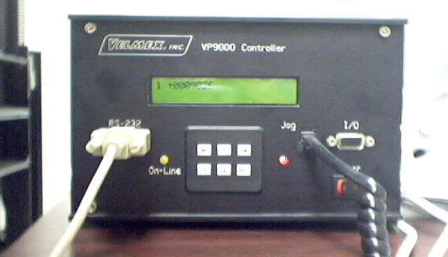

(A)

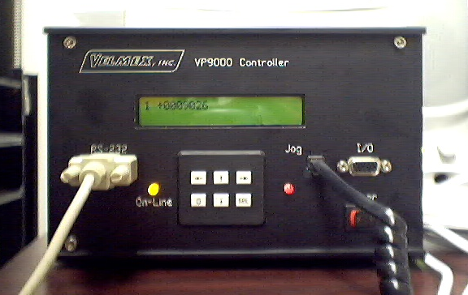

(B)

Figure 14A-B: An illustration of the front panel when the motor controller is in the online-mode.

The “E” puts the VP9000 on-line with echo “on” (echoes all characters received back to the host). The “F” puts the VP9000 on-line with echo “off.” The “G” puts the VP9000 on-line with echo “off” and tells the VP9000 to add a carriage return when it finishes a transmission. For WBFVF, the “E” was implemented so that the characters that the motor controller echoed were displayed on the PC terminal screen.⁴

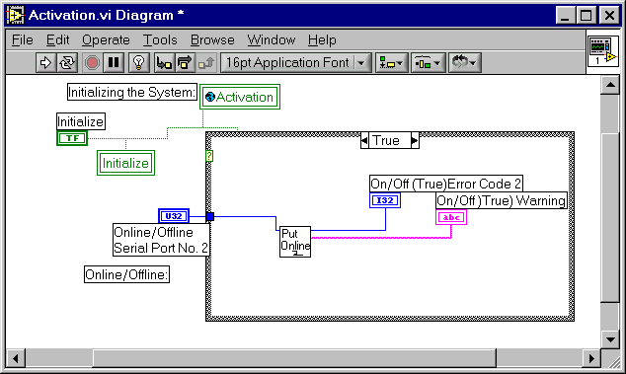

(A)
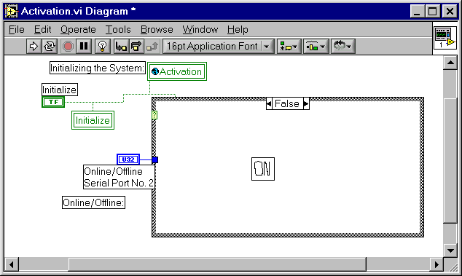
(B)

Figure 15A-B: Depicts the contents of the true and false cases for Activation.vi.

Figure 15 shows the diagram for the CGI scripted online-mode program. Ideally, when this program is called from the imagemap of the associated webpage, an “E” is sent to the motor controller. This response to a user input from a web browser marks the achievement of remote access of the physical instruments within a lab environment via LabVIEW.

**The troubleshooting methods that follow are mentioned to detail the steps toward consistent performance. All programs do function properly, yet lack consistently. **

- Deleted the global and local variables and left only the main online functions and added CGI scripts.
- Added an “always true” statement so that the VI would always execute.

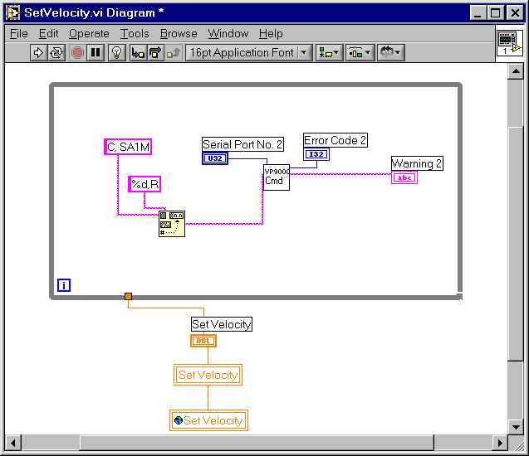
SetVelocity.vi

Figure 16: The diagram for the SetVelocity.vi.

Applying the original SetVelocity VI, it was noticed that the values within the myglobal2.vi, were updated appropriately, but the value was not updated on the viewer’s web browser and the corresponding command was not sent to the motor controller.

- Deleted the global and local variables and left only the main online functions and added CGI scripts.
- Added an “always true” statement so that the VI would always execute.
- Use a JPG image instead of LabVIEW front panel as imagemap with the SetVelocity program linked to the various designated hotspots.

Run_Demo.vi

From the onset, this program has run consistently, but regardless of the clear string commands sent to the motor controller, the profile loops prove to be additive (i.e, if the demonstration button is pressed once, the motor looped once, if pushed twice, the motor looped twice, etc.).

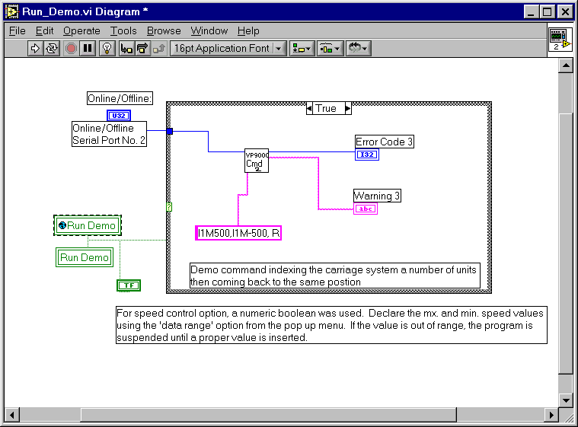
(A)

(B)

Figure 17A-B: Contents of the true and false case of Run_Demo.vi.

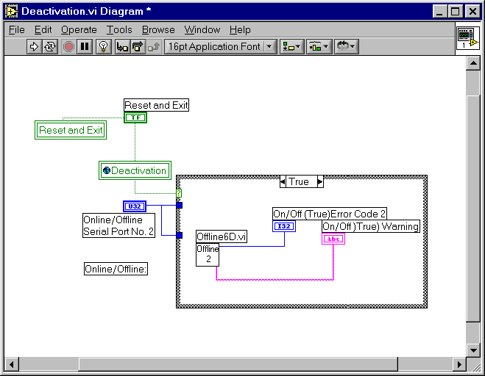
Deactivation.vi

(A)
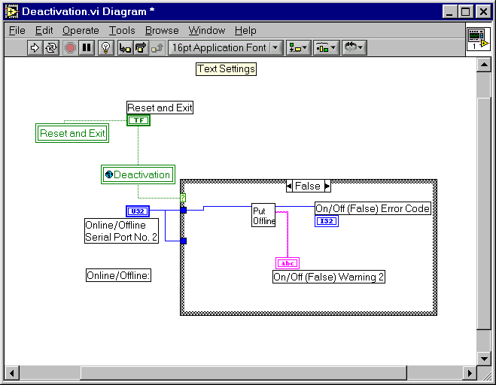
(B)

Figure 18A-B: Contents of the true and false case for Deactivation.vi.

Since the layout of offline was essentially the same as Activation.vi, the same troubleshooting methods were applied.

Web Page and Live Video Configuration

Introduction

The first step in the creation of the VirtuLab WBFVF Web Page was learning basic HTML editing. Basic HTML editing includes writing simple text, inserting pictures, creating hyperlinks from text and from pictures, and making tables. Once these basic steps have been established, the creation of frames can be implemented. Another method of HTML editing, such as the use of graphical programming, was also implemented. Microsoft Word 2000 was the graphical program used. Even though using Microsoft to create the web page was time efficient, it added coding specific toward Microsoft Word. This made any necessary editing complicated when attempting to write the HTML code by hand.
Live video streaming is an essential part of the VirtuLab Flow Visualization Facility. It enables students participating in the lab to view the remote flow visualization experiment in real time with a web cam. After the initial Web Page for the laboratory was created, a live video window was embedded using the following programs: RealPlayer, RealProducer, and RealServer. Essentially, RealProducer streams the live video feed onto the FAMU/FSU College of Engineering server, where the video data is processed and is viewable via the Internet with the RealPlayer software.

Web Page Configuration

The objective of the project was to create remote control access for the flow visualization experiment through the Internet. It was essential to create user friendly web pages that allowed the student users to quickly understand and complete the required laboratory. With this in mind, the Homepage shown below in Figure 19 was created. This web page consists of two frames: the left containing links to information about the VirtuLab senior design group, and the right frame containing the objective of the flow visualization facility. The links are references to all of the presentations, reports, updates, group information, and the schedule for the fall and spring semesters.

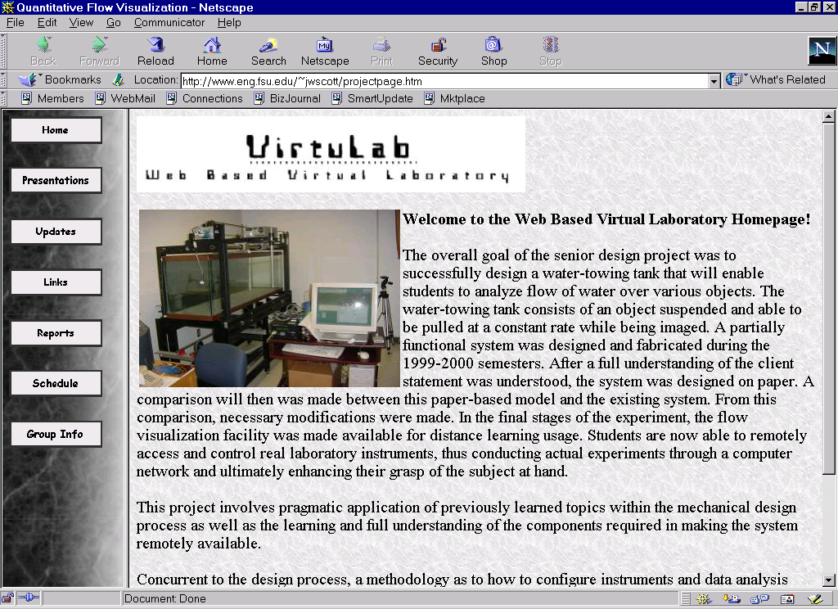

Figure 19: Homepage for the VirtuLab Flow Visualization Facility

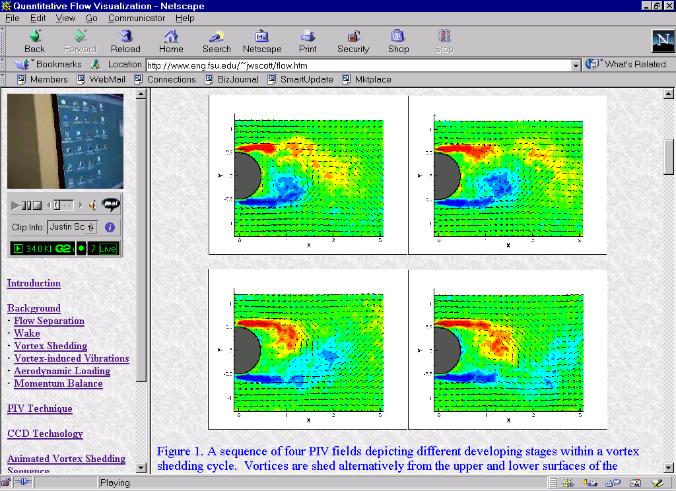

Figure 20: Homepage for the flow visualization experiment

The web page in Figure 20 consists of two frames: the left containing the live video controls and window, as well as links to information about the remotely controlled flow visualization laboratory. The links are then opened in the right frame. This web page was set up this way to ensure that the live video will not refresh when users look up different pages. When the live video starts (or refreshes), it takes about ten seconds to buffer the live video stream before the user can actually see the live video. By separating the two sides of the window, this prevents the user from experiencing a delay in the right side of the Web Page.

Live Video Configuration

The first step in setting up the live video for the flow visualization experiment was downloading the free RealProducer software from http://www.realnetworks.com/products/producer/ index.html?src=noref,rnhmpg_020701,rnhmln,gstartd_120100,nosrc. After the software was installed, it was necessary to configure the program for live video broadcast.
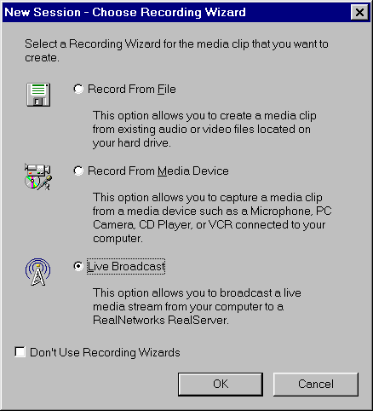

Figure 21: RealProducer live video configuration.

Figure 21 shows the first configuration window that pops up when opening RealProducer. Selecting the Live Broadcast icon allows the live video stream to be sent to the RealNetworks software on the FAMU/FSU College of Engineering server.
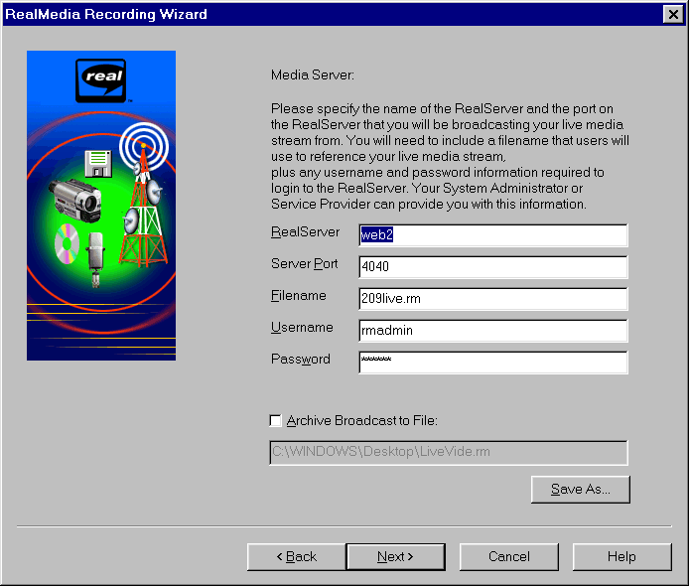
Figure 22: RealProducer Media Server Setup Window.

Figure 22 represents the Media Server setup window. This is where the RealServer access information is set up. This information was provided by the FAMU/FSU College of Engineering Webmasters (contact: Drew Kocur).

Figure 23: RealProducer Control Window.
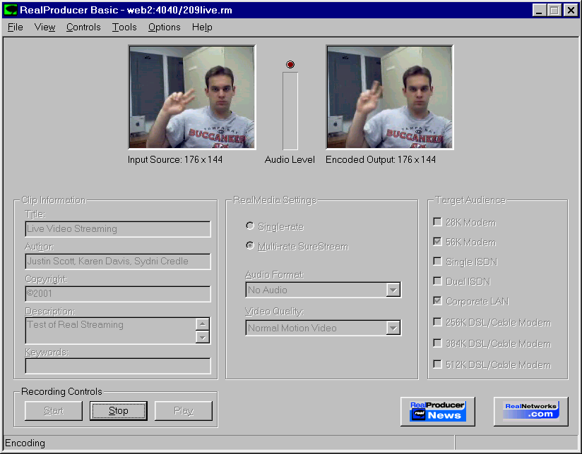
Figure 23 is the control window for the live video streaming. The two video windows above on the left and right show the input and output video stream, respectively. From this figure, it is shown that there is a delay between the input and output video. The output video is then sent to the RealServer software and processed so that it can be viewed over the Internet. This process also increases the delay to around 10 seconds. This 10-second delay is from the actual movement in front of the video camera to viewing it over the Internet.
This window also includes the video information, which can be seen on the left side of the control window shown in Figure 23. When the web page is viewed, this information is shown in the video controls in the left frame.
By selecting the target audience bandwidth, or Internet connection speed, RealProducer will send the video faster or slower to the viewer’s computer. For example, if a user has a 56k Internet connection, they will receive the video at less frames per second then a user that has a 256k connection.

Conclusion

Fundamental design issues that clarified the objectives and goals of the project were completed early on in the first semester. Specifications of the system as well as an in depth schedule based on the Work Breakdown Structure (WBS) promoted the efficiency of the team members and thus guided the project to success.
The designing and machining of the camera mount was the main priority during the first semester. Time and effort was spent researching different avenues of completing this task until the team approved a final design for fabrication. All materials and components needed for completion were ordered before the end of the first semester. Fabrication of components for the camera mount was requisitioned a scheduled for delivery in early January. Final assembly of the camera mount was finished by mid January.
Concurrent to the design and fabrication of the camera mount, the LabVIEW control aspects of the system were explored. Team members also carried out training with the motor controller. The first step was learning to manipulate the motor controller, which entailed front panel programming. Basic functions such as activation, speed variation, and distance traveled were learned.
The initial LabVIEW development strategy was based heavily on the use of reference manuals, online guides, and the technical support at National Instruments. Though these resources proved critical at the onset in terms of team development and acclimation to the scope of the problem at hand, the WBFVF team quickly ran into knowledge based barriers. It seemed that as the complexity of the WBFVF programs increased, the amount of technical resources decreased. The WBFVF team literally outgrew the support that was depended upon so heavily in the beginning.
The major problem regarding the LabVIEW programming was the reliability factor. Bottom line: the programs created for the WBFVF were not consistent. There were two different reasons for this inconsistency. First, there could have been a programming error and the problem could be rectified solely from the software side. The WBFVF team members ruled this possibility out because of previous successes. The second reason could simply have been the amount of usage on the host computer that held all the programs. At one point, the location of the computer that held all the programs was being used by a Fluids laboratory class as well as miscellaneous others. Solving this problem meant moving the computer to another location that proved to be more isolated, thus cutting down on persons that may be inadvertently changing settings.
With great success, the WBFVF team members forged through the LabVIEW programming portion of the project relying heavily on trial and error. The final deliverable was a product of numerous cycles, whereupon the knowledge learned from each iteration was implemented and tested during the next.
The creation of a web page for the experiment was essential in the last weeks of the project. The page is designed so that the student users can quickly and easily conduct the experiment. The last objective of the WBFVF group was to incorporate live video into the web page for the experiment. This was done using RealServer and RealProducer software in conjuction with a web cam.
Falling in line with the objective of the project, the interactive portion of the experiment via the web has been developed and is ready for use. With the Web-Based Flow Visualization Facility (WBFVF), students as well as teachers can now use such cutting edge technology as LabVIEW as the basis for the study of fluid mechanics.

Appendix A: NI Days



NIDays 2000 Agenda
15 Sessions

- Introduction to Real-Time Control
- Check Out the New Version of LabVIEW
- LabVIEW Programming Techniques: The Good, the Bad and the Ugly
- Introduction to Measurement Studio
- Tackling High-Channel Count Applications in LabVIEW
- Steps for Success with Vision
- Designing Motion Control Systems
- Measuring Strain and Displacement Accurately
- Building a Network-Based Data Logger
- Creating Parallel Test Systems for Faster Test Throughput
- Architecting Production Test Systems
- Distributed Measurement Systems
- Computer-based Vibration Measurement for Machine Condition Monitoring
- The Basics of Making Frequency Domain Measurements
- Monitoring and Control over the Web

Introduction to Real-Time Control
Control system designers increasingly utilize industry standard computing technologies to reduce development time and improve the connectivity and integration of their solutions. Learn about real-time and embedded control development, plus see a working example using LabVIEW RT and modular ruggedized real-time hardware.

Check Out the New Version of LabVIEW
If you currently use LabVIEW 5.0 or 5.1, attend this course to learn about the latest features in the newest LabVIEW release. The instructor will walk you through each of the new features and explain how to take advantage of them in your applications.

LabVIEW Programming Techniques: The Good, the Bad and the Ugly
Do you want to become a better LabVIEW programmer? This session is filled with useful tips and techniques for optimizing your LabVIEW development. Learn from real-world examples as LabVIEW developers describe better programming techniques based on their analysis of previously submitted user applications.

Introduction to Measurement Studio
Learn how to use Measurement Studio to ease the development of measurement and automation applications using standard text-based programming languages such as Microsoft Visual C++ and Visual Basic and LabWindows/CVI. Gets some hands-on instruction on how to use the new powerful programming tools to make you more productive and find out how much easier they make your development.

Tackling High-Channel Count Applications in LabVIEW
An application with a small number of channels can be easily developed by programming the data acquisition on a channel-by-channel basis, but what about having an application with a large number of channels to manage? National Instruments provides tools that can help increase your productivity. This session will outline the benefits of using LabVIEW and its add-on tools for data management, alarm configuration, and historical logging, for developing large channel count and distributed systems efficiently.

Steps for Success with Vision
This session is a step-by-step formula for new developers of industrial machine applications. Learn about camera selection, illumination techniques, image acquisition, and triggering techniques for quality assurance and inspection applications.

Designing Motion Control Systems
This mini course provides a comprehensive, practical approach to designing your motion control system from the ground up. Starting with a simple description of motion requirements, learn step-by-step how to select all necessary components including motion controller, power drive, motor, power transmission, and fixture. During the hands-on portion of this session you will use what you have learned to implement a simple motion system using National Instruments hardware and software. No prior motion control knowledge or programming experience required.

Measuring Strain and Displacement Accurately
During the first half of this session, you will learn how to accurately perform strain measurements. Learn about the role and benefits of various strain measurement technologies including bridge completion, shunt calibration, remote sensing, ratiometric compensation, temperature compensation, and offset nulling through hardware compensation. The second half of this session covers advanced position measurement technologies. Come learn when and how to use position measurement sensors like Linear-Variable Differential Transformers (LVDTs) or Rotational Variable Differential Transformers (RVDTs).

Building a Network-Based Data Logger
National Instruments data acquisition hardware and LabVIEW software, form an ideal combination for building a customizable system that acquires data and logs the data to disk. In this session you will learn the fundamental components required to acquire and log data to disk. Build a computer-based datalogger and then choose the hardware platform that best suits your application.

Creating Parallel Test Systems for Faster Test Throughput
Increasingly, automated test systems are using multi-head testers that test products in parallel to meet the throughput requirements of high-volume production lines. Learn how to use National Instruments software to architect a high-performance, maintainable multi-head test system that maximizes performance and hardware utilization. Techniques discussed will include multithreading, test synchronization, and sharing of hardware resources.

Architecting Production Test Systems
Choosing the right test platform is essential when developing production test systems. This session reviews the basics of PXI, computer based instrumentation, switching and fixturing. We explore different system configurations, methods of optimizing timing and synchronization between different instruments and present examples of hybrid systems - showing you how to integrate PXI, with VXI and GPIB based instruments. Finally we present test software solutions to improve your test performance. Includes: Instrumentation, Switching, Fixturing; System configuration (MXI-3); Timing; Software; Hybrid Systems.

Distributed Measurement Systems
Advances in networking technologies are continuously changing not only the way we do business, but also the way we set up our measurement systems. Distributed Measurement Systems address factors such as size, distance, environmental conditions, and sharing and controlling equipment in different locations. In this session you will learn how to take distributed measurements, as well as the basics of putting together a distributed measurement and control system.

Computer-based Vibration Measurement for Machine Condition Monitoring
Machine condition monitoring involves acquisition and analysis of vibration and other signals to check the condition of machinery and predict imminent failures. By continuously monitoring industrial equipment, you can reduce downtime and avoid catastrophic problems. With the PC and low-cost measurement hardware and software, the technique has evolved from something that was only appropriate for the most expensive and critical equipment to something that you can apply in a more general sense. This session will review some fundamentals of machine condition monitoring and discuss how you can apply National Instruments products for acquisition and analysis of vibration signals for the job.

The Basics of Making Frequency Domain Measurements
When performing frequency domain measurements, there are several things to consider in order to ensure that your measurement provides the accurate information that you need. This presentation will teach you the basic components of a measurement system and various frequency analysis methods that are primarily used in the fields of sound and vibration analysis. We begin by presenting the various signal conditioning considerations for capturing time domain waveforms for later frequency analysis including the sampling theorem, A/D technologies, spectral leakage, and smoothing windows. We then discuss three different methods of frequency analysis: FFT analysis, octave analysis, and swept sine analysis. The different advantages of these methods are discussed as well as how your application determines which method will be used.

Monitoring and Control over the Web
Learn how you can leverage the power of the web to monitor and control applications ranging from laboratory environments to industrial applications. This session covers LabVIEW and Lookout Internet technologies on how you can transform your application into a web based one.

Appendix B: Meeting Notes

1ST Meeting with Advisor/Client--Dr. Shih

Topics to be discussed:
1. Preliminary Imaging Camera Mount Design
2. Web Cam
3. Generation of Action Items List
4. Rescheduling of official bi-weekly meeting time

WEb based flow visualization facility
Client/Advisor Meeting with Dr. Shih

meeting Notes (9/12/00)
- Rescheduling of bi-weekly meeting to Friday at 2:00pm
-9/22/00 (Meeting cancelled due to hurricane Helene)
- Camera Mount
-Introduction of preliminary design for approval
-Referred to Bill Kincannon for fabrication
-Need: Tank measurements for final design
- Web Cam
-Favorable Model: VC-C3, by Canon
>Request demo software and pricing information
-Referred to Mike Conroy (3rd floor computer support team)
- LabVIEW
-Enterprise Connectivity Toolkit ($646.75)

New agenda items
F. Towing Tank Simulation
- Teleconference Challenge

WEB-Based Flow Visualization Facility
Client/Advisor Meeting with Dr. Shih

meeting Notes (9/26/00)
- Camera Mount
-Introduction of preliminary design for approval
-Referred to Bill Kincannon for fabrication
-Need: Tank measurements for final design
- Web Cam
-Favorable Model: VC-C3, by Canon
>Request demo software and pricing information
-Referred to Mike Conroy (3rd floor computer support team)
- LabVIEW
-Enterprise Connectivity Toolkit ($646.75)

New agenda items
F. Camera Mount Update
G. Teleconference Update
H. Motor Controller Update
I. VC-C3 Web Cam Update

WEB-Based Flow Visualization Facility
Client/Advisor Meeting with Dr. Shih

meeting Notes (10/6/00)
- Camera Mount
-Final design chosen for fabrication
-Need final designs to give to Bill Kincannon
- Web Cam
-Favorable Model: VC-C3, by Canon
-Pricing and contact information given to Dr. Shih
- LabVIEW
-Confirmation of ordering status.
-Need more time learning the software
- Teleconference
-Need to set up web conference facility
-Analyze Internet/Intranet connections

New agenda items
- Teleconference Update.
- VC-C3 Web Cam Update.
- LabVIEW attempts and frustrations.
- Work Breakdown Structure (WBS) and Scheduling

WEB-Based Flow Visualization Facility
Client/Advisor Meeting with Dr. Shih

meeting Notes (10/20/00)
- Camera Mount
-Final parts ordered
-Fabrication to be completed by 11/20/00
- LabVIEW
-Ordering status (should be here today).
-Need more time learning the software
- Teleconference
-Analyze Internet/Intranet connections
-Research capabilities (Dr. VanDommelen )

New agenda items (11/3/00)
- Teleconference Update.
- Motor Controller.
- LabVIEW Update.

WEB-Based Flow Visualization Facility
Client/Advisor Meeting with Dr. Shih

meeting Notes (11/3/00)
- Camera Mount
-Final parts ordered
-Fabrication to be completed by 11/20/00
- LabVIEW
-Ordering status (should be here today).
-Need more time learning the software
- Teleconference
-Analyze Internet/Intranet connections
-Research capabilities (Dr. VanDommelen )

New agenda items (11/17/00)
- Teleconference Update.
- Motor Controller.
- LabVIEW Update.

WEB-Based Flow Visualization Facility
Client/Advisor Meeting with Dr. Shih

meeting Notes (11/17/00)
- LabVIEW
-Received shipment of LabVIEW software and toolkits
-Need to load onto the computer
-Need: Representatives to attend NI Days Conference (Orlando, Fl - 11/9/00)
- Dr. Van Dommelen Meeting (Summary)
-Embedding of the source code for various web page components
-Demo of “Sharing” a workspace between two different users using NetMeeting and RealMedia/Windows Media
-Security issues and concerns
C. Motor Controller
-Clarification of profile loop constraints
-Need to modify user interface (front panel)

New agenda items (12/1/00)
D. Motor Controller programming scripts
E. LabVIEW Upgrade
-Version 6.i has been sent out today
-Shipment to be received by 11/21/00
-Maintenance Software?
- National Instruments “NI Days” LabVIEW Conference
- Web Page
-Preliminary design (http://www.eng.fsu.edu/~jwscott/seniordesign.htm)
-iVista software
H. NetMeeting
-Exploring capabilities
-Trying to rectify problems with video streaming
Web-Based Flow Visualization Facility
Client/Advisor Meeting with Dr. Shih

New Agenda Items (1/12/01)
- VC-C4 Web Camera
-Information and Literature
-WebVIEW software
B. Camera Mount
-Reordered right hand threaded nuts through John Cloos
-Fabrication close to completion
-Next Step: Assembly
C. LabVIEW 6.i / Motor Controller Programming
-Version 6.i has been installed
-Preliminary experiment module completed (available for client demonstration)
-Next step: use new software for remote control and monitoring
D. Web Page
-Primary Focus: Making the LabVIEW Front Panel available on the web
-Clarification of page content and structure

Web-Based Flow Visualization Facility
Client/Advisor Meeting with Dr. Shih

new agenda Items (1/26/01)
- VC-C4 Web Camera
A. Information and Literature
B. WebVIEW software
2. Camera Mount
A. Fabrication complete.
B. Performance/Functionality test on 1/24/01
-shortened the length of the screw to secure the camera to fixture better.
-decreased size of advancing handle to not interfered with camera.
-careful consideration as to the weight of the camera mount assembly. May decide to modify existing base plate if needed.
- Motor Controller Programming
- Weight of camera mount may affect the speed calibration
- In the process of fixing aesthetic characteristics of front panel. (more color, less text, more user friendly control buttons)
4. LabVIEW 6.i / Remote Control Programming
- Have a contingency plan as to how to remotely control the equipment
-Publish front panel in HTML, use image map with embedded CGI VI scripts to receive user input
B. Currently working through initial programming setbacks. Deadline: 2/5/01
5. Web Page
A. Primary Focus: Making the LabVIEW Front Panel available on the web
B. Clarification of page content and structure

Appendix C: Camera Mount Specifications

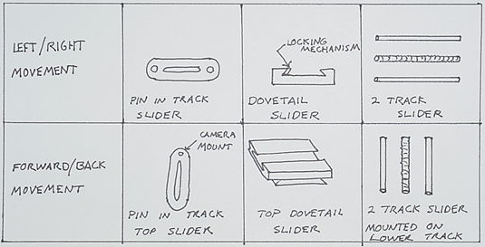

Figure C1: Morphological chart illustrating the three concepts for camera movement.

The morphological chart shows a pin in track slider, a dovetail slider, and a two track slider that controls movement with a threaded rod. These design options need to be evaluated for customer and engineering needs before a final concept is selected.

Table C1: Specification Table for Camera Mount Design
Specifications | Pin/Slider | Dovetail | 2 Track
Easily Manufactured | + | -- | +
Cost efficient | + | -- | +
Lightweight | + | -- | --
Easily used | -- | + | +
Capable of supporting camera | -- | + | +
Appearance uniform with equipment | -- | -- | +
Locking mechanism included | -- | + | +
Long lasting | -- | + | +
Total | 3 | 4 | 7

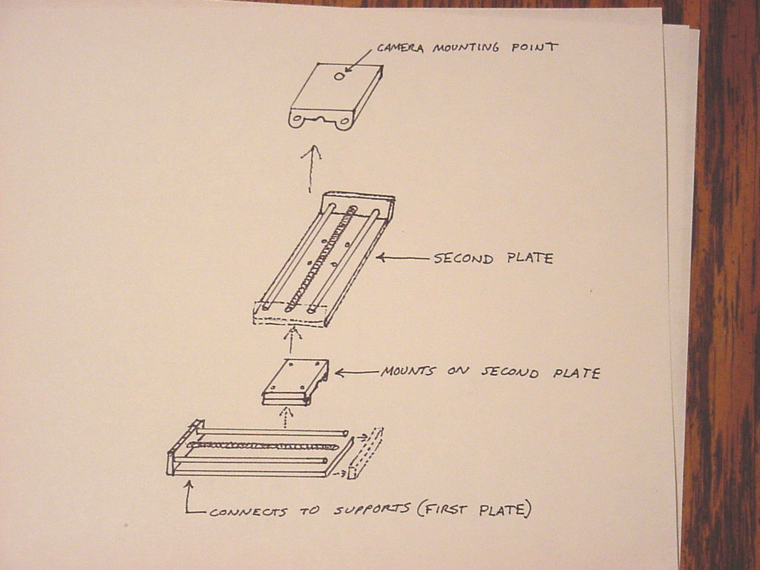
Table C1 illustrates the pros and cons of the three movement designs. It can been seen that the two track slider that controls movement with a threaded rod is the best movement design. The following is a preliminary sketch of the chosen design:

Figure C2: Exploded View of Initial Camera Mount Design

The next phase is creating detailed designs of this concept. These will include dimensions, locking mechanisms, materials, and the specific cost.

APPENDIX D - System Function Breakdown

Reservoir
In order to model the flow of a fluid over a cylindrical tube, there must be a holding tank for the chosen fluid. There were various options, but the most ideal was a tank.

Support
A support had to be designed to not only place the tank at an acceptable vantagepoint, but also had to be extremely durable and strong.

Medium
A fluid, in which the object will be pulled through, must be chosen in order to model the properties of flow around the cylinder.

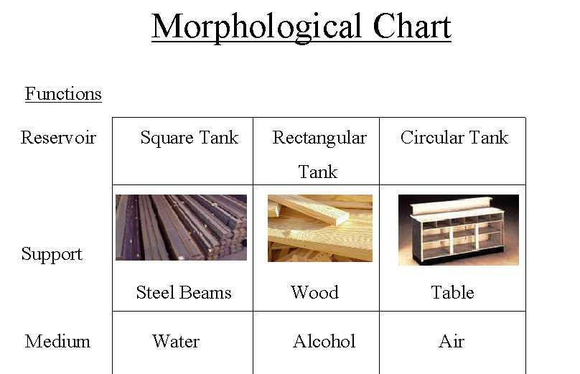
Figure D1: The morphological chart, which shows the concept options for the various functions.

Fluid Transfer
Once the fluid has been poured into the tank, there must be a way to also remove the fluid.

Synchronization/ Particle Tracking
The entire tanking system should have a timing element that will allow the camera and the cylinder to move at the same velocity and also remain in the same general area.

Figure D2: Morphological chart for flow visualization system.

Controls
Finally, to make the experiment remote accessed, a program is needed to control the motor. It is also necessary to place limitations on parameters (location and velocity of cylinder).

Illumination

This function provides the means for visual observation of the flow around the cylinder. Particles that have negligible effects upon the flow are dropped into the medium. The light source then illuminates the particles within the flow.

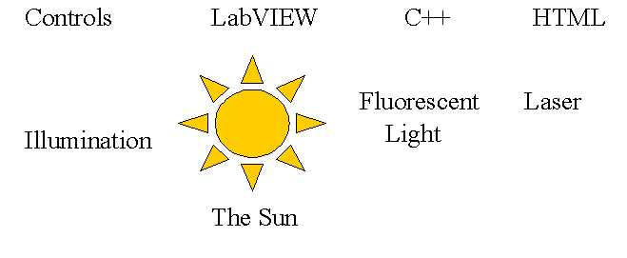

Figure D3: Morphological chart for flow visualization system.

Appendix E: E-mails

Date: Thu, 17 Aug 2000 17:45:19 -0400
From: shih@wombat.eng.fsu.edu
To: Karen A. Davis <kadavis@wombat.eng.fsu.edu>
Subject: Re: Proposal
Parts/Attachments:
1 Shown 15 lines Text
2 29 KB Application
3 Shown 11 lines Text
----------------------------------------

Hi:

I made some corrections and you guys should go through it again, especially the introduction part. Thanks.

Shih

Date: Fri, 18 Aug 2000 14:24:39 -0400
From: shih@wombat.eng.fsu.edu
To: Karen A. Davis <kadavis@wombat.eng.fsu.edu>

Hi:

The motor controller is working now; cable seems to be the problem. I will need one of you to make a cable for it. Thanks.

Shih

Date: Mon, 21 Aug 2000 13:01:24 -0400
From: shih@wombat.eng.fsu.edu
To: Karen A. Davis <kadavis@wombat.eng.fsu.edu>
Subject: Re: your mail

Hi:

You just need to buy the connectors since we already have the cable. You might want to talk to me again to see where you can find connectors for the cable. Thanks.

Shih

At 12:38 PM 8/21/00 -0400, you wrote:
Sydni looked up the cable on the internet from Radio Shacks web page, but she only found a female-female connector that had the right amount of ports. But we are still looking, it should not be hard to find. Did you want us to build the cable or buy a cable? Also, attached is the updated proposal, please let us know if we need to modify ome more. Thank you.

Karen Davis

Date: Mon, 21 Aug 2000 17:21:13 -0400
From: shih@wombat.eng.fsu.edu
To: Karen A. Davis <kadavis@wombat.eng.fsu.edu>
Subject: Re: your mail

Hi:

I would like to have my book and the motor controller manual back also. Thanks.

Shih

Date: Tue, 22 Aug 2000 17:54:39 -0400
From: shih@wombat.eng.fsu.edu
To: Karen A. Davis <kadavis@wombat.eng.fsu.edu>
Subject: Re: your mail

Hi:

I found a cable to work with the controller so you do not have to make one anymore. Thanks.

Shih

Date: Wed, 23 Aug 2000 13:56:33 -0400
From: shih@wombat.eng.fsu.edu
To: Karen A. Davis <kadavis@wombat.eng.fsu.edu>
Subject: Re: Revised Proposal
Parts/Attachments:
1 Shown 4 lines Text
2 34 KB Application
3 Shown 11 lines Text
----------------------------------------

Hi;

Here it is, however, you have to meet Dr. Luongo's requirements also. Thanks.

Date: Fri, 08 Sep 2000 17:48:32 -0400
From: shih@wombat.eng.fsu.edu
To: Sydni Credle <credle@wombat.eng.fsu.edu
Subject: Re: Bi-weekly Meeting

Hi:

Those times are not good for me. I will prefer maybe Friday afternoon from 2 to 3. However, we can meet Tuesday 11:30 next week.

Thanks,
Shih

At 05:08 PM 9/7/00 -0400, you wrote:

Hello Dr. Shih,

Karen, Justin, and I have just received confirmation of our Senior Design project from Dr. Luongo today. For the duration of the project it will be the three of us. We did not get a fourth member. Starting next week (9/11/00), we would like to meet with you regularly either Tuesday or Thursday from 11:30am-12:30 p.m. every other week. Contact me if these meeting times do not fit your schedule. At our first meeting, we should be able to give you a listing of possible web cams that may meet our application needs as well as show you preliminary design ideas for the camera mount.

Thank-you
-Sydni Credle

Date: Wed, 20 Sep 2000 09:53:38 -0500
From: <sydni@somethingorother.com>
To: jwscott@wombat.eng.fsu.edu
Cc: kadavis@wombat.eng.fsu.edu
Subject: flow surfing

If you guys have free time and want to surf, I found some cool pages on flow visualization, etc.
http://www.floworks.com/floworks.htm
-This is a webpage showing the capabilities of a software package called Floworks that can be used with the AutoCAD program called Solidworks http://www.ofs.co.uk/pivintro/index.html
-This is the almost the PIV technique bible. Live it, learn it, love it.
http://gvis.lerc.nasa.gov/gallery/flow_vis.html
-pictures and stuff
http://www.sli.unimelb.edu.au/envis/viz.sites.NAS.html
-a database of everything

-Sydni

Subject:
RE: web view software
Date:
Fri, 22 Sep 2000 12:22:43 +0900
From:
"Masato Fujiwara" <fujiwara.masato@canon.co.jp>
To:
<jwscott@wombat.eng.fsu.edu>
CC:
"ˆÀ“c‚³‚ñ" <hyasuda@cusa.canon.com>

Thank you very much for your e-mail. I will forward your inquiry to the responsible person in US.
I will ask him to contact you.

Best regards,

Masato Fujiwara
CM Planning
Canon Inc.

-----Original Message-----
�·�o�l : jwscott@wombat.eng.fsu.edu <jwscott@wombat.eng.fsu.edu>
ˆ¶�æ : webview@cis.canon.co.jp <webview@cis.canon.co.jp>
“úŽž : 2000”N 9ŒŽ 22“ú ‹à—j“ú Œß‘O 02:13
Œ�–¼ : web view software

I have a Canon VC-C3 camera and am interested in the web view software only. I would like some more information about this and a price. Also, I live in the US and not sure if it is available here. Thank you for your time.

Justin Scott

Subject:
RE: web view software
Date:
Mon, 25 Sep 2000 11:06:52 -0400
From:
hyasuda@cusa.canon.com
To:
jwscott@wombat.eng.fsu.edu

Thank you for your recent inquiry regarding Canon's new WebView Livescope image webcasting system.
WebView /Livescope is an innovative webcasting solution that allows viewers to take control of camera angle and zoom functions at a remote location from their desktop. The system transmits compressed video and still images recorded by Canon's VC-C3 Communication Camera over a LAN or the internet, allowing the user to view images, realtime, from a variety of viewing angles. WebView / Livescope consists of three components: the camera server software and camera hardware are installed at the camera site while the viewer software is downloaded to the viewer to access images and to control the camera.

For detailed information on the WebView / Livescope System, please visit Canon's website at www.x-zone.canon.co.jp/WebView-E. If you are interested in purchasing the system from an authorized WebView
reseller. Please contact:
Digatron, Inc.
2513 17th Street
Denver, CO 80211
( 303 ) 455 - 9545
www.digatronsecurity.com

WWW.Consulting, Inc.
50 Main Street
Westhampton Beach, NY 11978
( 631 ) 288 - 2174
www.wwwconsulting.com

Thank you for your interest in Canon WebView / Livescope.
Hitoshi Yasuda

Date: Wed, 27 Sep 2000 20:00:26 -0400
From: jwscott@wombat.eng.fsu.edu
To: kadavis@wombat.eng.fsu.edu
Subject: presentation 2
Parts/Attachments:
1 Shown 1 lines Text
2 41 KB Application
----------------------------------------

Wasn't sure if I sent it right the first time.

Date: Mon, 02 Oct 2000 15:20:09 -0400
From: Dr. Chiang Shih <shih@wombat.eng.fsu.edu>
To: credle@wombat.eng.fsu.edu, kadavis@wombat.eng.fsu.edu, jwscott@wombat.eng.fsu.edu

Hi:
Can one of you talk to Mr. Bill Kincanon about the camera plate design? I just gave him a plate that you might want to use.

Thanks.
Shih

Date: Tue, 03 Oct 2000 14:30:33 -0400
From: Dr. Chiang Shih <shih@wombat.eng.fsu.edu>
To: credle@wombat.eng.fsu.edu, kadavis@wombat.eng.fsu.edu, jwscott@wombat.eng.fsu.edu

Hi:

I received the digital video cameras and microphones and I would like to have two of you to test them out using Microsoft Netmeeting program. Please send someone to see me.

Thanks. Shih

Subject:
Re: camera mount design
Date:
Wed, 4 Oct 2000 19:29:26 -0400 (EDT)
From:
"William C. Kincannon" <kincann@wombat.eng.fsu.edu>
To:
Justin Warner Scott <jwscott@wombat.eng.fsu.edu>
CC:
"William C. Kincannon" <kincann@wombat.eng.fsu.edu>

I will be there Thursday until 10:00. Then back around 12:30.
--WK

Date: Wed, 4 Oct 2000 23:50:47 -0400 (EDT)
From: Sydni Credle <credle@wombat.eng.fsu.edu>
To: Karen A. Davis <kadavis@wombat.eng.fsu.edu>
Subject: specs doc
Parts/Attachments:
1 Shown 2 lines Text
2 28 KB Application, "sumpthin"

needs formatting...

Date: Thu, 5 Oct 2000 13:37:44 -0400 (EDT)
From: Sydni Credle <credle@wombat.eng.fsu.edu>
To: Cesar Augusto Luongo <luongo@wombat.eng.fsu.edu>
Cc: Karen A. Davis <kadavis@wombat.eng.fsu.edu>,
Justin Warner Scott <jwscott@wombat.eng.fsu.edu>
Subject: Group 6 Specifications
Parts/Attachments:
1 Shown 4 lines Text
2 901 KB Application, "Group6-Specifications"
----------------------------------------

This is a copy of our second deliverable: The Specifications

-Sydni Credle

Date: Sun, 15 Oct 2000 15:50:16 -0400 (EDT)
From: Karen A. Davis <kadavis@wombat.eng.fsu.edu>
To: Chiang Shih <shih@wombat.eng.fsu.edu>
Cc: Justin Warner Scott <jwscott@wombat.eng.fsu.edu>, Sydni Credle <credle@wombat.eng.fsu.edu> Subject: LabVIEW

I just wanted to let you know I asked Ding Li to put LabVIEW on the computer next to the flow tank. Sydni said that you were having problems and to talk to Ding Li about re-loading the program. I just wanted to give you an update.

Karen Davis

Date: Tue, 17 Oct 2000 18:10:42 -0400
From: jwscott@wombat.eng.fsu.edu
To: credle@wombat.eng.fsu.edu, kadavis@wombat.eng.fsu.edu
Subject: sfdvoLSN'[zsopvinzsd'[onib
Parts/Attachments:
1 Shown 1 lines Text
2 222 KB Application

Date: Wed, 18 Oct 2000 23:58:09 -0400 (EDT)
From: Sydni Credle <credle@wombat.eng.fsu.edu>
To: Justin Warner Scott <jwscott@wombat.eng.fsu.edu>
Cc: kadavis@wombat.eng.fsu.edu
Subject: wbs
Parts/Attachments:
1 Shown 0 lines Text
2 349 KB Application, "wbs"

Subject:
Teleconference meeting
Date:
Mon, 23 Oct 2000 22:15:36 -0400 (EDT)
From:
"Karen A. Davis" <kadavis@wombat.eng.fsu.edu>
To:
Chiang Shih <shih@wombat.eng.fsu.edu>
CC:
Sydni Credle <credle@wombat.eng.fsu.edu>,
Justin Warner Scott <jwscott@wombat.eng.fsu.edu>

I was wondering if we could demonstrate the web camera teleconference program Wednesday afternoon at 5 pm. We can meet you in your office and then go down stairs to room 109 where we have a camera set up, Justin can call from his house. If there is a time that would be better for you, please let me know.

Karen Davis

Date: Tue, 24 Oct 2000 09:52:20 -0400
From: Dr. Chiang Shih <shih@wombat.eng.fsu.edu>
To: Karen A. Davis <kadavis@wombat.eng.fsu.edu>
Subject: Re: Teleconference meeting

Hi:

Let's meet at 5:10 pm in my office since I will have an exam to give this
Wednesday and it might take a few more minutes to wrap it up. Thanks.

Shih

At 10:15 PM 10/23/00 -0400, you wrote:

I was wondering if we could demonstrate the web camera teleconference program Wednesday afternoon at 5 pm. We can meet you in your office and then go down stairs to room 109 where we have a camera set up, Justin can program Wednesday afternoon at 5 pm. We can meet you in your office and then go down stairs to room 109 where we have a camera set up, Justin can call from his house. If there is a time that would be better for you, please let me know.

Karen Davis

Date: Tue, 24 Oct 2000 16:50:35 -0400
From: davy@wombat.eng.fsu.edu
To: kadavis@wombat.eng.fsu.edu, culberts@wombat.eng.fsu.edu, cherolis@wombat.eng.fsu.edu, credle@wombat.eng.fsu.edu
Subject: National Instruments Workshop

Hey Guys, Today I discovered that each person have to sign up to to go to the work shop in Orlando individually. You must register on the NI web site. The address is www.ni.com/nidays. I also contacted NI to verify if students can attend. I will let you know once I find out.

Charney

Subject:
labVIEW workshop
Date:
Tue, 24 Oct 2000 18:36:46 -0400 (EDT)
From:
Sydni Credle <credle@wombat.eng.fsu.edu>
To:
Justin Warner Scott <jwscott@wombat.eng.fsu.edu>

Hey Justin,

I don't know if anyone talked to you during class today but Charney had this flier for a LabVIEW workshop to take place in Orlando on Nov. 9th. She said Dr. Shih would pay for one meal and gas. (It's only a day long seminar) I don't know the particulars but you can e-mail Charney or talk to Dr. Shih to get some more info.

-Sydni

Date: Thu, 26 Oct 2000 13:18:48 -0400 (EDT)
From: Sydni Credle <credle@wombat.eng.fsu.edu>
To: Chiang Shih <shih@wombat.eng.fsu.edu>
Cc: Karen A. Davis <kadavis@wombat.eng.fsu.edu>,
Justin Warner Scott <jwscott@wombat.eng.fsu.edu>
Subject: LabVIEW Backorder

Hello Dr. Shih,

To Follow up on the phone message I left you earlier today...

The status of our order for the LabVIEW teaching license and supplementary software and toolkits is that it is "Backordered" - meaning that it is still going through the proper channels that ensure proper documentation of the merchandise.

I couldn't get a concrete time as to when they think they can deliver. Best case = 1 week, (2 weeks at the latest) I will follow up early next week (monday) to check on the status again. In the meantime, if you have questions or comments concerning the order (#RF-ME 2890), here is the contact information for the person I spoke with:

Bobby Gonzalez
National Instruments
(800) 667-5347
ext. #30418

Date: Thu, 26 Oct 2000 15:51:01 -0500 (CDT)
From: karen.bauer@ni.com
To: credle@wombat.eng.fsu.edu
Subject: National Instruments Event Registration Information

Dear Sydni Credle,

This is to confirm your registration for the National Instruments seminar NIDays 2000. The seminar occurs on November 09, 2000, beginning at 08:00. The location of the seminar appears below: Wyndham Orlando Resort 8001 International Dr ORLANDO FL Space is limited. If you cannot attend the seminar, please notify us so that we can reallocate your reservation. Should you have questions, please call us at (800) 433-3488.

Sincerely,
Karen Bauer Sales Event Coordinator

From: Karen.Bauer@ni.com
Date: Tue, 31 Oct 2000 20:47:43 -0600 (CST)
X-Authentication-Warning: arapaho.natinst.com: applmgr set sender to Karen
Bauer using -r
To: shih@wombat.eng.fsu.edu
Subject: NIDays 2000 in Orlando, FL on Thursday, November 9!

Dear Chiang
Shih,

I want to send you a personal invitation to NIDays 2000 - find out how computer technology is revolutionizing the future of measurement and automation! Learn about emerging hardware, software, and
networking technologies and meet one-on-one with experts and third-party vendors at this technical conference and exhibition. The session is free, and lunch is included.

Technical sessions feature:

- Introduction to Real-Time Control
- Building a Network-Based Data Logger
- Steps for Success with Vision
- Making Frequency Domain Measurements
- Designing Motion Control Systems
- Check Out the New Version of LabVIEW!
- Introduction to Measurement Studio
- Creating Parallel Test Systems for Faster Test Throughput
- Architecting Production Test Systems
- Monitoring and Control Over the Web
- And much, much more!

Event Location:
Thursday, November 9, 2000
8:00 a.m. to 4:00 p.m.
Orlando, FL
Wyndham Orlando Resort
8001 International Drive
(407) 351-2420

To register, for directions, or for more information, please click here: http://www.ni.com/nidays/america.htm

You are receiving this e-mail because you have previously expressed an interest in National Instruments products and services. If you would prefer not to receive these seminar announcements in the future, please reply to this message with your request and I will remove you from the mailing list.

Sincerely,

Karen Bauer
National Instruments
(512) 683-9362

Subject:
Fwd: NIDays 2000 in Orlando, FL on Thursday, November 9!
Date:
Wed, 01 Nov 2000 09:11:49 -0500
From:
"Dr. Chiang Shih" <shih@wombat.eng.fsu.edu>
To:
credle@wombat.eng.fsu.edu, kadavis@wombat.eng.fsu.edu, jwscott@wombat.eng.fsu.edu

Hi:

FYI.
Shih

Date: Wed, 01 Nov 2000 08:29:06 -0600
From: William Kincannon <kincann@wombat.eng.fsu.edu>
To: Karen A. Davis <kadavis@wombat.eng.fsu.edu>
Subject: Camera Mount

Karen, I have a list of stuff you guys need to get. If you come by sometime I will give it to you.
--Bill

Date: Wed, 1 Nov 2000 13:23:04 -0500 (EST)
From: Dr. Leon VanDommelen <dommelen@wombat.eng.fsu.edu>
To: Karen A. Davis <kadavis@wombat.eng.fsu.edu>
Subject: Re: Inquiry

Karen,

My name is Karen Davis and I am working on a senior design project with Dr. Shih and my other group members are Sydni Credle and Justin Scott. I was wondering if you would be able to meet with our senior design group about the programming you used in the distance learning room. We are using netmeeting and would like some advice. Will you be able to meet us in your office between 11:30 and 12 Thursday 11/2.

That will be fine.

Date: Wed, 1 Nov 2000 18:02:02 -0500
From: Justin Scott <youaremailingme@worldnet.att.net>
To: credle@wombat.eng.fsu.edu
Cc: kadavis@wombat.eng.fsu.edu
Subject: Nov 2 presentation
Parts/Attachments:
1 Shown 2 lines Text (charset: ISO-8859-1)
2 369 KB Application
----------------------------------------

If you need me to do anything else, give me a call @ my house. Justin (574-2904)

Date: Wed, 1 Nov 2000 18:29:39 -0500 (EST)
From: Sydni Credle <credle@wombat.eng.fsu.edu>
To: Karen A. Davis <kadavis@wombat.eng.fsu.edu>
Subject: presentations
Parts/Attachments:
1 Shown 1 lines Text
2 482 KB Application, "pres-2"
3 129 KB Application, "pres-1"

Date: Mon, 6 Nov 2000 19:17:50 -0600 (CST)
From: karen.bauer@ni.com
To: credle@wombat.eng.fsu.edu
Subject: National Instruments Event Registration Information

Dear Sydni Credle, We would like to remind you that you are registered to attend the NIDays 2000, scheduled to begin at 08:00 on November 09, 2000. The seminar will be held at the following location: Wyndham Orlando Resort 8001 International Dr ORLANDO FL Space is limited. If you cannot attend the seminar, please notify us so that we can allocate your reservation. Should you have any questions, please call us at (800) 433-3488.

Sincerely, Karen Bauer Sales Event Coordinator

Date: Tue, 7 Nov 2000 13:14:38 -0500 (EST)
From: Anthony P. Cherolis <cherolis@wombat.eng.fsu.edu>
To: Karen A. Davis <kadavis@wombat.eng.fsu.edu>, John Culbertson <culberts@wombat.eng.fsu.edu>, Sydni Credle <credle@wombat.eng.fsu.edu>
Subject: Expense report for NI workshop

Hey all, We're supposed to turn in some sort of estimated expense report for the workshop. Talk to John Cloos in the ME office. He may expect a written estimate or something. Here's what Dr. Shih said he'd cover. -Breakfast and Dinner on Thursday -a total of two hotel rooms Wednesday night (Don't know what the arrangements are) -gas (rental car for Charney and Karen) BTW... John if you get this ---> we're planning on having a meeting this afternoon about purchasing the components. Since Senior Design is cancelled.

From: "Gibson, Karen" <KGibson@admin.fsu.edu>
To: "'cloos@eng.fsu.edu'" <cloos@wombat.eng.fsu.edu>
Subject: Greets Purchase Order #F44132 to McMaster-Carr
Date: Wed, 8 Nov 2000 09:34:34 -0500
MIME-Version: 1.0
Status:

Jon, Vendor says that item #3 (catalog number 91381A537) should be 35.95 per pack of 25. They also say that item #2 (catalog number 95365A315) should be $15.00 each. Please advise if this will be acceptable. If acceptable you will need to process a change order to the above purchase order in the Greets system.

Subject:
Your McMaster Carr order
Date:
Wed, 8 Nov 2000 10:20:52 -0500
From:
Jon Cloos <cloos@wombat.eng.fsu.edu>
To:
JWScott@wombat.eng.fsu.edu

Justin,

We have been advised of several pricing discrepancies on your order. Please double check pricing and items numbers and advise me of any corrections that need to be made.

Thanks,

Jon Cloos

Subject:
camera mount
Date:
Thu, 09 Nov 2000 12:28:15 -0600
From:
William Kincannon <kincann@wombat.eng.fsu.edu>
To:
jwscott@wombat.eng.fsu.edu
CC:
kadavis@wombat.eng.fsu.edu

Hello. Somehow one of the part numbers ordered was for a left hand threaded Part when we needed a right. They will have to be sent back and exchanged for the correct part.
--wk

-Sydni Credle
Date: Wed, 15 Nov 2000 23:26:46 -0500
From: Justin Scott <youaremailingme@worldnet.att.net>
To: kadavis@wombat.eng.fsu.edu
Cc: credle@wombat.eng.fsu.edu
Subject: pres
Parts/Attachments:
1 Shown 1 lines Text (charset: ISO-8859-1)
2 545 KB Application

Date: Mon, 27 Nov 2000 22:24:30 -0500 (EST)
From: Sydni Credle <credle@wombat.eng.fsu.edu>
To: Karen A. Davis <kadavis@wombat.eng.fsu.edu>
Subject: specifications document
Parts/Attachments:
1 Shown 4 lines Text
2 894 KB Application, "specifications"
----------------------------------------

I'll give you the hard copy when we walk to the car...my car.

-Sydni

Date: Tue, 28 Nov 2000 16:29:14 -0500
From: jwscott@wombat.eng.fsu.edu
To: kadavis@wombat.eng.fsu.edu
Subject: a little something (emails)
Parts/Attachments:
1 Shown 1 lines Text
2 46 KB Application
----------------------------------------

Date: Tue, 28 Nov 2000 17:50:21 -0500
From: jwscott@wombat.eng.fsu.edu
To: kadavis@wombat.eng.fsu.edu, credle@wombat.eng.fsu.edu
Subject: schedule
Parts/Attachments:
1 Shown 1 lines Text
2 121 KB Application
----------------------------------------

Date: Tue, 28 Nov 2000 17:52:10 -0500 (EST)
From: Sydni Credle <credle@wombat.eng.fsu.edu>
To: Karen A. Davis <kadavis@wombat.eng.fsu.edu>
Subject: I need...

Hey karen,

I need a copy of the WBS powerpoint file so I can make some changes.

-Sydni

Date: Tue, 28 Nov 2000 18:28:50 -0500 (EST)
From: Sydni Credle <credle@wombat.eng.fsu.edu>
To: Karen A. Davis <kadavis@wombat.eng.fsu.edu>
Subject: my e-mails
Parts/Attachments:
1 Shown 22 lines Text
2 52 KB Application, "e-mails"
----------------------------------------

Hey Karen,

We kinda declared you the leader of the coorespondence section of our report. I attached my e-mails which I already took the time to format in Word and list them in the order of the date.

Justin should have already sent his...you can send it back to him and tell him to format it himself if he hasn't already done so. Delete any messages that are repeated

I revised the skeleton and you don't really have to worry about the content of the web page until we get together thursday night. The only thing on your plate is the specifications and the correspondence.

I'll call later to make a game plan for wed., I won't be able to meet until after 8:30pm, maybe 9:00pm

Ping Pong
-Sydni

Date: Tue, 28 Nov 2000 23:21:34 -0500
From: Justin Scott <youaremailingme@worldnet.att.net>
To: credle@wombat.eng.fsu.edu
Cc: kadavis@wombat.eng.fsu.edu
Subject: Web Development for Final
Parts/Attachments:
1 Shown 1 lines Text (charset: ISO-8859-1)
2 275 KB Application
----------------------------------------

Here. Enjoy.
Date: Fri, 1 Dec 2000 09:29:42 -0800
From: joseph.laxton@ni.com
To: kadavis@wombat.eng.fsu.edu
Subject: RF-ME2890

Parts/Attachments:
1 Shown 5 lines Text
2 83 KB Application
3 7.5 KB Application
----------------------------------------

Karen,
Your order shipped on November 1st. Let me know if I can be of further assistance. Thank you.

(Embedded image moved to file: pic21538.pcx)
(Embedded image moved to file: pic16118.pcx)
[ Part 2, Application/OCTET-STREAM (Name: "pic21538.pcx") 111KB. ]
[ Cannot display this part. Press "V" then "S" to save in a file. ]

[ Part 3, Application/OCTET-STREAM (Name: "pic16118.pcx") 10KB. ]
[ Cannot display this part. Press "V" then "S" to save in a file. ]

Date: Mon, 4 Dec 2000 20:50:04 -0500 (EST)
From: Sydni Credle <credle@wombat.eng.fsu.edu>
To: Karen A. Davis <kadavis@wombat.eng.fsu.edu>
Cc: Justin Warner Scott <jwscott@wombat.eng.fsu.edu>
Subject: VirtuLab Announcement

Just a reminder of our meeting tomorrow (tues @ 2:30pm) to work on both the Spring proposal and the presentation for Thurs.

From talking briefly with Justin, the "Plan B" idea of showcasing the flow tank using archived video files instead of live video is best. We'll get those during our meeting.

-Sydni

Date: Tue, 05 Dec 2000 18:00:20 -0500
From: jwscott@wombat.eng.fsu.edu
To: kadavis@wombat.eng.fsu.edu
Subject: spring proposal
Parts/Attachments:
1 Shown 6 lines Text
2 23 KB Application
----------------------------------------

Hey Davis de Karen,

Sydni and I met today and got a lot done. She is a great girl. We finished the proposal (look @ it and + your 2 cents). We will try to meet tommorrow @ 12 @ the mag. lab to finish the presentation. If this
Ain't good, give us a call. See you later.

[ Part 2, Application/MSWORD 30KB. ]
[ Cannot display this part. Press "V" then "S" to save in a file. ]

Date: Tue, 5 Dec 2000 23:15:48 -0500 (EST)
From: Sydni Credle <credle@wombat.eng.fsu.edu>
To: Justin Warner Scott <jwscott@wombat.eng.fsu.edu>
Subject: meeting
Parts/Attachments:

Hey Justin,
Karen and I met tonight and did a lot on the final presentation. I have attached a copy of it. It has all the contents, but needs to be sorted out.
Bring your digital camera to our meeting @12:00pm. Let's change the location to the Fluids Lab instead so that we can go ahead and get the archived video files of the flow tank done. (I tried again after we met with the Intel software and it still didn't work because the flow computer isn't an NT machine)
We'll all get together to sort and put the finishing touches on the presentation after my thermal presentation (approx. @ 3:30pm) in the Magnet Lab.

Questions/Comments/Crying/Whining/Problems/Concerns....(#228-0535)
-Sydni Credle
Date: Thu, 7 Dec 2000 06:51:51 -0800
To: kadavis@wombat.eng.fsu.edu
Subject: Re: Florida State No Charge needs your approval.
Parts/Attachments:
1 Shown 41 lines Text
2 7.5 KB Application
3 79 KB Application
4 7.5 KB Application
----------------------------------------

Karen,
Here is an update to the shipping status of your order. The new estimated ship date is 12/15/00. Let me know if I can be of further assistance. Thank you.
(Embedded image moved to file: pic29658.pcx)

----- Forwarded by Joseph Laxton/AUS/NIC on 12/07/00 08:50 AM ----

Maria
Rodriguez To: Joseph Laxton/AUS/NIC@NIC
Rodriguez To: Joseph Laxton/AUS/NIC@NIC

cc: Carl Nybro/AUS/NIC@NIC

12/06/00 03:51 PM Subject: Re: Florida State No Charge needs your approval.

(Document link: Joseph Laxton)

Date: Thu, 07 Dec 2000 13:45:35 -0500
From: Dr. Chiang Shih <shih@wombat.eng.fsu.edu>
To: Karen A. Davis <kadavis@wombat.eng.fsu.edu>

Karen:

One of you should go to talk to Mr. Bill Kincanon ASAP. According to him, something need to be taken care of long time ago has not been done for the camera mount. Email me back after you have spoken with him. Thanks.

Shih

Date: Wed, 20 Dec 2000 08:13:02 -0500 (EST)
From: Karen A. Davis <kadavis@wombat.eng.fsu.edu>
To: Sydni Credle <credle@wombat.eng.fsu.edu>
Cc: Justin Warner Scott <jwscott@wombat.eng.fsu.edu>
Subject: Forwarded mail....

---------- Forwarded message ----------
Date: Thu, 07 Dec 2000 13:45:35 -0500
From: Dr. Chiang Shih <shih@wombat.eng.fsu.edu>
To: Karen A. Davis <kadavis@wombat.eng.fsu.edu>

Karen:

One of you should go to talk to Mr. Bill Kincanon ASAP. According to him, something need to be taken care of long time ago has not been done for the camera mount. Email me back after you have spoken with him. Thanks.
Shih

Date: Tue, 9 Jan 2001 10:07:09 -0500 (EST)
From: Justin Warner Scott <jwscott@wombat.eng.fsu.edu>
To: Karen A. Davis <kadavis@wombat.eng.fsu.edu>
Cc: Sydni Credle <credle@wombat.eng.fsu.edu>
Subject: Shih meeting

Greetings and happy new year! I spoke with Dr. Shih on Monday and he would like to meet with us at 2 PM on Friday. He wants the meetings to be at the same time as before....of course you will have to give or take an hour or so. If there are any problems with this, we can discuss a new time in Senior Design or something. See you later.

Justin

Date: Mon, 11 Dec 2000 12:11:11 -0600 (CST)
From: karen.bauer@ni.com

To: credle@wombat.eng.fsu.edu

Subject: National Instruments Event Registration Information

Dear Sydni Credle,

Thank you for attending National Instruments NIDays 2000 on November 09, 2000 at Wyndham Orlando Resort, ORLANDO FL. We enjoyed meeting you and hope that the seminar fulfilled your expectations.

As a leader in the computer-based measurement and automation industry, National Instruments strives to help you achieve your goals more quickly, efficiently, and at a lower total cost. Should you require more information or if you would like to discuss your application in more detail, please contact National Instruments via one of these convenient communication channels:

* Visit our Web site at www.ni.com
* Call one of our technical experts at (800) 433-3488 or (512)
338-9119
* Send us an e-mail at info@ni.com

Sincerely,

Karen Bauer
Sales Event Coordinator

Date: Sun, 14 Jan 2001 21:40:51 -0500 (EST)
From: Sydni Credle <credle@eng.fsu.edu>
To: Chiang Shih <shih@eng.fsu.edu>
Subject: LabVIEW demonstration

Hello Dr. Shih,

I wanted to set up a time to meet with you this Tuesday (1/16/01) in order to demonstrate our current progress of the LabVIEW experiment module. I am free from 10:30-11:15am.
-Sydni

I can also meet on wed. at the same time if tuesday is not good.

Date: Wed, 17 Jan 2001 17:14:16 -0500
From: jwscott@wombat.eng.fsu.edu
To: kadavis@wombat.eng.fsu.edu, credle@wombat.eng.fsu.edu
Subject: schedule

Parts/Attachments:
1 Shown 1 lines Text
2 67 KB Application
----------------------------------------

[ Part 2, Application/MSWORD 90KB. ]
[ Cannot display this part. Press "V" then "S" to save in a file. ]

Date: Mon, 22 Jan 2001 12:55:16 -0500
From: William Kincannon <kincann@wombat.eng.fsu.edu>
To: kadavis@wombat.eng.fsu.edu
Cc: jwscott@wombat.eng.fsu.edu, credle@wombat.eng.fsu.edu,
shih@wombat.eng.fsu.edu, luongo@magnet.fsu.edu
Subject: camera mount

The camera mount system has been designed, built, and is completed awaiting pick up. I will be looking forward to your installation and final report.
--wk

Date: Wed, 24 Jan 2001 10:26:48 -0500 (EST)
From: Karen A. Davis <kadavis@wombat.eng.fsu.edu>
To: Sydni Credle <credle@wombat.eng.fsu.edu>
Cc: Justin Warner Scott <jwscott@wombat.eng.fsu.edu>
Subject: Meetings

I just talked to Dr. Shih today and he wanted to know if we could move our meetings to 9 am on Fridays. If this is not okay, let me know when is good for all of us and I will ask Dr. Shih. He would like to met this Friday at 9 am if possible, if not, we can meet at 3 and then discuss with him a more convenient time for everyone. Also, any programs that are on the computer in 209 that we need, we need to make sure that we save it on a backup because he is getting new computer soon

Karen Davis

From: Sydni Credle [mailto:credle@wombat.eng.fsu.edu]
Sent: Thursday, January 25, 2001 1:05 PM
To: ltr@ltrpub.com
Subject: LabVIEW advice

Hello,

I am a beginner when it comes to programming with LabVIEW. I was wondering if anyone had a tip as to how to go about making a VI run automatically upon user command. Currently, I have it programmed so that the user has to actually press the "RUN" button after he/she has set their input values. Is there a way to bypass this step?

Thank-you,
Sydni Credle

Date: Fri, 26 Jan 2001 15:46:47 -0500 (EST)
From: Sydni Credle <credle@wombat.eng.fsu.edu>
To: Karen A. Davis <kadavis@wombat.eng.fsu.edu>
Subject: here's the manual for the toolkit

Parts/Attachments:
1 Shown 4 lines Text
2 1 MB Application, ""
----------------------------------------

Enjoy.

-Sydni

[ Part 2, "" Application/PDF 1.3MB. ]
[ Cannot display this part. Press "V" then "S" to save in a file. ]

Date: Fri, 26 Jan 2001 16:01:55 -0500 (EST)
From: Sydni Credle <credle@wombat.eng.fsu.edu>
To: Karen A. Davis <kadavis@wombat.eng.fsu.edu>
Cc: Justin Warner Scott <jwscott@wombat.eng.fsu.edu>

I cannot seem to find the excel file that I made of the Primavera schedule. I'll make a new one and send it along during the beginning of the next week before our next meeting.

-Sydni

Date: Mon, 29 Jan 2001 13:52:05 -0500 (EST)
From: Sydni Credle <credle@wombat.eng.fsu.edu>
To: Karen A. Davis <kadavis@wombat.eng.fsu.edu>
Cc: Justin Warner Scott <jwscott@wombat.eng.fsu.edu>
Subject: camera mount

I picked up the camera mount today from Bill and did another functionality test. Everything looks good. The advancing handle doesn't interfere with the camera anymore. We now need to get the poles so that we can also do a performance test which will determine whether or not more revisions concerning the weight have to be made.

I'll call the two of you later

-sydni

Date: Tue, 30 Jan 2001 11:25:46 -0600
From: LTR Mike Fortenberry <Mike_Fortenberry@ltrpub.com>
To: "'credle@wombat.eng.fsu.edu'" <credle@wombat.eng.fsu.edu>
Subject: Re: LabVIEW Advice

Sydni,

What you are observing is the normal behavior of the LabVIEW development system. You can't make the VI run automatically on user command, since the user commands won't work unless the VI is running. An unfortunate paradox, but easily circumvented.

You can set the VI to "Run when opened" using a "VI Setup" property. Look for VI Setup under the online help and there are a few examples of similar concepts. You will have to some additional code to handle the new user interface since the VI will be running continously. Also, remember to add a wait function if you use a While Loop to wait for user input. This prevents LabVIEW from using all of your excess CPU capability.

To get some more in-depth experience, consider a subscription to LabVIEW Technical Resource. Each issue includes a CD with example code. You can request a free sample issue at our web site.

Good Luck
Mike
_____________________________
Mike Fortenberry
LabVIEW Technical Resource
LTR Publishing, Inc.

Date: Tue, 30 Jan 2001 21:36:17 -0500 (EST)
From: Sydni Credle <credle@eng.fsu.edu>
To: LTR Mike Fortenberry <Mike_Fortenberry@ltrpub.com>
Subject: Re: LabVIEW Advice

Mr. Fortenberry,

Thank-you for getting back to me so soon. I'll try out what you have mentioned in your response. I'm sure it will work just fine.

Thanks again for your time,

-Sydni Credle
P.S-If you know of any LabVIEW programming web sites (besides ltrpub.com) that prove to be valuable resources, please let me know. Sometimes the information I need is hard to come by.

Date: Tue, 30 Jan 2001 22:37:48 -0500 (EST)
From: Sydni Credle <credle@wombat.eng.fsu.edu>
To: Justin Warner Scott <jwscott@wombat.eng.fsu.edu>
Cc: Karen A. Davis <kadavis@wombat.eng.fsu.edu>
Subject: excel schedule

Parts/Attachments:
1 Shown 17 lines Text
2 21 KB Application, ""
----------------------------------------

Here's the copy of the schedule in Excel format. Any changes are welcome. The file is located within Justin's workspace in the karen-sydni folder. (So Justin, you already have a copy)

-Presentation this week!!!
Yes, another one. This one is to be a punchy update on 'where we are right now'. Let's get together sometime wednesday (7:00pm ?) and get it over with.

-Justin: Place the order for the poles as we talked about in class. I really, really don't want to wait for them to come to us if it's going to be more than three working days (next mon.) If they can't guarantee speedy delivery, I'll pick them up myself to get things moving.

-Sydni

Date: Mon, 5 Feb 2001 10:57:26 -0500 (EST)
From: Justin Warner Scott <jwscott@wombat.eng.fsu.edu>
To: Karen A. Davis <kadavis@wombat.eng.fsu.edu>
Cc: Sydni Credle <credle@wombat.eng.fsu.edu>
Subject: Web Page

Hey Groupees,
I worked a little on the webpage last week. It still needs some work, but its a start. The URL is www.eng.fsu.edu/~jwscott/projectpage.htm. Check it out.
Later.

Date: Mon, 5 Feb 2001 13:04:12 -0500 (EST)
From: Sydni Credle <credle@wombat.eng.fsu.edu>
To: Justin Warner Scott <jwscott@wombat.eng.fsu.edu>
Subject: Re: Web Page

Hey Justin,
Looking good...(I'm talking about the webpage) Tell me which deliverables you need because I've been archiving them in my workspace. Karen and I met with the webmasters on Friday to get the LabVIEW software on the server. We decided to make it Unix/Solaris based. I'm scheduled to visit our main contact up there, Bruce Dennison, today and get the particulars as to how to access it. Dr. Shih has put a major deadline on software on the server with take away the problems that I have been having with it up to this point. Plus, I have a test in his class tomorrow (Yes, he's my favorite person) All that to say that if you need help this week on the webpage, don't come to me. Karen is your girl. Next week is good for me.
-Sydni (team member, not a "groupee")
Date: Tues, 6 Feb 2001 02:05:15 – 0400 (EST)
From: Sydni Credle <credle@wombat.eng.fsu.edu>
To: Justin Warner Scott <jwscott@wombat.eng.fsu.edu>
Subject: no meeting today.

Hello Justin,
I talked with Dr. Shih and he's okay with rescheduling the meeting to another time. I'll try to call you again today (your line was busy) to get you the message so that you won't waste your time comin gup to the building. I haven't been in contact with the LabVIEW installer. I think he's avoiding me. I'll track him down and try to get the status as to what the big hold up is.
Later,
Sydni

Date: Fri, 9 Feb 2001 16:19:59 -0500 (EST)
From: Changhun Jung <jung@wombat.eng.fsu.edu>
To: Sydni Credle <credle@wombat.eng.fsu.edu>
Cc: Changhun Jung <jung@wombat.eng.fsu.edu>
Subject: Re: sorry Labview is not available yet

Hello
First I am sorry. Labview was not installed successfully today. Installing on the server the program is much more complicated than installing on just my machine. the reason is i should care the program should be run for all student.

Maybe this afternoon another sysadmin will take care about the installing program. I will try again the installing the program next mon. again sorry.

I will email you when the program is available.

Thanks
Changhun Jung

On Wed, 7 Feb 2001, Sydni Credle wrote:

Hello Mr. Jung,

I would rather the LabVIEW 6.i software be installed correctly than just
"quickly". I understand that your schedule is busy and I appreciate the fact that you are devoting time to this.

Please send me another e-mail on Friday as to the status of the installation.

Thank-You,
-Sydni Credle

On Wed, 7 Feb 2001, Changhun Jung wrote:

Hello

My name is Changhun Jung. I did my best to install labview on the server. Actually it was installed correctly but you can not access the directory which has the labview. I did not know about that. but after install when i tested, the labview only in the systaff's machines was working. It is due to the NFS mount but when i installed I did not know that. Sorry Could you waiting till Fri day?

I will work on Friday 8:00-12:00 again.
Thanks
Changhun Jung

Date: Mon, 12 Feb 2001 08:40:42 -0500 (EST)
From: Changhun Jung <jung@wombat.eng.fsu.edu>
To: Sydni Credle <credle@wombat.eng.fsu.edu>
Subject: Re: sorry Labview is not available yet

Hello
This morning i heard that labview can not be installed on the server.
Last Friday other systaff tried to install but he failed. Because labview program use the /usr/included/sys and /usr/bin directory and the directories are not available to the student except systaff.

I think if you have the solaris machine in your office and have root passwd then i can install the labview program on your machine not server. then you can use this software.

Changhun Jung.

Date: Mon, 12 Feb 2001 08:46:46 -0500
From: Bruce Dennison <dennisb@wombat.eng.fsu.edu>
To: credle@wombat.eng.fsu.edu
Cc: cliff, jung
Subject: Lab View information

Upon close inspection of the install process for the LabVIEW package, we realize that this software can only be ran on a dedicated workstation. This workstation must have the instrumentation I/O adaptor card installed for the hardware drivers to initialize correctly at install time.

The software also installs support utilities in non shared directories such as /usr/bin and /usr/include which can not be shared over the network. To further make matters worse, the installation places its drivers into the /kernel/drv directory, another non sharable directory.

We regret that we will not be able to set this package up for you as a
server based application. It simply was built in such a way as to preclude use as a network installed package.

Bruce

-=-=-=-=-=-=-=-=-=-=-=-=-=-=-=-=-=-=-=-=-=-=-=-=-=-=-=-=-=-=-=-=-=-=-
Bruce Dennison Senior Systems Programmer
dennisb@eng.fsu.edu FAMU/FSU College of Engineering
Voice: (850) 410-6478 Computing and Communications Services
Fax: (850) 410-6484 System Administration
Date: Mon, 12 Feb 2001 12:49:54 -0500 (EST)
From: Sydni Credle <credle@wombat.eng.fsu.edu>
To: Karen A. Davis <kadavis@wombat.eng.fsu.edu>
Cc: Justin Warner Scott <jwscott@wombat.eng.fsu.edu>
Subject: Lab View information (fwd)

Hello,

I received this message this morning and am on the phone with LabVIEW people as we speak. First things first. I would like to re-install the 6.i software on BOTH fluids lab computers. Secondly, I'm going to try to make an appointment with Bruce to see if there is a way around this. If not, I'll try to get some of his time and re-open the troubleshooting process from the beginning as to why our personal attempts are not working.
Just wanted to keep you guys updated. I'll call both of you later this afternoon.
-Sydni

Date: Thu, 15 Feb 2001 02:13:10 -0500 (EST)
From: Sydni Credle <credle@eng.fsu.edu>
To: Bruce Dennison <dennisb@wombat.eng.fsu.edu>
Cc: credle@wombat.eng.fsu.edu, Cliff Browning <cliff@eng.fsu.edu>,
Changhun Jung <jung@eng.fsu.edu>
Subject: Re: Lab View information

Hello there.

I apologize for not getting back to you as soon as I received your message. First and foremost I want to thank all of you for taking the time out to try and install the LabVIEW software.

I wasn't fully aware of just what it would take to get the software on the server. I had hoped to solve some of the programming problems that I've been experiencing by making it a server based application, but I'll actively try to find another way.

If I have any general computer related questions in the future I know where to start.

Thanks again for all of your efforts. I appreciate it.

-Sydni Credle
Date: Thu, 15 Feb 2001 13:08:14 -0500 (EST)
From: Sydni Credle <credle@eng.fsu.edu>
To: jason.hobbs@ni.com
Subject: Re: SR#325403 G Web Server and the Internet Toolkit

Hello Jason,

I received your message yesterday and tried out what you advised early this morning. It worked!!! Well, I was only able to publish the front panel of my program. (I don't mind baby steps as long as they are forward)

Sometime today I will try the CGI VI scripting to make the program available remotely using an HTML web page.

I'll either call or write to tell you how everything goes.

-Sydni Credle

Date: Fri, 16 Feb 2001 00:57:30 -0500 (EST)
From: Sydni Credle <credle@wombat.eng.fsu.edu>
To: Justin Warner Scott <jwscott@wombat.eng.fsu.edu>
Subject: LabVIEW webpage

Hey Justin,
Karen and I made a lot of progress tonight...We are over the hump!! I'm not worried anymore. At any rate, here's the URL for the preliminary web design: http://labpc209.eng.fsu.edu/2.15.01.htm We are all set to use this for the demonstration with Dr. Shih tomorrow. If you can place this on your page that would be great. If not, we can have a very good meeting just the same. E-mail or call one of us if you can't make it tomorrow to tell us the status of the webpage.
Otherwise I'll See you Friday at 3:00PM

-Sydni

Date: Fri, 16 Feb 2001 15:53:35 -0500 (EST)
From: Sydni Credle <credle@eng.fsu.edu>
To: jason.hobbs@ni.com
Subject: more questions...

1) Is it possible to incorporate live video streaming into a LabVIEW
program and remotely control that same program via the Internet.

2) Do LabVIEW programs integrate better with a specific platform such as Internet Explorer versus Netscape.

-Sydni

Date: Mon, 19 Feb 2001 08:45:20 -0600
From: jason.hobbs@ni.com
To: Sydni Credle <credle@wombat.eng.fsu.edu>
Subject: Re: more questions...

Howdy Sydni,
1. Once you have incorporated live video streaming into your LabVIEW program, everything should behave the same as far as publishing and controlling the program accross the internet go.

2. LabVIEW programs generally behave the same in both Netscape and Internet Explorer. The only major difference is that Netscape suppports use of the ".monitor?" command and IE does not. Basically you can substitute this command for the ".snap?" command in the example I sent you earlier. The .monitor? command will constantly update your screen whereas the .snap? command will only update a single image.

Let me know if you have any further questions,
Jason

Date: Wed, 21 Mar 2001 17:12:21 -0500 (EST)
From: Sydni Credle <credle@wombat.eng.fsu.edu>
To: Karen A. Davis <kadavis@wombat.eng.fsu.edu>
Subject: Re: SR#325403 G Web Server and the Internet Toolkit (fwd)

---------- Forwarded message ----------
Date: Thu, 15 Feb 2001 13:08:14 -0500 (EST)
From: Sydni Credle <credle@eng.fsu.edu>
To: jason.hobbs@ni.com
Subject: Re: SR#325403 G Web Server and the Internet Toolkit

Hello Jason,
I received your message yesterday and tried out what you advised early this morning. It worked!!! Well, I was only able to publish the front panel of my program. (I don't mind baby steps as long as they are forward)
Sometime today I will try the CGI VI scripting to make the program available remotely using an HTML web page.

I'll either call or write to tell you how everything goes.

-Sydni Credle

On Wed, 14 Feb 2001 jason.hobbs@ni.com wrote:
Sydni,
Here are some answers to the questions that you were having.

To publish a VIs front panel to the web:
In LabVIEW select Tools>Options, select Web Server: Configuration and check the box to Enable the Web Server.
For Web Server: Brower Access and Web Server: Visible VIs type in an * and click add. This will allow users from all tcp addresses to see any VIs that you hav running in memory. You can restrict either of these fields in the appropriate field. Click OK to save the settings and then totally close and relaunch LabVIEW so that the G Web Server is activated. Then you can run a VI and view it with a web page on the same machine using the following url: http://localhost/.snap?filename.vi. To view on other
machines, just type in the ip address of the machine where the VI is running in place of local host.

To use CGI in a web page to control your LabVIEW program from a web browser using the Internet Toolkit:
The best place to start is the online help for the internet toolkit. Open LabVIEW and go to Tools>Internet Toolkit>Internet Toolkit Configuration and se the port to 100. This will make it different from the port being used by the G Web Server (discussed above). Select Tools>Internet> Toolkit>Start HTTP Server to start the server. With the HTTP Server running, you can type http://localhost:100 in your web browser to pull up a page with helpful information and CGI examples. This will point to the toolkit's root directory on localhost. Mine is C:\Program Files\National Instruments\LabVIEW 6\internet\home. Doing this is actually loading the index.htm file in that directory. The HTTP Server is handling all of that for you.

I am also attaching a simple example that demonstrates how to use the Internet Toolkit VIs in LabVIEW and is a start to finish example that will demonstrate a lot of the different aspects of what you will be doing. Read the readme for further instructions.

Let me know if you have any further questions.
Best regards,
Jason Hobbs
Applications Engineering

(See attached file: imapctl_lv5.zip)

Date: Wed, 21 Feb 2001 17:22:00 -0600
From: Matt.Holt@ni.com
To: Sydni Credle <credle@wombat.eng.fsu.edu>
Subject: Re: webpage
Parts/Attachments:
1 Shown 15 lines Text
2 5.5 KB Application
----------------------------------------

Here is the example that I promised.

You will need to make this folder your root directory in the options for
Web Configuration. You may need to just create a new web page with the web publishing tool and include this VI.

Certainly hope that this helps you. It worked on my computers and should do the same for you.

If you need any more help, give us a call and we will be glad to help out.

Thanks,
Matt Holt

Date: Wed, 21 Feb 2001 17:58:04 -0500 (EST)
From: Sydni Credle <credle@eng.fsu.edu>
To: matt.holt@ni.com
Subject: webpage

http://labpc209.eng.fsu.edu/2.20.01-activexexample.htm

-Sydni

Date: Thu, 22 Mar 2001 09:25:36 -0500
From: Mike Conroy <mike@wombat.eng.fsu.edu>
To: Karen A. Davis <kadavis@wombat.eng.fsu.edu>
Subject: Re: Inquiry

What time is the next class meeting ? I would like to meet several minutes before class so that I can evaluate the manner in which the laptop is used for instruction. If the laptop connects in the office, it should connect in the classroom.

Mike

At 05:11 PM 3/21/01, you wrote:
Hello, my name is Karen Davis and my group is working on a senior design project for Dr. Cesar Luongo's Senior Design class. Dr. Luongo says that he has the network capability on his laptop from his office in the COE but when he attempts to get onto the server from room B135, he is unable to make a successful connection. I was wondering if you maybe had a simple solution that you could e-mail us back with or else we could set up a time to meet you. Please let me know and if you have any questions, feel free to e-mail or call me or Dr. Luongo. Thank you for your time.

Sincerely,

Karen Davis
kadavis@eng.fsu.edu
531-9928

Dr. Luongo
luongo@magnet.fsu.edu
644-1095
410-6588

Date: Fri, 23 Mar 2001 10:28:16 -0800
From: Dr. Chiang Shih <shih@wombat.eng.fsu.edu>
To: Karen A. Davis <kadavis@wombat.eng.fsu.edu>
Subject: Re: Meeting Change

Hi:

Ok and let me know when. Thanks.

Shih

At 08:23 AM 3/23/01 -0500, you wrote:
Hello, Dr. Shih, our group are presently working on the operations manual and we would like to reschedule today's meeting to sometime next week.

Thank you ,
Karen

Subject: National Instruments LabVIEW/ Motion/ Vision/ User Groups in April!
Date: Tue, 27 Mar 2001 16:56:22 -0600 (CST)
From: Amity.Knight@ni.com
To: jwscott@wombat.eng.fsu.edu

Dear Justin Scott,

National Instruments invites you to join us for FREE seminars on LabVIEW, Motion/Vision software and hardware, and LabVIEW User Group Meetings!

The LabVIEW technical presentation takes an in-depth look at the graphical programming language inherent to LabVIEW, the industry-standard virtual instrumentation software.

Agenda:
* Introduction to LabVIEW and its capabilities
* Simple data acquisition using LabVIEW (analog I/O and digital I/O)
* Publish live data over the Internet
* Instrument control using LabVIEW (IEEE 488 industry standard)
* Data analysis with LabVIEW (power spectrum, filtering, signal generation, etc.)
* Deterministic control with LabVIEW Real-Time
* New features of LabVIEW 6i
* Overview of companion products that extend the functionality of LabVIEW

Motion/Vision Seminar
Steps for Success with Vision: 1:00 - 2:45 p.m.
This session is a step-by-step formula for new developers of industrial machine applications. Learn about camera selection, illumination techniques, image acquisition, and triggering techniques for quality assurance and inspection applications. Also, you will learn how to use NI IMAQ Vision Builder and NI IMAQ Vision to perform image processing such as pattern matching, edge detection, calibration, distance measuring, blob analysis, and OCR.

Designing Motion Control Systems: 3:00 - 4:30 p.m.
This mini course provides a comprehensive, practical approach to designing your motion control system from the ground up. Starting with a simple description of motion requirements, learn step-by-step how to select all necessary components including motion controller, power drive, motor, power transmission, and fixture. During this session, you will use what you have learned to implement a simple motion system using National Instruments hardware and software. No prior motion control knowledge or programming experience required.

You are also invited to attend a LabVIEW User Group meeting for the Gulf Coast Region. Two locations are available for your convenience. User group meetings offer a great opportunity to learn basic LabVIEW programming, pick up advanced programming tips, build networking relationships and see how other companies throughout the area use LabVIEW.

Agenda:
11:00 a.m. to 12:30 p.m.
Registration, Introductions, and Lunch (provided by National Instruments) New attendees are asked to introduce themselves, briefly discuss their experiences with LabVIEW, and give a description of their current and/or future applications.

12:30 to 1:00 p.m. - Discussion
The discussion will be on VI Server. Learn how to use LabVIEW and VI
Server to acquire, analyze and present anywhere within your network.

Event Locations:

Tuesday, April 10, 2001
8:30 a.m. to 12:00 p.m. (LabVIEW 6i)
1:00 to 4:30 p.m. (Motion/Vision)
Baton Rouge, LA
Baton Rouge Marriott
5500 Hilton Avenue
(225) 924-5000

Thursday, April 12, 2001
8:30 a.m. to 12:00 p.m. (LabVIEW 6i)
1:00 to 4:30 p.m. (Motion/Vision)
Tallahassee, FL
Doubletree Hotel
101 South Adams Street
(850) 224-5000

Wednesday, April 18, 2001
11:00 a.m. to 1:00 p.m. (LabVIEW User Group Meeting)
Slidell, LA
Ryan's Family Steak House
1100 Robert Road
(504) 847-0544

Friday, April 20, 2001
11:00 a.m. to 1:00 p.m. (LabVIEW User Group Meeting)
Ft. Walton Beach, FL
Golden Corral
414 Mary Esther Cut Off NW
(850) 244-6644

This session is FREE, but seating is limited. For reservations, directions, or for more information, please click here:
http://www.ni.com/seminars/usa.htm
or you can sent e-mail to:
mailto:ni.register@ni.com
or call one of our Customer Service Representatives toll-free at (888)
444-3539. We look forward to seeing you!

You are receiving this e-mail because you have previously expressed an interest in National Instruments products and services. If you would prefer not to receive these seminar announcements in the future, please reply to this message with your request and I will remove you from the mailing list.

Sincerely,

Amity Knight
National Instruments
(512) 683-9367

Subject: Real Server Live Video Streaming
Date: Mon, 02 Apr 2001 09:24:11 -0400
From: Andrew Kocur kocur@wombat.eng.fsu.edu
Organization: FAMU - FSU College of Engineering
To: jwscott@wombat.eng.fsu.edu, kadavis@wombat.eng.fsu.edu

Hello,

Regarding our conversation, I found some information you may want about streaming live video.

Go here:
http://www.realnetworks.com/products/producer/index.html?src=noref,rnhmpg_020701,rnhmln,gstartd_120100,nosrc and download the free version of real producer. Put it on the machine with the video camera and follow the instructions. Basically, you don't have a server yet, but you should at least be able to get the software installed and find out if it can see your video camera.

Next, copy some code from my test page so you can see how to embed the video in your web page:
http://www.eng.fsu.edu/~kocur/tv/tvtest.html

What you are concerned with is the embed stuff with the commands for the real player plugin. The rest of the page is a table with the pics of the television in it.

Finally, when you get this done, give me a call or come up and see me
and we'll see how you are doing.

later,
drew

--
Andrew Kocur
Multimedia Specialist
FAMU-FSU College of Engineering
2525 Pottsdamer Street
Suite 332M
Tallahassee, FL 32310
(850) 410-6657 Voice
(850) 410-6484 Fax

Appendix F: LabVIEW Virtual Instruments

Below are descriptions of the supplied VP9000 LabVIEW Virtual Instruments (VI’s). They are listed in alphabetical order with the exception of the “VP9000Cmd.vi”, which is listed first, because it is the most fundamental of the drivers.

VP9000Cmd.vi

This VI allows sending of an arbitrary string of characters to the Controller, over the Serial Port. It is the basic VI used by most of the more complex VI’s described later. It can also be used to send any string to the Controller, in order to implement functions not included with this driver set.

INPUTS

- Serial Port No. - U32 -
This input allows the user to specify the host’s Serial Port which is connected to the Velmex Controller. The default is COM2 (many PC’s use COM1 for the Mouse). This is an Unsigned Long Integer Control with the following definition:
0 = COM1, 1 = COM2, 2 = COM3, 3 = COM4

- Command Line - STR -
This input is used to specify the character string to be sent to the Velmex Controller. Read the Velmex Manual to ensure that proper protocol conventions are followed.

OUTPUTS

- Error Code - I32 -
The Error Code corresponds to the LabVIEW Serial Port Error Codes; 0 means no error occurred. Note that illegal commands to the Controller are not detected.

- Warning String - STR -
This provides a text description of any problems detected.

Absolute Index.vi

This VI lets the user move the Motion Stage to an absolute (destination) location. The distance to move (index) is calculated based on the the current position and the destination. Note that sending this command implements the motion only. Use the Wait for Prompt.vi VI immediately after to have the Controller signal when motion has stopped.

INPUTS

- Serial Port No. - U32 -
This input allows the user to specify the host’s Serial Port which is connected to the Velmex Controller. The default is COM2 (many PC’s use COM1 for the Mouse). This is an Unsigned Long Integer Control with the following definition:
0 = COM1, 1 = COM2, 2 = COM3, 3 = COM4

- Motor Number - U16 -
Specifies the Motor Number which the Controller will actuate. This is an Unsigned Integer with the following definition:
0 = Motor 1, 1 = Motor 2, 2 = Motor 3, 3 = Motor 4

- Absolute Index - I32 -
Used to input the destination, in steps, that the Controller will index the motor to.

OUTPUTS

- Error Code - I32 -
The Error Code corresponds to the LabVIEW Serial Port Error Codes; 0 means no error occurred. Note that illegal commands to the Controller are not detected.

- Warning String - STR -
This provides a text description of any problems detected.

Get Motor Position.vi

This VI queries the Controller for the position (in steps) of the selected Motor. To determine the rest position of a stage after the Index Motor.vi, use this VI after the Wait for Prompt.vi.

INPUTS

- Serial Port No. - U32 -
This input allows the user to specify the host’s Serial Port which is connected to the Velmex Controller. The default is COM2 (many PC’s use COM1 for the Mouse). This is an Unsigned Long Integer Control with the following definition:
0 = COM1, 1 = COM2, 2 = COM3, 3 = COM4

- Motor Number - U16 -
Specifies the Motor Number which the query refers to. This is an Unsigned Integer with the following definition:
0 = Motor 1, 1 = Motor 2, 2 = Motor 3, 3 = Motor 4

OUTPUTS

- Position (steps) -
The response to the query, giving the selected motor’s current position in steps.

- Error Code - I32 -
The Error Code corresponds to the LabVIEW Serial Port Error Codes; 0 means no error occurred. Note that illegal commands to the Controller are not detected.

- Warning String - STR -
This provides a text description of any problems detected.

Get Status.vi

This VI queries the Controller for its Status, by sending it the single character “V”. To quote the Velmex Manual, pg. 43, “If the VP9000 is running a program when it receives a ‘V’ the VP9000 will respond by transmitting the single character ‘B’. If the VP9000 is idle waiting for a command the VP9000 will respond by transmitting the single character ‘R’. When in the Jog/slew mode the VP9000 will always respond by sending a ‘J’ ”. This is a good VI to use after placing the Controller On-Line, to verify the Serial Port Link with the Controller.

INPUTS

- Serial Port No. - U32 -
This input allows the user to specify the host’s Serial Port which is connected to the Velmex Controller. The default is COM2 (many PC’s use COM1 for the Mouse). This is an Unsigned Long Integer Control with the following definition:
0 = COM1, 1 = COM2, 2 = COM3, 3 = COM4

OUTPUTS

- Status Response - STR -
The response to the Status query. If the Controller is On-Line, a single string character will be returned: an “R” if the Controller is idle (waiting for a Command), a “B” if it is busy running a program, and a “J” if it is in the Jog/slew mode.

- Write Error Code - I32 -
The Error Code corresponds to the LabVIEW Serial Port Error Codes; 0 means no error occurred. Note that illegal commands to the Controller are not detected. The Write Error Code refers to the Serial Port Write segment of this VI (sending of the “V” character).

- Read Error Code - I32 -
The Error Code corresponds to the LabVIEW Serial Port Error Codes; 0 means no error occurred. Note that illegal commands to the Controller are not detected. The Read Error Code refers to the Serial Port Read segment of this VI (reception of the Response Character).

- Warning String - STR -
This provides a text description of any problems detected.

Index Motor to Zero.vi

This VI lets the user move the Motion Stage to the defined Zero location. The distance to move (index) is calculated based on the the current position and the Zero location. Note that sending this command implements the motion only. Use the Wait for Prompt.vi VI immediately after to have the Controller signal when motion has stopped.

INPUTS

- Serial Port No. - U32 -
This input allows the user to specify the host’s Serial Port which is connected to the Velmex Controller. The default is COM2 (many PC’s use COM1 for the Mouse). This is an Unsigned Long Integer Control with the following definition:
0 = COM1, 1 = COM2, 2 = COM3, 3 = COM4

- Motor Number - U16 -
Specifies the Motor Number which the Controller will actuate. This is an Unsigned Integer with the following definition:
0 = Motor 1, 1 = Motor 2, 2 = Motor 3, 3 = Motor 4

OUTPUTS

- Error Code - I32 -
The Error Code corresponds to the LabVIEW Serial Port Error Codes; 0 means no error occurred. Note that illegal commands to the Controller are not detected.

- Warning String - STR -
This provides a text description of any problems detected.

Index Motor.vi

This VI lets the user move the Motion Stage a specified number of steps. Note that sending this command implements the motion only. Use the Wait for Prompt.vi VI immediately after to have the Controller signal when motion has stopped.

INPUTS

- Serial Port No. - U32 -
This input allows the user to specify the host’s Serial Port which is connected to the Velmex Controller. The default is COM2 (many PC’s use COM1 for the Mouse). This is an Unsigned Long Integer Control with the following definition:
0 = COM1, 1 = COM2, 2 = COM3, 3 = COM4

- Motor Number - U16 -
Specifies the Motor Number which the Controller will actuate. This is an Unsigned Integer with the following definition:
0 = Motor 1, 1 = Motor 2, 2 = Motor 3, 3 = Motor 4

- Steps to Index - I32 -
Used to input the number of steps that the Controller will index the motor.

OUTPUTS

- Error Code - I32 -
The Error Code corresponds to the LabVIEW Serial Port Error Codes; 0 means no error occurred. Note that illegal commands to the Controller are not detected.

- Warning String - STR -
This provides a text description of any problems detected.

InitSerP.vi

This VI initializes the host PC’s Serial Port to the parameters required by the VP9000, specifically 9600 Baud, 7 Data Bits, 2 Stop Bits, Even Parity, No Flow Control. This command should generally be used at the very beginning of any automation program, to ensure the host and the Controller’s ports’ are synchronized.

INPUTS

- Serial Port No. - U32 -
This input allows the user to specify the host’s Serial Port which is connected to the Velmex Controller. The default is COM2 (many PC’s use COM1 for the Mouse). This is an Unsigned Long Integer Control with the following definition:
0 = COM1, 1 = COM2, 2 = COM3, 3 = COM4

- Baud Rate - I32 -
Specifies the Baud Rate that the selected Serial Port (on the host PC) will be set to. The default is 9600. The VP9000 allows varying of its Baud Rate; if this is changed from 9600, be sure to initialize the host to the same rate.

OUTPUTS

- Error Code - I32 -
The Error Code corresponds to the LabVIEW Serial Port Error Codes; 0 means no error occurred. Note that illegal commands to the Controller are not detected.

- Warning String - STR -
This provides a text description of any problems detected.

Offline.vi

This VI takes the Velmex Controller Off-Line, by sending the “Q” character to the Controller. The Controller is returned to the Jog/slew mode, and host/controller interaction is disabled.

INPUTS

- Serial Port No. - U32 -
This input allows the user to specify the host’s Serial Port which is connected to the Velmex Controller. The default is COM2 (many PC’s use COM1 for the Mouse). This is an Unsigned Long Integer Control with the following definition:
0 = COM1, 1 = COM2, 2 = COM3, 3 = COM4

OUTPUTS

- Error Code - I32 -
The Error Code corresponds to the LabVIEW Serial Port Error Codes; 0 means no error occurred. Note that illegal commands to the Controller are not detected.

- Warning String - STR -
This provides a text description of any problems detected.

Online.vi

This VI places the Velmex Controller On-Line, by sending the “F” character to the Controller. This command is necessary prior to any host/controller interaction. This VI should be used immediately after the “InitVP9000.vi” in any automation program.

INPUTS

- Serial Port No. - U32 -
This input allows the user to specify the host’s Serial Port which is connected to the Velmex Controller. The default is COM2 (many PC’s use COM1 for the Mouse). This is an Unsigned Long Integer Control with the following definition:
0 = COM1, 1 = COM2, 2 = COM3, 3 = COM4

OUTPUTS

- Error Code - I32 -
The Error Code corresponds to the LabVIEW Serial Port Error Codes; 0 means no error occurred. Note that illegal commands to the Controller are not detected.

- Warning String - STR -
This provides a text description of any problems detected.

Run.vi

This VI sends “R” character to the Controller, which Runs any previously entered program. Note that the drivers described herein all include the “R” character when necessary; that is, if for instance the “Index Motor” VI is called, it will run without the need to send an additional “Run” command. The “Run.vi” VI might be used in situations where a program has been entered manually into the Controller, but it is desired to start it as part of a higher level program on the host PC.

INPUTS

- Serial Port No. - U32 -
This input allows the user to specify the host’s Serial Port which is connected to the Velmex Controller. The default is COM2 (many PC’s use COM1 for the Mouse). This is an Unsigned Long Integer Control with the following definition:
0 = COM1, 1 = COM2, 2 = COM3, 3 = COM4

OUTPUTS

- Error Code - I32 -
The Error Code corresponds to the LabVIEW Serial Port Error Codes; 0 means no error occurred. Note that illegal commands to the Controller are not detected.

- Warning String - STR -
This provides a text description of any problems detected.

WaitForPrompt.vi

This VI waits for a character to appear at the host PC’s Serial Port Input Buffer. It should be used after one of the Index commands, to note the termination of motion. Because the Controller moves only one stage at a time, it is prudent to use this VI to indicate that motion is done, prior to selecting and indexing another motor.

INPUTS

- Serial Port No. - U32 -
This input allows the user to specify the host’s Serial Port which is connected to the Velmex Controller. The default is COM2 (many PC’s use COM1 for the Mouse). This is an Unsigned Long Integer Control with the following definition:
0 = COM1, 1 = COM2, 2 = COM3, 3 = COM4

OUTPUTS

- Error Code - I32 -
The Error Code corresponds to the LabVIEW Serial Port Error Codes; 0 means no error occurred. Note that illegal commands to the Controller are not detected.

- Warning String - STR -
This provides a text description of any problems detected.

- Prompt Character Out - STR -
When stage motion ends, the Controller sends a single character to the host: a “^” character normally, or an “O” character to indicate overtravel to the limit switch, if the stage is so equipped, and if limit overtravel is enabled (see Velmex Manual)

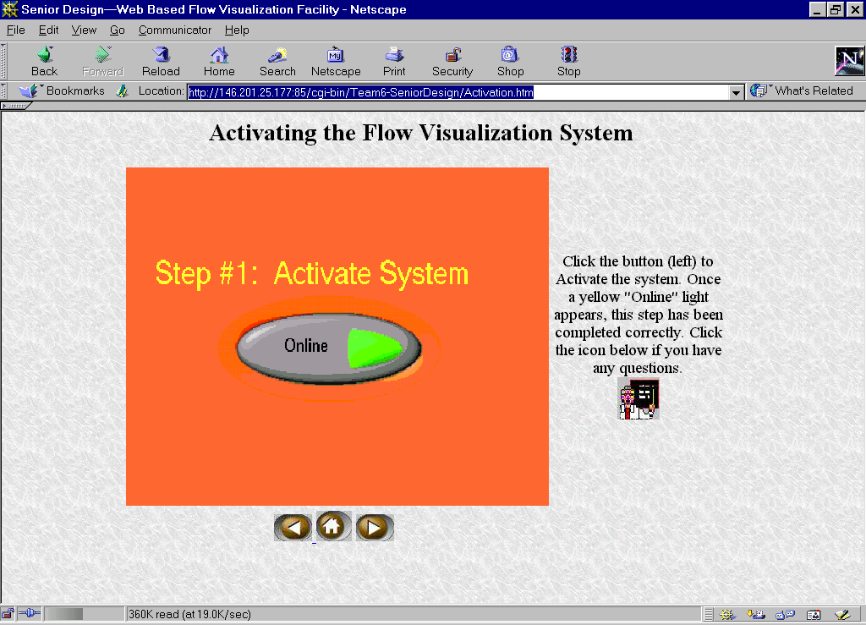
APPENDIX G: Web Page Pictures

Figure F1: Picture of the Activation window from the web browser.

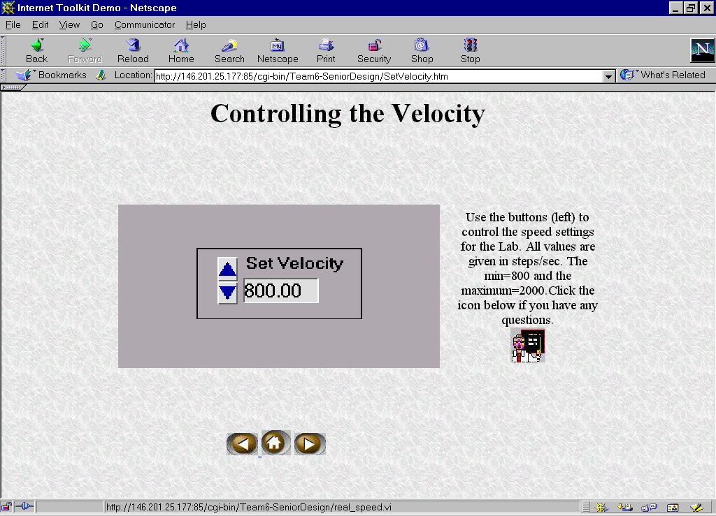
Figure F2: Picture of the set velocity window from the web browser.
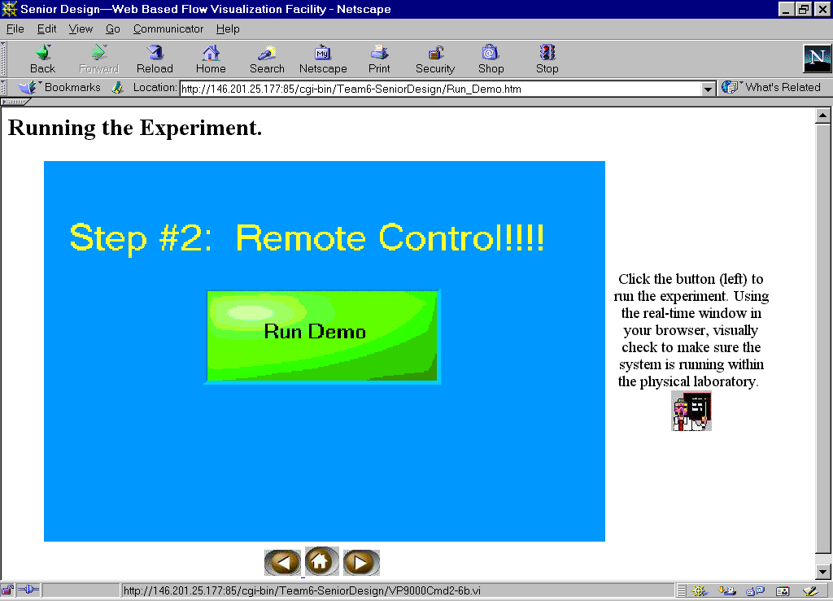
Figure F3: Run demo window.

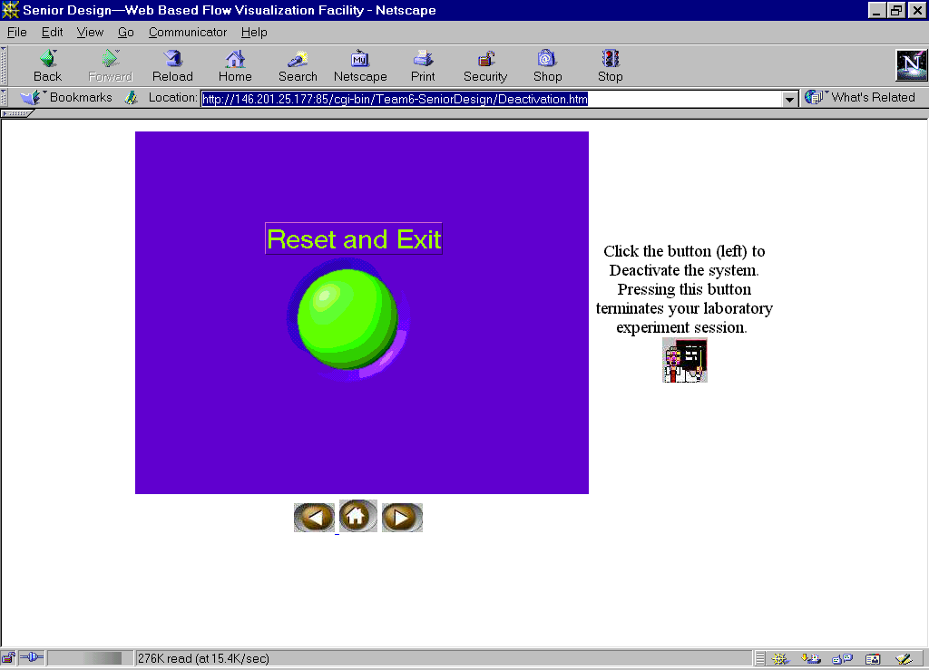
Figure F4: Deactivation window from the web browser.

References

1. Barry Hyman, "Fundamentals of Engineering Design," Prentice-Hall, 1998.

2. National Instruments Corporation, BridgeVIEW and LabVIEW: Internet Developer Toolkit for G Reference Manual, 1998.

3. Credle, S. S., K. A. Davis, and J. W. Scott, “Web-Based Flow Visualization Facility (WBFVF): Operation s Manual”, College of Engineering, Tallahassee, 2001.

4. Velmex Incorporated. “VP9000 Series Stepping Motor Controllers User’s Guide,” New York, 1996.

