VirtuLab: Web-Based Flow Visualization Facility
Final Design Report

Written By:

Justin W. Scott

Sydni S. Credle
Karen A. Davis

EML 4551-Senior Design
November 30, 2000

Table of Contents

Introduction……………………………………………………………………………..2

Specifications……………………………………………………………………………5

Work Breakdown Structure (WBS)………………………………………..15

Scheduling……………………………………………………………………………...17

Web Development………………………………………………………………..…20

LabVIEW ..……………………………………………………………………………..24

Conclusion .…………………………………………………………..………………..27

Appendices
A: NI Days………………………………….…………………………………………..28

B: Meeting Notes…………………………………………………………………….32

C: Camera Mount Specifications ……………..……………………………38
D: E-mails…………………………………………….…………………………………40
E: LabVIEW Virtual Instruments………………..………………………….56

Introduction

Client Statement: Design and build a towing tank facility and the associated imaging processing system capable of providing visualization-enhanced information to supplement the teaching of fluid mechanics. The facility should have computer-interfaced instrument control function and can be operated remotely via the Internet. This unique feature can increase students’ accessibility and provide distance learning capability.

Background
The teaching of fluid mechanics is often difficult because students are unable to visualize the complexities of the theory being taught. There is a necessity to find a link between theory and reality. It has been found that experimentation facilitates complete comprehension on the part of the students.

Design Project
Based on the overall goal is to successfully design a water-towing tank that will enable students to analyze flow of water over various objects. The water-towing tank consists of an object suspended and able to be pulled at a constant rate while being imaged. A partially functional system has been designed and fabricated already. After a full understanding of the client statement, the system will first be designed on paper. A comparison will then be performed between this paper-based model and the existing system. From this comparison, necessary modifications will be made. In the final stages of the experiment, the flow visualization facility will be made available for distance learning usage. Students will be able to remotely access and control real laboratory instruments, thus conducting actual experiments through a computer network and ultimately enhancing their grasp of the subject at hand.
This project involves pragmatic application of previously learned topics within the mechanical design process as well as the learning and full understanding of the components required in making the system remotely available.
Concurrent to the design process, a methodology as to how to configure instruments and data analysis remotely via software will be explored and implemented. The system will be based on LabVIEW coupled with other Internet programming techniques. Ideally, the remote laboratory system will take user commands, relay them to LabVIEW which would in turn control the real instruments in the laboratory, as shown in Figure 1 below.

Client

Client

Client

LabVIEW Internet Connectivity Tool set

Internet

Figure 1: Schematic diagram illustrating basic setup of web-based flow visualization system.

Personal
Computer
Motor Controller

Flow Visualization Facility
Visualization
Camera
WebCam
For Lab Video Image streaming

Below are listed the mechanical and computer aspects that need to be analyzed, modeled, and fabricated:

Mechanical Design Aspects
- Design mobile camera mounts
- Design synchronous linkage for laser/ optical platform
- Investigate and modify all necessary existing specifications:
- Motors
- Linear bearing system
- Gear analysis
- Loading Calculation
- Material Selection and Design
- Design plumbing system
- Successfully design and set up video recording system for the remote monitoring purpose

Computer-Related Aspects
- Remote instrument control via the Internet using LabVIEW programming
- Video studio design for the direct lab imaging recording
- Direct video and data streaming via the Internet using teleconference software
- Interface the physical laboratory with the Internet to create a virtual laboratory

Specifications

The initial phases of the design process are Concept Development and Specifications which involves identifying the customer’s needs, gathering information on competition and exploring possible alternatives, concept generation and selection, and defining the form and function of the project. Completions of these tasks are managed through research as well as the conducting of detailed information gathering sessions with the customer/client. It is important in these foundational steps to translate customer wants, which have little to no technical basis, into tangible engineering processes and sub-systems. The specifications will be broken down into five different subsystems; performance specifications/customer requirements, design specifications, engineering requirements, and design and performance parameters. The following is a design specification report of the Web-Based Flow Visualization Facility.

Performance Specifications/Customer Requirements
This area is dedicated to list the expectations for the performance of the design. The main objectives that were named by the client were remote control accessibility, live video streaming from the web page, a choice for velocity variation, use of LabVIEW programming, and low vibrations from the system.

Design Specifications

The design specifications will provide a detailed description of the completed design. Figure 2 shows the actual picture of the flow visualization facility.

Motor
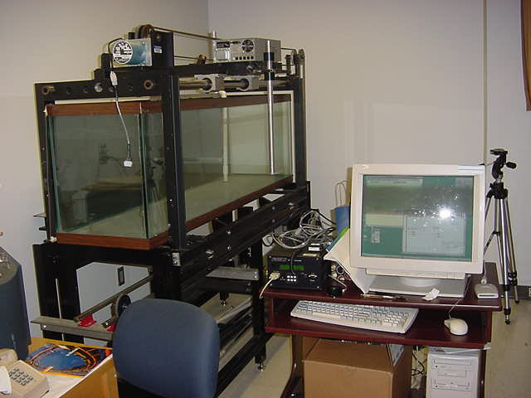
Camera mount location

Towing Tank

Web Cam Location

Motor Controller

Figure 2: Picture of the existing system.

Camera Mount Design

The first sub-design in the flow visualization design project was to design a camera mount that could be attached to the existing platform on the towing tank. The needs for the camera mount are listed as follows:

- Capable of forward/ backward movement
- Capable of left/ right movement
- Easy fabrication
- Cost efficient
- Locking mechanism
- Very strong (to support camera and lens attachment)
- Easy to use
- Lightweight

From these needs, ideas were developed and decided upon by placing the various ideas for the required functions into a morphological chart. Each component was then evaluated in order to choose a final design (morphological chart and evaluation data appear in Appendix C). This final design is shown in Figure 3 and 4.
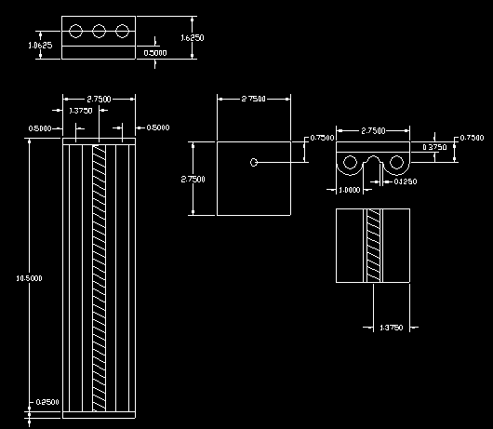
Figure 3: Detailed drawing of the top slider of the camera mount.

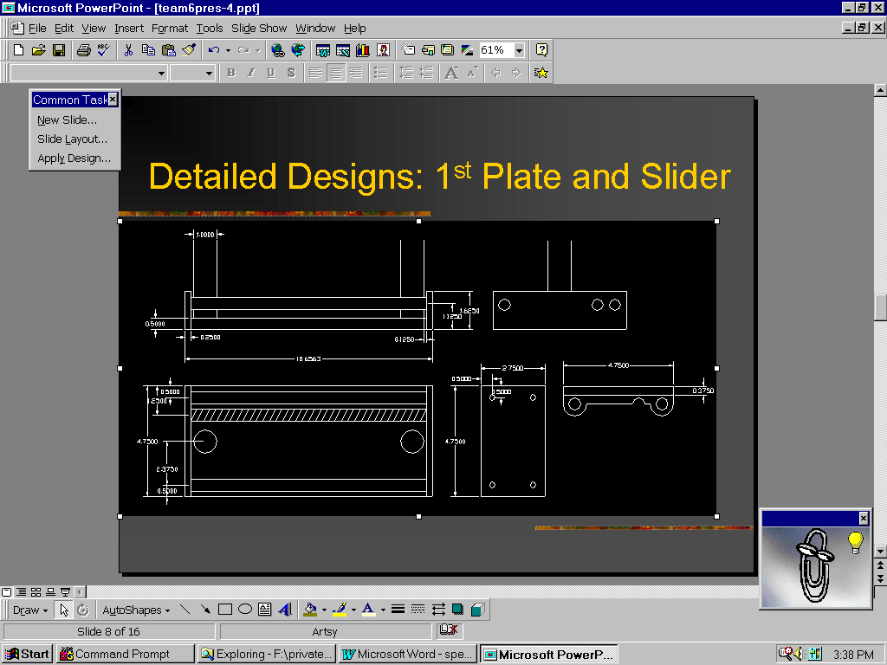Figure 4: Detailed drawing of the bottom slider of the camera mount.
Engineering Requirements

This section reveals the design and performance parameters that can contribute to achieving the customer requirements. After clarifying the client’s problem statement, the group initially started by evaluating the existing system and measuring and recording all the needed dimensions. The client then defined the desired functions for the camera mount. Research was performed to understand the capabilities of the LabVIEW program and the web camera. Once the software and hardware were ordered, independent research among group members, as well as networking with knowledgeable experts were performed to become proficient in all of the equipment.

Design Parameters
The client’s main concern for the function of the camera mount, was to ensure that the camera and the object were in synch with each other for accurate data acquisition. Also, the camera should be able to be adjusted to capture various points of the flow. For these reasons, a threaded track was chosen to allow fine adjustment. If in the future the client would like the camera mount to be remote controlled, the threaded tracks would also be fairly simple to add a motor onto.

Performance Parameters
Specifications are not only for the direct effects that an engineer may need to take into account, but also the indirect functions that may help prevent user confusion or accidents. For this project, an emergency stop and automatic reset will be implemented incase of a power outage or unexpected disconnection. This will help prevent any chance for the object to hit the sides of the tank. Next, the user will only be given a range of velocity (such as slow, medium, and fast) in order to reduce confusion and prevent hazards. Finally, there will be logins, passwords, and restricted files for security reasons.

Design Objectives
Based on an assessment of the client’s needs, a composite list of design objectives was compiled. Table 1 illustrates these needs along with evaluation numbers that designate the weight of importance placed on each item. The highest ranking an item could receive was a value of 10, while the lowest was a value of 1. The criteria for ranking came directly from client interaction.

Table 1. Composite List of Design Specifications.
Wishes of Demands (W/D) | Specifications | Importance (scale from 1-10)
D | Computer Interfaced Instrument Control | 10
D | Remote Operation via the Internet | 10
D | Direct Video and Data Streaming via Internet | 10
D | Low Vibrations | 10
D | Transparent Imaging Window | 10
D | Constant Object Velocity | 9
D | Synchronized Elements | 10
D | Easy Control of Motor | 9
D | Design of System Web Page | 7
W | Inexpensive | 8
W | Durable | 8
W | Safe for Human | 8
W | Doesn't Rust | 7
W | Easy to Use | 9
W | Pleasing to the Eye | 5
W | Long Life Expectancy | 6
W | Low Noise Output | 5
W | Speed Flexibility | 8
W | High Quality | 8
W | Splash Proof | 8
W | Stand Alone Physical Unit | 7
W | Easy Cleaning | 5
W | Starts Immediately | 8
W | No sharp Corners | 5
W | Stops Easily and Immediately | 8
W | High Material Strength | 6
W | Easy experiment Reset Control | 8
W | Shock Absorption | 5
W | Easy to Repair | 5
W | Low to no Contamination | 9
W | Safe for Environment | 6
System Function Breakdown

Reservoir
In order to model the flow of a fluid over a cylindrical tube, there must be a holding tank for the chosen fluid. There were various options, but the most ideal was a tank.

Support
A support had to be designed to not only place the tank at an acceptable vantagepoint, but also had to be extremely durable and strong.

Medium
A fluid, in which the object will be pulled through, must be chosen in order to model the properties of flow around the cylinder.

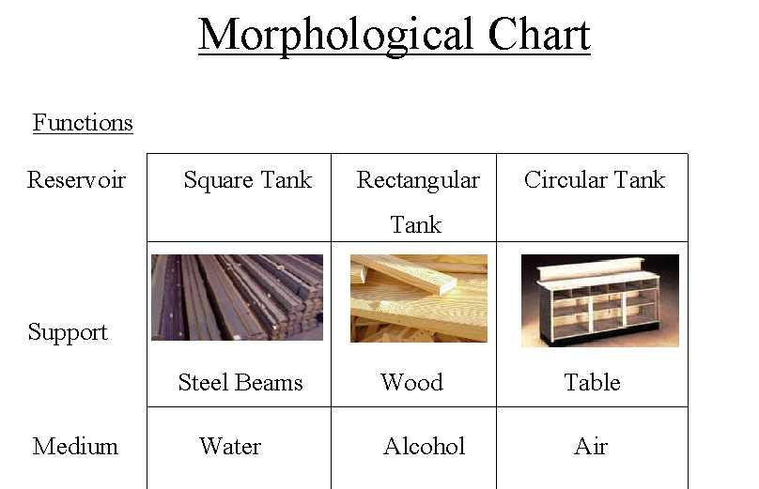
Figure 5: The morphological chart, which shows the concept options for the various functions.

Fluid Transfer
Once the fluid has been poured into the tank, there must be a way to also remove the fluid.

Synchronization/ Particle Tracking
The entire tanking system should have a timing element that will allow the camera and the cylinder to move at the same velocity and also remain in the same general area.

Figure 6: Morphological chart for flow visualization system.

Controls
Finally, to make the experiment remote accessed, a program is needed to control the motor. It is also necessary to place limitations on parameters (location and velocity of cylinder).

Illumination

This function provides the means for visual observation of the flow around the cylinder. Particles that have negligible effects upon the flow are dropped into the medium. The light source then illuminates the particles within the flow.

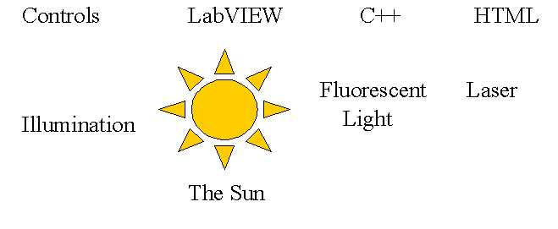

Figure 7: Morphological chart for flow visualization system.

Related Project
VLAB, a pilot web-based virtual laboratory on an oscilloscope experiment has been developed and launched for over 1000 first year undergraduate engineering students in the Faculty of Engineering in NUS (National University of Singapore). Rather than simulating the oscilloscope display on the client as is often done in other virtual laboratories, the system uses real-time video capture of the actual oscilloscope’s display. In addition, the use of the mouse to turn the control buttons and knobs of the instrument has been implemented do that a more realistic feel of the instrument is provided. Since its launch, VLAB has in general received positive feedback from numerous users and can be accessed from http://vlab.ee.nus.edu.sg/vlab

Closing
With design objectives clear and distinct, the next phase in our progression is System Architecture Refinement. This involves configuration analysis of processes and sub-processes as well as interfaces that are contained within the project. The nuances of the project will reveal itself as separate tasks that can be assigned and delegated for completion in the form of a Work Breakdown Structure (WBS). The WBS is critical in that it provides a figurative “roadmap” toward completion.

Work Breakdown Structure (WBS)

Within the project management cycle, extensive planning, scheduling and controlling takes place providing a “road map” to the completion of tasks from the onset of the project to the day of delivery. Planning is an integral part of the engineering design process in that it provides the answer to the ‘how’ question of undertaking a design activity.¹ Two key elements of the project management plan are the Work Breakdown Structure (WBS) and the Project Schedule.
The purpose of the WBS is to clearly state how each task is related to the whole project in terms of variables such as budget, schedule, performance, and responsibility. Through this, the project is partitioned into distinct work packages that can be tracked continuously for status at any time. The WBS should include the following³:

- Each project task as an element big enough to be identified and assigned to individual members of the team.
- Each task defined clearly and concisely.
- Each task described in such a way that comparison and analysis can be made in terms of such things as money, labor, and/or resources.

Figure 1 shows an illustration of the work breakdown structure for the Web-Based Flow Visualization Facility (WBFVF) Project. Using the tree diagram method, the tasks needed for completion have been listed according to the functional areas of organization within the experiment.² The functional areas are listed again for completeness below:

- Understand Customer Requirements
- Web Camera
- Camera Mount
- LabVIEW
- Motor Controller
- Teleconference
- Simulation/Testing
- Project Management Activities

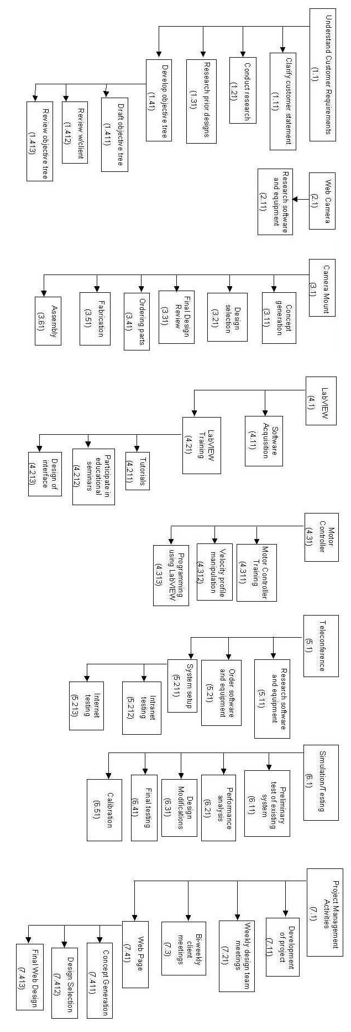
Figure 8: Illustration of work break down structure (WBS) for the Web-Based Flow Visualization Facility (WBFVF).

Scheduling: The Gantt Chart

Developing a schedule for a project involves deciding when each task and subtask listed within the WBS should begin and how long it should last. Ultimately, the process translates the list of project tasks into a timetable illustrating events along with respective completion dates.³
For the current WBFVF project, a Gantt chart was used to provide this visual representation of the relationships between the different pieces within the project. The Gantt chart is a bar chart that plots work activities against a time line.³ As seen in Figure 9, the project activities are listed on the vertical axis while the chronological time scale (in weeks) along the horizontal axis displays the schedule and duration for each task.¹ The solid lines show an activity’s duration in time. It should be noted that the project activities in the Gantt Chart can be found on the top tier of the WBS.
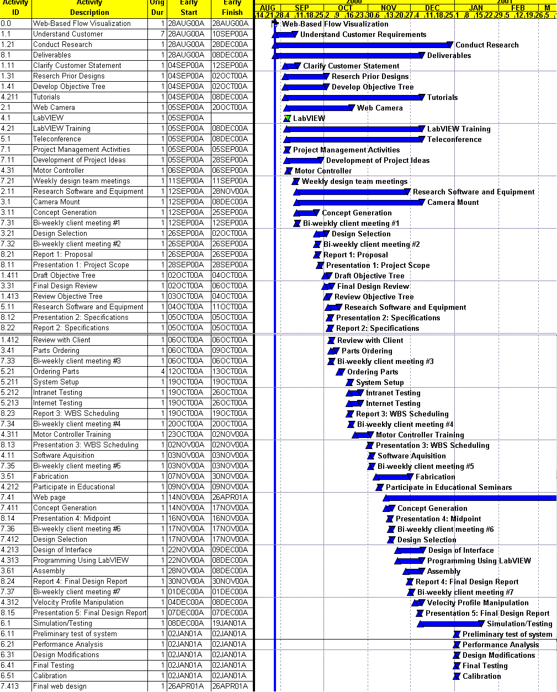
Figure 9: Gantt chart used for scheduling

Table 2: Division of Responsibilities
Tasks | Justin | Karen | Sydni
Understanding Customer Statement | X | X | X
Conduct Research | X | X | X
Research Prior Designs | X | X | X
Develop Objective Tree | X | X | X
Web Camera Research | X |  | X
Camera Mount Concept Generation | X | X | X
Camera Mount Design Selection | X | X | X
Camera Mount Design Drawings | X
Camera Mount Final Design Review | X
LabVIEW Research | X | X | X
LabVIEW Software Ordering |  | X | X
LabVIEW Programming |  |  | X
LabVIEW Motor Control | X | X | X
LabVIEW Educational Seminar |  | X | X
LabVIEW Tutorials | X | X | X
Teleconference Research | X | X | X
Teleconference System Setup | X | X | X
Teleconference Intranet Testing | X | X | X
Teleconference Internet Testing | X | X | X
Existing System Modifications | X | X | X
Weekly Design Team Meetings | X | X | X
Bi-weekly Client Meetings | X | X | X
Web Page Concepts | X
Web Page Design Selection | X
Web Page Live Video Research | X
Web Page Live Video Setup | X
Reports | X | X | X

Closing
The benefits of planning become clear when working with complex design projects that involve many people and extend over a long period of time. By making a management plan, large, complicated projects get divided into a series of smaller, manageable tasks that help to give the project a definite structure as well as keep the amount of time and effort wasted to a minimal.
Additionally, systematic planning provides a framework for communicating with clients, helps to allocate resources, and serves as a benchmark to measure progress during the project.¹ With the basic tools of the WBS and the schedule as presented in this report, the Web-Based Flow Visualization Facility proves to be one step closer to an efficient finish. These documents will be revisited in the future and gradually, expanded versions of these planning materials will be made to include variables mentioned before of materials, labor, and cost.³

VirtuLab Web Development

One of the main focuses of the virtual laboratory design project is the web development. Since the objective of the project is to be able to control the flow visualization experiment through the internet, it is essential to create user friendly web pages that will allow the student users to quickly understand and complete the required laboratory. Starting early next semester, the complete background information and necessary lab instructions will be created. Presently, the primary concern of the web design consists of setting up the live video streaming into the web page. The current program used to perform this task is Microsoft NetMeeting©, which is popular video conferencing shareware.
NetMeeting is a powerful tool that allows real-time communication and collaboration over the Internet or corporate Intranet. From a computer running the Windows 95, Windows 98, Windows NT® 4.0, or Windows 2000 operating system, users can communicate over a network with real-time voice and video technology. Users can work together on virtually any Windows-based program, exchange or mark up graphics on an electronic whiteboard, transfer files, or use the text-based Chat program. For this laboratory experiment, the only feature needed from NetMeeting is the video capabilities for use on the web page. Since NetMeeting is usually controlled in its own window (without the use of a web browser), the NetMeeting ActiveX Control must be implemented.
The NetMeeting ActiveX control enables integration of NetMeeting conferencing capabilities into Web pages. Web pages can be created with NetMeeting conferencing support using scripting languages, such as JScript® or VBScript. Then, users can place a call to the laboratory and access the video from the Web page. The ActiveX control resides in the same binary as NetMeeting, and laboratory users with NetMeeting 3 or later already have the ActiveX control installed on their computer. To access ActiveX conferencing on Web pages, users must have a browser that supports ActiveX controls, such as Microsoft Internet Explorer.

Figure 10: The computer used to stream the live video onto the Internet and control the experiment using LabVIEW.

When the ActiveX control is embedded into the source code of a Web page, the result is the shown below in Figure 11:
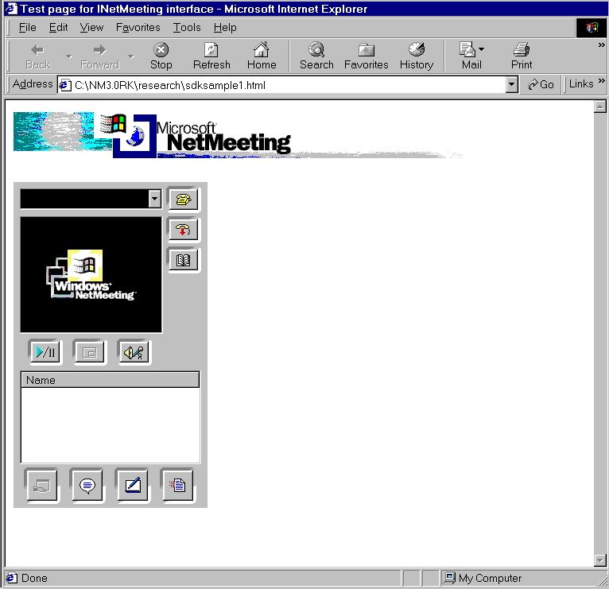
Figure 11: Sample of Web page with NetMeeting
The NetMeeting window above can also be edited so that the controls not needed, such as the chat or user name window, will not appear. From this web page, the user has control of all of the functions of NetMeeting. The Web page design is then separated into 2 different frames and edited to the fit the experiment’s needs. This allows the user to view the video of the experiment on the left side while linking to any other Web page in the right. The right side is where the actual experiment controls, procedure, and background information is found. This is illustrated below in Figure 12:

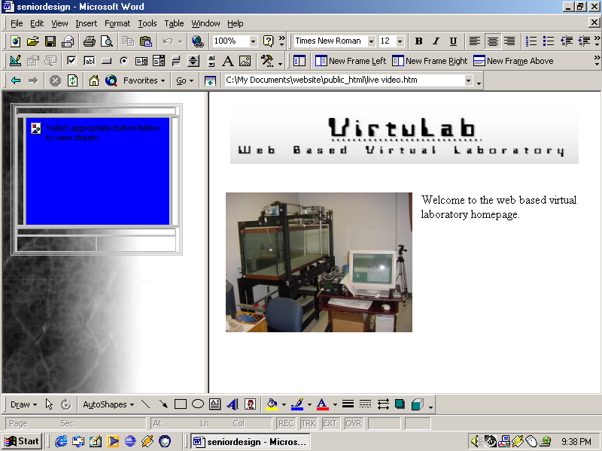

Figure 12: Sample Web page with NetMeeting and frames.

Video Quality
Since the experiment only calls for video data streaming through the internet, the speed of the data transfer, or bit rate, will be much faster as compared to the use of video, audio, and file transfer at the same time. This is because NetMeeting is configured so that video is the lowest priority, but when there is no audio, file transfer, etc., then the video becomes the first priority.
NetMeeting is configured with the typical bandwidths available on four different network types:
• 14.4 kilobits per second (Kbps) modem
• 28.8 Kbps or faster modem
• Cable, xDSL, or Integrated Services Digital Network (ISDN)
- Local area network (LAN)
When the user logs on to the VirtuLab Web page, they will be asked what type of Internet connection they are using. This ensures that video will be produced the most efficient for the speed of the Internet connection.

Recently, a better software solution was reached because NetMeeting will create setup problems within the FAMU/FSU College of Engineering network. The new software that will be implemented is Real Media through Real Server. This software is already configured on the COE network and only requires a small amount of input to set up in the experiment laboratory.
To get the live video running, a software program (not known yet) will be installed on the computer in the flow visualization laboratory. This software will stream the video data onto the COE servers. The Web page will be created in an engineering account on the COE network. By inserting a single line of code into the Web page source code, the streaming video will be linked into the Web page for control and viewing. The scheduled time of the video setup will take place is 12/04/00-12/08/00.
LabVIEW

LabVIEW, short for Laboratory Virtual Instrument Engineering Workbench, is a programming environment in which one can create programs with graphics. Other programming languages such as C++, Pascal, and Basic all use text in order to program while LabVIEW uses a graphical language called G. LabVIEW works on PCs running Microsoft Windows, Mac OS, Sun SPARCstations, and HP 9000/700 series workstations running HP-UX. (Wells 3)

G programming involves creating pictorial programs called block diagrams, thus eliminating a lot of the syntax involved with other formats. Together, Figures 13 and 14 show one of the basic programs called InitSerp.vi, which is used to initialize the Velmex VP9000 Series motor controller within the flow visualization system. The “.vi” (pronounced “vee eye”) suffix of the call name stands for ‘virtual instrument’ because their appearance and operation imitates actual instruments.

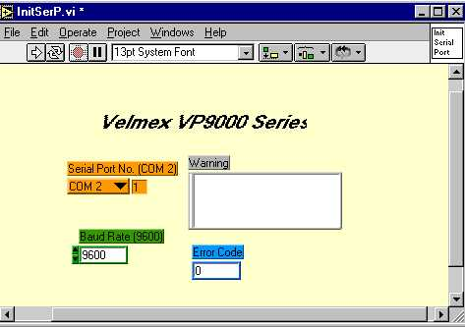
Figure 13: Front panel display of an example VI named InitSerp.vi.

The three main parts of a VI are the front panel, the block diagram, and the “sub-vi”. Figure A shows a an example front panel which serves as the user interface to controlling a physical instrument. (In this case, the Velmex VP9000 motor controller) Users can input data using the mouse and the keyboard as well as view results such as error warnings on the same screen. A main goal is to directly simulate the front panel of the instrument using knob, buttons, graphs, and various other controls. (Wells 6)

Figure B shows the actual source code behind the making of the front panel called the block diagram. The block diagram is composed of lower-level VIs, built-in functions, constants, and program execution control structures. The wires shown in the figure are indicators of the flow of data between the different components.

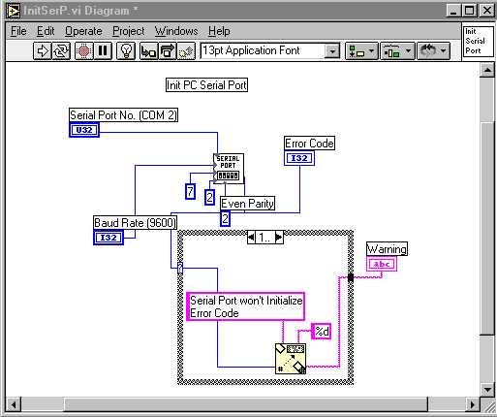
Figure 14: Block Diagram of a example VI showing the components of the InitSerp.vi program and the components linked with wires indicating the flow of information.

An icon and a connector can represent each individual VI. The representative components that can be used in a separate LabVIEW program. Any VI that is used within another VI is called a sub-VI. When a VI is used as a sub-VI, the connector is the mechanism used to wire data into it. The icon is used as an object in the block diagram of another VI.

A major reason for choosing LabVIEW for the automation of control for the WBFVF project is its ease of use as well as its connectivity. LabVIEW has built in functions that simplify communication over a network. Communication VIs allow for use of programs in networked applications using TCP/IP which has the following advantages over other protocols:

- Connection of computers from multiple platforms (Windows, Mac, Sun, HP).
- Communication with multiple computers simultaneously.
- Great geographical distances can separate networks.

These advantages can facilitate a situation where a person at the FAMU-FSU College of Engineering can have a VI running on a PC passing results to an analysis VI in Miami on a Power Macintosh, while someone observes the whole process in real time on a Sun machine in Holland.

Steps are being taken to harness the capabilities of LabVIEW to apply them to WBFVF project needs.

Conclusion

Fundamental design issues that clarify the objectives and goals of the project were completed early on in the semester. Specifications of the system as well as an in depth schedule based on the Work Breakdown Structure (WBS) promoted the efficiency of the team members and thus guiding the project to success.
The designing and machining of the camera mount was priority this semester because simulation and testing of the entire system could not be carried out until it was completed. Time and effort was spent researching different avenues of completing this task until a final design was approved by the team for fabrication.
Currently, all materials and components needed for completion have been ordered. The fabrications of components for the camera mount have been requisitioned and are scheduled for delivery in early January of next year at the latest. Upon delivery, the flow visualization system will be configured and a full simulation will be held followed by an intense period of performance analysis. Modifications to the design and/or the configuration to optimal settings is set to take place after the initial simulation. Subsequent testing and changes are to be completed within the calibration phase.
Concurrent to the design of the camera mount, the LabVIEW control aspects of the system were explored. Team members now have an extensive working knowledge of the software and its capabilities and are presently working to programmatically integrate the specific needs of the flow visualization system using LabVIEW. Team members also carried out training with the motor controller. The first step in learning to manipulate the motor controller entailed front panel programming. Basic functions such as speed, distance traveled, as well as looping functions were learned. Secondly, this knowledge was incorporated with LabVIEW and it is now possible to control the motor through the software.
Falling in line with the objective of the project, the interactive portion of the experiment via the web has been researched and developed as well. In developing the user interface, the major concern for team has been the "how" of the matter. Special care had to be made to allow for the learning curve when dealing with computer related issues that take members of the team out of their strictly mechanical comfort zones.

Appendix A: NI Days



NIDays 2000 Agenda
15 Sessions

- Introduction to Real-Time Control
- Check Out the New Version of LabVIEW
- LabVIEW Programming Techniques: The Good, the Bad and the Ugly
- Introduction to Measurement Studio
- Tackling High-Channel Count Applications in LabVIEW
- Steps for Success with Vision
- Designing Motion Control Systems
- Measuring Strain and Displacement Accurately
- Building a Network-Based Data Logger
- Creating Parallel Test Systems for Faster Test Throughput
- Architecting Production Test Systems
- Distributed Measurement Systems
- Computer-based Vibration Measurement for Machine Condition Monitoring
- The Basics of Making Frequency Domain Measurements
- Monitoring and Control over the Web

Introduction to Real-Time Control
Control system designers increasingly utilize industry standard computing technologies to reduce development time and improve the connectivity and integration of their solutions. Learn about real-time and embedded control development, plus see a working example using LabVIEW RT and modular ruggedized real-time hardware.

Check Out the New Version of LabVIEW
If you currently use LabVIEW 5.0 or 5.1, attend this course to learn about the latest features in the newest LabVIEW release. The instructor will walk you through each of the new features and explain how to take advantage of them in your applications.

LabVIEW Programming Techniques: The Good, the Bad and the Ugly
Do you want to become a better LabVIEW programmer? This session is filled with useful tips and techniques for optimizing your LabVIEW development. Learn from real-world examples as LabVIEW developers describe better programming techniques based on their analysis of previously submitted user applications.

Introduction to Measurement Studio
Learn how to use Measurement Studio to ease the development of measurement and automation applications using standard text-based programming languages such as Microsoft Visual C++ and Visual Basic and LabWindows/CVI. Gets some hands-on instruction on how to use the new powerful programming tools to make you more productive and find out how much easier they make your development.

Tackling High-Channel Count Applications in LabVIEW
An application with a small number of channels can be easily developed by programming the data acquisition on a channel-by-channel basis, but what about having an application with a large number of channels to manage? National Instruments provides tools that can help increase your productivity. This session will outline the benefits of using LabVIEW and its add-on tools for data management, alarm configuration, and historical logging, for developing large channel count and distributed systems efficiently.

Steps for Success with Vision
This session is a step-by-step formula for new developers of industrial machine applications. Learn about camera selection, illumination techniques, image acquisition, and triggering techniques for quality assurance and inspection applications.

Designing Motion Control Systems
This mini course provides a comprehensive, practical approach to designing your motion control system from the ground up. Starting with a simple description of motion requirements, learn step-by-step how to select all necessary components including motion controller, power drive, motor, power transmission, and fixture. During the hands-on portion of this session you will use what you have learned to implement a simple motion system using National Instruments hardware and software. No prior motion control knowledge or programming experience required.

Measuring Strain and Displacement Accurately
During the first half of this session, you will learn how to accurately perform strain measurements. Learn about the role and benefits of various strain measurement technologies including bridge completion, shunt calibration, remote sensing, ratiometric compensation, temperature compensation, and offset nulling through hardware compensation. The second half of this session covers advanced position measurement technologies. Come learn when and how to use position measurement sensors like Linear-Variable Differential Transformers (LVDTs) or Rotational Variable Differential Transformers (RVDTs).

Building a Network-Based Data Logger
National Instruments data acquisition hardware and LabVIEW software, form an ideal combination for building a customizable system that acquires data and logs the data to disk. In this session you will learn the fundamental components required to acquire and log data to disk. Build a computer-based datalogger and then choose the hardware platform that best suits your application.

Creating Parallel Test Systems for Faster Test Throughput
Increasingly, automated test systems are using multi-head testers that test products in parallel to meet the throughput requirements of high-volume production lines. Learn how to use National Instruments software to architect a high-performance, maintainable multi-head test system that maximizes performance and hardware utilization. Techniques discussed will include multithreading, test synchronization, and sharing of hardware resources.

Architecting Production Test Systems
Choosing the right test platform is essential when developing production test systems. This session reviews the basics of PXI, computer based instrumentation, switching and fixturing. We explore different system configurations, methods of optimizing timing and synchronization between different instruments and present examples of hybrid systems - showing you how to integrate PXI, with VXI and GPIB based instruments. Finally we present test software solutions to improve your test performance. Includes: Instrumentation, Switching, Fixturing; System configuration (MXI-3); Timing; Software; Hybrid Systems.

Distributed Measurement Systems
Advances in networking technologies are continuously changing not only the way we do business, but also the way we set up our measurement systems. Distributed Measurement Systems address factors such as size, distance, environmental conditions, and sharing and controlling equipment in different locations. In this session you will learn how to take distributed measurements, as well as the basics of putting together a distributed measurement and control system.

Computer-based Vibration Measurement for Machine Condition Monitoring
Machine condition monitoring involves acquisition and analysis of vibration and other signals to check the condition of machinery and predict imminent failures. By continuously monitoring industrial equipment, you can reduce downtime and avoid catastrophic problems. With the PC and low-cost measurement hardware and software, the technique has evolved from something that was only appropriate for the most expensive and critical equipment to something that you can apply in a more general sense. This session will review some fundamentals of machine condition monitoring and discuss how you can apply National Instruments products for acquisition and analysis of vibration signals for the job.

The Basics of Making Frequency Domain Measurements
When performing frequency domain measurements, there are several things to consider in order to ensure that your measurement provides the accurate information that you need. This presentation will teach you the basic components of a measurement system and various frequency analysis methods that are primarily used in the fields of sound and vibration analysis. We begin by presenting the various signal conditioning considerations for capturing time domain waveforms for later frequency analysis including the sampling theorem, A/D technologies, spectral leakage, and smoothing windows. We then discuss three different methods of frequency analysis: FFT analysis, octave analysis, and swept sine analysis. The different advantages of these methods are discussed as well as how your application determines which method will be used.

Monitoring and Control over the Web
Learn how you can leverage the power of the web to monitor and control applications ranging from laboratory environments to industrial applications. This session covers LabVIEW and Lookout Internet technologies on how you can transform your application into a web based one.

Appendix B: Meeting Notes

1ST Meeting with Advisor/Client--Dr. Shih

Topics to be discussed:
1. Preliminary Imaging Camera Mount Design
2. Web Cam
3. Generation of Action Items List
4. Rescheduling of official bi-weekly meeting time

WEb based flow visualization facility
Client/Advisor Meeting with Dr. Shih

meeting Notes (9/12/00)
- Rescheduling of bi-weekly meeting to Friday at 2:00pm
-9/22/00 (Meeting cancelled due to hurricane Helene)
- Camera Mount
-Introduction of preliminary design for approval
-Referred to Bill Kincannon for fabrication
-Need: Tank measurements for final design
- Web Cam
-Favorable Model: VC-C3, by Canon
>Request demo software and pricing information
-Referred to Mike Conroy (3rd floor computer support team)
- LabVIEW
-Enterprise Connectivity Toolkit ($646.75)

New agenda items
F. Towing Tank Simulation
- Teleconference Challenge

WEb based flow visualization facility
Client/Advisor Meeting with Dr. Shih

meeting Notes (9/26/00)
- Camera Mount
-Introduction of preliminary design for approval
-Referred to Bill Kincannon for fabrication
-Need: Tank measurements for final design
- Web Cam
-Favorable Model: VC-C3, by Canon
>Request demo software and pricing information
-Referred to Mike Conroy (3rd floor computer support team)
- LabVIEW
-Enterprise Connectivity Toolkit ($646.75)

New agenda items
F. Camera Mount Update
G. Teleconference Update
H. Motor Controller Update
I. VC-C3 Web Cam Update

WEb based flow visualization facility
Client/Advisor Meeting with Dr. Shih

meeting Notes (10/6/00)
- Camera Mount
-Final design chosen for fabrication
-Need final designs to give to Bill Kincannon
- Web Cam
-Favorable Model: VC-C3, by Canon
-Pricing and contact information given to Dr. Shih
- LabVIEW
-Confirmation of ordering status.
-Need more time learning the software
- Teleconference
-Need to set up web conference facility
-Analyze Internet/Intranet connections

New agenda items
- Teleconference Update.
- VC-C3 Web Cam Update.
- LabVIEW attempts and frustrations.
- Work Breakdown Structure (WBS) and Scheduling

WEb based flow visualization facility
Client/Advisor Meeting with Dr. Shih

meeting Notes (10/20/00)
- Camera Mount
-Final parts ordered
-Fabrication to be completed by 11/20/00
- LabVIEW
-Ordering status (should be here today).
-Need more time learning the software
- Teleconference
-Analyze Internet/Intranet connections
-Research capabilities (Dr. VanDommelen )

New agenda items (11/3/00)
- Teleconference Update.
- Motor Controller.
- LabVIEW Update.

WEb based flow visualization facility
Client/Advisor Meeting with Dr. Shih

meeting Notes (11/3/00)
- Camera Mount
-Final parts ordered
-Fabrication to be completed by 11/20/00
- LabVIEW
-Ordering status (should be here today).
-Need more time learning the software
- Teleconference
-Analyze Internet/Intranet connections
-Research capabilities (Dr. VanDommelen )

New agenda items (11/17/00)
- Teleconference Update.
- Motor Controller.
- LabVIEW Update.

WEb based flow visualization facility
Client/Advisor Meeting with Dr. Shih

meeting Notes (11/17/00)
- LabVIEW
-Received shipment of LabVIEW software and toolkits
-Need to load onto the computer
-Need: Representatives to attend NI Days Conference (Orlando, Fl - 11/9/00)
- Dr. Van Dommelen Meeting (Summary)
-Embedding of the source code for various web page components
-Demo of “Sharing” a workspace between two different users using NetMeeting and RealMedia/Windows Media
-Security issues and concerns
C. Motor Controller
-Clarification of profile loop constraints
-Need to modify user interface (front panel)

New agenda items (12/1/00)
D. Motor Controller programming scripts
E. LabVIEW Upgrade
-Version 6.i has been sent out today
-Shipment to be received by 11/21/00
-Maintenance Software?
- National Instruments “NI Days” LabVIEW Conference
- Web Page
-Preliminary design (http://www.eng.fsu.edu/~jwscott/seniordesign.htm)
-iVista software
H. NetMeeting
-Exploring capabilities
-Trying to rectify problems with video streaming
Appendix C: Camera Mount Specifications

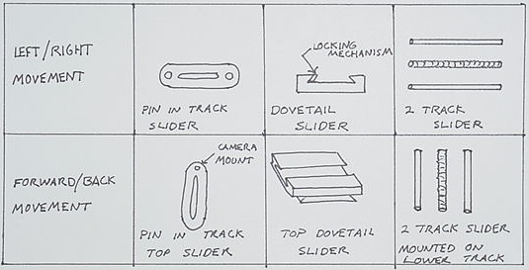

Figure 1: Morphological chart illustrating the three concepts for camera movement.

The morphological chart shows a pin in track slider, a dovetail slider, and a two track slider that controls movement with a threaded rod. These design options need to be evaluated for customer and engineering needs before a final concept is selected.

Table 1: Specification Table for Camera Mount Design
Specifications | Pin/Slider | Dovetail | 2 Track
Easily Manufactured | + | -- | +
Cost efficient | + | -- | +
Lightweight | + | -- | --
Easily used | -- | + | +
Capable of supporting camera | -- | + | +
Appearance uniform with equipment | -- | -- | +
Locking mechanism included | -- | + | +
Long lasting | -- | + | +
Total | 3 | 4 | 7

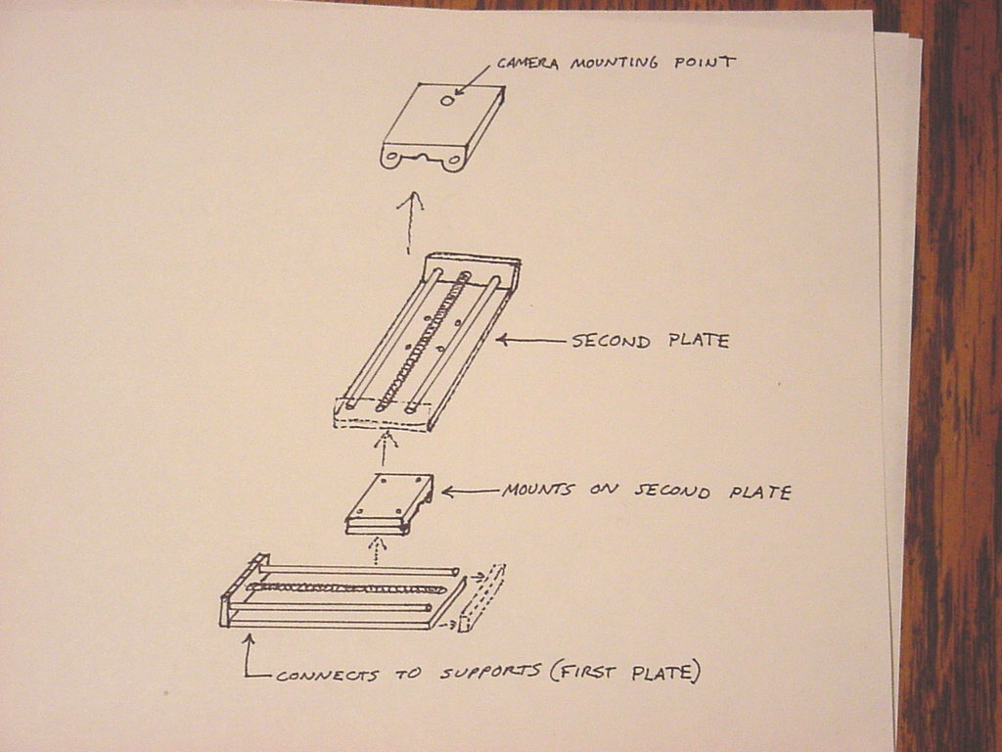
Table 1 illustrates the pros and cons of the three movement designs. It can been seen that the two track slider that controls movement with a threaded rod is the best movement design. The following is a preliminary sketch of the chosen design:

Figure 2: Exploded View of Initial Camera Mount Design

The next phase is creating detailed designs of this concept. These will include dimensions, locking mechanisms, materials, and the specific cost.

Appendix D: E-mails

Date: Thu, 17 Aug 2000 17:45:19 -0400
From: shih@wombat.eng.fsu.edu
To: Karen A. Davis <kadavis@wombat.eng.fsu.edu>
Subject: Re: Proposal
Parts/Attachments:
1 Shown 15 lines Text
2 29 KB Application
3 Shown 11 lines Text
----------------------------------------

Hi:

I made some corrections and you guys should go through it again, especially the introduction part. Thanks.

Shih

Date: Fri, 18 Aug 2000 14:24:39 -0400
From: shih@wombat.eng.fsu.edu
To: Karen A. Davis <kadavis@wombat.eng.fsu.edu>

Hi:

The motor controller is working now; cable seems to be the problem. I will need one of you to make a cable for it. Thanks.

Shih

Date: Mon, 21 Aug 2000 13:01:24 -0400
From: shih@wombat.eng.fsu.edu
To: Karen A. Davis <kadavis@wombat.eng.fsu.edu>
Subject: Re: your mail

Hi:

You just need to buy the connectors since we already have the cable. You might want to talk to me again to see where you can find connectors for the cable. Thanks.

Shih

At 12:38 PM 8/21/00 -0400, you wrote:
Sydni looked up the cable on the internet from Radio Shacks web page, but she only found a female-female connector that had the right amount of ports. But we are still looking, it should not be hard to find. Did you want us to build the cable or buy a cable? Also, attached is the updated proposal, please let us know if we need to modify ome more. Thank you.

Karen Davis

Date: Mon, 21 Aug 2000 17:21:13 -0400
From: shih@wombat.eng.fsu.edu
To: Karen A. Davis <kadavis@wombat.eng.fsu.edu>
Subject: Re: your mail

Hi:

I would like to have my book and the motor controller manual back also. Thanks.

Shih

Date: Tue, 22 Aug 2000 17:54:39 -0400
From: shih@wombat.eng.fsu.edu
To: Karen A. Davis <kadavis@wombat.eng.fsu.edu>
Subject: Re: your mail

Hi:

I found a cable to work with the controller so you do not have to make one anymore. Thanks.

Shih

Date: Wed, 23 Aug 2000 13:56:33 -0400
From: shih@wombat.eng.fsu.edu
To: Karen A. Davis <kadavis@wombat.eng.fsu.edu>
Subject: Re: Revised Proposal
Parts/Attachments:
1 Shown 4 lines Text
2 34 KB Application
3 Shown 11 lines Text
----------------------------------------

Hi;

Here it is, however, you have to meet Dr. Luongo's requirements also. Thanks.

Date: Fri, 08 Sep 2000 17:48:32 -0400
From: shih@wombat.eng.fsu.edu
To: Sydni Credle <credle@wombat.eng.fsu.edu
Subject: Re: Bi-weekly Meeting

Hi:

Those times are not good for me. I will prefer maybe Friday afternoon from 2 to 3. However, we can meet Tuesday 11:30 next week.

Thanks,
Shih

At 05:08 PM 9/7/00 -0400, you wrote:

Hello Dr. Shih,

Karen, Justin, and I have just received confirmation of our Senior Design project from Dr. Luongo today. For the duration of the project it will be the three of us. We did not get a fourth member. Starting next week (9/11/00), we would like to meet with you regularly either Tuesday or Thursday from 11:30am-12:30 p.m. every other week. Contact me if these meeting times do not fit your schedule. At our first meeting, we should be able to give you a listing of possible web cams that may meet our application needs as well as show you preliminary design ideas for the camera mount.

Thank-you
-Sydni Credle

Date: Wed, 20 Sep 2000 09:53:38 -0500
From: <sydni@somethingorother.com>
To: jwscott@wombat.eng.fsu.edu
Cc: kadavis@wombat.eng.fsu.edu
Subject: flow surfing

If you guys have free time and want to surf, I found some cool pages on flow visualization, etc.
http://www.floworks.com/floworks.htm
-This is a webpage showing the capabilities of a software package called Floworks that can be used with the AutoCAD program called Solidworks http://www.ofs.co.uk/pivintro/index.html
-This is the almost the PIV technique bible. Live it, learn it, love it.
http://gvis.lerc.nasa.gov/gallery/flow_vis.html
-pictures and stuff
http://www.sli.unimelb.edu.au/envis/viz.sites.NAS.html
-a database of everything

-Sydni

Subject:
RE: web view software
Date:
Fri, 22 Sep 2000 12:22:43 +0900
From:
"Masato Fujiwara" <fujiwara.masato@canon.co.jp>
To:
<jwscott@wombat.eng.fsu.edu>
CC:
"ˆÀ“c‚³‚ñ" <hyasuda@cusa.canon.com>

Thank you very much for your e-mail. I will forward your inquiry to the responsible person in US.
I will ask him to contact you.

Best regards,

Masato Fujiwara
CM Planning
Canon Inc.

-----Original Message-----
�·�o�l : jwscott@wombat.eng.fsu.edu <jwscott@wombat.eng.fsu.edu>
ˆ¶�æ : webview@cis.canon.co.jp <webview@cis.canon.co.jp>
“úŽž : 2000”N 9ŒŽ 22“ú ‹à—j“ú Œß‘O 02:13
Œ�–¼ : web view software

I have a Canon VC-C3 camera and am interested in the web view software only. I would like some more information about this and a price. Also, I live in the US and not sure if it is available here. Thank you for your time.

Justin Scott

Subject:
RE: web view software
Date:
Mon, 25 Sep 2000 11:06:52 -0400
From:
hyasuda@cusa.canon.com
To:
jwscott@wombat.eng.fsu.edu

Thank you for your recent inquiry regarding Canon's new WebView Livescope image webcasting system.
WebView /Livescope is an innovative webcasting solution that allows viewers to take control of camera angle and zoom functions at a remote location from their desktop. The system transmits compressed video and still images recorded by Canon's VC-C3 Communication Camera over a LAN or the internet, allowing the user to view images, realtime, from a variety of viewing angles. WebView / Livescope consists of three components: the camera server software and camera hardware are installed at the camera site while the viewer software is downloaded to the viewer to access images and to control the camera.

For detailed information on the WebView / Livescope System, please visit Canon's website at www.x-zone.canon.co.jp/WebView-E. If you are interested in purchasing the system from an authorized WebView
reseller. Please contact:
Digatron, Inc.
2513 17th Street
Denver, CO 80211
( 303 ) 455 - 9545
www.digatronsecurity.com

WWW.Consulting, Inc.
50 Main Street
Westhampton Beach, NY 11978
( 631 ) 288 - 2174
www.wwwconsulting.com

Thank you for your interest in Canon WebView / Livescope.
Hitoshi Yasuda

Date: Wed, 27 Sep 2000 20:00:26 -0400
From: jwscott@wombat.eng.fsu.edu
To: kadavis@wombat.eng.fsu.edu
Subject: presentation 2
Parts/Attachments:
1 Shown 1 lines Text
2 41 KB Application
----------------------------------------

Wasn't sure if I sent it right the first time.

Date: Mon, 02 Oct 2000 15:20:09 -0400
From: Dr. Chiang Shih <shih@wombat.eng.fsu.edu>
To: credle@wombat.eng.fsu.edu, kadavis@wombat.eng.fsu.edu, jwscott@wombat.eng.fsu.edu

Hi:
Can one of you talk to Mr. Bill Kincanon about the camera plate design? I just gave him a plate that you might want to use.

Thanks.
Shih

Date: Tue, 03 Oct 2000 14:30:33 -0400
From: Dr. Chiang Shih <shih@wombat.eng.fsu.edu>
To: credle@wombat.eng.fsu.edu, kadavis@wombat.eng.fsu.edu, jwscott@wombat.eng.fsu.edu

Hi:

I received the digital video cameras and microphones and I would like to have two of you to test them out using Microsoft Netmeeting program. Please send someone to see me.

Thanks. Shih

Subject:
Re: camera mount design
Date:
Wed, 4 Oct 2000 19:29:26 -0400 (EDT)
From:
"William C. Kincannon" <kincann@wombat.eng.fsu.edu>
To:
Justin Warner Scott <jwscott@wombat.eng.fsu.edu>
CC:
"William C. Kincannon" <kincann@wombat.eng.fsu.edu>

I will be there Thursday until 10:00. Then back around 12:30.
--WK

Date: Wed, 4 Oct 2000 23:50:47 -0400 (EDT)
From: Sydni Credle <credle@wombat.eng.fsu.edu>
To: Karen A. Davis <kadavis@wombat.eng.fsu.edu>
Subject: specs doc
Parts/Attachments:
1 Shown 2 lines Text
2 28 KB Application, "sumpthin"

needs formatting...

Date: Thu, 5 Oct 2000 13:37:44 -0400 (EDT)
From: Sydni Credle <credle@wombat.eng.fsu.edu>
To: Cesar Augusto Luongo <luongo@wombat.eng.fsu.edu>
Cc: Karen A. Davis <kadavis@wombat.eng.fsu.edu>,
Justin Warner Scott <jwscott@wombat.eng.fsu.edu>
Subject: Group 6 Specifications
Parts/Attachments:
1 Shown 4 lines Text
2 901 KB Application, "Group6-Specifications"
----------------------------------------

This is a copy of our second deliverable: The Specifications

-Sydni Credle

Date: Sun, 15 Oct 2000 15:50:16 -0400 (EDT)
From: Karen A. Davis <kadavis@wombat.eng.fsu.edu>
To: Chiang Shih <shih@wombat.eng.fsu.edu>
Cc: Justin Warner Scott <jwscott@wombat.eng.fsu.edu>, Sydni Credle <credle@wombat.eng.fsu.edu> Subject: LabVIEW

I just wanted to let you know I asked Ding Li to put LabVIEW on the computer next to the flow tank. Sydni said that you were having problems and to talk to Ding Li about re-loading the program. I just wanted to give you an update.

Karen Davis

Date: Tue, 17 Oct 2000 18:10:42 -0400
From: jwscott@wombat.eng.fsu.edu
To: credle@wombat.eng.fsu.edu, kadavis@wombat.eng.fsu.edu
Subject: sfdvoLSN'[zsopvinzsd'[onib
Parts/Attachments:
1 Shown 1 lines Text
2 222 KB Application

Date: Wed, 18 Oct 2000 23:58:09 -0400 (EDT)
From: Sydni Credle <credle@wombat.eng.fsu.edu>
To: Justin Warner Scott <jwscott@wombat.eng.fsu.edu>
Cc: kadavis@wombat.eng.fsu.edu
Subject: wbs
Parts/Attachments:
1 Shown 0 lines Text
2 349 KB Application, "wbs"

Subject:
Teleconference meeting
Date:
Mon, 23 Oct 2000 22:15:36 -0400 (EDT)
From:
"Karen A. Davis" <kadavis@wombat.eng.fsu.edu>
To:
Chiang Shih <shih@wombat.eng.fsu.edu>
CC:
Sydni Credle <credle@wombat.eng.fsu.edu>,
Justin Warner Scott <jwscott@wombat.eng.fsu.edu>

I was wondering if we could demonstrate the web camera teleconference program Wednesday afternoon at 5 pm. We can meet you in your office and then go down stairs to room 109 where we have a camera set up, Justin can call from his house. If there is a time that would be better for you, please let me know.

Karen Davis

Date: Tue, 24 Oct 2000 09:52:20 -0400
From: Dr. Chiang Shih <shih@wombat.eng.fsu.edu>
To: Karen A. Davis <kadavis@wombat.eng.fsu.edu>
Subject: Re: Teleconference meeting

Hi:

Let's meet at 5:10 pm in my office since I will have an exam to give this
Wednesday and it might take a few more minutes to wrap it up. Thanks.

Shih

At 10:15 PM 10/23/00 -0400, you wrote:

I was wondering if we could demonstrate the web camera teleconference program Wednesday afternoon at 5 pm. We can meet you in your office and then go down stairs to room 109 where we have a camera set up, Justin can program Wednesday afternoon at 5 pm. We can meet you in your office and then go down stairs to room 109 where we have a camera set up, Justin can call from his house. If there is a time that would be better for you, please let me know.

Karen Davis

Date: Tue, 24 Oct 2000 16:50:35 -0400
From: davy@wombat.eng.fsu.edu
To: kadavis@wombat.eng.fsu.edu, culberts@wombat.eng.fsu.edu, cherolis@wombat.eng.fsu.edu, credle@wombat.eng.fsu.edu
Subject: National Instruments Workshop

Hey Guys, Today I discovered that each person have to sign up to to go to the work shop in Orlando individually. You must register on the NI web site. The address is www.ni.com/nidays. I also contacted NI to verify if students can attend. I will let you know once I find out.

Charney

Subject:
labVIEW workshop
Date:
Tue, 24 Oct 2000 18:36:46 -0400 (EDT)
From:
Sydni Credle <credle@wombat.eng.fsu.edu>
To:
Justin Warner Scott <jwscott@wombat.eng.fsu.edu>

Hey Justin,

I don't know if anyone talked to you during class today but Charney had this flier for a LabVIEW workshop to take place in Orlando on Nov. 9th. She said Dr. Shih would pay for one meal and gas. (It's only a day long seminar) I don't know the particulars but you can e-mail Charney or talk to Dr. Shih to get some more info.

-Sydni

Date: Thu, 26 Oct 2000 13:18:48 -0400 (EDT)
From: Sydni Credle <credle@wombat.eng.fsu.edu>
To: Chiang Shih <shih@wombat.eng.fsu.edu>
Cc: Karen A. Davis <kadavis@wombat.eng.fsu.edu>,
Justin Warner Scott <jwscott@wombat.eng.fsu.edu>
Subject: LabVIEW Backorder

Hello Dr. Shih,

To Follow up on the phone message I left you earlier today...

The status of our order for the LabVIEW teaching license and supplementary software and toolkits is that it is "Backordered" - meaning that it is still going through the proper channels that ensure proper documentation of the merchandise.

I couldn't get a concrete time as to when they think they can deliver. Best case = 1 week, (2 weeks at the latest) I will follow up early next week (monday) to check on the status again. In the meantime, if you have questions or comments concerning the order (#RF-ME 2890), here is the contact information for the person I spoke with:

Bobby Gonzalez
National Instruments
(800) 667-5347
ext. #30418

Date: Thu, 26 Oct 2000 15:51:01 -0500 (CDT)
From: karen.bauer@ni.com
To: credle@wombat.eng.fsu.edu
Subject: National Instruments Event Registration Information

Dear Sydni Credle,

This is to confirm your registration for the National Instruments seminar NIDays 2000. The seminar occurs on November 09, 2000, beginning at 08:00. The location of the seminar appears below: Wyndham Orlando Resort 8001 International Dr ORLANDO FL Space is limited. If you cannot attend the seminar, please notify us so that we can reallocate your reservation. Should you have questions, please call us at (800) 433-3488.

Sincerely,
Karen Bauer Sales Event Coordinator

From: Karen.Bauer@ni.com
Date: Tue, 31 Oct 2000 20:47:43 -0600 (CST)
X-Authentication-Warning: arapaho.natinst.com: applmgr set sender to Karen
Bauer using -r
To: shih@wombat.eng.fsu.edu
Subject: NIDays 2000 in Orlando, FL on Thursday, November 9!

Dear Chiang
Shih,

I want to send you a personal invitation to NIDays 2000 - find out how computer technology is revolutionizing the future of measurement and automation! Learn about emerging hardware, software, and
networking technologies and meet one-on-one with experts and third-party vendors at this technical conference and exhibition. The session is free, and lunch is included.

Technical sessions feature:

- Introduction to Real-Time Control
- Building a Network-Based Data Logger
- Steps for Success with Vision
- Making Frequency Domain Measurements
- Designing Motion Control Systems
- Check Out the New Version of LabVIEW!
- Introduction to Measurement Studio
- Creating Parallel Test Systems for Faster Test Throughput
- Architecting Production Test Systems
- Monitoring and Control Over the Web
- And much, much more!

Event Location:
Thursday, November 9, 2000
8:00 a.m. to 4:00 p.m.
Orlando, FL
Wyndham Orlando Resort
8001 International Drive
(407) 351-2420

To register, for directions, or for more information, please click here: http://www.ni.com/nidays/america.htm

You are receiving this e-mail because you have previously expressed an interest in National Instruments products and services. If you would prefer not to receive these seminar announcements in the future, please reply to this message with your request and I will remove you from the mailing list.

Sincerely,

Karen Bauer
National Instruments
(512) 683-9362

Subject:
Fwd: NIDays 2000 in Orlando, FL on Thursday, November 9!
Date:
Wed, 01 Nov 2000 09:11:49 -0500
From:
"Dr. Chiang Shih" <shih@wombat.eng.fsu.edu>
To:
credle@wombat.eng.fsu.edu, kadavis@wombat.eng.fsu.edu, jwscott@wombat.eng.fsu.edu

Hi:

FYI.
Shih

Date: Wed, 01 Nov 2000 08:29:06 -0600
From: William Kincannon <kincann@wombat.eng.fsu.edu>
To: Karen A. Davis <kadavis@wombat.eng.fsu.edu>
Subject: Camera Mount

Karen, I have a list of stuff you guys need to get. If you come by sometime I will give it to you.
--Bill

Date: Wed, 1 Nov 2000 13:23:04 -0500 (EST)
From: Dr. Leon VanDommelen <dommelen@wombat.eng.fsu.edu>
To: Karen A. Davis <kadavis@wombat.eng.fsu.edu>
Subject: Re: Inquiry

Karen,

My name is Karen Davis and I am working on a senior design project with Dr. Shih and my other group members are Sydni Credle and Justin Scott. I was wondering if you would be able to meet with our senior design group about the programming you used in the distance learning room. We are using netmeeting and would like some advice. Will you be able to meet us in your office between 11:30 and 12 Thursday 11/2.

That will be fine.

Date: Wed, 1 Nov 2000 18:02:02 -0500
From: Justin Scott <youaremailingme@worldnet.att.net>
To: credle@wombat.eng.fsu.edu
Cc: kadavis@wombat.eng.fsu.edu
Subject: Nov 2 presentation
Parts/Attachments:
1 Shown 2 lines Text (charset: ISO-8859-1)
2 369 KB Application
----------------------------------------

If you need me to do anything else, give me a call @ my house. Justin (574-2904)

Date: Wed, 1 Nov 2000 18:29:39 -0500 (EST)
From: Sydni Credle <credle@wombat.eng.fsu.edu>
To: Karen A. Davis <kadavis@wombat.eng.fsu.edu>
Subject: presentations
Parts/Attachments:
1 Shown 1 lines Text
2 482 KB Application, "pres-2"
3 129 KB Application, "pres-1"

Date: Mon, 6 Nov 2000 19:17:50 -0600 (CST)
From: karen.bauer@ni.com
To: credle@wombat.eng.fsu.edu
Subject: National Instruments Event Registration Information

Dear Sydni Credle, We would like to remind you that you are registered to attend the NIDays 2000, scheduled to begin at 08:00 on November 09, 2000. The seminar will be held at the following location: Wyndham Orlando Resort 8001 International Dr ORLANDO FL Space is limited. If you cannot attend the seminar, please notify us so that we can allocate your reservation. Should you have any questions, please call us at (800) 433-3488.

Sincerely, Karen Bauer Sales Event Coordinator

Date: Tue, 7 Nov 2000 13:14:38 -0500 (EST)
From: Anthony P. Cherolis <cherolis@wombat.eng.fsu.edu>
To: Karen A. Davis <kadavis@wombat.eng.fsu.edu>, John Culbertson <culberts@wombat.eng.fsu.edu>, Sydni Credle <credle@wombat.eng.fsu.edu>
Subject: Expense report for NI workshop

Hey all, We're supposed to turn in some sort of estimated expense report for the workshop. Talk to John Cloos in the ME office. He may expect a written estimate or something. Here's what Dr. Shih said he'd cover. -Breakfast and Dinner on Thursday -a total of two hotel rooms Wednesday night (Don't know what the arrangements are) -gas (rental car for Charney and Karen) BTW... John if you get this ---> we're planning on having a meeting this afternoon about purchasing the components. Since Senior Design is cancelled.

From: "Gibson, Karen" <KGibson@admin.fsu.edu>
To: "'cloos@eng.fsu.edu'" <cloos@wombat.eng.fsu.edu>
Subject: Greets Purchase Order #F44132 to McMaster-Carr
Date: Wed, 8 Nov 2000 09:34:34 -0500
MIME-Version: 1.0
Status:

Jon, Vendor says that item #3 (catalog number 91381A537) should be 35.95 per pack of 25. They also say that item #2 (catalog number 95365A315) should be $15.00 each. Please advise if this will be acceptable. If acceptable you will need to process a change order to the above purchase order in the Greets system.

Subject:
Your McMaster Carr order
Date:
Wed, 8 Nov 2000 10:20:52 -0500
From:
Jon Cloos <cloos@wombat.eng.fsu.edu>
To:
JWScott@wombat.eng.fsu.edu

Justin,

We have been advised of several pricing discrepancies on your order. Please double check pricing and items numbers and advise me of any corrections that need to be made.

Thanks,

Jon Cloos

Subject:
camera mount
Date:
Thu, 09 Nov 2000 12:28:15 -0600
From:
William Kincannon <kincann@wombat.eng.fsu.edu>
To:
jwscott@wombat.eng.fsu.edu
CC:
kadavis@wombat.eng.fsu.edu

Hello. Somehow one of the part numbers ordered was for a left hand threaded Part when we needed a right. They will have to be sent back and exchanged for the correct part.
--wk

-Sydni Credle
Date: Wed, 15 Nov 2000 23:26:46 -0500
From: Justin Scott <youaremailingme@worldnet.att.net>
To: kadavis@wombat.eng.fsu.edu
Cc: credle@wombat.eng.fsu.edu
Subject: pres
Parts/Attachments:
1 Shown 1 lines Text (charset: ISO-8859-1)
2 545 KB Application

Date: Mon, 27 Nov 2000 22:24:30 -0500 (EST)
From: Sydni Credle <credle@wombat.eng.fsu.edu>
To: Karen A. Davis <kadavis@wombat.eng.fsu.edu>
Subject: specifications document
Parts/Attachments:
1 Shown 4 lines Text
2 894 KB Application, "specifications"
----------------------------------------

I'll give you the hard copy when we walk to the car...my car.

-Sydni

Date: Tue, 28 Nov 2000 16:29:14 -0500
From: jwscott@wombat.eng.fsu.edu
To: kadavis@wombat.eng.fsu.edu
Subject: a little something (emails)
Parts/Attachments:
1 Shown 1 lines Text
2 46 KB Application
----------------------------------------

Date: Tue, 28 Nov 2000 17:50:21 -0500
From: jwscott@wombat.eng.fsu.edu
To: kadavis@wombat.eng.fsu.edu, credle@wombat.eng.fsu.edu
Subject: schedule
Parts/Attachments:
1 Shown 1 lines Text
2 121 KB Application
----------------------------------------

Date: Tue, 28 Nov 2000 17:52:10 -0500 (EST)
From: Sydni Credle <credle@wombat.eng.fsu.edu>
To: Karen A. Davis <kadavis@wombat.eng.fsu.edu>
Subject: I need...

Hey karen,

I need a copy of the WBS powerpoint file so I can make some changes.

-Sydni

Date: Tue, 28 Nov 2000 18:28:50 -0500 (EST)
From: Sydni Credle <credle@wombat.eng.fsu.edu>
To: Karen A. Davis <kadavis@wombat.eng.fsu.edu>
Subject: my e-mails
Parts/Attachments:
1 Shown 22 lines Text
2 52 KB Application, "e-mails"
----------------------------------------

Hey Karen,

We kinda declared you the leader of the coorespondence section of our report. I attached my e-mails which I already took the time to format in Word and list them in the order of the date.

Justin should have already sent his...you can send it back to him and tell him to format it himself if he hasn't already done so. Delete any messages that are repeated

I revised the skeleton and you don't really have to worry about the content of the web page until we get together thursday night. The only thing on your plate is the specifications and the correspondence.

I'll call later to make a game plan for wed., I won't be able to meet until after 8:30pm, maybe 9:00pm

Ping Pong
-Sydni

Date: Tue, 28 Nov 2000 23:21:34 -0500
From: Justin Scott <youaremailingme@worldnet.att.net>
To: credle@wombat.eng.fsu.edu
Cc: kadavis@wombat.eng.fsu.edu
Subject: Web Development for Final
Parts/Attachments:
1 Shown 1 lines Text (charset: ISO-8859-1)
2 275 KB Application
----------------------------------------

Here. Enjoy.

Appendix E: LabVIEW Virtual Instruments

Below are descriptions of the supplied VP9000 LabVIEW Virtual Instruments (VI’s). They are listed in alphabetical order with the exception of the “VP9000Cmd.vi”, which is listed first, because it is the most fundamental of the drivers.

VP9000Cmd.vi

This VI allows sending of an arbitrary string of characters to the Controller, over the Serial Port. It is the basic VI used by most of the more complex VI’s described later. It can also be used to send any string to the Controller, in order to implement functions not included with this driver set.

INPUTS

- Serial Port No. - U32 -
This input allows the user to specify the host’s Serial Port which is connected to the Velmex Controller. The default is COM2 (many PC’s use COM1 for the Mouse). This is an Unsigned Long Integer Control with the following definition:
0 = COM1, 1 = COM2, 2 = COM3, 3 = COM4

- Command Line - STR -
This input is used to specify the character string to be sent to the Velmex Controller. Read the Velmex Manual to ensure that proper protocol conventions are followed.

OUTPUTS

- Error Code - I32 -
The Error Code corresponds to the LabVIEW Serial Port Error Codes; 0 means no error occurred. Note that illegal commands to the Controller are not detected.

- Warning String - STR -
This provides a text description of any problems detected.

Absolute Index.vi

This VI lets the user move the Motion Stage to an absolute (destination) location. The distance to move (index) is calculated based on the the current position and the destination. Note that sending this command implements the motion only. Use the Wait for Prompt.vi VI immediately after to have the Controller signal when motion has stopped.

INPUTS

- Serial Port No. - U32 -
This input allows the user to specify the host’s Serial Port which is connected to the Velmex Controller. The default is COM2 (many PC’s use COM1 for the Mouse). This is an Unsigned Long Integer Control with the following definition:
0 = COM1, 1 = COM2, 2 = COM3, 3 = COM4

- Motor Number - U16 -
Specifies the Motor Number which the Controller will actuate. This is an Unsigned Integer with the following definition:
0 = Motor 1, 1 = Motor 2, 2 = Motor 3, 3 = Motor 4

- Absolute Index - I32 -
Used to input the destination, in steps, that the Controller will index the motor to.

OUTPUTS

- Error Code - I32 -
The Error Code corresponds to the LabVIEW Serial Port Error Codes; 0 means no error occurred. Note that illegal commands to the Controller are not detected.

- Warning String - STR -
This provides a text description of any problems detected.

Get Motor Position.vi

This VI queries the Controller for the position (in steps) of the selected Motor. To determine the rest position of a stage after the Index Motor.vi, use this VI after the Wait for Prompt.vi.

INPUTS

- Serial Port No. - U32 -
This input allows the user to specify the host’s Serial Port which is connected to the Velmex Controller. The default is COM2 (many PC’s use COM1 for the Mouse). This is an Unsigned Long Integer Control with the following definition:
0 = COM1, 1 = COM2, 2 = COM3, 3 = COM4

- Motor Number - U16 -
Specifies the Motor Number which the query refers to. This is an Unsigned Integer with the following definition:
0 = Motor 1, 1 = Motor 2, 2 = Motor 3, 3 = Motor 4

OUTPUTS

- Position (steps) -
The response to the query, giving the selected motor’s current position in steps.

- Error Code - I32 -
The Error Code corresponds to the LabVIEW Serial Port Error Codes; 0 means no error occurred. Note that illegal commands to the Controller are not detected.

- Warning String - STR -
This provides a text description of any problems detected.

Get Status.vi

This VI queries the Controller for its Status, by sending it the single character “V”. To quote the Velmex Manual, pg. 43, “If the VP9000 is running a program when it receives a ‘V’ the VP9000 will respond by transmitting the single character ‘B’. If the VP9000 is idle waiting for a command the VP9000 will respond by transmitting the single character ‘R’. When in the Jog/slew mode the VP9000 will always respond by sending a ‘J’ ”. This is a good VI to use after placing the Controller On-Line, to verify the Serial Port Link with the Controller.

INPUTS

- Serial Port No. - U32 -
This input allows the user to specify the host’s Serial Port which is connected to the Velmex Controller. The default is COM2 (many PC’s use COM1 for the Mouse). This is an Unsigned Long Integer Control with the following definition:
0 = COM1, 1 = COM2, 2 = COM3, 3 = COM4

OUTPUTS

- Status Response - STR -
The response to the Status query. If the Controller is On-Line, a single string character will be returned: an “R” if the Controller is idle (waiting for a Command), a “B” if it is busy running a program, and a “J” if it is in the Jog/slew mode.

- Write Error Code - I32 -
The Error Code corresponds to the LabVIEW Serial Port Error Codes; 0 means no error occurred. Note that illegal commands to the Controller are not detected. The Write Error Code refers to the Serial Port Write segment of this VI (sending of the “V” character).

- Read Error Code - I32 -
The Error Code corresponds to the LabVIEW Serial Port Error Codes; 0 means no error occurred. Note that illegal commands to the Controller are not detected. The Read Error Code refers to the Serial Port Read segment of this VI (reception of the Response Character).

- Warning String - STR -
This provides a text description of any problems detected.

Index Motor to Zero.vi

This VI lets the user move the Motion Stage to the defined Zero location. The distance to move (index) is calculated based on the the current position and the Zero location. Note that sending this command implements the motion only. Use the Wait for Prompt.vi VI immediately after to have the Controller signal when motion has stopped.

INPUTS

- Serial Port No. - U32 -
This input allows the user to specify the host’s Serial Port which is connected to the Velmex Controller. The default is COM2 (many PC’s use COM1 for the Mouse). This is an Unsigned Long Integer Control with the following definition:
0 = COM1, 1 = COM2, 2 = COM3, 3 = COM4

- Motor Number - U16 -
Specifies the Motor Number which the Controller will actuate. This is an Unsigned Integer with the following definition:
0 = Motor 1, 1 = Motor 2, 2 = Motor 3, 3 = Motor 4

OUTPUTS

- Error Code - I32 -
The Error Code corresponds to the LabVIEW Serial Port Error Codes; 0 means no error occurred. Note that illegal commands to the Controller are not detected.

- Warning String - STR -
This provides a text description of any problems detected.

Index Motor.vi

This VI lets the user move the Motion Stage a specified number of steps. Note that sending this command implements the motion only. Use the Wait for Prompt.vi VI immediately after to have the Controller signal when motion has stopped.

INPUTS

- Serial Port No. - U32 -
This input allows the user to specify the host’s Serial Port which is connected to the Velmex Controller. The default is COM2 (many PC’s use COM1 for the Mouse). This is an Unsigned Long Integer Control with the following definition:
0 = COM1, 1 = COM2, 2 = COM3, 3 = COM4

- Motor Number - U16 -
Specifies the Motor Number which the Controller will actuate. This is an Unsigned Integer with the following definition:
0 = Motor 1, 1 = Motor 2, 2 = Motor 3, 3 = Motor 4

- Steps to Index - I32 -
Used to input the number of steps that the Controller will index the motor.

OUTPUTS

- Error Code - I32 -
The Error Code corresponds to the LabVIEW Serial Port Error Codes; 0 means no error occurred. Note that illegal commands to the Controller are not detected.

- Warning String - STR -
This provides a text description of any problems detected.

InitSerP.vi

This VI initializes the host PC’s Serial Port to the parameters required by the VP9000, specifically 9600 Baud, 7 Data Bits, 2 Stop Bits, Even Parity, No Flow Control. This command should generally be used at the very beginning of any automation program, to ensure the host and the Controller’s ports’ are synchronized.

INPUTS

- Serial Port No. - U32 -
This input allows the user to specify the host’s Serial Port which is connected to the Velmex Controller. The default is COM2 (many PC’s use COM1 for the Mouse). This is an Unsigned Long Integer Control with the following definition:
0 = COM1, 1 = COM2, 2 = COM3, 3 = COM4

- Baud Rate - I32 -
Specifies the Baud Rate that the selected Serial Port (on the host PC) will be set to. The default is 9600. The VP9000 allows varying of its Baud Rate; if this is changed from 9600, be sure to initialize the host to the same rate.

OUTPUTS

- Error Code - I32 -
The Error Code corresponds to the LabVIEW Serial Port Error Codes; 0 means no error occurred. Note that illegal commands to the Controller are not detected.

- Warning String - STR -
This provides a text description of any problems detected.

Offline.vi

This VI takes the Velmex Controller Off-Line, by sending the “Q” character to the Controller. The Controller is returned to the Jog/slew mode, and host/controller interaction is disabled.

INPUTS

- Serial Port No. - U32 -
This input allows the user to specify the host’s Serial Port which is connected to the Velmex Controller. The default is COM2 (many PC’s use COM1 for the Mouse). This is an Unsigned Long Integer Control with the following definition:
0 = COM1, 1 = COM2, 2 = COM3, 3 = COM4

OUTPUTS

- Error Code - I32 -
The Error Code corresponds to the LabVIEW Serial Port Error Codes; 0 means no error occurred. Note that illegal commands to the Controller are not detected.

- Warning String - STR -
This provides a text description of any problems detected.

Online.vi

This VI places the Velmex Controller On-Line, by sending the “F” character to the Controller. This command is necessary prior to any host/controller interaction. This VI should be used immediately after the “InitVP9000.vi” in any automation program.

INPUTS

- Serial Port No. - U32 -
This input allows the user to specify the host’s Serial Port which is connected to the Velmex Controller. The default is COM2 (many PC’s use COM1 for the Mouse). This is an Unsigned Long Integer Control with the following definition:
0 = COM1, 1 = COM2, 2 = COM3, 3 = COM4

OUTPUTS

- Error Code - I32 -
The Error Code corresponds to the LabVIEW Serial Port Error Codes; 0 means no error occurred. Note that illegal commands to the Controller are not detected.

- Warning String - STR -
This provides a text description of any problems detected.

Run.vi

This VI sends “R” character to the Controller, which Runs any previously entered program. Note that the drivers described herein all include the “R” character when necessary; that is, if for instance the “Index Motor” VI is called, it will run without the need to send an additional “Run” command. The “Run.vi” VI might be used in situations where a program has been entered manually into the Controller, but it is desired to start it as part of a higher level program on the host PC.

INPUTS

- Serial Port No. - U32 -
This input allows the user to specify the host’s Serial Port which is connected to the Velmex Controller. The default is COM2 (many PC’s use COM1 for the Mouse). This is an Unsigned Long Integer Control with the following definition:
0 = COM1, 1 = COM2, 2 = COM3, 3 = COM4

OUTPUTS

- Error Code - I32 -
The Error Code corresponds to the LabVIEW Serial Port Error Codes; 0 means no error occurred. Note that illegal commands to the Controller are not detected.

- Warning String - STR -
This provides a text description of any problems detected.

WaitForPrompt.vi

This VI waits for a character to appear at the host PC’s Serial Port Input Buffer. It should be used after one of the Index commands, to note the termination of motion. Because the Controller moves only one stage at a time, it is prudent to use this VI to indicate that motion is done, prior to selecting and indexing another motor.

INPUTS

- Serial Port No. - U32 -
This input allows the user to specify the host’s Serial Port which is connected to the Velmex Controller. The default is COM2 (many PC’s use COM1 for the Mouse). This is an Unsigned Long Integer Control with the following definition:
0 = COM1, 1 = COM2, 2 = COM3, 3 = COM4

OUTPUTS

- Error Code - I32 -
The Error Code corresponds to the LabVIEW Serial Port Error Codes; 0 means no error occurred. Note that illegal commands to the Controller are not detected.

- Warning String - STR -
This provides a text description of any problems detected.

- Prompt Character Out - STR -
When stage motion ends, the Controller sends a single character to the host: a “^” character normally, or an “O” character to indicate overtravel to the limit switch, if the stage is so equipped, and if limit overtravel is enabled (see Velmex Manual)

