Web-Based Flow Visualization Facility (WBFVF)

Operations Manual

Sydni S. Credle
Karen A. Davis
Justin W. Scott

Senior Design Project: April 3, 2001
Team 6

Professor: Dr. Luongo
Client/Advisor: Dr. Shih

Contents

- Camera Mount User Instructions . . . . . . . . . . . . . . . . . . . . . . . . . . . . . . .3
1.1 – Mounting the Camera . . . . . . . . . . . . . . . . . . . . . . . . . . . . . . . . . . . . . . .4
1.2 – Connecting the Video Camera to the Computer . . . . . . . . . . . . . . . . . . . . . 4
1.3 - Adjusting the Video Camera . . . . . . . . . . . . . . . . . . . . . . . . . . . . . . . . . . 5

2.0 LabVIEW . . . . . . . . . . . . . . . . . . . . . . . . . . . . . . . . . . . . . . . . . . . . . . . . . 6
2.1 – Introduction . . . . . . . . . . . . . . . . . . . . . . . . . . . . . . . . . . . . . . . . . . . . . .6
2.2 – Equipment . . . . . . . . . . . . . . . . . . . . . . . . . . . . . . . . . . . . . . . . . . . . . . .6
2.3 - LabVIEW Basics . . . . . . . . . . . . . . . . . . . . . . . . . . . . . . . . . . . . . . . . . . ..8
2.3.1 – Velmex Instrument Drivers . . . . . . . . . . . . . . . . . . . . . . . . . . . .11
2.3.2 – Preliminary Control Program . . . . . . . . . . . . . . . . . . . . . . . . . . . 14
2.4 – Global Variables and CGI Scripting . . . . . . . . . . . . . . . . . . . . . . . . . . . . . 16
2.5 – Interfacing with LabVIEW . . . . . . . . . . . . . . . . . . . . . . . . . . . . . . . . . . . .21
2.5.1 - Publish front panel of LabVIEW program using HTML . . . . . . . . . . .21
2.5.2 - Create HTML image map corresponding to
root elements within program . . . . . . . . . . . . . . . . . . . . . . . . . . .22

- Appendices . . . . . . . . . . . . . . . . . . . . . . . . . . . . . . . . . . . . . . . . . . . . . . . 23
3.1 - Appendix A: CGI Scripting Codes . . . . . . . . . . . . . . . . . . . . . . . . . . . . . . .23
3.2 - Appendix B: Troubleshooting . . . . . . . . . . . . . . . . . . . . . . . . . . . . . . . . . .29

- References . . . . . . . . . . . . . . . . . . . . . . . . . . . . . . . . . . . . . . . . . . . . . . . 31

1.0 - Camera Mount User Instructions

The first sub-design in the flow visualization design project was to design a camera mount that could be attached to the existing platform on the flow visualization towing tank. Explained below are the instructions for:

- Mounting the Camera
- Connecting the video camera to the computer for still picture imaging
- Adjusting the video camera for the desired image.

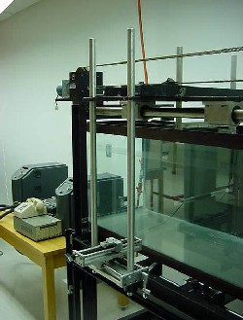

Towing Tank

Support poles for the camera mount

Camera Mount

Figure 1: Picture of the camera mount attached to the towing tank
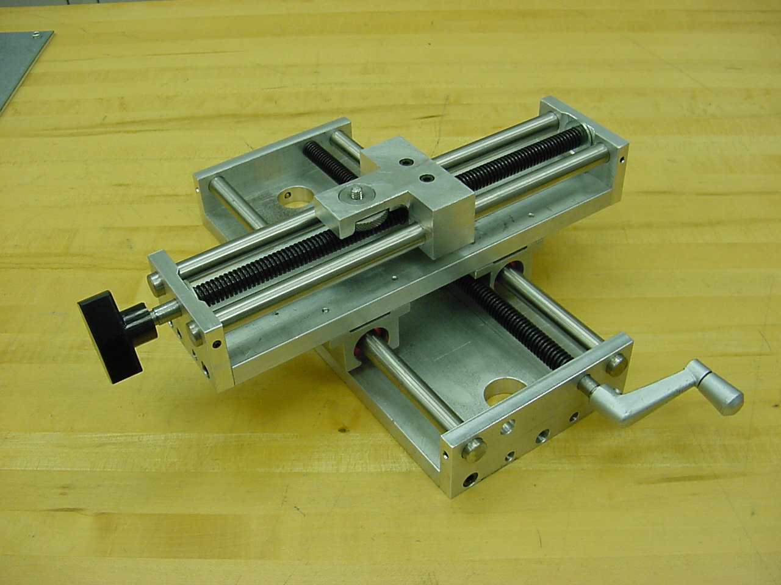

Holes for support poles

Video Camera connection screw/dial

Video Camera bottom slider adjustment control

Video Camera top slider adjustment control

Figure 2: Close-up picture of the camera mount

1.1 – Mounting the Camera

Note: Make sure the camera mount is tightly secured to the support poles, illustrated in Figure 1, before attempting to connect the video camera.

- Locate the mounting bracket on the bottom of the video camera.
- Position the video camera on the camera mount so that the mounting bracket lines up with the video camera connection screw, which is shown in Figure 2.
- Turn the dial, which is fixed to the connection screw, clockwise to connect the video camera to the camera mount
- Make sure the video camera is aligned perpendicular to the tank and secured tightly

1.2 - Connecting the Video Camera to the Computer

- Locate the parallel port on the back of the video camera
- Connect the parallel cable to the parallel port on the video camera
- Connect the other side of the parallel cable to the parallel port on the computer
1.3 - Adjusting the Video Camera

Note: Make sure the video camera is aligned perpendicular to the tank and secured tightly before adjusting. The procedure for this is located in the section titled, Setting Up the Video Camera on the Camera Mount.

- To move the video camera horizontally/pan control, crank the video camera bottom slider adjustment control, illustrated in Figure 2, until the desired position is acquired.
- To move the video camera forward or backward/zoom control turn the video camera top slider adjustment control, illustrated in Figure 2, until the desired position is acquired.
2.0 - LabVIEW

2.1 - Introduction

The following is a methodology as to how to configure instruments and data analysis remotely via LabVIEW6.i software. The system is based on LabVIEW coupled with other Internet programming techniques. The remote laboratory system accepts user commands, relays them to LabVIEW which in turn controls the instruments in the physical laboratory (An illustration is shown in Figure 3 below).

2.2 - Equipment

- Local PC
- LabVIEW6.i
- VP9000 Motor Controller
- Superior Electric Motor M092-FD08
- Water Reservoir/Support System
- Optical Laser Assembly
- Imaging Camera Mount
- CCD Imaging Camera
- Web Camera
- Netscape Communicator 4.7 (or higher)

Client

Client

Client

LabVIEW Internet Connectivity Tool set

Internet

Figure 3: Schematic diagram illustrating basic setup of web-based flow visualization system.

Personal
Computer
Motor Controller

Flow Visualization Facility
Visualization
Camera
WebCam
For Lab Video Image streaming

2.3 - LabVIEW Basics

LabVIEW, short for Laboratory Virtual Instrument Engineering Workbench, is a programming environment in which one can create programs with graphics. Other programming languages such as C++, Pascal, and Basic all use text in order to program while LabVIEW uses a graphical language called G. LabVIEW works on PCs running Microsoft Windows, Mac OS, Sun SPARCstations, and HP 9000/700 series workstations running HP-UX.¹

G programming involves creating pictorial programs called block diagrams, thus eliminating a lot of the syntax involved with other formats. Together, Figures 4 and 5 show one of the basic programs called InitSerp.vi, which is used to initialize the Velmex VP9000 Series motor controller within the flow visualization system. The “.vi” (pronounced “vee eye”) suffix of the call name stands for ‘virtual instrument’ because their appearance and operation imitates actual instruments.¹

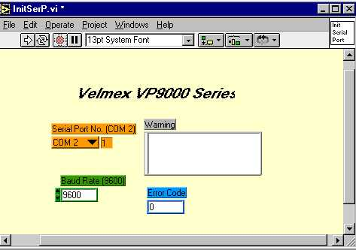

Figure 4: Front panel display of an example VI named InitSerp.vi.

The three main parts of a VI are the front panel, the block diagram, and the “sub-vi”. Figure 4 shows an example front panel which serves as the user interface to controlling a physical instrument. (In this case, the Velmex VP9000 motor controller) Users can input data using the mouse and the keyboard as well as view results such as error warnings on the same screen. A main goal is to directly simulate the front panel of the instrument using knob, buttons, graphs, and various other controls.¹

Figure 5 shows the actual source code behind the making of the front panel called the block diagram. The block diagram is composed of lower-level VIs, built-in functions, constants, and program execution control structures. The wires shown in the figure are indicators of the flow of data between the different components.

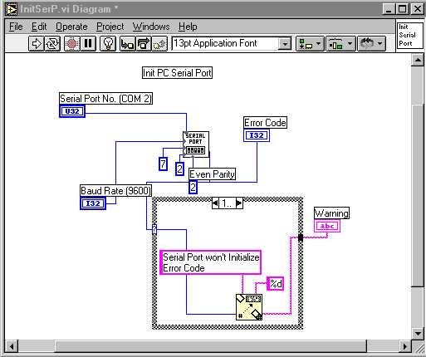

Figure 5: Block Diagram of a example VI showing the components of the InitSerp.vi program and the components linked with wires indicating the flow of information.

An icon and a connector can represent each individual VI. The representative components that can be used in a separate LabVIEW program. Any VI that is used within another VI is called a sub-VI. When a VI is used as a sub-VI, the connector is the mechanism used to wire data into it. The icon is used as an object in the block diagram of another VI.

A major reason for choosing LabVIEW for the automation of control for the WBFVF project is its ease of use as well as its connectivity. LabVIEW has built in functions that simplify communication over a network. Communication VIs allow for use of programs in networked applications using TCP/IP which has the following advantages over other protocols:

- Connection of computers from multiple platforms (Windows, Mac, Sun, HP).
- Communication with multiple computers simultaneously.
- Great geographical distances can separate networks.

These advantages can facilitate a situation where a person at the FAMU-FSU College of Engineering can have a VI running on a PC passing results to an analysis VI in Miami on a Power Macintosh, while someone observes the whole process in real time on a Sun machine in Holland.

2.3.1 - Velmex Instrument Drivers

The manufacturer, Velmex Incorporated, supplied the basic LabVIEW used to control the motor controller. From the Velmex Corporate webpage, www.velmex.com.² Command programs were downloaded and modified as needed.
Figures 6, 7 and 8 below show the programs that were used to initialize the motor controller, set the speed, and deactivate it.
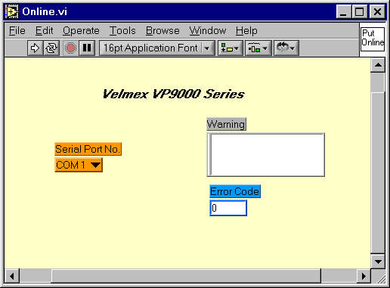
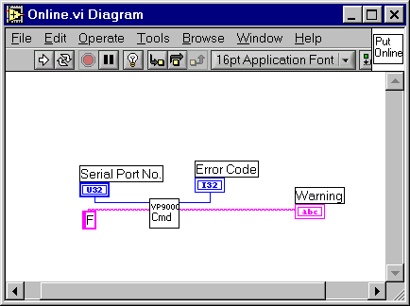
Figure 6a (left): This program puts the Velmex Controller on-line.
Figure 6b (right): Shows the diagram for the online program. By sending the “F” character to the Controller.

Figure 7a (left): This Program allows the user to enter a command line for the motor controller to execute.

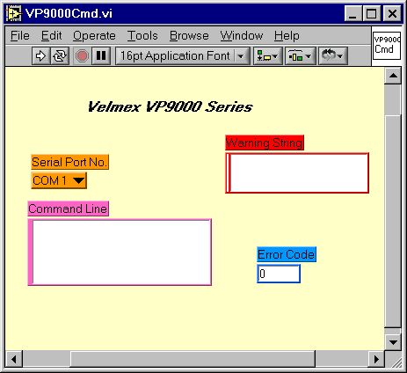
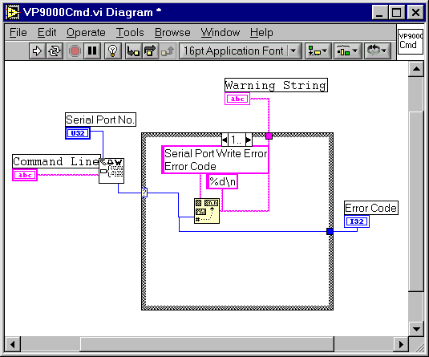
Figure 7b (right): Shows the diagram for the online program.
With the VP9000Cmd.vi program, users are able to input motor controller commands in the form of syntax strings. For example, to set the speed of the motor controller, the following command is used: SmMx, where little m is the motor # (1 in this case) and x is a numerical value from 0 to 8000 steps/sec. As seen in Figure 7a, there are warning and error indicators that relay to the user any problems that may arise, thus interrupting the LabVIEW session.
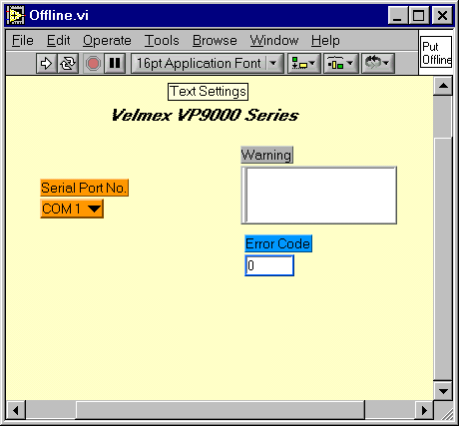
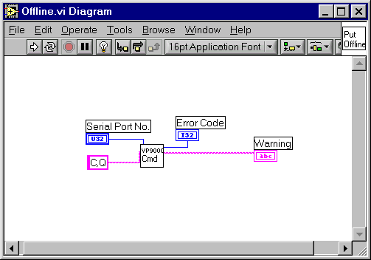
Figure 8a (left): This program used to deactivate the motor controller
Figure 8b (right): Shows the diagram to clear (C) and quit (Q) command session.
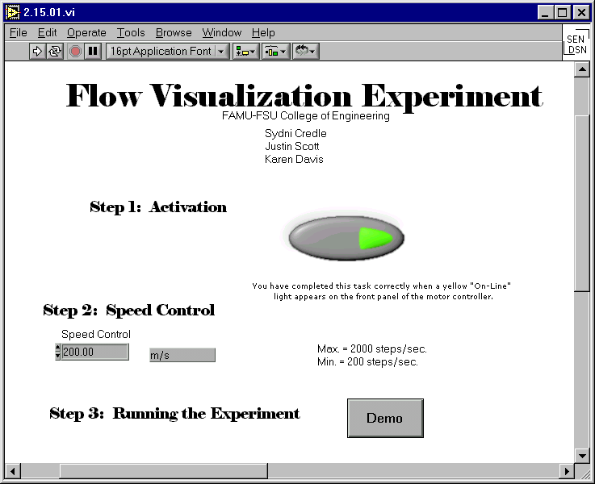
2.3.2 - Preliminary Control Program

Figure 9a: Front panel for the SeniorDesign.vi, incorporating all the functions to perform the experience.

For the Flow Visualization Facility project, the preceding programs for bring the system online (Online.vi), setting the speed (VP9000Cmd.vi), and Deactivation of the system (Offline.vi) were incorporated into one preliminary program called SeniorDesign.vi. (See Figure 9) With the SeniorDesign.vi program, all components needed for successful operation of the experiment were consolidated into one.

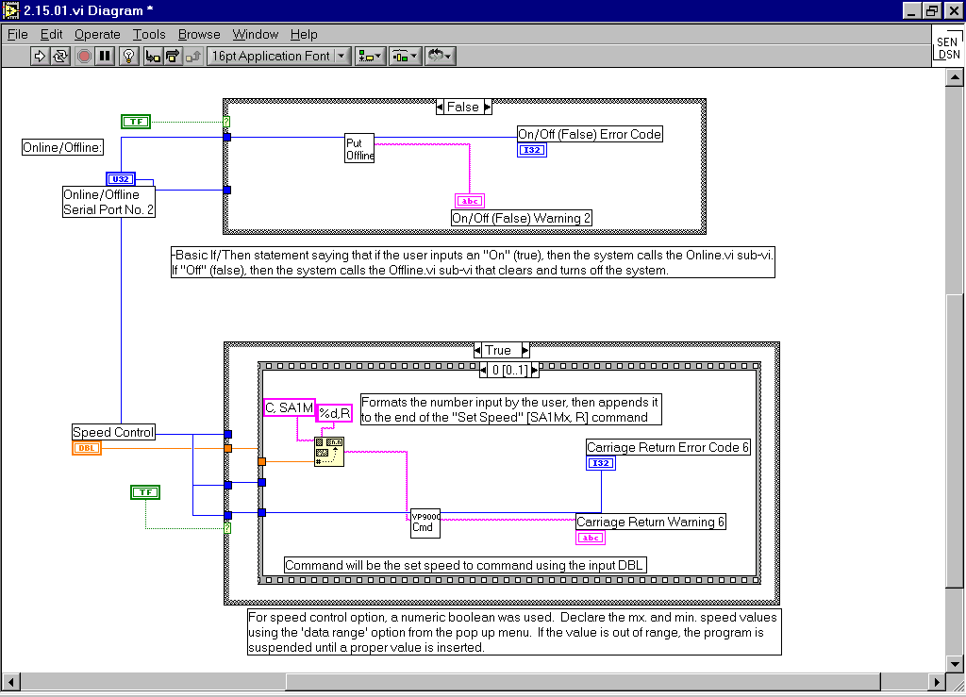

Figure 9b: Diagram of the SeniorDesign.vi.

2.4 - Global Variables and CGI Scripting

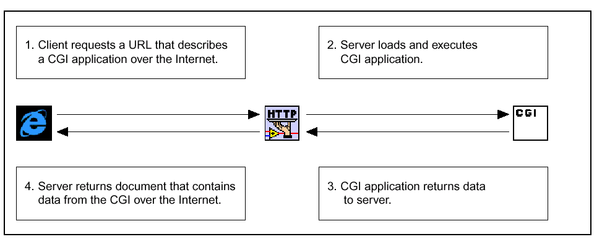
Figure 10: CGI Application Process.³

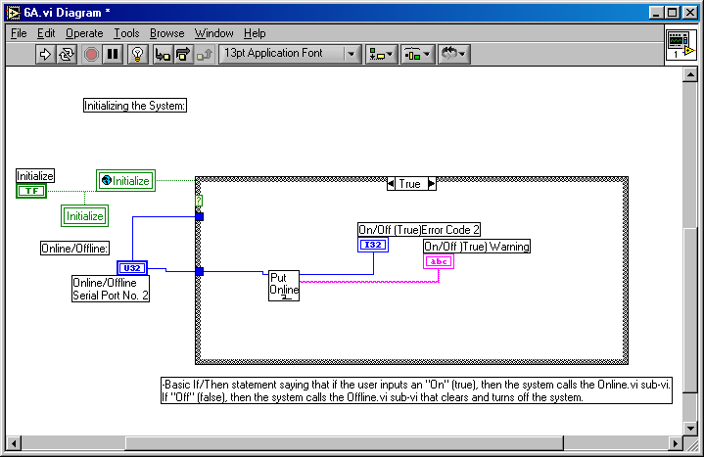

Figure 11: Is an illustration of the revised online program.

Figure 10 shows an illustration of just what happens programmatically between the LabVIEW and HTML during the remote access process.

Local variables provide a way to access front panel objects from several places in the block diagram of a VI in instances where one cannot or do not want to connect a wire to the object’s terminal.⁴ In Figure 11, the local variable is enclosed in the green triangle.

Global variables allow one to access values of any data type (or several types at the same time) between several VIs in cases where one cannot wire the subVI nodes, or when several VIs are running simultaneously. Global variables are similar to local variables, but instead of being limited to use in a single VI, global variables can pass values amongst several VIs.⁴ In Figure 11, the global variable is circled in red.
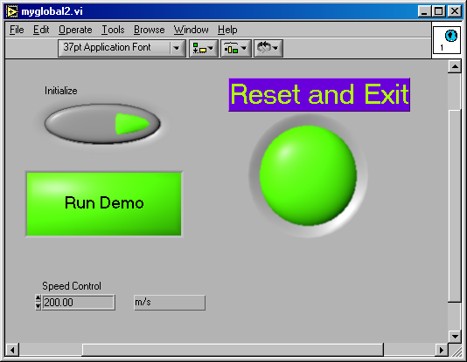

Figure 12: SubVI containing all global variables in the experiment.

All programs that require global variables are referenced to this subVI named myglobal2.vi. It contains all of the major buttons utilized by the client.

From the LabVIEW program 6A, there contains a reference to a subVI named Online2.vi, which is shown below in Figure 13.

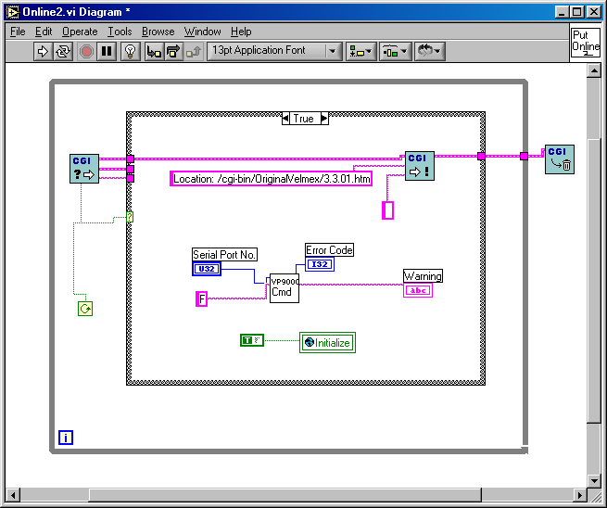

Figure 13: Shows the diagram for the subVI Online2, which is called from 6A, and includes CGI scripting, marked in red circles.

A CGI routine is any program capable of accepting information from a client (Web Browser), processing that information in some way and sending a response back to the client. For example, any webpage that contains HTML form elements-such as ring menus, text fields, radio buttons-and has a submit button for the user to press once the elements have been filled out uses a CGI routine to process the submission.⁵

The internet toolkit creates such CGI scripts in the form of CGI VIs, using standard G programming techniques. Figure 13, shows a CGI VI that reads the value of a radio button and relays the information to the respective LabVIEW program. Components that are circled in red are contained in every CGI VI. The left-most subVI is responsible for containing the environment and any content string submitted by the client and providing that information to the rest of the diagram. The next outlined subVI to the right is responsible for sending a response back to the client to be displayed in the browser. The last subVI frees the resources associated with this particular CGI call.⁵ Similar CGI programs for setting the speed and offline appear in Appendix A.

2.5 - Interfacing with LabVIEW Using a Web Browser

Viewing and controlling the various LabVIEW programs was made possible using the LabVIEW Interconnectivity ToolKit addon software. Remotely accessing LabVIEW control programs was achieved in the following way:

2.5.1 - Publish front panel of LabVIEW program using HTML.

In LabVIEW, select Tools>Options, select Web Server: Configuration and check the box to ‘Enable the Web Server.’ For Web Server: Browser Access and Web Server: Visible VIs type in an asterisk and click add. This will allow all users from all top addresses to see any VI that is running in memory. One can restrict either of these fields in the appropriate field. Click ok to save the settings and then totally close and relaunch LabVIEW so that the G Server is activated. To test for the correct configuration, type in the following URL: http://localhost/.snap?filename.vi. The running VI should be viewable from the same computer as the opened VI using this Web address. In order to view the front panel from another computer, simply replace localhost with host machine’s IP address.

Once LabVIEW programs are able to be viewed, the front panel is then able to be embedded into the source code of the HTML document. There are two options for embedding the front panel image; statically or dynamically. Static front panel images are obtained by using the .snap? argument. An example coding is as follows:

<HTML>
…
<IMG SRC=”.snap?FilePath.vi”>
…
</HTML>
Dynamic images are accomplished using the .monitor? code instead of .snap? An example of a dynamic HTML WebPages is as follows:

<HTML>
…
<IMG SRC=”.monitor?FilePath.vi”>
…
</HTML>

    - - Create HTML image map corresponding to root elements within program.

To successfully implement an image map into the HTML coding, the two major components that are needed are the IMG tags within the HTML document and the map information containing the coordinates.

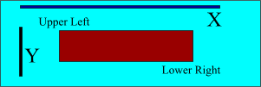

Figure 14: Illustration of how to get the proper layout coordinates.

Figure 14 shows the methodology for choosing the correct coordinates used for the ImageMap. As seen in Figure 14, X is considered the horizontal axis and Y is the vertical. The point (0,0) is the uppermost left corner and in the case of a 300X100 image, (300, -100) is the lowest right corner.⁶ An example of the source code needed for the image map is found below:

<MAP Name="buttons">
<AREA Shape="Rect" coords = "270,175,403,230"
HREF="/cgi-bin/OriginalVelmex/Online2.vi">
<AREA Shape="Rect" coords = "403,300,500,370"
HREF="/cgi-bin/OriginalVelmex/VP9000Cmd2.vi">
</MAP>

3.0 - Appendices

3.1 – Appendix A

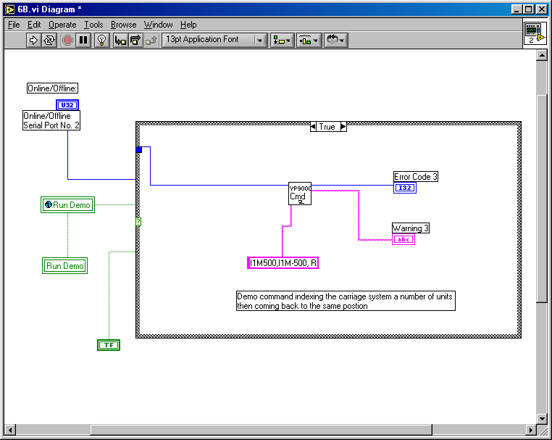

Figure A: The diagram used to run the demonstration.

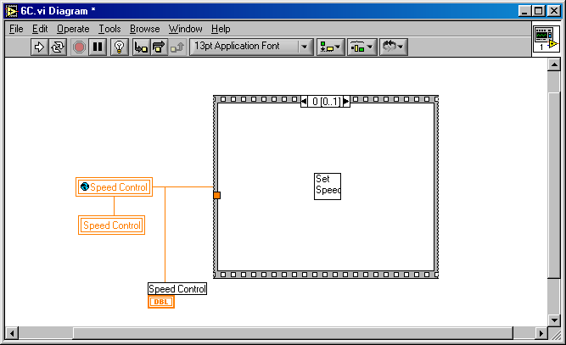

Figure B: Diagram used to set the speed specified by the client.

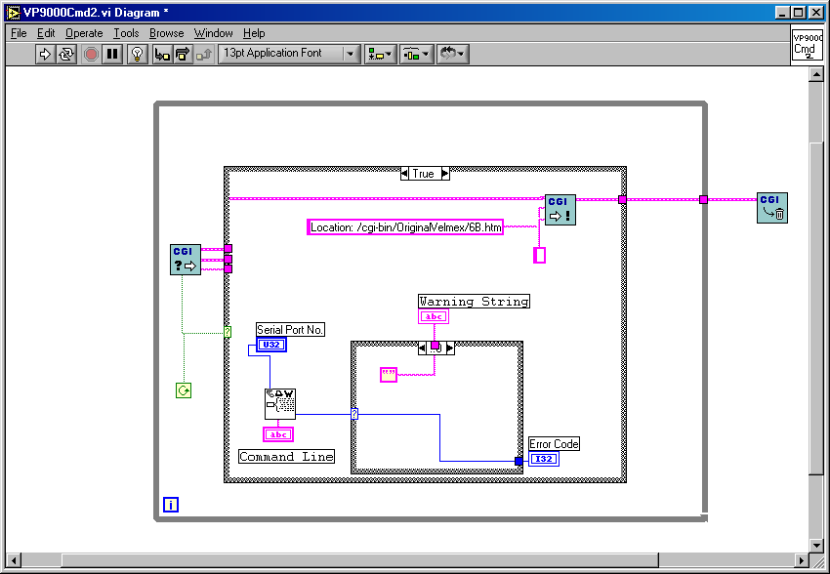

Figure C: VP9000 command with the CGI scripting.

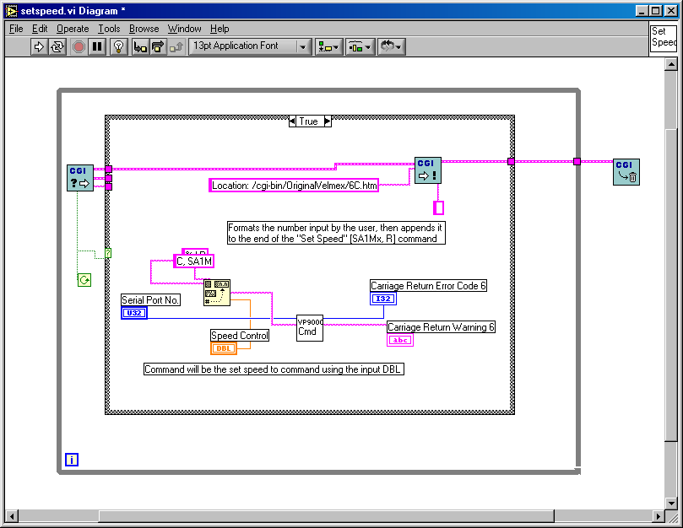

Figure D: Diagram of the set speed control program.

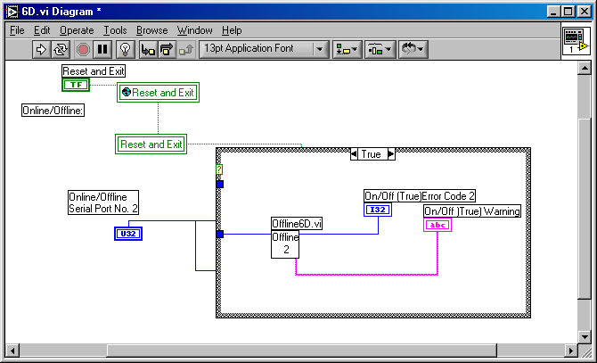

Figure E: Diagram used to deactivate the LabVIEW session.

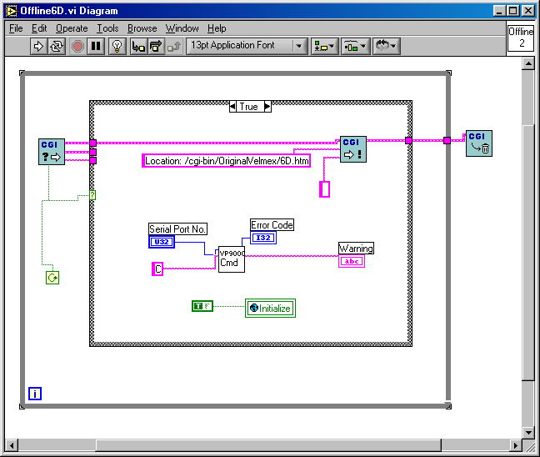

Figure F: The subVI used within the 6D program that includes the CGI scripting and global variables.

3.2 – Appendix B

LabVIEW Troubleshooting (Frequently Asked Questions)

- How come my LabVIEW front panel is not showing up in my web browser?

-The front panel not showing up can mean a few things. First, make sure the HTTP Server is running and configured properly. Second, the LabVIEW program you wish to view via the web must be ‘in memory’, meaning that the program must be opened already at the local host computer.

- An error comes up saying that one of the sub-VIs is running already. Why is that?

-Open the respective subVI by double clicking on the error message. Press the red stop symbol on the menu bar. This resets the program to initial settings.

- How do I dynamically control my LabVIEW programs using a web browser?

-See Interfacing With LabVIEW Using a Web Browser within the text.

- My .monitor? command is not working properly.

-Check the web browser platform. LabVIEW interfacing works best with Netscape Communicator 4.5. Other browsers such as Internet Explorer may not perform as well.

- My LabVIEW program is not responding to my user inputs.

-refer to question #1. And, check all physical connections between computer and experiment hardware.

- I can’t keep up with all the different programs that are needed.

-The creation of multiple LabVIEW programs including CGI scripting can seem overwhelming. The best advice, from programmer to programmer, would be to consolidate sub-functions. In LabVIEW, subVIs are referenced using a single icon. (see LabVIEW Basics) There is no point in confusing yourself visually with excess coding. Consolidate, consolidate, and consolidate.

- I want to make my own virtual laboratory, where do I start?

-Any endeavor needs a starting good game plan. Brainstorm and map out objectives clearly before even thinking of jumping into such a project. Thought put into a project beforehand saves time and frustration later on.

- I’m at my wit’s end! Things that are supposed to be working aren’t. What do I do?

-Consult with professionals. The technical service at National Instruments (the manufacturers of LabVIEW) is very good. Open a service request number for each problem that may arise. The technicians there will track your progress from beginning to end.
(1-800-IEE-E488)

- I don’t have CGI icons as options within my Functions menu?

-Try re-installing your Interconnectivity Toolkit. Perhaps it wasn’t installed correctly the first time. Call the technical resources at LabVIEW for more help (see question #8)

- I have general web publishing questions, where should I look?

-Web tutorials are all over the web. Just try typing keywords like HTML, Web publishing help, etc. into any search engine.

- Is there a separate manual for the Internet Toolkit for LabVIEW 6.i?

-The version of the toolkit available now, was produced with an earlier version of LabVIEW (version 5.1) and is still applicable for use with version 6.i. To our knowledge, there is no manual for the toolkit made especially for use with version 6.i.

4.0 - References

1. Wells, Lisa K. LabVIEW for Everyone Graphical Programming made Even Easier. Upper Saddle River: New Jersey, 1997.

- Velmex Incorporated, www.velmex.com, 2001.

- National Instruments Corporation, BridgeVIEW and LabVIEW: Internet Developer Toolkit for G Reference Manual, 1998.

- National Instruments, “Building an HTML with an Embedded VI Panel,” www.ni.com, 2000.

- National Instruments “Internet Toolkit Troubleshooting Wizard,” www.ni.com, 2000.

6. “ImageMap Tutorial”, http://www.bignosebird.com/imagemap.shtml, 2001.

Bottom of Form 1

