Background Information:
• Cummins has a fuel system distributor in production that seizes during overheating or debris ingestion.
• The warranty cost associated with the repair of the part is significant.
• Down time due to part failure is too long.


Senior Design Team Prototype- Operating Principles
During normal operation, a spring holds two disks at an angle (therefore not rotating relative to each other), transmitting torque to the rotor. At rotor seizure, a spring compresses, allowing the two disks to slip against each other, and results with the shaft spinning freely. The part geometry allows only one steady state angular orientation during normal operation.
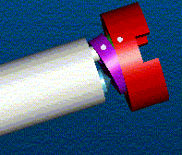
Customer Interim Solution:
A temporary coupling has been designed which is placed between the rotor and shaft. Shear pins in the coupling will break when disengagement torque is reached. It must be replaced after each seizure, and a high warranty cost is associated.
Design Objective:
Our goal is to design a mechanism that will enable the rotor to break away from the gear pump shaft when the rotor seizes and then re-engage at the same timing after seizure.
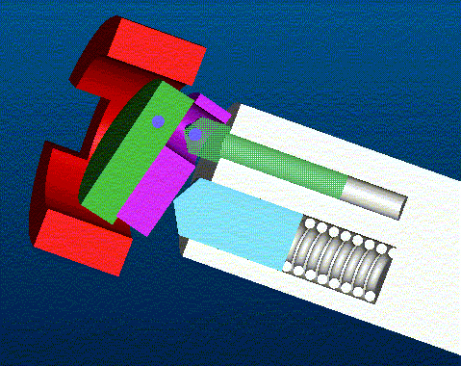

Concept Assembly Drawings

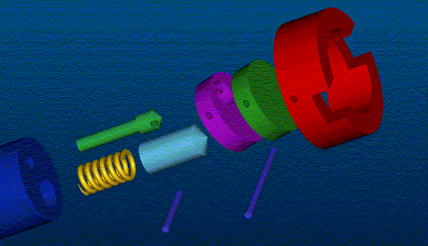
Team Members (left to right): Ben Nuttall, Michal Brown, Sean Edwards, Keron Miller.
Sponsor: Dr. Wayne Eckerle ,Cummins Engine Company.
Faculty Advisor: Dr. Farrukh Alvi

