Seizure Recovery System for Fuel System Distributor
Deliverable #2
Needs Assessment/Concept Selection

Senior Design Project – 2000/2001
Team #11

Michal Brown
Keron Miller
Sean Edwards
Ben Nuttall

Project Title: Seizure Recovery System for Fuel System Distributor

Sponsor: Cummins Engine Company

Background Information: A fuel system currently in production at Cummins Engine Company uses a distributor to route fuel from a high pressure accumulator to the engine cylinders. A gear pump powers a shaft, which drives a distributor that supplies fuel to the engine cylinders. At certain times due to either debris or overheating the distributor rotor seizes. The shaft then breaks to prevent progressive damage to the system. A solution to this problem must be found. Cummins currently is using a breakaway coupling to address this problem by reducing the repair cost, but there is a substantial warranty cost to the company associated with this.

Therefore, Cummins Engine Company proposes that a modification to the drive system of the distributor be designed to solve the problem. The intent of this modification is to disengage the drive rather than have the seizure cause the shaft to break. If at a given torque level the drive could rotate freely, and re-engage in the proper timing when the torque of the rotor fell below a certain value, then the distributor seizure would no longer be mission disabling. A modification of this kind would result in a reduction in the warranty repair cost per engine for the company.

Needs Assessment

Our objective is to design a mechanism that will enable the rotor to break away from the gear pump shaft when the rotor seizes and then re-engage when the rotor torque falls below a certain level, while maintaining the timing of the rotor upon re-engagement.

Target Specifications

Target disengagement torque of 30 in-lbs
Drag torque while disengaged should be less than 5 in-lbs
Must have a torsional fatigue life of 10 million cycles ±20 in-lbs
Must be able to disengage/reengage for at least 100 seizures without loss of torque
Must be able to reengage in the same angular position
Shaft alignment must be maintained
Wear resistance must be as good or better than the current design
Must be backwards compatible with the existing system, with the exception of the existing driveshaft. This implies that the new parts must occupy the same amount of volumetric space as the existing design; our design also must fit within the existing shaft-rotor connection.
Part must add less than $21 to the cost of the engine

Preliminary Concept Considerations

At this point in the design process there are several avenues we could pursue. The part could be mechanically actuated; or an electrical sensing device could be used to monitor the torque output of the shaft, with feedback to a controller. The customer has placed at our disposal an electrical engineer if we choose to go the latter route. We have begun the process of brainstorming, but due to our limited electrical and controls background, we have so far come up with purely mechanical solutions.

Concept #1: This concept involves two parts. One part will resemble a hollow cylinder (part of the shaft) with two small rounded protrusions on the inside wall. The second part will resemble a solid cylinder with two spring-loaded protrusions; similar to the beads found on common socket sets. Once inserted into each other, the protrusions will grip to provide sufficient power transfer during normal operation. Upon seizure of the distributor shaft the spring loaded protrusions will compress and allow the shaft to continue to rotate. Once the shaft has made one complete revolution the protrusions will come in contact again and attempt to turn the distributor shaft. If the shaft is still seized after this revolution then the process will repeat. A slight modification to this idea is also possible. Theoretically, if the spring-loaded protrusions were able to remain compressed for a set period of time then the shaft would be able to rotate freely until such time that the protrusions were re-engaged again

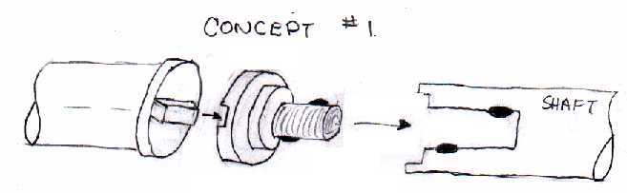
Figure 1. First concept, illustrated.

Concept#2: This concept would require a hole to be drilled in the shaft, and a spring-loaded part to fit between it and the rotor (the spring fits in the hole). The spring would hold the two parts together while rotating, but above disengagement torque the shaft would still rotate without the rotor.

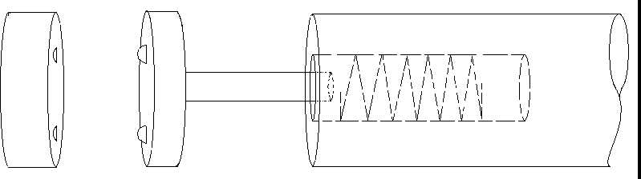
Figure 2. Second concept, illustrated.

Concept Selection

At this time a final concept decision has not been reached. The full extent of the problem statement was only recently fully understood, and therefore the team has not had
sufficient time to develop enough concepts to choose from. It is expected that as more concepts of the solution are developed, it will take only a minimal amount of time to decide on a final solution.

The concept selection will be determined by deciding which of the concepts best meets the target specifications, the most important of which seem to be the torque and size requirements.

Summary and Conclusion

The concepts that have been generated so far are preliminary ideas. It is expected that more concepts of possible solutions will be generated to provide a larger selection for a final design. It is expected that as consultation with the client progresses some concepts will be easily eliminated while others will need more refining. More research on mechanism design and power transmission couplings will be researched to gain ideas on alternate methods for solving this problem.

