

Seizure Recovery System For Fuel System Distributor

Guide to Fabrication and Assembly

Sponsored by: Cummins Engine Company

Michal Brown
Sean Edwards
Keron Miller
Ben Nuttall

April 3, 2001
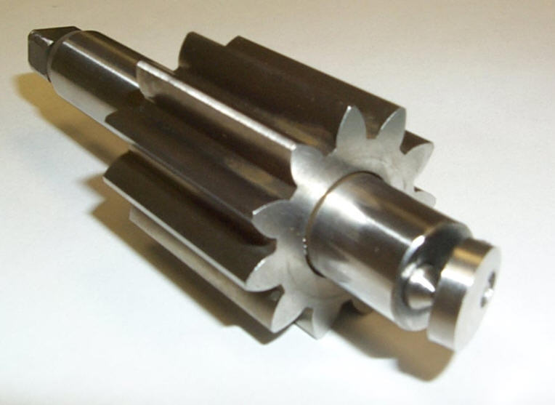
Introduction
This report includes all information needed to build a prototype of our concept. For each part, an overview of the machining process is provided, including tools used and, where applicable, the vendors we bought parts from. Also, the step-by-step assembly process we used is laid out. All manufacturing drawings can be found in the appendix.

Prototype manufacturing, by part
Part #1 - Coupling:
Please refer to drawing #1001 in the appendix
• The coupling was made from a ¾ in. steel rod
• The rod is shaved down to a diameter of 19 mm.
• The center is then hollowed out to a diameter of 12.70 mm(0.5") using a 1/2" drill bit and cut to a thickness of 7.15mm.
• The cross sections are cut out for gripping the distributor and the 1.0mm diameter hole for the pin is drilled. (See Appendix for hole placement and cutout size)
• Tools needed: grinder, lathe, milling machine, 1 mm drillbit, 1/2" drillbit, 3/16 endmill

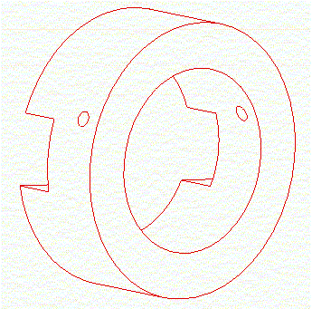

Part #2 - Disk 1:
Please refer to drawing #1002 in the appendix

• The disk is made from ½ in. stainless steel and shaved down to a diameter of 11.50 mm
• The disk is cut to a thickness of 3.0mm
• A 1.0mm pinhole is drilled through the disk at the location specified on the manufacturing drawing.
• Tools needed: grinder, lathe, mechanical saw, milling machine, 1 mm drillbit
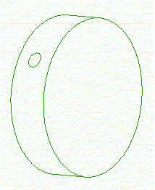

Part #3 - Disk 2:
Please refer to drawing #1003 in the appendix
• Disk 2 begins with a finished Disk 1
• A 3.97mm hole is cut through the face of the disk using a 5/32" drillbit; its centerline intersects with the centerline of the pinhole
- Tools needed: grinder, lathe, mechanical saw, milling machine, 1 mm drillbit, 5/32" drillbit
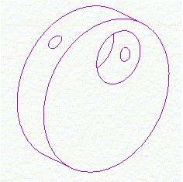

Part #4 – Shaft – Fuel Pump Drive:
Please refer to drawing #1004 in the appendix
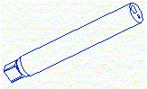
- The shafts from the original design of the fuel distributor can be modified to suit the new design.
- The end of the shaft nearest the distributor side is ground down 6mm to make the overall length of the shaft 90.86 mm. This creates a flat edge on the end of the shaft.
- Two holes are drilled into the flat end of the shaft. One 5 mm diameter hole is drilled at a distance of 2.5 mm from the axis of rotation of the shaft. The depth of this hole is 15.63 mm.
- A 2 mm diameter hole is drilled at a distance of 2.875 mm from the axis of rotation of the shaft. The depth of this hole is 15 mm.
- Tools needed: grinder, milling machine, 2 and 5 mm drillbits

Part #5 – Shaft Pin – Fuel Pump Drive:
Please refer to drawing #1005 in the appendix
- This is made from a stainless steel nitrided metric step pin, part number MS20-3-80, from the following company:
Dixie Industrial Supply
1105 Nandino Blvd
Lexington, KY 40511
Toll: (800)422-2616
Email: dix@lex.infi.net
- The end of the 2 mm portion is cut off to shorten the pin to 14 mm
- The 60 degree chamfer going from 2 to 3 mm is removed, leaving a 90 degree step
- A 1 mm through hole is drilled into the head of the pin
- The end of the pin is machined to a point
- Tools used: lathe, 1 mm drill bit
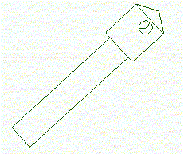

Part #6 – Spring – Fuel Pump Drive:
Please refer to drawing #1006 in the appendix
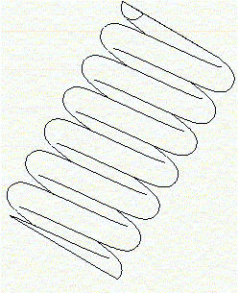
- Springs with the required size and spring constant can be ordered from:
Associated Springs
1705 Indian Wood Circle
Maumee, OH 43537
1-800-872-7732
www.asraymond.com
- part number C0180-032-0310:

Part #7 - Spring Pin – Fuel Pump Drive:
Please refer to drawing #1007 in the appendix
- The pin is made from a 3/16 stainless steel rod
- It is cut down to the 10mm overall length
- The 60 degree pointed tip is made using the tool bit on the lathe.
- Tools used: lathe
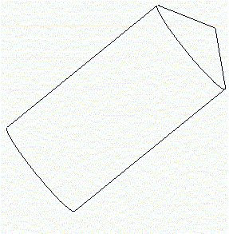

Part #8 – Pin:
Please refer to drawing #1008 in the appendix

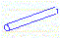
- This is a standard stainless steel dowel pin, which can be ordered from many industrial supply distributors.
- One such distributor is:
Metric Screw and Tool Company,
9 Lake Street
Wakefield, MA 01880
1-800-Metric-1
www.metricscrew-toolco.com
- The part # for this item if ordered from Metric Screw and Tool is 1A100VSMO/12771B-A1.

Part#9 – LongPin:
Please refer to drawing #1009 in the appendix
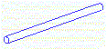
- This is a stainless steel dowel pin, however it is not a stock item with many suppliers. These pins can be custom made and ordered in large quantities from manufacturers such as:

Dowels, Pins & Shafts, Inc.
P.O. Box 1135
Dunedin, FL 34697-1135
727-461-1255
www.dowelspinsshafts.com

- The part # for this item if ordered from Dowels, Pins & Shafts, Inc. is MDK1-10
- Since this part could not be ordered in small quantities, the student design team had to improvise and decided to use the shank of 1mm diameter drill bits as replacements for this part in the design prototype.

Final Prototype Assembly
Please refer to drawing #1000 in the appendix

- Two assemblies of the parts described above need to be done to complete the overall assembly of the design prototype.
1.
- The first assembly involves part#’s 1001,1002, and 1009.
- Part #1009 (LongPin) is inserted through one of the drilled holes in part #1001(coupling), through part #1002(disk1) and then inserted through the other hole in part #1001. This will secure the small disk within the coupling

2.
- The second assembly involves part#’s 1003,1004,1005,1006,1007 and 1008.
- Part # 1005(ShaftPin) is inserted into the 2 mm diameter hole in Part #1004(shaft). The axis of the 1 mm diameter hole in #1005 is aligned perpendicular to a line connecting the centers of the 2mm and 5mm diameter hole in #1004(shaft). The part is secured in place using Loctite or any other suitable adhesive.
- Part #1006(spring) and #1007(springpin) are inserted into the 5 mm diameter hole of #1004(shaft). The pointed end of #1007 should protrude out of the hole slightly.
- Part #1003(disk2) is secured to Part#1005(shaftpin) with part#1008(pin) as shown in assembly drawing #1000.
- The assembly is correct and complete if the #1003(disk2) is held at an angle by the protruding end of #1007(springpin)

- The assembled shaft is then installed into the gear pump assembly in the same manner as the shafts used in the original design. The coupling assembly is then placed in between the distributor and the gear pump. The following are pictures of the assembled shaft and coupling:
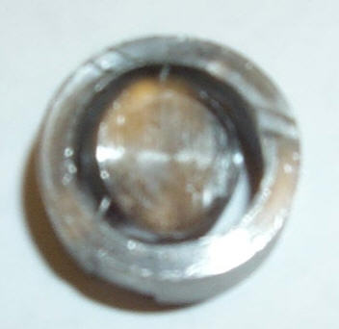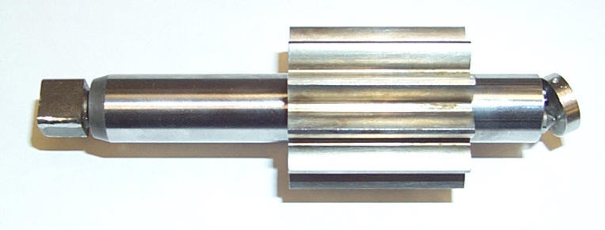

Appendix

Drawings

1000- ASSEMBLY, SEIZURE RECOVERY SYSTEM
1001 - COUPLING
1002 - DISK1
1003 - DISK2
1004 - SHAFT, FUEL PUMP DRIVE
1005 - SHAFTPIN, FUEL PUMP DRIVE
1006 - SPRINGPIN, FUEL PUMP DRIVE
1007 - SPRING, FUEL PUMP DRIVE
1008 - PIN
1009 - LONGPIN

