

Seizure Recovery System For Fuel System Distributor

Spring Semester Final Report

Prototype Test Results

Sponsored by: Cummins Engine Company

Michal Brown
Sean Edwards
Keron Miller
Ben Nuttall

April 5, 2001
TABLE OF CONTENTS
Introduction 1
Project Overview 1
Background 1
Design Process 1
Design Prototype Testing 1
Test Parameters 1
Test Setup 2
Testing Procedures 4
Results 4
Results from design team 4
Results from Cummins 5
Recommendations from Cummins 5
Analysis 5
Causes for failure 5
Other analysis that may have been helpful during the design process 6
Conclusion 6
APPENDICES 7
Appendix A -Design Request from Cummins
Appendix B - Scope
Appendix C - Specifications
Appendix D -Project Plan
Appendix E - Concepts (Sketch and description)
Appendix F - Calculations
Appendix G - Fall Semester Final Report
Appendix H - Spring Proposal
Appendix I - Patent Report
Appendix J - Guide to Fabrication and Assembly, (includes manufacturing drawings)
Appendix K - Class Presentations
Appendix L - Meeting Minutes
Appendix M - Email Correspondence (Fall and Spring)
Appendix N - Prototype Manufacturing Schedule
Appendix O - Industry Day Poster
Appendix P - Contents of attached CD-ROM

Introduction

As part of our senior design class, a design project has been completed. This report will briefly describe the problem, process used to come up with a design, and final concept we developed. It will also describe the experiments that were performed to see whether the design worked, provide the results that were obtained, and explain some possible reasons for those results.

Project Overview

Background
Cummins Engine Company has a design problem relating to their fuel system. The fuel system has a distributor rotor driven by a shaft. Occasionally, due to debris ingestion or overheating, the rotor seizes, and stress propagates along the shaft resulting in damage to components of the fuel system. To prevent this damage, a breakaway coupling, which shears during seizure, was installed between the shaft and rotor. However, a system is desired that will disconnect the shaft from the rotor while seizure is taking place, and then reengage the two once the rotor can turn again. The design statement as given to us by Cummins, including their specific torque and lifetime requirements, is given in the appendix.

Design Process
The design process as we followed it is long and drawn out, so a brief synopsis is provided here. If more information on this is desired, details of and reports from each step can be found in the appendix.

It was first necessary to take the design problem as presented by Cummins and restate it, specifying exactly what they needed and what was to be accomplished this year by the design team. Next, specifications for the design were determined, again mostly from the problem statement. On the project management side, a work breakdown structure and a schedule were decided upon and presented together as a project plan.

Concepts were created, by determining every possible method for performing each step by step task necessary to the problem solution and deciding which were feasible and which could be used together to create a design. Calculations were performed to decide which of these concepts would work the best, and a final concept was determined. Once the final concept was decided upon, manufacturing drawings were created and revised as necessary, and the design prototype was fabricated. Finally, testing was performed and results obtained, as described in the following sections.

Design Prototype Testing

Test Parameters
The testing of the design prototype is required to determine its suitability for use in the fuel distributor. The following functions of the prototype must be confirmed for the prototype to be a viable replacement for the current system in place:
- The prototype shaft and coupling assembly must transmit torque to the distributor effectively during normal operation of the fuel system (no seizures of distributor occurring).
- The prototype must transmit torque in both forward and reverse directions without loss of angular alignment during normal operation.
- During seizure of the distributor the prototype must disengage at approximately 30 in-lbs of torque.
- While in a disengaged position the system must continue to rotate with 5 in-lbs or less of drag torque.
- The prototype system must re-engage or attempt to re-engage after a 360-degree rotation of the fuel pump gear shaft.
- Upon end of seizure the prototype must re-engage and continue to transmit torque to the distributor effectively.

Test Setup
To test the functions described above of the prototype, the fuel pump and distributor provided to the design team by Cummins engine company is used. This is desired since the fuel pump and distributor are already set up to hold the prototype pieces in the exact positions required for their operation. The drawback to this test setup is that once all the pieces are in place and secured it is impossible to see exactly what is happening to the coupling and the shaft as shown in Figure 1.
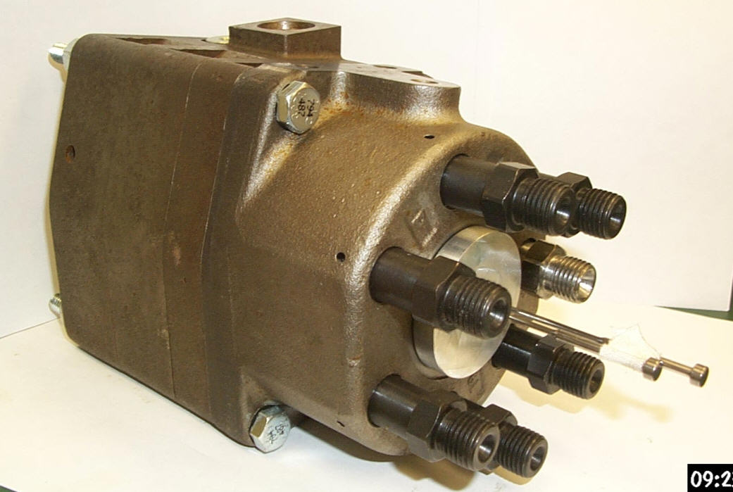

Figure 1

Alternative test setups were considered, such as fabricating pieces out of Plexiglas to hold the shaft and coupling in position and to allow for viewing through the glass. However it was determined that such a test setup would require very accurate machining and might lead to other unexpected problems with the test. A test method that would allow the team to use the existing fuel pump and distributor and to allow the team to determine if the distributor rotor was rotating was developed. The cap (shown in Figure 2) that secures the distributor rotor in place can be modified by drilling two holes through the part.

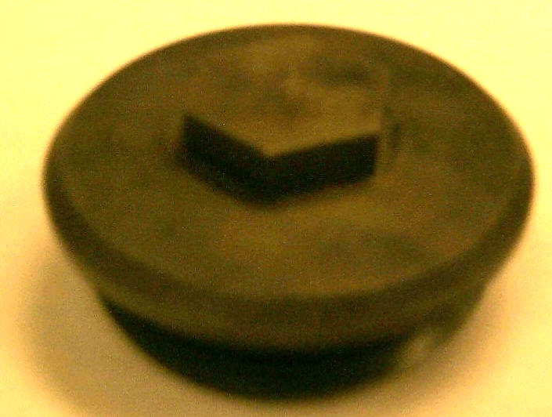

Figure 2
An attempt to modify the existing cap was made to allow for the two holes. However the cap material was extremely hard and drilling attempts were unsuccessful. A replacement cap to be used for the test was made from aluminum. The drilled holes will allow two pins to be inserted through the cap. One pin inserted through the center of the cap is secured with adhesive to the distributor rotor as shown in Figure 3.

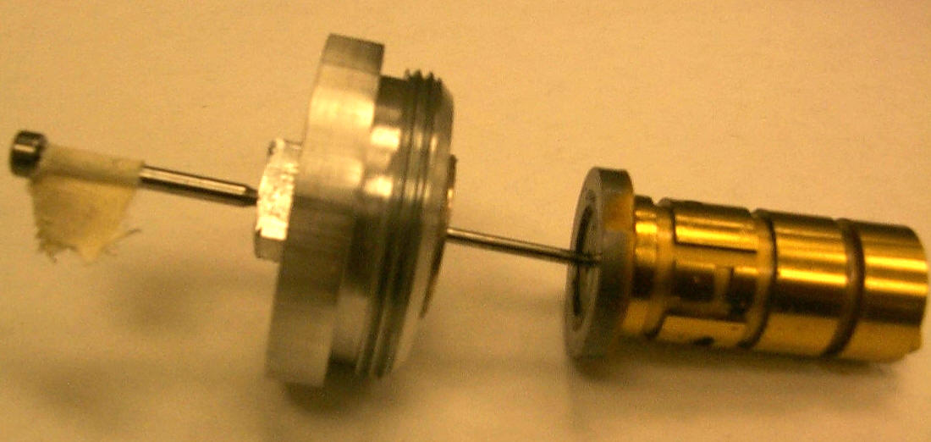

Figure 3
If the distributor rotor rotates within the distributor, the pin protruding from the cap will also rotate, and the motion may be observed. A second hole is drilled a specified distance from the center of the cap, and another pin can be inserted through this hole. The geometry of the distributor rotor is such that if this pin is inserted far enough the distributor rotor will not be able to rotate, just like during a seizure. The two together allow rotation to be observed and stopped at will.

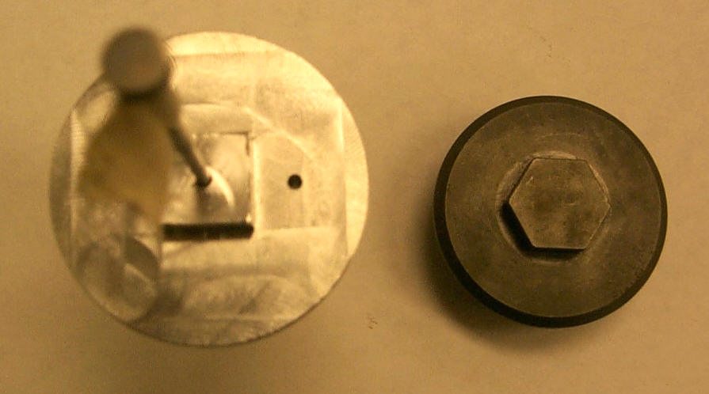

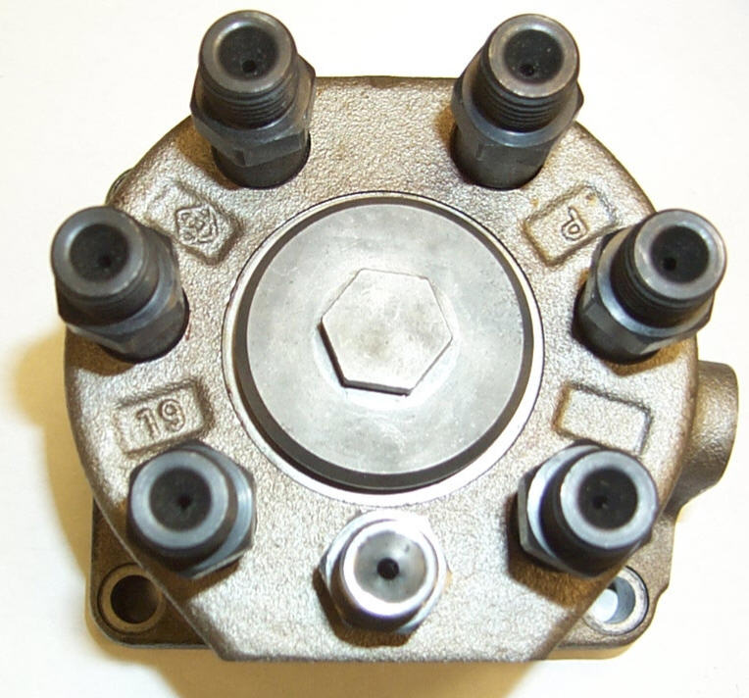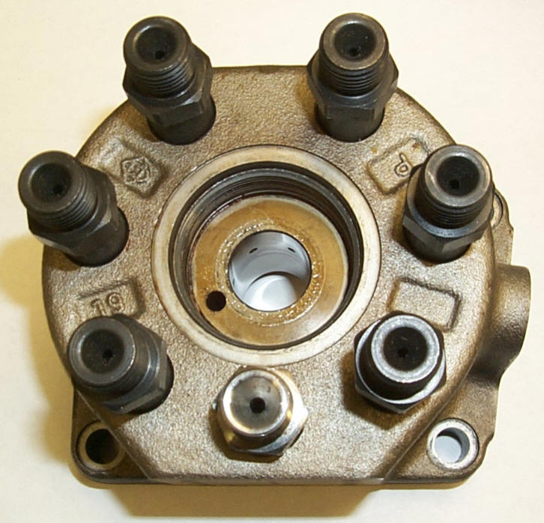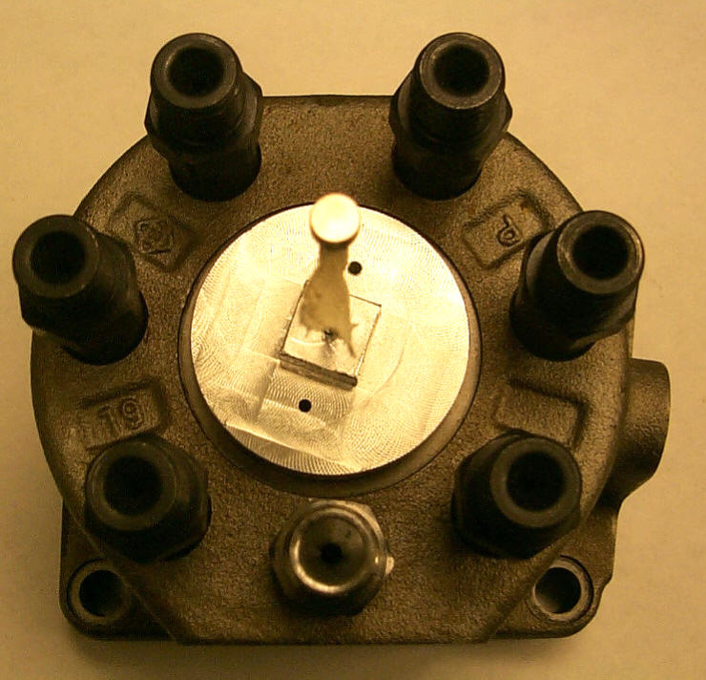

Figure 4

Rotation of the fuel pump shaft is accomplished by a 10 mm socket and ratchet. The socket will fit on the end of the shaft which extends out of the fuel pump. The socket can be added to a torque wrench which will allow for testing of the disengagement and drag torque.
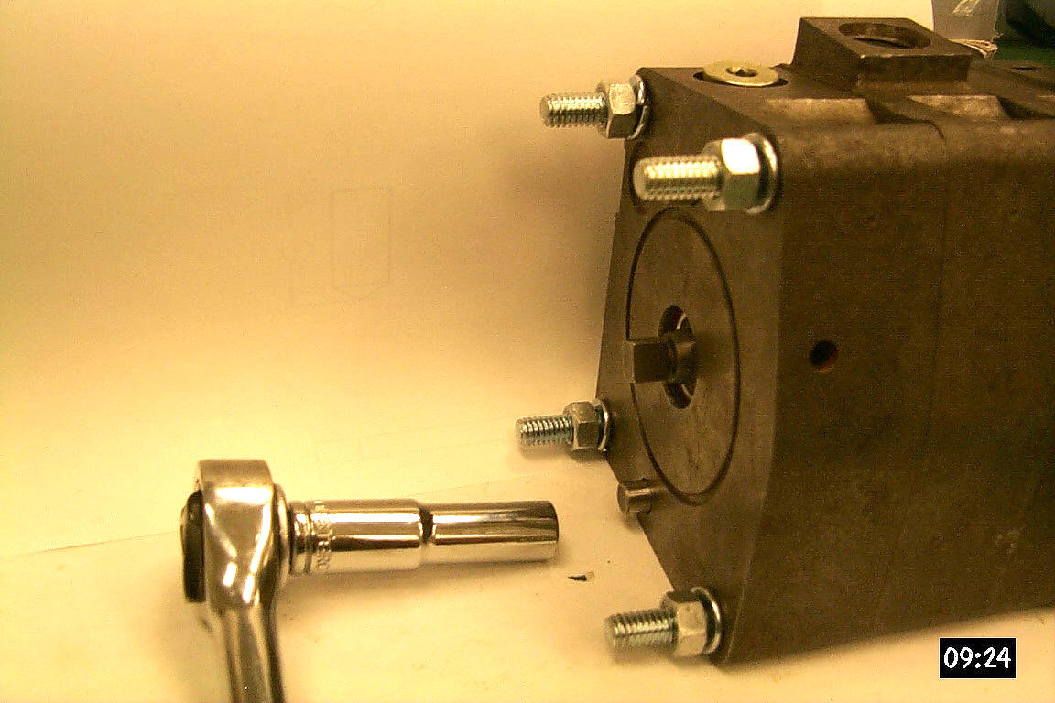

Figure 5

The original gear pump is disassembled. The shaft is removed from the fuel pump, followed by installation of the prototype shaft in the same position as the original shaft. This process is shown in Figure 6.

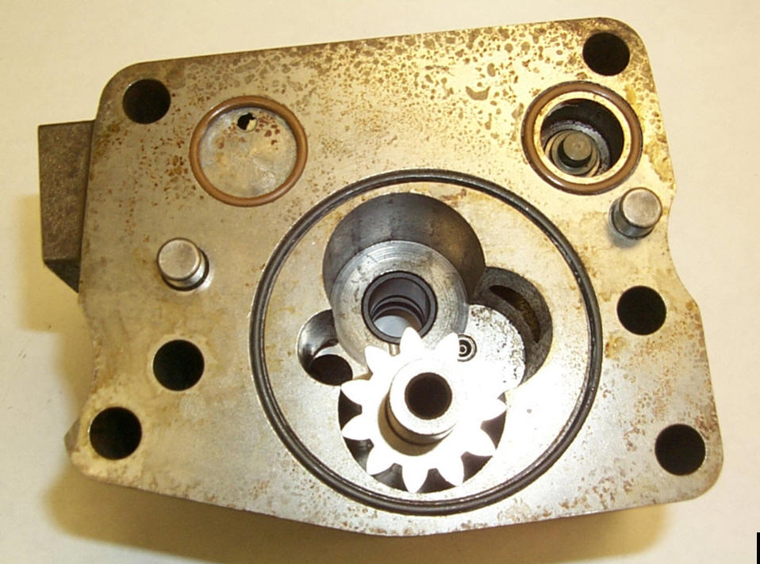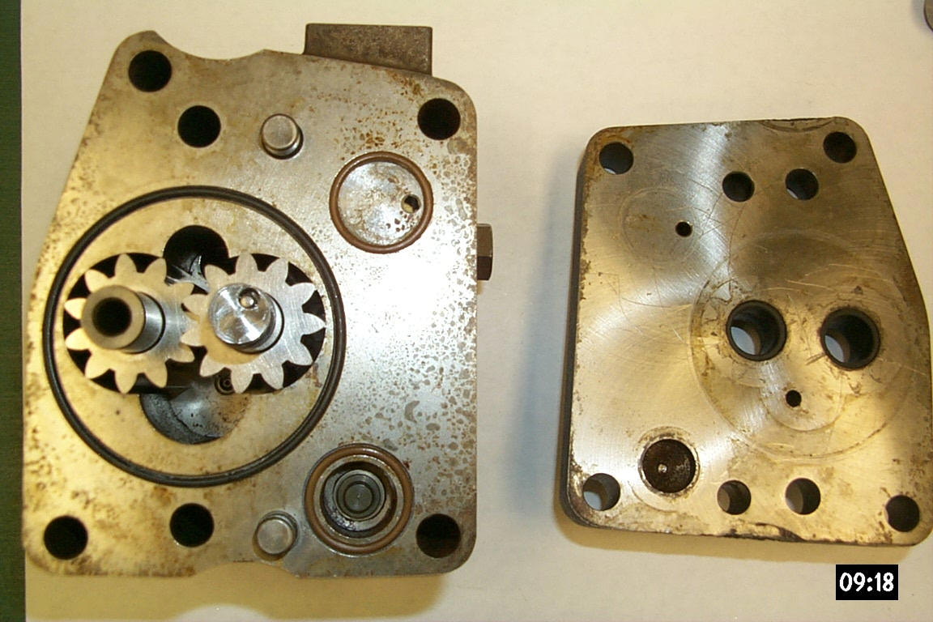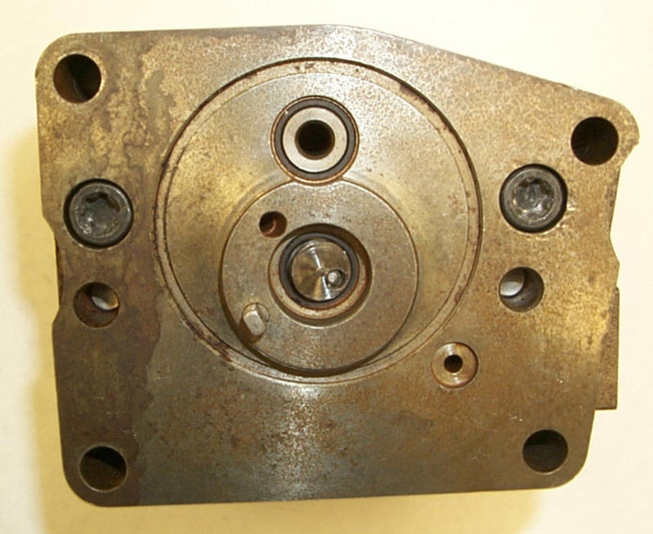

Figure 6

The gear pump is then reassembled securely. The coupling assembly is then placed between the fuel pump and the distributor such that the notch in the coupling aligns with the protrusion on the distributor rotor (see Figure 7).

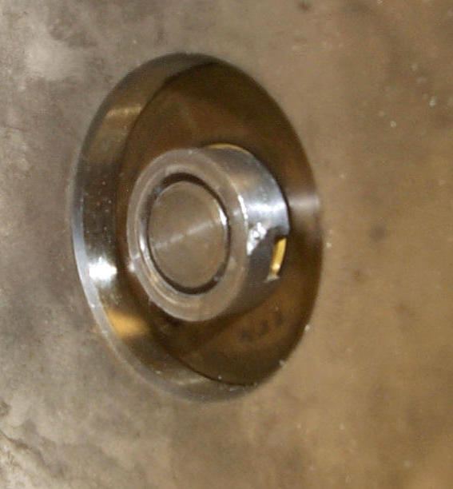

Figure 7

The coupling and rotor are then rotated by hand to align the pivoting axis of disk 1 and disk 2. Once aligned, the fuel pump and distributor are held firmly in place by hand and then secured with 4 bolts.

Testing Procedures
Each of the desired functions of the prototype is tested according to the following procedures:

- To test for the transmission of torque to the distributor rotor during normal operation, rotation is simply applied to the end of the shaft with the 10 mm socket and ratchet. Observation of the pin extending from the distributor side of the setup will indicate whether the distributor rotor is rotating. If the pin is rotating then torque is successfully being transmitted by the prototype tot he distributor. If the pin is not rotating, then the prototype is not transmitting torque to the distributor.
- A test for torque transmission in both forward and reverse directions is similar to the above procedure. Apply torque in one direction and check the pin for rotation. Then apply torque in the reverse direction and check for rotation of the pin. To check for angular alignment during a direction reversal, determine if the pin requires a certain amount of rotation by the ratchet before the rotor begins to turn again immediately following the direction change.
- To test the desired disengagement torque of the prototype, first insert the second pin into the distributor cap to provide a condition similar to a seizure. Set the torque wrench at a low setting (such as 20 in-lbs) and attach it to the end of the shaft. Attempt to rotate the system by applying pressure to the torque wrench. If the torque wrench disengages before the prototype while set at 20 in-lbs, then it is clear that the prototype is still capable of transmitting torque up to 20 in-lbs. Repeat the procedure, but increase the setting on the torque wrench to 21 in-lbs. Keep repeating the procedure and increasing the torque setting until the coupling within the setup disengages instead of the torque wrench.
- To test the level of drag torque while disengaged, disengage the coupling as in the above step. When the coupling has disengaged, set the level on the torque wrench to 1 in-lb. The torque wrench should disengage similarly to the above step. Increase the level on the torque wrench until it no longer disengages. This should give an approximate reading of the drag torque while the system is disengaged.
- The prototype should attempt to re-engage after 360 degrees of rotation after the initial disengagement. To check this, disengage the coupling as in step 3. Take note of the position of the wrench at the moment of disengagement. Keep turning the wrench about 360 degrees. The torque on the wrench should increase at this point. If it does then the system is re-engaging in the proper position.
- To test if the prototype will continue to transmit torque after the end of a seizure, disengage the system as described in step 3. Remove the pin preventing the distributor rotor from rotating. Continue to rotate the shaft using a wrench. The system should re-engage and continue to transmit torque. Check the pin secured to the distributor rotor. If it is rotating then the system has effectively resume normal torque transmission.

Results

Results from design team
When performing step 1 in the testing procedures outlined above, no movement of the test pin was noticed. This indicated that the disks were not transferring any torque to the pump shaft – a problem.

The shaft was then turned by hand so that we could feel what was happening. As one rotation of the shaft was completed, it first became progressively harder to turn the shaft, until it reached a short plateau of difficulty. Then it was as if an obstacle was passed, and it turned fairly easily for the remainder of the rotation. The cycle was repeated for each rotation. We hypothesized that either the disks did not have a good contact, allowing one to slip relative to the other; or the surface of the disks were contacting, but the angle of the disks was not large enough to force them to turn as a connected unit.

We were unable to get torque propagation in either direction; all other tests, which tested for disengagement and reengagement torque levels, were superfluous since there was no initial engagement to speak of.

Results from Cummins
The prototype that was sent to Cummins was subjected to a number of tests, all with the specific intent of observing how well the torque could be transferred from the driver side to the driven. Mr. Thomas Yeager at Cummins oversaw the testing process. He attempted to perform the following experiments:
- Bench Testing
- Assemble test setup and bench test to verify rotor drive.
- Lock rotor and determine torque to turn.
- Rig Testing
- Run the assembly on full pump rig and simulate a rotor seizure.

Mr. Yeager first ran into difficulties during initial assembly; there seemed to be some problem with the dimensioning as he found it difficult to phase the shaft, coupling, and rotor together so that the rotor would be fully seated in the distributor bore. The 40 mm plug for the distributor (which we think goes in place of the cap over the rotor - from Mr. Yeagers latest email it appears that this is just the cap that screws into the end - there are no specific modifications to it) was installed at a low torque value, but the drive shaft of the gear pump still would not turn the rotor freely. There was axial load present. Much like we did at our on campus testing Mr. Yeager tried a number of installations to see the best way to phase the components, but even after the best case phasing was established no transferal of torque was detected. As the torque on the gear pump was increased the shaft pin component was damaged as well as the pin bore. The shaft pin was straightened and a second attempt was made to perform bench testing on the design; this too proved to be unsuccessful.

The second test was also attempted, but was unsuccessful.

Recommendations from Cummins
Mr. Yeager suggested that we do the following:
- Measure the nominal distance from the gear to the coupling on the prototype that we kept and compare it to the dimension that he sent to us, 24.12mm.
- We did this, and got 25.58mm. We sent him email about this and from his lastest email, the difference between these two values indicates that the prototype assembly is too long, resulting in axial compression of the components during any installation attempt
- Repeat the bench testing on the prototype here, send to him if successful for further testing.

Analysis

Causes for failure
A number of factors may be the cause for the inability of our product to function during testing. Errors in calculations, manufacturing, or theory are possible causes for our final result.

An oversight during analysis in the early stages of design may have carried through the design process undetected. Calculations were reviewed and revised before made final, but errors may have still remained. Perhaps the angle of the disks was too small to allow for adequate torque transmission. Potentially the spring could also have been too weak. One other cause may lie in false assumptions. As with all designs certain assumptions are made and some may have been invalid.

The manufacturing stage of our product was completed by our team and not by machinists. Slight differences in the size of certain parts during machining will cause the product not to piece together properly. Since the parts were manufactured by hand, each part will never be the exact size as expected in our calculations. When dealing with pieces the size of our prototype, marginal errors can equal large problems.

Upon measurement of the design prototype it appears that the end of shaft with the disk and spring assembly protrudes too far out of the gear pump housing. This results in axial compression of the prototype components during assembly. This may have an adverse affect on the ease of rotation of the coupling.

One prototype assembly of the coupling had an overall assembled thickness greater than the design thickness due to the location of the installed disk. The disk was either too thick or the location of the pivoting axis hole was offset on either the coupling, disk or a combination of both. This oversized condition would also contribute to the problem of axial compression. Since axial compression is present it is difficult to say why the system was not able to transmit torque. The two disks were clearly in contact with each other.

Another possibility might be that our theory as a whole is not valid and other errors aside, the product would still not function. The torque limiting aspect of the design prototype appears to work effectively, since the system transmits no torque at all. It appears there is not enough contact area between the shaft and the coupling to transmit torque effectively. The system appears to be too ‘slippery’; there is simply not enough area on the coupling for the shaft to 'grab'. It is our belief due to our intense analysis and calculations that the theory is sound.

Although each of these reasons alone may be at fault for our product not functioning, it is more likely that a combination of these are the cause. The inefficiency in manufacturing puts more stress on other parts of our design process to be exact. If our calculations are incorrect in any way, the errors in machining could cause them to lose their validity.

Other analysis that may have been helpful during the design process
- A larger scale test prototype of the design could have been constructed. Tests on this large system could have been performed which may have been able to demonstrate the key operating principles behind the design. Problems with the design may have been detected earlier and appropriate changes to the geometry could have been made.
- More complex computer simulation programs could have been used to test the design before it was built. If the computer simulation indicated the concept would work, finite element analysis software may have been useful in determining weak components in the design.
- More suitable manufacturing methods could have been used to make the parts. The components needed for the design are extremely small. Perhaps someone specialized in micro-machining could have been contacted to build the parts for the design team.

Conclusion

Testing of the prototypes yielded results that indicate the design is unsuitable for use with the Cummins fuel system distributor. However, this may be due to inexpert prototype fabrication and not integral problems with the design. No further adaptations to the current prototypes or testing are planned at this time. As a solution to the original design problem it is suggested that alternative concepts be pursued by the client. The failure of the design prototype is disappointing to the design team; however, the team was successful in pursuing the steps associated with a design process and gained a lot of experience in project management. Experience in ordering materials and tools, as well as in machine shop operations, was also gained by members of the design team. These skills will be valuable in future engineering endeavors.

APPENDICES

Appendix A -Design Request from Cummins
Appendix B - Scope
Appendix C - Specifications
Appendix D -Project Plan
Appendix E - Concepts (Sketch and description)
Appendix F - Calculations
Appendix G - Fall Semester Final Report
Appendix H - Spring Proposal
Appendix I - Patent Report
Appendix J - Guide to Fabrication and Assembly, (includes manufacturing drawings)
Appendix K - Class Presentations
Appendix L - Meeting Minutes
Appendix M - Email Correspondence (Fall and Spring)
Appendix N - Prototype Manufacturing Schedule
Appendix O - Industry Day Poster
Appendix P - Contents of attached CD-ROM

Appendix A – Design request from Cummins

Appendix B - Scope

Appendix C - Specifications

Appendix D -Project Plan

Appendix E - Concepts (Sketch and description)

Appendix F - Calculations

Appendix G - Fall Semester Final Report

Appendix H - Spring proposal

Appendix I - Patent report

Appendix J - Guide to Fabrication and Assembly, (includes manufacturing drawings)

Appendix K - Class Presentations

Appendix L - Meeting Minutes

Appendix M - Email Correspondence (Fall and Spring)

Appendix N - Prototype Manufacturing Schedule

Appendix O - Industry Day Poster

Appendix P - Contents of attached CD-ROM

