Solar Car Body Design: Phase I

Project: 3D Solar Car Body
Group Members: E. G. Prather, K. Sampson, R. Taylor
Customer: Dr. T. Harrison
Date Due: 29 November 2001
Course: EML 455/21, Senior Design
Instructor: Dr. C. Luongo
WBS: 4.1.5.0

Table of Contents
Abstract 1
Note 2
Background 3
Design Process 5
Point Gathering 5
Point Importation 6
Modeling 7
Sectioning 11
Creating Engineering Drawings 13
Summary 15
References 17
Appendix A: Schedule 18
Appendix B: Clarifications 19
Flow Analysis 19
Quantity of Interpolation Points 19
Appendix C: Formal Advisor Contact 20
Appendix D: Engineering Drawings 22

Abstract
The creation of solar car teams at North American Universities has increased in frequency as governing bodies such as Formula Sun have organized more and more events. The Florida A&M University-Florida State University College of Engineering Solar Car Team was established in 1997 with construction of its first car. Currently, new standards regulating solar car body size are being implemented and a team was formed to generate a three-dimensional model from two-dimensional sketches drawn in previous semesters. Once created, this model would be used to create cross-sections used by the solar car team in the solar car manufacturing process.
The project was divided into five phases: point gathering, point importation, modeling, sectioning, and creating engineering drawings. First, the team created an Excel spreadsheet to organize the interpolation points. Next, a pair of Pro/E sketch files were drawn, one for the centerline section and the other for the edge section. After the sketch files had been created, they were imported into the sketcher when making a blend in a Pro/E part file. Then the model was used to generate the appropriate cross-sections required by the customer, Dr. Harrison. Finally, these cross-sections were used to make engineering drawings using Pro/E and AutoCAD (see attached Drawing Package).

Note

- It is recommended that readers use www.eng.fsu.edu/ME_senior_design/2002/folder11/3dscb_final_report_fall01_figures.ppt to refer to the figures referenced in this report.
- It is recommended that readers use www.eng.fsu.edu/ME_senior_design/2002/folder11/3dscb_autocad_package_fall01.ppt to view the engineering drawings created by the 3D Solar Car Body Team.

Background
Solar car races vary in duration from a sprint for several laps around a track to a cross-country marathon. This year’s FAMU-FSU College of Engineering Solar Car Team wishes to compete at the Formula Sun race in Topeka, Kansas, which takes place during May. The solar car body design team was formed to complete the design of a new solar car body because Formula Sun will require that the New International Standard (NIS) be met by 2003, which makes the current body design illegal. The NIS stipulates that the body may be at most 5m long, 1.8m wide, and 1.6m in height. This project involves generating a three-dimensional model of new solar car body from two-dimensional drawings using Pro/Engineer (Pro/E).
Students in previous solar car classes used a flow analysis program called Visual Foil 4.0 to perform a longitudinal analysis of airfoil data. Centerline and edge shapes for the new solar car body were then developed from this analysis. The program begins with a two-dimensional curve in a basic wing shape that the user can manipulate. As the curve is changed, the lift and drag coefficients change accordingly. When creating the centerline shape, the students first added the canopy region of the body to accommodate the chassis and driver. Then the remaining portions of the curve were adjusted until the lift and drag were as close as possible to zero. The edge shape was created in a similar fashion. These shapes were then transferred to a separate AutoCAD file.
Modeling the solar car’s body using Pro/E allows that model to be cut cross-wise into sections. These sections are necessary to fabricate the car’s design plug. The plug is a wooden framework that is filled with foam pieces (see Figure BG-1). This foam is then carefully shaped and coated, forming a male mold (see Figure BG-2). Once this male mold has cured and is sufficiently hard it is covered with fiberglass, which is then allowed to harden. The fiberglass shell is then cut into two pieces and removed from the male mold (see Figure BG-3). The fiberglass shell becomes the final mold needed to fabricate the solar car body. The pictures shown in Figures BG1 to BG3 are some of the materials used to create a 1:15 scale model (see Figure BG4).
Dr. Harrison supplied the team with the AutoCAD file containing the two shapes developed from Visual Foil 4.0. The first section is a representation of the edge of the solar car and the second section is a representation of the centerline of solar car (see Figure BG-5). The team must use Pro/E to generate a surface or a solid from these cross-sections, which involve importing either AutoCAD drawings or sets of data points from Microsoft Excel. The curvature of the surface of the solar car body must be very gentle to accommodate the laminated solar cells, which convert solar energy to electrical energy.
Ideally, the drag on the car should be zero, but that is generally impossible to accomplish. The lift on the car should also be zero. Allowances to accommodate a chassis must also be considered. The customer supplied the team with official regulations as stated by Formula Sun to use as guidelines (www.formulasun.org). The customer would like to have the appropriate cross-sections finished by the end of the Fall Semester 2001. Provided that the three-dimensional model and corresponding cross-sections are completed during Fall 2001, further design work regarding the chassis will begin during Spring 2001.

Design Process
The team began by meeting with the customer at the beginning of the semester to further clarify the scope of the project as stated above. The function analysis, concept generation and selection steps of the design process did not appear to apply to the project in a literal sense because all of the ideation and iteration regarding the sections had been done already. The group decided that the best method of modeling the solar car body would be to use the given cross sections as the sections of a blend. According the Pro/E Help File Index: “A blended feature consists of a series of at least two planar sections that Pro/ENGINEER joins together at their edges with transitional surfaces to form a continuous feature” (1). The blend feature is useful when one must generate a surface between two cross-sections that have different shapes.
For example, a blend can be used to make a funnel by using three circular sections of diameters ten, eight and two units. The funnel shown above is an example of a smooth blend. There also exists a straight blend. If the Straight option were chosen instead of the Smooth option when modeling the funnel, there would be straight lines drawn between sections instead of smooth lines (see Figures DP-1 to DP-3).

Point Gathering
The team was given an AutoCAD file containing the centerline and edge shapes. To avoid inputting each interpolation point manually, attempts were made to create a table of interpolation points from each spline. No method of generating a table could be found and each interpolation point was input manually. To do this, each spline curve was exploded into smaller curves, each of which is defined by three points. These points were then manually entered into a Microsoft Excel spreadsheet so they could be easily organized. Additionally, it was thought that Pro/E might have been capable of importing points from an Excel file to use as interpolation points for a spline curve.

Point Importation
The team began by opening a new sketch file in Pro/E (see Figure PI-1). It was noted that the noses of the centerline and edge shapes were not coincident at the origin (see Figure PI-2). It can be seen that the nose of the edge shape lies 185mm to the right of nose of the centerline shape. A reference frame was created so that the shapes could later be offset when inserted as blend sections in the Pro/E part file. To create this reference frame, perpendicular centerlines were drawn (see Figure PI-3).
After much trial and error, it was found that the best method of creating the spline was to draw an arbitrary spline and later insert additional interpolation points and dimension them from the reference frame. A spline is a curve drawn through a set of interpolation points. It is possible to edit the location of interpolation points of the spline by clicking the Defining Dimension button (see Figure PI-4). An arbitrary spline curve was drawn through four points as shown in Figure PI-4. The shape was stretched to its actual length of 4847mm before inserting and dimensioning any additional interpolation points. To do this, the gray, horizontal dimension of 14.22 (see Figure PI-5) displayed by Pro/E was double-clicked and a value of 4847 was entered (see Figure PI-6).
Experience showed the team that dimensioning the spline to approximately its full size would make inserting and dimensioning additional points easier. It was decided that the four points used to make the arbitrary spline should be dimensioned to be (0,0) (2030,570) (4847,6) and (1954,-173). In order to dimension an existing interpolation point, the team clicked on the interpolation point and then clicked on the vertical centerline. To place the dimension, the mouse was moved the interpolation point and the vertical reference and then center-clicked. The horizontal and vertical dimensions displayed by Pro/E were edited as explained above (see Figure PI-7).
It was decided to use every tenth point recorded from AutoCAD as the initial set of interpolation points because dimensioning each of the 394 points recorded from AutoCAD would have made the sketch files cluttered. Pro/E uses a pair of linear dimensions to display the position of each interpolation point relative to the reference frame instead of displaying each point’s position as an ordered pair of coordinates (e.g. (x,y)). The team felt that the overall shape would be faithful to the AutoCAD drawings, despite having one tenth of the interpolation points.
To insert additional interpolation points, the team double-clicked the spline curve. The dialogue box shown in Figure PI-8 appeared and the team clicked the Add button (see Figure PI-9). Then every tenth interpolation point was added and dimensioned. The initial centerline and edge shapes closely resembled the respective shapes in AutoCAD. To make the sketch files more accurate, the team added every fifth interpolation point. The team was still not satisfied with the canopy and nose regions of the shapes despite the increased accuracy yielded by adding every fifth interpolation point. The team decided to add all of the interpolation points around these areas of more extreme curvature (see Figures PI-10 and PI-11).

Modeling
A new part file was created and named. The units of the file were changed to millimeters. A blended protrusion was created. The sketch file containing the edge section was inserted, aligned vertically with the sketcher’s reference frame, and offset 185mm right of the sketcher’s reference frame. The section was toggled and the centerline section was inserted and aligned vertically and horizontally with the sketcher’s reference frame. The section was toggled once more and the second edge section was inserted, aligned vertically with the sketcher’s reference frame, and offset 185mm to the right of the sketcher’s reference frame. The sketch was finished, and Pro/E prompted the team to enter distances for Section 2, the distance between the first edge and the centerline, and Section 3, the distance between the centerline and the second edge. To allow for manufacturing error, a total width 1760mm was selected. Thus, values of 880mm were entered for the distances of Sections 2 and 3.

- The following steps were followed to create the model of the solar car body:
- Click File → New to create a new part file (see Figure M-1).
- Click Part → Set Up → Units to change the units of the file (see Figures M-2 to M-4).
- Click Create → Solid → Protrusion → Blend → Solid → Done to begin a blended protrusion (see Figure M-5).
- Click Parallel → Regular Sec → Sketch Sec → Done to continue the protrusion (see Figure M-6).
- Click Straight → Done (see Figure M-7). Pro/E will prompt the user to pick a sketch plane.
- Click Setup New → Plane → Pick and pick the datum plane labeled ‘Right’ (see Figure M-8).
- Click OK to confirm the direction indicated by the red arrow (see Figure M-9).
- Click Setup →Top → Plane → Pick and pick the datum plane labeled ‘Top’ (see Figures M-10 and M-11).
- The screen shown in Figure M-11 will appear.
- Click Close on the dialogue box and turn of the datum planes (see Figure M-12).
- Click Sketch → Data From File … to insert the first sketch file into the sketcher (see Figure M-13).
- Pick the appropriate section file from the dialogue box shown in Figure M-14 and click Open.
- The Scale Rotate Dialogue box will appear (see Figure M-15).
- Enter ‘1.0’ in the scale field of the Scale Rotate Dialogue box and press Enter on the keyboard three times.
- To confirm the entry, click the Green Checkmark located in the Scale Rotate Dialogue box (see Figure M-16).
- Click the Refit button to view the entire section because, although the section was completely inserted, the entire section was not visible (see Figures M-17 and M-18).
- It was noted that the blue reference frame of the sketch was above and to the left of the orange reference frame of the sketcher. Horizontally, the edge section should lay 185 units to the right of the orange reference. Vertically, the blue and orange references should be aligned. To properly align these reference frames, horizontal and vertical dimensions were created between reference frames the using the Defining Dimension button as above. The horizontal dimension should be changed to –185 and the vertical dimension should be changed to 0. The negative sign moved the blue reference frame from the left to the right side of the orange reference frame (see Figure M-19).
- To insert the second sketch, the first section must be deactivated. Click Sketch → Feature Tools → Toggle Section to deactivate the first section (see Figure M-20).
- The blue sketch of the edge turns gray, which means that it is deactivated and the next section, the centerline, can be inserted (Figure M-21).
- Insert the centerline section using the same procedure that was used to insert the edge section (see Figures M-22 to M-24).
- Insert horizontal and vertical dimensions to align the blue and orange reference frames (e.g. enter zero when editing the placed dimensions). The dialogue box shown in Figure M-25 may appear because of Pro/E’s tendency to align the blue vertical or horizontal reference of the centerline sketch with a point on the first edge sketch. Click 4 Constraint Point on Entity in the dialogue box and then click the Delete button.
- The sketch should now be aligned properly (see Figure M-27).
- To insert the third sketch, the second section must be deactivated. Click Sketch → Feature Tools → Toggle Section to deactivate the second section (see Figure M-28).
- The blue sketch of the centerline turns gray, which means that it is deactivated and the next section, the second edge, can be inserted (Figure M-29).
- Insert the centerline section using the same procedure that was used to insert the edge section (see Figures M-30 to M-35).
- Once the third section is inserted, click the royal blue checkmark as shown in (Figure M-36).
- Pro/E prompts the user for the distances for Sections 2 and 3, which refer to the distance between the first edge and the centerline and distance between the centerline and the second edge, respectively. To allow for manufacturing error, select the width of the body to be 1760mm. Enter 880 for Section 2 and Section 3 (see Figures M-37 and M-38).
- Click the Preview button and then the OK button as shown in Figures M-39 and M-40.

- The isometric, right, and front views of final model are shown in Figures M-41 to M-43.

Sectioning

Dr. Harrison stated that the engineering drawings of the cross-sections should contain the width and height of the cross-section as well as any radii or other pertinent dimensions. He also specified that his preference would be to have to drawings drafted in AutoCAD instead of Pro/E because it would make plotting easier. Dr. Harrison stated that the locations of the cross-sections should be at regular intervals. Previous sections were at highly irregular locations, which made fabrication of the plug very difficult. The team looked at the current locations of the cross-sections and rounded up or down to the nearest 25, 50, 75, or 100 mm (i.e. a cross-section located at 1389mm from the front of the car would be moved to 1400mm). The team decided that the sections should be located at the following distances (in mm) from the front of the model: 200, 450, 800, 1050, 1250, 1375, 1525, 1650, 1825, 1975, 2725, 3250, 3450, 3725, 4025, 4375, and 4725. Datum planes were created as planar references for each section the team intended to create. The datums created were parallel to and offset from the datum plane at the front of the model.

- Datum Planes were created using the following procedure:
- Click the Insert a Datum Plane button on the Datum Toolbar (Figure DP-1).
- The Menu Manager will appear as shown in Figure DP-2.
- Click Offset → Plane → Coord Sys → Pick and pick the datum plane at the front of the model (see Figure DP-3).
- Pro/E prompts the user to “Select location on model for offset value OR choose "Enter Value" from menu”. Click Enter Value, make sure the green arrow is pointing in the desired direction, enter 200, and click the green checkmark (see Figure DP-4).
- Then click Done on the Menu Manager.
- Repeat steps 1 through 5 until datum planes at each of the distances listed above are created.

- Cross-sections were created using the following procedure:
- On the Menu Manager, click Part → X Section → Cross Sec → Create → Planar → Single → Done (see Figure CS-1)
- Enter a name for the cross-section. The team entered 0200 and clicked the green checkmark (see Figure CS-2).
- The Menu Manager reappears. Click Create → Plane → Pick and pick the first datum plane that was created (it is probably called Datum1, see Figure CS-3). A cross-section is automatically created (see Figure CS-4). It is more visible when the datum planes are turned off (see Figure CS-5).
- Repeat this process for each datum plane and name the cross-sections accordingly (see Figures CS-6 and CS-7).

Creating Engineering Drawings
The cross-sections created above were first inserted into Pro/E engineering drawings. This was done so that the dimensions could be inserted, read and then manually redrawn in AutoCAD. An advantage of manually redrawing the engineering drawings in AutoCAD was that 50mm radii could be added to the four lower corners of the sections on all of the drawings. Additionally, a radius of 100mm was added to the top vertices of sections 200 through 1975 to increase the smoothness of the curvature of the final design.

- Engineering drawings were created in using the following steps:
- Click File → New. A dialogue box will appear (see Figure ED-1).
- Select the Drawing radio button and enter a name for the file (see Figure ED-1).
- Click OK and then a second dialogue box will appear (see Figure ED-2).
- Click the Empty with Format radio button (see Figure ED-3).
- Click the Browse button in the format section of the dialogue and select an appropriate frame (see Figure ED-3).
- Click OK. The window in Figure ED-4 appears.
- From the Menu Manager select: Drawing → Views → Add View → View Type → General → Full View → Section → Scale → Done (see Figure ED-5).
- From the Menu Manager Select Xsec Type → Full → Area Xsec → Done (see Figure ED-6).
- Pro/E prompts the user for a center point for the drawing view that is to be added. Click in the center of the drawing space (see Figure ED-7).
- Pro/E then prompts the user for a scale. Note the default scale (0.011) and then press Enter. The model will be inserted into the drawing and the Orientation dialogue box will appear (see Figures ED-8 and ED-9).
- Turn off the datum planes by clicking the Datum Planes On/Off button on the toolbar.
- In the Orientation dialogue box, click Saved Views, select Left, and click Set (see Figure ED-10) Note that the orientation of the drawing changes after clicking Set (see Figure ED-11). Click OK.
- Pick the name of the desired cross-section from the Menu Manager (see Figure ED-12).
- Center-click on the drawing space. The section will be crosshatched with yellow stripes (see Figure ED-13).
- To change the scale, click Modify → Change Scale and pick the section in the drawing. Enter 0.09 and click the Green Checkmark.
  - Dimensions were inserted into the engineering drawings using the following steps:
- Click Insert → Dimension → New Reference (see Figure D-1).
- Pick the left and right sides of the drawing and center-click between them to place the dimension (see Figure D-2).
- To dimension the height of the vertex, click the vertex and the bottom of the drawing and center-click between them to place the dimension. Pro/E will prompt the user to specify which type of dimension is desired, select Vertical (see Figures D-3 to D-5).
- To dimension the height of the side of the drawing, click the side of the drawing and center-click to the right of the drawing to place the dimension (see Figures D-6 and D-7).

Summary
The 3D Solar Car Body Team was assigned the project of creating cross-sections of the solar car at specified intervals from the nose of the solar car. The team used manually recorded in Microsoft Excel all the interpolation points of the spline curves representing the centerline and edge sections of the solar car body in two dimensions. The majority of these points were manually input into Pro/E sketch files to allow them to be imported to a Pro/E part file. A blended protrusion was used to create the model of the solar car in three dimensions, using the aforementioned Pro/E sketch files as the three sections of the blend. This model was then cut into seventeen cross-sections. Each of these cross-sections was inserted into a Pro/E drawing file and dimensioned to make intermediate engineering drawings. These intermediate engineering drawings were then manually redrawn in AutoCAD at the request of Dr. Harrison.

References
(1) PTC Pro/Engineer 20 I² Educational Edition, Help File (Press F1), Click Index, Type “spline command”

Appendix A: Schedule

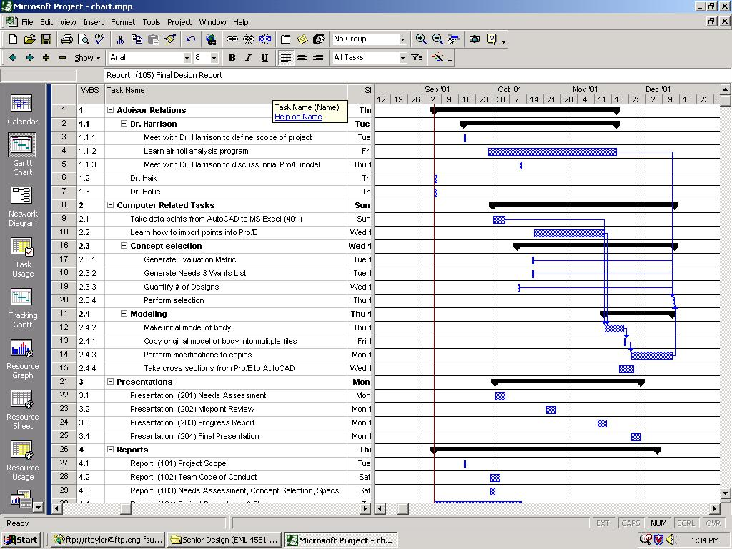

Appendix B: Clarifications

Flow Analysis
Dr. Harrison stated that he was confident that the three-dimensional model would have acceptable lift and drag coefficients/properties because the two-dimensional cross-sections from which the Pro/E model was derived possessed acceptable lift properties.

Quantity of Interpolation Points
Dr. Harrison stated that the team did not need to use all of the interpolation points recorded from AutoCAD. He was more concerned with the team’s generating a faithful representation of the body. Furthermore, Dr. Harrison stated that the team might need to use more of the interpolation points in areas of high curvature.

Appendix C: Formal Advisor Contact

- Dr. T. Harrison

- Dr. C. Luongo

Appendix D: Engineering Drawings

See www.eng.fsu.edu/ME_senior_design/2002/folder11/3dscb_autocad_package_fall01.ppt

