Air Intake and Exhaust Design for Formula SAE Car

Needs Assessment, Concept Generation and Selection and Specifications

Senior Design

October 4, 2001

James Cameron
Jason Esquivel
Anders Gerhart
Don Morton

- Needs Assessment

1.1 Need Statement

Design of an intake and exhaust system for a prototype racecar, scheduled for mass production at minimal cost for the weekend autocross racer. Intake and exhaust system must provide maximum horsepower and torque across the power band, provided a restricted intake and decibel limits placed on the design.

  - Demands

 | Specification | Score
Need | Air restrictor on intake | 10
Need | Restrictor before engine and after throttle body | 10
Need | Exhaust not to scrape ground | 10
Need | Exhaust outlet to be behind centerline rear axel | 10
Need | Exhaust not too high | 10
Need | Exhaust not too loud | 10
Need | Driver not subjected to exhaust fumes | 10

1.3 Wishes

 | Specification | Score
Want | Maximize air intake into engine | 8
Want | Free flow air filter | 5
Want | Good fuel atomization | 9
Want | Runner volume equal to cylinder displacement | 9
Want | Insulated exhaust | 7
Want | Maximize flow of exhaust | 7
Want | Minimum back pressure in exhaust | 7
Want | Minimal exhaust bends | 7
Want | Material to be composites and/or light metals | 6
Want | Least restricting muffler | 6
Want | Cool air intake | 5
Want | Maintain laminar air flow to injector | 8

- Concept Generation and Selection

2.1 Intake Manifold
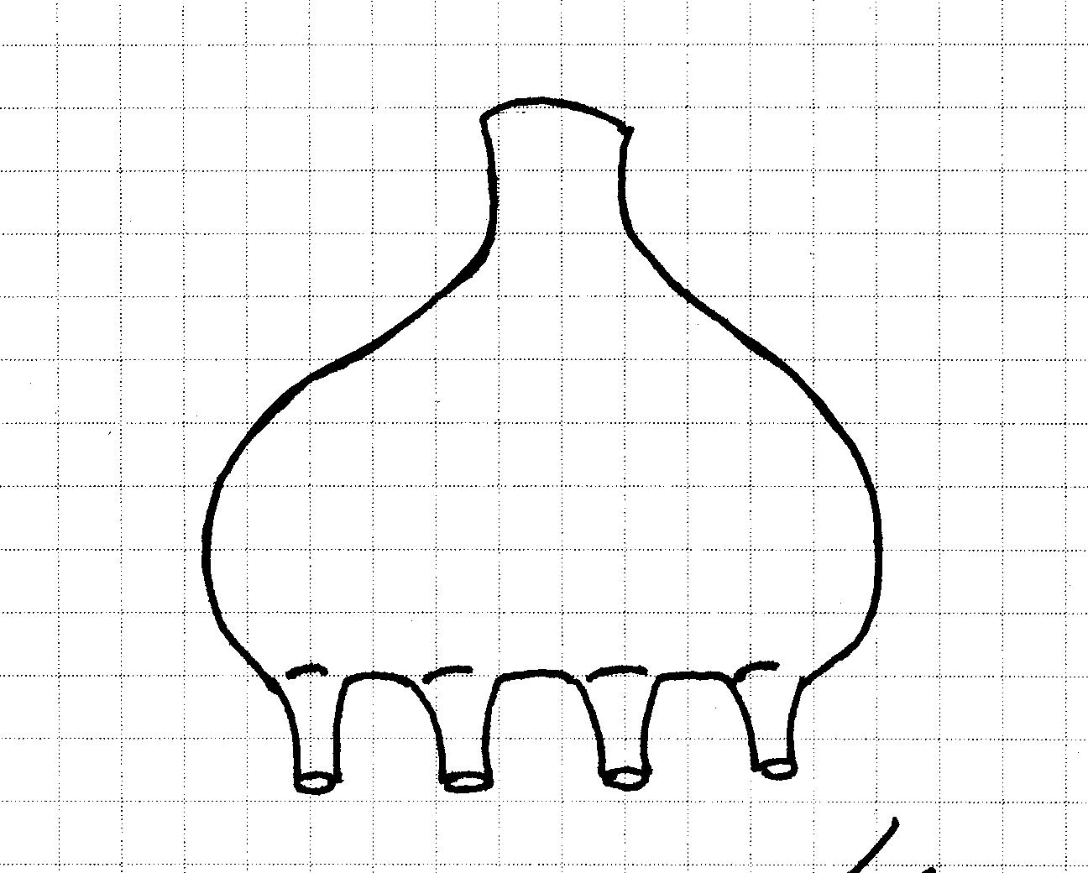
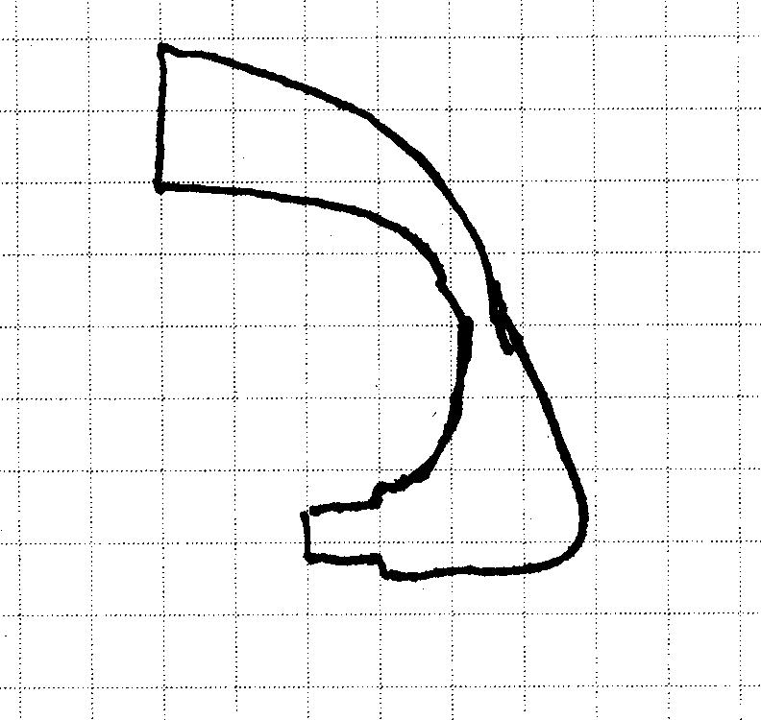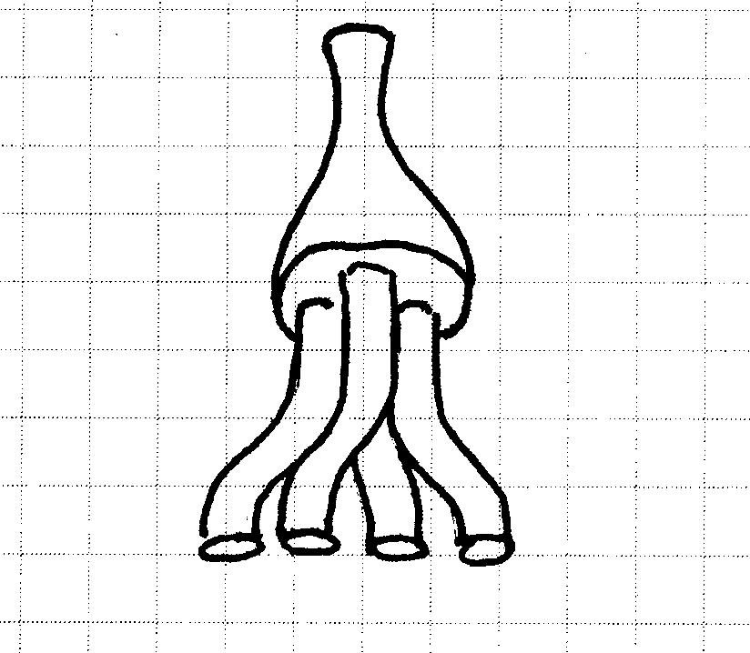

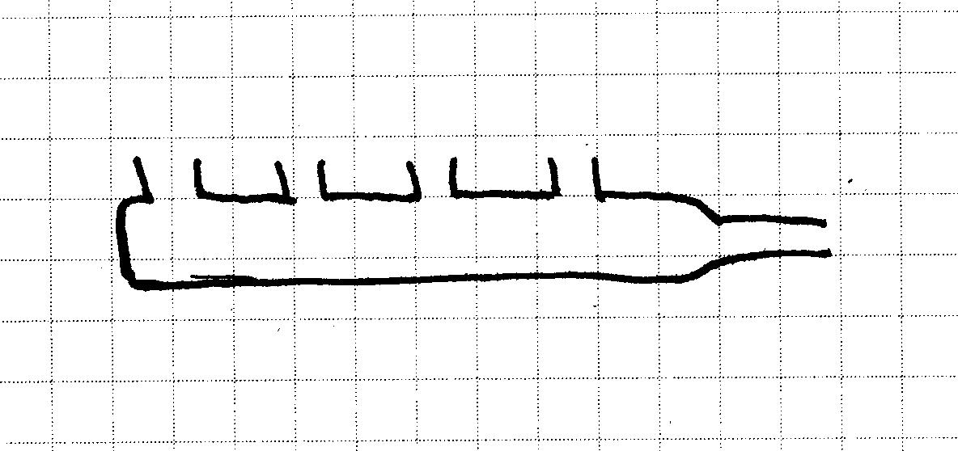

2.2 Exhaust Manifold
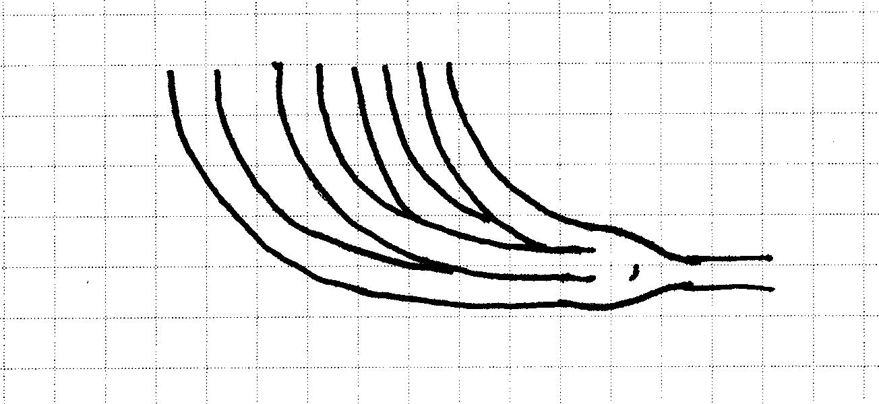

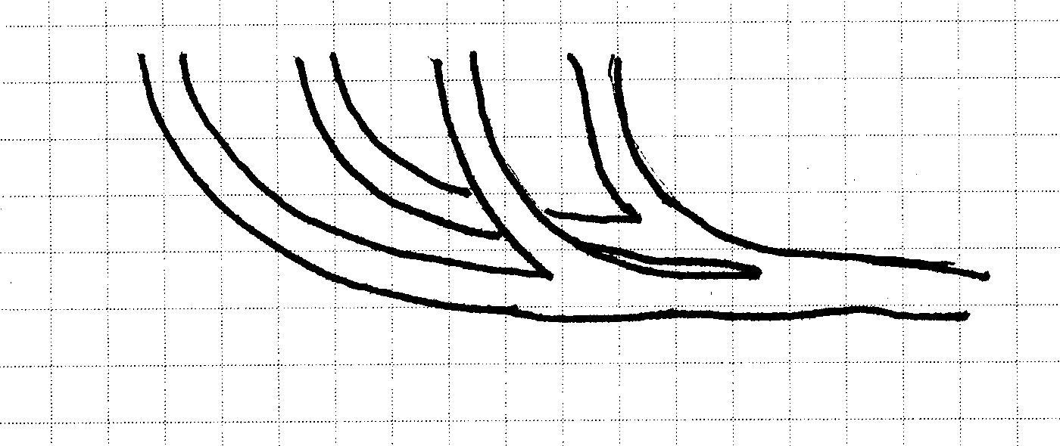
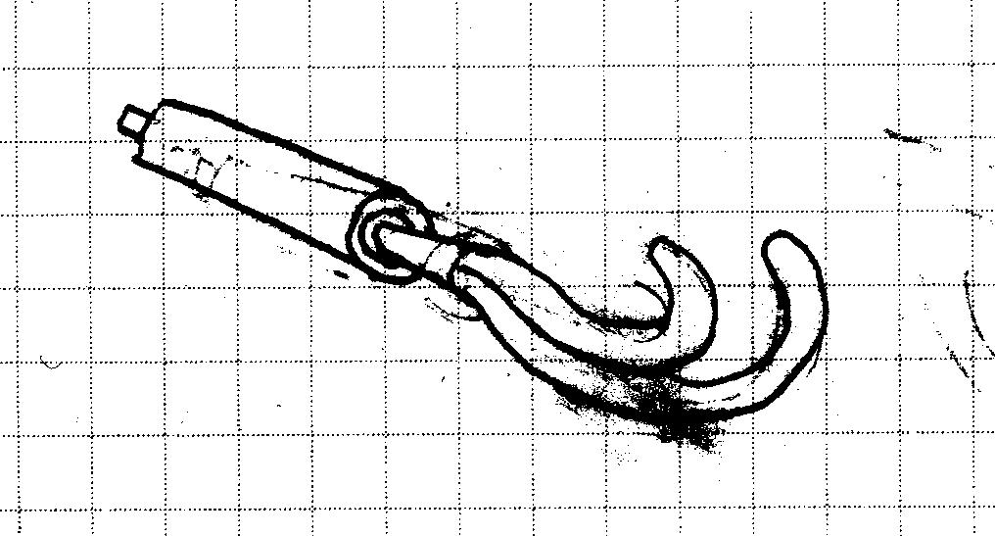

3.0 Specifications

Diameter of restrictor | 20 mm
Exhaust ground clearance | 60 mm (min)
Exhaust outlet height above ground | 80 cm (max)
Exhaust outlet distance behind rear axel centerline | 60 cm (max)
Exhaust sound level | 110 db (max)
Runner volume | 150 cc
Number of intake ports | 4
Number of exhaust ports | 4
Volumetric efficiency (delivered to engine) | 75% +/- 5%
Number of fuel injectors | 4
Exhaust outlets | 1

