

INTAKE & EXHAUST

Formula SAE
CBR 600 F3

Table of Contents

Formula SAE 1
Table of Contents 2
General Information 3
Safety Precautions 3
Tools required 4
Package Inspection 4
Intake 5
Plenum 5
Fuel Injectors 6
Throttle body 6
Air filter 7
Exhaust 8
Header pipes 8
O2 sensor 9
Muffler 10

General Information

Before attempting any installation, it is necessary that you are equipped with proper tools, and are thoroughly familiar with Honda CBR F3 engine design and construction. With your shop thus equipped, this will serve as a guide in performing the various steps necessary to do a complete a satisfactory job.

△ WARNING
Improper installation can create an unsafe condition that can cause serious injury or even death.

△ WARNING
Failure to properly follow instructions and precautions can cause serious injury or even death.

Follow the procedures and precautions in this manual carefully.

Safety Precautions

Make sure you use basic shop safety practices.
- Wearing appropriate clothing when working.
- Wear safety glass if hammering, drilling, grinding, or around pressurized equipment.

Make sure the engine is off and the key chuck is in the off direction before you begin any installation.
- Gasoline vapors and hydrogen gasses from battery are highly explosive.
- Potential shock and spark hazard if key chuck is in the on position.

The term “ INSERT,” “FASTEN,” “CONNECT ” and “TIGHTEN” are used as follows:

- INSERT– Manually place components into each other.

- FASTEN – Secure components together.

- CONNECT – assemble subcomponents or attach electrical devices.

- TIGHTEN – Secure bolts to recommended torque.

Tools required

- Flat head screw driver
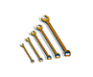

- 7mm Wrench
- 8mm Wrench
- 10mm Wrench

- 9/64 Allen Wrench


Package Inspection
Verify that the parts were not damaged during delivery by carefully unpacking all items in the shipping carton and look for obvious signs of damage. If any components are damaged repack parts in original package and contact your local distributor.


WARNING !
△ WARNING
Burn Hazard - Do not work on engine if hot or running.

Intake
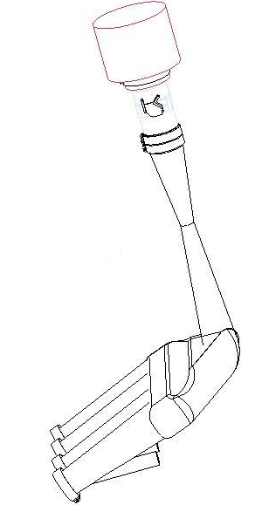

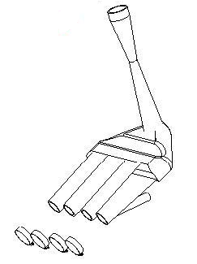

Plenum

- Fasten four (4) hose clamps to engine intake ports (Screwdriver).
- Insert runner ends directly into hose clamps, as seen in figure.
  - Be sure that intake curves towards top of car, not towards back of car.
- Tighten down hose clamp screws (Screwdriver or 8mm Wrench).
  - Be careful not to over tighten screws, this can damage the hose clamps.
- Screw intake pressure sensor into plenum, as seen in figure.
- Make electrical connections for pressure sensor.

Plenum Assembly

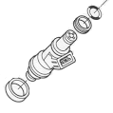
O-Rings

Fuel Injectors
- Apply a small amount of oil to all O-rings.
- Insert the fuel injectors into the fuel rail.
  - Be careful not to position the fuel injectors backwards, the electrical contacts should point towards the fuel rail.
- Insert free end of injectors into injector mounts on the runners of the plenum.
- Tighten fuel rail to engine block using tightening bolts (Screwdriver or 8mm Wrench).

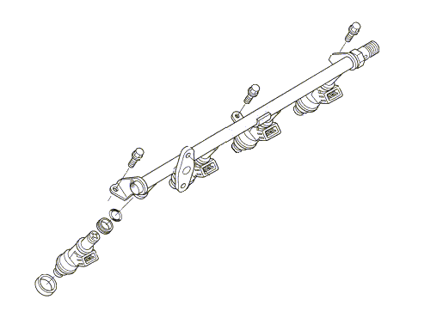
Fuel Injector

Fuel Rail Assembly

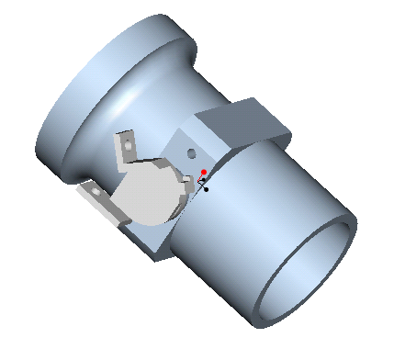

Throttle body
- Verify that all parts move, as seen in picture.
  - Fully opens
  - Fully closes
  - Moves smoothly through range of motion
- Check throttle cable for damage.
- Slide hose clamp 1 over restrictor side of the intake to midpoint of hose clamp.
Throttle Body
- 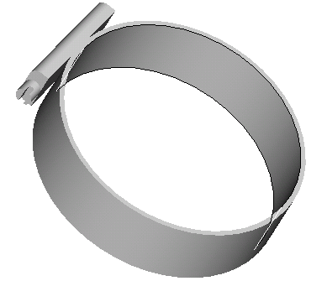Tighten hose clamp screw around restrictor (Screwdriver or 8mm Wrench).
  - Be careful not to over tighten hose clamp screw.
- Insert small end of throttle body into hose clamp until it touches the restrictor intake, inside the hose clamp.
- Tighten the hose clamp screw around throttle body (Screwdriver or 8mm Wrench). (SEE NEXT PAGE)
Hose Clamp

- Fasten throttle cable to throttle.
- Connect throttle position sensor (TPS) to throttle body using two (2) 1/8” bolts.
- Connect electrical harness of TPS to connecting plug.

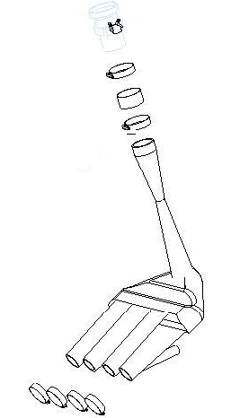
Throttle Body

Hose Clamp

Hose

Restrictor

Plenum

Throttle Body Assembly

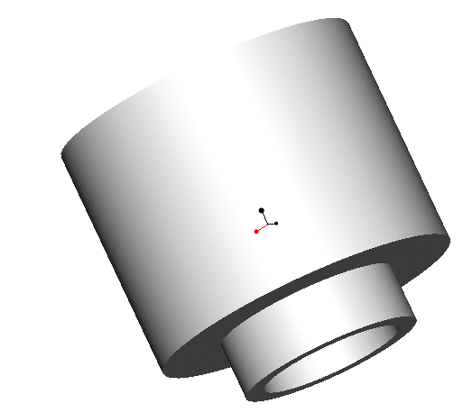

Air filter
- Slide Hose clamp over air filter flange hold in place.
- Slide air filter over large end of throttle body.
- Tighten hose clamp screw around throttle body (Screwdriver or 8mm Wrench).
  - Be careful not to over tighten hose clamp screw.

(SEE NEXT PAGE)

Air Filter

Air Filter

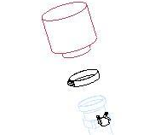
Hose Clamp

Throttle Body

Air Filter Assembly

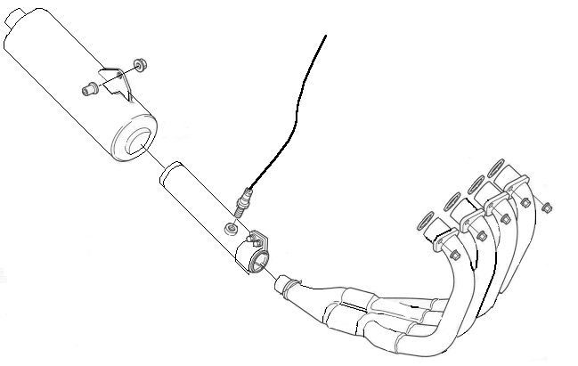

Exhaust

Header pipes
- Slide mounting plates up to collars on ends of exhaust headers.
- Align bolt holes in mounting plates to bolts on cylinder head.
Insert exhaust collars into exhaust ports on cylinder head (SEE NEXT PAGE)
- Tighten all nuts firmly against mounting plates using 10mm wrench.
  - 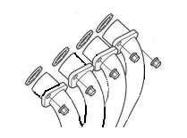Tighten nuts to 12 N*m

Mounting Plates

Bolts

Exhaust Header

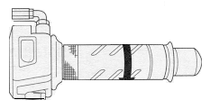O2 sensor
- Make sure O2 sensor is clean and free of debris
- Screw O2 sensor into exhaust pipe.
- Make electrical connections to wiring harness.

O2 Sensor
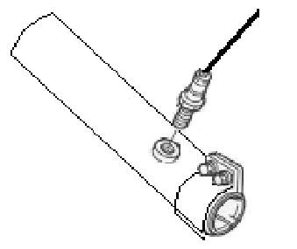

O2 Sensor Assembly

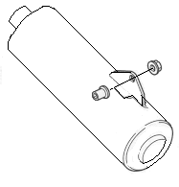

Muffler
- Slide muffler onto end of exhaust pipe.
- Use clamp 3 to connect muffler to header.
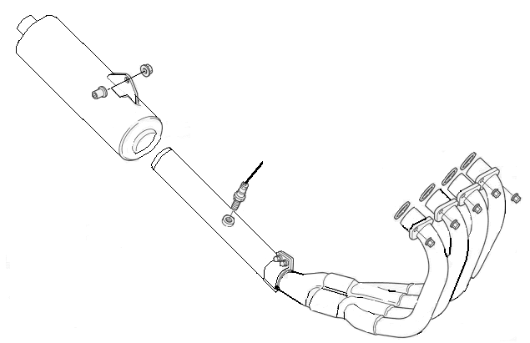

Muffler

Muffler Assembly

Warning!
- Make sure Fuel pump is not on.
- Battery key is in disable position.
- Do not test until the exhaust has been installed.
Engine must be cool.

Before stating engine, leave ignition off and turn on the fuel pump.
- Stand clear of the rear of the engine to assure that intake does not backfire and that connections are tight
- Once full pressure is obtained check for fuel leaks. After checking, the engine is ready to start.
- Start engine and let idle, confirm no leaks between the runner and fuel rail and exhaust is exiting out the muffler.

