Magnet Support Column

Group # 17
November 29, 2001
EML 4551 Senior Design

Group Members
Thomas Adams
Gabriel Andrews
Regina Redmond

Table of Context
Introduction 1
Background 1
Needs Assessment 1
Scheduling 4
Current Progress 6
Assembly 10
Part Explanation/Application 11
Procedure 12
Special Assembly Notes 14
Future Plans 15
Test Plan 15
Summary 20
Appendix A: Calculations and Drawings 21
Appendix B: Meeting Minutes and Other Procedures 22

List of Figures
Figure 1Metal form for sensor instrumentation of the column. 6
Figure 2 Illustrates the metal form and inflation bulb inside of the column. Sensors are applied to the top of the metal form and then the inflation bulb is used to provide the pressure to allow the sensors to attach to the column 7
Figure 3 View of the inside of the column. Here you can see the placement of the wires and sensors staggered throughout the column beginning with senor #4 8
Figure 4 Illustrates the idealized position of the Cryogenic Liner Temperature Sensors (CLTS) inside of the Column 9
Figure 5 The actual schedule with completed tasks and tasks remaining until the completion of the analysis of the new support system. 10
Figure 6 Shows the components associated with the new proposed magnet support system. From the top: Diffusion Jacket, Stainless Steel Column, Helium Gas Conduit, end caps. 11
Figure 7 Bottom end assembly. The bottom inside endcap is inserted into the column first followed by the reinforcement ring. The outside endcap is lasr and closes the ottom end of the column 13
Figure 8 Schematic for Cryogenic test…………………………………………………...18

Introduction

The National High Magnetic Field Laboratory (NHMFL) has requested assistance in building and testing a new design of the magnet support system. The existing design is highly complicated and extremely bulky. Dr. John Miller, a scientist in the Magnet Science and Technology Department, has designed a new support system that is simpler and more compact in hopes of replacing the existing design. The purpose of this project is to test the feasibility of this new design. The existing support structure is used to support the Hybrid magnet and to keep the magnet at a desired temperature; the main goal of the project is to verify that the new design fulfills these properties.

Background
The current Magnet Support system uses a series of thermal steps to achieve the proper temperature in which the Hybrid magnet must be kept. This process involves the use of super-cooled helium flowing through a network of pipes and tubing. If the finite number of steps used to cool the magnet were increased infinitely, the temperature of the system could be maintained more efficiently. This can be achieved if helium flow is introduced along the entire length of the support system.

Needs Assessment
The project’s ‘Needs’ were assessed to determine the basic requirements that must be met in order for the successful completion of the new magnet support system. After some deliberation, three fundamental requirements of the support system were sifted from the sands of ambiguity. Those ‘Needs’ were determined to be the following:
- There is a need to provide compressive support between the magnet and the surrounding environment.
- There is a need to transfer heat away from the magnet to the surrounding environment in order to protect Hybrid magnet from damage and maintain its proper workings.
- To ensure that the heat transfer is taking place efficiently, there is a need to facilitate turbulence of the helium flow that will carry the heat away from the column.
These three fundamental ‘Needs’ of the new support system will be met through the collaborative functions of the following parts of the new support system:
- Tubular Stainless Steel Column – will be used to support the Hybrid magnet in compression from the surrounding room temperature environment.
- Super-cooled Helium Gas – will be used to transfer the heat in the system because of its unique thermal properties at extremely low temperatures.
- A Diffusion Jacket – will help to generate a turbulent flow of the helium to induce better heat transfer between the working fluid and the tubular stainless steel column.

In hopes of verifying if the new support system would meet the needs of the design, a logical plan to carry out systematic fabrication and evaluation of the needs was devised. This plan has been divided into four main sections:
- Instrumentation: The instrumentation entails the wiring and installation of the temperature sensors and strain gauges. This process should be carefully done being that the instrumentation is extremely sensitive. Preparation of the column with extensive cleaning, sanding away of debris and neutralizing the surface along the inner walls, is essential to obtaining accurate measurements.
- Assembly: The assembly process includes the welding the structure together. The key to this assembly is to align each piece in its proper location, the design has a lot of hole alignment used to allow the helium to properly flow along the column therefore if the design is improperly assembled then the temperature gradient may not be achieved. The assembly process should be done very carefully being that welding can only be done once.
- Testing: The testing section is where the meat of the project lies, the results of the testing will be used to tell the integrity of the design. Two types of tests will be performed.
  - Mechanical Test: The mechanical test will be used to verify the strength of the column and the jacket around the outer diameter. The jacket will be tested for its effectiveness in helping to support the magnet. If it is seen that it does not help in supporting the load of the magnet it will be removed from the design.
  - Cryogenic Test: The cryogenic test will be used to verify that the proper mass flow rate can be achieved to adhere to the temperature gradient 4.2K-300K. The analysis of the data will be help to suggest modification to the design, in order to adhere to either more or less cooling.
- Analysis: The analysis section is when the reflection of the test results will take place. The feasibility of the design to support the desired thermal requirements will be determined from the results of the cryogenic tests as well as the load carrying characteristics of the column, from the mechanical test results. Modifications to the new design will be suggested in order to increase its performance.
The last sequence in the prescribe plan will provide the information from the mechanical test and the cryogenic test that will determine the success of the design and the feasibility of its actual implementation.

Scheduling
The major tasks of instrumentation, assembly, testing, and analysis were subdivided into smaller division to make it easier to track and document the progress of the total project. The resulting Work Breakdown Structure provides a detailed layout of the project from beginning to completion.
5.0
Analysis
Hybrid Magnet Support
4.0
Testing
2.0 Instrumentation
1.0
Project Assessment
3.0
Assembly
Identification of Need
Meeting with Authorities
Determining Project Goal
Project Scope
Specification Identification

Project Report #1

Installation

System Fabrication

Proper Component Orientation

Weld Components into Place

Cryogenic Testing

Structural Testing

Analyze Test Results

Note: Boxes directly under subsystem are subordinate systems to that particular subsystem.
From the WBS, it was possible to develop an intricate scheduling procedure. The procedure consists of all topics that were chosen to be systems and subsystems from the WBS. Below is the proposed schedule for the completion of the steps outlined above in the WBS.
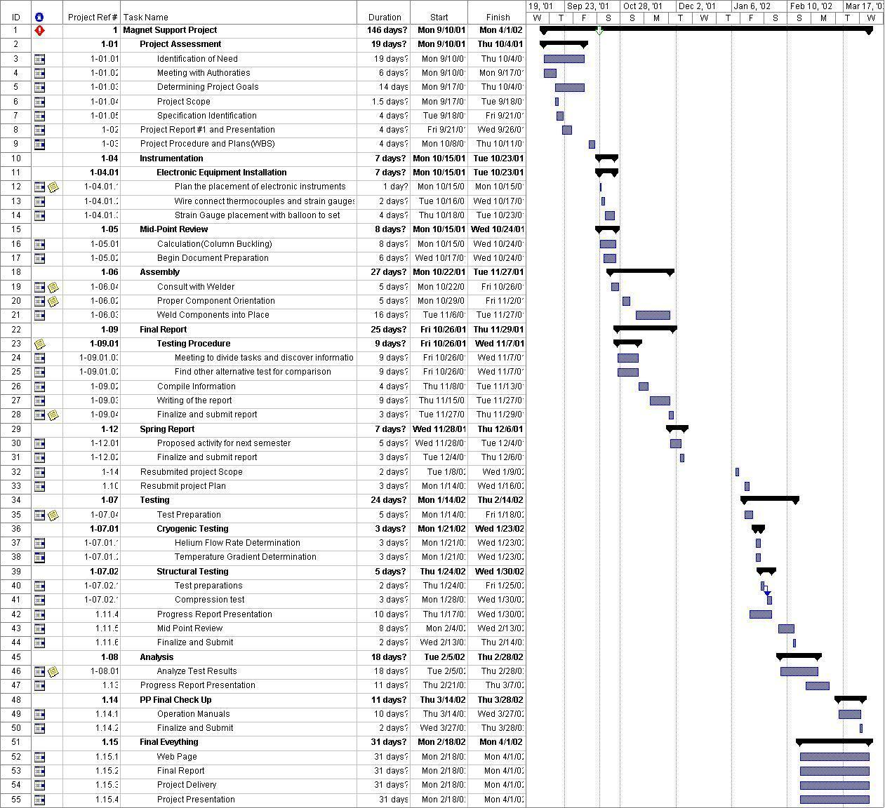

Once the schedule was complete, steps were begun to ensure its fulfillment in the time that had been allotted. Unfortunately, unforeseen items arose and effectively placed the actual events and the scheduled events out of phase. The detail of are current progress are discussed now.

Current Progress

There are several stages required for the completion of this project, the first of which being instrumentation. This process was scheduled to begin on October 15. The actual instrumentation did begin on schedule. Once it was determined that the system needed to be subjected to both compression and temperature gradient testing, it was evident that the column needed to be fitted with linear temperature sensors and strain gauges.
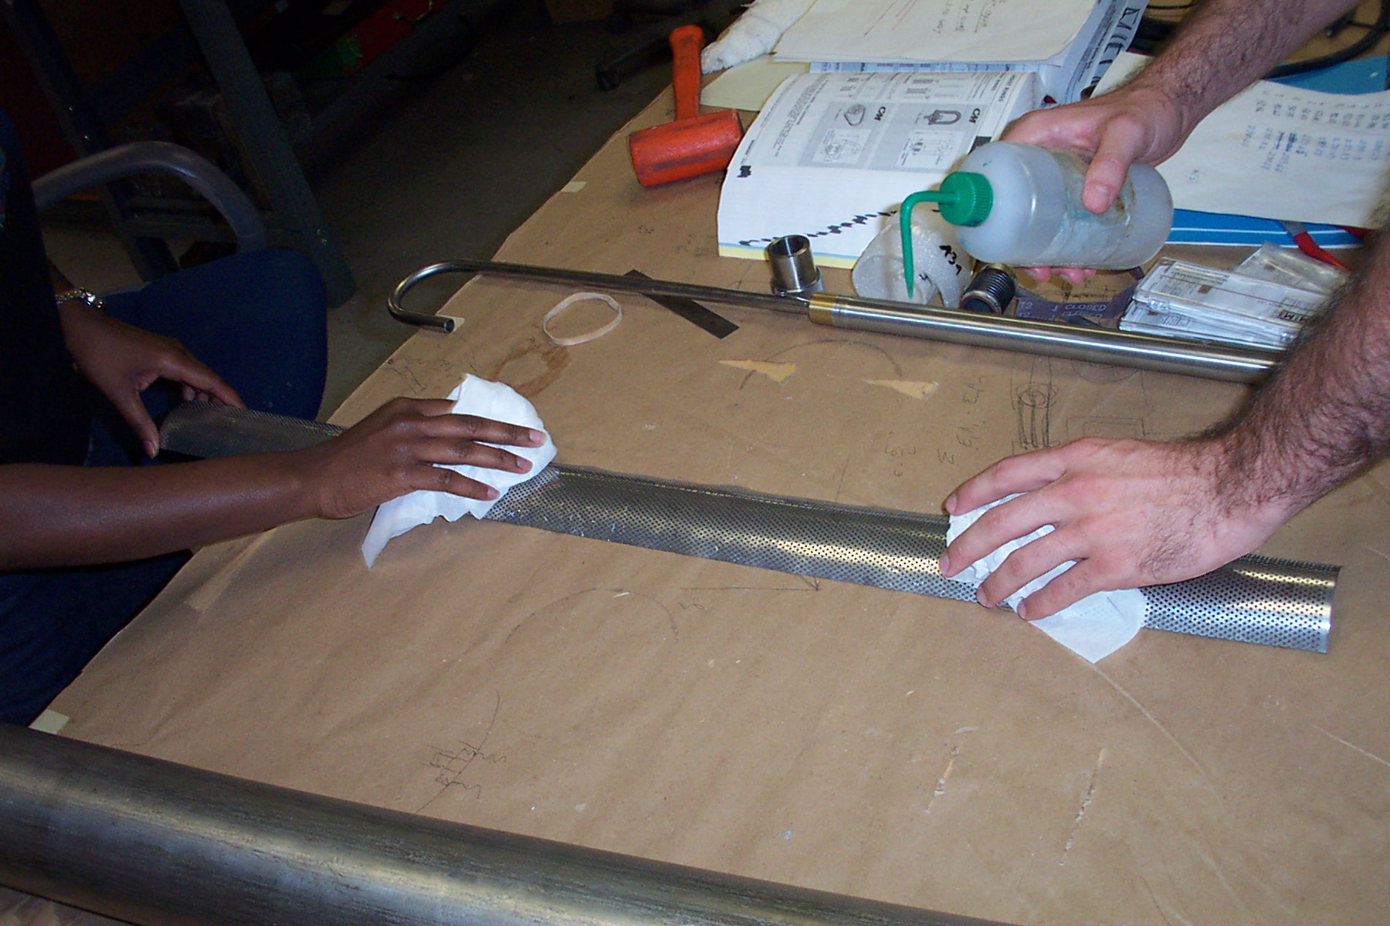
Figure 1Metal form for sensor instrumentation of the column.
Instrumentation of the column posed a major challenge. This first challenge, due to the column’s diameter it was difficult for to maneuver inside the column. Under normal circumstances, the instrumentation process would consist of properly preparing the application surface, gluing the gauge in place, and finally soldering the proper wiring to the gauge on an external surface. For the instrumentation of the column, an entirely new method to properly orientate all of the gauges and hold them against the inner wall of the column had to be created. The new method for instrumentation the column had to have enough pressure for the epoxy to cure and sustain that pressure over a period of time. The answer to this problem came by fabricating a metal form, which had the same length and radius of curvature as the column. Once the surface of the column was properly prepared for the placement of the sensors using a prescribe procedure, the wires were pre-soldered to the gauges. The gauges were then properly oriented to be equally spaced along the length of the metal form and then taped with double-sided tape to silicon pads. These pads were placed along the crest of the form. With the gauges in place, epoxy was then applied to them and the form was inserted into the column. Inflatable bulbs underneath the metal form provide the necessary pressure for the gauges to adhere to the inner wall of the column. An external heater was used to accelerate the curing process of the epoxy. Finally, after the epoxy cured over the period one day, the metal form was carefully removed.

Unfortunately, while removing the metal form from the column, the wires from the second gauge were pulled from the sensor connection pad and rendered the gauge useless. It is believed that the wires of the second gauge were pressed between the inner column wall and the metal form. Tape on the metal form, used to hold the gauges to the metal form, bonded to the second gauge wire due to the pressure from the inflatable bulb. This bond proved to be extremely strong and was able to withstand the force between the sensor pad and the removing of the metal form leaving the wires disconnected from the sensor pad.

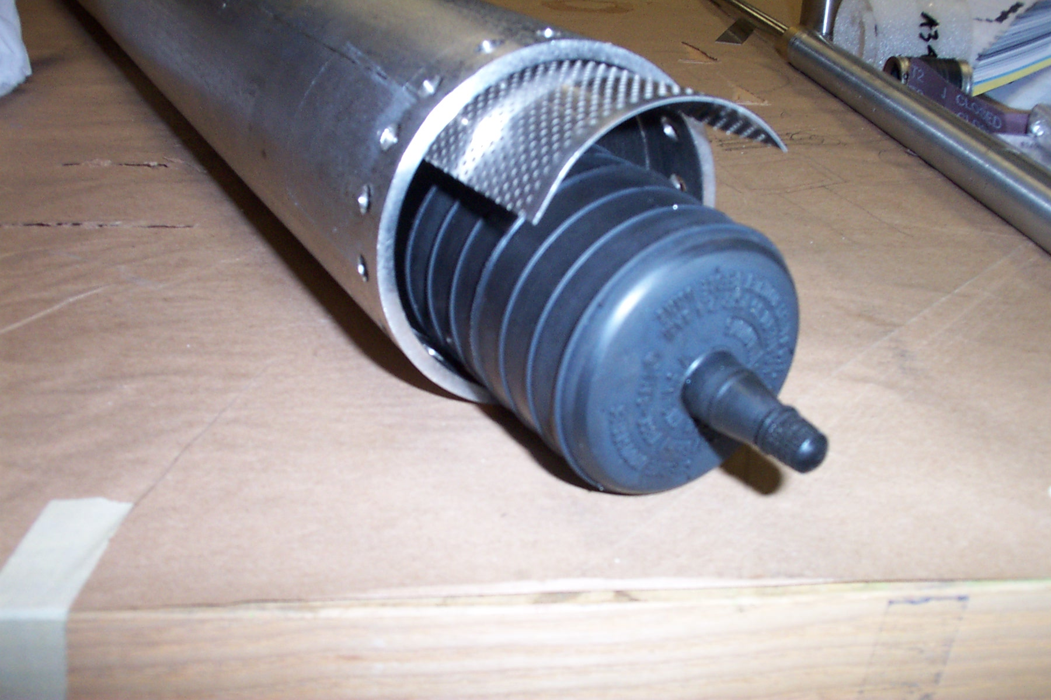
Another temperature gauge was still needed to better determine the temperature profile over the length of the column. It was decided that another gauge could be placed next to the now disconnected gauge to substitute. Unfortunately, this attempt at substituting the second temperature gauge did not succeed. This second attempt followed the same methodology as the first however this time taking in to consideration the location of the wires in reference to the tape used to secure the temperature gauge. After the substitute gauge was prepared, placed on the metal form, inserted into the column and left to cure, the metal form was removed only to find the gauge unsecured. The wires connected to sensor pads were accidentally removed while trying to retrieve the unsecured gauge. The cause of this set back is thought to have been improperly place tape. The tape used to secure the gauge to the column may have been loosely applied. The movement of the metal form caused by the insertion and inflation of the bulb may have dislodged the temperature gauge leaving it in an orientation that did not permit it to cure. Also it should be noted that the wires of the first temperature gauge were also 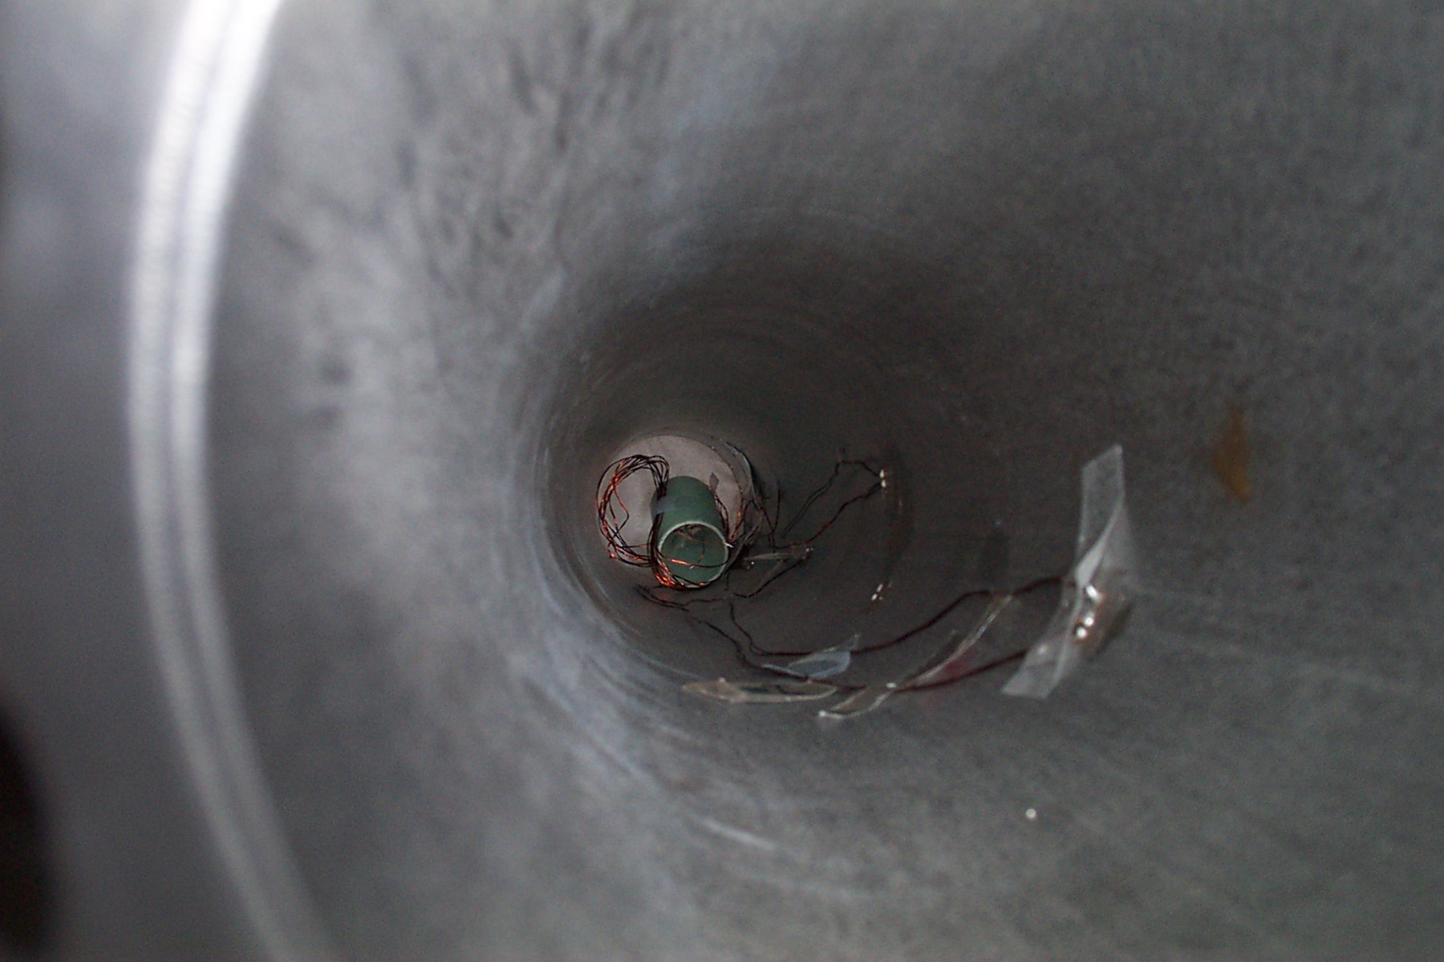
Figure 2 Illustrates the metal form and inflation bulb inside of the column. Sensors are applied to the top of the metal form and then the inflation bulb is used to provide the pressure to allow the sensors to attach to the column
Figure 3 View of the inside of the column. Here you can see the placement of the wires and sensors staggered throughout the column beginning with senor #4
Sensor #4
Sensor #3
Sensor #2
Sensor #1
removed with the removal of the metal form for replacing the second temperature gauge. Fortunately, the location of the first temperature gauge allowed the wires to be soldered back into position. On the third try, a gauge was successfully placed next to the original gauge and the process of attaching linear temperature sensors to the column was complete.

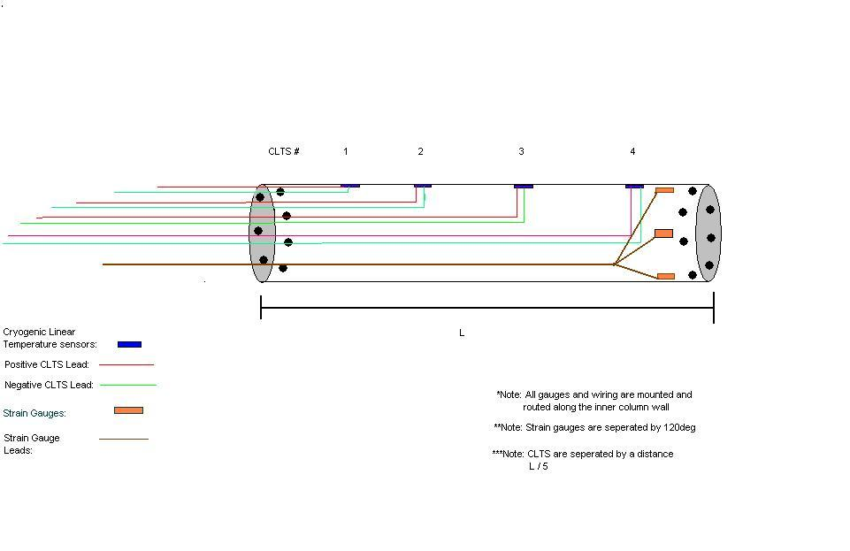
Figure 4 Illustrates the idealized position of the Cryogenic Liner Temperature Sensors (CLTS) inside of the Column

Following the completion of this step, the strain gauges needed to be fixed to the inside of the column. Once again, the surface of application was prepared using several grades of sandpaper and acidic solutions. The placement of the strain gauges differed from that of the temperature sensors, in that they were placed along the circumference of the column at 120deg intervals from each other on one end, where as the temperature sensors were placed in a straight line along the length of the column.
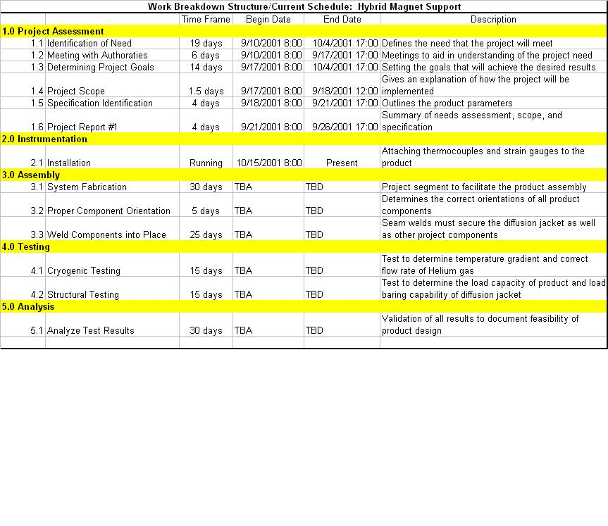
Figure 5 The actual schedule with completed tasks and tasks remaining until the completion of the analysis of the new support system.

Assembly
Once the instrumentation is completed, the assembly of the magnet support column is the next most important aspect of the design. A rushed and unplanned assembly could have significant affect on the following results. Subsequently the procedure is as follows:

Parts List:
Part | Mating Parts
Column | Inside Endcaps, Outside Endcaps, Diffusion Jacket, Reinforcement Rings
Inside Endcaps | Column, Reinforcement Rings
Reinforcement Rings | Column, Inside Endcaps, Outside Endcaps
Outside Endcaps | Reinforcement Rings, Column, Diffusion Jacket, Helium Gas Conduit
Helium Gas Conduit | Outside Endcaps, Helium Supply
Diffusion Jacket | Column, Outside Endcaps

Part Explanation/Application
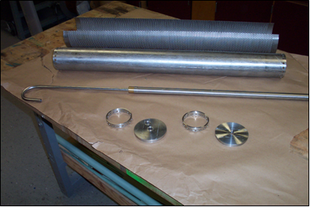
The magnet support is made of several parts that must be assembled to complete the final design. These parts are the column, end caps, reinforcement rings, helium gas conduit, and diffusion jacket.
Figure 6 Shows the components associated with the new proposed magnet support system. From the top: Diffusion Jacket, Stainless Steel Column, Helium Gas Conduit, end caps.

COLUMN - The column is the essential supporting mechanism for the completed assembly. The column must maintain the proper temperature gradient along its length in order not to cause damage to the Hybrid magnet. Subsequently, the column has 18 holes in each end to allow super cooled helium to flow through.

ENDCAPS - There are two types of end caps that will be placed on each end of the column. The first type is the inside end cap. The inside end cap is a solid fixture. This piece does not allow permeations of any other parts. The inside end cap will be assembled inside the bottom end of the column and will be welded to maintain an air tight seal inside the column. It will fit just above the 18 holes at the end of the column. . A second end cap, the outside end cap, with a hole for the helium gas conduit will be placed at the bottom end of the column just below the set of 18 holes. It too will be welded to the column. At the top of the column, a special inside end cap will be welded inside the column just below the set of holes. The inside end cap will have a cutout especially for the sensor wiring inside the column to pass through. There must be an air-tight seal around the wiring to create a chamber inside of the column between the solid bottom inside end cap and the special top inside end cap with wiring cutout.

REINFORCEMENT RINGS - The reinforcement rings will be implemented to give support to the column at the ends where the set of holes are located. It is believed that this end of the column is the weakest due to the removal of material to allow the helium to pass. The placement of the reinforcement rings will serve to distribute the applied load across a greater cross-sectional area.

HELIUM GAS CONDUIT - The Helium Gas Conduit will be the passage way in which the magnet support column assembly will receive a supply of super cooled fluid. The helium will help to maintain the proper temperature gradient along the column’s length.

DIFFUSION JACKET The diffusion jacket will be wrapped around the column to aid in the transfer of heat by inducing turbulent mixing. The diffusion jacket may also provide a minimal amount of strength to the assembly.

Procedure

The following are steps that should be carried out in sequential order to assemble the magnet support structure. Make sure that all parts have been proper cleaned and prepared before carrying out any permanent assembly procedure.

Step 1 – Begin with the COLUMN and the BOTTOM INSIDE ENDCAP. Since the COLUMN is symmetrical, choose an end to be the bottom and the top. At the bottom end, slide the BOTTOM INSIDE ENDCAP until it will not slide any further. There is a small groove that it will fit into. Once in place, weld the BOTTOM INSIDE ENDCAP to the COLUMN along the edge where the two parts touch.

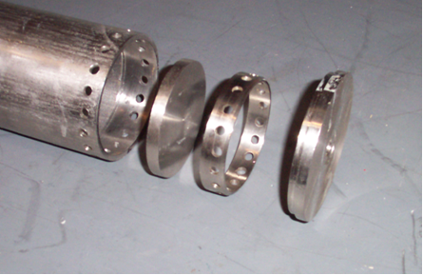
Step 2 – Slide one REINFORCEMENT RING into the bottom end of the COLUMN. Align the set of 18 holes in the bottom of the COLUMN with the set of holes in the REINFORCEMENT RING. Now weld the REINFORCEMENT RING to the COLUMN.
Figure 7 Bottom end assembly. The bottom inside end cap is inserted into the column first followed by the reinforcement ring. The outside end cap is last and closes the bottom end of the column

Step 3 – Wrap the DIFFUSION JACKET around the COLUMN to ensure a flush fit. Remove the DIFFUSION JACKET and seam weld along its length.

Step 4 – Slide the DIFFUSION JACKET over the COLUMN. Use the BOTTOM OUTSIDE ENDCAP to cap the COLUMN and the DIFFUSION JACKET. The DIFFUSION JACKET should fit an inside of the groove of the BOTTOM OUTSIDE ENDCAP. First weld the BOTTOM OUTSIDE ENDCAP to the COLUMN. Then weld the DIFFUSION JACKET to the BOTTOM OUTSIDE ENDCAP.

Step 5 – At the top of the column, slide the special TOP INSIDE ENDCAP into position just below the set of 18 holes. Allow the wires to pass through the cutout. Weld the TOP INSIDE ENDCAP to the COLUMN. Be careful not to weld the wiring to any part of the COLUM. Epoxy will be used to secure the wires and seal the cutout. Prepare the epoxy and apply it to the cutout and wiring.

Step 6 – Slide one REINFORCEMENT RING inside the top of the COLUMN. The REINFORCEMENT RING should fit just above the TOP INSIDE ENDCAP. Align the holes of the REINFORCEMENT RING with the holes in the COLUMN. Make sure that the wiring passes through the REINFORCEMENT RING and then weld the ring to the COLUMN.

Step 7 – Cap off the end of the COLUMN with the TOP OUTSIDE ENDCAP. The DIFFUSION JACKET should fit into a groove in the TOP OUTSIDE ENDCAP. Pass the wiring through the hole in the TOP OUTSIDE ENDCAP and weld the DIFFUSION JACKET to the TOP OUTSIDE ENDCAP.

Step 8 – The HELIUM GAS CONDUIT is the last to be assembled. Insert the hook at the end of the HELIUM GAS CONDUIT into the BOTTOM OUTSIDE ENDCAP. Weld the two parts together.

Special Assembly Notes

Air-tight seals - Air-tight seals must be established and maintained throughout the assembly. The introduction of outside fluids will cause improper temperature gradients and may damage the Hybrid magnet. For testing purposes, outside fluids will represent an open system in which the results would not be reliable. Flow rates will not be accurate as well as energy transfer and balance equations would not be valid.

Reinforcement Rings - The reinforcement rings will be implemented to give support to the column at the ends where the set of holes are located. It is believed that this end of the column is the weakest due to the removal of material to allow the helium to pass. The placement of the reinforcement rings will serve to distribute the applied load across a greater cross-sectional area.

Vacuum Pockets – A vacuum will be kept between the two inside end caps of the column as well as the space surrounding the column jacket assembly inside of the dewer. The purpose of the vacuum will be to reduce the convective mode of heat transfer from the surface of the column to the surrounding air to zero. Only the conduction path from the dewer flange at 300K to the helium

Future Plans
The first goal set for carrying out the remainder of this project will be to complete the instrumentation process by installing the last strain gauges along the inner wall of the column and performing continuity test to insure there well being. After this is accomplished the next task at hand will be to fully map out and finalize the assembly process and procedure for the system. Following the finalization of the design and assembly procedure, meetings will be scheduled with Robert Stanton, the designated welder, to allocate time for the actual welding to be done on the project.

Once the column/jacket assembly is completely manufactured, the next order of business will be to prepare it for the upcoming tests to be preformed. At this point, time will be scheduled for testing with all involved parties, and testing procedures will be finalized. Following this turn of events, the column assembly will be subjected to the pre described tests, and analysis will be preformed on all test results. This will bring about the conclusion of the senior design project as a whole.

Test Plan
After the assembly, the next step is to test the structural integrity and the thermal properties of the designed system in order to evaluate whether the needs of the design have been satisfied or if the issue still remains at large. A test plan was created to accomplish this evaluation.

The Cryogenic test will serve to evaluate the temperature profile along the length of the column. From these results it will be possible to determine what specific helium flow rate will be needed to produce a particular temperature profile. The desire profile will produce a temperature gradient ranging from 4.2 to 300K along the column’s length.

- Cryogenic Temperature / Flow-rate Testing
- Instrumentation and Adaptation
  - Drill blind hole in top plate of column assembly, and attach Thermocouple in order to measure boundary condition temperature of 300K.
  - Attach CERNOX temperature sensor to bottom plate of column assembly, in order to measure boundary condition temperature of 4.2 K.
  - Pass dewer flange over external Helium/Vacuum tubing of column assembly. Pass CLTS wiring through additional Helium/Vacuum/T-fitting/tubing assembly. Attach external Helium/Vacuum/T-fitting/ tubing assembly to existing Column assembly in a fashion that permits a vacuum tight seal. Seal wiring tubing interface with clamp able hose.
  - Pass CERNOX and Thermocouple wiring through appropriate flange whole. (All tubing or wiring that passes through flange will be properly aligned with appropriate flange wholes and sealed for vacuum purposes.)
  - Connect all CLTS, CERNOX, and Thermocouple wiring to appropriate Lab-view data acquisition terminals either through “hard wiring” or the use of terminal blocks.
  - Connect Vacuum lines to appropriate T-fittings.
  - Connect Anemometer type flow meter and valve to the appropriate T-fitting, in order to measure and regulate the velocity of the Helium exiting the system.
  - Connect Flow meter wiring to appropriate Lab-view data acquisition terminals either through “hard wiring” or the use of terminal blocks.
  - Connect Helium lines to flow meter / valve interface
  - Bolt Dewer Flange down to top of Dewer (It should be noted that the column assembly is supported in the Dewer by the connection of the incoming Helium line, and the flange fitting/ external Helium/Vacuum/T-fitting/ tubing assembly interface. However if this fitting is secured properly, this support system should be adequate.)
  - Connect Helium source line from Column assembly to Helium source
- Testing Procedure
  - Program and Calibrate Lab-view to record flow velocity from Anemometer, individual CLTS temperature readings, CERNOX temperature readings, and Thermocouple temperature readings.
  - Execute computer program to begin recording data
  - Open Helium supply valve to full position and open Helium regulation valve just enough to allow flow through the system
  - Observe temperature recordings from CLTS’, CERNOX, and Thermocouple after steady state temperature is reached
  - Continue to adjust Helium regulation valve and repeat step [4] until the optimum temperature gradient along the column, and appropriate boundary conditions, (as stated in step A 1-2 of Instrumentation /Adaptation) are achieved.
  - Record the Flow velocity used to achieve the optimum conditions in step [5].
- Analysis
  - From the optimum flow velocity recorded in step [B-6], the cross-sectional area of the Anemometer tube, and the density of the Helium used, calculates the optimum mass flow rate.
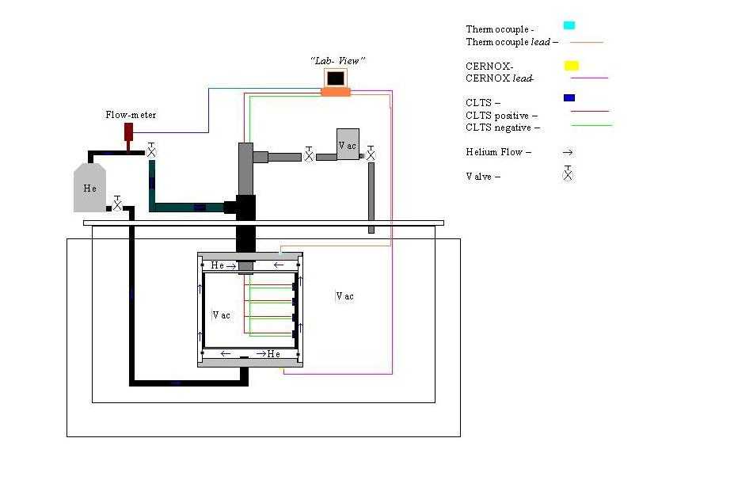
Figure 8 Schematic for Cryogenic test

The mechanical testing will be performed by Hydraulic Test to test the compressive strength of the column. The Hydraulic test uses a load cell to deliver a maximum of 10 Ton or 20,000 lbs per square inch to an object. It is capable of both tension and compression tests.
II. Mechanical Compression Testing
A. Load Cell Installation
- Cut off unnecessary tubing and fittings or flanges attached for the purpose of the cryogenic test, and machine end surfaces until they are flat and level if needed.
- Invert the column so that the wiring can pass through a hole in the bottom carriage of the load cell.
- Feed wires through bottom hole of load-cell carriage, place column in load-cell, and lower top portion so that it just holds the column in position.
B. Instrumentation
- Attach Strain gauge wiring to the built-in data acquisition computer of the hydraulic Tension / Compression testing machine.
- Calibrate built-in strain gauge conditioner to the appropriate sensitivity of our test, and zero position data so that the strain calculations will start from zero
- Program computer to increase compressive load over multiple intervals of a set time increment, until a desired load of 20,000lbs is reached.
C. Compression Test
- Execute Computer program to begin column compression
- Wait until maximum force has been exerted on column
- Set computer to return load-cell to initial position and remove column
D. Data Analysis
- Retrieve data from built in data acquisition computer in the form of “excel”-style spread sheet (Columns of data include Force exerted over each time increment, and the incremental strain for each interval of force exertion)
- Graph data and break down force equation, (F=Εδ[Α_{column} +CA_{jacket}] ), to determine how much of the load the diffusion jacket takes from the system
- The utility of the diffusion jacket can be seen from the value of the constant C, in the previous equation, which should range from zero to one. If C turns out to be approximately equal zero, then the diffusion jacket is bearing almost no load and therefore contributes nothing to the support of the magnet. At this point the diffusion jacket is simply an extra heat load on the system, and its design should be reevaluated accordingly.

Summary

A number of steps have been completed toward the final evaluation of the new magnet support design. Those steps include determining the method for installation of the Cryogenic Linear Temperature Sensors (CLTS) and the strain gauges, installation of the CLTS’s and creating a testing procedure that will allow each of the desired parameters to be properly measured. Instrumentation of the CLTS’s proved to be difficult due to complication with the methodology for installing the sensors. Unfortunately, the progress of the project has been set back accordingly. However, the assembly process and subsequent steps should move smoothly due to proactive communication with the welders and other individuals involved with the project. Looking ahead, a concise test plan has been produced which details the preparation, testing and analysis of the data resulting from evaluation of the column through cryogenic and structural means. All of these things should ensure the successful completion of the project.

Appendix A: Calculations
1. Strength of Column, Regina Redmond – This calculation details critical buckling load that the magnet column will under 2/3 the yield strength of steel.

Appendix B: Meeting Minutes and Other Procedures

  - Meeting on September 9, 2001
  - Meeting of October 13,2001
  - Meeting on October 24, 2001
  - Meeting on October 26, 2001
  - Meeting on November 02, 2001
  - Meeting on November 15, 2001
  - Meeting on November 16, 2001
  - Meeting on November 19, 2001
  - Meeting on November 27, 2001

