Final Design Report

Hybrid Magnet Cryotrap

Group 18
John Maatsch
Bryan Richard
Gerard Vaughn
Eric Myers

Project Description

WBS Code: 1000

I. Statement of Objectives

The objective of this document is to explain the necessary background information for the design of the hybrid magnet cryotrap. The background information includes the scope of the project, needs assessment, specifications, and some initial research designs provided by the customer.

II. Project Scope and Description

The scope of this project is to build a cryotrap to catch the contaminants (water, nitrogen and oil) that enter the system of the Hybrid Magnet at NHMFL (National High Magnet Field Laboratory). The function of a cryotrap is to freeze and capture the elements that are not desired in the system, while allowing the desired element to pass through without changes to the system. The Hybrid Magnet uses liquid helium to cool down the magnet. Since helium does not become a liquid until it reaches 4K a liquefier is used to cool down the helium. The problem is when the contaminants reach the liquefier they freeze and block the liquid helium from passing from the liquefier to the hybrid magnet. The cryotrap needs to be inserted into the system before the helium reaches the liquefier and after it has left magnet. Most of the contaminants enter the system from the vacuum pumps that pump the helium out of the magnet therefore the cryotrap will be placed after the vacuum pumps. 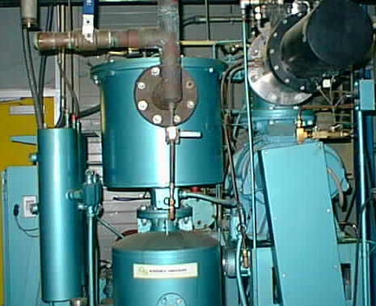
Figure 1. Vacuum Pump
The problem with the existing cooling system for the hybrid magnet at the National High Magnetic Field Laboratory (NHMFL) is contamination. Foreign particles, mainly oil and water, are being introduced to the helium flow. When helium reaches a temperature of below 2.2 Kelvin, its properties change and it becomes what is known as a superfluid. A superfluid demonstrates a complete lack of viscosity. Also, its thermal conductivity is enormously greater than a non-superfluid. Such a high thermal conductivity would help greatly in cooling down the hybrid magnet. However, the liquid helium can only become a superfluid if it is a pure substance. At this point in time, it is not due to the above-mentioned contaminants. Therefore, there is a need to rid the current system of all contamination. The current setup utilizes a liquefier, vacuum pump, and compressor for the circulation of liquid helium. After the helium circulates around the magnet and absorbs its heat, it is sent to the liquefier. This is because the heat from the magnet causes the liquid helium to begin to turn into gaseous helium. The liquefier in turn uses refrigeration and pressure to re-liquefy the helium. The compressor and vacuum pump are used to keep the helium flowing through the system. Due to the poor condition of the seals used in the vacuum pump (Figure 1), water and oil are introduced into the flow. However, the compressor is equipped with a device that filters out oil from the system. Thus, the only contaminant is water. This water is mixed in with the liquid helium flow and when it reaches the liquefier, it freezes and causes the liquefier to become clogged. At first, it might seem like the logical step would be to simply replace the faulty seals. This would however take a good deal of time and would have to done on a routine basis. In order to replace the seals, the entire system would have to be shut down and them brought back online. Therefore, a device is required to filter out the water particles while allowing the system to run continually.
Cryotraps are not new. There are cryotraps that are used in other magnet and cooling systems, however, the cryotrap that we must design will have to move much cooler material, with minimal pressure loss. The NHMFL has not been able to find a cryotrap that would fit into the system of their Hybrid Magnet. The production of such a cryotrap will allow for companies to implement liquid helium has a cooling substance into systems that generate extreme amounts of heat.

III. Needs Assessment

Needs Assessment

The general scope of this project is to build a cryotrap for the hybrid magnet at the National High Magnetic Field Laboratory (NHMFL). The hybrid magnet uses helium as a means of dissipating heat. Tubing filled with helium is wrapped around the magnet and the helium absorbs heat generated by the magnet. It is desired that the helium be cooled to or below 2.2 Kelvin. At this temperature, the helium becomes a superfluid. This means that the helium will become thermally superconductive. However, to become a superfluid, the helium must be pure, or without contaminants.
As it is right now, the system has contamination from water, nitrogen, and oil. It is our goal to design and build a cryotrap that will freeze out these contaminants leaving only pure helium. Also, there needs to be minimal pressure loss through and minimal heat gain to the system. In addition, liquid nitrogen is to be used as the coolant for the helium and a liquid level monitoring system for the nitrogen is to be implemented as well.
The pressure of the liquid nitrogen will have to be measured, as it will begin to turn into a gas as it absorbs heat from the helium flow. Since nitrogen gas expands tremendously from its liquid state, the monitoring of pressure is critical. The cryotrap will be implemented between the liquefier and compressor.
There are two compressors per liquefier; therefore two cryotraps per liquefier will be installed. This is so one cryotrap can be taken “offline” and the other put “online” when removal of the contaminants from the trap becomes necessary. Therefore, the entire system will not have to be shut down for routine maintenance of the cryotraps. In addition, the NHMFL would like a carbon filter and a heating system to remove contaminants if at all possible.

Needs Table

The needs table is a prorating of each demand and desire that the customer has given us based upon their importance. Each one is rated on a scale of one to ten (1 – 10).

Table 1. Needs Assessment Rating of Importance
Wishes or Demands  (D or W) | Requirements | Importance
D | Minimize pressure loss | 10
D | Freeze out primary contaminants | 10
D | Liquid nitrogen Coolant | 10
D | Liquid level maintenance system | 10
D | Minimum heat gain to coolant system | 10
D | Ability to handle both vacuum pumps | 10
W | Redundancy of system | 8
W | Carbon filter | 6
W | Heater system to remove contaminants (if carbon filter used) | 3

IV. Specifications

Description of Values

The temperatures provided in Table 1 were given to the team by the customer and relate directly to the function of the cryotrap. Each temperature describes at what point the contaminants will either freeze or liquefy. The pressure loss stated in metric one is a maximum. The volumetric flow rate is fixed, as it is dependant on the vacuum pumps. The dimensions (length, width, height) are based upon measurements of ceiling space; no floor measurements were made to date. The customer specified the cost of total material. The number of contaminants was based on previous experience with the system.

Values

Table 2. Specifications
Metric No. | Property | Units | Value
1 | Pressure Change | Pa | 3447
2 | Liquid Nitrogen Temperature | K | 77
3 | Liquid H2O Temperature | K | 373
4 | Solid H2O Temperature | K | 273
5 | Solid Oil Temperature | K | N/A
6 | Helium Inlet Temperature | K | 305±5
7 | Volumetric Flow Rate | m³/s | 0.472
8 | Length | m | 1.829±0.2
9 | Width | m | 1.067±0.3
10 | Height | m | 0.61±0.3
11 | Amount of Contaminants | ppm | 125±125
12 | Cost of Material | $ | 1000±100

V. Research Designs

First meeting with our clients, we were given a preliminary sketch (Figure 2) of the type of system that they desired. The preliminary sketch was a spiraling inlet tube with a charcoal filter inside the tube, submerged in a liquid nitrogen bath, surrounded by a vacuum jacket. As we researched on the Internet and through our clients we could not find an existing liquid nitrogen cryotrap. So we looked into the preliminary sketch to see if it was practical. The system was broken down to its main functions: cooling the flow through the trap, trapping the contaminants, and keeping the change in pressure under half of a psi. Through calculations we found the exit temperature of the flow through the system that they have given to us much colder than is required to freeze the main contaminant (water). Since, the contaminants would freeze early in the system, there would not be any problem for the contaminants to be trapped in the charcoal filter. The problem with their design is the change in pressure. The change in pressure was much greater than half of a psi, due to the spiral effect of the tube and the use of the charcoal filter. From evaluating the original design, it gives us an idea of what constraints we will have in coming up with our design. Since we cannot exceed a pressure drop of half a psi, we know that we cannot have too many bends or too thick of a filtration device.

He In He Out

filter

Figure 2 – Preliminary Sketch of Cryotrap

Project Management

WBS Code: 5000

I. Statement of Objectives

The objective of this portion of the report is to describe how the project and the group shall be managed. This describes the interpersonal communications between group members and the customer/sponsor. Included also is a breakdown of the work necessary for the completion of the design phase and a schedule of when these tasks are to be completed.

II. Documentation Procedures

A. Correspondence

- Electronic Correspondence

All electronic correspondence sent by a team member must be sent to all other team members and the sponsor (John Kynoch). Members are to leave the correspondence on their computer until such a time as it is deemed necessary to delete the correspondence. All relevant correspondence is to be included as appendices to all respective reports.

- Paper Correspondence

All paper correspondence written by a team member is to be copied and distributed at the weekly meeting. All relevant correspondence is to be included as appendices to all respective reports.

- Exceptions

All correspondence regarding personal matters in reference to the team shall not be distributed widely or copied. These matters shall be brought up by the team member to the group and worked out in discussion.

B. Personal Work

- Qualifications

Any drawings, calculations, programs, written ideas, reports and any other written or computer based work that is specifically geared towards the development of the cryotrap, or is in reference to the cryotrap shall be considered personal work.

- Documentation

The team member whom partakes in personal work on the project must notify the rest of the team and the sponsor, unless already approved to do so, and make their intentions clear as to the purpose of their work. The member proceeding with the work shall send periodic progress reports, the number of which shall be determined based on a work timeline given by the member. At the end of the work, the final product shall be produced in a report and made accessible to all of the members and the sponsors.

C. Reports

- Documentation

Every report must be distributed to each of the team members and the sponsor at the time of completion.

III. Experimental Methods

Definition of Experiment

An experiment in this project shall be defined as any computer simulation or product runs that are meant to test certain aspects of the product.

B. Safety Precautions

In the event of an actual product test run, all safety precautions must be followed exactly. Since the product involves the use of cryogenic fluids, it is necessary that an advisor must be there during these times.

C. Product Test Run

If the team wishes to have a product run, they shall give notice to their supervisor or sponsor at least one week in advance explaining what the purpose of the test is, the time that they will do it, and how they will obtain data. Any product experiment must be accompanied by a report explaining all of the above and the meaning of the results given.

D. Computer Experimentation

If a computer simulation is to be run a notice shall be given out to all of the team members and time shall be set at which all members shall attend. Any data recorded during the experiment shall be condensed into report form and given to the sponsor and each of the team members.

IV. Work Breakdown Structure

Description

The WBS or work breakdown structure is a way of visualizing a major project into tasks and subtask. The first level of the WBS defines general areas of work but also tasks. These tasks are considered the major milestones of the project and are therefore placed on the highest level of the chart. The second level represents the tasks needed to accomplish the higher order tasks. Each of these subtasks is key to the project and cannot be skipped at any level. The third level of the work breakdown structure represents non critical, but nonetheless necessary tasks. These subtasks represent what should be done before completing the predecessor task.
The WBS is to be followed completely. At no point may deviation be made. If a task is seen as to be needed to be broken up into smaller sub tasks, the team shall do so at their discretion, but at no point may a WBS level or task be deleted. If it is decided that the WBS be broken down further, the sponsor shall be told and a new WBS shall be written out.

WBS Chart

The WBS is included in Appendix A.

V. Scheduling Chart

Description

The Gantt chart we derived came from the WBS we created. We used the main tasks from the WBS to create the main task of the Gantt chart. We also created the timeline of the Gantt chart from selected presentations and deliverable due dates. From this point we worked backwards and broke down the main tasks into subtasks, and created corresponding timelines to each subtask.
The Gant chart is a scheduling method for the design of a cryotrap for the hybrid magnet. The chart is broken down into different tasks and activities that must be completed in a set order and in a specified period of time. The following is a description of the individual tasks listed in the Gant Chart.
Project Assessment: Assessing what will be needed to carry out and complete the project at hand. This is a lengthy task as more information will be gathered after the initial interview.
Scope of Project: The scope of the project consists of a general overview and briefing of the design. This will come from the customer as they relate what they desire and want the project to accomplish.
Need Assessment: This task goes hand in hand with the project assessment. This step entails determining major design requirements and/or functions. These are obtained from discussing the project with the customer.
Customer Introduction Interview: The first meeting between the customer and engineering team. Introductions are made and a general description and overview of the project are given.
Specifications: A more detailed scope of set of needs. These needs and wants are given by the customer and consist of hard data and numbers as requirements for the design.
Research Designs: Stage in which any background information is researched and an inquiry into existing designs is made. Information or components of other designs may be implemented into the design.
Conceptual Design: After understanding the basic function for the design, all ideas of how to accomplish the task are brainstormed together. Taking all requirements and specifications, concept designs are generated and appropriate designs are selected. Eventually, one design will come out of this phase.
Final Design: In this phase, the selected design is discussed with the customer for approval or further changes. Once approved, all relevant calculations will be made. These will include design considerations for the thermal, material, and fluid flow aspects of the design. These aspects are considered simultaneously as the three are inter-related.
Drawing Design: Once all calculations are complete and the customer has approved the final design, all the components and parts will be drawn using the computer aided drawing program, Pro-E. All drawings will be dimensioned, as they are the basis for the construction of the design set to occur in the following spring semester.

Gantt Chart

The Gantt chart is included in Appendix B of this report. The first Gantt chart in appendix B of the report is the original schedule; the second chart shows the actual achievements of the group. An explanation of how to read the charts is given in the appendix.

Concept Generation and Selection

WBS Code: 2000

I. Statement of Objectives

The objective of this part of the report is to detail how the initial concept ideas were generated and what methods were used to decide on which concept and configuration were to be implemented in the final phase of the design.

II. Quality Function Deployment

In order to determine which concepts would be allowed to go to the final selection a new ranking system had to be developed to judge each concept. The quality function deployment (QFD) table was used to develop this. First the needs were placed on the left side of the graph and the specifications were placed at the top of the graph. Then an “X” was placed wherever a need dealt with a particular specification (such as pressure loss is related to length). Under the heading of “New Ranking” in the QFD (which is included in Appendix C) the number of X’s were counted up for each need and placed in the first column.
Using these numbers (the highest and most important being 7), the original needs assessment ranking, and a consideration of what needs were important in the actual concept selection phase, the final ranking system was obtained. Every need is scaled from 1 to 10, ten being the highest. The system should be self evident, but there are two items that need explaining. The use of liquid nitrogen was not considered important in the actual design of the cryotrap so it was given design rating of 5, even though the needs assessment gave it a 10. The need to handle both vacuum pumps at once was given an 8, even though its specification rating was 7. This is because this ability is not dependant on the internal design of the cryotrap, but actually the external piping system.

III. Concept Designs
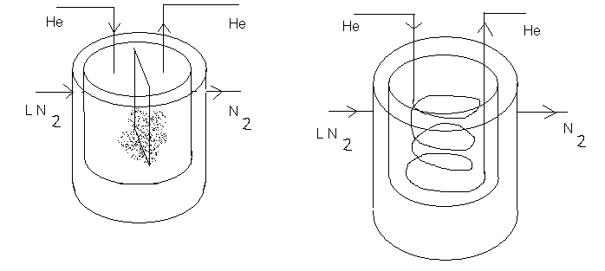
Figure 3. Concepts 1 and 2

Concept one (Figure 3) has a canister type configuration. The canister has two separate compartments: one for the He and one for the N₂. The inner compartment will hold the He. The He will enter the compartment through a pipe that ends shortly after it enters the compartment. The He will exit a pipe through a second pipe that has an opening at the very top of the compartment. The pressure causes the movement through the pipes from the flowing He. On the inside of the inner compartment is a separator that the contaminants will collect onto. The separator will also serve to create turbulence in the He stream to ensure contact of all particles with a surface, whether it is the separator or the inner wall of the canister. The outer compartment will house the N₂. The outer compartment must have a liquid level monitor to maintain a sufficient amount of N₂. The N₂ canister will be attached to the N₂ line. When the level of the N₂ gets to low, a control valve will open to allow N₂ to enter until an acceptable level is obtained. The two canisters will be enclosed inside a vacuum jacket to insulate the N₂.
Concept two also has the canister type configuration. This concept has two compartments as the first concept. The idea is the same except for the second concept; the inner compartment has the piping in coils and is continuous through the compartment. The continuous pipe allows more surface area for contaminants to freeze to. A negative to this design is the more coils the pipe has, the greater pressure loss. Also as the contaminants stick to the side of the pipe wall, the pipe will begin to clog and will eventually clog completely up. The N₂ canister is set up the same way as concept one.
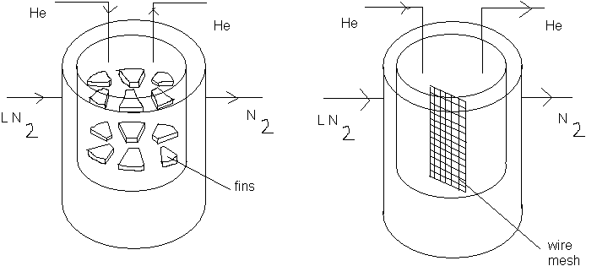
Figure 4. Concepts 3 and 4
Concepts three and four (Figure 4) are also canister type configurations. For concept three, the He pipe is open ended as in concept one. The pressure will create the movement of the He throughout the canister. In this concept, the inner canister is lined with a number of fins. The purpose of the fins is to create more surface area for the contaminants to collect on. The fins will also create turbulence to ensure all particles will come in contact with some surface inside the canister. The concept is designed for the He to fill the inner compartment and exit through a separate pipe. The outer canister has the same design as concept one and two.
Concept four is basically the same idea as concept one. The He enters an inner canister through an open pipe. The pressure created from the He filling the canister will cause the He to flow through the exit piping. Located in the canister is a wire mesh separator. The He will flow through this separator and the contaminants will freeze to the mesh. The mesh will be able to be removed for cleaning purposes. The N₂ canister has the same design as concepts one, two and three.

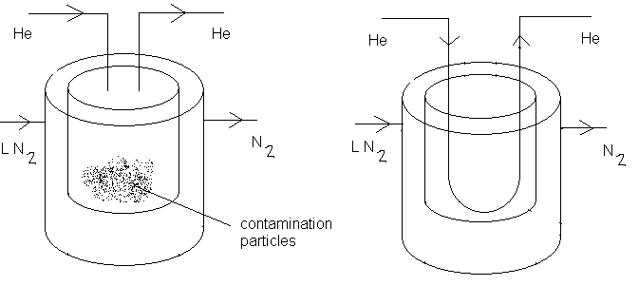

Figure 5. Concepts 5 and 6

Concepts five and six (Figure 5) are also canister type configurations. Concept five is the same basic design as one, three, and four. The He enters the canister through an open pipe and exits through a separate pipe. The difference in this design is the fact that there is no extra surface for the contaminants to freeze to. The contaminants only surface to freeze to is the inner surface of the canister. The major problem with this design is the fact that with such a low amount of area for contaminants to freeze to, there is no guarantee that all particles of the He flow will contact a wall and freeze out the contaminants. The N₂ canister is the same as the previous designs.
Concept six has the same basic idea as concept two. The He will enter the canister through a continuous pipe. However with this design has no filter or additional surface on the inside of the pipe to collect particles. One of the major drawbacks to this design is the same as concept five. Without additional surface area to ensure contact with every particle in the He flow, the flow at the centerline of the pipe may flow continuously through the pipe without having time to stick to the pipe wall.

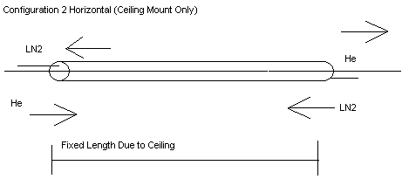
Figure 6. Configuration 1

The configurations are a way to orient the entire cryotrap system. Two configurations (Figure 6 and 7) were created and were evaluated to create the finished product. Configuration one is to have the entire system mounted to the ceiling. The canister will have a horizontal geometry with the length greatly exceeding the height. The inner pipe will be for the He. The second pipe will be for the N₂. The outer level of the pipe will be the vacuum jacket. One plus to this configuration is that with the cryotrap mounted on the ceiling, it will not obstruct any walking areas. One negative to this configuration is the actual weight of the cryotrap will make it difficult to mount.

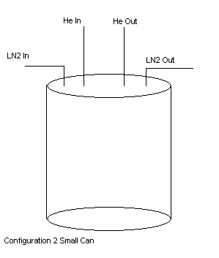
Figure 7. Configuration 2

Configuration two is a vertical canister. The canister will have a relatively large height compared to the radius of the canister. This configuration will not be mounted on the ceiling but on the floor and on top of one of the compressors. The vertical canister will allow for the same amount of volume but will be more obstructive.

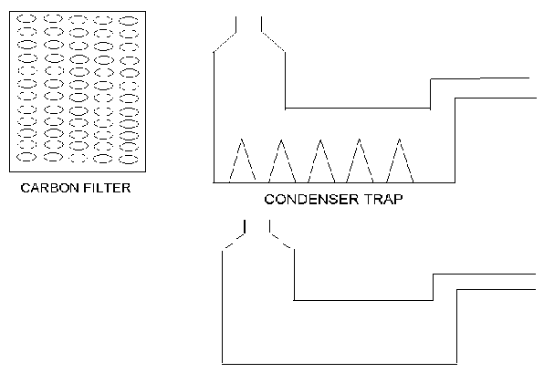

Figure 8. Filters
The cryotrap may have some type of filtration system (Figure 8) for the contaminants. The group came up with three different ideas for the type of filter to use. The first filter is a carbon filter. The filter has the ability to collect a large amount of contaminants before being replaced. The second filter is a condenser trap that has fins on the inside. The idea behind the filter is for the particles to freeze and collect on the fins. The fins will create a larger contact area for the particles to freeze and attach themselves. The third filter is the condenser trap without the fins. The filter will work in this system because the flow through the system is turbulent. If the flow slows down to a laminar flow the system will not work, but it is good because there is not a noticeable change in pressure within the filter.

IV. Concept Selection

The initial design selection uses a straight pipe configuration. It is placed horizontally along the ceiling and is suspended from the ceiling’s support beams with brackets. Due to its high thermal conductivity, copper was chosen as the pipe material. The existing piping system does not have to be altered much as the liquid nitrogen vessel and vacuum jacket simply surround the piping. From calculations, it was determined that the inner diameter of the helium flow piping should be 2.5 inches. The existing piping must connect with the 2.5-inch diameter piping necessary for the cryotrap. This is done with couplings. A coupling allows for two pipes of differing diameters to be joined together. In order to freeze out the water contamination, the liquid nitrogen needs to be in contact with approximately 5 feet of the helium flow pipe. At this length, all of the water particles are frozen and drop out of the helium flow. The liquid nitrogen vessel surrounding the pipe cannot be open to the atmosphere. Thus, a vacuum jacket was placed around it for insulation purposes. In addition, insulation was wrapped around the nitrogen vessel to further aid in keeping the nitrogen at a reasonable temperature. Due to a large expansion coefficient for nitrogen, small changes in temperature cause large changes in pressure. Because of this and heat absorption from the helium, the nitrogen turns into a gas. Eventually, the nitrogen vessel would explode when the pressure became great enough. Therefore, a pressure release valve is used to let out the pressure build-up as needed. Also, a liquid level monitor for the nitrogen is used to keep track of the amount of liquid nitrogen in the vessel at any given time. When the level is too low for the cryotrap to function properly and freeze out the contaminants, more nitrogen is added to the vessel. Furthermore, the given initial design constraints are met with this design. Contamination is successfully removed from the helium flow and the system has less than ½ psi pressure loss from entrance to exit of the cryotrap.
With this design, all goals set by the customer are fulfilled. All previous concepts did not meet the needed requirements in either one or more areas. Concepts1 and 2(Fig.3) caused a pressure loss greater than ½ psi and thus failed the main design criteria. In addition, the water particles would not completely freeze out, as there was not direct contact between the helium piping and the liquid nitrogen. Also, the pressure drop in Concepts 3 and 4 (Fig.4) was more than ½ psi due to the “open can” design. With these designs, the inlet helium pipe was cut off upon entering the can and the gaseous helium was allowed to fill the can eventually creating enough pressure to flow through the outlet pipe. This caused a pressure loss greater than the allowed ½ psi. Concept 5 (Fig.5) also caused a pressure loss greater than ½ psi and could not freeze out the contamination properly. Still, while able to rid the system of contamination, Concept 6 (Fig.5) also had too high of a pressure loss. Since this design could not be place on the ceiling, extra piping would have been required adding to the pressure drop across the system. Therefore, the straight pipe design was selected over all other possible designs since it successfully met all design needs given by the customer.

Final Design

WBS Code: 3000

I. Statement of Objectives

The objective of this section is to describe how the final design occurred. The first part shows the thermal design of the concept selection and discusses the development of the initial final design. The second part provides a chronological order of the events that occurred in early November that fundamentally changed the final design. Finally the final design will be shown and described, and part drawings shall be given

II. Thermal Design: Concept Selection

The thermal design phase of the project consisted of quantitatively verifying the design choice made, rather than qualitative. The first procedure was to gather data on how long the pipe needed to be in order to trap out the particles. It was assumed that the turbulence inside of the pipe would provide surface contact for all of the contaminants within the flow. This had to be checked to make sure the flow would be turbulent. The maximum length of piping that could be converted into the cryotrap on the ceiling would be 6 ft, so the length of the cryotrap was constrained to that requirement. Equation 1 (Appendix D) shows the values that were inputted into the program (see Appendix H). The flow rate and pipe length values were the constraints given to us by the customer and the location of the device. The customer also gave the material of the pipe, copper, to the group. By manipulating the diameter of the pipe in the program, the group was able to figure out a length that would generate the required temperature of ≤ 273K and maintain the pressure drop of ≤ 0.5 psi. Because the group decided to change the entire piping system that already exist at the magnet lab, the pressure loss created by the addition of the cryotrap was negligible.
Once the appropriate length and diameter was calculated, the area of the nitrogen bath was calculated. The amount of nitrogen that surrounds the helium must be enough to lower the temperature of the helium inside the entire 6 ft. pipe. With the initial 2.5 in. diameter, the group calculated a pipe with a diameter of 4 in. would have a sufficient volume of nitrogen.
Because the pipe had a relatively long length, it is required to have an effective vacuum jacket to insulate the nitrogen bath. This jacket would allow a conservation of nitrogen and maintain the lower temperature for a longer period of time. Because the vacuum jacket needs only to place a dead space entirely around the nitrogen vessel, a 5 in. diameter pipe would be used. The 0.5 in. space around the nitrogen vessel would be placed under a vacuum. The vacuum jacket must contact the nitrogen vessel in some manner; therefore, 3 G10 fiberglass rods were designed to hang the nitrogen vessel from the top of the vacuum jacket. The G10 is a great insulator, and allow for a minimal heat transfer through the rods.

III. Liquid Nitrogen Control System

One element of the cryotrap is the liquid nitrogen control system. The control system’s purpose is to maintain a sufficient amount of nitrogen in the canister. Nitrogen has a high expansion rate from a liquid to a gas. As the nitrogen evaporates, the gas takes out a much larger amount of area than nitrogen in liquid form. Several elements go into the liquid nitrogen control system. The first element is the fill port. The fill port is simply the hole that is used to refill the nitrogen canister once the level is too low. The canister may be filled manually or automatically.
The second element is a liquid level indicator (LLI). Because the cryotrap is entirely closed, it is vital to have the LLI. Without the LLI, there would be no way to know when the nitrogen level is too low and the system would begin to increase in temperature. The indicator is used to monitor the amount of nitrogen in the canister. LLIs are readily available on the market. For the cryotrap application, the type we will use has been narrowed to two types: a mechanical floating devices and an electric sensor. The mechanical device has two functions: to monitor the level and to serve, as a valve to add nitrogen once the level is too low. A ball is connected to a valve. Once the ball drops below a given level, a plug connected to it will release from the fill port opening. As nitrogen fills the chamber, the ball rises. Once the ball has risen to the desired mark, the fill port will be plugged up. The electric sensor is a two-part sensor. One sensor is at the high mark on the canister and one at the low mark. Once the liquid level is not in contact with the lower sensor, a control valve will open and the canister will fill. Once the nitrogen has reached the high sensor, the valve will close.
The third element of the liquid nitrogen control system is the vent. The vent serves to release gaseous nitrogen once the amount is too high. The vent is automatic and also available on the market. The vent comes from the top of the cryotrap and releases the gas into the atmosphere.
Because the liquid nitrogen control system consists of several commercially available parts, the sponsor will conduct the implementation of the system. The design of the control system will be installed once the final cryotrap design is determined.

IV. Contaminant Collection System

The purpose of the cryotrap is to freeze out all contaminants in the He flow. To accomplish this goal, a collection system must be created. In the initial design, the cryotrap was a horizontal, straight pipe. The inner wall of the pipe would serve as the collection surface of the contaminants and the turbulence of the flow would insure contact of each contaminant with the pipe wall. Upon meetings with the sponsor, it was determined this design would not work. The sponsor was concerned with the weight of the design not be able to be supported by the ceiling. Another concern with the first design was the fact that with no surface on the inside of the pipe, there was no certain way to ensure contact of each particle in the stream with a pipe surface.
The second design was a vertical, canister designed system. The He would enter through a copper pipe in the top of the canister, have one U-bend at the bottom of the N₂ canister and exits the top of the canister. The pipe would not have any structure in the pipe and the contaminants would stick to the walls of the pipe. There was concern that the pressure loss for such a configuration would be too large and could not meet the design specification given by the customers. After a meeting with the sponsor, the second design was agreed upon and calculations began. On November 9, 2001, the sponsor of the project changed important specifications that gave the group more freedom in the design. The maximum pressure drop increases from 0.5 psi to 1.0 psi. The additional pressure loss allowance gave the group the ability to consider the canister design as a viable solution. The maximum flow rate was decreased from 1000 ft³/min to 500 ft³/min. On November 12, 2001 through meeting with Kurt Cantrell, an employee of the National High Magnetic Field Laboratory who work with cryotraps, the group was informed that straight pipe with no additional surface area does not work in real world applications. Through this meeting the final contaminant collection system was created.
The collection system has two parts: the pipe wall and a mesh insert. The pipe wall is made of copper. The copper pipe is submerged in liquid nitrogen. Contaminants that come into contact with the walls will stick to them. The second part is the mesh insert. The mesh insert is a porous copper rod that is placed inside the actual copper pipe. The He will flow through the mesh and contaminants will stick to the surface of the mesh. The mesh is commercially available in standard sizes and is easily inserted into the pipes.

V. Vacuum Jacket

An important element of the cryotrap design is the vacuum jacket. The vacuum jacket’s purpose is to insulate the nitrogen vessel from the atmosphere. The vacuum jacket must be designed to withstand the pressure from the vacuum placed on it. During the design of the vacuum jacket, the distance from the top of the jacket to the top of the nitrogen vessel must be maximized in order not to transfer large amounts of heat from the atmosphere through the pipes entering the nitrogen vessel. The space between the vacuum jacket wall and the side and the bottom of the nitrogen vessel can be minimized as long as there exists a sufficient area of dead space.
One aspect of the vacuum jacket that must be remembered in design is everywhere the vacuum jacket touches a pipe must be completely sealed or else it will crumple when a vacuum is placed on it. To ensure airtight seals, the pipes entering the vacuum jacket will be stainless steel, the same material as the vacuum jacket. If the pipe had been all copper, as initially thought, the welds would be impossible to be airtight.
The vacuum jacket will also serve as a support for the nitrogen vessel. By using the LLI, the fill port and temperature gauge ports and welding these ports to the vacuum jacket and the nitrogen vessel, the vacuum jacket will hold the nitrogen vessel so it will be dead space around the sides as well as the bottom of the nitrogen vessel.

VI. Material Selection

Materials play an important part in all cryogenic applications. For the cryotrap a variety of materials will be used. For the vacuum jacket and the nitrogen vessel, stainless steel will be used. The sponsor of the project specified the group use stainless steel. Stainless steel piping found at the magnet lab will be used to create the vacuum jacket and the nitrogen vessel. The majority of the helium pipe will be made of stainless steel also. Through meetings with the customer, it was determined that due to the fact that the welds for the cryotrap should be air tight, a stainless steel to stainless steel weld would be the optimum choice. The portion of the pipe that will be submerged in liquid nitrogen will be made of copper. The sponsor chose copper because copper has a high thermal conductivity. Copper is also used in cryogenic systems already in use at the magnet lab. The fittings used to couple the copper pipe to the stainless pipe are also made of copper. The filtration system for the cryotrap is a copper mesh. Once again, the sponsor chose copper. This copper mesh can be found commercially. To insulate the nitrogen vessel from the atmosphere, it will be wrapped in several layers of multi-layer insulation. The insulation most widely used at the magnet lab is an aluminum mylar. Because the magnet lab has similar systems already in use, all of the materials used for our cryotrap were suggested to the group.

VII. Thermal Design: Final Design

The new specifications that the customer changed in the project were the volumetric flow rate and the pressure drop across the cryotrap. The volumetric flow rate was changed to .236 m3/s and the pressure drop allowed was raised to 1 psi. The reason for the change in the specifications was due to the new design that Kurt Cantrell suggested. Kurt Cantrell told the group that a straight pipe design for trapping contaminants using cryogenics has proven not to work and that some kind of bending in the pipe was needed. Also he said the some form of fin or mesh would be needed in order to assure that all of the contaminants would be trapped out of the piping system. He also said that a vacuum jacket could not be placed on a long straight pipe because the vacuum pulled on it would cause the whole thing to buckle and collapse in on it. The customer also prior to speaking to Kurt Cantrell that the cryotrap could not be placed on the ceiling because of concern that the beam structure in the room would not support the additional weight of the cryotrap.
With these considerations in mind the group decided to stop the design of the horizontal cryotrap and redesign. With all of these considerations, the group decided to go back and choose concept six in figure five. This was chosen not to fit the specifications originally given but to fit the new information obtained. The canister device would satisfy the vacuum jacket requirements. The U-bend allows for the contamination to coalesce at the bottom of the pipe, along with the mesh that will be fitted into the pipe. The problem with this design is that it had to be placed next to the nitrogen line on the floor or on the compressor. The customer decided that the compressor would be the optimal place to arrange it, as it would allow floor space to remain open for technicians. Due to this location, additional piping would be needed to connect the cryotrap to the original piping for the helium flow. The concern was that the pressure loss for this much piping plus the mesh would be too high. The customers agreed that our evaluation was correct and decided to change the specifications as described above.
The final concept (concept 6 in figure 5) was decided as the optimal one, and was agreed on by the group and the customers. Calculations had to be made in order to determine the new pipe length and the pipe diameter. Equation 3 (Appendix E) shows the input values to the program and Equation 4 shows the outputs that the program gave. The exit temperature of 267 K for 3 ft. was ample enough to satisfy the criteria but a length of 4 ft was decided upon to give a good margin of error for the freezing of the contaminants.
Once the pipe length was determined, the pipe diameter had to be chosen that would give the least amount of pressure drop. The total length of piping that would be used to connect the existing piping to the cryotrap and back again was decided to be 10 ft long. Four ninety-degree turns would be used. Two at the ceiling where the flow diverges to the cryotrap and reconvenes again at the ceiling, and two more were counted for the U-pipe inside of the liquid nitrogen vessel. Two forty-five degree turns were counted at the interface between the piping and the vacuum jacket. Given this information along with the Reynolds number and flow velocity obtained from the program, equation 5 and 6 (Appendix F) were used to come up with the pressure loss values for a 2.5-inch pipe and a 3-inch pipe. Though both of the pipe diameters espoused a pressure loss of less than half a psi, the three inch pipe was chosen because a smaller pressure drop would allow for more mesh to be used which would help in the freezing out of contamination.

VIII. Final Design

The final design makes use of a U-shaped pipe for the helium flow. It has an upright setup meaning that the fluid flow is primarily in the vertical direction. The cryotrap piping attaches to the existing piping system along the ceiling and turns down towards the ground. This is because the cryotrap is placed on top of the compressor. From the ceiling, the piping turns down 90 degrees. Since the existing piping is not directly overhead of the compressor, a 45-degree turn is made to reach the compressor. Due to vibrations caused by the compressor, a device is required to rest the cryotrap on damps the vibrations. The vibrations are transferred to the cryotrap as heat, which works against the liquid nitrogen. From the point of the 45-degree bend, the helium flows down into the cryotrap where it passes through two 90-degree curved bends. The centerline radius was determined to be 4.5 inches with an outside radius of 6 inches. The flow then follows the same path to reach the ceiling as it did coming down from the ceiling only in reverse. From design calculations, the inside diameter (ID) of the pipe was determined to be 3 inches. Inside the cryotrap the helium passes through a container of liquid nitrogen that freezes out the water particles. To aid in the removal of the contamination, a metallic mesh is inserted into the U-shaped section of the piping that is in contact with the liquid nitrogen. In order to fully freeze out all water particles, approximately 4 feet of the piping passes through the liquid nitrogen bath. In addition, a vacuum jacket surrounds the nitrogen container in order to insulate the nitrogen from the atmosphere. Exposure to the atmosphere is unwanted as this would lead to a rapid increase in the liquid nitrogen temperature. Since the coefficient of expansion for liquid nitrogen is quite large, a small change in temperature would cause a drastic change in pressure inside the vessel. Eventually, the pressure would build until the vessel exploded. In addition to the vacuum jacket, aluminum Mylar is wrapped around the liquid nitrogen container for added insulation. A vacuum jacket pulls a vacuum on the liquid nitrogen vessel keeping it at a relatively constant and safe temperature. Vacuum jackets are primarily constructed using stainless steel. The piping for the helium flow however, is made of copper because of its high thermal conductivity. For fabrication purposes, all piping into and out of the vacuum jacket are made of stainless steel. Therefore, copper piping is used until just before it reaches the cryotrap and a transition will be made to stainless steel. The same is done for the helium flow exiting the cryotrap.
For safety purposes, a liquid level monitoring system was implemented into the cryotrap. Over time, heat absorbed by the liquid nitrogen from the helium causes the nitrogen to turn to a gas. This in turn causes the liquid level to drop and therefore there would not be enough liquid nitrogen to fully freeze out the contamination. Therefore, a liquid level monitor was installed and when the level drops below the needed amount, new liquid nitrogen is added to the container by means of a fill port. Also, the system has a pressure release valve to get rid of the hazardous pressure due to the gaseous nitrogen.
All in all, the final design has a vertical orientation and is located on top of the existing compressor. Copper piping is used for the helium flow except for the section of pipe within the cryotrap. This portion is made of stainless steel as is the liquid nitrogen vessel and vacuum jacket. A pressure release valve and liquid level monitoring system are included for safety measures.

IX. Final Design Drawings

Note: All parts drawings can be found in Appendix I

A. Stainless Steel Pipe (Part 3120-2)

The stainless steel pipe is used in the design to help with the construction of the system. Copper piping could not be used throughout the system because copper does not weld well against the stainless steel liquid nitrogen canister and vacuum jacket. The steel pipe is joined to the copper piping from existing system and the copper U-bend that is submerged into the liquid nitrogen bath. The steel pipe has a diameter of three inches (the same diameter of the copper U-bend in the liquid nitrogen bath). The stainless steel piping is used solely for construction purposes for welding.

B. Copper U-bend Pipe (Part 3120-1)

Copper piping is used in the liquid nitrogen bath because it is a better conductor to freeze the contaminants. Inside the copper U-bend is copper mesh that is used to insure the capture of the contaminants. There is four feet of copper piping submerged in the liquid nitrogen bath and it has a diameter of three inches. The copper U-bend is joined to the steel piping after the steel pipe has been welded to the liquid nitrogen canister and the vacuum jacket.

C. Liquid Nitrogen Canister (Part 3300-1)

The liquid nitrogen canister is the housing for the liquid nitrogen bath and has a liquid level monitor to know when to refill the canister when the liquid nitrogen evaporates. Since nitrogen expands rapidly from liquid to gas, a pressure release valve is necessary in the canister. The release valve transports the nitrogen gas from the canister to the atmosphere. The liquid nitrogen canister has a diameter of 20 inches in diameter and 18 inches in height. The canister is made of stainless steel and has two three inch holes for the stainless steel piping. The canister is able to hold four feet of copper tubing that is necessary to freeze and trap the contaminants. The canister is welded to the stainless steel piping and surrounded by the vacuum jacket.

D. Vacuum Jacket (Part 3110-1)

The vacuum jacket is made of stainless steel and has a diameter of 30 inches and a height of 25 inches. The vacuum jacket is welded to the stainless steel pipe and houses the liquid nitrogen canister. The vacuum jacket is used to insulate the liquid nitrogen to decrease the amount of nitrogen evaporated. The reason stainless steel is used for the vacuum jacket is for one, it is easy to work with and two, it helps prevent the structure from crumbling when the vacuum pressure is put on it.

Appendix A

Work Breakdown Structure

Project Assessment

1000
Conceptual Design
2000
Scope of Project

1100

Needs Assessment

1200

Customer Introduction Interview
1300

Specifications

1310
Research Designs

1320

Objective Tree

2200
Concept Designs
2100

Concept Selection

2220
Customer Design Interview
2210
Material Design

Design Interview 3

Final Design Drawings

Design Parts

Design Assemblies

Final Design

3000
Thermal Design
3100
Heat Transfer Design
3110
Fluid Flow Design
3120
Customer Design Interview 2
3130
Material Design
3200
Material Design
3210
Liquid Nitrogen Control System
3300
Contaminant Collection System
3400
Final Design Drawings
3500
Presentation Progress Report
3220

Design Assemblies

3520

Design Parts

3510
Build & Test

4000
Project Management
5000

Obtain Materials
4100
Build

4200
Test

4300
Progress Reports to Professor
5400
Progress Reports to Client
5300
Develop Project Plans
5200
Attend Weekly Meetings
5100

Appendix B

Original Gantt Scheduling Chart

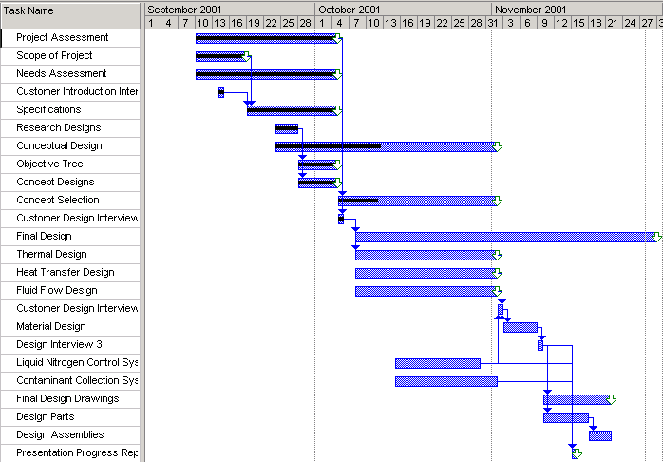

The GANT chart is a system of scheduling task within a project. Once all of the tasks have a certain amount of time given to them, a group can concentrate on finishing one specific task at a time. Once each of the tasks is finished, the project should be totally completed. The initial GANT chart for the hybrid magnet cryotrap was derived using the WBS. This GANT chart was derived under the assumption that the final design would not be due until a date during the second semester. However, the GANT chart was followed strictly as the group had chosen a horizontal ceiling mounted design. Upon a weekly review meeting with the sponsor, it was determined the design would not work. Because a generic program was used to do many of the calculations, the second design did not take a long amount of time to be devised. The initial GANT chart was not revised because the group considered the final product could still be produce by the due date. The GANT chart became obsolete on November 9, 2001. On that date, the initial specifications the group were given were relaxed giving more freedom in the design. As of November 9, 2001, a new GANT chart had to be created to accommodate for these new specifications. The dates for the completion of all calculations, drawings and the final design had to be pushed back. The ending date of the entire project was determined to be November 29, 2001 as the final report and presentation had to be turned in on this date. Arrows on the true GANT chart designate completion dates. As to date all task have been completed except for parts lists and engineering drawings.

True Gantt Scheduling Chart

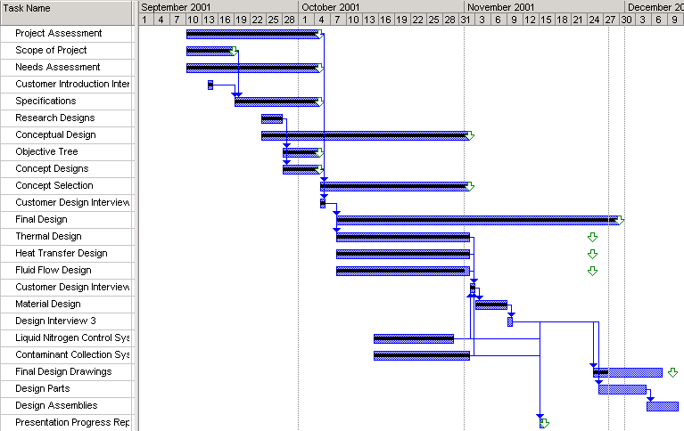

Appendix C

Quality Function Deployment
 |  | Specifications
 |  | ΔP | T_{LN} | T_{,H20} (Liquid) | T_{,H20} (Solid) | Volumetric flow rate | Length | Height | Width | Max cost of raw materials | T_{He} into cryotrap | Amt. Of Contaminants | T_{OIL} | New Rankings
Needs | Minimize pressure loss | X |  |  |  | X | X | X | X |  |  | X |  | 6 | 10
Needs | Freeze out contaminants | X | X | X | X | X |  |  |  |  | X |  | X | 7 | 10
Needs | Liquid nitrogen coolant |  | X |  |  |  |  | X | X | X | X |  |  | 5 | 5
Needs | Liquid nitrogen level maintenance system |  | X |  |  |  | X | X | X | X |  |  |  | 5 | 6
Needs | Minimum heat gain to coolant system |  | X |  |  |  |  | X | X | X |  |  |  | 4 | 7
Needs | Need to handle both vacuum pumps | X |  |  |  | X | X | X | X | X |  | X |  | 7 | 8
Needs | Redundancy of system | X |  |  |  |  |  |  |  | X |  | X |  | 3 | 5
Needs | Carbon filter | X |  |  |  |  |  | X | X | X |  | X |  | 5 | 4
Needs | Heater system (if carbon filter used) |  |  |  |  |  |  |  |  | X |  | X |  | 2 | 1
 | Units | Pa | K | K | K | m³/s | m | m | m | $ | K | ppm | K
 |  | 3447 | 77 | 373 | 273 | 0.472 | 1.83 | 1.07 | 0.61 | 1000 | 305 | 125 | 77
 |  | Engineering Targets

Appendix D

Design Calculations: Determination of Pipe Length 1

Statement of Objectives

The objective of this design calculation is to make a determination of the necessary pipe length that will bring the temperature of the helium flow down to the level necessary to freeze out the contaminants. Also an initial guess as to the diameter of the pipe is to be made along with several other flow values. A program has been written to accomplish this. A detailed description of how this program works is given at the end of the report in Appendix G.

Design Calculations

The first set of numbers entered into the program were:

Pipe Radius = 1.25 in.
Pipe Length = 6 ft. Equation 1
Num. of Pipes = 1
Flow Rate = .472

The output was
Texit = 267 K Equation 2
Reynolds = 77379
V = 149 m/s

Since the temperature was 70 degrees below what was necessary the pipe length was decreased by two thirds to 3 ft. The temperature found was 267.3 K. This was an acceptable temperature as it left an eight-degree margin of error.
Concern over the flow velocity was raised as it seemed very high and may not leave enough time for the contaminants to freeze out, so the radius was changed to 1.5 in. The output of the program was as follows.

Reynolds = 64482
V = 103.5 m/s

This velocity was reasonable enough and allowed enough time to freeze the particles out with a mesh.

Closing Statement

The calculations made within this document comprise the necessary data needed to decide the length of the pipe. The length that was settled on was 5 ft. as it gave a large margin of error to the amount of particles being collected on the pipe wall.

Appendix E

Design Calculations: Determination of Pipe Length 2

I. Statement of Objectives

The objective of this design calculation is to make a determination of the necessary pipe length that will bring the temperature of the helium flow down to the level necessary to freeze out the contaminants. Also an initial guess as to the diameter of the pipe is to be made along with several other flow values. A program has been written to accomplish this. A detailed description of how this program works is given at the end of the report in Appendix H.

II. Design Calculations

The first set of numbers entered into the program were:

Pipe Radius = 1.25 in.
Pipe Length = 3 ft. Equation 3
Num. of Pipes = 1
Flow Rate = .236

The output was
Texit = 267 K Equation 4
Reynolds = 9672.4
V = 74.5 m/s

III. Closing Statement

The calculations made within this document comprise the necessary data needed to decide the length of the pipe for the final design. The length that was settled on was 4 ft. as it gave a large margin of error to the amount of particles being collected on the pipe wall while still being able to fit into the cryotrap.

Appendix F

Design Calculations: Determination of Optimal Pipe Diameter

I. Statement of Objectives

The objective of this experiment is to determine the optimal pipe length and radius of curvature of the U-bend pipe inside the liquid nitrogen container.

II. Design Calculations

Two pipe diameters were chosen for optimal flow in the first design and were carried through to the other designs. In the final design it was necessary to choose the pipe diameter that would give the lowest pressure drop. The allowed pressure drop for the final design was 1 psi or 6894 Pa. Noting that the mesh that must be inserted into the piping system to collect the particles gave a half psi, or 3447 Pa pressure drop, the final design had to have less than half a psi pressure drop.
The Reynolds number and velocity of the fluid flow for the two pipe diameters were taken from the program for the corrected flow rate (a description of the program is given in appendix H).

Table 3. Reynolds and fluid flow velocity for different pipe diameters.
Pipe Diameter | 2.5 in. | 3 in.
Reynolds Number | 9672.4 | 8060.4
Flow Velocity | 18.6. m/s | 12.9 m/s

The friction factor for each flow regime was found by

f = 0.184*(Re)^-0.2 [1] Equation 5

The equivalent lengths for the 90-degree bends and the 45-degree bends were given in . For the two ninety degree turns at the ceiling the optimal curvature radius was used, but the two 90 degree bends inside the liquid nitrogen container had to be as short as possible so an r/D value of 1.5 was used (where r is the radius of curvature to the middle of the pipe).
With the equivalent lengths tabulated the pressure loss could be calculated.

ΔP = f*(V²/2)*(L/D+Le/D)*ρ Equation 6

Where f is the friction factor, V is the velocity, L/D is the total pipe length over the diameter of the pipe, Le/D is the equivalent lengths for the bends and ρ is the density. The results of the calculation are tabulated in Table 4 below.

Table 4. Results of Pressure Loss Calculation

Pipe Diameter | 2.5 in. | 3 in.
Reynolds Number | 38689 | 32241
Velocity | 74.52 m/s | 51.75 m/s
F | 0.022 | 0.023
Le/D (Outer 90° bends) | 40 | 40
Le/D (Inner 90° bends) | 24 | 24
Le/D (45° turns) | 32 | 32
L/D | 144 | 136
ρ | 0.17 kg/m³ | 0.17 kg/m³
Pressure Loss | 2520 Pa | 1219 Pa

III. Closing Statement

The purpose of this design calculation was to determine the pipe diameter that would give the least amount of pressure loss. The constraint was that the pressure loss had to be less than or equal to 0.5 psi or 3447 Pa, in order for the whole systems pressure drop to be less than or equal to 1 psi, or 6894 Pa. The results show that a pipe diameter of 3 in. would be optimal as it provides a pressure drop 2000 Pa. less than what the maximum constraint was set to. Though the 2.5 in piping could be used, it is advised that the least amount of pressure drop occurs within the piping system as possible.

Appendix G

Communication

The following are all email messages received by the group during this semester:

Date: September 13, 2001
From: John Maatsch
To: John Kynoch

Mr. Kynoch,

I represent my senior engineering design team in asking you to set up a time when we could meet with you and discuss the different projects being offered, and make a decision on the one, which we will undertake. Right now we would like a 12:30 meeting tomorrow. If this is inconvenient please email me back immediately and let me know when we can meet.
One of my colleagues should be emailing you a similar letter just in case you do not receive this one.
I look forward to working with you.

Thank You,
John Maatsch

Date: September 14, 2001
From: John Kynoch
To: John Maatsch

John,
Lets make it 1:00. Come into the Lab at the flagpoles and ask for me at the reception desk.
From: John Kynoch To: John Maatsch Date: September 14, 2001

In the next few weeks, all of you will have to go through the online maglab
safety training. Email Kyle Orth - orth@magnet.fsu.edu for information.
Your choice of project will dictate which safety training you will have to
go through.

Date: September 16, 2001
From: John Maatsch
To: John Kynoch
Mr. Kynoch,

The members of the senior design team and I got together today and was unable to decide on which project to undertake. We did agree that we need some more information about each of these projects. So, if it is not too much trouble, we would like a better description of each project when we meet tomorrow, also we want to take a look at each of these things, or the place where they will be applied, if it is not too much trouble.

Thank you,
John Maatsch

Date: September 24, 2001
From: John Maatsch
To: John Kynoch

Hi,
This is the preliminary needs statement. I've divided them into two
groups.
Demands
1. Freeze out contamination: Primary- oil water. Secondary - Nitrogen
2. Pressure loss < 0.5 psi
3. Minimal Heat Gain in LN
4. Liquid Level Control System
5. Easy Filter replacement
Wants
1. Heater system for filter removal
If there are any other suggestions please feel free to respond.
On another note, we need to change the meeting time because our Propulsion
class teacher wants to have class presentations on Friday at 2:00. The only
other time I can meet is 3:30 on Friday. I hope this is convenient for all,
if not email us back and we can discuss it.
John Maatsch

Date: September 25, 2001
From: John Kynoch
To: John Maatsch

A few comments....
The heater is needed to melt and vaporize any contaminants that have frozen
inside of the trap.
Specify Liquid Nitrogen on Demand 4.
An additional demand is to have redundancy so any single trap can be taken
off line and heated while the flow is diverted to another trap.
An additional want is to arrange the trap piping and valves so that we have
two units that can handle both vacuum pumps alone. This will allow us to
take one of them off line while we run both vacuum pumps through the
secondary unit.
3:30 is OK with me.

Date: October 3, 2001
From: John Maatsch
To: John Kynoch

John,
We have a couple of questions for you. If you can answer by tomorrow
afternoon that would be great.
1.What is the exit temperature of the helium from the vacuum pump?
2. Does the liquid nitrogen in the cryotrap have to be stationary, or can it
be flowing?
3. We were unable to find the freezing point of oil. so if you could get
that please let us know.
4. What amount of contaminants are in the helium flow. in ft^3 cont./ft^3
helium.
Thank you very much.
John Maatsch

Date: October 3, 2001
From: John Pucci
To: John Maatsch

>John,
>
>We have a couple of questions for you. If you can answer by tomorrow
>afternoon that would be great.
>
>1.What is the exit temperature of the helium from the vacuum pump?
About 80-120 degrees F
2. Does the liquid nitrogen in the cryotrap have to be stationary, or can it
>be flowing?
It doesn't have to be stationary, necessarily. But, flowing cryogen
liquids creates more heat (and increased boil-off) verses a static
volume. Also, where are you flowing it to?
>3. We were unable to find the freezing point of oil. so if you could get
>that please let us know.
I'm not sure of the exact temperature, but it will be rock solid at
LN2 temperature. Carryover of oil is not that much of a concern
anyway because the compressors use the same oil as the vacuum pumps.
The compressors have an oil coalescing system to remove the oil before
it's exhaust, but it doesn't work with water.
>
>4. What amount of contaminants are in the helium flow. in ft^3 cont./ft^3
>helium.
It's very small. It should be as low as 0.001 ppm, to as high as 250
ppm. (parts per million)

Date: November 8, 2001
From: John Pucci
To: John Maatsch

Sorry guys, it took so long for me to get back to you. We can
relax the specs of the design criteria for the pump's cryo trap down
to 500 ACFM of flow (from 1000 ACFM) and up to 1.0 p.s.i. max back
pressure (from 0.5 p.s.i.). See what you can come up with to have
the flow come down towards the compressor (to help mounting
configuration) and back up to the exhaust manifold. There was
probably something else, please let me know if any of you have any
questions.

Date: Fri, 26 Oct 2001 10:24:29 -0400
From: John G. Kynoch <kynoch@magnet.fsu.edu>
To: Bryan K. Richard <richard@wombat.eng.fsu.edu>
Subject: Re: cryotrap group

cantrell@magnet.fsu.edu

At 11:38 AM 10/25/2001 -0400, you wrote:
>Dear John,
>This is Bryan Richard from the senior cryotrap group. I tried to get in
>contact with Kurt Cantrell by phone but I have been unable to as of
>yet. I wanted to know if you had his email address so I could contact him
>electronically.
>
>Regards,
>Bryan K. Richard
>
>
Thanks, John

John G. Kynoch
Head of Facilities

Voice: (850)644-8965
Fax: (850)644-0534
email: kynoch@magnet.fsu.edu

National High Magnetic Field Laboratory
1800 E Paul Dirac Dr
Tallahassee, FL 32310

From :
  "Kurt Cantrell" <cantrell@magnet.fsu.edu>
To :
  "Bryan Richard" <bkeir@hotmail.com>
Subject :
  RE: question
Date :
  Wed, 7 Nov 2001 12:48:09 -0500

Bryan.
I've been out of town for over a week so I just received your e-mail. I'm trying to catch up right now so I've very busy but would be glad to help if it's not too late. E-mail me back and let me know if you still need some advice.

Kurt
-
----Original Message-----
From: Bryan Richard [mailto:bkeir@hotmail.com]
Sent: Sunday, October 28, 2001 3:25 PM
To: cantrell@magnet.fsu.edu
Subject: question

Dear Kurt,

My name is Bryan Richard and I am a senior at the college of engineering. For my senior project, a group of seniors and I are working with John Kynoch to help design a cryotrap for the hybrid magnet. John told me that you would be a good person to talk to about some possible "do's and don'ts" in designing the vacuum jacket, as far as welding problems, fixtures, etc. Your input would be greatly appreciated in our project. I have tried to reach you at the magnet lab by phone a couple of occasions but I have yet to catch up with you. If possible, could you email me a list of items you believe to important to the design of our vacuum jacket for the cryotrap.

Regards,
Bryan K. Richard
(850) 216-1579

Top of Form
From :
  "Kurt Cantrell" <cantrell@magnet.fsu.edu>
To :
  "Bryan Richard" <bkeir@hotmail.com>
Subject :
  RE: help
Date :
  Fri, 9 Nov 2001 08:25:22 -0500

Reply Reply All Forward Delete | Printer Friendly Version

Bottom of Form
Bryan,
You can come here anytime you like. I'll be here most of the day today except from 11:00 to 1:00 if you want to come on by. If not then it will have to be Tuesday as we aren't working on Monday. Let me know when you want to come by and I'll meet you at the front entrance of the lab. I assume you still have my number but just in case it's 645-5647.

Kurt

-----Original Message-----
From: Bryan Richard [mailto:bkeir@hotmail.com]
Sent: Thursday, November 08, 2001 11:29 PM
To: cantrell@magnet.fsu.edu
Subject: help

Kurt,
We still would greatly appreciate your help. What would be a good time for me to come to the lab and speak with you? One major question we have is how is a vacuum jacket around the cryotrap supported. Once again, thanks.
Bryan K. Richard

From :
  "Kurt Cantrell" <cantrell@magnet.fsu.edu>
To :
  <bkeir@hotmail.com>
Date :
  Wed, 14 Nov 2001 15:53:04 -0500

Top of Form

 | Reply Reply All Forward Delete | Printer Friendly Version

Bottom of Form
Bryan,
I thought about this a little and maybe the bellows in all of your lines is
a little much for a liquid nitrogen application. If you just make sure the
tube wall thickness is kept to a minimum, given the pressure differential
due to the vacuum jacket, and keep the length of the tubes, between where
they attach to the outside and where they are at 77K, relatively long then
your heat leak shouldn't be very high. Once you have a concept I would
calculate your conductive heat leak and estimate how long your nitrogen will
last before the level drops below the mesh or copper tube you'll use to trap
the water vapor. You should ask John Pucci what he thinks a reasonable
amount of time would be between having to refill the LN2. His number is
644-8517. Based on what he says you can then decide whether or not bellows
are necessary (if you're way off from what he says based on your
calculations). Anyway, the advantage of not using the bellows is that now
your pump line inlet and outlet tubes (the large tubes) can act as the
supports for the LN2 canister and then you don't need a G-10 post at the
bottom.
Either that or you can have bellows on the two large tubes (they will have
the largest conductive heat load) and use solid tubes for the vent, fill,
safety relief valve, and LLI tubes, spreading them out by 90 degrees, and
these can act as your supports to hold up the LN2 canister. You'll just
have to check the stresses.

Kurt

Top of Form
From :
  "Kurt Cantrell" <cantrell@magnet.fsu.edu>
To :
  "Bryan Richard" <bkeir@hotmail.com>
Subject :
  RE: cryotrap group
Date :
  Wed, 28 Nov 2001 10:11:48 -0500

 | Reply Reply All Forward Delete | Printer Friendly Version

Bottom of Form
Sure thing Bryan. Anytime between 3:00 and 5:00.

Kurt

-----Original Message-----
From: Bryan Richard [mailto:bkeir@hotmail.com]
Sent: Wednesday, November 28, 2001 3:04 PM
To: cantrell@magnet.fsu.edu
Subject: cryotrap group

Hello Kurt,
We are putting together a presentation and I want to know if there is a time today where I can come by and make photocopies of the catalogs that have the mesh material and pipe fittings.
Regards,
Bryan K. Richard

From :
  Eric D Myers <myers@wombat.eng.fsu.edu>
To :
  bkeir@hotmail.com
Subject :
  Re: cryotrap (fwd)
Date :
  Thu, 29 Nov 2001 09:04:40 -0500 (EST)

Date: Thu, 8 Nov 2001 23:40:56 -0500
From: John Pucci <pucci@magnet.fsu.edu>
To: Eric D Myers <myers@wombat.eng.fsu.edu>
Subject: Re: cryotrap

>John,
> Thanks for getting the info back to us. There was one more thing
>though. If you could find out the company that built the building housing
>the compressors and pumps, that would be great. We need to see what
>amount of weight we can suspend from the beams that were used. Also, do
>you know if John Kynoch will be back tomorrow by any chance? We ran into
>a problem with the vacuum jacket design. From what we were told, the max
>length the jacket can be is 2 feet without collapsing. Since our design
>called for a length of 4 feet, it looks like we're back to the drawing
>board right now. Thanks again!
> Eric Myers
> Hybrid Magnet Cryotrap Group

Eric-
Sorry, I knew there was something else... There is a label on
the platform mezzanine that states 125 PSF., but that's for the
weight rating of the upper, top surface. The company's name that
made the mezzanine is Republic Clerespan of Canton, Ohio. 1038
Belden Ave. N.E., Canton, Ohio 44705. Old phone number=
216-438-5800.

Other notes of reference for the company:
Dealer- Process Systems International (sub-contractor who sold to the NHMFL)
Customer-Job - NHMFL, F.S.U.
Location- Tallahassee, FL
Republic Job No.- 2196

I have the actual drawings for the mezzanine and I'll bring them
to you at the Friday afternoon meeting. Yes, I did talk to John
Kynoch today and he is planning on attending your meeting tomorrow in
the usual meeting room. See you then-

--
John A. Pucci
Hybrid/Cryogenic Operations
National High Magnetic Field Laboratory @ F.S.U.
Tallahassee, FL 32306-2740
Phone: 850-644-8517 FAX: 850-644-0534
Numeric Pager: 657-0123

From :
  Eric D Myers <myers@wombat.eng.fsu.edu>
To :
  bkeir@hotmail.com
Subject :
  Re: cryotrap (fwd)
Date :
  Thu, 29 Nov 2001 09:07:04 -0500 (EST)

Date: Thu, 04 Oct 2001 09:32:45 -0400
From: John G. Kynoch <kynoch@magnet.fsu.edu>
To: Eric D Myers <myers@wombat.eng.fsu.edu>
Subject: Re: cryotrap

I think that MVE was bought out by Chart Industries.

Here are a few more: Industrial Cryo Services ( Tampa)
ACME Cryogenics ( Allentown PA)
Oxford - England

Try a general search for cryogenic vessels. Google seems to work the best
when looking for industrial web pages. Also try
http://www.thomasregister.com/

At 05:53 PM 10/3/2001 -0400, you wrote:
>John,
> I was wondering if you could tell me the name of the company you
>gave me the other day. I was trying to find similar designs on the net
>but the name is abbreviated. It is MVE but it would help to know what
>this name stands for. Thanks.
> Eric Myers
>
Thanks, John

John G. Kynoch
Head of Facilities

Voice: (850)644-8965
Fax: (850)644-0534
email: kynoch@magnet.fsu.edu

National High Magnetic Field Laboratory
1800 E Paul Dirac Dr
Tallahassee, FL 32310

Appendix H

Program Description

I. Statement of Objectives

The objective of this document is to provide a description of how the program works and how it is used. A picture of the program interface is included along with the code in the final section of this appendix.

II. Description of the Program

The program provides a user friendly interface in which the user can enter several relevant values, which include pipe inner radius, temperature of coolant, volumetric flow rate, number of pipes, and temperature of fluid flow. From these variables and several internally defined values such as fluid flow density, specific heat capacity, and others the program uses a finite element method to model the differential equation for fluid flow. The number of divisions parameter in the interface is the number of elements being taken into consideration. The higher this number the more accurate the answer but the more time it takes to compute all the values. The program loops through each of the elements, computing heat loss and then determining the new temperature at the end of the element, until the calculation for the entire pipe is done. Once this is done the program outputs several useful values, such as flow velocity, final exit temperature, and Reynolds number (more can be seen on the interface picture below. These values can then be used for whatever purpose the user finds.

III. Closing Statements
The objective of this document was to describe how the thermal design systems works. The program interface was described showing what the user may input, how the results were tabulated, and what was displayed for the user.

Related Material

A. Code

Option Explicit
Dim TimeTotal As Single
Dim Qdot As Single
Dim Q As Single
Dim Cp As Single
Dim k As Single
Dim rho As Single
Dim Pr As Single
Dim mu As Single
Dim alpha As Single
Dim totalQ As Single
Dim Voldot As Single
Dim IR As Single
Dim l As Single
Dim TLN As Single
Dim Div As Single
Dim deltaL As Single
Dim area As Single
Dim Reynolds As Single
Dim tempflow As Single
Dim massdot As Single
Dim del As Single
Dim Vel As Single
Dim deltaT As Single
Dim mass As Single
Dim Nusselt As Single
Dim h As Single
Dim DelP As Single
Dim nPipes As Single

Private Sub cmdExit_Click()
End
End Sub
Private Sub cmdRun_Click()
Dim n As Long
IR = Val(txtIR.Text) * 0.0254
l = Val(txtPL.Text) * 12 * 0.0254
tempflow = Val(txtTHF.Text)
nPipes = Val(txtNPipes.Text)
TLN = Val(txtLnTemp.Text)
Div = Val(txtDiv.Text)
Voldot = Val(txtVFR.Text) / nPipes
Cp = 5195
k = 0.15
rho = 0.1627
Pr = 0.69
mu = 0.0000199
alpha = 0.000177
deltaL = l / Div
area = 3.1415 * (IR ^ 2)
del = 2 * IR
Vel = Voldot / area
lblVel.Caption = Vel
deltaT = deltaL / Vel
massdot = rho * Voldot
lblMassflow.Caption = massdot
mass = massdot * deltaT
lblMass.Caption = mass
TimeTotal = 0
totalQ = 0
Qdot = 0
Q = 0
Reynolds = (rho * Vel * del) / mu
lblRN.Caption = Reynolds
If Reynolds < 4000 Then
Nusselt = 3.66
Else
Nusselt = 0.023 * (Reynolds ^ 0.8) * (Pr ^ 0.3)
End If
h = (k * Nusselt) / del
lblh.Caption = h
For n = 1 To Div
Qdot = h * 2 * 3.1415 * IR * deltaL * (tempflow - TLN)
Q = Qdot * deltaT
tempflow = tempflow - (Q / (mass * Cp))
TimeTotal = TimeTotal + deltaT
totalQ = totalQ + Q
Next n
lblET.Caption = tempflow
lblNHL.Caption = totalQ
lblNPL.Caption = totalQ / TimeTotal
lblTotTime.Caption = TimeTotal
DelP = 0.184 * (Reynolds ^ -0.2) * (l / (4 * IR)) * rho * Vel ^ 2
lblPloss.Caption = DelP
End Sub

B. Program Interface

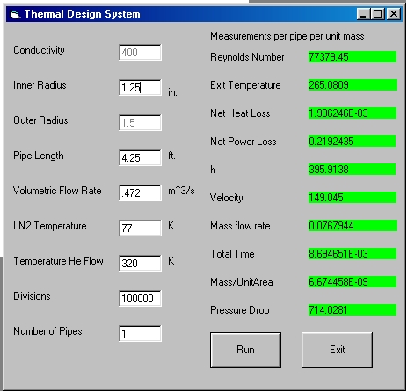

Appendix I

Final Design Drawings

Signature Page

The signature of the undersigned below is a declaration that the material contained within this report is true and that no falsification, plagiarism, or any perjury of any sort has been made. The signature also represents an agreement between the group members and the sponsors that they have come to an agreement about style, method, computations, and anything else of the sort.

____________________________________
John Maatsch

____________________________________
Bryan Richard

____________________________________
Gerard Vaughn

____________________________________
Eric Myers

____________________________________
John Kynoch

