Design and Optimization

I. Statement of Objectives

The objective of this document is to give a short overview of the steps involved in the creation of the final design. This paper will show the design methods used and their application to the project. Finally the design chosen will be detailed.

II. Project Scope and Description

The scope of this project is to build a cryotrap to catch the contaminants (water, nitrogen and oil) that enter the system of the Hybrid Magnet at NHMFL (National High Magnet Field Laboratory). The function of a cryotrap is to freeze and capture the elements that are not desired in the system, while allowing the desired element to pass through without changes to the system. The Hybrid Magnet uses liquid helium to cool down the magnet. Since helium does not become a liquid until it reaches 4K a liquefier is used to cool down the helium. The problem is when the contaminants reach the liquefier they freeze and block the liquid helium from passing from the liquefier to the hybrid magnet. The cryotrap needs to be inserted into the system before the helium reaches the liquefier and after it has left magnet. Most of the contaminants enter the system from the vacuum pumps that pump the helium out of the magnet therefore the cryotrap will be placed after the vacuum pumps. 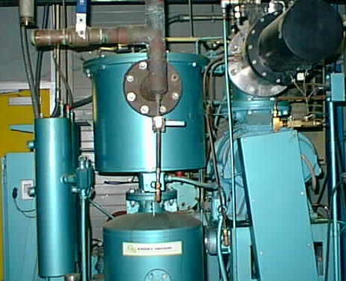
Figure 1. Vacuum Pump

The problem with the existing cooling system for the hybrid magnet at the National High Magnetic Field Laboratory (NHMFL) is contamination. Foreign particles, mainly oil and water, are being introduced to the helium flow. When helium reaches a temperature of below 2.2 Kelvin, its properties change and it becomes what is known as a superfluid. A superfluids thermal conductivity is enormously greater than a non-superfluid. Such a high thermal conductivity would help greatly in cooling down the hybrid magnet. However, the liquid helium can only become a superfluid if it is a pure substance. At this point in time, it is not due to the above-mentioned contaminants. Therefore, there is a need to rid the current system of all contamination. The current setup utilizes a liquefier, vacuum pump, and compressor for the circulation of liquid helium. After the helium circulates around the magnet and absorbs its heat, it is sent to the liquefier. This is because the heat from the magnet causes the liquid helium to begin to turn into gaseous helium. The liquefier in turn uses refrigeration and pressure to re-liquefy the helium. The compressor and vacuum pump are used to keep the helium flowing through the system. Due to the poor condition of the seals used in the vacuum pump (Figure 1), water and oil are introduced into the flow. However, the compressor is equipped with a device that filters out oil from the system. Thus, the only contaminant is water. This water is mixed in with the liquid helium flow and when it reaches the liquefier, it freezes and causes the liquefier to become clogged. At first, it might seem like the logical step would be to simply replace the faulty seals. This would however take a good deal of time and would have to done on a routine basis. In order to replace the seals, the entire system would have to be shut down and them brought back online. Therefore, a device is required to filter out the water particles while allowing the system to run continually.
Cryotraps are not new. There are cryotraps that are used in other magnet and cooling systems, however, the cryotrap that we must design will have to move much cooler material, with minimal pressure loss. The NHMFL has not been able to find a cryotrap that would fit into the system of their Hybrid Magnet. The production of such a cryotrap will allow for companies to implement liquid helium has a cooling substance into systems that generate extreme amounts of heat.

III. Needs Assessment

The general scope of this project is to build a cryotrap for the hybrid magnet at the National High Magnetic Field Laboratory (NHMFL). The hybrid magnet uses helium as a means of dissipating heat. Tubing filled with helium is wrapped around the magnet and the helium absorbs heat generated by the magnet. It is desired that the helium be cooled to or below 2.2 Kelvin. At this temperature, the helium becomes a superfluid. This means that the helium will become thermally superconductive. However, to become a superfluid, the helium must be pure, or without contaminants.
As it is right now, the system has contamination from water, nitrogen, and oil. It is our goal to design and build a cryotrap that will freeze out these contaminants leaving only pure helium. Also, there needs to be minimal pressure loss through and minimal heat gain to the system. In addition, liquid nitrogen is to be used as the coolant for the helium and a liquid level monitoring system for the nitrogen is to be implemented as well. The cryotrap will be implemented between the liquefier and compressor.

V. Optimization

The optimization of the system to reach the needs set by the customer was a series of iterative steps. From research, it was determined that the system would need a cryogenic fluid to cool down the helium flow so that the contaminants would freeze out. After several interviews with the customer, five parameters were used in the decision matrix for the design. The final design was determined by designing for each of the parameters independently

1. Liquid Nitrogen Control System

2. Contaminant Collection System

3. Vacuum Jacket

4. Material Selection

5. Thermal Design

VI. Final Design

The final design makes use of a U-shaped pipe for the helium flow. It has an upright setup meaning that the fluid flow is primarily in the vertical direction. The cryotrap piping attaches to the existing piping system along the ceiling and turns down towards the ground. This is because the cryotrap is placed on top of the compressor. From the ceiling, the piping turns down 90 degrees. Since the existing piping is not directly overhead of the compressor, a 45-degree turn is made to reach the compressor. Due to vibrations caused by the compressor, a device is required to rest the cryotrap on damps the vibrations. The vibrations are transferred to the cryotrap as heat, which works against the liquid nitrogen. From the point of the 45-degree bend, the helium flows down into the cryotrap where it passes through two 90-degree curved bends. The centerline radius was determined to be 4.5 inches with an outside radius of 6 inches. The flow then follows the same path to reach the ceiling as it did coming down from the ceiling only in reverse. From design calculations, the inside diameter (ID) of the pipe was determined to be 3 inches. Inside the cryotrap the helium passes through a container of liquid nitrogen that freezes out the water particles. To aid in the removal of the contamination, a metallic mesh is inserted into the U-shaped section of the piping that is in contact with the liquid nitrogen. In order to fully freeze out all water particles, approximately 4 feet of the piping passes through the liquid nitrogen bath. In addition, a vacuum jacket surrounds the nitrogen container in order to insulate the nitrogen from the atmosphere. Exposure to the atmosphere is unwanted as this would lead to a rapid increase in the liquid nitrogen temperature. Since the coefficient of expansion for liquid nitrogen is quite large, a small change in temperature would cause a drastic change in pressure inside the vessel. Eventually, the pressure would build until the vessel exploded. In addition to the vacuum jacket, aluminum Mylar is wrapped around the liquid nitrogen container for added insulation. A vacuum jacket pulls a vacuum on the liquid nitrogen vessel keeping it at a relatively constant and safe temperature. Vacuum jackets are primarily constructed using stainless steel. The piping for the helium flow however, is made of copper because of its high thermal conductivity. For fabrication purposes, all piping into and out of the vacuum jacket are made of stainless steel. Therefore, copper piping is used until just before it reaches the cryotrap and a transition will be made to stainless steel. The same is done for the helium flow exiting the cryotrap.
For safety purposes, a liquid level monitoring system was implemented into the cryotrap. Over time, heat absorbed by the liquid nitrogen from the helium causes the nitrogen to turn to a gas. This in turn causes the liquid level to drop and therefore there would not be enough liquid nitrogen to fully freeze out the contamination. Therefore, a liquid level monitor was installed and when the level drops below the needed amount, new liquid nitrogen is added to the container by means of a fill port. Also, the system has a pressure release valve to get rid of the hazardous pressure due to the gaseous nitrogen.
All in all, the final design has a vertical orientation and is located on top of the existing compressor. Copper piping is used for the helium flow except for the section of pipe within the cryotrap. This portion is made of stainless steel as is the liquid nitrogen vessel and vacuum jacket. A pressure release valve and liquid level monitoring system are included for safety measures.

Manufacturing and Assembly

I. Statement of Objectives

II. General Procedures

1. Documentation Procedures

A. Correspondence

- Electronic Correspondence

All electronic correspondence sent by a team member must be sent to all other team members and the sponsor (John Kynoch). Members are to leave the correspondence on their computer until such a time as it is deemed necessary to delete the correspondence. All relevant correspondence is to be included as appendices to all respective reports.

- Paper Correspondence

All paper correspondence written by a team member is to be copied and distributed at the weekly meeting. All relevant correspondence is to be included as appendices to all respective reports.

- Exceptions

All correspondence regarding personal matters in reference to the team shall not be distributed widely or copied. These matters shall be brought up by the team member to the group and worked out in discussion.

B. Personal Work

- Qualifications

Any drawings, calculations, programs, written ideas, reports and any other written or computer based work that is specifically geared towards the development of the cryotrap, or is in reference to the cryotrap shall be considered personal work.

- Documentation

The team member whom partakes in personal work on the project must notify the rest of the team and the sponsor, unless already approved to do so, and make their intentions clear as to the purpose of their work. The member proceeding with the work shall send periodic progress reports, the number of which shall be determined based on a work timeline given by the member. At the end of the work, the final product shall be produced in a report and made accessible to all of the members and the sponsors.

C. Reports

- Documentation

Every report must be distributed to each of the team members and the sponsor at the time of completion.

2. Experimental Methods

Definition of Experiment

An experiment in this project shall be defined as any computer simulation or product runs that are meant to test certain aspects of the product.

B. Safety Precautions

In the event of an actual product test run, all safety precautions must be followed exactly. Since the product involves the use of cryogenic fluids, it is necessary that an advisor must be there during these times.

C. Product Test Run

If the team wishes to have a product run, they shall give notice to their supervisor or sponsor at least one week in advance explaining what the purpose of the test is, the time that they will do it, and how they will obtain data. Any product experiment must be accompanied by a report explaining all of the above and the meaning of the results given.

D. Computer Experimentation

If a computer simulation is to be run a notice shall be given out to all of the team members and time shall be set at which all members shall attend. Any data recorded during the experiment shall be condensed into report form and given to the sponsor and each of the team members.

3. Work Breakdown Structure

Description

The WBS or work breakdown structure is a way of visualizing a major project into tasks and subtask. The first level of the WBS defines general areas of work but also tasks. These tasks are considered the major milestones of the project and are therefore placed on the highest level of the chart. The second level represents the tasks needed to accomplish the higher order tasks. Each of these subtasks is key to the project and cannot be skipped at any level. The third level of the work breakdown structure represents non critical, but nonetheless necessary tasks. These subtasks represent what should be done before completing the predecessor task.
The WBS is to be followed completely. At no point may deviation be made. If a task is seen as to be needed to be broken up into smaller sub tasks, the team shall do so at their discretion, but at no point may a WBS level or task be deleted. If it is decided that the WBS be broken down further, the sponsor shall be told and a new WBS shall be written out.

WBS Chart

The WBS is included in Appendix A.

4. Scheduling Chart

Description

Gantt Chart

The Gantt chart is included in Appendix B of this report. The first Gantt chart in appendix B of the report is the original schedule; the second chart shows the actual achievements of the group. An explanation of how to read the charts is given in the appendix.

III. Part List

Note: All parts drawings can be found in Appendix

The following is a final parts list and description for all components involved in the cryotrap system.
  - Liquid Nitrogen Vessel Pipe: This is a 12-inch diameter, sch.40 stainless steel pipe. This houses the liquid nitrogen used for contamination removal. Supplied by the National High Magnetic Field Laboratory (NHMFL).
  - Vacuum Jacket Pipe: This is an 18-inch diameter, sch.40 stainless steel pipe. This surrounds the liquid nitrogen vessel. In addition, it will serve to pull a vacuum on the liquid nitrogen vessel through the use of a vacuum pump. Supplied by the NHMFL.
  - Liquid Nitrogen Vessel End Cap: A 12-inch diameter, standard weight stainless steel hemisphere. This will attach to the top and bottom ends of the liquid nitrogen vessel. Also, the copper inlet and outlet pipes, nitrogen vent line, and liquid nitrogen sensor will be inserted through the top end cap. Supplied by Ferguson.
  - Vacuum Jacket End Cap: An 18-inch diameter, standard weight stainless steel hemisphere. This attaches to the ends of the vacuum jacket. All pipes and sensors inserted into top end cap are the same as for the liquid nitrogen vessel end cap. Supplied by Ferguson.
  - 90° Long Term Elbow: This is a 3-inch diameter copper elbow with a long radius. The two elbows positioned together will be used to form the U bend for the piping that will be immersed in liquid nitrogen. Supplied by Ferguson. (Part#: CLT9M)
  - 90° Elbow: This is a 3-inch diameter copper elbow. The elbow will attach to the copper piping and direct the pipe from the cryotrap to the main helium line. Supplied by Ferguson. (Part#: C9M)
  - Liquid Nitrogen Level Sensor: The sensor is made of 3/8 inch OD 304 stainless steel tubing. Capable of operating with virtually all cryogenic liquids. This is inserted through the top of the vacuum jacket and into the liquid nitrogen vessel to monitor the liquid nitrogen level. A connecting coaxial cable connects the sensor to the liquid level controller. Supplied by American Magnetics.
  - Model 186 Liquid Level Controller: The controller monitors the liquid level through the use of the liquid level sensor. It operates by measuring the sensor capacitance, which is directly related to the level of fluid present in the vessel. Includes programmable alarm functions and automated fill of cryogenic liquid. The user can define “high” and “low” points for liquid to be monitored. Equipped with 4-digit LED display, which provides level indication in inches, centimeters, or percent. 115 Vac input power. 0.1% accuracy. Dimensions: 3.8”H x 8.4”W x 11.1”D. Weight: 3.6 lbs. Supplied by American Magnetics.
  - Liquid Nitrogen Fill/ Vent Line: Made of ½-inch stainless steel piping. Fill line connects existing nitrogen line to cryotrap where liquid nitrogen will be diverted from the main line to the cryotrap through the use of a solenoid valve. This process will occur when deemed necessary by the automated fill system. Vent line allows for removal of excess nitrogen gas from system into atmosphere. The vent line is inserted into the top of the liquid nitrogen vessel where nitrogen gas is released as pressure builds inside vessel. Supplied by Ferguson. (Part#: DSP44LD)
  - Ball Valve: This is a 3-inch diameter bronze ball valve. Used to redirect helium flow back and forth between the main helium line and cryotrap. Supplied by Ferguson. (Part#: A7020201)
  - Valve: 3-inch diameter stainless steel valve. Used to connect vacuum jacket to the vacuum line, which will pull a vacuum on the jacket. The valve is vacuum rated. Supplied by Ferguson. (Part#: A8620001)
  - Copper Pipe: 3-inch diameter TypeL Hard copper pipe. Pipe will be used for helium flow transport through the liquid nitrogen vessel as well as for branching off from the main helium line. Supplied by Ferguson. (Part#: LHARDM20)
  - Tee: Copper tee. Used for branching helium flow from the main line to cryotrap. Supplied by Ferguson. Dimensions: 3” x 3” x 3”. (Part#: CTP)
  - Insulation: Aluminum Mylar insulation. Used to wrap liquid nitrogen vessel. Supplied by NHMFL.
  - Mesh: 3-inch diameter copper mesh. Placed inside copper U-bend pipe to trap and freeze out contaminants. Supplied by Pyramid Technologies.

IV. Manufacturing

Once the parts for the cryotrap have been received, some of the parts have to be machined. The first part to be machined is the top cap for the liquid nitrogen vessel. The holes for the inlet and outlet helium lines, the inlet and outlet for the liqud nitrogen lines, and the holes for the liquid level monitoring system will have to be drilled. The holes for the helium lines will be 3 in. each. The holes for the liquid nitrogen lines will be 1 in. each. The hole for the liquid level monitoring system will be 3/8 in. The drawing below shows the location of these holes as well as their dimensions.

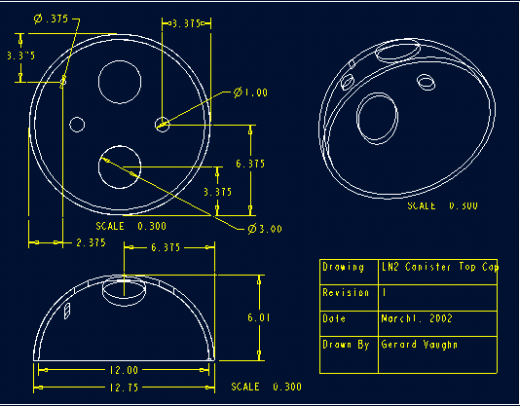

Figure XX: LN2 Canister Top Cap ProE Drawing

The second part to be machined is the vacuum jacket top cap. It will be machined in the same manner as the top cap for the liquid nitrogen vessel. The holes for the inlet and outlet helium lines, the inlet and outlet for the liqud nitrogen lines, and the holes for the liquid level monitoring system will have to be drilled. The holes for the helium lines will be 3 in. each. The holes for the liquid nitrogen lines will be 1 in. each. The hole for the liquid level monitoring system will be 3/8 in. The drawing below shows the location of these holes as well as their dimensions.

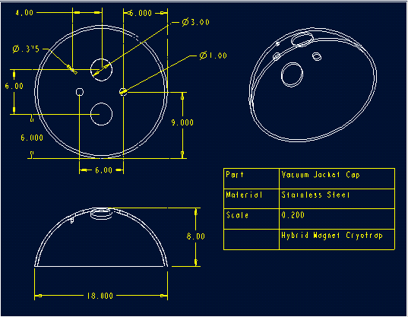

Figure XX: Vacuum Jacket Top Cap ProE Drawing

The actual vessels for the liquid nitrogen and the vacuum jacket will have very little machining done to them. The piping that the magnet lab has is in 21 ft. sections. The only machining done to the liquid nitrogen vessel will be cutting to the actual height which is 1 ft. The drawing below shows these dimensions.
The canister for the vacuum jacket requires a little more machining than that of the liquid nitrogen. Along with cutting the pipe to the actual length, a hole has to be drilled. This hole will serve as a vacuum port. The vacuum jacket canister with dimensions is shown below.

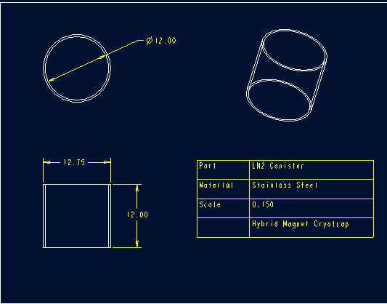

Figure XX: Liquid Nitrogen Canister ProE Drawing
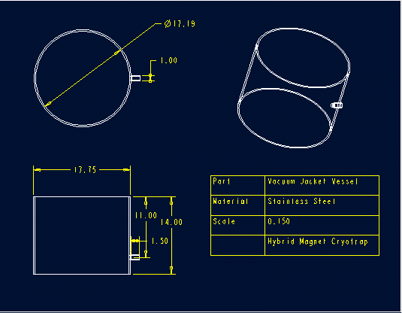

Figure XX: Vacuum Jacket Canister ProE Drawing

The caps for the bottom of the liquid nitrogen vessel and the vacuum jacket need no machining. The caps are ready for assembly once they have been received.
The piping for the interior of the cryotrap will need minor machining. The copper U-pipe will be machined down until the outer diameter is 3.004 in. The stainless steel pipes that complete the inner piping of the cryotrap will have a 3.004 in. hole bored in them 2 in. deep. The drawings for the machined U-pipe and the stainless steel pipe are shown below. It must be noted that the length values for the pipes may not be the final lengths of the pipes. These lengths are shown simply to show small portions of the pipes exiting the top of the cryotrap. The final lengths of the pipes will be determined by the NHMFL.

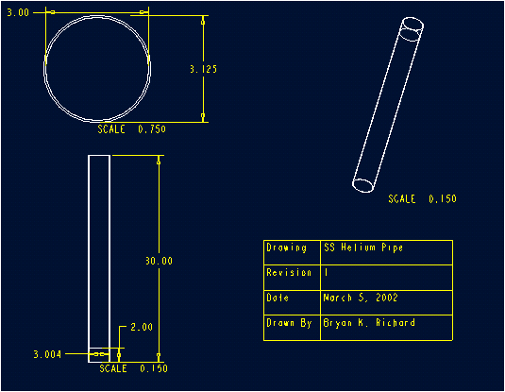

Figure XX: Stainless Steel Helium Pipe ProE Drawing

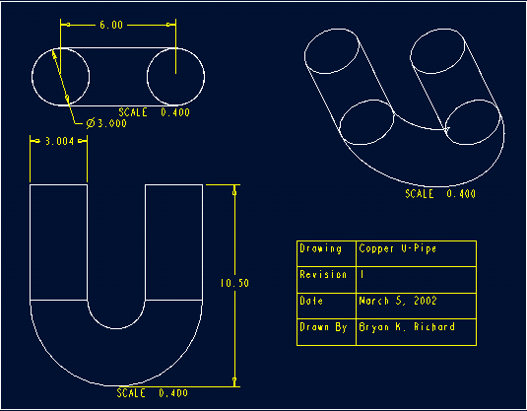

Figure XX: Copper Helium U-Pipe ProE Drawing

The final machining that needs to be done is to cut the liquid nitrogen fill line, the liquid nitrogen vent line, and the line that the liquid level monitoring sensor will go into. Drawings for each of these parts are shown below.

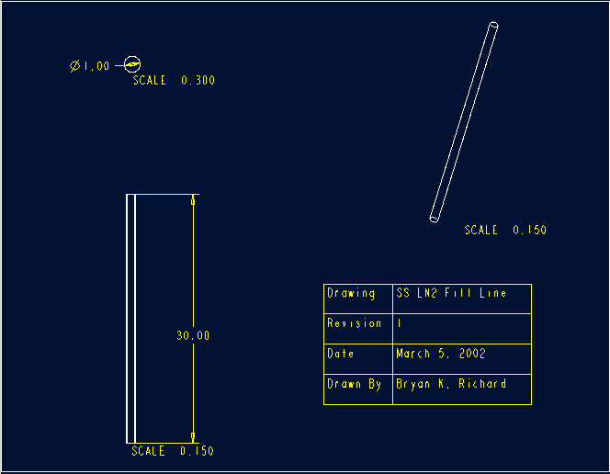

Figure XX: LN2 Fill Line ProE Drawing
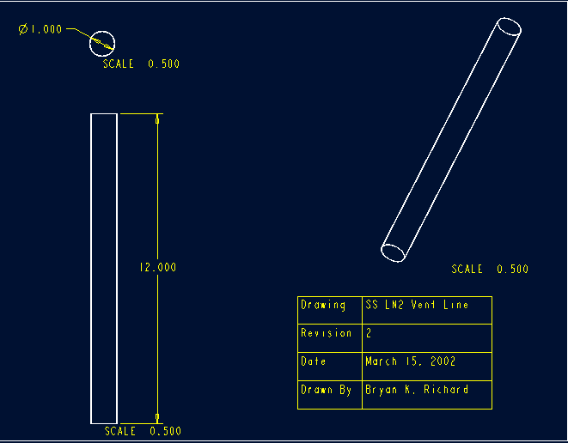

Figure XX: LN2 Vent Line ProE Drawing

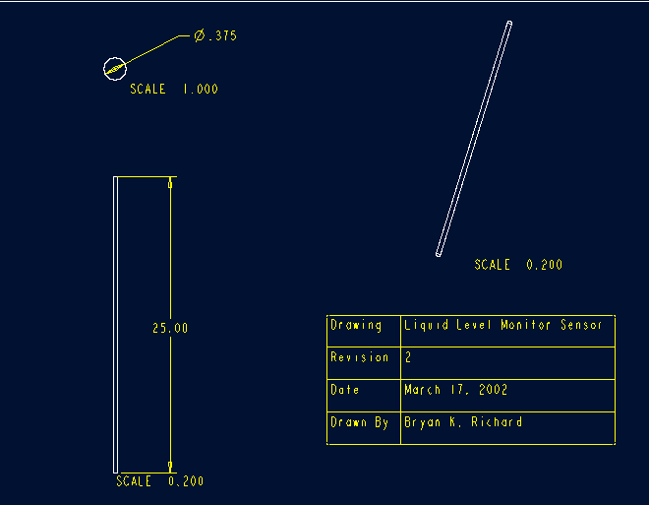

Figure XX: Liquid Level Monitor Sensor ProE Drawing

Once all the parts have been machined, the assembly process can begin. To begin the assembly, the cryotrap can be broken down into three subsystems: the internal piping system, the liquid nitrogen vessel, and the external vacuum jacket. For the internal piping, the parts need consist of two long turn 90° copper elbows, two 1 in. diameter stainless steel pipes, and the copper mesh filter. The copper elbows will be welded together in order to form a u-turn. Although the group has suggested copper elbows that will serve our purpose, the final selection will be up to the NHMFL. The final u-turn must be 10.5 in. high. Once the copper u-pipe has been assembled, the stainless steel pipes can be added. The pipes have been machine so that the copper u-pipe will be inserted into the two stainless steel pipes at a depth of 2 inches. The pipes will then be silver soldered together. The final step is inserting the mesh into one end of the pipe and stuffing the mesh into its proper position inside the copper u-pipe. The final sub-assembly minus the mesh is shown in the following figure.

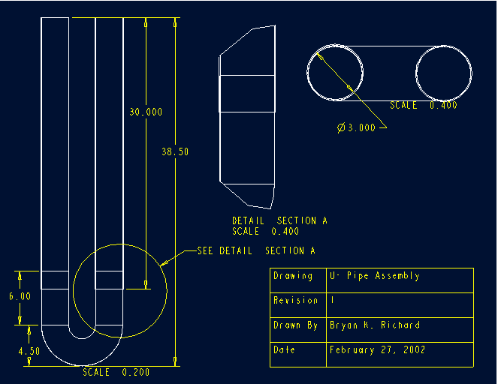

Figure XX: U-Pipe Subassembly ProE Drawing

Once the u-pipe subassembly has been placed together, the liquid nitrogen vessel can be assembled. First, the liquid nitrogen top cap must be welded to the piping assembly in a fashion that the position will allow for the final dimensions of the cryotrap shown in figure XX will be upheld. Due to the fact that the final piping length of the helium line will be determined once the installation will take place, the exact positioning is unknown. Next, the liquid nitrogen fill line will be welded to the top cap. The fill line must be welded so that 23 inches of the line will hang from the bottom of the top cap. This position is so that once the entire liquid nitrogen vessel is assembled, the exit point of the fill line will be as low as possible inside the vessel. Next, the liquid nitrogen vent line must be welded to the top cap. The vent line will be welded to the top cap so that the bottom of the pipe will be as close to the bottom of the top cap as possible. This exact position will be determined by the technician constructing the cryotrap. The pipe that the liquid level monitoring sensor will be place through must be welded. This pipe must also be welded in a manner in which the bottom of the pipe is as close to the bottom of the top cap as possible. This will allow for a maximum area that the sensor can monitor. Upon completion of this weld the rest of the liquid nitrogen vessel can be assembled. The liquid nitrogen canister is then welded to the top cap. Next, the bottom liquid nitrogen cap is welded to the bottom of the liquid nitrogen canister. Once the liquid nitrogen vessel is complete, it will be wrapped in 35 layers of aluminum mylar insulation. The insulation will be wrapped a single layer at a time with the liquid nitrogen vessel first being wrapped around the sides, then around the top and bottom. The process is then repeated until the vessel has been wrapped in 35 layers.
Once this subassembly has taken place, the vacuum jacket can be assembled. As with the liquid nitrogen vessel, the vacuum jacket top cap must be welded to the helium line in a manner that the bottom of the vacuum jacket top cap and top of the liquid nitrogen vessel has a 3-inch clearance. This dimension minimizes the heat transfer through the helium line and minimizes the size of the cryotrap while still performing within the requested specifications. Next the top cap can be welded to the liquid nitrogen fill line, vent line, and the liquid level monitor sensor pipe. Once these welds have been completed, the liquid nitrogen fill line will be wrapped in 35 layers of the aluminum mylar insulation used to wrap the liquid nitrogen line. Once the line is wrapped in insulation, the vacuum jacket canister is welded to the vacuum jacket top cap. The vessel must be oriented so that the outlet vacuum jacket port is on the top of the vessel. Then the vacuum jacket bottom cap is welded to the bottom of the vacuum jacket vessel. Finally, the vacuum pipe is welded to the vacuum port in the side of the jacket and a vacuum rated ball valve is placed on the pipe. Once completed the final cryotrap will look like the following figure. The cryotrap has been designed so that the pipes used for the helium, the liquid nitrogen fill and vent lines, and the liquid level monitor sensor pipes serve as the supports for the liquid nitrogen vessel. This design helps minimize the heat transfer that occurs with conduction through contact points.

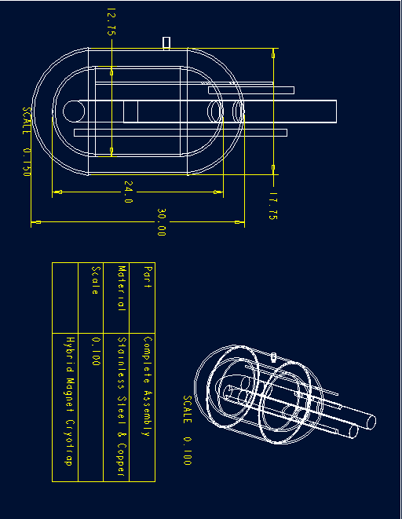

Figure XX: Complete Cryotrap ProE Drawing

V. Assembly

VI. Operation

Prototype

I. Statement of Objectives

The objective of the cryotrap prototype is to give a representation of the actual cryotrap interior system. The actual system will not be built and implemented into the Hybrid Magnet System until the summer. The prototype will show the components of the cryotrap, layout of the piping within the cryotrap and show the different layers of the system. The components of the cryotrap system include: the vacuum jacket, liquid nitrogen vessel, piping for helium flow line, liquid nitrogen fill line, liquid nitrogen vent and liquid level sensor. The components are arranged in the prototype the same way that they will be arranged in the actual cryotrap system. The width of the prototype is also the same, but the difference will be in the overall height. The prototype will be about half of the actual height of the cryotrap.

II. Scale Model

The scale model is constructed of PVC pipe and flexi-glass. Flexi-glass is used for the caps therefore the interior components is visible. The remaining components are made of PVC; see Table XX for Scale Model Parts List.

Table XX – Scale Model Parts List
Part Number | Quantity | Material | Description
01 | 1 | 16” PVC – 40 pipe | Vacuum Jacket Vessel
02 | 1 | 1” PVC – 40 pipe | Liquid Nitrogen Fill Line
03 | 1 | 1” PVC – 40 pipe | Liquid Nitrogen Vent
04 | 1 | 0.5” PVC – 40 pipe | Line for Liquid Level Sensor
05 | 1 | 12” PVC – 60 pipe | Liquid Nitrogen Vessel
06 | 2 | 1.5” PVC – 60 90° pipe | U - Bend for Helium Flow Line
07 | 2 | 1.5” PVC – 60 pipe | Piping for Helium Flow Line
08 | 1 | 1.5” PVC – 60 pipe | Connector for the U - Bend
09 | 2 | Flexi – glass | 16” Radial Cap for Vacuum Jacket Vessel
10 | 2 | Flexi – glass | 12” Radial Cap for Liquid Nitrogen Vessel

The first step in the construction of the scaled model is to cut the pipes to the right dimensions. The 16” PVC pipe for the vacuum jacket vessel (part #01) is cut to a height of 14” and the 12” PVC pipe for the liquid nitrogen vessel (part #05) is cut to a height of 12”. The next step is to cut the flexi-glass to make the caps (parts 09 & 10) for the vessels. When cutting the caps, leave an extra half of an inch for room to sand the caps for smoothness. (Note: Be careful when cutting the flexi-glass because it can melt and join back with itself. Flexi-glass can break easily.) Sand the caps down to their instructed radius. Next, cut the 1.5” PVC pipe (part #07) to a length of 18”, then make another cut again at 18” and the last cut on this pipe will be at 2.5” for the connector for the U-bend (part #08). There will be two cuts on the 1” PVC pipe, the first cut will be to 16” for the liquid nitrogen fill line (part #02) and the second cut will be to 5” for the liquid nitrogen vent (part #03). The last cut will be for the liquid level sensor line (part #04), which will be at a length of 2.5” on the 0.5” pipe.
Next, is to create the pipe for the helium flow line. See Figure XX for diagramed directions. When connecting the PVC, PVC Cement Glue is used to strengthen the connections. (Note: Be sure all of the piping is clean or the cement glue might not hold.) First, connect part #08 to the two 90° pipes (part #06) aligning the markings on the pipes. Finally, connect the two parts # 07 to the assembly of parts #06 and #08.

Part #07

Part #06

Part #07
Part #06

Part #08

Figure XX – Diagram for Connecting the Pipe for the Helium Flow Line (assembly #1).

Cutting the holes for the caps (parts #09 & #10) is the next step in creating the model. First mark an X form the center in the circle; see Figure XX for help. Next, mark 3” along each line from the center point. At the vertical points draw a circle of diameter 1-7/8” for a guide when cutting out the holes. At the horizontal points draw a circle of diameter 1-3/8” for a guide when cutting out the holes. Now draw a horizontal line at the center of the upper vertical circle, mark 4” from the center. At the mark draw a circle of diameter 7/8” for a guide when cutting out the holes. Now cut the designed holes for both of the caps. (Note: Be careful when cutting the flexi-glass because it can melt and join back with itself. Flexi-glass can break easily.)

3”
3”
3”
3”
4”

Figure XX – Diagram for cutting holes in caps.

The last procedure is assembling all of the parts. (Note: remove all paper from materials and clean all materials of dirt and debris.) Epoxy will be used to join all of the piping to the lids. First, epoxy the 16” vacuum vessel cap (part #09) that does not have any holes to the 16” vacuum jacket vessel (part #01) -- (assembly #1). Then epoxy the 12” liquid nitrogen vessel cap that does not have any holes to the 12” liquid nitrogen vessel (part #05) -- (assembly #2). Next epoxy the 12” liquid nitrogen vessel cap with the holes (part #05) to connected helium flow pipe (assembly #3) 10.5” from the bottom of the U-bend. (Note: Be sure to connect the pipe to the cap at the correct holes.) Now epoxy the liquid nitrogen fill line (part #02) to the left horizontal hole, 11” from the bottom. Epoxy the liquid nitrogen vent (part #03) flush against the liquid nitrogen vessel cap with the excess pipe facing up away from the U-bend. The liquid level sensor line (part #04) will need to be epoxied the same as the liquid nitrogen vent is epoxied to the nitrogen vessel cap. Now all of the piping is connected to the liquid nitrogen vessel cap (assembly #4). The next step is to epoxy the vacuum jacket vessel cap with holes (part #10) 1” above the assembly of the liquid nitrogen vessel cap and piping (assembly #4) -- (assembly #5). Now epoxy the joint liquid nitrogen vessel and cap (assembly #2) to the assembly of piping and caps (assembly #5) with the U-bend inside of the liquid nitrogen vessel (assembly #6). Finally, assembly #6 can be placed inside of the vacuum jacket vessel and cap (assembly #1). (Remember: Do not epoxy the vacuum jacket vessel and cap (assembly #1) to assembly #6.

III. Demonstration

IV. Conclusions

The prototype (scale model) of the cryotrap will allow for interested viewers to view the interior components of the cryotrap system. This will allow for a better understanding of how the system works. The prototype uses clear flat caps were the actual cryotrap uses standard end caps, therefore, reducing the actual height. The use of clear caps allows for the viewing of interior components. The prototype does not show the actual dimensions of the cryotrap system, but it shows each component. The prototype is limited due to cost efficiency and parts on site.

Conclusion

I. Statement of Objectives

II. Conclusion

Appendix A

Work Breakdown Structure
Project Assessment

1000
Conceptual Design
2000
Scope of Project

1100

Needs Assessment

1200

Customer Introduction Interview
1300

Specifications

1310
Research Designs

1320

Objective Tree

2200
Concept Designs
2100

Concept Selection

2220
Customer Design Interview
2210
Material Design

Design Interview 3

Final Design Drawings

Design Parts

Design Assemblies

Final Design

3000
Thermal Design
3100
Heat Transfer Design
3110
Fluid Flow Design
3120
Customer Design Interview 2
3130
Material Design
3200
Material Design
3210
Liquid Nitrogen Control System
3300
Contaminant Collection System
3400
Final Design Drawings
3500
Presentation Progress Report
3220

Design Assemblies

3520
Design Parts

3510

Build & Test

4000
Project Management
5000

Obtain Materials
4100
Build

4200
Test

4300
Progress Reports to Professor
5400
Progress Reports to Client
5300
Develop Project Plans
5200
Attend Weekly Meetings
5100

Appendix B

Gantt Scheduling Chart
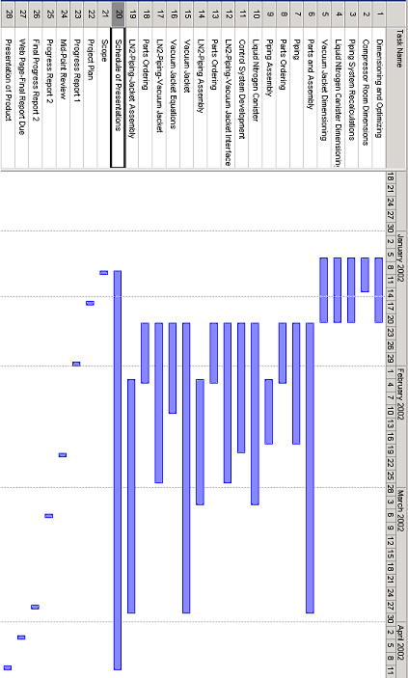

The GANTT chart is a system of scheduling task within a project. Once all of the tasks have a certain amount of time given to them, a group can concentrate on finishing one specific task at a time. Once each of the tasks is finished, the project should be totally completed. The initial GANTT chart for the hybrid magnet cryotrap was derived using the WBS. The GANTT chart was a guide as to when everything should be complete. When it was learned that the team would not be responsible for building the cryotrap, the GANT chart was used to construct a scale model and demonstration model.

Appendix G

Communication

The signature of the undersigned below is a declaration that the material contained within this report is true and that no falsification, plagiarism, or any perjury of any sort has been made. The signature also represents an agreement between the group members and the sponsors that they have come to an agreement about style, method, computations, and anything else of the sort.

____________________________________
John Maatsch

____________________________________
Bryan Richard

____________________________________
Gerard Vaughn

____________________________________
Eric Myers

____________________________________
John Kynoch

