FAMU-FSU Formula SAE

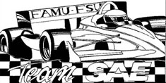

Senior Design

Suspension and Chassis

Concept Selection
October 3, 2002

Professor: Dr. Cesar Luongo

Advisor: Dr. Patrick Hollis
Secondary Advisor: Dr. Chiang Shih

Group 1
Bobby Dewar
Ben Robertson
Geoffrey Ottenberg
Kimberley Wright

Table of Contents

1.0 Chassis concept selection 2
1.1 Chassis design types 2
1.2 Chassis design types selection 3
2.0 Suspension concept screening 4
2.1 Suspension types 4
2.2 Suspension types category selection 5
2.3 Independent suspension types 5
2.4 Independent suspension type selection 6
3.0 References 7

1.0 Chassis Concept Screening

  - Chassis Design Types

The construction of a race car chassis falls into two main categories. They are either a space frame design or a composite monocoque design. A space frame construction is the most commonly used due to the cost of the tooling to build a monocoque chassis. The other main reason that a tubular space frame is used is because it is easily changed from one to the next. The only thing that defines a tubular space frame is a chassis constructed of tubing usually utilized in triangular shapes for the greatest rigidity. With a tooled (molded) composite chassis one particular mold will only make that part to those exact dimensions. Once the design is changed a new set of tooling must be made; which can be expensive. The benefit to a composite chassis is that once a good set of molds are built; another car can be built exactly like the first one very quickly and efficiently. A composite chassis can also be built without a set of molds. It would start with a sheet of preformed composite panels and cut them to the desired design and glue them together. The seams would be secured with a layer of composite fiber cloth in an epoxy matrix. The following two figures are pictures of a tubular space frame and a composite monocoque chasses.

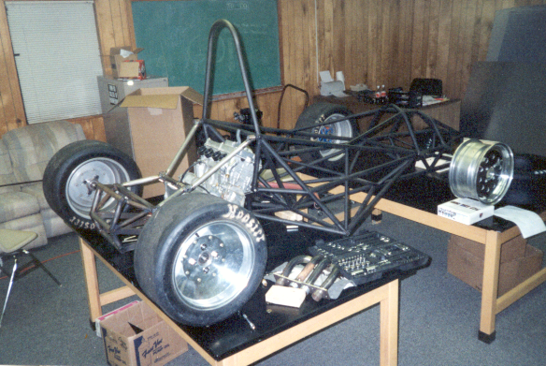

Fig 1.10 – Tubular Space Frame

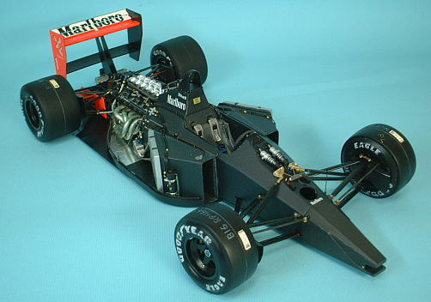

Fig – 1.11 – Composite Monocoque Chassis

  - Chassis Design Type Selection

Selection Criteria | Tubular Space Frame | Composite Monocoque
Rigidity | + | +
Manufacturability | - | +
Ease of Modification | + | 0
Weight | 0 | +
Costs | + | -
sum "+" | 3 | 3
sum "0" | 1 | 1
sum "-" | 1 | 1
net score | 2 | 2
Rank | 1 | 1

Selection Criteria |  | Tubular Space Frame |  | Composite Monocoque
 | % | R | S | R | S
Rigidity | 30 | 7 | 2.1 | 8 | 2.4
Manufacturability | 10 | 3 | 0.3 | 6 | 0.6
Ease of Modification | 5 | 5 | 0.25 | 5 | 0.25
Weight | 40 | 5 | 2 | 9 | 3.6
Costs | 15 | 5 | 0.75 | 3 | 0.45
score | 100 |  | 5.4 |  | 7.3
rank | 1-2 |  | 2 |  | 1
proceed | Y/N |  | Y* |  | Y

2.0 Suspension Concept Screening
2.1 Suspension Types

There are three main suspension categories. There are rigid axles, semi-rigid axles, and independent suspensions. A rigid axle is used as the rear axle in conventional rear-wheel drive. It is employed in as the front suspension in heavy and off-road vehicles. The track, tow-in, and the camber remain constant relative to the ground at all times regardless of body roll. A semi-rigid axle is used as the rear axle in front wheel drive applications. Since this is a rear wheel drive car a semi-rigid axle could be ruled out instantly without consideration but remains in for comparative analysis. The independent type suspensions allow for each wheel to move independent of each other. They are used as the front and/or rear suspension regardless of which wheels drive the car. The have small space requirements. They also have the greatest degree of kinematics latitude. If they are designed properly they allow for the track, toe-in, and camber to change with the body roll during cornering and acceleration and deceleration to improve traction and handling. The following figures shoe these three different types of suspensions.

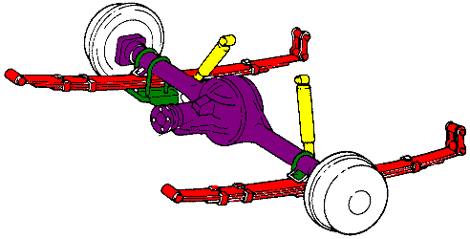
Fig 2.10 – Rigid Axle Suspension

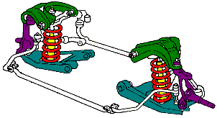

Fig 2.11 – Independent Suspension

2.2 Suspension Type Category Selection

Selection Criteria | Rigid Axles | Semi-rigid Axles | Independent Suspension
weight | 0 | - | +
compact space | - | - | +
mountable to chassis | 0 | 0 | 0
traction capability | + | 0 | +
adjustability | 0 | 0 | +
ease of replacement | 0 | 0 | +
ease of machining | + | 0 | -
strength | + | 0 | +
suspension travel | - | + | +
sum "+" | 3 | 1 | 7
sum "0" | 4 | 6 | 1
sum "-" | 2 | 2 | 1
net score | 1 | -1 | 6
rank | 2 | 3 | 1

2.3 Independent Suspension Types

There are many variations of the independent suspension. Figure 2.30 shows the most common type of independent suspension used in racing cars, which is the use of an upper and lower a-arm. The two different a-arms are not parallel to each other, are different lengths, and their mounting points are in different locations relative to each other on the upright holding the wheel and on the chassis as well.

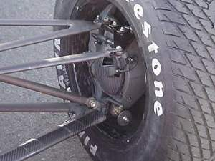

Fig 2.30 – Double A-Arm Attached to the Wheel

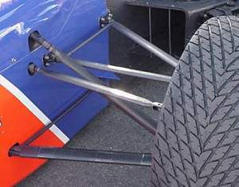

Fig 2.31 – Double A-Arm Attached to the Chassis

2.4 Independent Suspension Type Selection

Selection Criteria | Trailing Arm | Semi-trailing arm | Swing Axle | McPherson Strut | Upper & Lower A-arms
weight | + | + | + | - | +
compact space | - | 0 | - | 0 | +
traction capability | - | - | - | 0 | +
adjustability | 0 | 0 | + | + | +
ease of replacement | + | + | - | 0 | 0
ease of machining | + | + | - | - | +
strength | - | 0 | 0 | + | +
suspension travel | 0 | + | - | + | +
sum "+" | 3 | 3 | 2 | 3 | 7
sum "0" | 2 | 3 | 1 | 3 | 1
sum "-" | 3 | 1 | 5 | 2 | 0
net score | 0 | 2 | -3 | 1 | 7
rank | 4 | 2 | 5 | 3 | 1

3.0 References

Bauer, Horst (Editor-in-Chief). Bosch Automotive Handbook. SAE. 5th Edition. 2000

http://www.howstuffworks.com/champ-car.htm

