FAMU-FSU Formula SAE

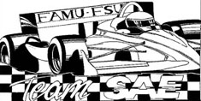

Senior Design

Suspension and Chassis

Design Specifications
October 3, 2002

Professor: Dr. Cesar Luongo

Advisor: Dr. Patrick Hollis
Secondary Advisor: Dr. Chiang Shih

Group 1
Bobby Dewar
Ben Robertson
Geoffrey Ottenberg
Kimberley Wright

Table of Contents

1.0 Design Specifications 1
1.1 Quantifiable Specifications 1
1.2 Additional Specifications 2
2.0 Customer Needs/Engineering Specifications Comparison 2 Appendix A A-1
Appendix B B-1
Appendix C C-1

Design Specifications

1.1 Quantifiable Specifications

Table 1.0: Quantifiable Specs with Min/Max Values
Specification | Minimum Value | Maximum Value | 2003 Formula SAE Rules Section | Appendix Reference

CHASSIS
Wheelbase | 1525 mm | TBD | 3.1.2
Torsional Deflection | TBD | TBD |  | Appendix A
Bending Deflection | TBD | TBD |  | Appendix B
Total Vehicle Mass (including drive train) | 0 | 226.79 kg
Ground Clearance (with 220lb driver) | 50.8 mm | 101.6 mm | 3.2.1

SUSPENSION
Wheel Travel | 50.8 mm | 76.2 mm | 3.2.3
Vehicle Track Width (Front) | X (TBD) | X (TBD) |  | Appendix C
Vehicle Track Width (Rear) | .75X | X | 3.1.3 | Appendix C
Wheels Diameter | 203.2 mm | TBD | 3.2.2
Lateral Acceleration (g=acceleration due to gravity) | 0.9g | 8g

COST
Overall Cost of Vehicle | $0 | $25000.00 | 4.3.3

1.2 Additional Specifications

In addition to these specifications, certain safety components must be included in the chassis to ensure safe operation of the vehicle. These safety regulations can be found in Sections 3.1-3.3 of the 2003 Formula SAE Rulebook. The vehicle must be able to perform all the dynamic events (Acceleration, Skid-Pad, Autocross, Fuel Economy, and Endurance) without catastrophic failure, i.e., it must be reliable enough to finish the competition. In light of the fact that it is a competition vehicle, in the event that the vehicle must be serviced, the component in question must be able to be removed, repaired or replaced, and reinstalled in no more than 1.5 hours, i.e., the vehicle must be maintainable. As there is a human component to the competition, the suspension and chassis must be aesthetically pleasing to the judges as they are the ones that do the scoring for the competition.

2.0 Customer Needs/Engineering Specifications Comparison

In order to ensure that the customers needs have been met, a comparison of the specifications and the customer’s needs was performed and is summarized in Tables 2.0 and 2.1. The comparison was performed separately for the suspension and the chassis.

Table 2.0: Customer needs/Engineering Specifications Comparison for the Chassis

Chassis
 | Engineering Specifications
Customer Requirements | Wheelbase | Torsional Deflection | Bending Deflection | Total Vehicle Mass | Ground Clearance | Costs
Complies with SAE rules | * |  |  |  | * | *
Safe | * | * | * |  | *
Stiff and Rigid |  | * | *
Cost effective to mass produce |  | * | * |  |  | *
Easy to operate | * | * | *
Maintainable |  |  |  |  |  | *
Light |  | * | * | * |  | *
Aesthetically pleasing | * |  |  |  | * | *
Units | mm | deg | mm | kg | mm | $
Engineering Targets | 1525 | TBD | TBD | 400 | 50.8 | free

Table 2.1: Customer needs/Engineering Specifications Comparison for the Suspension
Suspension
 | Engineering Specifications
Customer Requirements | Wheel Travel | Vehicle Track Width (front) | Vehicle Track Width (rear) | Wheel Diameter | Lateral Acceleration | costs
Complies with SAE rules | * |  | * | * |  | *
Safe | *
Stiff and Rigid | * |  |  |  | *
Cost effective to mass produce |  |  |  | * |  | *
Easy to operate | * | * | * |  | *
Maintainable |  | * | *
Light |  |  |  | * | * | *
Aesthetically pleasing |  |  |  | * |  | *
Units | mm | mm | mm | mm | m/s² | $
Engineering Targets | 50.8 | TBD | TBD | 330.2 | 1.4g | free

Appendix A: Definition of Torsional Deflection

The torsional deflection is defined as the angle through which the rear of the chassis deflects when a known torque is applied to the frame when the front of the chassis is held fixed.

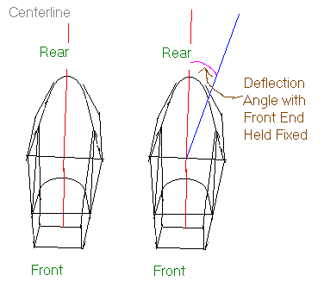

Appendix B: Definition of Bending Deflection

The bending deflection is defined as the maximum distance the bottom portion of the chassis moves from its original location when the chassis is simply supported and a known force is applied.

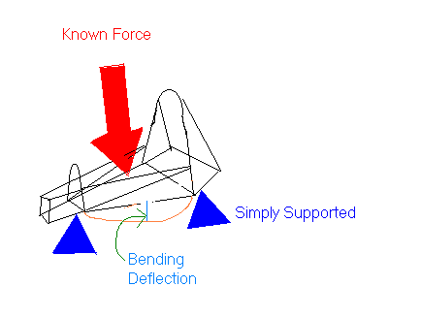

Appendix C: Explanation of Track Width Specifications

According to section 3.1.3 of the 2003 Formula SAE Rulebook, the width of one vehicle track must at a minimum be 75% of the larger track. We have chosen the front track width to be the wider of the two, so that the rear vehicle track width must at a minimum be 75% of this width.

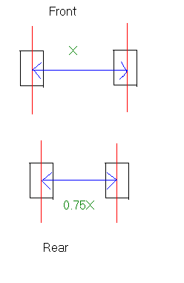

www.SAE.org/students/fsaerules.pdf

