Assembly Procedure

Parts Needed: Solid shaft, larger diameter hollow shaft, 2 identical pin holes, 2 identical deep groove ball bearings, 2 long stems, 1 short stem, 2 mirrors, pendulum ball, Hollow cylindrical shell

These are detailed instructions to assemble the prototype from its parts.

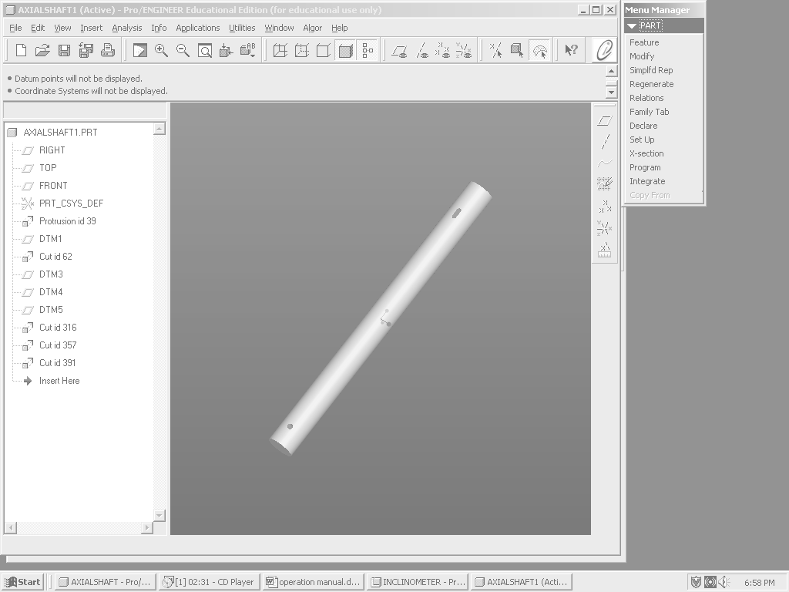
Hole 1
Hole 2
Shaft 1
Figure 2-1: Shaft 1
- Shaft 1 will connect to the pendulum stem and the mirror stem. There are two holes drilled perpendicular to the length through the center of the circle. These two holes are for the pendulum stem and the mirror stem. These components will be added in later steps.
- Shaft 1 should be press fit into the inside diameter of the bearings. The side with hole 2 should be inserted into the bearing.

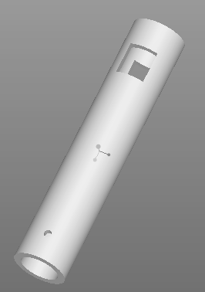
Section 2.1
Prototype Assembly
Shaft 2
Hole 3
Slot 1
Figure 2-2: Shaft 2

- Shaft 2 is hollow. This shaft will be press fit around the outer diameter of the bearing. This will allow for some space between the shaft 1 and shaft 2.
- There are slots cut in this shaft. Slot 1 should be lined up with hole 2 on shaft 1.

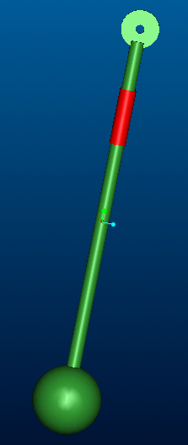
Pendulum Ball
Pendulum Stem
Pin Hole 1
Set Screw
Figure 2-Error! No text of specified style in document.: Completed Pendulum Stem
- The pendulum stem is a part that will go in one of the holes of the small diameter shaft. There is a pin hole connected to the top.
Section 2.1
Prototype Assembly

Rectangular Stem
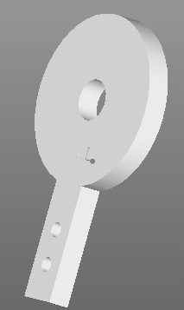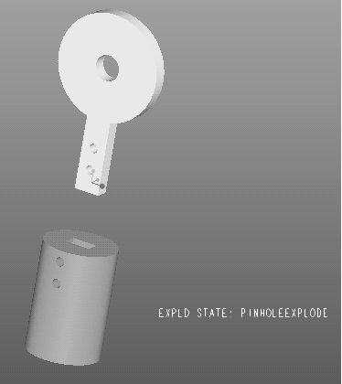
Figure 2-4: a.) Pin Hole; b.) Exploded View of Pin Hole Assembly

- The rectangular part of the pin hole will fit into the slit cut in the stem. Make sure the screw holes are aligned.
- Once these holes are aligned, screw the part in to secure it from movement.
- This part should now look like Figure 3-4 above, but with now pendulum ball attached.
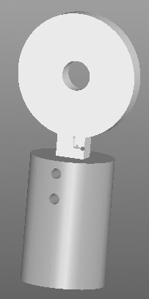
Figure 2-5: Completed Pin Hole Assembly
- This piece should now be inserted into hole 1 in shaft 1.
- This stem should be inserted into the hole until the desired lengths are reached.
- When the desired length is reached, the set screw should be tightened so the stem will not be able to have sliding motion.
- On the other end of the stem is screw thread. This will be screwed into the hole in the pendulum ball. This should be screwed in as tightly as possible.
Section 2.1
Prototype Assembly
- The assembly should now look like Figure 3-5 below.

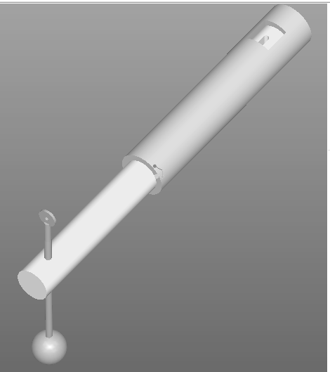
Figure 2-6: Partial Assembly to Step 13

- Pin hole 2 will be attached with the same procedure as the pendulum shaft pin hole.
- This stem will then screw into the hole on the top of the large diameter shaft. It should be screwed in as tightly as possible.
- It is also important to make sure that it is not turned once it is set. This could cause errors in data.
- The face of pin hole 2 should be parallel with the face of pin hole 1

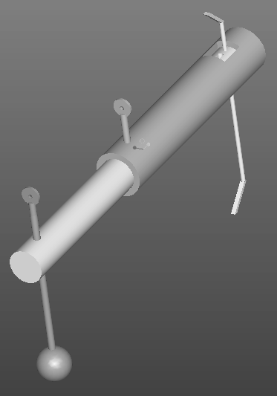
Section 2.1
Prototype Assembly
Pin Hole 2
Mirror Stem
Figure 2-7: Completed Assembly without Outer Casing
- The mirror stem will be inserted into hole 2 on shaft 1.
- The top portion of this stem should already be bent to a 45° angle. It may have the mirror already attached. The bottom part should still be straight to insert it into the hole.
- Insert the stem into the hole until the desired length.
- Once it is the desired length the bottom portion should be bent to 45° also
- A mirror should then be attached to this 45° bend.
- The assembly should look like figure 5 above
- Readjust the length if it changed any.
- Use a set screw to secure the position

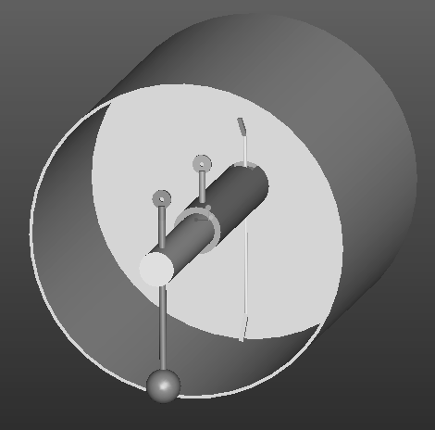
Outer Casing
Figure 2-8: Finished Assembly
- The outer casing is the part that will connect with the device in the magnet bore. It will experience the same rotation as the device. This is a hollow cylinder that has a solid disc at one end. It is all one rigid body.
Section 2.1
Prototype Assembly
- This solid disc will attach to the bearing. The bearing will be press fitted into the circular indentation on the inside surface. This will allow for independent rotation of the large diameter shaft and the small diameter shaft.

Experimental Apparatus
Section 2.2
Experimental Apparatus

Detector
The Metrologic Laser-Power meter was used to measure laser intensity. This is the major factor in the precision of the readings. This device has a range of 20 microwatts to 20 mW. This device may also be replaced in experiment. If it is replaced by a power meter that allows smaller readings, more precise readings may be taken.

Laser
Laser diode control unit by Power Technology, Inc. This was model: LDCU3/3663. This type of laser is Neodymium Ytrrium Argon Garnett (Nd:Yag).
The laser has an output power of 10 mW and a wavelength of 532nm. This laser has a beam diameter of 1mm with a tolerance of .2 mm. The laser may be changed as long as the beam diameter is 1 mm or larger.
Warning!! Do NOT stare directly into the laser beam emitter. Will cause blindness.

Prototype
Figure 2-8 is the completed device. It will be used to change the intensity of the light that goes in. The angle of tilt of the device is a function of the intensity that comes out of the device. The detector used to measure the intensity of light for this product must have a higher sensitivity than that of the detector used in the proof of principle prototype assembly experiment. The recommended detector for use with this product is the New Focus 2151 Femtowatt Photoreceiver, which has a detector diameter is 1.0mm. This detector measures wavelengths in the range of 300-1050nm with a maximum responsivity of 0.5 A/W.

