http://www.ccm.udel.edu/reports-pubs/Spring02-Reviews/April24th/Gama/Gama.ppt
Striker Bar
Incident Bar
Transmitter Bar
Strain Gage
Strain Gage
Specimen

http://scholar.lib.vt.edu/theses/available/etd-08232000-22140045/unrestricted/swyadec.pdf
THESIS PAPER (164pgs)

http://scholar.lib.vt.edu/theses/available/etd-41998-18465/unrestricted/ETD.pdf
THESIS PAPER

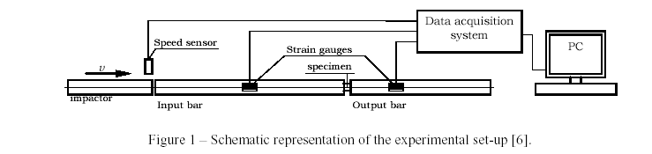
http://www.dem.ist.utl.pt/~bonemec/ABSTRACT-ferreira_vaz_simoesI.pdf

http://www.tut.fi/units/ms/elm/laitteet/hopkinson(eng).htm
ELECTRON MICROSCOPY
Hopkinson split bar (HSB)
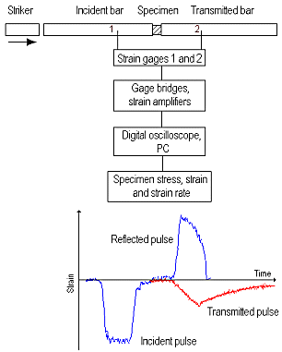
Hopkinson Split Bar technique is used to measure stress-strain response of materials at high strain rates, typically in the range 10²-10⁴ s⁻¹. The HSB method is based on the propagation of elastic pressure waves in solids. Figure 1 is a schematic illustration of the SHPB apparatus. When a striker, accelerated typically to a velocity of 2.5 to 20 m/s, hits the front end of the incident bar, a compressive stress wave is generated which propagates in the bar until it reaches the interface of the incident bar with the specimen. At the interface, part of the stress wave is reflected back as a pulse of tension, while the remaining part is transmitted through the specimen to the transmitter bar. The stress pulses generated are recorded at strain gage stations 1 and 2. The figure below shows an example of the generated stress pulses. Stress, strain, and strain rate in the specimen can then be calculated from the measured strains in the pressure bars.

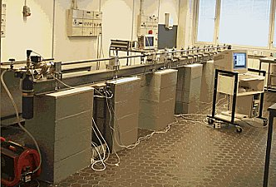
At the Institute of Materials Science at TUT we use high strength steel (AISI 4340) and aluminium (AA 7075) bars of 22 mm in diameter and 1200 mm in length. A wide variety of materials is being tested, including among others, polymer covers of paper machine rolls, steel tubes for automotive applications, steels for military applications, rocks etc.
Schematic illustration of the SHPB apparatus

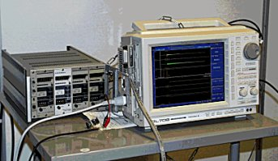
A Yokogawa DL 708 10/12-bit, 10 Msample digital oscilloscope is used to record the strain gage signals. As a triggering signal we use the signal from an optical sensor attached to the launcher tube. In all, three optical sensors are attached to the launcher tube to facilitate the measurement and calculation of the striker velocity. The strain gage amplifiers we use are Kyowa CDV 700A series signal conditioners having a bandwidth of 500 kHz. The digital oscilloscope is further connected to a PC, where the actual calculations are made using Matlab. Loading of the striker, pressurizing of the pressure accumulator and launching of the striker are all computer controlled.
Specifications
Type of loading: | compression
Duration of the loading pulse[s]: | 50…200·10⁻⁶
Strain rate range [s-1]: | 10²…10⁴
Loading range [kN]: | 0 … 250
Temperature range [°C]: | 20…120
Näytteen dimensiot [mm]: | D<22, h ~ 0.5*D
Future developments: | -Development of shear specimen geometry  -Testing of very soft polymer materials using viscoelastic pressure bars  -Development of high temperature testing
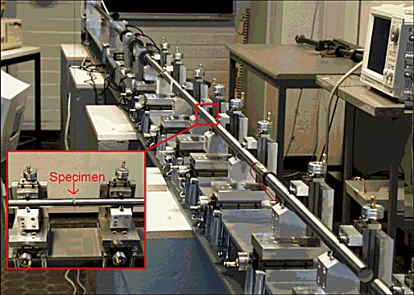
HSB equipment at the Institute of Materials Science at TUT

