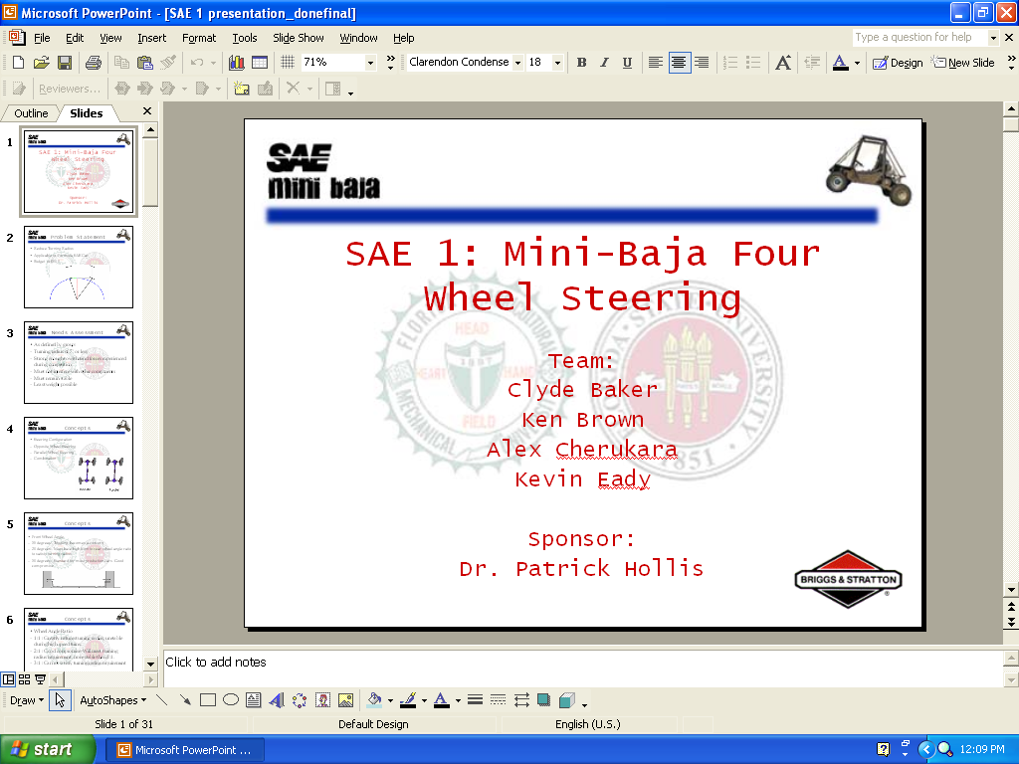

Table of Contents

Introduction 1
Design Process 4
Needs Assessment 4
Concept Generation 7
Design 11
System Geometry 11
Geometry 11
Force Analysis 12
Adams Analysis 16
Pro Engineer Modeling and FEA 17
Component Selection 19
Economic Analysis 22
Conclusion 23
Design Overview 23
Difficulties in Design 24
Objectives 25
Spring Agenda 26
References 27
Appendices
Appendix I: Project Procedures A-1
Appendix II: Project Scope A-3
Appendix III: Needs Assessment Report A-5
Appendix IV: Initial Product Specifications A-7
Appendix V: Concept Generation A-8
Appendix VI: Force Analysis Graphics A-12
Appendix VII: Force Analysis A-14
Appendix VIII: Graphs A-38
Appendix IX: Engineering Drawings A-43
Appendix X: Final Product Specifications A-49
Appendix XI: Contact List A-50

Introduction
_______________________________________________

The task presented to this design group in August 2003 was to design a four-wheel steering system for the Florida State University SAE Mini-Baja car. The purpose of this system is to significantly reduce the turning radius of the vehicle, thereby improving the performance of the vehicle during competition.
Many factors were taken into account when designing this system. The foremost criteria of the design was the reduction of the turning radius to seven feet or less. Stability of the vehicle during turns was also taken into consideration. The durability of the components was perhaps the most scrutinized factor having by far the largest amount of data for comparison. Among the other factors considered were system weight, proximity to moving components, application to other vehicles and lastly, budget.
Many of the concepts considered for this system are partially derived from existing systems used on vehicles. The concept chosen for this system implements a 5” travel rack and pinion assembly for both the front and rear subsystems. The steering column is fitted with a 2” 45 degree bevel gear mated to a 2” bevel gear for the front and a 4” bevel gear for the rear. This provides a maximum rack travel of 5” for the front subsystem and 2.5” for the rear. This translates to a maximum wheel angle of 30 degrees in front and 15 degrees in the rear. The rotational force is transferred to the pinions by means of shafts that run from the gear box to the rack and pinion assemblies
The geometry of this system was produced to provide the desired turning radius while maintaining the stability of the vehicle. Concerns were raised about the possible toggling of the front system if the front wheel angle was too large. Research of the front wheel angles of most production cars manufactured today showed that most implement an angle between 28-32 degrees depending on the intended application of the vehicle. Based on this data, along with the toggling concerns, the group felt it wise to define the front wheel angle at 30 degrees. At this time the stability of the car was addressed. Increasing the rear wheel angle could produce a smaller turning radius but may lessen the stability. Research was conducted concerning front to rear wheel angle ratios but no data could be found. After much debate a front to rear ratio of 2:1 was chosen giving a 15 degree rear wheel angle. The stability of the vehicle cannot be quantified but will be tested after construction and recorded qualitatively.
This system was designed to withstand the impact of hitting an obstacle at 20 mph with the collision occurring over .55 seconds. Factoring in the mass of the vehicle with the largest expected driver the collision produced a force of approximately 5600 N. This force is applied directly to the steering linkage without regard to the component of the force which would be absorbed by the suspension. This is obviously a worst case scenario which would not be anticipated even under the most extreme circumstances. In addition to this assumption a factor of safety of 1.5 was designed into the system. Taking into account the compressive/tensile forces along with the bending moments and shear forces it was found that the typical steel used in most steering components, AISI 1018, would be sufficient in this design as well. The lone exception was the tie rod ends which feel the largest stresses caused by the collision. The size of the ends were increased in order to reduce the stress on the component. It was decided to use 3/4” tie rod ends to reduce the stresses felt. AISI 4130 grade steel, or chrome -moly, was chosen for the tie rod ends. This is the strongest material commonly used on tie rod ends and it is commonly available through many part dealers.
The force analysis gives a fairly good estimate of the worst-case forces felt as the wheels turn from 0-30 degrees in front and 0-15 degrees in the rear. From these values it was determined that the largest stresses are felt when the wheels are at their maximum point of travel. The system designed is expected to be more than capable of handling our worst-case scenario. It is hoped that these conclusions will be confirmed during testing during the spring semester.

Design Process
_______________________________________________

Needs Assessment
The objectives set forth by the project sponsors, Dr. Patrick Hollis and FSU SAE president Patrick Middleton, was to reduce the turning radius of the car by means of a four wheel steering system and to accomplish the production of this system for $500 or less.
It was determined that a turning radius of less than 7’ would be required to efficiently navigate the most extreme turns during the Mini-Baja competition. The previous Baja car was found to have a turning radius of 14’ making it difficult to navigate the course. The goal for this design was to greatly reduce this radius to under 7’ if possible.
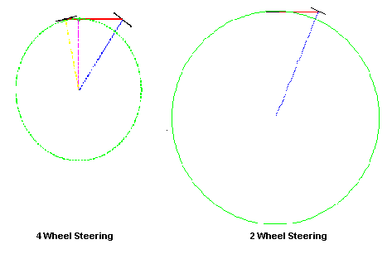
Figure 1: Turning Radius Comparison of 2 and 4 Wheel Steering Systems

The second most important aspect of our design was that it be strong enough to withstand the punishment of an off-road vehicle course. These courses are typically strewn with obstacles such as logs, stumps and small drops which could possibly break lesser steering systems. In fact the system that the new design will replace has had many failures specifically at the tie rod ends. A failure of this kind during competition would result in a drastic drop in the standings. Having confidence that the system will withstand all but the most extreme forces should allow the driver to take chances that normally would be out of the question with weaker systems.

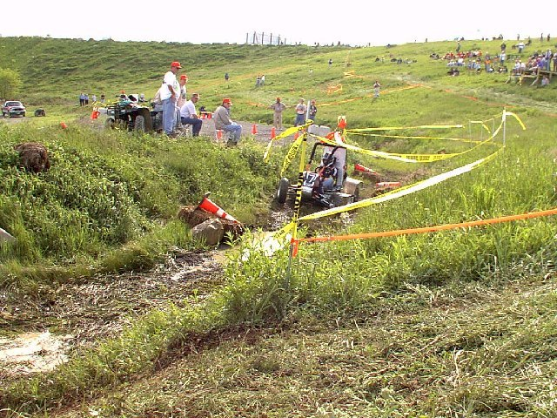
Figure 2: Typical Mini-Baja Course[1]

As with any car there is a limited amount of space available to install and mount components. The Baja car does not have an extraordinary amount of space available, so the size of the system had to be carefully scrutinized. There had to be clearance for the wheels to turn, the rack to travel and for the shafts to rotate freely. It was determined that in order to allow the rear wheels to travel 15 degrees the rear end of the car must be widened. A U-joint was chosen to give the rear shaft clearance over the swing arm but still allow it to rotate freely. Rear rack mounting was also a concern. There is not sufficient room to mount the rack in front of the rear axle so it must be mounted behind it, making it vulnerable to obstacles the driver may encounter. Additionally, the weight of the system was a concern as any extra weight can greatly hinder the performance of a vehicle. An effort will be made to reduce the weight of the components and materials used for the system.
Perhaps the most important factor that cannot be quantified is the comfort of the driver. When implementing a four-wheel steering system the “feel” of the car changes. With a front wheel steering system the car turns about the back wheels but a four wheel steering car will turn about some point between the front and rear wheels. One of the problems faced was trying to retain a “normal” feel but still achieving the desired turning radius. Another concern was the stability of the car during turns. Although the driver would be expected to slow down to take a sharp turn it must be predicted that at some time a sharp turn will be made at a high speed. For this reason the stability of the car was scrutinized, a fact reflected in the final design.
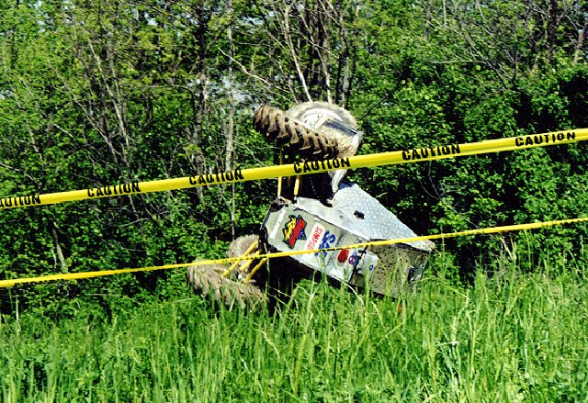
Figure 3: Possible Result of Instability During Turn[1]

Concept Generation
Many concepts were considered during the design process. Most concepts were either wholly or partially derived from other designs implemented on production vehicles. The process we used to create a complete concept was to break our needs into categories such as steering mode (parallel or opposite wheel), linkages, system type(rack and pinion or re-circulating ball bearing) and methods of achieving the desired front to rear ratio.
The first issue to be decided was which steering mode would be used. The three possible choices were parallel wheel steering, opposite wheel steering and a combination of the two. Parallel steering provides better stability at high speeds but does not help achieve the goal of a smaller turning radius. Opposite wheel steering will allow the reduction of the turning radius but will be unstable during high speed maneuvering. The combination of both systems employs the parallel wheel steering at high speeds and opposite wheels steering at lower speeds. However, this configuration would require the use of sophisticated electronics which are beyond this group’s base of knowledge and out of the project’s budget. Therefore the best choice for our design configuration is the opposite wheel steering setup.
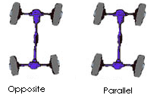
Figure 4: Opposite and Parallel Wheel Configuration [2]

Another aspect of the design deliberated upon was the wheel angles. Research found that most production vehicles use a front wheel angle of approximately 30 degrees. It was felt that this was a good angle for the front wheel because it was not extreme enough to reach a toggle condition when colliding with an obstacle but was large enough to help achieve the needed turning radius. It was felt that a front to rear angle ratio of 1:1 would make the car more unstable than a 2:1 ratio, although it would provide a greater reduction in the turning radius. The 2:1 ratio was chosen giving a 15 degree rear wheel angle.
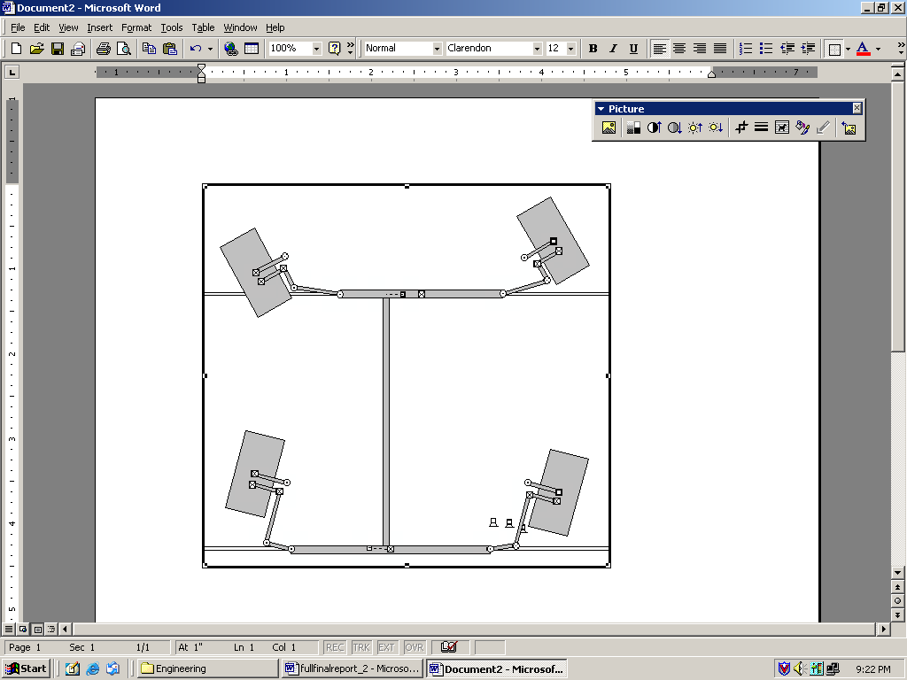
Figure 5: 2:1 Wheel Angle Ratio

The next dispute reconciled was which kind of steering mechanism would be implemented in the design. This turned out to be a fairly simple matter to settle as there are only two methods commonly used, re-circulating ball bearing and rack and pinion. The rack and pinion system is by far the most common and also the cheapest although it is not as rugged as the ball bearing system. The low cost and availability of the rack and pinion system made it the choice for this design. The strength of the ball bearing system was not an important factor in the decision as the rack was not expected to receive an extremely large force. Also, it was found from the previous Baja team’s experience that the rack and pinion system that had previously been used was very dependable.
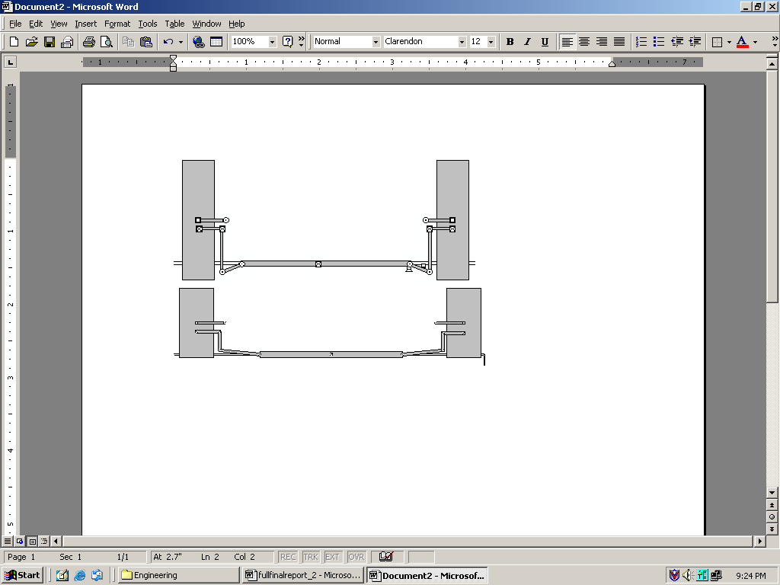
Figure 6: Comparison of Rear Geometry with No Gearing(Top) and 2:1 Gearing(Bottom)

Next, the method of joining the subsystems was considered. One solution considered was to run a shaft straight from the front rack to the rear rack without any gearing. The geometry of the front and rear subsystems would be designed to give the desired angles with each rack traveling the same distance. Another concept involved gearing the shaft to provide the rear rack with half the travel of the front rack. The front subsystem would be designed so the geometry would provide the desired wheel angles. The rear subsystem would also employ the same geometry as the front subsystem. Initially, it was decided to use the first concept because it was felt that avoiding unnecessary gearing would make the system more reliable, cheaper and easier to construct. However, when the rear subsystem was designed it was found that in order to give the desired angles the rack would have to be mounted more than 8” behind the rear axle and the steering arms must be 8” in length. This presents problems due to increased moments on the steering arms and increased vulnerability of the subsystem. For this reason the concept of gearing the shaft with a 2:1 ratio was chosen.
The last component of the design decided upon was the manner in which the steering column would control the system. One concept involved attaching the steering column directly to the front pinion as would be done on a conventional steering system. This was ruled out because it would be very difficult to attach the connecting shaft to the front rack. The only other option was to attach a bevel gear to the steering column and gear the connecting shafts at this gear. This is accomplished by mating the bevel gear to an identical bevel gear powering the front rack and a bevel gear twice the size powering the rear rack. These gears are housed inside of a gear box which is located in the driver’s cockpit. This was the concept chosen for this design.
The complete concept that was created was a four-wheel opposite wheel steering system composed of two subsystems, front and rear. Each subsystem is composed of the same components, has the same geometry and both are connected together by shafts which are geared with a 2:1 ratio.
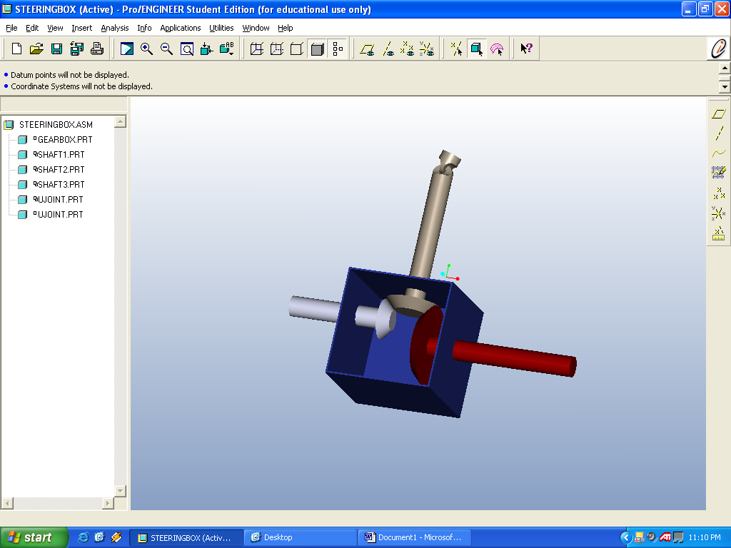
Figure 7: Gear Box Model. Front Shaft(left), Steering Column(center) and Rear Shaft(right).

Design
System Configuration
The configuration of this system is fairly straightforward. The steering column is fitted with a bevel gear. This gear is housed inside of a gear box where it meshes with two separate beveled gears. The first gear is identical to the steering gear and mounts on a shaft connected to the front pinion. The second gear has a radius twice that of the first and is mounted on a shaft connected to the rear rack. By using a 1:1 ratio for the front subsystem and a 2:1 ratio for the rear subsystem the desired 2:1 front to rear wheel angle ratio is achieved. As the steering column is rotated, the two shafts rotate, propelling the racks. As the racks move the tie rods push and pull the steering arms turning the wheels.

Geometry
The geometry of the system was designed so that the desired wheel angles are achieved at the maximum travel of the rack. Smartsketch software was used to generate the needed geometry when certain variables were defined and Working Model simulations were conduced to confirm the geometry was correct. In the case of the front system, the steering arm length was determined by defining the travel of the rack, the distance from the rack to the kingpin and the tie rod length. Initially, the back subsystem geometry was found by varying the tie rod lengths and the steering arm lengths to provide a maximum wheel angle of 15 degrees given 5” of total travel. However, when the decision to provide a front to rear rack travel of 2:1 was made it was decided to use to same geometry in the rear as was used in the front. The only difference between the two subsystems is the unequal rack lengths, caused by differing widths in the front and rear, but this has no real effect on the system.
Force Analysis
After the geometry of the subsystems were determined the force analysis could be conducted. The first step in performing force analysis on this system was to determine the maximum force that the system would be expected to feel. The mass of the car with the largest expected driver was found to be 743 pounds. The initial velocity of the car was set at 30 mph and reduced to 0 mph over a period of time. This elapsed time cannot be accurately predicted unless an experimental impact was conducted and this was not feasible as it would likely injure the driver. It was therefore decided to research the matter and find elapsed impact times for similar scenarios. When this failed to produce any usable data it was decided to assume an elapsed time of .7 seconds.
Figure 8: Force vs. Elapsed Time of Collision (20 mph-0mph)

As research continued it was found that many crash tests of production vehicles are conducted at 30 mph and the elapsed time of the collisions are somewhat less than .7 seconds. Based on this new information it was determined that it cannot be reasonably expected for this system to withstand an impact of 30 mph with a fixed object. The speed was therefore lowered to 20 mph but the elapsed time was reduced to .55 seconds. This produces an initial force of 5600 N that the system must withstand.
Figure 9: Comparison of Velocity and E.T. on Initial Force

Force analysis on this linkage was performed using Mathcad equation solving software. After using vector analysis to derive equations for the forces experienced, the equations were entered into Mathcad. The equations are dependent upon the initial force felt as well as the angle of the wheels and the angle of the impact. By changing these three values in Mathcad the shear forces and ultimate stresses can be found.
The force analysis of this system was performed by evaluating the system as statically loaded as opposed to dynamically loaded. At the time of analyzing the system the Adams force analysis software was inoperable. Dr. Hollis advised that evaluating the system as statically loaded using vector analysis would provide a reasonably accurate representation of the force distribution. A few assumptions were made when performing the vector analysis. The first assumption made was that the linkage behaves as though it is embedded in a wall at the pinion/rack junction. This was done to make the analysis of the system easier so the forces being transmitted to the opposite side of the linkage can be neglected. While this is not a correct assumption it provides a worst case scenario in which the linkage cannot move any further and therefore “locks out”.
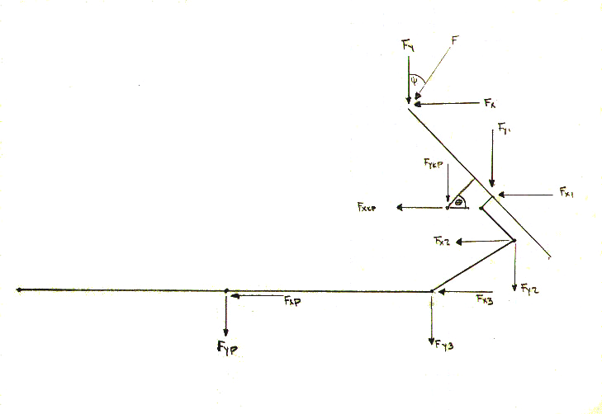
Figure 10: Force Analysis Diagram

Another assumption that was made was that the moments produced by the slight offsets in components could be neglected. This slightly lessened the forces that were experienced but by taking the worst case scenario in many other areas the force values are still much higher than they will be in reality.
The factor safety designed into this system was chosen to be two. It was desired that the system be as reliable as possible during competition and therefore should be able to withstand the anticipated forces with a fairly large margin for error. However, during a sponsor meeting with Dr. Hollis, the matter of high design strengths of the components was presented. The factor of safety appeared too high to achieve a reasonable design strength for the tie rod ends. After mentioning the numerous overestimations built into the force analysis his solution was to slightly reduce the factor of safety. At this time a factor of safety of 1.5 was chosen.
The maximum stress on each component is shown in Figure 10 as well as the design strength of the components. It was found that the largest stress acts upon the tie-rod end, rack and steering arm and the least force acts upon tie rod bolt. It can be seen that the racks, tie rod ends and steering arms all experience very similar maximum stresses, all around 650 MPa.
Figure 11: Component Force Breakdown

Adams Analysis

An in depth analysis using the motion program Adams will be performed next semester. This will validate or discredit the forces that have been calculated this semester and show any errors in the design before fabrication begins. A parallel wheel travel test will be performed to show how the steering system reacts to extreme suspension travel and to show how much bump steer there is, if any. This test will also show the likely hood of breaking components in the steering or suspension due to this travel. Another test that will be run is opposite wheel travel which will just confirm the results from the parallel wheel. Both of these tests should give the same results. Also a steering test will be run to show whether or not the steering system will toggle at extreme turns and give the amount of force that turning the wheels puts on the components of the steering system. The final test that will be run is a combination of a steering test and a parallel wheel travel test. This will be used to show the forces on the steering system during an impact with the wheels turned different amounts and it will show the stability of the vehicle as a whole during these maneuvers.

Pro Engineer Modeling and FEA

The whole steering system has been modeled in Pro-Engineer for a variety of reasons. The first of which is for use in the design of the system, making sure that none of the components interfere with critical components of the car such as the drivetrain. Secondly the Pro-E files are used by ALGOR in order to ensure that the three dimensional analysis of the system is drawn correctly due to the fact that it is much easier to render three dimensional models in Pro-E than in ALGOR. The final reason for doing the Pro-E modeling is to help with the fabrication of the steering system.
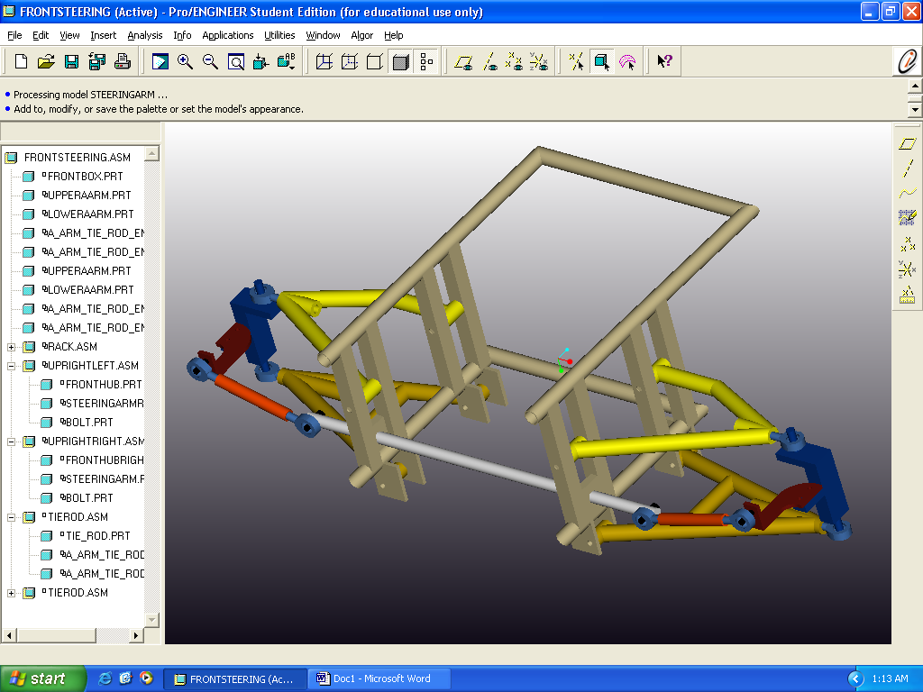
Figure 12: Front Steering Subsystem
Algor was used for finite element analysis and to verify the vector math calculations done by hand. The parts modeled in Pro-Engineer were imported directly into Algor and a mesh was applied along with the loads and boundary conditions to check for displacement values and to check the maximum stresses and their locations. The entire rear steering assembly was meshed at once and the expected forces and boundary conditions were applied. However, since certain components are manufactured from different materials and some joints did not transfer loads in a basic linear fashion, Algor was able to mesh the entire assembly but it was not able to transfer loads from one piece to the next. We decided that each part should be entered individually into Algor so that the boundary conditions and loads can be applied to the specific surface we choose and to ensure the program does not make any inaccurate assumptions about the joint type. We are still in the process of analyzing the main components.
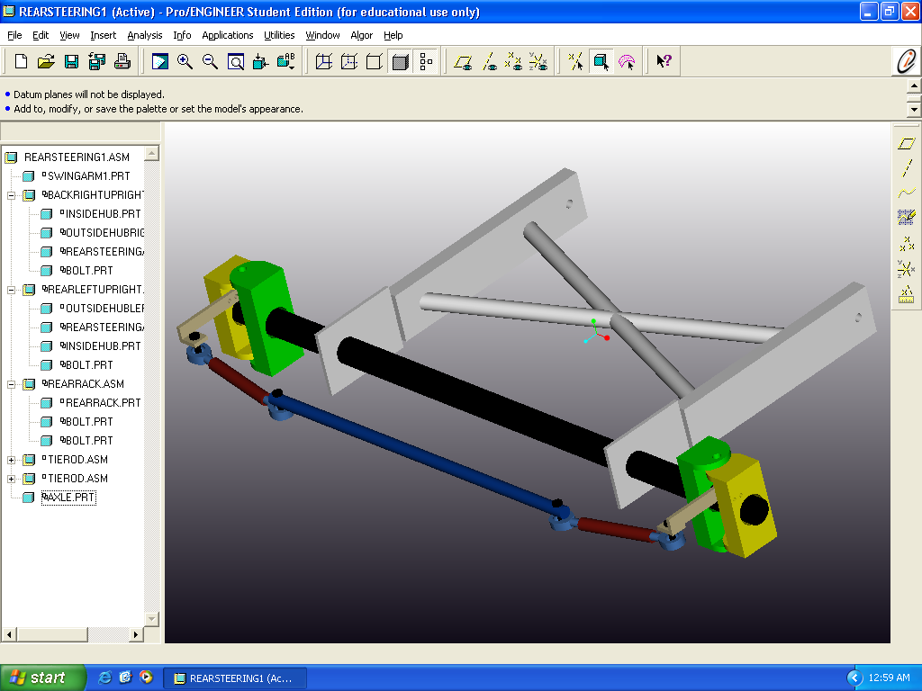
Figure 13: Rear Steering Subsystem
Component Selection
After the force analysis was completed the material and component selection was conducted. For the components that are to be constructed only the materials to be used were selected. For the other components such as tie rods, tie rod ends and the rack, the material and component selection was conducted simultaneously. It was initially found that the calculated design strengths were very high. The tie rod end design strength was especially high, around 1,800 MPa. This is well beyond a reasonable design strength for tie rod ends regardless of application. Additionally, such tie rod ends would be virtually impossible to find as the strongest material found in commonly available tie rod ends is chrome-moly which averages around 1,100 MPa.
The solution to this problem was to increase the size of the components experiencing abnormally large stresses. The first action taken was to increase the tie rod end diameter from 3/8” to ¾”. This reduced the expected stress from 1,500 MPa to 388 MPa. Increasing the diameter of the tie rod ends meant that the size of the tie rods would also have to be increased from .62” ID and 3/4” OD to 1.12” ID and 1.25” OD. This reduced the stress of the tie rods from 416 MPa to 233.5 MPa. The bolts also had to be enlarged when the tie rod end diameter was increased. The new bolt diameter must be ¾” to properly fasten to the tie rod ends. This reduced the expected stress from 553.5MPa to 69.8 MPa. Lastly, the steering arm thickness was increased. Initially a thickness of ¼” was chosen due to the availability of material in that size. However, in order to decrease the stress on the component the thickness was enlarged to 3/8”. Surprisingly this 1/8” increase thickness resulted in a decrease of about 175 MPa from 605.7 MPa to 429.4 MPa. Table 1 lists the final component dimensions and Figure 11 shows the reductions in stress as the dimensions change.
Figure 14: Comparison of Stresses Before and After Components Resizing

The next step was to compare the new design strengths to the strengths of materials commonly used in producing the components in question. The steering arms will be fabricated by the team using AISI 1018 steel. The average strength of this steel is about 650 MPA which is very close to the design strength of 644 MPa for this component. Next, the tie rod bolts were considered. With a design strength of 104 MPa any ¾” steel bolts should be more than sufficient for this application. The tie rods have a
design strength of 350 MPa. All steels commonly used in the
production of tie rods have strengths higher than this design strength.
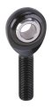
Figure 15: Chrome-moly Tie Rod Ends [3] Figure 16: Steel Rack with 5” Travel [4]

The tie rod ends were perhaps the most debated upon component. When inspecting the force analysis it was found that chrome-moly tie rod ends in the ½” size could possibly work but that it would be hard to meet the 1.5 factor of safety. It was decided instead to use ¾” steel ends. When searching for the ends that would be used it was discovered that ¾” chrome-moly ends would only be $3 more per end and the factor of safety would be easily achieved. It was decided that the ¾” chrome-moly ends would be used.
Component | Dimension
Steering Arm | L-4.5” x W-1” x t-3/8”
Tie Rod | L-7.07” x ID- ¾” x OD-1”
Tie Rod End | D- ¾”
Rack | L- 25” x D- ¾” Travel -5”
Bolt | D- ¾”
Table 1: Final Dimensions of Components

Next, the rack was considered. One rack is already in our possession, having been used on the previous baja-car steering system, and plans had been made to use an identical rack for the rear rack. The force analysis provided a design strength for the racks of 640 MPa. It was not known what type of steel was used to construct the rack. At the moment attempts to obtain this information from the vendor are being made. Based on the experience of those involved with the Baja-car in the past the previous rack had never had any problems withstanding the forces experienced during competition. Based on this information and the assumption that a low grade steel would not have been used to manufacture this rack it was decided to use the 11” rack and pinion system from dansperformanceparts.com.
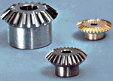
Figure 17: 2:1 Steel Bevel Gear Pair[5]
Lastly, the gears were selected. It was felt that any gear more than 4” would be too large and encroach on the legroom of the driver. However, any gear less than 2” was felt to be too small to be used in this application. This pointed to a 4” gear and two 2” pinions to be used in the gearbox of the system. Acceptable pairs were found at chicagogearworks.com and a few other gear manufacturers. As soon as the lowest price can be established the gears will be ordered.

Economic Analysis
The economic analysis for this project has proven to be very important as the budget for this design is small in comparison with the price of the components needed. Considering the most expensive items first, the rack desired was found at a couple different on-line retailers with the price ranging from $89.95 to $95.00. No cheaper acceptable substitutes could be found. Luckily, one usable rack has been salvaged from the previous system saving approximately 1/5 of our budget. Next, the tie rod ends consume a large portion of our budget at $15.95 each. The eight tie rod ends will cost a total of $136. The tie rods will cost an estimated $10.50 each which will total $42. The steering arms will be constructed from sheet metal which already belongs to the SAE club costing the group nothing. This leaves $137 for the remainder of the components and miscellaneous hardware. The gears are the only other component of substantial value not accounted for. At the moment, prices for steel 2:1 bevel gear pairs are being researched. Additional funding/sponsorship may have to be obtained if they cannot be bought for under $140 dollars.
Figure 18: Design Strength vs. Selected Material Strength

Conclusion
_______________________________________________

Design Overview
The four wheel system designed by this group reduced the turning radius of the vehicle from 14’ to 6.5’. The turning point of the car is 20” in front of the rear wheels of the car. It is expected that the car will retain a “normal” feel because the turning point is still relatively close to the rear axle of the car. The system consists of two rack and pinion systems, one for the front subsystem and one for the rear subsystem. They are coupled by means of geared shafts turned by a pinion mounted on the steering column. The gear for the rear shaft has twice the diameter of the front shaft gear and therefore the front rack travels 2” for every 1” that the rear rack travels. The front travels a maximum of 5” and the rear a maximum of 2.5”. The car utilizes an opposite wheel configuration meaning that as the front wheels turn to the right the rear wheels will turn to the left. This means that the racks will move in opposite directions. Both subsystems possess the same geometry and therefore the front wheels will turn 2 degrees for every 1 degree that the rear wheels turn. The front wheels turn 30 degrees in either direction and the rear wheels turn 15 degrees in either direction. The gears used in this design are a 2:1 beveled gear set consisting of a 4” steel beveled gear on the rear shaft, a 2” steel beveled gear on the front shaft and a 2” steel beveled pinion mounted on the steering column. Both 2” gears are identical and all gears are enclosed in a gear box located under the driver’s legs. This system should easily withstand the force of a 20 mph stationary object with the collision occurring over .55 seconds (equivalent to 5600 N).

Difficulties in Design
This design was not carried out entirely without incident but what problems did occur were relatively minor. The first and largest problem encountered was that the Adams modeling program was inoperable for the first half of the semester forcing the group to perform the force analysis by hand and to make many assumptions in doing so. Without force analysis the components could not be designed or selected to withstand the anticipated forces so vector analysis was conducted on the linkage.
The first assumption that had to be made was that analyzing the system as statically loaded would produce similar force values as dynamic analysis. It had to be assumed that the pinion/rack junction acted as a fixed point that would not move. Without this assumption the force would be expected to simply transfer throughout the linkage.
Another difficulty was that the expected initial force could not be positively identified and had to be estimated. Research was did not reveal the approximate time of a typical collision at 20 mph as there are many factors contributing to this value. Initially, the velocity was chosen to be 30 mph but as further research was conducted it was discovered that automotive head on crash tests were conducted at this speed. Obviously, at this speed the survival of the driver and not the steering system is the primary concern. Therefore the initial velocity was decreased and the elapsed time of the collision was estimated at .55 seconds.
The forces on the steering arm were also estimated. The steering arm was modeled as a straight bar due to the difficulty caused by the odd shape of the bar. Lastly, the slight bending moments on the components caused by the offset at the bolts was neglected.
Objectives
Looking back on the objectives put forth in the needs assessment it can be seen that the objectives have indeed been met or will be met in the spring semester. The most important requirement which was set forth by Dr. Hollis and Patrick Middleton was the reduction of the turning radius. Our initial goal of a 7’ turning radius was met with a turning radius of 6.5’. It is anticipated that the budget of $500 will be sufficient to fabricate this system. At the present time approximately $100 is left after ordering the components, not including the shafts and hardware (nuts, bolts and misc. items). The strength of the system should be more than sufficient if our force calculations are indeed accurate. The weight of the system was perhaps the least scrutinized of the objectives but the increase in weight is not expected to be dramatic. The space requirements have been met by using U-joints to fit the rear shaft around other components. The one concern raised was that the gear box may infringe upon the driver’s leg room and be unsafe. This will be addressed in the spring when the system is installed but plans have been made to mount the gear box halfway above and halfway below the bottom of the cockpit meaning that it should not infringe more than 2” above the bottom. The “feel” of the car cannot be determined until the system is installed and tested. This cannot be quantified but will instead be rated by the drivers of the car against the feel of the previous system. Along the same lines the stability of the car will rated by the drivers compared to the previous system.

Spring Agenda

The agenda for the spring semester begins with testing the previous system to acquire baseline performance data. The next phase is the construction of the system. The bulk of the semester will be allowed for construction so that it may be properly installed. Next, the new system will be tested. This will include evaluating the actual turning radius, stability, feel, straight-line performance, off-road course performance and driver comfort. The last stage will be to prepare an all inclusive report and presentation detailing the design, construction and tests performed as well as analysis of the test data and how well the objectives were met. In May after the final presentation has been made the car will entered into the SAE Mini-Baja competition and the true test will be conducted.

References
________________________________________________

Pictures

[1] www.rit.edu/~bajawww/home/
[2] http://www.pickuptruck.com/IMAGES/2002/gmc/denali/quadra.jpg
[3] http://www.speedwaymotors.com

[4] http://www.dansperformanceparts.com/buggy/susp/buggysusp%20rack&pinion.htm

[5] http://www.schafergear.com/chicagogear/gear_catalog/bevel_gears.html

Books

[6] Ashby, Micheal. Material Selection In Mechanical Design. Woburn, Massachusetts:
Butterworth-Heinemann, 2001.

[7] Callister, Henry. Material Science And Engineering An Introduction. New York: John
Wiley & Sons, Inc, 2000.
[8] Hibbler, R.C. Engineering Mechanics: Dynamics. Upper Saddle River, New Jersey:
Prentice Hall, 1998.

[9] Hibbler, R.C. Statics and Mechanics of Materials. Englewood Cliffs, New Jersey:
Prentice-Hall, 1993.

[10] Logan, Daryl. A First Course in the Finite Element Method Using Algor: Pacific
Grove, California, Brooks/Cole, 2001.

[11] Milliken, William F. Race Car Vehicle Dynamics Warrendale, Pa, Society of Automotive Engineers Inc.

Appendices
_______________________________________________

Appendix I: Project Procedures
Appendix II: Project Scope
Appendix III: Needs Assessment Report
Appendix IV: Initial Product Specifications
Appendix V: Concept Generation
Appendix VI: Force Analysis Graphics
Appendix VII: Force Analysis
Appendix VIII: Graphs
Appendix IX: Engineering Drawings
Appendix X: Final Product Specifications
Appendix XI: Contact List

