Body
_______________________________________________

Needs Assessment
The task presented to this group in September 2003 was to design a four wheel steering system for the Florida State University SAE Mini-Baja car. The objectives set forth by the project sponsors, Dr. Patrick Hollis and FSU SAE president Patrick Middleton, was to reduce the turning radius of the car by means of a four wheel steering system and to accomplish the production of this system for $500 or less.
It was determined that a turning radius of less than 7’ would be required to efficiently navigate the most extreme turns during the Mini-Baja competition. The previous Baja car was found to have a turning radius of 14’ making it difficult to navigate the course. The goal for this design was to greatly reduce this radius to under 7’ if possible.
The second most important aspect of our design was that it be strong enough to withstand the punishment of an off-road vehicle course. These courses are typically strewn with obstacles such as logs, stumps and small drops which could possibly break lesser steering systems. In fact the system that the new design will replace has had many failures specifically at the tie rod ends. A failure of this kind during competition would result in a drastic drop in the standings. Having confidence that the system will withstand all but the most extreme forces should allow the driver to take chances that normally would be out of the question with weaker systems. 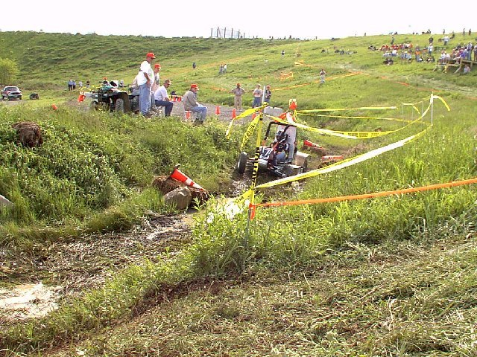
Figure 1: Typical Mini-Baja Course[1]

As with any car there is a limited amount of space available to install and mount components. The Baja car does not have an extraordinary amount of space available, so the size of the system had to be carefully scrutinized. There had to be clearance for the wheels to turn, the rack to travel and for the shafts to rotate freely. It was determined that in order to allow the rear wheels to travel 15 degrees the rear end of the car must be widened. A U-joint was chosen to give the rear shaft clearance over the swing arm but still allow it to rotate freely. Rear rack mounting was also a concern. There is not sufficient room to mount the rack in front of the rear axle so it must be mounted behind it, making it vulnerable to obstacles the driver may encounter. Additionally, the weight of the system was a concern as any extra weight can greatly hinder the performance of a vehicle. An effort will be made to reduce the weight of the components and materials used for the system.
Perhaps the most important factor that cannot be quantified is the comfort of the driver. When implementing a four-wheel steering system the “feel” of the car changes. With a front wheel steering system the car turns about the back wheels but a four wheel steering car will turn about some point between the front and rear wheels. One of the problems faced was trying to retain a “normal” feel but still achieving the desired turning radius. Another concern was the stability of the car during turns. Although the driver would be expected to slow down to take a sharp turn it must be predicted that at some time a sharp turn will be made at a high speed. For this reason the stability of the car was scrutinized, a fact reflected in the final design.

Concept Generation
Many concepts were considered during the design process. Most concepts were either wholly or partially derived from other designs implemented on production vehicles. The process we used to pick a concept was to break our needs into categories such as steering mode (parallel or opposite wheel), linkages, system type(rack and pinion or re-circulating ball bearing) and methods of achieving the desired front to rear ratio.
The first issue to be decided was which steering mode would be used. The three possible choices were parallel wheel steering, opposite wheel steering and a combination of the two. Parallel steering provides better stability at high speeds but does not help achieve the goal of a smaller turning radius. Opposite wheel steering will allow the reduction of the turning radius but will be unstable during high speed maneuvering. The combination of both systems employs the parallel wheel steering at high speeds and opposite wheels steering at lower speeds. However, this configuration would require the use of sophisticated electronics which are beyond this group’s base of knowledge and out of the project’s budget. Therefore the best choice for our design configuration is the opposite wheel steering setup.
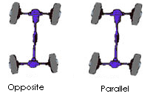
Figure :Opposite and Parallel Wheel Configuration [2]

Another aspect of the design deliberated upon was the wheel angles. Research found that most production vehicles use a front wheel angle of approximately 30 degrees. It was felt that this was a good angle for the front wheel because it was not extreme enough to reach a toggle condition when colliding with an obstacle but was large enough to help achieve the needed turning radius. It was felt that a front to rear angle ratio of 1:1 would make the car more unstable than a 2:1 ratio, although it would provide a greater reduction in the turning radius. The 2:1 ratio was chosen giving a 15 degree rear wheel angle.
Figure : 2:1 Wheel Angle Ratio

The next dispute reconciled was which kind of steering mechanism would be implemented in the design. This turned out to be a fairly simple matter to settle as there are only two methods commonly used, re-circulating ball bearing and rack and pinion. The rack and pinion system is by far the most common and also the cheapest although it is not as rugged as the ball bearing system. The low cost and availability of the rack and pinion system made it the choice for this design. The strength of the ball bearing system was not an important factor in the decision as the rack was not expected to receive an extremely large force. Also, it was found from the previous Baja team’s experience that the rack and pinion system that had previously been used was very dependable.
Next, the method of joining the subsystems was considered. One solution considered was to run a shaft straight from the front rack to the rear rack without any gearing. The geometry of the front and rear subsystems would be designed to give the desired angles with each rack traveling the same distance. Another concept involved gearing the shaft to provide the rear rack with half the travel of the front rack. The front subsystem would be designed so the geometry would provide the desired wheel angles. The rear subsystem would also employ the same geometry as the front subsystem. Initially, it was decided to use the first concept because it was felt that avoiding unnecessary gearing would make the system more reliable, cheaper and easier to construct. However, when the rear subsystem was designed it was found that in order to give the desired angles the rack would have to be mounted more than 8” behind the rear axle and the steering arms must be 8” in length. This presents problems due to increased moments on the steering arms and increased vulnerability of the subsystem. For this reason the concept of gearing the shaft with a 2:1 ratio was chosen.
The last component of the design decided upon was the manner in which the steering column would control the system. One concept involved attaching the steering column directly to the front pinion as would be done on a conventional steering system. This was ruled out because it would be very difficult to attach the connecting shaft to the front rack. The only other option was to attach a bevel gear to the steering column and gear the connecting shafts at this gear. This is accomplished by mating the bevel gear to an identical bevel gear powering the front rack and a bevel gear twice the size powering the rear rack. These gears are housed inside of a gear box which is located in the driver’s cockpit. This was the concept chosen for this design.
Design
System Configuration
The configuration of this system is fairly straightforward. The steering column is fitted with a bevel gear. This gear is housed inside of a gear box where it meshes with two separate beveled gears. The first gear is identical to the steering gear and mounts on a shaft connected to the front pinion. The second gear has a radius twice that of the first and is mounted on a shaft connected to the rear rack. By using a 1:1 ratio for the front subsystem and a 2:1 ratio for the rear subsystem the desired 2:1 front to rear wheel angle ratio is achieved. As the steering column is rotated, the two shafts rotate, propelling the racks. As the racks move the tie rods push and pull the steering arms turning the wheels.
Geometry
The geometry of the system was designed so that the desired wheel angles are achieved at the maximum travel of the rack. Smartsketch software was used to generate the needed geometry when certain variables were defined and Working Model simulations were conduced to confirm the geometry was correct. In the case of the front system, the steering arm length was determined by defining the travel of the rack, the distance from the rack to the kingpin and the tie rod length. Initially, the back subsystem geometry was found by varying the tie rod lengths and the steering arm lengths to provide a maximum wheel angle of 15 degrees given 5” of total travel. However, when the decision to provide a front to rear rack travel of 2:1 was made it was decided to use to same geometry in the rear as was used in the front. The only difference between the two subsystems is the rack length which is unequal due to the width of the rear end.
Force Analysis
The first step in performing force analysis on this system was to determine the maximum force that the system would be expected to feel. The mass of the car with the largest expected driver was found to be 743 pounds. The initial velocity of the car set at 30 mph and being reduced to 0 mph over a period of time. This elapsed time cannot be accurately predicted unless an experimental impact was conducted and this was not feasible as it would likely injure the driver. It was therefore decided to research the matter and find elapsed impact times for similar scenarios. When this failed to produce any usable data it was decided to assume an elapsed time of .7 seconds. As research continued it was found that many crash tests of production vehicles are conducted at 30 mph and the elapsed time of the collisions are somewhat less than .7 seconds. Based on this new information it was determined that it cannot be reasonably expected for this system to withstand an impact of 30 mph with a fixed object. The speed was therefore lowered to 20 mph but the elapsed time was reduced to .55 seconds. This produces an initial force of 5600 N that the system must withstand.
Figure : Comparison of Velocity and E.T. on Initial Force

Force analysis on this linkage was performed using Mathcad equation solving software. After using vector analysis to derive equations for the forces experienced, the equations were entered into Mathcad. The equations are dependent upon the initial force felt as well as the angle of the wheels and the angle of the impact. By changing these three values in Mathcad the shear forces and ultimate stresses can be found.
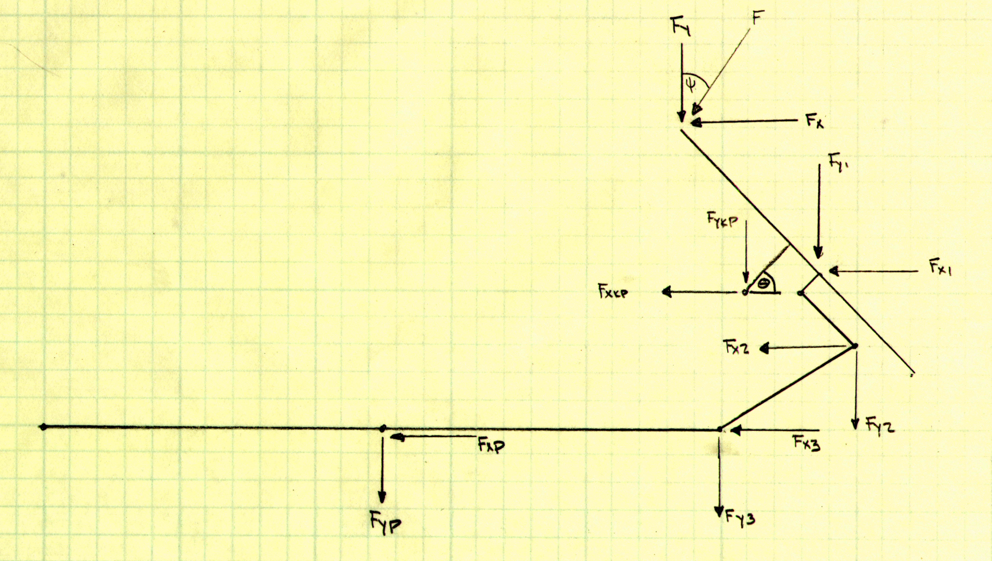
Figure : Force Analysis Diagram

The force analysis of this system was performed by evaluating the system as statically loaded as opposed to dynamically loaded. At the time of analyzing the system the Adams force analysis software was inoperable. Dr. Hollis advised that evaluating the system as statically loaded using vector analysis would provide an accurate representation of the force distribution. A few assumptions were made when performing the vector analysis. The first assumption made was that the linkage behaves as though it is embedded in a wall at the pinion/rack junction. This was done to make the analysis of the system easier so the forces being transmitted to the opposite side of the linkage can be neglected. While this is not a correct assumption it provides a worst case scenario in which the linkage cannot move any further and therefore “locks out”. Another assumption that was made was that the moments produced by the slight offsets in components could be neglected. This slightly lessened the forces that were experienced but by taking the worst case scenario in many other areas the force values are still much higher than they will be in reality.
The factor safety designed into this system was chosen to be two. It was desired that the system be as reliable as possible during competition and therefore should be able to withstand the anticipated forces with a fairly large margin for error. However, during a sponsor meeting with Dr. Hollis, the matter of high design strengths of the components was presented. The factor of safety appeared too high to achieve a reasonable design strength for the tie rod ends. After mentioning the numerous overestimations built into the force analysis his solution was to slightly reduce the factor of safety. At this time a factor of safety of 1.5 was chosen.
The maximum stress on each component is listed in table ______ as well as the design strength of the components. It was found that the largest stress acts upon the tie-rod end, rack and steering arm and the least force acts upon tie rod bolt. It can be seen that the racks, tie rod ends and steering arms all experience very similar maximum stresses, all around 650 MPa.
Figure : Component Force Breakdown

Component Selection
After the force analysis was completed the material and component selection was conducted. For the components that are to be constructed only the materials to be used were selected. For the other components such as tie rods, tie rod ends and the rack, the material and component selection was conducted simultaneously. It was initially found that the calculated design strengths were very high. The tie rod end design strength was especially high, around 1,800 MPa. This is well beyond a reasonable design strength for tie rod ends regardless of application. Additionally, such tie rod ends would be virtually impossible to find as the strongest material found in commonly available tie rod ends is chrome-moly which averages around 1,100 MPa .
The solution to this problem was to increase the size of the components experiencing abnormally large stresses. The first action taken was to increase the tie rod end diameter from 3/8” to ¾”. This reduced the expected stress from 1,500 MPa to 388 MPa. Increasing the diameter of the tie rod ends meant that the size of the tie rods would also have to be increased from ______ID and _____OD to ______ID and ______OD. This reduced the stress of the tie rods from 416 MPa to 233.5 MPa. The bolts also had to be enlarged when the tie rod end diameter was increased. The new bolt diameter must be ¾” to properly fasten to the tie rod ends. This reduced the expected stress from 553.5MPa to 69.8 MPa. Lastly, the steering arm thickness was increased. Initially a thickness of ¼” was chosen due to the availability of material in that size. However, in order to decrease the stress on the component the thickness was enlarged to 3/8”. Surprisingly this 1/8” increase thickness resulted in a decrease of about 175 MPa from 605.7 MPa to 429.4 MPa. Table ______ shows the reductions in stress as the dimensions change.
Figure : Comparison of Stresses Before and After Components Resizing

The next step was to compare the new design strengths to the strengths of materials commonly used in producing the components in question. The steering arms will be fabricated by the team using AISI 1018 steel. The average strength of this steel is about 650 MPA which is very close to the design strength of 644 MPa for this component. Next, the tie rod bolts were considered. With a design strength of 104 MPa any ¾” steel bolts should be more than sufficient for this application. The tie rods have a design strength of 350 MPa. All steels commonly used in the
production of tie rods have strengths higher than this design strength. The tie rod ends were perhaps the most debated upon component. When inspecting the force analysis it was found that chrome-moly tie rod ends in the ½” size could possibly work but that it would be hard to meet the 1.5 factor of safety. It was decided instead to use ¾” steel ends. When searching for the ends that would be used it was discovered that ¾” chrome-moly ends would only be $3 more per end and the factor of safety would be easily achieved. It was decided that the ¾” chrome-moly ends would be used. Next, the rack was considered. One rack is already in our possession, having been used on the previous baja-car steering system, and plans had been made to use an identical rack for the rear rack. The force analysis provided a design strength for the racks of
640 MPa. It was not known what type of steel was used to construct the rack. At the moment attempts to obtain this information from the vendor are being made. Based on the experience of those involved with the baja-car in the past the previous rack had never had any problems withstanding the forces experienced during competition. Based on this information and the assumption that a low grade steel would not have been used to manufacture this rack it was decided to use the 11” rack and pinion system from dansperformanceparts.com. Lastly, the gears were selected. It was felt that any gear more than 4” would be too large and encroach on the legroom of the driver. However, any gear less than 2” was felt to be too small to be used in this application. This pointed to a 4” gear and two 2” pinions to be used in the gearbox of the system. This pair was found at chicagogearworks.com and a few other gear manufacturers. As soon as the lowest price can be established the gears will be ordered.
Figure : Design Strength vs. Selected Material Strength

Components Selected
Economic Analysis

References
[1] www.rit.edu/~bajawww/home/
[2] http://www.pickuptruck.com/IMAGES/2002/gmc/denali/quadra.jpg
[3]

