Behold the Beast

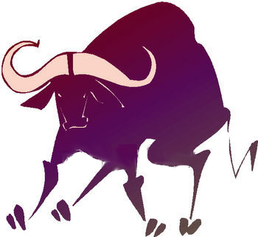

Team Solid Ox

Concept Generation and Selection

10/16/03

Angelo Caruso
James Finley

Amy Valenzuela

