FAMU-FSU College of Engineering
Society of Automotive Engineers Student Chapter

Senior Design Team #2
SAE II: Cockpit Ergonomics

Operations Manual

March 25, 2004

Advisor:
Dr. Patrick Hollis

Team:
Patrick Middleton
Christopher Hokes

Caution: Read and follow all Safety Rules and Operating instructions before operating the vehicles.
Safety Warnings

Warning: Safety belts can only work when used properly. Always properly wear seat belt when the vehicle is moving.

Warning: To help prevent loss of vehicle control or an accident, adjust the steering wheel only when the vehicle is not moving.

Warning: Never place any objects in the area of the pedals. In the case of sudden braking or an accident, an object could interfere with the pedals and you would not be able to brake or accelerate.

Warning: Never get out of the vehicle while the engine is still running. An unattended vehicle with a running engine poses a danger of personal injury or theft.

Warning: Never start or let the engine run in a confined area. Exhaust fumes from the engine contain carbon monoxide, a colorless and odorless gas that can be fatal if inhaled.

Warning: Never try to adjust pedals while the engine is on.

Warning: Before you check anything in the engine compartment, stop the engine and let it cool down. Hot components can burn skin on contact.

Warning: Do not try to start the Baja vehicle yourself. It is a two-person startup process.

Seat Belts

Seat belts are the single most effective means available to reduce the potential for serious injury and death in an automobile accident.

For your protection, always properly fasten your seat belt before operating the vehicle.

The seat belt used in the car is a R.J.S. Racing equipment 5-point harness.

To fasten the harness:
- Put both waist straps around your waist and in the center clamp
- Put both shoulder straps over your shoulders and in the center clamp
- Put the lower strap between your legs and into the center clamp
- Close the center clamp and lock it
- Tighten all the straps to a tight comfortable feel

To unfasten the harness:
- Lift up on the clamp to release the straps
- Take each strap out of the clamp
- Put both waist straps to there respected sides
- Put shoulder straps over your shoulder
- Step out of the vehicle

Safety belts can only work when used properly.

Safety belts must be properly positioned over the strongest bones of your body.

Never place your feet on the dashboard or the seat. Always keep both feet on the floor in front of the seat.

Never wear the shoulder part of the seat belt under your arms or any other place other than directed.

Never allow belts to become dirty or damaged. This will cause the belt not to work properly.

Damaged belts must be replaced immediately or serious injury could occur.

Formula Car

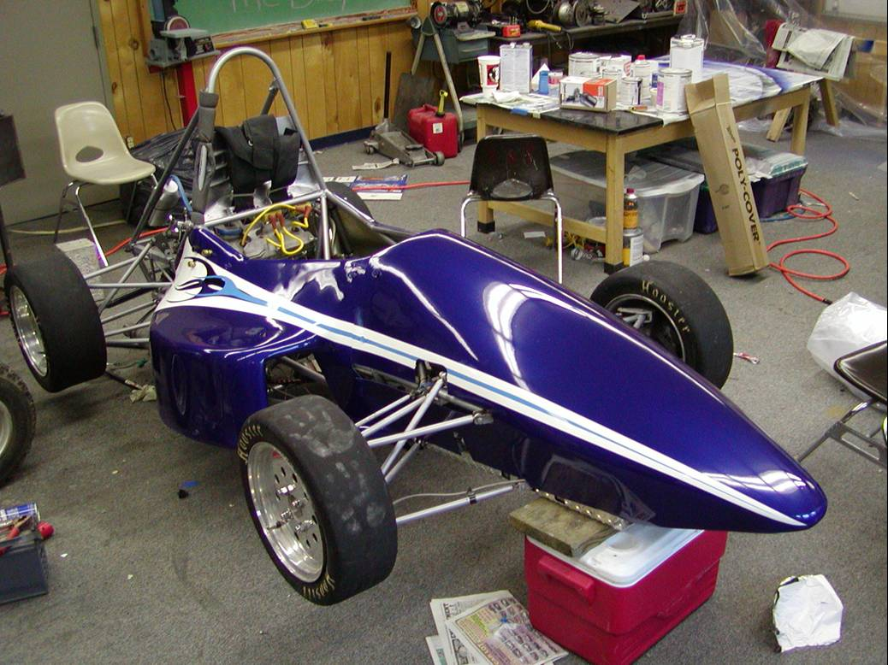
Controls and equipment

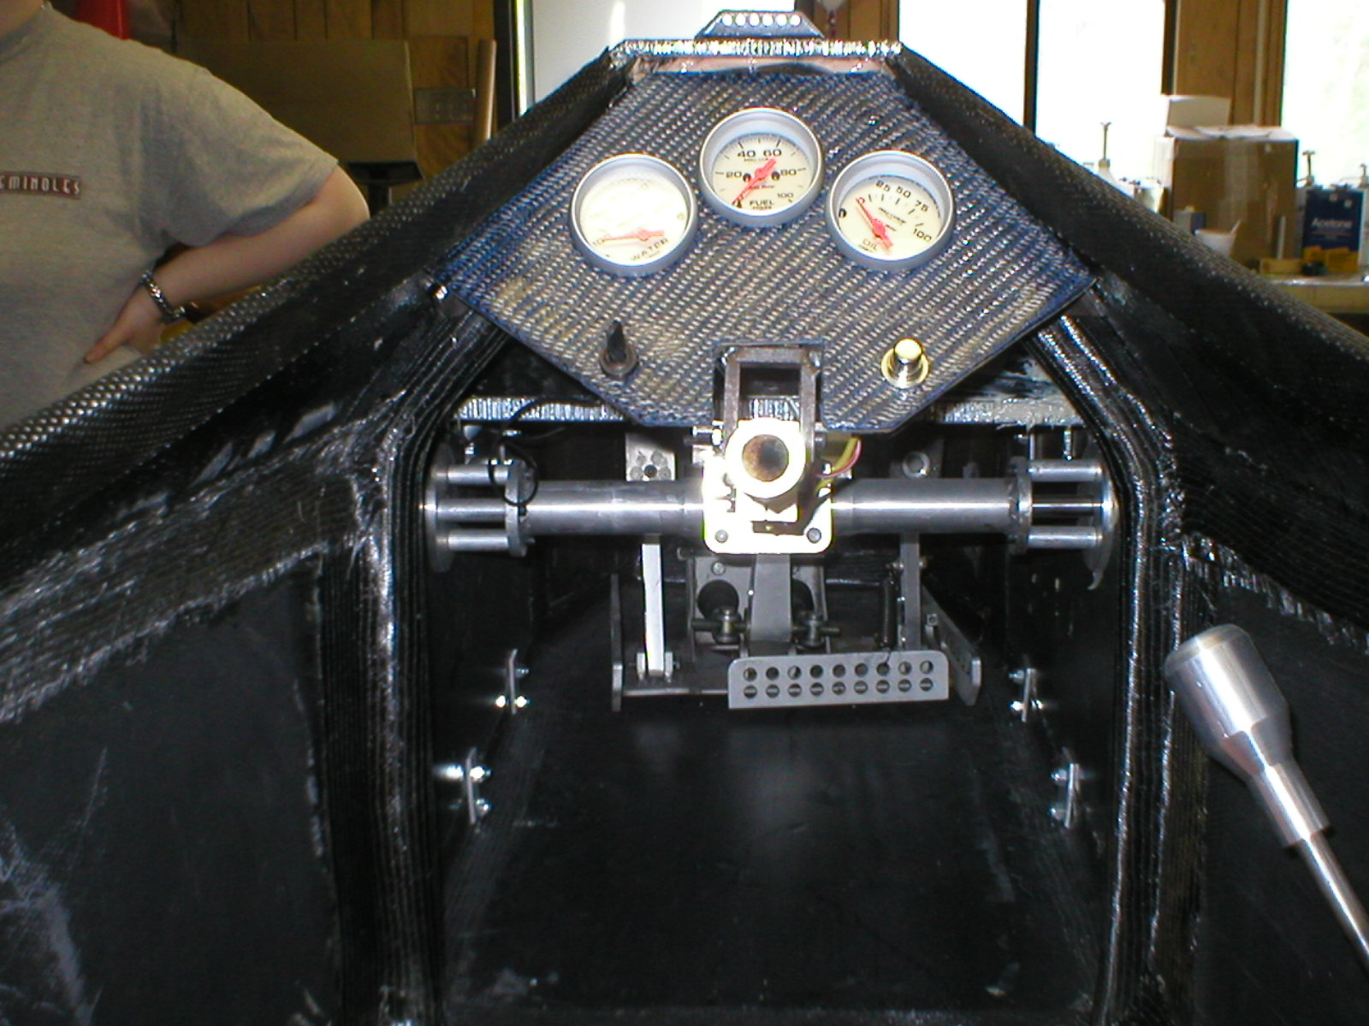
9
1

2
3
4
5
6
7
8
10
Figure: A picture of all the controls located in the cockpit

1. Water Temperature Gauge: Gauge located on the left of the dashboard
2. Fuel Pressure Gauge: Gauge located in the middle of the dashboard
3. Oil Pressure Gauge: Gauge located on the right of the dashboard
4. Kill switch: Switch located on the bottom left of the dashboard
5. Starter switch: Switch located on the bottom right of the dashboard
6. Clutch: Pedal located on the left side of the pedal tray
7. Brake: Pedal located in the middle of the pedal tray
8. Accelerator: Pedal located on the right of the pedal tray
9. Shifter: Knob located on the right side of the cockpit
10. Shift Light: Located on the top of the dashboard

Seat

The seats are interchangeable in order to make the ride more comfortable for each specific driver. There are two different sized inserts for the car, one is for larger drivers and the other is for smaller drivers.

To interchange the seat:
- Unbuckle the seat belts
- Place waist straps to the sides
- Place shoulder straps over the top of the seat
- Remove the seat from the bottom
- Place new seat in the cockpit
- Buckle your seat belt

Make sure the new seat is securely restrained in the cockpit before getting into the vehicle.

Always sit upright with your back against the backrest of the seat.

Gauges

When the car is started, make sure all the gauges are working before you start to drive the vehicle. If the gauges are not working, turn off the car and make sure the problem is fixed before the car is driven.

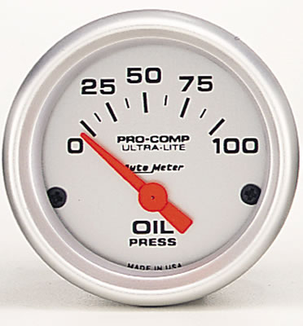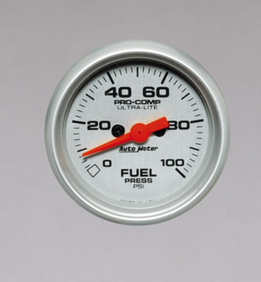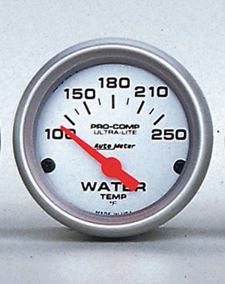

Figure 4: Oil pressure, fuel pressure, and water temperature gauges

Oil Pressure Gauge:

The Ultra-Lite series oil pressure gauge has a diameter of 2 1/16 inches, can display 0 to 100 psi, and operates electrically.
The Oil pressure gauge should not drop below 50 psi or go above 90 psi. The Oil pressure gauge should remain around 70 psi for optimum results. If the gauge reads outside of this range, turn off the car and get it inspected.

Fuel Pressure Gauge:

The Ultra-Lite series fuel pressure gauge has a diameter of 2 1/16 inches, can display 0 to 100 psi, and operates electrically.
The Fuel pressure gauge should read about 40 psi for optimum results. If the gauge does not read around 40 psi, turn off the car and get it inspected.

Water Temperature Gauge:

The Ultra-Lite series water temperature gauge has a diameter of 2 1/16 inches, can display 100 to 250 degrees F, and operates electrically.
The Water temperature gauge should not exceed 220 degrees F for optimum results. If the gauge reads more than 220 degrees F, turn off the car and get it inspected.

Shift Light

A tachometer is used in most vehicle applications, but we have chosen to do something a little different. We have chosen to use T-SPORT's Rev - Lite because it is much more advanced when compared to an old fashioned, "Flash Light" style shift light.
The Rev - Lite only covers a 1,000-rpm bandwidth on a 4-cycle engine. This means that when the red line is set at 11,000 rpm, the first light will come on at 10,000 rpm while the rest will come on in 200-rpm steps until the red line is reached.
We have chosen this Rev – Lite so that you never miss a shift point and you do not have to keep looking down at the tachometer on your dash while you are accelerating. The Rev – Lite will be mounted on top of the dashboard directly in sight of the driver at all times.

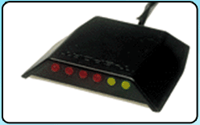

Figure 5: T-SPORT's Rev – Lite sequential shift light

Start the engine with the gear shifter in the neutral position and the clutch pedal depressed.

Always depress the clutch pedal fully when changing gears.

The green light at the end of the shift light represents the maximum allowable engine rpm (revolutions per minute) for all the gears. When this position is reached the next highest gear should be selected or the foot should be eased of the accelerator.

Up shifting early saves fuel and reduces wear on the vehicle.

Steering Wheel

The steering wheel must not be too close to the driver to reduce the risk of injury in the case of an accident.

Always hold the steering wheel on the outside of the steering wheel rim at the 9 o’clock and 3 o’clock positions to help maintain control of the vehicle.

Never hold the steering wheel at the 12 o’clock position or with your hands at other positions inside the steering wheel rim.

Holding the steering wheel improperly could cause injury to your hands in the case of an accident.

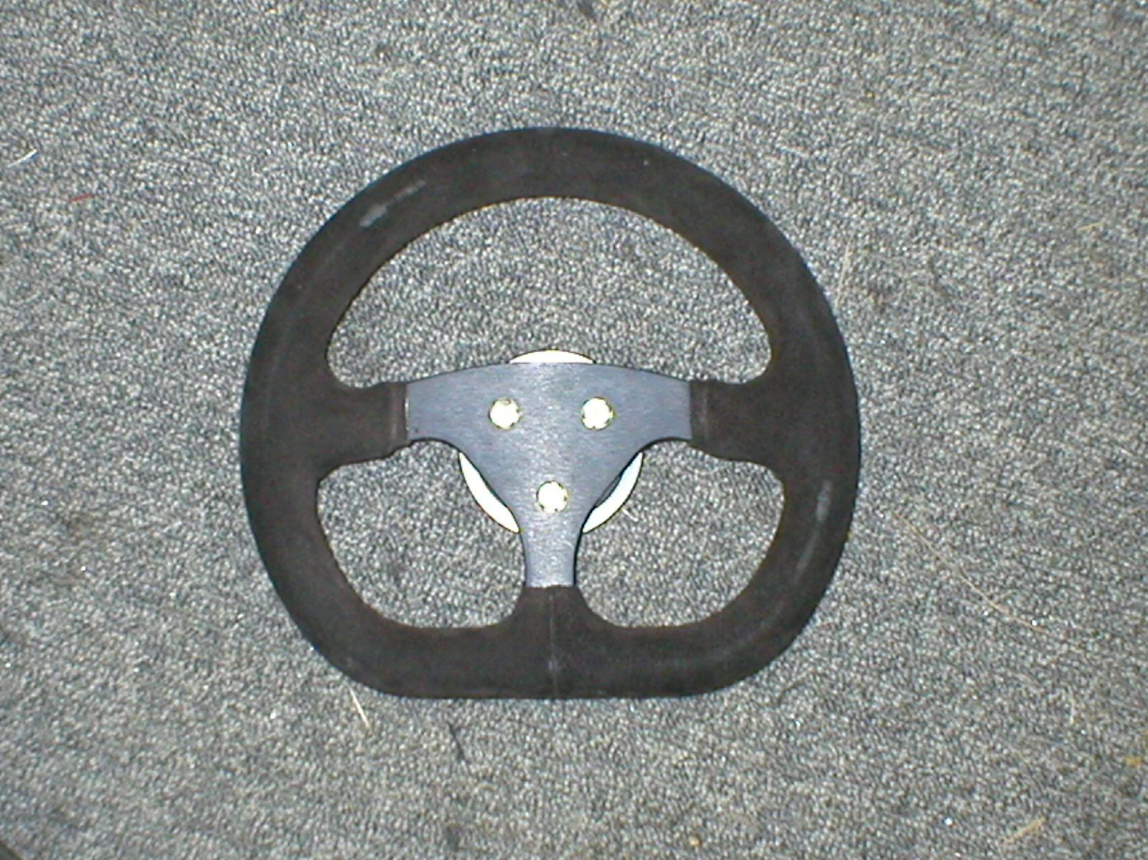
Figure 6: Formula steering wheel chosen from last years car to save money. Available in Suede. Has a diameter of 270mm.

To remove steering wheel:
- Pull on the release lever
- Lift the steering wheel off

To adjust the Formula steering wheel:
- Loosen the 6 bolts around the tie rods
- Loosen the bolt on the steering column
- Adjust the height of the steering wheel to the desired position
- Tighten all the bolts

Adjust the steering wheel so that when you sit with your back against the back of the seat, you can still grasp the top of the steering wheel.

Warning: To help prevent loss of vehicle control or an accident, adjust the steering wheel only when the vehicle is not moving.

Formula Shifter

A joystick style shifter is our chosen shifter for the Formula car.

The shifter mechanism is placed in the side pod so it does not interfere with the driver. The only part in the cockpit is the shift lever.

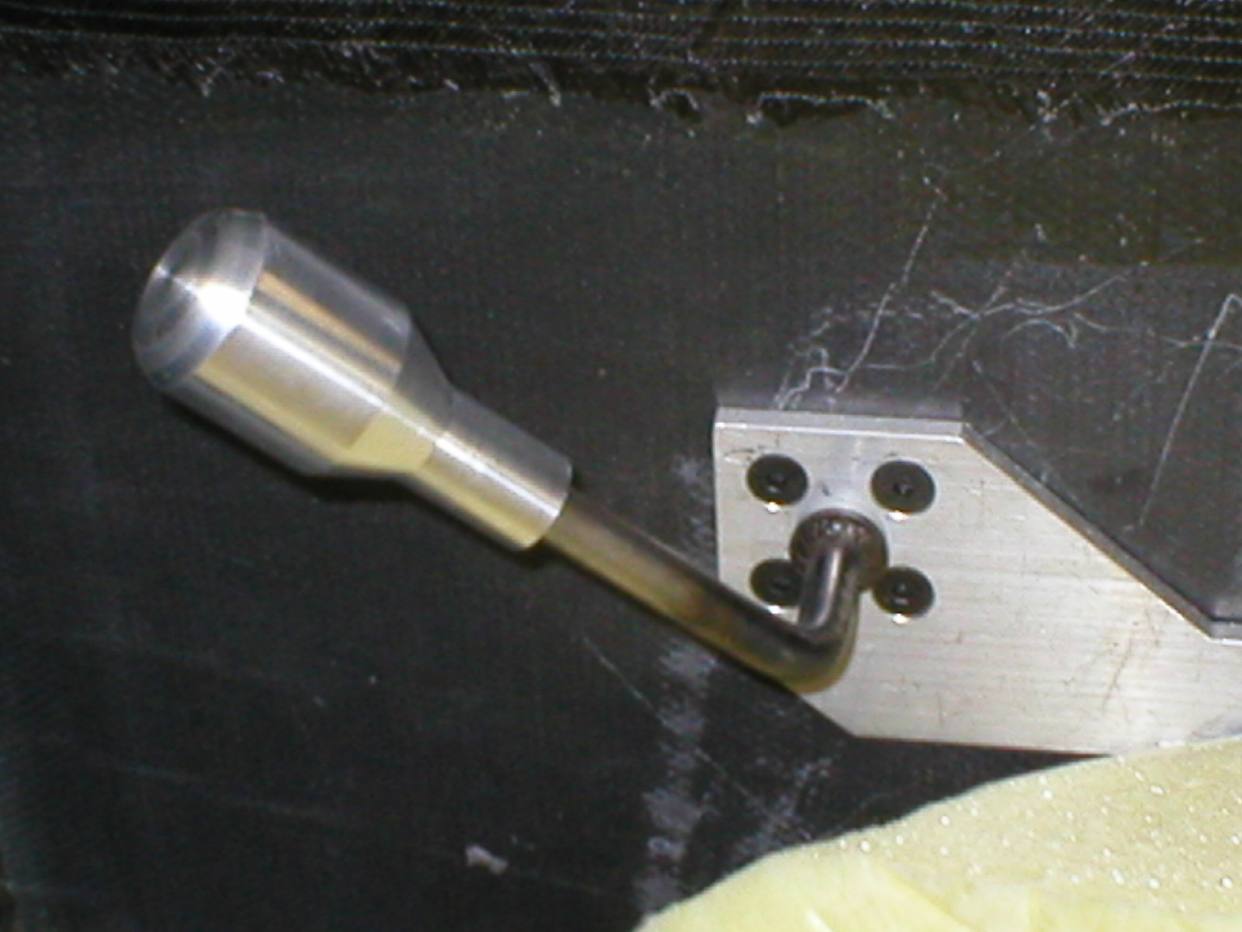
Up Shift
Down Shift

Figure 8: Parts and assembly of the Formula shifter installed on the car
Start the engine with the gear shifter in the neutral position and the clutch pedal depressed.

To shift the car up a gear:
- Depress the clutch pedal
- Move the shifter toward the driver
- Ease off the clutch slowly

To shift the car down a gear:
- Depress the clutch pedal
- Move the shifter away from the driver
- Ease off the clutch slowly

Always depress the clutch pedal fully when changing gears.

The green light at the end of the shift light represents the maximum allowable engine rpm (revolutions per minute) for all the gears. When this position is reached the next highest gear should be selected or the foot should be eased of the accelerator.

Up shifting early saves fuel and reduces wear on the vehicle.

Resting your hand on the shifter while driving will cause premature wear on the transmission.

Pedal Tray

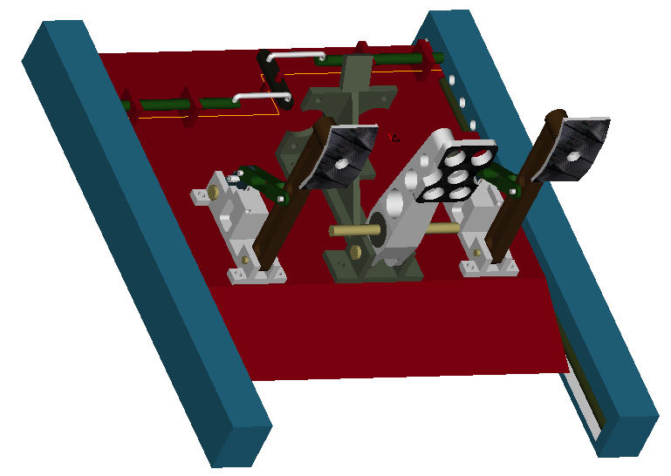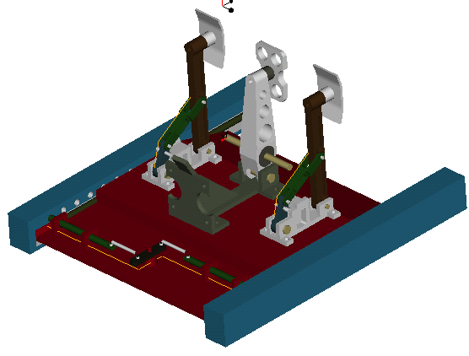
Figure 10: Pedal tray designs

The pedal trays come with an adjustability feature to accommodate all the SAE member’s different sizes. There is an adjustable lockout mechanism on the rear of the pedal tray that allows the driver to select from six different setting, each being separated only by one inch.

To adjust pedals:
- Pull and hold the knob located in cockpit
- Move the tray with your feet to the desired location
- Let go of the knob
- Move pedal tray forward or back to insure that it is locked in place

Adjust the pedals so that you can easily push the pedals all the way down while keeping your knee slightly bent.

The movement of the pedals must never be obstructed by any object in the cockpit.

All pedals must be able to return to their original position unhindered.

Warning: Never try to adjust pedals while the engine is on.

Warning: Never place any objects in the area of the pedals. In the case of sudden braking or an accident, an object could interfere with the pedals and you would not be able to brake or accelerate.

Starting

Do not attempt to start the vehicle without being fully strapped into the vehicle with all of the safety gear on.

To start the vehicle:
- Insert safety key and turn to on position
- Flip the switch on the dash to the on position
- Allow the fuel pump to prime
- Flip the switch on the dash to the off position
- Flip the switch on the dash to the on position
- Push starter button

Warning: Never get out of the vehicle while the engine is still running. An unattended vehicle with a running engine poses a danger of personal injury or theft.

Warning: Never start or let the engine run in a confined area. Exhaust fumes from the engine contain carbon monoxide, a colorless and odorless gas that can be fatal if inhaled.

Baja Car

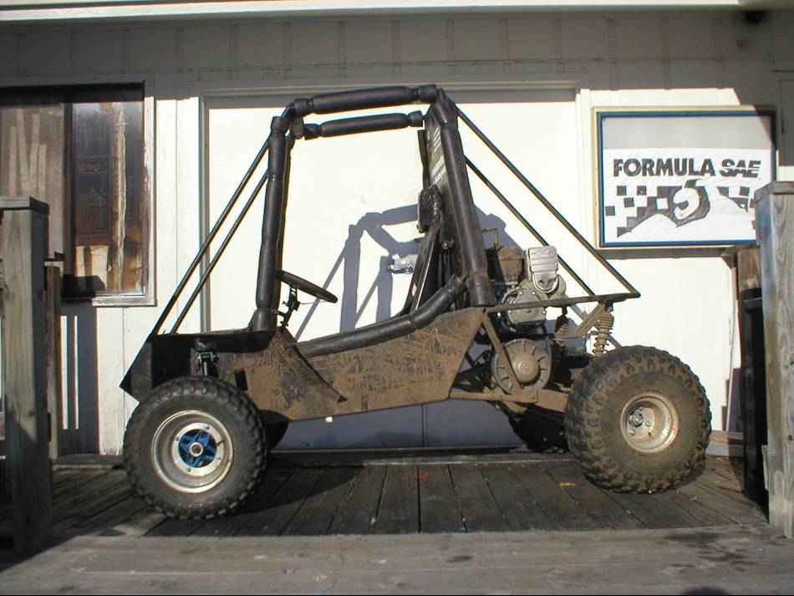
Steering wheel

The seat must not be too close to the steering wheel to reduce the risk of injury in the case of an accident.

Always hold the steering wheel on the outside of the steering wheel rim at the 9 o’clock and 3 o’clock positions to help maintain control of the vehicle.

Never hold the steering wheel at the 12 o’clock position or with your hands at other positions inside the steering wheel rim.

Holding the steering wheel improperly could cause injury to your hands in the case of an accident.

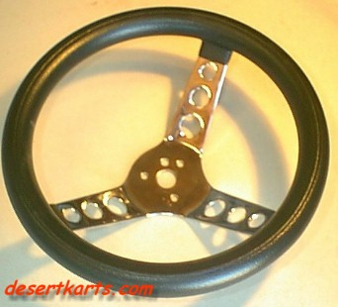
Figure 7: 11.5 inch steering wheel. Has three chrome spokes and padded wheel.

To remove steering wheel:
- Pull on the release lever
- Lift the steering wheel off

Shifter

The Baja shifter does not offer many options being that the current transmission only allows gear selection while the vehicle is at a stop.

A “joystick” shifter is the shifter used in this vehicle.

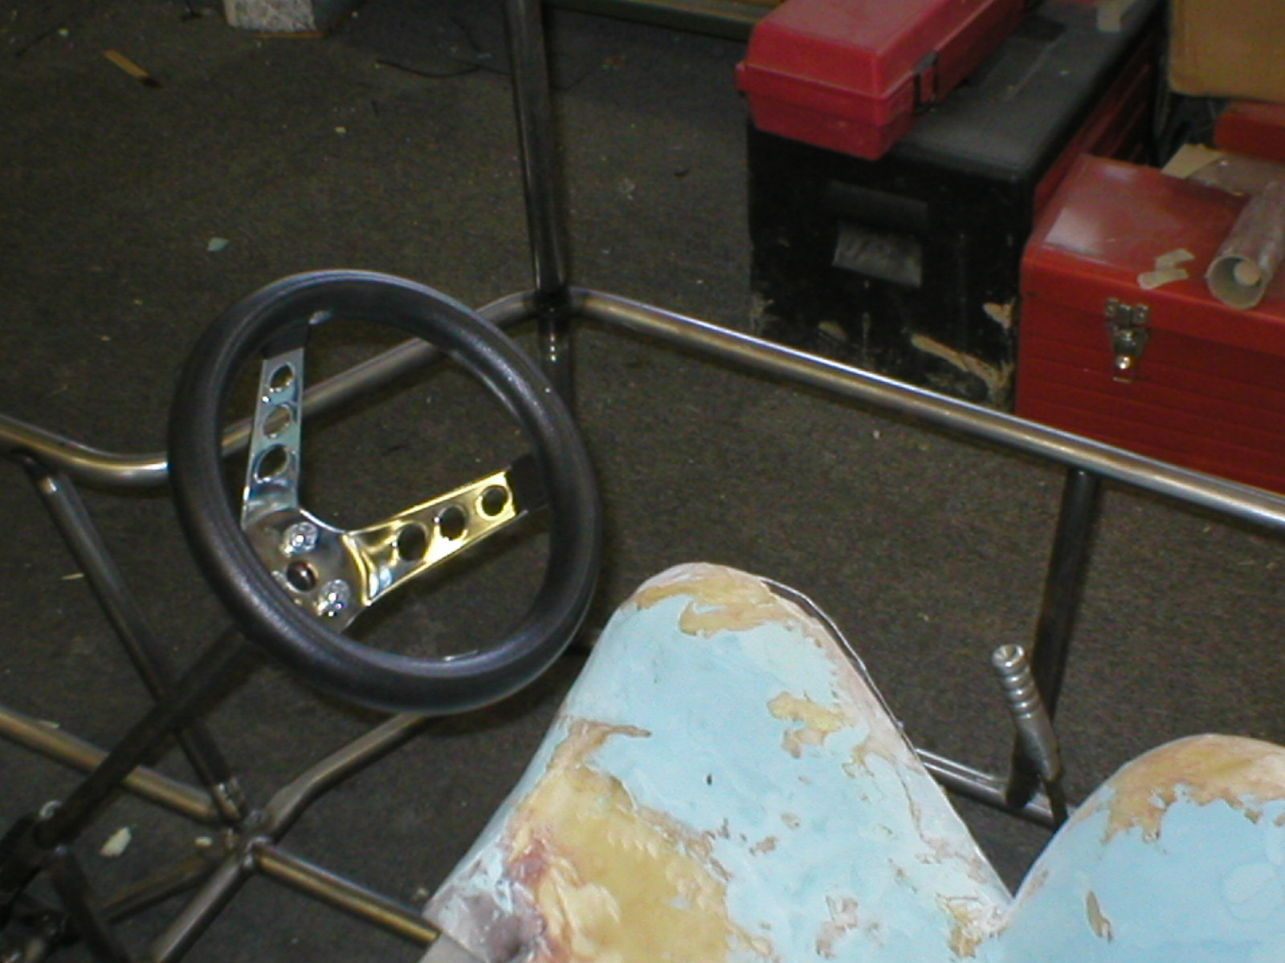
Up Shift

Down Shift
Figure 9: Picture of the shifter for the Baja car

Start the engine with the gear shifter in the neutral position and the clutch pedal depressed.

To shift the car up a gear:
- Depress the clutch pedal
- Move the shifter toward the driver
- Ease off the clutch slowly

To shift the car down a gear:
- Depress the clutch pedal
- Move the shifter away from the driver
- Ease off the clutch slowly
Always depress the clutch pedal fully when changing gears.

The green light at the end of the shift light represents the maximum allowable engine rpm (revolutions per minute) for all the gears. When this position is reached the next highest gear should be selected or the foot should be eased of the accelerator.

Up shifting early saves fuel and reduces wear on the vehicle.

Resting your hand on the shifter while driving will cause premature wear on the transmission.

Starting

Warning: Do not try to start the Baja vehicle yourself.

The Baja car requires two people in order to start the vehicle.

The driver must be securely restrained in the vehicle with all of the safety equipment on.

The “starter” is responsible for starting the vehicle for the driver.

To start the vehicle:
- Driver must be strapped in with all the safety gear on
- Flip the switch in the cockpit to the on position
- The “starter” will put the starter cord until the vehicle starts

Warning: Never get out of the vehicle while the engine is still running. An unattended vehicle with a running engine poses a danger of personal injury or theft.

Warning: Never start or let the engine run in a confined area. Exhaust fumes from the engine contain carbon monoxide, a colorless and odorless gas that can be fatal if inhaled.

Maintenance

Gauges:
For service, send the Auto Meter in a well, packaged shipping carton. Please include a note of what the problem is along with your phone number. If you are sending the product back for a warranty adjustment, you must include a copy of your sales receipt from the place of purchase.

Dealer Directory

Summit Racing
www.SummitRacing.com

LTB Motorsports
www.LTBMotorsports.com

Auto Meter Product, Inc.
www.AutoMeter.com

Warranty Information

T-SPORT Rev-Lite sequential shift light:
Returnable up to 14 days of the receipt of the product

Gauges:

Summit Racing
Returnable up to 90 days from the date shipped and they will refund the full purchase price.

Auto Meter Product, Inc.
All Auto Meter Gauge Works products will be free from defects in material and workmanship for a period of 3 years from the original date of purchase.

