MOAS Project: Wind Energy Demonstration

Concept Generation
&

Design Selection

Wind Energy Systems Inc.

Members
Nicholas Bembridge
Victor Fontecchio
Bradley Kroger
Michael Sheehan
Suzanne Shepherd

October 14, 2004
EML 4551
Introduction:

The Mary Brogan Museum of Arts and Science (MOAS) has a mission to offer inspiring educational experiences for people of all ages using links between science, mathematics, technology and visual arts. The Brogan Museum has always searched for new ways to stimulate the interest in and understanding of science. MOAS has currently proposed an energy-themed public education program focusing on the cost of electricity, rising price of fuel for vehicles and alternative sources to provide environmentally sound energy. In doing this, the museum has established the interest of working with the FAMU-FSU College of Engineering to create a wind-turbine demonstration that will educate the public on wind as an alternate source of energy.
The wind energy demonstration for the museum has several important specifications and constraints that need to be satisfied. The museum attracts guests of all ages, including the youth that attend the local school systems. The Brogan Museum believes these future thinkers of America are the main target audience. With this in mind, the design needs to concentrate on attracting and keeping the interest of the younger visitors as well as being educational enough to teach something new to the adult visitors. The key to keeping the younger museum visitors’ interest is to make the exhibit interactive, giving the children the chance to visualize physical effects. The design needs to be able to be viewed from more than one side that will enable a group of visitors to interact and learn from the exhibit at the same time. As well as multiple viewing angles, the design should also make all of the important moving parts visible. Since children are the main audience, the science and engineering aspects of the design need to be explained in simple terms, and should appeal to several different learning styles. The expected lifetime of the wind energy exhibit is several years; therefore, the design should be durable and require very little maintenance. However, the most important specification is the safety of the future visitors of the final exhibit. Once these specifications are met, an attractive professional looking museum exhibit will be produced.
The Brogan Museum’s specifications are not the only considerations that have found their way onto the design table. Other engineering-based ideas and components need to be implemented into the design in order to help demonstrate what is actually happening. A device to monitor and display the wind direction would help depict the amount of wind required to generate power from a turbine. The use of a diffuser to accelerate the wind’s velocity and the application of a mesh screen or honeycomb to regulate the flow of the wind will also be needed in the design to insure a laminar flow of air. A power output device needs to be installed to inform the audience of the amount of power that can be produced using wind energy. The idea of comparing two different types of wind turbines has also been discussed. Another idea to aide in understanding the principles of the exhibit includes a device to measure the rotational speed of the wind turbine. Although these components and ideas are not essential to the design, they will help convey the ideas and information to a wide variety of museum-goers.
With all this in mind, Wind Energy Systems Inc. has been created to design and fabricate the wind energy demonstration. Wind Energy Systems Inc. is comprised of five FAMU-FSU College of Engineering students in their senior year of study. The members of the company are Nicholas Bembridge, Victor Fontecchio, Bradley Kroger, Michael Sheehan and Suzanne Shepherd. Dr. Chiang Shih has also taken on the role of sponsoring the group. With these specifications, resources and ideas, the members of Wind Energy Systems Inc. have developed the following designs to be considered for the wind energy demonstration for the Mary Brogan Museum of Arts and Science.

First Design Generation:

The first design that Wind Energy Systems Inc. came up with was a simple wind energy exhibit using a hand-crank as the power source. The hand-crank would power a wind generation fan that would then cause a windmill to turn and power a DC motor. This DC motor would supply electrical energy to a power meter so that children could see the energy output by wind they created with the hand-crank. In order to make the exhibit more interactive to kids, the windmill would have an adjustable angle of attack to show different efficiencies of the exhibit. This design of an interactive science museum exhibit would have been ideal, but completely unrealistic. The hand crank would not be able to supply enough energy to a fan that would create enough wind to power the rest of the exhibit. The adjustable angle of attack on the windmill was deemed too complex of a task to complete in time when considering what needed to be done with the rest of the project.

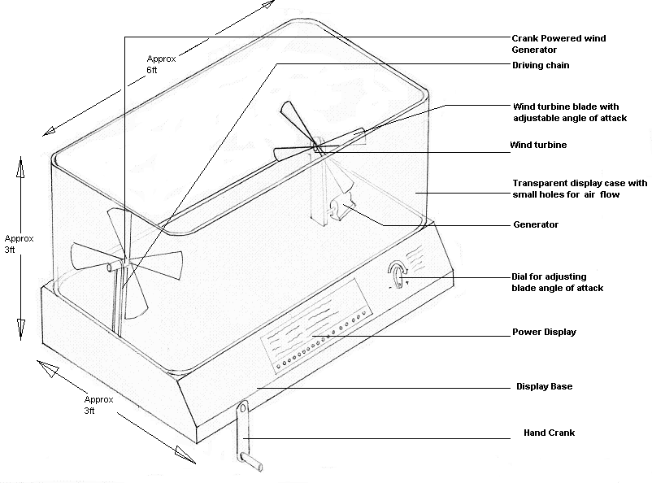
Figure 1: Basic model of original design of wind energy exhibit with hand-crank.

This initial design is a rough estimate of what the final project will look like. After making this sketch, the pros and cons of the concept were evaluated. The main components of the design that were evaluated were the hand crank, fan, turbine, power strip, size, casing, and angle adjustment dial. It was agreed that the hand crank would be removed. The power needed to generate the necessary wind speeds for the fan is too large to be generated by a simple hand crank. Even though this device makes the exhibit more interactive, an electric fan will replace the hand crank. Table 1 below gives a list of these pros and cons for the first design.

Table 1: First Design Evaluation
Component | Pro | Con | Reasons/Adjustments
Hand crank |  | X | Unrealistic due to the amount of wind that needs to be produced
Fan | X |  | Essential to project, but flow needs to be distributed evenly
Turbine | X |  | Turbine is necessary to generate power. Different types of turbine designs will be considered.
Angle Adjustment Dial | X |  | Helps to describe how important the angle of attack is to the project. Will help to make the project more hands on.
Power Strip | X |  | Necessary to give a visual depiction of power output
Size | X |  | Concurs with the museums initial outlines for the amount of space the project will be given
Casing | X |  | The clear plastic will allow for visualization from all sides; however, actual assembly of casing is still undecided

Second Design Generation:

In the second phase of design, several changes were made to overcome the flaws of the first design. The first item at hand was to remove the hand-crank. By making this change, something needed to be added to the design in order to make the exhibit more interactive. The wind generation fan to be selected would have a motor that is able to plug into any standard outlet and was specified to be able to have variable settings to create different wind velocities. It was also determined that a display of the velocity of the wind be added to the design. The idea of having two different types of wind turbines was also implemented; one of the turbines was to have a vertical axis, while the other would have a horizontal axis. The idea was that having two wind turbines operating under the same conditions would demonstrate differences in efficiencies. As shown in the Figure 2 below, it was proposed that the two wind turbines sit on a turntable so that observers of the exhibit could choose which turbine they wanted to operate and see the power output change as the turbines were moved in and out of the air flow. Unfortunately, by having the wind turbines on a turntable, it would be harder to ensure that the wiring would not become unattached or tangled by the constant rotation of the turntable. Another flaw in this design is that the plastic casing, shown to be curved, would be exceeding more expensive than the budget would allow. The power meters, which are not displayed in the figure, would also be hard to place on a design like this.

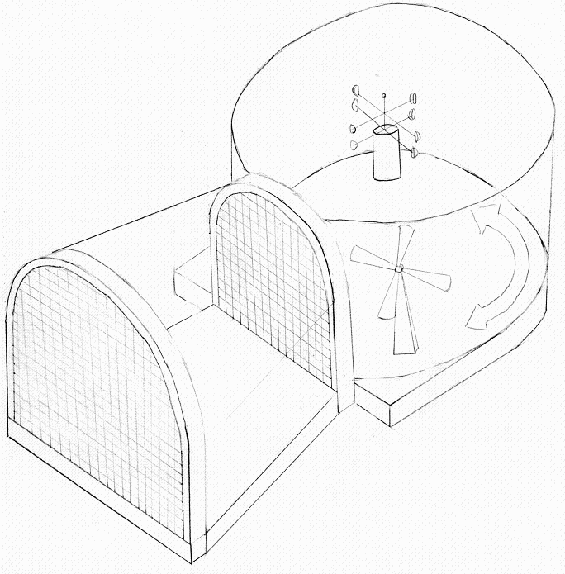
Figure 2: Second model of wind-energy exhibit with turntable design.

Once again the pros and cons were evaluated. Table 2 below outlines the reasons for variations to the model.

Table 2: Second Design Evaluation
Component | Pro | Con | Reasons/Adjustments
Fan | X |  | Electric fan will be used to output more power
Anemometer | X |  | Gives a concept as to the velocity of the wind hitting the turbine
Turbine Variation | X |  | Displays differences in efficiencies of turbines, and allows for increased interactivity
Turbine Turntable |  | X | This setup would be difficult to fabricate and it is more than likely that the internal wiring and components would become entangled as the table rotates
Power Meter Display |  | X | Cannot be easily placed on this model in a visually appealing way
Circular Plastic Casing |  | X | Too expensive to fabricate for this exhibit and exhibit would be too large and cumbersome

Third Design Generation:

The third design for our Wind Energy Exhibit for the MOAS was a further modification of the previous two designs. In this design after meeting with our sponsor as well as the director of the museum we decided that it would be a good idea to have two different types of wind turbines to demonstrate more than just one type of energy generation. The case that surrounds and protects the exhibit will still be a hard clear plastic that would cover both the sides and top of the display. To show the power that would be generated by the different wind turbines, there would be a type of visual power meter that consisted of light bulbs lined vertically that would light up sequentially with power; the more power the more bulbs that would light up. The air supply to the exhibit would be from a fan mounted on the end, the flow would be directed using a type of nozzle as well as a plastic mesh or honeycomb to try and equalize the flow throughout the chamber. All controls in this concept will be in front of the exhibit.

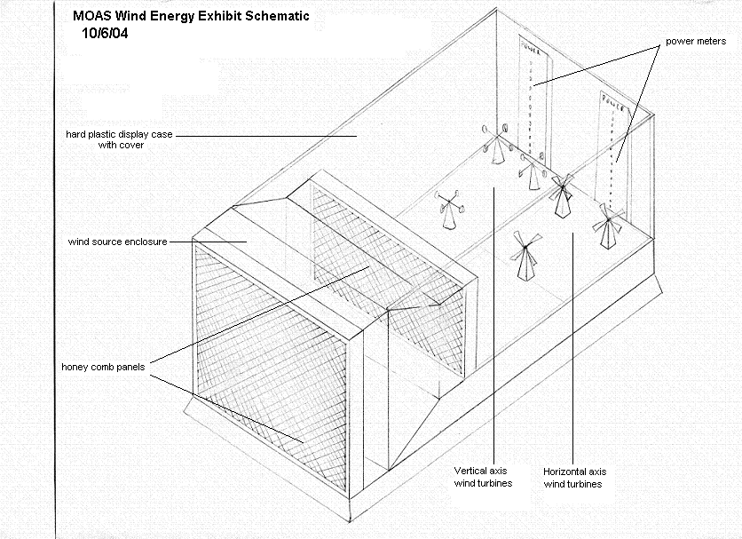
Figure 3: Third model of wind-energy exhibit utilizing a wind farm

This design is very close to a final, agreed-upon design; however, there are components that need to be evaluated and redesigned. Below in Table 3 these components’ pros and cons have been evaluated.

Table 3: Third Design Evaluation
Component | Pro | Con | Reasons/Adjustments
Plastic Mesh/Honeycomb | X |  | Equalizes and distributes the flow evenly throughout chamber
Visual Power Meters | X |  | Visually depicts power output to give a better comparison
Rectangular Casing | X |  | More realistic and less expensive than circular casing
Turbine Wind Farms |  | X | Multiple turbine wind farms would be too costly

Final Design Generation:

The group again met with the director of the museum as well as a group and though this design was rejected as a whole but many of the ideas would carry through to the next design. The biggest design change is that some manner of supporting frame would be integrated into the case. Plastic panels would then, be attached to the frame.. There will still be multiple wind turbines but due to complexity and cost there will only be one of each type. In this design the power meters are in the path of the flowing air, this will cause problems with the exiting of the fluid. To end this problem it was proposed to move the power meters to the base of the exhibit next to the controls. The idea of having many of the sides clear was the best option, but the director of the museum wanted to have writing about the exhibit on the wall facing the audience making it almost impossible to have the back wall clear. A good basic concept for the basis of the wind exhibit is shown below, and many of the concepts have been used in the following design; however, many have been modified. An artist rendition of this fourth iteration of the design is shown in Figure 4.

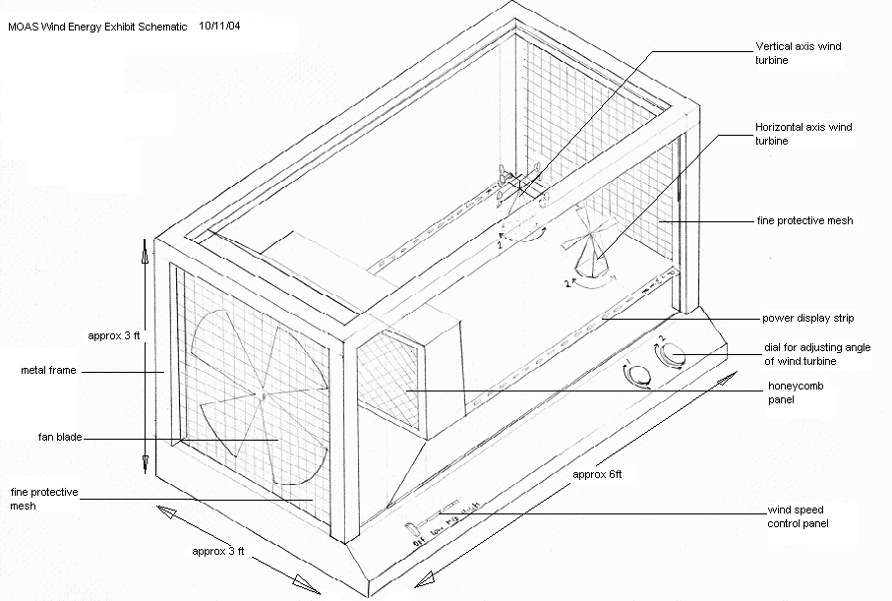
Figure 4: Fourth model of wind-energy exhibit utilizing two windmill types and a steel frame
Figure 4 depicts the final design for the project. This project will be enhanced with color and visual aides in order to make it appealing to all viewers. The wind turbines will be mounted on turntables to utilize different attack angles for the airflow, which will increase the level of interaction. The displayed model will be mounted on a base approximately 33 inches high in order to accommodate on-lookers of most heights. All of the final components are outlined below in Table 4.

Table 4: Final Design Generation
Component | Reasons
Casing | Composed of welded tubing to hold clear plastic sheets
Wind Turbines | Two different types will be used in order to display different efficiencies
Power Meters | Placed horizontally along exhibit so as to not interfere with other components
Size | Final design will fit into designated space
Angle Adjustment | Will vary angle of attack of turbines in order to further display efficiency differences
Anemometer | Display wind velocity of the fan
Fan | Powered by electricity and varied by a dial to create different flows
Plastic Mesh/Honeycomb | Creates an even flow to be distributed throughout the casing
Exhaust Wire Mesh | Allow exhaust wind to flow out of the casing

Conclusion:

The next steps for the group are to compile a formal proposal for the MOAS. This proposal will include a budget, plan for construction of the exhibit, list of needed supplies, list of possible manufacturers, and engineering drawings. The proposal will be presented to the museum in early November. Once the initial proposal has been presented and approved, the group will assist the museum in contracting another proposal in order to receive funding for the project.
Through meetings with the group sponsor, the museum coordinators, and members of the group, a final design for the wind-energy exhibit has been created and approved. The group began by first evaluating the product specifications, needs assessment, and project scope. The group’s final goals are still the same, but by continuous scrutiny and evaluations of the proposed designs, the members were able to choose a final design that meets the needs of the project in the best and most fitting way possible. In addition to the initial considerations, the museum staff also reviewed the final design as well as the appearance of the project.
The collaboration of the group and the museum staff has led to a successful and creative design selection. The project is educational, interactive and safe for museum-goers of all ages. The final design utilizes several angles from which to view the exhibit, as well as two types of wind turbines in order to display the difference between efficiencies for the vertical and horizontal axes. Not only are two different wind turbines used, different angles of attack for the air flow will be implemented to further increase interaction with the exhibit as well as understanding of the effects of wind energy. The display will be visually appealing and professional looking in order to convey a confidence about the principles within.
All of these ideas together combine to create a successful wind energy demonstration. With these concepts and careful planning, the resulting project will be a lucrative exhibit that provides a deeper understanding about wind energy.

