MOAS Project: Wind Energy Demonstration

Final Report Fall Semester

Wind Energy Systems Inc.

Members

Nicholas Bembridge

Victor Fontecchio

Bradley Kroger

Michael Sheehan

Suzanne Shepherd

December 2, 2004
EML 4551

1.0 Abstract: 3
1.1 Problem Definition 3
1.2 Design Goals and Objectives 4
1.3 Design Concept 5
2.0 Introduction 7
2.1 Museum Specifications 7
2.2 Engineering Considerations 8
3.0 Concept Generation 11
3.1 First Design 11
3.2 Second Design 13
3.3 Third Design 15
3.4 Fourth Design/Final Design 18
4.0 Concept Selection 21
5.0 Component Selection 23
5.1.0 Wind Generation 23
5.2.0 Power Generation 25
5.2.1 AC and DC Motors 25
5.2.2 Horizontal and Vertical axis Turbines 26
5.2.3 Wind Turbine Frame 30
5.2.4 Testing of the DC motor 31
5.3.0 Exhibit Casing 32
5.3.1 Welded Frame 33
5.3.2 8020 Aluminum Frame 34
5.3.3 Selection of Frame Material 37
5.4 Electronics 38
5.4.1 Start Button and Kill Switch 38
5.4.2 Power Output Display 39
5.4.3 Wind Speed Display 42
5.5.0 Pulley Design 43
6.0 Final Design Specifications 49
6.1 Exhibit Dimensions and Frame Design 49
6.2 Frame Material and Building Options 50
6.3 Cabinet Maker 51
6.4 Wind Generation 51
6.5 Wind Turbines 51
6.6 Power meters 53
6.7 Start Button 54
6.8 Kill Switch 54
6.9 Wind Velocity Measurement 55
6.10 Electrician 56
6.11 Honeycomb 56
7.0 Budget Analysis 58
7.1 Wind Generation Cost Analysis 58
7.2 Power Generation Cost Analysis 59
7.3 Casing Cost Analysis 59
7.4 Electronics Cost Analysis 60
7.5 Pulley System for Angle of Attack Analysis 61
7.6 Flow Management Cost Analysis 62
8.0 Future Work 63
8.1 Museum Deliverables 63
8.2 Plans for Spring Semester 65
9.0 Conclusion 67
Appendix A: Engineering Drawings 71
Appendix B: Material Selection 76
Appendix C: Cost Analysis 78
Appendix D: Calculations 82
Appendix E: Schedule 84

1.0 Abstract:

1.1 Problem Definition

Design a museum exhibit to demonstrate the abilities of wind energy to the general public of all ages. The Mary Brogan Museum of Arts and Sciences (MOAS) has recently decided to create a display explaining the different forms of energy conversion. As an educational museum, this facility focuses mainly on family entertainment; thus the exhibits are appealing to all ages. In order to create a link between the museum and the FAMU-FSU College of Engineering, the museum has asked the college to participate by creating an exhibit for the energy conversion demonstration. Thus, it was decided that a group of seniors would undertake the project for their senior design project.
Due to the expected appearance of several other exhibits, the group decided to create a wind-turbine demonstration to illustrate how wind can be used to generate power. Conflicts that arise are the wide range of ages that will be viewing the exhibit, meaning that the exhibit must be easy to understand. Not only must the exhibit be easy to understand, it must also be visually appealing in order to captivate the museum audience. By visually appealing, it is meant that the exhibit must be colorful, well planned, as well as professional looking. Also, several museum visitors must be able to view the exhibit at one time. Another necessity is to make the exhibit interactive. It is essential to create as many hands-on components as possible. This concept is being used in order to stimulate people of all learning styles. Lastly, the exhibit must be able to stand the test of time and last for many years so that its useful educational aspect can be utilized for as long as possible.

1.2 Design Goals and Objectives

The primary goal for this project is to create a visually appealing, educational exhibit that interests observers of all ages. First and the foremost, the exhibit must be safe. This means that the display cannot under any circumstances contain any threatening, hazardous, or potentially harmful parts. All ages must be able to interact with the exhibit without any possibility of injury. Next, the project must be able to endure wear and tear and to be displayed for many years. Although the exhibit must be durable, it is also important for it to be as interactive as possible. An interactive exhibit will draw people in and make them more curious about the subject, thus increasing the popularity of the exhibit. Also, having hands-on learning applies to a wider variety of learning types, making the exhibit beneficial and more exciting. In addition to causing a curiosity in people, the exhibit’s principles and overall display must be easy to understand for all ages due to the wide age range of people that attend the museum. It does no good to have an exhibit that looks nice but is difficult to understand because the whole point of its existence is to educate people on the specific topic. The final component to consider is the aesthetics of the display. This exhibit will be among other exhibits that are professionally fabricated, so in order to create a positive impression in the energy display, a finished and professional looking project is an absolute requirement. By combining the concepts and ideas of safety, interactive, educational, and visual appeal, the exhibit will be an excellent addition to the museum.

1.3 Design Concept

After collaborating amongst the group and the museum, it was decided that wind energy would be the chosen energy conversion method to add to the museum energy conversion display. To show this phenomenon, the main components of the exhibit will be a fan, wind turbine, generator, and a power display. The basic idea will be to have a fan producing a varying wind velocity. The wind will then hit the blades of the turbine and as the blades start to turn, the turbine will cause the generator to start producing electricity. The electricity will be used to power a light strip that will convey how much electricity is being produced using a given initial wind velocity.
In order to make the exhibit more interesting, there will be two different types of wind turbines used; one with a horizontal axis of rotation, and the other with a vertical axis of rotation. The horizontal axis of rotation turbine will have regular, straight-edged propeller blades, while the vertical axis of rotation turbine will have a three bar pattern with plastic molded cone shaped cups on the end of the bars. By having two different methods to harness the wind, the power output of each wind turbine will be different. Showing the different outputs of the each turbine will help to explain how different methods of wind energy conversion have different efficiencies.
To create more interaction, the wind turbines will be mounted on a rotating surface. This rotating surface will change the angle at which the wind is striking the turbine blades, thus changing the efficiency of the system. Having a variation of the angle of attack for two different turbines will help to better explain the idea that more desired power output relies on the available wind velocity. This will illustrate the reasoning for why wind energy converters are placed in certain locations.
The generator that will be used will be a DC motor running in reverse. The DC motor will be small in order to make the system work. If the magnetic resistance of the motor is strong, the turbine blades will not be able to overcome the resistance with the given wind velocity. Connected to the turbine is the power light display, which will essentially be a strip of sequential lights that will light up relative to the amount of electricity generated by the motor. Although the output given by the motor will be small, it will still be enough to power a control circuit for the light display. The light display scale will show when power is increasing or decreasing by lighting up more or less lights of the total strip.
Other components have been added to the project in order to make a better exhibit. One component that will be added is a honeycomb. This honeycomb will be placed in front of the fan, directly in the wind flow. This will make the airflow from the fan more even and laminar to create less variation in the experiment. To give a better idea of how much wind is necessary for a given output of electricity, a dial connected to the fan that will increase or decrease the wind speed will be added to the demonstration, as well as a digital display of the provided wind speed.

2.0 Introduction

The Mary Brogan Museum of Art and Science has endeavored to develop a series of energy-themed exhibits to educate the public on alternative fuel sources and renewable energy. The Florida State and Florida A&M College of Engineering has offered work with the museum in a joint venture that can benefit both organizations. The FSU/FAMU mechanical engineering curriculum incorporates a senior design project, which provides the students with a yearlong, career based, design application utilizing the needs and resources of several companies around the area. The FSU-FAMU Mechanical Engineering department has deemed it a worthy cause to design and fabricate a wind energy demonstration exhibit for the Mary Brogan Museum, while using the project to help educate and prepare the senior mechanical engineering students for the transition into the career world. Five senior mechanical engineering students, together with the Mary Brogan Museum, will design and fabricate a sub-scale wind energy demonstration to be displayed in the yearly energy-themed exhibit.

2.1 Museum Specifications

The wind energy demonstration for the museum has several important specifications and constraints that need to be satisfied. The museum attracts guests of all ages including the youth that attend the local school systems. The Brogan Museum believes these future thinkers of America are the main target audience. With this in mind, the design needs to concentrate on attracting and keeping the interest of the younger visitors as well as being educational enough to teach something new to the adult visitors. The key to keeping the younger museum visitors interest is to make the exhibit interactive, giving the children the chance to make something happen and visualize the effects. The design needs to be able to be viewed from more than one side, enabling a group of visitors to interact and learn from the exhibit at the same time. As well as multiple viewing angles, the design should provide visibility for all of the important moving parts. Since children are the main audience the science and engineering aspects of the design need to be explained in simple terms, and should appeal to several different learning styles. The wind energy exhibit will be in use for several years; therefore the design should be durable and require very little maintenance. However, the most important specification is safety due to the amount of visitors that will come in contact with the final exhibit. These specifications need to be met and an attractive professional looking museum exhibit will be produced.

2.2 Engineering Considerations

The Brogan Museum’s specifications are not the only considerations that have found their way onto the design table. Other engineering-based ideas and components need to be implemented into the design in order to help demonstrate what is actually happening. A device to monitor and display the wind direction would help depict the amount of wind required to generate power from a turbine. The use of a diffuser to accelerate the wind’s velocity and the application of a mesh screen or honeycomb to regulate the flow of the wind will also be needed in the design to insure a laminar flow of air. A power output device needs to be installed to inform the audience of the power that can be produced using wind energy. The idea of comparing two different types of wind turbines has also come up in the design process. The use of a pulley system to rotate the wind turbines will aid in the understanding the effects of the wind’s angle of attack on both a horizontal and vertical axis turbine. Although these components and ideas are not necessary, they will make the exhibit more interactive and help convey the information displayed in the design.
The final design has incorporated the previous constraints and specifications deemed important by the Mary Brogan Museum. First of all the exhibit needs to attract and keep the attention of both children and adult visitors; to insure this, interaction is the key. Therefore, the wind speed and angle of attack are variable and controlled by museum visitors. These two variables will result in different amounts of power produced by each wind turbine, and will be displayed via light towers wired to display the power output. These power meters will give the visitors the opportunity to visualize a cause and effect demonstration for each controlled variable. The visibility of the exhibit and all moving parts is the next area of concern. The designed exhibit will maximize the area of visibility, giving the exhibit the ability to entertain a group of museum visitors at one time. The wind turbines will be constructed as open-air turbines giving visibility to the DC generators and other inside components. The design must be durable and require very little maintenance due to the longevity it will be displayed. To ensure this specification, the casing will be constructed of aluminum with bolt on acrylic plastic inserts to enclose the exhibit. With safety in mind, the electronics, all moving parts, and the entire exhibit will be enclosed inside the casing. There will be vents on the sides of the exhibit, but only large enough for air to enter and exit the casing.
On the engineering side, several components have been added to aid in the understanding of what is actually happening in the exhibit. A major goal of the exhibit was to produce a comparison of two types of wind turbines. In order to create this comparison, both a horizontal axis and a vertical axis wind turbine will be constructed. The two designs will be compared by the power that each one will produce at various wind speeds and different angles of attack. A pulley system was designed to rotate both turbines through different angles of attack, enabling the comparison of which turbine design is more applicable in the real world. A Heavy Duty Mini-Vane CFM Thermo-Anemometer will be implanted in the exhibit in order to monitor and display the velocity of the generated wind. The idea of a diffuser to accelerate the wind’s velocity and the application of a mesh screen or honeycomb to regulate the flow of the wind were also considered in the design process to insure a laminar flow of air. A diffuser will not be used, however, the honeycomb screen will be a component of the exhibit in order to regulate and insure a laminar wind flow. To display the power output of the two wind turbines, two light towers will be used. These light towers will be wired so that the number of lights that are illuminated is directly proportional to the power being created.
With all this in mind, Wind Energy Systems Inc. has been created to design and fabricate the wind energy demonstration. Wind Energy Systems Inc. is comprised of five FAMU-FSU College of Engineering students in their senior year of study. The members of the company are Nicholas Bembridge, Victor Fontecchio, Bradley Kroger, Michael Sheehan and Suzanne Shepherd. With these specifications and ideas in mind, the members of Wind Energy Systems Inc. with the help of the sponsor Dr. Chiang Shih, have developed the following design to be considered for the wind energy demonstration for the Mary Brogan Museum of Arts and Science.

3.0 Concept Generation

Concept generation was a process of evolution in which a number of successive designs were put forth and critiqued. After each design was proposed it was evaluated and its strong and weak points were noted. In the next iteration of the design the advantageous characteristics of were carried forth while those thought to be unfavorable were either reworked or discarded altogether. After repeating this process a number of times, a suitable design was arrived upon. It was not the final design but rather one on which the final design would be based heavily. The design process saw many versions of the exhibit, each one getting progressively closer to the final design.

3.1 First Design

The first design was very primitive. This initial design was essentially a starting point to lie out the basic concept, and can be seen below in Figure 3.1. This design consisted of:
- A manually powered fan complete with a hand crank. A gear reduction system would also be needed to increase the number or revolutions per minute generated by the crank.
- A sturdy plastic casing to house the exhibit.
- An angle of adjustment knob that allowed variance in the angle of attack of the turbine blades.
- A DC motor run in reverse would be attached to the fan to generate power.
- An LED power output display to show how much energy was being generated.

Many points of this design were thought to be advantageous. The clear plastic casing would keep the public physically out of the exhibit while allowing them to see in. The DC motor run in reverse would be easy to implement and yields electrical energy when mechanical energy is supplied to it. An LED power display would serve as a visually appealing way to display how much power was being generated.
Shown in Figure 3.1 is a simple hand crank. It was initially thought that a hand crank could be implemented to power the fan using a gearing system. The gearing system would be able to provide revolutions per minute to the fan to create a useful wind supply. However, after more investigation, it was decided that in order to create a sufficient wind speed, the rate revolutions needed for the hand crank was too large for a child produce. Therefore, the exhibit would not work due to the low wind velocity produced by the fan. Even though the hand crank would make the exhibit more interactive, the idea is unrealistic.
The next flaw in this exhibit, though not as major, still required addressing. It was initially proposed that the angle of attack on the turbine blades be variable to demonstrate certain aerodynamic concepts (lift, drag, stall angle etc). This would show how turbine efficiency and output power could be affected by changing the angle of attack of just the blades themselves. This would require that the wind turbine be fitted with some manner of system to adjust the blades. This would require a complicated set up with a number of moving parts located on the small wind turbine. It also was now thought that the aerodynamic concept of varying the blade angle of attack and the ideas associated therewith would be too technical for the museum’s patrons. The adjustable angle of attack on the blades would also be very hard to see on a small-scale rotor in a plastic case. Individuals who have only casual knowledge of aerodynamic phenomenon would not be able to appreciate this concept and any effort to demonstrate it would more than likely be wasted. Therefore, the idea of changing the wind turbine’s blade angle was ultimately discarded.
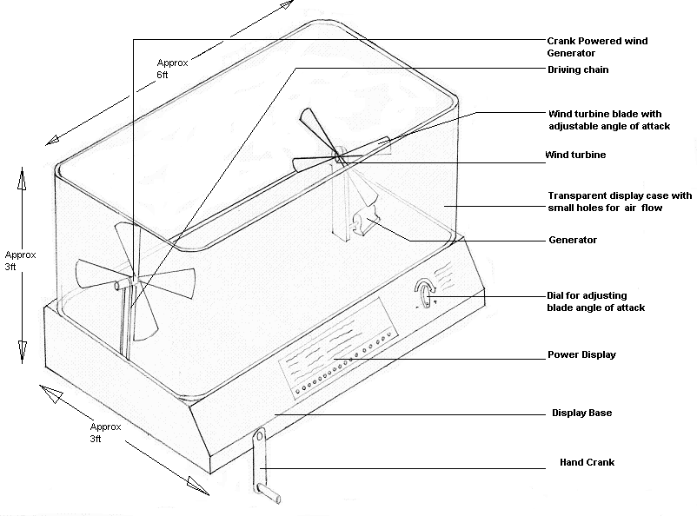Figure 3.1: First design generation of wind energy conversion exhibit.

3.2 Second Design

The second design considered for the project attempts to omit the flaws of the first design while improving its strong points and can be seen below in Figure 3.2.
It did incorporate a number of the concepts of the earlier design:
- A clear plastic casing
- An LED power display
- A DC motor acting in reverse as a generator.

Quite a few new features were added:
- Two different types of wind turbines (vertical and horizontal axes)
- Electrically powered wind generation system
- A honeycomb panel in front of the fan to normalize the air flow
- A nozzle system to increase the wind speed.
- A turntable system to move the wind turbine in and out of the path of the wind.
- A circular case to house the exhibit
- A mesh panel in front of the fan that allows air in but keeps fingers out.

The second design generation of the exhibit focused on the implementation of having two different wind turbines. Two different wind turbines would demonstrate the various design considerations that are taken into account due to the different efficiencies produced by each turbine. The difference in the turbines would be that one would rotate horizontally, while the other rotates vertically. The difference in axes would display two different ways to harness airflow.
As seen below in Figure 3.2, the wind turbines would be on a large turntable, allowing the viewer to choose which turbine to use in the circuit. This idea was unrealistic for several reasons. The first reason for elimination concerns the wiring for the exhibit. The turbine and generator need to be wired to the power output display, so having two turbines would cause conflict if trying to connect each to one power output display. The other reason for elimination is due to the actual turning of the turntable. It was decided that the wiring would become tangled and possible disconnected if the exhibit was abused or treated roughly. Because the exhibit needs to be durable, the large turntable would not be plausible.
The third main difference is the subtraction of the hand crank. As explained before, the input rotational speed of the crank is much too large to produce an acceptable working wind velocity. Instead of a hand crank, the fan will be powered by electricity. The fan will also have variations in wind speeds in order to explain how the airflow directly relates to the efficiency of the system.
The last main flaw of the second design is the actual casing for the exhibit. Clear plastic casing is relatively inexpensive if purchased in rectangular sheets; however, when it is requested that the plastic casing be rounded and connected together as one large piece, the price increases exponentially. Having a casing of this complexity would inevitably exceed the budget for the project and thus not be reasonable.

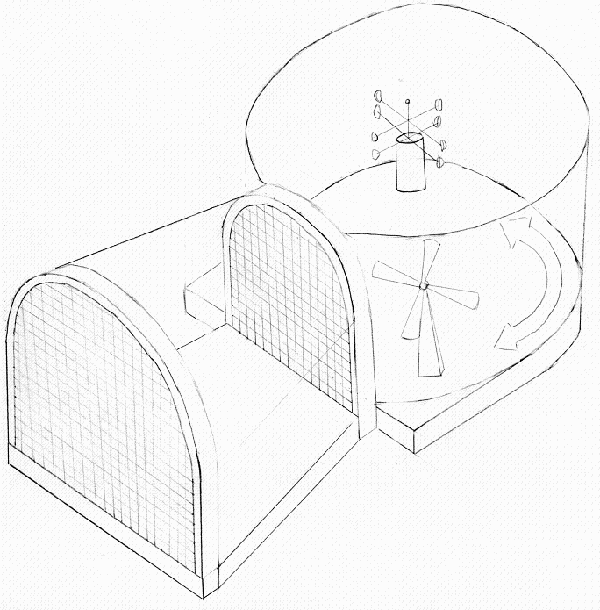
Figure 3.2: Second design generation.

3.3 Third Design

The third draft of the design again attempted to overcome the shortcomings of the first two designs. Ideas from both the first and second design were carried over into the third design.
It incorporated the favorable concepts of previous designs:
- Honeycomb panels
- Nozzle system
- Multiple wind turbines and the
- Electric fan.

And it included the following new concepts
- Square exhibit casing
- Two wind farms rather than two individual of wind turbines
- Two vertically standing power output displays.

In Figure 3.3 below, it can be seen that there are two different types of wind turbines. This idea, for reasons stated in Section 3.1 and Section 3.2, was popular with the museum associates, and thus, remains an integral part of the design; however, instead of having just one of each, the exhibit would contain a miniature “wind farm” to give a better depiction of an actual, real-life wind farm.
One major flaw of the second design was the circular plastic casing. Because of the shape of the casing, the cost would far overreach the project’s budget; therefore, for the third design, the rectangular plastic casing was reintroduced.
Another addition to the third design was the introduction of a vertical power display strip, located behind each wind turbine. This power output display would contain LED light bulbs that would light up sequentially with increasing power. The main concern with the power output display was for the exhibit viewers to be able to associate the correct power output with the respective wind turbine. It was decided that if the power display was located on the front panel of the exhibit, there would be confusion as to which turbine was associated with which power strip. By placing the power strips behind the turbines, it makes it easier to associate the power strip with the corresponding wind turbine. Also, positioning the power strip vertically also is more aesthetically pleasing and makes the display more intriguing.
One way to make improvements to the fan’s airflow would be to make an evenly distributed airflow throughout the exhibit’s chamber. By having an even airflow throughout the chamber, the experiment will have more control and introduce less error when displaying the efficiency of the wind turbine, due to the idea that the same amount of air is hitting each turbine. In addition to even airflow, a nozzle was initiated into the design to concentrate the wind from the fan onto the turbines. These components will all improve the overall result of the experiment.
Lastly, the controls of the display needed to be placed. In order to make them accessible for all heights of people, the controls will be placed on the front panel of the exhibit. Although not shown below in Figure 3.3, the controls will be located on the front most surface on a protruding panel.

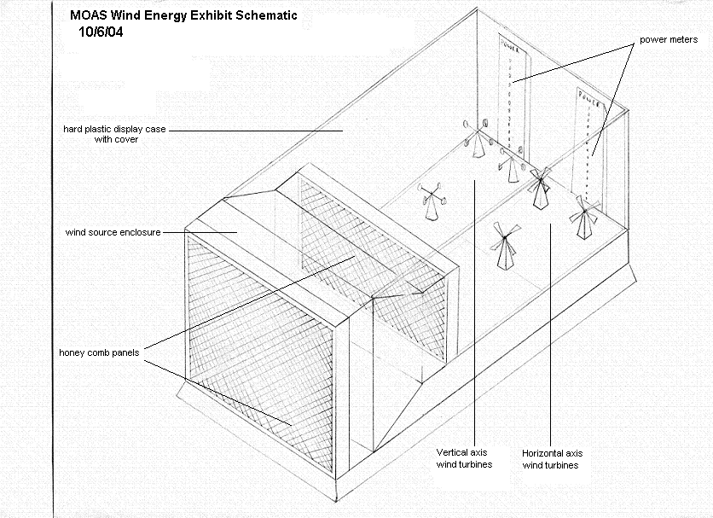
Figure 3.3: Third design generation.

3.4 Fourth Design/Final Design

After further collaboration with the museum coordinator, the final design was created. The fourth design was very similar to the third and featured:
- Honey Comb panels
- Nozzle system
- Rectangular Case
- LED Power display
- Protective mesh panels
- Electric powered Industrial fan
- Both Vertical and Horizontal axis wind mills

It also featured the following new additions:
- Metal frame supported plastic case
- One of each kind of wind mill

One major change from the third design to the fourth and final design was the implementation of the metal frame. As stated earlier, the expense to make a plastic casing with smooth, rounded edges would be more than the budget can allow. By employing a metal frame, the casing could consist of sheets of plastic connected together by the metal frame. The frame would also give added support in case of collisions or other destruction toward the exhibit. The frame would be made of welded-square tubing with a smooth, professional-looking finish.
The wind farm in the third design was also reconsidered. Having two different types of wind turbines and three of each kind means that the exhibit must house a total of six wind turbines. The first concern was space constraint. Because the exhibit has a maximum allowable space, having six turbines in the exhibit would not allow for each turbine to be exposed to an equal amount of flow. In addition to space constraint, the wiring necessary for the turbines would be more complicated and troublesome if repairs were ever needed. Finally, having six turbines would greatly increase the cost of the exhibit. Therefore, the exhibit will only house two turbines, one with a vertical axis of rotation and one with a horizontal axis of rotation.
Next, the power display meters were considered. The museum curator expressed an interest in having a mesh behind the wind turbines to allow for the children to actually feel the wind produced. This idea conflicted with the power displays due to their initial placement directly behind the turbines. In order to side step this problem, the power displays will be located along the sides of the exhibit. When placed here, it is still apparent which power display corresponds to which wind turbine, while also being out of the way of the wire mesh.
An idea that is not shown below in Figure 3.4 is the writing that will be placed on the back wall of the exhibit. This writing will help to explain the exhibit and the mechanics of what is happening. Although this will eliminate a side at which the exhibit can be viewed, assuring that viewers will understand the exhibit is much more crucial.
Two other important components that are not displayed in Figure 3.4 below are a start button and a kill switch. Both were by request from the museum, so in order to create a marketable exhibit, these ideas will be executed. The start button will initiate the start of the fan; however, there will still be a dial to vary the speed of the fan. The kill switch will help to save on power to the exhibit by turning off the fan if no one is viewing the exhibit. This will be connected to the fan and will terminate activity after a set amount of time. These two ideas are important to have a professional, useful finished product.
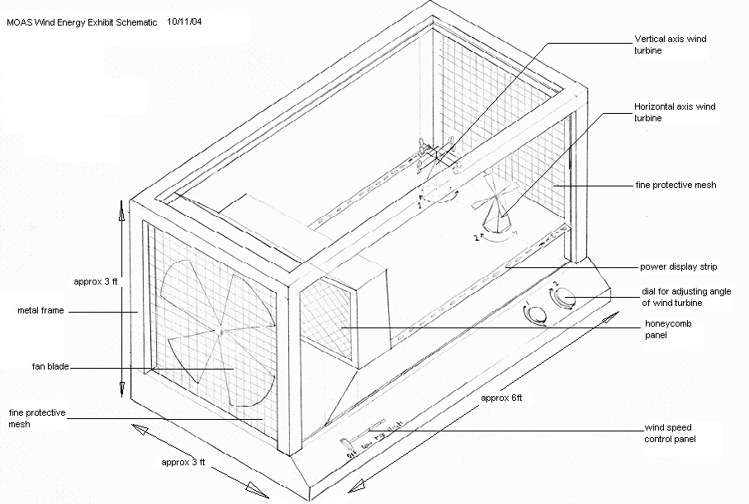Figure 3.4: Final Design Generation.
The final design generation shown above in Figure 3.4 contains all of the concepts that will definitely be included when constructing the exhibit. Other additions are the base that will raise the exhibit to a height that will appease viewers of various height ranges. Also, the implementation of color will make the exhibit look more professional. With all of these concepts combined, the final exhibit will be pleasing, educational, and well worthy to stand amongst the other museum exhibits.

4.0 Concept Selection

After four design iterations the final design has been conceived and approved. Table 4.1 below gives a summary of the components that were eliminated throughout the process as well as the reason for the necessary adjustment.
Table 4.1: Eliminated components
Component | Reasons/Adjustments
Hand crank | Unrealistic due to the amount of wind that needs to be produced
Angle of Attack | Very complicated and hard to see on a small scale
Turbine Turntable | May cause wiring or other internal components to tangle
Circular Plastic Casing | Too expensive to fabricate for this exhibit
Turbine Wind Farm | Too expensive and not realistic with space constraints

Table 4.2 below lists the final design components that will be initiated as well as the reasoning for each component.

Table 4.2: Final Design Components
Component | Reasons
Casing | Composed of welded tubing to hold clear plastic sheets
Wind Turbines | Vertical axis and horizontal axis will be used to display differences in efficiencies
Power Meters | Placed horizontally along exhibit so as to not interfere with other components
Size | Final design will fit into designated space
Angle Adjustment | Will vary angle of attack of turbines in order to further display efficiency differences
Anemometer | Display wind velocity of the fan
Fan | Powered by electricity and equipped with a dial to vary airflow
Plastic Mesh/Honeycomb | Creates an even flow to be distributed throughout the casing
Exhaust Wire Mesh | Allow exhaust wind to flow out of the casing
Start Button | Initiate the airflow by starting the fan
Kill Switch | Terminate fan activity after a given amount of time

The final selection of the components came due to extensive research, helpful answers from the museum curator, as well as teamwork from the group. The goals that were initially set to have an exhibit that is safe, educational, understandable, and aesthetically pleasing will be met if this project is constructed according the final design generation. The final design demonstrates several principles related to wind energy. The exhibit displays the difference in efficiencies between two turbines, as well as the importance of the angle of attack of the airflow. The professionalism of the display will also help to draw viewers to the exhibit, while the interactive dials and adjustments will further engage them. The final design meets all expected requirements and will be a huge contributor to the explanation of the occurrence of wind energy.

5.0 Component Selection

5.1.0 Wind Generation

Once the overall concept of the exhibit was finalized the component selection could begin. The first item to select was the fan to generate the wind. The fan needed to have a high velocity and be an adequate size so that it can supply enough wind to two wind turbines, but not so large that the cost would be too high. Another requirement of the fan was to have variable speeds of operation so that the user of the exhibit could change the wind speed and the thus the power output of the wind turbines. After doing some research on the Internet for different types of fans there were several options available in industrial fans and commercial fans.
Table 5.1.1: Comparison of Different Types of Fans
Fan Type | Diameter | Max Velocity | Min Velocity | Cost | Dial Switch
Air King Direct Drive Drum Fan | 36 in. | 19.3 mph | 13.9 mph | $358.00 | Yes
Air King Belt Drive Drum Fan | 42 in. | 21.6 mph | 15.4 mph | $515.00 | Yes
Air King Belt Drive Drum Fan | 36 in. | 22.6 mph | 16.2 mph | $478.31 | Yes
Qmark LDC20 | 20 in. | 31.0 mph | 18.2 mph | $215.25 | Yes
Qmark B-20P | 20 in. | 31.0 mph | 18.2 mph | $153.00 | No

The Air King Model fans are industrial fans that are designed for moving air at a large flow rate, not necessarily at a high velocity. The industrial fans do provide a significant velocity, but they are just too large in diameter and too expensive to meet budget requirements. When researching the commercial fans Qmark fans seemed ideal, they were smaller, cheaper, and offered higher velocities than the industrial fans. The Qmark LDC20 and B-20P are practically the same fan, the only difference is that the LDC20 is a pedestal fan and the B-20P is a fan that is supposed to be mounted on some other object. The problem with the B-20P is that the motor is controlled by a pull chain and not a dial switch; a pull chain switch is not desirable because the fan will be encased in plastic and the switch on the B-20P will not be accessible. The dial switch on the LDC20 is better than a pull chain, because it can be moved from the fan base to the outside of the plastic casing so the children can operate it. Table 5.1.2 shown below is a decision matrix ranking each category with 5 being the best rating and 1 being the worst. Table 5.1.2 shows that the Qmark LDC20 is the best option and can be seen in Figure 5.1.1 below Table 5.1.2.
Table 5.1.2: Decision Matrix of Different Types of Fans
Fan Type | Diameter | Max Velocity | Min Velocity | Cost | Dial Switch | Overall
Air King Direct Drive Drum Fan | 3 | 2 | 2 | 3 | 5 | 3
Air King Belt Drive Drum Fan | 1 | 3 | 3 | 1 | 5 | 2.6
Air King Belt Drive Drum Fan | 3 | 3 | 3 | 2 | 5 | 3.2
Qmark LDC20 | 5 | 5 | 5 | 4 | 5 | 4.8
Qmark B-20P | 5 | 5 | 5 | 5 | 1 | 4.2

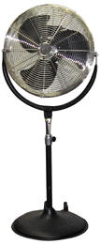
Figure 5.1.1: The Qmark LDC20 Light Duty Commercial Fan

5.2.0 Power Generation

5.2.1 AC and DC Motors

Now that the fan was selected we could start to select the parts for the power generation component of the exhibit. Actual real world wind turbines utilize an AC electric generator, which supply power at a constant output of power whether the wind is blowing or not based on changing the strength of the electric field in the generator. A person let alone a museum exhibit cannot easily explain this concept to small children, which is why DC motors were chosen. The DC motors are designed to take electrical energy from a battery and convert it to mechanical energy, but they can operate in reverse when they have permanent magnets in them, which will give an electrical output only when the shaft is spinning.
The only problem with using DC motors is that the permanent magnets in the motor may have too much resistance for the wind to turn the propeller and the shaft of the DC motor. After contacting several DC motor manufactures they offered no data on running their motors in reverse and leaving few options of knowing what kind of motor would suit our needs. To find a motor that will work, several DC motors were purchased from a local hobby shop to find one that would suit our needs. Coincidentally, when testing the motors the college of engineering had the Qmark LDC20 pedestal fan in the second floor computer lab, which made the testing much more realistic since that is the same fan that will be used in the exhibit. Table 5.2.1 shown below is a list of the motors tested and the results show that only the CRE-RE280 DC motor worked with the Qmark LDC20 used for testing.
Table 5.2.1: DC Motor Testing
Motor Tested | Voltage Output | Cost | Work
CRE-RE280 | 1.5-3.0V | $ 3.00 | Yes
EPS-350C | 7.2-8.4V | 16.63 | No
EPS-400C | 7.2-8.4V | 14.00 | No
S400 | 7.2-8.4V | 9.95 | No

5.2.2 Horizontal and Vertical axis Turbines

Horizontal and vertical axis wind turbines were the next part of power generation to be selected. The most common wind turbines are the horizontal axis wind turbines, and usually have two or three blades. Three bladed are more common than two blades, but the three bladed turbines are not that easily found for such a small-scale project. A small-scale two bladed horizontal axis wind turbine, on the other hand, was quite easy to find in the hobby shop, just by using one of the model airplane propellers.
There are several advantages to having a two bladed wind turbine compared to a three-blade model. A two-blade wind turbine is cheaper than a three-blade model and nearly has the same power coefficient when they have the same tip speed ratio. The cost of a two-blade model is also cheaper since only two blades need to be constructed rather than three. The three bladed design is however a more balanced and is slightly more efficient than the two-blade design as shown in Figure 5.2.1 below.
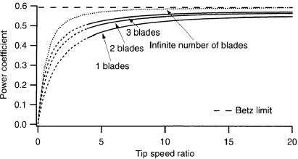
Figure 5.2.1: A graph of the power coefficient as a function of the tip speed ratio for several different number of blades in a horizontal axis wind turbine.

Table 5.2.2: Decision Matrix of One, Two, and Three Blade Wind Turbines
Number of Blades | Availability | Efficiency | Weight Balance | Real-World Example | Cost | Overall
One | 1 | 3 | 2 | 2 | 5 | 2.6
Two | 5 | 4 | 4 | 4 | 4 | 4.2
Three | 3 | 5 | 5 | 5 | 2 | 4

After comparing the two blade and three blade turbines is a decision matrix, Table 5.2.2 above, the two-blade design is sufficient for this project. A vertical axis wind turbine was not that easy to find.
There are several different types of vertical axis wind turbines; airfoils, Savonius rotors, and cup type wind turbines as shown below in Figure 5.2.2. Airfoils are quite common in vertical axis wind energy systems, but each airfoil (or blade) is quite expensive and the design involves a large amount of calculations so that they maximize the force on the airfoil by the wind. For the museum an airfoil would be too complex and would require so much calculation and design that it could be a senior design project in its own right. The fabrication of a small scale airfoil would also be quite expensive, because it would have to be fabricated in the COE machine shop from a piece of raw aluminum, while researching there were no pre-manufactured small-scale airfoils available for purchase.
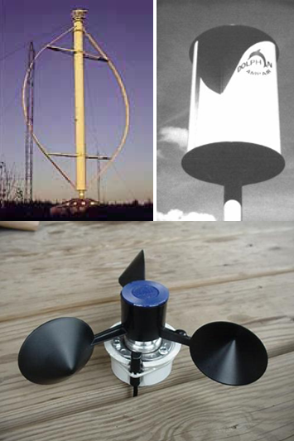
Figure 5.2.2: Pictures of Different Types of Vertical Axis Wind Turbines: Airfoil (Top Left), Savonius Rotor (Top Right), and Cup (Bottom).

Savonius rotors are quite simple in design when compared to the airfoils. A Savonius rotor is basically a large diameter tube cut in half and then rejoined in an orientation to catch the wind, like in Figure 5.2.3 below. Savonius rotors also are much easier for a child to understand than an airfoil, because you can easily see the cavity in the rotor in which the air flows. Although the Savonius rotor is much simpler in design and much easier to fabricate, the design is not very attractive to the viewer.
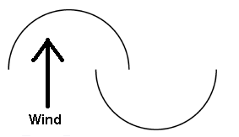
Figure 5.2.3: Diagram of the top view of a Savonius Rotor.
The cup design is commonly used in small handheld anemometers and sometimes used as small-scale wind turbines. Cup wind turbines are not the practical for large-scale vertical axis wind turbines, but for a small-scale demonstration, it is near perfect. A prefabricated rotor can be attained from any cup anemometer, the one that will be used in the project is shown in Figure 5.2.4 below donated from inspeed.com who make and manufacture hand-held cup anemometers.
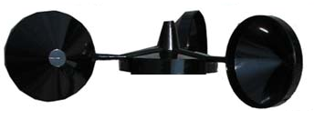
Figure 5.2.4: Plastic molded rotor that will be used for the vertical axis wind turbine.
The design is simple like the Savonius rotor, because the observer can see the cavity that the wind will flow into, but is more attractive than the Savonius. This design is the most practical choice to demonstrate a vertical axis wind turbine; this is shown by Table 5.2.3.
Table 5.2.3: Decision Matrix of the Vertical Axis Wind Turbines
Type of Turbine | Availability | Complexity | Attractiveness | Real-World Example | Cost | Overall
Airfoil | 2 | 1 | 5 | 5 | 1 | 2.8
Savonius Rotor | 5 | 5 | 2 | 3 | 3 | 3.6
Cup | 5 | 5 | 4 | 1 | 5 | 4

5.2.3 Wind Turbine Frame

Now that the wind turbines have been selected the next thing to be determined is what they are going to rest on in the exhibit casing. At first it was decided that the DC motors would be attached to frame trusses. These frame trusses were going to be made of metal purchased from the hobby shop and assembly like they are shown in Figure 5.2.5 below.
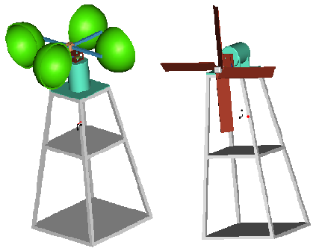
Figure 5.2.3: Vertical and horizontal axis wind turbines mounted on frame trusses.
After considering this option and doing more research it was determined that this design was not an accurate representation of the bases of wind turbines. Large-scale wind turbines are mounted on large single column towers. Thus the base was redesigned to reflect these towers and the base of the wind turbines will be as seen in Figure 5.2.4 below.
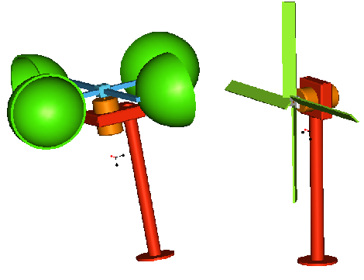
Figure 5.2.4: Vertical and horizontal axis wind turbines mounted on column towers.
Theses towers will be made of 3/8-inch diameter Aluminum rods purchased from McMaster that will cost $3.65 each.

5.2.4 Testing of the DC motor

After finding a DC motor that worked, a propeller was purchased from the hobby shop so that testing of power output could begin. The DC motor used in testing was the CRE-RE280 and had an eleven-inch propeller attached to it. The LDC20 fan in the second floor computer lab was used for the testing of the motor. The results of the testing are shown below in Table 5.2.4 below.

Table 5.2.4: Testing of the CRE-RE280 DC motor.
Angle of Attack: 0 Degrees from Center
Fan Setting | Velocity (m/s) | Voltage (V) | Current (amps) | Power (W) | Distance from Fan (in)
Lo | 4.45 | 0.3 | 0.2 | 0.06 | 12
Med | 6 | 0.4 | 0.3 | 0.12 | 12
Hi | 7.56 | 0.49 | 0.4 | 0.196 | 12
Angle of Attack: 30 Degrees from Center
Fan Setting | Velocity (m/s) | Voltage (V) | Current (amps) | Power (W) | Distance from Fan (in)
Lo | 4.45 | 0.22 | 0.1 | 0.022 | 12
Med | 6 | 0.27 | 0.2 | 0.054 | 12
Hi | 7.56 | 0.32 | 0.29 | 0.0928 | 12

The velocities shown in Table 5.2.4 are based on the volumetric flow rate of the fan in the exhibit; the volumetric flow rate was given by the fan manufacture. More extensive testing will take place next semester when the actual exhibit is constructed and possibly using a wind tunnel so that the wind will be contained as it will be when the exhibit is completed. Once the fan was turned to a setting thirty seconds was allowed to let the fan reach a steady state of output and then readings were taken of the output of the DC motor. The purpose of this preliminary testing is to find a rough estimate of the output of the DC motor so that Dr. Li of Electrical Engineering department can tell us the size and type of electrical equipment that will be needed to make a circuit that will signal the light towers to display the desired output.

5.3.0 Exhibit Casing

The biggest and most important part of the exhibit is the main frame that will hold everything together. When we met with our sponsor Mrs. Heather Whitaker, director of the Mary Brogan Museum, we were given size specifications for the exhibit. We were told that the exhibit needed to fit in with the other projects within the museum, with respect to size and shape. The exhibit should be approximately five feet long, four and one half feet tall, and three feet deep. From these dimensions and observing other exhibits in the museum a general idea for the shape of the exhibit casing was chosen.
The height that the actual exhibit, the wind turbines and fan, was also specification set by the museum at thirty inches. The control panel in other exhibits similar to ours was angled towards someone who might use it, as a group we also decided to incorporate this into our design; our control panel is to be set at an angle of thirty degrees from the horizontal.
The initial idea for the construction of the frame was to be out of steel, but after talking to the welder we were told of an aluminum product that would make frame construction much easier.

5.3.1 Welded Frame

The original idea for building the frame was to use a welded steel frame; our group found a welder and set up a meeting to discuss our design for a frame. The group initially had two different ideas for the construction of the welded frame. The first option was to use 2-inch angle iron. The second option was to use 2-inch square tubing cut and welded together. The main difference between the two ideas was weight and cost. Originally we were going to choose one of these two ideas based on what we learned from the welder. After talking to the welder and explaining our ideas, he told us he would not build the frame out of the 2-inch angle iron, due to the complexity of cuts and angles that would be needed to make it the frame strong and stable. The 2-inch square tubing would not be a problem to build and we were given a simple quote from the welder on building the frame. The cost for the raw material and cuts to build the frame would cost approximately $400. To weld the frame together would be additional cost depending on how long it took to finish the job, but the estimate was approximately $300 more. The total frame at this point would be $700, which was going to fit into the budget we have of $5000. The $700 would only be for the frame, no drilling or tapping of holes to attach panels for the exhibit, a major draw back to this idea.
The welded frame would be one solid piece, unfinished and without any of the drilled and tapped holes that would be needed to attach panels to the project. The welded steel frame would also be very heavy, and hard to transport due to the fact that it could not be taken apart. The welder told us of a company that makes modular aluminum pieces that he believed we might be able to build our frame out of, cheaper and easier, that company was 8020.

5.3.2 8020 Aluminum Frame

The frame made from the modular aluminum pieces produced by 8020 was the second option for construction of the frame. The company has designed their product to be modular, making it possible to build almost anything. The basic design of 8020 makes it possible to attach and connect parts to the frame with out drilling into the frame; only machine screws and nuts would be needed. It was decided after looking through the catalog, talking to the welder, and communicating our ideas with 8020 that the best way of constructing the fame would be through the use of the modular aluminum frame.
The basic design of the 8020 extrusions makes it possible to attach parts with out drilling holes into the material. Special nuts can be slid into the t-slot in the extrusion, see Figure 5.3.1 and Figure 5.3.2; when a part is to be attached a machine screw between the two pieces will clamp them together making a very strong joint, see Figure 5.3.3.
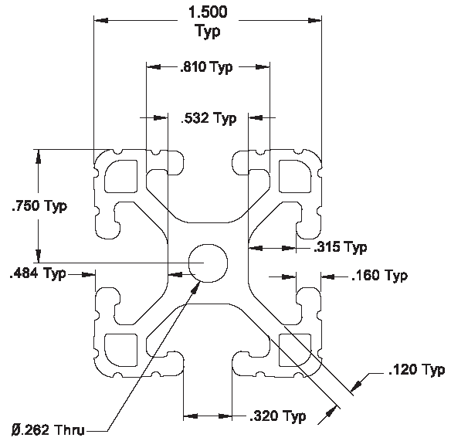
Figure 5.3.1: A cross sectional view of the 8020 extruded aluminum pieces that we will use to build the casing.

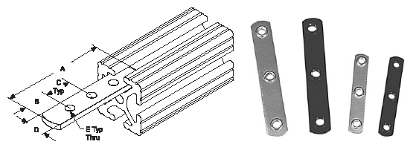
Figure 5.3.2: Specialized brackets that slide into the t-slots of standard 8020 extrusions that make it possible to attach pieces.

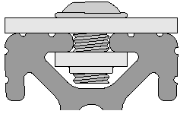
Figure 5.3.3: A side view of an 8020 piece showing how connections are made using machine screws and plates to hold everything together.

This clamping effect will make it possible to attach the clear plastic panels that will be needed in our project to allow museum guests to see into the exhibit; also wire mesh panels can be attached to the end in a similar manner so that air can flow through the exhibit.
Specialized 90° angle brackets, see Figure 5.3.4 have been designed by the 8020 company to join extrusions together. Using these brackets and the proper length extrusions will make the construction of our frame simple.
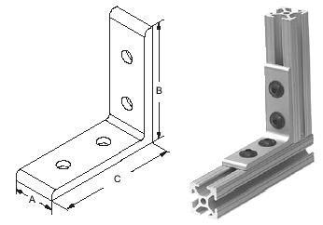
Figure 5.3.4: Engineering drawing and an example of a corner connection bracket

There are other specialized parts that can be purchased through the 8020 company, which we will use in the construction of the frame. Figure 5.3.5 show a bracket that allows the mounting of extrusions at a 30° angle with respect to each other; this matches the angle needed for the control panel on the exhibit. For a more finished look to the exhibit many of the exposed pieces on the exhibit will use a rounded over design of the 8020 extrusion as can be seen in cross section in Figure 5.3.6.
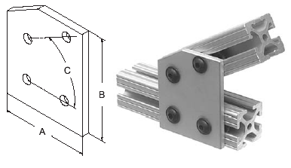
Figure 5.3.5: Engineering drawing and an example of the 30° connection bracket we will be using to connect the 8020 for the control panel

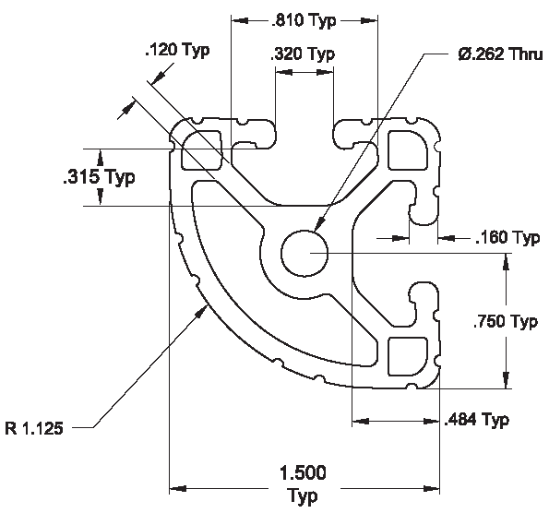
Figure 5.3.6: A cross sectional view of the rounded 8020 used in the corners of the exhibit.

5.3.3 Selection of Frame Material

In the end after the group weighed the options of using the welded steel frame and the modular aluminum frame, we decided to go with the aluminum frame from 8020. The best part about purchasing the materials needed to build the frame through the 8020 company is that they sell many of the extra parts we need for our frame, including leveling feet, clear plastic panels and mesh panels. This reduces the number of distributors that our group needs to deal with to build the project. With the final designed frame a parts list was made, this along with the engineering drawings were sent via email to an 8020 dealer who helped us finalize our design. The 8020 company has also been very helpful with our project answering all of the questions we have had, relating to cost and construction. All formal engineering drawings can be seen in Appendix A.

5.4 Electronics

5.4.1 Start Button and Kill Switch

Energy conservation was in mind for the next electrical component. Like every business, the museum has peak times and times when there are barely any visitors in the museum. With this thought it was decided to incorporate a kill switch into the exhibit. With no movement of the wind speed dial, this kill switch will cut power to the wind generation system after a programmed amount of time. The length of this time span can be altered by the museum to a setting applicable to either a busy season or a time where the visitor volume is very low. The desired kill switch will be purchased from Grainger, a local electronics supply distributor. The off delay octal base timer is designed by Dayton and will have a delay time range from 0.1 minute to 10 minutes. The price of this electrical component is $54.70 before tax. However, since Grainger is a local establishment, there will be no extra shipping or handling charges. The kill switch will minimize museum expenses for the running cost of the exhibit.
Now that the wind generation system will cut off after a time with no use, the need to restart the exhibit comes into account. The museum has expressed an interest in a start button. This button will be located on the Display panel of the exhibit; when pushed this button will start up the exhibit, giving power to the fan being used for the wind source. The Start button was furnished by the museum and will cost very little to wire into the exhibit. The kill switch and start button will be wired together with the fan speed dial. The Electrical Engineering Department, especially Dr. Hui Li, will aid in the design and wiring of this circuit.

5.4.2 Power Output Display

One main goal of the exhibit is to compare the power outputs of two different types of wind turbines. The two types of turbines, one vertical axis and one horizontal axis, will be compared at three different wind velocities and different angles of attack. Since a comparison is desired, a visualization of the power produced by each turbine is a necessity. After careful consideration, three ideas were in mind. The first idea was a convertible bar graph kit designed by Philmore Manufacturing. The second idea was to use mini status-indicating light towers found online at McMaster-Carr.com. The third idea for displaying the power outputs was to use analog voltmeters.
The idea of the convertible bar graph kit seemed to be the answer, and was the first avenue of interest. This electrical component is typically used to indicate sound levels in playback equipment, but may be used in other applications such as a meter in a receiver, level indicator in a field strength meter, et cetera. The kit displays the desired variable by the use of sixteen light emitting diodes (LED lights). LED lights are tiny, purely electronic lights that are extremely energy efficient and have a very long life. The input level for this component is user adjustable, where the sensitivity can be set all the way from millivolts to a few volts per step. This kit was available from Fouraker Electronics, a local electronics store, at a price of $24 per unit. However, since power is the product of voltage and current, and the wind turbines will provide different voltages and different current flows at the three different wind velocities, this setup would not successfully generate a true power meter.
The use of status indicating lights to display the power outputs was the next idea considered. These light tower units come with five lights with amber, blue, clear, green and red lenses. The bulbs are incandescent and have an estimated life of 7000 hours. The base and lenses are constructed of polycarbonate for durability and strength. The lenses dimensions are 2.2 inches in diameter by 2 inches in height. The total height of the unit with all five lenses enclosed between a mounting base and a top cap will be 17.5 inches tall, which would give a large enough display without drawing attention away from the rest of the exhibit. The only setback of these light towers was the application. In order for these light towers to display the power, they would need to be wired with a control circuit. With the help of Dr. Dave Cartes and the Electrical Engineering Department a rough circuit was created, Figure 5.4.1, using zener diodes and driver op amps aligned in series. The capacity of the zener diodes would be designed to give a step function; therefore as the voltage and current produced by a wind turbine increase, more lights will light up. In other words once the voltage capacity of the first zener diode is reached, the first driver op amp will send power to the first light in the light tower. Once the voltage increases to the capacity of the second zener diode, the second driver op amp will send power to the second light in the tower displaying an increase in the power supplied. The capacities of the zener diodes will be determined upon completion of further current and voltage testing of the DC motors. Two circuits will need to be constructed; however, one will be wired and tested with a light tower and wind turbine first. And then the second power meter will be constructed when the circuit proves itself during testing.
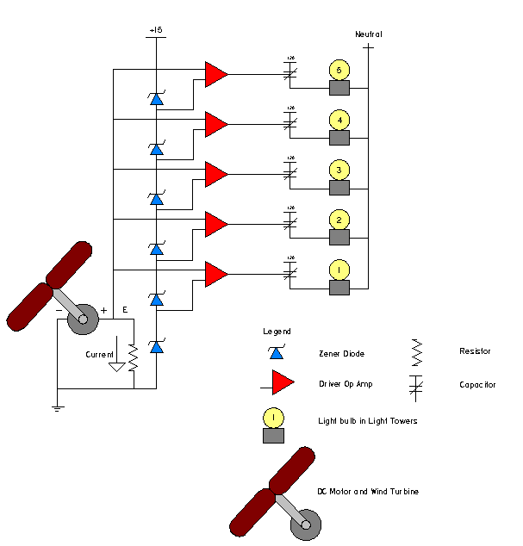
Figure 5.4.1: Circuit diagram to control the light towers
The light towers are the proposed idea, but the analog voltmeters will be used as a backup plan. These analog voltmeters would be very easy to wire into the exhibit, and would display the comparison between the two wind turbines. However, the voltmeters would not provide an attractive display of the power supplied. This idea will be saved just in case the wiring for the light towers is not applicable.

5.4.3 Wind Speed Display

The wind generated by the exhibit will be at three different velocities, since the fan operates at three settings. These wind velocities will need to be displayed in order to A Extech Heavy Duty Mini-Vane CFM Thermo-Anemometer be used to measure and display these velocities. The Extech model 471117 as displayed below in Figure 5.4.2 has a one half-inch LCD display and can measure the wind speed in several different units. Miles per hour will most likely be used as the primary unit in order to provide the wind speeds in a familiar form that every museum visitor will understand.

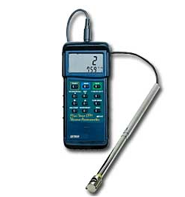Figure 5.4.2: Mini-vane anemometer, Extech model 471117.
This model of anemometer has the option to be used with an AC adapter; therefore, there will be no need to constantly interchange batteries. The air velocity wind sensor probe will be secured inside the wind exhibit while the display casing will be fastened to the control panel for readability and visitor interaction. This anemometer has a wind velocity range from 1.8 to 26.8 miles per hour giving a good range for the wind that will be produced in the exhibit. The anemometer will cost $459.00 and the optional AC adapter will be an extra $25.00. Shipping will be around $20.00, giving the final cost for the anemometer component and accessories will be $504.00 before tax. This component will be purchased from an Internet test equipment distributor.

5.5.0 Pulley Design

It had been previously agreed that both of the wind turbines would be placed on rotating platforms so that they would be able to turn with respect to the direction of the incoming wind. To accomplish this, it was decided that a turntable and pulley system would be used. A Pro/E model of the setup, with its important components labeled, is shown in Figure 5.5.1 below. Note well that the entire setup will be concealed from view, within the exhibit.
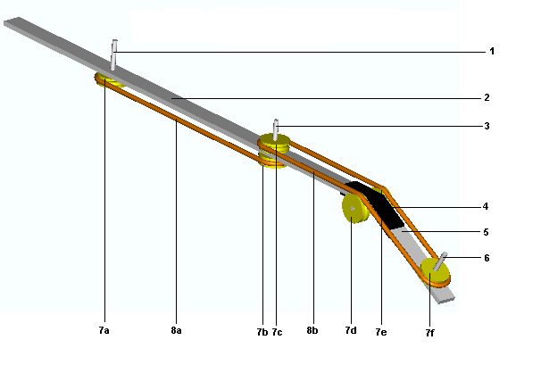
1 | Vertical axis mounting shaft
2 | Supporting cross bar 1
3 | Horizontal axis mounting shaft
4 | Cross bar connecting bracket
5 | Supporting cross bar 2
6 | Control dial mounting shaft
7a | Horizontal axis pulley wheels
7b | Transfer pulley wheel
7c | Vertical axis pulley wheel
7d&7e | Idler pulley wheels
7f | Input pulley wheel
8 | Round drive belts
Figure 5.5.1: Pro E picture of pulley system with all major components labeled in the chart.
The operation of the system is quite simple; to turn the wind turbines, the operator of the exhibit will turn the control dial (not shown). The control dial will be rigidly connected to the input pulley (7f) by the control-dial mounting shaft. This initial turning will be transferred over the idler pulleys (7d&e) to the vertical axis pulley (7c). The vertical axis pulley will be rigidly connected to the vertical axis turbine turntable (not shown) by the vertical axis-mounting shaft. The vertical axis pulley will also be rigidly connected to the transfer pulley and they will, as a result, turn together. The transfer pulley, as can be seen, is belt connected to the horizontal axis pulley, and so when it former turns, the latter will do the same. The horizontal axis pulley will itself be rigidly shaft connected to the horizontal axis turntable by the horizontal axis-connecting shaft. The overall effect is that when the input pulley is turned with the control dial, the vertical and horizontal axis pulleys will be turn. Note well that all of the pulleys are the same size so that they will all turn at the same angular rate.
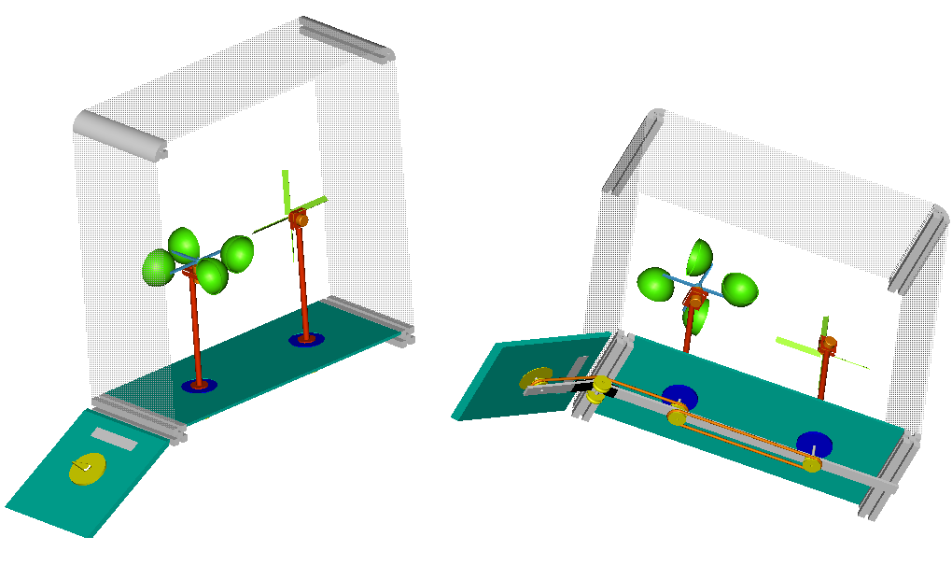Figure 5.5.2: Pro E picture of the pulley system in the exhibit casing
Figure 5.5.2 shows the pulley system as a part of the exhibit in the casing. The picture on the left shows a cross section of what would be seen by an onlooker. The figure on the right shows how and where the pulley system will be positioned within the exhibit. Notice that it is entirely hidden from view and the operator will only have to manipulate the dial on the control panel.
This setup was chosen because the parts required (pulley wheels and drive belts) are fairly easy to obtain and not very expensive. The assembly of the system is simple enough to be done in house, thus cutting costs even further. Other ideas for turning the turbines were tossed out on account of excessive cost, complexity or lack of reliability.
The important parts of this set up are the pulleys (6 in all) and the round belts (2 in all). The arrangement also includes 3 shafts, 2 support members and 2 connecting brackets. All components were selected with optimum cost and functionality in mind. The parts chosen to make up with pulley system will be obtained from an industrial supplier, McMaster. The major parts of the system are detailed below.
To deal with all the angles and turns involved, a round drive belt had to be chosen. Round drive belts can be put through many twists and turns unlike flat or v-belts. The round drive belt that was chosen is shown below. It is a simple urethane drive belt, for low horsepower applications such as this. An excerpt from the catalog page along with a simple diagram provided by the supplier is shown in Figure 5.5.3 below.
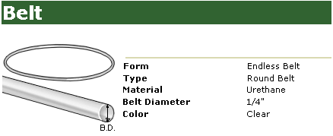
Figure 5.5.3: Belt data from McMaster-Carr

The pulley wheel chosen for the exhibit is shown in Figure 5.5.4; it is quarter inch bore diameter round drive belt pulley wheel, to match the round drive belt selected earlier. It is a small pulley wheel, also for low horsepower applications.
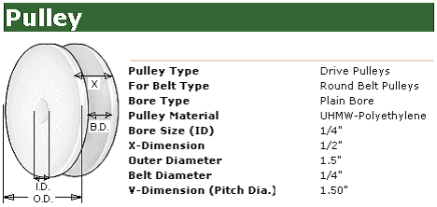
Figure 5.5.4: Pulley data from McMaster-Carr

The supporting cross members will be made of a single 2024 aluminum alloy bar. A single 36 inch piece will be cut into two pieces, one 27 inches in length and the other 7 inches in length. The members will be fastened together by two connecting brackets. The specifications of the aluminum along with a diagram (not to scale) are shown in Figure 5.5.5.

Figure 5.5.5: Aluminum cross members from McMaster-Carr

The connecting brackets required to connect the to support members will be thirty degree, outside mounted, angle brackets made of zinc-plated steel. The two brackets will be attached above and below the actual bend. A diagram of the part, along with an excerpt from the supplier catalog is shown in Figure 5.5.6 below.

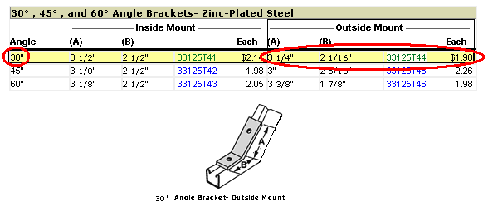
Figure 5.5.6: Connecting brackets for the pulley system from McMaster-Carr

All of the mounting shafts will be cut from a single rod. A quarter inch diameter by one-foot long rod made of 2024 aluminum will be used. A diagram from the supplier along with the catalog page extract is shown in Figure 5.5.7.


Figure 5.5.7: Aluminum shaft from McMaster-Carr

6.0 Final Design Specifications

As a group we were given the task of creating an alternative energy exhibit for the Mary Brogan Museum of Arts and Sciences. To be more specific the exhibit was to deal with wind energy. The first meeting with our sponsor Mrs. Heather Whitaker consisted of a simple sit down meeting where we discussed some of the ideas that the museum had for the exhibit. This included what major components they wanted in the exhibit, how the main parts of the exhibit should look, as well as some basic dimensions for the size of the exhibit. After meeting with Mrs. Whitaker the group was allowed to tour the museum to get an idea of what types of exhibits were already in place at the museum, and what was the overall sophistication level they exhibits were presented at. Our group also met with Dr. Shih who would help on the project and act as another sponsor, he also gave us some general ideas and suggestions as to what he thought should be included. After meeting with both of the project sponsors we as a group brainstormed and came up with more ideas as well as some simple drawings and concepts for the exhibit.

6.1 Exhibit Dimensions and Frame Design

In order for our exhibit to fit into the general scheme of the museum Mrs. Whitaker gave some basic dimensions for the overall size of the project during our first meeting. The exhibit should be approximately five feet long, four and one half feet tall, and three feet deep. The height that the actual exhibit, the wind turbines and fan, was also specification set by the museum at thirty inches. The control panel in other exhibits similar to ours was angled towards someone who might use it, as a group we also decided to incorporate this into our design; our control panel is to be set at an angle of thirty degrees from the horizontal. The basic idea for the over all shape of the exhibit can be seen in Figure 6.1.
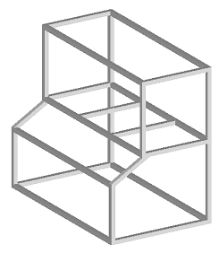
Figure 6.1: Frame design for the exhibit. Using the specifications given to us by the museum our final design for overall shape of the exhibit can be seen.

6.2 Frame Material and Building Options

Once a basic idea for the size and shape of the frame was selected a means of creating the frame needed to be found. A local welder was contacted about building the frame out of two inch square steel tubing. Engineering drawings were provided to the welder, he then was able to give us an idea of how he would build the frame, and a rough estimate as to what the cost might be. After looking at our design and some talking with the welder about what we were going to do with the frame he suggested that we look into a company that produces modular aluminum pieces that he believed might make it cheaper and easier to build the frame, that company was 8020. After doing some research about the products of the company and looking at examples, engineering drawings as well as a parts list was sent off to 8020 for a quote on building the pieces for the frame. Before deciding on which frame we would choose to use, the differences in the frames were compared.

6.3 Cabinet Maker

One of the requests from our sponsor was that our exhibit be similar in appearance to other exhibits within the museum. To fulfill this request the base of our exhibit needs to match the bases of other exhibits, the general trend throughout the museum is to have wooden laminate panels to make finish off the projects and make them more visually appealing. Our exhibit will have wooden panels fill in between the aluminum pieces of our frame. Mrs. Whitaker gave us the name of a Cabinet Maker that the museum uses to build things for the museum. Our plan is to have him build the inserts for the frame, so that they will be made to match other exhibits in the museum.

6.4 Wind Generation

The main goal of the project is to show an alternative energy source by using the wind to create power. To accomplish this, our project must have air moving through it to generate power using wind turbines. The wind in our exhibit will be generated from a fan that will be mounted inside the exhibit. The fan will have three different velocity settings that will be controlled from the control panel on the front of the exhibit. The fan we decided to purchase is the Qmark LDC20 Light Commercial Pedestal fan, which retails for a price of $215. The idea of purchasing already existing products was a requirement of Dr. Shih our other sponsor. This will insure that the project will look more professional as well as be more reliable.

6.5 Wind Turbines

The goal of the project is to generate power using wind turbines. One of the requests of the museum was to show different types wind energy conversion, to accomplish this goal two different types of wind turbines will be mounted in the project. The two main types of wind turbines used in the real world are vertical axis and horizontal axis turbines both of which will be demonstrated in the exhibit; see Figure 6.2 and Figure 6.3.
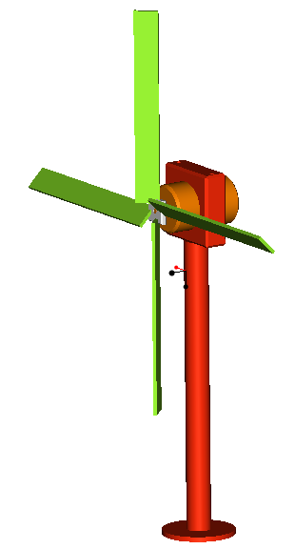
Figure 6.2: A Pro E generated concept for a horizontal axis wind turbine using a DC motor and blade assembly.

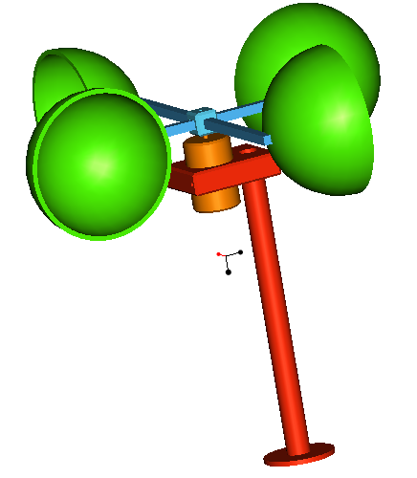
Figure 6.3: A Pro E generated concept for a vertical axis wind turbine using a DC motor and cup-blade assembly.
The turbines will turn small DC motors and create direct current that will be the input to a circuit to visually display the power generated. In order to simplify the construction and assembly of the project we will purchase wooden blades normally used for model aircraft and attach them to the DC motors. The blades are cheep, small, light weight and will be easily replaced if they break. The blades will turn a gearbox that will increase the RPM so that the DC motor will turn faster and create a higher output voltage. The entire assembly will be mounted on a simple vertical pole to make it more like actual turbines. Currently we are testing DC motors to determine which one will be the best fit for our project.
As an added feature to the exhibit we wanted to show the difference between the vertical axis and the horizontal axis turbines. The main difference being that the incident angle with which the wind encounters a vertical axis turbine does not matter, because it turns on a vertical axis the wind will always have the same angle. On a horizontal axis turbine the angle does matter, and to adjust for different wind directions the turbine must be rotated into the wind, if this does not occur the efficiency will drop. To show this in our exhibit we decided to rotate the bases on the turbines so that the incident angle of the wind changes. This will be accomplished through a pulley system that connects to a dial on the control panel of the exhibit, someone using the exhibit will be able to rotate the turbines freely and see the difference in power generation.

6.6 Power meters

The display of power created by the turbines is the main way of getting the message to visitors of the museum about wind energy as an alternative energy source. After going through many different ideas for showing the power generation, the best solution decided on by the group was through the use of a light system that would show sequentially how much power is being generated. The basic idea is to have a light tower wired into the DC output of the motors, the tower would consist of a number of light bulbs; they will light up sequentially as the power generated increases. This idea involves some complicated circuitry needed in order to have it work properly. We have enlisted the help of a few Professors from the college as well as an electrician referred to us by the museum. Some of the other exhibits in the museum us analog DC voltmeters to display things, if the light towers fail to work properly the backup plan is to also use DC voltmeters to show the power generation.

6.7 Start Button

Many exhibits in the museum have start buttons that turn the exhibit on; these buttons have two distinct advantages. The first and probably most important thing is it makes the exhibit more interactive; a child can walk up and turn the exhibit on giving them just a little more control as to what is going on. Secondly the start button keeps the exhibit from running constantly, cutting down on wear and tear of the exhibit as well as electricity used by the exhibit. The museum provided us with a start button that we can use in our exhibit, and it will be mounted on the control panel.

6.8 Kill Switch

One of the requests of the museum was to make sure the exhibit would be very interactive; one way of accomplishing this is to make sure that the fan is not always running. The idea is that the children should be able to walk over press the start button turning the exhibit on. They can then change the wind speed, the angle of attack of the wind turbines, and when they walk away makes sure the exhibit turns off. To accomplish this goal the museum informed us that they use kill switches in other exhibits. The kill switch can be wired into the exhibit and a time can be set so that the exhibit will turn off. Our kill switch will only control the fan, and the pressing of the start button will reset it, to perform this wiring we are going to use the electrician referred to us by the museum. An example of a kill switch can be seen in Figure 6.4.
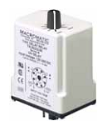
Figure 6.4: Picture of a cut off switch to turn off the power to the fan after a set period of time

6.9 Wind Velocity Measurement

A hot wire anemometer will be used to determine the wind velocity moving through the exhibit as a result of the fan. A hot wire anemometer works on the principle of energy balance. A wire is placed into a fluid flow, current is passed through the wire causing it to heat, when the wire reaches a constant temperature, and the power dissipated through the wire can be calculated using the Voltage, Current and Resistance. That same power that is dissipated must be imparted into the fluid flow, with some known properties of the fluid, in this case air the velocity can be determined as a function of power dissipation through the wire. A hot wire anemometer could be a challenging thing to build and calibrate in order to get accurate readings; because of this our group will purchase one. The hot wire anemometer will protrude into the airflow of the exhibit with a digital display of the wind velocity mounted on the control panel. The digital readout of the wind velocity in the exhibit was a request of the museum in order to give a little more interaction with the exhibit. The hot wire anemometer will be a costly part of the project, with budget estimates from research costing upwards of $500 to purchase. It has been decided that if budget concerns arise that this part of the project may be eliminated so that other parts of the project can continue on. An example of the type of hot wire anemometer that we plan to use in our exhibit can be seen in Figure 6.5.
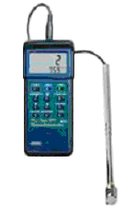
Figure 6.5: Picture of a hot wire anemometer to be used in the exhibit to display the wind velocity.

6.10 Electrician

Our project must work when we are completed with it at the end of the spring semester, and it must last for an extended period of time in the museum. To make sure that all the electronics of the project are wired correctly, the museum gave us the name of an electrician who has done work for them in the past. We will use him along with a professor from the electrical engineering department to aid us in the electronic parts of the project.

6.11 Honeycomb

Dr. Shih wanted our project to be more like a wind tunnel that might be used in research in a lab, in order to make the air flow through the exhibit more like that of a wind tunnel Dr. Shih suggested we use a honeycomb to straighten the flow. In a real world application the wind impinging an actual wind turbine will also not be perfectly parallel. Honeycomb can be purchased to fit our application at a relatively cheap cost, our dimensions for the honeycomb will be two feet square, one inch thick with a comb opening on the order of one quarter of an inch. This should add a little bit more of an experimental setup to the exhibit.
All of the specifications that our group is using to design and build a Wind Energy Exhibit for the Mary Brogan Museum of Arts and Sciences have been provided through much interaction with our project sponsors, Mrs. Heather Whitaker and Professor Shih. Current plans are to formally present our project to the MOAS on Friday December 3, 2004. After presentation to the museum we can begin to order parts, and start to build the exhibit.

7.0 Budget Analysis

The design and fabrication of this type of an exhibit can be quite expensive. However, the engineering students work will be of no cost to the museum. The only cost that the museum will incur is the cost of the materials and the labor of building the exhibit that cannot be done by the engineering students alone. After searching for the necessary materials to build the project and making contact with the COE machine shop and other businesses that will aid in the fabrication of the exhibit a budget was created to determine the cost of the exhibit. Table 7.1 below shows a basic break down of where the money will be spent on the project. In the table there is a 20% margin of error listed, this is 20% of the cost of the project and is there as a cushion to account for the unexpected expenses that will arise when building the project. If there is money that is left over, then that money will be given back to the museum, it would be more professional to ask for the money now and return the extra later, rather than run out of funds towards the end of the project and have to ask for more.
Table 7.1: Basic Budget Break Down
- Wind Generation | $ 415.25
- Power Generation | 352.64
- Electrical Systems | 1502.37
- Flow Management | 100.00
- Pulley System | 148.53
- Exhibit Casing | 1500.00
- 20% margin of error | 803.76
Total Cost | $4822.55

7.1 Wind Generation Cost Analysis

The only thing that needs to be purchased for the wind generation part of the project is the LDC20 fan made by Qmark and will be purchased from www.heatersplus.com. There will be additional costs of shipping and labor that the COE machine shop will perform to mount the fan into the exhibit casing. The COE machine shop charges a rate of $50.00 an hour and estimated labor costs is shown in the bill of the expenses; the wind generation bill of expenses is shown below in Table 7.2.
Table 7.2: Cost of Wind Generation
Part Description | Part Number | Manufacturer | Distributor | Cost
Variable Speed Fan | Qmark LDC20 | Qmark | HeatersPlus.com | $215.25
Shipping | N/A | N/A | N/A | 50.00
Labor | N/A | COE Machine Shop | N/A | 150.00
Total |  |  |  | $415.25

7.2 Power Generation Cost Analysis

The power generation part of the project is the most important part of the project when in conjunction with the light towers; it is the whole purpose of the project. The cost of the power generation however is rather inexpensive when compared to the other parts of the exhibit. The DC motors are very inexpensive, only costing $5.00 from the hobby shop. The breakdown of the cost of the power generation is listed in Table 7.3 below.
Table 7.3: Cost of Power Generation
Part Description | Part Number | Manufacturer | Distributor | Cost
Vertical Axis Turbine
DC Motor | CRE-RE280 | Aristo-Craft | Hobby Town USA | $ 5.00
Cup Rotor | Vortex Pro 1200 | InSpeed.com | InSpeed.com | 0.00
Base structure of Turbine |  |  |  | 13.82
Horizontal Axis Turbine
DC Motor | CRE-RE280 | Aristo-Craft | Hobby Town USA | 15.00
Propeller | 11 x 7 | Top Flite | Hobby Town USA | 5.00
Base structure of Turbine |  |  |  | 13.82
Labor | N/A | COE Machine Shop | N/A | 300.00
Total |  |  |  | $352.64

7.3 Casing Cost Analysis

The casing of museum exhibits can be quite expensive depending on how it is to be constructed. If the plastic sheets were to be joined together the price would be incredibly high, but by bolting plastic sheets to a metal frame the cost is much lower. The 8020 frame will cost approximately $1273.56 without the wooden panels placed into the openings. The wood paneling has an estimated cost of $226.44. The bill of expenses for the exhibit casing is shown in Table 7.4 below.
Table 7.4: Cost of the Exhibit Casing
Description | Part Number | Quantity | Distributor | Cost Per Item | Total
T-slotted extrusion | 1515 | 27 | 8020 | $17.05 | $ 460.32
Black PVC Coated Wire Mesh | 2474 | 2 | 8020 | $18.44 | 36.88
Clear Polycarbonate | 2609 | 3 | 8020 | $98.31 | 294.93
Deluxe Leveling Foot | 2190 | 4 | 8020 | $12.25 | 49.00
Hole Inside Corner Bracket | 4301 | 36 | 8020 | $4.05 | 145.80
90° Degree Pivot Nub | 4388 | 4 | 8020 | $4.55 | 18.20
Straight Arm | 4396 | 8 | 8020 | $5.25 | 42.00
Economy T-Nut | 3320 | 168 | 8020 | $0.57 | 95.76
Flanged BHSCS | 3330 | 8 | 8020 | $0.34 | 2.72
Parts Cut to Length/ Labor | 7010 | 36 | 8020 | $3.55 | 127.95
Wood | N/A | 1 | Wood Concepts | $226.44 | 226.44
Total |  |  |  |  | $1,500.00

7.4 Electronics Cost Analysis

The electronics that will go into the museum exhibit will be the most expensive part of the project. The electronics needed for the project are a kill switch, start button, control circuit, light towers, and an anemometer. The cost analysis for the electronics is shown in Table 7.5 and shows a total cost of $1502.37 for the electronics, labor, and other expenses associated with project.

Table 7.5: Cost of the Electronics
Part Description | Part Number | Manufacturer | Distributor | Price | Quantity | Cost
Power Meters
Light Towers | 8654T7 | Undetermined | McMaster-Carr | $142.06 | 2 | $ 284.12
Control Circuit | N/A | N/A |  | $150.00 | 2 | 300.00
Energy Conservation
Kill Switch | 6X154 | Dayton | Grainger | $54.70 | 1 | 54.70
Start Button | N/A | Unknown | Supplied by Museum | $0.00 | 1 | $0.00
Additional Wiring | N/A | N/A | Radio Shack | $50.00 | 1 | 50.00
Wind Speed
Anemometer | 407117 | Extech | Test equipment depot | $459.00 | 1 | 459.00
AC adapter | 156221 | Extech | Test equipment depot | $25.00 | 1 | 25.00
Labor | N/A | GT Electric | N/A |  |  | 300.00
Shipping |  |  |  |  |  | 29.55
Total |  |  |  |  |  | $1,502.37

As stated in Section 5.4.2, Power Output Display, if the light tower will not work in the exhibit, analog voltmeters will be used. These analog voltmeters can be purchased from McMaster-Carr and would cost approximately $70.00 each. If the voltmeters were used instead of the light towers, the cost will decrease by over $400.00, the only draw back is that the voltmeters are not nearly as visual or attractive as the light towers would be.

7.5 Pulley System for Angle of Attack Analysis

The pulley system that will be used to adjust the angle at which the wind hits the rotors of the wind turbines is a relatively inexpensive way to make the exhibit more interactive and educational. The cost of the pulley system material and associated expenses is less than $150.00. The museum requested that extra round belts be provided so that in case one fails it can be replaced quickly and easily so that the museum will not have to order another and wait for it to be delivered. Two extra round belts will be purchased in addition to the belt needed to build the pulley system, the will be purchased from McMaster-Carr and only cost $7.20 for each belt. The cost of the pulley system is shown in Table 7.6 below.
Table 7.6: Cost of the Pulley System
Part Description | Part number | Distributor | Unit price | Quantity | Cost
Connecting bracket | 33125T44 | McMaster-Carr | $1.98 | 2 | $ 3.96
Pulley | 6284K51 | McMaster-Carr | $6.34 | 6 | 38.04
Round drive belt | 1835T412 | McMaster-Carr | $7.20 | 4 | 28.80
Supporting cross bar | 89215K421 | McMaster-Carr | $17.10 | 1 | 17.10
Shafts | 9061K131 | McMaster-Carr | $10.63 | 1 | 10.63
Labor |  |  |  |  | 50.00
Total |  |  |  |  | $148.53

7.6 Flow Management Cost Analysis

The flow management system of the exhibit is quite simple and inexpensive. The honeycomb panel that will be used to insure laminar flow will be purchased from McMaster-Carr and will cost $50.00 with shipping. The other components of the flow management system are the wire mesh that will be the inlet and outlet ends of the airflow for the exhibit and are a part of the 8020 frame and the cost for the is seen in Table 7.5. The cost analysis for the flow management system is shown in Table 7.7 below.
Table 7.7: Cost of the Flow Management System
Product Description | Part Number | Manufacturer | Distributor | Cost
Honeycomb | 9635K73 | Undetermined | McMaster-Carr | $ 44.55
Front Wire Mesh (see Casing) | 2474 | 80/20 | 80/20 | N/A
Back Wire Mesh (see Casing) | 2474 | 80/20 | 80/20 | N/A
Labor |  |  |  | 50.00
Shipping |  |  |  | 5.45
Total |  |  |  | $100.00

8.0 Future Work

8.1 Museum Deliverables

Before the actual start of this project, one of the first duties outlined was a timeline projecting the completion of this exhibit. The main outline, as decided by the professor of the course, Dr. Luongo, was to have the design and planning completed by December 3, 2004. The spring semester is dedicated to the actual building and construction of the project, which is to be finished in April of 2005. The project has been progressing along as planned; however, the scheduling of the museum’s launch of the entire energy display falls earlier than the expected completion of this project. The energy conversion section of the museum with which this project is associated with is scheduled to be unveiled on January 28, 2005. The museum has been informed of this scheduling difference, and has approved the later completion of the project. Because the other energy exhibits will be displayed before this project is complete, it is desired by the museum to have something in the space where the wind energy exhibit will eventually be displayed. This will help to give the presence of the wind energy exhibit before its actual completion. To do this, there will be a pictorial display of what the exhibit will look like in the space where the exhibit will eventually be showcased. This display will be the first steps to explaining what viewers can expect in the near future.
In order to portray the exhibit, the display will have several pictures and descriptions of the design. The main section of the display will contain the final design as well as a detailed description of the design and how it will work. Pictures of the various components for the final design will be shown to give a better understanding of what the finished exhibit will eventually look like. Similar to the descriptions given for the final design, there will be a description for each components and any other necessary information. Lastly, there will be a timeline in order to let the people who view the exhibit know how long until this wind energy exhibit will be amongst the other exhibits. The display will also be updated periodically during the construction of the exhibit to show the progress made during the spring semester until it is completed. By compiling these figures and descriptions there will hopefully be a spark of curiosity lit in the public that will prod each person to come back to the museum to experience the completed exhibit.
Because this project will initially be absent from the other energy exhibits, it is apparent that there will be a large hole in this section of the museum that is concentrating on energy conversion. By creating this display it will help to fill this void and create the project’s presence and potential to show how it will enhance and compliment the other energy demonstrations. This energy exhibit is one that will be displayed in the museum for years to come, so that absence of this project for a few months is somewhat insignificant in the long term due to the durability and quality that is promised with this project. Although the projected completion date of the exhibit is next April, there is a possibility that the project will be completed earlier. If this scenario happens to occur, and if approval is received from the Dr. Loungo, Dr. Shih, and the museum, the exhibit may be able to be displayed before this deadline. However, even taking into account various conflicts and roadblocks that may occur when constructing the exhibit, it is most definite that the exhibit will be completed by no later than April. In the meantime the proper unveiling of the exhibit will be preceded by this display, which will help to create a clear picture of just exactly what the museum patrons can expect in the near future.

8.2 Plans for Spring Semester

Before the end of the fall semester most, if not all of the parts needed to fabricate the wind energy exhibit will be ordered. At the start of the spring semester more extensive testing will take place using the horizontal and vertical axis wind turbines. At first there will be testing of the electrical output of the horizontal and vertical axis wind turbines using the wind tunnel to determine the exact output of the DC motors at various velocities and angle of attack. This information will then be given to Dr. Li to determine the necessary zener diodes and driver op amps to create the control circuit. Once the control circuit design is completed it will be sent to the GT Electric to fabricate so that it can be installed into the exhibit. As the parts arrive from the various vendors, construction of the exhibit will commence.
The first part of building the exhibit will be the construction of the 8020 frame. Once the 8020 frame is constructed, the carpenter can take the necessary measurements to fabricate the necessary wooden panels that will be attached to the exhibit. While the carpenter is fabricating the wood panels, the support rods and support blocks will be constructed for the wind turbines. The pulley system for the wind turbines will also be constructed and installed onto the 8020 frame while the wooden panels are being made. After the wooden panels are completed, they will be attached to the frame and outer casing of the exhibit will be completed.
Once the outer casing of the exhibit is completed the interior of the exhibit can be installed. First the wind turbines will be installed into the casing and attached to the pulley system. The next components to be installed will be the fan and the light towers and then the electrician will come and do the wiring. The electrician will install the start button, kill switch, control dial for the fan, control circuit, and the anemometer. After the electrician is done installing the electrical components, the exhibit will be completed and final testing can begin. The final testing will test the completed exhibit to make sure everything is in working order before the unveiling of the exhibit at the museum. A schedule of this general outline is shown in Appendix E.

9.0 Conclusion

The Mary Brogan Museum has developed an energy themed exhibit that will educate the public on alternative fuel sources and renewable energy. With this in mind, the museum has expressed interest of working with the Florida State University/ Florida A&M University College of Engineering. Five students from the college of engineering, with help from the Mary Brogan Museum and sponsor Dr. Chiang Shih, will design and fabricate a sub-scale wind energy demonstration.
When the task to create a wind energy demonstration was decided, there were several undetermined specifications. After several meetings with Heather Whitaker, the museum’s coordinator of science exhibitions, these specifications were defined. The museum desired a professional looking, visually appealing, and interactive exhibit, which will be easy enough to understand for visitors of all ages. With this in mind, certain components were deemed necessary. Since young visitors are the target audience the exhibit must be safe during operation. With safety in mind, the electronics, all moving parts, and the entire exhibit will be enclosed inside the casing. There will be vents on both sides of the exhibit, large enough for air to enter and exit the casing, but small enough to prevent hands and other materials from entering the exhibit. The design must be durable and require very little maintenance due to the longevity it will be displayed. To ensure this specification, the casing will be constructed of aluminum with bolt on acrylic plastic inserts to enclose the exhibit. The exhibit also needs to attract and keep the attention of both children and adult visitors; to insure this interaction is the key. Therefore, the wind speed and angle at which the wind strikes the rotors are variable and controlled by museum visitors. These two variables will result in different amounts of power produced by each wind turbine, and will be displayed with the use of light towers rewired to display the power output. These power meters will give the visitors the opportunity to visualize a cause and effect demonstration for each controlled variable in a professional looking and visually appealing manner. The visibility of the exhibit and all moving parts is the next area of concern. The exhibit will maximize the area of visibility, enabling it to entertain a group of museum visitors at one time. The wind turbines will be constructed as open-air turbines giving visibility to the DC generators and other inside components.
With the input of sponsor, Dr. Chiang Shih, several components have been added to aid in the understanding of the exhibit. A major goal of the exhibit was to produce a comparison of two types of wind turbines. In order to create this comparison, two wind turbine designs, one with a horizontal axis of rotation, and the other with a vertical axis of rotation will be used. The two designs will be compared by the power that each one will produce at various wind velocities and different angles of attack. A pulley system was designed to rotate both turbines through different angles of attack, enabling the comparison of vertical and horizontal axis turbines. In order to display the power output of each wind turbine, two light towers will be used. These light towers will be rewired so that each light will represent a unit of power, and as the power output increases, the number of lights that are lit will increase. A Heavy Duty Mini-Vane CFM Thermo-Anemometer will be added to the exhibit in order to measure and display the velocity of the generated wind. A honeycomb screen will be a component of the exhibit in order to regulate and insure a laminar wind flow. With the addition of these components, the design will be a visually appealing, understandable, and interactive educational tool that will be able to be used for many years.
Designing and fabricating a museum exhibit can be quite expensive ranging from $5000 to $20000. At the beginning of the design process, the sponsor Dr. Chiang Shih came up with an estimated budget of $5000. The students’ work will be of no cost to the museum, therefore, this budget will mainly consist of building materials and labor costs due to contracting companies to do the work that the engineering students cannot undertake alone. After research for building materials and contact with the machine shop at the engineering school and other businesses that will aid in the fabrication of the exhibit, a finalized budget was created. The basic budget breakdown can be found in Table 7.1. The proposed budget of $4822.55, which includes a 20% cushion to account for the unexpected expenses that will arise when building the project, is under the estimated budget. This 20% cushion will only be used in the fabrication of the exhibit if it is needed, and will be returned to the museum if it is not used.
The design is ready for the construction phase, as parts will be ordered before the college closes for Christmas break. Once the materials arrive during the spring semester, the exhibit will be fabricated and tested. The testing will be conducted on several aspects. The first will be for safety, the main concern for the project. Once, the exhibit proves to be safe for all ages, the electronics and wiring will be retested insuring proper operation of these components. Once testing is done, the exhibit will be ready for operation in the museum.
The energy-themed exhibit opens on January 28, 2005. However, the wind energy demonstration will not be completed until the end of the spring semester. For the duration of time between the opening of the exhibit and the completion of the wind energy demonstration, certain deliverables will be given to the museum to indicate the status of the construction phase, and a background of what the exhibit will display. Once the wind energy demonstration is complete, it will be displayed at the College of Engineering for the final design presentation and open house, and then will be transported to the museum and implemented into the yearly energy-themed exhibit.
A final ProE rendition of the exhibit can be seen in Figure 9.1.
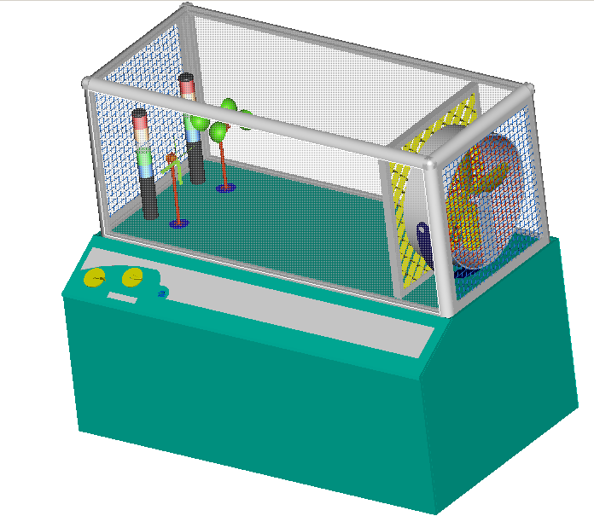
Figure 9.1: Final ProE rendition of the exhibit

Appendix A: Engineering Drawings
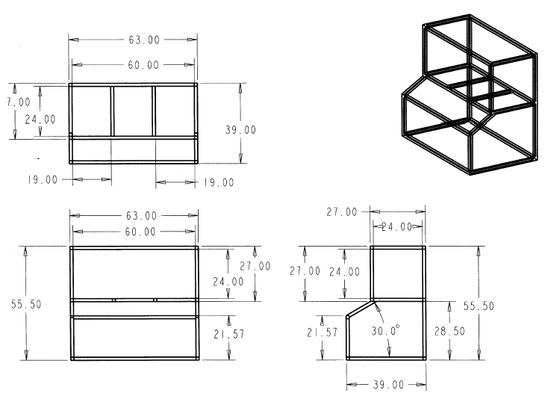
Figure A1: Engineering Drawing of the Casing for the Exhibit.
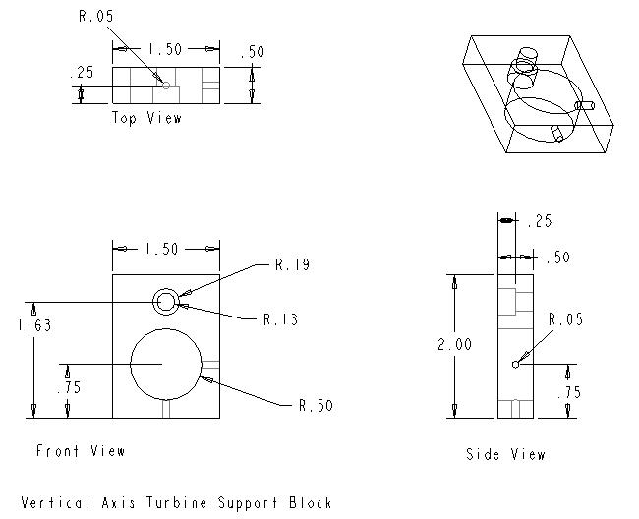
Figure A2: Engineering Drawings of the Vertical Axis Turbine Support Block

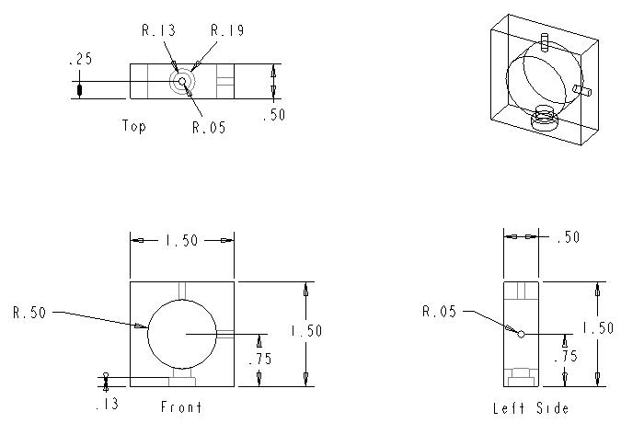
Figure A3: Engineering Drawings for Horizontal Axis Turbine Support Block Drawing

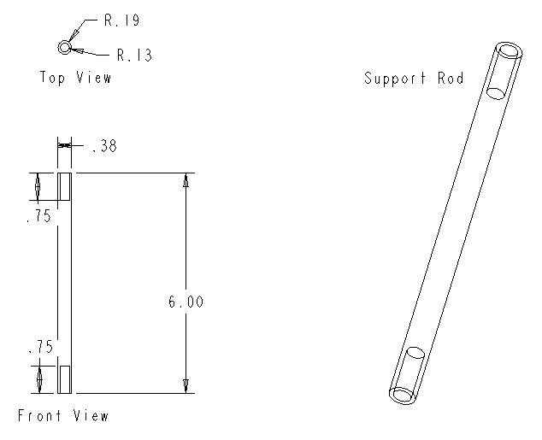
Figure A4: Engineering Drawings for Support Rod for the Turbine assembly

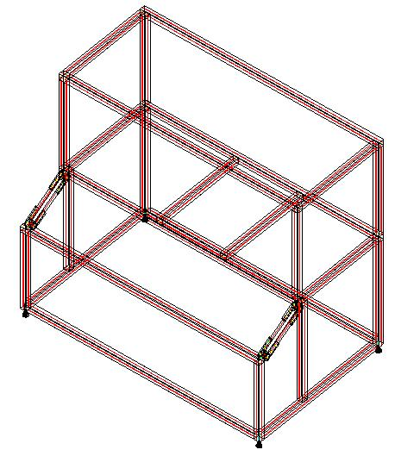
Figure A5: Assembly drawing sent to us by the 8020 company. It shows the feet brackets and hole spots for the assembly of our casing as well as two additional supports that we did not account for that 8020 felt we should include.

Figure A6: Cross sectional view of the 8020 extruded aluminum pieces that we will use to build the casing.

Figure A7: Specialized brackets that slide into the t-slots of standard 8020 extrusions that make it possible to attach pieces.

Figure A8: A side view of an 8020 piece showing how connections are made using machine screws and plates to hold everything together.

Figure A9: Engineering drawing and an example of a corner connection bracket

Figure A10: Engineering drawing and an example of the 30° connection bracket we will be using to connect the 8020 for the control panel

Figure A11: A cross sectional view of the rounded 8020 used in the corners of the exhibit.

Appendix B: Material Selection
Table B1: Specifications for Aluminum used to build support towers
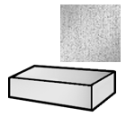 | Part Number 8975K442 | $20.34 Each
 | Shape | Sheets and Bars
 | Sheets and Bars Type | Plain
 | Plain Sheet Type | Rectangular Bar
 | Thickness | 0.5”
 | Thickness Tolerance | ±.009"
 | Length | 12”
 | Length Tolerance | ±1”
 | Width | 6”
 | Width Tolerance | ±0.044”
 | Material | Alloy 6061 Aluminum (Multipurpose)
 | Finish/Coating | Unpolished (Mill)
 | Tolerance | Standard
 | System of Measurement | Inch
 | Material Certification | Without Material Certification
 | Temper | T6511
 | Hardness | 95 Brinell
 | Yield Strength | 35,000 psi
 | Specifications Met | ASTM B221
 | Flatness Tolerance | ±0.006” per inch of width

Table B2: Specifications for Aluminum used to build support towers
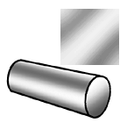 | Part Number 6750K151 | $3.65 Each
 | Shape | Rods
 | Coating Thickness | 0.001” to 0.002”
 | Length | 12”
 | Length Tolerance | ±1/16”
 | Diameter | 3/8”
 | Diameter Tolerance | ±0.003”
 | Material | Alloy 6061 Aluminum (Multipurpose)
 | Finish/Coating | Anodized
 | Tolerance | Standard
 | System of Measurement | Inch
 | Material Certification | Without Material Certification
 | Temper | T6
 | Hardness | Rockwell C70
 | Yield Strength | 40,000 psi
 | Straightness Tolerance | Not Rated
 | Coating Specifications Met | MIL-A-8625

Figure B1: Belt data from McMaster-Carr

Figure B2: Pulley data from McMaster-Carr

Appendix C: Cost Analysis
Table C1: Cost Breakdown for Wind Generation
Part Description | Part Number | Manufacturer | Distributor | Cost
Variable Speed Fan | Qmark LDC20 | Qmark | HeatersPlus.com | $215.25
Shipping | N/A | N/A | N/A | 50.00
Labor | N/A | COE Machine Shop | N/A | 150.00
Total |  |  |  | $415.25

Table C2: Cost Breakdown for Power Generation
Part Description | Part Number | Manufacturer | Distributor | Cost
Vertical Axis Turbine
DC Motor | CRE-RE280 | Aristo-Craft | Hobby Town USA | $ 5.00
Cup Rotor | Vortex Pro 1200 | InSpeed.com | InSpeed.com | 0.00
Base structure of Turbine |  |  |  | 13.82
Horizontal Axis Turbine
DC Motor | CRE-RE280 | Aristo-Craft | Hobby Town USA | 15.00
Propeller | 11 x 7 | Top Flite | Hobby Town USA | 5.00
Base structure of Turbine |  |  |  | 13.82
Labor | N/A | COE Machine Shop | N/A | 300.00
Total |  |  |  | $352.64

Table C3: Cost Breakdown for Exhibit Casing
Description | Part Number | Quantity | Distributor | Cost Per Item | Total
T-slotted extrusion | 1515 | 27 | 8020 | $17.05 | $ 460.32
Black PVC Coated Wire Mesh | 2474 | 2 | 8020 | $18.44 | 36.88
Clear Polycarbonate | 2609 | 3 | 8020 | $98.31 | 294.93
Deluxe Leveling Foot | 2190 | 4 | 8020 | $12.25 | 49.00
Hole Inside Corner Bracket | 4301 | 36 | 8020 | $4.05 | 145.80
90° Degree Pivot Nub | 4388 | 4 | 8020 | $4.55 | 18.20
Straight Arm | 4396 | 8 | 8020 | $5.25 | 42.00
Economy T-Nut | 3320 | 168 | 8020 | $0.57 | 95.76
Flanged BHSCS | 3330 | 8 | 8020 | $0.34 | 2.72
Parts Cut to Length/ Labor | 7010 | 36 | 8020 | $3.55 | 127.95
Wood | N/A | 1 | Wood Concepts | $226.44 | 226.44
Total |  |  |  |  | $1,500.00

Table C3: Cost Breakdown for Parts and Costs from the 8020 Company
Part Number | Quantity | Length (in) | Description | Cost Per Item | Total
1515 | 5 | 63.00 | T-slotted extrusion | $31.50 | $157.50
1515 | 2 | 60.00 | T-slotted extrusion | $30.00 | $60.00
1515 | 2 | 36.00 | T-slotted extrusion | $18.00 | $36.00
1515 | 2 | 28.50 | T-slotted extrusion | $14.25 | $28.50
1515 | 2 | 27.00 | T-slotted extrusion | $13.50 | $27.00
1515 | 10 | 27.84 | T-slotted extrusion | $12.00 | $120.00
1515 | 2 | 20.938 | T-slotted extrusion | $10.47 | $20.94
1515 | 2 | 10.375 | T-slotted extrusion | $5.19 | $10.38
2474 | 2 | 6.250 SQ ft | Black PVC Coated Wire Mesh | $18.44 | $36.88
2609 | 3 | 13.750 SQ ft | Clear Polycarbonate | $98.31 | $294.93
7010 | 27 | N/A | Parts Cut to Length | $1.850 | $49.95
7025 | 4 | N/A | Tap Extrusion Ends | $2.25 | $9.00
7095 | 2 | N/A | Shearing Expanded Metal | $9.75 | $19.50
7155 | 3 | N/A | Cut Polycarbonate Panels | $16.50 | $49.50
2190 | 4 | N/A | Deluxe Leveling Foot | $12.25 | $49.00
4301 | 36 | N/A | Hole Inside Corner Bracket | $4.05 | $145.80
4388 | 4 | N/A | 90° Degree Pivot Nub | $4.55 | $18.20
4396 | 8 | N/A | Straight Arm | $5.25 | $42.00
3320 | 168 | N/A | Economy T-Nut | $0.57 | $95.76
3330 | 8 | N/A | Flanged BHSCS | $0.34 | $2.72
 |  |  |  | Total | $1,273.56

Table C4: Cost Breakdown for Electronics
Part Description | Part Number | Manufacturer | Distributor | Price | Quantity | Cost
Power Meters
Light Towers | 8654T7 | Undetermined | McMaster-Carr | $142.06 | 2 | $ 284.12
Control Circuit | N/A | N/A |  | $150.00 | 2 | 300.00
Energy Conservation
Kill Switch | 6X154 | Dayton | Grainger | $54.70 | 1 | 54.70
Start Button | N/A | Unknown | Supplied by Museum | $0.00 | 1 | $0.00
Additional Wiring | N/A | N/A | Radio Shack | $50.00 | 1 | 50.00
Wind Speed
Anemometer | 407117 | Extech | Test equipment depot | $459.00 | 1 | 459.00
AC adapter | 156221 | Extech | Test equipment depot | $25.00 | 1 | 25.00
Labor | N/A | GT Electric | N/A |  |  | 300.00
Shipping |  |  |  |  |  | 29.55
Total |  |  |  |  |  | $1,502.37

Table C5: Cost Breakdown for the Pulley System
Part Description | Part number | Distributor | Unit price | Quantity | Cost
Connecting bracket | 33125T44 | McMaster-Carr | $1.98 | 2 | $ 3.96
Pulley | 6284K51 | McMaster-Carr | $6.34 | 6 | 38.04
Round drive belt | 1835T412 | McMaster-Carr | $7.20 | 4 | 28.80
Supporting cross bar | 89215K421 | McMaster-Carr | $17.10 | 1 | 17.10
Shafts | 9061K131 | McMaster-Carr | $10.63 | 1 | 10.63
Labor |  |  |  |  | 50.00
Total |  |  |  |  | $148.53

Table C6: Cost Breakdown for the Flow Management System
Product Description | Part Number | Manufacturer | Distributor | Cost
Honeycomb | 9635K73 | Undetermined | McMaster-Carr | $ 44.55
Front Wire Mesh (see Casing) | 2474 | 80/20 | 80/20 | N/A
Back Wire Mesh (see Casing) | 2474 | 80/20 | 80/20 | N/A
Labor |  |  |  | 50.00
Shipping |  |  |  | 5.45
Total |  |  |  | $100.00

Table C7: Budget Break Down Summary
Wind Generation | $ 415.25
Power Generation | 352.64
Electrical Systems | 1502.37
Flow Management | 100.00
Pulley System | 148.53
Exhibit Casing | 1500.00
20% margin of error | 803.76
Total Cost | $4822.55

Appendix D: Calculations

Appendix E: Schedule

Resources and Assignments | Start | Finish
Contact With Dr. Shih | September 2, 2004 | September 2, 2004
Team Building | September 6, 2004 | September 6, 2004
Meeting With MOAS | September 9, 2004 | September 9, 2004
Prepare Code of Conduct | September 6, 2004 | September 9, 2004
Submit Code of Conduct | September 9, 2004 | September 9, 2004
First Tuesday group meeting | September 14, 2004 | September 14, 2004
Prepare Project Scope | September 14, 2004 | September 16, 2004
Submit Project Scope | September 16, 2004 | September 16, 2004
1st Fall Progress Presentation (Victor) | September 23, 2004 | September 23, 2004
2nd Meeting with Dr. Shih | September 27, 2004 | September 27, 2004
Begin work on Website (Suzanne) | September 28, 2004 | September 28, 2004
Prepare Needs Assesment and Product Specifictaion | September 28, 2004 | September 30, 2004
Submit Needs Assemsment and Product Specification | September 30, 2004 | September 30, 2004
Prepare Project Schedule & Delgate of tasks | October 10, 2004 | October 14, 2004
Submit project schedule | October 14, 2004 | October 14, 2004
Tuesday group meeting | October 12, 2004 | October 12, 2004
2nd Meeting with MOAS | October 7, 2004 | October 7, 2004
3rd Meeting with Dr. Shih | October 8, 2004 | October 8, 2004
Tuesday group meeting | October 12, 2004 | October 12, 2004
First Sunday Group Meeting | October 10, 2004 | October 10, 2004
Prepare Concept Generation and Selection | October 10, 2004 | October 14, 2004
Submit concept generation and selection | October 10, 2004 | October 10, 2004
Calculations | October 18, 2004 | October 20, 2004
Budget Analysis | October 20, 2004 | October 22, 2004
Pro/E Design | October 19, 2004 | October 25, 2004
Tuesday Group meeting (Budget, Concept, Pro E, etc) | October 19, 2004 | October 19, 2004
Staff Meeting | October 14, 2004 | October 14, 2004
Prepare 2nd Fall Progress Presentation | October 17, 2004 | October 21, 2004
Tuesday group Meeting | October 19, 2004 | October 19, 2004
2nd Fall Progress Presentation (Nicholas) | October 21, 2004 | October 21, 2004
Sunday group meeting | October 10, 2004 | October 10, 2004
Tuesday Group meeting | October 12, 2004 | October 12, 2004
Meeting with Keith Larson (Victor) | October 13, 2004 | October 13, 2004
First trip to Hobbytown USA (Mike & Victor) | October 16, 2004 | October 16, 2004
Sunday group meeting | October 17, 2004 | October 17, 2004
Bi-weekly Meeting With MOAS | October 19, 2004 | October 19, 2004
Tuesday group meeting | October 19, 2004 | October 19, 2004
Sunday group meeting | October 24, 2004 | October 24, 2004
Meeting with Dr Dave (Brad) | October 25, 2004 | October 25, 2004
Bi-weekly meeting with MOAS | October 26, 2004 | October 26, 2004
Trips to Grainger & Radioshack (Brad & Victor) | October 26, 2004 | October 26, 2004
Tuesday Group meeting | October 26, 2004 | October 26, 2004
Sunday group meeting | October 31, 2004 | October 31, 2004
Tuesday group meeting | November 2, 2004 | November 2, 2004
Prepare 3rd fall progress presentation | November 2, 2004 | November 4, 2004
3rd Fall Progress Presentation (Mike) | November 4, 2004 | November 4, 2004
1st trip to 4 Acre Electronics (Brad) | November 6, 2004 | November 6, 2004
Individual member meetings w/ Dr Shih | November 8, 2004 | November 12, 2004
Trip to Hobbytown | November 16, 2004 | November 16, 2004
Tuesday Group meeting | November 16, 2004 | November 16, 2004
Prepare 4th fall progress presentation | November 16, 2004 | November 18, 2004
Fan and Motor testing (Victor) | November 16, 2004 | November 17, 2004
Meeting with Keith Larson (Victor) | November 17, 2004 | November 17, 2004
Meet with Dr Li (Brad) | November 18, 2004 | November 18, 2004
4th Fall Progress presentation (Brad and Suzanne) | November 18, 2004 | November 18, 2004
Prepare Fall Proposal & Presentation | November 16, 2004 | December 1, 2004
2nd trip to 4 Acre Electronics (Brad) | November 18, 2004 | November 18, 2004
Sunday group meeting (Proposal and Presentation) | November 21, 2004 | November 21, 2004
Meet with Dr Li (Victor) | November 22, 2004 | November 22, 2004
Fan and Motor Testing (Victor) | November 22, 2004 | November 22, 2004
Tuesday Group Meeting (Proposal and Presentation) | November 23, 2004 | November 23, 2004
Sunday group meeting (Proposal and Presentation) | November 28, 2004 | November 28, 2004
Tuesday Group Meeting (Proposal and Presentation) | November 30, 2004 | November 30, 2004
Fall Design Presentation | December 2, 2004 | December 2, 2004
Submit Fall Design Report | December 2, 2004 | December 2, 2004
Submit Spring Proposal to MOAS | December 3, 2004 | December 3, 2004
Web site Up and Running (Suzanne) | December 3, 2004 | December 3, 2004
Order Parts | December 6, 2004 | December 10, 2004
End of Classes | December 10, 2004 | December 10, 2004
Christmas Break | December 13, 2004 | January 3, 2005
Resume Classes | January 5, 2005 | January 5, 2005
First group meeting for the year | January 5, 2005 | January 5, 2005
Prepare restated project scope and presentation | January 5, 2005 | January 6, 2005
Submit restated project scope | January 6, 2005 | January 6, 2005
Project scope Presentation (Victor) | January 6, 2005 | January 6, 2005
First meeting with MOAS for the year | January 11, 2005 | January 11, 2005
Testing of wind turbines in wind tunnel | January 10, 2005 | January 20, 2005
Tuesday Group Meeting | January 11, 2005 | January 11, 2005
Prepare restatement of work and presentation | January 11, 2005 | January 13, 2005
Submit restatement of work | January 13, 2005 | January 13, 2005
Restated work presentation | January 13, 2005 | January 13, 2005
Sunday group meeting | January 16, 2005 | January 16, 2005
Prepare exhibit poster for museum | January 18, 2005 | January 28, 2005
Tuesday Group Meeting | January 18, 2005 | January 18, 2005
staff meeting | January 20, 2005 | January 20, 2005
Sunday group meeting | January 23, 2005 | January 23, 2005
Begin receiving parts | January 10, 2005 | January 20, 2005
Design of electrical system with Dr Li | January 24, 2005 | February 4, 2005
Tuesday group meeting | January 25, 2005 | January 25, 2005
Prepare 1st spring progress presentation | January 25, 2005 | January 27, 2005
1st Fall Progress Presentation (Nicholas) | January 27, 2005 | January 27, 2005
Submit exhibit poster to museum | January 28, 2005 | January 28, 2005
Sunday group meeting | January 30, 2005 | January 30, 2005
Assembling 80/20 Casing | January 31, 2005 | February 11, 2005
Tuesday group meeting | February 1, 2005 | February 1, 2005
staff meeting | February 3, 2005 | February 3, 2005
Consulting with Carpenter | February 14, 2005 | February 14, 2005
Carpenter fabrication of wood panel etc | February 14, 2005 | February 25, 2005
Construction of support blocks and rods for turbines | February 14, 2005 | February 18, 2005
Constructing Pulley system | February 14, 2005 | February 25, 2005
Tuesday group meeting | February 15, 2005 | February 15, 2005
Staff meeting | February 17, 2005 | February 17, 2005
Sunday group meeting | February 20, 2005 | February 20, 2005
Tuesday group meeting | February 22, 2005 | February 22, 2005
Prepare 2nd spring progress presentation | February 22, 2005 | February 24, 2005
2nd Spring Progress presentation (Mike) | February 24, 2005 | February 24, 2005
Sunday group meeting | February 27, 2005 | February 27, 2005
Assembly of turbines with pulley system | February 28, 2005 | March 1, 2005
Tuesday group meeting | March 1, 2005 | March 1, 2005
Staff meeting | March 3, 2005 | March 3, 2005
Wiring by G T Electric | March 2, 2005 | March 15, 2005
Final project review | March 17, 2005 | March 17, 2005
Final Testing | March 16, 2005 | March 22, 2005
Operations manuals due | March 24, 2005 | March 24, 2005
Walk through for open house presentation | March 31, 2005 | March 31, 2005
Web Page due | March 31, 2005 | March 31, 2005
open house | April 7, 2005 | April 7, 2005

