MOAS Project: Wind Energy Demonstration

Team Building

Wind Energy Systems Inc.

Members
Nicholas Bembridge
Victor Fontecchio
Bradley Kroger
Michael Sheehan
Suzanne Shepherd

September 9, 2004
EML 4551

The team activity that we all agreed upon was to meet for lunch at Firehouse Subs. We all sat down, had lunch and discussed, in general, our expectations for the project and ourselves. All of us met at the restaurant time except for Brad Kroger because his car broke down; thus, he was unable to make it. Brad did however call and notify the group of his absence and apologized that he could not attend.
The meeting was very pleasant, and although we were there because of our senior design project, we tried to talk about school and engineering as little as possible. The reason for this was to really get to know the other members of the group outside of school. It was interesting to see the other group members’ interests as well as to learn about the different paths each member will take once graduated.
The activity was successful in that the food was good, the team had a good bonding experience, and Brad was not hurt when his car broke down. Figure 1 below is a picture of the group. Although this is not a picture from our actual team building activity, we decided to sacrifice that picture in order to include Brad. We feel it’s more important to be united for our first team picture. This event really helped to kick off our project and we are now ready to shift our focus to the task at hand.

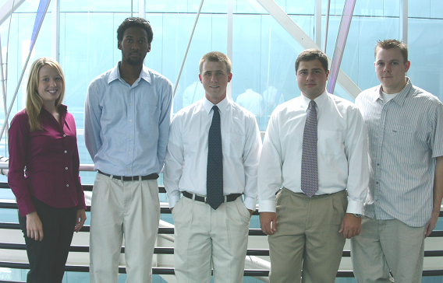

Figure 1: MOAS team members. Starting from left: Suzanne Shepherd, Nicholas Bembridge, Michael Sheehan, Victor Fontecchio, Bradley Kroger

