1.0 Introduction
In this project Cummins has asked to design a thermal fatigue failure testing rig for an aluminum sample. The aluminum sample is going to be tested because of the extreme temperature changes that occur in the head of an operating diesel engine. The fatigue testing to be done on the aluminum sample will be constrained thermal fatigue. This means the material will not be allowed to expand with rising temperature, which will place the sample under compression. The sample will also be in tension as it cools down. A significant property for materials under constrained thermal fatigue is the coefficient of thermal expansion. The higher the thermal expansion coefficient, the higher the compressive stress.
While an engine is operating the cylinder head goes through rapid changes in temperature due to the intake of outside air and the exhaust of the hot cylinder gases. This causes thermal fatigue in the cylinder head, which causes a crack to form. Thermal fatigue failure is one of the most important life-limiting mechanisms in cylinder heads. As the engine continues to operate, the crack that may have originated in a small insignificant corner of the inner cylinder head will continue to grow and eventually cause a complete failure of the engine. To test this process many different attributes have to be identified
Thermal fatigue damage can be characterized with respect to crack length and density of cracks but in this experiment the metal is constrained in order to apply stress on the sample. In our experiment we will go a little further than looking at the crack length. Based on our experimental findings, we will look at the mechanical properties of certain aluminum alloys under constrained thermal-mechanical fatigue. At the end of our experiment we want to be able to make estimations of thermal fatigue life of different aluminum based on their mechanical properties.
A primary location for potential failure has been an area called the "valve bridge" of the cylinder head, which is part of the combustion chamber. The thermal cycles are not related to the combustion event directly. These thermal stresses are actually related to the heating up to operating temperature and the cooling down of the engine. This causes stresses by restricting the ability of the material in the valve bride to expand due to thermal cycling.

2.0 Background Research
ASTM test methods
Comparing metal fatigue and fracture to material properties requires extensive analysis and testing. The control of fracture and fatigue has become a high priority of designers and materials researchers. Outlined below are two ASTM Test Methods, ASTM Test Method E 466, ASTM Test Method E 606 , some Key Factors in fatigue testing performance, low cycle fatigue systems and thermal-mechanical fatigue testing.
ASTM Test Method E 466 - Constant Amplitude Axial Fatigue Test
Attributes of the E 466 ASTM test method of axial load fatigue testing:
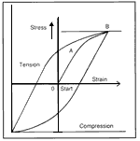

Figure 2.0.1: ASTM Figure
The guidelines in the selection of materials for use under cyclic stress conditions evaluates the effects of material shape, surface condition, stress level, and related factors on fatigue life of metallic materials. It also covers tests of materials in the regime where the strains are mostly elastic during critical loading throughout the test. It is limited to axial notched and un-notched specimens that are subjected to a periodic function of constant cyclic amplitude.
Examples of Important Fatigue Applications Subjected to Cyclic Loads
- Rotating shafts or axles
- Aircraft wings
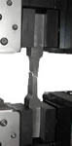
Figure 2.0.2: Fatigue Fracture Testing Sample
Key Factors in Performing Fatigue Tests
- Specimen alignment
- Specimen surface condition
A high level of precision is needed in setting and maintaining cyclic loading parameters and test frequency. Due to any misalignment of a specimen will produce bending, causing premature failure and giving erroneous results. Strain gauges are recommended to measure and thus eliminate bending strains, which could be induced in the specimen during a test. Repeatability of gripping alignment is also critical to a successful test program because of the time required for realignment. Precise, dynamically rated extensometers enable measuring the axial deformations.

ASTM Test Method E 606 - Constant Amplitude Low-Cycle Fatigue Test
Broadly applied methods for constant amplitude low-cycle fatigue testing, typically of homogeneous metallic materials. Uniform, though not necessarily ambient, temperature, pressure, humidity, etc., is applied to the test specimen. Tests are conducted in constant amplitude stress or strain cycling (without hold times). Such tests are useful in developing data from mechanical design, materials R&D, process and quality control, product performance, and failure analysis. Lots of valuable information can be obtained regarding the stability of materials under cyclic loading, or whether changes occur due to cyclic plastic straining, and when cracks begin to form.

Low Cycle Fatigue (LCF) Testing
The test system should be free of backlash in the loading train since through-zero loads are applied in tension and compression. The system measures the components of strain resulting from the thermal expansion as well as mechanically induced deformation and, therefore, can control total strain on the specimen to match a required test profile. Thermal-mechanical fatigue testing requires specially designed water-cooled grips and extensometers so that the test system does not fail before the specimen.

3.0 Design Selection:
3.1 Design 1:
Design one is a very simple design. In this design the aluminum sample will be placed in a furnace for a specified period of time in which the sample will be allowed to reach the desired temperature of 500°F. Once it has reached this temperature it will then be removed by using a pair of insulated tongs. Once removed from the furnace it can ether be placed on a cooling table to cool naturally or, to increase the cooling rate, it can be placed in a cooling bath. Even though this design has a very low cost and is very simple to operate it was quickly discarded. The major flaw in this design are because the large number of cycles that the sample has to go through. Knowing this, the amount of time that is required for this method of heating and cooling is unsatisfactory. The large amount of time and the fact that the sample has to be manually makes the amount of tedious user time required will be almost unbearable. Another one of the major flaws in this design is that the sample has to be constrained for it to see the mechanical stress. For this to happen it most be placed with some type of restricting device and this device will also have to go trough the thermal cycling with it. Having this device go through the thermal cycling will cause it to also expand and contract with the sample and therefore not be restrictive enough to work properly.
3.2 Design 2:
In this design a more automated, self-contained system was desired. For this reason,it was designed to have a clamping stand that will hold the sample in place similar to that of a C-clamp. The heating of the sample is done by placing an electric heating coil near the sample. For the cooling in this design it was decided that forced convection could be used. The air can be blown over the sample by the use of a fan or a type of air-conditioning unit so that colder air is blown over the sample and cooling will occur at a faster rate. The heating and the cooling of the sample will be controlled electronically so that the user does not have to be present during the total time it takes to test the sample. The temperature and load measurements of this sample can also be easily taken. The largest drawback to using this method is that clamp that is holding the sample is not isolated from the temperature fluctuation and therefore will expand and contract with the sample. This method will also require a large amount of time to complete the testing of the sample.
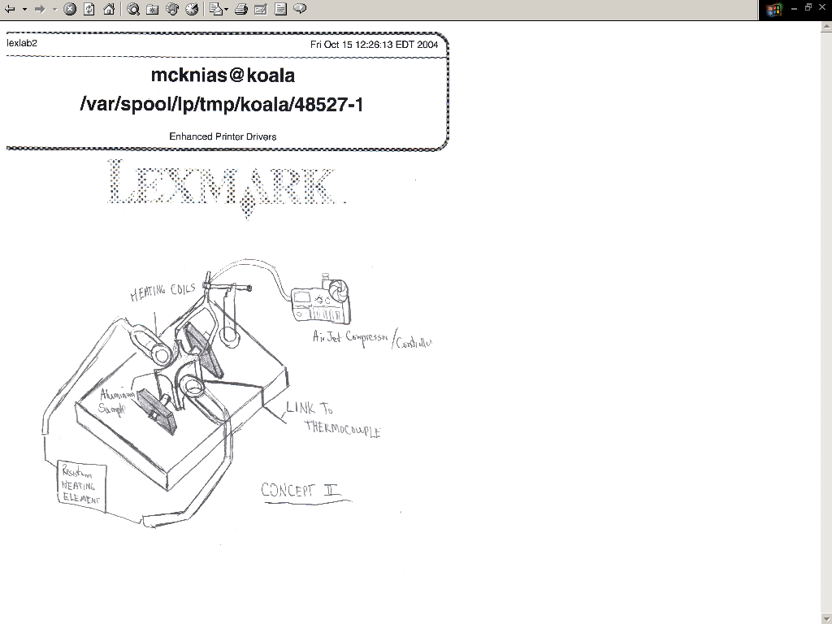
Figure 3.2.1: Sketch of Design 2
3.3 Design 3:
The principal ideas with this design was conceived to shorten the length of time required to heat and cool the sample so that to total time to failure will be shortened. Due to this we considered different methods of transferring the heat to the sample. The method that was chosen to heat the sample was by placing it in a hot oil bath, which can be heated through electricity or propane. The bath will be at a controlled temperature above the required temperature of the sample so that the heat will transfer to the sample faster. The cooling would be done by placing the sample in a cold water bath. The sample will also be within a C-clamp type of device. This sample and the clamp can be placed from one bath to the other through a mechanical mechanism. These are two principle drawbacks to this design. The first of these drawbacks that the clamp is also being placed in the heating and cooling baths with the sample and therefore expanding and contracting along with the sample. This will cause inaccurate results by reducing the amount of stress seen by the sample. The measuring of the load in the sample will also be more difficult to obtain because the load cell has to be able to withstand the heating a cooling. The other drawback to this system is that it is unsafe because the when the sample is removed from the water bath it will have moisture on it. This moisture will then be carried with it to the hot oil bath, which will cause the oil to splatter and possibly cause a fire or burn the operator.
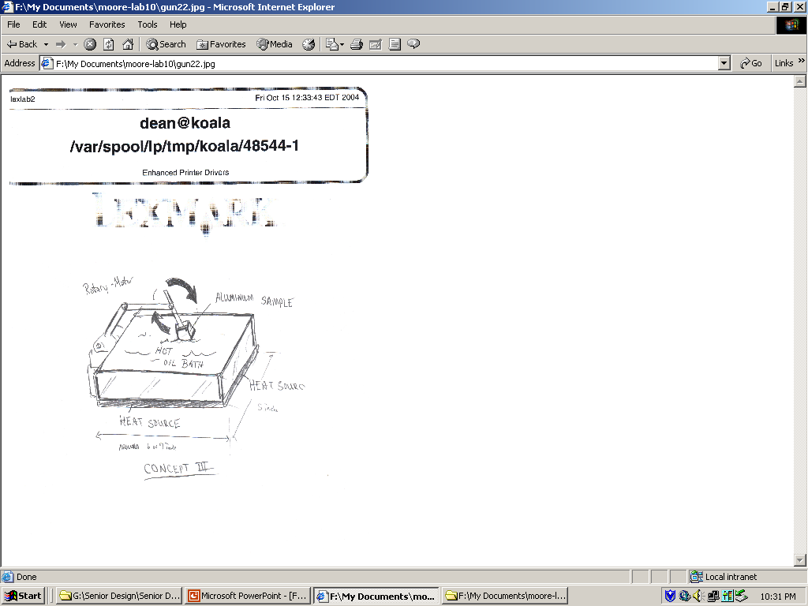
Figure 3.3.1: Sketch of Design 3
3.4 Design 4:
In this design we looked at design 2 and revised it so that it would be more suitable. To do this we decided to use the same method of heating by placing a heating coil around the sample. The cooling of the sample is going to be done through natural convection. The principle drawback to design 2 is that the clamps that are holding the specimen are not isolated from the thermal fluctuation. In this design the clamps are going to be cooled to limit the effects of the thermal fluctuation. This design will have the ability to measure temperature and load. The heating of this design will be controlled electronically which will relieve the user from having to be next to the testing apparatus all of the time. In this design the principle drawback is it complexity and cost.
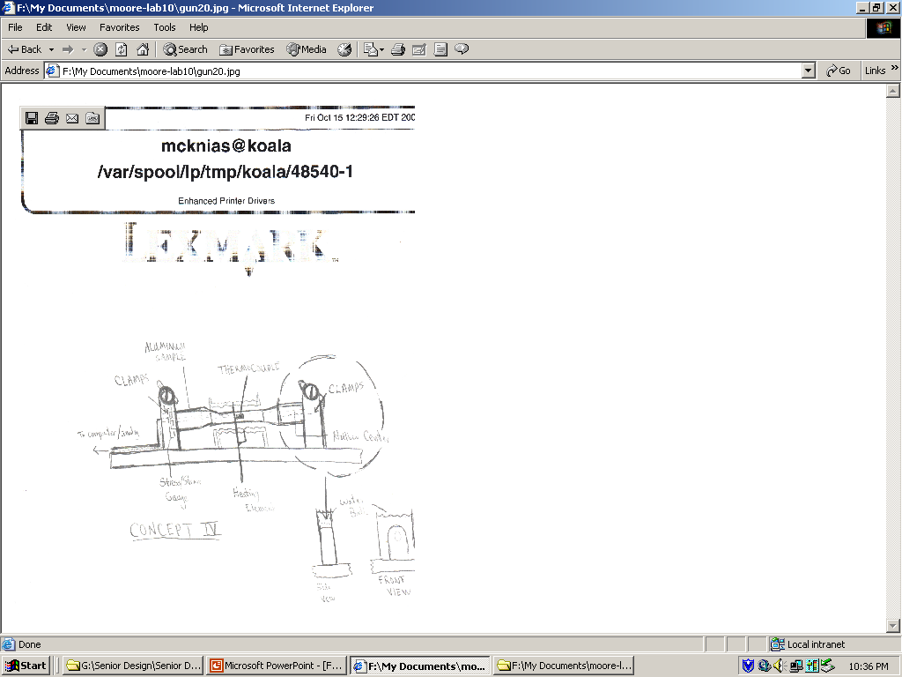
Figure 3.4.1: Sketch of Design 4
Once these designs were though up a weighting system for the design was created. We placed the largest amount of emphasis on the effectiveness of the design because not matter what if we do not get useable accurate results from this design we did not achieve anything. The next most important factors in this design were the length of time and cost of the design. Operator safety was the next concern that was taken into account. The final concern in the final design was overall design complexity. Once this weighting method was decided the design were placed into a design matrix to decided which design would be the best to proceed with.
Table 3.4.1: Design Matrix
4.0 Final Design
From the design matrix shown in table 1 it can be seen that design 4 is the most suitable design to proceed with. In case of any problem with design 4 the next best design that can be used will be design 2. The initial setup for this design was to make a sample that will produce appropriate results. The shape of the sample was decided to be cylindrical because this will make it easier to obtain proper results. To take proper temperature measurements the center of the sample is bored out to allow the placement of a thermocouple. The sample will have a center diameter of .47” with an increase in size at the end of the sample to .7” diameter. The total length of the sample will be 3.7”. This sample is shown below in figure 4.0.1.

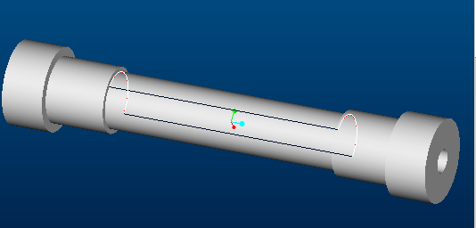

Figure 4.0.1: Sample Design
Once the sample shape was decided upon the design of the holding clamps had to be made. The decision was made so that clamps hold the sample through friction. To accomplish the friction holding the clamp was designed to have a strap type clamp that will be bolted down over the sample. This strap will keep the sample from popping out of the hold or moving laterally. Circulating water over the clamp will provide the cooling of the clamp. With a pump that produces a 60 gallons per hour flow rate the calculated energy loss of the clamp would be 180 Watts. This heat loss was calculated for the most extreme case that the clamp will be placed in. Because the conduction through the aluminum sample will only be 130 Watts the loss of heat through the clamp was found to be more then enough to keep the clamp at a stable temperature. The clamps will also have a mechanical stop so that if the friction clamps fail the sample not be able to expand. One of the clamps is shown in figure 4.0.2. This clamp has a hole in the backside of the to be able to slide the thermocouple and wire through into the sample.
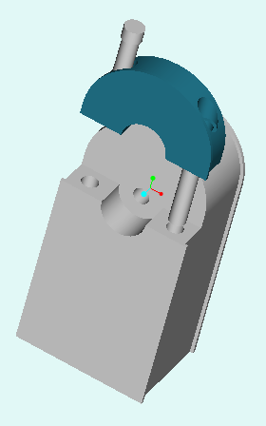
Figure 4.0.2: Stationary Clamp
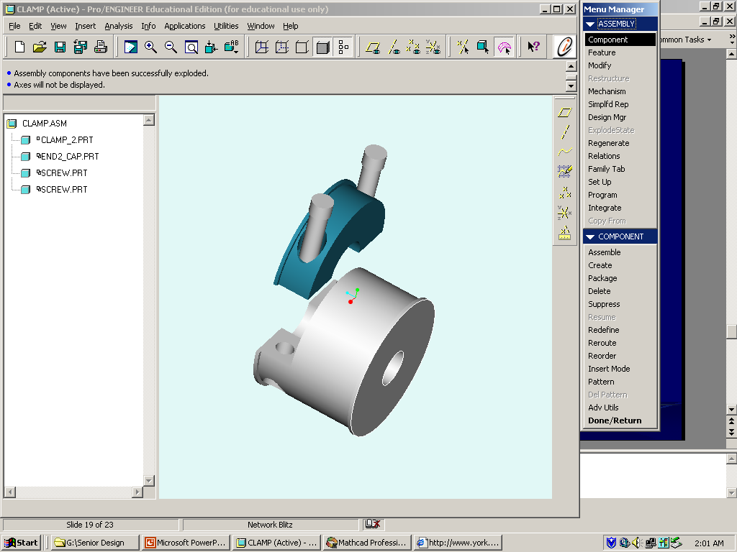
Figure 4.0.3 Connecting Clamp
The clamp shown in figure 4.0.3 is the clamp that is going to be used to connect the sample to the load cell. This will be connected to the cell through the threaded hole in the backside of the clamp. Both of the clamps will have clamps will have raised edges to direct the water flow over then and to increase the amount of surface area to transfer heat. The complete design will look similar to what is show in figure 4.0.4.
Figure 4.0.4: Complete Pro-E of Design

5.0 FEM Analysis
In the preliminary phase of our design, Algor was used to do a finite element analysis of the test rig and the sample itself. The purpose of these analyses was to see the effects of the heat from the sample on the test rig. It will primarily be used to gauge the effectiveness of cooling the clamps with water in order to negate the effects of thermal expansion to the clamps. As shown in the previous design drawing the clamps will play a crucial role in preventing the sample from expanding along the horizontal axis. This will cause the clamp to experience tension and compression during the heating and cooling processes much like the cylinder heads of diesel engines.
The analysis consisted of 4 separate analyses. The first test was done on the sample, the remaining test where all done on the clamps of the test rig. Each test will be discussed in detail with a couple of figures. The rest of the figures will be presented in the appendix
The first analysis involved constraining the sample at both ends and raising the temperature of the entire sample to 450(F. The ends where constrained to simulate actual cylinder heads and also the real life sample will be constrained at both ends. The temperature used throughout the FEM analysis is 450(F. As stated the sample will be heated to a uniform temperature. As such the analysis involved raising the temperature of each individual node. Once this was done the displacement of the sample and the Von Misses stress where analyzed. The figure below shows the displacement in the vertical direction. If the sample is constrained then it should experience a bulge similar to one below. This should induce the compressive and tensile force similar to cylinders.
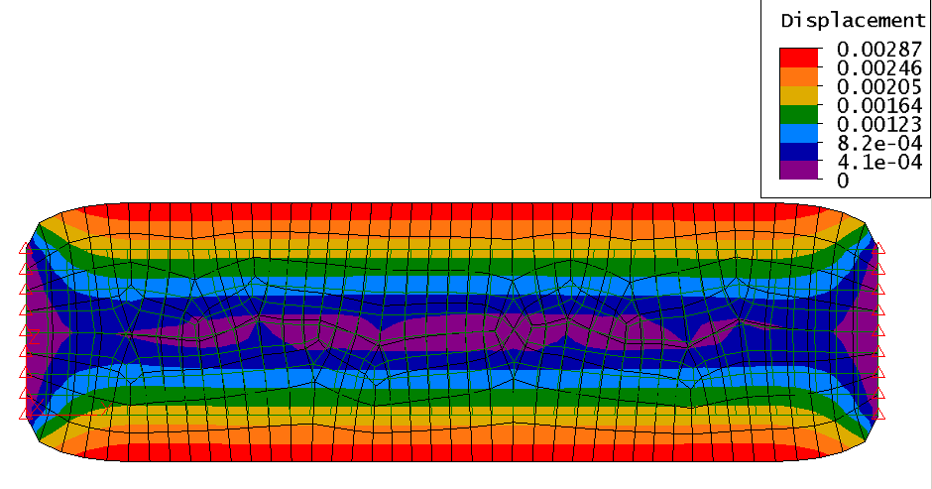
Figure5.0.1: Displacement of Sample
The second analysis was a steady-state heat transfer analysis of the clamp. The analysis was done with an applied temperature of 450(F to the inner ring. This will be the contact point between the clamp and the sample. Since the sample will heated to a uniform temperature of 450(F, applying 450(F to inner area of the clamp should simulate the actual testing. This analysis focused only on the heat distribution that the clamp will experience with the effect of water running over the clamps. The results showed that the entire clamp reach temperatures over 400 degrees. This is obviously unacceptable if we want to minimize the effects of the heat on the clamps. Also in this model only convection through the air was taken into account.
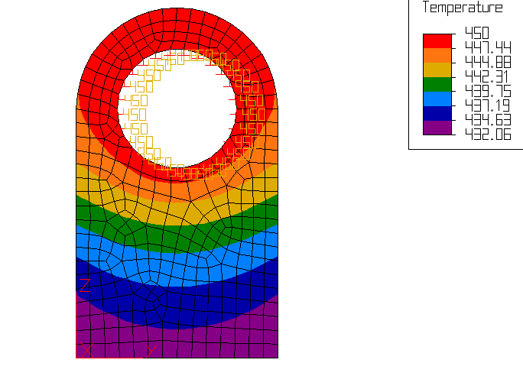
Figure 5.0.2: Thermal Distribution of Clamp
To compliment the thermal analysis, a linear static stress analysis was done to check the displacement the clamp would experience. The same set of parameters that where used for the thermal analysis where also used for the static stress analysis. A temperature of 450(F was applied to the inner ring of the clamp and the displacement as well as the stress of the clamp where analyzed. The displacement results are shown below and the stress will be presented in the appendix. As shown in the figure 3, the clamp experience displacement in the outward from the ring. In a sense the diameter of the ring expands. Since the clamp will be using friction as one way to hold the sample, any expansion will have adverse affects on the ability of the clamps to secure the sample from moving. As such the displacement as well as the temperature of the clamps needs to be minimized.
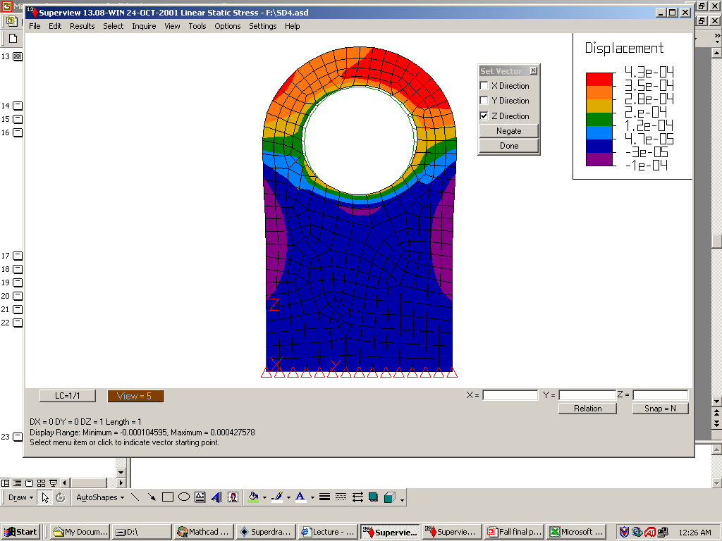
Figure 5.0.3: Displacement of Clamp
The 4th analysis was another thermal analysis very similar the first thermal analysis of the clamp. The first analysis used an applied temperature of 450(F to inner ring and convention coefficient of 0.038 in*lbf/(s*F*in2). This value was obtained from MathCAD calculations. On this analysis and an additional 15.155 in*lbf/(s*F*in2) was added to convection coefficient for a total of 15.193. This simulates the clamp loosing heat form the natural convection and the water running over the clamps. The value for the convection of coefficient for water was found in MathCAD using flow rates and properties of water at film temperature. The figure shows a large decrease in the temperature of the clamps as well as a lower temperature distribution. The linear static stress analysis couldn’t be done with the convection, but from the lower temperature the plate experiences the displacement should be much lower than the previous analysis. The minimum temperature before taking into account heat loss through water was 432.06 (F. After the addition of water the minimum temperature was 81.65(F. So the water addition is definitely a must in the design.
Figure 5.0.4: Second Temperature Distribution of Clamp
The FEM analysis where a basic 2-D shapes that had a given thickness. While this is pretty accurate we hope to achieve more accurate values next semester using our Pro-E model in Algor. These same 4 analyses will be done on the full 3-D model.
This analysis was quite satisfactory in validating the use of water-cooling the clamps.

6.0 Cost Analysis

The table below shows the breakdown of the predicted cost. There are several points to highlight. The cast iron couldn’t be found online so we are hoping to get some assistance from Cummins in securing the cast iron samples or maybe finding a local shop to cut them. Cummins has also said they would supply or either specify the types of aluminum to be used in the testing. The controller for the heating source is still to be determined because we did not find one to meet our specifications, mainly an all in one heat source and controller. Next, if our budget allows we really want to get a digital thermocouple with an easy interface and LCD screen. This would really help on the accuracy and data collection on the samples. However it was rather expensive so we choose and optional cheaper thermocouple in the event we went over budget. This needs to be reviewed with Cummins and our department. Also, we are still looking for a local professor or maybe at the Magnet Lab that would have a load test that we could use to beginning testing immediately before we build our own tester. This might cut down on cost if we can find one locally. That is our projected cost, which will be revised next semester.
Table 6.0.1: Cost Analysis

7.0 Conclusion

Testing the aluminum samples for thermal fatigue involved several factors. The main factor was actually simulating the stresses that actual engine heads experience. This and other factors contributed to the selection of our fourth design idea as stated earlier. The FEM analysis confirmed that the use of water to cool the clamps is an aspect we must have in our design. Keeping the effects of thermal expansion to a minimum on the clamps will be very important. Also, even though the water will help, there will undoubtedly be some expansion. In this case the backing on each clamp will prove very important in keeping the sample constrained. Having finalized our design, we only need to contact Cummins and get some final input on the types of aluminum to be used and any design modifications. Also, we will due further testing using the 3-D Pro-E model in Algor next semester when the license becomes available. So at this point we have a definite design that we would like to produce next semester pending further testing and an approval by a concrete contact at Cummins.
8.0 Bibliography

Web sites

http://www.tytlabs.co.jp/

http://www.blackwell-synergy.com/

http://www.scientific.net/

http://www.ncode.com/

Books

Ashby, Micheal. Material Selection In Mechanical Design. Woburn, Massachusetts:
Butterworth-Heinemann, 2001.

Callister, Henry. Material Science And Engineering An Introduction. New York: John
Wiley & Sons, Inc, 2000.
Hibbler, R.C. Engineering Mechanics: Dynamics. Upper Saddle River, New Jersey:
Prentice Hall, 1998.

Cengel, Yunus. Fundamentals of Thermal Fluid sciences

Logan, Daryl. A First Course in the Finite Element Method Using Algor: Pacific
Grove, California, Brooks/Cole, 2001.

