


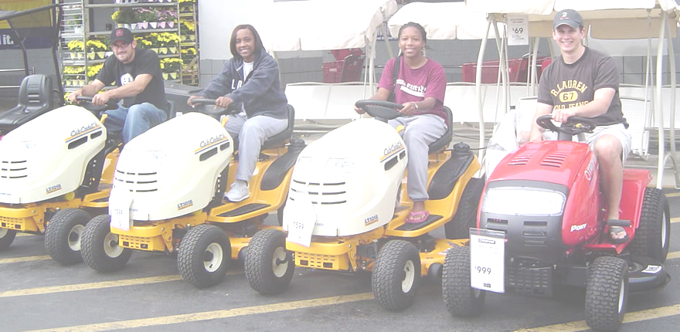

Final Design Package
December 2,2004





FAMU-FSU
College of Engineering

Fall 2004 – Spring 2005 Academic Year
Sponsored by Eglin Air Force Base
Captain Brian Tredway, Martin Eilders,
Joel House
Tamika Dean • Mike Flatau
Steve Lydzinski • Stephanie Taylor
1 Introduction
__________________________________

  - Problem Definition

The purpose of this project is to design and operate an autonomous lawnmower using the art and science of navigation to rapidly and accurately mow a field of grass. The design will be used in the Institute of Navigation (ION) Second Annual Autonomous Lawnmower Competition sponsored by the ION’s Satellite Division and administered by the Dayton Section of the ION. The lawnmower that completes the mowing in the shortest time will win the competition.

This competition will be held in Dayton, Ohio and will occur between June 9-10 or June 16-17. Thursday will be the inspection and qualification day and the main competition will take place on Friday. The team must qualify on Thursday to be eligible for competition on Friday.
There will be cash awards presented to the top three teams. The awards are – 1st prize: $2,500; 2nd prize: $1,500; 3rd prize: $1,000. In addition, special international recognition will be provided for all participating teams through ION publications and announcements at the 2005 ION Annual Meeting. The winning teams will also be given an invitation to display their lawnmowers during the Annual Meeting, and given the opportunity to make a 20-minute presentation on their autonomous lawnmower design. Finally, videotapes of the competition event will be distributed to sponsors, media, and the public.

In addition to moving a lawn in the shortest time, teams will be judged on a detailed report that provides the cost of the prototype and a projected production cost of the mower. The team with the best report will also receive a $1,500 cash prize. The production cost of the mower shall be evaluated by the judges for feasibility and penalty seconds shall be added to the total time score according to the following formula:

Production costs ≤ $2,000: no penalty seconds
Production costs in excess of $2,000: 10 seconds for every $100

  - Rules and Regulations

In order to achieve success in the design project the team needs to research possible solutions to designing an effective autonomous lawnmower, whether using modifications of an existing lawnmower or building a lawn mower from scratch. When deciding on a final design, the design rules and requirements for the Autonomous Lawnmower Competition must also be taken into consideration.

Design rules of the competition are as followed:

- Lawnmowers must be autonomous and shall not be remotely controlled
- Must be in direct contact with ground at all times
- Power must be combustible fuel and/or batteries
- Manual and wireless remote emergency stop required
- Mowing function shall cease within 3 s and the lawnmower shall be stopped within a distance of 3 m upon emergency stop
- Radio navigation system e.g. inertial Sensors and GPS
- Lawnmower must carry all equipment
- All weather capable

Design requirements are as followed:

- Length ≤ 2.0 m
- Width ≤ 1.5 m
- Height ≤ 1.0 m
- Cutting Width ≤ 1.5 m
- Lawnmower Weight ≤ 250 kg
- Speed ≤ 10 km/h
- Start Time ≤ 5 min

The competition itself uses a rectangular area of 150 m² as the designation path the lawnmower must travel, inclines not to exceed 1 in 10 m. GPS mask angle shall not exceed 20 degrees in any direction. The course also includes two as well as a 3m-safety buffer. There is the option of competing with or without the obstacles since this is the first time the team has entered the competition. The field is seen below in Figure 1.1.

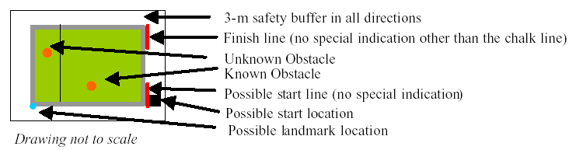
Figure 1.1 Competition Field

Abiding to the competitions rules and requirements, the goal is to develop a working prototype that has the ability to autonomously maneuver around a rectangular course and avoid randomly placed obstacles. These goals have unforeseen challenges that must not be overlooked. Such challenges include power sources, electronic sensors, computer programming, controls and integrating mechanical and electrical components to negotiate the course.

The goal will be achieved by building an autonomous lawnmower from scratch that has the capability to self-navigate and mow a rectangular area. This lawnmower will use a global positioning system (GPS) along with an electronic compass for location and orientation respectively; bump switches for obstacle avoidance and object oriented programmable integrated circuit, OOPic™, for general direction. The lawnmower will be battery powered to reduce the heat and vibrations transmitted to the electrical systems. The requirements given by the autonomous lawnmower competition must be met to be a successful project. The team understands and accepts the requirements needed to achieve success.

  - Sponsor

Eglin Air Force Base, EAFB, is the team sponsor. Eglin AFB is limited to hardware donations and funding support. Eglin AFB has sponsored several FAMU-FSU College of Engineering senior design projects in the past. Our team is greatly appreciative to all that Eglin has contributed for the success of this project.

- Design Project

2.1 Needs Assessment

To complete the goal successfully, the needs of everyone involved had to be determined. The need for the team is determined from the need of the course and the need of the sponsor. This is a class assignment, so throughout the course of the year the necessary deliverables needed to perform well in the class have to take into account. Along with the needs for the course, the sponsor’s need must be fulfilled. The two contacts been working at EAFB are Captain Brian Tredway and Martin Eilders. Once the sponsors’ need is met, the focus can be moved to the course needs, and both of these fall under the needs of the team.

Sponsor’s Need

The main priority is to fulfill the need of our sponsor, or the customer. They have been determined as follows, in order of priority:

- Create an autonomous lawn mower to enter into the competition
- Make it safe
- Make it work according to the specifications and incorporate (GPS)
- Compete in the competition
- Make aesthetically appealing
- Win the competition

Create an autonomous lawn mower
The most important need is to build an autonomous lawn mower. To do this, feasible concepts must be developed. Once the concepts are developed, a decision can be made as to which concept will be used, and then determine the best method to develop the final product.

Make it safe
Safety is a priority, not only because of the rules and requirements set out for the competition, but it’s a priority when developing an autonomous vehicle. The lawn mower won’t be controlled, but programmed since it must be autonomous. The speed of the lawn mower is limited to 10 km/hr. It must also be equipped with a local and remote controlled kill switch. This is to avoid any accidents that could occur. The local button must be clearly visible, and has it’s own requirements. The button must have to ability to stop both the forward motion of the lawn mower, and the rotation of the blade.

Make it work according to the specifications and incorporate GPS
Controlling an autonomous lawn mower is a difficult task. The definition of success has been defined to create a vehicle that has the ability to travel in a straight line, for the necessary amount of time, turn and follow a line parallel to the line just traveled, and avoids any obstacles. To achieve success GPS will be used to navigate the lawn mower through the necessary path.

Compete in the competition
The 2nd Annual Autonomous Lawn Mower Competition will be held in Dayton, Ohio in June 2005. In order to compete, the rules outlined for the competition must be followed. The rules can be seen in Appendix A. Along with representing the school at the competition, Eglin Air Force Base would also be represented. The sponsors will also be in attendance at the competition.

Make aesthetically appealing
The ultimate purpose of a product is the ability to sell the product on the market. In the marketing aspect, the aesthetics of the lawn mower are almost as important as the ability of the lawn mower to cut grass. The look of the lawn mower will also be representing the school and Eglin Air Force Base.

Win the competition
Winning the competition will result in a final product using the art and science of navigation to rapidly and accurately mow a field of grass. By reaching this point, the needs of the design project would have been fully satisfied.

Course Needs

As stated previously, the project is a class assignment so there are necessary deliverables needed to complete the course. The needs to complete the course have also been, and they are as follows, in order of priority:

- Fulfill the needs of our sponsors
- Complete the necessary deliverables (reports, presentations)
- Complete the necessary deliverables in a timely manner
- Keep the class and the professor aware of our progress

Fulfill the needs of our sponsors
The needs of the sponsors have already been stated. Fulfilling the sponsors’ need is the most important need for the class because this is what the class is about. A project is assigned and the final product must be produced meeting the customer’s needs and wants.

Complete the necessary deliverables
A grade will be given at the end of the year. The grade will be determined on numerous factors, one of which is completing the necessary deliverables. Deliverables are mini-tasks, which keep the project on target. They can be reports or presentations. The reports are to keep Dr. Luongo aware of our progress, and vary anywhere from the scope of the project to the plan to finish the project. The presentations consist of progress reports, to inform the class of project and the progress that is being made. Dr. Luongo and the other class members could be considered a secondary customer, since he’s the professor for the course and all of the deliverables are available to the class members.

Complete the necessary deliverables in a timely manner
It is not good enough just to complete the deliverables. They must be completed and submitted on the appropriate deadline. This will allow for any corrections to be made before EAFB reviews them. Turning in the deliverables by the deadline is also professional.

Keep the class and the professor aware of our progress
By keeping the class professor and the class aware of the progress being made, constructive criticism can be given, which will only benefit the team and the project. They could bring things to the attention of the team that might have not been thought of, but could be beneficial to the overall project. Dr. Luongo and the class members are also secondary customers, so they should also be aware of what progress is being made toward a final product.

The team needs are to fulfill the needs of our sponsor, first and then the course. The team needs are the same as the sponsors’, more or less, to build an autonomous lawn mower, and enter it in the competition, and win. The need for the course is to complete all of the work in a timely manner, and receive an A in the course.

- Concept Generation and Selection

3.1 Concept Generation

The design of the AutoMow 2K5 has been refined several times in order to reach the final prototype layout. The team worked hard to brainstorm and derive several possible designs in order to establish the best possible design for autonomous lawn mowing. By working together, the team was able to evolve the initial crude design into the thought out space saving final prototype design.

3.1.1 Initial Design
The initial design was based on a robotic mower that would be built from scratch. The schematic can be seen in Figure 3.1. It was based on a medium sized platform that would be able to turn about its own radius. The driving wheels were placed on either side while swiveling casters were situated in the front and rear for stability. A gas or electric powered lawnmower engine with a blade would be mounted in the center of the robot. Plenty of open space was left for the electronic components and power sources. A sheet metal blade guard would be placed over and around the robot’s platform in order to shield the blade from objects and, more importantly, people.

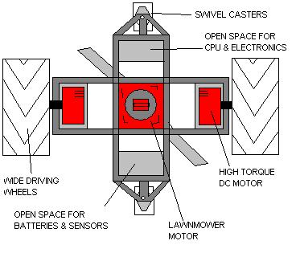
Figure 3.1 Schematic of the Initial Design

3.1.2 Lets Try to Modify
The initial design seemed to have too many components that needed to be specially machined and welded for the application. This got the team thinking about the possibility of taking a pre-built lawnmower and modifying it in order to make it run autonomously. At the time, this seemed like a perfect answer to the simplicity of the working prototype. The group spent several hours looking into existing lawnmowers that could be used for this application. Both gas and electric powered lawnmowers were studied. As the design of the modified lawnmower continued, the group ran into some problems. Because the platform for the robotic lawnmower was already constructed, there were several constraints that the team had to work around in the design process. The size and weight

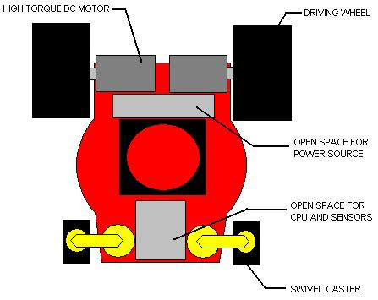
Figure 3.2 Modified lawnmower schematic.

of the pre-constructed lawnmower was too large for practicality purposes. The driving motors were required to be larger than desired for simple assembly. Also, the construction of the lawnmower required the driving wheels to be mounted to the rear of the robot as seen in Figure 3.2. This meant that there would be more force to be overcome when the robot was desired to turn. The turning radius was also not as tight as the previous design, which would set the robot up for poor maneuverability.

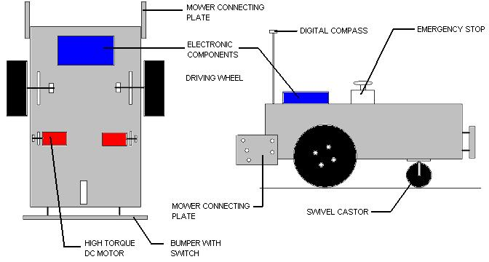
Figure 3.3 The schematic for the robotic platform designed to pull mower behind.

3.1.3 Back to the Drawing Board
The team went back to the drawing board once it was realized that modifying an existing lawnmower for autonomous navigation would be just as time consuming as building a robot from scratch. By building a robot from scratch, the team would be able to create the best possible design for the application, without the design boundaries set by a pre- built lawnmower. At this time the team was considerably worried about the overall cost of the robotic lawnmower. Thus, the idea of designing a robotic platform that could pull or drag a lawn-mowing device was contrived, seen in Figure 3.3. Through this design, the team could design and build the initial robot in order to proceed to develop the computer programming that would take up the bulk of the spring semester to design. This would allow the mowing device to be purchased later in the spring semester once the team could prove that the design would actually work.

3.1.4 A Full Circle
In October, the team met with their sponsor and it was determined that as long as the expenses were justified, cost was not an issue. This would allow the team to combine the lawnmower and the robot platform into a single device. The team acquired a pre-assembled rectangular frame free of charge that could be used for the new platform. All of the specifications for the final design were based on this frame that measures 16 inches by 20 inches.
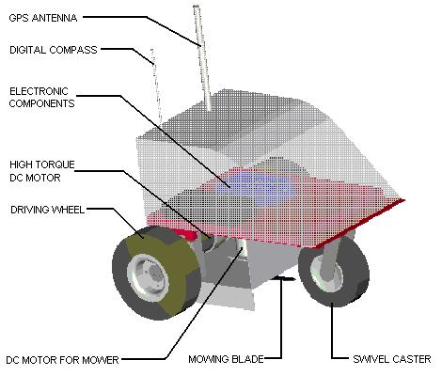
Figure 3.4 Schematic of the final design for the AutoMow 2K5 prototype.

Ideas from the initial design and the robot platform design were combined in order to allow for the final evolution of the AutoMow 2K5 prototype. A small-scaled robotic platform that carries a 12-inch rotating blade is the result. The high torque driving motors will be mounted to the bottom of the main frame of the robot as seen in Figure 3.4. A bent sheet metal shield will prevent the majority of the debris that the mower creates from getting to the motors. All of the electrical components will be located on the main platform of the robot, underneath the metal housing. The robot maintains a tight turning radius by maintaining a relatively large driving wheel base compared to the length of the robot. The overall small size of the final design is ideal for the transportation of the prototype during the testing phase.

3.2 Project Plan

Once this project was assigned, the planning had to begin. The course is yearlong; hence the project year long, meaning time is limited. Not only are there course deliverables due on a regular basis, progress in production also has to be made to produce a final product. After talking with previous teams, it was decided to have all of the conceptual ideas finished by the end of the semester, so the necessary parts could be ordered before the Christmas break came. Another goal was to not procrastinate. Each team member is taking other courses, so the project would be juggled with the other courses. To successfully come up with a plan, Microsoft’s Project software was used. This software allowed for timelines to be set up, and account for everything occurring during the semesters, even breaks. Along with using the software, the team also had to prioritize. By prioritizing, focus could be placed on the necessary items, instead of spending too much time on the unnecessary items.

As stated previously, a timeline of two semesters was given to complete the project and a produce an autonomous lawn mower that could mow a field of grass, along with avoiding obstacles. During the course of the semesters, there are also deliverables due for the course. To organize all of the deadlines required and the deadlines we made, all of the information was placed in Project. By using Project, all of the deadlines, and amount of time needed to fulfill each one was visible. The timeline can be seen below in Figure 3.5. Tasks are also able to be given a number of priority and can be given a percentage of how complete it is.

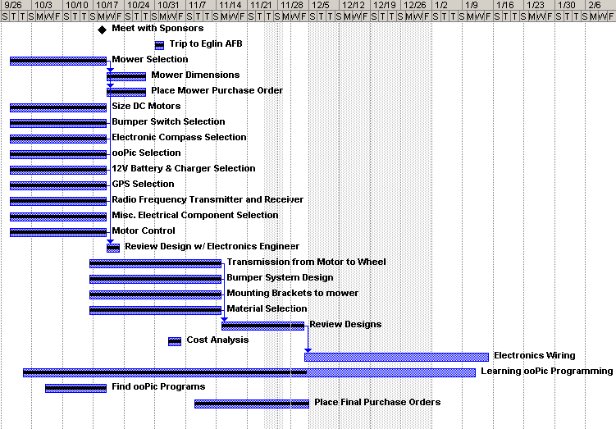

Figure 3.5 Fall Timeline

Prioritizing was just as important as creating the timeline. By prioritizing, time was spent where it needed to be, on the necessary items. A majority of the subcomponents were also accounted for. Different kits could be used, which contained major components and smaller items that would be needed, such as batteries and chargers. This not only saved time, but it also saved money. Once more focus was placed on the big items instead of every single component; everything fell in place.

By completing this plan, not only will the project be completed, but it will also be a success. The timeline will assist with staying on task, while prioritizing will avoid spending any unnecessary time.

- AUTOMOW 2K5!!

4.1 Design Options

The mechanical and electronic components for the autonomous lawn mower were selected for their compatibility and ease of use. The mechanical components are only a small percentage of the total components needed. They include the lawn mower, power, and transmission. The mechanical parts are important for the overall build, but minor in comparison to the selection of the electronic components needed. The electronic components include the microcontroller, motor controller, navigation, and avoidance systems. They must be designed to work together to achieve a common goal, autonomous navigation.

4.1.1 Mechanical

Lawnmowers
The first decision the team had to decide upon was the design of lawn mower. Due to the small budget, the size of the mower had to be kept small. This eliminates the possibility of using a riding lawn mower. The two alternatives are a modified push mower or a custom-built lawn mower.

Modification of an existing lawn mower would ensure that the device could mow grass effectively. Inexpensive lawn mowers can be purchased at the local home improvement stores for fewer than two hundred dollars. The desired features, such as mulching and bagging would remain but the propulsion would need to be added. The dimensions of the lawn mower would have to be known before any additional modifications could be attached. This design would have the ability to be marketed as a final product.

A lawn mower built from the ground up could be created and customized to fit the requirements of the competition. The custom built lawn mower could be created with a smaller overall width, increasing the maneuverability of the vehicle. Using a smaller frame and fewer parts, the overall cost of the mower would be reduced. The final product developed for this design would need to be created in a package that could be marketed. Similar designs have been created, but lack the navigational guidance that a GPS guided lawn mower would possess.

Power
The sources of power are combustible fuels, electric power or a combination of the two. A gas-powered mower could be equipped with an alternator and a generator to provide an AC power source that could be use for propulsion. The combination would provide the necessary power to cut through thick grass and travel long distances before refueling. The difficulty with an alternator is transferring the power from the rotating shaft. This would require the combustion engine have two shafts or to tap directly into the power of a single shaft engine. This is potentially dangerous if all safety precautions are not followed.

An alternative is a combustion engine used for cutting the grass and DC power for the propulsion system. The battery needed would depend upon the size of the motors used. Typical DC motors use between 12 and 90 volts. A 90-volt DC gear motor can achieve high speeds and torque reaching over 1000 in-lb, where an inexpensive 12-volt gear motor can reach only acquire 50 in-lb at low speeds. The cost of the 90-volt gear motors can easily reach $300 per motor, not including the expense of the batteries.

The final considered design is a lawn mower that is fully dependent upon battery power. A benefit of a DC power source is the versatility of a universal power supply. The propulsion of the entire vehicle can be controlled by the use of a DC battery. Noise and vibrations from a combustion engine could be eliminated and the difficulty of creating a mechanism to stop power to the blade can be replaced with an inexpensive switch. The main disadvantage would be the time needed to replenish the power of the batteries.

Transmission
Another source of power is the use of a transmission from the motors to the wheels. Reducing the speed of the motors with pulleys, gears, or roller chains would increase the torque. This would allow an inexpensive, high rpm, DC motor to be used.

Pulleys can be used to transmit the power from large distances but require tension and are subject to slip in wet conditions. Gears can transfer large amounts of power but can bind up in dirty conditions. The gears would need to be enclosed, adding additional cost. Roller chains are another option but may become dislodged if misaligned. Adding a transmission would provide additional power, but add cost and may be unreliable in certain environments. An optimum design must be determined to select a more powerful motor or a transmission.

4.1.2 Electronics

Microcontrollers
Microcontrollers are inexpensive devices that can be programmed to perform various functions. A microcontroller contains several electronic components, such as a central processing unit, input and output connections, and random access memory. They are typically used for specific functions like in engines to control air and fuel mixtures, televisions to project images, and microwave ovens to adjust power. Dedicated microcontrollers usually have one function and can be programmed with read only memory. However, microcontrollers such as PICs, Stamps and the OOPic can be implemented into a wide variety of applications.

Programmable integrated circuits (PIC) are available by numerous vendors and are used for numerous applications. PICs are simple controllers that are rated by the speed of the processor, amount of RAM available, number of input and output lines available and the special features available. Two specific PICs are the Basic Stamp and the OOPic.

The Basic Stamp, shown in Figure 4.1, is a product of Parallax and is designed to be programmed using Microsoft Visual Basic. The ability to program using Visual Basic allows for the easy use. Stamps can be connected to a computer using the serial connection in the back of most computers and can be powered by a 9V battery. Stamps are slow in comparison to dedicated microcontrollers but allow for rapid prototyping. They are available in two configurations, the BS1 and the BS2. The difference between the BS1 and the BS2 is the processing speed, total memory, number of input and output lines, and the number of instructions it is capable of handling.

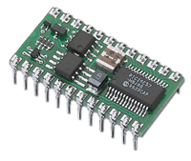 | 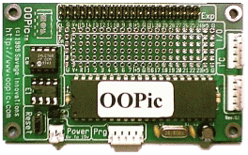
Figure 4.1 Basic Stamp 2 Chip | Figure 4.2 OOPic Chip and Board

The object oriented programmable integrated circuit (OOPic), Figure 4.2, is a product of Savage Innovations. The OOPic can be programmed using Visual Basic, C, or Java and is similar to the Basic Stamp in its ease of use and rapid prototyping. However, the OOPic is an event-based microcontroller. Meaning the microcontroller can run one program and when an event, such as a bumper, is triggered, the controller can respond by recalling the program that must be used to maneuver around an object. Added complexity can be added by using multiple events. The events can be arranged in means to define the importance of any one event. Importance of physical contact would have a higher priority than detection of an object with sonar. This makes the OOPic an excellent choice for control of the autonomous lawn mower.

Motor Control
The microcontrollers have the ability to output commands to various components but lack the ability to control the direction of an electric motor. Electric motors can rotate in two directions, clockwise, and counterclockwise. Reversing the flow of current in an electric motor can change the rotation. This can be accomplished by manually connecting the positive to negative or negative to positive terminals, depending on the desired rotation. However, in robotics, this is impractical. Relay switches and H-Bridges can be used to perform the task of reversing an electric current. Simplified diagrams of relay switch and H-bridge operation is shown in Figures 4.3 and 4.4 respectively.

Simple relay switches are comprised of the following mechanical parts: Electromagnet, armature, spring, and a set of electrical contacts. When the relay is in the off position, the motor receives no current in either direction. In the forward direction, the electromagnet is turned on and pulls a metal contact to complete a circuit. To reverse the direction of the current, the electromagnet is turned off and the spring returns the metal contact back to the original position completing a different circuit. In environments where vibrations are large, relay switches can respond erratically causing errors in the system response.

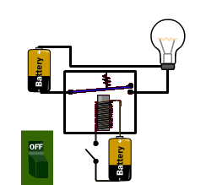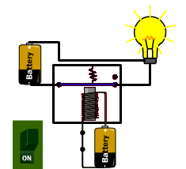  www.howstuffworks.com | 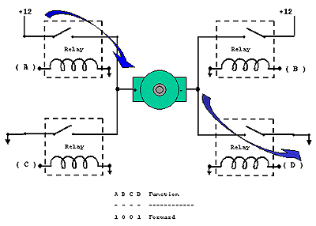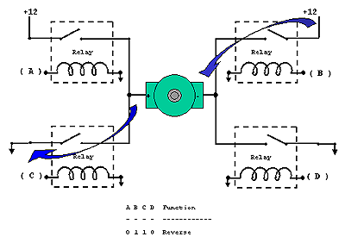  www.dprg.org/tutorials/1998-04a/
Figure 4.3 Relay Switch Operation | Figure 4.4 H-Bridge Operation

H-Bridges are similar to relay switches, but use electrical components to control the direction of an electric motor. They use a combination of transistors, diodes, and inductors to control the direction of the electric current and, in more advanced bridges, can control the amount of current flowing through the circuit. High-end H-Bridges can control large amounts of current using low power logic from a microcontroller.

Navigation
The navigation of the autonomous lawn mower can be accomplished in a large variety of methods using complex algorithms. However, the complexity is limited by the ability of the microcontroller to interpret and manipulate the data. The options considered for the design of the robot are encoders, GPS, and a digital compass.

Encoders are used in simple robotic platforms to determine the number of rotations of a wheel. Inexpensive encoders use a black and white pattern on the wheel and count the number of rotations the wheel completes. If the diameter of the wheel is known it can be input into a program where the microcontroller can interpret the distance traveled. However, if the wheel were allowed to slip, the encoder would provide inaccurate results. Encoders are also limited because they lack the ability to determine boundaries.

A Global Positioning System (GPS) receiver is a device that can be used to determine the distance traveled and the boundaries. The GPS units provide a location on Earth’s surface by using 3 or more satellites. Approximately 30 satellites orbit the earth at 6 different planes, Figure 4.5. Each satellite provides a unique signal that the GPS receivers detect. The distance from each satellite is determined by calculating the time to receive a signal and is used to triangulate the location of the receiver. Most receivers are only accurate to within a few meters. Differential GPS (DGPS) receivers can be used to improve accuracy. DGPS receivers use a second receiver at a known location and correct for errors. High-end receivers can provide accuracy to a few centimeters but can be costly.


Figure 4.5 GPS Satellites

A digital compass would provide direction to the vehicle by detecting the earth’s magnetic field. Initially, the compass can be calibrated and given a ‘North’ heading to orient the direction of the vehicle. An algorithm in the microcontroller would be implemented to turn the vehicle until a heading of N + 90º is obtained. Inexpensive sensors range from $15 to $50 and can provide accuracies up to a few degrees.

Avoidance Systems
Obstacle avoidance can be achieved by using a combination of contact switches and remote sensors input to the microcontroller. The sensors can be connected to the microcontroller and trigger an event. The priority of the event would then determine an effective method of maneuvering around an obstacle.

Inexpensive bump switches can be placed on the vehicle in a variety of locations and providing a reliable means of obstacle avoidance. The bump switches would be a high priority event within the microcontroller due to the physical contact needed to detect an object. The bump switch is limited because a high-speed impact could cause extensive damage to the vehicle.

A combination infrared sensors and bump switches could provide a means of slowing the vehicle to a safe impact speed. IR sensors us a beam of light and detect the amount of reflected light. They are limited because they only use line-of-sight to detect objects. Meaning, an object outside the line of the IR beam would not be detected.

Adding ultrasonic sensors would provide a means of detecting obstacles in a wider field of view. Ultrasonic sensors send a pulse of sound that is reflected back when an obstacle is present. Together, the bump switch, IR sensors, and ultrasonic sensors would provide a redundant means for detecting obstacles.

4.1.3 Robot Kits

There are many robotic kits & platforms available on the market that have desired features needed for the autonomous lawn mower. The kits are available with radio or autonomous control. Most kits come with a microcontroller, power supplies, motors, and motor controllers. Advanced kits offer programs that are ready to be implemented into the microcontroller. The ability to modify an existing platform would greatly reduce the time needed to create a fully autonomous vehicle.

Super Droid Trekker
One robotic kit is the Super Droid Trekker robotic kit, Figure 4.6. This kit includes an OOPic microcontroller, obstacle avoidance sensors, digital compass and a mobile platform. The price of a Trekker robot can range from $169 that includes the most basic components, to $619 that includes every component the company can offer. The main benefits of a Trekker robotic kit are the programs that have been developed by hobbyists and engineers. They include programs for the OOPic that can follow lines, detect fires, and catch balls. The Trekker robotic kit would be an ideal platform to test the components needed for autonomous control.

Advanced Robot Starter Kit
The Advanced Robotic Starter Kit, Figure 4.7, is another robotic kit offered by hobbyists interested in combat robots. The advanced robot starter kit includes wheels, hubs, DC motors, motor controllers, power supplies, and radio controllers. This kit has been proven reliable in hostile conditions and is offered for approximately $1500. They include the hardware to build a robotic vehicle, but require a platform to mount the components.

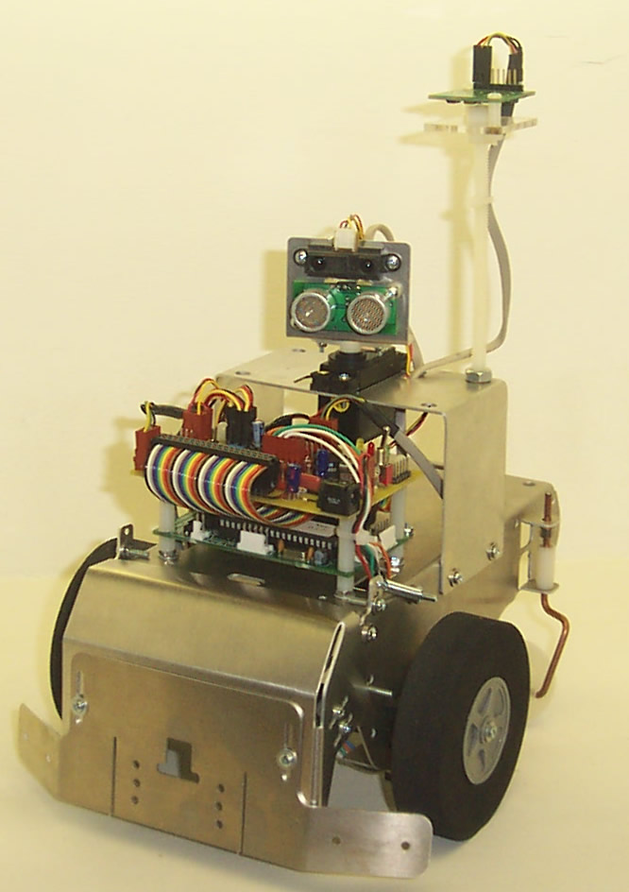 | 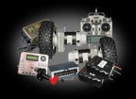
Figure 4.6 Super Droid Trekker | Figure 4.7 Advanced Robot Starter Kit
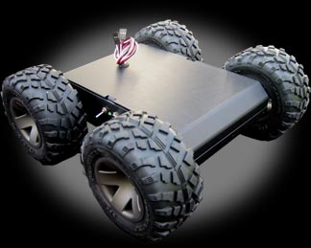 | 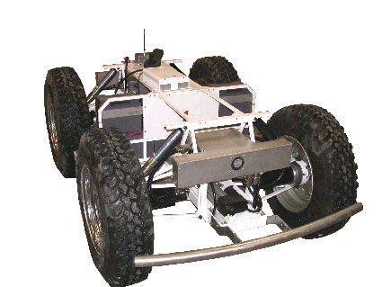
Figure 4.8 MMP-5 Robotic Platform | Figure 4.9 RobuCar ATV Robot

MMP-5 Robotic Platform
The MMP-5 robotic platform, shown is Figure 4.8, is a small robotic kit available for $495. It comes complete with four DC motors, speed controllers, a power supply, and is ready to use with a basic stamp or an OOPic microcontroller. They are designed for education, research and development, robotic competitions or personal projects. This platform can be upgraded to include larger wheels, more powerful motors or a wide variety of other components. The MMP-5 measures only 10.25 inches by 10.25 inches by 4.1 inches in length, width, and height respectively. This platform would be ideal for a small-scale prototype but may not provide enough power to cut grass.

RobuCar ATV Robot
A much larger platform is the RobuCar, Figure 4.9, manufactured by Robosoft. The RobuCar is an all terrain vehicle that includes 2 Motorola MPC 555 microcontrollers, 4 high torque DC motors, four-wheel steering, on board power supply, and an optional on-board PC. This vehicle measures 1.3m wide, 1.8m long, 0.6m high and can carry a payload of 300kg. This platform would have the ability to autonomously carry large payloads, but at a cost of over $50,000.00, this vehicle is well out of the budget of this project.

Summary

To meet the needs of the design, the combination of the power and controls has to perform according to the desired specifications. A design decision based upon the uncertainty of the project had to be made. The platform used for the autonomous lawn mower has to be reliable and durable and the selected microcontroller has to be able to accept the power, navigation equipment and the avoidance systems. The components that have been considered for the design of the autonomous lawn mower must have the compatibility to work together. The design decisions in the following section will discuss the mechanical and electrical components selected.

4.2 Design Decisions

4.2.1 Mechanical

Lawnmower design
A custom built lawn mower was determined to be the best solution for this project (Refer to section 3.2). Again, the lawn mower has to be created to meet the demands of the competition. Therefore, the overall shape and look of the lawn mower would be dictated by the electronic systems needed to fit on the vehicle. Also, a smaller design would reduce the number of parts needed, lessen the overall cost, and allow the mower more maneuverability and versatility.

Power
DC power was chosen because of the ability to power the entire system from a single power source. The batteries that will be used are two 24-volt Nickel Metal Hydride battery packs. Alone, a single battery pack can provide 3.3 amp hours and 24 volts of power. For added voltage the two battery packs can be connected in series. If more amp hours are needed, the batteries can be connected in parallel, resulting in a total of 6.6 amp hours and 24 volts of total power. The NiMh battery requires a 16-hour charge time and has a lifetime of over 500 cycles. The total run time for the motors was determined to be approximately 16 minutes. Details of these calculations can be found in Appendix C. To supply the entire network of electrical components, a power distribution grid with multiple voltage regulators will be required.

Transmission
Based upon the analysis of uncertainty, the decision to use a direct drive instead of a transmission was made. To create a transmission for a custom vehicle, shafts, bearings, mounts, and pulleys-gears-chains would have to be purchased or machined. The use of additional part and inexpensive gear motors has the potential to be unreliable. A direct drive propulsion system would allow for a smaller percentage of failure.

4.2.2 Electrical

Microcontroller
The microcontroller selected for the autonomous lawn mower is the object oriented programmable integrated circuit. The OOPic provides an inexpensive prototyping platform for only $74 with cables, which can be programmed using a serial connection from a computer. Numerous publications for the OOPic can be found online. One publication is, “Programming and Customizing the OOPIC Microcontroller” by Dennis Clark, which includes product support on OOPic.com and programming code that can be manipulated to perform the desired tasks.

In particular the OOPic II+ was chosen because of the wide variety of applications that it can handle. The features are shown below in Table 4-1. The OOPic II+ has software developed into the microcontroller, making it possible for inexperienced programmers to customize the controller. The B.2+ Firmware was developed specifically for the OOPic II. It provides predefined objects that are ready to connect and use with the microcontroller platform. An example of an object is oCompassDV, which will read a Devantech magnetic compass and convert the data to a heading value. The details of the microcontroller can be found in the table below.

Table 4-1 OOPIC II+ Features

Microcontroller | PIC16F877
Speed | 20MHz
Analog to Digital Channels | 7-10bit channels
Object Memory | 86 bytes
Variable Memory | 72 bytes
Program Code Space | 8 KB
EEPROM | 256 bytes

The microcontroller is clocked at 20MHz and can provide 7 channels to convert an analog signal such as a voltage, to a digital signal or bits of information. The object memory is the available space to define inputs such as a digital compass or motor controller. Each object usually occupies only a few bytes of information, allowing for multiple objects to be used. Variable memory is a bit or bytes of information used to define a value. These values are used to store and compare data. The total program code space is the amount of programmable actions the microcontroller can perform. Electronically erasable programmable read only memory (EEPROM) is the amount of space available for storing data. EEPROM can be upgraded to store up to 2000 bytes of information.

Motor Control
The RoboteQ AX2500, Figure 4.10, is a dual channel motor controller for computer guided robotic vehicles. The motor controller was selected because it can provide forward and reverse speed control by the use of an embedded H-bridge. The AX2500 controller can handle large amounts of current while providing a stable platform for sensitive electronics. The logic can be input through a serial RS-232 connection or a 5V analog connection. For added safety, the controller can be equipped with an emergency stop button through a simple connection.

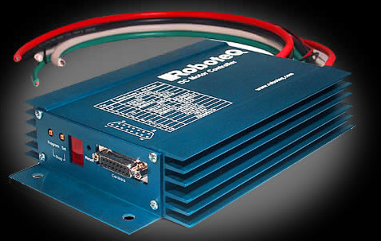
Figure 4.10 RoboteQ AX2500 Motor Controller

The AX2500 motor controller shown above is equipped with connections for two DC motors, two 12V to 40V power supplies, microprocessor, and an emergency stop. The high cost of $495 is justified by the power capacity and proven reliability it provides.

Navigation
The GPS unit, provided by Eglin Air Force Base, is the Thales A12 Sensor shown below in Figure 4.11. This sensor was selected by EAFB for it’s relatively low cost of $500.00 and the ability to provide location and direction. The GPS unit uses NMEA protocol that provides longitude, latitude, altitude, heading, and speed. The A12 sensor can provide real time position accuracy of 3.0 meters. It can provide readings approximately 150 seconds from a cold start and updates once per second.

The A12 sensor will connect to the microcontroller to provide the location and boundary conditions of the field. When the microcontroller receives a location that is outside the boundary, the vehicle will maneuver to the closest acceptable location. The path of the vehicle will also be recorded into the EEPROM to compare results.

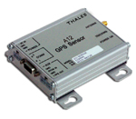 | 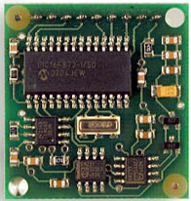
Figure 4.11 Thales A12 GPS Sensor | Figure 4.12 Devantech Digital Compass

Digital Compass
The Devantech CM03 digital compass uses two Philips KMZ51 magnetic field sensors to detect the earth’s magnetic field, Figure 4.12. The two sensors are offset at 90º to provide the horizontal direction of the compass. This compass was selected because it is easily incorporated into the OOPic microcontroller through an I2C connection. The compass can provide accuracy up to 3º and have a resolution of 0.1º. It can be powered from the microcontroller with only 5V and draws only 0.02 amps. For only $49.50, the Devantech Magnetic Compass is an ideal choice for determining the vehicle’s orientation.

The digital compass will connect to the I2C connection on the microcontroller. The compass will provide the direction of the vehicle, navigate a straight line, and navigate left and right turns.

Avoidance Systems
To detect and avoid obstacles, the autonomous lawn mower will use a combination of a bump switch, IR sensor, and an ultrasonic sensor. These sensors shown in Figures 4.14 – 4.15, were selected due to their low cost and reliability in similar robotic packages.

The bump switch will be required to physically detect obstacles and have a higher priority than the IR or Ultrasonic sensors. The bump sensor is an inexpensive lever switch that can be purchased at Radio Shack.

The Sharp GP2D12 IR sensor, sold for $12.95, can detect objects that are directly in front of the vehicle. The IR sensor operates using only 5 volts and has a range between 10 to 80cm. The IR sensor is required because objects that absorb sound waves from the ultrasonic sensor will be detected with this infrared sensor.

Similar to the IR sensor, the Devantech SRF04 ultrasonic sensor, for only $34.00, will determine the presence of an object by sending and receiving a reflected signal. However, the ultrasonic sensor can detect objects 23º in either direction. It operates using only 5 volts at 0.03 amps and has a range from 3cm to 3m. The sensitivity of the sensor can detect a 3cm diameter stick at a distance of over 2 meters.

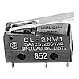 | 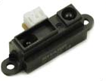 | 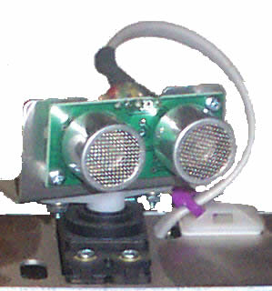
Figure 4.13 Bump Switch | Figure 4.14 IR Sensor | Figure 4.15 Ultrasonic Sensor

The combination of these three sensors will provide a redundant system capable of avoiding medium to large objects. The three sensors will be used in conjunction with the microcontroller that can interpret the incoming data and manipulate the direction of the vehicle.

4.2.1 Robotic Kits

The Trekker Navigator Plus robotic kit, Figure 4.16, will be used for the testing the electronic components. For $409, it comes equipped with a trekker chassis, OOPic II+ controller, OOPic II expansion card, electronic compass, wheel encoders, sweeping IR and ultrasonic scanners, and a bumper switch that can be used in the full-scale autonomous lawn mower. The expansion card contains connection for servos, sensors, LCD screens, and potentiometers to fine-tune the motor control. The Trekker robotic kit will be used in the initial design stage of creating working programs for the autonomous lawn mower. The time to develop the navigation software will be reduced because the small mobile platform allows for indoor testing.

Figure 4.16 Trekker Navigator Plus | Figure 4.17 Advanced Robot Starter Kit

Advanced Robot Starter Kit
The advanced robot starter package shown in Figure 4.17, is designed for a two-wheel drive, heavyweight (220lb) robot. The kit comes with two gear motor-hub-wheel assembly, dual speed controller, two 24V rechargeable batteries, battery charger, charger power supply, power switch, radio controller, and 12-gauge wire. This package contains everything but a platform.

The two-wheel assembly contains a powerful DC gear motor, hubs, and 10 inch wheels that are ready to be assembled. The speed controller in this package is a Vantec RDFR33. This controller has been replaced with the RoboteQ AX2500 Motor Controller due to the versatility of the AX2500. The NiMh rechargeable batteries provide 24 volts of power and 3.3 amp hours. To charge the batteries, an Astroflight 112 charger and a 13-amp power supply are included. Also included is an optional 9-channel radio controller. The radio controller will be used for the operation of the radio kill switch. Including the upgraded motor controller, this package sells for $2000.

Summary of Selected Components

The selected mechanical, electrical, and robotic kits are shown below in Table 4-2. They were chosen because of their compatibility and reliability. The mechanical components include the lawn mower, power, and transmission. The electrical components include the microcontroller, motor control, navigation, and avoidance systems. The robotic kits were chosen due to the mechanical and electrical components included. The Trekker Robot includes all the sensors needed but the GPS and the starter kit includes all the mechanical components but the robot platform. The cost analysis and justification of the components is explained in the next section.

Table 4-2 Selected Components

 | System | Parts
Mechanical | Lawn Mower | Custom Built
Mechanical | Power | 2-24V NiMh Rechargeable Batteries
Mechanical | Transmission | Direct Drive
Electrical | Microcontroller | OOPic II+
Electrical | Motor Control | RoboteQ AX2500
Electrical | Navigation Systems | Thales A12 GPS Sensor
Electrical | Navigation Systems | Devantech Digital Compass
Electrical | Avoidance Systems | Bump Switch
Electrical | Avoidance Systems | Sharp GP2D12 IR Sensor
Electrical | Avoidance Systems | Devantech SRF04 Ultrasonic Sensor
Robotic Kits | Trekker Navigator Plus | Includes Most Sensors Above
Robotic Kits | Advanced Robot Starter Kit | Includes Wheels, Motors, Controllers, Power

4.3 Cost Analysis

The components for the construction of the autonomous lawnmower were selected based on compatibility and their effectiveness toward the designed application. Although cost will always be a factor, expensive parts were utilized in our design selection.

4.3.1 Mechanical Components

The mechanical components that were selected for the design consists of the DC Motor used to drive the mowing blade, the cutting blade itself, the swiveling caster for the front of the robot, and the various raw materials needed for construction. The selected components and their costs can be found in Table 4-3. The justification of the costs of the important parts is explained below.

DC Motor
The main focus of the project was to design an autonomous robot. This enabled the selection of a relatively cheap DC motor (part # 6331K13) from McMaster-Carr for the blade driving motor. The 3450 rpm 12 volt DC motor should be strong enough for our application and retails for $53.71.

Swiveling Caster Wheel
In order to maintain mobility, a swiveling caster was selected for the front of the robot. The use of a caster wheel will enable the robot to move freely in all directions. The original caster selected was roughly $60. The cost of this component was lowered by decreasing the diameter of the wheel size and checking other vendors. The final selected caster wheel costs $36.27.

Raw Materials
Several components fall under this category. This includes the sheet metal required for the body and chassis of the robot, the metal bars used for various shafts, and the bearings required for the lawnmower assembly. All of these parts are necessities and therefore, their cost is justified.

    - Electrical Components and Robot Kits

The electrical components were selected based on compatibility. In order to ensure compatibility, kits were utilized whenever applicable. The high cost of these robot kits is justified by the fact that they are proven to work together. This avoids the possibility of wasted time and money due to the selection of incompatible electrical components.

Trekker Robot Kit
The Trekker Robot Kit contains all the necessary brain components for the robot design. It includes the microcontroller, the sensors, and wiring that is ensured to all work together. The components can be removed from this robot and then easily attached to the final prototype robot. The Trekker Kit also enables the team to begin work on the extensive computer programming required for the navigation of the robot. These advantages highly outweigh the somewhat steep price of $409 for the kit.

Table 4-3 Cost Analysis

 | Component | Cost (each) | Quantity | Total Cost
Electronics | Trekker Robot | $409.00 | 1 | $409.00
Electronics | Robot Starter Kit | $1,983.00 | 1 | $1,983.00
Electronics | GPS System* | $500.00 | 1 | $500.00
Electronics | RF Receiver | $25.99 | 1 | $25.99
Electronics | Emergency Stop | $36.89 | 1 | $36.89
Mechanical Components | DC Motor | $53.71 | 1 | $53.71
Mechanical Components | Cutting Blade | $18.39 | 1 | $18.39
Mechanical Components | Caster | $36.27 | 1 | $36.27
Mechanical Components | Raw Materials | $117.18 | 1 | $117.18
 | *Donated and therefore not factored into FSU/FAMU Budget
 | Electronics | $2,954.88
 | Mechanical | $225.55
 | Total Cost | $3,180.43

Advanced Robot Starter Kit
This is the most expensive set of components used for the team’s design. However, it comes complete with compatible batteries, motors, wheel assemblies, and power controller. The motors with hub and wheel assembly are perfect for the design since they are specifically arranged for similar applications. The power controller is compatible with the microcomputer that will be used from the Trekker Robot Kit. Although this kit alone costs roughly $2000, utilizing pre-packaged parts will save a great amount of time. This will allow the team to work on the computer programming that the success of the project relies on.

The selection of the parts used in the design was based on the individual part’s effectiveness. The advantages of using the expensive components far outweigh the drawbacks of their high cost. The amount of time that will be saved by using these expensive pre-packaged kit components will prove to be crucial to the completion of the AutoMow 2K5 prototype.

- Conclusion

5.1 Restating Project

After reviewing the design rules and requirements, a brief idea of the necessary components was made. Something is needed that is able to move and cut grass simultaneously with out the use of anyone pushing the lawn mower, cutting the grass autonomously. To be able to cut the grass autonomously, there will have to be some type of software to provide movement the lawn mower. The goal is for the grass to be cut in an orderly fashion, so orientation will have to be added to the lawn mower, so it will have a certain path to follow.

The most important factor in producing an autonomous lawn mower is for it to be autonomous. To make it autonomous, it was decided to build it as a robot so it could be programmed to perform the necessary task. By programming it, direction and the orientation of it on the lawn can be controlled. A cutting device will also be built along with the lawn mower, which would perform the task of cutting the grass. The robot with the lawn mower, or the cutting device, would have to remain in contact with the ground at all times in order to move and cut the grass simultaneously.

The next task was to determine how to produce and provide movement to the robot and create a cutting device, strong enough to cut through grass. After talking with our sponsors, it was decided the best way to build the robot was to obtain a robot platform, and modify it to the needs of the team. A robot platform was found containing all of the parts necessary, and fits all of the specifications and requirements needed to complete the project. The platform also has the necessary components for needed to incorporate the program, which will inform the robot of the path to take. A simple programming language will be used to input the path needed for the lawn mower. To create the cutting device, it was decided to build the lawn mower by attaching a cutting blade to a motor to cut the grass.

After it was determined how to build and provide movement to the lawn mower, the next function taken into account, was providing orientation to the movement of the robot and the programs. Our sponsors wanted GPS incorporate to provide the orientation. Along with the GPS, an electronic compass will be used to ensure the accuracy of the lawn mower. The GPS will keep it within the boundary of the area, and the electronic compass will keep it going in the right direction. Between the two of these, the lawn mower should follow whatever path we lay out for it.

The first task to completing this project was accomplished just by determining the specifications needed. By using a robot platform and a cutting device, an autonomous lawn mower can be produced. To provide movement, a programming language will be used to write a path for the lawn mower to follow. Lastly, to provide the orientation, GPS and an electronic compass will be used to keep it in the boundaries.

5.2 Future Plan & Spring Agenda

To have a final product for the competition in June, future plans also have to be determined. As stated previously, the first semester was used to create conceptual ideas, and place purchase orders in for all of the parts. Once the parts are received, the ideas will be able to be implemented. The Trekker Robot and the Robot Kit have already been purchases, so building of the Trekker Robot can begin before the end of the semester. The assembly of the Robot Kit will start at the beginning of the new semester. Once a good understanding of programming and the movement of the Trekker Robot are grasped, the components needed for the lawn mower will be dismantled and placed on the Robot Kit. Testing of the lawn mower will then begin, and any necessary changes can be made before the competition. The Spring Agenda mostly consists of the building and testing of the final product, AutoMow 2K5! and completing the deliverables due for the course.

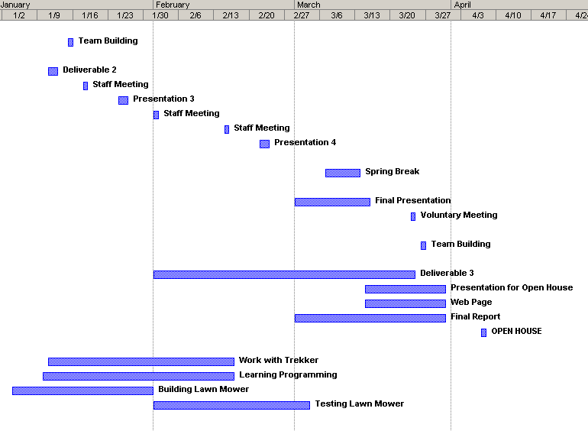

Figure 5.1 Spring Agenda

References
____________________________________

6.1 Books

A. Hughes. “Electric Motors and Drives”, Butterworth-Heinemann Publishing, Austin
Hughes, 1990.

D. Clark. “Programming and Customizing the OOPic Microcontroller”. McGraw-Hill,
New York, 2003.

6.2 Internet Addresses

    - Mechanical Components
www.grainger.com
www.lowes.com
www.mcmaster.com
www.mfgsupply.com

    - Electrical Components
www.acroname.com
www.digi-key.com
www.dinsmoresensors.com
www.jameco.com
www.microchip.com
www.oopic.com
www.parallax.com
www.radioshack.com
www.thales.com
www.themachinelab.com

    - Robotic Kits
www.robotcombat.com
www.robosoft.fr/robucarTT.html
www.superdroidrobots.com

    - How-To Sites
www.dprg.org/tutorials/1998-04a/
www.howstuffworks.com

    - Autonomous Lawn Mower Competition Rules and Regulations

www.ion.org/satdiv/lawnmower.cfm
6.3 Journals/Articles

R. Willgoss & V. Rosenfeld, 2003 “High Precision GPS Guidance of Mobile Robots”,
Intelligent Agents Research Groups. Sydney, Australia.

Appendix A

ION Papers

The Second Annual Autonomous Lawnmower Competition

The Institute of Navigation (ION) announces the Second Annual Autonomous Lawnmower Competition sponsored by the ION’s Satellite Division and administered by the Dayton Section of the ION.

The purpose of the competition is for universities and colleges to design and operate an Autonomous lawnmower using the art and science of navigation to rapidly and accurately mow a field of grass. The lawnmower that completes the mowing in the shortest time will win the competition.

The competition will be held in Dayton, Ohio prior to the start of the ION’s 2005 Annual Meeting (27-29 June 2005) held in Cambridge, Massachusetts. The competition will occur between a Thursday and Friday. There are currently two possible dates: June 9-10 or June 16-17 – the final dates and location will be updated by January 2005 (posted on the ION web page). Thursday will be the inspection and qualification day. The main competition will take place on Friday. Teams must qualify on Thursday to be eligible for competition on Friday.

There will be cash awards presented to the top three teams. The awards are – 1st prize: $2,500; 2nd prize: $1,500; 3rd prize: $1,000. In addition, special international recognition will be provided for all participating teams through ION publications and announcements at the 2005 ION Annual Meeting. The winning teams will also be given an invitation to display their lawnmowers during the Annual Meeting, and given the opportunity to make a 20-minute presentation on their autonomous lawnmower design. Finally, videotapes of the competition event will be distributed to sponsors, media, and the public.

In addition to mowing a lawn in the shortest time, teams will be judged on a detailed report that provides the cost of the prototype and a projected, current production cost of their mower. The team with the best report will also receive a $1,500 cash prize. The production cost of the mower shall be evaluated by the judges for reasonableness and penalty seconds shall be added to the total time score according to the following formula:

Production costs = $2,000: no penalty seconds

Production costs in excess of $2,000: 10 seconds for every $100 or portion thereof.

For a complete description of the competition and the rules, please go to the ION website at www.ion.org.

Dates of Competition: Either Thursday June 9th - Friday, June 10th 2005; or Thursday June 16th – Friday, June 17th 2005 (prior to the Annual Meeting of the ION (27 – 29 June 2004) in Cambridge, Massachusetts) Final date will be posted on ION’s website by January 2005.

Location: Dayton, Ohio (test site to be announced by January 2005)

Purpose: Design and operate an autonomous unmanned lawnmower using the art and science of navigation to rapidly and accurately mow a field of grass. The lawnmower that completes the mowing in the shortest time will win the competition.

Prizes: 1st prize: $2,500; 2nd prize: $1,500; 3rd prize: $1,000. In addition, the team with the best report will also receive a $1,500 cash prize.

Recognition:
- International recognition of all participating teams through ION publications.

2. Special recognition at the 2005 ION Annual Meeting to be held in Cambridge, Massachusetts, June 27 – 29, 2005.
3. An invitation to display the winning lawnmowers in the ION exhibit area during an upcoming ION Meeting.

4. The 1st, 2nd, and 3rd prize winners will be given the opportunity to give a 20 minute presentation on their autonomous lawnmower design at the 2005 ION Annual Meeting.

5. Videotapes of the competition event will be distributed to sponsors, media, and the public.

Lawnmower Design Rules:
- Lawnmowers shall be autonomous and unmanned and shall not be remotely controlled during the competition. All navigational equipment, controls, power, shall be carried by the lawnmower, with the exception of one local differential GPS station.

2. For safety, a maximum lawnmower speed of 10 km/hr shall be enforced.

3. The lawnmower shall be equipped with both a manual and a wireless (radio frequency) remote emergency stop capability. The wireless emergency stop shall be effective for the entire field of operation plus 10 m in all directions. The manual emergency stop shall be easily accessible by a standing operator behind the lawnmower, and shall be red in color and have a diameter of at least 40 mm. After the initiation of an emergency stop, the mowing function shall cease within 3 s and the lawnmower shall be stopped within a distance of 3 m. Lawnmowers that are determined to be unsafe by the judges shall not be operated in the competition.

4. Lawnmower dimensions shall not exceed the following:
Length: Not to exceed 2.0 m
Width: Not to exceed 1.5 m.
Height: Not to exceed 1.0 m.

Lawnmower weight shall not exceed 250 kg.

Lawnmower cutting width shall not exceed the previously stated 1.5 m width of the mower. However, the lawnmower’s cutting width, in meters, shall be divided by 0.5 m, a normalization factor. This number shall be a time multiplier and calculated into the official cutting time before any time penalties are added.
5. Lawnmower movement shall be accomplished through direct contact with the ground. Power shall either be provided by combustible fuel, batteries, or both.

Safety Check and Qualifying Test:
- All lawnmowers will be inspected to ensure conformity to the lawnmower type specifications (size, weight, propulsion). A safety check will be conducted to test the functionality of the lawnmower manual and wireless emergency stop, and verify that the top speed of the lawnmower is below 10 km/h. Judges and/or officials will disqualify lawnmowers that fail to meet these requirements before the end of the first day of the event. Teams may fine tune their lawnmowers and resubmit for inspection and/or safety test during the first day. No changes to maximum speed control software and hardware will be allowed after passing the safety qualification test.

- All entries will be required to pass a qualifying certification on the first day of the event. The lawnmowers must demonstrate the ability to mow a predetermined rectangular path void of any obstacles. Judges/officials will determine compliance with all rules. In the event of any conflict, the judges’ decision shall be final.

Practice Session:
There will be a two-hour period on the morning of the main competition when teams will be allowed to operate their mowers on their designated course without cutting the grass.

Navigation rules:
1. The lawnmower may use any or all of the existing radio navigation systems, as well as lawnmower-based sensors (e.g. inertial sensors, vision, etc.). Navigation systems that require local installations shall not be used (e.g. buried wires, poles, etc.). Note that local differential GPS base stations are allowed.

Area of operation description:
- The competition area shall be rectangular in shape and not exceed 150 square meters, inclines not to exceed 1 in 10 m. GPS mask angle shall not exceed 20 degrees in any direction.

2. Two obstacles, standard orange construction barrels, shall be located within the playing field. One obstacle’s coordinates shall be given along with the playing field’s coordinates. The second obstacle will be in a predefined section of the field (at least a 3x10 m section), but at an undisclosed location (teams will not be given the barrel’s coordinates, but it’s size and shape will be the same as the known barrel) until after the lawnmower is in its starting position and set into autonomous mode (with no more communication from the team).

3. The start location of the lawnmower shall be aligned with the field edge, as shown below. The start location shall be within 1 m from the start line, but no closer than 0.5 m. Each team may choose a start location that fulfills these requirements.

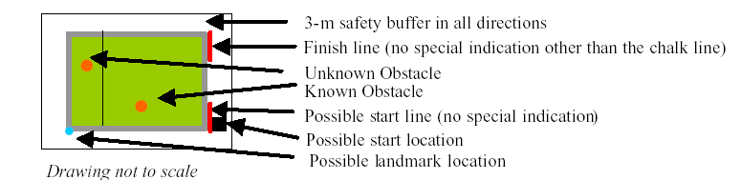

- A landmark shall be placed on one of the corners of the course. The landmark shall be a colored pole, up to 1.5 m in height.

- The edges of the field shall be indicated by a chalk line. A second chalk line will indicate the 3-m safety buffer in all directions.

6. The corner coordinates of each field, including the starting corner, shall be made available by the Dayton Section of The ION at least 24 hours before the competition. At the start of the second event day, each team will be assigned its own field of operation and there shall be no overlap between the fields. The coordinates shall be Earth-Centered-Earth-Fixed in the WGS-84 coordinate system.

Competition Teams:
1. Teams may be comprised of undergraduate and/or graduate students, and must be supervised by at least one faculty advisor. Interdisciplinary teams are encouraged (EE, ME, CS, etc.). Students must staff each team. Only the student component of each team will be eligible for the awards. Faculty supervisor will certify that all team members are bonafide students on the application form. Business/Non-Engineering students are encouraged to join teams to promote marketing, sponsorships, and other program management functions.

2. Team sponsors are encouraged. Sponsors’ participation will be limited to hardware donation and/or funding support. Sponsors’ logos may be placed on the lawnmower and may be displayed inside the team’s maintenance area. Teams should encourage sponsor attendance.

3. Schools may have more than one entry. Each entry must be based on a different chassis and navigation system and must be documented by a separate application form, submitted in accordance with all deadlines. Each form must be accompanied with a $200.00 non-refundable registration fee made payable to: ION, Dayton Section. This fee includes up to 5 ION student memberships (up to a $100.00 value).

- Intention to compete must be received no later than March 1, 2005, by mailing your application form to the Institute of Navigation, Dayton Section, Attn: Mr. Ken Weis, 5100 Springfield St, Wright Point 2, Suite 419, Dayton, OH 45431.

5. A sheltered maintenance area will be provided. Teams will be allowed to arrange for their own sheltered maintenance area provided that all logistics are pre-coordinated with the Dayton Section of The ION.

Competition Rules and Match Scoring:
1. All rulings by the judges shall be final.

2. The mowers should be designed to operate in any weather condition. In the event of inclement weather the competition may be postponed. The judges shall make this decision.

3. The lawnmower shall start operation within 5 minutes after the assigned start time. The timer will be started from zero when the lawnmower crosses the start line. The team shall declare completion of the mowing operation by crossing the finish line and bringing the lawnmower to a stop within the safety zone, or if the team’s lead informs the judges that the mower has is not capable of continuing. Upon crossing of the finish line, the timer will be stopped.

4. Thirty seconds shall be added to the total time for each square meter that has not been mowed in the main course.

5. Ten seconds shall be added to the total time for each square meter that has been mowed in the 3m-safety zone around the main course.

6. Only properly cut grass will be counted toward the competition. The determination of a
proper cut shall be the responsibility of the judges. The lawnmower’s cutting width, in meters, shall be divided by 0.5 m. This number shall be a time multiplier and shall be calculated into the official cutting time before any time penalties are added.

Report: Each team shall submit a report no later than 5:00pm on Friday, 21 May 2005.

- The report shall contain a summary of the lawnmower and associated navigation design. Teams are encouraged to submit their report at the earliest opportune time. Some small changes to the final lawnmower design after the report has been submitted shall be tolerated.
- The report shall provide the cost of the prototype and a projected, current production cost of the lawnmower. The production cost of the lawnmower shall be evaluated by the judges for reasonableness and penalty seconds shall be added to the total time score according to the following formula:

Production cost = $2,000: no penalty seconds
Production cost in excess of $2,000: 10 seconds for every $100 or portion thereof.

The judges shall adjust the production cost estimates upwards if the reported costs are deemed unreasonable. Note that the cost of the prototype may be much higher than the production cost without incurring penalty seconds. However, the cost of the prototype may be used by the judges to determine if the projected, current production cost of the lawnmower is reasonable.

3. The report shall be submitted electronically. A late time-penalty shall be added to the total time score at 60 seconds per day or part thereof.

Disqualification Rules:
1. Failure to pass the emergency stop test (either or both radio frequency and manual)

2. Speed violations.

3. Lawnmower poses a safety hazard as determined by the judges.

4. If any part of the lawnmower is outside the safety buffer (3 m in any direction outside the field of operation), the emergency stop shall be activated, and the run terminated.

- Two failures to start the lawnmower within 5 minutes of the assigned start time. Following the first failure, the team will be allowed up to 30 minutes to repair the lawnmower. A new safety check and/or qualifying test shall be conducted by the judges following the repair.

Indemnification and insurance:

2.10.1 Teams will be required to sign an application form prior to no later than 5:00pm on Friday, 21 May 2005. The Application Form will contain an Indemnification Agreement that will need to be executed by an individual from the team’s sponsoring institution who has authority to bind the institution for which he or she signs.

2.10.2 Additionally, the Team’s sponsoring institution will also be required to supply the Dayton Section of the Institute of Navigation with a Certificate of Insurance at the time the Application Form is submitted. The certificate is to show commercial general liability coverage in an amount not less than $1 million.
Appendix B

Final Design Drawings

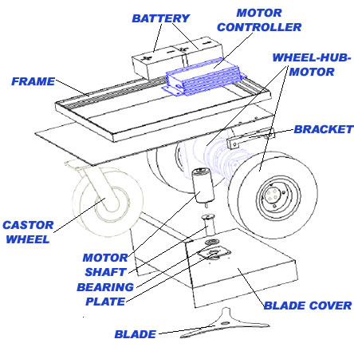
Figure B.1 Exploded View of Lawn Mower

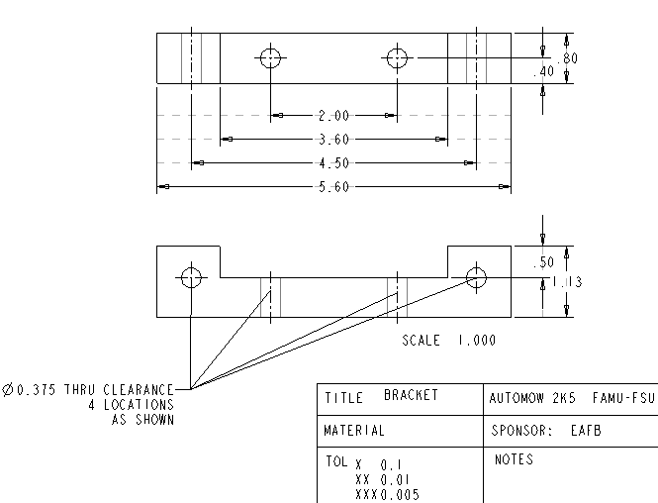
Figure B.2 Bracket for Wheel-Hub-Motor Assembly (Quantity: 2)

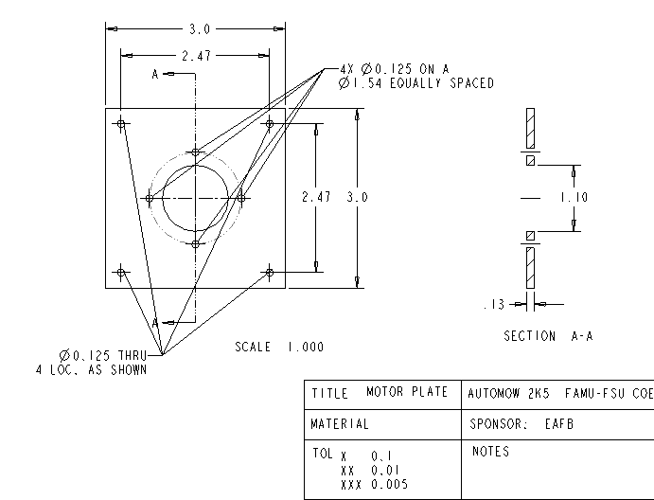
Figure B.3 Mounting Plate for DC Motor (Quantity: 1)

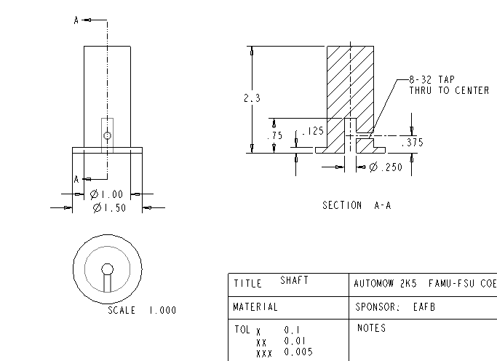
Figure B.4 Shaft for Cutting Blade (Quantity: 1)
Appendix C

Calculations

The total run time of the lawn mower must be calculated. First, the amount of power needed by the drive motors must be determined. The power needed is a function of the power needed by the wheels. The amount of torque needed is calculated below.

The drive motors selected have been tested in a dynometer for amount of current needed and the output torque. The dynometer test is shown below.

Estimated average power consumed per motor in normal operation is 11.1 amps

