About the Authors

  Tamika Dean | Tamika Dean is a graduating senior from Orlando, Florida. Tamika is pursuing her Mechanical Engineering Bachelor of Science degree. When she graduates she plans on continuing her career as a mechanical engineer, by getting a job in the engineering industry, and eventually receiving her PE license and a graduate degree in engineering. Tamika’s main interests in engineering are automotive, design, and robotics. She chose this project for the same reason she chose mechanical engineering, “I’m a hands-on person and I like to create things.”
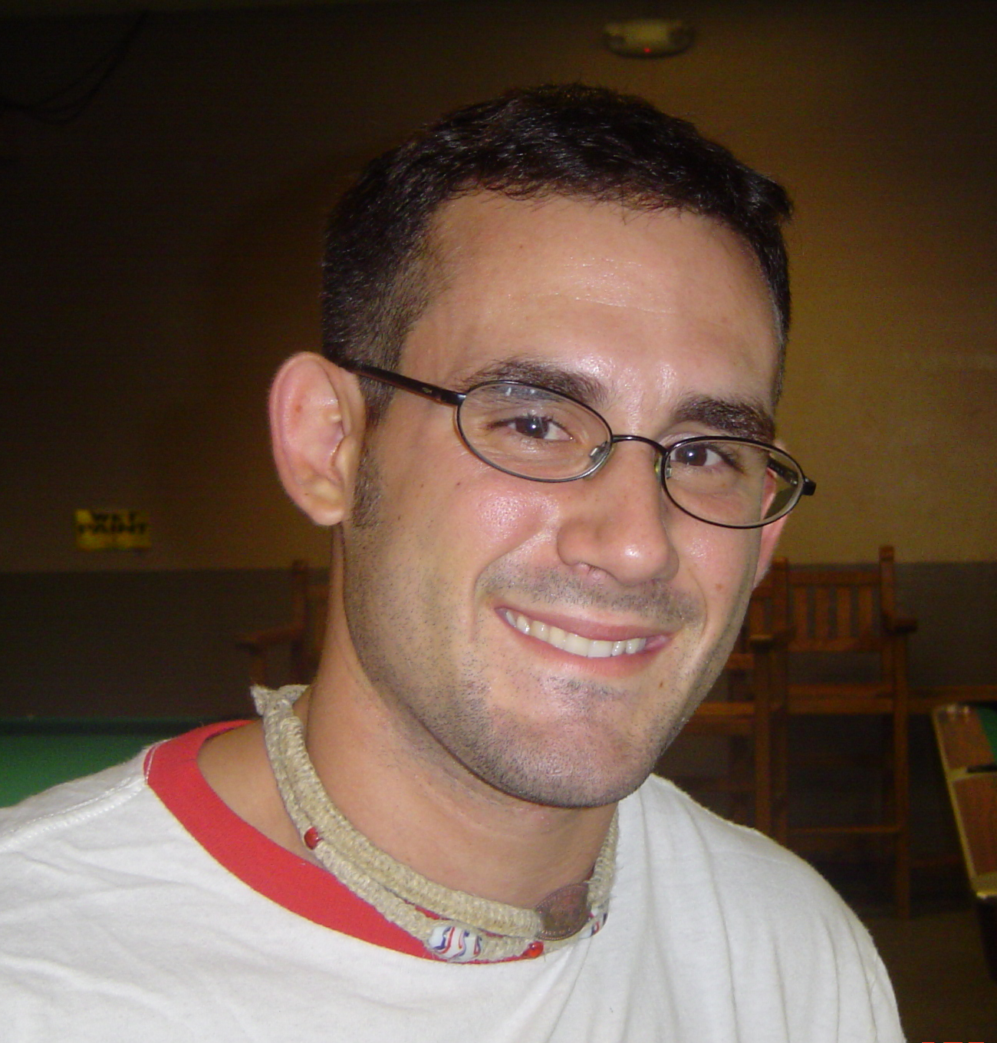  Mike Flatau | Michael Flatau is a Florida State University graduating senior from Tampa, Florida. Once he receives his Bachelors in Science, he plans on continuing his education in the Florida State University mechanical engineering graduate program. Michael is a member of ASME and is currently working for Landmark Design, an architectural design company in Tallahassee, Florida. He chose the Autonomous Lawn Mower project because he has always been interested in robotics and enjoys the design challenges that the project presents.
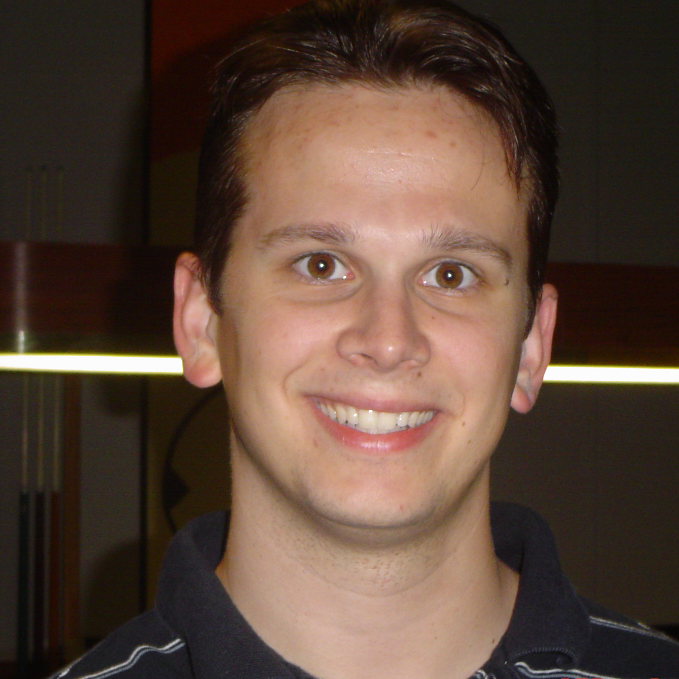  Steven Lydzinski | Steven Lydzinski is a graduating mechanical engineering student at Florida State University. At the College of Engineering, Steve is the president of the American Society of Mechanical Engineers, a member of the Mechanical Engineering Honor Society, and works part time in the Cryogenics Laboratory at the National High Magnetic Field Laboratory. Steve selected the Autonomous Lawn Mower project because of the extensive challenges and multiple disciplines required for an autonomous vehicle.
  Stephanie Taylor | Stephanie Taylor is a graduating senior at Florida Agricultural and Mechanical University. She is from Detroit, Michigan and is currently pursuing her Bachelor of Science Degree in Mechanical Engineering. As a child, Stephanie found great pleasure in the idea of taking things apart and rebuilding them. To this day the feeling remains, this fulfillment sparked her desire of becoming a Mechanical Engineer. Upon graduation she plans to enter Corporate America and find employment in the Design aspects of Mechanical Engineering. Stephanie chose the Autonomous Lawnmower project because she felt it would be beneficial to her future goals of being a Designer.

Acknowledgements

The Autonomous Lawn Mower Team would like to thank the following individuals and affiliates for their assistance with the development of the project:

Affiliates:
The FAMU-FSU College of Engineering – FAMU-FSU COE
The National High Magnetic Field Laboratory – NHMFL
Eglin Air Force Base – EAFB

Sponsors:
Captain Brian “Reece” Tredway – EAFB
Martin Eilders – EAFB
Dr. Joel House – EAFB

Professors:
Dr. Luongo – FAMU-FSU COE
Dr. Moore – FAMU-FSU COE
Dr. Cartes – FAMU-FSU COE

Student Advisors:
Jeffery Cooper
Daniel Braley

Additional Assistance:
Dr. David Hilton, Physicist – NHMFL
James A. Powell, Electronics Engineer – NHMFL
Scott Maier, Technician – NHMFL
Table Of Contents

About the Authors i
Acknowledgements ii

Unit 1 Introduction
  - Problem Definition 1
  - Rules and Requirements 1
  - Sponsor 3

Unit 2 Design Project
  - Needs Assessment 4

Unit 3 Concept Generation and Selection
  - Concept Generation 7
  - Project Plan 10

Unit 4 AUTOMOW 2K5!!
  - Design Options 12
  - Design Decisions 19
  - Cost Analysis 25

Unit 5 Conclusion
  - Restating Project 27
  - Future Plans & Spring Agenda 28

References 29

Appendices
A. ION Rules 31

B. Final Design Drawings 38

C. Calculations 40

