


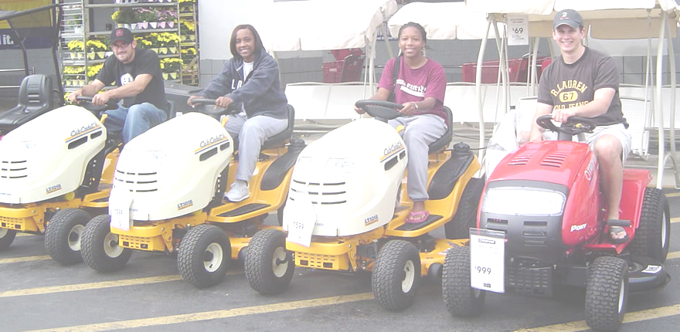

Spring Proposal
December 2, 2004





FAMU-FSU
College of Engineering

Fall 2004 – Spring 2005 Academic Year
Sponsored by Eglin Air Force Base
Captain Brian Tredway, Martin Eilders,
Joel House
Tamika Dean • Mike Flatau
Steve Lydzinski • Stephanie Taylor
1.0 Introduction

The purpose of this project is to design and operate an autonomous lawnmower using the art and science of navigation to rapidly and accurately mow a field of grass. The design will be used in the Institute of Navigation’s (ION) 2nd Annual Autonomous Lawn Mower Competition, sponsored by the ION’s Satellite Division. The competition will take place in June of 2005 in Dayton, Ohio.

To successfully complete this project the needs of the sponsor, Eglin Air Force Base, must be fulfilled. The sponsor’s needs have been defined as follows:

- Create an autonomous lawn mower to enter into the competition
- Make it safe
- Make it work according to the specifications and incorporate global positioning software (GPS)
- Compete in the competition
- Make aesthetically appealing
- Win the competition

This project must also fulfill the needs of the senior design class. These needs have been defined as follows:

- Fulfill the needs of our sponsors
- Complete the necessary deliverables (reports, presentations)
- Complete the necessary deliverables in a timely manner
- Keep the class and the professor aware of our progress

Once the needs of Eglin Air Force Base and the senior design class are fulfilled, the project will be considered a success.

2.0 Design Selected

The AutoMow 2K5 lawn mower will have the capability to autonomously and accurately mow a field of grass. The lawn mower will consist of a navigation, propulsion, and avoidance systems. These systems will be used in conjunction with a mobile platform capable of traversing open terrain. Figure 2.1 displays the components and sensors assembled in the final design of the autonomous lawn mower.

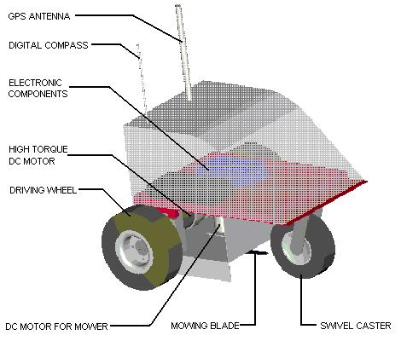
Figure 2.1 Final design of the AutoMow 2K5 autonomous lawn mower.

The propulsion systems include the DC gear motors, wheels, and power. The DC gear motors selected include a wheel and hub attachment for ease of assembly and use. These motors can produce the necessary torque to propel the vehicle through the open field. Large 24 VDC batteries are needed to supply the motors and control systems of the lawn mower and have a storage capacity of 6.6 amp hours. Power consumption of the electrical components is shown in table 2-1. With continuous operation, the autonomous lawn mower will have a total run time of approximately 15 minutes before the batteries will need to be recharged.

Table 2-1 Power consumption of the electronic components.

Navigation systems include the OOPIC microcontroller, GPS sensor, and a digital compass. The OOPIC microcontroller is specifically designed for robotics and will be used for general direction of the lawn mower. It has the ability to upgrade to higher-level sensors and the versatility to conform to programmers trained in Microsoft Visual Basic, C, or Java languages. The Thales GPS sensor uses a collection of satellites to give a general location. It will be used for defining the boundary of the open field. The digital compass will give the lawn mower direction and can be used with the microcontroller to orient the direction of the vehicle.

The avoidance systems must have the ability to detect randomly placed objects located in the path of the vehicle. To accomplish this task, a bump switch, infrared sensor, and a sonar sensor will be used with the microcontroller. The bump switch requires physical contact to detect an object and is necessary for obstacle avoidance. The infrared and the sonar sensor will be used together to detect objects from a distance.

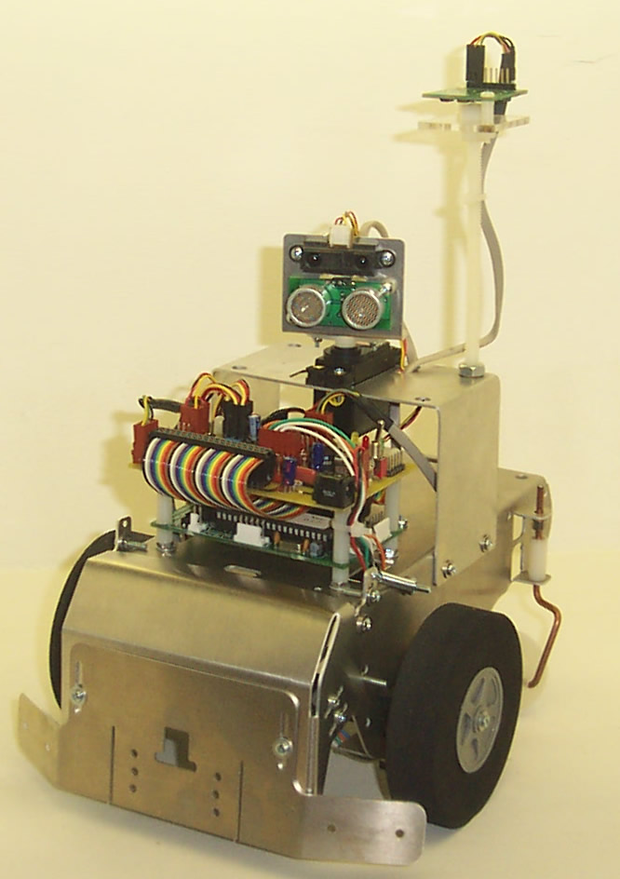
Figure 2.2 Trekker Robotic Platform

Together the propulsion, navigation, and avoidance systems will work to accomplish the goal of accurately mowing a field of grass. The assembly of the final product will be accomplished following extensive testing of the sensors and equipment. Initially, the sensors will be tested independently to check for functionality and function. Once the sensors have been proven to work, they will be combined onto the Trekker Robotic Platform. This robotic platform will allow the sensor to be used together on a platform that is similar to the final vehicle.

The Trekker robot will allow the programming of the microcontroller to be tested. The programming code will be developed in stages. First, the robot will have to be able to perform simple tasks such as travel along a straight line. Eventually, the tasks can be developed into more complex algorithms that will include all the functions that the autonomous lawn mower will use.

3.0 Resources

During the spring semester the Automow 2K5 autonomous lawnmower will be constructed and tested. In order to build the design several resources will be utilized. The machine shop in the FSU-FAMU College of Engineering will be used in order to create the brackets and shafts needed for the final construction of the robot. The cover, blade guard, and main platform of the robot are to be constructed of sheet metal. Parker Services will be aiding the team with the production of the sheet metal parts for the design. Once the parts are properly machined and acquired, the team will provide the tools necessary for the construction of the robot. The electrical components that require soldering will be assembled in the robotics laboratory on FSU-FAMU campus.

With the construction of the robot complete, the team will begin testing. A laboratory equipped with computers and the proper software will be required for the accurate testing of the robot. Individuals at the FSU-FAMU College of Engineering have agreed to assist with the wiring and testing of the design including an Electrical Engineering student that has agreed to assist with the programming.

- Spring 2005 Semester Plan

To have a final product for the competition in June, future plans also have to be determined. As stated previously, the first semester was used to create conceptual ideas, and place purchase orders in for all of the parts. Once the parts are received, the ideas will be able to be implemented. The Trekker Robot and the Robot Kit have already been purchases, so building of the Trekker Robot can begin before the end of the semester. The assembly of the Robot Kit will start at the beginning of the new semester.

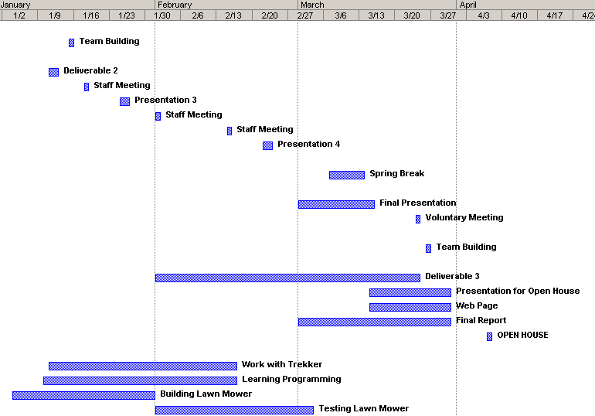
Figure 3.1 Spring 2005 Timeline

Once a good understanding of programming and the movement of the Trekker Robot are grasped, the components needed for the lawn mower will be dismantled and placed on the Robot Kit. Testing of the lawn mower will then begin, and any necessary changes can be made before the competition. The Spring Agenda mostly consists of the building and testing of the final product, AutoMow 2K5! and completing the deliverables due for the course.

- Conclusions

The AutoMow 2K5 autonomous lawn mower will be developed and tested in the spring of 2005. Initially, the Trekker Robotic Platform will be used to develop and test the algorithms at the FAMU-FSU College of Engineering. The programs will first be developed for simple tasks, such as traversing a straight line, then extend into more complex algorithms. The AutoMow 2K5 will rapidly and accurately mowing a field of grass using the navigation, propulsion, and avoidance systems and will win the 2005 autonomous lawn mower competition.
Appendix A – Contact Information

Mechanical Engineering Senior Design Students

Tamika Dean
Email: dean@eng.fsu.edu

Mike Flatau
Email: msf0552@fsu.edu

Steven Lydzinski
Email: Lydzinsk@magnet.fsu.edu

Stephanie Taylor
Email: taylost@eng.fsu.edu
Appendix B – Bill of Materials

Component | Part # | Vendor | Vendor Contact | Unit Price | Qty | Total Cost
Trekker Robot | TP-021-000 | Super Droids Robots | (909) 863-1976 | $409.00 | 1 | $409.00
Platform
IR Sensor
Bump Switch
Sonar Sensor
Compass
Wiring
Robot Starter Kit | ROBOTKIT06 | Robot Combat | (707) 849-7329 | $1,983.00 | 1 | $1,983.00
Driving Motors
Wheel Assembly
Motor Controller
Power Source
Wiring
GPS System | A12 SENSOR | Thales | 800-922-2401 | $500.00 | 1 | $500.00
RF Receiver | 61-2667 | Radio Shack | 800-613-7080 | $25.99 | 1 | $25.99
Emergency Stop | 6785K71 | McMaster Carr | (562) 692-5911 | $36.89 | 1 | $36.89
DC Motor (Mower) | 6331K13 | McMaster Carr | (562) 692-5912 | $53.71 | 1 | $53.71
Cutting Blade | 27-9743 | Manufacturer's Supply | 800-826-8563 | $18.39 | 1 | $18.39
Caster Wheel | 22925T71 | McMaster Carr | (562) 692-5914 | $36.27 | 1 | $36.27
1018 Steel 24"x24" Sheet Metal | 6544K16 | McMaster Carr | (562) 692-5915 | $21.00 | 2 | $42.00
1018 Steel 4"x24" Sheet Metal | 9517K161 | McMaster Carr | (562) 692-5916 | $25.32 | 1 | $25.32
1018 Steel Rod 1.25"x0.875"x12" | 8910K814 | McMaster Carr | (562) 692-5917 | $17.90 | 1 | $17.90
1018 Steel Rod 1.5" dia x 12" | 8920K312 | McMaster Carr | (562) 692-5918 | $18.00 | 1 | $18.00
Bearing | 5909K63 | McMaster Carr | (562) 692-5919 | $3.49 | 4 | $13.96
 |  |  |  | Total |  | $3,180.43
 |  |  | After Subtracting Parts Supplied by Eglin | Total |  | $288.43

Appendix C – Product Specifications

OOPIC II+
 | Voltage | 6-15 V
 | I/O Connectors | 40pins
 | Memory | 2 EEPROM Sockets
 | Network Connections | 2 I2C
 | Size | 2” x 3.5” x 5/8”
Thales A12 GPS Sensor
 | Voltage | 10-18V
 | Current | 80mA
 | Accuracy | 3m
 | Weight | 8.5 oz
 | Size | 4.38”w x 1.16”h x 4.12”d
Devantech CMPS03 Digital Compass
 | Voltage | 5V
 | Current | 20mA
 | Resolution | 0.1 Degree
 | Accuracy | 3-4 degrees
 | Weight | 0.03 oz
 | Size | 32mm x 35mm
Devantech SRF04 Ultrasonic Sensor
 | Voltage | 5V
 | Current | 30mA
 | Frequency | 40kHz
 | Max Range | 3m
 | Min Range | 3cm
 | Sensitivity | 3cm diameter stick at > 2m
 | Weight | 0.4 oz
 | Size | 1.75”w x 0.625”h x 0.5”d
Sharp GP2D12 IR Scanner
 | Voltage | 5V
 | Current | 33mA
 | Max Range | 80 cm
 | Min Range | 10 cm
 | Sensitivity | 24 cm
 | Size | 44.5mm w x 13mm h x 13.5mm d
NPC-T64 DC Gear Motor
 | Voltage | 24V
 | Speed | 230rpm
 | Gear Ratio | 20:1
 | Weight | 13 lbs
PN-3300BP-24 Batteries
 | Voltage | 24V
 | Max Current | 80 amps
 | Amp Hours | 3.3 Ahrs
 | Weight | 2 lbs
 | Size | 5.75”w x 2.2”h x 2.25”d
RoboteQ AX2550 Motor Controller
 | Voltage | 12V
 | Current | 150mA
 | Control | Dual H-bridge
 | Weight | 2lbs
 | Size | 7”w x 1.8”h x 5.5”d

