Bill of Materials (Tetrahedral Array Frame)

Part | Designation # | Quantity
2” x ¼” OD Bolt | A | 3
¼” Steel Washer | B | 6
¼” Steel Nut | C | 3
Sorbothane® Bushing | D | 3
Sorbothane® Washer | E | 3
Main Base UHMW-PE | F | 1
RDS Adapter Plate | G | 1
Threaded Brass Inserts | H | 8
1” Nylon Standoffs | I | 2
Motor Adapter Plate | J | 2
Interior Slider Link | K | 1
6” Lead Screw | L | 1
Z2684X-V Stepper Motor | M | 1
Igus® Clevis Joint | N | 9
Igus® Clevis Pin | O | 9
Igus® Clevis Clip | P | 9
Acrylic 90º Connector Link | Q | 3
Connector Rod | R | 3
Extension Rod | S | 3
Slider Guide Pin | T | 1
Exterior Slider Link | U | 1
Center Shaft | V | 1
Acrylic Microphone Mount (Bottom) | W | 3
Acrylic Microphone Mount (Top) | X | 1
8-32 UNC Set Screw | Y | 16
Optional Acrylic Microphone Adapter Plate | Z | 4

Specifications

Part | Specification | Type
Floating Bolt | 5 in-lbs | Torque
Slide Track | 4 inches | Stroke Length
Stepper Motor | HSI Z2684X-V | Part #
Guide Pin | 3/16” | Major Diameter
Set Screws | UNC 8-32 | Thread Pitch
Microphone Mount Bolts | UNC 8-32 Machine Screw | Screw Type and Thread Pitch
Microphone Adapter Mount Bolts | UNC 5-40 Machine Screw | Screw Type and Thread Pitch
Microphone Adapter Plate Standoffs | ¼” Nylon | Length and Material
Main Base Assembly

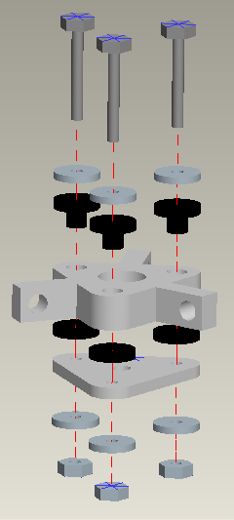
A
B
D
F
E
G
B
C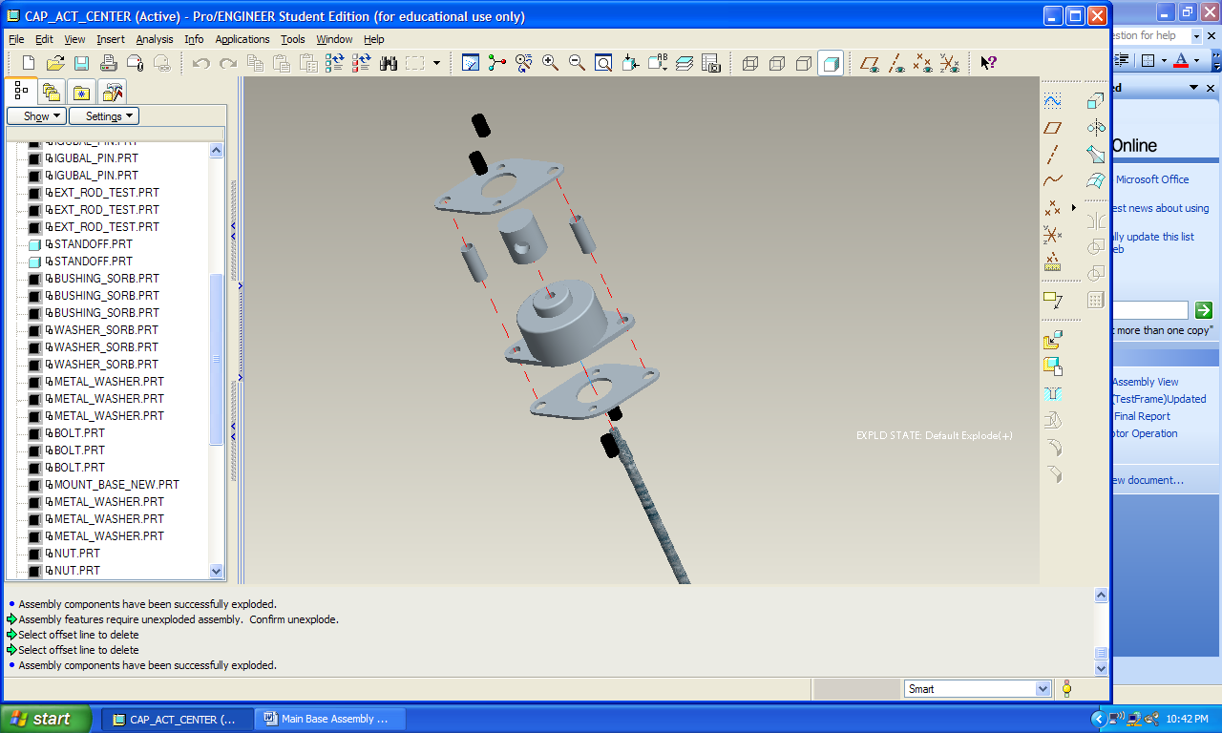

Actuation System Assembly

L
I
J
J
H
K
M

Connecting and Extension Rod Assembly

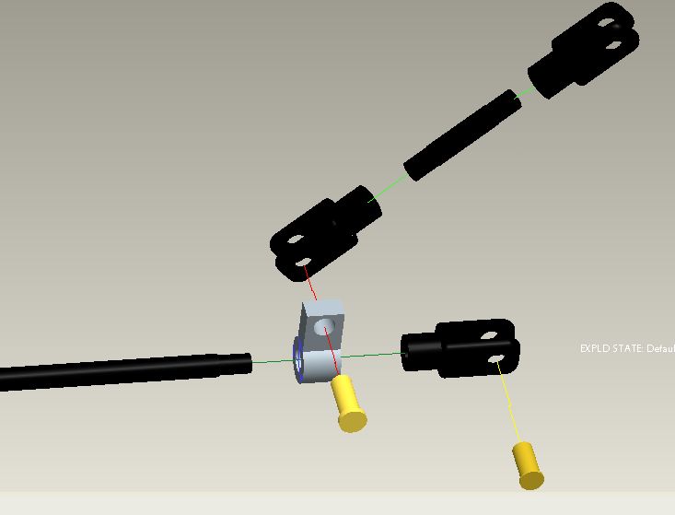
N
O
Q
S
R

Center Shaft and Slider Track Assembly

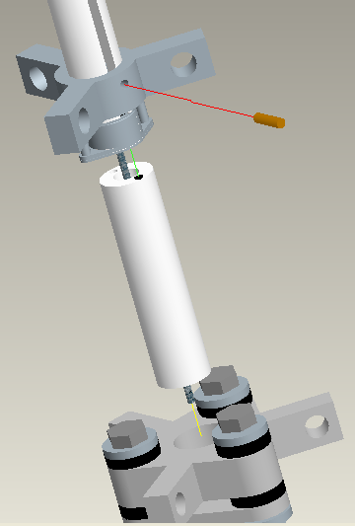
U
T
V
Assembled Base Plate
Assembled Actuation System
H
Slider Track

Rod to Base Assembly

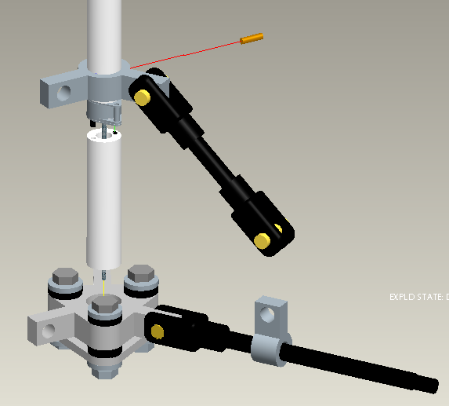
Assembled Extension Rod
Assembled Connecting Rod
Insert Center Shaft Here
Insert Clevis Pin Here

Completed Assembly

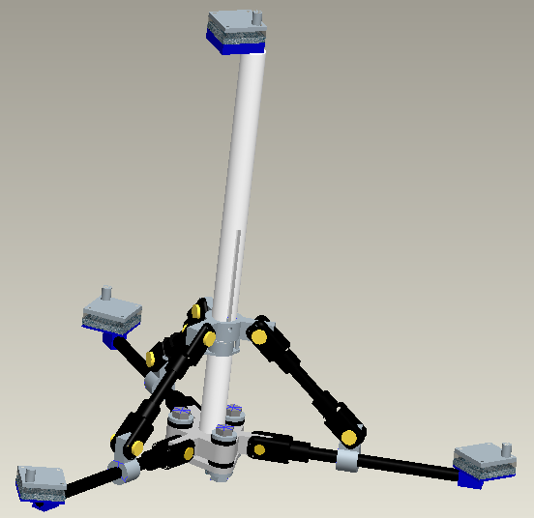
X
W

