Bill of Materials (T-Base Array Frame)

Part | Designation # | Quantity
1.5” x ¼” OD Bolt | A | 4
¼” Steel Washer | B | 8
¼” Steel Nut | C | 4
Sorbothane® Bushing | D | 4
Sorbothane® Washer | E | 4
T-Base UHMW-PE | F | 1
VEX™ Robot Adapter Plate | G | 1
Extension Rod | H | 2
Center Shaft | I | 1
Acrylic Microphone Mount (Bottom) | J | 3
Acrylic Microphone Mount (Top) | K | 1
8-32 UNC Set Screw | L | 8
Optional Acrylic Microphone Adapter Plate | M | 4

Specifications

Part | Specification | Type
Floating Bolt | 5 in-lbs | Torque
Set Screws | UNC 8-32 | Thread Pitch
Microphone Mount Bolts | UNC 8-32 Machine Screw | Screw Type and Thread Pitch
Microphone Adapter Mount Bolts | UNC 5-40 Machine Screw | Screw Type and Thread Pitch
Microphone Adapter Plate Standoffs | ¼” Nylon | Length and Material
Extension and connecting Rod | 0.375” ABS | Major Diameter
Center Shaft | 0.5” UHMW-PE | Major Diameter
Motor Adapter Plate Screws & Nuts | UNC 4-40 Machine Screws and Nuts | Thread Pitch
T-Base Assembly

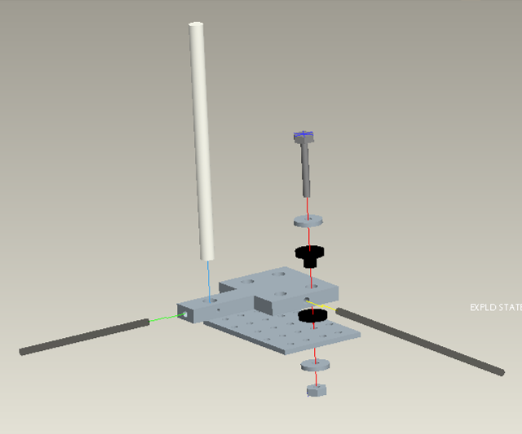
A
B
C
D
E
B
F
G
H
H
I
Completed Assembly

