T-Base Array
Installation and Operating Manual

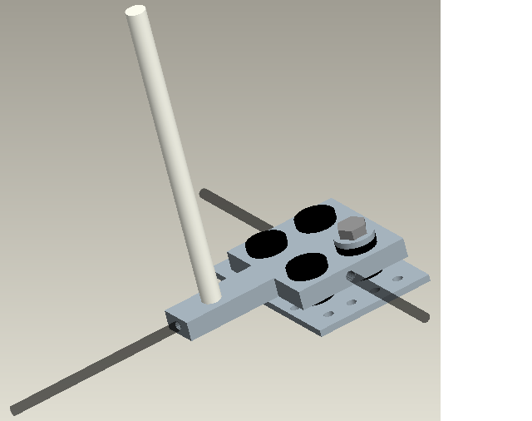

T-Base Array Housing

The T-Base array that has been designed and built is a frame to hold four microphones in a tetrahedral orientation with a microphone to microphone distance of ten inches. This array is a non-collapsible array in a “T” orientation. This array features the same vibration isolation mechanisms as the collapsible array.

Intended Use

T-Base Array integrates acoustic sensor eye to VEX™ Robot. Operation of array damps mechanical vibration received through the structure to the acoustic eye sensor caused by the movement of the robot platform.

Function

Physically attaches acoustic sensor eye to applicable platform. Array frame decouples acoustic sensor eye from direct contact with any applicable platform.

 Safety Instructions

T-Base Array contains protruding edges that may cause harm to user if not carefully handled.

T-Base Array Precautions

DO NOT allow array to come in close proximity with temperatures in excess of 120° F.

DO NOT over torque the Sorbothane® bushing bolts. Do not exceed 5 in-lbs of torque.

DO NOT over tighten setscrews. Stripping of thread material WILL occur.

DO NOT impose heavy loads on array frame. Material damage WILL occur.

Features

This array has been designed in a “T” orientation to be able to accommodate the VEX™ robot on which it will be mounted.

Vibration isolation is also incorporated in this half size array. The same techniques used in vibration damping for the Tetrahedral Collapsible array are used in this T-Base array. See the previous array feature section for details.

This array also features microphone to microphone distance adjustability. This array can accommodate several microphone types due to the fact that the microphone to microphone distances can be fine tuned. The mounting methods by which the microphones can be attached are also versatile.

Assembly

Major components of tetrahedral array come pre-assembled. Only small adjustments of rods are required to operate array.

Adjustments of rods can be viewed in the exploded assembly drawings in the assembly manual.

If complete disassembly and reassembly is required see schematic layout in the assembly manual.

Operation

The main base of the array has been designed to bolt to the adapter plate provided for attachment to the VEX™ robot.

The microphone adjustability is identical to the Tetrahedral Collapsible array. The same microphone mounting boards and adapter plates are used.

Maintenance/ Adjustment

T-Base Array comes preassembled with main adjustments already in place. For fine- tuning of microphone sensors all extension rods, microphone plates and adapter plates are adjustable using a 5/64” Allen wrench for setscrews.

For maintenance purposes follow these key points:

- T-Base array is mainly maintenance free.
- Check periodically for signs of wear and tear and replace any damaged or worn components.
- Check floating bolt torque to ensure complete damping characteristics on array.
Bill of Materials (T-Base Array Frame)

Part | Designation # | Quantity
1.5” x ¼” OD Bolt | A | 4
¼” Steel Washer | B | 8
¼” Steel Nut | C | 4
Sorbothane® Bushing | D | 4
Sorbothane® Washer | E | 4
T-Base UHMW-PE | F | 1
VEX™ Robot Adapter Plate | G | 1
Extension Rod | H | 2
Center Shaft | I | 1
Acrylic Microphone Mount (Bottom) | J | 3
Acrylic Microphone Mount (Top) | K | 1
8-32 UNC Set Screw | L | 8
Optional Acrylic Microphone Adapter Plate | M | 4

Specifications

Part | Specification | Type
Floating Bolt | 5 in-lbs | Torque
Set Screws | UNC 8-32 | Thread Pitch
Microphone Mount Bolts | UNC 8-32 Machine Screw | Screw Type and Thread Pitch
Microphone Adapter Mount Bolts | UNC 5-40 Machine Screw | Screw Type and Thread Pitch
Microphone Adapter Plate Standoffs | ¼” Nylon | Length and Material
Extension and connecting Rod | 0.375” ABS | Major Diameter
Center Shaft | 0.5” UHMW-PE | Major Diameter
Motor Adapter Plate Screws & Nuts | UNC 4-40 Machine Screws and Nuts | Thread Pitch
T-Base Assembly

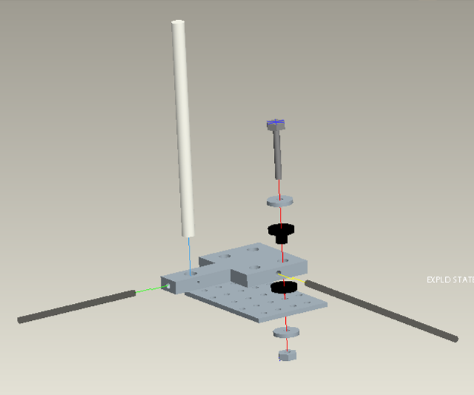
A
B
C
D
E
B
F
G
H
H
I
Completed Assembly

