Tetrahedral Collapsible Array

Installation and Operating Manual

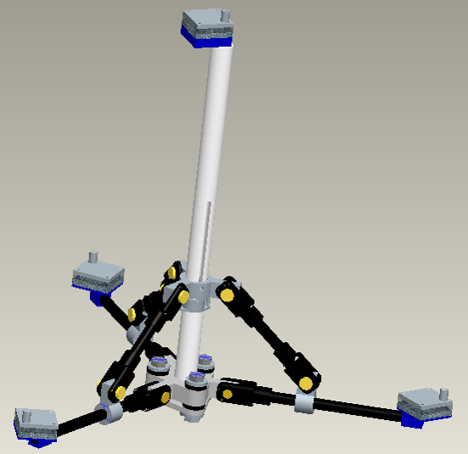

Tetrahedral Collapsible Array Housing

The tetrahedral array frame has been designed and built to house four microphones in a tetrahedral orientation with a microphone-to-microphone distance of twenty inches.

Intended Use

Tetrahedral Array frame integrates acoustic sensor eye to RDS (Robot Demonstration System) or any other applicable robot platform. Operation of array damps mechanical vibration received through the structure to the acoustic eye sensor caused by the movement of the robot platform.

Function

Physically attaches acoustic sensor eye to applicable platform. Array frame decouples acoustic sensor eye from direct contact with any applicable platform. Remotely retracts or deploys acoustic sensor eye for transportation or navigational needs.

 Safety Instructions

Incorrect wire connection will result in stepper motor damage or possible fire hazard. DO NOT cross coil wiring on stepper motor (reference stepper motor controller manual for proper wiring schematics).

Keep extremities clear from array at all times during retraction and deployment.

Stepper motor may become hot during operation (Temperatures up to 75°C). DO NOT touch stepper motor during operation and up to 15 minutes after operation.

Keep fingers away from guide track (slider slot) at all times.

Tetrahedral Array Precautions

DO NOT operate stepper motor while tetrahedral array is in the toggled position. Severe damage may occur to lead screw and or stepper motor.

DO NOT continue to operate stepper motor once fully deployed or retracted position is reached. Stepper motor damage may occur.

DO NOT allow array to come in close proximity with temperatures in excess of 120° F.

DO NOT over torque the Sorbothane® bushing bolts. Do not exceed 5 in-lbs of torque.

DO NOT over tighten setscrews. Stripping of thread material WILL occur.

DO NOT impose heavy loads on array frame. Material damage WILL occur.

DO NOT hand drive the slider mechanism. Binding may occur in array frame.

Features

Actuated by a single bi-polar stepper motor.

Utilizes simple four-bar slider linkages for retraction and deployment.

Integrates a sliding, dual slider, slot track system for actuation.

Full collapsibility into toggled position for ease of transportation.

Complete vibration damping characteristics enhanced throughout the array frame.

Adjustability of the microphone-to-microphone distances on the apices of the tetrahedral frame.

Adaptability of multiple microphone sensor designs utilizing optional adapter plates.

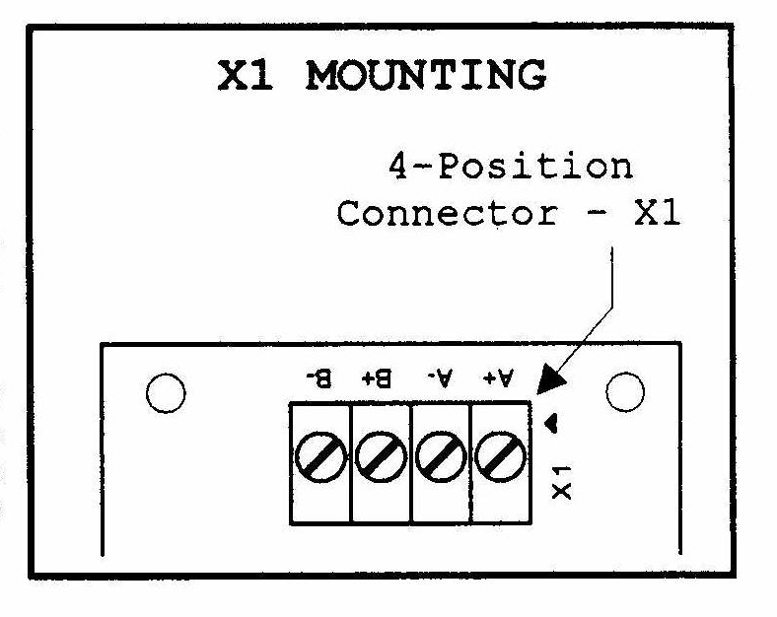
Coil 1 Ground
Coil 1 Power
Coil 2 Power
Coil 2 Ground
(Figure 1)

Assembly

Major components of tetrahedral array come pre-assembled. Only small adjustments of rods are required to operate array.

Adjustments of rods can be viewed in the exploded assembly drawings in the assembly manual.

Connect stepper motor to stepper motor controller following wiring sequence seen in figure 1. Reference stepper motor controller manual for further schematics.

If complete disassembly and reassembly is required see schematic layout in the assembly manual.

Operation

To deploy or retract tetrahedral array frame follow the following sequence.

- Adjust switch 3 on stepper motor controller to change direction of stepper motor for deployment or retraction.
  - For deployment place switch 3 in the open position as seen in figure 2.
  - For retraction place switch 3 in the closed position as seen in figure 2.

- Adjust switch 2 on stepper motor controller to change between full or half step mode. (For explanation of full or half step mode see stepper motor controller manual).
  - For Full Step place switch 2 in close position as seen in figure 2.
  - For half Step place switch 2 in open position as seen in figure 2.

- Power on stepper motor by placing switch 1 in the open position as seen in figure 2.
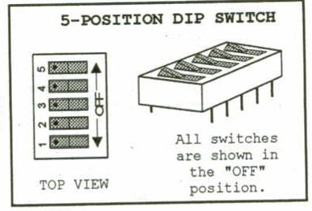
(Figure 2)

Maintenance/ Adjustment

Tetrahedral array comes preassembled with main adjustments already in place. For fine- tuning of microphone sensors all connecting rods, extension rods, microphone mounts and adapter plates are adjustable using a 5/64” Allen wrench.

For maintenance purposes follow these key points:

- Lubricate slider track periodically if motor becomes labored.
- Lubricate pin joints if binding occurs.
- Clean any dirt or debris from slider track before operation.
- Check periodically for signs of wear and tear and replace any damaged or worn components.
- Check floating bolt torque to ensure complete damping characteristics on array.

Bill of Materials (Tetrahedral Array Frame)

Part | Designation # | Quantity
2” x ¼” OD Bolt | A | 3
¼” Steel Washer | B | 6
¼” Steel Nut | C | 3
Sorbothane® Bushing | D | 3
Sorbothane® Washer | E | 3
Main Base UHMW-PE | F | 1
RDS Adapter Plate | G | 1
Threaded Brass Inserts | H | 8
1” Nylon Standoffs | I | 2
Motor Adapter Plate | J | 2
Interior Slider Link | K | 1
6” Lead Screw | L | 1
Z2684X-V Stepper Motor | M | 1
Igus® Clevis Joint | N | 9
Igus® Clevis Pin | O | 9
Igus® Clevis Clip | P | 9
Acrylic 90º Connector Link | Q | 3
Connector Rod | R | 3
Extension Rod | S | 3
Slider Guide Pin | T | 1
Exterior Slider Link | U | 1
Center Shaft | V | 1
Acrylic Microphone Mount (Bottom) | W | 3
Acrylic Microphone Mount (Top) | X | 1
8-32 UNC Set Screw | Y | 16
Optional Acrylic Microphone Adapter Plate | Z | 4

Specifications

Part | Specification | Type
Floating Bolt | 5 in-lbs | Torque
Slide Track | 4 inches | Stroke Length
Stepper Motor | HSI Z2684X-V | Part #
Guide Pin | 3/16” | Major Diameter
Set Screws | UNC 8-32 | Thread Pitch
Microphone Mount Bolts | UNC 8-32 Machine Screw | Screw Type and Thread Pitch
Microphone Adapter Mount Bolts | UNC 5-40 Machine Screw | Screw Type and Thread Pitch
Microphone Adapter Plate Standoffs | ¼” Nylon | Length and Material
Extension and connecting Rod | ½” ABS | Major Diameter
Center Shaft | 0.99” Hollow UHMW-PE | Major Diameter
Center Shaft | 0.45” Hollow UHMW-PE | Inner Diameter
Motor Adapter Plate Screws & Nuts | UNC 4-40 Machine Screws and Nuts | Thread Pitch
Main Base Assembly

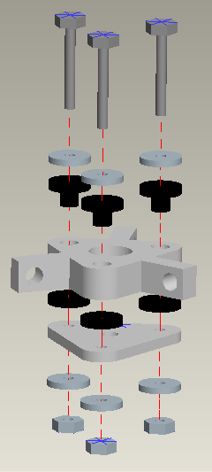
A
B
D
F
E
G
B
C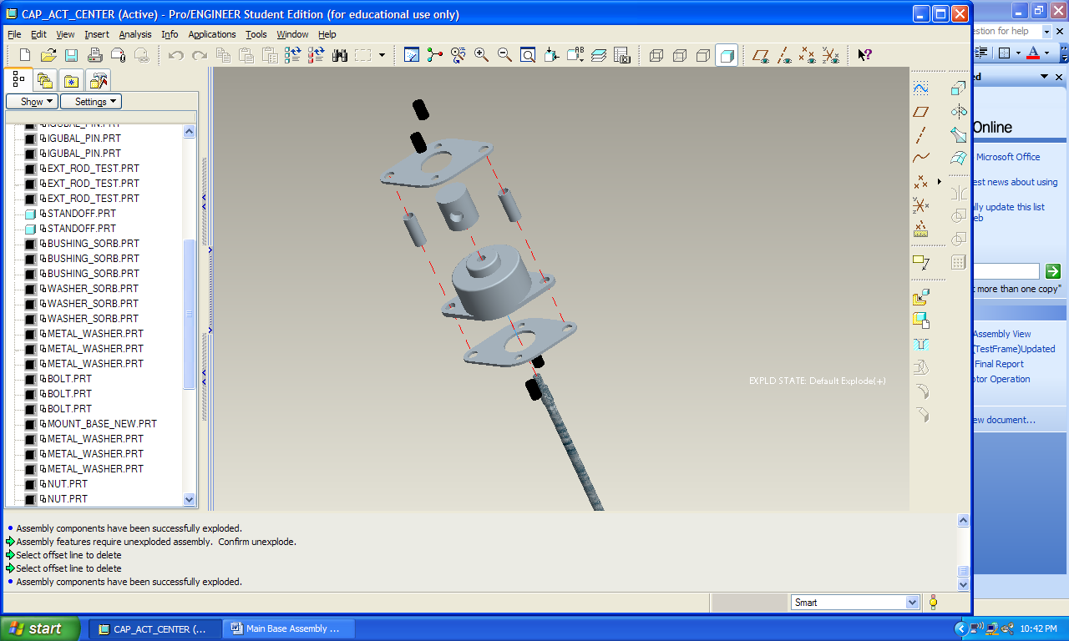

Actuation System Assembly

L
I
J
J
H
K
M

Connecting and Extension Rod Assembly

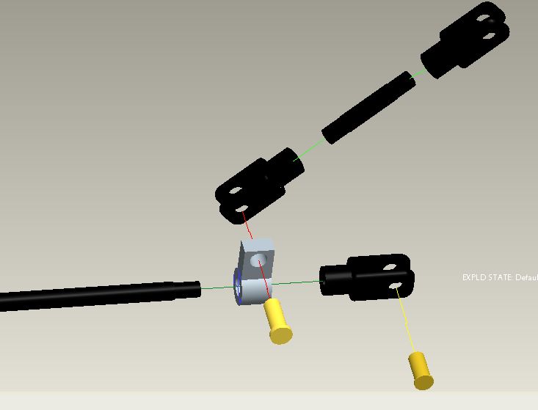
N
O
Q
S
R

Center Shaft and Slider Track Assembly

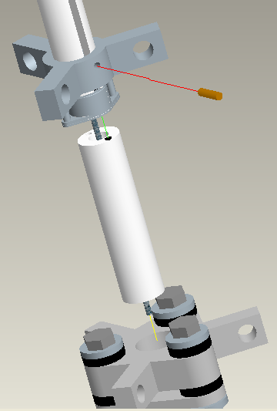
U
T
V
Assembled Base Plate
Assembled Actuation System
H
Slider Track

Rod to Base Assembly

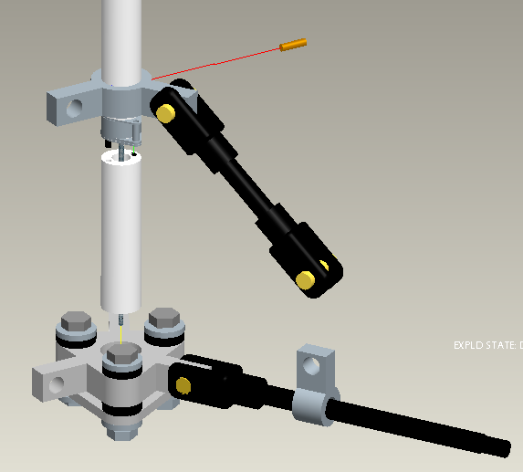
Assembled Extension Rod
Assembled Connecting Rod
Insert Center Shaft Here
Insert Clevis Pin Here

Completed Assembly

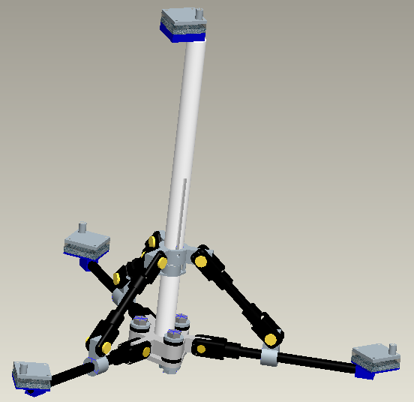
X
W

