Senior Design Project: Assembly Manual
Team 12: Moving Armor Target (MAT) Elevated Track

Sponsor: Lockheed Martin
(Contact: Mr. Horace Turner)

Group Members:

Thomas Hutton

Cleon Stanley
Jacob Feist
Sladana Lazic

04/04/2006

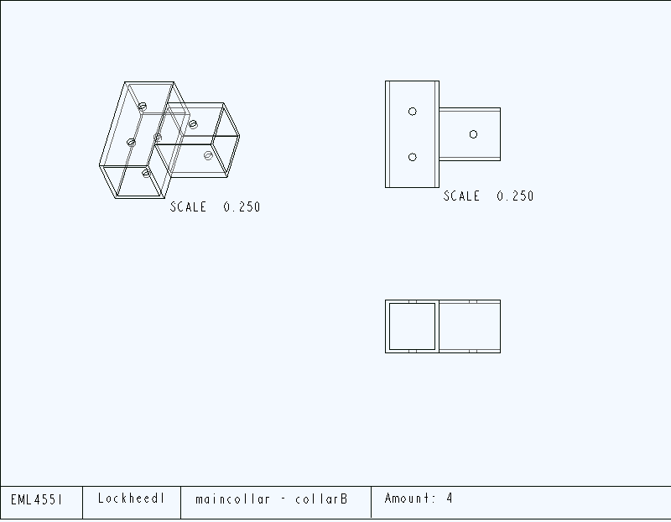
Fig. D-1: Main Collar-Collar B
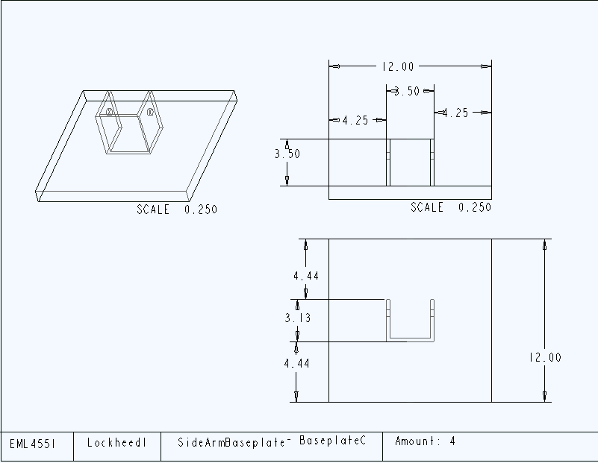
Fig. D-2: Side Arm Baseplate – Baseplate C
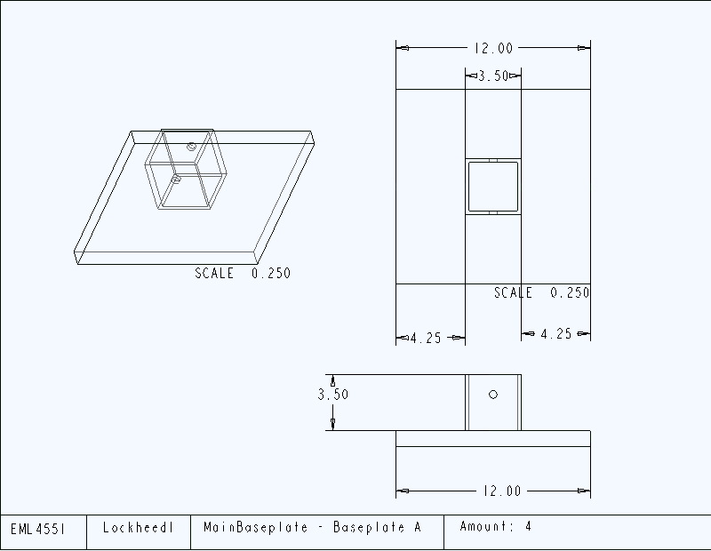
Fig. D-3: Main Baseplate – Baseplate A
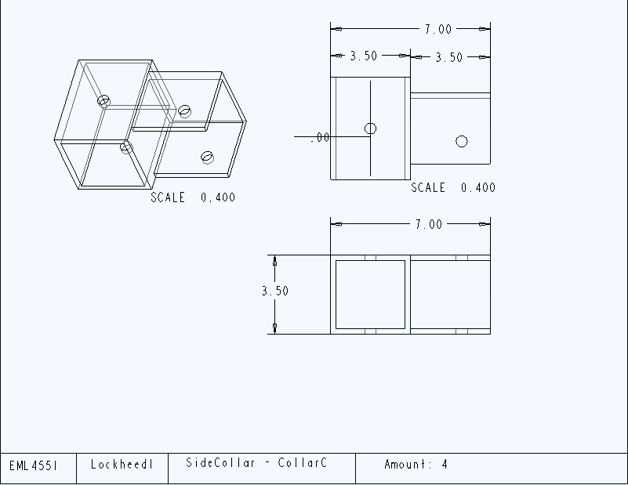

Fig. D-4: Side Collar – Collar C

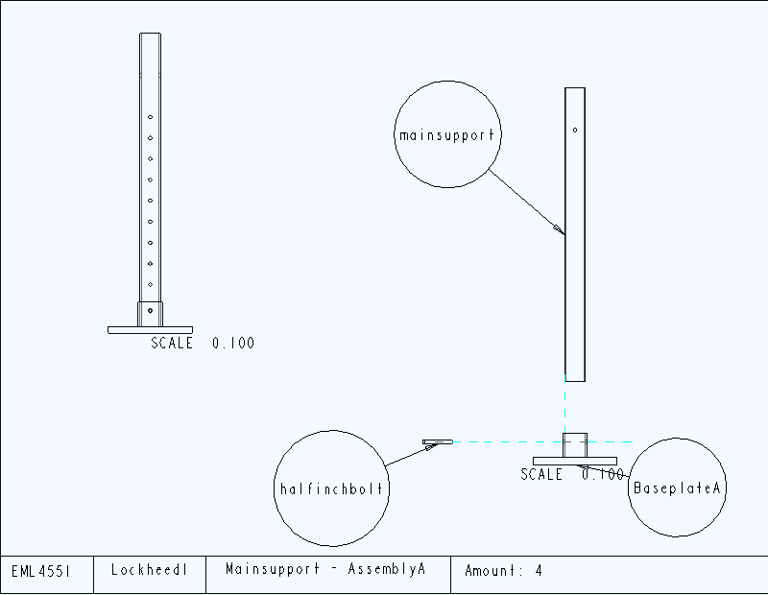
Fig. D-5: Main support – Assembly A

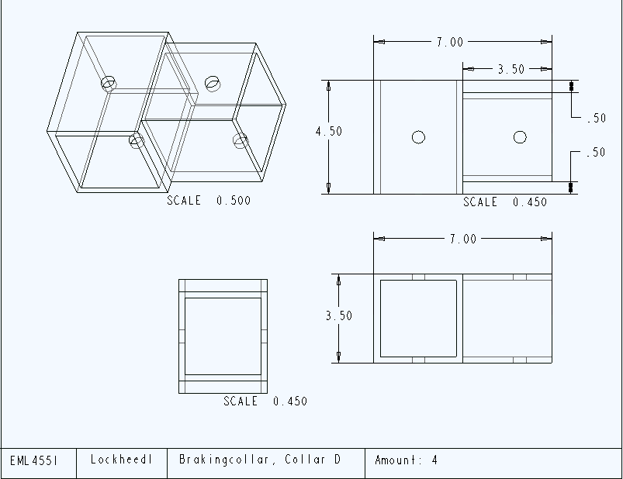
Fig. D-6: Breaking Collar – Collar D
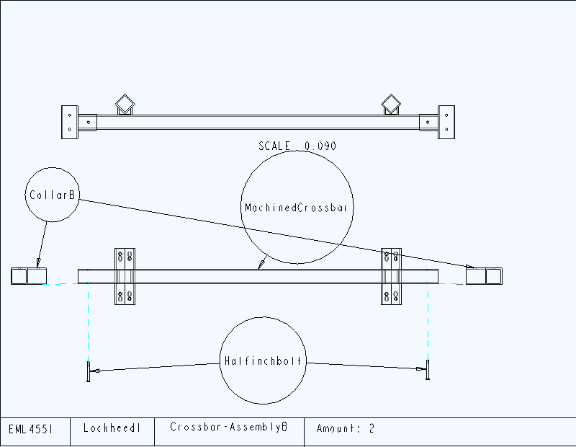
Fig. D-7: Crossbar – Assembly B
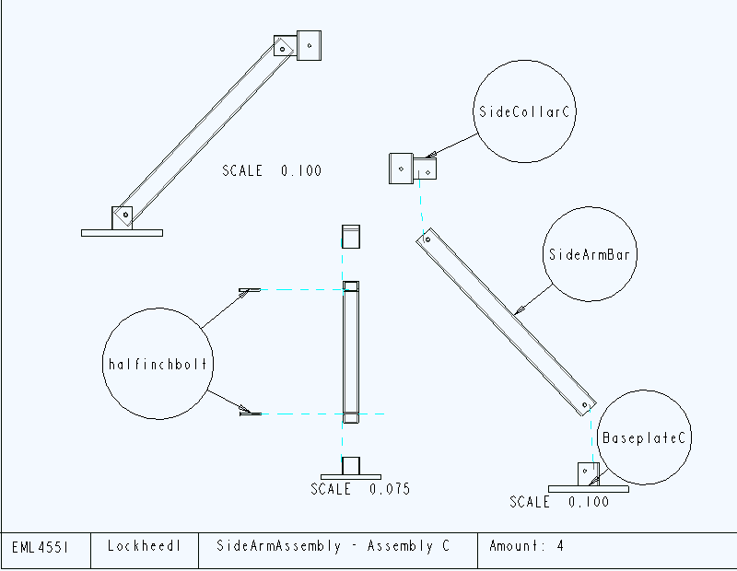
Fig. D-8: Side Arm Assembly – Assembly C
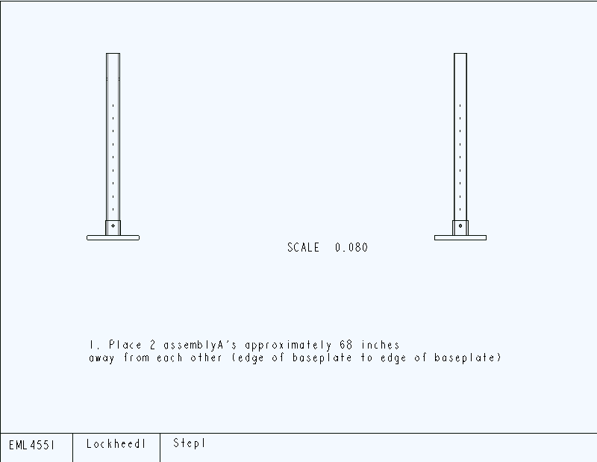
Fig. D-9: Step 1
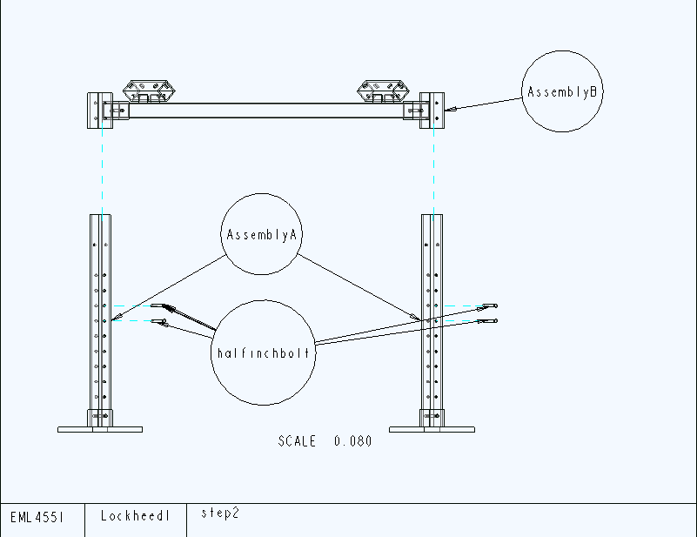
Fig. D-10: Step 2
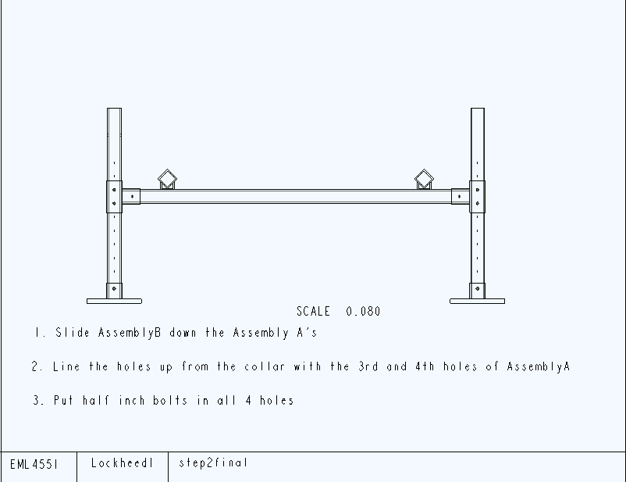
Fig. D-11: Step 2- final
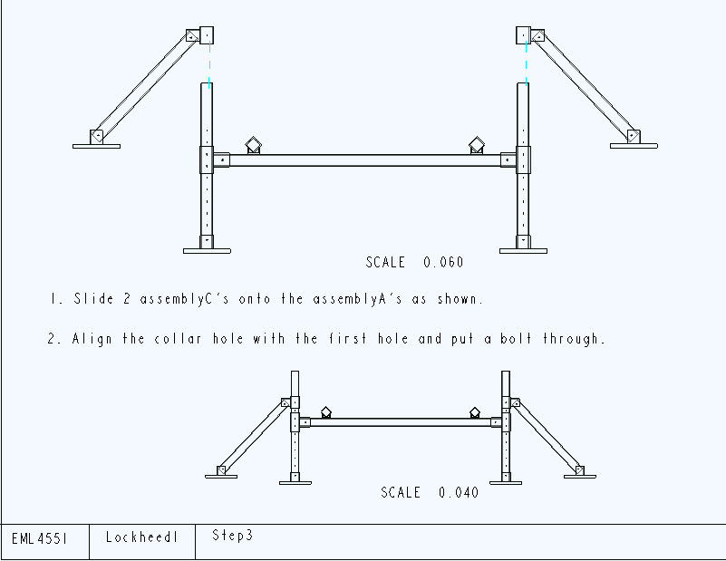
Fig. D-12: Step 3
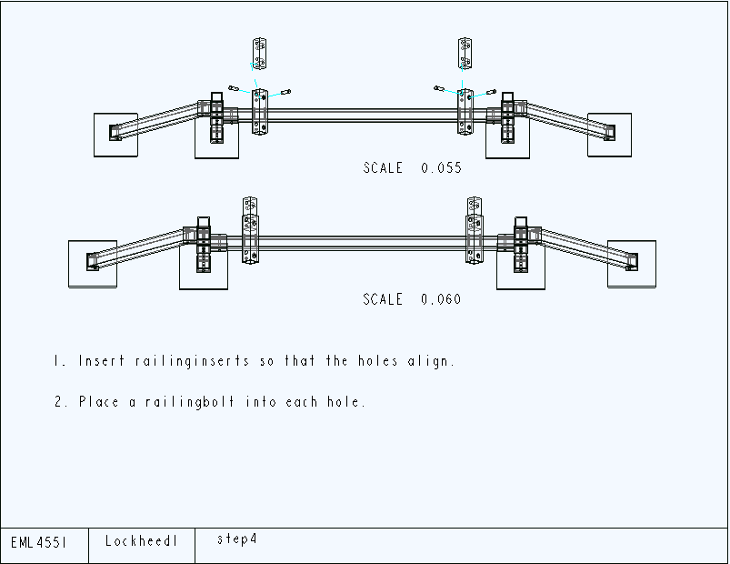
Fig. D-13: Step 4
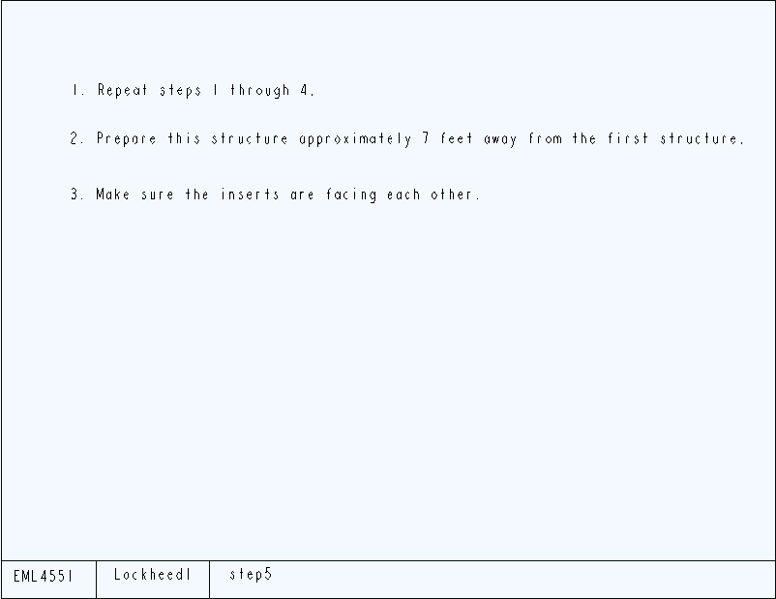
Fig. D-14: Step 5
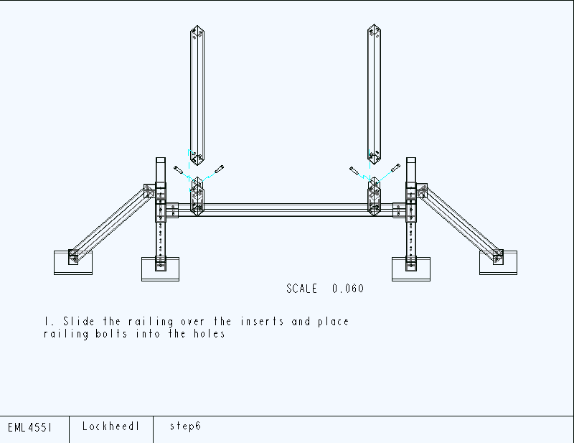
Fig. D-15: Step 6
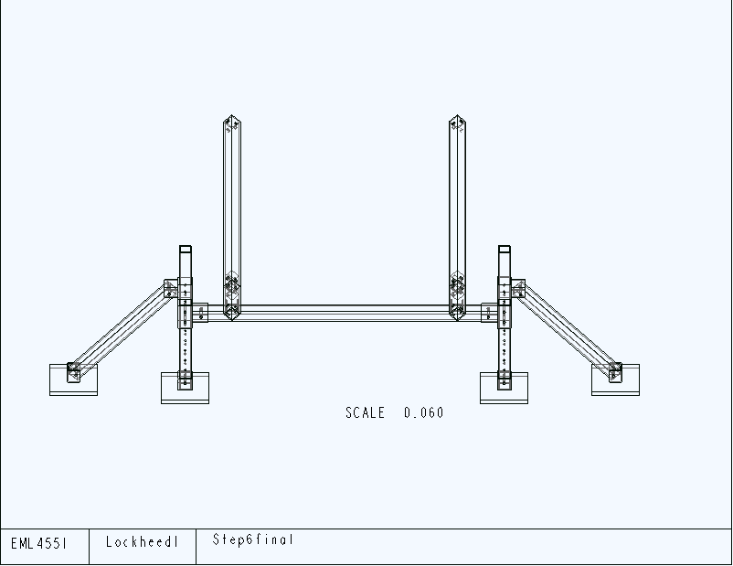
Fig. D-16: Step 6 – final
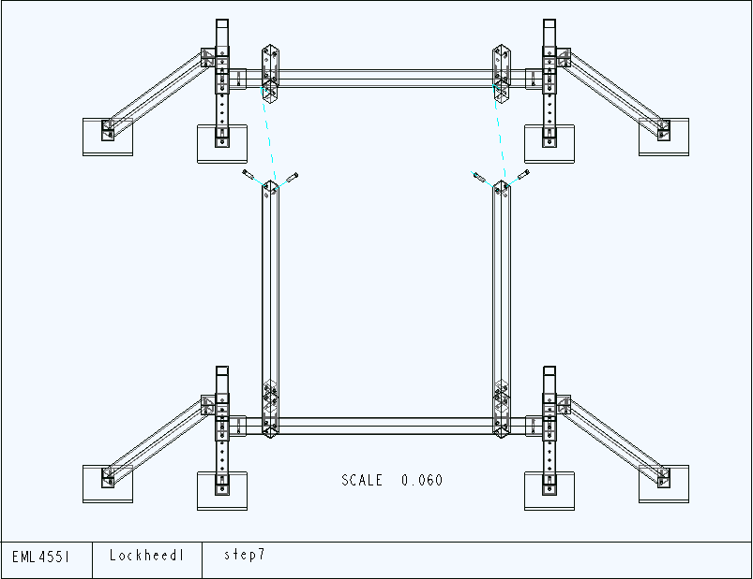
Fig. D-17: Step 7
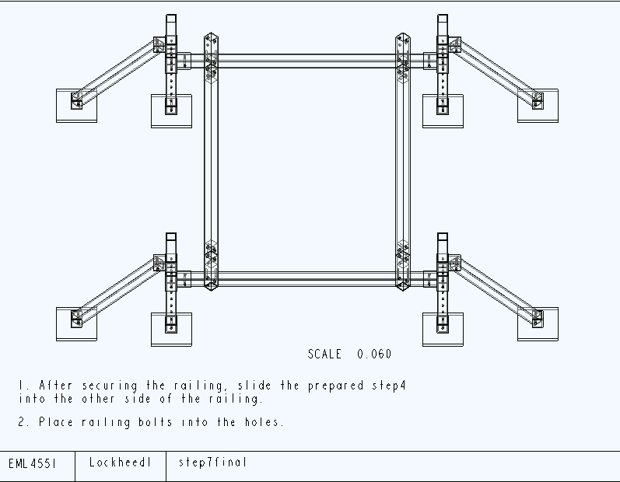
Fig. D-18: Step 7 – final

