Senior Design Project: Final Report (Spring Semester)
Team 12: Moving Armor Target (MAT) Elevated Track

Sponsor: Lockheed Martin
(Contact: Mr. Horace Turner)

Group Members:

Thomas Hutton

Cleon Stanley
Jacob Feist

Sladana Lazic

04/04/2006

Table of Contents: Page #:

Introduction……………………………………1-3
  - Project description and scope ……………………1
  - Background research……………………………..2
  - Statement of Need………………………………...2-3
  - Specifications……………………………………...3

Design Process………………………………….3-11
  - Concept generation……………………………….3-4
  - Preliminary designs ………………………………4-10
    - Height adjustable…………………….4-6
    - Stability on any terrain………………6
    - Connection of parts…………………..7-8
    - Wheel support………………………..8-10
  - Selection process…………………………………..10-11

Final Design…………………………………….12-14
  - Description…………………………………………12-13
  - Feasibility…………………………………………..13-14

Machining Process………………………………14-16
  - Ordering Process and Issues……………………….14-15
  - Process and Issues…………………………………..15-16

Assembly Process………………………………...16-17
  - Assembly Issues and Solutions………………………17
  - Assembly Testing……………………………………..17

Conclusion…………………………………………18-19
  - Achieved Goals………………………………………...18-19

Appendix A: References
Appendix B: Calculations
Appendix C: Machining
Appendix D: Assembly
Appendix E: Drawings

Abstract:

A simple concept is used to redesign the track that a Moving Armor Target cart is running on. This cart weighs 2100 pounds and at top speed it runs 36.5 ft/s. It is also often set out to withstand wind speeds of 57.4 ft/s.
Currently our sponsor is using standard railroad tracks. These need to be redesigned so that they can be portable. The track should be functional in any climate and on any soil. The parts of the track should be easy to assemble so that minimum labor and tools are required.
In order to ensure that the track is portable and it can be assembled by a minimum number of people, we made the individual parts not heavier than 90 lbs. The maximum required weight of one component was 160 lbs. The parts are all easy to attach and assemble due to simple collar-pin design, which requires minimum tools.
The moveable cross tie design makes it possible to change the elevation of the main rails. Added stability is ensured true angled side supports and lateral support bars. This makes this design useable in all weather conditions and on all territories.
This design is proven to work at worst conditions since the vertical force applied to the main rail at the highest speed of the cart, with the worst wind conditions, turned out to be 1.886e3 lbs, which is still smaller than the gravitational force of 2100 lbs in this case. This shows that our design will not fail under the worst conditions.
Another way to show that our design is safe is the fact that the factor of safety due to bending of the main rail is 2.4. This is an appropriate factor of safety considering that our design will not have people on it but it still needs to remain on the rails.
To prove that the assembly time has been reduced as expected we conducted three different assemblies and measured the respective times. The average assembly for this section with three people was 5 minutes and 34 seconds. This leads us to believe that a full-length assembly would take 22 hours, which is good when compared to the two weeks that the regular railroads need to be assembled.

I. Introduction
Lockheed Martin Simulations, Training & Support (LM STS) has asked us to redesign their current Moving Armor Target (MAT) tracks. This introduction describes our project, the background research that was conducted, and specifications of the project. The actual project plans for the design and machining are attached in the Appendix C and D, respectively.
  - Project description and scope
The sponsor for this project builds practice targets for several military agencies. One of their designs simulates a moving tank. In order to have the target moving, the cart that carries the plywood image of the tank has to move on railroad tracks. These track have proven as insufficient since they are difficult an expensive to move due to their weight and assembly time. The standard railroad tracks can’t be used in snow or sad without major adjustments in design. Since the customers require these tracks to be very mobile and useable anywhere in the world, it is important to adjust the design to their needs.
A low cost design for the MAT track is needed. The new tracks need to be portable and lightweight. The design should be easy to assemble with minimum tools. The cart has to be secured to the tracks so that it can withstand the heavy winds that are sometimes applied to it. The parts need to be easily assembled probably through interlocking. The material that is being used should be lightweight, non-corrosive, and readily available off the shelf. The base of the track has to be designed so that it is stable on any soil, even when the track is elevated.
  - Background research
The main focus of background research in the fall semester was to get familiar with the project. A visit to the sponsor Lockheed Martin Simulation, Training & Support (LM STS) facilities in Huntsville, Alabama was set up in the first couple of weeks. There we were able to look at current design of the track, take pictures of the cart, and get input, information, and ideas from the sponsors on what they expect from this project and us.
The next step was to research what was already out there. Current railroad systems had to be researched and what can be improved on them noted. Researching roller coaster designs and automatic gate designs for ideas and similarities proved very helpful.
In the second semester our focus was mainly on machining and assembly therefore that is what we had to focus on. We researched different materials that could be used for this design. Decisions had to be made according to four basic criteria: Availability, Cost, Machineability, and Suitability. The details of our decision process and the result will be described further in the next chapters of this report.
  - Statement of Need
The standard tracks need to be redesigned to develop a track that is portable and light but can carry a cart that is moving at 36.5 ft/s (~40 KPH). This cart weighs up to 2100 lbs (~952.5 kg). The wheels of the cart need to be clamped so that the cart will not tip when winds with speed of up to 53.7 ft/s (~60 KPH) are applied to it. The components of the track should be able to carry standard railroad wheels or V-groove wheels. The individual parts of the track also have to be interlocking so that they can be assembled with minimum tools. The material used to build the tracks needs to be lightweight and non-corrosive. In order to be cost effective the material ideally should be available off the shelf.
  - Specifications
Length of track | 984 ft – 1804 ft (~300 m – 500 m)
Elevation of track | Up to 19.7 inches (~0.5 m)
Minimum radius of track curves | 426.5 ft (~130 m)
Slope grade of the track | -5 to +5 degrees
Maximum weight of track components | 150 lbs (~68 kg)
MAT weight | 2100 lbs (~ 952.5 kg)
MAT dimensions | 7 ft by 22ft
MAT speed | 54.7 ft/s (~ 60 KPH)

II. Design Process
In this chapter the design process is described in detail. After generating the general concept, several preliminary designs were presented and then one final design was chosen.
  - Concept generation
Different concepts were generated according to the needs of the client. The four main needs were identified and several designs used to eliminate those problems.
First on the list is the elevation of the tracks. The elevation should be easily adjustable. Second is the stability on any kind of terrain that can be established with little manpower. Third is the connection of the parts. Preferably the parts should be interlocking with little or no tools. The fourth need is to stabilize the cart on the tracks by using a support for the wheels or by using specially designed wheels.
  - Preliminary designs
This section is used to describe the different designs that were developed to eliminate the four main needs of the client.
    - Height adjustable
Four different designs are presented to adjust the elevation of the tracks. The first design (Fig. 2-1) is a simple stationary box frame with cross bars and side supports. The whole system is connected with pins.
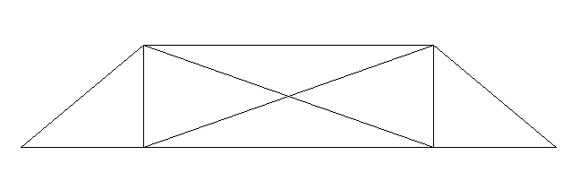

Fig. 2-1: Box frame design
The second choice (Fig. 2-2) is the cylinder pin model. This design is based on the cylinder in cylinder model. You have one cylinder that is attached to the base and therefore to the ground. The slightly larger cylinder is attached to the rails so that it can be moved along the base cylinders. Both cylinders have overlapping holes through which you can put a pin. That is how you establish the adjustable height of the rails.
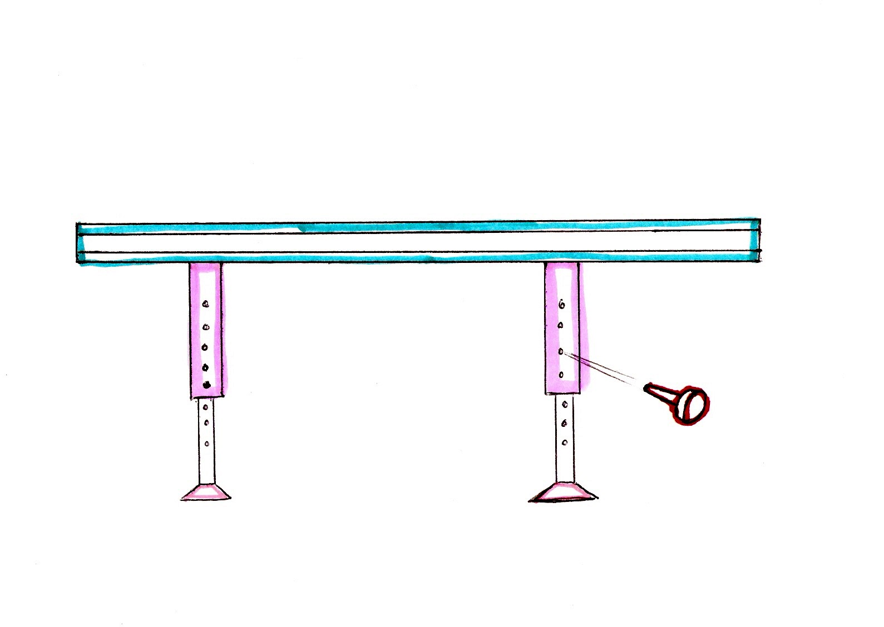

Fig. 2-2: Cylinder in cylinder pin model
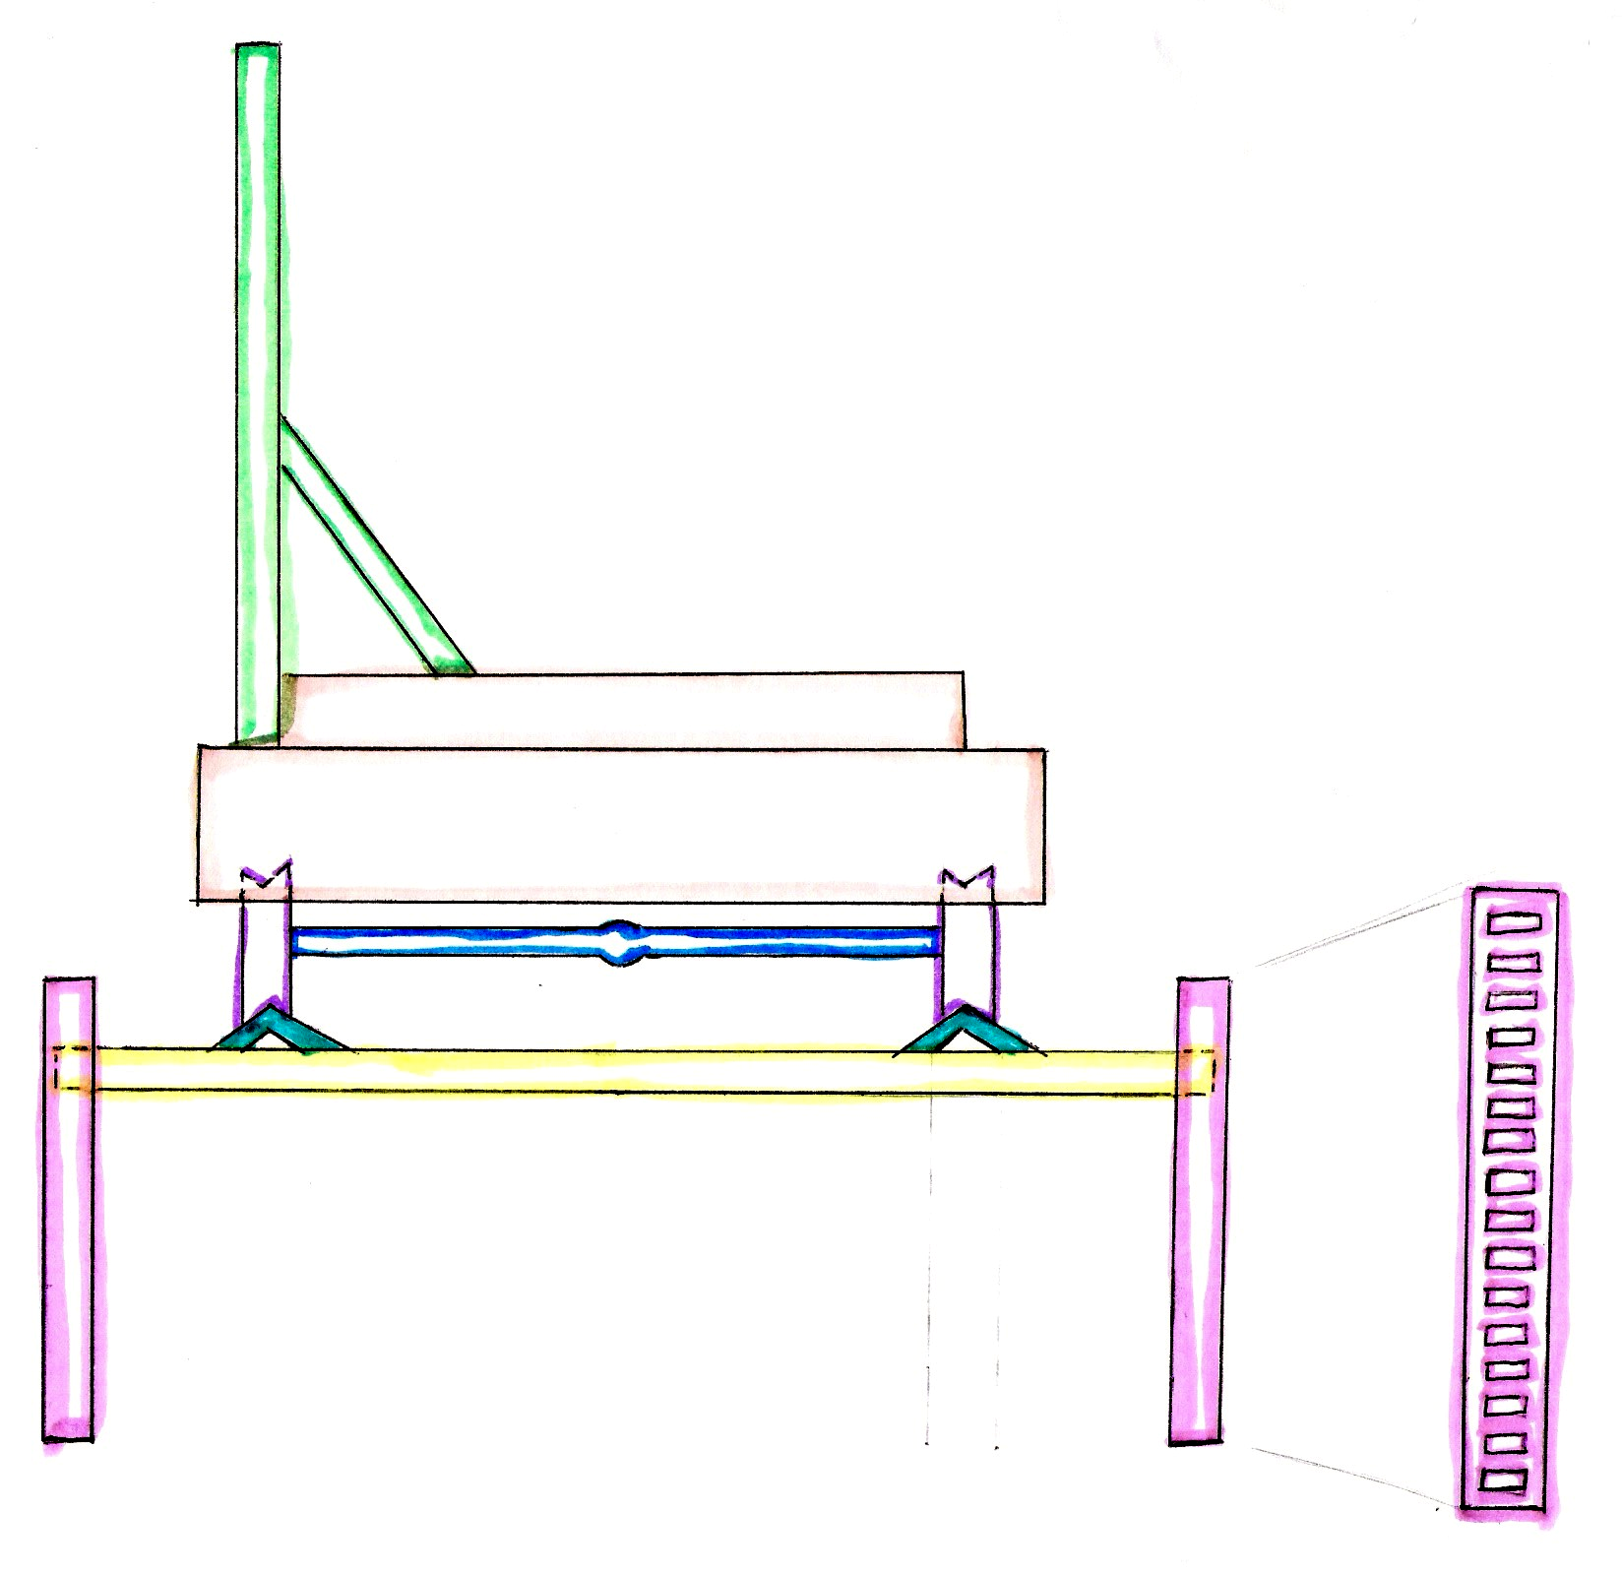
The third concept (Fig. 2-3) also allows for the tracks to be elevated and the elevation adjusted. This concept uses a single piece of notched metal as the leg. The height of the track is adjustable by placing the cross ties on different levels on the leg. The track is supported by the cross ties and therefore the tracks height changes as the cross tie level changes.

Fig. 2-3: Notched leg design
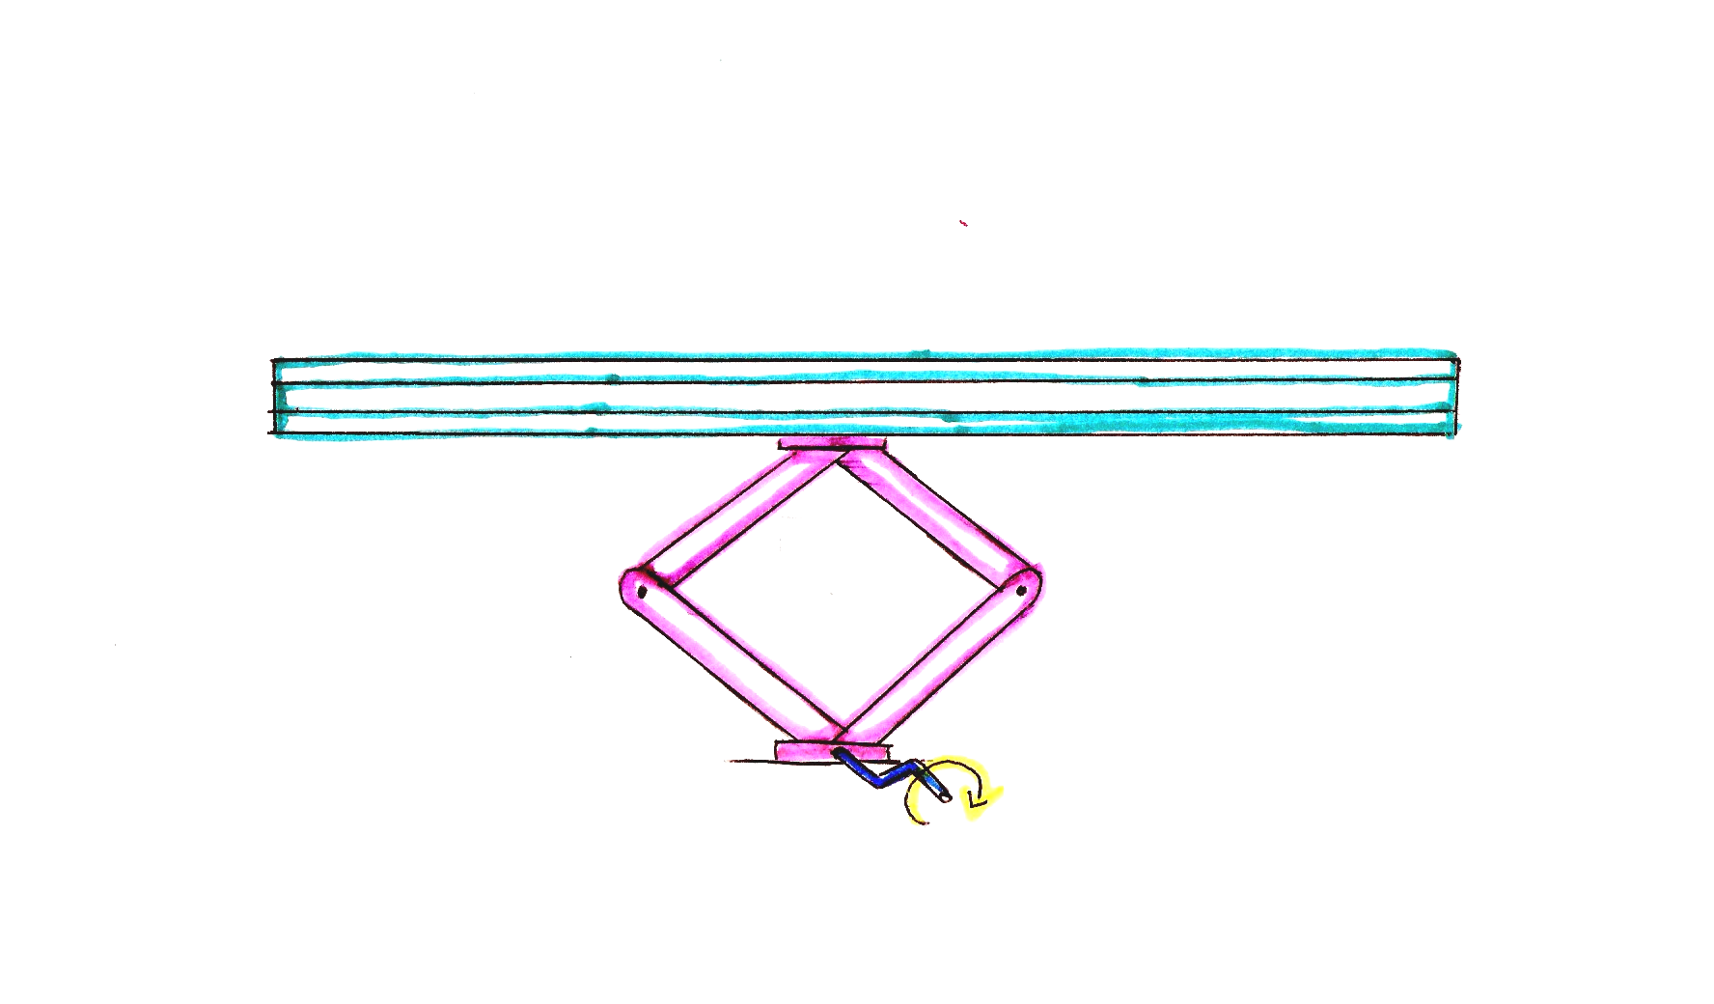
The fourth and last concept (Fig. 2-4) in this section is the hand powered crank system. The hand powered crank supports the tracks in certain spacing. It is a simple design that uses the hand powered crank to adjust the height of the tracks.

Fig. 2-4: Hand powered crank design
    - Stability on any terrain
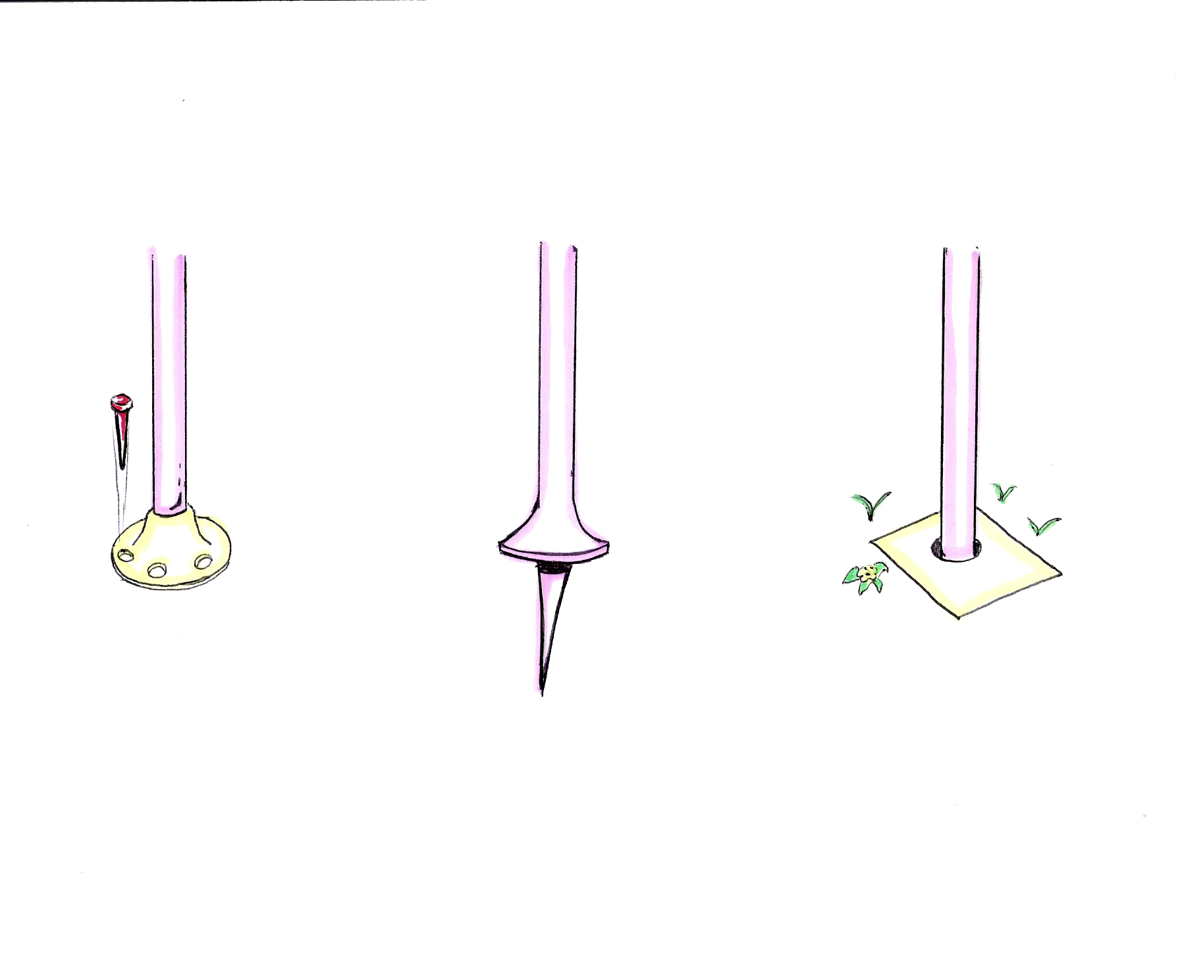
To establish the stability of the tracks when they are elevated on any terrain three designs are introduced (Fig. 2-5). Design A has a rubber base with removable metal spikes. Design B has a metal base with a single protruding metal spike. Design C is secured to the ground with concrete as its base.
Design A
Design B
Design C

Fig. 2-5: Base designs

    - Connection of parts
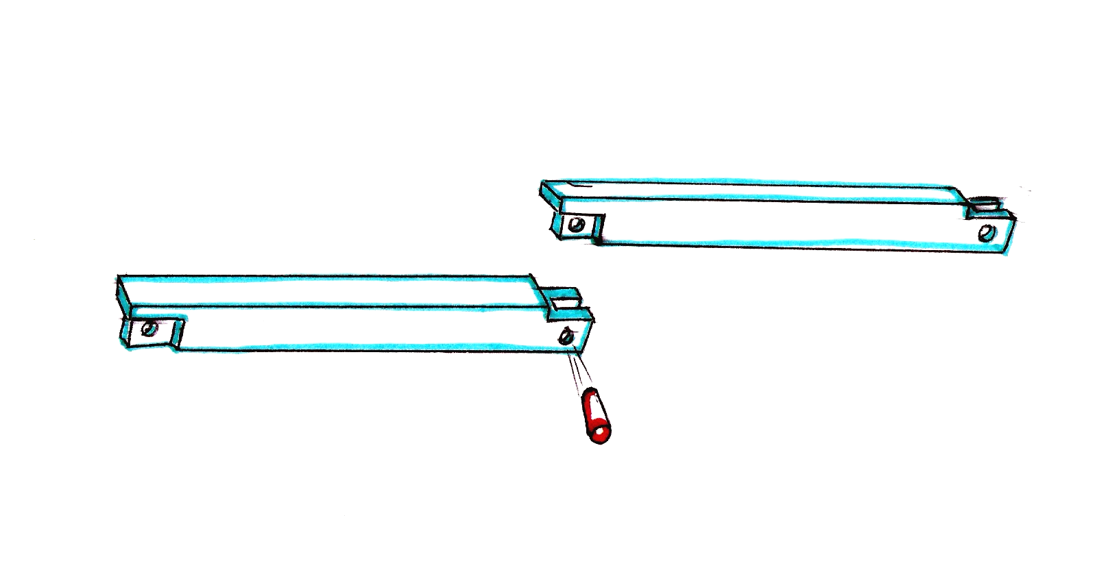
A major part of the design is to connect all the parts by using as little tools as possible. The following three designs may be used to accomplish this. The first concept (Fig. 2-6) is that each piece of the track is designed with a slot and a notch. The top part of the notched section has a flange that supports the weight of the track and helps to keep it in place.

Fig. 2-6: Slot and notch design
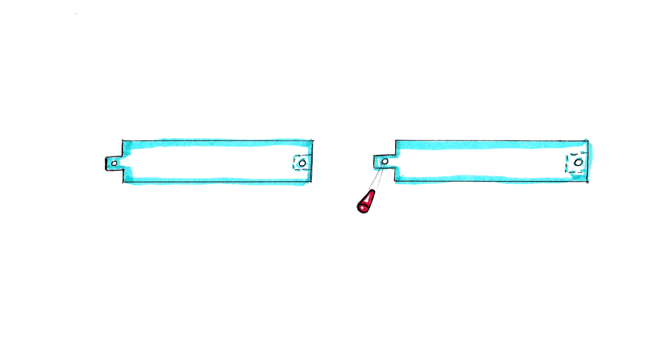
The second concept (Fig. 2-7) works by machining a protrusion and a slot in each part of the track and securing them with a single pin.

Fig. 2-7: Slot and pin design
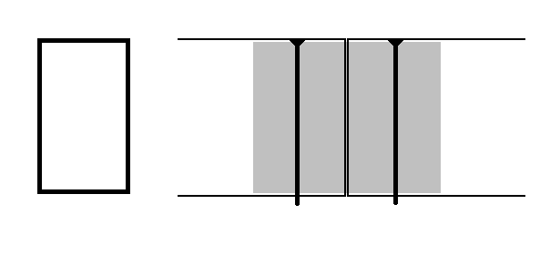
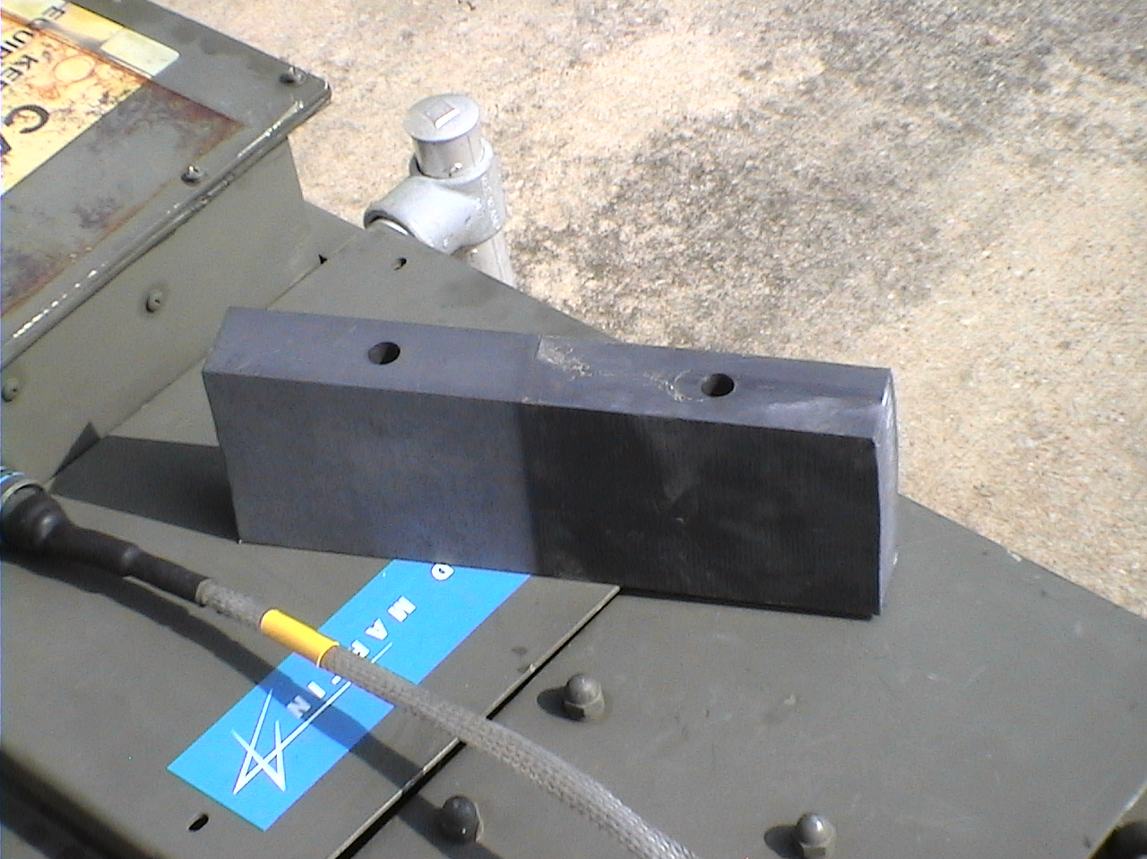
The sponsor already uses the third design (Fig. 2-8). It keeps the tracks separated 56.5 inches, the standard railroad width. Crossties have grove and pin system that allows for easy assembly.

Fig. 2-8: Grove and pin design
    - Wheel support
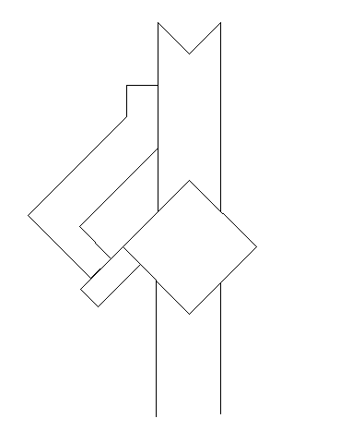
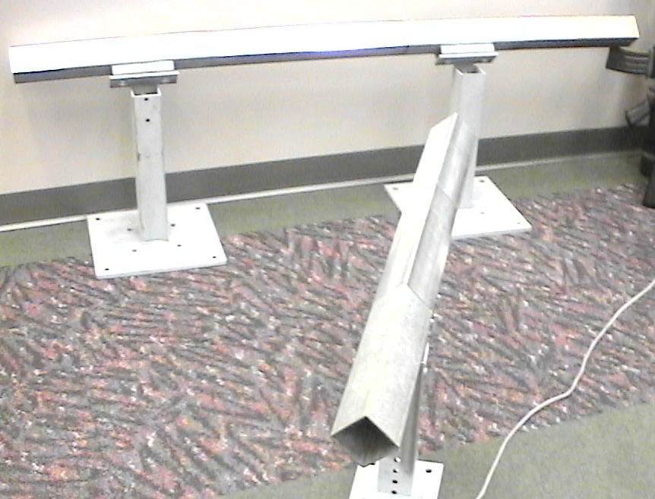
Four designs are presented to offer support for the wheels under high winds and weights. In the first design (Fig. 2-9) a v-groove wheel is used with a side support. This offers stability and uses the v-groove design that is preferred by the sponsor.

Fig. 2-9: V-groove design

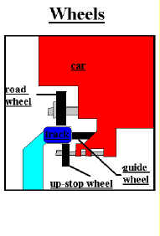
The second design (Fig. 2-10) uses an “up-stop wheel” that stops the cart from tipping. This design is used for a regular round railroad wheel.

Fig. 2-10: Up-stop wheel design
The third design (Fig. 2-11) has an “under wheel” that is located on the outside of the track instead of the inside. This means the supports will have to be just on the other side of the track to limit the stress in the supports. This can be added after the cart is loaded.
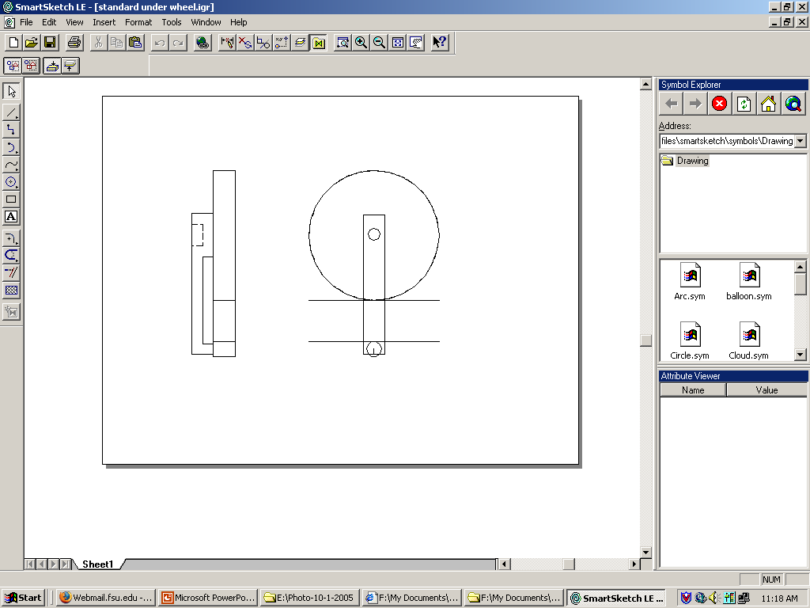

Fig. 2-11: Under wheel design
The fourth design (Fig. 2-12) works by using secondary wheels that run on notched track. It can be attached to the cart itself or to the primary wheels. This configuration can resist horizontal as well as vertical forces, thus keeping the cart on the track.
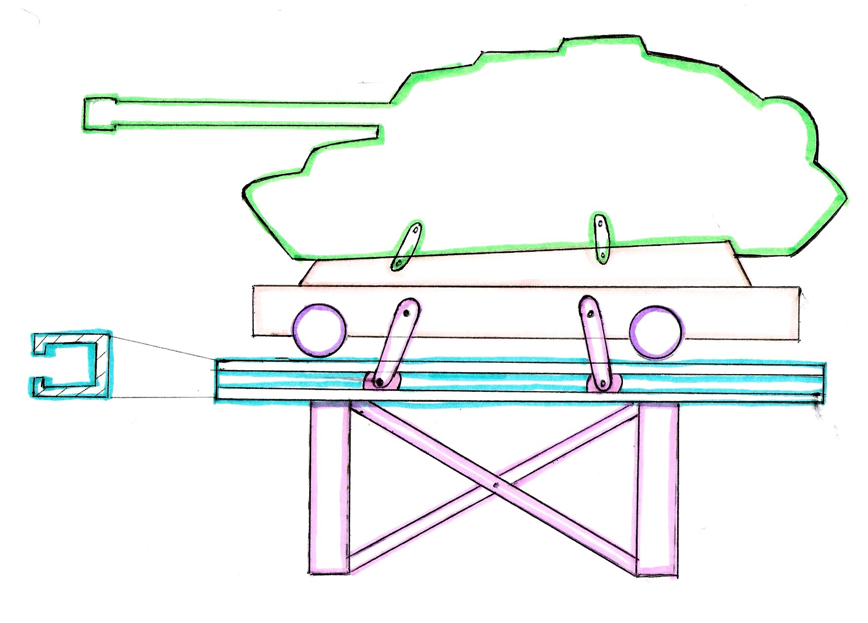

Fig. 2-12: Notched track design
  - Selection process
Different concepts were determined for the different requirements that this design needs to fit. After talking to the sponsor and reviewing the conceptual ideas deeper, the advantages and disadvantages of the preliminary concepts were obvious. In this section the unusable concepts are identified and the reasons behind it. The combination of the used designs is described in the following “Final Design” chapter.
The “Notched Leg” design as seen in Fig. 2-3 was eliminated because is unstable and the stress on each cut is too high. The “Hand powered crank” design that was shown in Fig. 2-4 is too expensive and unstable for this project, as determined by our sponsor. Even though the box-frame design (Fig. 2-1) doesn’t offer adjustability in height it can be used due to its stability. If the box-frame design is combined with the cylinder in cylinder design (Fig. 2-2), the result is a stable, height adjustable design.
When considering the designs for the base, all of the above-mentioned designs in Fig. 2-5 are acceptable, depending on the terrain.
In order to connect the parts of the track in a stable fashion any of the designs mentioned in 2.2.3 would be all right, but since the track has to be able to curve, the concepts shown in figures 2-6 and 2-7 have to be eliminated as useable concepts.
After the sponsor stated that he wants us to consider only v-groove wheels, and that we have no way of altering the original cart, it was decided that the last section of the preliminary designs (2.2.4 Wheel support) will be eliminated from the final design.

Final Design

The final design was constructed out of several ideas from the original concepts mentioned in the Design Process Chapter. In this Final Design Chapter the complete design is described, the feasibility proven and the necessary adjustments explained.
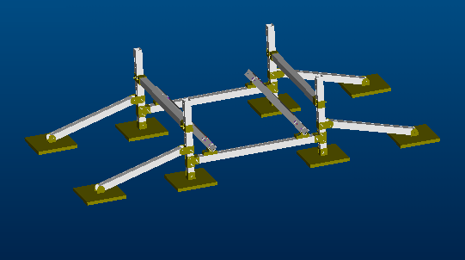
Main Rail
Cross ties
Angled Side Arms
Base stands
Breaking Support Arm

Fig. 3-1: Final Design (assembled)
  - Description
The final design for this project consists of 7 feet long bars that are connected in a collar-pin fashion. The square cross section of the bars is 3 inches by 3 inches.
First there are four stands (Fig. 3-1) that have holes along their length. They are anchored to the ground by either concrete or metal spikes. The stands should be anchored by concrete if it is going to stay in that place for a while, if it is going to be moved frequently you can use metal spikes on the four corners of the base. Next the two cross ties are connected to the four stands. The crossties have collars bolted onto their ends. These collars slide onto the stands and are connected to the stands by a pin that goes through the collar and through the overlapping hole in the stand. By changing the elevation of the cross ties you also change the height of the rail. The actual rail is connected to the cross ties by a small piece of square tubing that is welded to the crossties. These pieces are connected to the main rail (Fig. 3-1) by a nylon insert that is only slightly smaller than the cross section of the rail. Half of the insert is in the main rail and the other half is inside the piece that is welded onto the crossties. By inserting pins that attach both pieces to the nylon insert, you also connect the main rail to the crosstie.
Next you slide the collars that are bolted onto the angled side arms (Fig. 3-1) onto the base stands. These angled side arms are anchored to the ground in the same fashion as the base stands. Again a pin is keeping the collar of the side arm connected to the base stand. These support bars help stabilize the main rails and base stands.
Finally the breaking support bars (Fig. 3-1) are added. They are connected to the base stands sideways so that they prevent the domino effect onto the base stands. Again the breaking support bars are held in place by a collar- pin design.
  - Feasibility
The calculation of the weight of the bars (Appendix B-1) concluded that a 7 feet bar that has a square cross section area of 16 inches squared will weigh about 90 pounds if it is made out of standard steel with density of 0.284 lb/in^3.
To ensure that the cart will stay on the rails in case of 54.7 ft/s wind speeds the vertical down wind force (Appendix B-3) on the cart is calculated. This force turned out to be 1.88e3 lbs that is still less than the force of 2100 lbs that acts on the cart due to gravity.
For the safety of the project the safety factor of the main rail was calculated (Appendix B-4). For the main rail the maximum allowable stress is 102e3 lb/in^2 (“Static and Mechanics of Materials”, R.C. Hibbler). From there we can calculate the factor of safety, which in this case is a safe 2.4.
The deflection of the beam under maximum load (Appendix B-6) would be 0.137 in which is small compared to the cross sectional area of the beam that is 16 in^2.
The connector beam or cross tie is analyzed to ensure that it will hold the necessary load. The factor of safety for the connector beam, due to maximum momentum is 26, which is very high.
These results show that our design should uphold the necessary loads without failure. The cross sectional area was changed to 9 inches squared for the prototype that we’ve build, due to budget limits. We still recommend that the original 4in by 4in-squared tubing is used for the machining by the sponsor.

Machining Process
The machining for this project was pretty simple mostly cuts and holes. Some of the welding we had to have done by the machine shop. Even though the machining wasn’t complicated, they are still some smaller issues that occurred and that will be addressed in this chapter as well as issues when the materials were ordered.
  - Ordering Process and Issues
The biggest issue at the beginning of spring semester is the ordering of materials. It is a delicate matter due to many complications: ordering through the school, finding the right materials, getting shipments on time. We were lucky to find our material at a local store, therefore the shipping didn’t take as long as some other places would have. Also this store works frequently with the College of Engineering therefore the purchasing order was issued a bit faster. We still had three problems to deal with. The first issue was that the cost of the 4in by 4in square tubing and 4.5in by 4.5in square tubing exceeded our budget by over one hundred percent. Due to this we changed our dimensions to 3in by 3in tubing and for the collars we used 3.5in by 3.5in. This still went over our budget but we were able to get it approved. The second problem we were facing was how to transport the raw material that was way too long for any of the available trucks. We were able to talk to the owners of the store and they were nice enough to cut the pieces for us in an appropriate length for transporting. The last issue was the storing of our material that was fairly large. In the beginning we had to store it privately with a friend, and then we found a more permanent solution by using one of the portables attached to the school.
  - Machining Process and Issues
The machining process is a slow one when it comes to steel. The facilities at the FAMU/FSU college of engineering can machine steel but they aren’t the best prepared for material. This, however, was a problem that had to be worked around. Initial designs had rounded ends for the side arm, side arm collar, and side arm base plate. The CNC machine at the college however couldn’t machine steel. The design was then changed to use the 3.5x3.5 tubing and cutting off an end (Fig. 4-1). This lead to another problem, however; when the tubing was cut it “kinked” in. It was thought that the tubes should have moved out when they were cut but the tubing was loaded in compression and not tension. This became quite a problem because of the strength of the material. A bolt was sewn through the holes and a cable attached, the cable however broke. The solution that was used was to use a scrap piece of tubing and use a press to press it into the “U” shaped cut pieces. By using the press to press the wider diameter tube into the “kinked” pieces it widened them out. Some were widened too much and were pressed back. This was the main problem during machining. A more detailed account of machining can be found in the Appendix C.
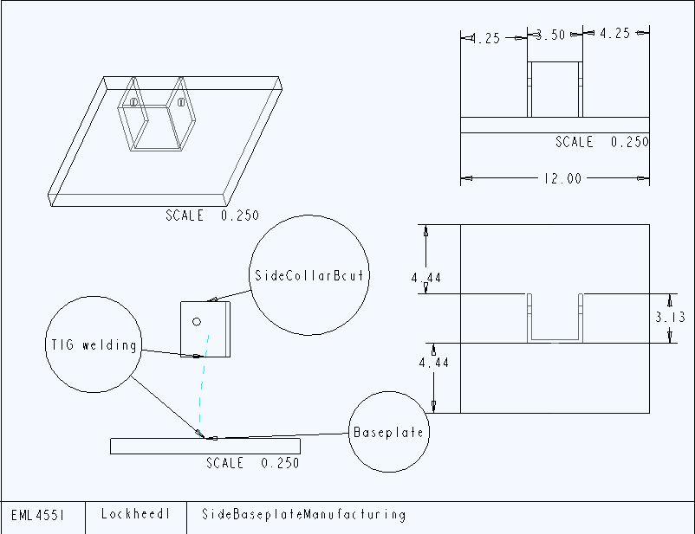
Fig.4-1: Machining of Side Base Plate

Assembly Process
Assembly is a big part of this project since one of the main objectives is to make the railroad portable and easy to assemble. There were some issues that we had to address during the first assembly that will be discussed in the following chapter. Also we recorded the assembly times to show the time related advantage of this design.
  - Assembly Issues and Solutions
A problem that became immediately apparent was that the tubing had a seam 2/3 down the inner diameter. This made it impossible to use the 3.5x3.5 tubing as a collar. The solution to the problem was to purchase steel grade grinding stones and grind out the seam. A test 3x3 piece was used in order to make sure the seam was grinded down enough. This however didn’t prove to be a good test because certain pieces were still getting hung up during assembly. The solution was to take the collars back into the shop and grind them out until the seam was completely gone. The collars were then tested on the actual main support to make sure of a proper fitting. The step by step process of the assembly is added in Appendix D.
  - Assembly Testing
The original objective of this project was to make this product portable and easy to assemble. After some slight issues with the first assembly (they were explained above in section 5.1), the next step was to run through a couple assemblies in order to determine the time necessary to assemble this section of the rails. The average time of the assembly after three runs was 5 minutes and 35 seconds. Since each section is about 7-8 feet long, to assemble the maximum length of the track (~1800ft) it would take roughly 22 hours with three people.

Conclusion
  - Achieved Goals
The main goals of our project are to create a portable, lightweight track. This track also needs to be adjustable in height so that it will function in any climate or on any soil. The track is not supposed to fail if the cart that is moving on the track weighs 2100 pounds, travels at speed of 36.5 ft/s and has to withstand wind speeds of 54.7 ft/s.
The track is easy to move since it is build out of parts that mostly interlock and are connected by collars and pins. The heaviest part of the track is the main rail that will weigh about 90lbs (Appendix B-1).
The collar-pin design (Fig. 3-1) that we used to connect all the parts to the stands makes the height of the track adjustable which is a key need in our design requirements.
The vertical force on the main rail is calculated under the worst wind conditions and at highest weight and speed. It turned out to be 1.886e3 lbs, which is still less than the maximum gravity weight at that point, which is 2100 lbs. This proves that the cart will not tip over when operating under the worst conditions on the track designed by us.
To ensure safety of our project we calculated the factor of safety duet to the bending stress. The safety factor is 2.4 (Appendix B-4), which is appropriate for our design considering that even though the cart is not carrying people it still needs to remain safely on the rails.
Some additional requirements for our project were that it has to be able to curve a radius of 430 ft, which is feasible due to the flexible nylon insert connection between the main rails and the cross bars. This give us some flexibility as well as in sloping as in the curving of the course.
One of the main requirements for the design was to decrease the assembly time. After conducting three assemblies, the average assembly time with three people came out to be 5 minutes and 34 seconds for one 7 feet section of the track. A full 1800 feet track would take about 22 hours which is a huge improvement. According to our sponsor the current regular railroad takes about two weeks to assemble with two teams of five people.

APPENDIX A
References:
    - “Static and Mechanics of Materials”, R. C. Hibbler, Prentice Hall
    - “Machine Design-An Integrated Approach, 2nd edition, Robert L. Norton, Prentice Hall
    - Sally Corporation
World Wide Web: http://www.sallycorp.com/
    - Metal Fabrications: Tallahassee, FL
APPENDIX B

B.1 Weight of the main rail
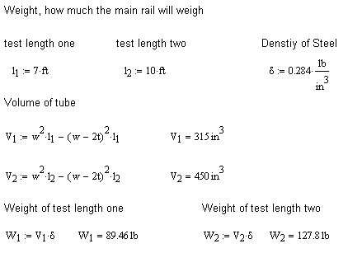

B.2 Moment of Inertia of cross section of main rail
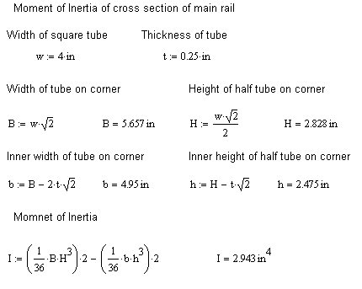

B.3 Weight distribution when experiencing maximum wind speed
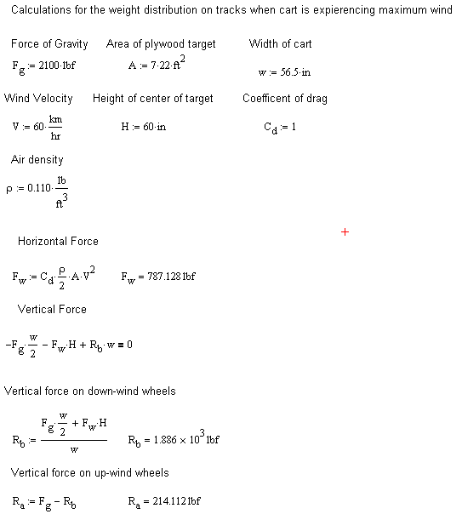

B.4 Safety factor calculations due to bending in main rail
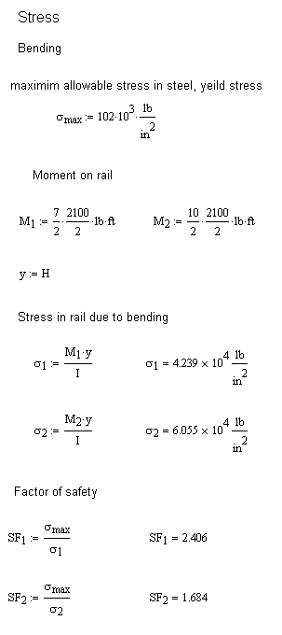

B.5 Shear stress in main rail
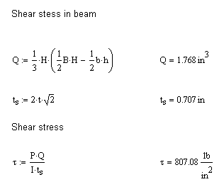
B.6 Deflection of main rail under greatest load
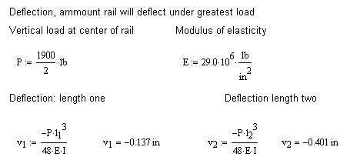

B.7 Distributed forces in the connector rail
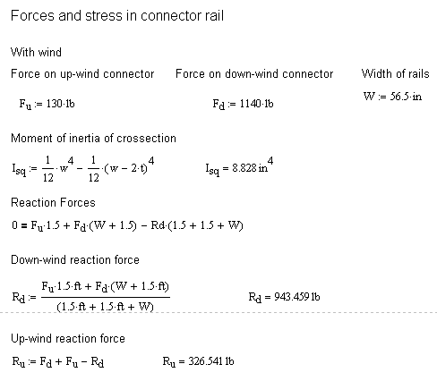

B.8 Safety factor in the connector rail
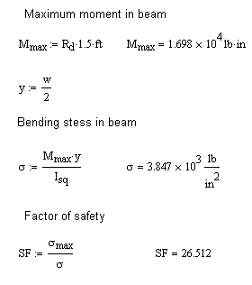

APPENDIX C:
Machining:
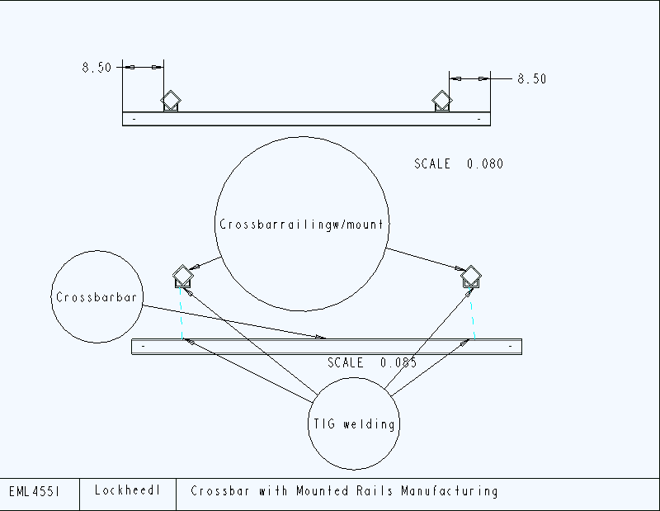
Draw. C-1: Machining of Crossbar

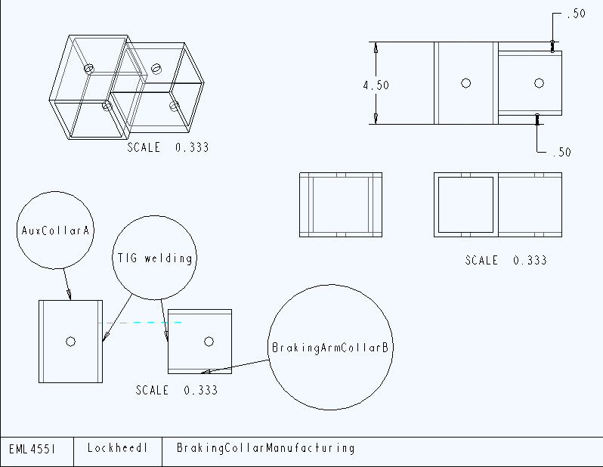
Draw. C-2: Machining of Breaking Collar

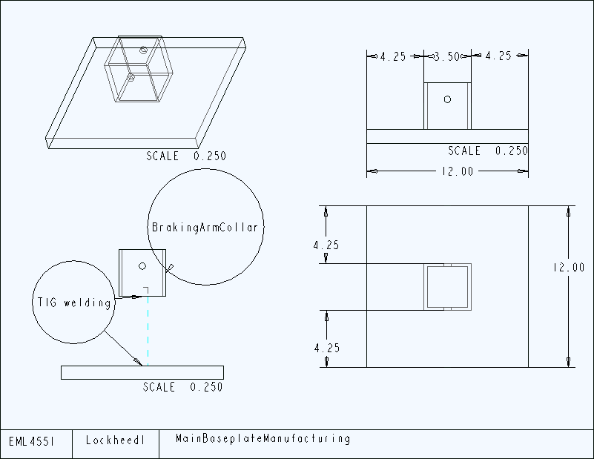
Draw. C-3: Machining of Baseplate

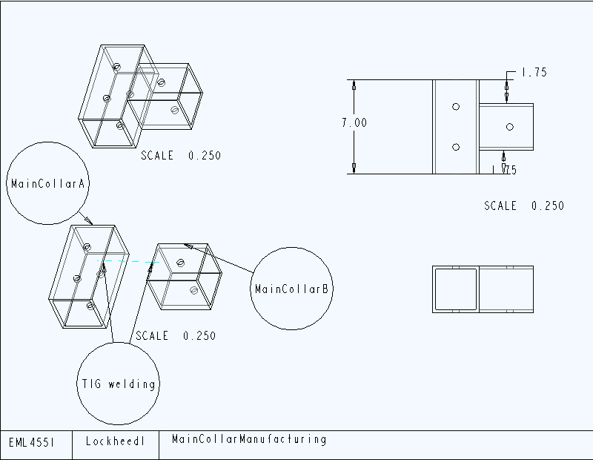
Draw. C-4: Machining of Main Collar
Draw. C-5: Machining of Side Baseplate
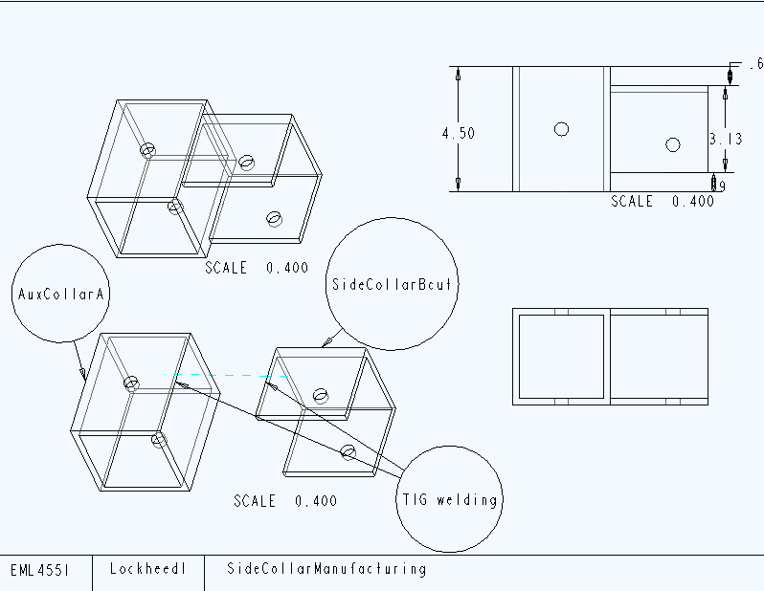
Draw. C-6: Machining of Side Collar
APPENDIX D:
Assembly:
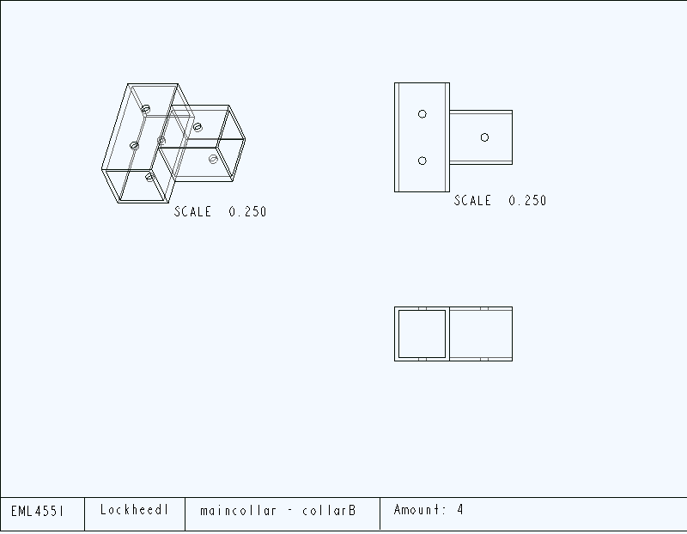
Fig. D-1: Main Collar-Collar B
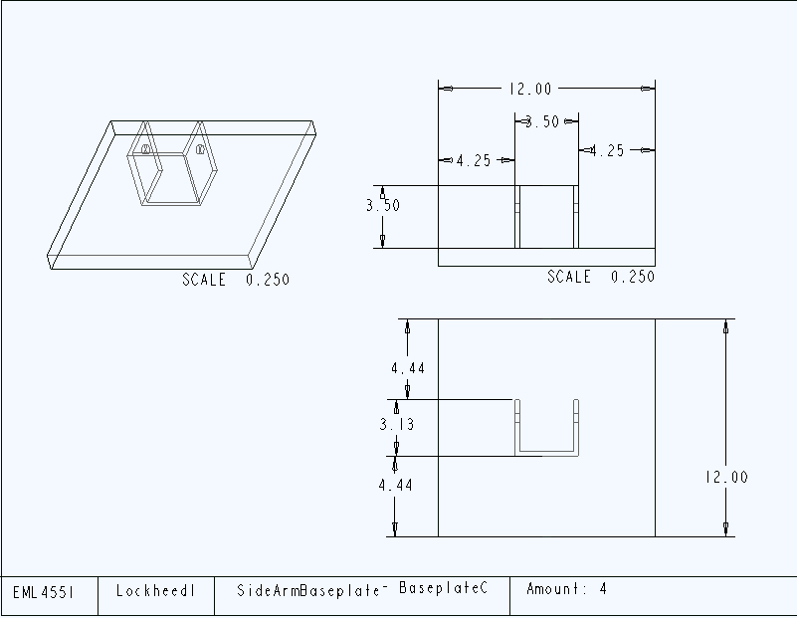
Fig. D-2: Side Arm Baseplate – Baseplate C
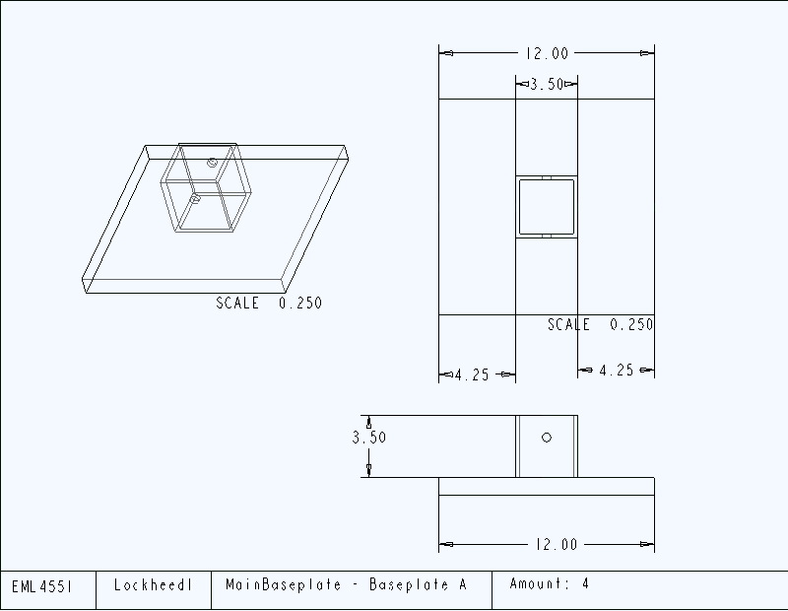
Fig. D-3: Main Baseplate – Baseplate A
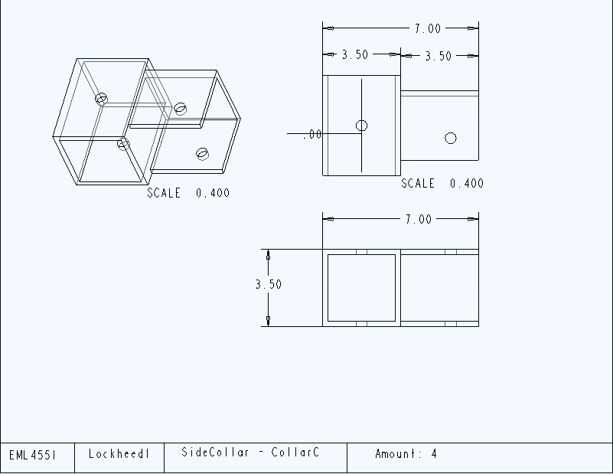

Fig. D-4: Side Collar – Collar C

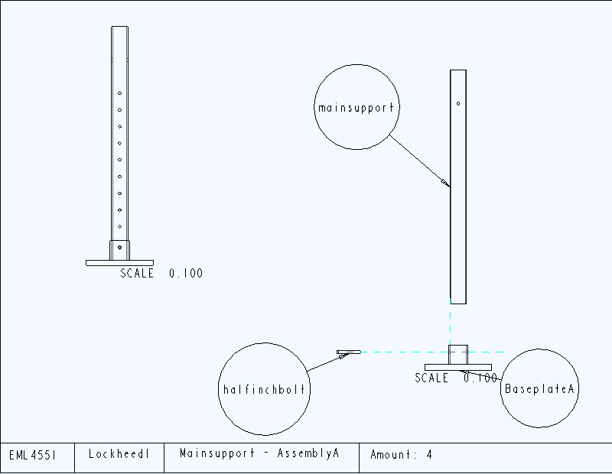
Fig. D-5: Main support – Assembly A

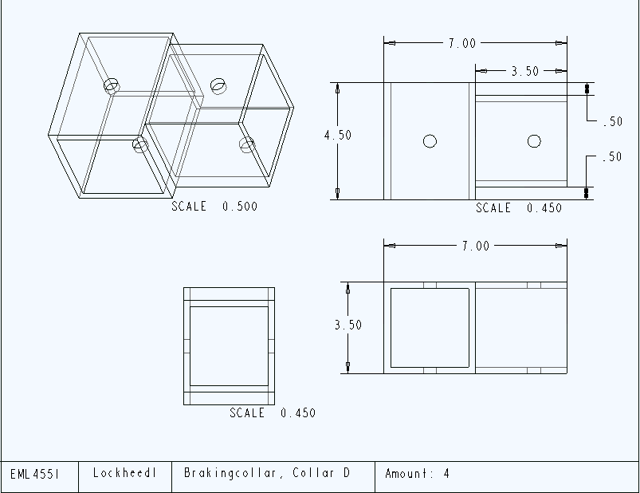
Fig. D-6: Breaking Collar – Collar D
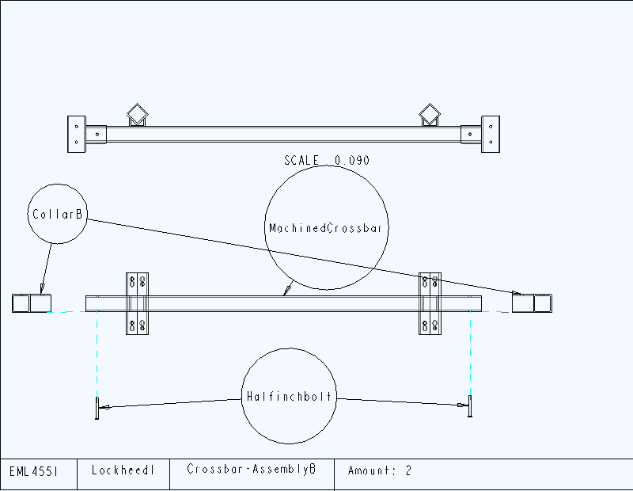
Fig. D-7: Crossbar – Assembly B
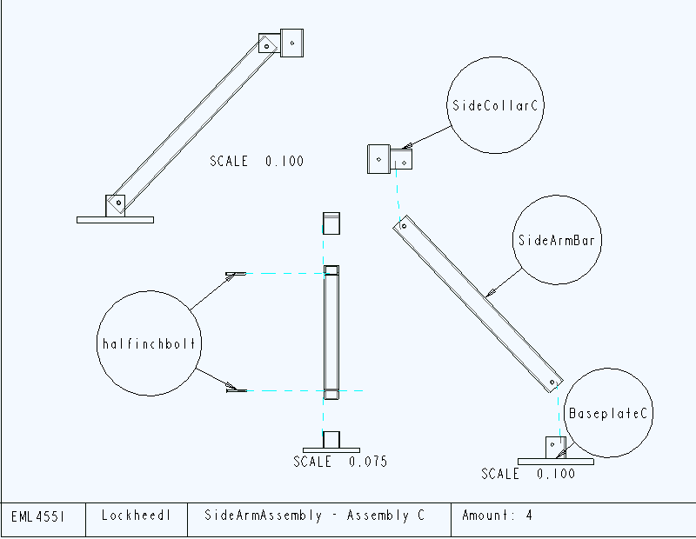
Fig. D-8: Side Arm Assembly – Assembly C
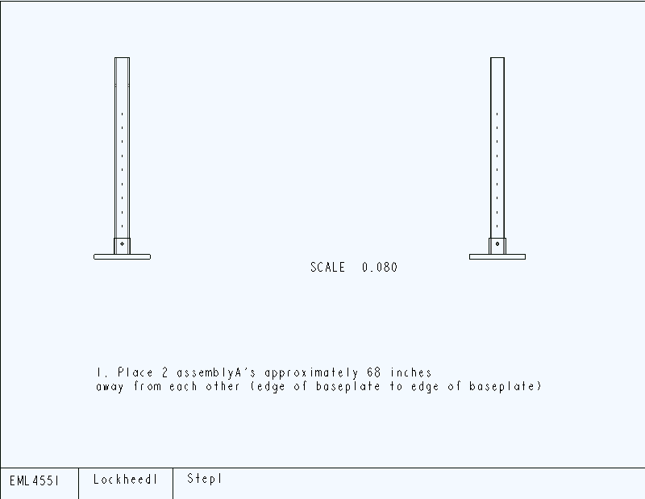
Fig. D-9: Step 1
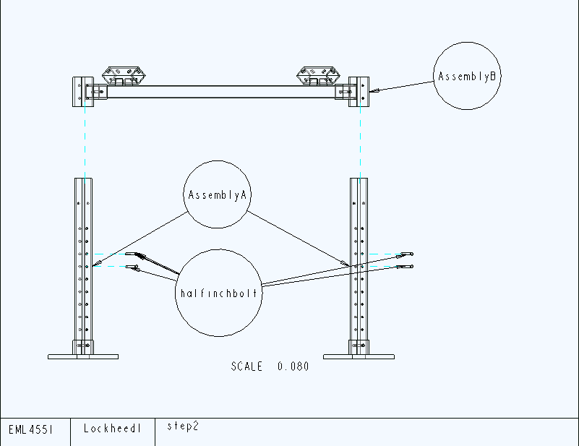
Fig. D-10: Step 2
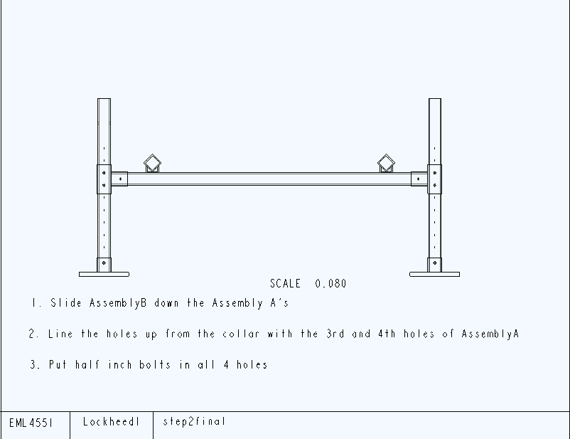
Fig. D-11: Step 2- final
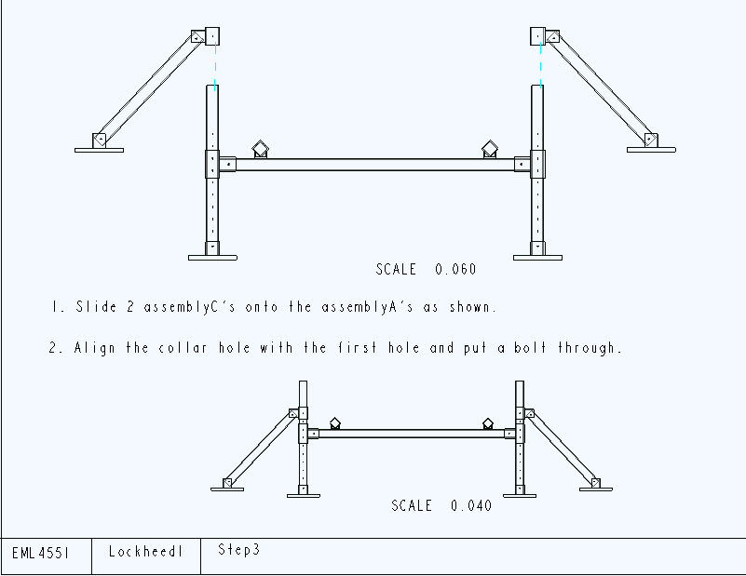
Fig. D-12: Step 3
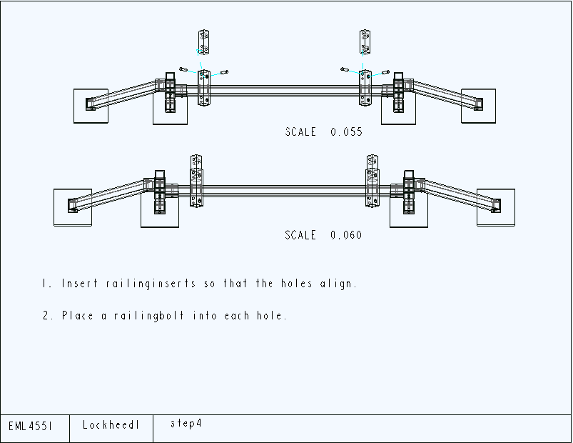
Fig. D-13: Step 4
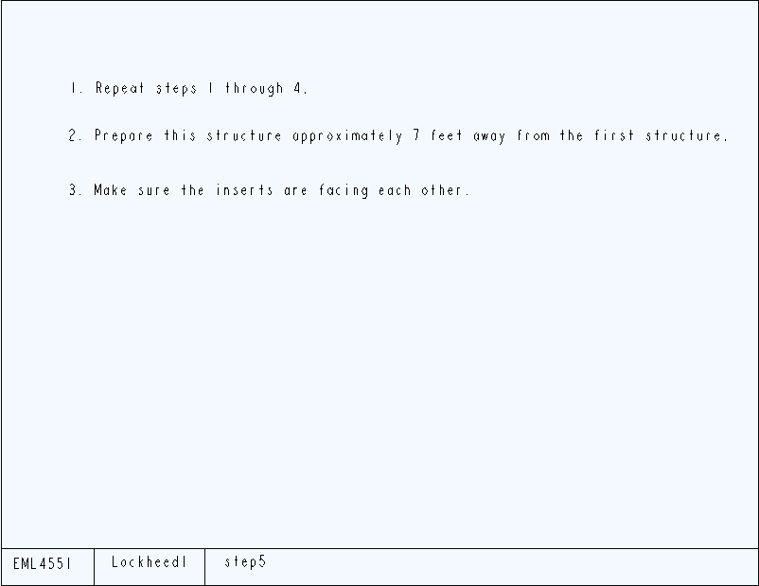
Fig. D-14: Step 5
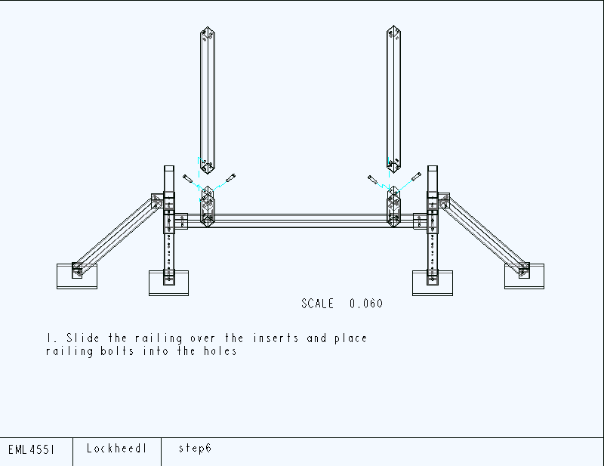
Fig. D-15: Step 6
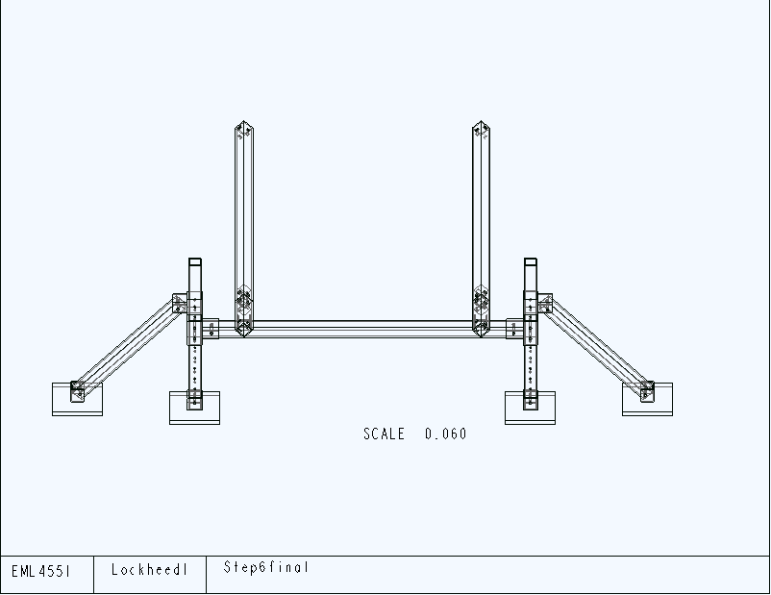
Fig. D-16: Step 6 – final
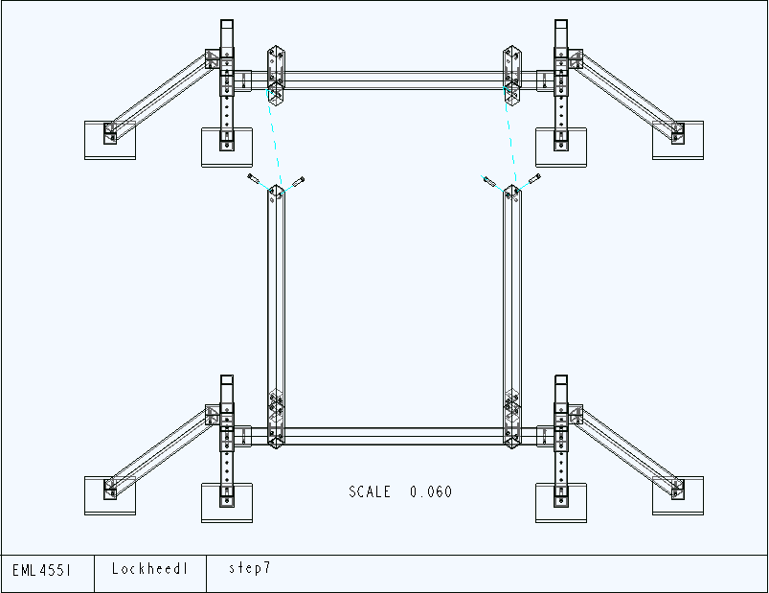
Fig. D-17: Step 7
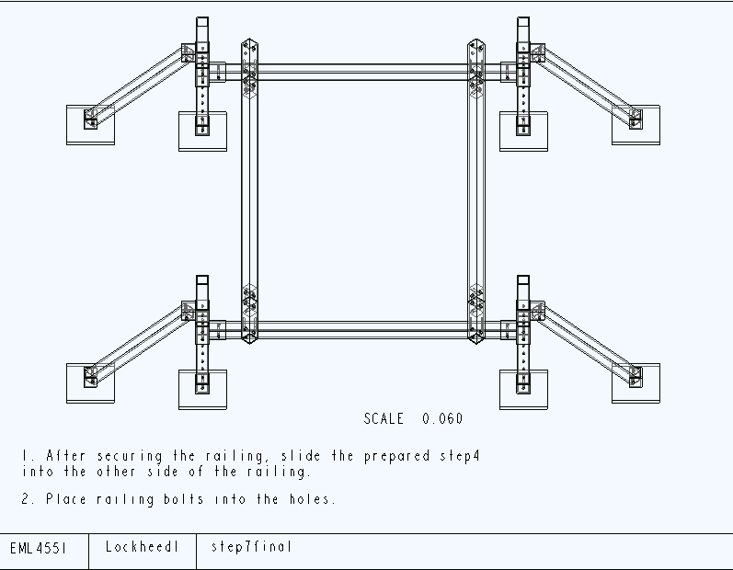
Fig. D-18: Step 7 – final
APPENDIX E:
Drawings:
