2525 Pottsdamer Street
FAMU/FSU College of Engineering
Tallahassee, FL 32310-6046
(727) 946-2128
UAV Research International

Final Design Package

“Providing integrated consultation to MAV project engineers at Eglin AFB”

Table of Contents

Table of Contents 1
1.0 Abstract 3
2.0 Introduction 4
2.1 Project Background 4
2.2 Needs Statement 5
2.3 Project Specifications 5
2.3.1 MAV Description 5
2.3.2 Testing Facilities 5
2.3.3 Testing Parameters 5
2.4 Project Planning 6
3.0 Design Generation and Selection 7
3.1 Background Research 7
3.1.1 Open-circuit tunnels 7
3.1.2 Closed-circuit tunnels 7
3.2 Concept Generation 8
4.2.1 Semi Air Stream Halo 8
3.2.2 Turntable 9
3.2.3 Fixed Blowers 10
3.2.4 Free Flight Wind Tunnel 11
3.2.5 Free Flight 12
3.3 Support Systems 13
3.3.1 Measuring Devices 13
3.3.2 Mounting Design 14
3.4 Design Selection 15
4.0 Design Procedure 17
4.1 Wind Tunnel 17
4.1.1 Tunnel Geometry 18
4.1.2 Constrained Wind Tunnel Geometry 21
4.2 Flow Quality 22
4.2.1 Honeycomb 23
4.2.2 Settling Screens 23
4.3 Flow Fan 24
4.4 Instrumentation 26
4.4.1 Flight Dynamics Measurement 26
4.4.2 Flow Quality Measurement 27
4.4.3 Data Display/Analysis 32
4.5 MAV Handling 34
5.0 Cost Analysis 39
6.0 Wind Tunnel Design Analysis 41
6.1 Introduction 41
6.1.1 Model Objective 42
6.1.2 Model Testing 43
6.1.3 Scaling Effects 43
6.2 Model Manufacturing 44
6.2.1 Manufacturing 44
6.2.2 Parts and Purchase Order Problems 47
6.2.3 Status of Scale Model 48
7.0 Conclusion 50
Appendix A 52
Appendix B 53
Project Procedure 53
Background Information 53
Idea Generation 53
Concept Selection 53
Design Analysis 53
Final Design Review 53
Appendix C 55
Ideal Wind Tunnel Geometry 56
Appendix D 63
Appendix E 65
Appendix F 67
Appendix G 71
Appendix H Wind Tunnel Geometry 71
Constrained Wind Tunnel 72

1.0 Abstract
This project had the purpose of designing an MAV characterization facility for the Air Force Research Lab at Eglin Air Force Base. The facility was to be able to test the actual flight dynamics of multiple MAVs. After careful consideration the design team decided to explore the feasibility of designing and manufacturing a free flight wind tunnel. Such a tunnel would be used to facilitate free flight of Micro Aerial Vehicles or MAVs. Two wind tunnel geometries were explored. One tunnel was designed to provide the best possible flow quality and sufficient testing space for the largest of possible MAVs tested. The second was constrained by readily available facilities at Eglin AFB. Calculations were carried out to maximize flow quality through the addition of flow improvement devices like mesh screens and honeycombs. Instrumentation systems were researched and packaged into a practical system for the facility. A novel tethering system was designed to safely release the MAV into the free stream. Finally, drawings of the entire system were compiled. These systems integrate together to comprehensively test and analyze an MAV during flight.

2.0 Introduction

2.1 Project Background

A new focus area of research within the Flight Vehicles Integration Branch (MNAV) of the Air Force Research Laboratory Munitions Directorate is on Micro Air Vehicles (MAVs). MAVs are characterized by small vehicle size (O 10 cm), low flight speeds (O 10 m/s), and low Reynolds number (O 10,000-100,000). Motivation for this work is fueled by the need for increased situational awareness (especially in urban environments), remote sensing capability, “over the hill” reconnaissance, precision payload delivery, and aid in rescue missions. Micro Air Vehicles can be considered a sub-class of uninhabited air vehicles (UAVs). UAVs have been developed in recent years by leveraging traditional aerospace science technologies. However, the engineering maturity required for MAV development has not kept pace. For instance, due to the extremely small size of MAVs, the flow field is dominated by separated flow regimes on the order of the vehicle size. Also, the small size of MAVs gives rise to small inertias that make the MAV more susceptible to wind gusts. Development of MAVs will require both a capability to test and assess emerging concepts. Traditional methods for testing MAVs, such as within a wind tunnel, may not be sufficient. Oftentimes, the MAV proceeds directly to flight trials without sufficient knowledge of the MAV’s aerodynamic and/or flight mechanic properties. While outdoor flight trials are sometimes adequate for qualitative testing, innovative and unconventional designs may cause frustration in the flight trials. Additionally, as the precision and capabilities of MAV continues to be stretched, a new “aerodynamic characterization” facility is envisioned that would allow for flight-testing within a laboratory environment. This aerodynamic characterization facility may, in fact, be a suite of facilities that are designed to analyze MAV aerodynamics, flight mechanics, GN&C aspects, and so forth.

2.2 Needs Statement

- Environment should be suitable for dynamic characteristics of MAV, i.e. laminar flow, turbulence, wind gusts, etc.
- Testing facility should include multiple setups for testing various conditions (i.e. wind gusts at different angles, etc.)
- Devise extensive manuals and procedures for operation of said testing facility
- Provide an analysis of the facility to ensure desired operation
- Develop engineering drawings and figures of facility
- Compile a detailed purchase order of all necessary parts and equipment
- The final design should be practically feasible

2.3 Project Specifications

2.3.1 MAV Description
- Weight → 100 – 200 (g)
- Flight Speed → 0 – 25 (m/s)
- Exterior Material → Carbon Fiber Composite
- Wing Tip Length → 15 – 30 (cm)
- MAV Flight Control → Both 2 and 3 axis
- Type of Thrust → Pusher, Puller, None

2.3.2 Testing Facilities
- Permanent access to two (2) 40’ x 30’ x 14’ fully enclosed rooms
- Temporary access to large warehouse (Area TBD)
- The facility will allow for repeatable testing so that no physical damage to the MAV occurs

2.3.3 Testing Parameters
- Test flight mechanics in the following range of flight situations
- Data will be continuously recorded during testing to allow for a comparison between flight dynamics and variable free stream conditions
- Straight and Level Flight Speed → Range 0 – 25 (m/s)
- Wind Gust Velocity → Range 0 – 10 (m/s)

- Wind Gust Angle → Theta and Beta Range from -90 to 90 degrees. Theta and Beta ranges shown in figure 15 in Appendix A.

2.4 Project Planning

Our project plan as shown in Appendix B guides us through the semester. We decided to separate our design into three major sections as shown in our design tree in Appendix B. We divided our final design analysis into; tunnel geometry, instrumentation, and MAV handling. Tunnel geometry consists of the design of the wind tunnel ducting, selection of the flow fan, and design of the settling screens and honeycomb. Instrumentation will involve onboard measurement, and data collection/display. MAV handling is the final section and covers the control and release of the MAV inside the tunnel.

3.0 Design Generation and Selection

3.1 Background Research

The initial and most apparent wind tunnels come in all shapes and sizes. According to their application, different attributes are needed to simulate the proper environment. The components of a wind tunnel are arranged to deliver a high quality, uniform flow (in both velocity and time) to the test section. There are two main wind tunnel configurations:

3.1.1 Open-circuit tunnels

"Suck down" tunnels are those with an open entry to the atmosphere and an axial fan or centrifugal blower downstream of the test section. The idea is to suck the air through the fan, creating a flow field in front of the fan. This means that the blower has to reuse the exit air after it has traveled through the laboratory. Not only does this mean a low efficiency but it is also cause for high swirl and fairly low quality flow fields inside the test section. This is the traditional K-12 wind tunnel one may have built in school.
"Blower" tunnels have a fan or blower upstream of the test section (usually a true centrifugal blower). These sorts of tunnels are very flexible since one can attach almost any type of test section to the tunnel. Entry swirl is again a possible problem, but in general blower tunnels are much less sensitive to entry conditions than suck down tunnels. Of course the exit flow from a centrifugal blower is unsteady and not uniform meaning the quality of the resulting flow field is nowhere near what we need for our application.

3.1.2 Closed-circuit tunnels

Closed-circuit tunnels are also known as “racecourse" or "closed-return". Closed circuit tunnels have better flow quality than open circuit tunnels in principle. However, care is needed in the design of these tunnels to ensure good flow at the fourth turn (just before the contraction to the test section). Corner vanes (angled sheets of material which guide the airflow through 90 degree turns) reduce some turbulence but by themselves

only provide somewhat better flow than an open-circuit tunnel. The real advantage comes from the addition of flow quality improvement devices, such as honeycombs and screens. These reduce turbulence in both lateral and axial flow directions and can bring turbulence levels to less than 0.2% (“Turbulence Reduction through Screens” – CITE).
After carefully considering all available options, it is immediately clear to us that we will have to use a closed circuit tunnel. Then it just remains to decide on speed, air pressure, and size of the tunnel. Since our maximum speeds will not exceed 25m/s we obviously do not have to worry about supersonic capabilities. The pressure on the inside of the tunnel should be atmospheric since that is the environment the MAV will be flying in. And for once the small scale of the MAV comes in handy for testing purposes since this allows us to build a full-scale wind tunnel.

3.2 Concept Generation

4.2.1 Semi Air Stream Halo

A novel idea from our design team is the Semi Air Stream Halo or SASH. This device features a semi-circular, rotating track inside of which is mounted a high-powered blower. Said blower is thusly allowed to rotate inside the SASH, traversing a full 360 degrees around the MAVs roll axis. Furthermore, the halo itself can be rotated on its own axis, allowing the SASH to project incident wind around the pitch axis. The ASH is also mounted on a slotted track that allows it to traverse longitudinally along the MAV. See the below figures for detail.

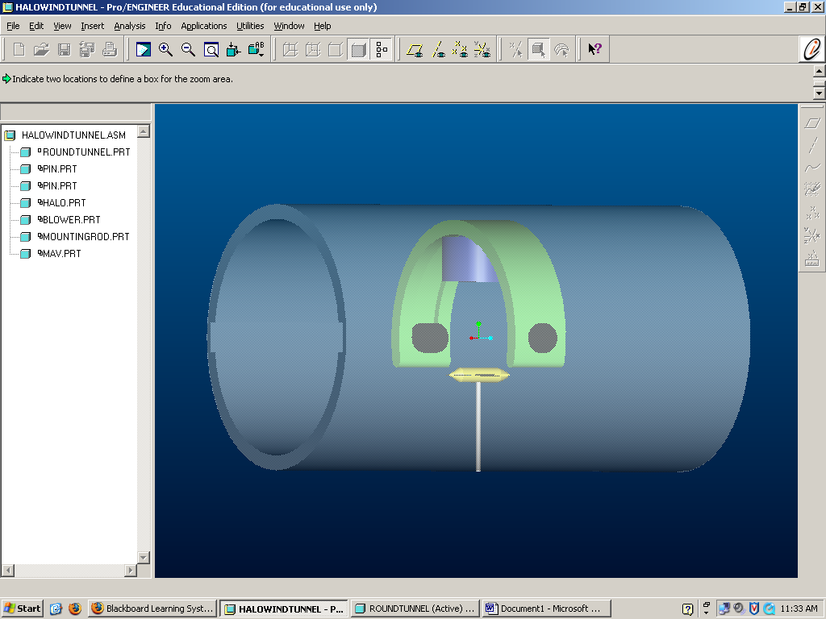
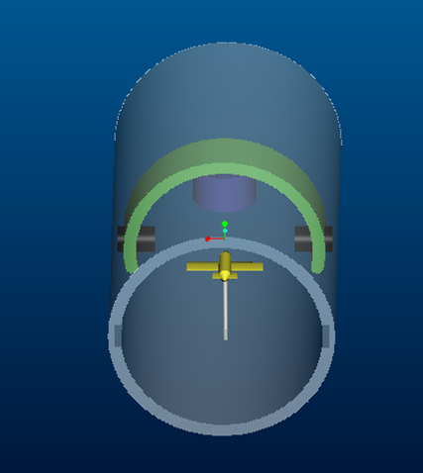

Figure 1 Detailed view of the MAV inside wind tunnel with SASH application

3.2.2 Turntable

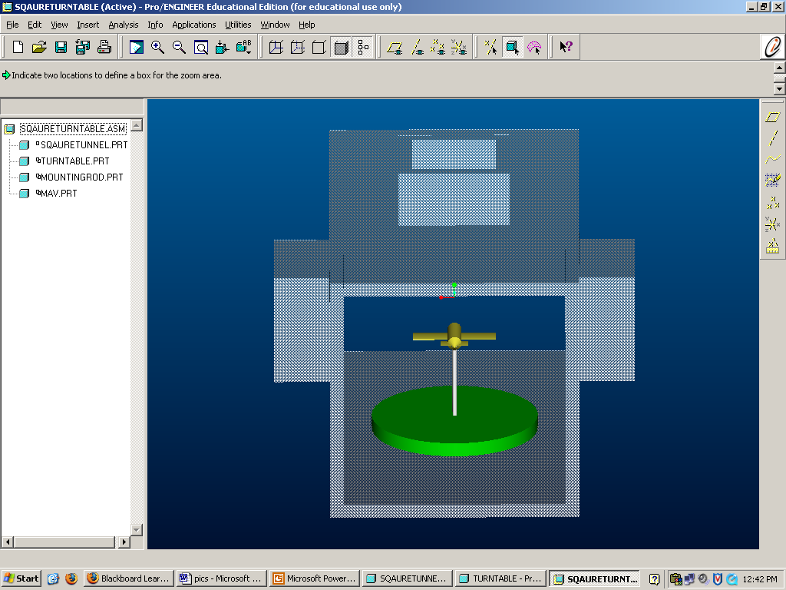
Another novel idea from our design team is the turntable design. This requires the MAV to be fixed from the bottom and attached to the turntable itself. The user can then control the MAVs yaw via a remote control joystick or knob located outside the test section. The big advantage of this design is that it allows us to achieve any yaw angle without any setup change whatsoever. See below figure for detail.

Figure 2 Turntable (green) attached to MAV in wind tunnel

3.2.3 Fixed Blowers

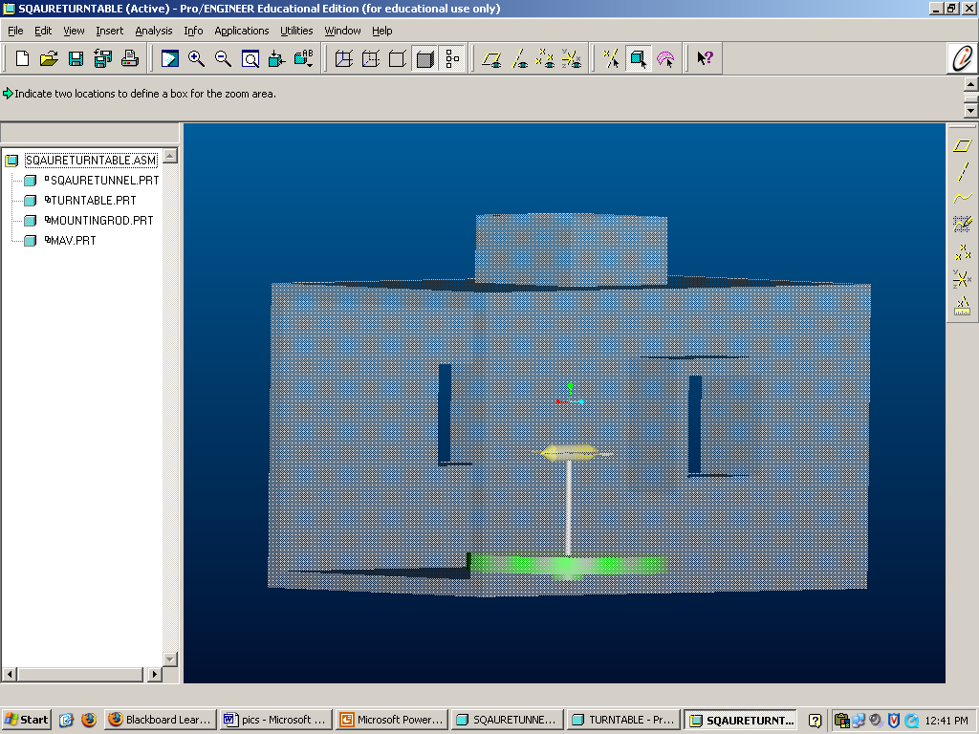
The idea of fixed blowers is mainly concerned with wind gusts and varying incident wind angles. This design would allow the operator to place the MAV in a working wind tunnel and then project gusts from the nine, twelve, and three o’clock positions (assuming MAV is directly incident to wind tunnel flow). As can be seen in the figures, impulse blowers mounted in the respective openings would facilitate this. Controls to these blowers would be mounted externally on a control panel. Both Figure 2 above and Figure 3 below show the fixed blower design with the turntable addition.

Figure 3 Side view of the fixed blower design with turntable option.

3.2.4 Free Flight Wind Tunnel

The free flight wind tunnel has been successfully created before (Pope, 17) and is basically a conventional wind tunnel modified to allow for actual free flight of the test subject, an MAV in our case. The idea is to create a force balance around the center of gravity of the MAV, essentially canceling out the force from the incident wind tunnel flow with the thrust of the engine and negate the force of gravity through the lift force generated by the airfoils. In theory, the MAV would then have a true groundspeed of 0 m/s while the indicated air speed (IAS)—measured by the onboard pitot tube—would read anything between 5-25 m/s depending on the velocity of the incoming flow. See the below figure for a visual explanation:
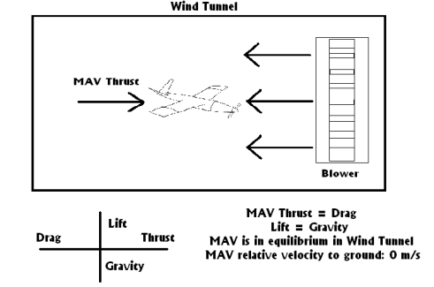
Figure 4 MAV Force diagram illustrating the concept of a free flight wind tunnel

For safety reasons the MAV would have to be fixed initially and then released. Options include a tether system, a ball joint, clamps, rails or a number of other applications. Instrumentation could either be onboard, off-board or both. Strain balances and other external sensors could provide the same measurements as the onboard gyros and accelerometers included in the autopilot component.

3.2.5 Free Flight

This is just what it sounds like. The free flight idea is based on the fact that the best representation of the MAVs behavior would of course be to fly it in the environment it will be used in – air. By programming a precise path into the onboard autopilot, the user can observe the response and motion of the MAV through a variety of tools. First of course the Kestrel autopilot provides a plethora of information via the included instrumentation. These can be used to plot linear and angular acceleration VS time for all three axes. This information can then be used to integrate for velocity and position (though the GPS also provides position data). Independent sensors also provide velocity of the MAV, as well as altitude and attitude. Off board sensors would be utilized in the form of high-speed cameras and smoke machines (mainly for visual inspection).
By flying the MAV through an Air Stream Halo we could then create incident wind gusts at any roll angle and almost any pitch angle. The pitch axis would be limited since we cannot place the blower directly in front of the MAV. However, this approach would provide a relatively simple and cost efficient design. On the other hand, the data obtained from this method would not be much more than what is currently available. See below figure for detail:

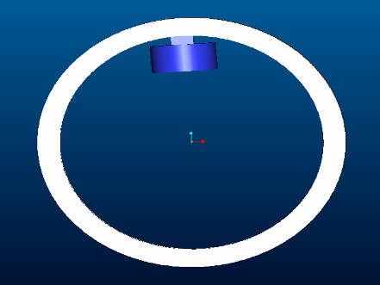
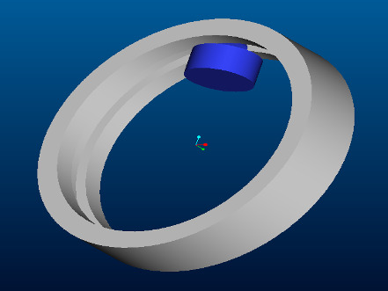

Figure 5 Free Stream Halo

3.3 Support Systems

3.3.1 Measuring Devices

In the wind tunnel design the MAV will be mounted on a strain gauge to measure compression and tension, which can then be used to determine lift. A multi-axis strain gauge can be used not only to measure lift but also drag and other flight dynamic forces such as pitch, roll and yaw. Using the multi-axis strain gauge would measure forces and moments about all three axis of rotation. The multi-axis strain gauge will require precise calibration and would have to be mounted accurately to obtain any useful data.
The multi-axis strain gauge would not allow for free flight however. For free-flight to be obtained the flight dynamic measurement devices would have to be on-board. This will require wireless communications between the MAV and ground control software so that data may be analyzed. Rate gyros mounted about the three axes of rotation as well as accelerometers would give relevant attitude estimation data. Differential and absolute pressure sensors would be needed to measure airspeed and altitude.

There are currently micro autopilots in use that employ multiple rate gyros, pressure sensors and other various data acquisition tools (such as wind estimation) to get information from the MAV to the user as well as control the movement of the MAV.

3.3.2 Mounting Design

To mount the MAV in a wind tunnel there are a few options. Conventionally a 1, 2, or 3 strut mount design is used, supporting the MAV in different underbelly locations as can be seen in the below pictures 1 and 2. In order to use these designs effectively in a wind tunnel one would have to run a simulation with the struts only and then with the MAV attached. By then “subtracting” the mounting results from the mounted MAV results we can get accurate flow and velocity data. Another option is to use a rear mounted attachment point. In this setup the MAV is held from behind via a variety of clamps or fittings:

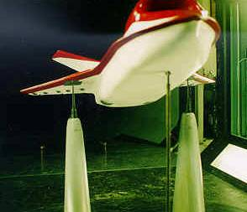
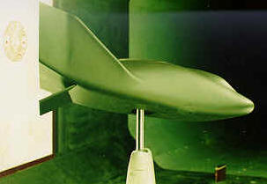
Pictures 1 and 2 Three and one strut mounting designs
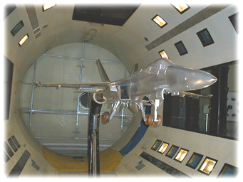
Picture 3 F-18 model attached via rear mount

3.4 Design Selection

Decision Matrix
Design | Test MAV Turning Dynamics | Tests straight and level flight | Resemble Free Flight | Tests Wind Gusts | Controllability of Environment | Total
Air Stream Halo | 10 | 2 | 3 | 10 | 9 | 34
Turntable | 4 | 5 | 2 | 4 | 9 | 24
Fixed Blowers | 6 | 5 | 2 | 5 | 8 | 26
Free Flight Wind Tunnel | 2 | 10 | 10 | 1 | 5 | 28
Free Flight with Halo | 6 | 3 | 10 | 1 | 1 | 21
In order to select the best design avenue it is necessary to compare the designs against each other. The best way to do this was in the form of a decision matrix which can be seen below in chart 1.
Chart 1 Decision Matrix

Another option would be to use a tether system in which the MAV is suspended by individual tethers coming from the ceiling of the wind tunnel test section. This is only feasible for the free flight wind tunnel since it does not rigidly fix the MAV in place. Based on this information it should be no surprise that our initial selection for final design concept was the ASH. However, after discussing the idea in detail with out sponsor it was amicably agreed that a free flight wind tunnel would be more beneficial to Eglin AFB. Dr. Abate indicated that it would be best to continue in an evolutionary avenue rather than attempting to revolutionize current technology since not only funding is more difficult to obtain but also the design itself may be beyond the scope of this design project. Our lack of official training or knowledge in aerodynamics makes this a larger hurdle than it would have been for Embry Riddle seniors and the free flight wind tunnel itself should be more than enough work for our limited time span. Furthermore, after speaking with Ken Blackburn at the MAV division of the Air Force Research Laboratory (AFRL) we decided that more pertinent data could be collected from a free flight wind tunnel. Based on these factors we decided to press on with the free flight wind tunnel.

4.0 Design Procedure

4.1 Wind Tunnel

To design a free flight wind tunnel we must first define the two most important properties of the tunnel. The first is the dimensions of the test section. The larger the test section, the larger the wind tunnel. The maximum wind tunnel size is six times the size of the test section. This is very costly and limits us to a small test section. Fortunately, we are trying to fly a small aircraft in the test section. In order for the MAV to perform maneuvers the usable test section should be at least twice its wingspan. For the largest MAV that will be flying in the tunnel, one with a 12” wingspan, we would need 2 feet of usable space in any given direction, resulting in a 4 square foot area. However, this is the absolute minimum, and we have doubled the linear requirements in order to avoid limiting the testing capabilities of the free flight wind tunnel. This means that we need a 4ft x 4ft test section to fly in. When moving longitudinally against the flow we will allow for 10ft of movement for the MAV. Due to the tunnel geometry there is extra room on the side of the wind tunnel that contains the test section (between turn 4 and turn 1). Now that we know the cross-section we need to fly in we need one more factor to design our wind tunnel, flow quality.
The quality of the flow for our application will be defined as velocity fluctuations in the direction of the airflow. To fly our MAV we need a flow quality that has velocity fluctuations of less than 1% of the free flow. To achieve this, a series of screens and a honeycomb will take out the axial and lateral fluctuations of the flow that form when the air passes through the fan. The best method to increase flow quality in the test section however is the contraction ratio. This is the ratio of the cross-sectional area of the tunnel at its maximum point, just before the test section, versus the cross-sectional area of the test section itself. The larger the contraction ratio, the slower the airflow is when it passes through the screens and honeycomb. There is no exact way to know what the

quality of flow will be without testing, but by using similar techniques as previously built wind tunnels; we get a good idea of what the flow quality will be. For example, the CSU Industrial Aero tunnel in Ft. Collins, CO, has similar attributes to our tunnel: a single return, closed test section as well as a similar test section area and velocity requirements. The CSU tunnel has a contraction ratio of 4.0 and a corresponding turbulence factor of .5% (Pope, 24). This information, along with specifications from several other tunnels gives us a great amount of confidence that if we choose a contraction ratio of 6, combined with the screens and honeycomb, will give us a flow quality of less than 1%. We will now discuss the particular design of the wind tunnel. The tunnel geometry describes the design of the ducting of the wind tunnel that the flow will pass through. The flow quality section will describe the design of the settling screens and honeycomb, and the following section will describe the selection of the flow fan.

4.1.1 Tunnel Geometry

In this section we will talk about two different tunnel geometries. One will utilize the full test section and contraction ratio, while the other is designed to fit inside the space currently provided at Eglin AFB. The first, larger design will be called the ideal wind tunnel and have a usable test section area of 4ft x 4ft and a contraction ratio of 6. All calculations are shown in Appendix C. Our actual test section area will be larger than the 16 square feet mentioned above in order to account for boundary layer phenomenon and flow separation. Since the total usable area in the test section is only 80% of the total area (Pope, 39) our test section must be 4.5ft x 4.5ft. The test section as described above will be 10 feet long. In order to familiarize any uninitiated reader with wind tunnel geometry below is a Pro/E drawing of the large geometry wind tunnel:

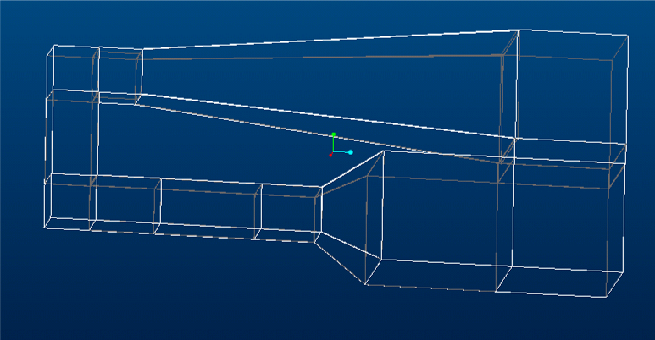
Figure 6 A layout of the wind tunnel
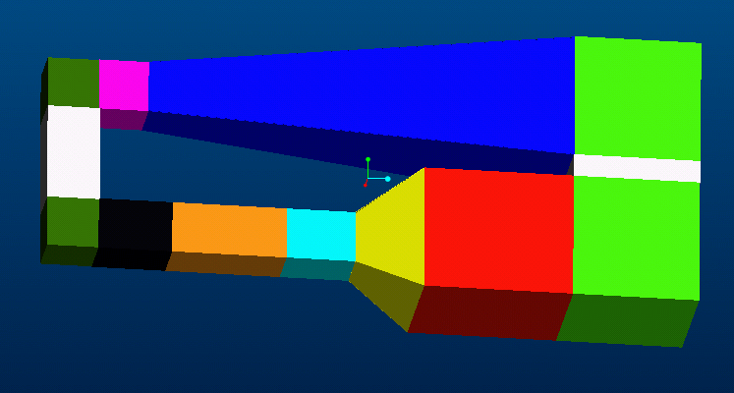
Figure 7 Wind tunnel layout with each section color coded
Test Section (Orange), First Diffuser (Black), Turn 1 (Dark Green),
Fist Spacer (Gray), Turn 2 (Dark Green), Fan (Pink), Second Diffuser (Blue),
Turn 3 (Green), Second Spacer (Gray), Turn 4 (Green), Settling Chamber (Red), Contraction Cone (Yellow), Small Area Settling Chamber (Cyan).

After the airflow passes through the test section it will encounter the first diffuser. This diffuser would normally increase the area from the test section area to the fan area. However the diameter of the fan is the same as the height and width of the test section. This means no area change is necessary. For this reason the diffuser now acts as a spacer. The spacer simply moves the flow to the first turn.
Turns 1 and 2 are simple 90-degree turns moving the flow across the tunnel gap as shown in figure 6. In the turns are turning vanes that help move the flow with the least amount of pressure loss. Even at optimal design the first two corners account for 60% of the static pressure loss for the tunnel. The loss in the turn is 15% of the dynamic pressure, which is vastly better than a turn without vanes.
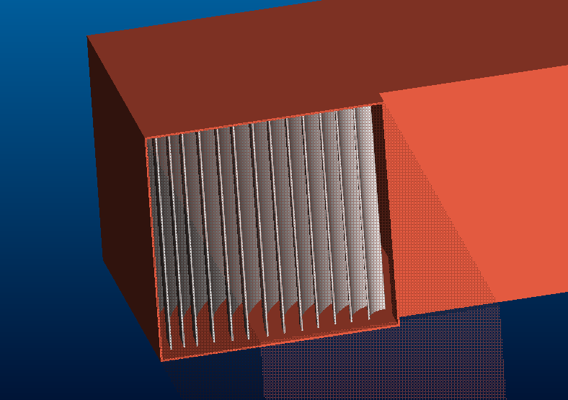
Figure 8 Corner vanes facilitating smooth 90 degree turns
Anther spacer is needed in between the turns to move the flow across the tunnel gap. The width of the tunnel across the first two turns and turn spacer is 17ft. The fan width, which has been given to us by the manufacturer, is 54 inches, while the length, as shown in Appendix D, is 52 inches. To ensure that flow separation does not occur, a nacelle must be installed that covers the fan motor in the center of the tunnel. The nacelle has a conical taper that creates a more even flow following the fan. Anti-twist vanes also help minimize the swirl of the flow coming off the fan. The major part of flow instability is created by the axial rotation of the fan, so combating these negative effects is paramount. The total length of the fan section comes to 8.5ft.
The second diffuser increases the cross-sectional area from that of the fan to 6 times that of the test section. The optimal angle of diffusion that will not separate the flow is 5 degrees. This means that the length of the diffuser needs to be 37.3ft. This is the bulk of the length of the tunnel, but it is necessary to provide quality flow. The total length of the wind tunnel is 61.3ft, much greater than the space available at Eglin AFB, but again necessary for quality flow. We will briefly discuss the size of the tunnel that can fit into the space available later in this section. Turns 3 and 4 have a height and width of 11.02 ft and again are both 90-degree turns. They are identically scaled to the first 2 turns, except the spacer between the 3rd and 4th turn is only 2 feet. The spacer is to prevent the flow from having to make a 180-degree turn.
Next is the large area settling chamber. This area allows the flow out of the 4th turn to settle out at the tunnel’s lowest velocity. We allowed 10 feet this section. Following the chamber are the honeycomb and settling screens. The designs of these are described in detail in section 5.1.2. The added length to the tunnel from the honeycomb and screens is 3 feet.
The most crucial part of the tunnel comes next, the contraction cone. This cone increases the speed of the air to that desired at the test section over a short distance. Flow separation at the contraction cone is a large concern for wind tunnels. To ensure this does not happen the contraction cone is usually designed to contract, not as a square, but as an octagon. This technique is commonly used to keep the flow laminar through the contraction cone and to our final section; the small area settling chamber. This is the last section before the flow arrives at the test section and the MAV. At this point, if the honeycomb and settling screens have done their job, the flow quality will be of sufficient quality for the MAV to fly in.

4.1.2 Constrained Wind Tunnel Geometry

For these calculations we wish to find the largest wind tunnel that will fit inside the space available at Eglin AFB. The room size is 40x30x15 ft, which is considerably smaller than the size of the ideal wind tunnel. The only aspect of the ideal tunnel that is

too large for the room is the tunnel length. We need to shorten the tunnel by 21.3 ft. This can be done two ways. The first is to decrease the area ratio. By decreasing the size of the large settling chamber, we decrease the length of the diffuser needed to increase the area. We chose not to do this because this method negatively affects the quality of the flow. Instead we chose to decrease the size of the test section. Decreasing the size of the test section, and keeping the area ratio the same, facilitates a decrease in the size of the large settling chamber. When the large settling chamber decreases, the length of the second diffuser also decreases. Appendix C shows the calculations used to find the largest test section possible to fit into our 40ft long room. We found that using a test section of 3 ft x 3 ft, that the total length of the test section is 36.63 ft. This would mean that the largest MAV that this would test properly would be one with a wingspan of 8 in or less. However, it is possible to fit a full test section (4.5’ x 4.5’) into the specified space, but sacrifices must be made for the area ratio and consequently flow quality.

4.2 Flow Quality

In this wind tunnel design the flow quality will be of paramount importance. As illustrated by “A NEW LOW-TURBULENCE WIND TUNNEL FOR BIRD FLIGHT EXPERIMENTS AT LUND UNIVERSITY, SWEDEN“ by C. J. Pennycuik, Thomas Alerstam, and Anders Hedenstrom, achieving a flow quality of 0.06% is possible. In their setup a wind tunnel was designed to study free flight of birds and gave very accurate data. Considering we will be flying a MAV, this level of quality flow may not be necessary but we will nevertheless strive for the highest possible quality with our imposed constraints.
For a “clean” test section, one with no mounts, struts, fairings, etc., there would be no up-flow or cross-flow, the velocity profile at each point would be uniform, and there would be no turbulence. Of course, this is not what can actually be obtained so the question then becomes what flow quality is acceptable for the desired application. In this section we will discuss the methods to improve flow quality to the maximum extent possible in our wind tunnel design.
As mentioned previously, it is advantageous to install anti-swirl vanes behind the fan. These vanes improve quality in the second diffuser (section after the fan and before turn 3) – see figure 7 for a layout of the wind tunnel. Low quality in the second diffuser usually results in up flow and cross-flow in the test section. The turning vanes themselves must be well machined and all burrs removed to prevent them from making the flow turbulent. After the flow passes through the diffuser it will move through turn 3 and finally exits turn 4. Here, it will encounter the settling chamber, then a honeycomb and 3 screens. Most of the theory and calculations in this section were based on Low Speed Wind Tunnel Testing by William Rae and Alan Pope.

4.2.1 Honeycomb

While screens and contractions reduce the longitudinal components of turbulence (basically mean velocity variations), honeycombs are used to reduce lateral components of turbulence. By having a cell length of about 6 to 8 times the cell diameter, the honeycomb can effectively streamline the flow (See Appendix E). Though few tests have actually been completed, the qualitative effects of a honeycomb are obvious. For our application a length/diameter ratio of 6 was chosen in accordance with widely accepted design theory.
Of course a honeycomb will generate some turbulence of its own with eddy sizes of the same order as the cell diameter. These decay much more slowly than the small-scale turbulence generated by screens. It is thus advantageous to place the honeycomb as far upstream as possible.

4.2.2 Settling Screens

A screen is usually made of wires interwoven to form square or rectangular meshes. Screens make the flow velocity profile more uniform by imposing a static pressure drop.

This is because a screen or anything imposing a hydrodynamic resistance in a constant area passageway will experience a drag force and thusly reduce the overall pressure of the flow passing through said screen. These screens are mounted in slots ahead of the contraction cone. Utilizing a support frame they can be slid in and out of the tunnel to facilitate easy cleaning and interchanging of screens if necessary. For a detailed mathematical determination of screen mesh size and wire diameter see Appendix E. For this wind tunnel design maximum flow quality was to be achieved so our design calls for 3 screens with increasing open-air ratios (β). As might be expected the open-air ratio is defined as the open area divided by the area covered by the mesh. Since open air ratios below 57% can cause flow instabilities the screens have an open-air ratio of 58%, 66% and 77% respectively. This design is analogous to using incrementally finer sieves to filter out smaller and smaller particles until one is left with a homogeneous mixture. The K value for these aggregate screens was found to be 1.23 indicating a respectable pressure drop. Since pressure drop is directly proportional to flow quality improvement we want the K value to be as high as possible.

4.3 Flow Fan

The flow fan selection is based on two factors, the volume flow rate through the tunnel and the required static pressure rise. The cross-sectional area at the test section and the maximum air velocity of 25 m/s allows us to calculate the volume flow rate. Our maximum flow rate becomes 100,000 CFM (cubic feet per minute). The static pressure rise requires tunnel dependent calculations. To calculate the static pressure loss from friction in duct sections equation 1 is used.

Equation 1
Equation 2
Equation 3

In equation 1, V is local velocity, D is the characteristic diameter, and L is the section length. In equation 2, λ is the skin friction coefficient which is based on the Reynolds number. The pressure loss in each of the sections is calculated in Appendix F and shown below in chart 2. The result is a static pressure loss of 594.5 Pa throughout the wind tunnel if we add a 10% loss to account for losses on joints and leaks in the tunnel walls. This does not account for the pressure loss from the friction and swirl-induction the MAV will have on the flow. The above pressure loss equates to 2.39 inches of water, a standard unit of pressure used by fan manufactures. With this calculation and our volume flow rate we can now choose a fan. The fan best suited for our application is the Howden Buffalo 54-26 series fan. Its specified duty is 100,000 CFM and it induces a static pressure rise of 6 inches of water at specified duty. This gives us a safety factor of 3 in our pressure calculation. The fan is direct drive and has controllable pitch to change the flow velocity. As stated earlier the fan has a 54 in diameter, and a 125 HP motor.
 | Section | Pressure Loss (Pa) | Total Loss (%)
1 | Test Section | 29.9 | 5.0
2 | Diverger #1 | 17.2 | 2.9
3 | Corner #1 | 181.9 | 30.6
4 | Spacing #1 | 24.4 | 4.1
5 | Corner #2 | 181.9 | 30.6
6 | Fan Section | 12.4 | 2.1
7 | Diverger #2 | 46.2 | 7.8
8 | Corner #3 | 5.06 | 0.9
9 | Spacing #2 | 0.07 | 0.0
10 | Corner #4 | 5.06 | 0.9
11 | Large Settling | 0.33 | 0.1
12 | Screens | 13.7 | 2.3
13 | Honeycomb | 2.2 | 0.4
14 | Contraction Cone | 2.9 | 0.5
15 | Small Settling | 17.2 | 2.9
 | Sub-Total | 540.4
 | 10% for leaks/joints | 54.0 | 0.1
 | Total | 594.5 | 100

4.4 Instrumentation

The principal objective of our project is to provide Eglin Air Force Base with a facility to test basic maneuvers of their micro air vehicles (MAVs). Therefore, a very important part of the project involved data collection, not only for the flow quality of the wind tunnel but also for the dynamic flight characteristics of the MAVs. The instrumentation used will be divided into on-board measurement (the flight dynamics) and flow-quality measurement. Each of these categories will then be subdivided into hardware and software so that the raw data taken from testing can then be transferred to personal computers and analyzed.

4.4.1 Flight Dynamics Measurement

The on-board measurements will be taken using a miniature autopilot. The autopilot will not only allow for flight control but will also relay collected data to a personal computer for analysis. The smallest autopilot with the most necessary features is the Procerus UAV Kestrel Autopilot. The Kestrel Autopilot is light and reliable and doesn’t sacrifice any capabilities to cut weight and size. At 16.65 grams (2” x 1.37” x .47”), Kestrel 2.2 is the smallest and lightest full-featured micro autopilot on the market. The Kestrel Autopilot System gives users robust guidance and control as well as smooth and successful integration and repeatability. The autopilot control system provides intelligent, autonomous flight control of single or multiple unmanned aerial vehicles, complete with GPS waypoint navigation and autonomous takeoff, flight and auto-landing capabilities for mini and micro UAVs. Combined with Virtual Cockpit ground control software, the Kestrel is a highly effective, easily integrated avionics package for a variety of military and commercial applications. The Kestrel Autopilot uses an external GPS unit for inertial navigation and wireless modems communications between the ground station and autopilot. Kestrel Autopilot can guide mini and micro UAVs autonomously and/or receive dynamic user commands through the ground station. It uses three-axis rate gyros and accelerometers for attitude estimation, as well as differential and absolute air pressure sensors for airspeed and altitude measurement. Below are some features of the Kestrel Autopilot.

Features:
    - Fits within 2.73 in2 Area & 1.29 in3 Volume
    - 3-Axis Angular Rate Measurement
    - 3-Axis Acceleration Measurement
    - 2-Axis Magnetometer
    - Absolute and Differential Pressure Sensors
    - 20 Point Sensor Temperature Compensation
    - External Power at 3.3V and 5V, 500mA
    - Efficient Switching Power Regulation
    - Battery Voltage and Current Monitor
    - 29MHz Processor w/ 512K RAM & FLASH
    - 4 Serial Ports (Std.,SPI,I2C) w/ Digital Clock or I/O
    - 4 Standard Servo Ports
    - 12 Digital I/O (6 bi-directional, 3 input, 3 output)
    - 3 Analog Inputs @ 12bit resolution
    - Optional Piggy-Back Modem Header
    - Wind Estimation
    - Multiple Fail safes
    - Multi-UAV Support
    - Convoy Following Support
    - Auto-trim

4.4.2 Flow Quality Measurement

The flow quality within the wind tunnel will be measured using a pitot-static tube to measure the velocity in the wind tunnel and a hot-film anemometer will be used to measure any variations/fluctuations in flow quality. They will be controlled using a traversing system controlled by LabView software.

Pitot-Static Tube
The flow velocity of the free-flight wind tunnel will be measured using a pitot-static tube. The pitot-static tube, is a combination of a static port and the pitot tube, and is set up in the following manner (shown in Figure 7 below). By aligning the tube with the flow direction, and assuming the flow is steady, one-dimensional, incompressible and inviscid, one can derive the following from Bernoulli’s equation:
where V is flow velocity, r is the density of the fluid, p_{stag} is the stagnation pressure of the free-stream and p_{stat} is the static pressure.
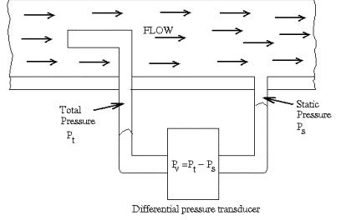

Figure 9 Pitot-Static Tube

Hot-Film Anemometer
The hot-film anemometer that will be used is a straight fiber-film probe with a thin coating. We chose a hot film probe because they are superior to hot-wire probes since they have better frequency response, improved heat conduction, and easy maintenance. Hot-films have better frequency response (when electronically controlled) than hot-wires of the same diameter because the sensitive part of the sensor is distributed on the surface rather than including the entire cross section as with a wire. There is lower heat conduction to the supports due to the low thermal conductivity of the substrate material, which allows for a shorter sensor length. Hot-film probes easier to maintain and clean due to a thin quartz coating on the surface that resists accumulation of foreign material. They can be found at Dantec Dynamics and can be purchased online. This particular hot-film anemometer has a sensor perpendicular to the probe axis and mounts with the probe axis parallel to the direction of flow.

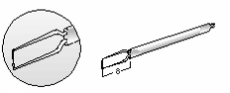
Figure 10 Hot-Film Probe
Hot-film anemometers measure the mean and fluctuating velocities in free-stream one-dimensional flows. Hot-film anemometers can be used in two different modes: the constant temperature mode and the constant current mode. Both modes make use of the physical principle of forced convection heat transfer. When using the constant current mode, a fixed electric current flows through the small film, which is exposed to the flow velocity. The film then reaches an equilibrium temperature since the internally generated heat due to electrical resistance balances with the convective heat loss from the fluid

velocity. The film temperature must adjust itself to match changes in the convective losses until a new equilibrium temperature is obtained. Given that the convection coefficient is a function of the flow velocity, the equilibrium film temperature can be used as a measure of velocity. This is accomplished by measuring the electrical resistance across the film. In the constant-temperature mode (which is what we will be using to gauge turbulence), the current through the film is adjusted to maintain a constant film temperature. The current required to compensate the convective heat loss can then be used to measure the flow velocity using the following equations. The bridge circuit shown in the figure below is set up by setting the adjustable resistor to the resistance you wish the probe and its leads to have during operation. The other two legs of the bridge have identical resistance. The servo amplifier tries to keep the error voltage at zero (meaning the resistances of the two lower legs of the bridge match). When you first power the circuit, it will adjust the bridge voltage such that the current flowing through the probe heats it to the ambient air temperature. This then gives you a resistance value for the ambient air temperature. When we put the probe in a flow, the air flowing over it will try to cool it but in order to keep the temperature (resistance) constant. The bridge voltage will have to be increased: the faster the flow, the higher the voltage.
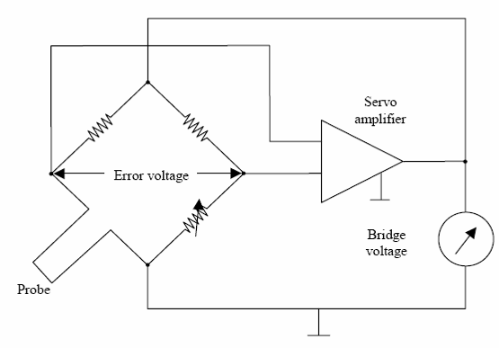
Figure 11 CTA Bridge Circuit

For equilibrium, the energy balance equation of a hot-film is:
Equation 4
In equation 4 I is the current, R_{f} is the film resistance, T_{f} is the film temperature, T_{a} is the surrounding fluid (in this case, air) temperature, h is the convection coefficient and A is the surface heat transfer area. For a wide range of velocities, the convection heat transfer coefficient, h, can be related to the instantaneous convection velocity V. Based on the empirical evidence, King's law has been shown to be valid for a thin film operated in constant temperature mode. King's law states:
Equation 5
where A₀ and A₁ are considered to be constants under fixed operating conditions. For a properly designed system, the supplied current can be directly related to the anemometer output, E, that is,:
Equation 6
where C₀ and C₁ are constants that are to be determined, and E₀ is the voltage measured at zero jet velocity.

Traversing System
The hot- film anemometer and pitot-static tube will be positioned inside the test section of the free-flight wind tunnel using a Linear BiSlide from Velmex Incorporated. This system will allow for 50 inches of travel along two axis and will be controlled using LabView software. The Linear BiSlide has a 0.1-inch lead screw and weighs approximately 23.1 lbs. (See Appendix G)

4.4.3 Data Display/Analysis

Virtual Cockpit
Virtual Cockpit 2.0 is the Windows XP-based ground control software for the Kestrel™ Autopilot System. It allows for monitoring and in-flight adjustments on a computer. Virtual Cockpit users can interact with micro air vehicles in a variety of different modes, including stick and rudder, altitude-heading-velocity commands and dynamic waypoint specification. It allows operators to configure, monitor, issue commands to the autopilot and ground station wireless communications hardware, upload flight plans and change waypoints, all while the UAV is in the air. Some features of Virtual Cockpit are listed below.
Features:
- Simplified user interfaces
- Geo-referenced maps (large map area)
- Easy-to-use mode support – readily accessible buttons
- Intuitive flight planning – easy click-and-drag waypoint placement, management and editing
- In-flight mission reprogramming and waypoint uploading
- Dynamic re-tasking and adjustment
- Flight plan save and retrieve capabilities
- Fully configurable, integrated precision data logging
- User-configurable fail safes
- Telemetry data playback from within the Virtual Cockpit
- Integrated video (video and still shots, text/data overlays)
- Hardware-in-the-loop simulation: Aviones Simulator
- Real-time graphing of PID loop performance
- In-flight PID gain tuning – graphical PID loop selection
- Priority messaging window
- Audible warning sounds (configurable)
- Remote TCP/IP connection
- Flight timer
- Auto-trim - initiate auto-trim capability, save values to autopilot
- Two-axis, stabilized gimbal camera support with manual control through joy stick
- Game pad controller to manipulate UAV without RC experience or RC controller
- Multi-agent – now easier than ever to fly multiple UAVs (autonomously or with pilot-in-the-loop) while receiving and monitoring real-time UAV status (battery voltage, telemetry, etc.)
- Convoy Following Support - now with GPS on the Commbox ground station, users can manage multiple UAVs in convoy following applications
LabView
The National Instruments LabVIEW Base Package provides configuration for performing data acquisition and analysis, instrument control, and basic data presentation. You can connect to a wide array of hardware devices for PCI and PXI data acquisition, instrument control, motion control, and vision inspection. The Labview software is Windows XP based and will be used to control the traversing system from Velmex Inc. as well as display the data collected from the hot-film anemometer and pitot-static tube.
Dell Precision Workstation 380
This high performance machine features a 3.2 GHz dual core Intel Pentium D processor with 1 GB of RAM, as well as, NVIDIA Quadro FX 4500 graphics card. Since any 3-D or rendering software will be very intensive on the processor and require a high-end graphics card and plenty of random access memory (RAM) this workstation was an ideal and economical choice. Along with its Windows XP Professional operating system this computer is more than adequate to run Virtual Cockpit 2.0 and LabView 8 and also allows for future software and hardware additions.

4.5 MAV Handling

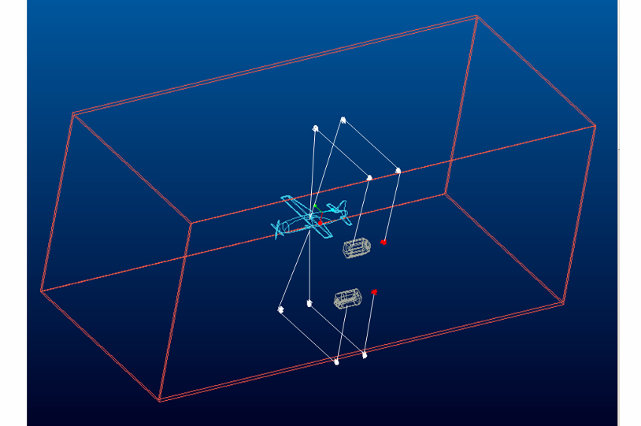

Figure 12 MAV Attachment Set Up

The MAV is initially suspended midway in the rectangular test section of the Wind tunnel by a set of tethers. The MAV is restrained initially both above and below the MAV’s center of mass. Sets of tethers are connected to the MAV by looping around hooks, which are fixed above and below the MAV’s center of mass. The upper tether ends extend towards the top of the wind tunnel where they exit (through a set of bushings) and are directed by a set of small pulleys down the sidewall of the wind tunnel to a clamp and release mechanism on one end and an automatic reel on the other. The lower tether follows the same path as the upper, but instead extending toward the floor of the tunnel before being guided by a pulley set up the side wall of the tunnel where one end is clamped and the other is fed to an automatic reel (upper and lower tethers have their own respective clamps and reels, to allow for individual release). When the MAV is

stabilized the tethers are systematically released. At this time the tether clamp is opened and the automatic reel pulls the line in. The set-up also allows for increasing or decreasing tension is the tether as necessary during testing. The MAV is suspended midway in the test section. Other apparatus is attached to the test section to accommodate overall desired testing set-up.
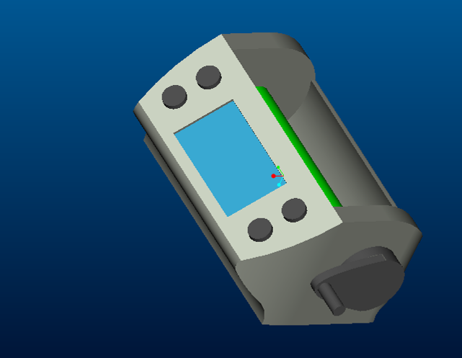
Figure 13 Automatic Reel
An automatic reel, shown above in figure 13, is utilized to allow for quick spool-in of tether once clamp is released. The product selected to meet this need is the Miyamae's Command X-1. The Miyamae's Command X-1 is manufactured by Swingcast, and has several features that are ideal for the project application. It’s lightweight, electric (allowing for automatic winding), and has the capability for tension adjustment as well as fast winding. Some important specs of the X-1 are it’s winding speed of 290 to 600 rpm,

and hoisting capability of 17 lbs. Dimensions of the X-1 measure 4.5*3*6 in. (L*W*D). The automatic reels are positioned midway along the side of the test-section vertically in line with each other. One reel is positioned with the line-in pointed upwards for the upper tether, while the other is positioned downwards for the lower tether.

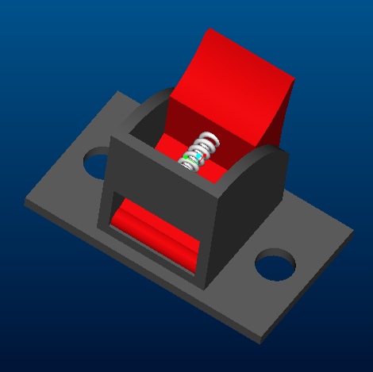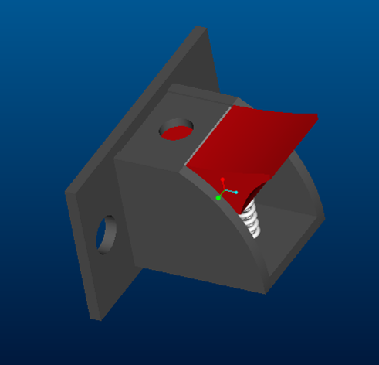
Figure 14 Tether Clamp

The tethers in the setup are fixed and released by a spring-loaded clamp that allows for a secure restraint as well as instantaneous release. The tether is fixed and released by a tab button. When the tab is pressed, the spring-loaded clamp is released and the tether can either be inserted or released. This set-up is simple in design, yet perfect for our need. The design of the restraint and release mechanism is illustrated in Pro-E drawings and can be easily and inexpensively designed and fabricated, or sourced (using a similar product) from Radio Shack with the Gold Series 2-position Terminal plate (model#274-632). The tether clamps are positioned on the sidewall of the wind tunnel horizontally in-line with their respective automatic reels.

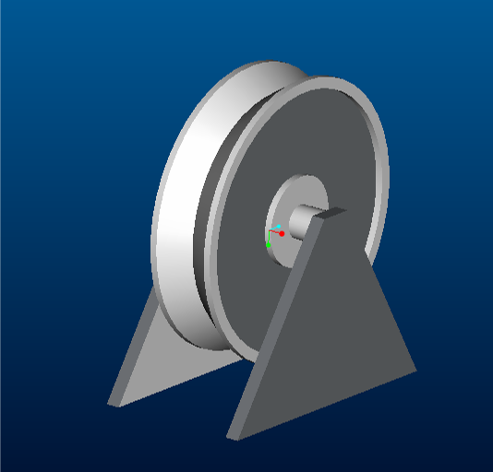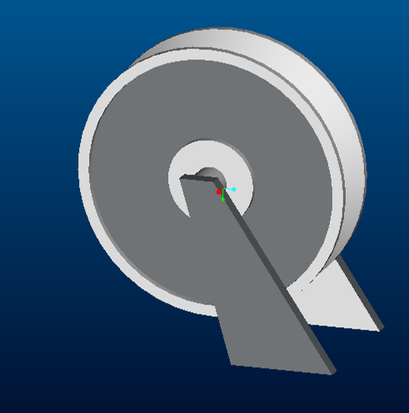

Figure 15 Small Pulleys

Small pulleys, shown above in figure 15, are utilized in our setup to smooth the movement of the tether as it runs its assigned path. A set of two small pulleys are centered on top of the wind tunnel, while a second set is mounted (on top) inline with the first set farther back where the top cross-section of the tunnel meets the side. The upper tether ends (after looping around the top hook on the MAV) exit through the top of the tunnel where they are immediately ran on top of pulleys and guided towards the side of the wind tunnel where a second set or pulleys eases the 90 deg drop to the side wall. This set-up is copied symmetrically for the lower tether. From here the tether ends are ran to the clamp and reel on the side of the wind tunnel.

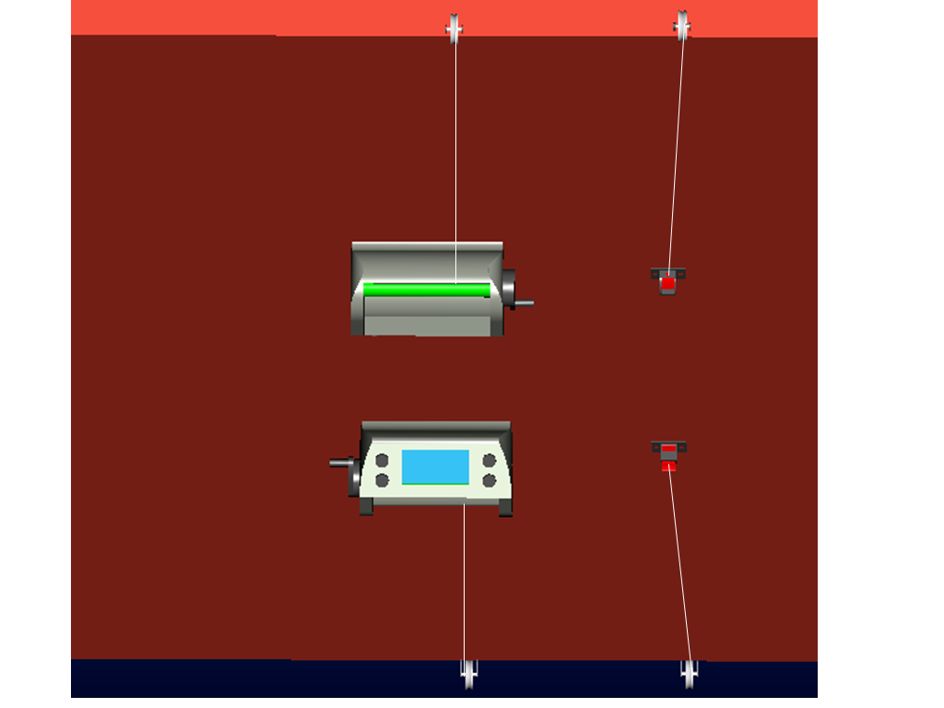
Figure 16 Pulley and Reel Set up

The small pulleys measure 30mm in diameter and are constructed of plastic, which allows for a lightweight, free-rotating set-up. E-Clec-Tech is the manufacturer of the pulley (model # DIYMCH06) that will be used for this apparatus

5.0 Cost Analysis
The preliminary budget for this project, as given to us by Dr. Abate, was $300,000. After sourcing prices for the various components of the Free-Flight Wind Tunnel System, we have compiled a product purchase list, which includes the individual product title, quantity, cost, company it will be purchased from, and the product number (refer to Appendix I). The total cost of our project, not including the price for the sections of the wind tunnel or the price of the settling screens, was approximately $40,254. The price of the wind tunnel sectioning and settling screens cannot be determined without extensive engineering analysis by Engineering Lab Design. Due to the associated cost, Engineering Lab Design is completing this work on a low priority basis. After careful research into wind tunnel fabrication we have been able to determine that the cost of the free-flight wind tunnel will be less than $250,000 keeping us under our $300,000 budget.

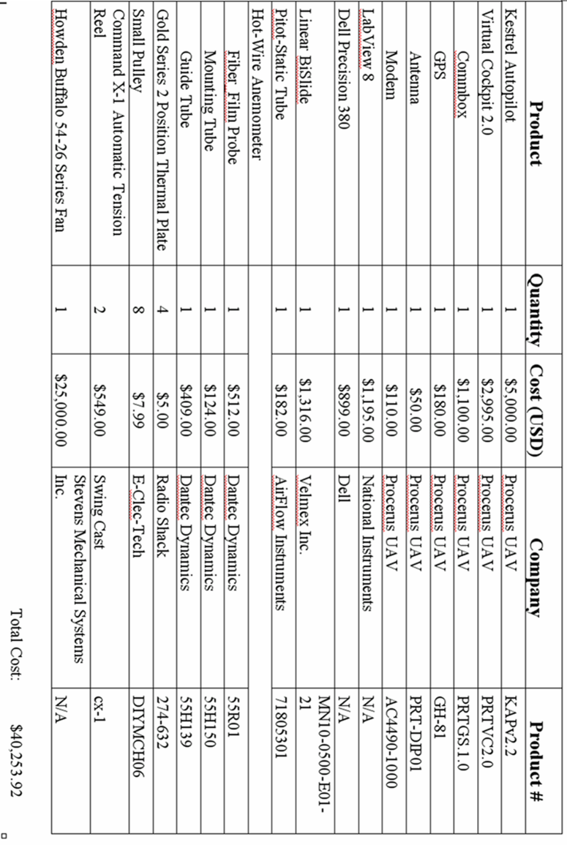

6.0 Wind Tunnel Design Analysis

6.1 Introduction

In continuing the task of designing a characterization facility for Eglin, we must proceed to the next step of testing our design. Our goal is to verify the effectiveness and reliability of the facility we have designed. It would be extremely useful for our customer to have complete confidence in the fact that our design is sound. We need data to back up our claims that a MAV will be able to obtain free flight in a wind tunnel. The best way to achieve this is to build the wind tunnel ourselves and actually test the tunnel with an MAV inside. Although accurate, building the wind tunnel is out of the question. The amount of man-hours and money that would go into building a 40 ft wind tunnel is out of the question for our group with the budget and time constraints bound upon us.
Other options before us are designing the wind tunnel in a computational fluid dynamics program that can simulate the wind tunnel and predict the flow through the tunnel. This program would be extremely useful, as to give us the ability to make changes to the tunnel easily and see the effects of every aspect of the tunnel. However, this too, is out of our group’s reach. A program of this level would require much more programming experience than any in our engineering program attain. Moving in a different direction, another option before us is to build a scale model of the wind tunnel.
A scale model costs a fraction of the full size tunnel. Not only would it give us the ability to make easy changes to the tunnel design but also allow us to simulate many different environments that would be extremely expensive and time consuming with the full scale tunnel. Scale models of tunnels are the most common way in industry that tunnels are tested before beginning any construction. They give the most freedom at the cheapest price, but they are not perfect. When scaling down tunnels properties like Reynolds number change, making any results obtained with a scale model more complicated to analyze. Also, we have no MAV small enough to fly in a model any smaller than the full size tunnel. Even with these drawbacks the scale tunnel is the best option for our design group to analyze. It is the most feasible option, and will allow us the only opportunity to verify any part of our design. A scale wind tunnel is an excellent

opportunity for our group to not only tests the validity of our design, but to fulfill the requirement of our class to physically build a part of our design.

6.1.1 Model Objective

As I have already mentioned, we will not be able to test every aspect of the scale model. The model is obviously too small to actually fly anything inside of it. Regardless, the one thing we can test is the quality of airflow in the tunnel. The most important attribute of our tunnel is to produce extremely laminar flow through the test section for the MAV to fly in. If we have any flow velocity fluctuations, the resulting movement of the MAV cannot be distinguished between the inert flight characteristics of the MAV or actual disturbances in the flow. We need to be certain that our flow is very smooth in order to obtain usable data from the movement of the MAV. For this reason the scale model will be used to test the flow quality. It is very realistic to obtain this information from a scale tunnel. A scale model will be built and the velocity of the flow through the test section will be measured. The small variations in relative velocity will determine the amount of turbulence present in the test section and ultimately if the design is sound. Along with the flow though the test section, other problematic flow areas can be addressed. By using smoke injection we will be able to do a number of other tests in the scale tunnel. The smoke injection will give us the ability to “see” the flow move around the tunnel so we can watch the flow as it passes though each section and determine if a change to that section needs to be made. When looking at the flow through the diffusers we will watch for flow separation. Changes can then be made to the angle of diffusion to correct for separation. Next, test the diffuser again and observe improvements to determine whether further corrections are necessary. The flow through the turning vanes can also be observed to see if the flow is over-turned or under-turned. The turning vanes can be adjusted and re-tested. Modifications of the tunnel can be carried out as long as necessary in order to be confident in the design of the tunnel, or, in the worst case scenario, until the determination is made that the design is unfit for this particular application.

6.1.2 Model Testing

To test the turbulence through the test section a hot wire anemometer can be placed in the test section to measure the instantaneous velocity fluctuations. The percent of relative velocity fluctuations will give the relative turbulence trough the test section. The hot wire is extremely useful in that it can give the velocity fluctuations in multiple axes. This will allow the user to see the turbulence in the axial direction as well as the lateral axis. Knowing what direction the flow is turbulent in will tell you if our honeycomb (settles flow in lateral) or settling screens (settles flow in axial) are not effective or marginally effective. Using a hot wire is extremely easy and requires minimal set up. The test section of the model is removable and can be formatted to fit any set up. Multiple test sections can be manufactured and interchanged, for easy testing. Another testing option is flow visualization. Using a fine screen with an extremely large open air ratio in the test section along with small strings attached to the screen, the user can see a representation of the flow move through the test section. Any spin in the flow will be visible by the orientation of the strings. If the flow is turbulent the strings will flutter in the stream. These tests can be used to test and observe the flow through the test section. This brings up the scaling effects. In any testing of a model the integrity of the test depend upon the relationship of the model to full scale. We must analyze the properties that change due to scaling.

6.1.3 Scaling Effects

For any ducting the Reynolds number depends upon the size of the duct. As the ducting size decreases, so does the Reynolds number. For our model our scale is 1/12 the full scale design, and our Reynolds number is also 1/12 that of the full scale model. This completely changes the flight dynamics of the fluid. How the MAV acts in the full scale environment is not necessarily how it would act in the scale model. Fortunately, what we are testing is completely independent of Reynolds number. As stated above the testing to be done in the tunnel is a velocity measurement in the test section. The properties that define velocity are independent of Reynolds number as shown in equation 7 below.

Equation 7 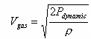

In this equation the velocity is dependent only on the dynamic pressure and gas density. This is extremely useful in telling us that our testing is completely relevant. We are not testing for Reynolds number, and thus can neglect the effects of scaling for our application.

6.2 Model Manufacturing

6.2.1 Manufacturing

Manufacturing the scale model this semester was extremely time intensive. Our group put much more time into fabrication than we ever expected. Our original timetable projected manufacturing to be complete in three weeks with three group members working three days a week for 4 hours. Even though we did complete fabrication within three weeks, it took four group members working five days a week for six hours a day. This was due to all the precision milling that was required for every part, as described in the sections below.
The tunnel was almost entirely constructed of acrylic. We used ¼ inch thick sheets for all the ducting because that particular size fit well into our budget constraints and was also adequately strong for our desired application. Though we had initially planned on milling each piece to obtain exact specifications and tolerances, it quickly became clear that this course of action was not feasible in the allotted time frame. Machining our entire tunnel structure on an end mill would have been incredibly cumbersome and the required time would have taken us well past the due date for the entire project. So, instead we used band saws to cut the sheets down to size. Though certainly less accurate and precise, this method proved to save us a great deal of invaluable time and was still exact enough to provide us with quality parts.
For all straight sections of the tunnel we simply cut four equal sheets of acrylic and then, using clamps and acrylic cement, joined the pieces together to form a hollow rectangular section of the wind tunnel. By using an overlapping method to assemble these pieces we were able to save significant time, approximately 25% of each operation, since we did not have to readjust the band saw guide twice for every piece.
Since the diffusers needed to be exact to achieve a tight fit with the outward angle of 5°, it was impossible to achieve this kind of precision with a band saw. Instead, with the aide of a few adapter plates and a steady hand, the diffusers were machined to exact specifications on mills in order to assure a tight fit with the rest of the tunnel structure. It was not possible to use an overlapping technique here due to the geometry of the component and the resulting method of physically joining them together. Specifically, since the diffusers’ cross sectional area increases outwards as you move along the part it was not possible to clamp them in the same manner that was used with the straight pieces. Consequently, team members were utilized to hold the parts together while the acrylic cement dried to handling specs. Another hurdle in construction was the fact that the second diffuser was much too large to be machined in any mill here at the College of Engineering, so we were forced to break it down even further. By cutting our drawings in half lengthwise and then cutting the second half again, we obtained pieces that were small enough to be manufactured in the available machine shops and then glued those pieces together to create the final product.
The most challenging part of any wind tunnel to manufacture is definitely the contraction cone. This vital section reduces the cross sectional area of our scaled tunnel by a factor of 6, increasing flow velocity without generating turbulence. The geometry of the cone itself is not very difficult to draw out in a CAD program (Pro/Engineer) but constructing it out of acrylic sheets is impossible. After brainstorming the issue, it was decided that the best recourse for this dilemma was to employ the local rapid prototyping program. Rapid prototyping is a form of Computer Aided Manufacturing (CAM) which takes a virtual model, breaks it down into cross sections and then manufactures each one of these sections in physical space. This way the virtual and physical model is almost

perfectly identical. The way this is accomplished, is by converting the Pro/Engineer file to the STL format used in stereo lithography CAD. Using Fused Deposition Modeling (FDM) the rapid prototype here at Florida State heated up the polycarbonate material, moved it through the extrusion nozzle and thusly created layer after layer of the contraction cone. The Pro/Engineering model and physical model are shown below in images 17 and 18. Unfortunately, the FDM 2000 built by Phoenix Analysis & Design Technologies was too small to manufacture the entire cone at once so we had to cut the design into four quarters. Each quarter took about 40 hours to complete and there were numerous occurrences of the FDM machine running out of material and the cone falling over.

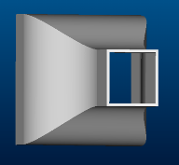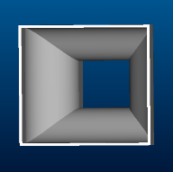
Image 17

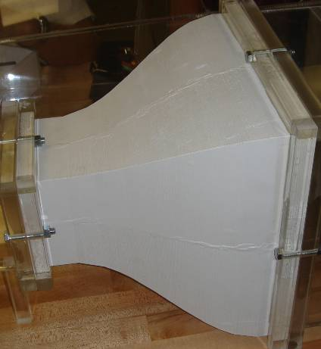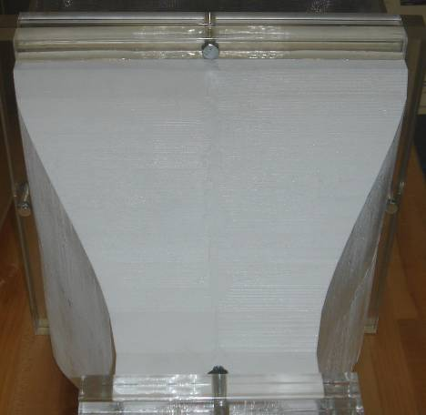
Image 18
The last challenge to overcome then was the settling chamber. The objective of the chamber is to provide space for the 3 screens and the honeycomb and give the flow a chance to calm itself before entering the contraction cone. A more detailed discussion of flow straightening can be found in section 4.2. After researching possible options and looking at wind tunnels available here at Florida State University, it was clear that a sliding frame would be the best option for the screens. First, slots were cut into the sides, bottom, and top of the settling chamber to create a guide for the insert-able frame. Then, using .093 thick acrylic sheets, a frame for the screens was constructed. This frame consisted of two equal length rectangular spacers. Using superglue, the screens were flattened and attached to the frame; one in front, one in the middle- sandwiched between the two spacers, and one in the back. This final piece was then slid into the precut slots for a tight fit. After this, the top was attached and secured with acrylic cement. The completed settling chamber is shown below in image 19.

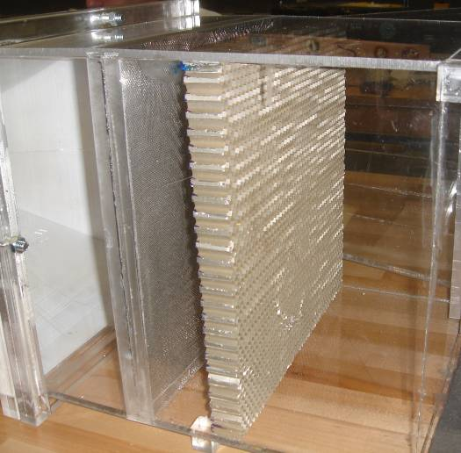
Image 19

6.2.2 Parts and Purchase Order Problems

Since we had initially planned to have a purely theoretical senior design project with no actual fabrication, we did not decide on building the scaled tunnel until late in the fall semester. This was a considerable problem since the engineering purchasing department has an extremely long lead time in cutting purchase orders. Even though we promptly

submitted all paperwork by January 20, our last part did not actually arrive until March 28. Obviously, this was a significant blow to our fabrication progress. Though we completed all the non-material dependent tasks that we could during the wait time, much of our most valuable resource was squandered due to the departmental bureaucracy. Due to the extremely strained schedule our team has exhausted themselves the last three weeks to produce the model. This setback was a major issue as it encroached heavily on the fabrication schedule and consequently model testing. The machining of parts was further slowed by machine availability as other classes, like M.E. Tools, as well as other senior design groups were all vying for machine time concurrently.

6.2.3 Status of Scale Model

Our team is proud to report that manufacturing of the scale model has been completed. As you can see in image 20 all sections of the tunnel have been joined. All the turning vanes have been turned and placed into their respective turns. Each turn has a removable top, for easy access and modification of the vanes. The fan has been placed into the tunnel, and a control box has been made to house the power wires. The control box also contains two 2-position toggle switches which control ON-OFF for the two power settings HIGH and LOW, as seen in image 21. The settling chamber contains the honeycomb and three settling screens. The contraction cone is assembled, and attached to its framing. The framing encircles the cross section of each end of removable sections. The removable sections are bolted to each-other via the framing around the ends. Every connection contains one bolt on each side and a custom gasket to produce a seal. This keeps air from escaping the tunnel, reducing the flow quality and dynamic pressure. No more assembly is required and no more parts need to be built. Unfortunately, this does not mean the tunnel is ready for testing.
At this stage the turning vanes need to be tested, and correctly oriented. This is a very time intensive and precise procedure. Each turning vane must be tested with flow visualization to determine the angle of attack, and trailing edge geometry. This allows us to establish if the vane over or under-turns the flow. If the vane is oriented correctly then it is set in place. Our vanes are still free standing to allow them to be oriented correctly. The required amount of testing sums to over a hundred flow tests and analysis, something our team simply did not have enough time to complete. For this reason we could not perform any flow tests with any amount of confidence since we could not truthfully say where the turbulence is isolated, or whether our settling chamber was inadequate.

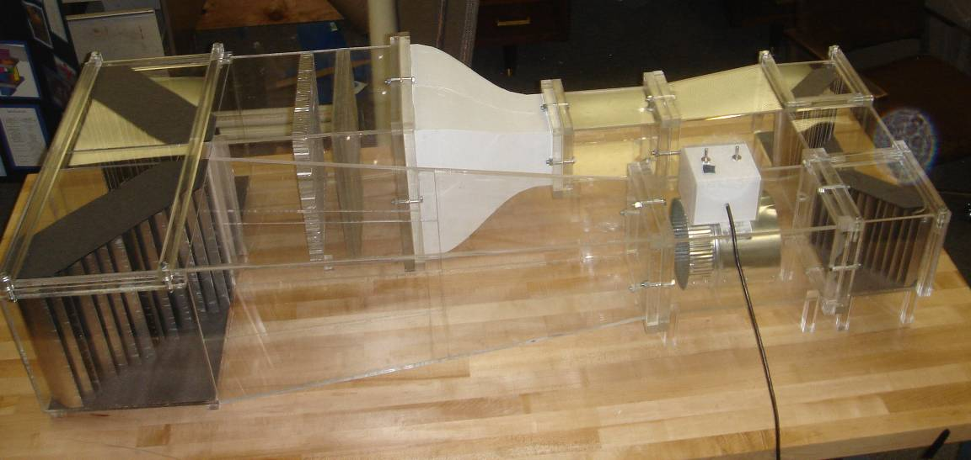
Image 20

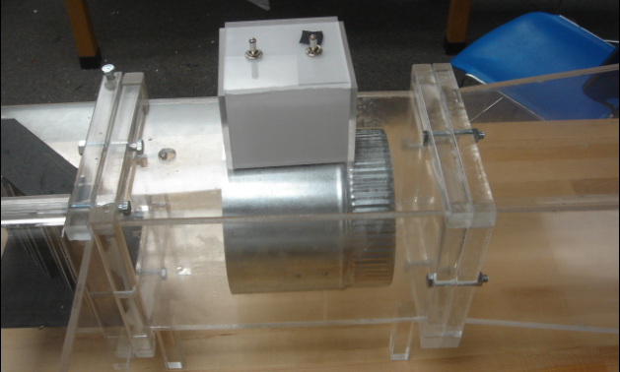
Image 21

7.0 Conclusion
In this report we were primarily concerned with the design of a free flight wind tunnel. The first design option will provide maximum flow quality to the MAV in its simulated environment (the test section) but is significantly longer than the currently available facilities at Eglin AFB at approximately 67 feet. However, we are confident that this design will inherently have sufficient air flow quality to successfully fly the MAV in free flight. Of course the question remains if the MAV and its integrated systems will be able to handle free flight.
The second design is significantly shorter at approximately 36 feet. This will easily fit into the 40 x 30 x 14 foot room allotted to us by Eglin AFB. Due to the constricted area it was necessary to cut the test section down to 3 x 3 feet. This effectively limits the size of the MAV to be tested to an 8 inch wingspan, smaller than the maximum 12 inch wingspan. Depending on the facilities available at Eglin AFB it is of course recommended design option 1 be utilized to construct this free flight wind tunnel. However, if this is not feasible design option 2, the constrained wind tunnel, will probably still give sufficient flow quality to successfully fly the MAV. The only estimations we can make are by comparing our design to other wind tunnels that have already been built and tested. From these comparisons we find that flow would still be sufficient. Nonetheless, advanced computational fluid dynamics (CFD) software could be the only possible way for us to make a more precise estimation at the flow quality in the tunnel without building a scale model. However, this software is not only complex and difficult to use but also requires enormous computing power on the level of supercomputers. There are a few consultant firms who provide this service at a costly rate, however. We have taken the next step to do this analysis ourselves.
The scale model built will be quite adequate to determine if our original design is adequate to complete the task we have given to it. We have manufactured a quality tunnel while incomplete, it is the immovable foundation and housing for invaluable testing that can be done on the wind tunnel design. I am completely confident that if our materials had arrived when we had planned for them we would have had the time to complete the analysis of the turning vanes and start testing the flow through the test section. The information from this tunnel will be extremely useful to tell if our condensed tunnel design will suffice.
Regardless of which wind tunnel design is used, the instrumentation to obtain our flight data remains the same. By utilizing the onboard autopilot and the associated software we can acquire attitude, airspeed, and altitude readings. With this data we can break down maneuvers into roll, pitch, and yaw to characterize the motion of the MAV.
Just like instrumentation, our tether system would remain the same for both tunnels. Using a tension controlled reel we can run a lightweight line through hooks on the top and underside of the MAV. These reels can then control and sense force imparted on the string. Using a simple release mechanism the MAV can then be completely unconfined and conduct free flight.
Most of these systems were custom designed to meet our very specific application. We believe that our integrated system is the best avenue for characterizing MAV flight dynamics with the imposed constraints.

Appendix A
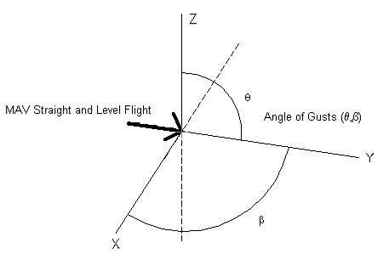
Figure 15

Appendix B
Project Plan

Project Procedure
- Contact Eglin
- Obtain project requirements and desirable outcomes of project
- Create Project Specifications, Procedures, Schedule

Background Information
- Research MAV
- Research prior MAV characterization facilities
- Research all facilities that characterize flight mechanics

Idea Generation
- Create at least three possible facilities to characterize MAV
- List the parameters each facility will test
- List pros and cons of each facility
- Present on conceptual design review

Concept Selection
- Choose best design
- Divide facility into subsystems to be designed independently
- Assign group members to head specific subsystems

Design Analysis
- Develop engineering drawings and detailed equipment purchases for establishing facilities

Final Design Review
- Combine subsystems / Integrate design
- Analysis of complete facility
- Prepare Spring Proposal

Design Tree

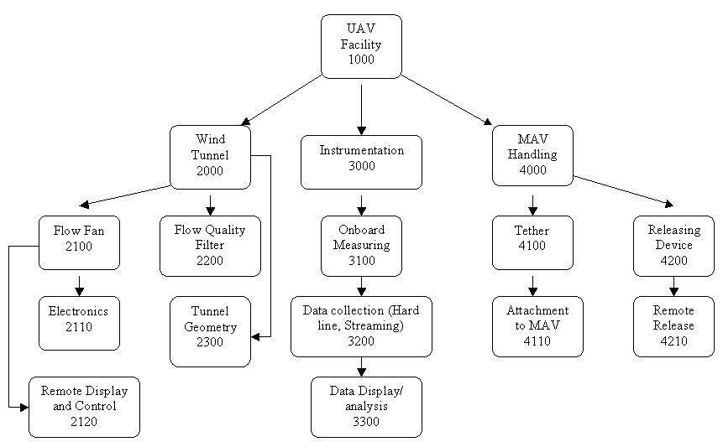

Appendix C

Ideal Wind Tunnel Geometry

Constrained Wind Tunnel Geometry

Appendix D

Appendix E

Appendix F

Appendix G
Fiber-Film Probe, Thin Coating, Straight
Product # : 55R01
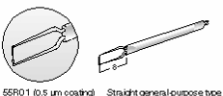
Technical Data For Fiber-Film Sensors
Thickness of Quartz Coating | 0.5 micrometers
Medium | Air
Sensor Material | Nickel
Sensor Dimensions | 70 micrometer diameter, 1.25 mm long
Sensor Resistance | 6 Ohm
Temperature Coefficient of Resistance | 0.40 %/*C
Maximum Sensor Temperature | 300 *C
Maximum Ambient Temperature | 150 *C
Minimum Velocity | 0.05 m/s
Maximum Velocity | 350 m/s
Frequency Limit | 175 kHz

Mounting Tube, Straight, Long, 4mm
Product # 55H150
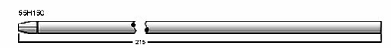
Guide Tube, Long, l = 440 mm

Product # : 55H139

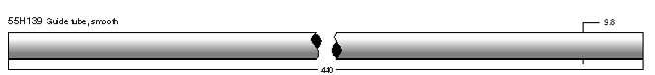

Linear BiSlide

Product # MN10-0500-E01-21

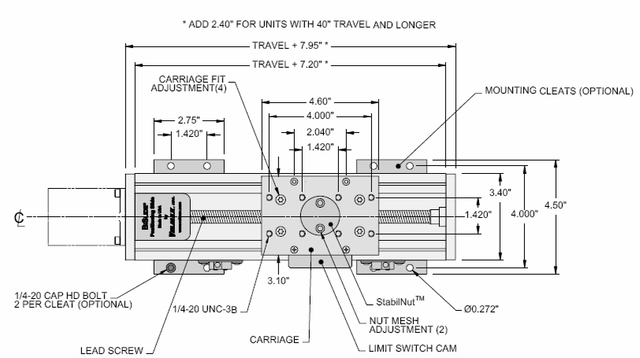

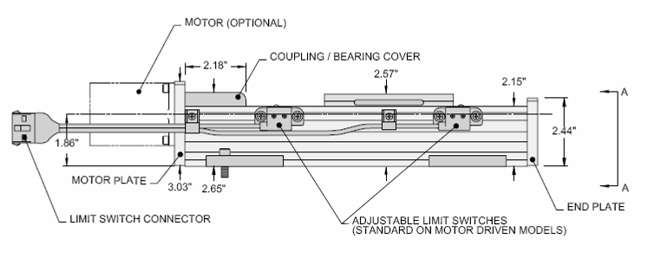

Telescopic Pitot-Static Tube

Company: AirFlow Instruments

Product # 71805301

0.2 to 0.98 m (8 to 39 in.) variable length

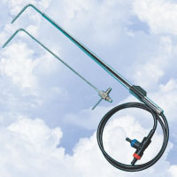

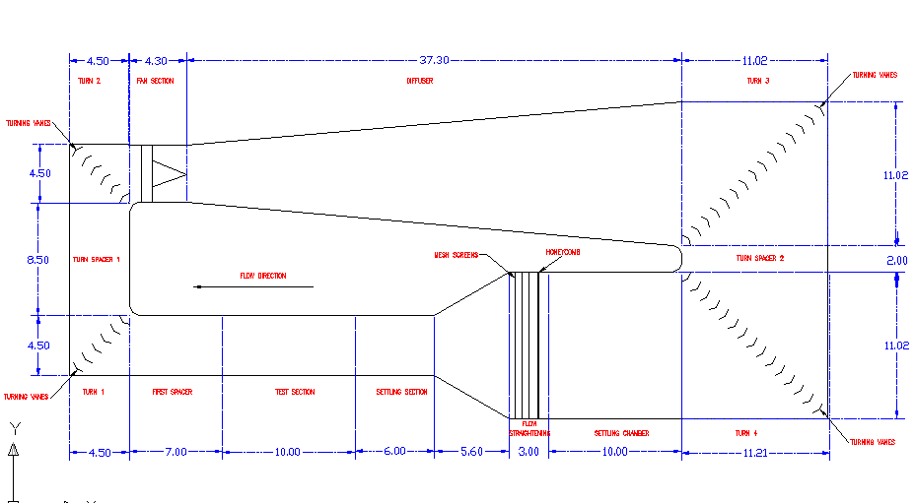
Appendix H Wind Tunnel Geometry

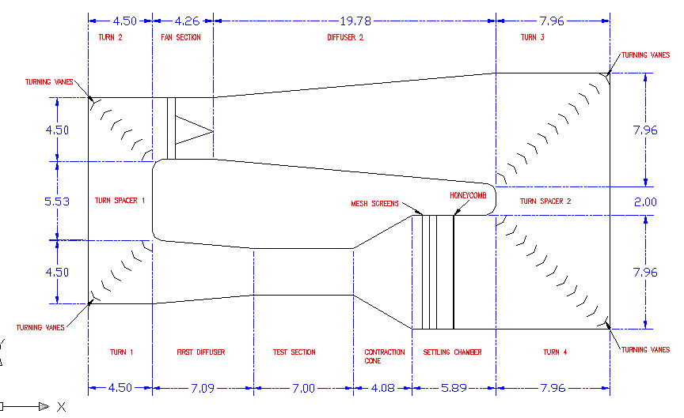
Constrained Wind Tunnel

