Table of Contents
Abstract 3
Introduction 4
Project Plan 5
Problem Description 7
Background Information 9
Properties of Diesel Exhaust 9
Diesel Engines 10
Diesel Soot Filters 12
Concept Generation 13
Idea #1: Exhaust force measurement system 13
Idea #2: Continuous Dilution Method 14
Idea #3: Temperature Monitoring 15
Idea #4: Particulate Measurement through Electrical Current Analysis 16
Idea #5: Incandescence Soot Measurement 18
Decision Matrix 19
Industry Research/Solutions 21
Horiba Instruments 21
Executive Summary 21
Product/Technology of Interest 22
Suggested Future Actions 22
Argonne National Laboratory 24
Executive Summary 24
Product/Technology of Interest 24
Suggested Future Actions 25
Company: NGK Insulators, LTD 25
Executive Summary 25
Product/Technology of Interest 26
Suggested Future Actions 29
Finalized Solution 30
Thermodynamic Background 30
Thermodynamic Project Application 31
Thermodynamic Model 32
Experimental Research Setup 33
Preliminary Experiment 33
Main Experiment 33
Experimental Research Procedure 35
Sample Data Analysis 37
Challenges 38
Conclusion to final solution 39
Conclusion 41
References 42
Appendix A…………..………………………………………………………...………..A1
Appendix B…………..………………………………………………………...………..B1

- Abstract

The project assigned to our group was to develop a sensor that is capable of measuring the amount of particle matter accumulated in a diesel particle filter. Our corporate sponsor, Cummins Inc. (represented by Mr. Roger England) specified that our measurement system had to operate while the truck was in motion, measure soot with an accuracy of + ½ gram per liter, range in diameter size from 9 inches to 13 inches, be fairly reproducible, capable of directly measuring the amount of soot in the filter, able to fit and operate on the vertical stack of a semi-truck, cost effective, durable, and able to withstand high temperatures. We focused our research on discovering previously developed ideas, as well as developing a firm understanding of diesel soot, the diesel particulate filter, and diesel engines. We then determined the best way to apply scientific principles to this research to solve our problem. After generating several concepts we decided to place our main focus on a method where we correlate exhaust system temperature measurements with the amount of soot collected in the filter. As we pursued the task allotted to us we ran into a number of problems that changed the nature of our project from a test and fabricate to a purely research project. One particular problem we ran into was that even though we had a feasible idea it had already been tested by the Cummins’ company and found not to be practical to there specific specifications. Our group discussed these developments with our sponsor, Robert England, and we came too the conclusion that our project would need to change from a test and fabricate to a purely research type. To accommodate our new transition to a purely research project we broke the project into two short term solutions and one long term solution. This would allow us to give Cummins a test bed to use for their future applications which may give them a solution to the problem they face with their diesel soot particle filter.
- Introduction

The senior design project assigned to us was to fabricate a measuring device that would measure the amount of soot that accumulates in a diesel particle filter. This is a particular problem for diesel engines because the amount of soot accumulation directly affects the regeneration process that takes place in the diesel particle filter. The regeneration process involves the burning off of this excess soot matter by the high temperatures generated from the engine output. The collected particulates are oxidized and turned into ash, which is the black matter seen spewing from the stack of a semi-truck. The problem that occurs is that once the filter becomes to full of soot matter the temperatures become so high that damage starts to occur to the cordierite material that makes up the diesel soot filter. This damage causes the output of the diesel engine to start to lag, because now with excess build up of soot matter the engine becomes backed up and exhaust build up causes the diesel engine to work harder and burn more fuel as the result of this particular problem. Now with stricter pollution laws as well as the increase in gas prices this not only becomes a problem for Cummins, but there customers as well.

Our overall task for this assignment from Cummins Inc is to develop a particular sensor device that will measure the total amount of soot matter that has accumulated in the diesel particle filter. This device will alert the driver or any person operating the vehicle that the diesel particle filter needs to be replaced before damage occurs to the filter and the efficiency starts to decrease. Now there are various complications, such as uneven soot distribution, that prevent an accurate weight evaluation to occur. Therefore, array of more unconventional and creative techniques have been devised to solve the problem.
- Project Plan

Our original project plan from the fall has been changed going into the spring semester. With this in mind we developed a new project timeline that would allow us to meet our demands, keep our deadlines, and allow us time to possibly surpass even our own expectations. With this in mind, we began our project plan by listing the Spring 2006 deadlines required by the FAMU-FSU College of Engineering Senior Design Project class. They are as follows:
- January 31: Presentation on Progress
- February 28: Mid-point Presentation
- March 14: Staff meetings
- March 21: Staff meetings
- March 28: Final project review
- April 4: Operations Manuals, Web pages, Final Reports Due
- April 6: OPEN HOUSE
- April 13: Exit interviews

Our next level of consideration was to get in contact with Mr. Roger England and report our progress, concerns and questions to him. When speaking with Mr. Roger England he stated that he wanted to take the project in a different direction. He wanted us to find industry solutions to the problem, along with a research/experimental solution. The goal of this was to keep us from getting overwhelmed with the complexity of the problem.
With this new information in mind we would setup a new schedule and deadlines that incorporated these industry solutions and a researched solution. Being highly motivated by our class deadlines and company deadlines, we decided to collect all of our ideas and construct our own personal project timeline (located on appendix page B-10). This timeline was created with the mindset that we would not work to complete our tasks right before the deadline but keep a progressive flow of work continued for the entire semester. By planning constant meetings with our sponsoring company, as well as our instructor we kept ourselves on task and focused toward the final goal of constructing a definitive, robust research report on a possible solution to our project. Even in times where our work was halted, we progressed with our timeline by directing our research to another resource, such as collaboration with the second Cummins team. The status meeting road signs we included in our timeline and our dedication to continually staying active kept us true to our path and at all times moving forward.

- Problem Description

Cummins Inc. produces their diesel filters through their Fleetguard/Nelson business division. Fleetguard/Nelson business is a leading designer and manufacturer of filters, filtration and exhaust systems for on- and off-highway applications ranging from diesel-powered equipment to small, gasoline engine applications. The specific type of filter we are targeting is known as the Fleetguard Emissions Solution diesel particulate filter (product brochure can be found on appendix page B-7). These filters are made of dense cordierite. They typically have a cell density of 300 cells per square inch with 8 mil thick walls. Alternating cells are plugged at each end of the filter, forcing the exhaust gas to pass through the cell walls. Soot that enters the filter at high velocity, from engine speeds, tends to be concentrated in the rear of the filter inlet channels. This high speed soot also exhibits higher density than the soot accumulated at idle speeds, which tends to collect on the front of the filter. The collected soot is eventually oxidized in the filter and turned to ash. The soot oxidation process can be well controlled when the amount of soot is limited, but if it exceeds specified limits, the thermal gradients will damage the filter. A soot oxidation schedule which is too frequent results in loss of fuel economy, as often the oxidation of soot requires additional fuel.

In order to circumvent this problem and provide a possible solution, the overall goal of the Cummins 1 Senior Design Team is to develop a filter sensor that will enable the operator to directly determine how much soot and other particulates are present in the filter at any given time. This can be accomplished by any reasonable means, with methods including measuring the soot flowing into the filter or measuring the amount of soot in the filter. As delineated in prior teleconferences that we had with our Cummins contact (Roger England), the following are specifications for the soot filter sensor. The needs are ranked in order of importance and criticality, with 1 being the most critical requirement.

- Accuracy of + ½ gram per liter
- Diameter ranging in size from 9 inches to 13 inches
- Fairly reproducible (in the range of 200,000 units per year)
- Capable of directly measuring or correlating to the amount of soot in the filter
- Able to take measurements while vehicle is in operation
- Able to fit and operate on the vertical stack of a semi-truck or horizontally in a pickup truck.
- Cost effective
- Durable
- Able to withstand high temperatures

- Background Information

Before any true advancement could be made in terms of solving the aforementioned problem, sufficient background research had to be conducted. The research was conducted on three specific areas:

- Properties of Diesel Exhaust
- Diesel Engines
- Diesel Soot Filters

These areas were deemed by both the Cummins 1 Senior Design Team and Cummins as areas critical to the overall understanding of the problem and subsequently development of any future concept.

Properties of Diesel Exhaust

Diesel fuel is a mixture of many different hydrocarbon molecules. The combustion, both complete and incomplete, of diesel fuel forms a complex mixture of hundreds of organic and inorganic compounds in the gas and particle phases.

- Gaseous Components of Diesel Exhaust:
        - Carbon dioxide
        - Oxygen
        - Nitrogen
        - Water vapor

- Toxicologically Relevant Gaseous Components:
- Aldehydes (formaldehyde, acetaldehyde, acrolein)
- Benzene
- 1,3-butadiene
- Polycyclic aromatic hydrocarbons (PAHs)
- Nitro-PAHs

- Particulate Component of Diesel Exhaust (Diesel Particulate Matter - DPM):
          - Elemental carbon
          - Adsorbed organic compounds
          - Small amounts of sulfate, nitrate, metals, and other trace elements

The hazards of diesel exhaust are as follows:
- The components of diesel exhaust (DE) emissions are a public concern for the following reasons:
- Emissions from diesel engines include over 40 substances that are listed by the EPA as hazardous air pollutants.
- Components of DE contain potential cancer causing substances such as arsenic, benzene, formaldehyde, nickel, and PAHs.
- The diesel particulate matter (DPM) is very small (90% are less than 1um by mass), making DPM easy to respire into the deep lung.
- DPM has hundreds of chemicals adsorbed to their surfaces, including many known or suspected carcinogens.
- There are many irritants and toxic chemicals in the gaseous phase of DE.

Diesel Engines

The first step in designing a component for an exhaust system is to collect information on the engine it will be attached to. The engine produces all emissions that will pass through our measurement system so it is crucial that we know exactly what these engines can do. Being that Cummins is a large engine producer and is responsible for multiple classes of engines in uses that range “from emergency vehicles to 18-wheelers, berry pickers to 360-ton mining haul trucks”, we have to choose a particular focus to avoid overextending ourselves. Our group has chosen to focus on the Cummins engines that belong to their “On-Highway” class. This class is broken down further into Medium Duty Trucks, Heavy Duty Trucks, Dodge Ram, Motor Homes, School Buses, Urban Buses and Shuttles, as well Fire and Emergency vehicles. The Cummins engines that service these vehicles are listed as follows:

- Cummins ISB (picture on right): 185 – 275 hp
  - Medium Duty Trucks
  - Motor Home
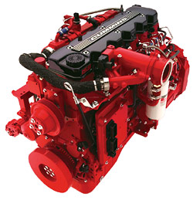
  - School Bus
  - Urban Bus & Shuttle
  - Fire & Emergency
- Cummins ISL: 310 – 350 hp
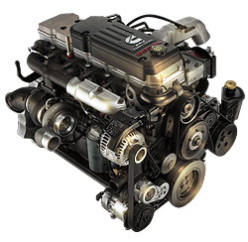
  - Medium Duty Trucks
Figure 5.1
  - Motor Home
  - Urban Bus & Shuttle
  - Fire & Emergency
- Cummins ISX: 385 – 565 hp
- Heavy Duty Trucks
- Motor Home
- Fire & Emergency
- Cummins 610 Turbo Diesel (picture on right): 325 hp
- Dodge Ram 2500/3500

Figure 5.2

Diesel Soot Filters

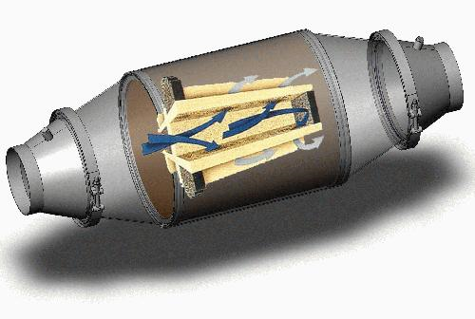

Figure 5.3

The diesel particulate filter is not complicated or even complex. The filter works on the same principle as every other filter. It is made from very adsorbent material that looks like a solid piece so as to catch the soot but with small porous holes that allow the exhaust vapors to escape through the exhaust stack. The material is usually cordierite or silicone carbide which also helps by absorbing diesel fumes. Figure 5.3 gives you a good view of what a diesel soot filter system looks like. This helps us by giving us an idea of where we might be able to place the sensor and how it will take the readings in the filter itself. The cordierite filter is basically a cylinder placed into a metal can (Actual cylinder picture can be found on appendix page B-6). Usually filter cans are made from heavy gauge steel to deal with the high exhaust temperatures being produced from the diesel engine. The filter can is clamped on by means of two clamps located on both ends of the filter, which allows for easy maintenance whenever it is necessary. Another important aspect of figure 5.3 is that it shows exactly how the soot and other particles are caught in the filter. The figure displays an enlarged representation of the operating portion of the filter. The exhaust gases (blue arrows) enter an input channel of the filter and then pass through the cordierite walls of the filter. As the gas passes through the wall it deposits the particulate matter on the filter walls and exits through the output channel (grey arrows).

- Concept Generation

In order to ultimately solve the impending problem, the following concepts were researched and evaluated. Each concept was submitted to the Cummins sponsor for review. Following are the brief expositions stating a synopsis of each concept, as well as a brief elucidation of the problems and issues associated with each problem as seen by the Cummins sponsor and the Cummins research group.

Idea #1: Exhaust force measurement system

- Concept

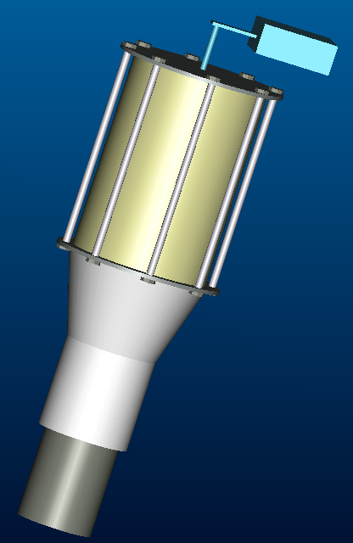
The idea behind this design is to use the exhaust flow rate to our advantage. For example at different engine rpm’s the exhaust flow rate will change. The goal is to calculate the amount of force the exhaust exerts at different engine speeds. The actual mechanism that goes onto the exhaust pipe is a simple filter with an attachment that bolts to it then slides into the exhaust pipe allowing it to slide in one direction at least a half-inch. Allowing the filter and attachment to slide allows the exhaust to push the filter, where on the other side is a device that will measure the amount of force exerted by the flow rate. Now when the filter starts to become clogged with soot the exhaust gases will create more of a force on the filter when trying to pass through it causing the filter slide more against the measuring device. The goal is to find a relation between the forces that the exhaust exerts without a filter and then with a filter and find a relation to how much soot is in the filter.

- Problems/Complications:

Apparently, this particular idea has previously been tried by Cummins to solve the problem. Using experimental data, it was determined that the velocity at which soot comes into a filter has a direct relationship with the overall affect on delta P measurements. At high velocities, the soot accumulates at the rear channels of the filter, thus having a relatively small impact on pressure changes. On the other hand, lower entrance velocities are equated with a more even distribution of soot, and thus a more significant delta P affect. Soot production is not a function of engine speed, and thus doesn’t allow for correlation of delta P measurements with soot distribution.
Figure 6.1

Idea #2: Continuous Dilution Method

            - Concept

The concept of this idea is based on a thermal fluids theory. As stated in our initial project proposal (found on appendix page B-5), the original idea for this problem was to measure the change in the back pressure using ΔP sensors in front of and behind the filter. The addition of soot to the filter would restrict the air flow through the filter and lower the back pressure, giving a measurable phenomenon to correspond with the amount of soot in the filter. Unfortunately, when the engine is at high speeds, soot comes into the filter at a quicker rate and collects at the rear of the filter. This soot also has a higher density. This disrupts the ΔP measurement. This particular concept focuses on regulating the speed of the soot entering the filter. By continuously diluting the flow of the diesel exhaust into the filter, you can almost assure all soot will be uniform and this allows for an accurate ΔP measurement.

            - Problems/Complications

Dilution as a solution was determined to pose additional problems. The amount of dilution would be based solely on the rate of soot collected in the filter, which is precisely what the ultimate goal of the project is to discover. The solution is based solely on another factor, which is also unknown, and is thus not a viable solution. Furthermore, it was discovered that dilution could pose two other possible problems. The first is that an exhaust pumping mechanism would be required for operation, resulting in lower efficiency and fuel economy. Secondly, the back-pressure of the engine could be raised, also resulting in lower fuel economy and efficiency.

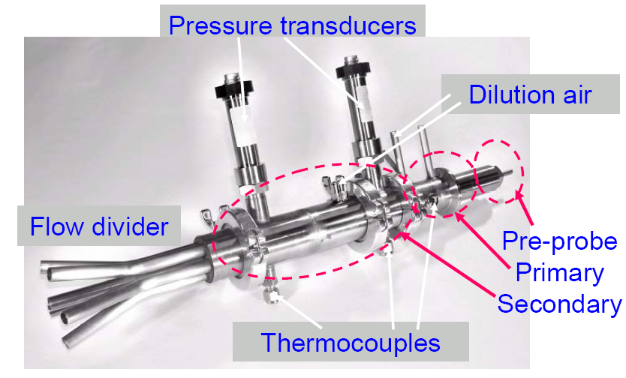

Figure 6.2

Idea #3: Temperature Monitoring

- Concept

The concept of this idea also comes from thermal fluids. Each material has a specific heat that tells how much it will heat up based on how much energy is put into it. The more material there is, the harder an object is to heat up. This concept focuses on the fact that there should be a change in the specific heat of the filter system once it begins collecting soot. The more soot on the filter, the harder it should be to heat. The concept of this idea is to measure the initial specific heat of an empty filter system as well as the specific heat of a “full” filter system. The filter collecting soot should be somewhere between this range. By monitoring the heat of the exhaust gas entering the filter system (energy added to system) and then measuring the temperature response of the filter system, we should be able to locate the position of the filter between the ranges previously mentioned. This should be a direct correlation to the amount of mass in the filter.

- Problems/Complications

Typically, thermocouples have a tendency to become less accurate and responsive when exposed to heat for long periods of time. For this reason, other types of measuring devices (RTDs) and special high-temp thermocouples were considered as possible alternatives. Also, considering the numerous factors involved (i.e. pressure drop, inconsistent mass, geometry), the system is extremely difficult to model mathematically.

Idea #4: Particulate Measurement through Electrical Current Analysis

- Concept
  - Electrical conductivity is a measure of how well a material accommodates the transport of electric charge:
- A conductor such as a metal has high conductivity.
- An insulator like glass or a vacuum has low conductivity.
- The conductivity of a semiconductor is generally intermediate, but varies widely under different conditions, such as exposure of the material to electric fields or certain frequencies of light.

Ohm’s Law can be used to describe conductivity voltage is equal to the product of the current applied and the resistance, V=I*R. The electrical conductivity () is described by the equation

Where ρ is the resisitivity.
  - By applying a constant voltage to the filter and knowing the resistance caused by the cordierite in the filter, one can determine the resulting current using the relation

with I being the resistance, V the voltage, and R the resistance. Once the filter begins to fill with soot and other particulates, the resistance caused by the filter will ultimately change as a result of the different electrical properties of the soot, specifically the charge mobility and the resistivity. This change will result in a variance of current. If the current is know that properly coincides with the filter being empty as well as full of particulates, it can then be directly determined how much sot has accumulated in the filter.

A small voltage source will need to be installed directly where the soot is to be colleted. Several outputs of electrical wiring can run from strategically placed areas within the filter. These will travel directly into an ammeter that will directly measure the current of the “electrical system” that has been created.

- Problems/Complications

Exhaust systems are typically extremely hostile due to high temperatures and unpredictable driving conditions. Using sensitive circuitry in this exhaust environment calls into question the durability of different components of the systems, including the wiring and the power supply. Furthermore, concerns were raised as to the feasibility of having the appropriate number of wires connected to the filter for accurate current measurements to take place.
Constant
Applied
Voltage
Ammeter
(Measures
Current)
Wiring
Particulates (Soot)
Cordierite
Filter
Power Supply
(Supplies Voltage)
Vehicle Stack
Exhaust

Figure 6.3: Particulate Measurement through Electrical Current Analysis

Idea #5: Incandescence Soot Measurement

- Concept
  - The concept for this particular soot sensor will involve the use of a laser. Using a laser to determine the amount soot in a diesel particle filter seems to be an outstanding idea. By using a laser to measure the amount of soot particles in a particle filter you would receive real time information that will be used in an instant. This would allow a person to change the filter without causing any kind of excess damage by late management. The information would be accurate and in detail due to assistance by the on-board computer that most vehicles have installed today.
  - The theory behind my concept is to take the measurements directly from the temperature in the diesel soot filter. The laser would heat up the soot particles by piggy backing through the filter and setting up a field that would take measurements from the heated particles. The idea will be that as the particles are being caught by the filter that the heated particles will not cause a major temperature deviation but as the filter gathers more and more soot the laser will heat up more particles. This in turn would cause a major increase in temperature because the laser is heating more and more particles. This would trigger the sensor to alert for the filter to be changed.
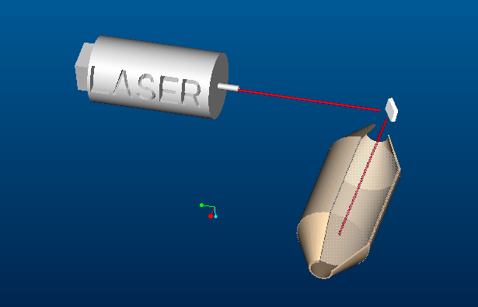
- Problems/Complications

Considering this application requires the use of a laser that is based on radioactive technology, the repairs to this apparatus could pose to be extremely complicated as well as costly. Also, the bulky setup couldn’t be reduced to a size that could reasonably suit the design specifications.
Figure 6.4

Decision Matrix:

The initial concept selection was based on a decision matrix (Figure6.4) that featured the factors that were deemed a high priority by the group and the Cummins sponsor. These factors include cost, production time, idea complexity, mass productivity, and other more “specific” factors that were relative to each idea. Figure 6.4 shows that the Cummins 1 research group determined that. Based on the predetermined factors, Concept #3, Temperature Monitoring, was the prime choice. Fortunately, this decision coincided with the evaluation done by the Cummins sponsor, who too decided that Concept #3 would be the optimal choice.

Decision Matrix:

Figure 6.4

Factor quantifying system:

1 – Very Poor

2 – Poor

3 – Average

4 – Good

5 – Excellent

Largest Total: Most reasonable idea

Concept 3 was selected to be the most possible idea using the decision matrix.
- Industry Research/Solutions

In order for Cummins to stay competitive in the diesel engine market, the company must stay well-informed on the most current technology. Therefore, the market was analyzed to determine which solutions are presently in place to solve the design problem. Data will be gathered directly from vendors and manufactures to complete this aspect of the evaluation. The industry solutions, deemed as “short term projects”, each are accompanied by an executive summary containing general information about the company as well as the concept. Further, each concept was evaluated for feasibility relative to solving the diesel soot filter problem, and suggested future actions are given as a way for Cummins to deicide which solutions might be worth further consideration.

- Horiba Instruments

  - Executive Summary

“Since its establishment in 1953, Horiba has secured its position as a key manufacturer of measuring and analytical devices and markets a vast array of sophisticated products to countries around the world. In particular, Horiba's engine emissions analyzers are contributing greatly to the development of low-emission, fuel-efficient engines being carried out by automakers worldwide. As the world's leading supplier of engine-measurement solutions, HORIBA offers products, systems, and services for...
All Types of Engines
Automotive, Off-Road, Small Utility, Truck and Bus, Aeronautic, Marine, Industrial
All Types of Applications
Engine Performance, Exhaust Emissions, Fuel Economy, Particulate Emissions, Fuel Cell Performance, Engine Tuning, And More
All Types of Testing
Research and Development, Certification, Production Monitoring, Durability, Inspection/Maintenance, Quality Testing

  - Product/Technology of Interest

After contacting representatives at Horiba and explaining the problem, the following solution was proposed:

MEXA-1370PM--Super-Low-Mass Particulate Matter Analyzer
This instrument provides separate accurate measurements of soot, SOF, sulfate, and total particulate matter in diluted engine exhaust gas through a newly-developed vaporization and oxidation/deoxidation technique in only four minutes.
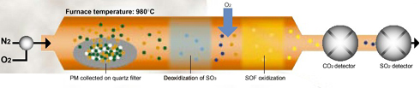
Figure: 7.1
Samples of tunnel-diluted exhaust gas are drawn through a quartz filter according to conventional procedures. From there, evaluation process is performed via the following steps:
- Filter is placed in the analyzer's furnace and heated to 980°C in a N2 gas flow.
- SOF and sulfate in trapped particles are vaporized by heat in N2 atmosphere
- Vaporized sulfate is deoxidized to SO2 by heat and measured by SO2 NDIR detector.
- Vaporized organic fraction is oxidized by constant flow of O2 and measured as CO2 by NDIR detector.
- Output of CO2 detector is integrated while N2 is flowing to determine SOF mass.
- Output of CO2 detector is integrated while O2 is flowing to determine soot mass.

Detection of masses as low as 0.2 µg is possible in only four minutes using this method.

  - Suggested Future Actions

This concept would be rather difficult to implement into the Cummins diesel system. The presented concept has two components, an analyzer unit and a data processing PC unit. The analyzer is by far the most critical piece; it is here where the vaporization, oxidation/deoxidation techniques are used. Table 7.1 shows the approximate weights and dimensions for all components of the total design. The table illustrates that the weight of the analyzer unit is approximately 200 lbs. According to AutoZone, every 200 pounds of unnecessary weight shaves one mile per gallon off the total fuel mileage.

Dimensions | W X H X D  Analyzer Unit:  690 x 577 x 803 mm  14.2 x 22.7 x 31.6 in  Data Processing PC Unit:  360 x 140 x 428 mm  14.2 x 5.5 x 16.9 in
Weight | Analyzer Unit:  Approx. 90 kg  Approx. 198.4 lb  Data Processing PC Unit:  Approx. 12 kg  Approx. 26.5 lb
Table 7.1

In addition to the reduction in fuel efficiency, the analyzer unit would occupy 10,185 square inches of space. This prevents the analyzer from being incorporated into the stack of any vehicle. Yet, the most flawed aspect of this idea is the need for a sample of the filter to be physically placed into the analyzer unit. This essentially means that real time measurements can’t be taken while the vehicle is in motion, unless a system was devised to remove a small portion of the filter and transport into the analyzer unit. Even then, by removing a piece of the filter, you degrade the overall integrity of the filtering system by allowing more particulates to escape through the exhaust.
The Cummins research group came to the conclusion that the best course of action would be to work cooperatively with Horiba to develop new technology that would better suite the needs of the Cummins Diesel Soot Filter project. When presented with this idea, representative from Horiba had this response:

- Argonne National Laboratory

  - Executive Summary
Argonne is developing technologies to help make advanced vehicles a reality. The laboratory's Transportation Technology R&D Center brings together scientists and engineers from many disciplines to find cost-effective solutions to the problems of transporting people and goods from one place to another -- issues like vehicle emissions and energy supply.
Argonne has been conducting transportation research for three decades. The laboratory's main sponsor for this research is the U.S. Department of Energy, but Argonne also works with U.S. manufacturers on a wide range of transportation technologies.
  - Product/Technology of Interest
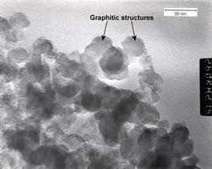
Researchers at Argonne have created a special thermophoretic sampling device to gain a better understanding of the nature of diesel PM. A process known as thermophoretic force causes particles to move from the high temperature to a low temperature range as they move across a temperature spectrum. Thermophoretic sampling works by collecting PM as it moves across the temperature spectrum. Since this method requires no dilution/treatment of the emissions stream before sampling, making it an exceptional idea in which to study the true nature of the PM being collected.
Presently, high-resolution transmission electron microscope (TEM) equipped with photographic and data recording capabilities are being used by Argonne scientists to capture information about PM found in the emissions obtained with the thermophoretic sampler (see Fig 7.2.). With this technology, the sizes of agglomerated particles, the oxidation degree shown by the particles, individual particle sizes and the number of graphitic structures within the agglomerated PM.
Figure: 7.2
  - Suggested Future Actions
Numerous attempts were made in effort to contact representatives at Argonne’s Transportation Technology R&D Department in hopes of obtaining more information relative to solving the issue of directly measuring soot in diesel filter, but all attempts were unsuccessful. It is know that with the aforementioned technology, the sizes of agglomerated particles, the oxidation degree shown by the particles, individual particle sizes and the number of graphitic structures within the agglomerated PM can all be further examined. This information may prove vital in order to make significant progress in conducting real-time soot measurements.
Also, Argonne is making strides in the following fields:
- Investigating the effects of engine rpm and load on particulate formation and oxidation
- Examining the internal microstructure of diesel particulates, and
- Exploring the impact fuel properties (such as sulfur content) have on the size, shape, and content of diesel particulate matter.
With this in mind, the Cummins Research Group recommends that further attempts are made to contact representatives at Argonne in hopes that an open dialogue can be initiated and resolution can eventually be reached.

- Company: NGK Insulators, LTD
  - Executive Summary
“By promoting material research and developing production technologies, which expand the potential applications of fine ceramics, NGK continues to supply state-of-the-art products in all types of business fields as well as to explore and develop the potential uses of fine ceramics. This includes the area of diesel particulate filters (DPFs), which eliminate particulate in the exhaust gas emitted from diesel automobiles. The system which applies DPF has been examined for urban buses and other possibilities.”
  - Product/Technology of Interest

Pressure Drop of Segmented Diesel Particulate Filter

This idea uses the flow resistance of a segmented Diesel particulate filter. Filter flow resistance is expected to remain below a certain limit as to minimize the adverse effect of exhaust flow blockage, due to the continuous particulate filtration and deposition build-up in the filter on the Diesel engine.

Both Cordierite and Silicon Carbide filters perform the action of particulate filtration via passing the engine exhaust gas though their filtration walls typically a fraction of a millimeter thick. Flow passage through the filtration walls generates a fair amount of resistance to the flow, which is a non-negligible component of the total filter pressure drop.

The difference between the magnitudes of the flow resistance of a monolithic vs. a segmented filter due to the flow through the filtration walls: given two identical monolithic and segmented filters, the segmented filter holds lower filtration wall area, resulting in a higher flow resistance that the Cordierite filter does.
Figure 7.3: A monolithic (Cordierite) filter left vs. a segmented
(silicon Carbide) filter composed of 16 individual segments.

Existing models for pressure drop of wall-flow filters have mostly targeted monolithic filters. Some have been demonstrated to yield notable accuracy when tested under a wide range of practical conditions. However it is possible to use identically the pressure drop model of a monolithic wall-flow filter for a segmented one as long as the two primary filter variables influenced by the segmentation, filter filtration wall area and open frontal area, are represented adequately in the model. In practice it is more advantageous to have a single model that would adjust filter parameters accordingly depending on the filter type.

Filtration walls form the core elements of the filter structure where the actual filtration of particulate takes place. In a monolithic filter, total filtration area is simply the sum of individual filtration areas of inlet channels. Now in a segmented filter some of the inlet channels use all four sides of their filtration walls while some other channels could only use three of their side filtration walls even though they structurally posses four; these latter are the channels that are adjacent to the cement attaching neighboring segments of the filter.
Figure 7.4: Inlet channels of a segmented Silicon Carbide filter.
As far as filter flow resistance is concerned, a segmented design has two primary effects on the filter response: given a filter volume, segmentation reduces the net filtration wall area of the filter; it also slightly reduces the filter open frontal area. Both effects cause an increase in the filter pressure drop. At first, a reduction of 15% in the filtration wall area might appear negligible; however, a close scrutiny reveals that the consequence on the filter pressure drop is certainly non-negligible. This substantial drop can be seen in figure 7.5.
Figure 7.5: Pressure drop of a segmented filter (dashed line) vs. a monolithic filter.

Segmented and monolithic filters differ in their flow resistance, commonly known as pressure drop. In this work, an existing, validated pressure drop model for monolithic filter has been customized for a segmented filter. Model predictions have been compared to experimentally-collected data, demonstrating the model accuracy.

  - Suggested Future Actions

Depending on what information the Cummins research group will receive from NGK who have been contacted numerous times this type of solution may or may not be acceptable for Cummins. If and when the information requested is received, the goal will be to decipher the calculations and variable so that the mathematical model can be altered to fit the problem. Once that is achieved theoretical calculations will be done to see if the same results are achieved. If the outcome is excellent then an experimental test can be preformed on an actual diesel engine.

- Finalized Solution: The Filter Heat-Soot Correlation Method

Thermodynamic Background

In order to devise a solution to this problem it was necessary for the R&D (Research and Development) team to utilize a strong knowledge of thermodynamics. For this particular project, it was necessary to have a sound background in thermodynamic modeling of a heat exchanger system. One of the basic principles of Thermal-Fluid Sciences is the definition of a system. A system is defined as a quantity of matter or a region of space chosen for study. Many engineering problems involve simplifying a particular area or object into a basic thermal system. In an engineering analysis, the system under study must be defined carefully. The system is then measured and analyzed to find out what its particular characteristics (or properties) are: such as pressure, temperature, or volume. Then, as the system is altered due to internal or external influences, the properties of the system are monitored in order to obtain the desired information.
In the case of this particular project, the desired information is the gain in mass of a system due to a flow of gases passing through the system. The exhaust gases pass through the diesel particulate filter depositing diesel particulate matter (soot) and heat. As these items are added to the system, the volume remains the same but various properties of the system change (such as the weight, total density, etc.). It is the belief of the Cummins Research Group that the best correlation to the mass gain of the filter is the thermal conductivity of the system.
The thermal conductivity of a system is a measure of the ability of the system to conduct heat. The thermal conductivity of matter (materials, systems, etc.) changes as the matter is altered. Particularly, as the mass of a system increases, the ability of the system to conduct heat will increase. The energy required to raise the temperature of the system by one degree will decrease. This is the foundation of the Filter Heat-Soot Correlation Method.

Thermodynamic Project Application

Upon conversing with Dr. Chiang Shih and Dr. Juan Ordonez of the FAMU-FSU College of Engineering Staff, it was decided to model the Diesel Particulate Filter as a thermal heat exchanger system. A thermal heat exchanger is a device that facilitates the exchange of heat between two substances. In reference to this project, the heat is being exchanged from the exhaust gases to the filter. The diesel filter was modeled as a constant volume open system. The boundaries of the system were defined as the control volume enclosed by the outer surface of the filter. The flow of exhaust gases passes through the filter control volume adding heat and depositing diesel particulate matter. The indirect result of the mass increase of the system is that the system attains a lower overall specific heat capacity (referring to both the filter and the soot). Specific heat capacity is the amount of energy required to raise the temperature of one unit mass of a substance by one degree. Though the engine may be passing exhaust gas through the filter with the same energy as before, the filter will get hotter due to the soot deposited on its internal walls.
The key to measuring the amount of soot in the filter is to monitor the change in specific heat capacity of the overall system. A filter with no soot will have a specific heat capacity of roughly 0.35 cal/g-ºC (which is the approximate specific heat capacity of cordierite). When the filter is “full” of soot (amount of soot specified by Cummins operational limits), it will have a lower overall specific heat capacity. The specific heat capacity of diesel soot needs to be determined by experimentation for a detailed analysis of the filter system. Between being “empty” and “full”, the overall specific heat capacity will change as a direct result of the increase of diesel soot mass in the filter system. Through experimentation and correlation tests, it should be possible to program a computer to estimate the amount of diesel soot in a filter based on the measured overall specific heat capacity of the system.
The specific heat capacity of the system is a measure of how much the temperature of the system changes as a result of the amount of energy placed in it. The temperature of a given body of matter is a good estimate of the amount of energy it possesses. The energy content of a gas flow can be roughly approximated by a temperature measurement of the gas. This is a calorimetric analysis. Therefore, the energy deposited into the filter can be determined by a temperature measurement of the exhaust gas before it passes through the filter and a temperature measurement of the gas after it passes through the filter. Once the added energy is know, it is only a matter of determining the resulting temperature response of the system to find the specific heat of the overall system.
This method of specific heat monitoring should provide a solution to the project problem at hand. Through experimentation, this theory and process can be refined to the point where it can become even more accurate. This meets the requirements of the problem as well as provides opportunities for further research in order to make the product even better.

Thermodynamic Model

The thermodynamic model of this system is based on the concept of a thermal heat exchanger. Though the filter has many channels, it was decided to initially make the model of the system as simple as possible in order to obtain clearer measurements. In order to achieve this, the thermodynamic model of the system was simplified into a simple hollow cylinder open on both ends that was made of cordierite with identical mass to the actual filter. The exhaust gases pass through the center of the cylinder and deposit particulate matter on the inner surface of the cylinder. The gases also transmit heat to the cylinder. This simple model is an accurate reflection of the actual Diesel Particulate Filter system. Following is a diagram of the model.

Figure 8.1: The yellow cylinder represents the filter. The red arrow represents the exhaust gases. The dark grey interior represents the diesel soot being deposited on the walls of the filter.
Experimental Research Setup

Preliminary Experiment
The preliminary experiments consist of finding properties of materials that are helpful to the operation of the main experiment. These properties are: the specific heat capacity of diesel soot (specifically the kind of soot expected from Cummins engines); and the specific heat capacity of the Diesel Particulate Filter that Cummins utilizes. The diesel soot specific heat capacity may be listed in various scientific journals or Society of Automotive Engineers (SAE) reports. The other more company specific property values can be found through simple experiments involving measuring the temperature response of the substance in the presence of an energy (heat) stream. Once these values are obtained, it will be possible to proceed with the main experimental research.

Main Experiment
A decent deal of extensive experimental research needs to be performed in order to change this suggestion from a theory to a concrete solution. The experimental test setup should include a filter (in can) hooked up to a controlled simulated exhaust system. Temperature measurement devices should be placed directly upstream and downstream of the filter in the exhaust system. Temperature measurement devices should also be placed on the interior as well as the exterior of the filter. The temperature measurement devices should be placed in a grid setup around and inside the filter so as to attain longitudinal and latitudinal temperature measurements. This should account for geometry based heating of the filter. Following is a sample diagram of a simplified filter (no channels) with a possible grid setup for temperature measurement device locations. The web circular grid on the front surface of the cylinder should be duplicated more than once moving lengthwise down the filter.
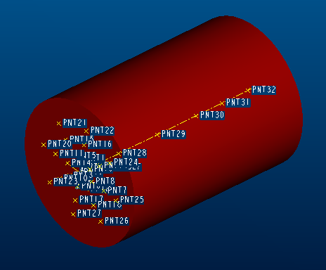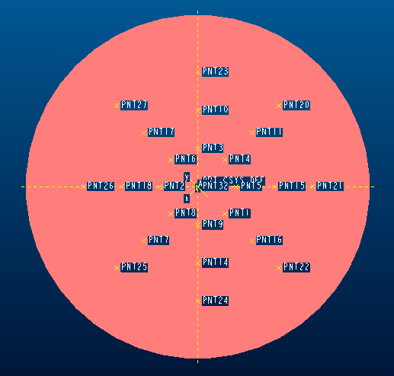
Figure 8.2
The filter temperature data should be weighted and averaged based on the importance of the measurement location on or in the filter. This should give an accurate overall thermal model of the filter.
The first experimental phase consists of passing a soot-free heat stream of gas through the filter. The temperature data should give a good idea of the thermal response (specific heat capacity) of an “empty” filter.
The next phase consists of gradually loading the filter with soot by passing a stream of exhaust gases through the filter. This stream of exhaust gases should closely approximate the normal operation of the vehicle that the filter will be placed on. The temperature measurement devices should be constantly monitored to observe the overall specific heat change of the system. After set time intervals, the filter should be removed from the exhaust system and measured to find out the amount of diesel soot that has accumulated in the filter. The set time interval should be based on assumed time needed to accumulate a significant amount of soot. The shorter the interval of time, the more data will be available for the correlation study. This will make the final system capable of monitoring smaller amounts of soot. The filter soot measurement can be performed using a weight comparison between the original weight of the filter and the weight following engine operation (soot loading). There are also previously mentioned soot measurement methods that were discarded because they were too complicated for utilization during truck operation. These can be utilized in the experimental research at this step to get an accurate determination of the soot content of the filter. Once the soot content of the filter has been determined, the filter should be placed back into the exhaust system and the cycle restarted. This cycle of loading soot and removing to measure soot (while monitoring temperature) should be repeated until the filter is deemed “full” of soot.
The final phase is the analysis of the temperature response data. Each overall system specific heat value should be correlated with a measurement of how much soot mass is in the system. This should result in a chart correlating real time temperature measurements with the amount of soot content in the system, thus solving the project problem.

Experimental Research Procedure

Introduction: The following procedure is a suggestion of methods for which to proceed with the experimental determination of data to be used with the specific heat monitoring method.
- Assemble Test Equipment
  - Phase I Setup
    - Create controlled environment for placing filter into soot-free heat stream, such as a wind tunnel or simulated exhaust system with heat gun replacing actual engine.
    - Assemble test supports that allow filter to be placed in path of heat stream with stream passing through filter channels and not over surface.
  - Phase II Setup
    - Create a simulated diesel exhaust system with an actual engine. Controls should be set up so that the engine operation will closely approximate that of a vehicle in expected usage. The engines exhaust should pass through an exhaust system with pipes leading to test supports for diesel particulate filter. MAKE SURE EXHAUST SYSTEM IS IN WELL VENTILATED AREA OR EXHAUST GASES LEAVING THE FILTER ARE PUMPED TO A LOCATION FOR SAFE DISSIPATION.
    - Assemble test supports that allow filter to be placed in path of exhaust gases so that gases pass through filter channels and not over surface. This setup should be almost identical to the placement of the filter in the “can” for the standard Cummins exhaust system setup. The test supports should allow for the filter to be removed and inserted back into the exhaust system without significant disruption to the operation of the exhaust system. This removal and re-insertion will be performed while the engine is off.
- Assemble Temperature Monitoring Equipment
  - The standard method of experimental temperature method, as indicated by Cummins is the usage of K-thermocouples.
    - Flow Energy Measurement: Thermocouples should be placed directly upstream and directly downstream of the test supports for the filter. The data resulting from these thermocouples should be fed directly into a computer data management program (such as National Instruments LabVIEW) for calorimetry usage.
    - Temperature Response Measurement: Thermocouples should be placed in a grid setup around and inside the filter. The data resulting from these thermocouples should be fed directly into a computer data management program (such as National Instruments LabVIEW) for specific heat determination usage.
- Prepare Mass Measurement Equipment
  - Depending on the method used for filter soot content mass measurement, this equipment can be as simple a weight scale or as complicated as one of the methods previously mentioned in the report.
- Phase I Experimental Procedure
  - Position thermocouples upstream and downstream of test supports.
  - Position thermocouples at specified locations on filter.
  - Place filter into test supports and secure it in place.
  - Activate thermocouples and computer data management program.
  - Turn on heat flow source (heat gun or wind tunnel).
  - Record thermal response data of filter to incoming energy.
  - When enough data is obtained to make specific heat calculation turn off the heat flow and temperature monitors.
- Phase II Experimental Procedure
  - Position thermocouples upstream and downstream of test supports.
  - Position thermocouples at specified locations on filter.
  - Place filter into test supports and secure it in place.
  - Activate thermocouples and computer data management program.
  - Turn on exhaust gases source (engine).
  - Record thermal response data of filter to incoming energy.
  - After set interval of time, turn off engine source and remove filter.
  - Measure amount of soot in filter.
  - Place filter back into test supports and secure it in place.
  - Go back to Step 5 and repeat this cycle until filter is considered “full” (according to Cummins specifications).

Sample Data Analysis

Phase I Data: The data obtained from Phase I can be split into flow energy data (temperature measurements upstream and downstream of filter) and temperature response data (filter temperature measurements). Using calorimetry, it is possible to determine the amount of energy deposited in the filter using just the upstream and downstream measurements. Once weighted and averaged, the filter temperature data should give an accurate overall thermal model of the filter. The temperature response data and flow energy data can then be placed into the specific heat formula to determine the overall specific heat of the filter system.
Phase II Data: The data obtained from Phase II can be split into flow energy data, filter temperature response data, and soot mass measurement data. Using calorimetry, it is possible to determine the amount of energy deposited in the filter using just the upstream and downstream measurements. The filter temperature data should give an accurate overall thermal model of the filter. The temperature response data and flow energy data can then be placed into the specific heat formula to determine the overall specific heat of the filter system for each given time interval. Each specific heat should then be correlated with the mass measurement data for that time interval.
This correlation of specific heat and filter soot content is what will be used to build the Filter Heat-Soot Model for real time measurements. In actual truck operation, the thermocouples will be placed in the same locations as the experimental research. The on-board computer should be able to use the same experimental method to determine the specific heat of the filter system at any given time. Once this specific heat is found, the computer will place it into the previously obtained Filter Heat-Soot Model to determine the correlating amount of diesel soot in the filter.

Challenges

There are various challenges associated with this method. An ideal exhaust system setup would allow for formula modeling of the system. The temperature data could be input directly into the formula and there would be no need to establish a correlation model. Unfortunately, there are various factors that complicate the situation: pressure change, longitudinal and latitudinal temperature discrepancies, varied soot densities, changing mass, etc. These factors add many more terms and formulas to the thermodynamic model. Over an extended period of time, it may be possible to develop an extensive thermodynamic model for the filter system, but currently it is unfeasible. These various factors also affect the current solution, but replicating them during the research phase (simulated diesel exhaust system) should result in the Filter Heat-Soot Model being robust enough to account for them.
Another crucial challenge is the implementation of this conceptual method into actual usage. The key problem is temperature measurement. While the K-Thermocouples are adequate for experimental research, they will not last if used in actual vehicle operation. They become inaccurate after prolonged exposure to a high heat environment. The solution to this problem was discovered through extensive research.
Stabilized Type K Reduced Drift Thermocouples: This project requires a temperature measuring device able to withstand the extreme temperatures found in the diesel particulate filter, as well as endure the harsh conditions associated with actual vehicle usage. Past experiences suggested the usage of the standard temperature measuring devices, such as RTDs, thermocouples, thermistors, and infrared sensors. Thermocouples are the best temperature measurement device for the task due to a large selection variety, economical price, and Cummins familiarity (they are currently used for Cummins laboratory experiments). Unfortunately, all thermocouples have the fault of not being reliable over long periods of exposure to high heat environments. For short exposures to temperatures of 1000۫ F (538۫ C) the Type K thermocouple is the preferred thermocouple. The problem that occurs with the Type K thermocouple is that once it is exposed to temperatures of 1000۫ F (538۫ C) and above it begins to experience drift. Drift within a thermocouple is a product of long term exposure to intense heat which damages the thermocouple wire and causes the readings to fluctuate from 6F (3C) at 1,000F (538C) and as much as 9F (5C) at 2,000F (1093C). The solution to this problem is an altered Type K Thermocouple.
The suggested device for vehicle operation is known as a Stabilized Type K Reduced Drift Thermocouple Wire. This product was located on the TE Wire & Cable website (www.tewire.com/9-21.html). The Stabilized Type K Thermocouple has an innovative fabrication process. In order to correct the problem of drift, special treatments along with the heat treatment are used to secure the heat calibration which is needed to give accurate readings at 1000۫ F (538۫ C) and above. In order to further stabilize the Type K Thermocouples, the tips are coated in platinum and the sheath used to cover the thermocouple wire is constructed with heavy duty heat resistance materials. These new thermocouples meet all requirements needed for implementation into an actual vehicle exhaust system.

Conclusion to final solution

The Filter Heat-Soot Correlation method is a robust research proposal and eventual solution to the problem proposed by Cummins. The method is rooted in a strong thermodynamic background with well established concepts. The simplified thermodynamic model provides an accurate representation model of the diesel particulate filter system. These all contribute to the construction of a thorough experimental research plan. If the experiment is performed correctly, the data should provide a correlation model giving a direct relationship between the measured specific heat of the filter system and the diesel content of the filter system. By placing this correlation model into the on-board vehicle computer system and using Stabilized Type K Reduced Drift Thermocouple Wire to attain real-time temperature measurements, the Filter Heat-Soot Correlation method should solve the Cummins soot measurement problem.
- Conclusion

The Cummins I Senior Design Team has taken what was once an abstract idea, and has laid the groundwork for the successful overall development of a test bed that will later give the final solution to the diesel soot measurement device. The problem was defined by our sponsor, and sufficient background research was conducted on diesel soot filters, properties of diesel exhaust, and diesel engines in order to gain a better understanding of the problem at hand. The specifications determined by the sponsor and the group have been integrated into a lengthy but concise list. Brainstorming on possible solutions for the problem were evaluated, with each idea being evaluated for overall feasibility. Even though some particular problems did occur in project, which forced us to change the overall focus of the project from a test and fabricate to one of purely research. We still managed to accomplish our new assigned goals of giving the Cummins company two short term solutions and one final solution. The two short term solutions will allow the Cummins Company to use available research and technology to test and see if this answer to their problem and the long term solution will allow for an extensive testing that will be adaptable to the pace required for Cummins Company to come up with a workable solution. This proposed solutions, whether they be short term or long term will allow for an actual application that will give the Cummins company an answer to their problem.

X. References

Masoudi, Mansour. (2005). Pressure Drop of Segmented Diesel Particulate Filters. SAE100: SAE Technical Paper Series, 2005-01-0971

Nakamura, Shigeo. The Development of PM Measurement Systems at Horiba. 17-21.

www1.umn.edu/eoh/hazards/hazardssite/dieselexhaust/dieselcharacter.html

www.warddiesel.com/specs.asp

www.eere.energy.gov/vehiclesandfuels/pdfs/deer_2004/session12/2004_deer_kittleson2.pdf

www.ncbi.nlm.nih.gov/entrez/query.fcgi?cmd=Retrieve&db=PubMed&list_uids=12733029&dopt=Abstract

www.atmosphericglow.com/applications/B3C8D1_diesel_soot2.htm

www.cummins.com

www.edie.net/Library/TechnologyDB/view_entry.asp?ID=1602

en.wikipedia.org/wiki/Soot

www.thefreedictionary.com/soot

www.matter-engineering.com/products/pas2000.html

www.lav.ethz.ch/research/projects/actual_projects/Experimentals/kistler_pryrometry

powerlab.mech.okayama-u.ac.jp/~esd/comodia2001/3-19.pdf

www.ca.sandia.gov/pmc/pdfs/IEA.2003.Annual.pdf

powerlab.mech.okayama-u.ac.jp/~esd/comodia2004/B6_1_005.pdf

www.ca.sandia.gov/pmc/pdfs/COMODIASootEmissionsPaper.pdf

www.anl.gov/

www.wikipedia.com

www.ngk.co.jp/english/

www.horiba.com

http://www.osti.gov/bridge/purl.cover.jsp?purl=/759070-JnTbA1/webviewable/

http://www.iop.org/EJ/abstract/0957-0233/10/8/401/

http://www.wipo.int/ipdl/IPDL-CIMAGES/view/pct/getbykey5?KEY=05/16497.050224&ELEMENT_SET=DECL

http://www.cambustion.co.uk/applications/dms500/dms05v01%20DPF%20measurement.pdf#search='diesel%20particulate%20filter%20measurement'

