Table of Contents
I.
Abstract 2
II. Introduction 3
III. Project Plan 4
IV. Problem Description 6
V. Background Information 8
Properties of Diesel Exhaust 8
Diesel Engines 10
Diesel Soot Filters 11
VI. Concept Generation 13
Concept Generation 13
Idea #1: Exhaust force measurement system 13
Idea #2: Continuous Dilution Method 14
Idea #3: Temperature Monitoring 16
Idea #4: Particulate Measurement through Electrical Current Analysis 17
Idea #5: Incandescence Soot Measurement 20
Concept Selection 21
Decision Matrix 21
VII. Proposed Solution 22
The Temperature Measurement Method 22
VIII. Spring Proposal 28
Short Term Ideas 28
Idea #1: Flame Ionization Detection Method 28
Idea #2: Pressure Drop of Segmented Diesel Particulate Filter 30
Long Term Solution (Research Proposal) 33
IX. Conclusion 34
X. References 35
XI. Appendix…..………………………………………………………………………...A1


- Abstract

The project assigned to our group was to develop a sensor that is capable of measuring the amount of particle matter accumulated in a diesel particle filter. Our corporate sponsor, Cummins Inc. (represented by Mr. Roger England) specified that our measurement system had to operate while the truck was in motion, measure soot with an accuracy of + ½ gram per liter, range in diameter size from 9 inches to 13 inches, be fairly reproducible, capable of directly measuring the amount of soot in the filter, able to fit and operate on the vertical stack of a semi-truck, cost effective, durable, and able to withstand high temperatures. We focused our research on discovering previously developed ideas, as well as developing a firm understanding of diesel soot, the diesel particulate filter, and diesel engines. We then determined the best way to apply scientific principles to this research to solve our problem. After generating several concepts we decided to place our main focus on a method where we correlate exhaust system temperature measurements with the amount of soot collected in the filter. This concept is based on the theory that the heat capacity of the filter system will increase proportionally with the soot collected. With the calculations we collected and the research we performed we feel that we are fully prepared to design and operate an experiment to optimize the performance of our Temperature Measurement Method solution to our Cummins Inc. proposed problem. While performing our long term Temperature Measurement Method research, our sponsor has suggested that we collect short term solution methods as well. With our knowledge and skills we hope to find a solution to the problem assigned to us and fully satisfy all of our requirements.

- Introduction

Diesel engines are known for their compression ratios, which directly result in high engine efficiencies. Yet, one issue that has plagued both the designers and users of diesel engines for large-vehicle applications is the “doubled-edge sword” that is regeneration. As soot and other particulates collect in the filters of the diesel engines, the regeneration process occurs, meaning that the collected particulates are oxidized and turned into ash. While this process serves to effectively clean the filter, the regeneration process typically requires supplementary fuel, thus designating that a frequent regeneration schedule would ultimately result in a loss of fuel economy. Furthermore, the regeneration process is only easily regulated up until a specified amount of particulates are collected in the filter. Once this amount is exceeded, the temperatures that are required to successfully complete the oxidization process become too extreme, thus damaging the filter and reducing its overall life efficiency.

In order to rectify this issue, global power leader Cummins Inc. has commissioned the Cummins 1 Senior Design Team at the FAMU/FSU School of Engineering to develop a method that will allow for direct measure of the amount of soot and other particulates that are present in the filter of a diesel engine. Various complications, such as uneven soot distribution, prevent an accurate weight evaluation to occur. Therefore, arrays of more unconventional and creative techniques have been devised to solve the problem.

- Project Plan

A solid plan (whether it be for a business or a project) is the first crucial step in efficiently achieving goals. In our particular case, we needed to develop a realistic secure project timeline that would allow us to meet our demands, keep our deadlines, and allow us time to possibly surpass even our own expectations. With this in mind, we began our project plan by listing the Fall 2005 deadlines required by the FAMU-FSU College of Engineering Senior Design Project class. They are as follows:

- September 8: Project Kick-Off
- September 29: Needs Assessment Report & Project Scope Completed
- October 6: Product Specification & Project Procedures/Project Plan Completed
- October 11: Conceptual Design Review
- October 20: Concept Generation and Selection Completed
- November 9: Interim Design Review
- December 6: Final Design Package & Spring Proposals Completed
- December 8: Final Design Review

Our next level of consideration was for our customer: Cummins Inc. The company was directly represented to us by Mr. Roger England. We had our first teleconference with him on September 16, in which he expressed his demands, specifications, and expectations for our progress. Instead of a rigid timeline with dates and deadline, he preferred to approximate allotted time periods for tasks as we developed our research and theories. His first expectation was for us to take roughly two to three weeks to research Diesel Soot so that we would be equipped to generate a concept to measure it based on its properties. The rest of his expectations progressed as the project developed.

Being highly motivated by our class deadlines and company deadlines, we decided to collect all of our ideas and construct our own personal project timeline (located on appendix page A-5). This timeline was created with the mindset that we would not work to complete our tasks right before the deadline but keep a progressive flow of work continued for the entire semester. By planning constant meetings with our sponsoring company, as well as our instructor we kept ourselves on task and focused toward the final goal of constructing a definitive, robust research report on a possible solution to our project. Even in times where our work was halted, we progressed with our timeline by directing our research to another resource, such as collaboration with the Cummins 2 Senior Design Team. The status meeting road signs we included in our timeline and our dedication to continually staying active kept us true to our path and at all times moving forward.

- Problem Description

Cummins Inc. produces their diesel filters through their Fleetguard/Nelson business division. Fleetguard/Nelson business is a leading designer and manufacturer of filters, filtration and exhaust systems for on- and off-highway applications ranging from diesel-powered equipment to small, gasoline engine applications. The specific type of filter we are targeting is known as the Fleetguard Emissions Solution diesel particulate filter (product brochure can be found on appendix page A-9). These filters are made of dense cordierite. They typically have a cell density of 300 cells per square inch with 8 mil thick walls. Alternating cells are plugged at each end of the filter, forcing the exhaust gas to pass through the cell walls. Soot that enters the filter at high velocity, from engine speeds, tends to be concentrated in the rear of the filter inlet channels. This high speed soot also exhibits higher density than the soot accumulated at idle speeds, which tends to collect on the front of the filter. The collected soot is eventually oxidized in the filter and turned to ash. The soot oxidation process can be well controlled when the amount of soot is limited, but if it exceeds specified limits, the thermal gradients will damage the filter. A soot oxidation schedule which is too frequent results in loss of fuel economy, as often the oxidation of soot requires additional fuel.

In order to circumvent this problem and provide a possible solution, the overall goal of the Cummins 1 Senior Design Team is to develop a filter sensor that will enable the operator to directly determine how much soot and other particulates are present in the filter at any given time. This can be accomplished by any reasonable means, with methods including measuring the soot flowing into the filter or measuring the amount of soot in the filter. As delineated in prior teleconferences that we had with our Cummins contact (Roger England), the following are specifications for the soot filter sensor. The needs are ranked in order of importance and criticality, with 1 being the most critical requirement.

- Accuracy of + ½ gram per liter
- Diameter ranging in size from 9 inches to 13 inches
- Fairly reproducible (in the range of 200,000 units per year)
- Capable of directly measuring the amount of soot in the filter
- Able to take measurements while vehicle is in operation
- Able to fit and operate on the vertical stack of a semi-truck
- Cost effective
- Durable
- Able to withstand high temperatures

- Background Information

Before any true advancement could be made in terms of solving the aforementioned problem, sufficient background research had to be conducted. The research was conducted on three specific areas:

- Properties of Diesel Exhaust
- Diesel Engines
- Diesel Soot Filters

These areas were deemed by both the Cummins 1 Senior Design Team and Cummins as areas critical to the overall understanding of the problem and subsequently development of any future concept.

Properties of Diesel Exhaust:

Diesel fuel is a mixture of many different hydrocarbon molecules. The combustion, both complete and incomplete, of diesel fuel forms a complex mixture of hundreds of organic and inorganic compounds in the gas and particle phases.

- Gaseous Components of Diesel Exhaust:
        - Carbon dioxide
        - Oxygen
        - Nitrogen
        - Water vapor
        - Carbon monoxide
        - Nitrogen compounds
        - Sulfur compounds
        - Low-molecular-weight hydrocarbons

- Toxicologically Relevant Gaseous Components:
        - Aldehydes (formaldehyde, acetaldehyde, acrolein)
        - Benzene
        - 1,3-butadiene
        - Polycyclic aromatic hydrocarbons (PAHs)
        - Nitro-PAHs

- Particulate Component of Diesel Exhaust (Diesel Particulate Matter - DPM):
        - Elemental carbon
        - Adsorbed organic compounds
        - Small amounts of sulfate, nitrate, metals, and other trace elements

The hazards of diesel exhaust are as follows:
- The components of diesel exhaust (DE) emissions are a public concern for the following reasons:
- Emissions from diesel engines include over 40 substances that are listed by the EPA as hazardous air pollutants.
- Components of DE contain potential cancer causing substances such as arsenic, benzene, formaldehyde, nickel, and PAHs.
- The diesel particulate matter (DPM) is very small (90% are less than 1um by mass), making DPM easy to respire into the deep lung.
- DPM has hundreds of chemicals adsorbed to their surfaces, including many known or suspected carcinogens.
- There are many irritants and toxic chemicals in the gaseous phase of DE.
- Oxides of nitrogen, component of urban smog, are in the gaseous phase of DE.
- There is likelihood that people in both ambient and occupational settings can be exposed to DE.
- DE has the potential to cause adverse health effects including cancer, pulmonary and cardiovascular diseases.
- Studies show workers exposed to higher levels of DE are more likely to develop lung cancer.
- In 1990, the state of California identified DE as a chemical known to cause cancer.
- The International Agency for Research on Cancer has concluded that DE probably causes cancer in humans.
- The EPA has proposed classifying DE as a probable human carcinogen.

Diesel Engines:

The first step in designing a component for an exhaust system is to collect information on the engine it will be attached to. The engine produces all emissions that will pass through our measurement system so it is crucial that we know exactly what these engines can do. Being that Cummins is a large engine producer and is responsible for multiple classes of engines in uses that range “from emergency vehicles to 18-wheelers, berry pickers to 360-ton mining haul trucks”, we have to choose a particular focus to avoid overextending ourselves. Our group has chosen to focus on the Cummins engines that belong to their “On-Highway” class. This class is broken down further into Medium Duty Trucks, Heavy Duty Trucks, Dodge Ram, Motor Homes, School Buses, Urban Buses and Shuttles, as well Fire and Emergency vehicles. The Cummins engines that service these vehicles are listed as follows:

- Cummins ISB (Figure 5.1): 185 – 275 hp
          - Medium Duty Trucks
          - Motor Home
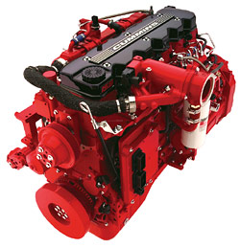
          - School Bus
          - Urban Bus & Shuttle
          - Fire & Emergency
- Cummins ISC: 260 – 315 hp
          - Medium Duty Trucks
Figure 5.1
          - Motor Home
          - School Bus
          - Urban Bus & Shuttle
          - Fire & Emergency
- Cummins ISL: 310 – 350 hp
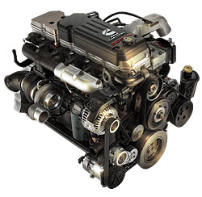
          - Medium Duty Trucks
          - Motor Home
          - Urban Bus & Shuttle
          - Fire & Emergency
- Cummins ISM: 280 – 450 hp
          - Heavy Duty Trucks
          - Motor Home
          - Urban Bus & Shuttle
          - Fire & Emergency
- Cummins ISX: 385 – 565 hp
          - Heavy Duty Trucks
          - Motor Home
          - Fire & Emergency
- Cummins 610 Turbo Diesel (Figure 5.2): 325 hp
          - Dodge Ram 2500/3500
Figure 5.2

Diesel Soot Filters:

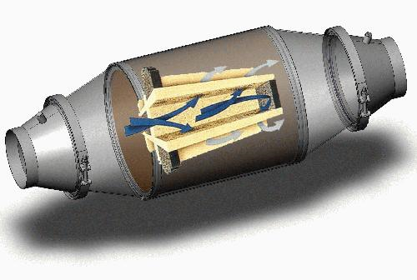

Figure 5.3

The diesel particulate filter is not complicated or even complex. The filter works on the same principle as every other filter. It is made from very adsorbent material that looks like a solid piece so as to catch the soot but with small porous holes that allow the exhaust vapors to escape through the exhaust stack. The material is usually cordierite or silicone carbide which also helps by absorbing diesel fumes. Figure 5.3 gives you a good view of what a diesel soot filter system looks like. This helps us by giving us an idea of where we might be able to place the sensor and how it will take the readings in the filter itself. The cordierite filter is basically a cylinder placed into a metal can (Actual cylinder picture can be found on appendix page A-11). Usually filter cans are made from heavy gauge steel to deal with the high exhaust temperatures being produced from the diesel engine. The filter can is clamped on by means of two clamps located on both ends of the filter, which allows for easy maintenance whenever it is necessary. Another important aspect of figure 5.3 is that it shows exactly how the soot and other particles are caught in the filter. The figure displays an enlarged representation of the operating portion of the filter. The exhaust gases (blue arrows) enter an input channel of the filter and then pass through the cordierite walls of the filter. As the gas passes through the wall it deposits the particulate matter on the filter walls and exits through the output channel (grey arrows).

There is actually very little information available on devices used to measure the amount of particulates that accumulate in filters as it relates to proactive maintenance of or knowing when a filter should be replaced. Many companies suggest that proactive or predictive maintenance should be performed in reference to the overall life of the filter, as described in the following passage:

“The electronic control module, which drives the diverter unit, features a circuit board housed in a small (5x6x8) metal enclosure. This is conveniently mounted for access. The circuit board holds the timer control where the duration of the filter cycle is set. The board also features a series of LED lights that monitor each function of the system. An hour meter mounted in the electronic control module is designed to be used as a guide to determine when a filter is nearing replacement.”

-Ward Diesel Filter Systems

The determination of how much particulate matter is in the filter, and the age for replacement is crucial to overall engine operation and efficiency.

VI. Concept Generation and Selection

Concept Generation

Idea #1: Exhaust force measurement system

- Concept (Figure 6.1)
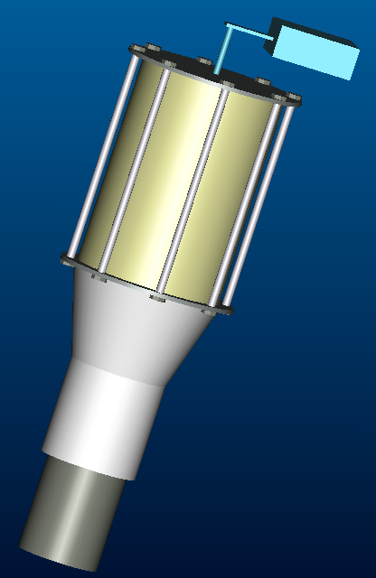
  - The idea behind this design is to use the exhaust flow rate to our advantage. For example at different engine rpm’s the exhaust flow rate will change. The goal is to calculate the amount of force the exhaust exerts at different engine speeds. The actual mechanism that goes onto the exhaust pipe is a simple filter with an attachment that bolts to it then slides into the exhaust pipe allowing it to slide in one direction at least a half-inch. Allowing the filter and attachment to slide allows the exhaust to push the filter, where on the other side is a device that will measure the amount of force exerted by the flow rate. Now when the filter starts to become clogged with soot the exhaust gases will create more of a force on the filter when trying to pass through it causing the filter slide more against the measuring device. The goal is to find a relation between the forces that the exhaust exerts without a filter and then with a filter and find a relation to how much soot is in the filter.

- Specifications
  - 9 in by 13 in cylindrical filter
  - Aluminum flat plate that bolts to bottom of filter
Figure 6.1
  - Pressure sensitive measuring device that attaches to top of filter
  - Hollow cylinder that slides into specified exhaust pipe diameter and attaches to aluminum flat plate.

- Factors
  - COST: A rough estimate of the cost is the price of the filter, metal and measuring device. It will approximately be about 300 dollars for everything but the filter and the computer.
  - TIME OF PRODUCTION: The time it will take to manufacture one product would be about two days (rough estimate).
  - COMPLEXITY OF IDEA: The complexity of this idea is on the moderate side due to the fact that there will need to be a computer module calculating the changing force and the difference as the engine changes speeds
  - MASS PRODUCTION CAPABILITY: The ability to mass produce the filter seems very possible due to the lack of complexity in the mechanism. The only difficult aspect is the computer module, which once the programming if figured out it is only a matter of copying it.
  - SPECIFIC FACTORS: Overheating of measurement device under harsh exhaust conditions; Filter itself degrading because of heat; Seizing of sliding mechanism due to heat, soot and environmental conditions.

Idea #2: Continuous Dilution Method

- Concept
  - The concept of this idea is based on a thermal fluids theory. As stated in our initial project proposal (found on appendix page A-8), the original idea for this problem was to measure the change in the back pressure using ΔP sensors in front of and behind the filter. The addition of soot to the filter would restrict the air flow through the filter and lower the back pressure, giving a measurable phenomenon to correspond with the amount of soot in the filter. Unfortunately, when the engine is at high speeds, soot comes into the filter at a quicker rate and collects at the rear of the filter. This soot also has a higher density. This disrupts the ΔP measurement. This particular concept focuses on regulating the speed of the soot entering the filter. By continuously diluting the flow of the diesel exhaust into the filter, you can almost assure all soot will be uniform and this allows for an accurate ΔP measurement.

- Specifications
  - A Dilution System must be set up in the exhaust system before the filter and be capable of the following things:
    - Monitoring the pressure of the exhaust gas entering the probe
    - Monitoring the pressure of the exhaust gas exiting the probe
    - Controlling the dilution ratio
    - Controlling the dilution solution temperature
  - Mass Measurement System: Includes a calculation computer and a pressure monitor behind the filter
    - Must be capable of comparing the pressure of exhaust gas entering the filter (from dilution probe) to the pressure of exhaust gas exiting the filter
    - These inputs go into the system and are compared to a clean filter to determine how much soot is in the filter.

- Factors
  - COST: The cost of this system may be relatively high due to the moderately complicated nature of the dilution system. The dilution probes must monitor a lot of factors and adjust its operation automatically
  - Time of Production: The time of production for this concept is primarily in the development stage. Once the concept is secured and perfected the production should not take long with dedicated machinery. It will be even quicker with the purchase of previously constructed dilution probes.
  - Complexity of Idea: The complicated nature of this idea falls primarily into the dilution. It will take a small amount of experimenting to determine the correct formula to input into the computer system so the dilution ratio adjusts to engine conditions correctly.
  - Mass Production Capability: Once the design is specified and perfected this machinery should be easily duplicated on a mass level. The computer system for this structure should be adaptable to any exhaust system it is placed on and not require any personalization.
  - Specific Factors: Currently there is little technology available for controlled dilution. The probes must be fabricated almost from the ground up.

Idea #3: Temperature Monitoring

- Concept
  - The concept of this idea also comes from thermal fluids. Each material has a specific heat that tells how much it will heat up based on how much energy is put into it. The more material there is, the harder an object is to heat up. This concept focuses on the fact that there should be a change in the specific heat of the filter system once it begins collecting soot. The more soot on the filter, the harder it should be to heat. The concept of this idea is to measure the initial specific heat of an empty filter system as well as the specific heat of a “full” filter system. The filter collecting soot should be somewhere between this range. By monitoring the heat of the exhaust gas entering the filter system (energy added to system) and then measuring the temperature response of the filter system, we should be able to locate the position of the filter between the ranges previously mentioned. This should be a direct correlation to the amount of mass in the filter.

- Specifications
  - This concept is mostly research to find properties of the soot accumulating on the filter and the properties of the cordierite filter to determine how the temperature will alter.
  - Temperature Measuring System
    - A temperature probe (most likely a sturdy thermocouple system) will be placed in the exhaust system before the filter to measure the amount of heat entering the filter.
    - A temperature probe system will be placed throughout the filter to monitor how the filter responds to the heat being placed into the filter by the exhaust gas.

- Factors
  - COST: This system should have a very low cost. The thermocouple system should have a relatively small cost depending on how exact they need to be. The most expense should come from the monitoring system which is easily available.
  - TIME OF PRODUCTION: It should not take long to construct this system or add it into the filter construction process. Once optimal placement locations on the filter are found, the process should be almost complete. The machinery is very simple.
  - COMPLEXITY OF IDEA: This is a VERY simple idea. It is just a comparison of temperature and changes in properties of a system. It is a simple thermodynamics problem. The only complexities arise from analyzing the properties of soot and cordierite.
  - MASS PRODUCTION CAPABILITY: This system is incredibly easy to produce on a mass scale. Thermocouples and thermocouple monitoring systems are easy to acquire. They should also be easy to integrate into the filter construction process.
  - SPECIFIC FACTORS: I’m not sure if this idea will work. The specific heat change of the filter due to soot build-up could be immeasurable. Also, it will be difficult to differentiate heat input from the exhaust gases from heat input from other sources.

Idea #4: Particulate Measurement through Electrical Current Analysis

- Concept (Figure 6.2)
  - Electrical conductivity is a measure of how well a material accommodates the transport of electric charge:
- A conductor such as a metal has high conductivity.
- An insulator like glass or a vacuum has low conductivity.
- The conductivity of a semiconductor is generally intermediate, but varies widely under different conditions, such as exposure of the material to electric fields or certain frequencies of light.

Ohm’s Law can be used to describe conductivity voltage is equal to the product of the current applied and the resistance, V=I*R. The electrical conductivity (σ) is described by the equation

Where ρ is the resisitivity.

b. By applying a constant voltage to the filter and knowing the resistance caused by the cordierite in the filter, one can determine the resulting current using the relation

with I being the resistance, V the voltage, and R the resistance. Once the filter begins to fill with soot and other particulates, the resistance caused by the filter will ultimately change as a result of the different electrical properties of the soot, specifically the charge mobility and the resistivity. This change will result in a variance of current. If the current is know that properly coincides with the filter being empty as well as full of particulates, it can then be directly determined how much sot has accumulated in the filter.

A small voltage source will need to be installed directly where the soot is to be colleted. Several outputs of electrical wiring can run from strategically placed areas within the filter. These will travel directly into an ammeter that will directly measure the current of the “electrical system” that has been created.

- Specifications
  - Able to accommodate a 9 inch by 13 inch filter
  - Ammeter must reside far enough away from the system as to not cause measurement error due to high temperatures.
  - Voltage must be applied directly to cordierite filter

- Factors
  - COST: The tools needed to construct system, including the wiring, are relatively inexpensive
  - TIME OF PRODUCTION: The time it will take to manufacture one product would be about two days.
  - COMPLEXITY OF IDEA: The design itself is uncomplicated
  - MASS PRODUCTION CAPABILITY: The ease of mass production is directly related to the complexity of design. Manufacturing could be integrated into standard auto assembly.
  - SPECIFIC FACTORS: Heat sensitive system, Vibration sensitive system

Constant
Applied
Voltage
Ammeter
(Measures
Current)
Wiring
Particulates (Soot)
Cordierite
Filter
Power Supply
(Supplies Voltage)
Vehicle Stack
Exhaust

Figure 6.2: Particulate Measurement through Electrical Current Analysis

Idea #5: Incandescence Soot Measurement

- Concept (Figure 6.3)
  - The concept for this particular soot sensor will involve the use of a laser. Using a laser to determine the amount soot in a diesel particle filter seems to be an outstanding idea. By using a laser to measure the amount of soot particles in a particle filter you would receive real time information that will be used in an instant. This would allow a person to change the filter without causing any kind of excess damage by late management. The information would be accurate and in detail due to assistance by the on-board computer that most vehicles have installed today.
  - The theory behind my concept is to take the measurements directly from the temperature in the diesel soot filter. The laser would heat up the soot particles by piggy backing through the filter and setting up a field that would take measurements from the heated particles. The idea will be that as the particles are being caught by the filter that the heated particles will not cause a major temperature deviation but as the filter gathers more and more soot the laser will heat up more particles. This in turn would cause a major increase in temperature because the laser is heating more and more particles. This would trigger the sensor to alert for the filter to be changed.
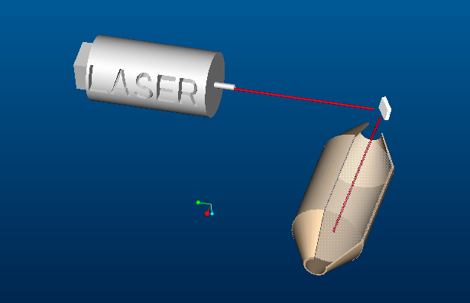
- Specifications
  - Operates at high temperatures
  - Fits into a space no bigger than 9 in by 13 in
  - Able to withstand sudden movement
Figure 6.3
  - Easily replaced if damaged

- Factors
  - COST: Using a laser would give you accurate data but the cost would be extreme.
  - TIME OF PRODUCTION: Forging a laser would take time because the circuits and lenses would take precision to construct which would take a lot of time.
  - COMPLEXITY OF IDEA: The system would be very complex for the simple fact that programming and additional equipment would have to be added in order to give accurate readings and the casing would have to be of a hard material that would take time to build.
  - MASS PRODUCTION CAPABILITY: This would not be so bad because once we had all the components it’s only a matter of assembly.
  - SPECIFIC FACTORS: It would be up to spec because once we get the initial design it would be easy to adjust it. The current state of laser technology may not be advanced enough to produce a laser capable of measuring diesel particles.

Concept Selection:

Decision Matrix:

Factor quantifying system:

1 – Very Poor

2 – Poor

3 – Average

4 – Good

5 – Excellent

Largest Total: Most reasonable idea

Concept 3 was selected to be the most possible idea using the decision matrix.
- Proposed Solution

The Temperature Measurement Method:

After the selection process established that the best plan to proceed with was temperature monitoring we had to develop this into a workable idea. The first step of this development process is to validate the scientific principles used to formulate this concept. It is crucial to make sure that we aren’t stretching the laws of physics to solve our problem. This concept builds off of a basic thermodynamic principle that as an object gains more mass it will be more difficult to raise its temperature. To apply this particular physical phenomenon to our problem, we enlisted the help of FAMU-FSU College of Engineering professor Dr. Juan Ordonez to perform the following thermodynamic study of our exhaust system. The following calculations section presents a valid scientific solution to achieve our goal:

Calculations (Nomenclature found on appendix page A-12)

The first step in modeling this type of method is to break the diesel exhaust into two components, air and soot. You can then model each component with different equations since they do not have a chemical effect on one another. Using

(1.1)

for each species. Equation (1.1) then simplifies into

(1.2)

Soot
Filter
Air
Air
Soot(1-η)
Figure 7.1

The next step is to take a look at the energy aspect of the model. Since the filter is what we are trying to model we’re going to assume it is a constant volume. The resulting energy equation is:

(1.3)

(1.4)

Since ΔE_{K}, ΔE_{P} are equal to zero,. Since work is equal to zero, that term gets dropped out of the equation,, and . Equation 1.3 then becomes:

(1.5)

A breakdown of the mass and energy components of the system are:

(1.6)

(1.7)

(1.8)

Breaking equation 1.8 into each of its components results in:

(1.9)

Continuing the calculations this way results into many complications and assumptions. A simpler way to model the filter and the flow of diesel soot would be to assume the mass is constant. A constant mass can be assumed if the change in mass between full and empty is negligible. Taking this into account and rewriting equation 1.3:

(1.10)

With equation 1.10, a plot of soot mass flow rate versus temperature can be calculated. Once a plot is created, a trend can be found to related temperature to the amount of soot within the filter.

With a little more refinement, these calculations can be advanced enough to translate into the trucks onboard computer. This computer would use these formulas to translate the temperature measurements from the exhaust system into a quantitative measure of how much soot is in the diesel particulate filter.

Measurement System

The next step of our design process is to analyze our exhaust system environment to find the best locations for our temperature sensors. We weren’t provided with any specific dimensions or product specifications for our system so all dimensions and diagrams are approximated from general research. This general nature allows our system to be translated to any vehicle exhaust system (Pick-up Truck, Semi-Truck, etc.). Diagram 7.1 illustrates our general exhaust system:

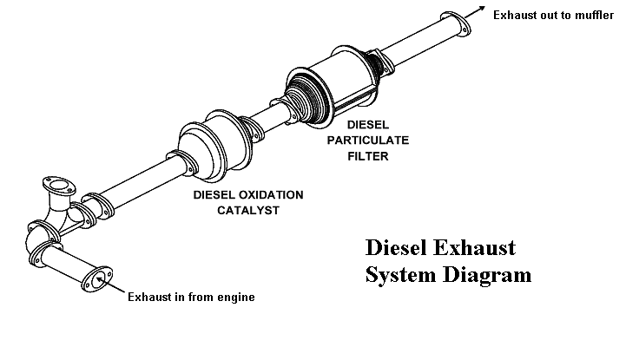

Diagram 7.1

This diagram shows the flow of the diesel exhaust gases from the engine through the exhaust system and to the outside environment. The DPF (Diesel Particulate Filter) is placed strategically so that it can remove the soot from the exhaust gas right before it exits the vehicle. Diagram 7.2 is a close-up detailed depiction of our particular DPF filter:

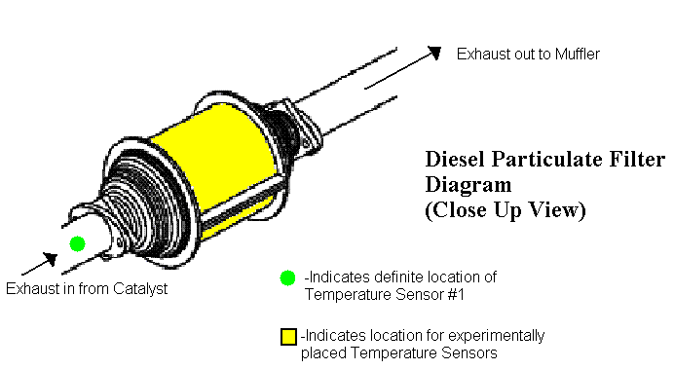

Diagram 7.2

As stated in the diagram legend, the green dot is our first definite location for a temperature sensor. This crucial temperature sensor measures the temperature (heat content) of the exhaust gas entering the DPF. Theoretically, this temperature sensor will tell how much heat is entering the system and our formulas should correlate this heat entering the system and temperature reaction of the filter system to how much soot has collected in the filter. The yellow portion indicates the focus of our upcoming experimental testing. This testing will be performed to determine the optimal locations for placing temperature sensors in the filter system to monitor the temperature response of the system. A better view of the filter system can be viewed in the pictures of our 3D computer prototype:

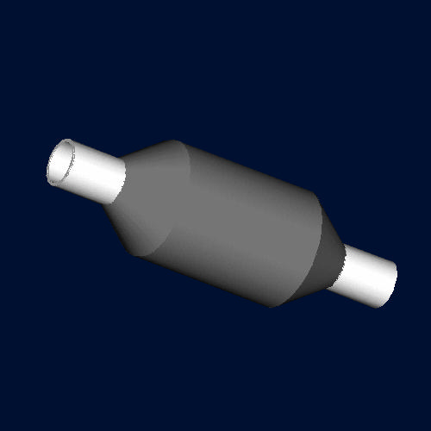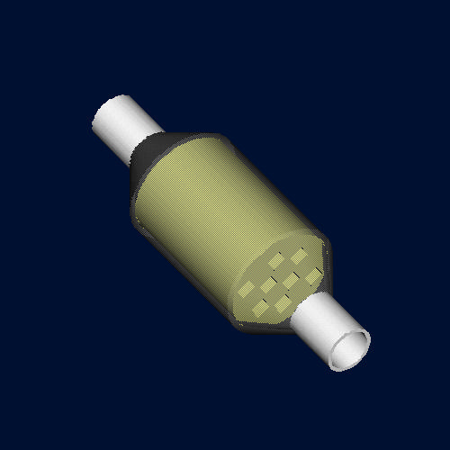

Figure 7.2 Figure 7.3

Figure 7.2 depicts the normal viewing status of our prototype; Figure 7.3 depicts our prototype with a clear exterior so you can view the filter inside. It is possible to view the alternating plugged filter channels inside the filter on the transparent exterior view of the filter which can be found on appendix page A-13. Our filter is a greatly simplified model with very few channels. The next phase of our research is to determine where we should place our sensors in the filter system. Possible locations are on the filter outer shell, exhaust entering channels, or exhaust exiting channels. Our tentative experiment setup is to hook a filter system up to an operating engine and test different temperature sensor location configurations to find which configuration gives the best representation of the temperature response of the entire filter system.

When this idea was presented to our sponsor, he showed concern with finding a temperature measuring sensor capable of operating reliably in the hostile exhaust system environment. These sensors must endure and measure high, quickly changing temperatures for long periods of time. The thermocouples we proposed initially in our concept generation would not be able to meet these requirements. After collaborating with the FAMU-FSU College of Engineering Cummins 2 Senior Design Team we found that they had a couple of possible solutions to this problem. They have a very solid temperature measurement method that involves a system of Resistance Temperature Detectors. This convinced us to run our project cooperatively with them. A solid partnership increases the chances of success for both Cummins groups. With this solid research background we are fully prepared to enter into the next phase of our research project.

- Spring Proposal

The following message was given to us by our sponsor Mr. Roger England:

“As far as your spring deliverable, I would like to see one or two practical short term proposed solutions, and also one proposed research project on a theoretical method that you believe would work with some development. For Cummins to stay competitive, we need to stay on top of technology. This includes what is available in the market (short term solution) and what can we specifically develop to give us a competitive advantage over our competition (long term, research project). Given this, I would like to see you assessment of what is available commercially (short term answer), and also what do you think would be the best way to tackle this problem from a basic science point of view (proposal for research project). The proposed research project should be scientifically sound theory, but no actual data is necessary. Data should be available from the manufacturers on the short term solution.”

Short Term Ideas

Idea #1: Flame Ionization Detection Method

The goal of this method is to allow for real-time measurement. With the flame ionization detection (FID) method, the exhaust gas is burned by a hydrogen flame and the particulate matter (PM) concentration is calculated based on the ion current that develops during the burning. This method can continuously measure soot and soluble organic fraction (SOF) independently. In the figure below it shows the flow of gas used with this method as well as the signal outputs by the detectors during the engine exhaust measurement.

Basically the exhaust gas flow is split into two lines, one at 191°C, and one with the temperature adjusted to 52°C. In the 52°C line, the solid components in the gas are removed by a filter, so only the gaseous components are fed to the FID. While the 191°C line, the gas is fed directly to the FID.
Figure 8.1
The output from the 191°C line includes a pulse signal. The signal is caused by carbon particles, and is proportional to the soot concentration. The difference in the amount of vaporized hydrocarbons under each condition correlates to the SOF concentration. Using both the filter weighing method and the FID method, measurements are made for various types of engines, and the measurement results used to calibrate the mass concentration scale.

In figure 8.2 it shows the results of the continuous PM measurement of a diesel vehicle running on a chassis dynamometer. From the figure, we can see that both soot and SOF mass emissions vary with vehicle speed. The MEXA-1220PM, a continuous PM that uses the FID method, has become quite popular as a measurement system that can quickly and easily collect data which is vital to engine research and development.
Figure 8.2
Idea #2: Pressure Drop of Segmented Diesel Particulate Filter

This idea uses the flow resistance of a segmented diesel particulate filter. Filter flow resistance is expected to remain below a certain limit as to minimize the adverse effect of exhaust flow blockage, due to the continuous particulate filtration and deposition build-up in the filter on the diesel engine.

Both Cordierite and Silicon Carbide filters perform the action of particulate filtration via passing the engine exhaust gas though their filtration walls typically a fraction of a millimeter thick. Flow passage through the filtration walls generates a fair amount of resistance to the flow, which is a non-negligible component of the total filter pressure drop.

The difference between the magnitudes of the flow resistance of a monolithic vs. a segmented filter due to the flow through the filtration walls are that given two identical monolithic and segmented filters, the segmented filter holds lower filtration wall area, resulting in a higher flow resistance than the Cordierite filter does.
Figure 8.3: A monolithic (Cordierite) filter left vs. a segmented
(Silicon Carbide) filter composed of 16 individual segments.

Existing models for pressure drop of wall-flow filters have mostly targeted monolithic filters. Some have been demonstrated to yield notable accuracy when tested under a wide range of practical conditions. However it is possible to use the pressure drop model of a monolithic wall-flow filter for a segmented one as long as the two primary filter variables influenced by the segmentation, filter filtration wall area and open frontal area, are represented adequately in the model. In practice it is more advantageous to have a single model that would adjust filter parameters accordingly depending on the filter type.

Filtration walls form the core elements of the filter structure where the actual filtration of particulate takes place. In a monolithic filter, total filtration area is simply the sum of individual filtration areas of inlet channels. In a segmented filter some of the inlet channels use all four sides of their filtration walls while some other channels could only use three of their side filtration walls even though they structurally posses four; these latter are the channels that are adjacent to the cement attaching neighboring segments of the filter.
Figure 8.4: Inlet channels of a segmented Silicon Carbide filter.
As far as filter flow resistance is concerned, a segmented design has two primary effects on the filter response: given a filter volume, segmentation reduces the net filtration wall area of the filter; it also slightly reduces the filter open frontal area. Both effects cause an increase in the filter pressure drop. At first, a reduction of 15% in the filtration wall area might appear negligible; however, a close scrutiny reveals that the consequence on the filter pressure drop is certainly non-negligible. This substantial drop can be seen in figure 8.5.
Figure 8.5: Pressure drop of a segmented filter (dashed line) vs. a monolithic filter.

Segmented and monolithic filters differ in their flow resistance, commonly known as pressure drop. In this work, an existing, validated pressure drop model for monolithic filter has been customized for a segmented filter. Model predictions have been compared to experimentally-collected data, demonstrating the model accuracy.

Long Term Solution (Research Proposal)

After careful evaluation of various options and taking into account the results of our concept decision matrix, we determined that the Temperature Measurement Method would be the most appropriate selection for the long term solution.

- Conclusion

The Cummins I Senior Design Team has successfully taken what was once an abstract idea, and has laid the groundwork for the successful overall development of a diesel soot particulate sensor. The problem was defined by our sponsor, and sufficient background research was conducted on diesel soot filters, properties of diesel exhaust, and diesel engines in order to gain a better understanding of the problem at hand. The specifications determined by the sponsor and the group have been integrated into a lengthy but concise list. Brainstorming on possible solutions for the problem were evaluated, with each idea being evaluated for overall feasibility. The optimal design, the Temperature Measurement Solution, was selected and is still being further developed by the team. Collaboration with the Cummins 2 Senior Design Team has begun and will continue into the upcoming semester. Also, two other short term solutions have been identified that will be intensely research by the group and further developed by the sponsoring company.

X. References

Masoudi, Mansour. (2005). Pressure Drop of Segmented Diesel Particulate Filters. SAE100: SAE Technical Paper Series, 2005-01-0971

Nakamura, Shigeo. The Development of PM Measurement Systems at Horiba. 17-21.

www1.umn.edu/eoh/hazards/hazardssite/dieselexhaust/dieselcharacter.html

www.warddiesel.com/specs.asp

www.eere.energy.gov/vehiclesandfuels/pdfs/deer_2004/session12/2004_deer_kittleson2.pdf

www.ncbi.nlm.nih.gov/entrez/query.fcgi?cmd=Retrieve&db=PubMed&list_uids=12733029&dopt=Abstract

www.atmosphericglow.com/applications/B3C8D1_diesel_soot2.htm

www.cummins.com

www.edie.net/Library/TechnologyDB/view_entry.asp?ID=1602

en.wikipedia.org/wiki/Soot

www.thefreedictionary.com/soot

www.matter-engineering.com/products/pas2000.html

www.lav.ethz.ch/research/projects/actual_projects/Experimentals/kistler_pryrometry

powerlab.mech.okayama-u.ac.jp/~esd/comodia2001/3-19.pdf

www.ca.sandia.gov/pmc/pdfs/IEA.2003.Annual.pdf

powerlab.mech.okayama-u.ac.jp/~esd/comodia2004/B6_1_005.pdf

www.ca.sandia.gov/pmc/pdfs/COMODIASootEmissionsPaper.pdf

