Figure yyy. Acceleration vs Frequency

This is what I might say about this in a presentation/paper.

- Yellow curver represents vibration at the ceiling
- White curve represents vibration at the projector
- It can be seen here that throughout the frequency range, the vibration amplitude is lower at the projector than it is at the base
  - This is especially evident from 7 to 8 Hz range, where there is as much as 50% reduction in amplitude
- More experiments should be made to further examine the damping system. It would be recommended to pre-load the spring dampers to varying degrees and test again.
- All three plots show similar results, suggesting the system is working to varying degrees throughout the frequency spectrum investigated here
- Do NOT go into the .5” displacement of the shake table. It will only confuse them like it confused luongo. If they ask later, we can explain it then.
- I believe the data is conclusive, the system is working….so some degree

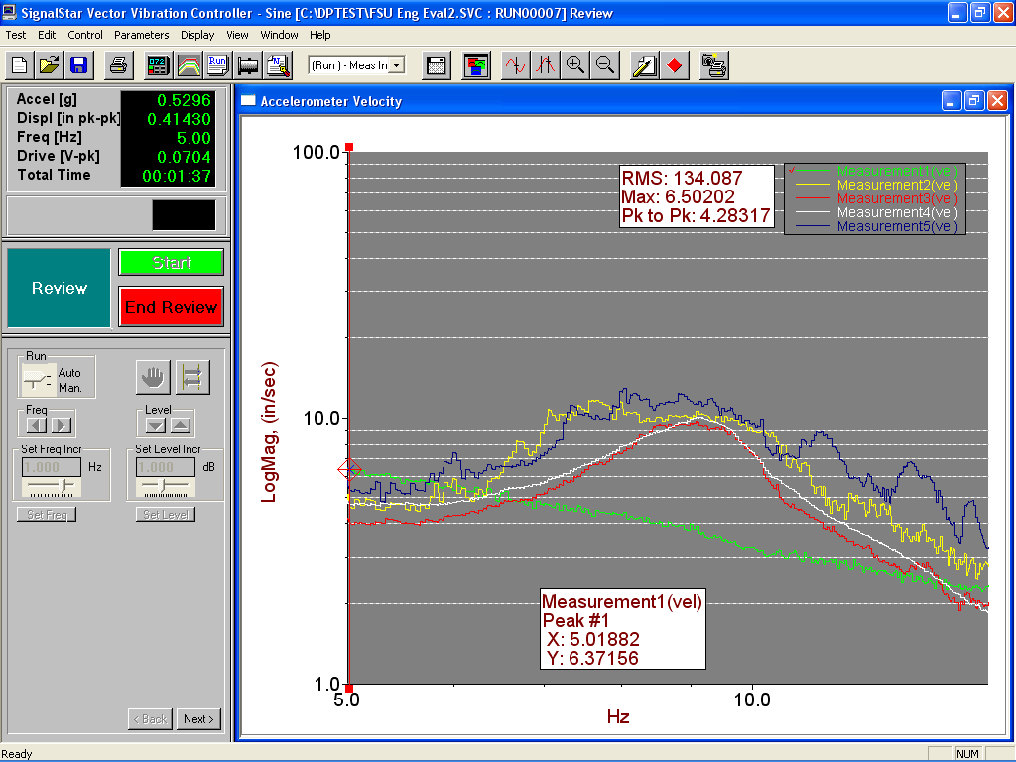
Figure 666. Velocity vs Frequency

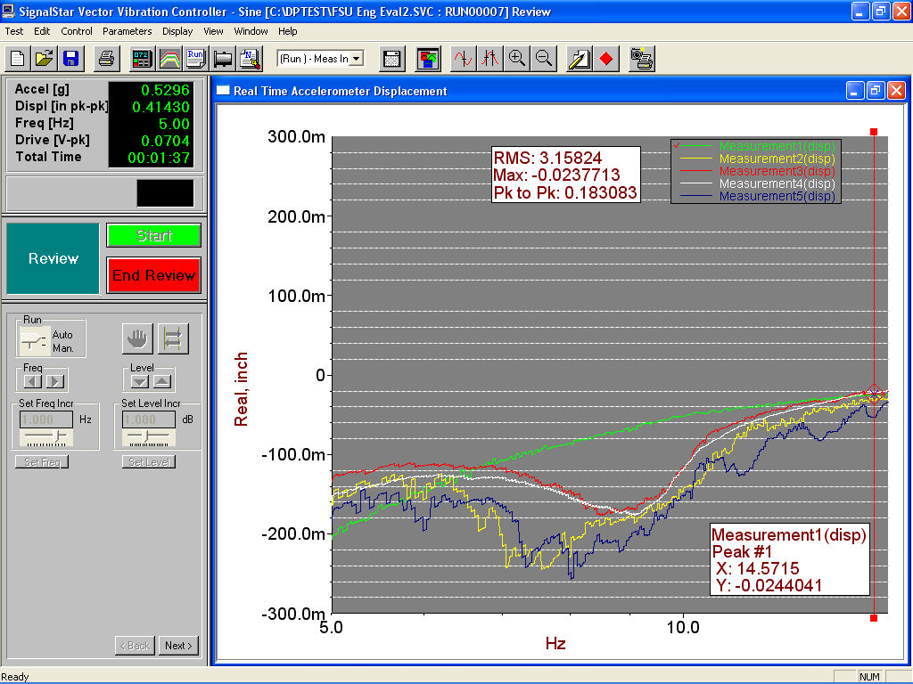
Figure 187. Displacement vs Frequency

