Project Scope
Team 12 is in charge of design and fabrication of a Bio Diesel plant. First off Bio diesel refers to a diesel-equivalent processed fuel derived from biological sources (such as vegetable oils) which can be used in unmodified diesel-engine vehicles. It is thus distinguished from the straight vegetable oils or waste vegetable oils used as fuels. Bio diesel is biodegradable and non-toxic, and typically produces about 60% less net lifecycle carbon dioxide emissions than petroleum-based diesel, as it is itself produced from atmospheric carbon dioxide via photosynthesis in plants. Some vehicle manufacturers are positive about the use of bio diesel, citing lower engine wear as one of the fuel's benefits. Bio diesel is a better solvent than standard diesel, as it 'cleans' the engine, removing deposits in the fuel lines. However, this may cause blockages in the fuel injectors if an engine has been previously run on petroleum diesel for years. For this reason, car manufacturers recommend that the fuel filter be changed a few months after switching to bio diesel (the fuel filter, as part of a routine maintenance plan, is generally replaced anyway). Most manufacturers release lists of the cars that will run on 100% bio diesel.
We are required to build a portable (small easy to pack away), and self sustaining (not connected to a power grid) Bio diesel manufacturing plant with a budget of 2000 dollars. Our Sponsor (John Deep) for the Bio- Diesel plant from Eglin AFB, wants us to get the team to think in terms of systems engineering. The Project although not terribly complex will require some research and thought to be able to get each system configuration we gather to work well with another. There are currently Bio diesel kits you can buy, but our main goal is to rethink they way bio diesel is made and make it more efficient, user friendly and cost effective. We will be using new oil, used oil and actual raw seeds for the feedstock. Since we will need to have an elaborate system to gather the oil from the raw seeds a design will be implemented but not necessary a built prototype. With our budget we should have enough money to design and build a working scale model of our problem.

We were required to gain general knowledge on how Bio- Diesel is made; Our Group members took this information before our conference call and researched the subject.

During our conference call we learned what more we had to do and plan. Some steps in designing considerations we have to take into account are:

- Design or adapt a processing system capable of producing feedstock from various sources (i.e. raw seeds, virgin seed oil, or
waste vegetable oil).
- Design or adapt a bio-diesel processor that is capable
of operation in an isolated location (i.e. does not require connection
to the power grid).
- Design or adapt a dispensing system that is capable of
operation in an isolated location (i.e. does not require connection to
the power grid).
- Determine the feasibility of using this system at
isolated locations.

Our initial phase of project would assess the feasibility of such a system. Safety is paramount and all hazards would have to be identified, assessed and mitigated to acceptable levels. Final phases of the program would either:

- Design and fabricate a prototype with operating instructions and
perform tests to demonstrate production output and real world
feasibility; or
- Provide a Technical Report, Tooling list, Engineering Drawing of
Final Design and Operating Instructions

There are several non-power grid options available and this is
where the project requires thought and discussion. We will be required to come up with a design to produce a batch size between 25 and 100 gallons (limited by ease of construction and materials available). The system should have portability for ease of transport. Since there are several ways to accomplish this it requires thought and discussion.
The dispensing system needs a way to transfer the Bio-diesel from its production vat to its final storage container and/or to a vehicle or different portable container. All of these considerations are what make this project a challenge. Any change to one aspect has impacts on the others. The options and impacts form the systems engineering basis our team need to consider.

On the following page is a guideline of what needs to happen in order for proper Bio diesel to be made. Our design will vary as we will use our engineering knowledge to put the proper components together to improve production

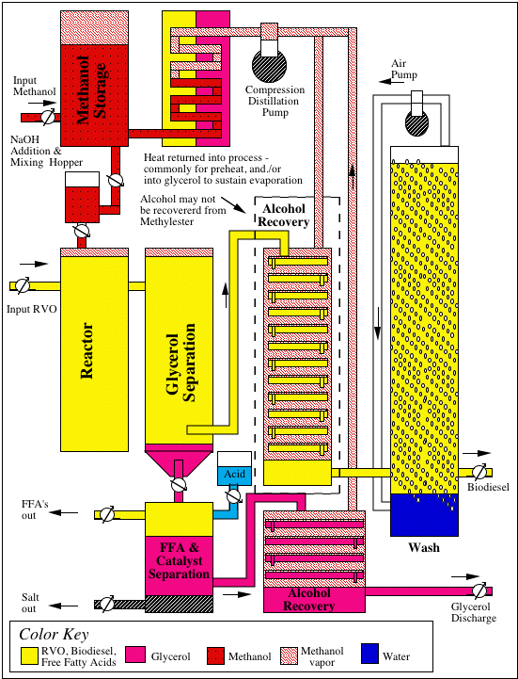

References:

http://www.biofuelsservices.com/ConceptualPlant.png
http://www.wikipedia.com/biodiesel

