Eglin AFB
Composite Manufacturing
Spring Scope and Project Plan
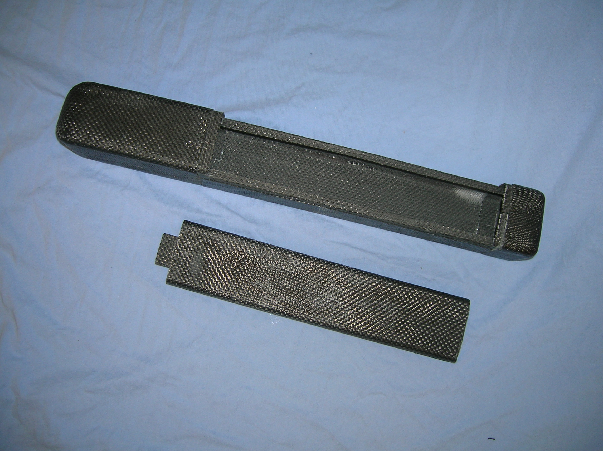
Senior Design 2008
Group 15
Brandon Bair
John Brewer
Darnell Brown
Rob Contes

17 Jan 2008

Team Website
http://www.eng.fsu.edu/~brewe/GROUP15.htm

Spring Scope and Project Plan
Project Scope
The Scope of this project is to design a fuselage for the Bullwinkle micro aerial vehicle and “hire” a manufacturer for production.

Semester Objectives
Group 15 has developed and constructed a prototype of the Bullwinkle Micro Aerial Vehicle. The objectives for the Spring Semester are as follows:
- Build Models
- Test Models
- Streamline Manufacturing
- Document and Quantify Manufacturing
- “Hire” Manufacturer

Build Models

One prototype has been constructed to teach students the hands on aspect of composites. Further models will be constructed for testing and streamlining.

Test Models

Group 15 will construct a pneumatic cannon to propel the fuselage to a velocity of 20m/s at a target at an angle of 30 degrees. In the first week of the spring semester the pneumatic cannon and an impact ramp that is variable from 15 to 45 degrees were constructed. The exit velocity will be verified using high speed film. This will also allow the impact to be viewed so that deformation can be observed.
In addition to impact testing, the motor will be bench tested in the fuselage to insure that motor head does not sacrifice shell integrity.

Streamline Manufacturing

Because of the learning curve, constructing the first prototype took a number of man hours in a two week time frame. However, the time required for a skilled worker to produce one fuselage should be much less. The group will work to minimize construction time without sacrificing quality.
Paralleling the use of time is the use of materials. Because of the unusual geometry, excess material was used in the lay-up process. Thus, when the parts were removed from the bags and trimmed, a substantial amount of carbon fiber and processing material was wasted. The group will design patterns for each piece of required material in order to use material more efficiently. Also, if less processing material is used, then less material goes to the landfill.

Document and Quantify Manufacturing

Each step of the process will be meticulously documented so that the process may be refined and duplicated. For each step, the group will quantify material use, resin use, and other pertinent values to make the process more efficient.

“Hire” Manufacturer

The goal of this project is not only to produce a design or prototype but to produce a direct source of manufactured products. The end state should allow engineers at the Air Force Research Lab to contact the selected company and order a desired number of fuselages.

Budget
Item | Availability | Price ($)
Carbon Fiber | Composites Lab | 0
Resin | Composites Lab | 0
Lay-up Materials  - Peel Ply  - Flow Media  - Vacuum Bag | Composites Lab | 0
Cannon Parts  - PVC/Metal  - Glue  - Other | Common Hardware | 140  10  50
Cannon Test Rig  - Wood/Metal  - Hardware  - Other | Common hardware | 100  25  25
Buffer |  | 200
Total |  | 550

