Deriving the Velocity Expression – Qui Van

This paper derives the inlet velocity expressions used in the 2D and 3D COMSOL models.

The reason why the inlet velocity expression is important is because the flow velocity is a parameter that needs to be controlled and to obtain accurate results from the system, the inlet flow velocity needs to be correct.

First the 2D case will be addressed and then the 3D case will be investigated.

The COMSOL model used in the 2D portion of the document is 2D_solved_ss.mph.
A solved model is used because it can display model properties (plot parameters).

With the COMSOL model loaded, bring up the Constants dialog box.
Enter the two constants:
D 0.0127[m]
A pi*D^2/4
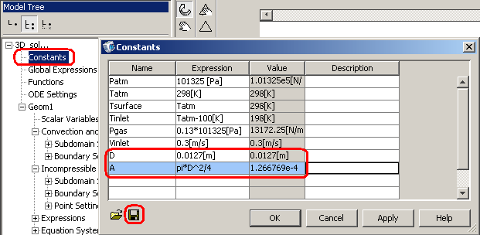Defining New Geometry Constants

These two constants define the diameter and cross sectional area of the bores of the flow cell.
These constants will simplify certain expressions used later.
Save the new set of constants, either by overwriting the old constants file or creating a new file.
This set of constants will be saved as flow_cell_constants_2.txt.

For every 2D flow cell model, the flow channel inlet is just a straight line.
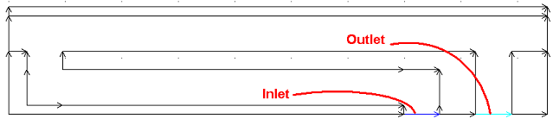Channel Inlet and Outlet for the 2D Case

In 2D COMSOL models, all geometry lines are described by a parameter s. s goes from 0 at the start point of the line to 1 at the end point of the line. This parameter allows the user to specify the distance along any geometry line which can be used in expressions to define properties along a geometry line.

To visually see what values s assumes along the inlet, go to Postprocessing->Plot Parameters…
In the General tab, uncheck all Plot type checkboxes except for the Boundary and Geometry edges checkboxes.
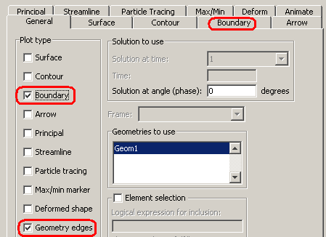
Plot Parameters Options

Go to the Boundary tab.
In the Expression field, enter s.
Press Apply.
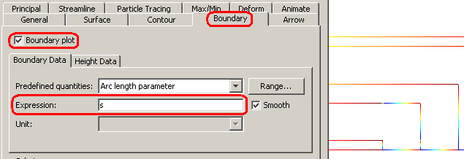Boundary Plot, Arc Length Parameter

Notice how all geometry lines change color.
Press OK to exit the Plot Parameters options.
Zoom in on the inlet.
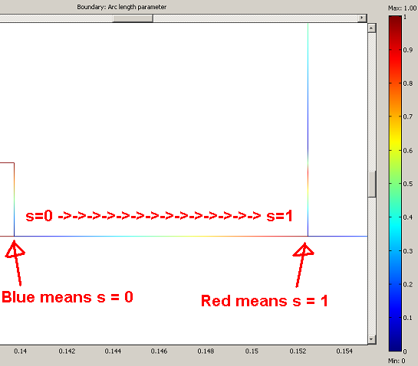Arc Length Arc Length Parameter at the Inlet

The figure above shows that s goes from zero at the left end of the inlet to 1 at the right end of the inlet.
This arc length parameter gives the user a way to reference the inlet boundary and will be used to specify the inlet velocity along the inlet boundary.

If the inlet velocity profile is constant, the expression for the inlet velocity is V_{inlet}, where V_{inlet} is a constant.
If the inlet velocity profile is linear and goes from 0 to V_{inlet}, the inlet velocity expression is V_{inlet}*s.
The expression for the inlet velocity profile has the form V(s) = V_{inlet}*v(s) where v(s) is a function of s.
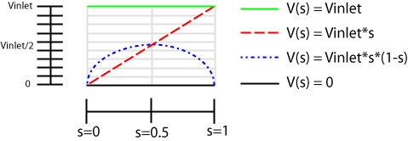
Possible Velocity Profile Expressions

The first requirement of the inlet velocity profile is that it needs to be a parabolic (page 612 [1]).
The second requirement is that the average velocity of this profile should equal a velocity specified by the user. This requires the mean velocity of the velocity profile to equal the inlet velocity, 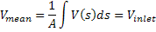, where A is the area of the inlet and V_{inlet} is the velocity specified by the user.

A parabolic expression that will satisfy the first condition is , where C₁ is a constant and s is the arc length parameter.
The actual expression should be of the form 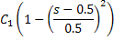 , but since this is just the 2D case, accuracy is not that important.
The velocity expression above fulfills the first requirement but not the second requirement.
For the mean velocity to equal V_{inlet}, C₁ should equal 6*V_{inlet} from the following derivation.

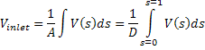
A = D since the geometry is 2D and the area of the inlet is the length of the inlet.
Substituting s = x/D into the velocity expression,
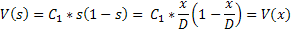
The mean velocity is then equal to
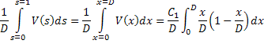
Integrating,
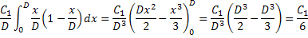
So,
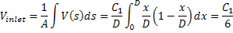
and

If the expression is used as the inlet velocity, it needs to be checked to make sure the mean velocity is correct.
In COMSOL with the 2D model loaded, define the expression above as the inlet velocity and solve the coupled system.
Go to Postprocessing->Boundary Integration…
Select the inlet of the channel in the viewport.
In the Expression field, enter v/D.
Press Apply.
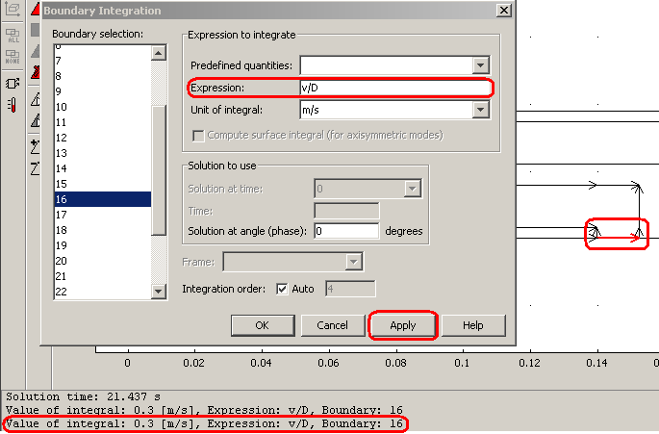Verification of the Mean Velocity

The status pane should display the value of the mean velocity which should equal V_{inlet} as specified in Constants.

As a check, change V_{inlet} in Constants to another value and solve the model again.
Check the mean velocity at the inlet with the Boundary Integration technique and make sure that it is equal to V_{inlet}.

To observe the velocity profile at the inlet, go to Postprocessing->Domain Plot Parameters…
Go to the Line/Extrusion tab.
Select the inlet in the viewport.
In the Predefined quantities options, select Non-Isothermal Flow (chns)->Velocity Field.
Make sure all other settings are as shown in the following figure.
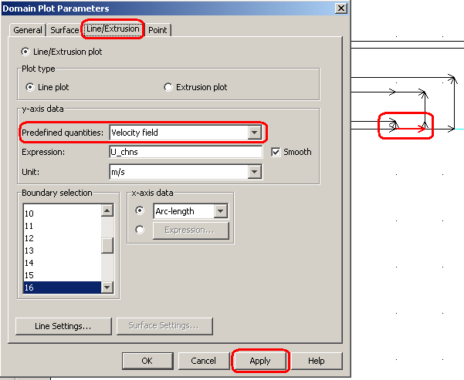
Domain Plot Paramters

Press Apply to bring up a plot of the inlet velocity.

The plot should look like an inverted parabola as follows.
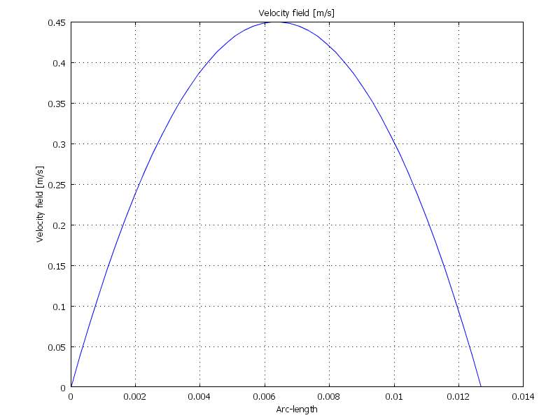Velocity Profile

The figure above shows the specified velocity profile along the inlet.
The inlet velocity is zero at the ends of the inlet and maximum at the center.

Using integration to obtain the mean velocity at the outlet shows that it is not equal to the inlet velocity.
The reason for this is undetermined.

A further check would be to make sure the mass flow rate in equals the mass flow rate out.

For the 3D case:

The model used is 3D_solved_ss.mph.
Load the constants file flow_cell_constants_2.txt.

The arc length parameter for the 3D case is different than the 2D case.
In the 2D case, the inlet is a line, whereas for the 3D case, the inlet is a circular surface.

To visualize the 3D inlet arc length parameters, bring up the Plot Parameters dialog box.
Clear all Plot type checkboxes in the General tab.
Go to the Boundary tab and check the Boundary plot checkbox.
In the Expression field enter s1.
Press Apply.
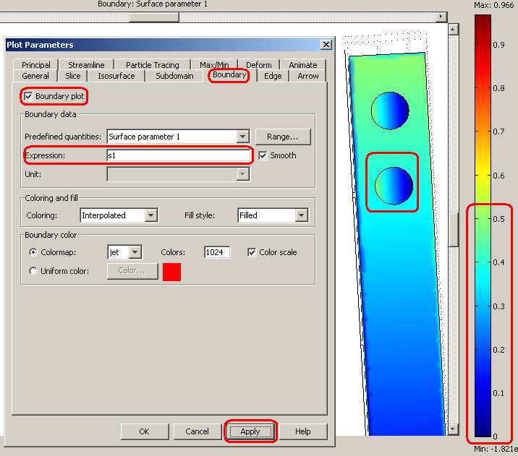s1 Arc Length Parameter

Notice the gradient of the inlet port goes from blue to green or from s=0 to s=0.5 and not to 1.
Enter s2 in the Expression field.
Again the gradient of the inlet port only goes from blue to green and the direction of the gradient is perpendicular to the direction of the gradient for the parameter s1.

The velocity expression for the inlet in the 3D case is similar to the 2D case. The velocity needs to be 0 at the boundary and maximum at the center.
An expression that has these features is 1-16*((s1-0.25)^2+(s2-0.25)^2).
Enter this expression into the Expression field of the Boundary tab.
Press Apply.
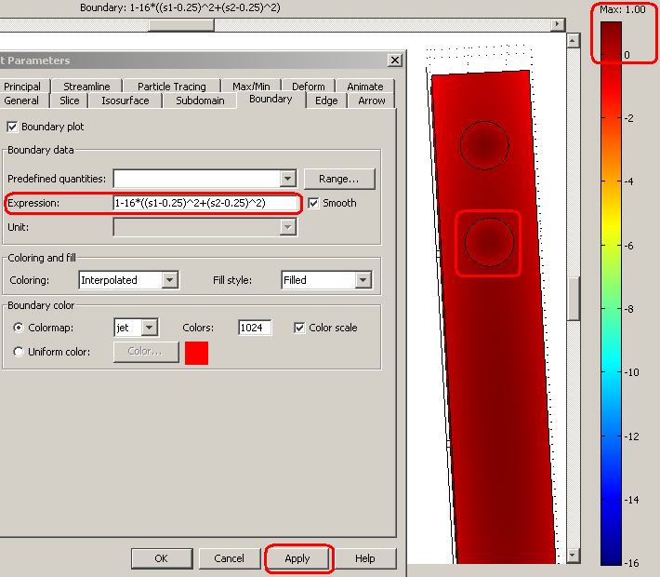 Expression: 1-16*((s1-0.25)^2+(s2-0.25)^2)

It is difficult to judge whether this expression is valid due to the low contrast ratio of the color map of the inlet.
Go to the General tab.
Check the Element selection checkbox.
Enter the inequality x<0.001 && y>0.135 && y<0.155 in the Logical expression for inclusion field.
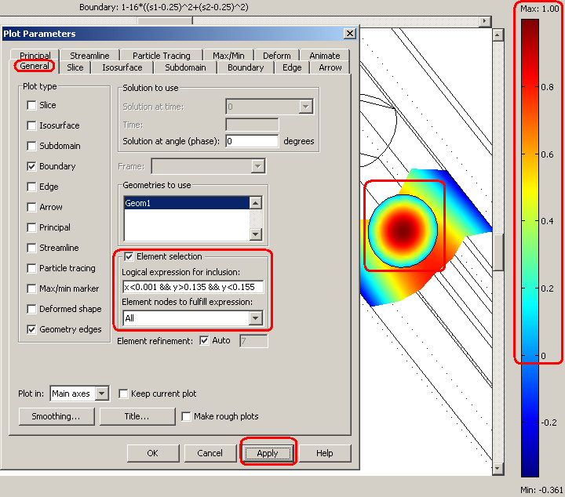Inlet Close-up

The figure above shows that the expression does give the desired results, 0 at the boundaries and maximum (1) at the center.
Uncheck the Element selection checkbox.
Press OK to exit Plot Parameters.

The next step is to generate the final velocity expression whose mean velocity is equal to the user specified V_{inlet}.
The expression:
will give a mean velocity equal to V_{inlet} and is derived as follows.

Take
with
Substitute x and y for s₁ and s₂ as follows.
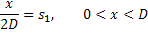
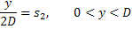
These substitutions give
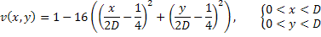
Make another substitution
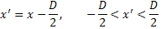
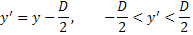
to get
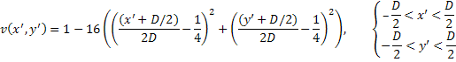
Simplifying results,
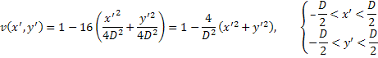
The mean velocity is defined as
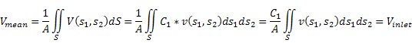
The integral can be evaluated by transforming the coordinate system to polar coordinates
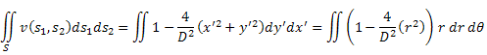
The integral on the right hand side evaluates to
Plugging this back into the mean velocity equation gives
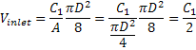
or
The final velocity expression with a parabaloidal profile and a mean velocity of V_{inlet} is

Load the model 3D_solved_ss.mph.
Check that the inlet velocity expression is equal to

Go to Postprocessing->Boundary Integration…
In the viewport select the flow channel inlet.
In the Expression field, enter U_chns/A.
This expression will evaluate the mean velocity at the inlet.
The status pane should show the value of the mean velocity.
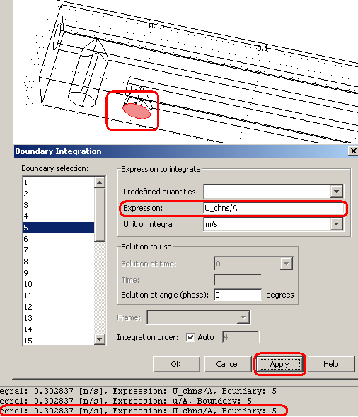
Mean Velocity at the Inlet

If an error occurs, enter the expression U_chns/(pi*0.0127^2/4) into the expression field.
This expression is the velocity divided by the area of the inlet.

The value of the mean velocity should equal V_{inlet} as specified in Constants.
It might be a little off due to the large size of the mesh elements.
With a finer mesh, the mean velocity should approach V_{inlet} but a finer mesh is also more difficult to solve due to the increase in size of the system.

Integrating the mean velocity at the outlet should give a mean velocity close to V_{inlet} also.

Due to the error from low resolution, the inlet velocity expression can be altered to give a velocity closer to the desired inlet velocity.
Just change the constant C₁, which is 2 in the expression above, until the mean velocity is equal to the inlet velocity.

