4th Deliverable

Group # 16

Rabei Rabei
Michael Boyle
Michael LaBeach
Andrew Magaletti

October 16, 2008

Table of Contents

- Abstract……………………………………………………3
- Introduction……………………………..…………..…….4
Background......................................................................5
- Performance Specification……………...………………..6
- QFD Chart………………………………………..……….7
- Analysis………………………………….………………...8
- Idea Selection……………………………………………..13
Decision Matrix……………………………………………13
- Cost analysis ………………………………………… …...14
- Conclusion….……………………………………………..16
- Reference…..…………………………………………...…17
- Appendix……………………………………………….….18
Stress Analysis……………………………………….....19
Circuit Diagram………………………………………....21
AutoCad Drawings……………………………………...23

Abstract

The goal for this project is to optimize a 1974 Converted Electric VW Bug. Based on some boundary conditions, there was a common understanding of achieving higher efficiency ratings in three categories, which are speed, range, and torque. Speed for a quick travel from point A to point B, as well as maintain highway speeds for a short period of time. Range is a factor due to the fact that the batteries do not charge themselves, so based on full batteries the vehicle can travel until the batteries are fully discharged. Problems will be encountered in order to achieve the requirements. First of all, the current electric bug has a controller that is able to handle 72 volts, and in order to gain the required speed of 70 mph, the controller should supply the motor with 96 volts which is not possible through the current controller. Second of all, in order to optimize the range of the electric bug from 30 miles to 50 miles, 6 more batteries are needed. But if connected the same way as the current batteries than the resultant voltage will be 144 volts and the controller could only handle 72 volts. Research was conducted on current electric bugs in order to better understand the project and attack the problem. First of all a 24V field voltage battery was added in order to supply the motor with extra 24 volts as shown in figure A6, adding the field voltage battery will add more voltage to the motor without the use of the controller; this will increase the VW current maximum speed of 57 mph to a speed of 70 mph. Moreover, connecting the batteries in a parallel/series will decrease the voltage from 144 volts to 72 volts as shown in figure A6, and this will increase the current maximum range of the car of 30 miles to 50 miles.

Introduction

The project’s objective was to optimize an electric 1974 Volkswagen Beetle. After speaking with the client and inspecting the car, the group realized that a lot of work needed to be done. First of all, the client proposed to overcome some problems that were faced while driving the car, such as going up hills, going fast enough to not get passed in a neighborhood, and leaving the house to run errands instead of going to get the newspaper out front. Some secondary tasks presented were to fix the lighting system and to distribute the weight around the vehicle evenly. From the concepts that will be generated, one will fit the proposed budget, as well as, accomplish the goals that the customer has defined.

Background

Motors
The two most commonly used motors in electric cars are Series Wound and Shunt Wound motors in that order.
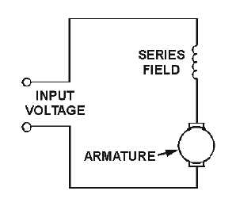
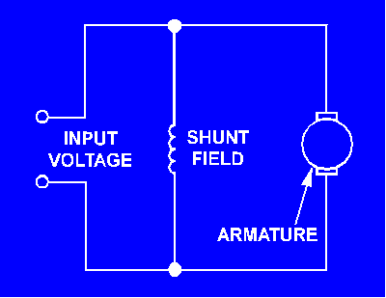
In a series wound motor, the field windings are wired in series with the armature (See Figure left). This means that when power is supplied to a series wound motor, the armature and field currents are identical. This translates to higher torques at low speeds and lower torques at higher speeds. As a load is applied, the speed decreases but the torque increases. Special care must be taken with series motors because if they are run without a load, they will damage themselves from high speed conditions.
In a shunt wound motor, the field windings and armature are wired in parallel (See Figure right). This enables the motor to maintain a near constant speed with a varying load. It does this by decreasing the torque output. Therefore, if this motor starts with a load applied, it will usually stall. This motor is usually used when a constant speed and precise speed regulation are required.

Controllers
Most all controllers for DC motors in electric cars use basically the same principle. That principle is Pulse Width Modulation, or PWM. This is how it works: The controller is able to turn the motor on and off about 15,000 times per second. This is the “pulse”. In order to control the speed, the time between pulses is either widened or shortened using a potentiometer. This causes the motor to either speed up or slow down.

Batteries
Battery choice in an electric car is very important and there are many options to choose from. The most commonly used battery is the Deep Cycle Battery. Deep cycle batteries are named this because they are designed to discharge to as low as 20% capacity over several cycles. They are used in electric cars because they deliver a constant voltage as the battery discharges.
Deep cycle batteries come in many different forms including gelled, AGM (Absorbed Glass Mat), and flooded (wet) batteries.
Gelled batteries are filled with a gelified electrolyte made from sulfuric acid and silica fume. This makes the resulting substance immobile and enables the battery to be positioned in many different orientations without spilling.
AGM, or absorbed glass mat, batteries use fine glass fibers mixed with an electrolyte. AGM batteries are more stable and have a lower internal resistance.
Flooded lead-acid batteries are the most commonly used batteries in today’s electric cars. They are made of a series of lead plates submersed in an acid solution. This is why they can only be mounted in the upright position. We will use flooded lead-acid batteries in the electric Beetle.
Performance Specification
- The Vehicle must attain a top speed of 70 mph
Based on background research it was concluded that the motor has to receive 96 volts in order for the vehicle to attain a top speed of 70 mph. Moreover that could be accomplished by either buying a new controller that is able to transfer 96 volts to the motor or by adding a 24 volt AGM Deep Cycle field voltage battery.
- The VW bug should be able to range 50 miles without the need to charge
From background research, more batteries are needed in order for the vehicle to range more miles without the need to charge. Adding 6 batteries and connecting all the batteries in a series parallel mode would make the car range about 55-60 miles.
- The Vehicle must be able to climb a 15 degree hill at 20 mph for more than 30 seconds
Based on background research, a 24 volt AGM Deep cycle field voltage battery could be used to overcome the torque added on the motor while traveling incline hills.
- The car must have working headlights
New headlights need to be purchased and new wires are also needed.
- The motors terminals must not melt after driving
Based on consultation from professors at the Engineering school, it was concluded that a new terminal is needed. Furthermore, the reason behind the problem was a gap between the terminal metals that caused the current to jump in between metals and that lead to a very high temperature that melted the terminal.
- The car should be able to handle all the weight caused by adding the batteries
A stress analysis was conducted on the bottom floor of the car using a computer simulated program called Algore to make sure that the car is able to handle all the weight added. Figures 1A-2A show the stress analysis of the floor before the batteries were added, on the other hand figures 3A-4A show the stress analysis after the batteries were added. Moreover the distribution of the batteries is also shown by figures 8A-9A using a computer program called AutoCAD, in which 3 batteries were placed in the front and 9 batteries were placed in a cage in the back.

QFD Chart

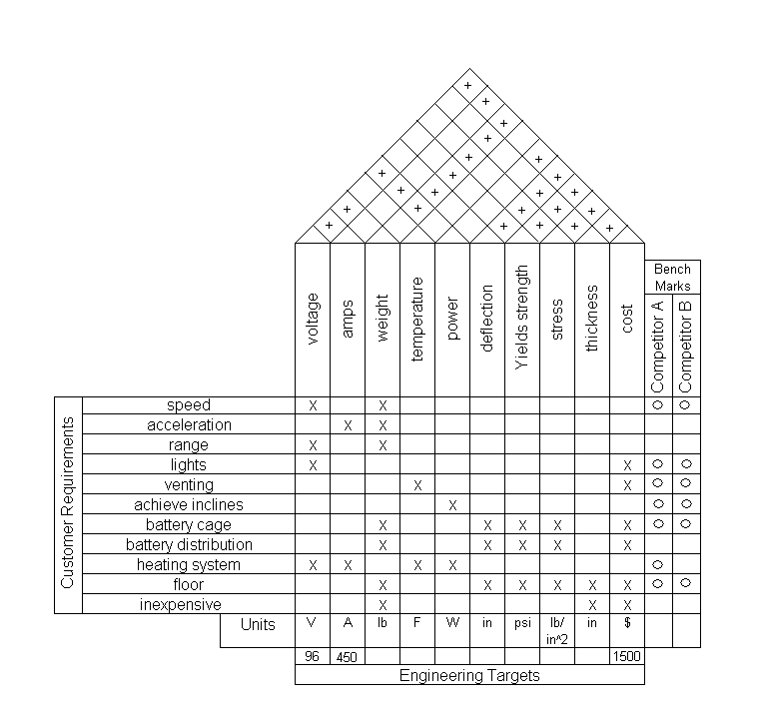
Figure 1: Quality Function Deployment

Figure 1 is a Quality Function Deployment chart that includes customer requirements, engineering requirements, engineering targets, competitive benchmarks and matrix of requirement relations. Moreover the chart shows the relationship between the customer requirements, engineering requirements and competing products. Moreover, competitor A is Dr. Larry Tilman from Ohio who used 12 batteries and the same type of motor. Competitor A achieved inclines, a speed of 70 mph, and a range of 50 miles. Competitor B is Michael Barkley from Oklahoma who used the same type of motor and controller, and connected 12 batteries in series in which he has a range of 30 miles, and a speed of 70 mph.

Analysis
Concept 1

Six new batteries will be added to the car in order to achieve more range. The batteries will be distributed in the car by adding 3 batteries to the front part of the car and 3 batteries to the back part of the car next to the 6 existing batteries. The batteries will be connected in a series parallel mode in order to produce only 72 volts as shown by figure A6 instead of 144 volts as shown in figure A5. Moreover a 24 volt battery pack will be added to give the motor more power for climbing hills.

Analysis:
Cost:
The 6 Deep Cycle 12 volts batteries will be used since they are cheaper than the already existing Trojan batteries. Also a 24 volt pack battery will be added to help the car move and overcome inclines. Estimated cost $530.00.
Speed:
Adding the batteries to the car will increase the weight and thus affect the speed negatively, each battery weighs 66 lbs and all six batteries weigh 396 lbs. but adding the 24 volt battery pack will provide the motor with more voltage causing an increase in the speed, therefore the cars speed will increase to 65 mph.
Range:
The voltage increases by increasing the amount of batteries, also the range increases by increasing the voltage. The cars range is 35 miles before the need to charge, but by adding the 6 batteries the car is able to run for 60 miles before the need to charge.
Achieve inclines:
Adding the batteries will not increase the power but increase the weight. Therefore the car will struggle more in achieving inclines because of the added weight, but the 24 volt pack battery will accommodate for the difference.
Safety:
The car has 6 Trojan 12 volts existing batteries and 6 Deep Cycle 12 volts batteries, and by adding a different type of battery might not be as safe. Therefore each two Trojan batteries will be connected in parallel while each two 6 Deep cycle batteries will also be connected in parallel and then all the batteries will be connected in series.
Complexity:
This is a moderately complex design because of the batteries connection and the cables used to connect the batteries. The batteries are distributed around the car and are connected in a combination of series and parallel mode, which makes it more complicated in regards of connection.

Summary:
This concept minimizes cost and lowers the speed but increases range. This concept maintains a relatively simple and efficient approach to the problem, making it one of the most likely candidates to be selected because of restrictions included in the budget.
Concept 2

Opting for a new AC motor will increase the speed, the torque, and the mileage of our vehicle. We will also need to the change the controller to a DC-AC power inverter. An inverter will convert the DC power that batteries generate and convert it to AC power that is accepted by the motor. This concept is shown in figures A9 and A10.

Analysis:
Cost:
The AC Motor will be used since they use the Trojan batteries more efficiently. The controller would have to be replaced with an inverter to convert the DC power from the batteries to an acceptable AC power for the Motor. Estimated cost $4000.00.

Speed:
The new motor will give the vehicle added speed due to how the AC Motor handles different frequencies, the higher the frequency the faster the car. Estimated speed 60

Range:
The way the AC Motor draws its power from the batteries through the inverter. The cars range is 35 miles before the need to charge, so by adding the AC Motor will affect to total range positively. Estimated range 45 miles

Achieve inclines:
AC motors are the rated the best piece of equipment when combating hills or rough terrain. This will handled the vehicle inability to climb inclines.

Safety:
The vehicle will be using the same batteries it has, 6 Trojan 12 volts batteries and by adding an AC motor will cut on weight, theoretically improving the speed and overall range. As long as the proper procedures are taken removal of the motors as well as the controller, the optimization will be safe.

Complexity:
This project calls for a lot of labor and patience. The difficulties that will arise while introducing this concept will probably occur with the removal and the installation of the old and new motors, respectively. Problems may happen with the connection of the inverter to the existing system

Summary:

All tasks can be met with the change from DC to AC power. The vehicle will be more effective in the three categories of speed, range, and torque. This concept provides a quick and effective solution to the problems recently encountered with the vehicle.
Concept 3

A new controller will be added to the car as well as ten new batteries to increase the total system voltage to 96V. The addition of ten new batteries will help increase the speed and by connecting the batteries in series/parallel the range will be increased as well. The new controller allows the system voltage to be increased from 72V to 96V. This concept is shown in figures A11 and A12.

Analysis:
Cost:
Buying a new controller is not cheap and since we will also be buying batteries as well the cost of this budget will exceed the budget. The cost of the ten batteries will be around $800 and a new Curtis Controller costs around $1400. The reason we chose the Curtis Controller is because it is one of the most reliable.
Speed:
The speed of the system will increase by about 15mph since the system voltage will have 24V more than the existing. The one draw back is the addition of ten batteries which will add 660 pounds to the car. The estimated speed for the car with the weight and new power will be about 65 mph.
Range:
The range will be increased because of the addition of the 10 batteries. By putting them in a series/parallel configuration the range is now doubled compared to its initial range. The range now is 70 miles as compared to 30 miles.

Achieve inclines:
By increasing the total voltage of the system it will be able to climb hills. The reason is because the motor does not have any low end torque due to the motor being shunt wound. The increased voltage will help to go up inclines while moving but from a stand still the motor will still have the same problems.
Safety:
By changing the controller to a more powerful one the system will now be more danger for someone working on it. By switching the batteries to a series parallel the system will also have more amps which will increase the amps and that would be dangerous to anyone who touches it.
Complexity:
The new configuration will be more complicated because we will be adding 10 new batteries and a new controller. On top of adding new batteries we will also be rewiring the battery configuration from a series to a parallel series which will be a very complex system.

Summary:
This concept is a costly one because we are buying more batteries and a controller. Both are very costly and will deteriorate our budget faster than anticipated. The range and speed will see great increases which are two objectives that we are trying to meet for the client. Unfortunately the ability to go up inclines; safety and complexity will not be beneficial in this concept
Concept 4
Nine 8V Batteries to Achieve 72V

Components needed:
(9) 8V Deep Cycle Batteries
24V Battery Pack

This setup would use the current motor and controller. The main difference is the power source. 9 8V batteries wired in series would be used to deliver 72V to the armature with a separate 24V battery pack powering the field voltage. 8V batteries have a higher energy density than 12V batteries because they deliver the same or more amps at a similar weight. Because of the higher energy density, they last longer than a 12V battery. This means an increase in range. This concept is shown in figures A13 and A14.
Cost:
Using 9 8V Deep Cycle batteries would cost $720.00. This does not include the 24V field voltage source price of $120.00.
Speed:
This configuration would offer an increase in top speed because an 8V battery pack would weigh less. Estimated top speed: 70mph
Range:
This is directly related to weight and battery configuration. The 9 8V batteries would be wired in series in order to achieve 72V. However, because of their increased energy density, range would be increased. Estimated range: 45 Miles
Achieve inclines:
The 24V field voltage enables the vehicle to climb hills without problem. This is part of a separate circuit that switches on when the key is turned. It enables the field to charge to its maximum before power is supplied to the armature through the controller.
Safety:
The safety concerns with this setup are the same as any high voltage/high amperage setup. An additional concern is the weight of the battery pack. It needs to be properly secured to prevent movement in a crash.
Complexity:
The complexity is moderate due to the separate field and armature voltages. It requires a bit more wiring and planning. However, the lesser the batteries means slightly less complex.

Summary:
The ideal batteries for electric cars are low voltage, high amperage batteries. These tend last the longest. Using 6V batteries would have the highest energy density but they are expensive and more would be required to reach 72V. This translates to more weight and more cost. 8V batteries provide a nice compromise because they have high enough energy density, are cheaper than 6V’s, and only 9 would be needed. With 72V to the armature and 24V to the field, both a top speed of 70mph and hill climbing could be realized. However, with only 9 batteries, a range of 50 miles may not be able to be achieved.

Concept 5
New Motor, New Controller, 96V series/parallel

Components needed:
Advanced DC L91-4003 Series Motor
Kelly Controls KDH09500A
(10) 12V Deep Cycle Batteries

This setup represents the easiest and cheapest way to reach the clients needs. It would use a new series wound motor, a new 500A controller, and 10 additional 12V deep cycle batteries. The batteries would be wired in series/parallel configuration. This concept is shown in figures A15 and A16.
Cost:
Expensive. The Advanced DC L91 costs $1004.86, the Kelly controller costs $799, and the 10 additional batteries would cost at least $700. Total cost coming to $2506.86.
Speed:
This option would obviously enable an increase in top speed. At 96V, the pack and the motor should be able to bring the car to about 80mph.
Range:
The 16 12V batteries would be wired in a series/parallel configuration. This means that the amperage drain on each of the batteries will be cut in half which translates to an increased range.
Also by changing from a shunt wound motor to a series wound, efficiency is increased. Estimated range: 70 miles
Achieve inclines:
With the series motor, the vehicle will be able to climb hills because it will have a low end torque when a load is applied (hill). The startup torque will not be as good as with a shunt wound with a separate field power source.
Safety:
The safety concerns with this setup are the same as any high voltage/high amperage setup. An additional concern is the weight of the battery pack which will be around 1056lb. It needs to be properly secured to prevent movement in a crash.
With any series wound motor, if power is supplied without a load, the motor will “run away” and possibly explode.
Complexity:
The complexity of this setup is minimal. The most complex part is the battery wiring. The rest is essentially plug and play.
Summary:
There is no doubt that this configuration would be able to achieve the desired goals. With a top speed of ~80mph, a range of 70 miles, and the ability to climb hills, this setup would meet and exceed performance requirements. It would be nice to do, but at the cost of over $2500, far exceeds the budget.

Idea Selection

Decision Matrix

Table 1: Decision Matrix

Decision Matrix | Cost |  | Range |  | Speed |  | Safety |  | Torque |  | Complexity |  | Total
Decision Matrix | Weight | % | Weight | % | Weight | % | Weight | % | Weight | % | Weight | % | Total
CONCEPT 1 | 90 | 0.4 | 80 | 0.2 | 70 | 0.2 | 60 | 0.05 | 70 | 0.1 | 70 | 0.05 | 79.5
CONCEPT 2 | 30 | 0.4 | 50 | 0.2 | 60 | 0.2 | 40 | 0.05 | 90 | 0.1 | 40 | 0.05 | 47
CONCEPT 3 | 60 | 0.4 | 90 | 0.2 | 70 | 0.2 | 50 | 0.05 | 60 | 0.1 | 60 | 0.05 | 67.5
CONCEPT 4 | 80 | 0.4 | 50 | 0.2 | 80 | 0.2 | 60 | 0.05 | 70 | 0.1 | 70 | 0.05 | 71.5
CONCEPT 5 | 40 | 0.4 | 90 | 0.2 | 95 | 0.2 | 30 | 0.05 | 80 | 0.1 | 30 | 0.05 | 64

As shown by table 1, concepts 3 and 4 scored the highest range but they were discarded because of the budget constraint. Concepts 2 and 5 were discarded because of the addition of the motor which is the most expensive part in the car. Therefore, Concept number 1 is the best idea that fits the projects since the cost is one of the biggest constraints in the VW bug project.

Cost Analysis

Batteries
$840.00 From Battery Source for 12 Deep Cycle 12V Batteries
$420.00 From Battery Source for 6 Deep Cycle 12V Batteries if no resale

Field Voltage Battery
$110 24V AGM Deep Cycle

Wire
$150 2/0 AWG Welding Cable

Terminals
$11.20 Battery Lug, Straight (4) from www.evparts.com
$52.80 Battery Terminals (12) from www.evparts.com

Box material
$27.00 (2) 4’ x 8’ x .5” Plywood from Home Depot
$30.00 Carpet material from flea market

Floor Repair
$50 12 x 48 0.125" ALUMINUM 5052-H32 BARE SHEET

Cage Material
$80.84 from www.onlinemetals.com shipped as shown by table 2
Table 2: Cage material individual prices
$13.00 4’ x 8’ x .5” Plywood from Home Depot
Total for above essentials: $1365.00
Fuse Holder
$20.52 Bussmann 4164 Limiter Fuse Block

Blower
$19.99 DETMAR TUNNEL BLOWER 3 or 4 INCH from www.overtons.com

Filter
$25.00 Conical Air Filter from ebay

Exhaust Fan
$29.99 Solar Powered Exhaust Fan from internet

Heat Sinks for Controller
$10.00 P4 Heatsink from ebay

Lights
Front turn signal
1157
2 Amber LED for $13.32 Shipped from ebay
Rear turn signal
1156
2 Amber LED for $10.82 Shipped from ebay
Tail light
67/97
2 Red LED for $10.82 Shipped from ebay
Stop light
1156
2 Red LED for $10.82 Shipped
http://stores.ebay.com/US-Home-Direct_W0QQfrsrcZ1QQfsubZ15198670QQtZkm
New Dashboard
$61.76 from automotix.net

Seat Upholstery
$80.74 TMI SLIP-ON SEAT UPHOLSTERY from carparts.com

Total: $1652.74

Total does not include possible resale of parts, tax, or shipping on some items unless noted. Also does not include regulators. This is still being researched as to their effectiveness in lead-acid batteries.

Regulators - $240.00 (6) Mk2 Rudman Regulators from Manzanita Micro

Conclusion

By analyzing our various concepts with respect to top speed, range, torque, and cost, we were able to make an informed decision on the best concept. By adding 6 additional deep cycle batteries to the existing 6 and wiring them in a series/parallel configuration in conjunction with a constant field voltage of 24V we will be able to meet all of the customer’s needs at the minimal cost. The series parallel wiring configuration means that 2 batteries will be wired in parallel with each other and then that set will be wired in series with a similar set and so on (See Figure A6 in Appendix). As explained in the background section, shunt wound electric motors can maintain a constant speed under varying loads. This causes a drop in torque. In order to compensate for this drop in torque, a constant voltage from a separate battery pack will be provided to the field windings. This will enable the car to move against an applied load (a hill).
As an accompaniment to the vehicle, a completed manual on how to convert an internal combustion vehicle to run on electric power will also be published. This will inform the reader on all the steps that need to be taken to create an electric vehicle including car selection, battery selection, engine removal, battery arrangement, motor selection, controller selection, safety issues, charger issues and selection, and more. The manual aims to make our research and experience available for others to use and improve upon.
Electric cars have always been sort of a dream in the automotive world. However, because of the cost of maintenance and expensive battery packs, they have never been able to break into mainstream production. But now, with ever increasing gas prices and emerging technologies, they are becoming more appealing every day. This project will successfully show the possibility of converting a common internal combustion engine car into an electric environmentally friendly car.

References

Matthies, Rob. "Prevent a Zivan from killing batteries." buysellcommunity. 2008. 13 Oct 2008 <http://www.buysellcommunity.com/sale/OEPHLHPD/>.

Chancey, Mike. "1968 Volkswagen Beetle." 2008. evalbum. 13 Oct 2008 <http://www.evalbum.com/1798>.

Wayne, Wang. "ELectric Car." 2008. FOTKI. 13 Oct 2008 <http://public.fotki.com/WAYNEWANG/electric-car-beetle-ev-/page2.html>.

Jerry. "Electric Car Conversion." EVconverter. 2008. 13 Oct 2008 <http://jerryrig.com/convert/>.

"Wilderness E.V." 2008. 13 Oct 2008 <http://e-volks.com/kit3.html>.

Appendix

Stress Analysis
Displacement
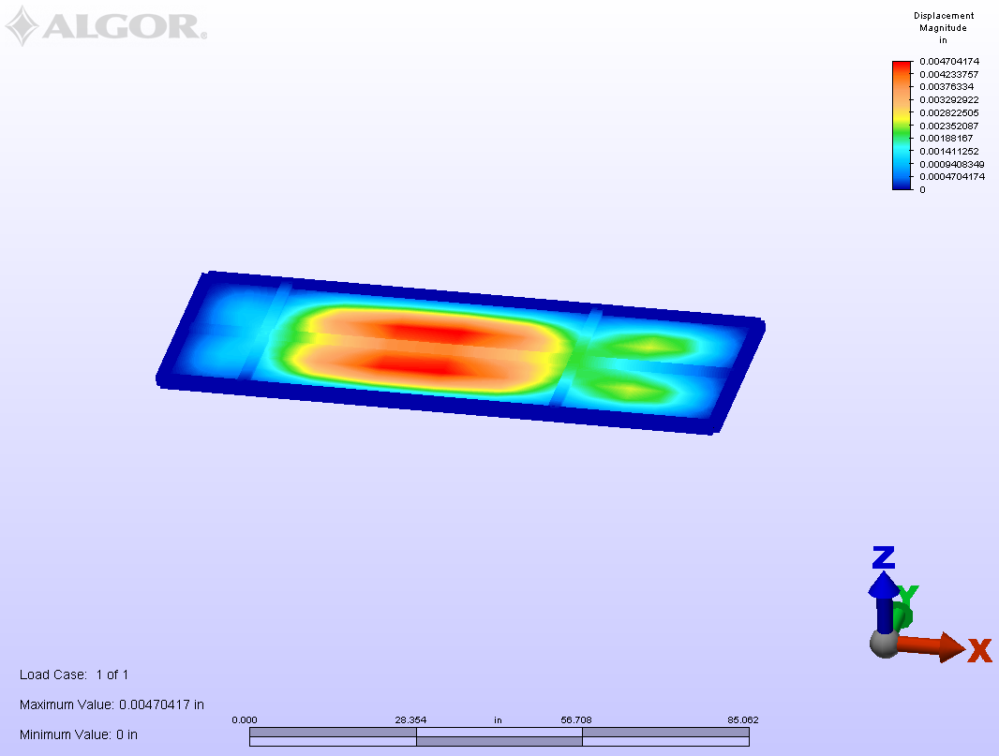
Figure A1: Displacement Analysis of the bottom floor using 0.125 in sheet metal

Stress
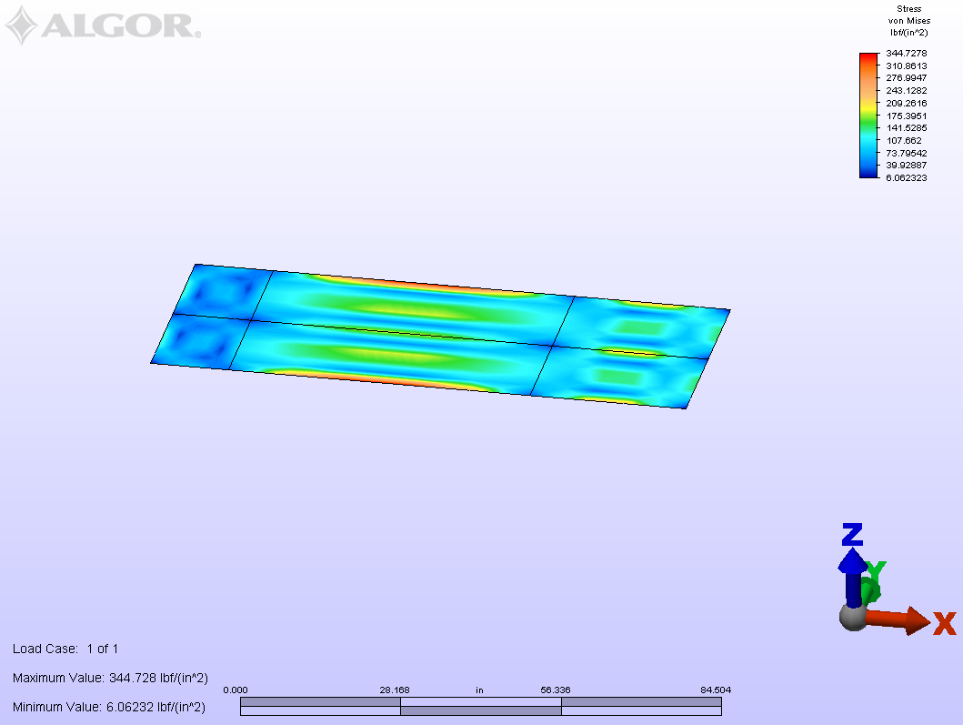
Figure A2: Stress Analysis of the bottom floor using 0.125 in sheet metal

Displacement
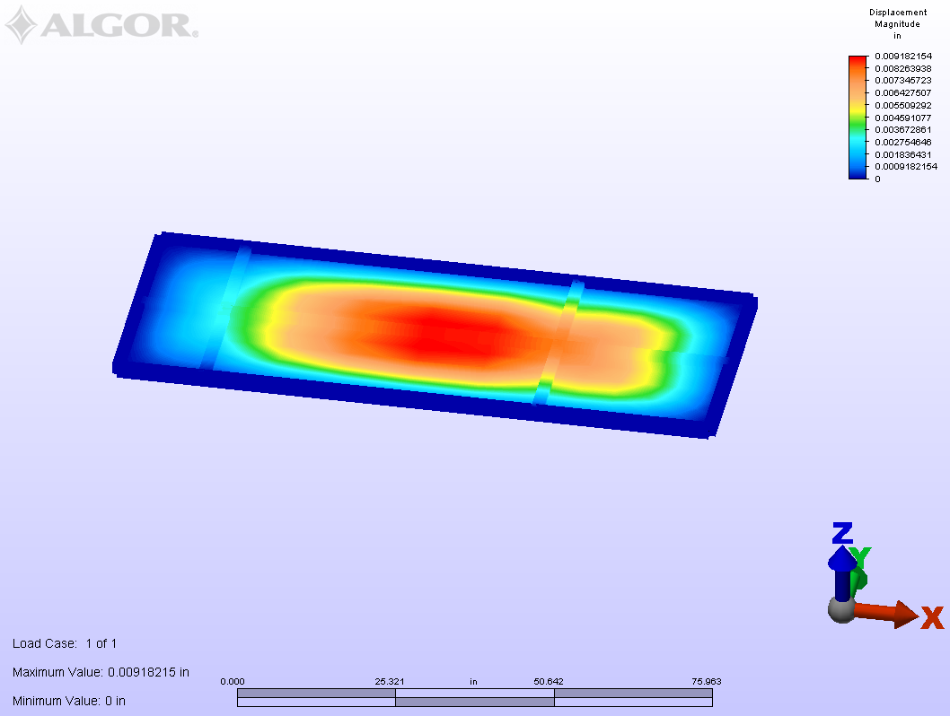
Figure A3: Displacement Analysis of the bottom floor using 0.125 in sheet metal after adding batteries
Stress
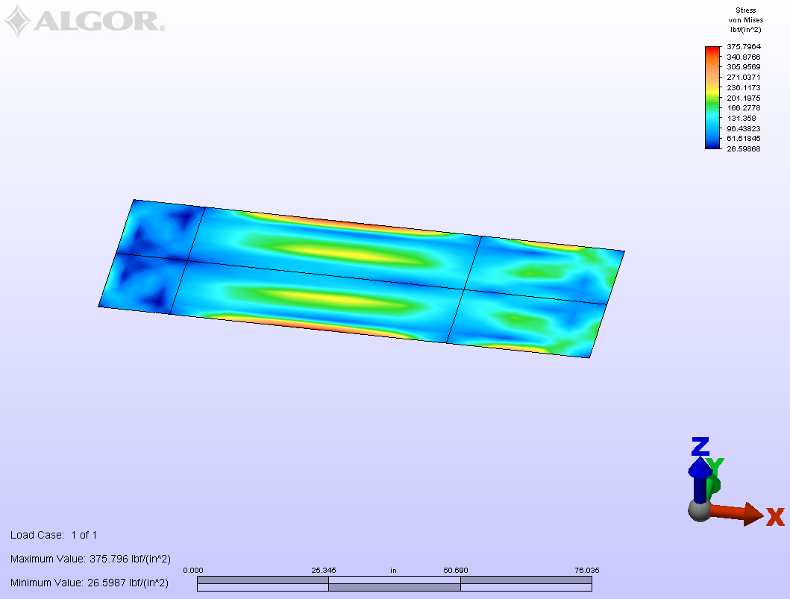
Figure A4: Stress Analysis of the bottom floor using 0.125 in sheet metal after adding batteries

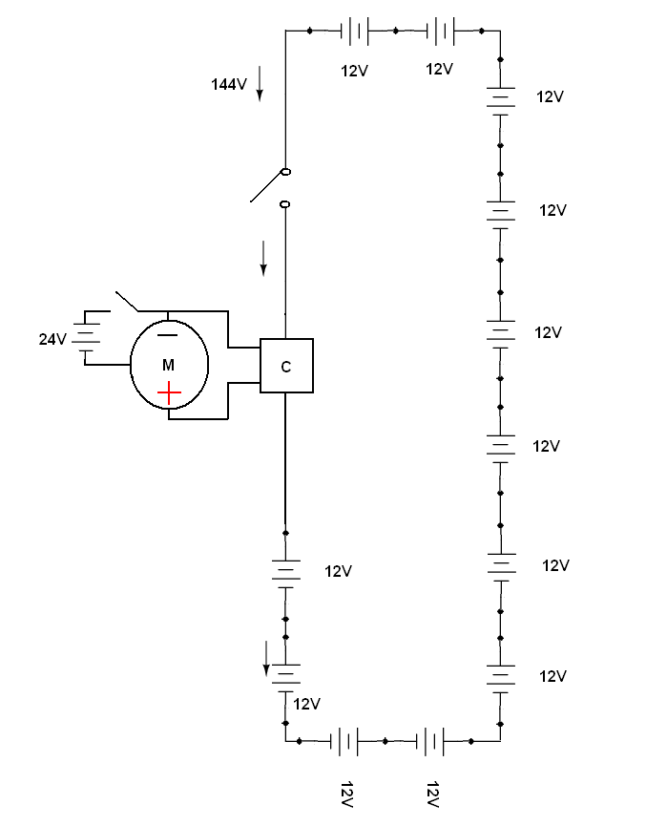
Figure A5: 12 batteries connected in series mode generating 144 volts

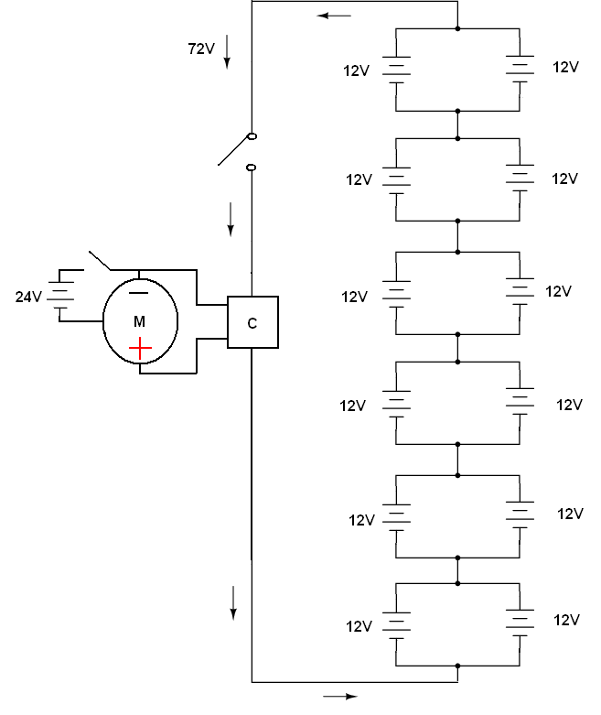
Figure A6: 12 batteries connected in parallel mode generating 72 volts

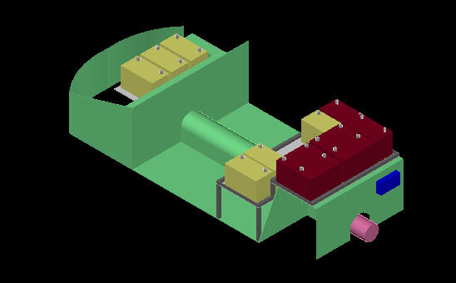
Figure A7: 6 batteries added (concept #1)

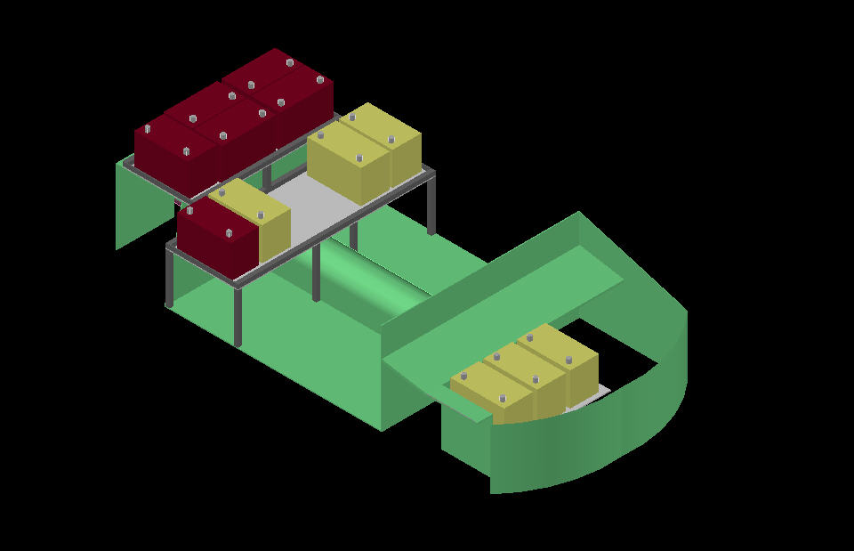
Figure A8: 6 batteries added (concept #1)

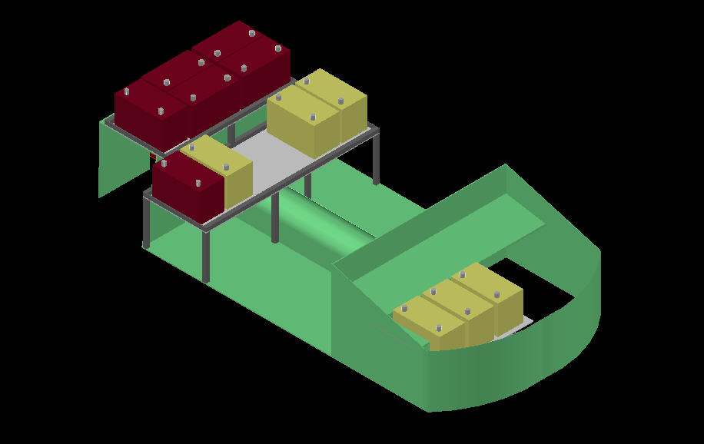
Figure A9: AC motor added (concept #2)

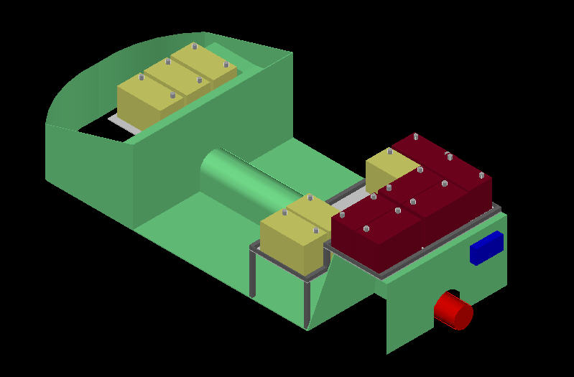
Figure A10: 6AC motor Added (concept #2)

.
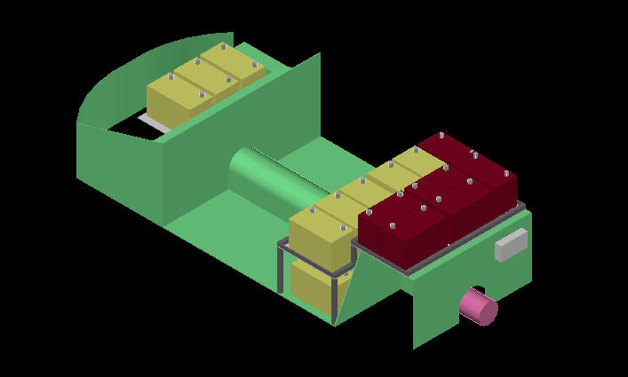
Figure A11: 10 Batteries added and a new controller (concept #3)

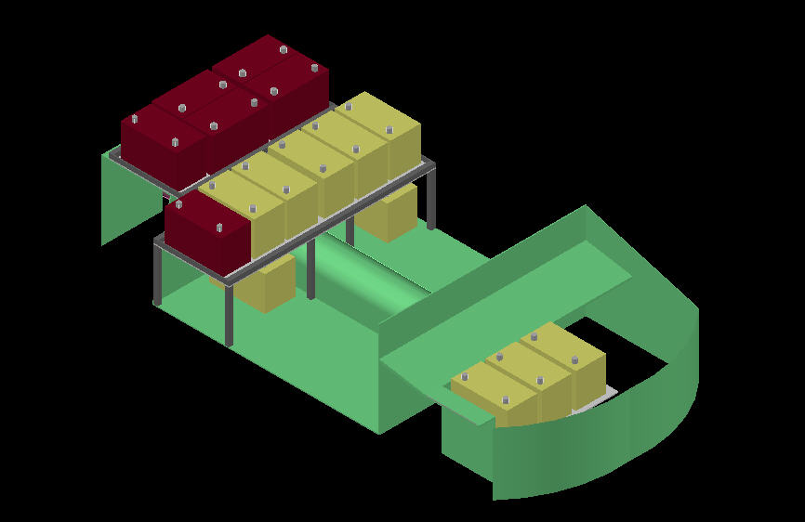
Figure A12: 10 Batteries added and a new controller (concept #3)

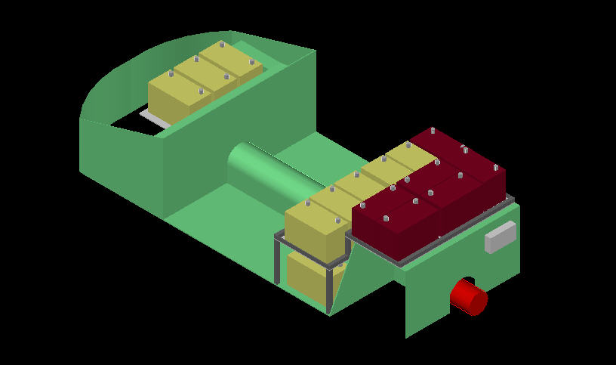
Figure A13: six 12 volt batteries placed by nine 8 volt Batteries (concept #4)

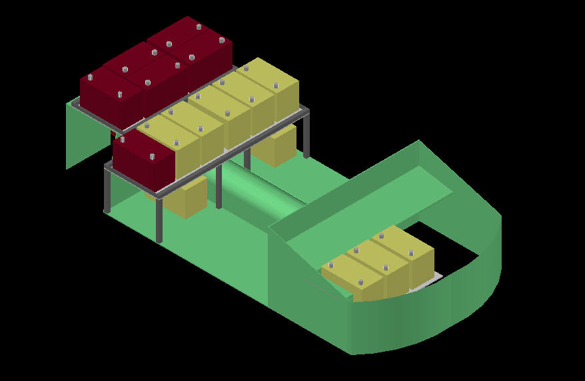
Figure A14: six 12 volt batteries placed by nine 8 volt Batteries (concept #4)

Figure A15: New motor, new controller and 10 batteries (concept #5)

Figure A16: New motor, new controller and 10 batteries (concept #5)

