Final Deliverable

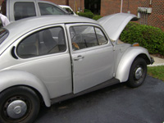

Group # 16

Rabei Rabei
Michael Boyle
Michael LaBeach
Andrew Magaletti

October 16, 2008

Table of Contents
List of Figures……………………………………………………………4

- Abstract…………………………………………………………………..5
- Introduction……………………………..…………………..…………...7
  - Background...........................................................................................8
  - Car information....................................................................................13
  - Project Scope…………………………………………...…………….15
- Performance Specification……………...…….…………..…………….16
- QFD Chart………………………………………………...……………..19
- Concept Generation and Analysis …………………………..…………20
  - Concept 1………………………………………………….………….20
  - Concept 2 ……………………………………………………….……23
  - Concept 3………………………………………………………….….26
  - Concept 4 …………………………………………………….....……29
  - Concept 5…………………………………………………….……….32
- Idea Selection……………...……...……………………………..……….35
  - Decision Matrix………………..………………………….………….35
- Testing………………………………………………………..…………..36
  - Hill Climbing…………………………………………..……………..36
  - Speed…………………………………………………...……………..38
  - Range…………………………………………………...…………….40
  - Weight Distribution…………..……………………………………….41
- Modeling and Analysis…………………………………………………..42
  - Bottom Floor…………………………………………….……………42
  - Battery Cage……………………………………………..……………43
  - Front compartment………………………………………..…………..50
  - Controller…………………………………………………..………53
- Cost analysis ………………………………………….………...……..55
- Conversion Manual……………………...………………………...….56
- Safety Precautions………………………………………………….....63
- Conclusion….…………………………………….…………………....64
- References…..…………………………………….……...…………….65
- Appendix……………………………………….……….……………...67
  - Calculations………………………………………………………..68
  - Battery Configuration……………………………..…………...…76
  - Pro Engineering Drawings……………………………..………...78
  - Cost Tables………………………………………………………...90

List of Figures
Figure # | Description | Page #
1 | Series Wound motor | 9
2 | Shunt Wound motor | 9
3 | Rotor Types | 10
4 | Alltrax controller | 11
5 | Gelled Battery | 11
6 | AGM Battery | 12
7 | Fluid Acid Battery | 12
8 | Quality Function Deployment | 19
9-A&B | 6 batteries added (Concept #1 Rear & Front View) | 22
10-A&B | AC motor added (Concept #2 Front & Rear View) | 25
11-A&B | Batteries & New Controller (Concept #3 Front & Rear) | 28
12-A&B | Nine 8 volt Batteries (concept #4 Front & Rear) | 31
13-A&B | New Motor, Controller & 10 batteries (Concept #5 Front &Rear) | 34
14 | Hill climbing | 36
15 | Speed | 38
16 | Range | 40
17-A&B | Before & After of Floor Pans | 42-43
18-A&B | Displacement & Stress Analysis Before Adding more Batteries | 43-44
19-A&B | Displacement & Stress Analysis After Adding more Batteries | 44-45
20-A&B | Assembly & Exploded Views of Rear Battery Cage | 47
21 | Battery Cage holding 7 Batteries | 48
22 | Forces acting on Rear Battery Cage | 48
23-A&B | Stress & Displacement Analysis | 49
24-A&B | Assembly & Exploded Views of Front Compartment Battery Cage | 50-51
25-A&B | Displacement & Stress Analysis | 51-52
26 | Alltrax Controller | 53
Abstract
The goal for this project is to optimize a 1974 Converted Electric VW Bug. Based on some boundary conditions, there was a common understanding of achieving higher efficiency ratings in three categories, which are speed, range, and torque. Speed for a quick travel from point A to point B, as well as maintain highway speeds for a short period of time. Range is a factor due to the fact that the batteries do not charge themselves, so based on full batteries the vehicle can travel until the batteries are fully discharged. Problems will be encountered in order to achieve the requirements. First of all, the current electric bug has a controller that is able to handle 72 volts, and in order to gain the required speed of 70 mph, the controller should supply the motor with 96 volts which is not possible through the current controller. Second of all, in order to optimize the range of the electric bug from 30 miles to 50 miles, 6 more batteries are needed. But if connected the same way as the current batteries than the resultant voltage will be 144 volts and the controller could only handle 72 volts. Third of all, the electric bug is not able to move from a dead start if parked on an incline because of the extra torque added to the motor. Therefore research was conducted on current electric bugs in order to better understand the project and attack the problem. First of all a 24V field voltage battery was added in order to supply the motor with extra 24 volts as shown in figure A3-1 (Appendix), adding the field voltage battery will add more voltage to the motor without the use of the controller; this will preload the motor with 24V and make the car able to move from a dead start if parked on an incline, also this will increase the VW current maximum speed of 57 mph to a speed of 70 mph. Moreover, connecting the batteries in a parallel/series will decrease the voltage through the controller from 144 volts to 72 volts as shown in figure A3-2 (Appendix), and this will increase the current maximum range of the car of 30 miles to 50 miles.

Introduction

In the mid 1800s, a gentleman by the name of Robert Anderson of Scotland developed the first crude electric carriage. Afterwards, a few more inventors in the Europe area were also working on their versions of an electric vehicle(s). It was not until the late 1800s that America focused on these unique vehicles. The Electric Carriage and Wagon Company of Philadelphia developed America’s first commercial application of the electric vehicle implementing a fleet of New York City taxis in 1897. The discovery of Texas crude oil reduced the price of gasoline so that it was affordable to the average consumer. Then there was an initiation of mass production of internal combustion engine vehicles by Henry Ford. He made these vehicles widely available and affordable in the $500 to $1,000 price range. The price of the less efficiently produced electric vehicles continued to rise. In 1912, an electric roadster sold for $1,750, while a gasoline car sold for $650. The need for alternate energy sources has recently soared through the roof due to America’s dependence on crude oil as the nation’s primary energy source.
The objective of this project is to optimize an already converted electric 1974 Volkswagen Beetle. After speaking with the client and inspecting the car, the group realized that a lot of work needed to be done. The client proposed to overcome problems that he faced while driving the car, problems such as, going up hills, attaining speed limits in neighborhoods, and power endurance. The client also presented some secondary tasks that need attention after the primary tasks are completed. These tasks are to fix the lighting system and to distribute the added weight around the vehicle. Clients specifications will help generate concepts to fit the proposed budget and accomplish the set goals that the customer has clearly defined.

Background
An electric car is a type of alternative fuel car that utilizes electric motors and motor controllers instead of an internal combustion engine (ICE). The electric power is usually derived from battery packs in the vehicle. In general terms an electric car is a rechargeable battery electric vehicle. Vehicles using both electric motors and other types of engines are known as hybrid electric vehicles and are not considered pure electric vehicles (EVs) because they operate in a charge-sustaining mode.
A purely electric vehicle is comprised of three main components that provide stable motion throughout the vehicles journey. The components are as followed:
Motors
There are two types of motors are commonly used in electric cars; AC and DC motors. DC motors have two configurations which are Series Wound and Shunt Wound motors. There are two types of AC motors, depending on the type of rotor used. The first is the synchronous motor, which rotates exactly at the supply frequency or a sub multiple of the supply frequency. The magnetic field on the rotor is either generated by current delivered through slip rings or by a permanent magnet. The second type is the induction motor, which turns slightly slower than the supply frequency. The magnetic field on the rotor of this motor is created by an induced current.

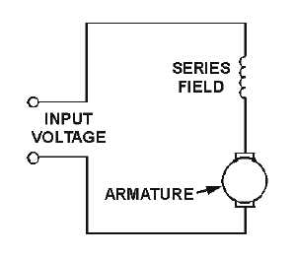
In a series wound motor, the field windings are wired in series with the armature ( Figure 1). This means that when power is supplied to a series wound motor, the armature and field currents are identical. This translates to higher torques at low speeds and lower torques at higher speeds. As a load is applied, the speed decreases but the torque increases. Special care must be taken with series motors because if they are run without a load, they will damage themselves from high speed conditions.

Figure 1: Series Wound motor

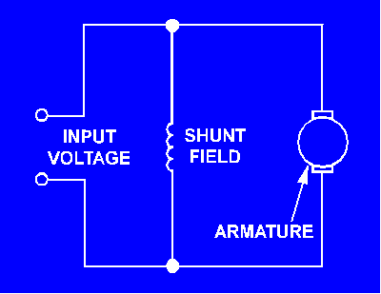
In a shunt wound motor, the field windings and armature are wired in parallel (See Figure 2). This enables the motor to maintain a near constant speed with a varying load. It does this by decreasing the torque output. Therefore, if this motor starts with a load applied, it will usually stall. This motor is usually used when a constant speed and precise speed regulation are required.

Figure 2: Shunt Wound motor

A synchronous electric motor is an AC motor distinguished by a rotor spinning with coils passing magnets at the same rate as the alternating current and resulting magnetic field which drives it as shown in figure 3. Another way of saying this is that it has zero slip under usual operating conditions. Contrast this with an induction motor, which must slip in order to produce torque.
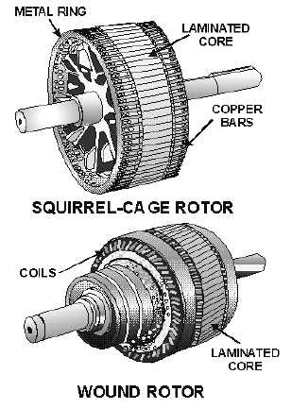
Figure 3: Rotor Types

An induction motor (IM) is a type of asynchronous AC motor where power is supplied to the rotating device by means of electromagnetic induction. Other commonly used name is squirrel cage motor due to the fact that the rotor bars with short circuit rings resemble a squirrel cage (hamster wheel).

Controllers

Most all controllers for DC motors in electric cars use basically the same principle. That principle is Pulse Width Modulation, or PWM. This is how it works: The controller is able to turn the motor on and off about 15,000 times per second (figure 4). This is the “pulse”. In order to control the speed, the time between pulses is either widened or shortened using a potentiometer. This causes the motor to either speed up or slow down.
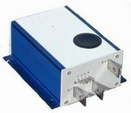
Figure 4: Alltrax controller

Batteries

Battery choice in an electric car is very important and there are many options to choose from. The most commonly used battery is the Deep Cycle Battery. Deep cycle batteries are named this because they are designed to discharge to as low as 20% capacity over several cycles. They are used in electric cars because they deliver a constant voltage as the battery discharges. Moreover, Deep cycle batteries come in many different forms including gelled, (Absorbed Glass Mat), and flooded (wet) batteries.
Gelled batteries (figure 5) are filled with a gelified electrolyte made from sulfuric acid and silica fume. This makes the resulting substance immobile and enables the battery to be positioned in many different orientations without spilling.
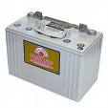
Figure 5: Gelled Battery
AGM, or absorbed glass mat batteries (Figure 6) use fine glass fibers mixed with an electrolyte. AGM batteries are more stable and have a lower internal resistance.
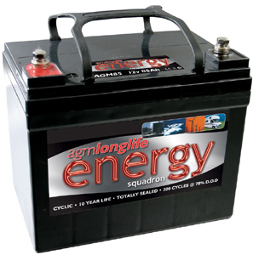
Figure 6: AGM Battery
Flooded lead-acid batteries as shown in figure 7 are the most commonly used batteries in today’s electric cars. They are made of a series of lead plates submersed in an acid solution. These batteries are only be mounted in the upright position because in any other oreintation acid would leak out of the top of the battery. Fooded lead-acid batteries will be used in the Electric Beetle.
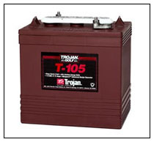
Figure 7: Fluid Acid Battery

Car Information

1974 VW Beetle Classic

1. Finished converted in October, 2006.

2. Has a Shunt 15kw electric motor.

3. Has a Alltrax controller with 6 trojan batteries.

4. Has Zivan 72/96 volt battery charger, and a 12 volt battery charger wired together to plug into a 120v house hold current.
5. Has body work and repainted the summer of 2007.

6. Has a complete new brake system from the emergency handle to the tires.

7. Has two new tires on the front. The back tires have alot of treat on them.

8. Has a volt meter, amp meter, and a curtis 72volt fuel gauge for the battery pack.

9, No cracks in any windows. The wipers work as well.

10. The interior has been cleaned down to the floor boards. A surface of rust was removed from the floor boards and all the floor boards were painted.

11. 5 batteries were placed behind the back seat, also the seat portion of the back seat was removed and a platform of plywood was build and covered with outdoor stainresistant carpeting to place the last 12 volt battery for the motor battery system and the one 12 volt battery for the 12 volt car system.

12. The front seats are not in good shape but they work.

13. The dash board needs to be replaced as well. The speed-o-meter works, the radio works.
14. The car has no heater or air conditioning.

15. The car has been stored in a garage.

16. Nothing has been done to the undercarriage, but it seams to handle the weight two people and the batteries very nicely. The previous owner drove the car around his subdivision and put around two hundred miles on the motor and battery pack. The cars top speed was 45 mph but have never tested the maximum distance the battery pack will achive. When he drives it around his our subdivision, he will discharge the battery pack down three bars going about 10 to 15 miles and not going any faster the 35 mph.

Project Scope

The expectation of the project is to optimize a 1974 electric bug. After receiving the electric car the group should become more familiar with the electrical components used in the car. Moreover, the car will be tested for speed, range and torque by changing the connection of the electric system and the batteries. Using the data collected, the group should be able to meet the customer’s needs of increasing the speed, range and torque while not exceeding the budget given. Designing a cage to hold the batteries is also extremely important and must be taken into consideration when designing such a system.
After purchasing and implementing the system upgrades to the car, the group should demonstrate performance improvements on the electric bug.

Performance Specification
- The Vehicle must attain a top speed of 70 mph
Based on background research it was concluded that the motor has to receive 96 volts in order for the vehicle to attain a top speed of 70 mph. Moreover that could be accomplished by either buying a new controller that is able to transfer 96 volts to the motor or by adding a 24 volt AGM Deep Cycle field voltage battery.
- The VW bug should be able to range 50 miles without the need to charge
From background research, more batteries are needed in order for the vehicle to range more miles without the need to charge. Adding 6 batteries and connecting all the batteries in a series parallel mode would make the car range about 55-60 miles.
- The Vehicle must be able to climb a 15 degree hill at 20 mph for more than 30 seconds
Based on background research, a 24 volt AGM Deep cycle field voltage battery could be used to overcome the torque added on the motor while traveling incline hills.
- The car must have working headlights
New headlights need to be purchased and new wires are also needed.
- The motors terminals must not melt after driving
Based on consultation from professors at the Engineering school, it was concluded that a new terminal is needed. Furthermore, the reason behind the problem was a gap between the terminal metals that caused the current to jump in between metals and that lead to a very high temperature that melted the terminal.
- The car should be able to handle all the weight caused by adding the batteries and the battery cage
A stress analysis was conducted on the bottom floor of the car using a computer simulated program called ALGORE to make sure that the car is able to handle all the weight added. Figures 18-A and 18-B show the stress analysis of the floor before the batteries were added, on the other hand figures 19-A and 19-B show the stress analysis after the batteries were added. Moreover the distribution of the maximum number of batteries is also shown by figures 11-A and 11-B using a computer program called AutoCAD, in which 3 batteries were placed in the front and a total of 13 batteries were placed in a cage in the back.
- Protection of electrical components from environmental elements
The engine compartment has vents that are allowing moisture and precipitation to reach our electrical components. The vents for the engine compartment will need to be covered with some type of material to reduce the amount of water getting in.
- Reconfiguration of smart battery charger
The current Zivan charger is over charging the batteries and jeopardizing the longevity of the batteries. From background research a shunt with a light bulb is used to notify the user when the batteries are fully charge. The shunt will also reduce the amount of voltage going to the battery to zero when the battery is fully charged thus reducing the risk of over charging the batteries.
- Rewiring the charge cable to exit out the gas fuel door
The owner has requested that the charging cable for the Zivan charger be relocated so that the cable can retract and detract through the fuel door. The addition of a retractable extension cord will be needed as well as wiring to reach from the charger to the location of the retractable extension cord.
- Dead battery testing
From talking with a knowledgeable source about electric vehicles, the use battery restoration will be experimented with. The source has said that using a battery conditioner, shaking the battery for a period of time and charging and discharging the battery will bring life to a “dead” battery. There is no evidence that this is correct so experimentation will be conducted on a dead battery to see if this process is accurate.
- Shaker table
If the dead battery testing proves to be successful a shaker table will be used for shaking the batteries. The shaker table will allow for more batteries to be shaken and will reduce the amount of time to shake the batteries.

QFD Chart
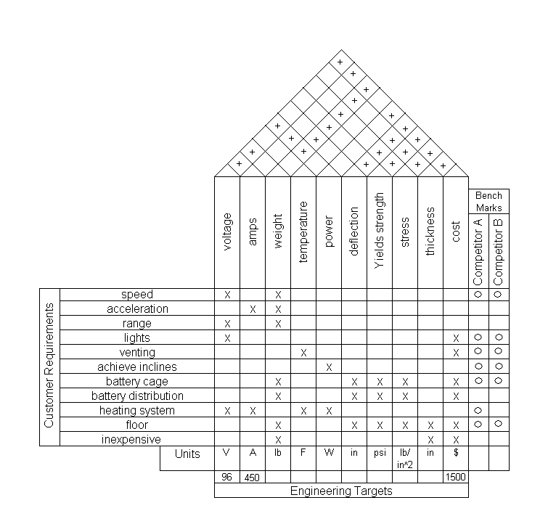
Figure 8: Quality Function Deployment

Figure 8 is a Quality Function Deployment chart that includes customer requirements, engineering requirements, engineering targets, competitive benchmarks and matrix of requirement relations. Moreover the chart shows the relationship between the customer requirements, engineering requirements and competing products. Moreover, competitor A is Dr. Larry Tilman from Ohio who used 12 batteries and the same type of motor. Competitor A achieved inclines, a speed of 70 mph, and a range of 50 miles. Competitor B is Michael Barkley from Oklahoma who used the same type of motor and controller, and connected 12 batteries in series in which he has a range of 30 miles, and a speed of 70 mph.
Concept Generation and Analysis

Concept 1

Six new batteries will be added to the car in order to achieve more range. The batteries will be distributed in the car by adding 6 batteries to the back part of the car next to the 6 existing batteries. The batteries will be connected in a series parallel mode in order to produce only 72 volts as shown by figure A6 instead of 144 volts as shown in figure A5. Moreover a 24 volt battery pack will be added to the front part of the car to give the motor more power for climbing hills. This concept is shown in figures 9A and 9B.

Analysis:

Cost:
The 6 Deep Cycle 12 volts batteries will be used since they are cheaper than the already existing Trojan batteries. Also a 24 volt pack battery will be added to help the car move and overcome inclines. Estimated cost $530.00.
Speed:
Adding the batteries to the car will increase the weight and thus affect the speed negatively, each battery weighs 66 lbs and all six batteries weigh 396 lbs. but adding the 24 volt battery pack will provide the motor with more voltage causing an increase in the speed, therefore the cars speed will increase to 65 mph.
Range:
The voltage increases by increasing the amount of batteries, also the range increases by increasing the voltage. The cars range is 35 miles before the need to charge, but by adding the 6 batteries the car is able to run for 60 miles before the need to charge.

Achieve inclines:
Adding the batteries will not increase the power but increase the weight. Therefore the car will struggle more in achieving inclines because of the added weight, but the 24 volt pack battery will accommodate for the difference.
Safety:
The car has 6 Trojan 12 volts existing batteries and 6 Deep Cycle 12 volts batteries, and by adding a different type of battery might not be as safe. Therefore each two Trojan batteries will be connected in parallel while each two 6 Deep cycle batteries will also be connected in parallel and then all the batteries will be connected in series.
Complexity:
This is a moderately complex design because of the batteries connection and the cables used to connect the batteries. The batteries are distributed around the car and are connected in a combination of series and parallel mode, which makes it more complicated in regards of connection.

Summary:
This concept minimizes cost and lowers the speed but increases range. This concept maintains a relatively simple and efficient approach to the problem, making it one of the most likely candidates to be selected because of restrictions included in the budget.

Concept 1 CAD Drawings
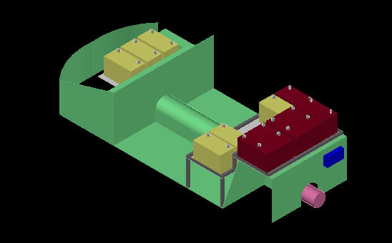
Figure 9-A: 6 batteries added (Concept #1 Rear View)

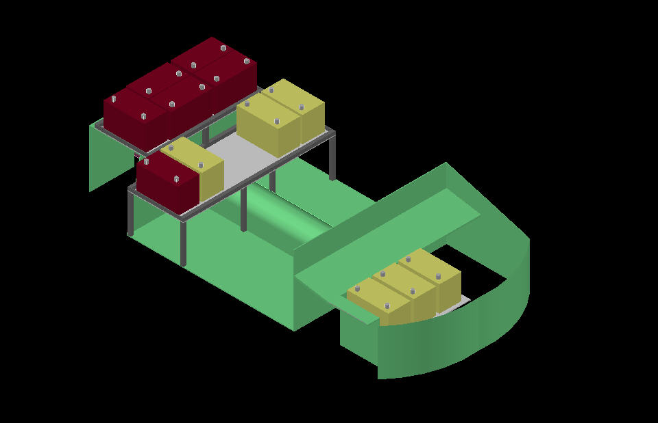
Figure 9-B: 6 batteries added (concept #1 Front View)

Concept 2

Opting for a new AC motor will increase the speed, the torque, and the mileage of our vehicle. The controller needs to be changed to a DC-AC power inverter. An inverter will convert the DC power that batteries generate and convert it to AC power that is accepted by the motor. This concept is shown in figures 10-A and 10-B.
Analysis:

Cost:
The AC Motor will be used since the use of the Trojan batteries is more efficient. The controller would have to be replaced with an inverter to convert the DC power from the batteries to an acceptable AC power for the Motor. Estimated cost $4000.00.
Speed:
The new motor will give the vehicle added speed due to how the AC Motor handles different frequencies, the higher the frequency the faster the car. Estimated speed 60
Range:
The way the AC Motor draws its power from the batteries through the inverter. The cars range is 35 miles before the need to charge, so by adding the AC Motor will affect to total range positively. Estimated range 45 miles
Achieve inclines:
AC motors are the rated the best piece of equipment when combating hills or rough terrain. This will handled the vehicle inability to climb inclines.
Safety:
The vehicle will be using the same batteries it has, 6 Trojan 12 volts batteries and by adding an AC motor will cut on weight, theoretically improving the speed and overall range. As long as the proper procedures are taken removal of the motors as well as the controller, the optimization will be safe.
Complexity:
This project calls for a lot of labor and patience. The difficulties that will arise while introducing this concept will probably occur with the removal and the installation of the old and new motors, respectively. Problems may happen with the connection of the inverter to the existing system

Summary:

All tasks can be met with the change from DC to AC power. The vehicle will be more effective in the three categories of speed, range, and torque. This concept provides a quick and effective solution to the problems recently encountered with the vehicle.

Concept 2 CAD Drawings

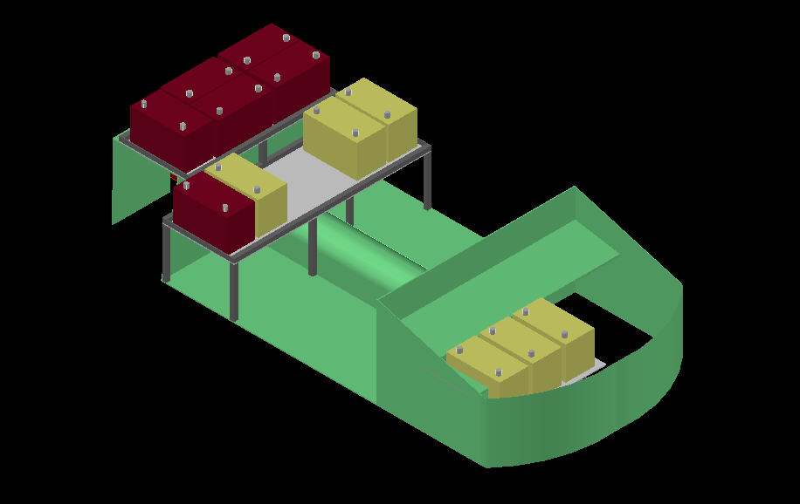
Figure 10-A: AC motor added (Concept #2 Front View)

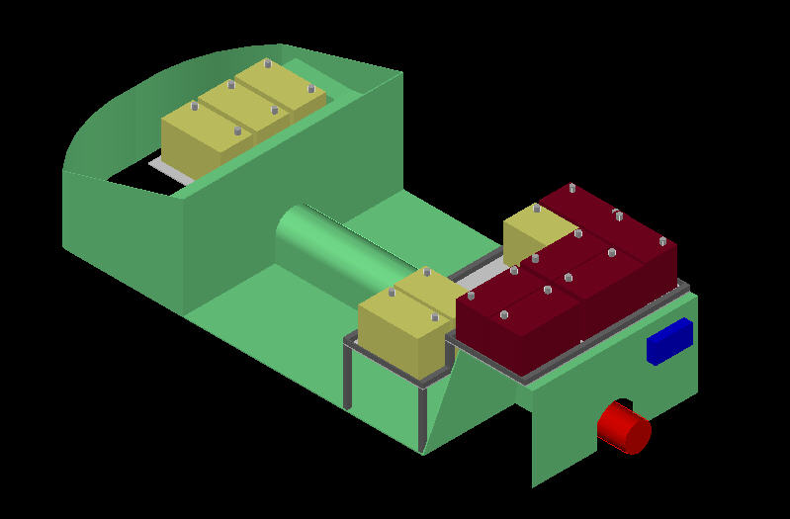
Figure 10-B: 6AC motor Added (Concept #2 Rear View)
Concept 3

A new controller will be added to the car as well as ten new batteries to increase the total system voltage to 96V. The addition of ten new batteries will help increase the speed and by connecting the batteries in series/parallel the range will be increased as well. The new controller allows the system voltage to be increased from 72V to 96V. This concept is shown in figures 11-A and 11-B.
Analysis:

Cost:
Buying a new controller is not cheap and since we will also be buying batteries as well the cost of this budget will exceed the budget. The cost of the ten batteries will be around $800 and a new Curtis Controller costs around $1400. The reason we chose the Curtis Controller is because it is one of the most reliable.
Speed:
The speed of the system will increase by about 15mph since the system voltage will have 24V more than the existing. The one draw back is the addition of ten batteries which will add 660 pounds to the car. The estimated speed for the car with the weight and new power will be about 65 mph.
Range:
The range will be increased because of the addition of the 10 batteries. By putting them in a series/parallel configuration the range is now doubled compared to its initial range. The range now is 70 miles as compared to 30 miles.

Achieve inclines:
By increasing the total voltage of the system it will be able to climb hills. The reason is because the motor does not have any low end torque due to the motor being shunt wound. The increased voltage will help to go up inclines while moving but from a stand still the motor will still have the same problems.
Safety:
By changing the controller to a more powerful one the system will now be more danger for someone working on it. By switching the batteries to a series parallel the system will also have more amps which will increase the amps and that would be dangerous to anyone who touches it.
Complexity:
The new configuration will be more complicated because we will be adding 10 new batteries and a new controller. On top of adding new batteries we will also be rewiring the battery configuration from a series to a parallel series which will be a very complex system.

Summary:

This concept is a costly one because we are buying more batteries and a controller. Both are very costly and will deteriorate our budget faster than anticipated. The range and speed will see great increases which are two objectives that we are trying to meet for the client. Unfortunately the ability to go up inclines; safety and complexity will not be beneficial in this concept

Concept 3 CAD Drawings
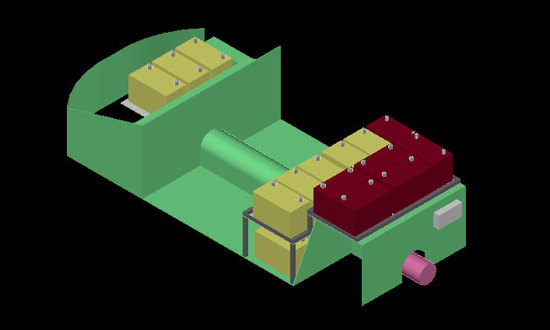
Figure 11-A: 10 Batteries added and a new controller (concept #3)

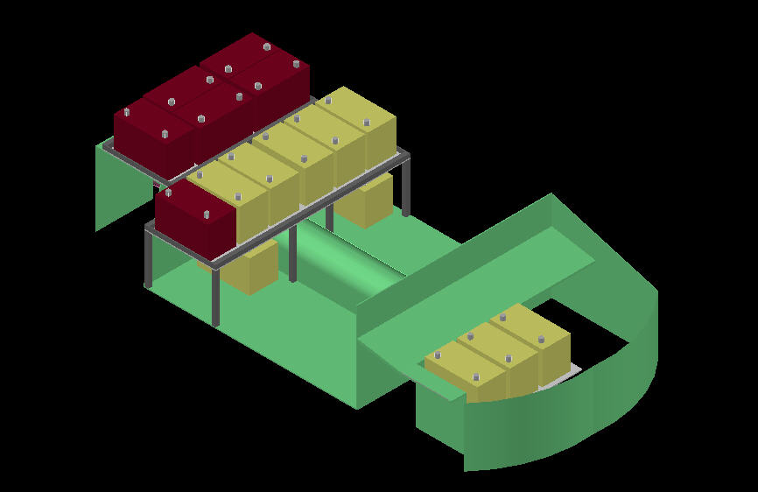
Figure 11-B: 10 Batteries added and a new controller (concept #3)

Concept 4

Components needed: (9) 8V Deep Cycle Batteries, and 24V Battery Pack

This setup would use the current motor and controller. The main difference is the power source. 9 8V batteries wired in series would be used to deliver 72V to the armature with a separate 24V battery pack powering the field voltage. 8V batteries have a higher energy density than 12V batteries because they deliver the same or more amps at a similar weight. Because of the higher energy density, they last longer than a 12V battery. This means an increase in range. This concept is shown in figures 12-A and 12-B.

Analysis:

Cost:
Using 9 8V Deep Cycle batteries would cost $720.00. This does not include the 24V field voltage source price of $120.00.
Speed:
This configuration would offer an increase in top speed because an 8V battery pack would weigh less. Estimated top speed: 70mph
Range:
This is directly related to weight and battery configuration. The 9 8V batteries would be wired in series in order to achieve 72V. However, because of their increased energy density, range would be increased. Estimated range: 45 Miles
Achieve inclines:
The 24V field voltage enables the vehicle to climb hills without problem. This is part of a separate circuit that switches on when the key is turned. It enables the field to charge to its maximum before power is supplied to the armature through the controller.
Safety:
The safety concerns with this setup are the same as any high voltage/high amperage setup. An additional concern is the weight of the battery pack. It needs to be properly secured to prevent movement in a crash.
Complexity:
The complexity is moderate due to the separate field and armature voltages. It requires a bit more wiring and planning. However, the lesser the batteries means slightly less complex.

Summary:

The ideal batteries for electric cars are low voltage, high amperage batteries. These tend last the longest. Using 6V batteries would have the highest energy density but they are expensive and more would be required to reach 72V. This translates to more weight and more cost. 8V batteries provide a nice compromise because they have high enough energy density, are cheaper than 6V’s, and only 9 would be needed. With 72V to the armature and 24V to the field, both a top speed of 70mph and hill climbing could be realized. However, with only 9 batteries, a range of 50 miles may not be able to be achieved.

Concept 4 CAD Drawings
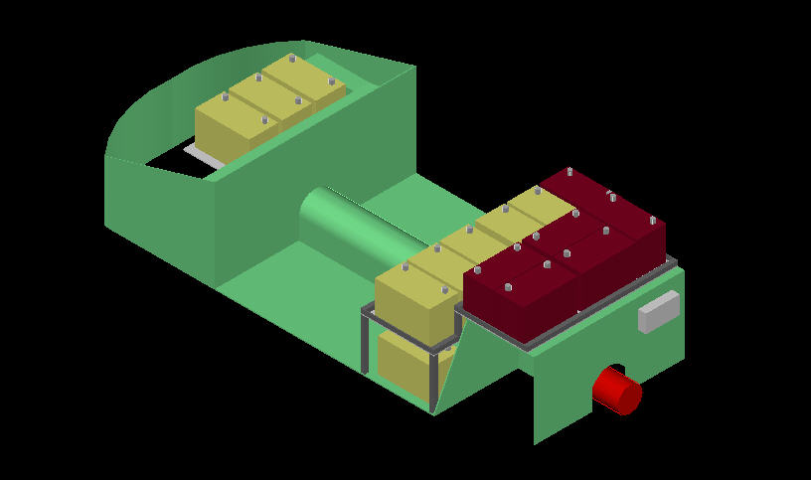
Figure 12-A: six 12 volt batteries placed by nine 8 volt Batteries (concept #4)

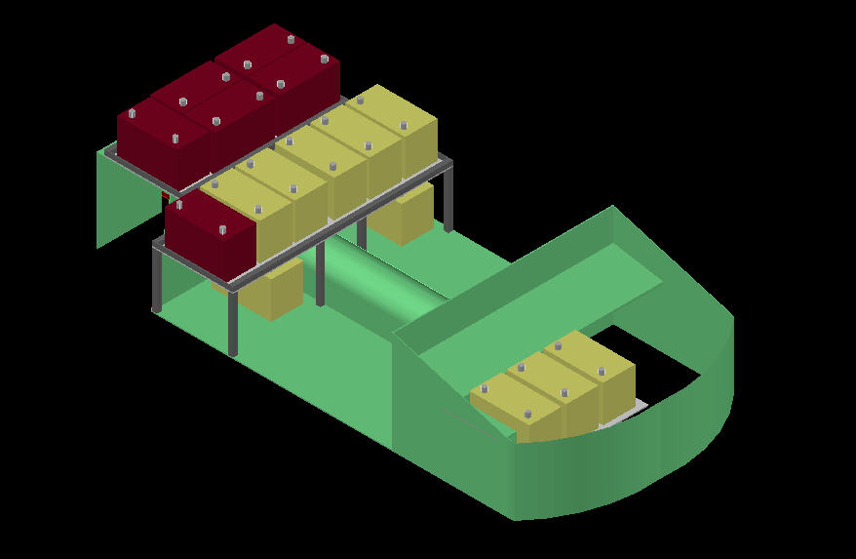
Figure 12-B: six 12 volt batteries placed by nine 8 volt Batteries (concept #4)

Concept 5

Components needed: Advanced DC L91-4003 Series Motor, Kelly Controls KDH09500A, and (10) 12V Deep Cycle Batteries

This setup represents the easiest and cheapest way to reach the clients needs. It would use a new series wound motor, a new 500A controller, and 10 additional 12V deep cycle batteries. The batteries would be wired in series/parallel configuration. This concept is shown in figures 13-A and 13-B.

Analysis:

Cost:
Expensive. The Advanced DC L91 costs $1004.86, the Kelly controller costs $799, and the 10 additional batteries would cost at least $700. Total cost coming to $2506.86.
Speed:
This option would obviously enable an increase in top speed. At 96V, the pack and the motor should be able to bring the car to about 80mph.
Range:
The 16 12V batteries would be wired in a series/parallel configuration. This means that the amperage drain on each of the batteries will be cut in half which translates to an increased range.
Also by changing from a shunt wound motor to a series wound, efficiency is increased. Estimated range: 70 miles

Achieve inclines:
With the series motor, the vehicle will be able to climb hills because it will have a low end torque when a load is applied (hill). The startup torque will not be as good as with a shunt wound with a separate field power source.
Safety:
The safety concerns with this setup are the same as any high voltage/high amperage setup. An additional concern is the weight of the battery pack which will be around 1056lb. It needs to be properly secured to prevent movement in a crash.
With any series wound motor, if power is supplied without a load, the motor will “run away” and possibly explode.
Complexity:
The complexity of this setup is minimal. The most complex part is the battery wiring. The rest is essentially plug and play.
Summary:

There is no doubt that this configuration would be able to achieve the desired goals. With a top speed of ~80mph, a range of 70 miles, and the ability to climb hills, this setup would meet and exceed performance requirements. It would be nice to do, but at the cost of over $2500, far exceeds the budget.

Concept 5 CAD Drawings
Figure 13-A: New motor, new controller and 10 batteries (concept #5)

Figure 13-B: New motor, new controller and 10 batteries (concept #5)

Idea Selection

Decision Matrix

Table 1: Decision Matrix

Decision Matrix | Cost |  | Range |  | Speed |  | Safety |  | Torque |  | Complexity |  | Total
Decision Matrix | Weight | % | Weight | % | Weight | % | Weight | % | Weight | % | Weight | % | Total
CONCEPT 1 | 90 | 0.4 | 80 | 0.2 | 70 | 0.2 | 60 | 0.05 | 70 | 0.1 | 70 | 0.05 | 79.5
CONCEPT 2 | 30 | 0.4 | 50 | 0.2 | 60 | 0.2 | 40 | 0.05 | 90 | 0.1 | 40 | 0.05 | 47
CONCEPT 3 | 60 | 0.4 | 90 | 0.2 | 70 | 0.2 | 50 | 0.05 | 60 | 0.1 | 60 | 0.05 | 67.5
CONCEPT 4 | 80 | 0.4 | 50 | 0.2 | 80 | 0.2 | 60 | 0.05 | 70 | 0.1 | 70 | 0.05 | 71.5
CONCEPT 5 | 40 | 0.4 | 90 | 0.2 | 95 | 0.2 | 30 | 0.05 | 80 | 0.1 | 30 | 0.05 | 64

As shown by table 1, concepts 3 and 4 scored the highest range but they were discarded because of the budget constraint. Concepts 2 and 5 were discarded because of the addition of the motor which is the most expensive part in the car. Therefore, Concept number 1 is the best idea that fits the projects since the cost is one of the biggest constraints in the VW bug project.

Hill Climbing
Figure 14: Hill Climbing

In the hill climbing test, we timed how fast the car climbed up a hill of known grade and length. The main pack voltage was kept a constant 72V in both trials. The grade was 6.8% and the length of the hill was 143ft, as shown by the calculations in the appendix. The main variable was the use of the field pack. In the 1st trial, the field pack was applied, enabling the car to climb the hill in an average time of 8.75 seconds. In the 2nd trial, the field pack was removed and the car was retested. The results showed a substantial decrease in performance, climbing the hill in an average of 19.23 seconds. On the final run of the 2nd trial, the car could not even make it up the hill. We believe that the only reason the car climbed the hill in the first three runs of the 2nd trial is because the field winding was still magnetized from the 1st trial (Figure 14). The results of this test gave us quantifiable data in which to compare future testing results with. The raw data is shown in the following table.
Table 2: Hill Climbing

Hill Climbing
w/ FP (s) | w/o FP (s) | Run
9.2 | 14.2 | 1
8.6 | 18.4 | 2
7.9 | 25.1 | 3
9.3 | * | 4
8.75 | 19.23333 | <- Average

*Note: In the last run of the without field pack trial, the car never made it up the hill. This value was left out to be commented on in the graph.

Speed
Figure 15: Speed

The results of the speed test are in figure 15. The car was taken to its top speed three separate times with and without the field pack. The results showed an overall increase in top speed when using the field battery pack. Without using the field pack, the average top speed was 51mph. When the field pack was applied, the average top speed increased to 65.5mph. In the last run using the field pack, the main contactor terminal melted off. This was attributed to a loose connection that caused a short. The raw data is shown in table 3. Without the field pack, the previous top speed was 45mph. It was increased to 56 by lengthening the accelerator pedal thus causing more displacement of the potentiometer. This drives the controller faster.

The green line in Figure 15 shows our expected top speed upon completion of the project. It should be around 70mph, meeting the client’s requirements.
Table 3: Raw Data Runs

Speed
w/ FP(mph) | w/o FP (mph) | Run
64 | 45 | 1
67 | 56 | 2
 | 52 | 3
65.5 | 51 | <- Average

Range

Figure 16: Range

The chart above (Figure 16) shows the current range of the car and the range we expect to achieve upon completion of the project. The average max range is currently 31.35 miles. This is measured at full discharge of the batteries. When the project is completed, a range of 53 miles is predicted. The table below shows the raw data.
Table 4: Raw Data Runs

Range
w/o FP (mi) | Run
33.3 | 1
29.4 | 2
31.35 | <- Average

Weight distribution

The distribution of weight in the vehicle will only affect the traction on the tires not the overall performance with speed, torque, and range. We conducted an experiment to prove this theory; the experiment was done by putting one group member who weighs 190 lbs, which is approximately the weight of 3 trojans batteries, was placed on the hood of the vehicle to simulate adding 3 batteries in the hood compartment of the vehicle. Two group members were placed inside the vehicle to simulate the weights of the vehicle occupants during daily travel. The test was conducted in the same fashion as the torque experiment, the only difference, after the group member who was placed on the hood was relocated inside of the vehicle to simulate all batteries placed in the rear. Trails showed that the car traveled up the hill at the same rate in either orientation (batteries in front compartment or rear of car).

Modeling and Analysis

Bottom Floor

The bottom floor of the car was rusty when the car was received as shown in figure 17-A, therefore the bottom floor was cleaned by the removal of the dust as shown in figure 17-B. A stress analysis was conducted on the bottom floor as shown in figures 18A and 18B that showed a maximum stress of 345psi and a maximum displacement of 0.0047in. Afterwards another stress analysis was conducted after adding the battery cage with a maximum number of 15 batteries, the analysis showed a maximum stress of 375psi and a maximum displacement of 0.009 as shown by figures 19A and 19B.

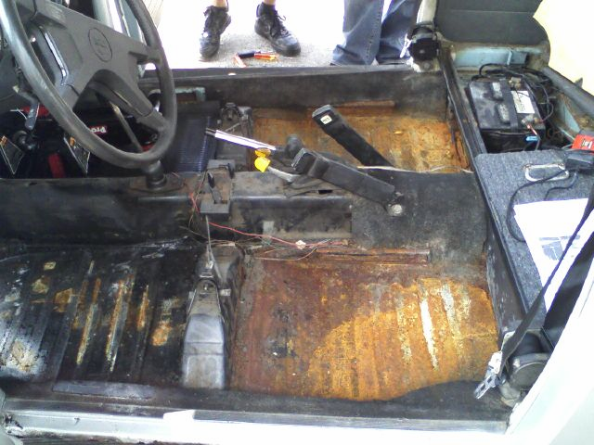
Figure 17-A: Floor pans of the electric bug when first received

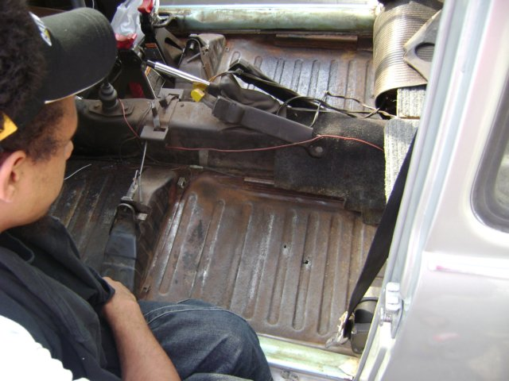
Figure 17-B: Floor pans of the electric bug after removing rust

Stress Analysis
Displacement
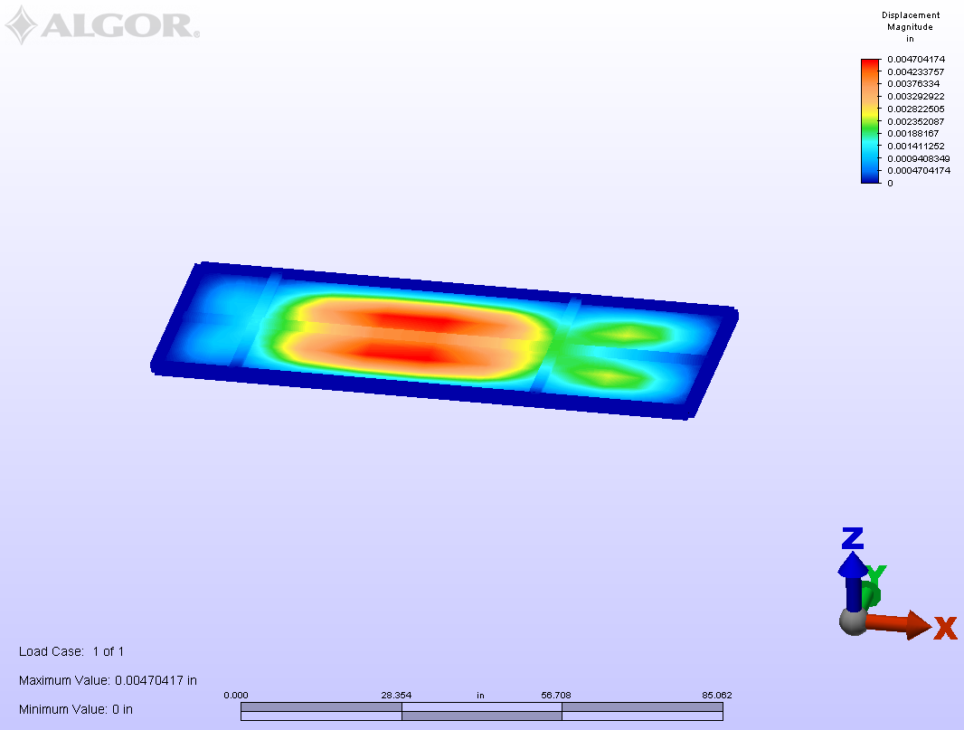
Figure 18A: Displacement Analysis of the bottom floor using 0.125 in sheet metal
Stress
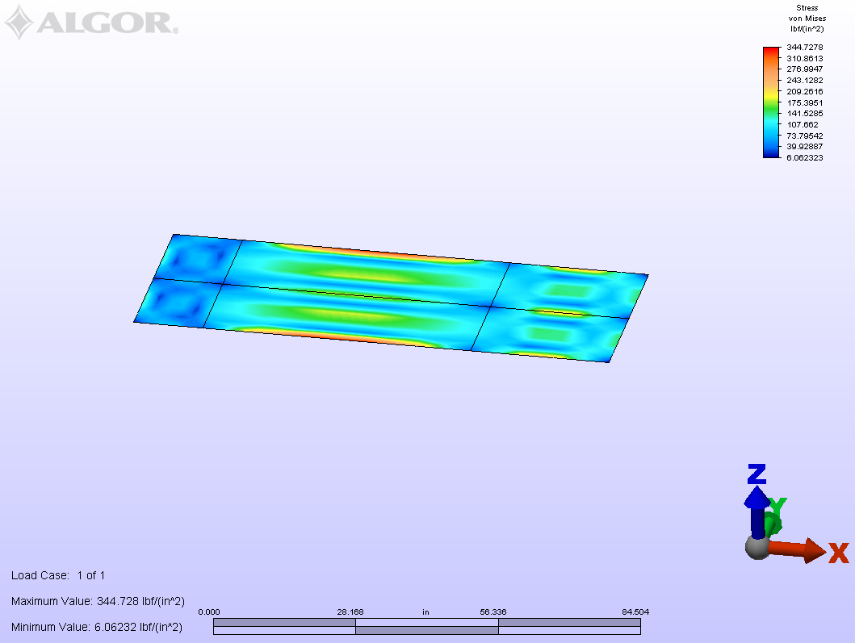
Figure 18-B: Stress Analysis of the bottom floor using 0.125 in sheet metal

Displacement
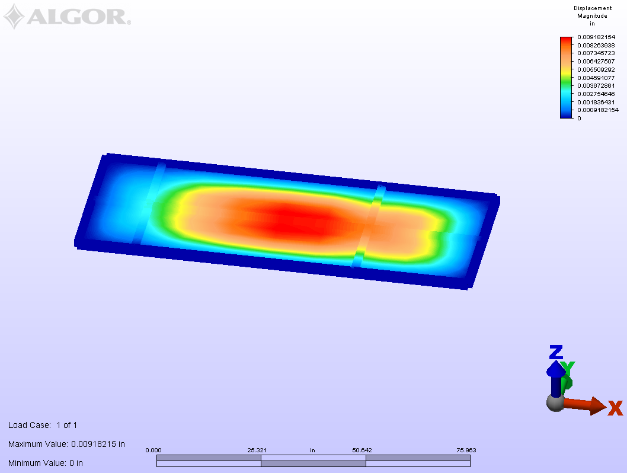
Figure 19-A: Displacement Analysis of the bottom floor using 0.125 in sheet metal after adding batteries.

Stress
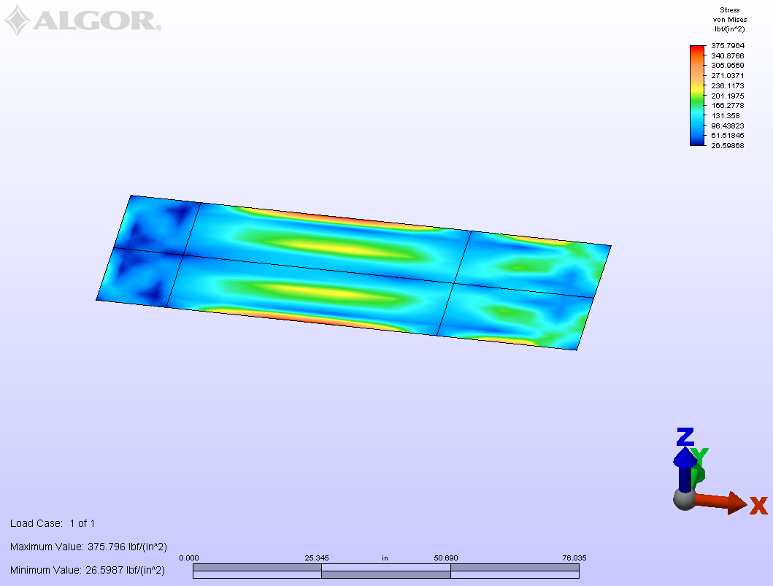
Figure 19-B: Stress Analysis of the bottom floor using 0.125 in sheet metal after adding batteries

From the maximum stress and displacement values it was concluded that the bottom floor will not fail since the maximum stress of 375 lb/in^2 is below the failure value of the floor metal at 36,000 psi.

Battery Cage

A battery cage was build in order to hold some of the batteries needed, the cage is going to be placed in the back of the car taking the place of the back seat. Moreover, the cage is able to hold 7 batteries as shown by figure 21, and is going to be made out of steel A-36, this material was chosen because steel is strong and not too expensive, this decision was also made based on some calculations made in order to make sure that the cage will not fail because of the weight or braking. The cage was built using a computer program called Pro-E as shown by figures 20A and 20B (bill of materials and individual parts figures are shown in the appendix by figures A-4-1 through A-4-17). Moreover a stress analysis using a computer assimilated program called Algore was used in order to do a stress analysis to make sure that all the material will not fail because of the weight or in case of breaking. An analysis was done by applying different forces as shown by figure 22, in which a downward force of 462lbf was applied based on calculating the weight of the batteries, and also a side force of 618lbf was applied that was attained by pressing on the breaks completely while going 70mph which is the top speed of the car (Algore calculations could be found in the appendix under Algore battery cage calculations). A maximum stress of 21,343 lb/in^2 and a maximum displacement of 0.41 inches was attained as shown by figures 23-A and 23-B respectively, as a result the material will not fail since steel-A36 fails at a stress of 36,000 lb/in^2.

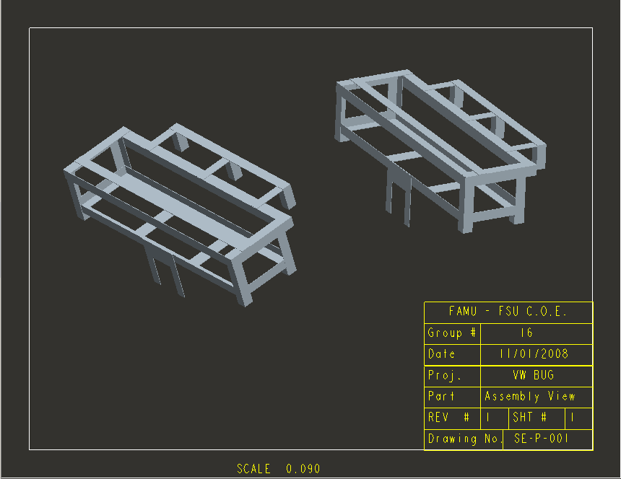
Figure 20A: rear battery cage assembly view

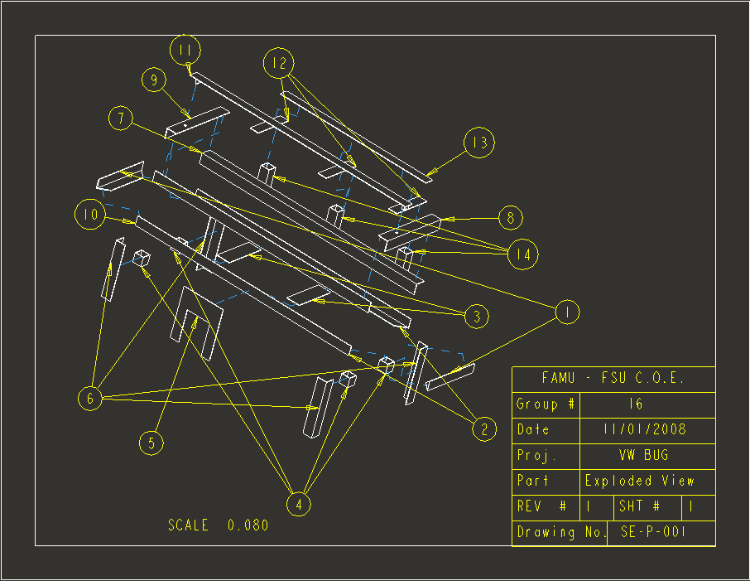
Figure 20-B: rear battery cage Exploded view
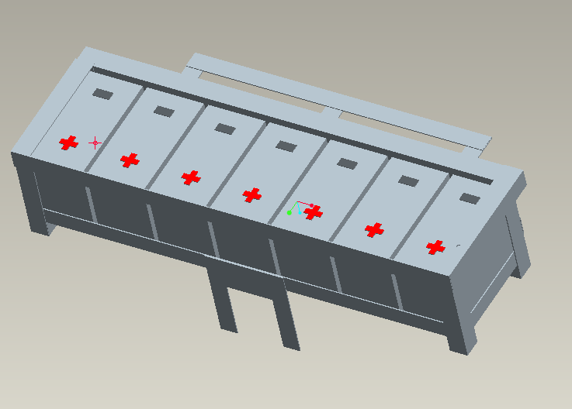
Figure 21: Battery cage holding 7 batteries

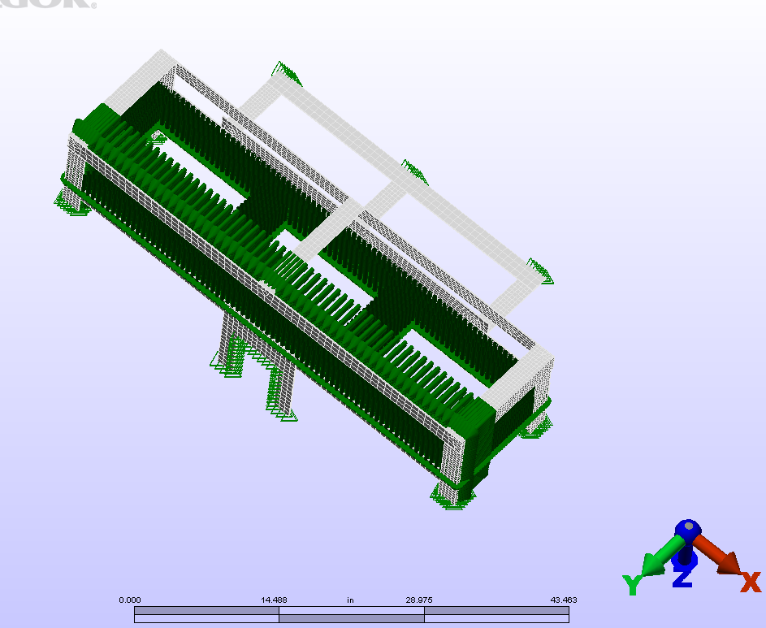
Figure 22: Forces acting on the battery cage
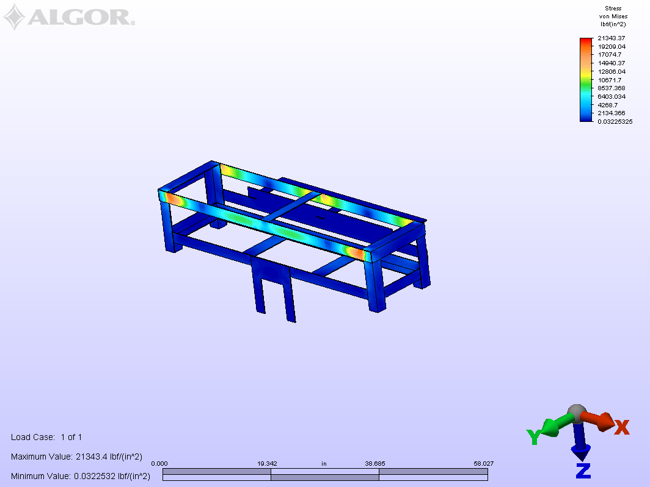
Figure 23-A: Stress Analysis using Algore (maximum stress 21,343 lb/in^2)

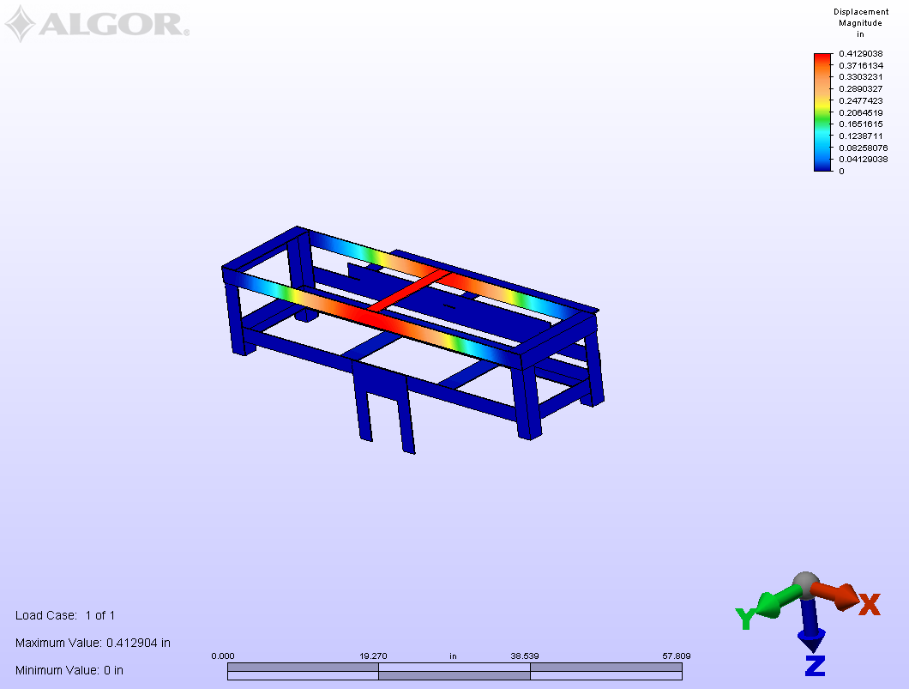
Figure 23-B: Displacement Analysis using ALGORE (maximum Deflection of 0.41in)

Front compartment

A battery cage is need for the front of the car. There is a cavity where the gas tank used to sit in the VW Beetle that could be used to store extra equipment in the vehicle. To distribute some of the battery weight, a cage will be fabricated in the extra space. Pro\E will be used to build a prototype of the way it should be designed; as seen in Figures 24-A and 24-B (individual part figures are shown in the appendix by figures A-5-1 through A-5-6). Stress analysis was also conducted using Algore to make sure that the design is able to hold the weight of the field pack batteries shown in figures 25-A and 25-B. Theoretical analysis was conducted to see how much force was applied to each member, shown in figures. The Analysis done by Algore shows that the braces will only displace 0.0068 inches and have maximum stresses of 3318 $\frac{\text{lbf}}{{\text{in}}^{2}}$ with 40 pounds acting on each brace, which makes the design feasible.
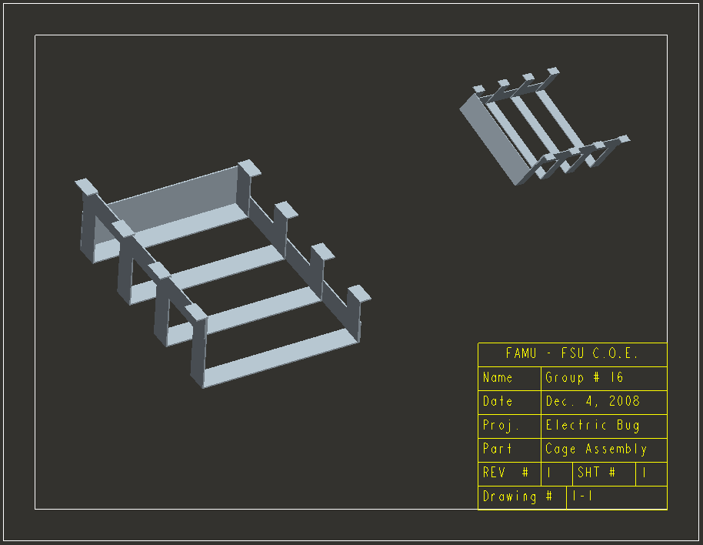
Figure 24-A: Front Compartment battery cage assembly view
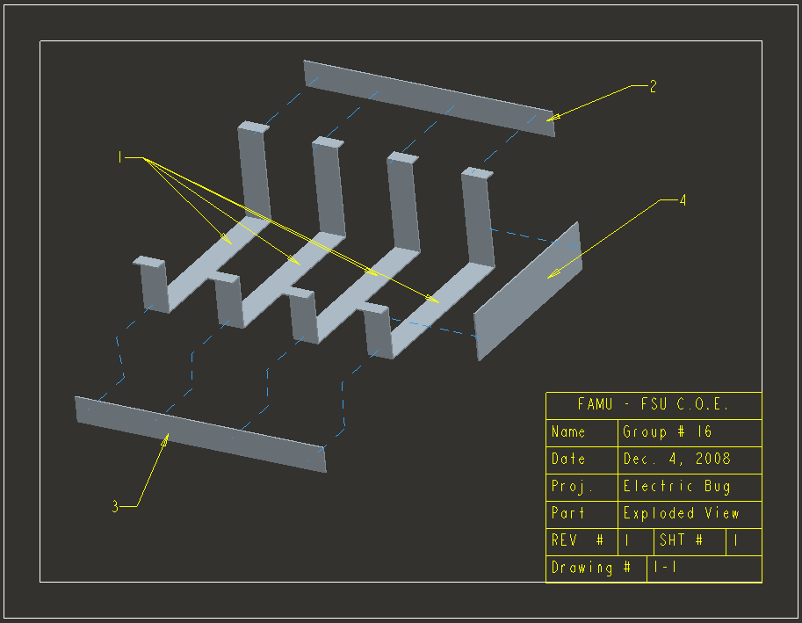
Figure 24-B: Front Compartment battery cage Exploded view

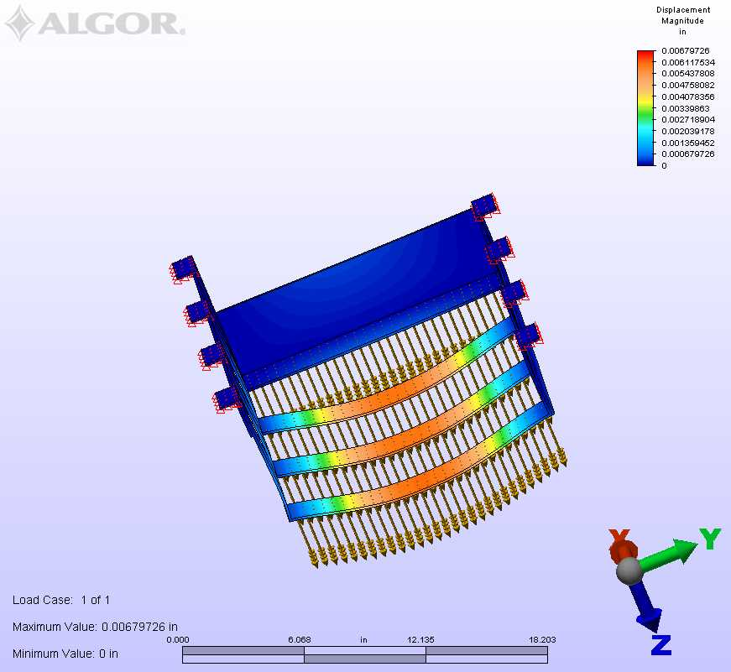
Figure 25-A: Displacement Analysis using ALGORE (maximum Displacement0.006 in)

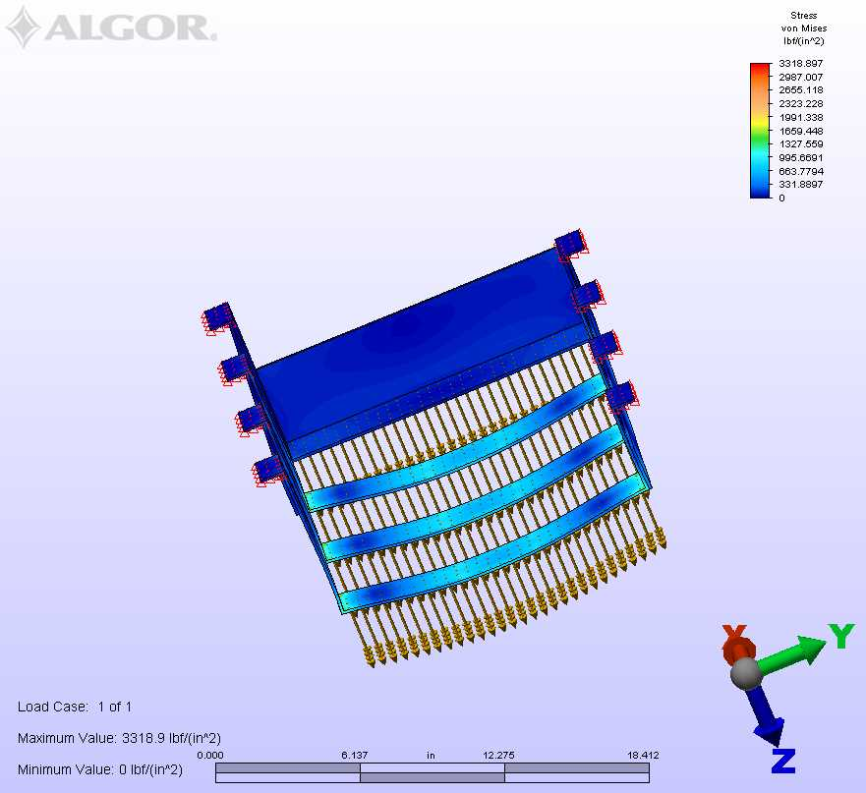 Figure 25-B: Stress Analysis using ALGORE (maximum Stress 3318 lb/in^2)

Controller

Figure 26: ALLTRAX Controller

Effective heat dissipation is a concern in an electric car, as with many mechanical engineering systems. The Alltrax 7245 Controller (figure 26) will be managing the power output of the battery pack and controlling the motor using pulse width modulation. The battery pack will output 72 volts of DC power. The controller is rated to receive voltages between 24-72 volts. This means that it will be operating at its upper limit. Preliminary testing revealed that during normal operation, the controller tends to overheat. The controller has a built in temperature safety switch. When the temperature gets too high, the controller shuts down to prevent damaging itself. This of course causes the car to become inoperable.
In order to combat this shut down, three approaches were considered. The first was to use heat sinks to draw more heat away from the device through natural convection. The second was to use fans to cool the device through forced convection. The third is a combination of the two.
The controller does have an existing heat sink, however, the fins are very small and do not provide enough heat dissipation, especially in warmer months. This is also the reason that adding heat sinks to the controller housing is difficult. The rough surface of the existing heat sink makes good contact with the metal difficult. It is for this reason that the controller cooling system will be comprised of two 92mm 43.5CFM fans blowing directly onto the existing heat sink. They will be supported by an angle bracket mounted just above the controller on the device board.

Cost Analysis

Table 5: Cost of each part needed

The above table shows future expenditures. The total budget came to $1,408.60 with $91.40 remaining. (Table A1). It shows the contact information and product page of each component. Below is the table showing the metals selection for the battery cages. A-36 steel was chosen because it is inexpensive, easily welded, and strong enough for our application. The expanded versions of the tables are listed in the Appendix (Table A2).
Table 6: Cost of steel parts
Conversion Manual
The first thing that needs to be done before any items are bought for the conversion is to do research. Research on how the car will be used in daily life, what kind of car you want to convert and how much money is going to be spent. The reason the research on how the car will be used is done is so that a car is not converted for city miles and then used for driving on the highway or used for city driving and then driven up into the mountains. Chances are the car will not work well in either situation. So to overcome this obstacle, the customer needs to write a list of places the car will be driven to. The next thing to research is the car that will be used for the conversion. Not every car can be used for an electrical conversion and not all cars are the best ones to use for conversions. Some of the best cars to use for beginners are Volkswagen Beetles and Rabbits, Chevrolet S-10s, Porsche 914 or any car that is relatively small in size and shape. Converting cars bigger than these is possible but in the long run will cost more. Also the body work of the car needs to be checked, and getting a car that is completely rusted inside and out is not a good idea. Likewise getting a car that has holes or a bent frame will not be a good choice. A car that is old but is in good shape, with little rust and four tires is a good choice and won’t cost as much as rebuilding a rusted car. The final aspect to consider is the total amount of money being spent on the overall conversion. This is one of the hardest things to do because problems that happen while the conversion is going on cannot be foreseen, so use proper judgment and leave plenty of room for error.
Once the car has been chosen for the conversion and a budget has been set it is time to remove the car’s engine. This must be done because there is no need for the engine as it will be replaced by the electric motor. Also remove all parts that are associated with the motor except for the transmission. The existing transmission can still be used. Any other parts that are not necessary can be taken out, the lighter the car the better the performance. The system could be planed once the parts mentioned are out of the car. There are four major parts that will need to be researched and bought to complete the conversion. The motor, the controller or inverter, battery charger and batteries are the main components that need to
Now that there is room it is time to decide on the system that will be installed into the car. There are three different motor types that will determine the other components of the system. The first type of motor, and the most popular, is the series wound DC motor. The reason why these motors are so popular is because they are fairly cheap, very efficient and rarely need servicing. These are great advantages for a beginner to electric cars. A disadvantage of the series wound DC motor is that it does not go up hills very well. If living where there are hills this would not be a very good choice. Another motor type that is used is the shunt wound motor. These motors can be fairly cheap because most of them were aircraft generators. The advantages of using this motor are the same as using the series wound. The disadvantage of using this motor is that if there is any load on the engine it will not have any torque to move the car. This means that even the smallest of inclines will have the motor moving the car at a snail’s pace. There is a way to overcome this obstacle and that is to add a 24 volt battery pack to your system and connect it to the field of the motor so that 24 volts is charging the motor. This will help to over come any low end torque problems that may occur. One other advantage that the shunt wound motor has is that it is better suited for regenerative braking. Regenerative braking is an advantage in that it helps to recharge the batteries whenever the motor is not being used to propel the car. If the car is coasting down a hill, the regenerative braking can be set up to work by tapping on the brakes on the way down the hill. By tapping on the brakes, a switch is activated changing the polarity of the motor so that the flow of electricity is going toward the batteries. Regenerative braking has been said to add about 10-20% to the final range. The final motor type that is used is the 3-phase AC induction motor. This motor uses AC but does not require the use of different batteries. The same batteries can be used for this motor as would be used for the other motors. The only difference is this motor system requires that an inverter be used instead of a controller. The down side to using this motor is that inverters are very expensive. The inverter is the most costly piece on this system. The advantages of using this motor are that it can drive up hills with no problem, can move bigger cars with no problem and the range on a AC motor is better. The reason for the range being better is because it uses the batteries more efficiently than a DC motor and it works the best with regenerative braking.
The next component to then choose is the controller. The controller is the brains of the whole system. It takes the power from the battery system and controls the flow to the motor. For an AC motor an inverter is required which can change the power from the system from DC to AC. The most popular controller is manufactured by Curtis. They provide the best control for the motor and are efficient in transferring the power to the motor. A down side to get the most popular controller is that it is the most costly. Below is a table with three different controllers that are commonly used with their prices listed.
Table 7: 3 controller specifications & cost
Description | Voltage Range | Cost
Alltrax Controller | 24-72 | 782.4
Curstis | 48-72 | 825
Kelly Controller | 48-72 | 518
Getting a motor might have put a dent in the budget but the purchasing of a controller can break the bank. Like with motors the more power that is needed the higher the price of the controller. This is where the research for what the car will be used for. If range and power are a main requirement then getting a controller that can handle a high voltage will be necessary. On the other hand if the car is not in a hilly area and will not be used constantly then a high voltage controller may not be necessary. Keep in mind that controllers have a range of voltages that they can handle so getting a controller that can handle a higher voltage in the future may be wise to get.
The next component to get is the charger. If running the car more than one time is an objective that needs to be achieved, then getting a battery charger is needed. This is another pricey item that needs to be well researched before being bought. Some tips before buying a charger are to know the voltage of the battery system and buy the appropriate charger. Do not buy a bigger charger thinking that because it has twice the output of the battery system it will charge them in half the time. This may be true but damage is being done that can hurt the budget. Overcharging batteries is never a good idea. The battery will eventually die and a new one will have to be ordered. Overcharging can be stopped but it is only used on the appropriate charger. The way to beat overcharging is by using battery regulators. Many battery regulators are available in a variety of specifications. Regulator selection will depend on your voltage, the type of battery (Flooded SLA, AGM, Gel, etc), and the amount of charger current. How it works is that when the battery reaches a certain voltage, the voltage from the charger is shunted to the regulator, protecting the battery from overcharging. A cheap, effective way to do this is by using Zener regulators. A Zener regulator is basically a resistor in parallel with a light bulb. When the battery is full, the power is shunted to the resistor, the path of least resistance, and the light bulb turns on, dissipating superfluous energy in the form of light and heat.
The final main component that is needed for the car is the battery. It powers the whole entire car and choosing the right battery is a must. There are two main battery types to choose from a lithium-ion battery or a wet cell battery. Wet cell batteries are the most common and most popular among electric car enthusiasts. Wet cell batteries are also cheaper and more environmentally friendly compared to a lithium-ion battery. The one advantage a lithium-ion battery has over a wet cell battery is that it can hold a charge much longer. Since the lithium-ion battery can hold a charge longer it can extend the range of the vehicle which is a major advantage. Any wet cell battery purchased for the system needs to be a deep cycle battery. Using a regular car battery will work but it is not efficient enough to handle the power that is required. When the system draws power it weakens the battery by increasing the amount of discharge when the battery is in standby. When the battery is dead the discharge rate is so high that the battery can no longer hold any charge. This is why using a small car battery is a bad idea because they will be drawn down faster than a deep cycle battery. One disadvantage to deep cycle batteries is the price, although they are cheaper than lithium-ion batteries. Deep cycle batteries are tall and have more material in them compared to a smaller battery. This is what drives the price up. Below is a table that shows four different batteries and there prices.
Table 8: Four different battery types/prices
Description | Voltage | Price
Trojan | 12 | 193.95
Trojan | 8 | 160.95
Optima | 12 | 175
Optima | 12 | 159

As can be seen from the table above, the prices can vary from name brand to voltage, so do as much research and ask around on battery prices because there may be a deal or there may be a new battery coming out with better specifications than what is out at the present.
Once the four components have been researched and ordered it is time to install and test. The fun part about converting a car to electric is testing. There is no accurate data on how far a car will go with so many batteries or with a big motor. This is because there are so many variables that can affect the car, such as friction, how the driver accelerates, the temperature of the day, how old the batteries are, etc. Using equations the top speed, range and torque can be calculated but these values may never be reached. This is why testing and driving the car is so important. Keep a log of how far the car has been driven and always keep up with the maintenance of the car. Having an electric car does not mean that it is maintenance free. Motors may need to be oiled and batteries always need to be topped of with water. The one rule that needs to be heeded is “Be Careful”. Electricity is very dangerous. Use extreme caution when working with the batteries. Always use the one hand rule and never accidentally connect to battery terminals together. This could cause a “mushroom cloud” which is deadly. Even the most skilled and knowledgeable electricians can have bad luck, don’t be one of them.
The average cost of electricity to charge an electric car is $0.1147 per kilowatt hour, and the average cost to charge an electric car every day for a year is $84.15, moreover the total cost to convert a car and power it for one year is $4,191, and the average cost to refuel a car for a year is $2,716. These calculations are shown in the appendix under the converter manual calculations.

Safety precautions
Safety precautions needs to be considered when dealing with batteries and electricity, the precautions are explained through the following
- Wear safety goggles and a face shield when testing, charging or working near batteries.
- Protective clothing should also be worn since Battery electrolyte is corrosive.
- sparks, flames, burning cigarettes or other ignition sources away from batteries at all times since Batteries contain an explosive mixture of oxygen and hydrogen gas
- Inspect the battery for physical damage (especially loose) before driving.
- Never touch the electric system when the car is turned on

Conclusion
By analyzing various concepts with respect to top speed, range, torque, and cost, an informed decision on the best concept was made. By adding 6 additional deep cycle batteries to the existing 6 batteries and wiring the batteries in a series/parallel configuration in conjunction with a constant field voltage of 24V, all the customer needs will be met at the minimal cost. The series parallel wiring configuration means that 2 batteries will be wired in parallel with each other and then that set will be wired in series with a similar set and so on (See Figure A3-2 in Appendix). As explained in the background section, shunt wound electric motors can maintain a constant speed under varying loads. This causes a drop in torque. In order to compensate for this drop in torque, a constant voltage from a separate battery pack will be provided to the field windings. This will enable the car to move against an applied load (a hill).
As an accompaniment to the vehicle, a completed manual on how to convert an internal combustion vehicle to run on electric power will also be published. This will inform the reader on all the steps that need to be taken to create an electric vehicle including car selection, battery selection, engine removal, battery arrangement, motor selection, controller selection, safety issues, charger issues and selection, and more. The manual aims to make our research and experience available for others to use and improve upon.
Electric cars have always been sort of a dream in the automotive world. However, because of the cost of maintenance and expensive battery packs, they have never been able to break into mainstream production. But now, with ever increasing gas prices and emerging technologies, electric cars are becoming more appealing every day. This project will successfully show the possibility of converting a common internal combustion engine car into an electric environmentally friendly car and optimizing the car for a better speed and range.

References

Matthies, Rob. "Prevent a Zivan from killing batteries." buysellcommunity. 2008. 13 Oct 2008 <http://www.buysellcommunity.com/sale/OEPHLHPD/>.

Chancey, Mike. "1968 Volkswagen Beetle." 2008. evalbum. 13 Oct 2008 <http://www.evalbum.com/1798>.

Wayne, Wang. "ELectric Car." 2008. FOTKI. 13 Oct 2008 <http://public.fotki.com/WAYNEWANG/electric-car-beetle-ev-/page2.html>.

Jerry. "Electric Car Conversion." EVconverter. 2008. 13 Oct 2008 <http://jerryrig.com/convert/>.

"Wilderness E.V." 2008. 13 Oct 2008 <http://e-volks.com/kit3.html>.

Appendix

Calculations

ALGORE battery cage calculations
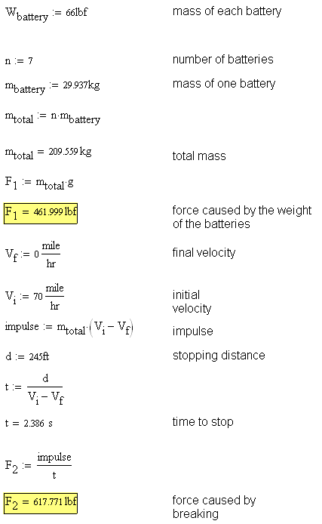

ALGORE calculations (Force Acting on the side area shown in figure 8A)

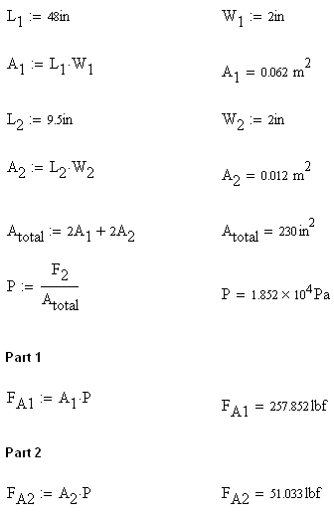

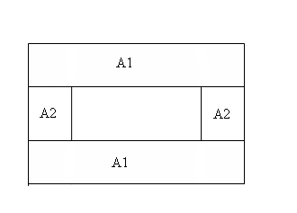
Figure A1-1: Side Area of the Battery Cage

ALGORE calculations (Force Acting on the bottom area shown in figure 8B)

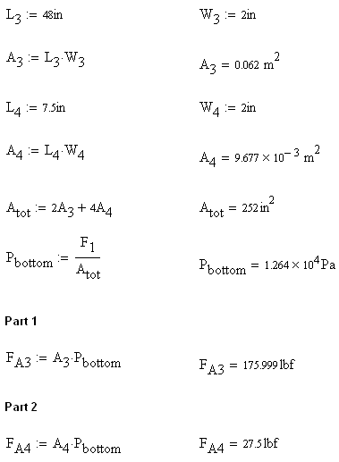

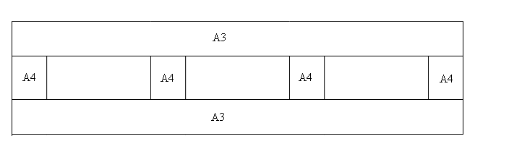
Figure A1-2: Bottom Area of the Battery Cage

Algore calculations for front part
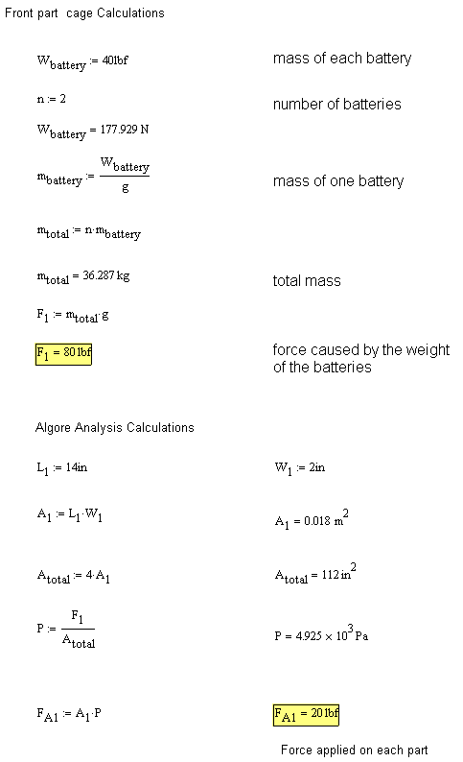

Conversion manual calculations
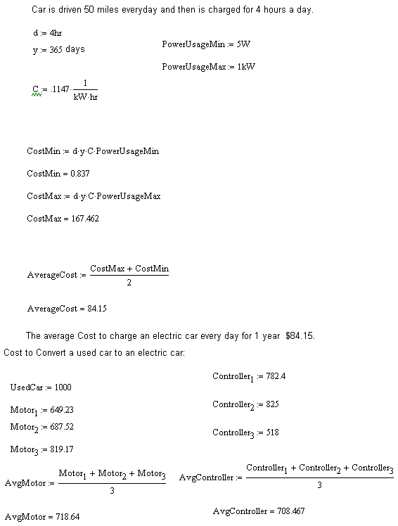

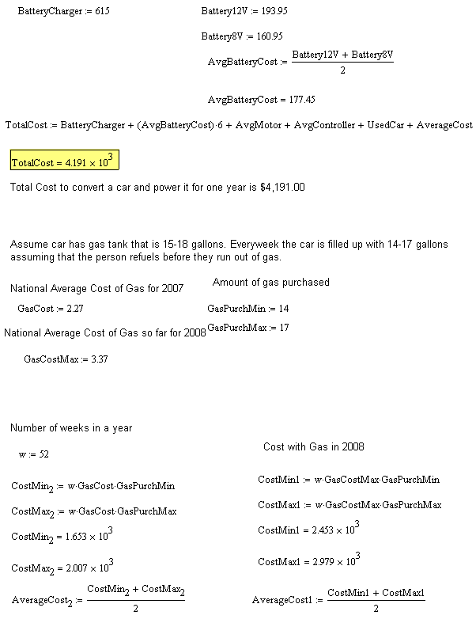

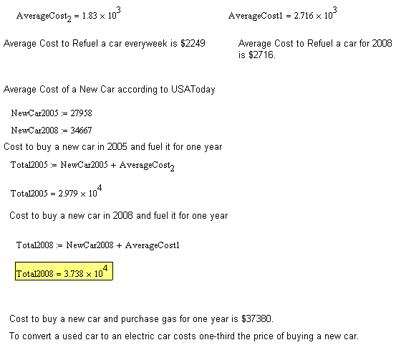

Grade Calculations

Figure A2: How to Measure the grade
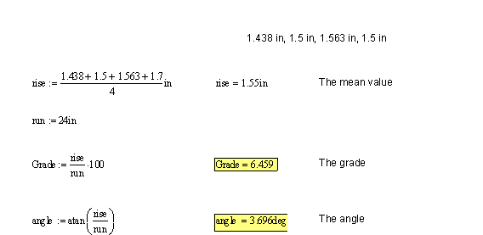

Battery Configuration

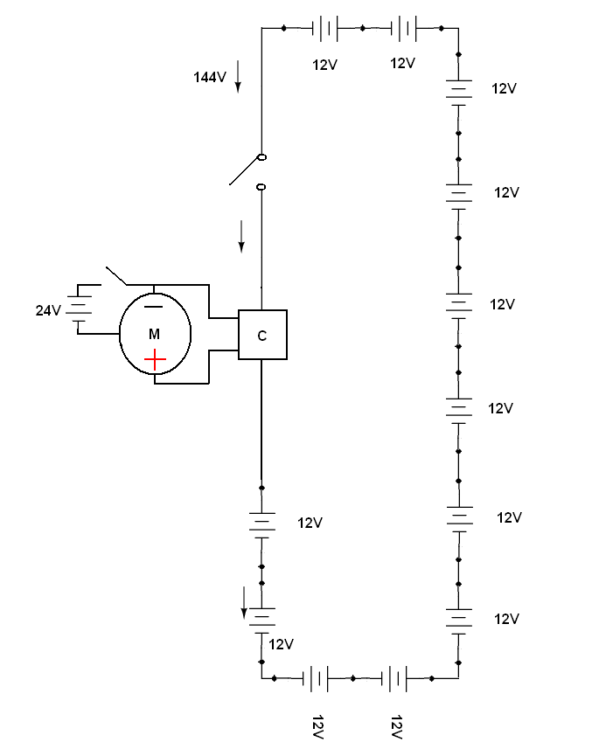
Figure A3-1: 12 batteries connected in series mode generating 144 volts

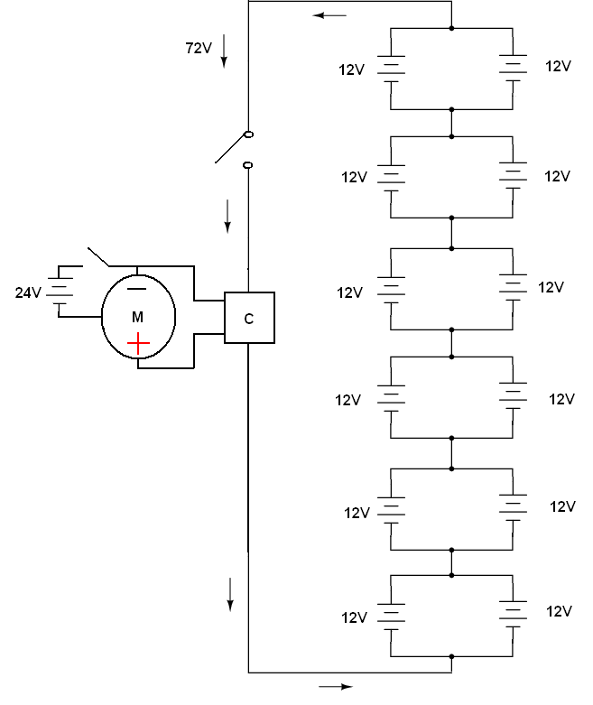
Figure A3-2: 12 batteries connected in parallel mode generating 72 volts

Pro Engineering Drawings
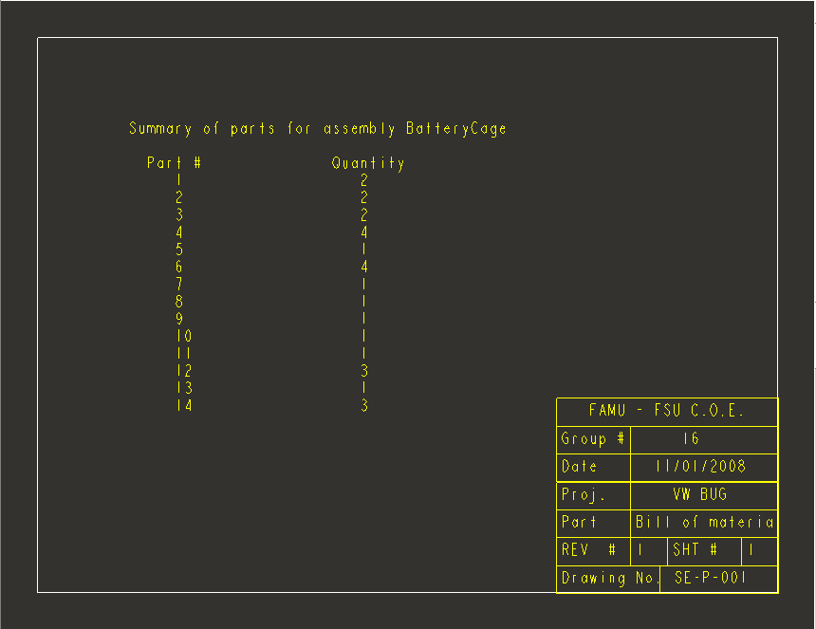
Figure A4-1: battery cage bill of materials

Figure A4-2: battery cage assembly view

Figure A4-3: battery cage exploded view

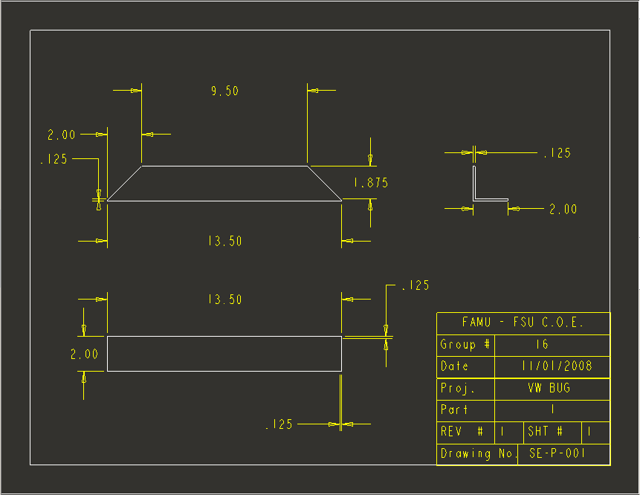
Figure A4-4: battery cage part 1

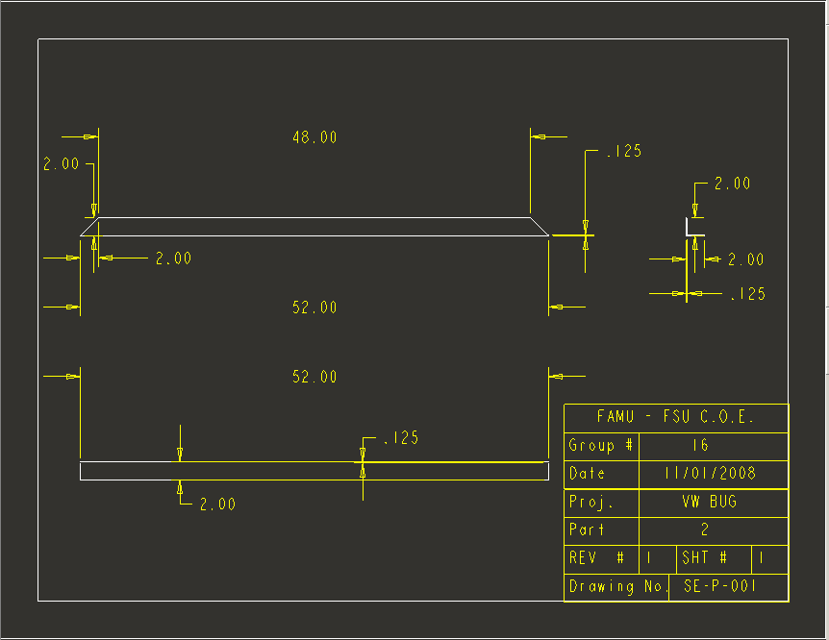
Figure A4-5: battery cage part 2

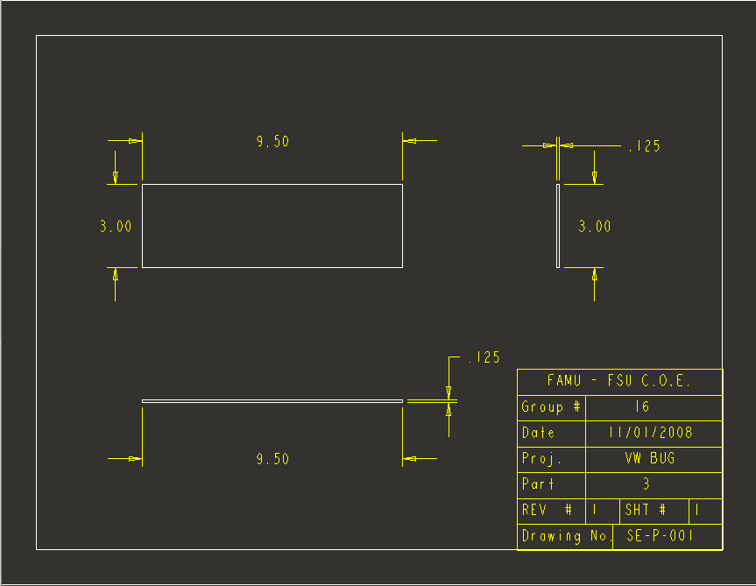
Figure A4-6: battery cage part 3

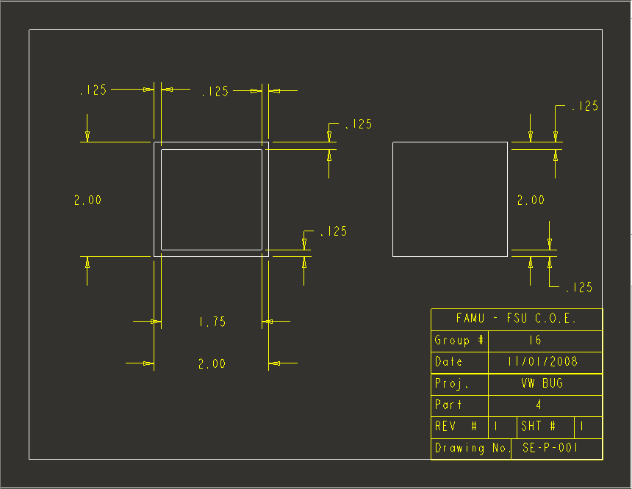
Figure A4-7: battery cage part 4

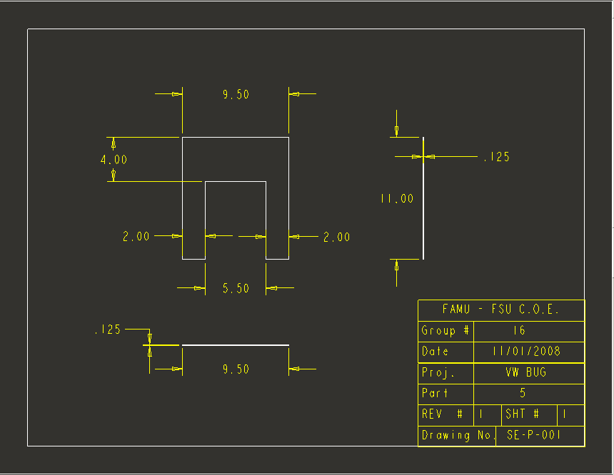
Figure A4-8: battery cage part 5

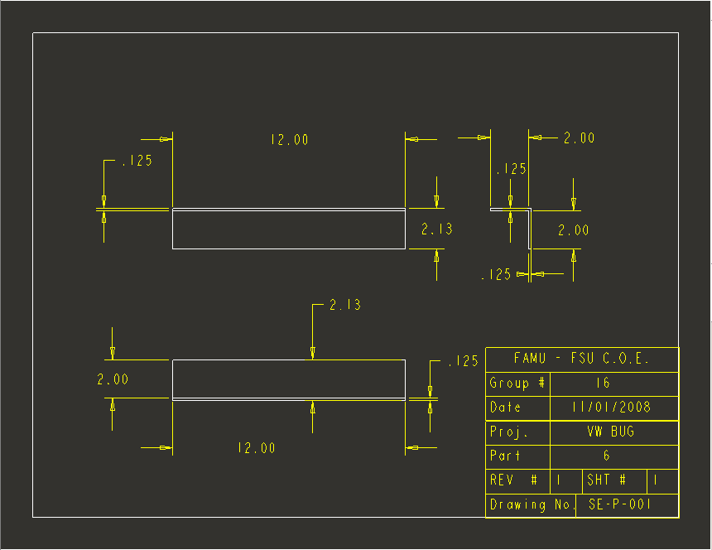
Figure A4-9: battery cage part 6

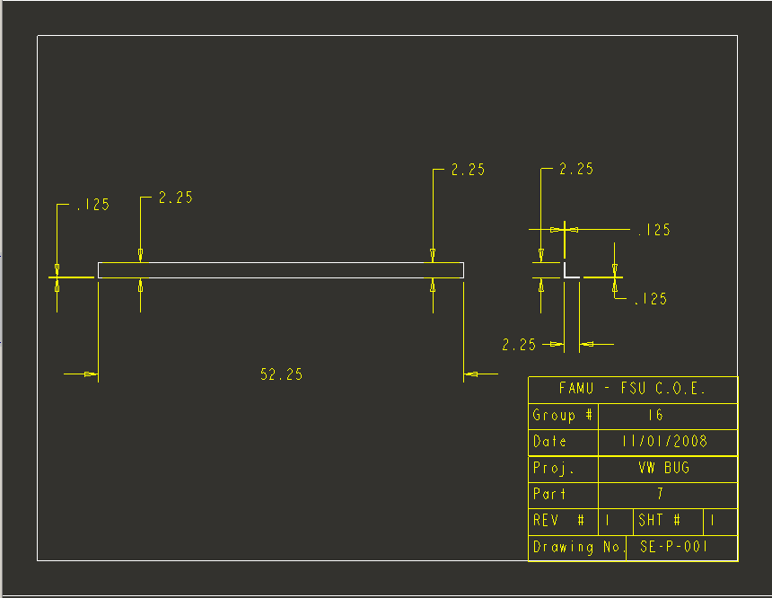
Figure A4-10: battery cage part 7

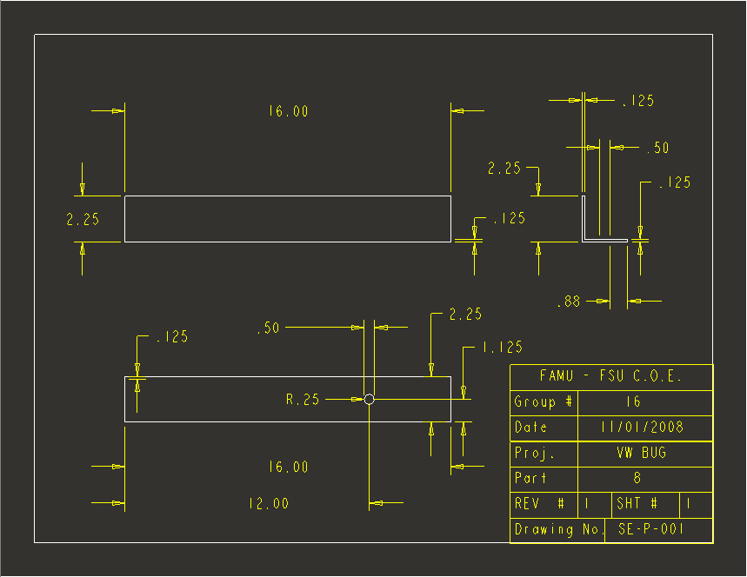
Figure A4-11: battery cage part 8

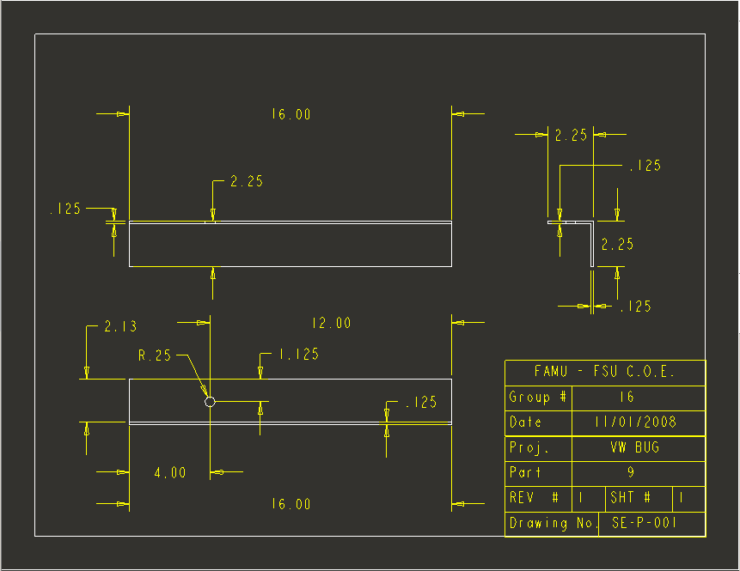
Figure A4-12: battery cage part 9

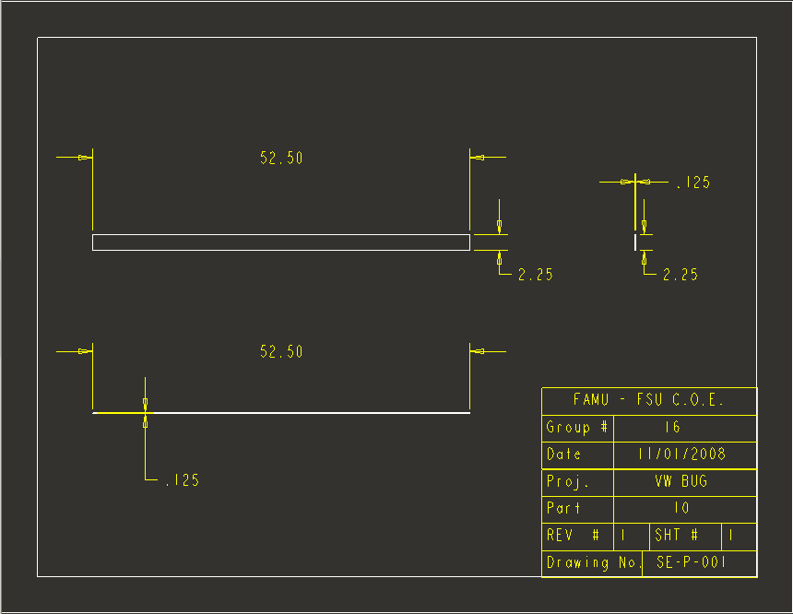
Figure A4-13: battery cage part 10

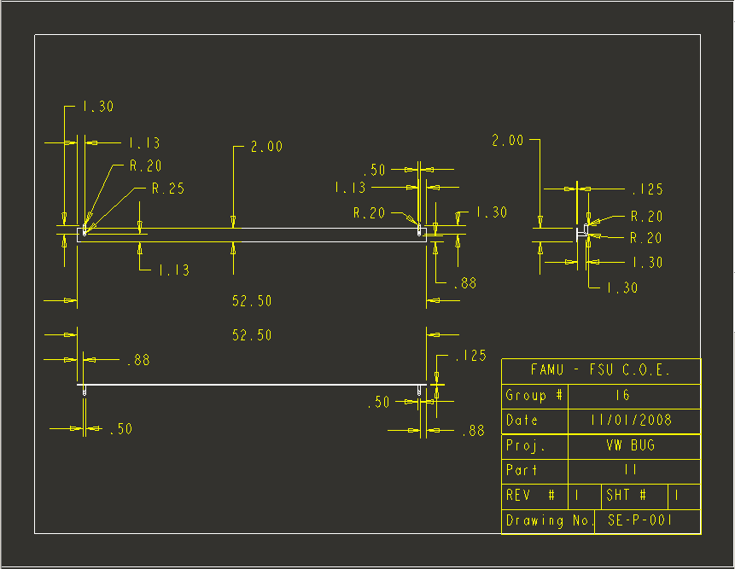
Figure A4-14: battery cage part 11

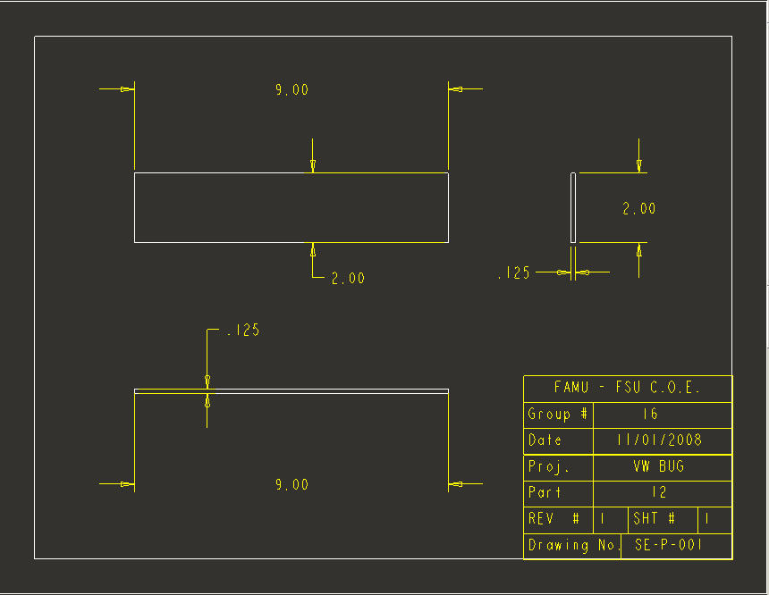
Figure A4-15: battery cage part 12

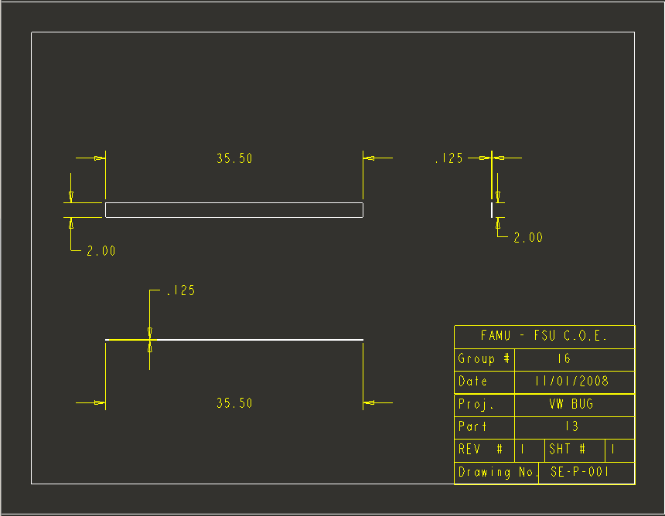
Figure A4-16: battery cage part 13

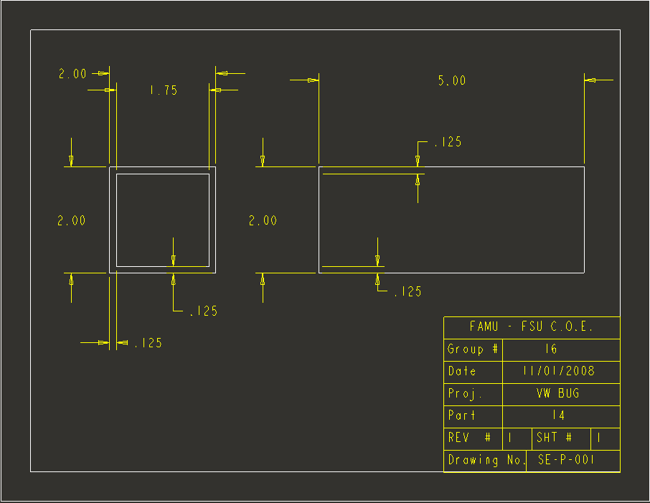
Figure A4-17: battery cage part 14

Front Compartment Cage
Pro Engineering Drawing
Figure A5-1: battery cage part 7
Figure A5-2: battery cage part 7
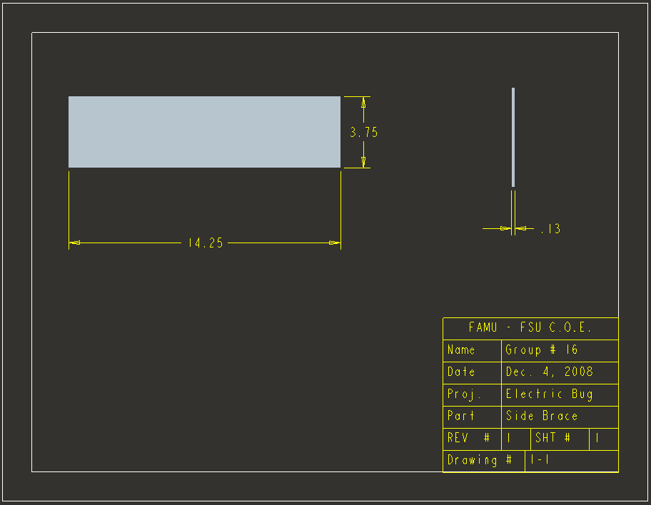
Figure A5-3: battery cage part 7

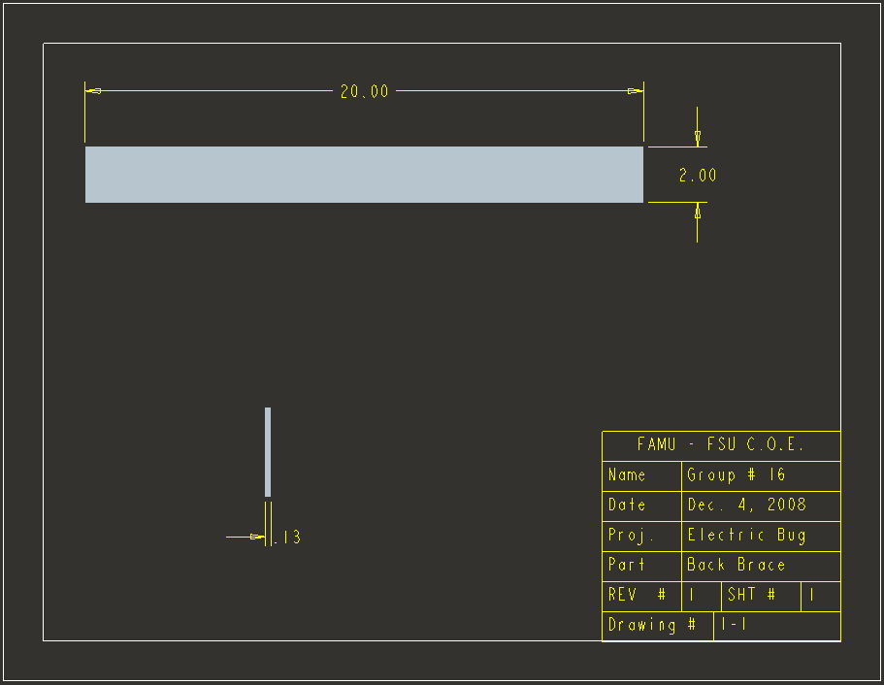
Figure A5-4: battery cage part 7

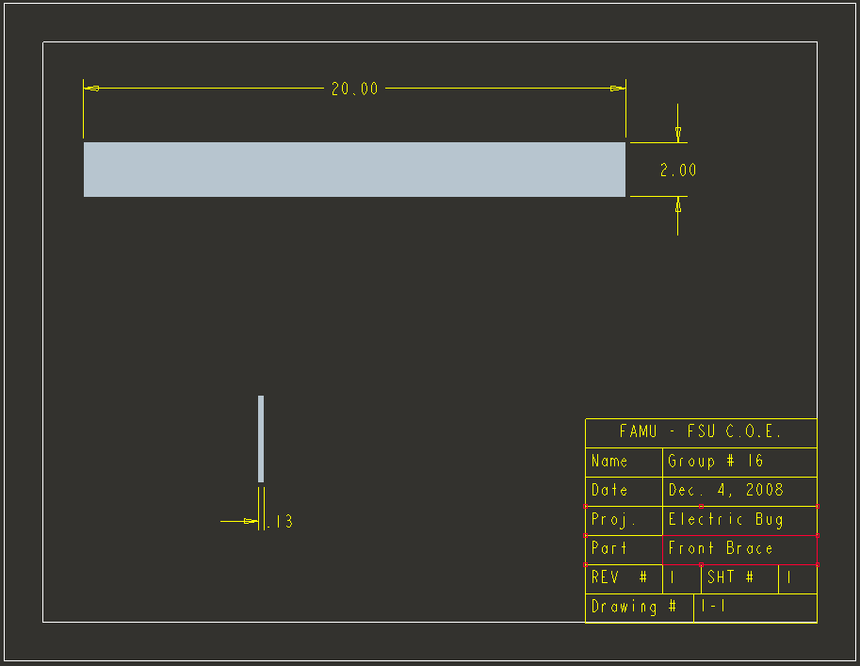
Figure A5-5: battery cage part 7

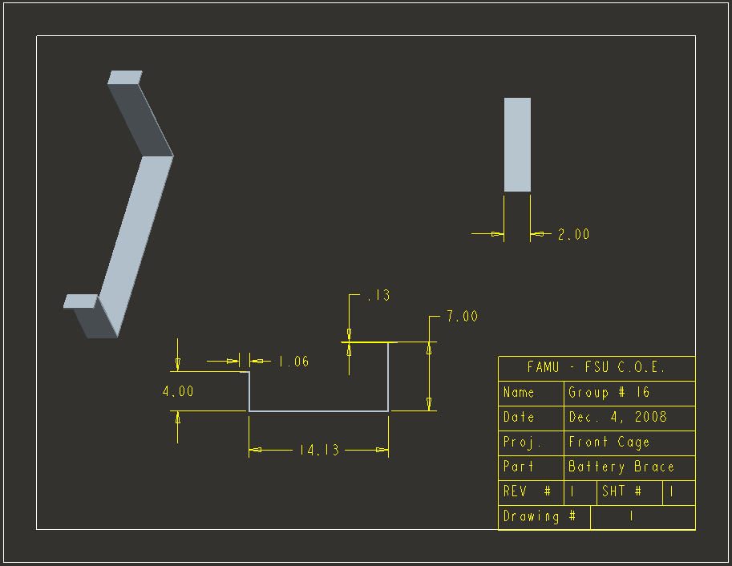
Figure A5-6: battery cage part 7

Expanded Cost Tables
Table A1: Cost of each part needed

Table A2: Cost of steel parts

