Electric 1974 VW Beetle
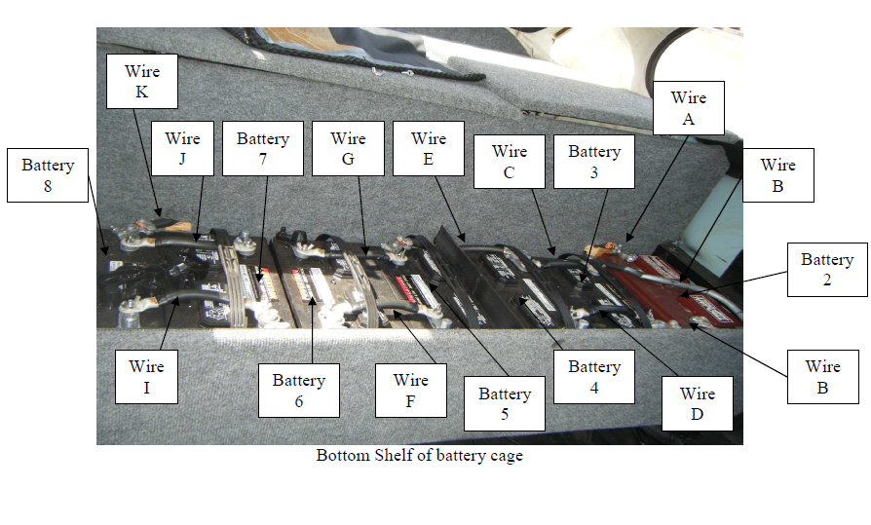

Operations Manual

Contents
General…………………………………………………………………………………………………..3
  - Introduction…………..……………………………………………………………….3
  - Dangers, Cautions, Notes and other definitions………………………4
  - Batteries…………………………………………………………………………………5
  - Motor……………………………………………………………………………………..5
  - Controller………………………………………………………………………………..5
  - Battery Charger……………………………………………………………………….5
  - Fans…………………………………………………………………………………………6
  - Filter……….……………………………………………………………………………….6
  - Wires……………………………………………………………………………………….6
Installation and Removal Procedures…………..………………………………………….7
2.1 Installation of Front Battery Cage…………………………………………….7
2.2 Removal of Front Battery Cage….……………………………………………..8
2.3 Installation of Batteries into the Front Cage……………………………..9
2.4 Removal of Batteries from the Front Cage……………………………….11
2.5 Installation of Main Battery System…………………………………………12
2.6 Installation of Battery Cage Covers…………………………………………..17
2.7 Removal of Battery Cage Covers……………………………………………...18
Operating Procedures……………………………………………………………………………..20
3.1 Starting the Car………………………………………………………………………..20
3.2 Turning the Car Off…………………………………………………………………..20
3.3 Charging the Car……………………………………………………………………….21
3.4 Unplugging the Charging Cable of the Car…………………………………22

1.1 Introduction
The operations manual is intended to provide the owner of the vehicle with intended information to operate, install and remove equipment in a safe manner. The new equipment in the car was added to increase the overall performance of the car. The operations manual provides guides on removing batteries, wiring and the front cage as well as the equipment that is connected together.

1.2 Dangers, Cautions, Notes and other definitions

DANGER - means there exists a risk that can cause serious injury or death to the operator or bystanders if the procedure is not observed.

CAUTION – means there exists a risk to the equipment if the procedure is not observed.

NOTE – draws attention to an item that is of importance.

1.3 Batteries
Johnson Controls 12V Deep Cycle
Number of batteries: 6
Model #: MRVDC27MX-BJC

Trojan Deep Cycle
Number of batteries: 6
Everstart 12V
Number of batteries: 3
Model #: 24DC-6

1.4 Motor
Jack and Heintz G29 - Provided

1.5 Controller
Alltrax AXE 7245 - Provided

1.6 Battery Charger
Zivan NG1 - Provided
Black and Decker 12V Float Charger
Number of Chargers: 3
Output Amps: 2

1.7 Fans
Detmar Tunnel Blower
CFM: 170
Diameter: 3”

Link Depot
Model #: FAN-9025-S
Bearing Type: Sleeve
RPM: 2500RPM
Air Flow: 43.5CFM
Noise Level: 28.8dBA
Power Connector: 4 Pin
Color: Black
Dimensions: 92 x 92 x 25mm

Sunon
Dimensions: 75x75x30mm
Voltage: 12VDC
Voltage Range: 10.2-13.8 VDC
Start Voltage: 5VDC
Fan Speed: 3400 RPM
Air Flow: 13.6 CFM
Air Pressure: 0.60 in-H2O
Rated Current: 0.30A
Rated Power: 3.6W
Noise: 43.5 dBA

1.8 Filter
3” Cone Filter
1.9 Wires
2/0 Gauge Welding Cable – Main battery pack, motor, controller, etc.
10 Gauge Wire – Field pack
20 Gauge Wire – Fans
6 Gauge Wire – Field pack
Installation and Removal Procedures
2.1 Installation of Front Battery Cage
Part List:
Front Battery Cage – Part A
5/16” bolt (6) – Part B

Tools Required:
Socket Wrench

- Place the front battery cage (Part A) in the front compartment of the car. See figure 1 for orientation and placement of the cage.
- Insert bolts (Part B) into the holes and screw in tightly. See figure 1 for the placement of bolts.

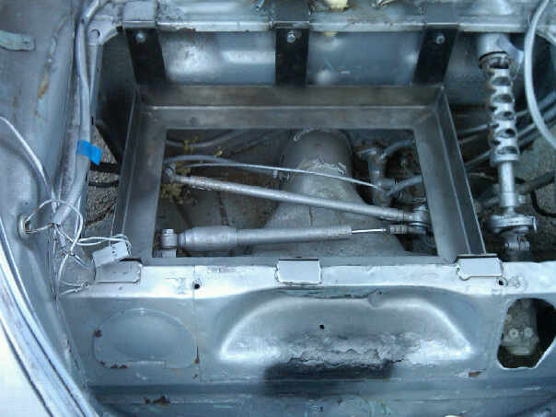
Front of car
Taller uprights go toward the rear of the car. (Part A)
Location of the bolts. (Part B)
Figure 1: Orientation of Front Battery Cage and location of bolts.

2.2 Removal of Front Battery Cage

Part List:
Front Battery Cage – Part A
5/16” bolt (6) – Part B

Tools Required:
Socket Wrench

- Unscrew the five bolts (Part B) that are holding the front battery cage in place. See figure 2 for the location of the bolts.
- Remove the battery cage (Part A) from the front compartment.

Location of the bolts. (Part B)
Figure 2: Shows the location of the bolts to be removed.

2.3 Installation of Batteries in the Front Battery Cage
Part List:
Batteries (2) – Battery 1 and 2
Black Wire – Part A
Red Wire – Part D
Connector Wire – Part C
Charger wires (2) – Part B and E

Tools Required:
Socket Wrench
Wrench

DANGER: When working with batteries, always follow the One-Hand Rule! The One-Hand Rule is when working on batteries only one hand should come in contact with the battery! If two hands come in contact serious injury may occur!
DANGER: Do not let a positive wire and a negative wire come in contact with each other!
DANGER: Do not let the contacts on a battery ever be connected by any metal! The circuit will be closed and the battery will explode! Serious injury may occur!
- Place the two batteries, 1 and 2, into the front battery cage. See figure 1 for orientation of batteries in the front battery cage.
NOTE: See Figure 3 for steps 2 through 6, for exact wiring connections.
- Attach the black wire (Part A) that is located in the front compartment to the negative contact on battery 1.
- Attach the battery charger (Part B) to battery 1. Attach the negative contact of the battery charger to the negative contact of battery 1 and the positive contact of the battery charger to the positive contact of battery 1.
- Take the wire (Part C) and attach one end of the wire to the positive contact on battery 1. Attach the other end to the negative contact on battery 2.
- Attach the red wire (Part D) that is located in the front compartment to the positive contact on battery 2.
- Attach the battery charger (Part E) to battery 2. Attach the negative contact of the battery charger to the negative contact of battery 2 and the positive contact of the battery charger to the positive contact of battery 2.
Part A

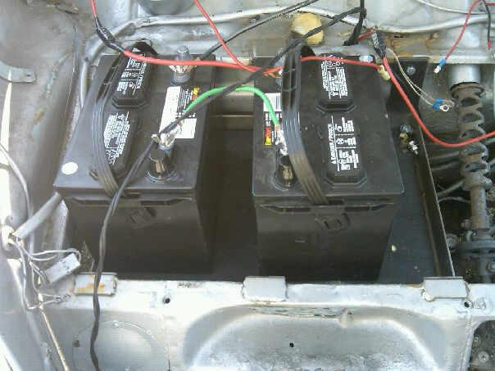
Battery 1
Battery 2
Part C
Part D
Figure 3: Shows orientation of the batteries and the wiring configuration.

2.4 Removal of Batteries from the Front Battery Cage

Tools Required:
Socket Wrench
Wrench

DANGER: When working with batteries, always follow the One-Hand Rule! The One-Hand Rule is when working on batteries only one hand should come in contact with the battery! If two hands come in contact serious injury may occur!
DANGER: Do not let a positive wire and a negative wire come in contact with each other!
DANGER: Do not let the contacts on a battery ever be connected by any metal! The circuit will be closed and the battery will explode! Serious injury may occur!
- Disconnect the wires from the negative side of battery 2. This includes the black wire and the float charger wire.
- Disconnect the green wire, the wire that connects battery 2 to battery 1, from battery 2 as well as the float charger wire.
- Now disconnect the green wire and the float charger wire from battery 1.
- Disconnect the red wire and the float charger wire that is connected to the positive side of battery 1.

2.5 Installation of Main Battery System
Part List:
Batteries (12) – Battery 1 - 12
Electrical cables (19) – Wire A – M
Motor
Controller
Solenoid
Junction
Tools Required:
Socket Wrench
Wrench
DANGER: When working with batteries, always follow the One-Hand Rule! The One-Hand Rule is when working on batteries only one hand should come in contact with the battery! If two hands come in contact serious injury may occur!
DANGER: Do not let a positive wire and a negative wire come in contact with each other!
DANGER: Do not let the contacts on a battery ever be connected by any metal! The circuit will be closed and the battery will explode! Serious injury may occur!
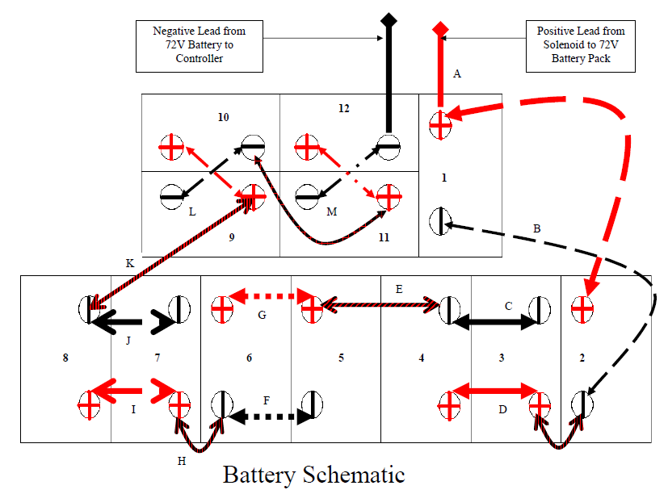
Figure 2: Wiring diagram for batteries located in the rear battery cage. Red lines denote a positive to positive connection. Black lines denote a negative to negative connection. Black and red lines denote a connection between a positive and negative.

- Attach the first end of Wire A to the controller.
- Attach the flag terminal of Wire A to the positive terminal of Battery 1.
- Attach the second terminal of Wire A to the positive terminal of Battery 2.
- Attach one end of Wire B to the negative terminal of Battery 1.
- Attach the flag terminal of Wire B to the negative terminal of Battery 2.
- Attach the final terminal of Wire B to the positive terminal of Battery 3.
- Attach Wire C to the negative terminals of Battery 3 and Battery 4.
- Attach Wire D to the positive terminals of Battery 3 and Battery 4.
- Attach Wire E to the negative terminal of Battery 4 to the positive terminal of Battery 5.
- Attach Wire F to the negative terminals on both Battery 5 and Battery 6.
- Attach Wire G to the positive terminals on both Battery 5 and Battery 6.
- Attach Wire H to the negative terminal on Battery 6 and to the positive terminal on Battery 7.
- Attach Wire I to the positive terminals on both Battery 7 and Battery 8.
- Attach Wire J to the negative terminals on both Battery 7 and Battery 8.
- Attach one end of Wire K to the negative of Battery 8.
- Attach the flag terminal in Wire K to the positive terminal of Battery 9.
- Attach the end of Wire K to the positive terminal of Battery 10.
- Attach the end of Wire L to the negative terminal of Battery 9.
- Attach one of the flag terminals on Wire L to the negative terminal of Battery 10.
- Attach the next flag terminal located on Wire L to the positive terminal on Battery 11.
- Attach the end of Wire L to the positive terminal on Battery 12.
- Attach one end of Wire M to the negative terminal on Battery 11.
- Attach the flag terminal located on Wire M to the negative terminal on Battery 12.

NOTE: Refer to Figure 4 for correct connections for steps 16-23.

Figure 4: Rear battery compartment labeled for assistance.

NOTE: Refer to Figure 5 and 6 for correct connections for steps 24-30.

- Attach Wire M to “B-“ on the Alltrax controller.
- Connect one end of Wire N to the “M-“ on the Alltrax controller.
- Connect Wire A to the left side of the solenoid.
- Connect one end of Wire O to the right end of the solenoid and the other end to the Junction.
- Connect one end of Wire P to the Junction and the other end to “B+” on the Alltrax controller.
- Connect Wire Q from the “B+” connection on the Alltrax controller to the positive connection, “B” on the motor.
- Connect the other end of Wire N to the negative connection point, “E”, on the motor.
Wire A
Controller
Solenoid
Junction

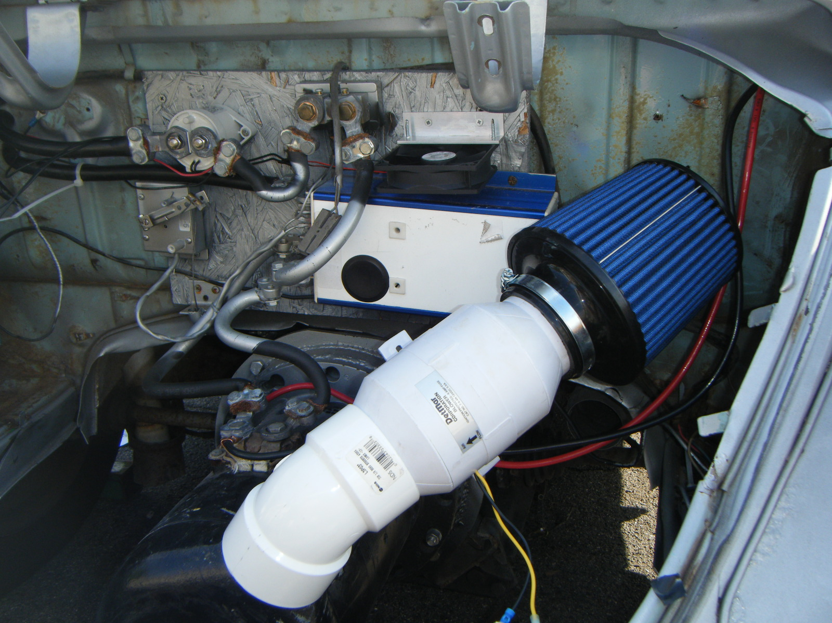
Wire M
Motor
Figure 5: Shows the connections and locations of the wires, motor, controller, junction and solenoid.

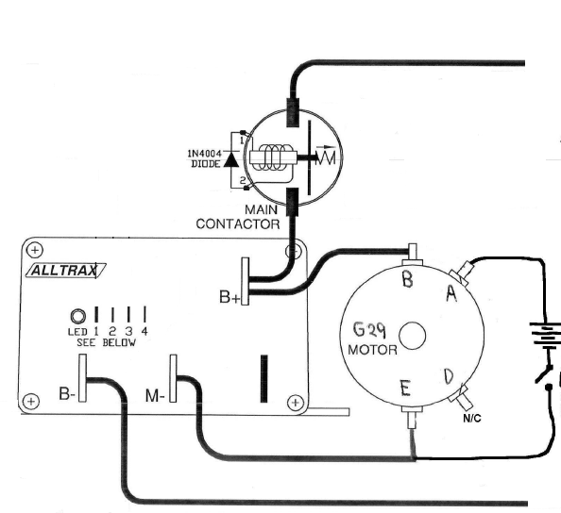
Wire M
Wire N
Wire Q
Wire A

Figure 6: Shows a wiring diagram for connections on the motor and controller.

2.6 Installation of Battery Cage Covers
Part List:
Wing nuts
Battery Cage Covers (4) – Part A-D

- Place Part A on to the front face of the front battery compartment.
- Screw on a wing nut on to each of the 2 bolts protruding through the cover.
- Place Part B on to the top face of the front battery compartment.
- Screw on a wing nut on to each of the 4 bolts that are protruding through the cover.
- Place Part C and Part D on to the top of the rear batteries.
- Screw a wing nut on to each of the 6 bolts that is protruding through the covers.

NOTE: Refer to Figure 7 for location of protruding bolts.

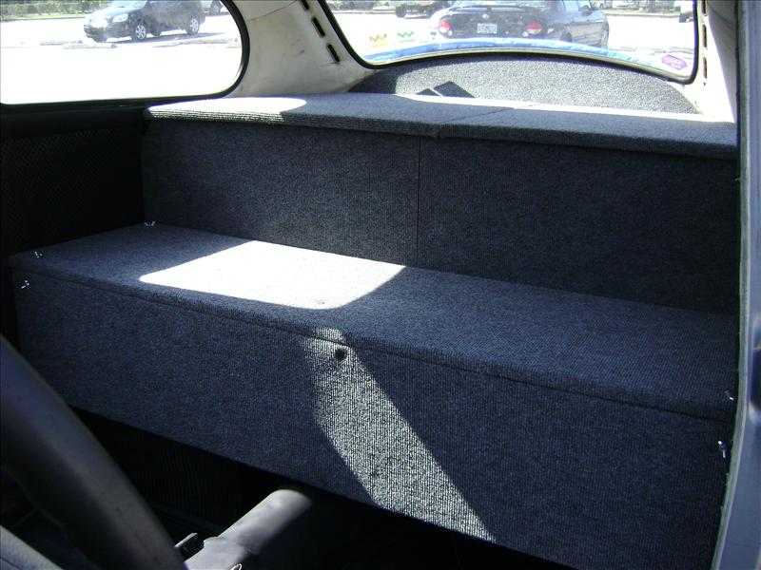
Figure 7: The pink dots show the location of the bolts protruding through the covers.

2.6 Removal of Battery Cage Covers
- Remove all the wing nuts from each of the bolts that are protruding through the covers. See figure 8 for location of wing nuts to be removed.
- Remove each battery cover.

Figure 8: The yellow dots show the location of the wing nuts that need to be removed.

Operating Procedures

3.1 Starting the Car

- Insert the key into the ignition slot.
- Turn the key to the right. This will unlock the steering wheel.
- Turn the ignition switch, which is located to the left of the speedometer, to the ON position as shown in Figure 9.
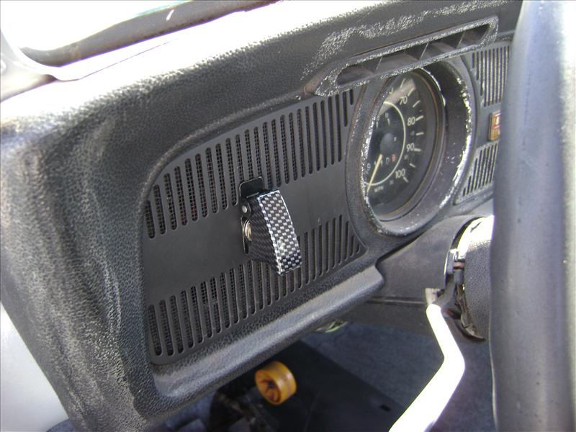
Switch in ON position.
Figure 9: Shows the location of the power switch.

NOTE: Turning the switch on will engage the auxiliary battery, which will power the motor fan and the auxiliary car systems, and the main battery system, which powers the car.

CAUTION: When driving the car DO NOT push the accelerator down all the way. Doing this may melt a terminal or cause damage to the electrical system.

3.2 Shutting the Car Off

CAUTION: Car needs to be at a complete stop with the emergency brake on, before shutting the car off.

- Turn the ignition switch, which is located to the left of the speedometer, to the OFF position.

NOTE: Turning the switch off will disengage the auxiliary battery, which powers the motor fan and the auxiliary car systems, and the main battery system, which powers the car.

- Turn the key in the ignition switch to left. This will lock the steering wheel.
- Remove the key from the ignition.

3.3 Charging the Car

- Open the fuel door, which is located on the exterior of the car on the front passenger side. See figure 10 for location.
- Plug the female end of an extension cord to the male end of the plug located in the fuel door compartment.

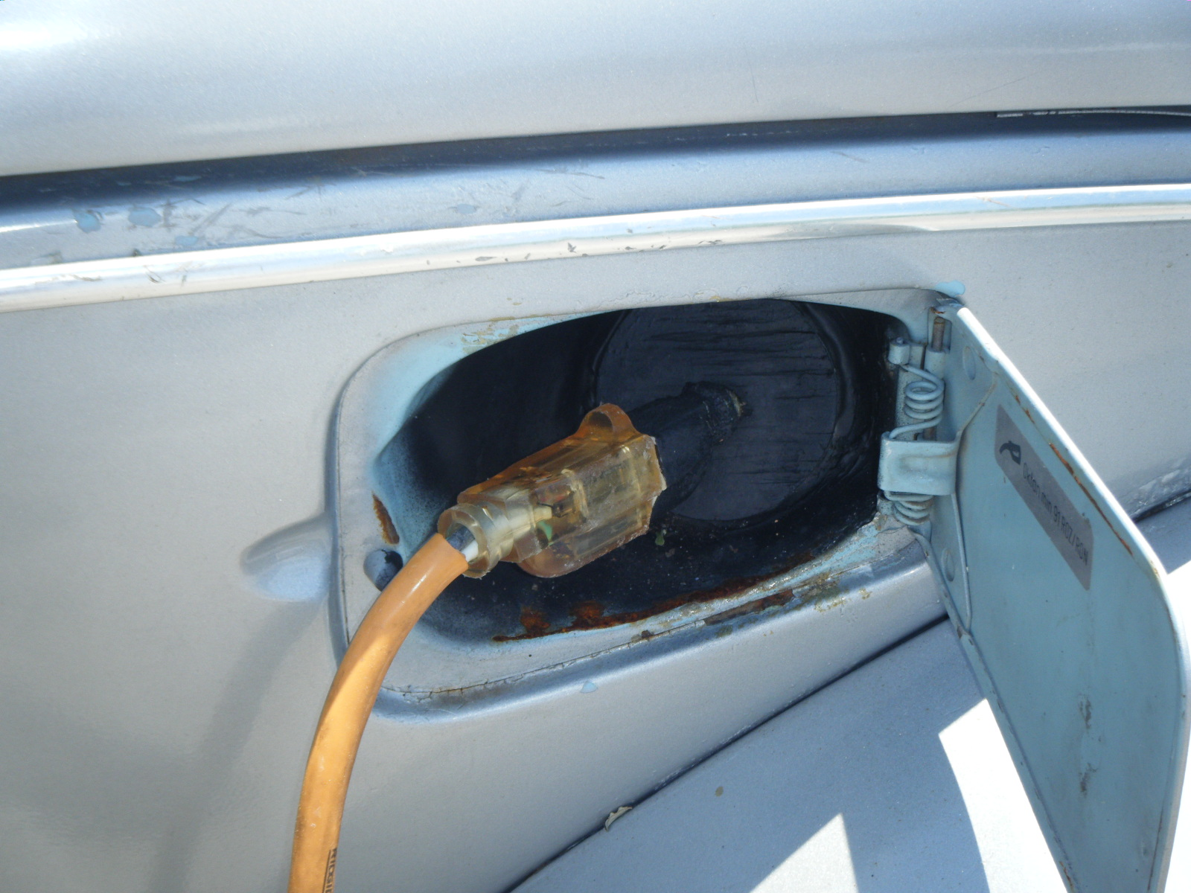
Fuel door compartment
Charging cable
Figure 10: Shows the location of the charging cable as well as how it is to be connected to an extension cable.

NOTE: Plugging the car in will power a power strip located in the rear compartment of the battery box. Attached to this power strip is the Zivan Charger, 3 Black and Decker trickle chargers and the Hydrogen Ventilation fan.

3.4 Unplugging the Charging Cable of the Car

- Unplug the extension cord from the plug located inside the fuel door compartment.
- Close the fuel door to cover the male plug and protect it from the environment.

NOTE: Unplugging the extension cord will cease power to the power strip located in the rear compartment of the battery box. This will cease power to the Zivan charger, which recharges the main battery system, 3 float chargers and the hydrogen ventilation fan.

