Team 2: 900 MHz NMR Probe Cryogenic Gas Supply System
Product Specifications

September 30, 2008

Team members:
Rebecca Altman
Jason Kitchen
Zac Stevenson
Jessica Vanterpool

It has been determined the following list of design specifications based on the project description provided by our sponsor, and further detailed from our background research and initial meeting with the sponsor. Our project falls under the adaptive or development design process, since we seek to improve the reliability, ease of use, and efficiency of an existing cryogenic gas delivery platform. At this stage of concept development, we categorize the specifications into the overall platform and subsystems as follows:
Platform Level Specifications
- System shall be capable of providing a cryogenic nitrogen gas stream in order to convectively cool the NMR probe sample to a minimum temperature of 103 K.
- Final sample temperature shall be controlled by an existing closed loop feedback PID resistive heater controller. Operation of the cryogenic gas delivery system must not impede this controller’s tolerance range of + 0.5 K.
- System components stationed inside the field of the 900 UWB must be non-magnetic.
- System shall support nitrogen gas flow rates of up to 2 SCFM.
Subsystem Specifications
- Heat Exchanger (HX) Dewar Liquid Nitrogen Refill
  - Gas supply platform shall be capable of continuous operation for an indefinite period, therefore liquid nitrogen bath in HX dewar shall be maintained by means of an automatic level controller which is not part of the current system.
  - Change-out of liquid nitrogen cylinders supplying the HX dewar may occur up to once daily, so long as operation of gas delivery platform is not interrupted.
- Gas Delivery Transfer Line
  - Since nitrogen vapor accumulation from HX dewar boil-off is a possible asphyxiation hazard, the HX dewar must not be located in the confined space pit underneath the 900 UWB magnet. Instead a transfer line of at least 3 m in length shall allow the dewar to be stationed to the side of the magnet outside the pit. Current platform’s transfer line is not long enough to meet this specification.
  - Transfer line and associated fittings shall be well insulated to reduce thermal losses, thereby reducing consumption of liquid and gaseous nitrogen to lower levels than current system.
- NMR Probe Dewar
  - NMR probe has an existing bore tube which accepts a 15 mm diameter probe dewar, therefore any newly designed dewar shall not exceed this diameter constraint for the portion inserted into the probe body.
  - If dewar is made from conductive material, it must not extend farther than 1.41 m up the probe body, so that its presence will not affect the characteristics of the RF transmission line circuit.
  - If probe dewar is constructed from vacuum jacketed tubing, it shall have an operator for periodic pumping to vacuum level pressure.
- Sample Heater
  - A heater shall be incorporated into the platform which is compatible with the Bruker sample temperature controller as noted in specification B. Therefore the heater should have similar electrical resistance and utilize a thermocouple as does the current probe heater.
  - If a newly designed heater is used in this system it shall be fabricated of material which will not oxidize under high temperature so that oxidation residue will not enter the nitrogen gas stream which could contaminate the sample or damage the precision bearings of the MAS rotor and stator.
  - Location of the heater in the system must be close enough to sample thermocouple so that heater controller feedback signal is able to maintain the + 0.5 K temperature tolerance. The location of the current heater in the base of the probe is close enough to meet these criteria.

Schedule
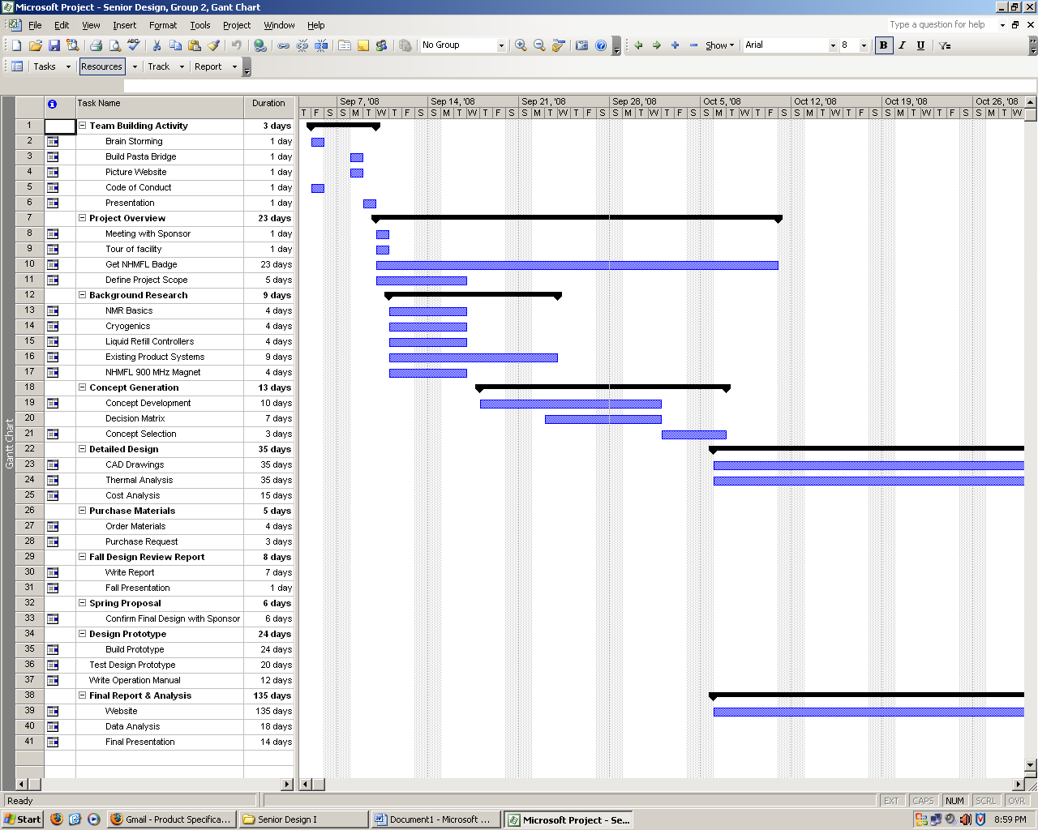

Update

As of this week we have accomplished meeting with our sponsor and advisor. While meeting with them the resulting expectations of the project were made clear. Several different design ideas were also explained thoroughly which gave us a basis on where, and how to start on designing a better Cryogenic supply system. Research on similar Cryogenic supply systems has been done and taken into consideration for design ideas, as well as fresh ideas thought of by the team. In order to stay on track with our progress a schedule has been made and completed, however it may be subject to change. In the next few weeks we plan to create a list of advantages and disadvantages for each design idea. Once this is done a decision matrix will be made, then a selection will be made by choosing the highest ranking design idea. After this is done we will begin a detailed analysis on the selected design.

